Ethanolic Extract of African Walnut Fruits on Male Reproductive Parameters in Adult Male Wistar Rats

Abstract
This study seeks to investigate the effects of African Walnut Fruit in the reproductive system of adult male Wistar rats. Twenty (20) male rats were used for this present study. Animals were grouped into Control, Low (500 mg/kg) and High Dose (1500mg/kg) of African Walnut fruits. These fruits were extracted using standard procedures. The extract was administered orally using oral gavage for 21 days. Twenty- four (24) hours after the last administration of the plant extract, the animals were sacrificed. Testis and epididymis were harvested and used for histological studies; semen was collected for semen analysis. Data were expressed as mean ± S.E.M. The difference between the tested groups and the control was analysed using a one-way ANOVA. Values were considered statistically significant when p is ≤ 0.05. The results gotten from this study showed that consumption of this fruit extract increased sperm count (control: 483.33 ± 90.83; low dose: 583.33 ± 50; high dose: 500 ± 57.74), sperm viability (control: 80 ± 2.89; low dose: 83 ± 1.58; high dose: 85 ± 2.89) and testosterone levels (control: 1.157±0.06; low dose: 1.370 ± 0.056; high dose: 1.295 ± 0.021). African walnut fruits has shown a significant effect on male reproductive parameters. This natural plant possesses the tendency to improve sperm count, sperm viability, and morphology which may likely solve the problem of infertility.
Key words: Semen analysis, testis, Histological studies

Key words: Semen analysis, testis, Histological studies

INTRODUCTION

The World Health Organization (WHO) describes clinical infertility as a disease of the reproductive system defined by the failure to achieve clinical pregnancy after 12 months or more of regular unprotected sexual intercourse (Hochschild et al.,2009). This disease, which affects one in seven couples, may be due to female factors, male factors, or both. A male infertility factor with abnormal semen parameters is found in approximately 50% of couples seeking infertility treatment (Jungwirth et al., 2012). Infertility is one of the problems of human society. According to World Health Organization (WHO), 15-10 percent of couples have experienced some forms of infertility problems which 40% of these problems are due to male factor (Bashir et al.,2009; Kashani et al.,2012).
Reproductive ability in males contain the production of semen containing normal spermatozoa (quality) in the adequate number(quantity), together with the desire and ability to mate(Oyeyemet al.,2008). The main causes of male infertility include endocrine diseases, malignancies and genetic anomality, but the cause remains unknown in 50% of cases. Mild and severe male infertility are frequently used in the literature to describe an abnormal semen assessment but are purely descriptive and without clear definition and relationship to the aetiology, which is only found in approximately 50% of cases. Different treatments like surgery, chemical and herbal drugs and laboratory methods are available to help infertility. According to several studies, a number of botanical medicines has positive effect on sperm parameters (Sinclair.,2005).
Adequate sperm production and function require a healthy urogenital tract to allow normal fertility. Inflammatory processes and bacterial infections have been associated with male infertility, but the exact mechanisms remain poorly understood(Gimeneset al.,2012). The effect of an acute infection might not be as deleterious as a chronic infection where silent inflammatory process might have long-lasting negative impact on sperm function, spermatogenesis, and permeability of the vas deferens and/or ejaculatory duct. Pathogens that chronically colonize the male urogenital tract could have a negative impact on fertility by affecting the parameter of the semen assessment (count or motility) or even by inducing apoptosis(Eleyet al., 2005).
For centuries, traditional medicine has used herbs and plants to increase fertility. Withaniasomnifera (Ashwagandha) is a traditional medicinal herb that has been used for years in traditional medicine. It helps to boost male fertility and sperm health (Ambiye, 2013). Studies have shown that ashwagandha increases sperm count and motility, and increase levels of reproductive hormones. Since ashwagandha acts as an antioxidant, it may protect sperm cells from damage caused by oxidative stress (Sengupta, 2018). The use of plant extracts as a fertility enhancer in man is now on the increase because of the shifting of attention from synthetic drugs to natural plants (Dada et al.,2009). Studies have shown that, despite the high prevalence and psychological consequences of the disorder, relatively few men had sought for orthodox treatment prior to the introduction of sildenafil (McKinley et al.,1999). Reduced sexual performance among the males though associated with aging process has always been a matter of great concern to man. Researches carried out to identify the potential risks factors for male infertility indicated that there were associations between male infertility and previous exposure to sexually transmitted diseases, unorthodox medication and moderate consumption of alcohol (Okonofuaet al., 2005).
Ultimately, men benefit from African walnut consumption, specifically regarding their sexual health. Eating African walnut will supercharge the libido, enhance sexual experience, prevent sexual dysfunction and increase the reproductive effects of the released sperm. African walnut is an edible nutthat is consumed traditionally by men (Okonwo&ozoude, 2014). Walnuts, when administered to men placed on western diet, were also identified to, respectively, increase sperm motility, vitality, and normal morphology significantly (Robbins et al.,2012).

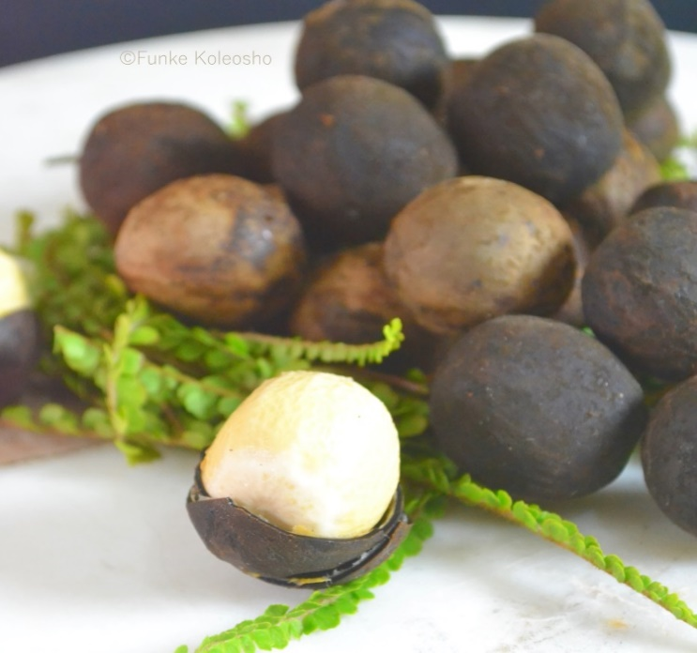
Figure 1: African walnut fruit

METHODS AND MATERIALS
Plant Collection
Fresh African Walnut fruits were bought obtained from Rivers State University farm located in Port Harcourt, Nigeria. A voucher sample was deposited in the herbarium located in the Department of Plants Science and Biotechnology, Rivers State University for proper identification and authentication. Some of the fruits were washed, and air dried for twenty two days. Dried fruits were pulverized into fine powder using electric blender.

About 2500 grams of grinded walnut sample were extracted by complete soaking in 80% ethanol for 48 hours. Plant extract to solvent ratio was 40 g : 2500ml. the mixture was shaken periodically at regular intervals in order to achieve maximum extraction. After 72 hours, the solution was filtered twice using Whatman No 1 filter paper. The collected filtrate (extract) was concentrated using a thermo-regulated water bath at mild temperatures (from 35ºC-40ºC) until complete dryness was achieved, leaving a paste (crude extract).

Study Models
Twenty healthy male albino Wistar rats (180±20g body weight) were purchased from Animal House Unit of the Department of Human Anatomy, Rivers State University, Nigeria. Animals were housed in standard cages and maintained under the 12hr light/dark cycle. The rats were acclimatized for a period of 21 days before the commencement of the experiment. The rats had unlimited and unrestricted access to water before and during the experiment. Rats were fed with standard rat feed. Plant extracts were administered using the oral gavage.

Experimental Protocol
LD₅₀ studies
The Lorke’s method of determination of LD₅₀ was used for the present study. This method involves two phases:
PHASE 1: 9 mouse was used in this phase. Animals were grouped into 3 groups, with each group containing 3 animals. Group 1 received 500mg/kg, group 2 received 1000mg/kg, group 3 received 2000g/kg. After 24 hours, no death was recorded.
PHASE 2: 9 mouse was used. Animals were grouped into 3 groups each containing 3 animals. Group 4 received 2000mg/kg, group 5 received 4000mg/kg and group 6 received 5000mg/kg.
Since no animal died at 5000mg/kg, the dosage calculation for low dose and high dose were 1 ∕10 × 5000 and 3∕10 ×5000 respectively.
Study Design and Administration of Extracts
The rats were randomly divided into six (6) groups as follows:
Group 1. Served as normal control and received 1ml distilled water orally daily for 21 days.
Group 2. Served as test group I . Low dose of Ethanolic extract of African Walnut fruit extracts orally per daily for 21 days
Group 3. Served as test group II .High dose of Ethanolic extract of African Walnut fruit extracts orally per day for 21 days
Duration of Studies
This study was conducted for a period of 21 days in the animal house of the Rivers State University, College of Medical Sciences.
Procedure for Semen Analysis Test
Semen was gotten from the epididymis and analyzed using a method described by Victor et al. (2023)
Semen collection
The testis together with the epididymis was excised. The distal epididymis was then cut open to expose the semen for collection by applying a little pressure on the caudal epididymis to squeeze the semen into a microscope slide. Two drops of 2.9% sodium citrate were added and the slide was covered with a coverslip for examination and examination under the microscope. The sperm cells were classified into non-motile, sluggish, or actively motile. The percentage of the motile sperm was calculated by dividing the number of motile cells by the total number of counted sperm cells following the method described by Osuchuku (2016). The sperm was carried out using the Neubauer Haemocytometer.
Sperm motility
Semen was squeezed from the caudal epididymis onto a pre-warmed microscope slide (27ºC) and two drops of warm 2.9% sodium citrate were added, the slide was then covered with a warm cover slip and examined under the microscope x400 magnification. Ten fields of the microscope were randomly selected and the sperm motility was assessed randomly. Sperms were labelled as motile, sluggish, or immotile. The percentage of motile sperm cells was defined as the number of motile sperms divided by the total number of counted sperms (i.e. 100).
Sperm morphology
This was done by adding two drops of warm Walls and Ewas stain (Eosin/Nigrosin can also be used) to the semen on a pre-warmed slide, a uniform smear was then made and air-dried; the stained slide was immediately examined under a microscope using x400 magnification. Five fields of the microscope were randomly selected and the types and number of abnormal spermatozoa were evaluated from the total number of spermatozoa in the five fields; the number of abnormal spermatozoa was expressed as a percentage of the total number of spermatozoa.
Sperm count
This was done by removing the caudal epididymis from the right testes and blotting with filter paper. The caudal epididymis was immersed in 5mls formol-saline in a graduated test-tube and the volume of fluid displaced was taken as the volume of the epididymis. The caudal epididymis and the 5mls formol-saline were then poured into a mortar and homogenized into a suspension from which the sperm count was carried out using the improved Neubauer haemocytometer under the microscope.
Sperm viability (life/dead ratio)
This was done by adding two drops of warm Eosin/Nigrosin stain to the semen on a pre-warmed slide, a uniform stain was then made and dried with air, the stained slide was immediately examined under the microscope using x400 magnification. The live sperm cells were unstained while the dead sperm cells absorbed the stain. The stained and unstained sperm were counted and the percentage was calculated.
Statistical Analysis
Data was expressed as mean ± S.E.M using Statistical Package for Social Sciences version (SPSS) 25.0. Mean differences between the control and the other groups were tested using One Way Analysis of Variance (ANOVA). Values were considered statistically significant when p is less than or equal to 0.05 (P≤0.005). The difference between the sample mean was calculated using Kramer’s post-hoc test.

RESULTS

Table 1: Effect of Ethanolic extract of African Walnut fruit on Semen Analysis
Groups | Volume | pH | Viability | Normal | Abnormal | Active | Sluggish | Dead | Sperm Cells Count
LD  Mean ± S.E.M | 0.333 ± 0.037 | 8 ± 0 | 83.33 ± 1.58* | 83.33 ± 1.58* | 16.67 ± 1.65* | 78.33 ± 1.58 | 10 ± 0* | 11.67 ± 1.58 | 500 ± 57.74*
HD  Mean ± S.E.M | 0.3 ± 0.058 | 8 ± 0 | 85 ± 2.89* | 85 ± 2.89* | 15 ± 2.89* | 83.33 ± 3.33 | 8.33 ± 1.66* | 8.33 ± 1.66 | 583.33 ± 50*
Control  Mean ± S.E.M | 0.333 ± 0.021 | 8 ± 0 | 80 ± 2.89* | 80 ± 2.89* | 21.67 ± 4.46* | 21.67 ± 4.46* | 10 ± 0* | 15 ± 5 | 483.33 ± 90.83*
F | 0.476 | 0 | 18.098 | 19.342 | 13.543 | 17.756 | 8.654 | 13.890 | 15.433
P-Value | 0.678 | 0.0 | 0.0003 | 0.0034 | 0.0001 | 0.0043 | 0.0012 | 0.0025 | 0.0005

key
HD= High Dose
LD= Low Dose
S.E.M= Standard Error of Mean

Table 2: Effect of Ethanolic extract of African Walnut fruit on FSH, LH & Testosterone
 | Control  Mean ± SD | Mean ± SD  (Low dose) | Mean ± SD  (High Dose) | F | P
FSH | 0.63000±0.05292 | 0.5400±0.04248 | 1.3300±0.07071 | 91.862 | 0.00
LH | 0.7000±0.05000 | 0.6350±0.02111 | 1.2950±0.09192 | 77.466 | 0.01
Testosterone | 1.1567±0.06028 | 1.3700±0.05657 | 1.2950±0.02121 | 10.741 | 0.025

Key: Low Dose(500mg/kg)
High Dose(1500mg/kg)

Table 3: Effect of Ethanolic extract of African Walnut fruit on Liver Function
 | Control  Mean ± SD | Mean ± SD  (Low dose) | Mean ± SD  (High dose) | F | P
AST | 35.0000±8.0000 | 21.5000±4.94975 | 22.0000±9.89947 | 2.405 | 0.206
ALT | 31.6667±3.05505 | 21.5000±0.70711 | 16.5000±2.12132 | 25.356 | 0.005
ALP | 38.3333±5.5075 | 38.0000±21.2123 | 24.00000±4.9475 | 1.003 | 0.444
TP | 73.000±2.0000 | 66.5000±2.1213 | 64.5000±1.1213 | 11.815 | 0.021
ALB | 44.0000±1.0000 | 40.5000±0.70711 | 40.0000±2.8284 | 4.639 | 0.091
TB | 7.0667±1.4364 | 4.65000±0.77782 | 5.1000±1.6970 | 2.217 | 0.225

ALT and TP significantly decreased
Table 4: Effect of Ethanolic extract of African Walnut fruit on Kidney Function
 | Control  Mean ± SD | Mean ± SD  (low dose) | Mean ± SD  (High dose) | F | P
CB | 4.5667±0.64292 | 2.5500±0.77782 | 3.1000±1.4142 | 3.207 | 0.0148
K | 4.6000±0.24658 | 4.6000±0.14142 | 4.2000±0.98995 | 0.401 | 0.694
Na | 145.667±4.1633 | 138.5000±9.1923 | 136.5000±9.1923 | 0.0439 | 0.673
Ur | 4.7667±0.25166 | 116.5000±26.162 | 112.0000±56.568 | 0.240 | 0.797
CR | 82.6667±8.7368 | 82.5000±3.5355 | 71.5000±9.1923 | 0.290 | 0.763
HC03 | 22.667±2.0816 | 26.0000±1.4142 | 25.5000±3.5355 | 1.429 | 0.340

HISTOLOGY

Section of the testis displayed spermatocyte, spermatids, secondary and primary spermatocyte (Plate I). Section of the testis showed normal well-preserved seminiferous spaces, tunica albuginea and congested blood vessels. The interstitial spaces were normal (Plate II). Section of the testis showed a widened and empty interstitial space with reduced Leydig cells. The tubule shows mild exfoliation and normal spermatocytes (Plate III).

Section of the epipidymis displayed Basal cells, tubules lined by pseudostratified columnar cells, most of which have a cytoplasmic blue which are few cells with pyknotic nuclei and clear vacuole. The lumen contains abundant/ heavy spermatids. The interstitium is slightly widened (Plate IV) Section of the epipidymis showed widened Interstitial space. There are few chronic inflammatory cells seen within the interstitial space. The tubules are lined by tall columnar cells (Plate V). Section of the epipidymis displayed a well preserved epididymal tubule lined by pseudostratified columnar epithelium. The lumen contains stored spermatids (Plate VI).

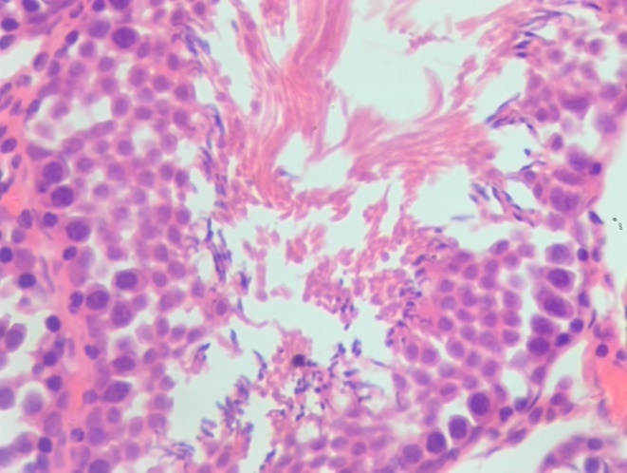
PRIMARY SPERMATOCYTE

SPERMATOGONIA
SERTOLI CELLS
SPERMATIDS
SPERMATOCYTE
SECONDARY SPERMATOCYTE
X400

PLATE I: Photomicrograph showing section of testicular tissue. Group 1 (Control Group). Section displayed spermatocyte, spermatids, secondary and primary spermatocyte, Sertoli cells and spermatogonia. H & E x400

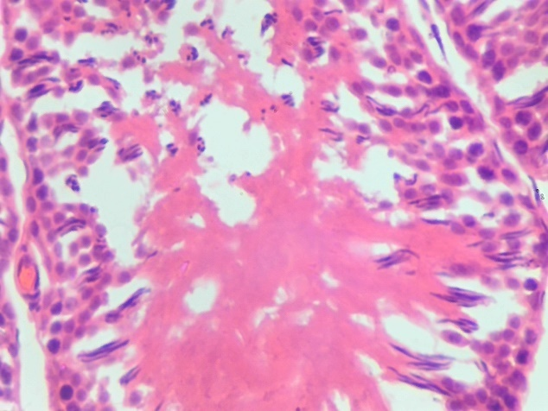
SPERMATOGONIA

SPERMATOCYTE

PRIMARY SPERMATOCYTE

SECONDARY SPERMATOCYTE

SPERMATIDS

X400
PLATE II:Photomicrograph showing section of testicular tissue Group 3 (Low Dose-500mg/kg African walnut) showed normal well-preserved seminiferous spaces, tunica albuginea and congested blood vessels. The interstitial spaces were normal.Features are those of hyperactive normal testis. H&Ex400

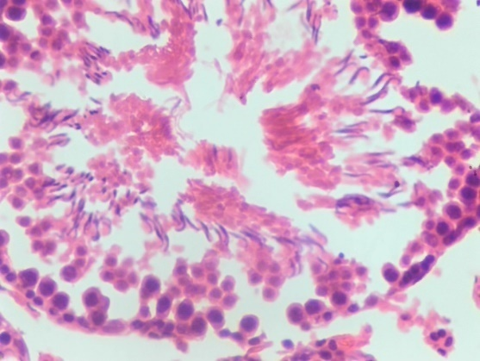
SPERMATOCYTE

SPERMATOGONIA

PRIMARY SPERMATOCYTE

SECONDARY SPERMATOCYTE

SPERMATIDS

X400
PLATE III: Photomicrograph showing section of testicular tissue. Group 4 (High Dose- 1500mg/kg African Walnut) showed a widened and empty interstitial space with reduced Leydig cells. The tubule shows mild exfoliation and normal spermatocytes. H&E x400

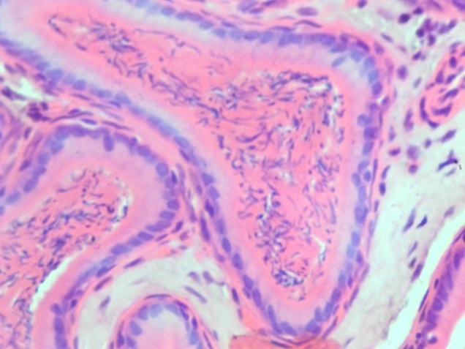
PSEUDOSTRATIFIED
COLUMNAR
EPITHELIUM

SPERMATOCYTES

SEMINIFEROUS TUBULES

BASAL CELL

X400
PLATE IV: Photomicrograph showing section of epididymal tissue(CONTROL GROUP 1) displayed Basal cells, tubules lined by pseudostratified columnar cells, most of which have a cytoplasmic blue which are few cells with pyknotic nuclei and clear vacuole. The lumen contains abundant/ heavy spermatids. The interstitium is slightly widened. H&E x400

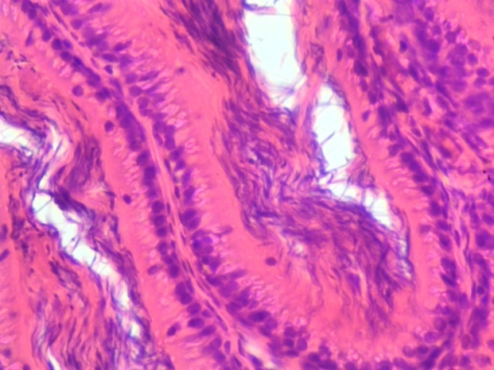
SEMINIFEROUS TUBULES

SEMINIFEROUS TUBULES

PSEUDOSTRATIFIED
COLUMNAR
EPITHELIUM

BASAL CELL

X400

PLATE V: Photomicrograph showing section of epididymal tissue (Low Dose-500mg/kg African Walnut) with widened Interstitial space. There are few chronic inflammatory cells seen within the interstitial space. The tubules are lined by tall columnar cells. H&E x 400
.

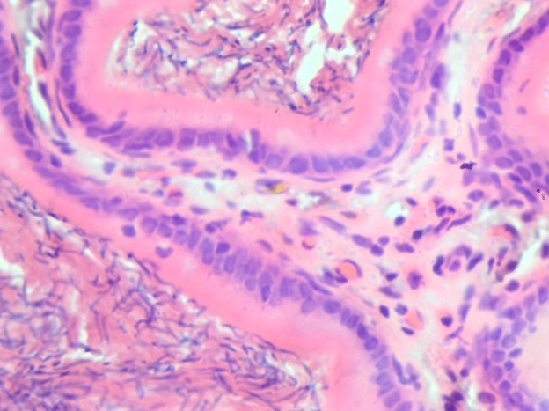
PSEUDOSTRATIFIED
COLUMNAR
EPITHELIUM

SEMINIFEROUS TUBULES

BASAL CELL

X400
PLATE VI: Photomicrograph showing section of epididymal tissue (High Dose-1500mg/kg African walnut). Displaying a well preserved epididymal tubule lined by pseudostratified columnar epithelium. The lumen contains stored spermatids. H&E x400

DISCUSSION
Male infertility is of great health concern in the world today. Herbal interventions provides cheaper and easily accessible alternative for the treatment of infertility (Popović et al., 2016). Sperm count and sperm motility have been reported to play an important role in male fertility. Some fruits like garden egg, cucumber, bell peppers, guava, kiwis, bananas (medium size) have been reported to improve male reproductive characteristics (Victor et al., 2025).
In this present study, there was marked rise in sperm count was observed in African walnut fruit. This implies that African walnut can be used in the management of male fertility. This agrees with Obinna et al. (2009) who stated that plant extracts capable of causing a marked increase in sperm count and can be used in the management of male fertility. This finding was supported by Njila et al., (2019), who reported that plant extracts capable of increasing sperm count and morphology provide strong evidence of fertility potential. There was a significant decrease in the sluggish motility of sperm cells. This suggests that sperm sluggish motility conditions could be addressed and ameliorated by consumption of African walnut. This agrees with Uloneme (2021), who stated that the consumption of Corchorus olitorius (Jute mallow) leaves will address and ameliorate sluggish motility conditions because it significantly reduced sluggish motility of sperm cells.

Histologic sections of the testis in African Walnut group showed a widened interstitial space with abundant/ heavy spermatids. This indicated an accelerated blood flow and an increase in the level of testosterone. This agrees with Ojo and Salawu (2021), they reported that an increased testicular interstitial blood flow and intracellular spaces in cockerel’s testis is indicated an accelerated blood flow and level of testosterone, which will result in improved spermatogenesis in the testicle and finally increased fertility.
Histologic sections of the epididymis in African Walnut group showed the lumen contains abundant/ heavy spermatids and a widened Interstitial space. This implies that Walnut may likely increase the rate of fertility in adult male Wistar rats. This study was not in agreement with Orheruata (2019), they reported that low and high doses of M. pruiens will likely cause anti fertility because it caused a spermatogenic arrest.
CONCLUSION
This natural plant possesses the tendency to improve sperm count, sperm viability, and morphology which may likely solve the problem of infertility in male Wistar rats.

REFERENCES
Popović Z, Matić R, Bojović S, Stefanović M, Vidaković V. Ethnobotany and herbal medicine in modern complementary and alternative medicine: An overview of publications in the field of I&C medicine 2001-2013. J Ethnopharmacol 2016; 181: 182-192

P.D, Victor, OKPORA, C.O, KRUKRU, E.E, OKPORA, C.K, DIDIA, M.K, Wami-Amadi, C-F, Osaat, R.S, and Paul, J.N. 2025. “Effect of Solanum Melongena (Garden Egg) Ethanolic Extract on Reproductive Hormones, Semen Quality, and Testicular Histology in Adult Male Wistar Rats”. Advances in Research 26 (6):450-60. https://doi.org/10.9734/air/2025/v26i61562.

Acar, O.C., Gokmen, V., Pellegini, N. & Fogliano, V. (2009). Direct evaluation of the total antioxidant capacity of raw and roasted pulses, nuts and seeds. European Research and Technology, 229(6): 961-969.

Ambiye (2013). Evid Based Complement Alternat Med. 2013, 2013:571420. Published online 2013 Nov. 28. DOI:10.1155/2013/571420. PMCID.

Burubai, W., Akpor, A.J., Igoni, A.H. & Puyate, Y.T. (2007). Effects of temperature and moisture content on the strength properties of Monodora myristica (African Nutmeg) International Agrophysics, 21(1): 217-223.

Banjoko, S.O. & Adeseolu, F.O. (2013). Seminal plasma PH, Inorganic phosphate, Total and ionized Calcium Concentrations In The Assessment of Human Spermatozoa Function. J Clin Diagn Res. 7(11):2483-6 doi:10.7860/JCDR/2013/6194.3585. PMID:24392378.

Chijioke, O.C., Assumpta, A.C., Lawrence, E. & Sunday, U. (2017). ‘Effects of black walnut leaf extract on the reproductive organ of male albino rats’. International Journal of Homeopathy and Natural Medicine 3(2), 9-14. https://doi.org/10.11648/j.ijhnm. 20170301.12.

Dimitriadis, F., Tsiampali, C., Chaliases, N., Tsoundi, P., Takenaka, A. & Sofikitis, N. (2015). The Sertoli cells as the orchestra conductor of spermatogenesis.

Di Fiore, M.M., Boni, R., Santillo, A., Falvo, S., Gallo, A. & Esposito S. (2019). D-aspartic acid in vertebrate reproduction: Animal models and experimental designs. Biomolecules. 9(9): 445. DoI: 10.3390/biom 9090445

Ekwe, C.C. & Ihemeje, A. (2013). ‘Evaluation of physiochemical properties and preservation of African Walnut’, Academic Research International 4(6): 501-512.

Franca, L.R.R., Avelar, G.F. & Almeida F.F.L. (2005). Spermatogenesis and sperm transit through the epididymis in mammals with emphasis on pigs. Theriogenology, 63(2):300-318, ISSN 0093-691X.

Gimenes, F., Souza, R.P., Bento, J.C., Teixeira, J.J.V., Maria-Engler, S.S. & Bonini, M.G. (2014). Male Infertility: a public health issue caused by sexually transmitted pathogens. Nat Rev Urol. 11(12):672-687.

