Case Report

Central Serous Chorioretinopathy Induced by Work Stress: A Case Report

.
ABSTRACT
Central serous chorioretinopathy (CSC) is a retinal disorder characterized by serous detachment of the neurosensory retina, predominantly affecting young and middle-aged males. Psychological stress has been recognized as an important precipitating factor. We report a case of a 37-year-old male who presented with sudden, painless visual deterioration in the left eye associated with increased occupational stress. Clinical examination and optical coherence tomography (OCT) confirmed the diagnosis of CSC. The patient was managed conservatively with observation and stress reduction counseling, resulting in complete anatomical and visual recovery within one month. This case highlights the importance of identifying work-related stress as a modifiable risk factor in CSC.

Keywords: Central serous chorioretinopathy, work stress, optical coherence tomography

1. INTRODUCTION

Central serous chorioretinopathy (CSC) is a chorioretinal disorder characterized by the accumulation of serous fluid beneath the neurosensory retina, primarily resulting from dysfunction of the retinal pigment epithelium (RPE) and increased choroidal vascular permeability [1]. This pathological process leads to localized neurosensory retinal detachment, most commonly involving the macula, and manifests clinically as blurred vision, metamorphopsia, micropsia, and reduced contrast sensitivity.
CSC predominantly affects males between the third and fifth decades of life and is considered one of the most frequent non-surgical retinopathies encountered in ophthalmic practice [2,3]. Although acute CSC is often self-limiting, recurrent and chronic forms may result in persistent subretinal fluid, progressive photoreceptor damage, and permanent visual dysfunction [4].
The pathophysiology of CSC is multifactorial and involves a complex interaction between choroidal vascular dysregulation and impairment of the outer blood–retinal barrier. Enhanced choroidal thickness and hyperpermeability increase hydrostatic pressure beneath the RPE, facilitating leakage of fluid into the subretinal space [5]. Advances in multimodal retinal imaging, particularly optical coherence tomography (OCT) and indocyanine green angiography, have provided compelling evidence supporting the central role of choroidal abnormalities in CSC development [6].
Several systemic, pharmacological, and psychological factors have been implicated in CSC onset. Established risk factors include exogenous corticosteroid use, endogenous hypercortisolism, hypertension, sleep disturbances, and autonomic dysfunction [4,7]. Among psychological contributors, work stress has emerged as a significant precipitating factor. Prolonged exposure to demanding workloads, time pressure, and limited recovery periods has been associated with neuroendocrine imbalance and sustained activation of the hypothalamic–pituitary–adrenal (HPA) axis [8].
Work stress is associated with elevated endogenous cortisol levels, which may influence choroidal vascular permeability and RPE pump function, thereby promoting subretinal fluid accumulation [8]. Previous studies have demonstrated a strong association between CSC and stress-related psychological profiles, with affected individuals reporting reduced visual performance and impaired quality of life [9,10]. This case report describes a presentation of CSC induced by work stress and highlights the importance of identifying modifiable psychosocial factors in disease management.
Case Report
A 37-year-old male presented to the ophthalmology clinic with a one-week history of sudden, painless reduction of vision in the left eye. The visual impairment was not accompanied by ocular pain, headache, photophobia, or other systemic or neurological symptoms. The patient denied any previous similar episodes.

Medical and Social History
The patient was born at term following an uncomplicated pregnancy and delivery, with no history of perinatal or developmental abnormalities. He reported no known systemic medical conditions, including hypertension, diabetes mellitus, autoimmune disease, or endocrine disorders. There was no prior history of ocular disease, trauma, or surgery, and he had never experienced similar visual symptoms in the past. Family history was negative for hereditary ocular disorders, retinal disease, or significant systemic illnesses.
The patient was not taking any prescription or over-the-counter medications, including corticosteroids, sympathomimetics, or hormonal therapy, and denied the use of recreational drugs or anabolic agents. He reported no known drug or environmental allergies. A comprehensive review of systems, including neurological, cardiovascular, and endocrine symptoms, was unremarkable.
Social history revealed that the patient was employed in an administrative role requiring prolonged computer use and sustained attention. Over the preceding months, he had experienced a marked increase in workload, extended working hours, and heightened job-related responsibilities, resulting in significant occupational stress. He reported limited opportunities for rest and recovery and described persistent psychological strain in the period leading up to symptom onset.
Ophthalmological Examination
On presentation, uncorrected distance visual acuity was 6/6 in the right eye and 6/18 in the left eye, with no improvement upon pinhole testing in the affected eye. Pupillary examination revealed equal, round, and reactive pupils bilaterally, with no relative afferent pupillary defect. Intraocular pressure, measured by Goldmann applanation tonometry, was 13 mmHg in the right eye and 14 mmHg in the left eye.
Extraocular movements were full and painless in all directions of gaze. Confrontation visual field testing demonstrated full peripheral visual fields in both eyes. Color vision testing was normal in the right eye and subjectively reduced in the left eye.
Slit-lamp biomicroscopy of the anterior segment was unremarkable in both eyes, revealing a clear cornea, normal conjunctiva and sclera, a quiet and deep anterior chamber, a round and reactive iris, and a clear crystalline lens without evidence of inflammation or cataract formation.
Following pharmacologic dilation, fundus examination of the right eye demonstrated a healthy optic disc with sharp margins, a normal macula, and intact retinal vasculature. Examination of the left eye revealed localized macular elevation with subtle loss of the foveal reflex and a yellowish, circular lesion with indistinct margins suggestive of subretinal fluid accumulation. The optic disc appeared normal in size, color, and contour, and the retinal vessels were within normal limits, with no hemorrhages or exudates observed.
Optical Coherence Tomography
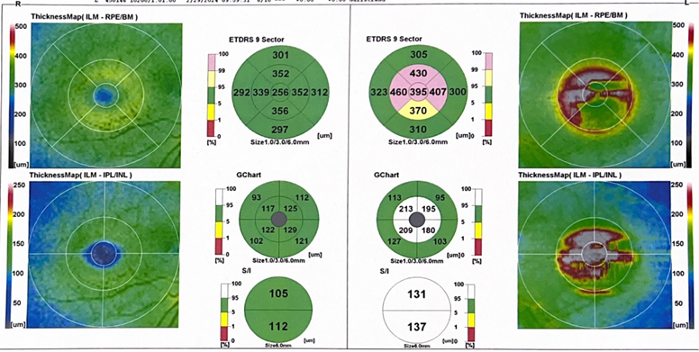
Spectral-domain optical coherence tomography of the left eye demonstrated a well-defined serous detachment of the neurosensory retina involving the fovea, with accumulation of subretinal fluid and mild elevation of the retinal pigment epithelium. The outer retinal layers appeared intact, with no evidence of intraretinal cystoid changes or choroidal neovascularization. These findings were consistent with a diagnosis of acute central serous chorioretinopathy. Optical coherence tomography of the right eye showed normal macular architecture.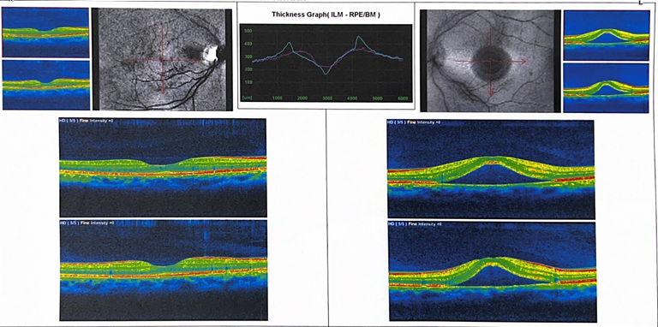

Fig. 1- Optical Coherence Tomography of the Left and Right Eye

Diagnosis

Based on the clinical findings and OCT results, the patient was diagnosed with central serous chorioretinopathy of the left eye.

Management and Follow-Up

Given the acute presentation and absence of high-risk features, the patient was managed conservatively with observation. He was counseled regarding the association between psychological stress and CSC and advised on stress management strategies and lifestyle modification.

At one-month follow-up, the patient reported marked subjective improvement in vision. Uncorrected visual acuity in the left eye improved to 6/6. Repeat OCT demonstrated complete resolution of subretinal fluid with restoration of normal macular anatomy.
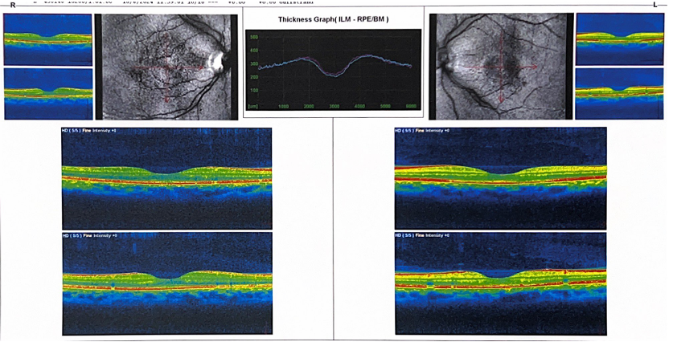
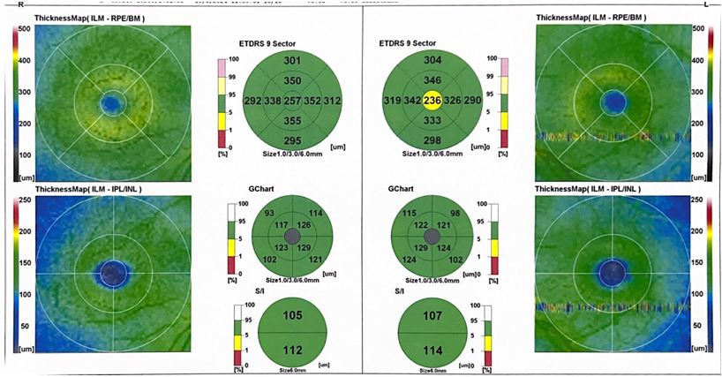
Fig. 2- Improved Visual Acuity of the Left Eye
3. discussion

Central serous chorioretinopathy is currently understood as a disorder primarily involving choroidal hyperpermeability and compromised retinal pigment epithelium (RPE) barrier integrity [11]. Contemporary models emphasize the role of the pachychoroid spectrum, characterized by increased choroidal thickness, dilated choroidal vessels, and altered choroidal blood flow, which collectively increase hydrostatic pressure beneath the RPE and promote subretinal fluid accumulation [12]. This process ultimately results in neurosensory retinal detachment and the visual disturbances characteristic of CSC.

Work-related stress plays a critical role in CSC pathogenesis through sustained activation of the hypothalamic–pituitary–adrenal (HPA) axis and sympathetic nervous system, leading to persistently elevated endogenous cortisol levels [8]. Recent evidence suggests that cortisol and other stress-related hormones may influence mineralocorticoid receptor signaling within the choroid and RPE, thereby increasing vascular permeability and impairing fluid transport mechanisms [13]. These stress-mediated neuroendocrine effects provide a biologically plausible explanation for the observed temporal relationship between occupational stress exposure and CSC onset.

Individuals experiencing chronic work stress often demonstrate prolonged psychological strain, autonomic imbalance, and maladaptive coping responses. Recent clinical studies have confirmed significantly higher perceived stress levels, anxiety scores, and stress-related personality traits among patients with CSC compared with control populations, reinforcing the concept of CSC as a stress-sensitive chorioretinal disorder [14,15]. Recognition of occupational stress as a major precipitating factor is therefore essential for accurate risk stratification and individualized disease management.

Acute CSC is generally regarded as a self-limiting condition, with spontaneous resolution occurring within three to four months in many cases [3]. Current consensus guidelines continue to recommend conservative management as the first-line approach in uncomplicated acute CSC, emphasizing observation, patient reassurance, and modification of precipitating risk factors, including work-related stress [11,16]. In the present case, early identification and alleviation of occupational stress resulted in complete anatomical resolution and full visual recovery without pharmacologic or invasive intervention.

Importantly, recent longitudinal studies have demonstrated that persistent psychological stress is associated with higher recurrence rates and progression to chronic CSC, which may lead to irreversible photoreceptor and RPE damage [20]. Integrating assessment of occupational stress and psychological well-being into routine clinical evaluation allows for a more holistic, patient-centered management strategy. Early stress mitigation may not only reduce recurrence risk but also improve long-term visual prognosis and overall quality of life.

4. Conclusion

This case highlights occupational stress as a significant precipitating factor in the development of central serous chorioretinopathy. Early recognition of psychological and occupational stressors is essential, as timely identification allows for targeted patient education and implementation of conservative management strategies. Counseling patients regarding stress reduction, work–life balance, and coping mechanisms may contribute to normalization of neuroendocrine activity and reduction of choroidal hyperpermeability.
Conservative management focused on modification of work-related stressors, combined with close clinical observation, can result in complete anatomical resolution and favorable visual outcomes without the need for pharmacological or invasive interventions. Furthermore, addressing psychosocial factors may reduce the risk of recurrence, which is a major concern in patients with CSC. Incorporating assessment of occupational stress into routine clinical evaluation enables a more holistic, patient-centered approach and may significantly improve long-term prognosis, functional vision, and overall quality of life.

Competing interests

No conflict of interest.

Consent

written informed consent was obtained from the patient for publication of this case report

References

- Gemenetzi M, De Salvo G, Lotery AJ. Central serous chorioretinopathy: An update on pathogenesis and treatment. Eye. 2010;24(12):1743–1756.
- Wang M, Munch IC, Hasler PW, Prünte C, Larsen M. Central serous chorioretinopathy. Acta Ophthalmol. 2008;86(2):126–145.
- Yannuzzi LA. Central serous chorioretinopathy: A personal perspective. Am J Ophthalmol. 2010;149(3):361–363.
- Nicholson B, Noble J, Forooghian F, Meyerle C. Central serous chorioretinopathy: Update on pathophysiology and treatment. Surv Ophthalmol. 2018;63(1):1–21.
- Spaide RF, Hall L, Haas A, et al. Indocyanine green angiography of central serous chorioretinopathy. Retina. 2015;35(10):1923–1936.
- Cheung CMG, Lee WK, Koizumi H, Dansingani K, Lai TYY, Freund KB. Pachychoroid disease. Eye. 2019;33(1):14–33.
- Liegl R, Ulbig MW. Central serous chorioretinopathy. Ophthalmologica. 2014;232(2):65–76.
- Conrad R, Geiser F, Kleiman A, Zur B, Karpawitz-Godt A. Stress-induced hormone changes in central serous chorioretinopathy. Psychosom Med. 2014;76(6):489–495.
- Sahin A, Bez Y, Kaya MC, et al. Psychological distress and quality of life in patients with central serous chorioretinopathy. Eur J Ophthalmol. 2014;24(4):595–602.
- Lahousen T, Painold A, Luxenberger W, et al. Psychological factors associated with central serous chorioretinopathy. Psychosomatics. 2016;57(6):593–600.
- American Academy of Ophthalmology. Retina and Vitreous Preferred Practice Pattern. San Francisco: AAO; 2022.
- van Rijssen TJ, van Dijk EHC, Yzer S, et al. Central serous chorioretinopathy: Update on pathophysiology, diagnosis, and treatment. Prog Retin Eye Res. 2022;89:101017.
- Daruich A, Matet A, Behar-Cohen F. Central serous chorioretinopathy and corticosteroids: Pathophysiological links and therapeutic implications. Surv Ophthalmol. 2022;67(5):1321–1334.
- Kim YK, Woo SJ, Park KH, et al. Association between perceived stress and central serous chorioretinopathy: A prospective observational study. Retina. 2023;43(4):742–750.
- Lee JY, Choi EY, Shin YU. Psychological stress and autonomic dysfunction in patients with central serous chorioretinopathy. BMC Ophthalmol. 2022;22:412.
- Lotery A, Sivaprasad S, O’Connell A, et al. Long-term outcomes and recurrence risk factors in central serous chorioretinopathy. Eye. 2024;38(2):289–297.

