Epidemiological Trends, Seasonality, and Spatial Distribution of Scrub Typhus in Kerala, India: A Thirteen-Year Analysis (2012–2024)

Abstract
Scrub typhus, caused by Orientia tsutsugamushi, is a major cause of acute undifferentiated febrile illness in South India. This study describes the epidemiological, seasonal, and spatial trends of scrub typhus in Kerala from 2012 to 2024 using secondary surveillance data. A total of 6,824 confirmed cases and 127 deaths were reported during the study period, yielding an overall case fatality rate of 1.86%. Disease incidence showed marked temporal fluctuations, with major peaks in 2015, 2022, and 2024, indicating persistent endemic transmission with periodic outbreaks. Seasonal analysis revealed a highly significant variation in case occurrence (χ² = 1070.5, df = 2, p < 0.001), with the highest burden during winter (47.9%) followed by the monsoon season (36.2%). Spatial analysis demonstrated pronounced geographic heterogeneity, with Trivandrum district contributing over 70% of reported cases. The findings underscore the continuing public health importance of scrub typhus in Kerala and highlight the need for strengthened surveillance, early diagnosis, and targeted district-specific control strategies.
Keywords: Scrub typhus; Epidemiology; Seasonal variation; Case fatality rate; Kerala
- Introduction
Scrub typhus is a vector-borne zoonotic disease caused by the obligate intracellular bacterium Orientia tsutsugamushi and transmitted to humans through the bite of infected larval trombiculid mites (chiggers) (Kelly et al., 2009). The disease is endemic within the so-called “tsutsugamushi triangle,” extending from northern Japan and eastern Russia to northern Australia and South Asia, including India (Paris et al., 2013). In recent decades, scrub typhus has re-emerged as a leading cause of acute undifferentiated febrile illness in several parts of Asia, accounting for substantial morbidity and mortality (Taylor et al., 2015).
In India, scrub typhus has transitioned from a historically neglected infection to a major public health concern, particularly after large outbreaks reported since the early 2000s (Mathai et al., 2003; Varghese et al., 2006). Clinical manifestations range from mild febrile illness to severe complications such as acute respiratory distress syndrome, meningoencephalitis, and multi-organ dysfunction, often resulting in fatal outcomes if diagnosis and treatment are delayed (Chrispal et al., 2010; Peter et al., 2015). Despite the availability of effective antimicrobial therapy, case fatality rates remain variable across regions due to differences in awareness, diagnostic capacity, and healthcare access (Rathi & Rathi, 2010).
Kerala, a state located along the southwestern coast of India, has reported a steady increase in scrub typhus cases over the past decade, with several districts experiencing recurrent outbreaks (Renu et al., 2025). The state’s diverse ecology- characterized by forest fringes, plantations, and high rainfall provides favourable conditions for chigger vectors and rodent reservoirs (Samuel et al., 2020). Seasonal factors, particularly monsoon-associated vegetation growth and agricultural activities, are known to influence disease transmission dynamics (Mahajan, 2005; Lee et al., 2015).
Although several hospital-based and outbreak investigations have described the clinical profile of scrub typhus in South India, comprehensive long-term analyses examining temporal trends, seasonal variation, geographic distribution, and mortality patterns at the population level remain limited. Systematic evaluation of surveillance data is essential to understand disease burden, identify high-risk districts, and inform targeted public health interventions.
Therefore, the present study aimed to analyze the epidemiological trends of scrub typhus in Kerala over 13 years (2012–2024), with specific emphasis on incidence, mortality, seasonal distribution, district-wise heterogeneity, and case fatality rates, using state-level surveillance data.
2.0 Materials and Methods
2.1. Study design and data source
A retrospective, descriptive epidemiological study was conducted using secondary surveillance data on scrub typhus reported in Kerala, India, for the period from January 2012 to December 2024.
2.2. Keywords and databases used for data retrieval
The search strategy employed a combination of Medical Subject Headings (MeSH) terms and keywords, including “scrub typhus,” “Orientia tsutsugamushi,” “acute undifferentiated febrile illness,” “epidemiology,” “seasonal variation,” “spatial distribution,” “case fatality rate,” and “surveillance.” Geographic qualifiers such as “Kerala” and “South India” were applied to identify region-specific studies. Scrub typhus data were collected retrospectively from officially published annual surveillance reports available as PDF documents on the web portal of the Directorate of Health Services (DHS), Government of Kerala. These reports form part of the state public health surveillance system and are released under the Integrated Disease Surveillance framework. Year-wise PDF reports titled “Data on Communicable Diseases – Kerala” were accessed for the study period, and information on scrub typhus cases and deaths was extracted manually. The extracted variables included year of reporting, number of confirmed cases, number of deaths, and district-wise distribution. All data used in the analysis were secondary in nature and obtained exclusively from publicly accessible DHS surveillance documents, without any modification or reclassification of the reported figures (Directorate of Health Services [DHS], 2012–2024).
2.3. Study area
Kerala is a southwestern coastal state of India characterized by diverse ecological settings, including coastal plains, midlands, and forested highlands. The state is administratively divided into 14 districts, all of which were included in the present analysis.
2.4. Data collection and variables
Information extracted from the DHS database included the annual and district-wise number of confirmed scrub typhus cases, number of deaths attributed to scrub typhus, and year of reporting. For seasonal analysis, cases were categorized into three seasons based on local climatic patterns: monsoon, winter, and summer. Population data required for rate calculations were obtained from official state population estimates used by the health department.
2.5. Epidemiological measures
The following epidemiological indicators were calculated:
- Incidence rate, expressed as cases per 1,000,000 population per year
- Mortality rate, expressed as deaths per 1,000,000 population per year
- Case fatality rate (CFR), calculated as the proportion of deaths among confirmed cases
- Death-to-case ratio, calculated for comparative assessment across districts and years
2.6. Statistical analysis
Descriptive statistics were used to summarize temporal, seasonal, and spatial trends in scrub typhus occurrence. Seasonal variation in case distribution was assessed using a chi-square goodness-of-fit test, assuming equal expected distribution of cases across seasons. The statistical analyses were performed using Microsoft Excel. Results were presented in the form of tables and graphical representations.
2.7. Ethical considerations
The study utilized secondary data available in the public domain and did not involve human participants directly. Therefore, ethical committee approval and informed consent were not required.
3.0 Results
3.1. Overall burden of scrub typhus in Kerala (2012–2024)
Between 2012 and 2024, a total of 6,824 confirmed scrub typhus cases and 127 deaths were reported in Kerala, indicating sustained endemic transmission over the 13-year study period. The overall case fatality rate (CFR) for the study period was 1.86%. The annual disease burden showed considerable inter-year variability, with evidence of intermittent outbreak-like surges rather than a uniform trend.
3.1.1. Temporal trends in incidence and mortality
The year-wise distribution of scrub typhus cases and deaths is presented in Table 1. During the initial surveillance years (2012–2013), case numbers were relatively low, with only 39 and 68 cases reported, respectively. A sharp increase was observed in 2014 (433 cases), followed by a major peak in 2015, when 1,149 cases and 15 deaths were reported, corresponding to the highest incidence rate (31.8 per million population) during the early phase of the study.
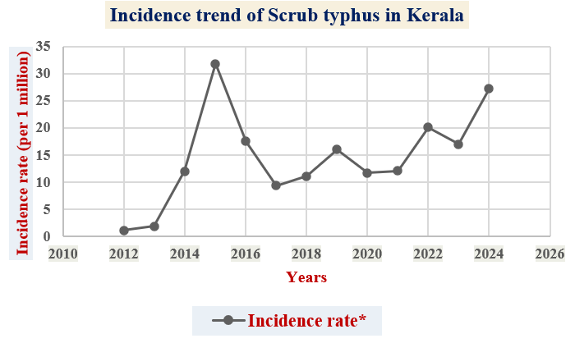
Fig.1 – Incidence trend of scrub typhus in Kerala
Table 1. Year-wise incidence and mortality rates of Scrub typhus in Kerala (per 1,000,000 population)
Year | Cases (n) | Deaths (n) | Incidence rate*  (Per 1 million population) | Mortality rate*  (Per 1 million population)
2012 | 39 | 4 | 1.1 | 0.11
2013 | 68 | 0 | 1.9 | 0.00
2014 | 433 | 6 | 12.0 | 0.17
2015 | 1,149 | 15 | 31.8 | 0.42
2016 | 633 | 3 | 17.5 | 0.08
2017 | 340 | 5 | 9.4 | 0.14
2018 | 400 | 6 | 11.1 | 0.17
2019 | 579 | 14 | 16.0 | 0.39
2020 | 423 | 8 | 11.7 | 0.22
2021 | 438 | 6 | 12.1 | 0.17
2022 | 727 | 24 | 20.1 | 0.66
2023 | 614 | 17 | 17.0 | 0.47
2024 | 981 | 19 | 27.2 | 0.53
Total | 6,824 | 127 | 189.0 | 3.5

Following 2015, a decline in reported cases was noted until 2017; however, incidence again fluctuated in subsequent years. Moderate surges were observed in 2019 (579 cases) and 2020 (423 cases). A notable resurgence occurred in 2022, with 727 cases and the highest annual mortality (24 deaths), yielding a mortality rate of 0.66 per million population. The year 2024 recorded 981 cases, indicating a renewed increase in disease burden toward the end of the study period.
Overall, mortality trends broadly paralleled incidence patterns, although variations in CFR were observed across years, suggesting differences in outbreak intensity, early diagnosis, and case management.
3.1.2. Seasonal distribution of scrub typhus cases
Seasonal distribution of scrub typhus cases is summarized in Table 2. Of the total 6,824 cases, the highest proportion occurred during the winter season (3,268 cases; 47.9%), followed by the monsoon season (2,469 cases; 36.2%). The summer season accounted for the lowest number of cases (1,087 cases; 15.9%) mentioned in Fig.
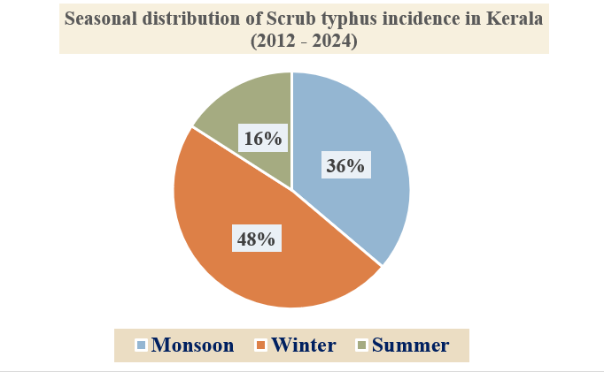
Fig. 2 - Seasonal distribution of scrub typhus in Kerala
A chi-square goodness-of-fit test demonstrated a highly significant seasonal variation in scrub typhus incidence (χ² = 1070.5, df = 2, p < 0.001), indicating that case occurrence was not uniformly distributed across seasons. The pronounced winter predominance suggests seasonal ecological and behavioural factors influencing transmission dynamics.
Table 2. Seasonal distribution of scrub typhus cases in Kerala
Season | Observed cases (n) | Percentage (%) | Expected cases | χ² contribution | p-value
Monsoon | 2,469 | 36.2 | 2,274.7 | 16.6 | —
Winter | 3,268 | 47.9 | 2,274.7 | 434.2 | —
Summer | 1,087 | 15.9 | 2,274.7 | 619.7 | —
Total | 6,824 | 100 | — | 1070.5 | < 0.001*
*Expected cases calculated assuming equal distribution across seasons.
*Chi-square test showed a highly significant seasonal variation (χ² = 1070.5, df = 2, p < 0.001).
3.1.3. District-wise distribution of scrub typhus cases
Marked geographic heterogeneity was observed in the case distribution of scrub typhus within districts. Trivandrum district accounted for the overwhelming majority of reported cases (5,063 cases; 74.19%), establishing it as a major hotspot of scrub typhus transmission in the state.
Other districts with notable case contributions included Wayanad (478 cases; 7.0%), Kozhikode (326 cases; 4.78%), and Kollam (183 cases; 2.68%). Most remaining districts reported fewer than 100 cumulative cases over the study period, each contributing less than 1% of the total burden.
Temporal patterns within districts showed repeated surges in Trivandrum during 2014–2016 and again from 2021–2024, while districts such as Wayanad and Kozhikkode exhibited intermittent increases consistent with localized transmission.
3.1.4. District-wise case fatality rate analysis
Although Trivandrum reported the highest number of cases and deaths (65 deaths), its CFR remained relatively low (1.28%), suggesting effective early diagnosis and case management.
In contrast, several districts with comparatively fewer cases exhibited disproportionately higher CFRs. Thrissur recorded the highest CFR (8.62%), followed by Idukki (6.56%), Malappuram (5.97%), and Kollam (4.92%). Districts such as Kozhikkode (3.37%), Kannur (4.20%), and Pathanamthitta (2.99%) also demonstrated moderate CFRs despite lower overall incidence.
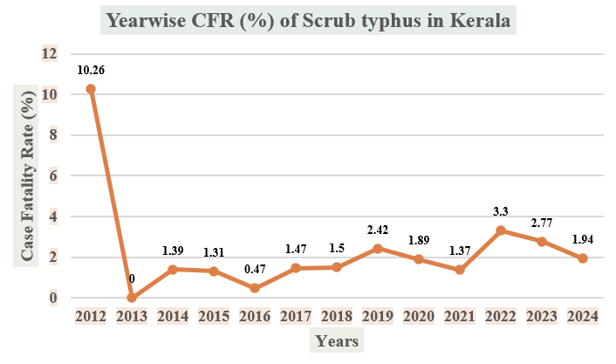
Fig. 3 – Trend in Case Fatality Rate (CFR%) of scrub typhus in Kerala
Notably, the Ernakulam district reported no deaths during the study period, despite recording confirmed cases, indicating favourable clinical outcomes. The observed variability in CFR highlights differences in healthcare access, diagnostic timeliness, and clinical awareness across districts. The year-wise trend in CFR (%) is illustrated in the Fig.3.
3.1.5. Incidence and mortality rates
The incidence and mortality rates per million population are presented in Table 1. The cumulative incidence over the study period was 189 per million population, while the cumulative mortality rate was 3.5 per million population. Years with higher incidence generally corresponded to increased mortality rates, although the magnitude of mortality varied, reflecting fluctuations in CFR across years.
4.0. DISCUSSION
The present study provides a comprehensive long-term epidemiological assessment of scrub typhus in Kerala over a 13-year period (2012–2024), highlighting persistent endemic transmission with marked temporal, seasonal, and spatial heterogeneity. The sustained occurrence of cases throughout the study period, with intermittent outbreak-like surges, confirms scrub typhus as an important public health concern in the state.
4.1.1. Temporal trends and disease burden
The observed fluctuations in annual incidence, with major peaks in 2015, 2022, and 2024, are consistent with reports from other parts of South India that describe scrub typhus as a re-emerging infection characterized by periodic outbreaks rather than a steady increase (Varghese et al., 2006; Chrispal et al., 2010). The sharp rise in cases after 2014 may reflect a combination of true increases in transmission and improved clinical awareness and diagnostic capacity following recognition of scrub typhus as a major cause of acute undifferentiated fever in India. Similar post-2010 increases have been documented in Tamil Nadu and Karnataka, where strengthened surveillance led to higher detection rates (Devasagayam et al., 2021).
Despite relatively high case numbers in recent years, the overall CFR of 1.86% observed in this study is lower than earlier Indian reports, which documented CFRs ranging from 7% to 30% in hospital-based studies (Mathai et al., 2003; Chrispal et al., 2010). This reduction likely reflects earlier diagnosis, prompt initiation of doxycycline or azithromycin, and improved case management within the public health system of Kerala.
4.1.2. Seasonal variation in scrub typhus incidence
A key finding of this study is the highly significant seasonal variation in scrub typhus incidence, with a clear predominance during the winter and monsoon seasons. This seasonal pattern aligns with earlier studies from South India and Southeast Asia, which reported peak transmission during post-monsoon and cooler months (Mahajan, 2005; Lee et al., 2015). Increased vegetation density, higher rodent populations, and greater human exposure during agricultural and outdoor activities during these seasons are likely contributors to enhanced transmission.
The relatively lower incidence during summer months observed in this study further supports the role of climatic and ecological factors in influencing chigger activity and human exposure. These findings emphasize the importance of seasonal preparedness, particularly strengthening surveillance and clinician alertness during winter and monsoon periods.
4.1.3. Spatial heterogeneity and district-wise differences
The pronounced geographic clustering of cases, with Trivandrum district accounting for more than 70% of the total burden, highlights substantial spatial heterogeneity within the state. Similar focal clustering has been reported in scrub typhus–endemic regions, where transmission is often concentrated in specific ecological niches such as forest fringes, scrub vegetation, and peri-urban agricultural zones (Kelly et al., 2009). The consistently high case numbers in Trivandrum may reflect a combination of favourable ecological conditions, dense population, and better reporting mechanisms.
In contrast, several districts with relatively low case numbers demonstrated disproportionately high CFRs. This inverse relationship between incidence and CFR has been reported in previous studies and may indicate delayed diagnosis, limited clinical suspicion, or reduced access to specialized care in low-burden districts (Rathi & Rathi, 2010). The absence of reported deaths in Ernakulam despite confirmed cases suggests effective case management and early treatment.
4.1.4. Public health implications
The findings of this study underscore the need for district-specific public health strategies rather than uniform statewide interventions. High-burden districts require sustained vector control, environmental management, and community awareness programs, while low-incidence but high-CFR districts warrant focused clinician training and diagnostic strengthening to reduce mortality. Integrating scrub typhus into routine differential diagnosis of acute febrile illness, particularly during high-risk seasons, remains critical.
4.1.5. Limitations
This study relied on secondary surveillance data, which may be subject to underreporting and variations in diagnostic practices across districts and years. Additionally, information on individual-level clinical features, laboratory confirmation methods, and treatment outcomes was not available, limiting deeper analysis of risk factors for mortality. Nevertheless, the long study duration and statewide coverage provide valuable insights into the epidemiology of scrub typhus in Kerala.
5.0 Conclusion
In conclusion, scrub typhus remains an endemic and periodically epidemic disease in Kerala, with significant seasonal and spatial variation. The declining overall CFR alongside persistent transmission highlights progress in case management but also underscores the need for continued surveillance, early diagnosis, and targeted public health interventions to further reduce disease burden and prevent deaths in the state.

References
Chrispal, A., Boorugu, H., Gopinath, K. G., Chandy, S., Prakash, J. A. J., Thomas, E. M., and Abraham, A. M. (2010). Scrub typhus: An unrecognized threat in South India—Clinical profile and predictors of mortality. Tropical Doctor, 40(3), 129–133.
Devasagayam, E., Dayanand, D., Kundu, D., Kamath, M. S., and Kirubakaran, R. (2021). The burden of scrub typhus in India: a systematic review. PLoS Neglected Tropical Diseases, 15(7), e0009619.
Directorate of Health Services (DHS), Government of Kerala. (2012–2024). Data on communicable diseases: Annual surveillance reports. Thiruvananthapuram, India: Directorate of Health Services. Retrieved January 25, 2026, from https://dhs.kerala.gov.in/en/data-on-communicable-diseases
Directorate of Health Services, Government of Kerala. (2025). Data on communicable diseases. https://dhs.kerala.gov.in/en/data-on-communicable-diseases/
Kelly, D. J., Fuerst, P. A., Ching, W. M., and Richards, A. L. (2009). Scrub typhus: The geographic distribution of phenotypic and genotypic variants of Orientia tsutsugamushi. Clinical Infectious Diseases, 48(Suppl 3), S203–S230.
Lee, H. W., Cho, P. Y., Moon, S. U., Na, B. K., Kang, Y. J., Sohn, Y., et al. (2015). Current situation of scrub typhus in South Korea from 2001–2013. Parasites & Vectors, 8(1), 238.
Mahajan, S. K. (2005). Scrub typhus. Journal of the Association of Physicians of India, 53, 954–958.
Mathai, E., Lloyd, G., Cherian, T., Abraham, O. C., Cherian, A. M., and John, T. J. (2003). Serological evidence of scrub typhus in southern India. Transactions of the Royal Society of Tropical Medicine and Hygiene, 97(2), 133–137.
Paris, D. H., Shelite, T. R., Day, N. P. J., and Walker, D. H. (2013). Unresolved problems related to scrub typhus: A seriously neglected life-threatening disease. The American Journal of Tropical Medicine and Hygiene, 89(2), 301–307. https://doi.org/10.4269/ajtmh.13-0064
Peter, J. V., Sudarsan, T. I., Prakash, J. A. J., and Varghese, G. M. (2015). Severe scrub typhus infection: Clinical features, diagnostic challenges and management. World Journal of Critical Care Medicine, 4(3), 244–250. https://doi.org/10.5492/wjccm.v4.i3.244
Rathi, N., and Rathi, A. (2010). Rickettsial infections: Indian perspective. Indian Pediatrics, 47(2), 157–164.
Renu, G., Jaganathasamy, N., Ranganathan, K., Kumari, K., Kumar, A., and Paulraj, P. S. (2025). Risk factors of scrub typhus infection in children and adults in Kerala, south India. Asian Pacific Journal of Tropical Medicine, 18(2), 84-92.
Samuel, P. P., Govindarajan, R., Krishnamoorthi, R., and Rajamannar, V. (2020). A study on ectoparasites with special reference to chigger mites on rodents/shrews in scrub typhus endemic areas of Kerala, India. Entomon, 45(4), 285-294.
Taylor, A. J., Paris, D. H., and Newton, P. N. (2015). A systematic review of mortality from untreated scrub typhus. PLoS Neglected Tropical Diseases, 9(8), e0003971. https://doi.org/10.1371/journal.pntd.0003971
Varghese, G. M., Abraham, O. C., Mathai, D., Thomas, K., Aaron, R., Kavitha, M. L., and Mathai, E. (2006). Scrub typhus among hospitalised patients with febrile illness in South India: Magnitude and clinical predictors. Journal of Infection, 52(1), 56–60. https://doi.org/10.1016/j.jinf.2005.02.001

