Original Research Article
Antibiotic sensitivity pattern of Streptococcus isolates

from bovine mastitis in Wayanad District of Kerala, India
Keywords: Bovine mastitis, Streptococcus, antibiogram, biofilm
ABSTRACT
Aims:
The study was carried out to assess the occurrence and biofilm production ability of mastitis causing streptococci and its antimicrobial resistance pattern from cases of clinical bovine mastitis in dairy cows of Wayanad district, Kerala.
Study Design:
A cross-sectional study based on bacteriological and laboratory investigation of milk samples.
Place and Duration of Study:
Milk samples were collected from dairy farms and rural households in Wayanad district, Kerala. The samples were processed in the Department of Veterinary Epidemiology and Preventive Medicine, College of Veterinary and Animal Sciences, Pookode, Wayanad, Kerala during the study period.
Methodology:
A total of 104 milk samples were aseptically collected from cows showing clinical signs of mastitis. Samples were cultured on Brain Heart Infusion agar and examined using standard microbiological procedures. Presumptive identification of Streptococcus spp. was done based on colony characteristics, Gram staining and standard biochemical tests, followed by molecular confirmation by polymerase chain reaction targeting the 16S rRNA gene. Biofilm formation was detected using the Congo Red Agar method. Antimicrobial susceptibility testing was performed using the Kirby–Bauer disc diffusion method on Mueller–Hinton agar according to Clinical and Laboratory Standards Institute guidelines and the resultant patterns were analysed. Isolates showing resistance to three or more antimicrobial classes were considered multidrug resistant.
Results:
Among the 104 bacterial isolates obtained, 90 (86.54%) were Gram-positive cocci, of which 19 (18.26%) were identified as Streptococcus spp. Biofilm production was observed in 17 isolates (89.47%), although the intensity of biofilm formation varied. Antibiotic sensitivity test showed that isolates showed the 78.95% of the isolates were resistant to tetracycline, followed by enrofloxacin and amoxicillin–clavulanate (57.89%). Thirteen out of the nineteen streptococci were found to be multidrug resistant.
Conclusion:
The findings indicate that mastitis due to biofilm-forming haemolytic streptococci is widely prevalent in the study area. Majority of the isolates were multidrug resistant, which may contribute to reduced response to therapy. Routine antimicrobial susceptibility testing and rational use of antibiotics are therefore essential for effective mastitis management.

1. INTRODUCTION
India is the world's leading producer and consumer of milk since 1998, with a record output of 247.87 million tonnes in 2024-25 (Department of Animal Husbandry and Dairying). Despite having the largest cattle herd, India's per-cow milk yield lags behind major dairy nations, partly due to diseases like bovine mastitis, a major cause of reduced production, poor milk quality, economic losses from discarded milk, treatment costs, and premature culling. Mastitis is multifactorial, predominantly caused by bacterial pathogens (Bradley, 2002). The pathogen spectrum is known to evolve with farm management and antimicrobial use (Ruegg, 2017). While historical focus was on Staphylococcus aureus and Escherichia coli, recent shifts highlight growing roles of environmental and opportunistic bacteria (Oliver et al., 2011).
Streptococcus species are increasingly significant in clinical and subclinical mastitis. Traditionally, Streptococcus agalactiae dominated as a contagious pathogen, but improved hygiene and mastitis control programs like teat dipping and milking hygiene have markedly reduced contagious pathogens globally, leading to a shift in prevalence toward environmental streptococci such as Streptococcus uberis and Streptococcus dysgalactiae (Tomazi et al., 2018). These organisms cause persistent infections, elevated somatic cell counts, recurrent cases, and lower treatment success. Their pathogenicity arises from adhesion to mammary epithelial cells, evasion of host immune defences, induction of inflammation, and biofilm formation, which limits antimicrobial penetration and efficacy (Fidelis et al., 2024; Bjarnsholt et al., 2013). Frequent antibiotic use without susceptibility testing drives antimicrobial resistance, reducing treatment success, promoting chronic infections, and posing risks to animal and public health via resistance transfer (Naranjo-Lucena et al., 2023).
Thus, streptococci form an interesting and increasingly important group of bovine mastitis pathogens that warrant closer investigation. There remains a significant knowledge gap regarding their occurrence, pathogenicity profiles and phenotypic antibiotic sensitivity patterns in the Indian context, particularly in regions like Kerala, where intensive dairy farming is prominent. Studying streptococci in mastitis and their antimicrobial susceptibility patterns is therefore crucial for developing effective control strategies, improving therapeutic outcomes, and mitigating the spread of antimicrobial resistance in Indian dairy herds. The present study investigates the occurrence of streptococci in clinical cases of bovine mastitis, their haemolytic and biofilm formation potentials, and antibiotic sensitivity patterns in dairy farms of Wayanad District, Kerala.
2. MATERIALS AND METHODS
2.1 Study Design and location
The study population comprised of 104 dairy cows presented with clinical mastitis from dairy farms and rural households in Wayanad district of Kerala, India.
2.2 Sample Collection
A total of 104 milk samples were aseptically collected from clinically mastitic quarters of dairy cows after discarding the initial foremilk. When multiple quarters were affected in a single animal, samples were pooled per cow. Milk samples were collected into sterile screw-capped vials, labelled, and transported immediately to the laboratory under cold conditions for bacteriological analysis.
2.3 Isolation and Identification of bacterial isolates
The milk samples were inoculated into Brain Heart Infusion (BHI) and incubated aerobically at 37 °C for 18–24 hours. Streptococci were identified based on colony characteristics, Gram staining properties, catalase and oxidase tests. Presumptively identified isolates were confirmed by Polymerase chain reaction (PCR) targeting the Streptococci specific PCR targeting the 16S rRNA gene.
2.4 Molecular confirmation
Molecular confirmation of Streptococcus spp. was performed by PCR targeting the 16S rRNA gene using primers described by Shomeet al. (2011) (forward: GCTAATACCGCATAAGAGTTAACA; reverse: GGTAGATTTTCCACTCCTACCAA), yielding a 317 bp amplicon. Genomic DNA was extracted from presumptively identified isolates using the HiPurA® Bacterial Genomic DNA Purification Kit (MB 505, HiMedia, Mumbai, India). DNA purity and concentration were assessed using a NanoDrop 2000 UV–Vis spectrophotometer, and the final DNA concentration was adjusted to 20 µg/mL. PCR was carried out in a 25 µL reaction volume containing 12.5 µL of 2× EmeraldAmp PCR Master Mix (TaKaRa Bio Inc., USA), 1 µL each of forward and reverse primers (10 pmol), 5 µL of template DNA, and 5.5 µL of nuclease-free water. Amplification conditions consisted of an initial denaturation at 94 °C, followed by 30 cycles of denaturation at 94 °C for 30 s, annealing at 60 °C for 30 s, and extension at 72 °C for 45 s. PCR products were resolved by agarose gel electrophoresis and visualised under UV transillumination. Isolates were considered positive based on the presence of an amplicon of the expected size.
2.5 Hemolysis and Biofilm Assays
Hemolytic activity was detected by culturing the isolates in blood agar. The isolates were cultured on blood agar plates containing 5 per cent sheep blood in BHI agar and incubated at 37 °C for 24 hours. The plates were examined for hemolytic activity, and the reactions were classified as partial (α), complete (β) or non-hemolytic.
Biofilm formation was assessed using the Congo red agar (CRA) technique. Basne et al. (2023). The CRA medium was prepared using BHI agar (52 g/L) supplemented with sucrose (36 g/L), agar (10 g/L), and Congo red dye (0.8 g/L). The Congo red solution was prepared separately as a concentrated stock and sterilised by autoclaving, then incorporated into the medium after cooling to approximately 55 °C. The medium was poured into sterile Petri plates, which were subsequently inoculated with the test isolates and incubated at 37 °C for 24–48 h. Biofilm-producing isolates formed black colonies with a dry, crystalline appearance, while non- or weak biofilm producers exhibited red-coloured colonies.
2.6 Antibiogram
The antimicrobial susceptibility of Streptococcus isolates was assessed by the Kirby–Bauer disc diffusion method on Mueller–Hinton agar (MHA) following the Clinical and Laboratory Standards Institute guidelines (CLSI, 2023). The antimicrobial agents evaluated were amoxicillin–clavulanic acid- 20/10 µg (AMC), cefoperazone- 75 µg (CPZ), cefoperazone–tazobactam- 75/10 µg (CTZ), tetracycline- 30 µg (TET), gentamicin- 10 µg (GEN), enrofloxacin- 5 µg (EN), and co-trimoxazole- 25 µg (COT).
For each isolate, a bacterial suspension adjusted to the 0.5 McFarland standard was prepared and evenly inoculated onto MHA plates. Antibiotic discs were placed aseptically, and the plates were incubated at 37 °C for 24 hours. Zones of inhibition were measured and categorised as susceptible, and resistant in accordance with CLSI interpretative criteria (CLSI, 2023).
3 RESULTS AND DISCUSSION
3.1 Isolation and identification
All 104 milk samples obtained from mastitis-affected cows yielded bacterial growth on BHI agar. Among the isolates, 90 (86.54 per cent) were identified as Gram-positive cocci, while the remaining were Gram-negative bacilli. Among the 90 Gram-positive cocci, 19 isolates (18.26 per cent) exhibited chain arrangement on Gram staining (Fig. 1A), were catalase and oxidase- negative. The colonies appeared small, circular, smooth, glistening, butyraceous, umbonate, greyish-white to translucent in brain heart infusion agar (BHIA) (Fig. 1B), which are characteristic of Streptococcus spp.

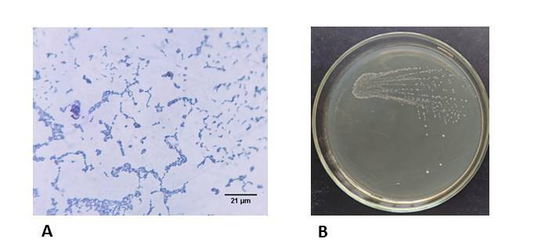
Fig. 1: A Gram-positive cocci arranged in chains. B: Small, circular, smooth, glistening, greyish-white to translucent colonies on BHIA.
All the 19 isolates produced 317 bp amplicons on agarose gel electrophoresis of PCR products (Fig 2). Findings are in agreement with Shome et al. (2011) amplification of a 317 bp fragment of the 16S rRNA gene of Streptococcus agalactiae isolated from bovine mastitis milk samples.
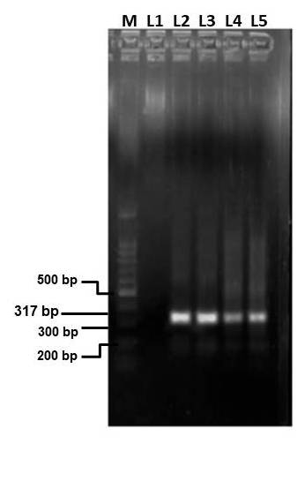
Fig 2. Agarose gel electrophoresis of PCR amplified 16S rRNA gene of S. agalactiae with an amplicon size 317 bp. L1: 100 bp DNA ladder, L2 and L3: Negative and positive control and L4 to L6: Sample.
The observed frequency of Streptococcus spp. in mastitis cases (18.26 per cent) is consistent with Indian epidemiological reports documenting a comparable prevalence of Streptococcus spp. among bovine mastitis pathogens (Krishnamoorthy et al., 2021). Internationally, the prevalence of Streptococcus spp. in bovine mastitis has been reported to be lower in Europe and North America compared to India, based on regional pooled estimates from global systematic reviews and meta-analyses. Internationally, the lower prevalence of Streptococcus spp. in bovine mastitis is attributed to effective mastitis control programs, improved milking hygiene, and routine herd health monitoring in developed dairy systems (Bradley, 2007).
3.2 Hemolysis and biofilm formation
All the isolates produced clear β-hemolysis on blood agar (Fig. 3B.) Haemolysis on blood agar is a key phenotypic marker for assessing the virulence of streptococci causing bovine mastitis. β-haemolytic streptococci are commonly associated with acute and severe mastitis, whereas non-haemolytic strains are more often linked with subclinical or chronic intramammary infections (Quinn et al. 2011). Haemolysins contribute to mastitis pathogenesis by damaging mammary epithelial cells, releasing iron and nutrients, and intensifying local inflammatory responses, thereby facilitating bacterial persistence within the mammary gland (Kabelitz et al. (2021). Although haemolytic activity does not directly confer antimicrobial resistance, it indirectly contributes to treatment failure by increasing tissue damage and limiting effective antimicrobial penetration, leading to more severe clinical outcomes (Krishnamoorthy et al., 2021)
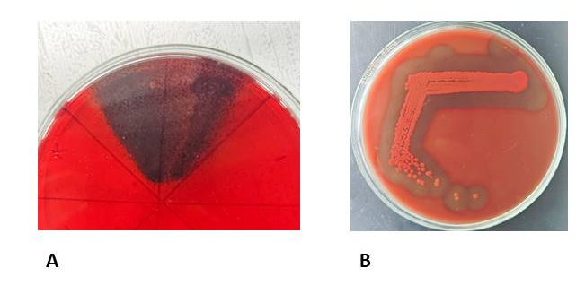
Fig. 3: A Streptococci forming black crystalline colonies in CRA, indicating biofilm formation. B: Streptococci producing clear xone of hemolysis in blood agar (BHI supplemented with5% sheep blood)
Of the 19 isolates, five were strong biofilm producers, five exhibited moderate biofilm formation, seven were weak biofilm producers, and two did not form biofilms (Fig. 3A). Biofilm formation is an important virulence-associated trait of mastitis-causing Streptococcus spp., as it contributes to the persistence within the mammary gland by protecting bacterial cells from host immune responses and facilitating long-term colonisation. This mechanism has been implicated in chronic and recurrent intramammary infections caused by streptococci as observed by Srithanasuwan et al. (2022). Although streptococci are not traditionally considered as aggressive biofilm producers, the predominance of moderate to strong biofilm formation among the isolates in the present study suggests possible regional variation in biofilm expression, which requires further investigation. The findings of the present study indicate that biofilm formation could be a common phenotypic trait among mastitis-associated Streptococcus isolates IN the region. A similarly high prevalence of biofilm formation among Streptococcus spp. has been reported by Simojoki et al. (2012), highlighting strain-dependent variability in biofilm expression. Biofilm-associated streptococci exhibit increased tolerance to antimicrobial agents and host immune defences, contributing to recurrent or chronic mastitis and reduced therapeutic efficacy (Donlan and Costerton, 2002).
3.3 Antibiogram
Antimicrobial susceptibility testing of the 19 isolates showed the highest resistance to TE, with 78.95 per cent, followed by EN and AMC with 57.89 per cent resistance, followed by gentamicin, showing resistance in 52.63 per cent, CPZ and CTZ at 36.84 per cent. COT showed the lowest resistance, with only 26.32 per cent of the isolates (Table 1, Fig. 4, Fig 5 and Fig. 6).
Tetracycline resistance was the most frequently observed phenotype in the present study with 15 (78.95 per cent). Streptococcus
isolates exhibited resistance to tetracycline, followed by resistance to enrofloxacin in 11 (57.89 per cent) isolates. A similar predominance of TET resistance was reported by Zhang et al. (2021). Low resistance to co-trimoxazole observed in the present study is consistent with reports by Ndirangu et al. (2022) showing high susceptibility of mastitis-associated Streptococcus isolates.
In the present study, 13 Streptococcus isolates met the criteria for multidrug resistance, defined as resistance to three or more antimicrobial classes (Fig 7.) (Magiorakos et al., 2012). The high occurrence of MDR among mastitis-associated streptococci suggests substantial antimicrobial selection pressure at the field level. Similar multidrug resistance patterns in bovine mastitis streptococci have been reported in earlier studies, indicating that these organisms are increasingly acquiring resistance to commonly used therapeutic agents (Kaczorek et al., 2017, Ruegg, 2017)

Table 1. Result of antibiotic susceptibility profile of Streptococcus spp.
Antibiotic disc | Sensitive | Resistant
AMC | 8 (42.1%) | 11 (52.89%)
CPZ | 12 (63.2%) | 7 (42.11%)
CTZ | 12 (63.2%) | 7 (42.11%)
TET | 4 (21.1%) | 15 (78.95%)
GEN | 9 (47.4%) | 10 (52.6%)
COT | 14 (73.7%) | 5 (26.32%)
EN | 8 (42.1%) | 11 (57.89%)

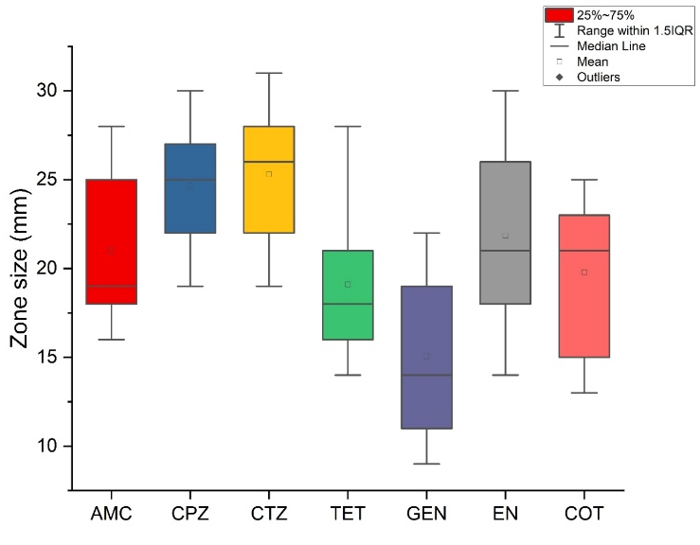
Fig. 4. The box plot illustrating the zone of inhibition diameters (Y-axis) for different antibiotics used (X-axis).
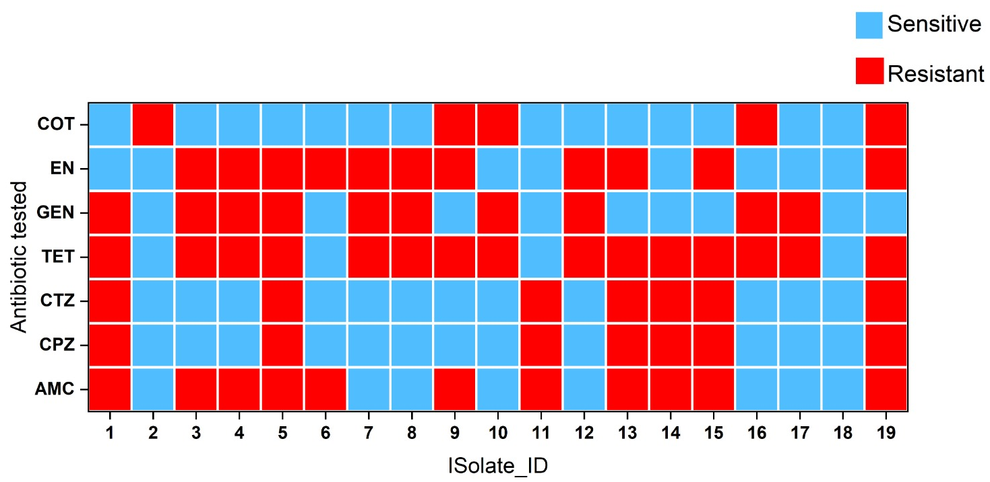
Fig. 5. A heatmap representing the antimicrobial susceptibility patterns of Streptococcus spp. The X-axis denotes the individual bacterial isolates (Isolate ID), while the Y-axis represents the antibiotics tested. Blue indicates sensitive isolates, and red indicates resistant isolates
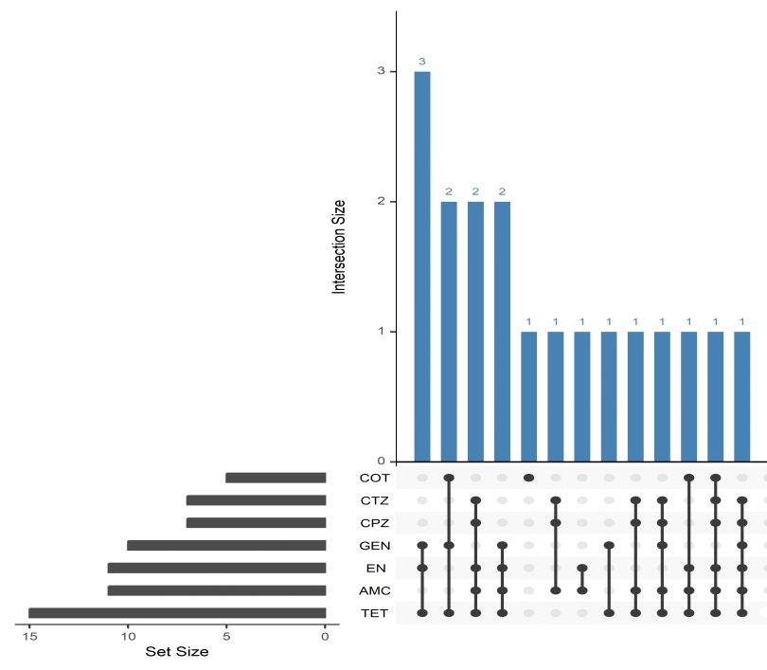
Fig. 6. UpSet plot illustrating antimicrobial resistance pattern intersections among Streptococcus spp. isolates. Vertical bars represent the number of isolates exhibiting each unique combination of resistance, while connected dots indicate antibiotics to which resistance was observed in a given intersection. Horizontal bars show the total frequency of resistance to individual antibiotics across all isolates.

CONCLUSION
Streptococcus spp. accounted for 18% of the bacteriological etiology of bovine mastitis in the study area. Molecular confirmation by 16S rRNA gene–based PCR validated the biochemically identified isolates, highlighting the reliability of PCR for accurate confirmation of bacterial isolates. All isolates were hemolytic and 17 of 19 exhibited biofilm-forming ability, indicating enhanced virulence and increased tolerance to antimicrobials and biocides among mastitis-causing Streptococci. Resistance to commonly used antimicrobials, including amoxicillin–clavulanic acid, cefoperazone, enrofloxacin, and tetracycline, was frequently observed, with 13 of 19 isolates exhibiting multidrug resistance, reflecting substantial antimicrobial selection pressure under field conditions. These findings suggest an increasing occurrence of pathogenic, multidrug-resistant Streptococcus spp. associated with bovine mastitis in the region and emphasise the need for larger-scale studies with molecular characterisation of resistance determinants.
INSTITUTIONAL APROVAL
IRB approval for the research work : KVASU/DAR/A3/246/2025(1) Dated 12/2/2025, of the Director of Academics and Research, Kerala Veterinary and Animal Sciences Univeristy, Pookode, Wayanad, Kerala.

Disclaimer (Artificial intelligence)
Author(s) hereby declare that generative AI technologies such as Large Language Models, etc have been used during the editing of manuscripts. This include ChatGPT and Grammarly AI for reviewing and editing the text of the manuscript.
REFERENCE
Basnet, A., Tamang, B., Shrestha, M. R., Shrestha, L. B., Rai, J. R., Maharjan, R., ... & Rai, S. K. (2023). Assessment of four in vitro phenotypic biofilm detection methods in relation to antimicrobial resistance in aerobic clinical bacterial isolates. PLoS One, 18(11), e0294646.https://doi.org/10.1371/journal.pone.0294646
Bauer, A. W., Kirby, W. M., Sherris, J. C., and Turck, M. (1966). Antibiotic susceptibility testing by a standardized single disk method. American journal of clinical pathology, 45(4_ts): 493-496.
Bjarnsholt, T., Ciofu, O., Molin, S., Givskov, M., & Høiby, N. (2013). Applying insights from biofilm biology to drug development—can a new approach be developed?. Nature reviews Drug discovery, 12(10), 791-808. https://doi.org/10.1038/nrd4000
Boonyayatra, S., Pata, P., Nakharuthai, P., & Chaisri, W. (2016). Antimicrobial resistance of biofilm-forming Streptococcus agalactiae isolated from bovine mastitis. J. Vet. Sci. Technol, 7(5). https://doi.org/10.4172/2157-7579.1000374
Bradley, A. J. (2002). Bovine mastitis: an evolving disease. The veterinary journal, 164(2), 116-128. https://doi.org/10.1053/tvjl.2002.0724
Clinical and Laboratory Standards Institute. (2023). Performance standards for antimicrobial susceptibility testing (33rd ed.). Clinical and Laboratory Standards Institute. https://clsi.org/standards/products/veterinary-medicine/documents/vet01.pdf
Donlan, R. M., & Costerton, J. W. (2002). Biofilms: survival mechanisms of clinically relevant microorganisms. Clinical microbiology reviews, 15(2), 167-193. https://doi.org/10.1128/cmr.15.2.167-193.2002
Fidelis, C. E., Orsi, A. M., Freu, G., Gonçalves, J. L., & Santos, M. V. D. (2024). Biofilm formation and antimicrobial resistance of Staphylococcus aureus and Streptococcus uberis isolates from bovine mastitis. Veterinary Sciences, 11(4), 170. https://doi.org/10.3390/vetsci11040170
Hogan, J., & Smith, K. L. (2003). Coliform mastitis. Veterinary research, 34(5), 507-519. https://doi.org/10.1051/vetres:2003022
Jadhav, P. V., Das, D. N., Chetana, K. R., Tarate, S. B., & Shome, B. R. (2013). Application of pcr based technique for detection of common mastitis pathogens in milk samples of Hf crossbred cattle. Glob. J. Bio-Science Biotechnol., 2, 409-412.
Kabelitz, T., Aubry, E., van Vorst, K., Amon, T., & Fulde, M. (2021). The role of Streptococcus spp. in bovine mastitis. Microorganisms, 9(7), 1497.https://doi.org/10.3390/microorganisms9071497
Kaczorek, E., Małaczewska, J., Wójcik, R., Rękawek, W., & Siwicki, A. K. (2017). Phenotypic and genotypic antimicrobial susceptibility pattern of Streptococcus spp. isolated from cases of clinical mastitis in dairy cattle in Poland. Journal of Dairy Science, 100(8), 6442-6453. https://doi.org/10.3168/jds.2017-12660
Krishnamoorthy, P., Suresh, K. P., Jayamma, K. S., Shome, B. R., Patil, S. S., & Amachawadi, R. G. (2021). An understanding of the global status of major bacterial pathogens of milk concerning bovine mastitis: A systematic review and meta-analysis (Scientometrics). Pathogens, 10(5), 545.
https://doi.org/10.3390/pathogens10050545
Magiorakos, A. P., Srinivasan, A., Carey, R. B., Carmeli, Y., Falagas, M. E., Giske, C. G., ... & Monnet, D. L. (2012). Multidrug-resistant, extensively drug-resistant and pandrug-resistant bacteria: an international expert proposal for interim standard definitions for acquired resistance. Clinical microbiology and infection, 18(3), 268-281. https://doi.org/10.1111/j.1469-0691.2011.03570.x
Naranjo-Lucena, A., & Slowey, R. (2023). Invited review: Antimicrobial resistance in bovine mastitis pathogens: A review of genetic determinants and prevalence of resistance in European countries. Journal of dairy science, 106(1), 1-23. https://doi.org/10.3168/jds.2022-22267
Ndirangu, P. N., Kipronoh, A. K., Mungube, E. O., Ogali, I. N., Omwenga, S. G., Ndung'u, D. N., & Maichomo, M. W. (2022). Prevalence of bovine mastitis and antimicrobial sensitivities of the bacterial causes in smallholder farms of Kisumu County, Kenya. Journal of Agriculture and Rural Development in the Tropics and Subtropics (JARTS), 123(2), 247-255. https://doi.org/10.17170/kobra-202212057194
Oliver, S. P., Murinda, S. E., & Jayarao, B. M. (2011). Impact of antibiotic use in adult dairy cows on antimicrobial resistance of veterinary and human pathogens: a comprehensive review. Foodborne pathogens and disease, 8(3), 337-355. https://doi.org/10.1089/fpd.2010.0730
Quinn, P. J., Markey, B. K., Leonard, F. C., Hartigan, P., Fanning, S., & Fitzpatrick, E. (2011). Veterinary microbiology and microbial disease. John Wiley & Sons.
Ruegg, P. L. (2017). A 100-Year Review: Mastitis detection, management, and prevention. Journal of dairy science, 100(12), 10381-10397. https://doi.org/10.3168/jds.2017-13023
Saed, H. A. E. M. R., & Ibrahim, H. M. M. (2020). Antimicrobial profile of multidrug-resistant Streptococcus spp. isolated from dairy cows with clinical mastitis. Journal of advanced veterinary and animal research, 7(2), 186. https://doi.org/10.5455/javar.2020.g409
Shome, B. R., Bhuvana, M., Mitra, S. D., Krithiga, N., Shome, R., Velu, D., ... &
Rahman, H. (2012). Molecular characterization of Streptococcus agalactiae and Streptococcus uberis isolates from bovine milk. Tropical animal health and production, 44(8), 1981-1992. https://doi.org/10.1007/s11250-012-0167-4
Simojoki, H., Hyvönen, P., Ferrer, C. P., Taponen, S., & Pyörälä, S. (2012). Is the biofilm formation and slime producing ability of coagulase-negative staphylococci associated with the persistence and severity of intramammary infection?. Veterinary Microbiology, 158(3-4), 344-352. https://doi.org/10.1016/j.vetmic.2012.02.031
Srithanasuwan, A., Pangprasit, N., & Suriyasathaporn, W. (2022). Comparison of virulence patterns between Streptococcus uberis causing transient and persistent intramammary infection. Frontiers in Veterinary Science, 9, 806674.
Tomazi, T., Ferreira, G. C., Orsi, A. M., Gonçalves, J. L., Ospina, P. A., Nydam, D. V., Moroni, P., & Dos Santos, M. V. (2018). Association of herd-level risk factors and incidence rate of clinical mastitis in 20 Brazilian dairy herds. Preventive veterinary medicine, 161, 9–18. https://doi.org/10.1016/j.prevetmed.2018.10.007
Zhang, T., Niu, G., Boonyayatra, S., & Pichpol, D. (2021). Antimicrobial resistance profiles and genes in Streptococcus uberis associated with bovine mastitis in Thailand. Frontiers in Veterinary Science, 8,705338. https://doi.org/10.3389/fvets.2021.705338

