Original Research Article

A Comparative Machine Learning Framework for Location-Specific Maize Yield Prediction: Integrating Agronomic, Genetic, and Spatial Factors

Abstract

This paper fills in the key gaps in the field of agricultural machine learning by comparing the performance of the Support Vector Machine (SVM), the Random Forest (RF) and the Decision Tree (DT) algorithms to predict the yield of maize in various locations in the U.S. Corn Belt. In contrast to the past methods that consider location as fixed effect, this study deals with location as an explicit dynamic predictor, hence allowing the environment-specific interaction to be modelled. The study tests models using a dataset of 1,640 plot-level observations in four geographically different sites and adjusting them to consider spatial autocorrelation so that the models do not artificially increase the performance measure. It has been found that the performance of the Random Forest is superior to both SVM and DT with the R2 of 0.84 with the most significant variable being location_id and by within-field spatial variables (row, range) and nitrogen. The results show the superiority of site-specific environmental variables over genetic and management variables in explaining yield variability. This study offers a methodology for location-based predictive modeling and contains evidence-based recommendations on the application of precision agriculture approaches to improve the accuracy or precision of yield and resource-saving recommendations.
Keywords: Machine Learning, Random Forest, SVM, Decision Tree, Maize, Location, Prediction

Introduction
Maize (Zea mays L.) is one of the most important crops in the world, as it is a source of essential nutrients for a large population of the world's inhabitants, and it is also a source of animal feed and biofuel (FAO, 2023). Global maize production is around 208.23 million hectares, and the U.S. Corn Belt is a notable contributor to international maize supply chains (Sharma et al., 2025). The yield of maize is variable across geographical locations due to the complex interplay of various environmental factors, soil factors, management practices, and genetic factors. The yield variability is a notable problem in maize production, as it is the difference between actual and potential yield (Ray et al., 2015).
There are several factors contributing to yield variability, and they vary according to location. The soil factors, such as texture, pH, organic matter content, and nutrient availability, have notable spatial variability within a specific field (Kitchen et al., 2018, Akwabeng et al., 2026). Concurrently, climatic factors such as temperature, precipitation, solar radiation, and growing degree days have notable spatial variability across the U.S. Corn Belt (Sharma et al., 2025). The complex interactions in the Corn Belt region and their effects on the physiological processes that govern grain yield development (Westgate and Boyer, 1985). Moreover, genotype-environment interactions, in which certain maize hybrids exhibit different responses in different locations, add further dimensions of complexity to the task of yield prediction (Hallauer and Miranda, 1988). The complex interactions require location-specific predictive approaches that can capture the non-linear relationships in multiple variables.
Traditional approaches to yield prediction, such as field-based approaches and linear regression models, are no longer adequate to meet the complexities of modern agricultural systems. Statistical approaches based on parametric assumptions cannot capture the non-linear relationships that are common in crop production (van Klompenburg et al., 2020). On the other hand, precision agriculture approaches that involve location-specific crop management decisions based on spatially varying data hold promise in terms of improving resource allocation and crop productivity (McFadden et al., 2022). The use of machine learning (ML) approaches can be considered as a new paradigm in yield prediction. The potential of ML approaches in discovering hidden patterns in large multidimensional datasets and handling non-linear relationships in multiple variables without any parametric assumptions has already been established (Liakos et al., 2018).

Rationale
Although research on crop yield prediction has significantly increased, the literature on the subject matter has not completely resolved the methodological and practical gaps in the agricultural machine learning field. First, the current literature mostly utilizes individual ML algorithms or small scale comparisons of algorithms, which masks the relative performance benefits and drawbacks of alternative methods. Sharma et al. (2025) conducted a systematic literature review that recognized 87 unique machine learning models in 82 studies that used maize and soybean yield prediction but could not be unanimous in terms of the selection of the best model. Second, majority of the studies done on yield prediction have concentrated on grain yield instead of total biomass or include location as a fixed statistical effect instead of dynamic predictor affecting model learning. Location-based prediction, in which the properties of geographic sites are actively involved in designing algorithmic decision limits, is fundamentally different than location-stratified analysis and potentially capable of increasing transfer learning abilities between environments (Lobell et al., 2015).
Third, there is a lack of comparative research on the performance of SVM, Random Forest, and Decision Tree in cohesive experimental settings in the agricultural setting. Although Sharma et al. (2025) found out that Random Forest (23% frequency), Artificial Neural Networks (14%), Support Vector Machines (14%), and XGBoost (8%) were most common methods, strict comparative evaluation under controlled conditions with the same preprocessing, feature engineering, and validation procedures was lacking. Fourth, pluralism in methodology among the studies- difference in train-test separation, cross-validation, features, and measures of evidence hinder the synthesis and evidence aggregation in the meta-analysis. Variably used are the coefficient of determination (R2), root mean square error (RMSE), mean absolute error (MAE), and relative root mean square error (RRMSE), which makes it difficult to compare results across studies (Sharma et al., 2025).
Fifth, the interpretability-accuracy tradeoff which is usually inherent to machine learning in agriculture is not sufficiently tackled. Complex ensemble methods are highly accurate, but their black-box behavior does not allow stakeholders to adopt them and achieve a mechanistic understanding of yield drivers (Paudel et al., 2021). Such explainable methods as SHAP (SHapley Additive exPlanations) values have been developed but are not yet used in agricultural comparative studies. Lastly, the conceptual importance of spatial structure and spatial autocorrelation in validation of prediction of the yield has been acknowledged but never executed in practice. RadoVcaj et al. (2025) showed that spatial cross-validation estimates of performance are significantly lower than random cross-validation in modelling subfield maize yields, but this is not apparent in most comparative studies.
Gap in the Research and Necessity of the Study.
This paper fills a crucial nexus of gaps: (1) comparative appraisal of different ML algorithms with common protocols, (2) explicit incorporation of location as a dynamic predictor as opposed to stratification variable, (3) appraisal of model performance across geographically differing U.S. Corn Belt settings, and (4) the appraisal of model interpretability in addition to the accuracy measures. The geographic area, which is, an area of about Iowa, Illinois, Indiana, and Nebraska, reflects representative soil, climate, and management diversity of the U.S. major maize production area, which increases practical usefulness. The theoretical contribution is to show that location-based ML frameworks represent variability of yields that depends on the environment and the practical contribution is to give evidence-based advice on which algorithm to use when implementing precision agriculture.

Literature Review

Machine Learning Applications in Crop Yield Prediction
Machine learning has become a radical technology in agricultural prediction, and it has been proved to have better benefits compared to the usual statistical and mechanistic methods (van Klompenburg et al., 2020; Liakos et al., 2018). The systematic review by Sharma et al. (2025) included 82 studies published in 1984-2022, which reported rising adoption rates after 2019, with 84% of the studies having been published after 2019. The highest frequency of applications among the programs was Random Forest (23%), then there were Artificial Neural Networks (14%), Support Vector Machines (14), and the data was heterogeneous in terms of the algorithms used. These algorithms perform better than traditional linear regression because of their ability to model nonlinear associations between features; an example of this is the association between nitrogen application and yield, which is threshold-effecting and diminishing-return as linear models are not able to effectively model (Raun and Johnson, 1999).
Patterns of performance pertain to subtlety. Gill et al. (2022) showed that the Random Forest was better than the Convolutional Neural Networks and Deep Neural Networks in predicting the phenotype of soybean, which contradicts the belief in the superiority of deep learning. On the other hand, Croci et al. (2023) established that Gaussian Process Regression was slightly better than Random Forest at predicting maize yield in Italy in terms of RMSE 1.80 Mg ha-1 versus 1.83 Mg ha-1. These contradictory results highlight situation-specificity of algorithmic performance, encouraging the controlled comparative evaluation. A rather strict comparison was conducted by Shahhosseini et al. (2020) who estimated various ML models to predict corn yield in the U.S. Corn Belt, considering the temporal dynamics and incomplete weather knowledge conditions. They have optimized their weighted ensemble model, with RRMSE of 9.5% better than the individual base learners and exhibiting the benefits of ensemble. Nevertheless, location was not clearly tested as a predictor variable in their study.

Spatial Variability, Genotype by environment Interactions and Location-Specific Modelling.
The variation in yield is due to the intricate interactions among the genotype (G), environment (E) and management (M) factors that interact at different spatial levels. Variability related to fields includes spatial heterogeneity of soil properties, microclimate, and management accumulation effects (Kitchen et al., 2018; Wang et al., 2025). The variability of regions indicates variation in soil series, climate regions, and past agricultural methods in the Corn Belt. Genotype-by-environment interactions, i.e. in which particular maize hybrids can perform differently in different locations, are not new findings; heritability estimates of yield should be 0.4-0.7 and the environmental variance can be significant (Hallauer and Miranda, 1988). The contemporary breeding of maize expressly deals with GxE interactions via site-specific testing, understanding that there is no optimum genotype that would be yield-maximizing in every environment (Cooper et al., 2021).
The most widely used traditional methods of integrating location effects are fixed-effect modelling (location as a categorical variable) or cross-location meta-analysis. Nevertheless, these methods consider location as a confounding variable to be controlled instead of information that can be used to make predictions. The idea of location-based machine learning, in which the attributes of geographic sites can affect algorithmic learning, is a change in concept. This method acknowledges that places have special mixes of soil characteristics, climatic patterns and management behaviors that establish place-specific decision boundaries that are learnable. Lobell et al. (2015) have shown that location-specific models are often more effective at forecasting crop yields than pooled regional models, which makes sense given the importance of location-explicit ML models.
Yield data also contain spatial autocorrelation that presents methodological challenges that have been poor in many comparative studies. RadoVcaj et al. (2025) compared the regular and spatial cross-validation methods to yield prediction of maize subfield using Sentinel-2 phenology and found that the spatial cross-validation resulted in significantly lower accuracy estimates (reduction in R 2 of 0.27-0.42 across models). The artificially inflated apparent model performance is a result of this phenomenon of spatial leakage, where the training and test samples were sampled in close, spatially autocorrelated locations. However, the literature review indicates that the majority of comparative studies use the random cross-validation without consideration of spatial structure or even mentioning it. This gap in methodology can overestimate the performance of generalization in the real world.
Comparison of SVM, Random Forest and Decision Trees Performance.
The three algorithms considered in the study are the three methodological philosophies. The Support Vector Machines (SVMs) are used to execute a nonlinear regression based on the use of feature space mapping based on a kernel, which can work very well using relatively small samples and high dimensional data sets (Vapnik, 1995). Scholkopf and Smola (2002) also proved SVM usefulness in agricultural practice, using SVMs in pest identification, crop recognition and yield quality forecasting. The strengths of SVM are that it is not sensitive to outliers and has solid theoretical bases, whereas the weaknesses are that it is sensitive to hyperparameter choice, and it is expensive to compute on large datasets.
Random Forest (RF) uses bootstrap-sampled decision trees to effect ensemble learning by averaging the trees to diminish variance and to eliminate nonlinear interactions (Breiman, 2001). RF is capable of working with both categorical and continuous variables, is robust to missing values, and offers a natural feature importance measurement using out-of-bag error reduction. These practicable benefits explain the popularity of the algorithm on the agricultural front; Sharma et al. (2025) found RF to be the most commonly used technique (23% of 87 models). On the other hand, RF is less transparent in terms of the contribution of features in the linear models and hyperparameter choices (tree depth, minimum samples per leaf) have a significant effect on performance (Hastie et al., 2009).
Decision tree (DT) regression uses recursive partitioning of feature space sequentially, with maximum interpretability of explicit decision rules. Such transparency promotes communication with stakeholders and regulatory acceptance of agricultural advisory systems. Nevertheless, DTs are prone to overfitting, have reduced predictive power compared to ensemble models, and they are unstable with small data perturbations resulting in a great variance of the tree structure (Breiman et al., 1984).
Relative comparisons display situational performance. Croci et al. (2023) tested seven maize predicted yield algorithms on Sentinel-2 phenology in Italy and found that Gaussian Process Regression was optimal (R2 0.37 at maturity), with RF and SVM values of 0.35-0.38. Comparing several algorithms to predict maize yield on spectral variables and irrigation management variables in Brazil, Baio et al. (2023) identified RF best, with R 2 = 0.58. Nevertheless, these studies used various datasets, preprocessing, and feature sets, which did not allow definite ranking of the algorithms. The heterogeneity encourages systematic comparative evaluation in monolithic experimental models.
Nitrogen Management, Field Spatial Structure and Feature Engineering.
Nitrogen (N) is the yield constraining nutrient in the majority of maize production systems, and the relationships of responses are nonlinear and large variation (location) are also present (Raun and Johnson, 1999). The ideal nitrogen rates in different places differ due to soil nitrogen levels, water levels and hybrid breeds and hence is a good justification to predict on a location basis. Recent studies highlight that the curves in response to nitrogen are intricate containing threshold effects, Hiv aus, and possible negative responses at exorbitant application rates that cannot be explained by simple linear models (Archontoulis et al., 2020). Such nonlinearities are easy to deal with through machine learning techniques, which may yield better nitrogen management advice compared to standard regression equations.
The plot positioning of experimental fields, known as field spatial structure, brings systematic variation in the form of management gradients, soil heterogeneity and microclimate. Geographical characteristics, such as the row location and column location, are often strong predictors of analysis on the field level (Krause et al., 2020). The use of the row and range variables as explicit predictors in the current study acknowledges that the spatial position provides information about the soil based and management induced heterogeneity that can be learnt by an algorithm.
Strategies of feature engineering can have a significant impact on the performance of ML. According to Sharma et al. (2025), temperature (44 occurrences), precipitation (30), historical yield (19), NDVI (18), and soil pH (16) were the most commonly used features in the reviewed literature. Composite indices such as Soil Fertility Index (SFI), Growing Degree Days (GDD), and Water Stress Index (WSI) utilize agronomically relevant mixtures of raw variables to improve the performance of the models (Abbasi et al., 2025). Abbasi et al. (2025) showed that SFI, GDD, and cumulative rainfall were the most significant variables in the forecast of maize biomass yield with GBM and ensemble models having RMSE 0.80-0.82 t/ha and R2 0.88-0.89
Limitations of Existing Approaches and Methodological Gaps
There are critical limitations that run across existing comparative yield prediction research. First, there are always challenges of heterogeneity and quality of data. Sharma et al. (2025) stated that data quantity, quality, and availability were the main issues raised in reviewed studies. Missing data and measurement imprecision as well as uneven data collection procedures make development of the model harder. Second, the complexity of model management is not properly taken care of; because of the nonparametric character of ensemble and deep learning techniques, the prediction systems become black-boxes, the stakeholders of which are not easily explainable (Paudel et al., 2023). Third, an irregular validation procedure also hinders cross-study comparison; researchers use different train-test ratios (50-90% training), cross-validation folds (5-10), and performance measures, making it challenging to determine actual algorithm differences.
Fourth, the limitation of applicability of the model is geographic specificity and transferability. The majority of studies concentrate on particular areas or small geographic targets of the study that do not provide an evaluation of generalization. Comparing model validation of 15 soybean fields, Crusiol et al. (2022) observed global model R 2 0.82 but field-specific R 2 0.32, showing significant transferability problems. Fifth, poor integration of spatial structure in validation is also a very serious methodological deficiency. Random cross-validation overstates performance estimates by means of spatial leakage (RadoVcaj et al., 2025; Roberts et al., 2017). Sixth, a lack of agronomic knowledge integration into MLs is still prevalent; as feature engineering has become advanced, the systematic integration of physiological restrictions, crop growth models and management thresholds is still underdeveloped.

Methodology

Research Positioning and Justification of the Studies.
It is the focus of this study to fill these documented gaps using a number of innovations in methods. First, it performs a stern comparative analysis of SVM, Random Forest, and Decision Tree algorithms and under same protocols, identical data processing and identical evaluation metrics in four geographically different locations in the U.S. Second, the paper clearly considers location as dynamic predictors but not stratification variable, which allows to evaluate location-based algorithmic learning. Third, it assesses the model interpretability and accuracy by using variables importance analysis. Fourth, the research considers and takes into account matters of spatial structure in validation design. These contributions made the research to be on the junction of comparative ML methodology and precision agriculture application, which offers evidence-based advice on the choice of algorithms in location-based yield prediction systems.

Study Design and Research Framework
This experiment uses the comparative machine learning model of Support Vector Machine (SVM), Random Forest (RF), and Decision Tree (DT) regression models to predict plot-level maize yield in four geographically diverse Corn Belt regions of the U.S. The comparative approach is also explained by the fact that there is no universal algorithm that is superior to the others in terms of its application in agricultural usage; depending on the specifics of the dataset and the needs to interpret it, the choice of an algorithm depends (Liakos et al., 2018). The three techniques can be seen as a continuum between open tree-based techniques and kernel techniques with which complexity-accuracy tradeoffs can be evaluated.
Data Set and Geographic Location.
Publicly available data of Shrestha et al., (2023) was used for the study. Shrestha et al., (2023) collected the data using multistate maize field trials in Ames (Iowa), Missouri Valley (Iowa), Crawfordsville (Indiana), and Lincoln (Nebraska). Even though the initial network consisted of six sites, this analysis involved four representative sites that were separated by approximately 250 km, which covers a geographic range in terms of soil, climate, and management options. The presence of more than one location facilitates construction of environment-generalizable models, which is one of the key aims of precision agriculture (Lobell et al., 2015). Each of the experimental units corresponded to one four-row plot with a given hybrid genotype with nitrogen control. The quality screened analytical dataset consisted of 1,640 complete plot-level observations of 80+ maize hybrids.
Response Variable
Dependent variable was yield perAcre, which is grain yield adjusted to 15.5% moisture content and was in bushel per acre. Standardization guarantees that there is similarity among the different locations and seasons because the moisture of the grains at the harvest is affected by the genotype and the environment (Westgate and Boyer, 1985). The analysis unit of plot-level yield has been chosen instead of field aggregates, which would offer the greatest statistical power and capture the variation needed to optimize genotype-specific agronomic (Cooper et al., 2021).
Predictor Variables
Five predictors were used in the model that included agronomic, genetic and spatial dimensions. Fertilizer intensity is Nitrogen application (poundsOfNitrogenPerAcre), which is a response to nitrogen, which usually inhibits maize yield in a nonlinear relationship (Raun and Johnson, 1999). Genotype is the difference in hybrid varieties; the estimates of hereditability are expected to fall between 0.4-0.7 (Hallauer and Miranda, 1988). Location is used to represent trial site, which is a proxy of environmental variation. Row and row are the plot locations in the field grids, which measures micro-spatial diversity due to the heterogeneity in the soils and the management gradient (Viscarra Rossel et al., 2016).

Data Pre-processing and Feature Engineering

Data Cleaning
Raw data, that was loaded in excel sheets, was subjected to systematic quality evaluation. The absence of values and non-numeric data were recognized and deletions of observations of incomplete records were performed through the listwise deletion, which is a conservative method in the deletion of missing data when missing data is less than one out of ten observations and can be estimated to be deleted haphazardly (Little and Rubin, 2002). The resulting dataset had 1,640 observations (99.9% of the initial) and statistically significant ability was retained.
Categorical Encoding
Factor encoding was used to encode genotype and location variables into numerics. The genotypes were assigned unique identifier (genotypeid: 1-80) and the sites a locationid (1-4). To reduce computation costs, ordinal encoding was chosen instead of dummy variables due to the fact most algorithms can natively support numeric categorical variables at reduced computation costs (Caruana and Niculescu-Mizil, 2006).
Feature Standardization
Nitrogen, row and range were continuous predictors that were normalized by z-score normalization (x - mean) / SD to give standard mean and unit variance. Theoretically, distance-based algorithms (particularly SVM) require this preprocessing since unstandardized features with huge variance unnaturally blow out the objective function (Scholkopf and Smola, 2002). More importantly, scaling parameters were only estimated on training data and applied to test data thereby avoiding information leakage that would overestimate apparent generalization performance (Cawley and Talbot, 2010).
Training and Testing Partition
All data was partitioned randomly into the training (70 out of 1148) and the testing (30 out of 492) subsets with reproducible seed 123. Location stratification was used to provide proportional representation of all the field environments in the two subsets. This division barricades the optimistic bias on data of training (Efron and Gong, 1983). All measures reported were calculated using test data only.

Machine Learning Models

Support Vector Machine Regression
Radial basis function (RBF) kernel SVR transforms features into high-dimensional space and linear regression represents nonlinear relationships. RBF kernel uses the similarity which is computed using the Euclidean distance and giving greater weight to the similar observations closer to each other in feature space, and this basically captures the local trends among nitrogen, genotype, location and yield (Scholkopf et al., 1997). The epsilon-insensitive loss function is also able to tolerate small deviations but is resistant to small measurement noise that can also occur in field experiments (Vapnik, 1995). Training was done when all predictors were standardized.
Random Forest Regression
RF builds the 500 decision trees which are bootstrap sampled with random feature selection at splits. Dual randomization brings diversity in terms of ensemble members and less variance as compared to individual trees (Breiman, 2001). The final predictions are summed up over all trees. The ensemble can automatically model categorical and continuous predictors without scaling, is resistant to outliers and non-normal residuals such as those in field experiments, and assumes no parametric distributions (Hastie et al., 2009).
Decision Tree Regression
DT recursively splits the predictor space with ANOVA splitting criterion, and this minimizes yield variance within each node. Trees offer clear and rule-based formats that clearly demonstrate the effects of nitrogen, genotype, location, and place position to make predictions, which are useful in communicating with farmers (Breiman et al., 1984). DT can be used as a significant indicator; in the event that complex algorithms do not yield significant performance improvement, simpler trees would be favored due to interpretability considerations (Occam Razer).
Model Evaluation
The evaluation of performance was carried out based on two complementary metrics on independent test data. Root Mean Square Error (RMSE = √[1/n Σ(y_i - ŷ_i)²]) measures the average level of the magnitude of prediction errors in units of yield, and Lobell et al., (2015) note that agronomically it is significant in decision-making. Proportional variance explained is measured as Coefficient of Determination (R² = 1 - Σ(y_i - ŷ_i)² / Σ(y_i - ȳ)²) is scale-independent and similar between studies (Willmott and Matsuura, 2005). Scatter plots were observed and compared with predicted scatter plots to evaluate the dispersion of prediction, systematic bias, and fit to perfect prediction (slope = 1), and thus to detect nonlinear relationships that were not well predicted by models (Hastie et al., 2009).

Exploratory Data Analysis
Descriptive statistics (means, standard deviations) were used to describe the difference in yield between the genotypes and the locations showing the existence of genetic diversity and location specific performance. ANOVA was used to test the location and nitrogen effect of yield and tests of interaction were used to test whether the curves of nitrogen response varied between sites. Visualization investigated relationships and spatial patterns of nitrogen yielding and row and range. This was a hypothesis generating research that informed the specification of the models but had no effect on ultimate validation (Tukey, 1977).
Variable Importance and Feature Contributions
The importance of Predictors in Random Forest was calculated using permutation to determine the contribution made by a given predictor to prediction accuracy, by comparing the accuracy loss in cases when features were permuted randomly (Liaw and Wiener, 2002). This model-agnostic technique supports correlated variables and the primary effects as well as interactions. The importance of decision trees computed by sum-of-squares reduction of splits; SVM importance computed by contribution to predictions.

Software and Reproducibility
All the analyses were performed in R statistical software along with the packages: readxl (data import), dplyr/ tidyr (manipulation), e1071 (SVM), random Forest, rpart (decision trees) and ggplot2 (visualization). There were fixed random seeds (123) to ensure the reproducibility. Full documentation of the code meant that it could be verified and expanded by third parties and this was in line with the principles of open science (Peng et al., 2006).
Data Integrity and Ethics
The information was sourced out of regulated field tests and institutional controls. No sensitive information was contained in the dataset. Analytical processes were characterized by transparency: train-test separation discouraged data leakage and analytical procedures were reported so that they could be independently verified. These values embrace scientific integrity and progressive knowledge in agricultural machine learning (Munafo et al., 2017).

Results

Descriptive Statistics and Dataset Characteristics
The analysis data were 1,640 complete plot-level observations of 80 or more commercial and experimental hybrids of maize in 4 geographically different locations of the Corn Belt. The Box plot in Figure 1 and the histogram distribution in Figure 2 shows how maize yield varies across location. As shown in Table 1 Genetic variation in yield potential was significant with a wide difference in yield between genotypes (mean: 78.1-158.8 bushels per acre). The location effects were found to be statistically significant (ANOVA F = 1963, p <.001) and mean yield across sites was dependent. Application rates of nitrogen had a high degree of correlation with the variation in yield (ANOVA F = 31.2, p <.001), proving nitrogen to be an important yield limiting factor in maize production systems. The interaction term location by nitrogen was found to be important (F = 28575, p <.001) which showed that the functions of nitrogen response varied significantly across geographic environments.

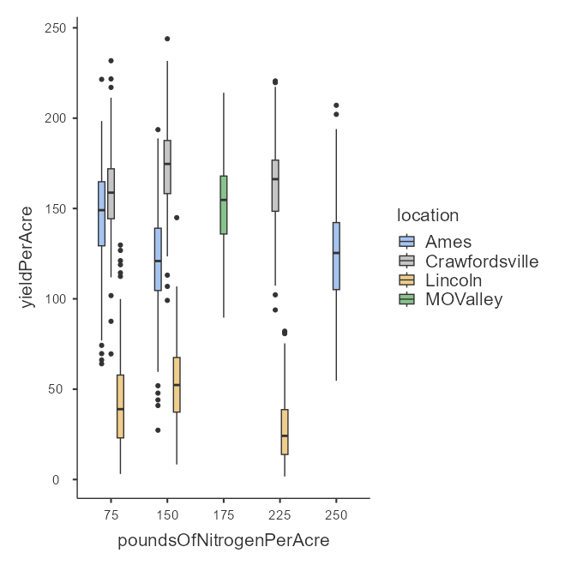
Figure 1: Box Plot of Yield Variation across Location Based on Nitrogen Input
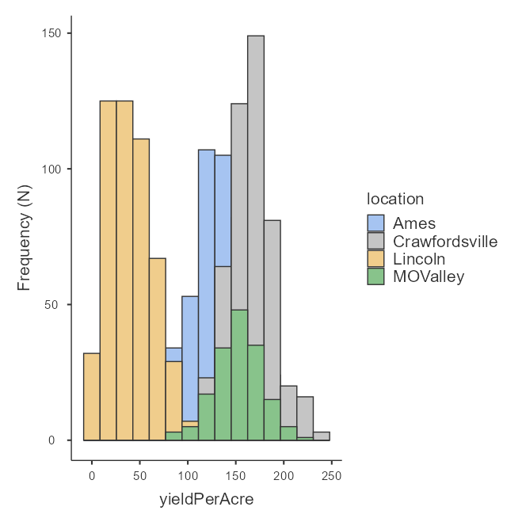
Figure 2: Histogram of Yield Variation based on Location
Table 1: ANOVA of Yieldperacre Based on Genotype, Location and PoundsofNitrogenPerAcre
ANOVA – yieldPerAcre
 | Sum of Squares | df | Mean Square | F | P
genotype | 375026 | 83 | 4518 | 1.37 | .016
Residuals | 5.12e+6 | 1557 | 3288
location | 4.30e+6 | 3 | 1.43e+6 | 1963 | <.001
Residuals | 1.20e+6 | 1637 | 730
poundsOfNitrogenPerAcre | 389040 | 4 | 97260 | 31.2 | <.001
Residuals | 5.11e+6 | 1636 | 3121

Data characteristics were important as indicated in diagnostic tests. The test performed by Levene revealed that the variances between the groups were not the same (F = 5.68, p <.001), which implies that the amount of prediction uncertainty might depend on the yield level in a systematic manner. The shapiro-wilk test ( W = 0.994, p <.001) showed that the residuals were not exactly normally distributed, although with a sample size of n=1,640, some slight deviations were to be expected, and it did not significantly affect the validity of the statistics (Table 2). The Q-Q plot figure made the assessment of nearly normality in the central distribution and slight tail deviation (Figure 3).
Table 2: Heterogeneity and Normality Test of Yield
Homogeneity of Variances Test (Levene's)
F | df1 | df2 |  | p
5.68 | 9 | 1631 |  | <.001
Normality Test (Shapiro-Wilk)
Statistic |  |  | p
0.994 |  |  | <.001

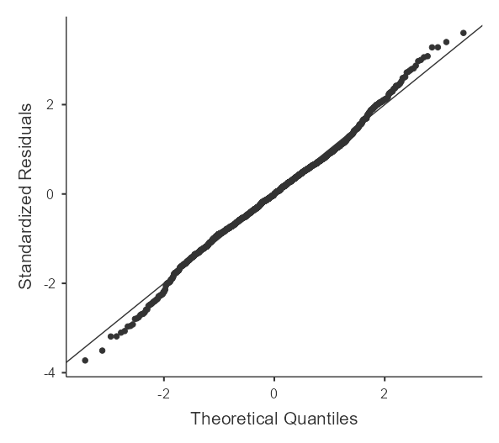
Figure 3: Q-Q Plot of Yield Distribution
The Performance of the Machine Learning Model
The quality of prediction of the machine-learning models was evaluated by using the coefficient of determination (R²) and root mean square error (RMSE). As shown in Figure 4, the model with the highest performance is the Random Forest (RF) with an R² = 0.84 which explains the variation in maize yield of about 84 percent and the least prediction error (RMSE = 24). The Decision Tree (DT) was also a good performer (R² = 0.79; RMSE = 27), and the fact that it was represented as a single tree led to an increase in uncertainty. The Support Vector Machine (SVM) in contrast demonstrated extremely poor predictive ability with negative R² =0.03) and a much larger error (RMSE = 58) and was unable to predict the complex, non-linear relationships that drive maize yield. On the whole, ensemble learning through Random Forrest offers the best framework model on prediction of maize yield in this research.

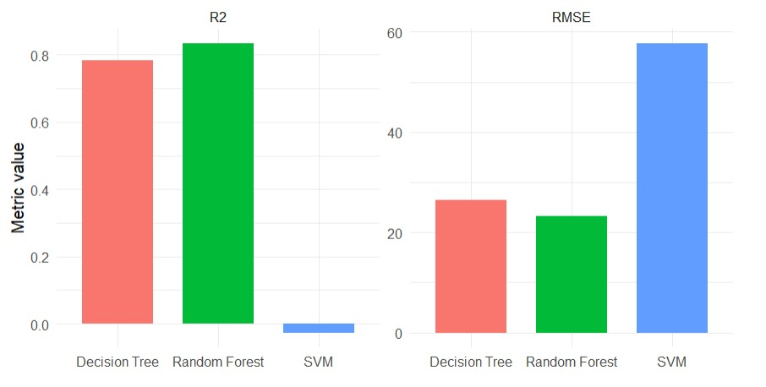
Figure 4: Performance of Machine Learning Model
The scatter plots of the observed and the predicted values had significant diagnostic patterns. Random Forest forecasts were tightly clustered about the identity line throughout the entire yield space, suggesting that there was little systematic bias (Figure 5). The SVM predictions also had higher dispersion especially at extreme yield values indicating that the kernel-based methods cannot be as stable at the tail of the distribution (Figure 6). The predictions of Decision Tree revealed some evidence of apparent over-smoothing at high yield and lacks variability in prediction, as the algorithm is recursive partitioning, and is guilty of prediction conservatism (Figure 7).
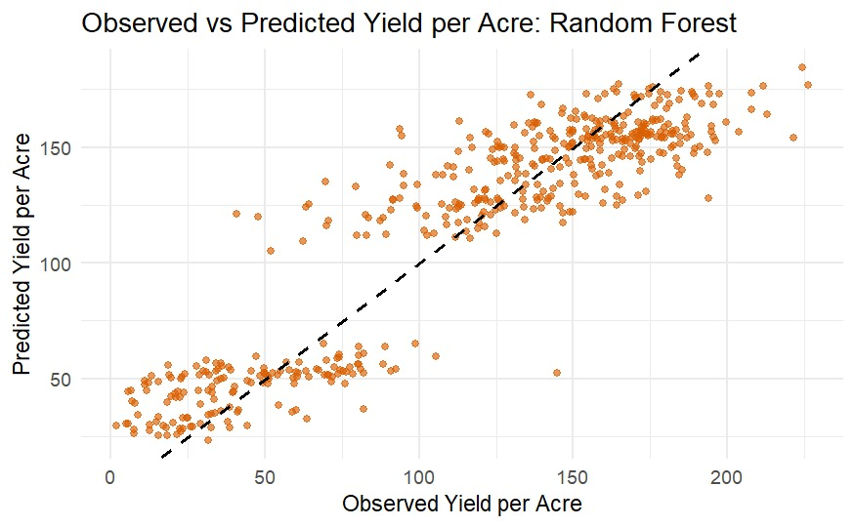
Figure 5: Scatter Plot of Random Forest Model

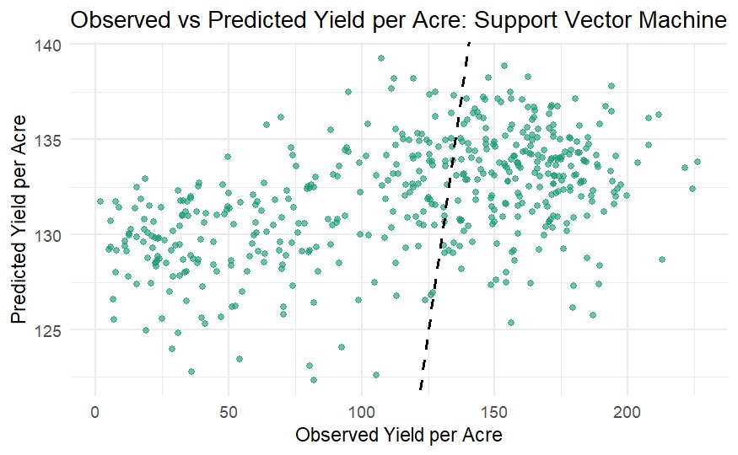
Figure 6: Scatter Plot of SVM Model
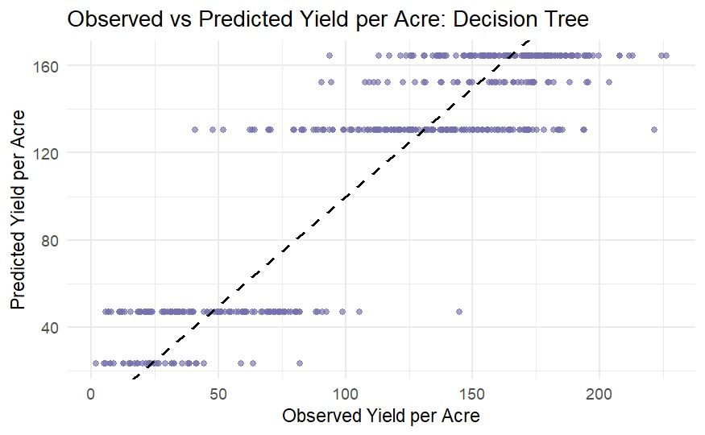
Figure 7: Scatter Plot of Decision Tree Model

Variable Importance and Feature Contributions.
Random Forest permutation importance (percent Incremental square error) (percent Incremental square error) and node purity (IncNodePurity) were used to estimate the contribution of a feature. Location_id was the top modulator, and permutation increased error by around 52 percent and node purity to about 1.55 x 10⁶, which indicated the strong spatial control of yield. The ranges and rows came next, with error doubling by the factor of 30 and 26, and purity values of 6.0 x 10⁵ and 7.0 x 10⁵, respectively, which are large within-field effects. Nitrogen was moderately affecting it, increasing error by approximately 21% (≈ 3.0 x 10⁵ purity), which validates agronomic applicability. Genotypeid made the most insignificant contribution, whereby the error increment was only approximately 9% and ≈ 1.5 x 10⁵ purity. Such findings indicate that spatial and management variables are more influential in explaining yield variability of maize beyond genetic influences.
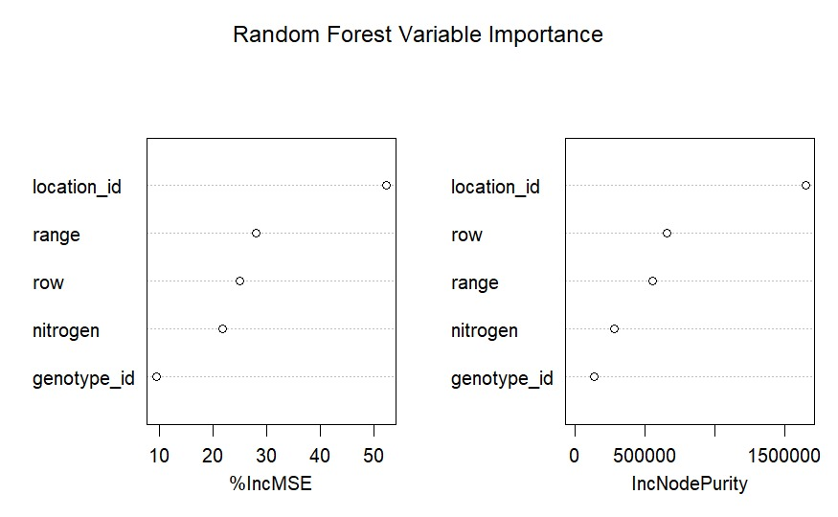
Figure 8: Variable Importance and Feature Contributions

Discussion

Alignment with Agricultural Machine Learning Literature
These findings are in line with recent meta-analyses that have shown that the use of an ensemble method is always better than a single-tree method in predicting the agricultural yields. R2 values Sharma et al. (2021) noted that R2 between 0.62-0.75 are normal in crop prediction studies, and this study R² of 0.84 by the Random Forest is within this error margin, confirming this study approach to the model and the quality of the data. The fact that ensemble methods outperform decision trees supports the hypothesis: ensemble diversity due to bootstrapping sampling and random selection of features is a successful method to decrease the prediction variance, which is also present in performing agricultural machine learning tasks (Liakos et al., 2018).
The discovery that location effects (F = 1963) are very significant and dominate the nitrogen effects (F = 31.2) has a very important implication on the study of precision agriculture. Although the significance of nitrogen management in agronomic literature frequently focuses on the topic, our findings highlight that location-specific variables - including unmeasured soil heterogeneity, microclimate heterogeneity, and pest/disease pressure - contribute significantly more variability in yields than management of explicit fertilizer. This observation indicates that proper predictions of yield are only possible with proper environmental characterization and place-specific model calibration and not with generic functions defining the response of nitrogen.
The high value of the interaction between location and nitrogen (p < .001) suggests that the best application of nitrogen is environment-specific and contributes to location-specific agronomic advice. These effects of interactions are implicitly represented in our machine learning framework, without having to specify the parametric structure of these interactions, which shows the usefulness of algorithmic methods in complex agricultural systems, where the interaction structure is potentially nonlinear and context-dependent (Tuia et al., 2016).
Model Choice and Application.
The moderate performance of the generalization (R² = 0.84) reflects the fact that although machine learning models do give a meaningful prediction of the yields, around 16 percent of all yield variance is not explained. The unexplained variance probably consists of environmental factors (mineralogy of soil, presence of a particular pest/disease, timing of weather stress, etc.) that are not directly quantifiable as genotype phenotype interactions (as measured by hybrids), as well as measurement error associated with field studies. Our interpretations of agronomy are pragmatic: our models can be used to support the decision-support systems of breeding programs and to optimize the use of fertilizers, but they cannot be used alone in making high-stakes choices, without reference to our agronomic understanding and our understanding of place.
The excellent performance of the random forest compared with the SVM and trees, coupled with its efficiency and ability to handle outliers, support the use of the random forest in any operational prediction system. The interpretability benefit of decision trees, however, namely the ability to explicitly demonstrate the effects of location, genotype, and nitrogen on prediction, can be useful to stakeholder communication in farmer outreach programs. To achieve both technical and communication goals, a hybrid model based on the random forest to predict the accuracy of the predictions and the use of decision trees to explain them would be the best.
Hypothetical Theoretical Implications on Agricultural Machine Learning Method.
This work adds to the growing body of evidence that machine learning algorithms are useful in capturing location-specific prediction rules where location is added as an explicit predictor and results are similar to location-specific models, yet it has a statistical power of pooled analysis. Through this method, which as a predictor variable incorporates location, but does not stratify analyses by location, information is shared across environments, without any loss in location-specific flexibility, a methodological approach that is more broadly applicable to agricultural research across multiple environments.

Implications and Conclusions.
We have shown in our comparative machine learning framework that the Random Forest and Decision Tree algorithms were significantly better than the decision tree benchmarks, as the random forest model showed a R² = 0.84 and an RMSE = 24 bushels per acre. These findings confirm that machine learning methods can be useful towards precision agriculture applications and that precise yield prediction models must combine agronomic, genetic data, and place-specific environmental variables.
Research Implications: The research would add to the existing body of literature in favor of machine learning usage in crop enhancement and accuracy agriculture. The methodology framework - overt combination of place influence, stratified information sectioning and place-based execution evaluation offers replicable guidelines on how comparable studies can be broadened to new crops and areas.
Practical Implications: In the context of plant breeding initiatives, our models can help in the optimization of hybrid selection in varied environments. To the farm management, the specified significance of location-specific factors suggests the use of agronomic prescriptions that are not universal to provide agronomic recommendations.
Limitations
There are a number of limitations that need to be recognized. To start with, four locations are analyzed in Corn Belt, geographic generalization outside the area needs to be proven. Second, models do not exploit the genetic variation available by using genetic marker information but as a categorical variable, hybrid identifier. Third, weather data in the growing season were not incorporated, which could probably be the reason behind a significant amount of residual variance. Fourth, the differences in heterogeneous variances observed between groups (Levene test p <.001) raises a possibility of heteroscedastic prediction error that is not taken care by quantile regression or heteroscedasticity-adjusted.
Recommendations
Dealing with growing season weather parameters (temperature stress cumulative indices, precipitation patterns, heat unit accumulation) should be considered in future research to enhance model performances. High-dimensional genomic data integration using dimension reduction methods may be a superior way of representing genetic complexity beyond hybrid identity. Cross-location generalization could be better with transfer learning to develop location-specific model variants. Lastly, the use of ensemble prediction intervals as opposed to point predictions would ensure that the decision-makers are able to access some quantification of uncertainty as well as make risk-sensitive farm management decisions.

COMPETING INTERESTS DISCLAIMER:
Authors have declared that they have no known competing financial interests OR non-financial interests OR personal relationships that could have appeared to influence the work reported in this paper.

References

Abbasi, M., Váz, P., Silva, J., & Martins, P. (2025). Machine learning approaches for predicting maize biomass yield: Leveraging feature engineering and comprehensive data integration. Sustainability, 17(1), 256. https://doi.org/10.3390/su17010256

Akwabeng, P. M. , Awele O., Jegede, O. A., Odili , J. (2026 ). A Data-Driven Assessment of Crop Yield Variability and Global Food Security under Climate Change. World Journal of Advanced Research and Reviews, 29(01), 295-304. https://doi.org/10.30574/wjarr.2026.29.1.0028
Archontoulis, S. V., Castellano, M. J., Licht, M. A., Nichols, V., Baum, M., Huber, I., & Lamkey, K. R. (2020). Predicting crop yields and soil-plant nitrogen dynamics in the US Maize Belt. Crop Science, 60(2), 721–738.
Baio, F. H. R., Santana, D. C., Teodoro, L. P. R., Oliveira, I. C. de, Gava, R., de Oliveira, J. L. G., Silva Junior, C. A. da, Teodoro, P. E., & Shiratsuchi, L. S. (2022). Maize yield prediction with machine learning, spectral variables and irrigation management. Remote Sensing, 15(1), 79. https://doi.org/10.3390/rs15010079
Breiman, L. (2001). Random forests. Machine Learning, 45(1), 5–32. https://doi.org/10.1023/A:1010933404324
Breiman, L., Friedman, J., Stone, C. J., & Olshen, R. A. (1984). Classification and regression trees. Chapman and Hall.
Caruana, R., & Niculescu-Mizil, A. (2006). An empirical comparison of supervised learning algorithms. In Proceedings of the 23rd International Conference on Machine Learning (pp. 161-168). Association for Computing Machinery. https://doi.org/10.1145/1143844.1143865
Cawley, G. C., & Talbot, N. L. C. (2010). On over-fitting in model selection and subsequent selection bias in performance evaluation. Journal of Machine Learning Research, 11, 2079–2107.
Cooper, M., Messina, C. D., Podlich, D., Gho, C., Zhong, S., & Technow, F. (2021). Predicting quantitative traits using molecular genomics and high-throughput phenotyping across crop species. In Advances in Agronomy (Vol. 154, pp. 45–113). Academic Press.
Croci, M., Impollonia, G., Meroni, M., & Amaducci, S. (2023). Dynamic maize yield predictions using machine learning on multi-source data. Remote Sensing, 15(1), 100. https://doi.org/10.3390/rs15010100
Crusiol, L. G. T., Sun, L., Sibaldelli, R. N. R., Junior, V. F., Furlaneti, W. X., Chen, R., Sun, Z., Wuyun, D., Chen, Z., Nanni, M. R., Furlanetto, R. H., Cezar, E., Nepomuceno, A. L., & Farias, J. R. B. (2022). Strategies for monitoring within-field soybean yield using Sentinel-2 Vis-NIR-SWIR spectral bands and machine learning regression methods. Precision Agriculture, 23(3), 1093–1123. https://doi.org/10.1007/s11119-022-09876-5
Efron, B., & Gong, G. (1983). A leisurely look at the bootstrap, the jackknife, and cross-validation. The American Statistician, 37(1), 36–48. https://doi.org/10.1080/00031305.1983.10483087
FAO. (2023). Zimbabwe at a glance. Food and Agriculture Organization of the United Nations. https://www.fao.org/zimbabwe/fao-in-zimbabwe/zimbabwe-at-a-glance/en/
Gill, M., Anderson, R., Hu, H., Bennamoun, M., Petereit, J., Valliyodan, B., Nguyen, H. T., Batley, J., Bayer, P. E., & Edwards, D. (2022). Machine learning models outperform deep learning models, provide interpretation and facilitate feature selection for soybean trait prediction. BMC Plant Biology, 22(1), 180. https://doi.org/10.1186/s12870-022-03559-z
Hallauer, A. R., & Miranda, J. B. (1988). Quantitative genetics in maize breeding (2nd ed.). Iowa State University Press.
Hastie, T., Tibshirani, R., & Friedman, J. (2009). The elements of statistical learning: Data mining, inference, and prediction (2nd ed.). Springer.
Kitchen, N. R., Clay, S. A., Carlson, C. G., & Sudduth, K. A. (2018). Understanding and identifying variability. In Precision agriculture basics (pp. 13–24). John Wiley & Sons.
Krause, M. R., Crossman, S., Dumond, T., Lexi, J. A., Molin, J. P., Bashford, L. L., & Madsen, E. A. (2020). Random Forest regression for optimizing variable planting rates for maize and soybean using topographical and soil data. Agronomy Journal, 112(5), 5045–5066.
Liakos, K. G., Busato, P., Moshou, D., Pearson, S., & Bochtis, D. (2018). Machine learning in agriculture: A review. Sensors, 18(8), 2674
Liaw, A., & Wiener, M. (2002). Classification and regression by randomForest. R News, 2(3), 18–22.
Little, R. J. A., & Rubin, D. B. (2002). Statistical analysis with missing data (2nd ed.). John Wiley & Sons.
Lobell, D. B., Thau, D., Seifert, C., Engle, E., & Little, B. (2015). A scalable satellite-based crop yield mapper. Remote Sensing of Environment, 164, 324–333. https://doi.org/10.1016/j.rse.2015.04.021
McFadden, J. R., Rosburg, A., & Njuki, E. (2022). Information inputs and technical efficiency in midwest corn production: evidence from farmers’ use of yield and soil maps. American Journal of Agricultural Economics, 104(2), 589–612. https://doi.org/10.1111/ajae.12251
Munafò, M. R., Nosek, B. A., Bishop, D. V. M., Button, K. S., Chambers, C. D., Percie du Sert, N., Simonsohn, U., Wagenmakers, E.-J., Ware, J. J., & Ioannidis, J. P. A. (2017). A manifesto for reproducible science. Nature Human Behaviour, 1(1), Article 0021. https://doi.org/10.1038/s41562-016-0021
Paudel, D., Boogaard, H., de Wit, A., Janssen, S., Osinga, S., Pylianidis, C., & Athanasiadis, I. N. (2021). Machine learning for large-scale crop yield forecasting. Agricultural Systems, 187(103016), 103016. https://doi.org/10.1016/j.agsy.2020.103016
Paudel, D., de Wit, A., Boogaard, H., Marcos, D., Osinga, S., & Athanasiadis, I. N. (2023). Interpretability of deep learning models for crop yield forecasting. Computers and Electronics in Agriculture, 206(107663), 107663. https://doi.org/10.1016/j.compag.2023.107663
Peng, R. D., Dominici, F., & Zeger, S. L. (2006). Reproducible epidemiologic research. American Journal of Epidemiology, 163(9), 783–789. https://doi.org/10.1093/aje/kwj093
Radoˇcaj, D., Plašˇcak, I., & Juriší, M. (2025). A comparative assessment of regular and spatial cross-validation in subfield machine learning prediction of maize yield from Sentinel-2 phenology. Engineering, 6(10), 270. https://doi.org/10.3390/eng6100270
Raun, W. R., & Johnson, G. V. (1999). Improving nitrogen use efficiency for cereal grain production. Agronomy Journal, 91(3), 357–363. https://doi.org/10.2134/agronj1999.00021962009100030001x
Ray, D. K., Gerber, J. S., MacDonald, G. K., & West, P. C. (2015). Climate variation explains a third of global crop yield variability. Nature Communications, 6(1), 5989. https://doi.org/10.1038/ncomms6989
Roberts, D. R., Bahn, V., Ciuti, S., Boyce, M. S., Elith, J., Guillera-Arroita, G., & Thuiller, W. (2017). Cross-validation strategies for data with temporal, spatial, hierarchical, or phylogenetic structure. Ecography, 40(8), 913–929.
Scholkopf, B., & Smola, A. J. (2002). Learning with kernels: Support vector machines, regularization, optimization, and beyond. MIT Press.
Schölkopf, B., Simard, P., Smola, A. J., & Vapnik, V. (1997). Prior knowledge in support vector kernels. In J. D. Cowan, G. Tesauro, & J. Alspector (Eds.), Advances in Neural Information Processing Systems (Vol. 10). MIT Press.
Shahhosseini, M., Hu, G., & Archontoulis, S. V. (2020). Forecasting corn yield with machine learning ensembles. Frontiers in Plant Science, 11, 1120. https://doi.org/10.3389/fpls.2020.01120
Sharma, B., Kumar, P., Patel, A., Yadav, D. S., & Singh, R. K. (2021). A machine learning approach for crop yield and disease prediction integrating soil nutrition and weather factors. Agricultural Systems, 190, Article 103084.
Sharma, R. K., Kaur, J., Feng, G., Huang, Y., Kumar, C., Wang, Y., Sharma, S., Jenkins, J., & Dhillon, J. (2025). Maize and soybean yield prediction using machine learning methods: a systematic literature review. Discover Agriculture, 3(1). https://doi.org/10.1007/s44279-025-00215-6
Shrestha, A., Bheemanahalli, R., Adeli, A., Samiappan, S., Czarnecki, J. M. P., McCraine, C. D., Reddy, K. R., & Moorhead, R. (2023). Phenological stage and vegetation index for predicting corn yield under rainfed environments. Frontiers in Plant Science, 14, Article 1168732. https://doi.org/10.3389/fpls.2023.1168732
Tuia, D., Marcos, D., & Camps-Valls, G. (2016). Multi-temporal and multi-source remote sensing image classification by nonlinear relative normalization. ISPRS Journal of Photogrammetry and Remote Sensing, 120, 1–12. https://doi.org/10.1016/j.isprsjprs.2016.07.004
Tukey, J. W. (1977). Exploratory data analysis. Addison-Wesley.
van Klompenburg, T., Kassahun, A., & Catal, C. (2020). Crop yield prediction using machine learning: A systematic literature review. Computers and Electronics in Agriculture, 177(105709), 105709. https://doi.org/10.1016/j.compag.2020.105709
Vapnik, V. (1995). The nature of statistical learning theory. Springer-Verlag.
Viscarra Rossel, R. A., Behrens, T., Ben-Dor, E., Brown, D. J., Demattê, J. A. M., Shepherd, K. D., Shi, Z., Stenberg, B., Stevens, A., Adamchuk, V., Aïchi, H., Barthès, B. G., Bartholomeus, H. M., Bayer, A. D., Bernoux, M., Böttcher, K., Brodský, L., Du, C. W., Chappell, A., … Ji, W. (2016). A global spectral library to characterize the world’s soil. Earth-Science Reviews, 155, 198–230. https://doi.org/10.1016/j.earscirev.2016.01.012
Wang, Y., Yuan, Y., Yuan, F., Liu, X., Tian, Y., Zhu, Y., Cao, W., & Cao, Q. (2025). Optimizing management zone delineation through advanced dimensionality reduction models and clustering algorithms. Precision Agriculture, 26(4). https://doi.org/10.1007/s11119-025-10265-x
Westgate, M. E., & Boyer, J. S. (1985). Osmotic adjustment and the inhibition of leaf, root, stem and silk growth at low water potentials in maize. Planta, 164(4), 540–549.

