Histopathological alterations in the liver of common carp (Cyprinus carpio L.) fingerlings fed a diet supplemented with Agaricus bisporus

Abstract
The present study aimed to evaluate the histopathological changes in liver tissues of common carp (Cyprinus carpio L.) fed a diet supplemented with Agaricus bisporus. A total of six experimental diets containing 28% protein were prepared. The control diet was prepared without supplementation of A. bisporus powder (ABP) whereas the treatment diets were supplemented with ABP at an inclusion level of 2%, 4%, 6%, 8% and 10%. The experiment was conducted for 180 days followed by four-day challenge test and the histopathological evaluation was carried out on fish following the challenge with Aeromonas hydrophila. Common carp fingerlings were stocked at a density of 10 nos. in each plastic tubs (70 L) having 3 replicates. Fish supplemented with 8% of ABP showed significantly higher growth than other groups. The results of challenge test against A. hydrophila showed that administration of ABP supplemented diets significantly increased common carp resistance against disease and the highest survival rate (90%) was observed in the fish supplemented with 8% ABP. The liver histopathological study demonstrated that fish supplemented with 8% ABP exhibited markedly fewer to no pathological changes in liver tissue as compared to control group, reflecting its beneficial effect. The present results confirmed the immunomodulatory effects of A. bisporus and support its potential use as a natural alternative immunostimulant for common carp aquaculture.
- Introduction
Fish plays a vital role in the human diet, offering a rich source of protein, essential nutrients and beneficial fats (Maulu et al., 2021). The fishing and aquaculture sectors play a unique and expanding role in providing people with food, nourishment and employment. Feed is a critical link in the aquaculture value chain, as the success of fish growth largely depends on the quality of raw materials used in feed formulations. These ingredients directly influence the growth rate of cultured fish species under various environmental conditions. Hence, for effective and sustainable aquaculture operations, it is essential that the raw materials used are not only nutritionally sufficient but also commercially viable (Chaitanawisuti et al., 2011). One of the most promising approaches in maintaining fish health involves strengthening their immune system through the prophylactic use of natural immunostimulants. The use of prebiotics, probiotics, medicinal herbs and mushrooms as environmentally acceptable substitutes for antibiotics is growing (Katya et al., 2014). These natural immunostimulants enhance non-specific defense mechanisms and improve disease resistance in aquaculture species (Dalmo & Seljelid, 1995). Researches have shown that herbal extracts possess immunostimulatory properties and could serve as affordable, non-toxic alternatives to vaccines, antibiotics and chemotherapeutic agents in culture of finfish and shellfish (FAO, 2020).
Edible mushroom species such as button, milky, oyster and reishi mushrooms are renowned for their immunostimulatory properties (Zheng et al., 2012). Various forms of mushrooms-including dry powder, extracts, liquid mycelial biomass, stalk waste extracts and exopolysaccharides can be incorporated into fish and shellfish diets to boost health and immunity (Mohan et al., 2022). The biologically active compounds in mushrooms, such as glycoproteins, enzymes, phenolics and lipids, have been shown to modulate immune responses and enhance disease resistance in aquaculture animals (Zhang et al., 2007; Ullah et al., 2018). Furthermore, mushrooms are recognized as medicinal foods due to the presence of bioactive compounds like polyphenols, ergothioneine, essential vitamins, minerals and polysaccharides (Tian et al., 2012).
Among the cultivated mushrooms, the white button mushroom (Agaricus bisporus) stands out for its economic importance, market demand and global distribution (Liu et al., 2013). A. bisporus, a member of the family Agaricaceae and class Basidiomycetes, is indigenous to European and North American grasslands and is still the most widely consumed mushroom globally. In India, it dominates the market, contributing about 90% of the country's total mushroom production with a global share of 40%. A. bisporus are increasingly being seen as next-generation health food supplements which are low in fat, cholesterol-free, rich in high-quality protein and a potential solution to nutritional deficiencies in developing countries (Liu et al., 2013). A. bisporus are rich in β-glucan which is considered as a key polysaccharide. β-glucan acts as a prebiotic, supporting the growth of beneficial gut bacteria while inhibiting harmful pathogens, thereby enhancing immunity (Smiderle et al., 2011).
The most studied proteins of A. bisporus are lectin and tyrosinase (also often called polyphenol oxidase, PPO) and lectin (Weijn et al., 2013). Lectins are sugar binding proteins and its activity can be defined by the agglutination of foreign particles, which are known to display antitumour, antiproliferative and immunomodulatory activities (Santos et al., 2014). PPO catalyzes the conversion of L-tyrosine to L-3,4 dihydroxyphenylalanine (usually called L-DOPA), which is subsequently transformed into dopaquinone, which is a precursor in melanin biosynthesis (Weijn et al., 2013). Melanines are responsible for inhibition of the growth of microorganisms by suppressing the activity of extracellular proteinases and chitinases. In addition, PPO also increases phagocytosis, nodule formation, encapsulation and promote haemolymph protein. It contains the small molecules (phenolic compounds, indoles, statins, and other secondary metabolites). Ergothioneine is an antioxidant associated with protection of monocytes activity, the indoles are associated with anticancer and antiaging bioactivity, while ergosterol and ergocalciferol help to prevent vitamin D efficiency (Muszynska et al., 2017).
The intensification of aquaculture to meet the growing global demand for common carp (Cyprinus carpio L.) has made fish populations more vulnerable to infectious diseases (Mirghaed et al., 2019). The rise in bacterial infections has led to widespread mortality and significant losses in aquaculture operations (Post, 2011; Nielsen et al., 2001). Aeromonas hydrophila, a gram-negative bacterium is one of the most significant pathogenic bacteria affecting carp species (Alavinezhad et al., 2021; Harikrishnan et al., 2010). A. bisporus is well known for its immune boosting properties in humans and animals. However, there is very limited information available regarding its administration in aquaculture. Therefore, the present study investigates the histopathological evaluation of liver in common carp (Cyprinus carpio L.) fingerlings fed a diet supplemented with Agaricus bisporus powder (ABP).
- Material and Methods
2.1 Fish and Experimental Diets
The common carp fingerlings (average weight 8.0 g) were brought from the Aquaculture Research and Training Institute (ARTI) located in Hisar to the wet lab, College of Fisheries Science, Hisar, Haryana. Fish were acclimatized for 2 weeks and fed with commercial diet twice a day. The experiment was conducted in total 18 circular plastic tubs (70 L) filled with filtered and disinfected freshwater. Six treatments and three replications were used in a completely randomized design (CRD) for the experiment. Each tub was stocked with 10 nos. of fish which was well aerated. Fish were fed 2 times a day at the rate of 3% of their body weight for 6 months. The experiment was executed according to approved animal care protocols.
Total six experimental diets were prepared in the laboratory including control diet ABP₀ (without A. bisporus powder) and five treatment diet ABP₁ (2%), ABP₂ (4%), ABP₃ (6%), ABP₄ (8%) and ABP₅ (10%) with ABP supplementation (Table 1). Experimental feed was formulated by using Pearson’s Square method and in all experimental diets 28% protein level was maintained. Fresh A. bisporus was procured from mushroom farm, CCS HAU, Hisar. Then cleaned, cut, shade dried and powdered in a mixture grinder. Experimental diet was prepared using ingredients, soyabean meal, fishmeal, rice bran and wheat flour. Prior to feed preparation, the proximate composition of all ingredients was analyzed by following the standard methodology (AOAC, 2019) to ensure 28% protein level in experimental diets. The required quantities of ingredients were weighed accurately. The materials were thoroughly combined with the necessary amount of water; the dough was prepared and cooked in autoclave. After steam cooking, vitamin and mineral mixture was added and mixed well. The pellets of feed were spread on plastic sheet, sun dried and placed in clearly labelled plastic containers.
Table 1. The treatment details were designed as follows:
Treatment | Amount
ABP₀ | Control diet
ABP₁ | Diet supplemented with 2% ABP
ABP₂ | Diet supplemented with 4% ABP
ABP₃ | Diet supplemented with 6% ABP
ABP₄ | Diet supplemented with 8% ABP
ABP₅ | Diet supplemented with 10% ABP
2.2 Histopathology of Fish Liver
Histopathological evaluation was carried out on fish following the challenge with A. hydrophila. After completion of feeding experiment of 180 days the same animals were used for challenge test against A. hydrophila. Each fish was intramuscularly injected with A. hydrophila at a dose of 0.1 ml of bacterial suspension containing 1.0x10⁷ cfu/ml. Following administration of bacterium, fish was monitored for four days at every 12 h interval to evaluate survival rate and disease progression.
For histopathological evaluation the fish were euthanized by adding 250–500 mg of MS-222 to one liter of water before dissection. The liver was carefully removed and preserved in a 10% formalin solution as a fixative, keeping a tissue-to-fixative ratio of 1:20 to avoid harm. The tissue samples were dehydrated using increasing ethanol concentrations (70–100%), cleaned in xylene and embedded in paraffin wax (Moustafa et al., 2020). Using a semi-automatic microtome, tissue sections with a thickness of 5 μm were cut, stained with hematoxylin and eosin (H&E) and examined under a light microscope at a high power (40X) magnification.
2.6 Statistical Analysis
The significant differences (P=0.05) were analyzed using a one-way analysis of variance (ANOVA) and Duncan’s post hoc for multiple comparisons among the treatments using a statistical tool IBM® SPSS® version 22.0 software. The mean±standard error (SE) was used to represent the results.
- Result and Discussion
During 180 days of experimental period, the rearing conditions remained stable and no adverse effects of experimental diets was observed on common carp. All the water quality parameters were maintained within the optimum range. The ABP₄ group exhibited a significant increase in total weight and specific growth rate compared to the control and other dietary treatments. This group also demonstrated a higher protein efficiency ratio and a significantly improved feed conversion ratio, indicating enhanced feed utilization and growth performance. The survival rate of common carp following challenge with A. hydrophila is presented in Table 2 and illustrated in Figure 1. During the 96-h trial against A. hydrophila, the common carp fed with ABP supplemented diets displayed significantly less susceptibility to A. hydrophila than that in the control group. A statistical study revealed that the treatments differed significantly (P=0.05). Fish fed with 8% ABP (90.0ª±0.00) showed significantly (P=0.05) higher survival rate than all other treatments. The survival rate was significantly lower in ABP₀ group (33.3e±3.33).
A. hydrophila is a pathogen that is often found in freshwater and seriously harms the Indian carp industry (Devi et al., 2024). Thus, the presence of in-feed medications that can stop A. hydrophila infections is a huge triumph because they aid in the development of natural resistance (Barman et al., 2013). Hadiuzzaman et al. (2022) found that β-glucan enhances the activity of white blood cells in the immune system, thereby boosting resistance to pathogens. These findings are consistent with the results reported by Harikrishnan et al. (2021) where A. bisporus polysaccharides diet enhanced the survival rate of Ctenopharyngodon idella after challenge against A. hydrophila upto 98.6%. The similar result was obtained by Van Doan et al. (2017) where supplementation of Cordyceps militaris SMS at 10 gkg⁻1 alone or in combination with probiotic Lactobacillus plantarum could enhance the immunity and survival rate of Nile tilapia.
Histopathology is widely used to study the pathological alterations due to various chemicals or biological infectious agent as biological markers (Camargo & Martinez, 2007: Forouhar Vajargah et al., 2018). In the current study, addition of ABP to the fish’s diet reduced the pathological changes associated with A. hydrophila in liver tissue with an obvious effect in fish of ABP₄ group. Microscopic examination of the liver samples revealed that fish supplemented with 8% ABP showed polygonal shaped hepatocytes with homogenous cytoplasm and a central spherical nucleus with clear cell boundaries. Vacuolation, which is the formation of small cavities or spaces within cells, was observed in the liver of fish, fed with 2% and 4% ABP. Eosinophilic granular cells and congestion of blood vessel were observed in fish fed with 6 & 10% ABP respectively. In control diet fed fish, strongest damages were observed in the hepatocytes which showed necrosis, extensive reduction of glycogen leading to vacuolation, eosinophilic granular cells and congestion in the tissue. ABP supplemented feed has less adverse effects on the liver tissues of the fish as compare to control fed fish (Figure 1 A-F). The histopathological examinations showed multiple tissue damages in the liver with histopathological changes which appeared to be good biomarkers for the assessment of diseases caused by A. hydrophila. This result is corroborated with the finding of Enyidi and Nwosu (2023). As ABP inclusion exceeded 8%, histopathological damage and tissue lesions were observed following A. hydrophila infection–likely due to oxidative stress and metabolic overload, which may have induced immunosuppression over 180 days, as excessive β-glucans can downregulate immune receptors, particularly evident in fish of ABP₅ group (Dawood et al., 2020; Aminzadeh et al., 2024; Katya et al., 2014; Enyidi & Nwosu, 2023). Similar study with Tilapia showed that experimental intramuscular infection with A. hydrophila at levels of 10⁷ cfu/fish produced characteristic ulceration leading to open wounds, focal necrosis or vacuolation of hepatocytes, congestion of hepatic sinuses and haemorrhages in the liver (Azad et al., 2001).
Table 2. Survival rate (%) of common carp in different treatments after challenged against A. hydrophila
Treatment | Mean±SE
ABP₀ | 33.3e±3.33
ABP₁ | 50.0^{d}±0.00
ABP₂ | 56.7^{c}±3.33
ABP₃ | 73.3^{bc}±3.33
ABP₄ | 90.0ª±0.00
ABP₅ | 80.0^{b}±0.00
C.D. | 7.343
S.E. (m) | 2.357

Fig. 1. Survival rate (%) of common carp under different dietary treatments during challenge test against A. hydrophila.

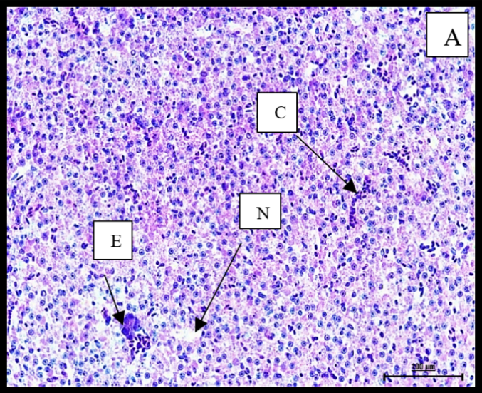 | 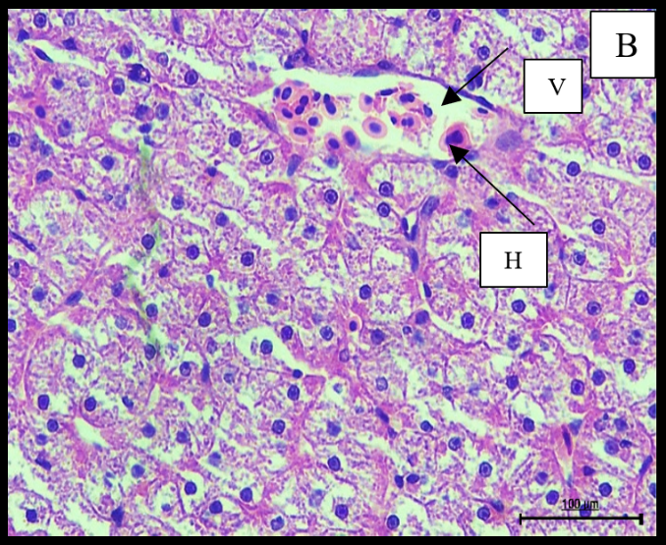
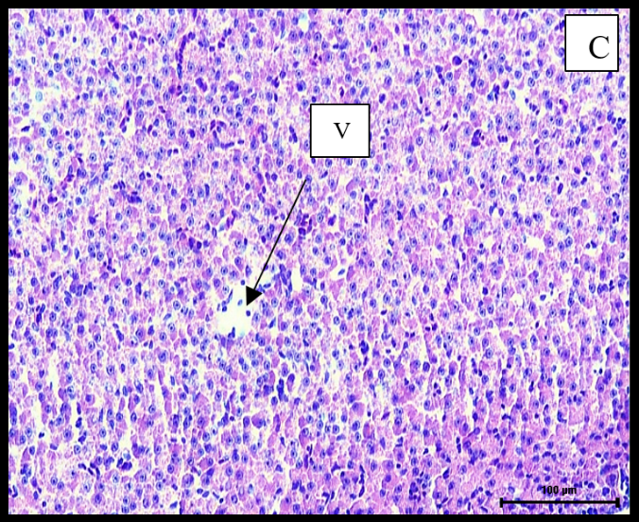 | 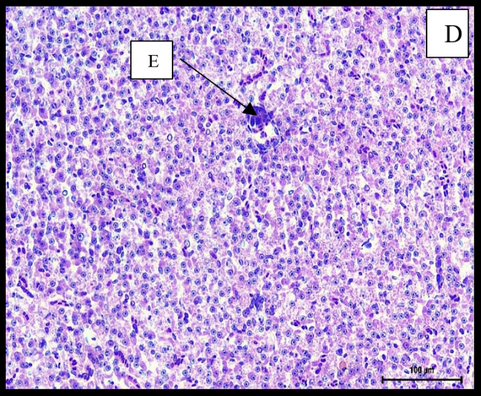
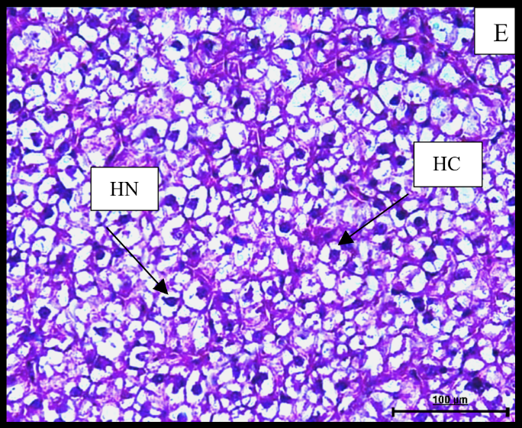 | 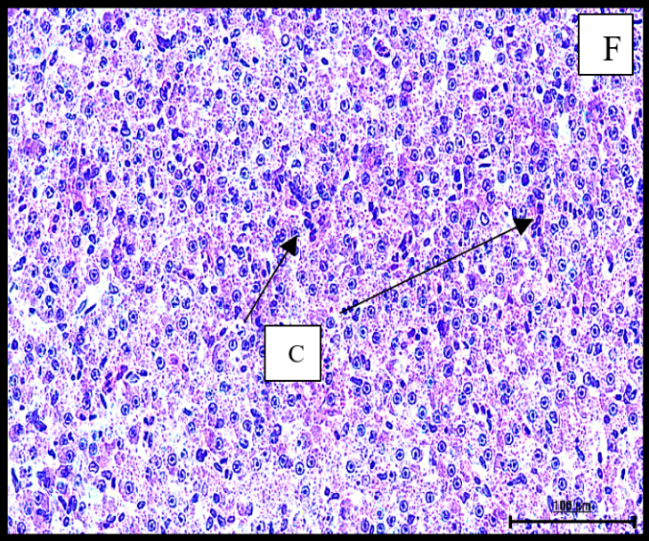

Fig. 2. (A-F): Microphotograph displaying changes in the liver tissue of common carp (A) ABP₀ group displaying necrosis (N), eosinophilic granular cells (E) and congestion (C). (B) ABP₁ group exhibiting haemorrhages (H) and vacuolation (V). (C) ABP₂ group showing vacuolation. (D) ABP₃ group exhibiting eosinophilic granular cells. (E) ABP₄ group showing normal hepatocytic cells (HC) and nucleus (HN) (F) ABP₅ group displaying congestion. Tissue sections observed at 40X magnification and 100 μm scalebar. (H&E Stain).
- Conclusion
The immunostimulatory role of ABP was supported by decreased mortality following A. hydrophila challenge and enhanced histopathological parameters. Carp development and immunity seem to be greatly enhanced by the bioactive substances included in ABP, especially β-glucans, antioxidants and other nutrients. The present investigation comes to the conclusion that dietary supplementation of ABP has significant positive effects on the histopathology of common carp. Therefore, dietary inclusion of ABP at 8% can be recommended as an effective, eco-friendly and sustainable feed additive in common carp aquaculture, offering a promising strategy to improve growth performance, strengthen disease resistance and reduce reliance on antibiotics.
Disclaimer (Artificial Intelligence)
Author(s) hereby declares that NO generative AI technologies such as Large Language Models and text-to-image generators have been used during the writing or editing of this manuscript.

References
Alavinezhad, S. S., Kazempoor, R., Ghorbanzadeh, A., & Gharekhani, A. (2021). Isolation of Aeromonas hydrophila and evaluation of its pathological effects on Koi fish (Cyprinus carpio). Iranian Journal of Medical Microbiology, 15(4), 465–476.
Aminzadeh, A., Jafari, V., & Hoseinifar, S. H. (2024). The effects of dietary Agaricus bisporus powder on growth performance, haematological indices, and serum immune response in beluga (Huso huso) juvenile. Frontiers in Marine Science, 11, 1487586. https://doi.org/10.3389/fmars.2024.1487586.
AOAC. (2019). Association of Official Analytical Chemist. (21 ed., 1). AOAC, Washington, DC, USA.
Azad, I.S., Rajendran, K.V., Rajan, J.J.S., Vijayan, K.K., & Santiago, T.C. (2001). Virulence and histopathology of Aeromonas hydrophila in experimentally infected tilapia, Oreochromis mossambicus (L.). Journal of Aquaculture in the Tropics, 16(3), 265–275.
Barman, D., Nen, P., Mandal, S.C., & Kumar, V. (2013). Immunostimulants for aquaculture health management. Journal of Marine Science: Research and Development, 3(3), 1–11. http://dx.doi.org/10.4172/2155-9910.1000134.
Camargo, M. M., & Martinez, C. B. (2007). Histopathology of gills, kidney and liver of a Neotropical fish caged in an urban stream. Neotropical Ichthyology, 5, 327–336. https://doi.org/10.1590/S1679-62252007000300013.
Chaitanawisuti, N., Choeychom, C., & Piyatiratitivorakul, S. (2011). Effect of dietary supplementation of brewer’s yeast and nucleotide singularly on growth, survival and vibriosis resistance on juveniles of the gastropod spotted babylon (Babylonia areolata). Aquaculture International, 19, 489–496. https://doi.org/10.1007/s10499-010-9364-1.
Dalmo, R. A., & Seljelid, R. (1995). The immunomodulatory effect of LPS, laminaran and sulphated laminaran [β (l, 3)‐D‐glucan] on Atlantic salmon, Salmo salar L., macrophages in vitro. Journal of Fish Diseases, 18(2), 175–185. https://doi.org/10.1111/j.1365-2761.1995.tb00275.x.
Dawood, M.A., Eweedah, N.M., El-Sharawy, M.E., Awad, S.S., Van Doan, H., & Paray, B.A. (2020). Dietary white button mushroom improved the growth, immunity, antioxidative status and resistance against heat stress in Nile tilapia (Oreochromis niloticus). Aquaculture, 523, 735229. https://doi.org/10.1016/j.aquaculture.2020.735229.
Devi, W. M., Saha, H., Irungbam, S., & Saha, R. K. (2024). A novel approach in valorization of spent mushroom substrate of Cordyceps militaris as in-feed antibiotics in Labeo rohita against Aeromonas hydrophila infection. Environmental Science and Pollution Research, 31(53), 62305–62314. https://doi.org/10.1007/s11356-023-29899-3.
Enyidi, U.D., & Nwosu, C. (2023). Effects of oyster mushroom, Lentinus sajor-caju on growth, gut histology and haematology of Clarias gariepinus. Journal of Aquatic Sciences, 38(1), 21–37. https://dx.doi.org/10.4314.jas.v38i1.3.
FAO. (2020). The State of World Fisheries and Aquaculture. Food and Agriculture Organisation of the United Nations. https://doi.org/10.4060/ca9229en.
Forouhar Vajargah, M., Mohamadi Yalsuyi, A., Hedayati, A., & Faggio, C. (2018). Histopathological lesions and toxicity in common carp (Cyprinus carpio L. 1758) induced by copper nanoparticles. Microscopy Research and Technique, 81(7), 724–729. https://doi.org/10.1002/jemt.23028.
Hadiuzzaman, M., Moniruzzaman, M., Shahjahan, M., Bai, S. C., Min, T., & Hossain, Z. (2022). β-Glucan: mode of action and its uses in fish immunomodulation. Frontiers in Marine Science, 9, 905986. https://doi.org/10.3389/fmars.2022.905986.
Harikrishnan, R., Balasundaram, C., & Heo, M. S. (2010). Potential use of probiotic-and triherbal extract-enriched diets to control Aeromonas hydrophila infection in carp. Diseases of Aquatic Organisms, 92(1), 41–49. https://doi.org/10.3354/dao.
Harikrishnan, R., Devi, G., Van Doan, H., Balasundaram, C., Thamizharasan, S., Hoseinifar, S.H., & Abdel-Tawwab, M. (2021). Effect of diet enriched with Agaricus bisporus polysaccharides (ABPs) on antioxidant property, innate-adaptive immune response and pro-anti inflammatory genes expression in Ctenopharyngodon idella against Aeromonas hydrophila. Fish & Shellfish Immunology, 114, 238–252. https://doi.org/10.1016/j.fsi.2021.04.025.
Katya, K., Yun, Y. H., Park, G., Lee, J. Y., Yoo, G., & Bai, S. C. (2014). Evaluation of the efficacy of fermented by-product of mushroom, Pleurotus ostreatus, as a fish meal replacer in juvenile Amur catfish, Silurus asotus: effects on growth, serological characteristics and immune responses. Asian-Australasian Journal of Animal Sciences, 27(10), 1478. https://doi.org/10.5713/ajas.2014.14038.
Liu, J., Wu, Y. C., Kan, J., Wang, Y., & Jin, C. H. (2013). Changes in reactive oxygen species production and antioxidant enzyme activity of Agaricus bisporus harvested at different stages of maturity. Journal of the Science of Food and Agriculture, 93(9), 2201–2206. https://doi.org/10.1002/jsfa.6027.
Maulu, S., Nawanzi, K., Abdel-Tawwab, M., & Khalil, H. S. (2021). Fish nutritional value as an approach to children's nutrition. Frontiers in Nutrition, 8, 780844. https://doi.org/10.3389/fnut.2021.780844.
Mirghaed, A. T., Yarahmadi, P., Soltani, M., Paknejad, H., & Hoseini, S. M. (2019). Dietary sodium butyrate (Butirex® C4) supplementation modulates intestinal transcriptomic responses and augments disease resistance of rainbow trout (Oncorhynchus mykiss). Fish & Shellfish Immunology, 92, 621–628. https://doi.org/10.1016/j.fsi.2019.06.046.
Mohan, K., Karthick Rajan, D., Muralisankar, T., Ramu Ganesan, A., Marimuthu, K., & Sathishkumar, P. (2022). The potential role of medicinal mushrooms as prebiotics in aquaculture: A review. Reviews in Aquaculture, 14(3), 1300–1332. https://doi.org/10.1111/raq.12651.
Moustafa, E.M., Dawood, M.A., Assar, D.H., Omar, A.A., Elbialy, Z.I., Farrag, F.A., Shukry, M., & Zayed, M.M. (2020). Modulatory effects of fenugreek seeds powder on the histopathology, oxidative status, and immune related gene expression in Nile tilapia (Oreochromis niloticus) infected with Aeromonas hydrophila. Aquaculture, 515, 734589. https://doi.org/10.1016/j.aquaculture.2019.734589.
Muszynska, B., Kala, K., Rojowski, J., Grzywacz, A., & Opoka, W. (2017). Composition and biological properties of Agaricus bisporus fruiting bodies- A review. Polish Journal of Food and Nutrition Sciences, 67(3), 173–181. https://doi.org/10.1515/pjfns-2016-0032.
Nielsen, M. E., Høi, L., Schmidt, A. S., Qian, D., Shimada, T., Shen, J. Y., & Larsen, J. L. (2001). Is Aeromonas hydrophila the dominant motile Aeromonas species that causes disease outbreaks in aquaculture production in the Zhejiang Province of China?. Diseases of Aquatic Organisms, 46(1), 23–29. https://doi.org/10.3354/dao.
Post, G. (2011). Response of rainbow trout (Salmo gairdneri) to antigens of Aeromonas hydrophila. Journal of Fisheries Research Board of Canada, 23(10), 1487–1494. https://doi.org/10.1139/f66-139.
Santos, A. F., Da Silva, M. D. C., Napoleao, T. H., Paiva, P. M. G., Correia, M. D. S., & Coelho, L. C. B. B. (2014). Lectins: Function, structure, biological properties and potential applications. Current Topics in Peptide and Protein Research, 15, 41–62.
Smiderle, F. R., Ruthes, A. C., Van Arkel, J., Chanput, W., Lacomini, M., Wichers, H. J., & Van Griensven, L. J. (2011). Polysaccharides from Agaricus bisporus and Agaricus brasiliensis show similarities in their structures and their immunomodulatory effects on human monocytic THP-1 cells. BMC Complementary and Alternative Medicine, 11(1), 1–11.
Tian, Y., Zeng, H., Xu, Z., Zheng, B., Lin, Y., Gan, C., & Lo, Y. M. (2012). Ultrasonic-assisted extraction and antioxidant activity of polysaccharides recovered from white button mushroom (Agaricus bisporus). Carbohydrate Polymers, 88(2), 522–529. https://doi.org/10.1016/j.carbpol.2011.12.042.
Ullah, M. I., Akhtar, M., Awais, M. M., Anwar, M. I., & Khaliq, K. (2018). Evaluation of immunostimulatory and immunotherapeutic effects of tropical mushroom (Lentinus edodes) against eimeriasis in chicken. Tropical Animal Health and Production, 50(1), 97–104.
Van Doan, H., Hoseinifar, S.H., Tapingkae, W., Chitmanat, C., & Mekchay, S. (2017). Effects of Cordyceps militaris spent mushroom substrate on mucosal and serum immune parameters, disease resistance and growth performance of Nile tilapia (Oreochromis niloticus). Fish & Shellfish Immunology, 67, 78–85. https://doi.org/10.1016/j.fsi.2017.05.062.
Weijn, A., Bastiaan-Net, S., Wichers, H. J. & Mes, J. J. (2013). Melanin biosynthesis pathway in Agaricus bisporus mushrooms. Fungal Genetics and Biology, 55, 42–53. https://doi.org/10.1016/j.fgb.2012.10.004.
Zhang, M., Cui, S. W., Cheung, P. C. K., & Wang, Q. (2007). Antitumor polysaccharides from mushrooms: a review on their isolation process, structural characteristics and antitumor activity. Trends in Food Science & Technology, 18(1), 4–19. https://doi.org/10.1016/j.tifs.2006.07.013.
Zheng, H., Liu, H., Liu, W., Sun, Z., & Zhang, Q. (2012). Changes of total carotenoid and lipid content in scallop tissues of Chlamys nobilis (Bivalve: Pectinidae) during gonad maturation. Aquaculture, 7(12), 342–343. https://doi.org/10.1016/j.aquaculture.2012.01.037.

