Original Research Article
Establishing DNA fingerprinting profiles for Diospyros melanoxylon Roxb. (kendu) by ISSR, RAPD and SCoT markers for further applications in genetic diversity assessment

ABSTRACT
The present investigation aimed to establish molecular marker-based approach to assess genetic diversity of D. melanoxylon Roxb. natural tree populations exist in different Forest regions in Odisha. In addition, high-quality genomic DNA isolation protocol was established from the leaves. Three different marker systems, such as inter simple sequence repeat (ISSR), random amplified polymorphic DNA (RAPD), and start codon targeted polymorphism (SCoT) were screened with kendu genomic DNA, to optimize and obtain clear, scorable and reproducible DNA fingerprinting profiles through polymerase chain reaction (PCR). Twenty-seven-number of ISSRs, 15-number of RAPDs and 9-number SCoT markers were considered for the study. Out of 27-ISSR markers, 17-markers gave scorable alleles. In averse, all RAPD and SCoT markers responded and gave clear and scorable alleles. The ISSR markers (AC)₈T, (GA)₈YT, (GA)₈T, (AC)₈C, and CAGCGACAAG demonstrated strong amplification performance, collectively spanning 45.8% of the total alleles. In contrast, SCoT markers SCoT23, SCoT40, SCoT9, SCoT12, SCoT17, and SCoT34 provided a wider genomic representation, accounting for 77.1% total allele coverage. Meanwhile, the RAPD markers CCGCCTAGTC, ACCTGGACAC, GACCGCTTGT, AGCCAGCGAA, CACACTCCAG, CCGCCCAAAC, and CACCTTTCCC amplified 59% of the total alleles. The established DNA isolation and PCR optimized protocols for different marker systems are highly useful in providing a reliable molecular framework for future studies on genetic diversity assessment thereby implementing appropriate conservation strategies for kendu natural forest populations. The present work is the first report in developing DNA fingerprinting for kendu adopting RAPD, ISSR and SCoT molecular markers for further genetic diversity assessment.
Keywords: Conservation; Diospyros melanoxylon; DNA fingerprinting; Genetic diversity; ISSR; RAPD; SCoT

1. INTRODUCTION
Forests harbour the silent legacy of genetic wealth, and within them, forest trees like D. melanoxylon Roxb. embody the intricate link between ecology, economy, and human culture. Kendu is deciduous species of the family Ebenaceae stands as a keystone component of India’s dry deciduous forests (Kumari and Kumar, 2021). The species predominantly occurs in the tropical and subtropical deciduous forests of central and eastern India. It thrives in dry tropical habitats, particularly in north tropical moist deciduous, southern tropical dry deciduous, and northern tropical dry deciduous forest zones. The natural range of D. melanoxylon extends across the states of Madhya Pradesh, Maharashtra, Odisha, Chhattisgarh, Andhra Pradesh, Jharkhand, Rajasthan, Bihar, Uttar Pradesh, Gujarat, and parts of West Bengal, Karnataka, Kerala, and Tamil Nadu (Kumari and Wani, 2017). States such as Uttar Pradesh, Gujarat, and Rajasthan exhibit comparatively lower abundance and collection potential due to limited forest cover and climatic constraints. In Odisha the species is distributed widely across almost all districts of the state, with particularly dense populations observed in Sundargarh, Keonjhar, Deogarh, Angul, Kalahandi, Kandhamal, Balangir, Boudh, and Malkangiri (Kumari and Kumar, 2021; Kumari and Wani, 2017). Beyond its ecological importance in sustaining biodiversity and maintaining soil stability, it sustains millions of rural livelihoods through the bidi leaf trade, making it both a biological and socio-economic asset (Rathore, 1972). In addition to its industrial value, the bark, fruits, and leaves of D. melanoxylon possess notable medicinal properties and are traditionally used for treating dysentery, skin diseases, and various other ailments (Gupta et al., 2013).
The species further possesses remarkable medicinal potential; its bark, fruits, and leaves contain a spectrum of phytochemicals with antioxidant, antimicrobial, and anticancer properties, placing it among India’s most valuable forest bioresources (Kumari and Wani, 2017; Al-Rashid et al., 2017; Thakur et al., 2025). The species contains several bioactive compounds among which the pentacyclic triterpenoid ursolic acid is predominant, exhibiting potent chemo-preventive, anti-cancer and analgesic activities in various in vivo and in vitro studies (Rathore et al., 2017). Despite its ecological and economical importance, the species face increasing threats from overexploitation, habitat degradation, and irregular regeneration, leading to concerns about its genetic integrity and long-term sustainability (Kumari and Wani, 2015; Chandrashikha et al., 2021; Qureshi et al., 2025).
Assessment of genetic diversity provides crucial insights into the evolutionary dynamics, adaptive potential, and population structure of plant species, thereby forming the foundation for their effective conservation and gene pool improvement (Mousa et al., 2023; Ninh et al., 2024). While morphological and biochemical markers have traditionally been used for plant diversity studies, they offer limited resolution in detecting genome-wide variability. In contrast, molecular markers provide a more precise, reproducible, and reliable approach to estimate genetic variation, enabling the identification of genetically diverse and distinct populations suitable for conservation and breeding initiatives (Surabhi et al., 2013; Hinge et al., 2022; Hromadova et al., 2022).
In studies on various wild plant species, RAPD, ISSR, and SCoT markers have consistently revealed high levels of genetic variation, demonstrating their reliability for assessing natural populations (Surabhi et al., 2017; Kallamadi et al., 2015; Diallo et al., 2024; Poeaim et al., 2025). RAPD markers showed broad genome-wide coverage with substantial polymorphism, ranging from 76% in okra, 97.9% in passion fruit, and 100% in maize highlighting their utility for rapid diversity screening (Ho et al., 2021; Hamdan et al., 2024; Mohamed et al., 2025). ISSR markers similarly produced moderate to high polymorphism, including 80.10% in Lepidium sativum, 62.71% in Shorea robusta, and 93.4% in Aquilaria malaccensis, reflecting their strong reproducibility and ability to target microsatellite-rich regions (Surabhi et al., 2017; Kumar and Yadav, 2029; Banu et al., 2025). The SCoT markers, which amplify gene-associated regions, generally showed higher informativeness, generating ~82.5% polymorphism in bread wheat and 86.94% in Annamocarya sinensis (Pan et al., 2024; Altaf et al., 2025). Comparable outcomes have been reported in kendu population exists in Jharkhand, where RAPD and ISSR markers detected 73.96% and 85% polymorphism, respectively (Kumari and Kumar, 2021; Kumari and Kumar, 2020). While SCoT markers yielded exceptionally high polymorphism (97%) across 95 germplasm samples of Diospyros in China (Deng et al., 2015).
Overall, these findings demonstrate that, though these three marker systems effectively capture the genetic variability, where ISSR and SCoT offered a higher reproducibility and gene-linked resolution than RAPD. Despite these limited evidences, no genetic diversity assessment has yet been conducted for D. melanoxylon populations in Odisha Forest regions, and also forest populations exist across different geographic regions in India, leaving the genetic structure, population differentiation, and adaptive variability of this economically important species completely unexplored. The absence of baseline molecular data represents a significant research gap, lack of effective conservation planning and in situ and ex situ germplasm management initiatives for the species.
Previous studies on D. melanoxylon have largely concentrated on its taxonomy, ecology, and phytochemical composition, with an un-explored molecular and genetic diversity studies. The limited genetic studies reported so far are often constrained by small sample sizes, narrow geographic representation or reliance on a single marker system (Kumari and Kumar, 2021; Kumari and Kumar, 2020; Deng et al., 2015; Guan et al., 2020). Consequently, a comprehensive molecular characterization is essential to generate baseline information on the genetic composition of natural populations, which can guide conservation and sustainable management efforts (Surabhi et al., 2017).
The objectives of this study were (i). to optimize a reliable and efficient protocol for the isolation and purification of high-quality genomic DNA from D. melanoxylon leaves, and (ii). standardize suitable molecular markers, including ISSR, RAPD, and SCoT, based on their effective genome spanning ability, reproducibility and reliability. The ultimate goal was to support future genetic diversity assessment studies there by conservation of field gene banks of D. melanoxylon in Odisha.
2. MATERIALS AND METHODS
2.1 Plant material
Healthy and disease-free leaves of D. melanoxylon Roxb. were collected from ex situ germplasm unit of Regional Plant Resource Centre (RPRC), Bhubaneswar, Odisha, to ensure the extraction of high-quality genomic DNA.
2.2 DNA isolation, quality and quantity check
Genomic DNA was isolated using the DNeasy Plant Mini Kit (Qiagen, Cat. No. 69104) according to the manufacturer’s instructions. Briefly, 100 mg of finely chopped leaf tissue was homogenized using prechilled mortar and pestle with liquid nitrogen. The homogenate was mixed with buffer AP1 and RNase A to remove RNA contaminants and incubated at 65°C for 10 min. with gentle inversion. The lysate was clarified using buffer P3 on ice, subsequently centrifuged at 14,000 rpm for 5 minutes to achieve clarification. The supernatant was carefully decanted into a QIAshredder column to remove debris and then passed through a silica spin column to bind the DNA. The bound DNA was washed sequentially with buffer AW1 and buffer AW2 to remove proteins, phenolic compounds, and other inhibitors. Finally, the DNA was eluted with 50 µl of pre-warmed buffer AE (65°C) to ensure maximum recovery and stored at -20°C until further use.
The concentration and purity of genomic DNA was assessed spectrophotometrically using a NanoDrop instrument by measuring absorbance at 260, 280, and 230 nm. The purity was evaluated based on the A260/280 and A260/230 ratios. An A260/280 ratio of 1.7-1.9 and an A260/230 ratio of 2.0-2.2 were regarded as indicative of high-quality DNA, free from protein and polysaccharide contamination (Rossini et al., 2025). DNA concentration was standardized to 50ng/µl for PCR amplification. The integrity of extracted DNA was further verified by electrophoresis on a 0.8% (w/v) agarose gel prepared in 1×TAE buffer. The gel was resolved at 80 V, treated with ethidium bromide (EtBr), and imaged using a ChemiDoc documentation system (Bio-Rad, USA), to confirm the presence of sharp, high-molecular-weight DNA bands without smearing, indicating intact DNA suitable for molecular analysis.
2.3 PCR screening of different markers
Primers were chosen following an initial PCR screening that evaluated their ability to produce distinct, well-resolved, scorable banding pattern using D. melanoxylon genomic DNA. Primers that showed no amplification, generated very weak bands, or resulted in complex and difficult to interpret patterns were excluded from further consideration. Only those that consistently produced clear, reproducible, and informative banding profiles were retained for subsequent genetic diversity analysis.
During the preliminary evaluation, 27 ISSRs (Surabhi et al., 2017; Surabhi and Pattanayak, 2015), 15 RAPDs (Kumari and Kumar, 2021), and 9 SCoT primers (Guan et al., 2020) (IDT, India) were assessed. Based on PCR screening, 17 ISSR, all RAPD and SCoT markers were selected for further comprehensive analyses. Details of primers considered in this study were depicted in Table 1, 2, and 3.
DNA fingerprinting profiles were developed using ISSR, RAPD, and SCoT markers. Several combinations of annealing temperatures, cycle numbers, and reagent concentrations were initially tested and the following conditions were established as the most effective for consistent amplification. For ISSR analysis, seventeen primers were selected based on their reproducibility, amplification clarity, and annealing efficiency. PCR amplification was carried out in a total reaction volume of 25 µl containing 2.5 µl of 10× Taq buffer A (with 15 mM MgCl₂), 0.3 µl of 25 mM MgCl₂, 1.0 µl of 10 mM dNTPs, 0.2 µl of Taq DNA polymerase (5 U/µl), 1.0 µl of primer (10 µM), and 1.0 µl of genomic DNA (50 ng/µl), with nuclease-free water making up the final volume (Surabhi et al., 2017). For ISSR markers, the PCR programme consisted of an initial denaturation at 94°C for 2 min, followed by 40 cycles of denaturation at 94°C for 30 sec, primer-specific annealing range between 30-48°C for 1 min, and extension at 72°C for 2 min, with a final extension at 72°C for 7 min and a final step of 4°C (hold).
RAPD amplification was performed using fifteen decamer primers chosen for their ability to generate clear and reproducible banding profiles. Each 25 µl reaction comprised 2.5 µl of 10× Taq buffer A, 0.5 µl of 25 mM MgCl₂, 2.0 µl of 10 mM dNTPs, 0.2 µl of Taq DNA polymerase (5 U/µl), 1.5 µl of primer (10 µM), and 1.0 µl of genomic DNA (50 ng/µl), with sterile water added to make up the total volume (Kumari and Kumar, 2021). For RAPD amplification, the optimized programme included an initial denaturation at 94°C for 4 min, followed by 44 cycles of denaturation at 94°C for 1 min, annealing at 40°C for 1 minute, and extension at 72°C for 2 min, concluding with a final extension at 72°C for 15 min and a final step of 4°C (hold) (Kumari and Kumar, 2020).
As part of the optimization process, PCR reactions were evaluated at 36, 40, and 42 cycles to identify the most effective amplification regime. SCoT marker amplification was conducted to detect gene-targeted polymorphisms associated with the conserved ATG start codon regions. PCR reactions was performed in a final volume of 20 µl containing 2.5 µl of 10× Taq buffer A, 2.0 µl of 25 mM MgCl₂, 1.6 µl of 10 mM dNTPs, 0.2 µl of Taq DNA polymerase (5 U/µl), 1.0 µl of primer (10 µM), and 1.0 µl of genomic DNA (50 ng/µl), with nuclease-free water used to reach the desired volume (Guan et al., 2020). For SCoT markers, amplification was optimized using an initial denaturation at 94 °C for 3 min, followed by 40 cycles of denaturation at 94 °C for 1 min, annealing at 48–50 °C for 1 min, and extension at 72 °C for 2 minutes, with a final extension step at 72 °C for 5 min and a final step of 4°C (hold) (Deng et al., 2015; Yang et al., 2015). Among 36, 40 and 42 cycles, 40 PCR cycles proved superior, yielding sharper, more intense, and consistently reproducible banding patterns. Remarkably, this cycle number produced nearly twice as many clear and scorable bands as the other conditions, demonstrating optimal amplification efficiency without introducing nonspecific products.
2.4 Agarose gel electrophoretic separation of PCR products, imaging and scoring
PCR products were separated by agarose gel (2%, w/v) electrophoresis, using 1×TAE buffer. For each 25 µl of PCR reaction mix a 5 µl of loading dye was added. Samples were then loaded onto the gel, along with a molecular size marker (500 bp). Electrophoresis proceeded at a constant 80V until the dye front migrated approximately three-fourths of the gel's length. The gel was stained with ethidium bromide and captured the image with Bio-Rad ChemiDoc gel documentation system. The analyses for each marker system were performed twice, clear, reproducible and scorable allelic patterns were recorded with the aid of Quantity One 1-D analysis software (Bio-Rad).

3. RESULTS
High-quality genomic DNA was consistently extracted from the leaf tissue, and the PCR conditions were systematically optimized for each marker type to ensure precise, reproducible, scorable and clear amplification pattern. The combination of these marker systems enabled a comprehensive assessment of genetic variation across the species, laying a solid foundation for large-scale molecular characterization and conservation studies (Fig. 1, Fig. 2a and 2b).

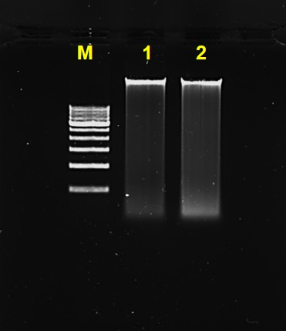

Fig. 1. Visualization of DNA Sample isolated from leaf of D. melanoxylon in 0.8% agarose.

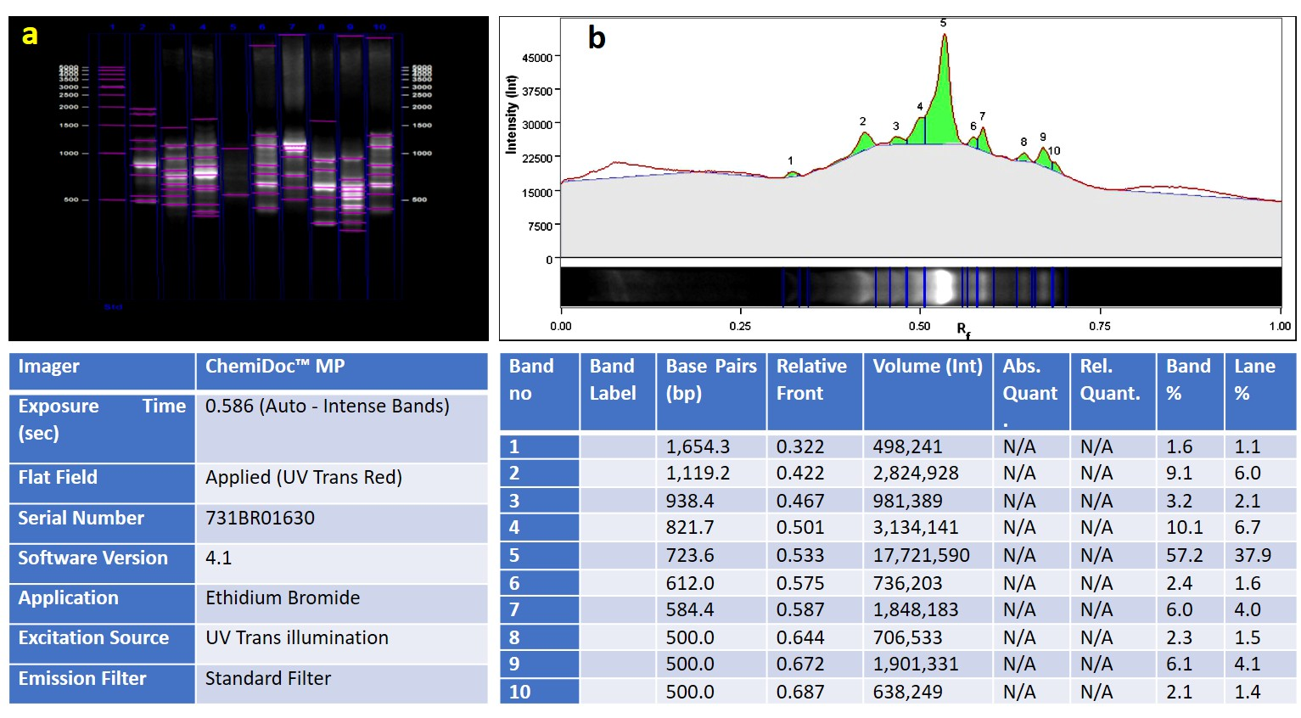
Fig. 2a and 2b. DNA fingerprinting profile which was developed after resolving PCR product made from 9 SCoT markers (2a). Pink horizontal lines indicate the automated detection of band positions and intensities, while blue vertical boundaries define individual lanes for quantitative analysis (2b). The gel image was subjected to Quantity One 1D analysis software to assess the size distribution and relative abundance of DNA fragments.

The standardized ISSR protocol generated reproducible and distinct alleles ranging between 500 and 2149 bp. Among the primers, (AC)₈T produced the maximum number of alleles (10), indicating high amplification efficiency and strong primer-template complementarity. Primers (AC)₈AA, (GA)₈YT, and (GA)₈C produced 7-9 alleles, reflecting genome spanning and coverage ability of the markers tested. Conversely, primers (CA)₇C and (GA)₈YC exhibited weak or inconsistent amplification, likely due to sub-optimal primer binding or low genomic repeat frequency. The ISSR markers showed excellent reproducibility potential, making them highly effective for detecting genome-wide polymorphism for future genetic diversity assessment applications. Their high sensitivity to microsatellite regions allows for detailed examination of genetic relatedness, population differentiation, and clonal variation, establishing ISSR as a powerful tool for genetic diversity assessment in D. melanoxylon Fig. 3 and Table 1.

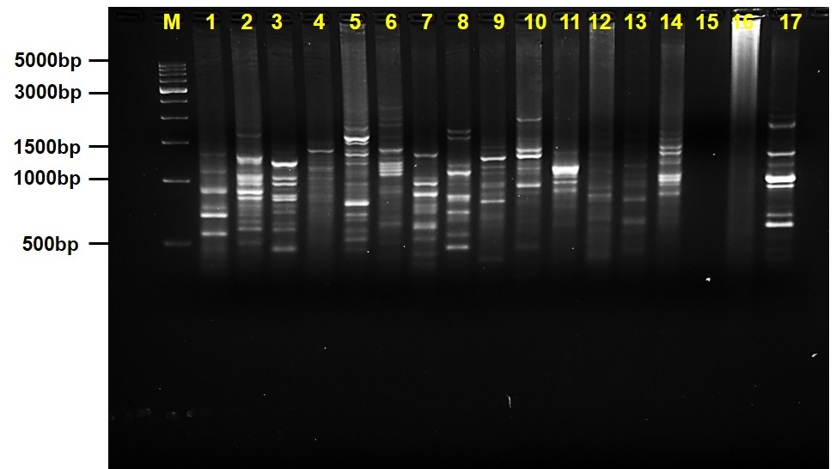

Fig. 3. ISSR fingerprinting profile of D. melanoxylon using 17-primers and M is a molecular size marker (500bp)

Sl. No. | Short form | T_{m} | Length of amplified alleles (bp) | Total no. of alleles | Reference
1 | (GA)₈YG | 48°C | 560-1321 | 6 | Surabhi et al., 2017
2 | (AC)₈ AA | 48°C | 605-1287 | 7 | Surabhi et al., 2017
3 | (AC)₈C | 48°C | 500-1408 | 8 | Surabhi et al., 2017
4 | TGG(AC)₇ | 48°C | 1048-1560 | 4 | Surabhi and Pattanayak, 2015
5 | (AC)₈T | 48°C | 513-1807 | 10 | Surabhi and Pattanayak, 2015
6 | (AC)₈YT | 48°C | 608-1400 | 5 | Surabhi and Pattanayak, 2015
7 | (GA)₈YT | 46°C | 500-1364 | 9 | Surabhi and Pattanayak, 2015
8 | (GA)₈C | 46°C | 500-1796 | 7 | Surabhi and Pattanayak, 2015
9 | (GA)₈T | 43°C | 500-1492 | 9 | Surabhi et al., 2017
10 | (CT)₈G | 43°C | 835-1336 | 4 | Surabhi et al., 2017
11 | (GA)₈A | 43°C | 901-1134 | 3 | Surabhi et al., 2017; Surabhi and Pattanayak, 2015
12 | (CA)₈G | 45°C | 973-2149 | 5 | Surabhi et al., 2017; Surabhi and Pattanayak, 2015
13 | (GA)₈YC | 45°C | 639-1228 | 4 | Surabhi et al., 2017; Surabhi and Pattanayak, 2015
14 | (GAA)₆ | 40°C | 891-1698 | 7 | Surabhi et al., 2017; Surabhi and Pattanayak, 2015
15 | (AG)₈YA | 43°C | NA | NA | Surabhi et al., 2017; Surabhi and Pattanayak, 2015
16 | (CA)₇C | 43°C | NA | NA | Surabhi et al., 2017; Surabhi and Pattanayak, 2015
17 | CAGCGACAAG | 30°C | 615-2250 | 8 | Surabhi et al., 2017
Total |  |  |  | 96

Table. 1. List of ISSR primers, annealing temperature, length of amplified alleles (bp) generated and total number of amplified fragments in D. melanoxylon.
The optimized RAPD assay yielded clear, sharp, and scorable amplification profiles with amplified alleles size ranging from 500 to 2755 bp. A total of 105 reproducible alleles were obtained across all markers tested, demonstrating efficiency of the marker system. Among the primers, CACACTCCAG produced the greatest number of amplified bands (11), followed by AGCCAGCGAA and ACCTGGACAC with 9-10 bands each. The presence of high number of alleles indicated effective genome-wide coverage. In contrast, TTCCCCCCAG and CAAACGTCGG generated weak or inconsistent bands, suggesting limited sequence complementarity Fig. 4 and Table 2.

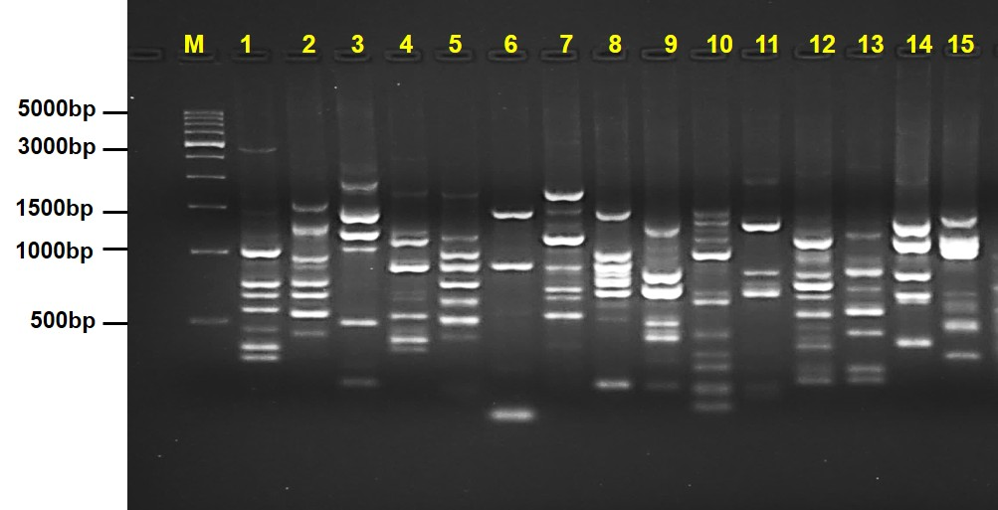

Fig. 4. RAPD fingerprinting profile of D. melanoxylon using 15-primers and M is molecular size marker (500bp).
Sl. No. | RAPD Primer Sequence (5’-3’) | T_{m} | Length of amplified alleles (bp) | Total no. of alleles | Reference
1 | CCGCCTAGTC | 35.8 °C | 500 - 2755 | 10 | Kumari and Kumar, 2021
2 | ACCTGGACAC | 33.4°C | 500 - 1469 | 8 | Kumari and Kumar, 2021
3 | ACAACGCGAG | 36.7°C | 500 - 1804 | 6 | Kumari and Kumar, 2021
4 | TCTCCGCCCT | 40.7°C | 500 - 1174 | 6 | Kumari and Kumar, 2021
5 | TTCCGAACCC | 34.2°C | 500 - 1126 | 7 | Kumari and Kumar, 2021
6 | CAAACGTCGG | 34.2°C | 500 - 1389 | 3 | Kumari and Kumar, 2021
7 | GACCGCTTGT | 35.7°C | 528 - 1639 | 8 | Kumari and Kumar, 2021
8 | AGCCAGCGAA | 38.3°C | 500 - 1370 | 9 | Kumari and Kumar, 2021
9 | GTTGCGATCC | 33.5°C | 500 - 1191 | 7 | Kumari and Kumar, 2021
10 | CACACTCCAG | 31.2°C | 500 - 1389 | 11 | Kumari and Kumar, 2021
11 | TTCCCCCCAG | 37.4°C | 660 - 1242 | 3 | Kumari and Kumar, 2021
12 | CCGCCCAAAC | 39.0°C | 500 - 1065 | 8 | Kumari and Kumar, 2021
13 | CACCTTTCCC | 31.5°C | 500 - 1158 | 8 | Kumari and Kumar, 2021
14 | GTGCAACGTC | 34.7°C | 500 - 1208 | 5 | Kumari and Kumar, 2021
15 | CCCGCTACAC | 36.9°C | 500 - 1295 | 6 | Kumari and Kumar, 2021
Total |  |  |  | 105

Table. 2. List of RAPD primers, total number of amplified fragments, and length of amplified alleles (bp) generated in D. melanoxylon.
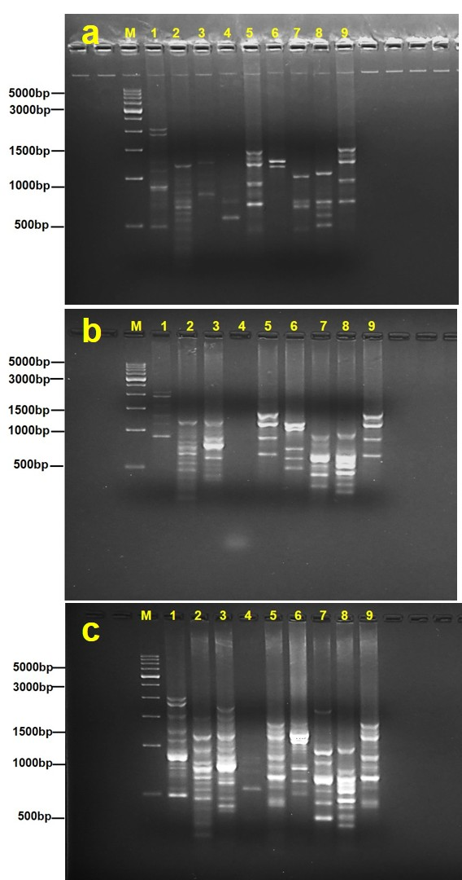
The optimized PCR reaction produced clear and scorable amplification products ranging from 500 to 2104 bp. Among these, SCoT9, SCoT12, SCoT17, and SCoT34 showed the high number of alleles, i.e. 9-10 distinct and reproducible alleles, whereas SCoT20 yielded low number of alleles Fig. 5a, 5b, 5c and Table 3.

Fig. 5a, b and c. SCoT fingerprinting profile of Diospyros melanoxylon using nine primers. Images (5a), (5b), and (5c) represent PCR amplification profiles obtained from 36, 42, and 40 cycles, respectively. M is a molecular size marker (500bp).
Primer ID | SCoT Primer Sequence (5’-3’) | T_{m} | I |  | II |  | III |  | Reference
Primer ID | SCoT Primer Sequence (5’-3’) | T_{m} | 36 cycles |  | 42 cycles |  | 40 cycles |  | Reference
Primer ID | SCoT Primer Sequence (5’-3’) | T_{m} | Length of amplified alleles (bp) | Total no. of alleles | Length of amplified alleles (bp) | Total no. of alleles | Length of amplified alleles (bp) | Total no.  of alleles | Reference
SCoT9 | CAACAATGGCTACCAGCA | 52.9°C | 500-2062 | 6 | 888-2104 | 5 | 500-1939 | 9 | Guan et al., 2020
SCoT12 | ACGACATGGCGACCAACG | 58.4°C | 547-1185 | 6 | 500-1132 | 7 | 500-1450 | 9 | Guan et al., 2020
SCoT17 | ACCATGGCTACCACCGAG | 57.1°C | 800-1255 | 5 | 500-1124 | 5 | 500-1654 | 10 | Guan et al., 2020
SCoT20 | ACCATGGCTACCACCGCG | 60.8°C | 566-724 | 2 | 735 | 0 | 539-1069 | 2 | Guan et al., 2020
SCoT23 | CACCATGGCTACCACCAG | 55.7°C | 500-1428 | 4 | 633-1283 | 4 | 500-1288 | 8 | Guan et al., 2020
SCoT26 | ACCATGGCTACCACCGTC | 57.3°C | 1185-1275 | 3 | 500-1081 | 5 | 502-1112 | 7 | Guan et al., 2020
SCoT33 | CCATGGCTACCACCGCAG | 58.9°C | 500-1024 | 4 | 500-874 | 6 | 500-1604 | 7 | Guan et al., 2020
SCoT34 | ACCATGGCTACCACCGCA | 59.7°C | 508-1075 | 5 | 500-895 | 9 | 500-927 | 10 | Guan et al., 2020
SCoT40 | CACCATGGCTACCACCAG | 55.7°C | 718-1500 | 5 | 618-1263 | 4 | 545-1288 | 8 | Guan et al., 2020
Total |  |  |  | 40 |  | 45 |  | 70

Table. 3. List of SCoT primers, total number of amplified fragments, and length of amplified alleles (bp) generated in D. melanoxylon.

4. DISCUSSION
The extraction of genomic DNA from woody plant species encounters substantial obstacles attributable to elevated concentrations of secondary metabolites, specifically polyphenols, polysaccharides, and lignin polymers that undergo co-precipitation with target nucleic acids. Which demonstrably inhibits enzymatic functions, including interference of PCR amplification of nucleic acids and restriction endonuclease digestion (Rossini et al., 2025; Garg et al., 2025). These contaminants quantifiably reduce the yield and purity of the DNA preparations, consequently compromising suitability of the sample in precision molecular applications (Mishra et al., 2023). A key achievement of this work was the extraction of high-quality genomic DNA from leaf tissues rich in secondary metabolites, an inherent challenge in many forest tree species. Consistent DNA yield and purity enabled stable downstream PCR amplification, emphasizing the importance of optimized DNA isolation protocols for recalcitrant woody perennials (Khanuja et al., 1999; Varma et al., 2007). The integrity and concentration of the genomic DNA was critical for achieving in distinct and reproducible fingerprinting profiles across the markers.
The presence of multiple di- and tri-nucleotide repeat-based ISSR primers also supports their ability to survey highly mutable regions of the genome, enables fine-scale differentiation among individuals (Abd- Dada et al., 2023; Galvan et al., 2003; Shooshtari et al., 2024). These findings are consistent with previous reports where ISSR markers demonstrated high polymorphism and repeatability in tree species and long-lived perennials (Surabhi et al., 2017; Wolfe et al., 1998). While RAPD markers are often criticized for issues related to reproducibility (Mondal and De, 2025), the carefully optimized reaction conditions particularly annealing temperature and cycle number ensured clear and scorable bands in our study. The successful application of RAPDs highlights their utility as rapid, cost-effective markers for preliminary screening and genotype differentiation in D. melanoxylon. The SCoT markers provided a complementary perspective by targeting gene-rich regions associated with the start codon ATG (Collard and Mackill, 2009). This aligns with earlier findings that SCoT markers are highly informative in tree species, due to their relatively greater association with expressed genomic regions and universal nature (Luo et al., 2010; Puneeth et al., 2023; Orman et al., 2025). SCoT markers, being gene-targeted, offered unique insights into functionally important regions of the genome (Badr and Jaki, 2024). Their strong reproducibility and ability to reveal functional variation make them valuable for exploring adaptive traits and assessing genetic diversity linked to expressed regions, providing a bridge between molecular variation and potential phenotypic diversity (Collard and Mackill, 2009) The absence or weaker amplification with primers like SCoT20 reflects inherent differences in primer specificity and possible low-copy regions in the kendu genome (Ozbek, 2024; Rasul et al., 2025).
The comparative analysis of all the three marker systems revealed that, the RAPD yielded highest number of total alleles (105), followed by ISSR (96) and SCoT (70 at optimal cycle number). Though the RAPD yielded high number of alleles in overall, ISSR exhibited higher consistency and clarity, while SCoT contributed unique gene-targeted information. The combined application of these markers thus enhances the depth and breadth of genomic interrogation (Tiwari et al., 2016; Gogoi et al., 2020; Porandla et al., 2025). The complementary nature of these three markers provided a strong rationale for integrated platform in conducting future studies on intra and inter-population genetic variation for species like D. melanoxylon, where data base information is still sparse.
The study emphasizes that optimized PCR parameters, including annealing temperature and cycle number, are essential for achieving reproducible fingerprinting profiles (Potter et al., 2023; Sisodiya et al., 2025). The comparison of 36-, 40-, and 42-cycle regimes for SCoT markers clearly demonstrated that 40 cycles provided the optimum amplification efficiency (Fig. 5a, 5b, and 5c), generating nearly twice the number of distinct allelic fragments compared to other cycle settings. The cycle-dependent variation highlights the importance of PCR optimization in establishing reliable fingerprinting profiles.
Collectively, the ISSR, RAPD, and SCoT marker systems revealed high reproducibility, confirming their effectiveness and applicability for molecular characterization of D. melanoxylon. The integration of these markers establishes a comprehensive synergistic molecular framework for evaluating genetic variability, describing population structure, and delivering effective conservation strategies within and among populations of kendu.
The present study successfully established reproducible fingerprinting profiles using three different marker systems for D. melanoxylon, an important forest tree species, where the genetic and genome resources are scares. Standardization of PCR based DNA fingerprinting protocols using three marker systems allowed robust amplification of complementary genomic regions of kendu, thereby creating a reliable platform for future genetic diversity assessment and population structure studies. The results clearly demonstrate that all the three marker systems contributed uniquely and synergistically to span complementary genomic regions of kendu.
5. CONCLUSION
In this study, efficient and reproducible molecular markers protocols were optimized for DNA isolation and genetic analysis in D. melanoxylon using ISSR, RAPD, and SCoT markers. The optimized conditions produced clear, reproducible and scorable amplification profiles, confirming their reliability for DNA fingerprinting and genetic diversity assessment. Among the tested markers, ISSR (AC)₈ T, (GA)₈YT, (GA)₈T, (AC)₈ C and CAGCGACAAG showed the highest amplification efficiency by covering 45.8% of the genome. In comparison the SCoT23, SCoT40, SCoT9, SCoT12, SCoT17, and SCoT34 showed broader genome coverage of 77.1% and RAPD markers CCGCCTAGTC, ACCTGGACAC, GACCGCTTGT, AGCCAGCGAA, CACACTCCAG, CCGCCCAAAC, CACCTTTCCC covered 59% of the genome. These findings establish a robust molecular framework for large-scale genetic characterization of D. melanoxylon populations. The optimized protocols can be effectively applied in future genetic diversity assessment studies, phylogeographic mapping, and identification of superior clones. In addition, cross introduction of germplasm to restore optimal genetic variation of a particular population, where the genetic diversity dropped significantly, minimizing the impact of plant diseases, and protecting the population from the climate change factors. Integration with advanced genomic and metabolomic tools will further enhance understanding of the species adaptive diversity and support its conservation, restoration and species genetic improvement programs.

Abbreviations
DNA- Deoxyribonucleic acid
EtBr- Ethidium bromide
ISSR- Inter simple sequence repeats
PCR- Polymerase chain reaction
RAPD- Random amplified polymorphic DNA
SCoT- Start codon-targeted polymorphism

Declarations
Competing interests
The authors declare no competing interests.

REFERENCES
Abd-Dada, H., Bouda, S., Khachtib, Y., Ait Bella, Y., & Haddioui, A. (2023). Use of ISSR markers to assess the genetic diversity of an endemic plant of Morocco (Euphorbia resinifera O. Berg.). Journal of Genetic Engineering and Biotechnplogy, 21(1):91 https://doi.org/10.1186/s43141-023-00543-4
Al Rashid, M.H., Mandal, V., Mandal, S.C., & Amirthalingam, R. (2017). Diospyros Melanoxylon Roxb in cancer prevention: Pharmacological screening, pharmacokinetics and clinical studies. International Journal of Pharmacognosy, 4(7):217-23. http://dx.doi.org/10.13040/IJPSR.0975-8232.IJP.4(7)217-23
Altaf, M.T., Nadeem, M.A., Ali, A., Liaqat, W., Bedir, M., Baran, N., Ilić, A., Ilyas, M.K., Ghafoor, A., Dogan, H., & Aasim, M. (2025). Applicability of Start Codon Targeted (SCoT) markers for the assessment of genetic diversity in bread wheat germplasm. Genetic Resources and Crop Evolution, 72(1):1205-18. https://doi.org/10.1007/s10722-024-02016-0
Badr, A., & Zaki, H. (2024). Genetic diversity of Citrullus colocynthis populations using phytochemical analysis and SCoT marker variations. Genetic Resources and Crop Evolution, 71(5):2341-53. https://doi.org/10.1007/s10722-023-01783-6
Banu, S., Baruah, D., Bhagwat, R.M., Sarkar, P., Bhowmick, A., & Kadoo, N.Y. (2015). Analysis of genetic variability in Aquilaria malaccensis from Bramhaputra valley, Assam, India using ISSR markers. Flora-Morphology, Distribution, Functional Ecology of Plants, 217:24-32. http://dx.doi.org/10.1016/j.flora.2015.09.007
Chandrashikha, P., Prajapati, R.K., & Prakash, N.A. (2021). Evaluation of chemical composition and changes occur under fridge storage of tendu nectar (Diospyros melanoxylon Roxb.). Journal of Pharmaceutical Innovation, 10(11): 21-29. http://www.thepharmajournal.com
Collard, B.C., & Mackill, D.J. (2009). Start codon targeted (SCoT) polymorphism: a simple, novel DNA marker technique for generating gene-targeted markers in plants. Plant Molecular Biology Reporter, 27(1):86-93. https://doi.org/10.1007/s11105-008-0060-5
Deng, L., Liang, Q., He, X., Luo, C., Chen, H., & Qin, Z. (2015). Investigation and analysis of genetic diversity of Diospyros germplasms using SCoT molecular markers in Guangxi. PLOS One, 10(8):1-13 10.1371/journal.pone.0136510
Diallo, S., Badiane, F.A., Kabkia, B.N., Diédhiou, I., Diouf, M., & Diouf, D. (2024). Genetic diversity and population structure of cowpea mutant collection using SSR and ISSR molecular markers. Scientific Reports, 14(1):31833. https://doi.org/10.1038/s41598-024-83087-y
Galván, M.Z., Bornet, B., Balatti, P.A., & Branchard, M. (2003). Inter simple sequence repeat (ISSR) markers as a tool for the assessment of both genetic diversity and gene pool origin in common bean (Phaseolus vulgaris L.). Euphytica, 132(3):297-301. https://doi.org/10.1023/A:1025032622411
Garg, R., Kaler, S., Kumar, A., & Kant, R. (2025). High-yield DNA extraction protocol for Azadirachta indica overcoming metabolite interference. Academia Molecular Biology and Genomics, 2(2):1-8. https://doi.org/10.20935/AcadMolBioGen7730
Gogoi, B., Wann, S.B., & Saikia, S.P. (2020). Comparative assessment of ISSR, RAPD, and SCoT markers for genetic diversity in Clerodendrum species of North East India. Molecular Biology Reports, 47(10):7365-77. https://doi.org/10.1007/s11105-008-0060-5
Guan, C., Chachar, S., Zhang, P., Hu, C., Wang, R., & Yang, Y. (2020). Inter-and intra-specific genetic diversity in Diospyros using SCoT and IRAP markers. Horticultural Plant Journal, 6(2):71-80. https://doi.org/10.1016/j.hpj.2019.12.005
Gupta, V., Maithili, V., & Vishwakarma, P.K. (2013). Comparative study of analgesic activity of Diospyros melanoxylon (Roxb.) bark and root bark. Journal of Natural Remedies, 13(1):15–18. https://www.researchgate.net/publication/250002953
Hamdan, Y.A., Hawamda, A.I., Basheer-Salimia, R., & Salman, M. (2024). Genetic diversity assessment of Palestinian okra landraces (Abelmoschus esculentus L.) through RAPD marker. Genetic Resources and Crop Evolution, 71(7):3555–3562. https://doi.org/10.21203/rs.3.rs-3536240/v1
Hinge, V.R., Shaikh, I.M., Chavhan, R.L., Deshmukh, A.S., Shelake, R.M., Ghuge, S.A., Dethe, A.M., Suprasanna, P., & Kadam, U.S. (2022). Assessment of genetic diversity and volatile content of commercially grown banana (Musa spp.) cultivars. Scientific Reports, 12(1):7979. https://doi.org/10.1038/s41598-022-11992-1
Ho, V.T., Ngo, T.K., Phan, T.H., Ta, T.T., & Tran, T.K. (2021). Genetic diversity among passion fruit (Passiflora edulis) accessions of Southern Vietnam using RAPD and ISSR markers. SABRAO Journal of Breeding and Genetics, 53 (1): 1-14. http://sabraojournal.org/wp-content/uploads/2021/03/SABRAO-J-Breed-Genet-53-1-1-14-HO.pdf
Hromadová, Z., Gálová, Z., Mikolášová, L., Balážová, Ž., Vivodík, M., & Chňapek, M. (2023). Efficiency of RAPD and SCoT markers in the genetic diversity assessment of the common bean. Plants, 12(15):2763. https://doi.org/10.3390/plants12152763
Kallamadi, P.R., Nadigatla, V.G., & Mulpuri, S. (2015). Molecular diversity in castor (Ricinus communis L.). Industrial Crops and Products, 66:271-81. https://doi.org/10.1016/j.indcrop.2014.12.061
Khanuja, S.P., Shasany, A.K., Darokar, M.P., & Kumar, S. (1999). Rapid isolation of DNA from dry and fresh samples of plants producing large amounts of secondary metabolites and essential oils. Plant Molecular Biology Reporter, 17(1):74. https://doi.org/10.1023/A:1007528101452
Kumar, V., & Yadav, H. K. (2019). Assessment of genetic diversity in Lepidium sativum L. using inter simple sequence repeat (ISSR) marker. Physiology and Molecular Biology of Plants, 25(2): 399-406. https://doi.org/10.1007/s12298-018-0622-4
Kumari, A., & Kumar, A. (2020). Assessment of genetic diversity of Diospyros melanoxylon Roxb. (kendu) growing in Jharkhand, India using ISSR markers. The Journal of Plant Science Research, 37(1): 23-31. http://doi.org/10.17605/OSF.IO/RC37F
Kumari, A., & Kumar, A. (2021). Assessment of genetic diversity of Diospyros melanoxylon Roxb. (kendu) growing in Jharkhand, India using RAPD markers. The Journal of Plant Science Research, 37(1):23-31. https://doi.org/10.32381/JPSR.2021.37.01.3
Kumari, G., & Wani, A. M. (2015). Seed source variability in half sib families of Diospyros melanoxylon Roxb. under open field condition. International Journal of Advanced Research, 3(11):161-8 https://www.researchgate.net/publication/312369001
Kumari, G., & Wani, A. M. (2017). Genetic variability in thirty half-sib families of Diospyros melanoxylon (Roxb.). International Journal of Engineering Science Technology and Research, 4(6):314-319. https://www.researchgate.net/publication/318982466
Luo, C., He, X.H., Chen, H., Ou, S.J., & Gao, M.P. (2010). Analysis of diversity and relationships among mango cultivars using Start Codon Targeted (SCoT) markers. Biochemical Systematics and Ecology, 38(6):1176-84. https://doi.org/10.1016/j.bse.2010.11.004
Mishra, G., Meena, R.K., Kant, R., Pandey, S., Ginwal, H.S., & Bhandari, M.S. (2023). An improved Shorea robusta genomic DNA extraction protocol with high PCR fidelity. Biology Methods & Protocols, 8(1):1-6. https://doi.org/10.1093/biomethods/bpad039
Mohamed, A.M., Bakry, H.S., Soltan, H.A., & Asaad, M.R. (2025). Combining ability and genetic diversity of promising maize (Zea mays L.) inbred lines under varying water regimes assessed via diallel analysis and RAPD markers. Zagazig Journal of Agricultural Research, 52(3) 513-527. https://doi.org/10.21608/zjar.2025.445122
Mondal, A., & De, K.K. (2025). Genetic diversity investigation of some Darjeeling Himalayan Rhododendron species based on RAPD method. Journal of Applied Biology & Biotechnology, 13(2): 215-221. https://doi.org/10.7324/JABB.2025.209056
Mousa, M.A., Abo-Elyousr, K.A., & Ibrahim, O.H. (2023). Evaluation of genetic variability within a collection of Cumin genotypes using RAPD, ISSR, SRAP and scot SCoT markers and variability of in vitro callus induced therefrom. Horticulturae, 9(7): 742.https://doi.org/10.3390/horticulturae9070742
Ninh, T.T., Nguyen, T.P., Dang, H.T., Chu, H.D., Dinh, T.S., Nguyen, X.C., Pham, T.D., Nguyen, T.H., & Nong, T.H. (2024). Assessment of genetic diversity of Stephania rotunda Lour. collected in Northern Vietnam using RAPD and ISSR markers. Australian Journal of Crop Science, 18(7): 374-381. https://doi.org/10.21475/ajcs.24.18.07.pne19
Orman, E., Çakar, D., Alkan, M., Özer, G., Güler, E., & Gündoğdu, M. (2025). Genetic diversity and population structure of Turkish European chestnut (Castanea sativa) genotypes assessed using start codon targeted polymorphism (SCoT) markers. Genetic Resources and Crop Evolution, 72: 6507–6519. https://doi.org/10.1007/s10722-025-02342-x
Özbek, Ö. (2024). Molecular markers used to reveal genetic diversity and phylogenetic relationships in crop plants. OBM Genetics, 8(4):25. http://dx.doi.org/10.21926/obm.genet.2404274
Pan, H., Deng, L., Zhu, K., Shi, D., Wang, F., & Cui, G. (2024). Evaluation of genetic diversity and population structure of Annamocarya sinensis using SCoT markers. PLOS One, 19(9):e0309283. https://doi.org/10.1371/journal.pone.0309283.
Poeaim, S., Sangsoy, V., & Tangthirasunun, N. (2025). Evaluation of genetic diversity by molecular markers in Indian gooseberry (Phyllanthus emblica). International Journal of Agriculture and Technology, 21(1): 177-190. https://li04.tci-thaijo.org/index.php/IJAT/article/view/4105
Porandla, M., Dhondi, P., Lingampelly, A., Kamilla, P., Abbagani, S., Kondi, R.K.R., & Kasula, K. (2025). Molecular insights into the genetic diversity of Curcuma longa L.: a comparative study with RAPD, ISSR and scot markers. Discover Plants, 2:345. https://doi.org/10.1007/s44372-025-00423-w
Potter, K.M., Jetton, R.M., Whittier, W.A., Crane, B.S., Hipkins, V.D., Echt. C.S., & Hodge, G.R. (2023). Table Mountain Pine (Pinus pungens): Genetic Diversity and Conservation of an Imperiled Conifer. Forest Science, 69(1): 58-72. https://doi.org/10.1093/forsci/fxac043
Puneeth, P.V., Lata, S., Yadav, R.K., Wankhede, D.P., Tomar, B.S., Choudary, H., Tomer, A., Bidaramali, V., & Talukdar, A. (2023). Exploring the genetic diversity using CAAT box-derived polymorphism (CBDP) and start codon targeted (SCoT) markers in cultivated and wild species of okra (Abelmoschus esculentus (L.) Moench). Genetic Resources and Crop Evolution, 70(3): 749-761. https://doi.org/10.1007/s10722-022-01458-8
Qureshi, F.Q., & Reddy, V.V. (2025). Systematic Review on phytochemical and Pharmacological Aspects of Diospyros Melanoxylon Roxb. Journal of Pharmacological and Pharmaceutical Research, 2(1): 24-24. http://dx.doi.org/10.5455/JPPR.20250117044642
Rasul, K.S., Majeed, H.O., Faraj, J.M., Lateef, D.D., & Tahir, N.A. (2025). Genetic diversity and relationships among Iris aucheri genotypes determined via ISSR and CDDP markers. Genetic Resources and Crop Evolution, 72(3): 3235-3248. https://doi.org/10.1007/s10722-024-02152-7
Rathore, J. S. (1972). Diospyros melanoxylon, a bread-winner tree of India. Economic Botany, 26(4): 333-339. https://doi.org/10.1007/BF02860703
Rathore, K., Singh, V. K., Jain, P., Rao, S.P., Ahmed, Z., & Singh, V.D. (2014). In-vitro and in-vivo antiadipogenic, hypolipidemic and antidiabetic activity of Diospyros melanoxylon (Roxb). Journal of Ethnopharmacology, 155(2):1171-1176. https://doi.org/10.1016/j.jep.2014.06.050
Rossini, B.C., Guyot, R., Alcantara, M.A., Batista, A.C., Bourgeois, Y., de Moraes, Silvestre, M.A., Alves, P.F., de Moraes, S.M., de Moraes, M.L., & Marino, C.L. (2025). High-quality DNA extraction method enabling long-read sequencing in challenging native plant species. Academia Molecular Biology and Genomics, 2(4):1-9. https://doi.org/10.20935/AcadMolBioGen7956
Shooshtari, L., Pour-Aboughadareh, A., Etminan, A., Ghorbanpour, M., & Bocianowski, J. (2024). Genetic diversity and population structure of Iranian oak (Quercus spp.) accessions based on ISSR and CBDP markers. Genetic Resources and Crop Evolution, 71(8): 5127-5139. https://doi.org/10.1007/s10722-024-01857-z
Sisodiya, S., Debnath, M., Jain, D., & Shekhawat, S.S. (2025). An integrated approach using morphological, biochemical, and RAPD markers to assess the genetic diversity of Olive (Olea Europaea L.) cultivars in India. Scientific Reports, 15(1):18664. https://doi.org/10.1038/s41598-025-02815-0
Surabhi, G.K., & Pattanayak, S. (2015). Deciphering the genetic identity and fidelity of banana through inter simple sequence repeats fingerprinting. Horticultural Biotechnology Research, 8(1):16-22. https://updatepublishing.com/journal/index.php/hbr/article/view/2902
Surabhi, G.K., Mohanty, S., Meher, R.K., Mukherjee, A.K., & Vemireddy, L.N. (2017). Assessment of genetic diversity in Shorea robusta: an economically important tropical tree species. Journal of Applied Biology & Biotechnology, 5(2): 110-117. 10.7324/JABB.2017.50218
Thakur, K., Barik, S., Raju, N., Gadhiya, J.D., Kumar, S., & Mishra, S. (2025). Medicinal and economical uses of Diospyros melanoxylon. Medicinal Trees of India, 2: 41-51. https://doi.org/10.5281/zenodo.15905932
Tiwari, G., Singh, R., Singh, N., Choudhury, D.R., Paliwal, R., Kumar, A., & Gupta, V. (2016). Study of arbitrarily amplified (RAPD and ISSR) and gene targeted (SCoT and CBDP) markers for genetic diversity and population structure in Kalmegh [Andrographis paniculata (Burm. f.) Nees]. Industrial Crops and Products, 86: 1-11. https://doi.org/10.1016/j.indcrop.2016.03.031
Varma, A., Padh, H., & Shrivastava, N. (2007). Plant genomic DNA isolation: an art or a science. Biotechnology Journal: Healthcare Nutrition Technology, 2(3):386-92. https://doi.org/10.1002/biot.200600195
Wolfe, A.D., Xiang, Q.Y., & Kephart, S.R. (1998). Assessing hybridization in natural populations of Penstemon (Scrophulariaceae) using hypervariable inter simple sequence repeat (ISSR) bands. Molecular Ecology, 7(9):1107-1125. https://doi.org/10.1046/j.1365-294x.1998.00425.x
Yang, Y., Yang, T., & Jing, Z. (2015). Genetic diversity and taxonomic studies of date plum (Diospyros lotus L.) using morphological traits and SCoT markers. Biochemical Systematics and Ecology, 61: 253-259. https://doi.org/10.1016/j.bse.2015.06.008

