Review Article

Litter Dynamics in Tropical and Subtropical Forest and Agroforests

ABSTRACT
Litterfall represents a key ecological process that mediates the transfer of organic matter from the arboreal canopy to the forest floor, thereby regulating nutrient cycling within terrestrial ecosystems. This deposition of senescent plant material alters the availability of essential soil nutrients, which in turn supports plant growth dynamics and enhances overall forest productivity. Litter decomposition is a fundamental process to cycle elements within the ecosystem which have a dominant effect on plant productivity, soil fertility, and carbon storage. The aspect of litter dynamics (litter production and decomposition) plays a vital role in sustainable forest management in tropical and subtropical forest and these systems are highly productive, hotspots of biodiversity, support livelihood of millions of people, bridges gap between demand and supply of wood and other forest produces, and strongly depends on internal nutrient cycling. Therefore, it is imperative to understand the dynamics of litter production in tropical forest and considering this fact review work was carried out on the litter dynamics of tropical and subtropical forest and agroforests ecosystems.
Keyword: Litterfall, nutrient cycling, decomposition, forest, agroforestry systems

- INTRODUCTION
Nutrient dynamics in vegetation play a significant role in determining the circulation and storage of nutrients in an ecosystem. In natural ecosystem nutrient cycling has played a vital function in balancing the interaction between organism and environment (Adhikari 2006), and directly related to productivity in forest ecosystems by providing available nutrients for plant growth and development (Krishna and Mohan 2017). Nutrients enter in an ecosystem by particulate deposition, gaseous fixation, precipitations, and weathering of soil parent materials and are transferred by a large number of interdependent processes like litter fall, decomposition, uptake of nutrients, and intra-translocation. The chemical elements of the soil removed by the plants are retained at the time of physiological death in certain plant parts particularly in the twigs, leaves, and bark (Johnson et al. 1982).
Litter fall refers the shedding of vegetative and reproductive plant organs caused by physiological stress, senescence, mechanical factors (e.g. wind), a combination of these factors, or by death and weathering of the whole plant in a given time period (Krishna and Mohan 2017) and one of the important events in the forest ecosystem, facilitates the return of nutrients and add significant amount of carbon into the soil (Izayas and Udayakumar 2024). Total litterfall encompasses both leaf litter and non-leaf litter components, including reproductive organs, bark fragments, twigs, and amorphous fractions that are not readily separable. The global terrestrial litter production has been estimated as 39 to 54 Gigaton (Gt) yr⁻¹, in which global forest litter production was 29 Gt yr⁻¹. Nearly about, 13 per cent of the world’s annual litterfall is constituted by tropical forests.
Litterfall patterns are predominantly regulated by intrinsic plant attributes such as plant productivity and phenological cycles, in conjunction with seasonal variations and diverse environmental factors; and globally litter production among different forest types ranged from 3 to 11 Mg h⁻¹ yr⁻¹ (Zhang et al. 2014). The amount of litter accumulated on the forest floor can indicate productivity of ecosystem (Hofmockel et al. 2011), and litter accumulated at the surface layer is subjected to decomposition by the act of soil fungi, bacteria, and micro-and macro fauna, and become a source of organic matter to soils, nutrients to plant and soil faunal community (Singh et al. 1999). The litter on the forest floor act as input - output system of nutrient, and subsequently, after decomposition contribute to the regulation of nutrient cycling, primary productivity, and to the maintenance of soil fertility in forest ecosystems (Pandey et al. 2007, Olson 1963, Singh et al. 1999), whereas litter accumulation on the surface check weed growth, acts as a protective layer for maintaining soil physical properties like retention of soil moisture, buffering against soil temperature, protect the soil from erosive impact of rain and reduces surface water run- off (Shanmughavel et al. 2000). Litter decomposition is a major pathway for providing organic and inorganic elements for the nutrient cycling processes and controls nutrient return to the forest ecosystem.
2.METHODOLOGY
This review paper was prepared by analysing previously published scientific research article, review paper, and book, were collected from well-known major academic databases such as ResearchGate, Google Scholar, PubMed and Web of Science. The literature search used the following key words: leaf litter, agroforestry, soil micro-organism, decomposition agroforestry systems, tropical, subtropical forest.

- LITTER DYNAMICS IN FOREST ECOSYSTEM
Litterfall is the main path for the return of nutrients to the soil and humus formation in tropical forest systems. Forest serves as a primary reservoir of carbon and nutrients in the terrestrial ecosystem (Ahirwal et al. 2021) and play a vital role in the biogeochemical cycling of nutrient elements (Fig.1). Amount of nutrients delivered by annual litterfall to the soil through decomposition is an important factor for sustainable forest production and provides an index of forest productivity (Hussain et. al. 2010). According to Argao et al. (2009) the quantity and quality of litter determine the functioning of forest ecosystem further, litter production pattern in ecosystems varies depending on soil fertility, elevation, latitude, stand structure, climate, and tree species composition (Becker et al. 2015, Parsons et al. 2014).
Tropical forest k values were often recorded greater than 1.0 which indicate leaf litter turnover in a year or less than a year (Alvarez et al. 1992) and the varying k value may be due to the nutrient content of leaves and season ((Songwe et al. 1995). Decomposition of litter is also influenced by physicochemical characteristics of the plant parts and decomposer organisms present in the soil and environmental factors (Devi and Yadava 2007).
Anthropogenic disturbances, such as fire, logging, and fuelwood extraction, exert substantial impacts on structure and composition of forest. In addition, both human-induced and natural disturbances can diminish the quantity and quality of annual litterfall, reduce litter depth, alter stand basal area, decrease coarse woody debris volume, and lower understory density (Mishra et al. 2004). Variability in litterfall among forest species is further influenced by environmental factors such as temperature, light availability, and rainfall. Decomposition proceeds through three principal mechanisms: fragmentation of litter into smaller particles, leaching of soluble compounds into the soil, and microbial catabolism by decomposer organisms (Giweta 2020).

3.1 IMPORTANCE OF LITTER PRODUCTION IN FOREST
- Net primary productivity is measured by litter production, as litter is the main source of soil organic carbon and nutrients cycling.
- In addition to tree height and diameter, forest litter indicate primary output
- The decomposition of plant litter determines the carbon cycle, it controls the concentration of carbon dioxide (CO₂) in the atmosphere, which indirectly influence global climate change
- Litter protects seed and seedlings
- It helps in the reduction of soil temperature and evapotranspiration
- Litter can change the community structure and impairs the performance of other species.
- It increases the infiltration capacity of soil

- LITTER DYNAMICS IN AGROFORESTRY SYSTEMS

Depletion of nutrients and soil’s organic matter is a serious threat to agricultural production and food security in many tropical countries (Lal 2004). Agroforestry, is a sustainable land-use system and optimal production of any agroforestry practice is influenced by suitable tree- crop combination, amount of soil nutrients, moisture conditions, and rate of organic matter decomposition (Chundawat and Gautam 1993, Nair 1984). It is believed that agroforestry promotes a more efficient nutrients cycling than traditional agriculture system (Fig.2) (Hussain et al. 2010) having higher turnover rate, and low rate of output or losses from the system (Kumar et al. 2024). Hence, the role of litter production and decomposition is highly inevitable for management of soil fertility of this unique agroforestry landscape. Apart from the quantity of leaf litter produced, the extent to which nutrients are returned back to the soil is largely governed by the rate of leaf litter decomposition whereas decomposition processes are influenced by a range of abiotic and biotic factors, such as microclimatic conditions, soil nutrient status, litter composition, and the chemical quality of the litter itself (Dawoe et al. 2010).
Litter decomposition is a critical process that maintains soil fertility and enhance soil organic matter in agroforestry systems, strongly influenced by factors such as tree density, stand age, timing and quantity of litterfall, soil biota, litter chemistry, and prevailing environmental conditions (Kerthika et al. 2024). (Fig. 3). Nowadays, intensive agriculture with excessive use of agrochemicals impacts ecosystem severely by making soil a dead entity. Decomposition is directly involved in carbon and nitrogen balance through plant-soil interaction which is a result of the combined interaction of physical, chemical, and biological processes in the soil ecosystem (Aerts 2006). Moreover, Species richness and tree species in any ecosystem affect soil attributes viz., soil physical, chemical, and biological properties, quantity and chemistry of litterfall (Hansson et al. 2011).
5.CONCLUSION

This review studies clearly indicate that the litter production, decay rate, and nutrient return in tropical forest and agroforestry systems are highly influenced by the tree species, age of stand, spatial geometry, forest type, and climatic conditions, litter production ranged from 1.86 - 16 t ha⁻¹ yr⁻¹, with peak litterfall commonly occurring during summer or dry seasons and the lowest during monsoon or wet periods. Leaf litter consistently formed the major proportion of the total litter production, often exceeding 50-70 per cent whereas, bark, twigs, and reproductive component contributed comparatively less. Species diversity of tree plays a vital role in regulating decomposition dynamic and nutrient cycling, with decay constant (k) varied from 0.10 – 6.67, also influenced by aridity, precipitation factor, quality of litter, and physical, chemical, and biological properties of soil. Agroforestry and silvopastoral systems often exhibited higher litter productivity and nutrient recycling than monoculture plantation, indicating their ecological and soil fertility benefits. Litter dynamics have a significant role in healthy functioning of tropical and subtropical forest ecosystem, which show strong seasonal litter fall patterns may help to predict ecosystem responses to environmental changes. Hence, to understand the processes and mechanism of soil enrichment in tree- based cropping systems, it is imperative to study the litter fall quantification, factor affecting, effect of tree management practices on litter dynamics, and also emphasize the importance of integrating suitable fast growing woody perennial in managed landscapes to improve soil health and ecosystem productivity.

REFERENCES
Adhikari, E. (2006). Litter fall, litter decomposition and soil conditions of forest ecosystems. M.Sc. Thesis, Tribhuvan University, Nepal.
Aerts, R. (2006). The freezer defrosting: Global warming and litter decomposition rates in cold biomes. Journal of Ecology, 94, 713–724.
Ahirwal, J., Puja Saha, P., Nath, A.; Nath, A. J.; Deb, S. & Sahoo, U. K. (2021). Forests litter dynamics and environmental patterns in the Indian Himalayan region. Forest Ecology & Management, 499. https://doi.org/10.1016/j.foreco.2021.119612
Alvarez, S. F. J., Sanchez, G. R., Sanchez-Gallen, I., & Gonzalez-Iturbe, J. A. (1992). Methods for the study of primary productivity and decomposition in terrestrial communities. Department of Ecology, Faculty of Science, UNAM.
Archana, V., Kumar, P., Soni, M. L., Pawar, N., Pradhan, U., Tanwar, S. P. S., & Kumar, S. (2021). Litter production and litter dynamics in different agroforestry systems in the arid western region of India. Biological Agriculture & Horticulture. https://doi.org/10.1080/01448765.2021.1971110 (doi.org in Bing).
Argao, L. E. O. C., Malhi, Y., Metcalfe, D. B., Silva-Espejo, J. E., Jimenez, E., Navarrete, D., & Asquez, R. (2009). Above- and below-ground net primary productivity across net primary productivity across ten Amazonian forests on contrasting soils. Biogeoscience, 6, 2759–2778.
Becker, H., Pabst, J., Mnyonga, J., & Kuzyakov, Y. (2015). Annual litterfall dynamics and nutrient deposition depending on elevation and land use at Mt. Kilimanjaro. Biogeoscience Discussion, 2, 10031-10057.
Chundawat, B. S., & Gautam, S. K. (1993). A Textbook of Agroforestry. New Delhi: Oxford and IBH Publisher, pp. 64-69.
Christanty, L., Abdoellah, O. S. & Marten, G. G. (1996). Traditional agroforestry in West Java: The talun–kebun system. In: Selected Papers of the International Workshop on Agroforestry Systems. Southeast Asian Studies / ICRAF.
Cuevas, E. and Lugo, A. E. (1998). Dynamics of organic matter and nutrient return from litterfall in tropical forest ecosystems. Forest Ecology and Management, 112, 263-279.
Dai, S., Wei, T., Tang, J., Xu, Z., & Gong, H. (2023). Temporal changes in litterfall and nutrient cycling from 2005–2015 in an evergreen broad-leaved forest in the Ailao Mountains, China. Plants, 12, 1277.
Dawoe, E. K, Isaac, M. E., & Quashie-Sam, J. (2010) Litterfall and litter nutrient dynamics under cocoa ecosystems in lowland humid Ghana. Plant Soil, 330, 55–64
Devi, A. S., & Yadava, P. S. (2007). Wood and leaf litter decomposition of Dipterocarpus tuberculatus Roxb. in a tropical deciduous forest of Manipur, Northeast India. Current Science, 93, 243-246.
Dinesha, S. (2018). Analysis of litterfall pattern, nutrient return, decomposition and budgeting ecosystem carbon under Swietenia macrophylla King (Indian mahogany) plantation. M.Sc. Thesis, Uttar Banga Krishi Viswavidyalaya, Cooch Behar, West Bengal.
George, M. (1982). Litter production and nutrient return in Eucalyptus hybrid plantations. Indian Forester, 108(4), 253–260. DOI: https://doi.org/10.36808/if/1982/v108i4/10813
George, S. J., & Kumar, B. M. (1998). Litter dynamics and cumulative soil fertility changes in silvopastoral systems of a humid tropical region in central Kerala, India. International Tree Crops Journal, 9(4), 267-282.
Gill, H. S., Abrol, I. P. and Chelvan, S. (1987). Effect of Eucalyptus tereticornis plantations on soil properties of alkali soils in north-western India. Soil Use and Management, 3 (1), 6–9.
Giweta, M. (2020). Role of litter production and its decomposition, and factors affecting the processes in a tropical forest ecosystem: A review. Journal of Ecology and Environment, 44, 11. https://doi.org/10.1186/s41610-020-0151-2
Gupta, G., Yadava, G. S., Maurya, D., & Mishra, S. V. (2010). Litter dynamics under different pruning regimes of Albizia procera based agroforestry system in semi-arid region. Asian Science, 5 (2), 93-97.
Hofmockel, K. S., Zak, D. R., Moran, K. K., & Jastrow, J. D. (2011). Changes in forest soil organic matter pools after a decade of elevated CO₂ and O₃. Soil Biology and Biochemistry, 43 (7), 1518-1527. https://doi.org/10.1016/j.soilbio.2011.03.030
Hossain, M., Siddique, M. R. H., Rahman, M. S., Hossain, M. Z., & Hasan, M. M. (2011). Nutrient dynamics associated with leaf litter decomposition of three agroforestry tree species (Azadirachta indica, Dalbergia sissoo, and Melia azedarach) of Bangladesh. Journal of Forestry Research, 22 (4), 577-582.
Iloyanomon, C. I., Taiwo, N., & Ogbeide, C. E. (2020). Leaf litter production and nutrient return in coffee (Coffea canephora) plantations of different ages in Ibadan, Nigeria. International Journal of Plant & Soil Science, 32 (18), 41-51.
Izayas, J. E., & Udayakumar, M. (2024). Assessment of annual litterfall of woody plant community. Current World Environment, 19(2), 853–863.
Jamaludheen, A., & Kumar, B. M. (1999). Litter of multipurpose trees in Kerala, India: Variations in the amount, quality, decay rates and release of nutrients. Forest Ecology and Management, 115, 1-11.
Johnson, D. W., D. W. Cole., C. S. Bledsoe., K. Cromack., R. L. Edmonds., S. P. Gessel., C. C. Grier., B. N. Richards & K. A. Vogt (1982). Mineral cycling, basic concepts and their application in a tropical rain forest, 123-145 in R. L. Edmonds, Editor. Nutrient Cycling in forests of the Pacific Northwest. US/ IBP synthesis Series 14, Hutchinson Ross Publishing Company, Pennsylvania.
Keerthika, A., Parthiban, K. T., Chavan, S. B., Shukla, A. K., Gupta, D. K., & Venkatesh, V. (2024). Leaf litter decomposition in different tree species of multifunctional agroforestry: Decay constant and initial litter chemistry. Environment, Development and Sustainability. https://doi.org/10.1007/s10668-024-04536-2
Krishna, M. P., & Mohan, M. (2017). Litter decomposition in forest ecosystems: A review. Energy, Ecology and Environment, 2 (4), 236-249.
Kumar, S., & Tewari, L. M. (2015). Pattern of litter fall in Pinus roxburghii Sarg. forest in Kumaun Himalaya, India. Indian Journal of Ecology, 42(1), 219–223.
Kumar, T., Kumari, B., Bangarwa, K. S., & Johar, V. (2017). Effect of tree spacings on litter production and decomposition under Eucalyptus tereticornis based agroforestry system. Indian Journal of Ecology, 44 (5), 596-598.
Kumar, D., Sinha, N. K., Mishra, R., Kumar, J., Wanjari, R. H., Prasad, R. & Nagwanshi, A. (2024). Agroforestry for nutrient cycling and soil health improvement. Indian Society of Agroforestry, 32-34.
Lal, R. (2004). Soil carbon sequestration impacts on global climate change and food security. Science, 304, 1623-1629.
Leishangthem, D., & Singh, M. R. (2021). Litter production pattern and leaf litter decomposition rate from three dominant tree species found in a subtropical semi-evergreen riparian forest of Dikhu river, northeast India. International Journal of Ecology and Environmental Sciences, 3 (1), 185-196.
Lekha, A., & Gupta, S. R. (1989). Decomposition of Populus and Leucaena leaf litter in an agroforestry system. International Journal of Ecology and Environmental Sciences, 15, 97-108.
Mishra, B. P., Tripathi, O. P., Tripathi, R. S., & Pandey, H. N. (2004). Effects of anthropogenic disturbance on plant diversity and community structure of a sacred grove in Meghalaya, north east India. Biodiversity Conservation, 13, 421–36.
Nair, P. K. R. (1984). The role of trees in soil productivity and protection. In: P. K. R. Nair (Ed.), Agroforestry Systems in the Tropics. London: Kluwer Academic Publishers, pp. 567-589.
Nongmaithem, R. S., Arunachalam, A., Patel, D. P., & Viyol, S. (2019). Seasonal dynamics of litter accumulation in agroforestry systems of Navsari district, Gujarat. Climate Change and Environmental Sustainability, 7 (2), 123-129.
Olson, J. S. (1963). Energy storage and balance of producers and decomposer in ecological systems. Ecol., 44, 322-331.
Pandey, R. R., Sharma, G., Tripathi, S. K., & Singh, A. K. (2007). Litterfall, litter decomposition and nutrient dynamics in a subtropical natural oak forest and managed plantation in northeastern India. Forest Ecology and Management, 240, 96-104.
Parsons, S. A., Valdez-Ramirez, V., Congdon, R. A., & Williams, S. E. (2014). Contrasting patterns of litterfall seasonality and seasonal changes in litter decomposability in a tropical rainforest region. Biogeosciences, 11, 5047-5056.
Prescott, C. E. (2002). The influence of the forest canopy on nutrient cycling. Tree Physiology 22, 1193–1200.
Rajvanshi, R. & Gupta, S. R. (1985). Litter production and nutrient return in Dalbergia sissoo plantations in India. Annals of Forestry, 13 (1),50-56.
Rahman, M. M., Tsukamoto, J., Tokumoto, Y., & Shuvo, M. A R. (2013). The role of quantitative traits of leaf litter on decomposition and nutrient cycling of the forest ecosystems. Journal of Forest Science, 29, 38–48.
Roy, M. M., Singh, K. A. and Sharma, R. A. (1998). Litter production and nutrient return in Hardwickia binata based silvipastoral system at Jhansi, India. Indian Journal of Forestry, 21(4), 321–325.
Roy, M. M., & Nigam, G. (2001). Litter production pattern in an Acacia tortilis based silvo-pastoral system in the dry tropics. Indian Forester, 127(4), 457–461.
Salako, F. K. & Tian, G. (2001). Litter production and nutrient dynamics under Acacia leptocarpa in southern Nigeria. Agroforestry Systems, 53, 123–134.
Shanmughavel, P., Peddappaiah, R. S. & Muthukumar, T. (2000). Litter production and nutrient return in Bambusa bambos plantation. J. Sustain. For., 11 (3), 71-82.
Sharma, E., Rai, S. C. & Sharma, R. (1997). Litter production and nutrient cycling in Citrus reticulata based agroforestry systems of Sikkim Himalaya, India. Agroforestry Systems, 38, 245-256.
Sharma, E. & Ambasht, R. S. (1987). Litterfall, decomposition and nutrient dynamics in Alnus nepalensis and Citrus reticulata based agroforestry systems of the eastern Himalaya (Darjeeling, India). Agroforestry Systems, 5, 239-253.
Shukla, A. K., Srivastava, P. K., Singh, B., Behera, S. K., & Thomas, T. (2017). Litterfall patterns and soil nutrient chemistry in varied tropical deciduous forests. International Journal of Chemical Studies, 5 (6), 1203-1210.
Singhal, V., Roy, T., Singh, C., Ghosh, J. & Bhat, S. (2019). Leaf litter production and decomposition dynamics in four agroforestry tree species of western Himalayas. J. Pharmacogno. Phytochem., (1), 198-201
Singh, K. P., Singh, P. K., & Tripathi, S. K. (1999). Litterfall, litter decomposition and nutrient release patterns in four native tree species raised on coal mine spoil at Singrauli, India. Biol. Fertil. Soils 29, 371-378. https://doi.org/10.1007/s003740050567.
Singh, B. (2009). Return and release of nutrients from poplar litterfall in an agroforestry system under subtropical condition. J. Indian Soc. Soil Sci., 57 (2), 214-218.
Singh, B., Gill, R., & Kaur, N. (2007). Litterfall and nutrients return in poplar plantation varying in row directions and spacings. Indian Journal of Agroforestry, 9 (1), 33-37
Songwe, N. C., Okali, D. U. U., & Fasehun, F. E. (1995). Litter decomposition and nutrient release in a tropical rainforest, Southern Bakundu Forest reserve. Cameron Journal of Tropical Ecology, 11, 333-350.
Sudha, H. (2024). Decomposition and nutrient releases pattern of leaf litter of selected tree species in South Gujarat. M.Sc. Thesis, Navsari Agricultural University, Navsari.
Toky, O. P., & Singh, V. (1983). Litter dynamics in short-rotation high density tree plantations in an arid region of India. Agric., Ecosyst. Environ., 45, 129-145.
Toky, O. P. and Ramakrishnan, P. S. (1982). Structure and function of traditional bamboo-based agroforestry systems in north-eastern India. Agroforestry Systems, 1, 47-61.
Tripathi, O. P., Pandey, H. N., & Tripathi, R. S. (2009). Litter production, decomposition and physico-chemical properties of soil in three developed agroforestry systems of Meghalaya, Northeast India. Afr. J. Plant Sci., 3 (8), 160-167.
Uma, M., Saravanan, T. S., & Rajendran, K. (2014). Growth, litter fall and litter decomposition of casuarina equisetifolia in a semiarid zone. J. Trop. For. Sci., 26 (1), 125-133.
Yadav, R. S., Yadav, B. L., & Chhipa, E. B. R. (2008). Litter dynamics under different tree species in a semi-arid region of Rajasthan, India. Agroforest. Syst., 73, 1-12.
Zhang, H., Yuan, W., Dong, W., & Liu, S., (2014). Seasonal patterns of litterfall in forest ecosystem worldwide. Ecol. Complex. 20, 240-247. https://doi.org/10.1016/j. ecocom.2014.01.003

Table 1. Litter dynamics under forest and agroforestry systems
No. | Reference | Forest | Tree species | Result
1 | Keerthika et al. (2024) | Agroforestry Forest college and Research Institute, Mettupalayam, India | Tectona grandis, Melia dubia, Annona muricata, Psidium guajava, Pterocarpus santalinus, Swietenia macrophylla, Neolamarckia cadamba, Lagerstroemia lanceolata, Terminalia arjuna, Annona squamosa, Gmelina arborea, Syzygium cumini, Moringa oleifera, Jatropha curcas, Calophyllum inophyllum, Pongamia pinnata, Simarouba glauca | Observed highest decay constant (k year¹) for Neolamarckia cadamba (3.03 ± 0.30) followed by Tectona grandis (2.85 ± 0.27) and Annona muricata (2.81 ± 0.19) whereas, Calophyllum inophyllum (0.86 ± 0.13), Pterocarpus santalinus (1.02 ± 0.12) and Melia dubia twigs (1.10 ± 0.25) exhibited the lowest rate of decomposition.
2 | Izayas and Udayakumar (2024) | Southern thorn Forest, Tamil Nadu, India | January - December 2019 | The annual litter production was 8.06 t ha⁻¹yr⁻¹. Out of total litter production deciduous species accounted for 95%. Litterfall peaked during the month of March (1.2189-ton ha⁻¹) followed by February (1.1925 t ha⁻¹) and April (1.1523 t ha⁻¹), while the month of September recorded the lowest litterfall (0.1582 t ha⁻¹). Leaf litter constituted the highest proportion of annual litterfall followed by amorphous, wood, and reproductive organ.
3 | Sudha (2024) | Navsari, Gujarat | Ailanthus excelsa, Albizia procera, Dalbergia latifolia and Pterocarpus marsupium | Ailanthus excelsa exhibited highest decay rate (0.48) followed by Albizia procera (0.32) and slowest in Dalbergia latifolia (0.10). The maximum release of nutrients in decaying leaf litter followed the order as A. excelsa (N-82.15, P-84.05, K-90.93 %), A. procera (N-81.18, P-82.60, K-90.02 %), Pterocarpus marsupium (N-57.34, P-56.32, K-82.67 %) and D. latifolia (N-51.38, P-49.46, K-81.93 %), respectively.
4 | Dai et al. (2023) | Evergreen broad-leaved forest, Ailao Mountains, China | 2005 – 2015 | Litter production ranged from 7.12 to 9.40 t ha⁻¹, with an annual average of 8.11 t ha⁻¹. Leaf litter representing 42- 62 % of the total litterfall.
5 | Ahirwal et al. (2021) | Tropical, subtropical and temperate forests of Indian Himalayan region | - | Litterfall was significantly (P < 0.001) higher in tropical forests (5.89 Mg ha⁻¹yr⁻¹) compared to subtropical (4.24 Mg ha⁻¹yr⁻¹) and temperate forests (3.83 Mg ha⁻¹yr⁻¹) similarly, significantly higher mean k- value was recorded for tropical forests (2.74 yr⁻¹) compared to subtropical (1.21 yr⁻¹) and temperate forests (1.0 yr⁻¹). Variations in litterfall showed that forests located between 3000 and 4000 m altitudinal ranges have significantly lower annual litterfall (1.95 Mg ha⁻¹yr⁻¹).
6 | Leishangthem and Singh (2021) | Subtropical semi ever green riparian forest, North east India | Melia azedarach Terminalia chebula Duabanga grandiflora | The highest annual litterfall was recorded for Melia azedarach (16.99 t ha⁻¹ yr⁻¹) followed by T. chebula (10.52 t ha⁻¹ yr⁻¹) and D. grandiflora (9.54 t ha⁻¹ yr⁻¹). Maximum litterfall occurred during winter season. Annual decomposition rate ranges from 0.92 - 1.51k yr⁻¹ and among studied species D. grandiflora decomposed at faster rate followed by M. azedarach and T. chebula.
7 | Archana et al. (2021) | Agroforestry Arid western region of India | Prosopis cineraria Tecomella undulata Hardwickia binata | H. binata produced highest litterfall (9.44 Mg ha⁻¹ y⁻¹) followed by P. cineraria (8.94 Mg ha⁻¹ y⁻¹) and T. undulata (3.74 Mg ha⁻¹ y⁻¹). The highest return of nutrients through litterfall was recorded in P. cineraria, followed by H. binata and lowest were recorded for T. undulata
8 | Iloyanomon et al. (2020) | Plantations Ibadan, Nigeria Age of plantation (11, 19, 24 and 51 years) | Coffee (Coffea canephora) | Maximum mean leaf litter quantity (3.51 t ha⁻¹yr⁻¹) produced by 51-year-old coffee plantation and the lowest leaf litter (2.50 t ha⁻¹yr⁻¹) produced by 11-year-old plantation.
9 | Nongmaithem et al. (2019) | Agroforestry systems, South Gujarat | Agri-horticultural system Agri-horti-silvi-cultural system Agri-silvi-cultural system Horti-pastoral system Homegarden system | Highest total floor litter biomass was found in the homegarden system. Seasonal pattern of litter biomass accumulation was similar in all the system with highest in dry and early winter and lowest in the wet season.
10 | Singhal et al. (2019) | Agroforestry system Western Himalayas | Grewia optiva Celtis australis Bauhinia variegata Ficus roxburghii | The highest annual litter production was recorded in Grewia optiva (2548 Kg ha⁻¹year⁻¹) followed by Celtis australis (2250 Kg ha⁻¹ year⁻¹) whereas Ficus roxburghii (1860 Kg ha⁻¹ year⁻¹) produced lowest annual litter.  C. australis (2.30) had significantly higher decomposition rate whereas F. roxburghii (1.05) exhibited slowest rate of decomposition.
11 | Dinesha (2018) |  | Plantation Swietenia macrophylla King (Indian Mahogany) | Recorded annual litter production of 6920.2 kg ha⁻¹yr⁻¹ and 8387.65 kg ha⁻¹yr⁻¹ in 2016-17 and 2017-18, respectively and out of total litter production contribution of leaf litter was maximum (79 %) and (81 %) in 2016-17 and 2017-18, respectively with unimodal litter production.
12 | Kumar et al. (2017) | Agroforestry system with 17x1x1, 6x1.5 and 3x3 m in Haryana Agricultural University, Hisar. | Eucalyptus tereticornis | The maximum litter fall (1.392 t ha⁻¹ year⁻¹) was recorded in 6 x 1.5 m spacing during winter season and highest decomposition rate was reported in July-August.
13 | Shukla et al. (2017) | Tropical deciduous forests, Northen India | Dry miscellaneous forest (DM) Natural Sal mixed forest (SM) Teak plantation forest (TP) | Recorded highest annual litterfall in the DM (dry miscellaneous forest) followed by the SM (Natural Sal mixed forest) and the TP (Teak plantation forest). Seasonally, maximum litterfall was recorded during the summer and lowest during the winter season in all the forest types.
14 | Kumar and Tewari (2015) | Forest, Kumaun Himalaya | Pinus roxburghii | Recorded total annual litter production of 693.3 g/m² of which contribution of leaf, wood and miscellaneous litters were 80.72 per cent, 17.57 per cent and 1.72 per cent, respectively. The highest leaf litterfall (51.5%) was in summer season, followed by the monsoon (29.7%), winter (12.3%) and post monsoon seasons (6.5%) similarly, maximum wood litterfall (38.9%) was also recorded in summer season, followed by the monsoon (31.5%), winter (21.4%) and post monsoon seasons (8.1%) whereas, miscellaneous litterfall was highest in the summer season (39.6%), followed by the winter (35.5%), monsoon (22.1%) and post monsoon seasons (12.9%).
15 | Uma et al. (2014) | High-density plantation (10,000 trees ha⁻¹), Semiarid zone of Tamil Nadu, India | Casuarina equisetifolia | The maximum litterfall (5.19 t ha⁻¹ year⁻¹) was recorded by 3 years old plantation followed by 4.69 and 0.64 t ha⁻¹ year⁻¹ in 2- and 1-year old plantations. Peak period of litterfall was recorded from April to June.
16 | Hossain et al. (2011) | Agroforestry system, Bangladesh | Azadirachta indica Dalbergia sissoo, and Melia azedarach | Reported comparatively higher decay constant (k) for M. azedarach which was 6.67 followed by A. indica (5.12) and D. sissoo (3.91).
17 | Gupta et al. (2010) | Agroforestry system, Jhansi, India | Albizia procera A. procera unpruned + fallow A. procera unpruned + Crop A. procera pruned 50% + Crop A. procera pruned 70% + Crop | Annually, total litter production was found in the order: A. procera un-pruned + fallow >A. procera un-pruned + cropping >A. procera pruned 50 per cent + cropping >A. procera pruned 70 per cent + cropping. Irrespective of pruning regimes, monthly litter production was maximum in the month of April followed by May. Seasonally maximum litter production was reported in the summer and minimum under rainy season except under control (unpruned Albizia procera + fallow), it was minimum in the winter season
18 | Tripathi et al. (2009) | Agroforestry systems, Meghalaya | khasi mandarin (Citrus reticulata), Alder (Alnus nepalensis) and khasi pine (Pinus kesiya) | Total annual litter production was higher in khasi pine (557.9 g m⁻²) followed by alder (358.5 g m⁻²) and khasi mandarin (265.5 g m⁻²) based agroforestry system. Alder litter showed maximum weight loss (88.0%) followed by khasi mandarin litter (79.0%) and khasi pine litter (61.0%).
19 | Singh (2009) | Agroforestry system, subtropical condition | Populus deltoides | Highest litterfall (5.94 Mg ha⁻¹) found in six-year-old plantation and lowest in the one-year-old (0.39 Mg ha⁻¹). Nutrient return through litterfall increased significantly with increase in age of plantation. The 20amount of nutrients returned through litterfall varied depending upon the age and growth of trees, quantity of litterfall addition and concentration of nutrients in litterfall.
20 | Yadav et al. (2008) | Semi-arid region, Rajasthan, India. | Dalbergia sissoo Acacia nilotica | Annual production of litter fall ranged from 36 to 54 kg tree⁻¹ year⁻¹ and was highest under Dalbergia sissoo and lowest under Acacia nilotica. The highest decomposition rate was observed in P. cineraria while slowest in A. nilotica.
21 | Singh et al. (2007) | Plantation (5-year-old) with three spacings (5 x 4 m, 8 x 2.5 m and 11 x 3 m) | Populus deltoides | Recorded higher litterfall in 5 x 4 m (5621 kg ha⁻¹) and 8 x 2.5 m (5479 kg ha⁻¹) spacings than 11 x 3 m (4912 kg ha⁻¹), with maximum litter fall was observed during November to December than other months.
22 | Pandey et al. (2007) | Subtropical natural oak forest and managed plantation, Northeast, India | - | The maximum litterfall (547.7 g m⁻² yr⁻¹) was recorded in natural forest as compared to managed plantation (419.9 g m⁻² yr⁻¹). The percent ash-free mass remaining at the end of experiment was 10% and 13% at forest and plantation sites, respectively which indicate higher decay rate in forest
23 | Roy and Nigam (2001) | Silvo pastoral system, raised on degraded land in semi-arid conditions of Jhansi, India | Acacia tortilis | Recorded average litter production of 4.72 t ha⁻¹. Out of total litter production, leaves contributed about 62.4 per cent, reproductive structures 23.02 per cent and twigs 14.58 per cent.
24 | Jamaludheen and Kumar (1999) | Multipurpose tree species | Acacia auriculiformis, Ailanthus triphysa, Artocarpus heterophyllus, Artocarpus hirsutus, Casuarina equisetifolia, Emblica officinalis, Leucaena leucocephala, Paraserianthes falcataria, Pterocarpus marsupium | The highest average annual litter production was reported in Acacia auriculiformis (12.69 Mg ha⁻¹yr⁻¹) followed by Paraserianthes falcataria (9.17 Mg ha⁻¹yr⁻¹) and the lowest for Pterocarpus marsupium (3.42 Mg ha⁻¹ yr⁻¹). Further, they reported that out of the nine species, litter samples of only three species (L. leucocephala, Ailanthus triphysa, and Paraserianthes falcataria) decomposed completely during the experimental period (i.e. 9, 10 and 11-months) respectively.
25 | George and Kumar (1998) | Silvopastoral system Central Kerala, India | Leucaena leucocephala, Casuarina equisetifolia, Acacia auriculiformis and Ailanthus triphysa | Acacia auriculiformis produced significantly maximum (6.27 Mg/ha) litter. Annual litter production ranged from 1.92-6.27 Mg ha⁻¹  Rapid mass loss was observed for casuarina.
26 | Lekha and Gupta (1989) | Alley cropping Agroforestry system | Populus deltoides and Leucaena leucocephala | The annual litter production was 268 g m⁻² and 246 g m⁻² for P. deltoides and L. leucocephala, respectively. In P. deltoides based system peak leaffall occurred in December whereas, for L. leucocephala-based system it was recorded in April
27 | George (1982) | Plantation Age (Five, seven and ten-year-old) | Eucalyptus hybrid | Maximum litter production (6207 kg ha⁻¹) was recorded in ten-year-old plantation while minimum (3377 kg ha⁻¹) in five-year-old. Leaf litter contributed 66 to 76 per cent, twig 16- 24 per cent, and bark 5 -10 per cent of the total litter production.
28 | Toky and Singh (1983) | Energy Plantation (4- and 8-year-old) | Acacia nilotica Eucalyptus tereticornis and Leuceana leucocephala | The 4-yr-old stands of L. leucocephala and E. tereticornis produced similar litter i.e (7.5 t ha⁻¹ yr⁻¹ and 7.2 t ha⁻¹ yr⁻¹), respectively and about twice that produced in A. nilotica (4.2 t ha⁻¹ yr⁻¹). Litterfall production was maximum during summer and minimum during winter. Further they reported maximum weight loss in L. leucocephala followed by A. nilotica, and significantly (P< 0.05) lower in E. tereticornis

Table 2. Litter production in tropical and subtropical tree species in forest and agroforestry systems

Species or Agroforestry systems | Location | Stand age  (Year) | Litterfall  t/ha/yr | Source
Casuarina equisetifolia | Kerala, India | - | 6.44 | Jamaludheen and Kumar (1999)
Artocarpus hirsutus | Kerala, India | - | 3.92 | Jamaludheen and Kumar (1999)
Artocarpus heterophyllus | Kerala, India | - | 6.23 | Jamaludheen and Kumar (1999)
Ailanthus triphysa | Kerala, India | - | 4.57 | Jamaludheen and Kumar (1999)
Emblica officinalis | Kerala, India | - | 5.18 | Jamaludheen and Kumar (1999)
Leucaena leucocephala | Kerala, India | - | 5.09 | Jamaludheen and Kumar (1999)
Leuceana. Leucocephala | Hissar, India | 8 | 11.9 | Toky and Singh (1983)
Leuceana. Leucocephala | Hissar, India | 4 | 7.52 | Toky and Singh (1983)
Species or Agroforestry systems | Location | Stand age  (Year) | Litterfall  t/ha/yr | Source
Eucalyptus tereticornis | Hissar, India | 8 | 9.1 | Toky and Singh (1983)
Eucalyptus tereticornis | Hissar, India | 4 | 7.2 | Toky and Singh (1983)
Swietenia macrophylla | West Bengal, India | - | 8.4 | Dinesha (2018)
Grewia optiva | Uttarakhand, India | 20 | 2.54 | Singhal et al. (2019)
Melia azedarach | Nagaland, India |  | 16.99 | Leishangthem and Singh (2021)
Terminalia chebula | Nagaland, India |  | 10.52 | Leishangthem and Singh (2021)
Duabanga grandiflora | Nagaland, India |  | 9.54 | Leishangthem and Singh (2021)
Evergreen broad-leaved forest | China | - | 8.11 | Dai et al. (2023)
Southern Thorn Forest | Tamilnadu, India | - | 8.05 | Izayas and Udayakumar (2024)
Prosopis cineraria | Jodhpur | - | 8.94 | Archana et al. (2021)
Acacia auriculiformis | Ibadan, Nigeria | 3 | 6.92 | Salako and Tian (2001)
 | Ibadan, Nigeria | 7 | 12.11 | Salako and Tian (2001)
Species or Agroforestry systems | Location | Stand age  (Year) | Litterfall  t/ha/yr | Source
 | Kerala, India (woodlot) | 8.8 | 12.7–12.9 | Kunhamu et al. (1994)
 | Palakkad, Kerala, India  (pruned silvipasture) | 5 | 6.27 | George and Kumar (1998)
Acacia leptocarpa | Ibadan, Nigeria | 3 | 7.60 | Salako and Tian (2001)
 | Ibadan, Nigeria | 5 | 10.7 | Salako and Tian (2001)
Acacia nilotica | Karnal, India (alkaline soil) | 4 | 2.5 | Gill et al. (1987)
 | Karnal, India (alkaline soil) | 5 | 3.8 | Gill et al. (1987)
 | Karnal, India (alkaline soil) | 6 | 4.9 | Gill et al. (1987)
 | Karnal, India (alkaline soil) | 7 | 5.7 | Gill et al. (1987)
Ailanthus triphysa | Palakkad, Kerala, India (woodlot) | 8.8 | 4.57 | Jamaludheen and Kumar (1999)
 | Palakkad  (pruned silviculture) | 5 | 1.92 | George and Kumar (1998)
Species or Agroforestry systems | Location | Stand age  (Year) | Litterfall  t/ha/yr | Source
Albizia stipulata | silvipasture)  Sikkim, India | — | 3.7 | Sharma et al. (1997)
Citrus reticulata  Alnus nepalensis | Darjeeling, India | 7 | 3.15 | Sharma and Ambasht (1987)
 | Darjeeling, India | 17 | 5.20 | Sharma and Ambasht (1987)
 | Darjeeling, India | 30 | 5.66 | Sharma and Ambasht (1987)
 | Darjeeling, India | 46 | 5.79 | Sharma and Ambasht (1987)
 | Darjeeling, India | 56 | 5.45 | Sharma and Ambasht (1987)
Anthocephalus chinensis | Puerto Rico | 26 | 8.1 | Cuevas and Lugo (1998)
Artocarpus heterophyllus | Palakkad, Kerala, India | 8.8 | 6.23 | Jamaludheen and Kumar (1999)
Artocarpus hirsutus | Palakkad, Kerala, India | 8.8 | 3.92 | Jamaludheen and Kumar (1999)
Casuarina equisetifolia | Palakkad, Kerala, India | 8.8 | 6.44 | Jamaludheen and Kumar (1999)
Species or Agroforestry systems | Location | Stand age  (Year) | Litterfall  t/ha/yr | Source
Citrus reticulata | Sikkim, India | - | 3.8 | Sharma et al. (1997)
Dalbergia sissoo | India | - | 4.75 | Rajvanshi and Gupta (1985)
Dendrocalamus hamiltonii | Meghalaya, India | 10 | 3.50 | Toky and Ramakrishnan (1982)
 | Meghalaya, India | 15 | 3.90 | Toky and Ramakrishnan (1982)
 | Meghalaya, India | 20 | 5.20 | Toky and Ramakrishnan (1982)
Eucalyptus Saligna | Puerto Rico | 25 | 13.17 | Cuevas and Lugo (1998)
Eucalyptus tereticornis | Karnal, India (alkaline soil) | 4 | 1.02 | Gill et al. (1987)
 | Karnal, India (alkaline soil) | 5 | 1.07 | Gill et al. (1987)
 | Karnal, India (alkaline soil) | 6 | 1.10 | Gill et al. (1987)
Hardwickia binata | Jhansi, India (silvipasture) | 23 | 8.15 | Roy et al. (1998)
Hernandia sonora | Puerto Rico | 26 | 8.96 | Cuevas and Lugo (1998)
Gigantochloa spp. | West Java, Indonesia  (bamboo-talun–kebun  system) | Early fallow | 2.0 | Christanty et al. (1996)
Species or Agroforestry systems | Location | Stand age  (Year) | Litterfall  t/ha/yr | Source
 | West Java, Indonesia  (bamboo–talon–kebun  system) | Mature fallow | 3.5 | Christanty et al. (1996)
Hibiscus elatus | Puerto Rico | 26 | 13.7 | Cuevas and Lugo (1998)

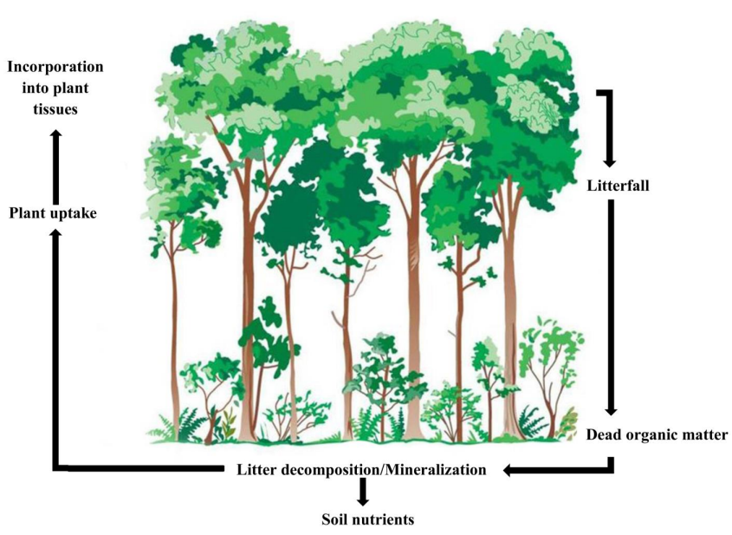
Fig 1. Generalized model of nutrient cycling process in forest ecosystem
(Source; Rahman et al. 2013)

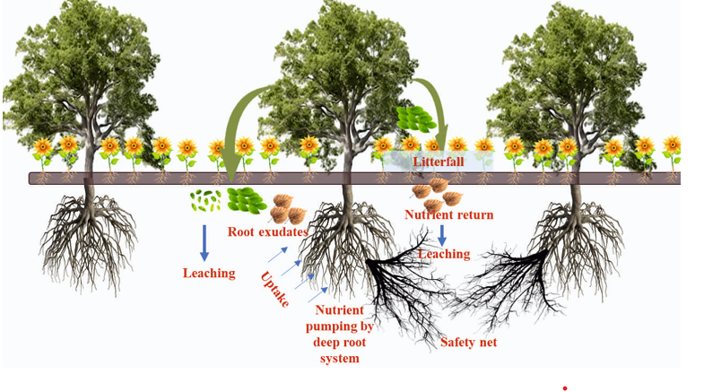
Fig 2. Litterfall and decomposition affecting soil nutrients cycling in agroforestry system
(Source; Kumar et al. 2024)

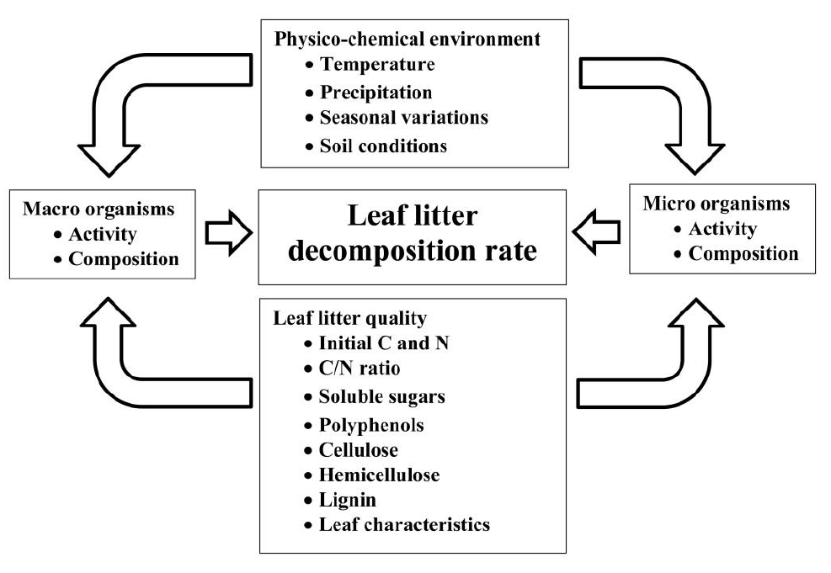
Fig 3. Factors affecting litter decomposition rate
(Source; Prescott et al. 2002)

