Ichthyofaunal diversity of Hathnikund Barrage, Haryana, India

Abstract
This study provides a detailed assessment of fish diversity in the Hathnikund Barrage, Haryana, from September 2022 to March 2024. A total of forty-seven fish species were recorded, representing five orders and eight families. The fish species belonged to orders Cypriniformes followed by Siluriformes, Perciformes, Anabentiformes and Synbranchiformes. The families were Cyprinidae, Siluridae, Bagridae, Ailiidae, Sisoridae, Ambassidae, Channidae and Mastacembelidae. The order Cypriniformes was the most dominant, encompassing 70% of the species, with Cyprinidae being the most prevalent family. The conservation status (IUCN status), of these species varied, with 85% classified as Least Concern and only 2 % belonged to endangered category. The study observed fluctuations in diversity indices, with Shannon’s index ranging from 3.48 to 3.68, and Simpson's 1-D diversity index from 0.96 to 0.97.
Keywords: Hathnikund barrage, Fish diversity, Species diversity index, IUCN status
Introduction
Each ecosystem on earth makes important contribution to human welfare and every species plays an important role in maintaining its ecosystem functional. The aquatic ecosystem is home to a very large number of organisms and hence it deserves attention (Hussain & Husain, 2013). India is endowed with several rivers (14 major rivers, 44 medium rivers, and innumerable minor rivers) (Das et al., 2012). Yamuna River basin is the second largest tributary of the Ganga (India's longest river), having a total catchment area of 345,848 km2. It originates from the Yamunotri Glacier in Uttarakhand, India, at a height of 6387 meters on the south western slopes of Banderpooch peaks. It travels 1376 kilometres through four main Indian states: Uttarakhand, Haryana, Delhi, and Uttar Pradesh before converging with the Ganga at Triveni Sangam in Prayagraj, Uttar Pradesh (Joshi et al., 2022).
In Haryana the major part of the river water is diverted into eastern and western Yamuna canals through the Hathnikund barrage. The Hathnikund barrage is a prominent water management structure located on the Yamuna River in Haryana's Yamuna Nagar district. The barrage was built in 1999, approximately 3 kilometers upstream of the Tajewala barrage and 220 kilometers upstream of the Wazirabad barrage. (Gawade et al. 2015; Kumar et al. 2020). It holds a significant role in regulating water flow and overseeing various water-related endeavours within the area. The primary purpose of the Hathnikund Barrage is to redirect water from the Yamuna River to support irrigation, drinking water provision and industrial requirements in Haryana and surroundings of Delhi National Capital Region (NCR). During the dry season, no water is permitted to flow downstream from the Hathnikund barrage, resulting in sections of the river between Hathnikund and Delhi nearly drying up (Joshi et al., 2016). The Upper Segment and the Delhi segment, constituting 145 kilometers of the Yamuna River from Hathnikund to Okhla/Kalindi Barrage plays crucial roles in evaluating Delhi's vulnerability to floods (Kumar et al., 2020).
India is considered as a hotspot of freshwater fish diversity and contributes a high number of the world’s endemic biological resources (Dahanukar et al., 2004). India makes up around 7.7% of the world's total fish diversity with 1,673 marine and 994 freshwater species (Froese & Pauly, 2020). As of September (2020), 34,300 species of fish had been described, according to Fish Base that exceeds the total number of all other vertebrate species, including birds, mammals, reptiles, and amphibians (Mishra et al., 2021). A crucial first step in any assessment is species identification, which is especially important for behavioural studies Biodiversity refers to the genetic and biological diversity of populations, species, communities, and ecosystems (Hiddink et al., 2008). The biodiversity can be quantified in terms of genetic diversity, species characteristics, biotic communities, their processes and their structure. A diversity index is a quantitative measure used to assess the variety and distribution of species within a specific ecological community or habitat. Commonly used diversity indices include the Shannon-Wiener index, Simpson's index, and the Berger-Parker index, among others. These indices consider factors such as species richness (the number of different species) and species evenness (the relative abundance of each species) to provide a comprehensive assessment of biodiversity within a given area. According to Flores et al. (2009), species richness, the number of species in a given area and species abundance or the relative number of species, make up fish diversity. The management of fish habitat diversity is becoming very difficult for assessment of the effects of habitat modification on fish populations both before and after the changes take place (Bhattacharya et al., 2020).
2. Material and Methods
The present study was carried out during the study period of September 2022 to March 2024 on a quarterly sampling basis to assess the fish diversity of Hathnikund barrage, Haryana.
2.1 Climate of Haryana
Haryana is found within northwest India. The zone experience is highly regarded in summer and markedly cold in winter. In between are the pleasant months of spring. The most rainfall is 216 cm² and therefore the minimum rainfall ranges from 25 to 38 cm².
2.2 Study Area
The Hathnikund barrage is situated about 40 km. from Yamuna-nagar district in Haryana. The Hathnikund barrage is situated between 30.3265° North latitude and 77.4656°" East longitudes.
Table 1. Details of study site
Location
Geographical coordinates | 30.3265° N; 77.4656° E
District | Yamuna-nagar
Accesses | 40 km from Yamuna-nagar
Year of construction | 1999
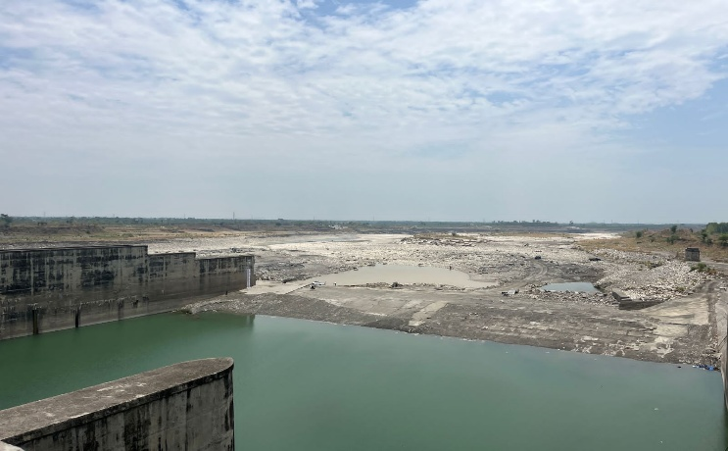

1a
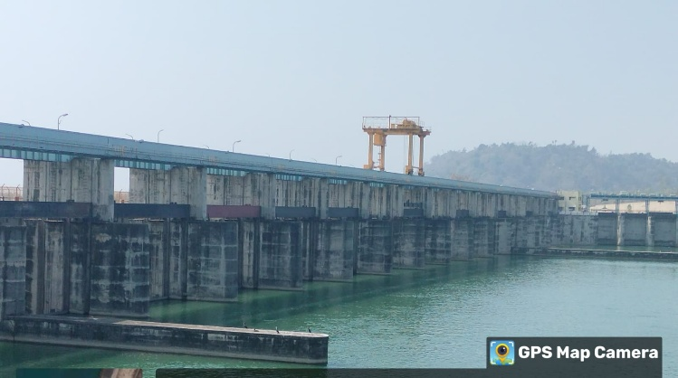
1b
Fig. 1 (a,b)Hathnikund Barrage

2.3 Collection of fish sample
Fish sample were collected from the designated sampling site with help of local fishermen. The commonly used gears were gill net. After the collection, the fishes were examined, and pictures of different fish species were clicked with help of camera on the spot. The number and type of fish species were counted, and fishes were released back to the water. The Fish database was also used to classify the fish species under order, family, genus and species category.
2.4 Fish diversity index-
- Species diversity index
Fish biodiversity analysis was done from the collected samples. Species diversity of fishes was determined by using Standard biodiversity indices like Simpson’s Index (D), Simpson’s Index of Diversity: 1-D, Shannon-Weiner Diversity Index (H’) and Margalef Richness Index (DMg) were applied to calculate the species diversity, evenness and richness (Simpson 1949; Shannon-Weaver 1963; Margalef 1958 respectively).
(i) Shannon-Weiner Diversity Index (d) = d
$$d=∑(\frac{ni}{N})log2(\frac{ni}{N})$$
Where,
d = Species diversity
ni = Number of individuals of i^{th} species.
N = Total number of individuals in the sample
(ii) Simpsons Index
$$\left(D\right)=1-∑\left(\frac{n\left(n-1\right)}{N\left(N-1\right)}\right)$$
Where,
n = number of individuals of one species
N = total number of all individuals,
(D)= Simpson‟s Index of Diversity
(iii) Margalef Richness Index
$$\left(DMg\right)=Log\frac{(n-1)}{N}$$
Where,
n= total number of specie,
N = total number of individuals in the sample,
ln =natural logarithm
2.5 Catch frequency
Based on the monthly catches, the catch frequency was calculated for each fish family. A frequency number was assigned to each fish family according to the number of times fish from that family were collected per unit effort during the study period. The percentage of catch frequency was then calculated as follows:
$$Catch frequency =\frac{Occurrence of fish family per catch)}{Total number of catches}×100$$

The scale proposed by Tamang et al. (2007) was used to determine the catch frequency status of the fishes. According to this scale fishes were categorized as: 91-100% common, 81-90% abundant, 61-80% frequent, 31-59% occasional, 15-30% sporadic, 05-14% rare and less than 5% extremely rare
3. Results and discussion
Fish diversity of Hathnikund barrage
Present study conducted on Ichthyofaunal diversity of Hathnikund Barrage, Haryana, India. A total of forty-seven (47) fish species were recorded from the Hathnikund barrage belonging to 5 orders and 8 families. The fish species belonged to orders Cypriniformes followed by Siluriformes, Perciformes, Anabentiformes and Synbranchiformes. The families were Cyprinidae, Siluridae, Bagridae, Ailiidae, Sisoridae, Ambassidae, Channidae and Mastacembelidae (Table.1). Samal et al. (2016) recorded 45 species belonged to 31 genera and 15 families and 6 orders. Bhatnagar et al. (2016) found 59 species belonged to 39 genera, 20 families and 7 orders in various water bodies and fish market of Haryana. Singh (2021) reported that the Ottu reservoir in Haryana harboared 36 fish species from 26 genera, 12 families and 5 orders. Dahiya (2023) documented 64 fish species from (Yamunanagar, Panipat and Faridabad) encompassing 9 orders and15 families. In the present study, the order Cypriniformes exhibited the greatest diversity, others order was siluriformes, Perciformes, Anabantiformes, and order Synbranchiformes (Fig.2). Similarily Shelke (2016) also identified the cypriniformes as a dominant order in their study, followed by order Perciformes, Siluriformes, Osteoglossiformes, Parapsilorhynchidae and Scorpaeniformes. (Singh,2021; Das et al.,2023; Goswami & Singha, 2023) also reported the similar findings.

Fig 2: Percentage distribution of Ichthyofaunal Order in Hathnikund barrage
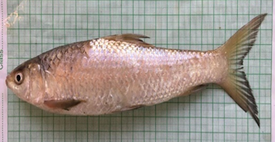 | 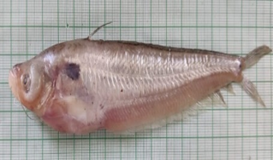 | 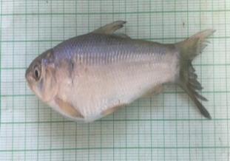
Plate 1: Cirrhinus reba | Plate 2: Ompak bimaculatus | Plate 3. Labeo gonius
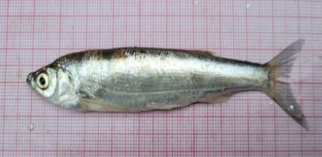 | 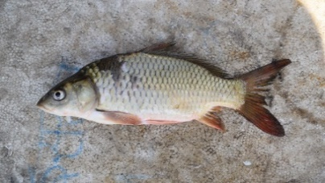 | 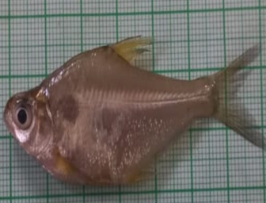
Plate 4: Salmophasia bacaila | Plate 5: Cyprinus carpio | Plate 6: Osteobrama cotio
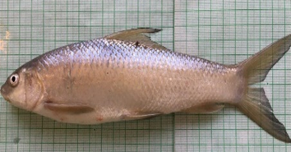 | 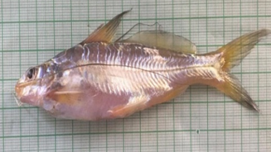 | 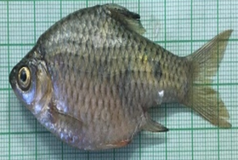
Plate 7: Labeo boggut | Plate 8: Mystus tengara | Plate 9: Pethia ticto
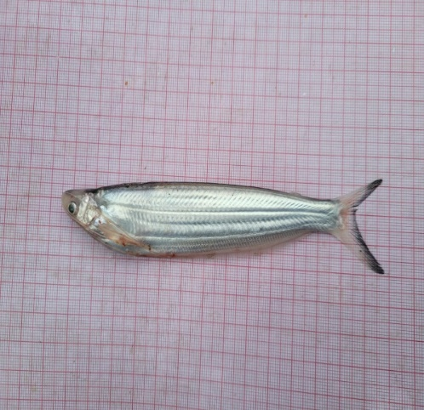 | 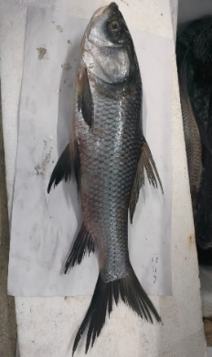 | 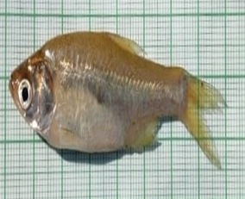
Plate 10: Ailia coila | Plate 11. Labeo calbasu | Plate 12: Devario devario
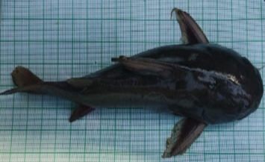 | 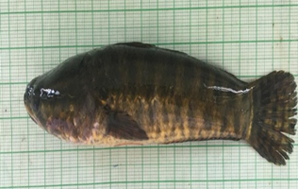 | 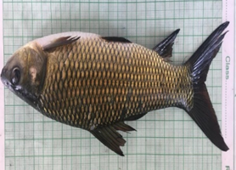
Plate 13: Rita rita | Plate 14: Channa marulius | Plate 15: Labeo rohita
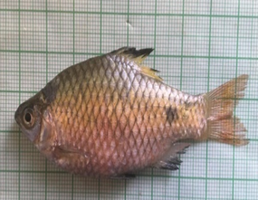 | 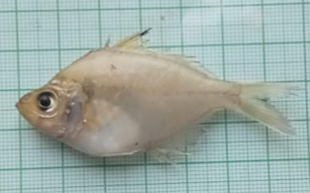 | 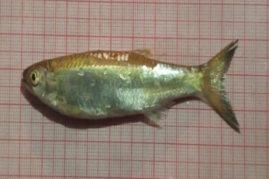
Plate 16: Puntius chola | Plate 17: Parambassis ranga | Plate 18: Barilius barila
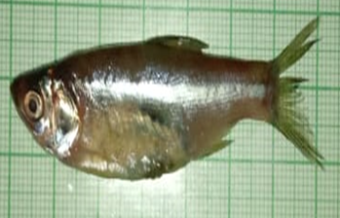 | 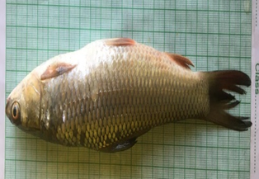 | 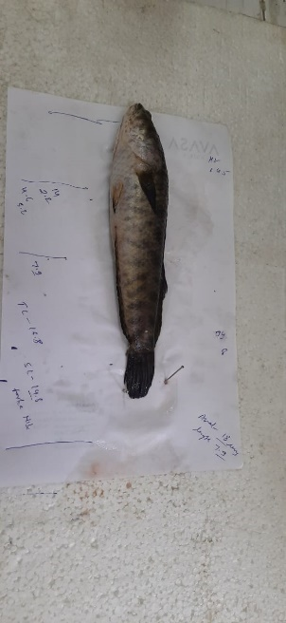
Plate 19: Amblypharyngodon mola | Plate 20: Cirrhinus mrigala | Plate 21: Channa puctatus
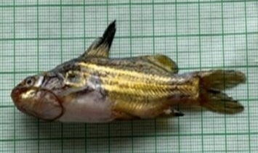 | 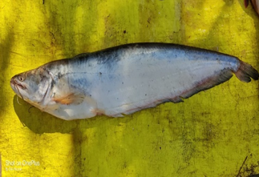 | 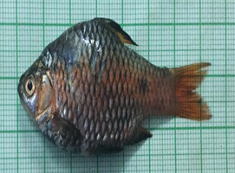
Plate 22: Mystus vittatus | Plate 23: Wallago attu | Plate 24: Puntius sophore
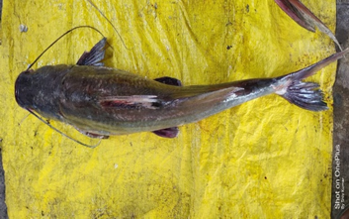 | 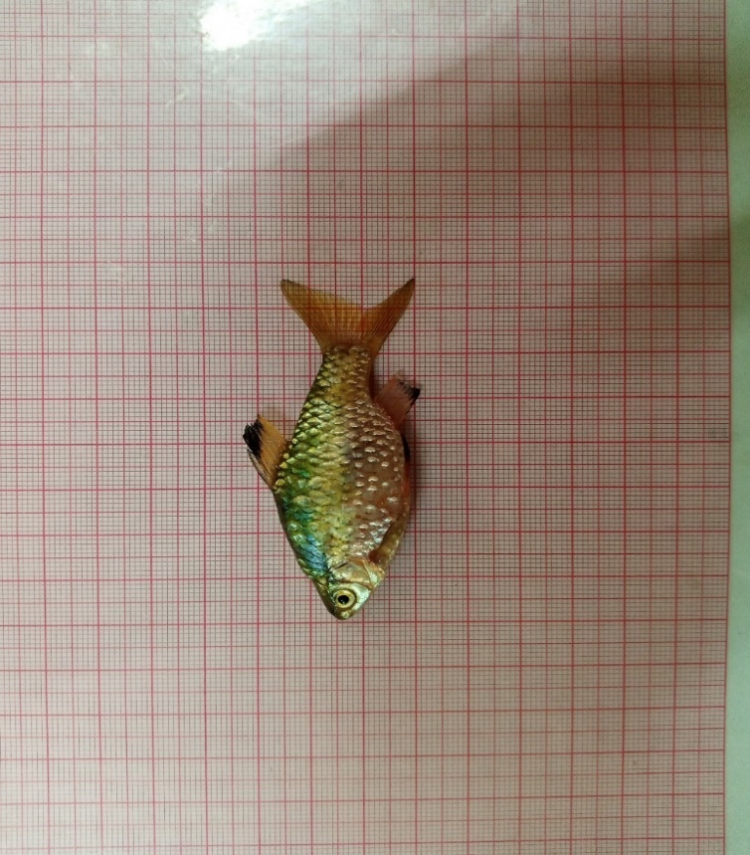 | 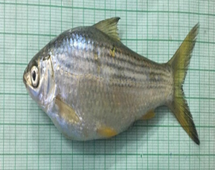
Plate 25: Sperata seenghala | Plate 26: Punctius conchonius | Plate 27: Puntius sarana
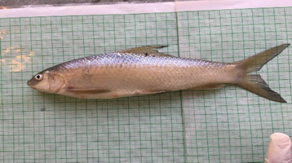 | 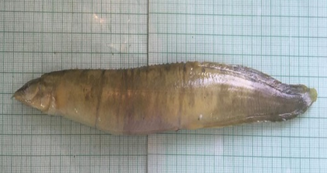 | 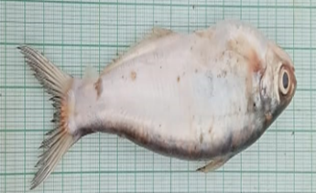
Plate 28: Labeo bata | Plate 29: Mastacembalus armatus | Plate 30: Eutropiichthys vacha
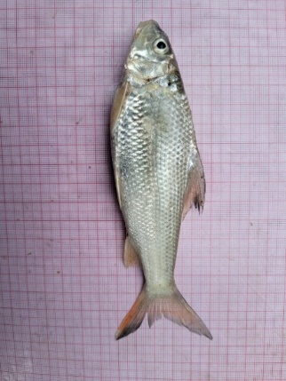 | 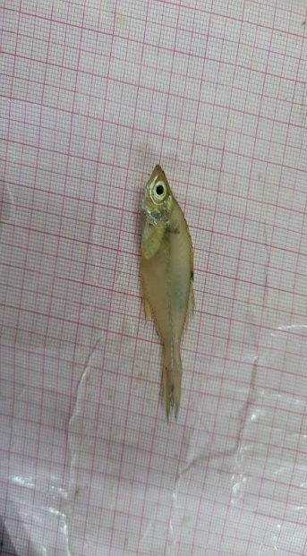 | 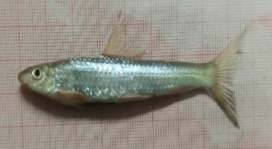
Plate 31: Chagunius chagunio | Plate 32: Chanda nama | Plate 33: Crossochelius latiuslatius
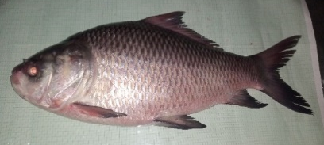 | 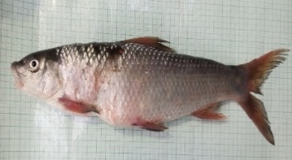 | 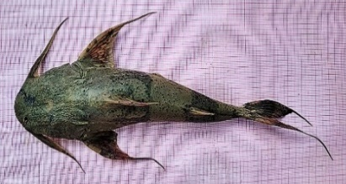
Plate 34: Catla catla | Plate 35: Labeo pangusia | Plate 36: Bagarrius bagarius
Plate (1-36): Glimpses of Fish diversity at Hathnikund barrage
Table 2. Fish diversity of Hathnikund barrage with their IUCN status
S No. | Order: Family: Fish species | Common Name | IUCN Status
 | Order: Cypriniformes Family: Cyprinidae
 | Tor putitora (Hamilton, 1822) | Mahaseer | EN
 | Salmophasia bacaila (Hamilton, 1822) | Large Razorbelly Minnow/ chail | LC
3. | Chela cachius (Hamilton, 1822) | Silver Hatchet Chela | LC
4. | Labeo boggut (Sykes, 1839) | Boggut Labeo | LC
5. | Labeo bata (Hamilton, 1822) | Bata | LC
6. | Catla catla (Hamilton, 1822) | Katla | LC
7. | Labeo rohita (Hamilton, 1822) | Rohita | LC
8. | Labeo calbasu (Hamilton, 1822) | Orangefin labeo/Pattharchat | LC
9. | Labeo gonius (Hamilton, 1822) | Kursa labeo/Sirheen | LC
10. | Labeo pangusia (Hamilton 1822) | Pangusia Labeo | NT
11. | Cirrhinus mrigala (Hamilton, 1822) | Mrigal | LC
12. | Cirrhinus reba (Hamilton, 1822) | Reba Carp | LC
13. | Cyprinus carpio (Linnaeus, 1758) | Common carp/ Golden | VU
14. | Aspidoparia morar (Hamilton,1822) | Asala | LC
15. | Barilius barila (Hamilton, 1822) | Barred baril/Chedra | LC
16. | Barilius barna (Hamilton, 1822) | Glar/Dudhnea | LC
17. | Barilius vagra (Hamilton, 1822) | Gheur | LC
18. | Barilus bendelisis (Hamilton, 1807) | Angura /Bhareli | LC
19. | Punctius ticto (Hamilton, 1822) | Ticker | LC
20. | Punctius conchonius (Hamilton, 1822) | Rosy barb/ Pothi | LC
21. | Punctius chola (Hamilton, 1822) | Swamp barb/Puthi | LC
22. | Punctius sophore (Hamilton, 1822) | Pool barb/ Pothi | LC
23. | Salmophasia Phulo (Hamilton, 1822) | chail | LC
24. | Raimas bola (Hamilton, 1822) | Trout Barb/Chilwa | LC
25. | Puntius sarana (Hamilton, 1822) | Olive barb /Sar puti | LC
26. | Crossochelius latiuslatius (Hamilton, 1822) | Gangetic Latia | LC
27. | Chagunius chagunio (Hamilton, 1822) | Chaguni | LC
28. | Osteobrama cotio (Hamilton, 1822) | Seesa | LC
29. | Aspidoparia jaya (Hamilton, 1822) | jaya | LC
30. | Amblypharyngodon mola (Hamilton 1822) | Mola Carplet/Murla | LC
31. | Bangana dero (Hamilton, 1822) | Kalabans | LC
32. | Devario devario (Hamilton, 1822) | Devario Danio/ Makhani | LC
33. | Garra gotyla (Gray, 1830) | Gotyla/ Kali | LC
 | Order: Siluriformes Family: Siluridae
34. | Ompok bimaculatus (Bloch 1794) | Indian Butter-catfish/ Papta | NT
35. | Wallago attu (Bloch & Schneider, 1801) | Mullee | VU
 | Order: Siluriformes Family: Bagridae
36. | Mystus vittatus (Bloch 1794) | Striped Dwarf Catfish/Tengra | LC
37. | Mystus tengara (Hamilton 1822) | Tengara catfish | LC
38. | Seperata seenghala (Sykes, 1839) | Giant River-catfish/ Singhara | LC
39. | Rita rita (Hamilton, 1822) | Rita/Kagga | LC
40. | Sperata aor (Hamilton, 1822) | Long-whiskered catfish | LC
 | Order: Siluriformes Family: Ailiidae
41. | Ailia coila (Hamilton 1822) | Kajuli/ Gangetic Ailia | NT
 | Order: Siluriformes Family: Sisoridae
42. | Bagarrius bagarius (Hamilton, 1822) | Goonch | NT
 | Order: Peciformes Family: Ambassidae
43. | Chanda nama (Hamilton, 1822) | Chanda | LC
44. | Parambassis ranga (Hamilton, 1822) | Indian glassy fish | LC
 | Order: Anabentiformes Family: Channidae
45. | Channa marulus (Hamilton, 1822) | Saur/Sole | LC
46. | Channa punctatus (Bloch, 1793) | Spotted Snakehead/ Sauli | LC
 | Order: Synbranchiformes Family: Mastacembelidae
47. | Mastacemebellus armtus (Lacepede, 1800) | Baam | LC

In the present study the most dominant family was Cyprinidae containing 70% of fish species Similarily Dahiya (2023) found that the Cyprinidae family was the most dominant, representing 52% of the fish species (Fig.3).
Fig 3: Percentage distribution of Ichthyofaunal Families in Hathnikund barrage

IUCN status of fish species
In the present study the majority of species (40 species, 85%), fall into to the Least concern category. and only 2% (1 species) as Endangered category. According to Bhatnagar et al. (2016), 3.39% of species are classified as endangered, 18.64% are considered vulnerable, 6.78% are categorized as Lower Risk Near Threatened and Vulnerable, and 2.5% are classified as Lower Risk Least Concern.Similarly, Rao (2023) categorized 41 species as Least concern contributing 83.67%, 5 species contributing 10.20% were categorized as Near Threatened, one species contributed 2.04%, was classified as Vulnerable (VU), and there were species listed as Not Evaluated (NE) and Data Deficient (DD) (Fig. 4).
Fig 4: Species composition as per IUCN status
Catch frequency
In the present study the fishes of families Cyprinidae and Siluridae were present in catches each months, shows the catch frequency status of common occurance (Table.3). Fishes of the families Bagridae and Channidae showed the status of being abundant while the family Ailiidae and Ambassidae showed status of being frequent. The family Mastacembelidae showed status of being occasional. Similarily, Rao (2023) studied Ichthyofaunal diversity of Gotta Barrage at Hiramandalam, Vamsadhara River and found fish population status showed that, the fish population showed that 25species, constituting, accounting for 14.28%, were moderately common, and five species, contributing 10.20%, were less common in the total catch.
Table 3: Catch frequency of Hathnikund barrage’s fishes
Family | Catch Frequency | Catch Frequency | Catch Frequency status
Cyprinidae | 7 | 100.00% | Common
Siluridae | 7 | 100.00% | Common
Bagridae | 6 | 85.71% | Abundant
Ailiidae | 5 | 71.43% | Frequent
Sisoridae | 4 | 57.14% | Occasional
Ambassidae | 5 | 71.43% | Frequent
Channidae | 6 | 85.71% | Abundant
Mastacembelidae | 4 | 57.14% | Occasional

Diversity indices of fish species
A diversity index is a mathematical assessment of species diversity within a community. Diversity indices offer more information on community composition than just species richness, as they consider relative abundance of various species. (Spellberg, 2008). Diversity indices reaveal the rarity and commonness of species in a population. In present study Shannon (or Shannon-Wiener) diversity index, Simpson diversity index and Margalef diversity index have been calculated for the fish species.
Species diversity index
The detailed diversity indices including the Shannon Weiner diversity index, Simpson diversity index, Margalef Richness Index are presented in Table 4.
1 Shannon Weiner diversity index
In the present study the Maximum values of Shannon’s index recorded in September 2022 with the value (3.68) whereas lowest value was recorded in December 2023 with the value (3.48) from Hathnikund barrage. The result revealed that in the month of September 2022 equality of fish species was highest and equality of abundance of fish species was lowest in the month of December 2023. Similarly, Samal et al. (2016) also recorded Shannon – Weiner index for fish diversity in the Budhabalanga river ranged from 3.35 to 3.359 and found species diversity peaked in October (H’=3.359), coinciding with favourable post -monsoon conditions such as sufficient water and abundant food resources and the diversity lowest was in July (H’=3.62) and Naik et al. (2013) also discovered Shannon diversity was highest in Kherda(2.68) than Mashala (2.62) and Sharannagar (2.37).
2 Simpson diversity index
In the present study the Simpson diversity index was highest with the value 0.97 and lowest value observed 0.96. Halim et al. (2021) reported the index ranged from (0.139-0.155).
3 Margalef Richness Index
The range of Margalef richness index is unbounded and shows a perfect linear relationship with species richness. In the present study the Maximum values of Margalef Richness Index recorded in September 2022 with the value (9.07) whereas lowest value was recorded in December 2023 with the value (7.63) from Hathnikund barrage. Similarly, Alam et al. (2021) mention the highest Margalef’s richness 7.95 in January. Hasan et al. (2021) also found the Margalef’s richness (D) index of the selected waterbodies during the study period ranged 4.37 to 8.73.
Table 4: Diversity indices of fish species
Sampling Months | Shannon Weiner diversity index | Simpson diversity index | Margalef Richness index
September-2022 | 3.68 | 0.97 | 9.07
December-2022 | 3.52 | 0.96 | 7.78
March-2023 | 3.59 | 0.97 | 8.45
June-2023 | 3.60 | 0.97 | 8.53
September-2023 | 3.60 | 0.97 | 8.48
December-2023 | 3.48 | 0.96 | 7.63
March-2024 | 3.51 | 0.96 | 8.43

Conclusion
The present study revealed that, the Hathnikund barrage support a rich and stable fish diversity with a total 47 fish species recorded over the study period. The dominance of the order Cypriniformes and family Cyprinidae indicates that the barrage provides suitable ecological conditions for major and minor carp species. Most of the recorded fish species found in the least concern category, suggesting that the fish community is presently under relatively low conservation threat, however the presence of endangered and near threatened species signify the need for continues monitoring and management. The consistently high value of Shannon and Simpsons diversity indices reflect good species richness and evenness, indicating a healthy aquatic ecosystem.
Conflict of interest
Authors have declared that no competing interests exist
Disclamier (Artificial Intelligence)
Author (s) hereby declare that NO generative AI technologies such as Large Language Models (ChatGPT, COPILOT, etc) and text-to-image generators have been used during writing or editing of this manuscript.
References
Bhatnagar, A., Yadav, A. S. and Neeru, N. (2016). Fish diversity of Haryana and its conservation status. Journal of Applied and Natural Science, 8(2): 1022-1027
Bhattacharya, M., Chini, D. S., Kar, A., Patra, B. C., Malick, R. C. and Kumar Das, B. (2020). Assessment and modeling of fish diversity related to water bodies of Bankura district, West Bengal, India, for sustainable management of culture practices. Environment, development and sustainability, 22: 971-984.
Dahanukar, N., Raut, R. and Bhat, A. (2004). Distribution, endemism and threat status of freshwater fishes in the Western Ghats of India. Journal of biogeography, 31(1):123-136.
Dahiya, T. (2023). Assessment of fish species biodiversity in Yamuna River (Haryana): a post covid 19 analyses. Journal of Experimental Zoology, 26(1): 817-824.
Das, B. K., Ray, A., Johnson, C., Verma, S. K., Alam, A., Baitha, R. and Sarkar, U. K. (2023). The present status of ichthyofaunal diversity of river Ganga India: Synthesis of present v/s past. Acta Ecologica Sinica, 43(2): 307-332.
Das, M. K., Naskar, M., Mondal, M. L., Srivastava, P. K., Dey, S. and Rej, A. (2012). Influence of ecological factors on the patterns of fish species richness in tropical Indian rivers. ActaIchthyologicaet Piscatoria, 42(1): 47.
Flores, S., Araya, P. R. and Hirt, L. M. (2009). Fish diversity and community structure in a tributary stream of the Paraná River. Acta Limnologica Brasiliensia, 21(1): 57-66.
Froese, R. and Pauly, D. (2020). Fish Base. 2020. World Wide Web Electronic Publication. Available at: Http://Www. Fish base. Org (Accessed on 8 January 2018).
Gawade, S., Pardeshi, K. and Sankhua, R. N. (2015). Flood Mapping of Yamuna River, Delhi, India. Global Journal of Multidisciplinary Studies, 4(7).
Goswami, P. and Singha, S. (2023). Fish diversity of the Beki River, Assam, India: Present status and conservation needs. Ecocycles, 9(2): 1-6.
Halim, K. A., Karim, S. R., Uddin, M. A., Hasanuzzaman, K. M., Ali, M. N., & Rahmatullah, S. M. (2021). Determination on fish diversity indices from Chalan Beel, Bangladesh. International Journal of Fisheries and Aquatic Studies, 9(5): 89-94.
Hasan, K., Sabiha, S., Reza, A. S., Meherin, K. M. and Amin, A. (2021). Computational study of Richness and Diversity Indices of fish species in rivers and other wetland areas and fish marketplaces under Kurigram District, Banglades. World Journal of Advanced Research and Reviews, 12(3): 434-457.
Hiddink, J. G., MacKenzie, B. R., Rijnsdorp, A., Dulvy, N. K., Nielsen, E. E., Bekkevold, D. and Ojaveer, H. (2008). Importance of fish biodiversity for the management of fisheries and ecosystems. Fisheries Research, 90(1-3): 6-8.
Hussain, J. A. K. I. R. and Husain, I. K. B. A. L. (2013). Water quality hot spots in Indian rivers. IAHS Publication, 361: 150-157.
Joshi, K. D., Alam, A., Jha, D. N., Srivastava, S. K. and Kumar, V. (2016). Fish diversity, composition and invasion of exotic fishes in river Yamuna under altered water quality conditions. Indian Journal of Animal Sciences, 86(8): 957-963.
Joshi, P., Chauhan, A., Dua, P., Malik, S. and Liou, Y. A. (2022). Physicochemical and biological analysis of river Yamuna at Palla station from 2009 to 2019. Scientific Reports, 12(1): 2870.
Kumar, M., Sharif, M. and Ahmed, S. (2020). Flood estimation at Hathnikund Barrage, river Yamuna, India using the peak-over-threshold method. ISH Journal of Hydraulic Engineering, 26(3): 291 300.
Margalef, D. R. (1958) Information theory in Ecology, International Journal of General Systems, 3: 36 71.
Mishra, S. P., Mishra, D. B. and Mishra, A. K. (2021). Diversity of Fresh Water Fishes and their Conservation Status in Eastern Uttar Pradesh, India. International Journal for Modern Trends in Science and Technology, 7(8): 69-77.
Naik, A. K., Somashekara, S. R., Kumar, J., Mahesh, V., Benakappa, S., Anjaneyappa, H. N. and Nayana, P. (2013). Assessment of Fish Biodiversity in Upper Mullamari Reservoir, Basavakalyan, Karnataka (India). International Journal of Fisheries and Aquaculture Sciences, 3(1): 13-20.
Rao, K. R. (2023). Ichthyofaunal diversity of Gotta Barrage at Hiramandalam, Vamsadhara River, Srikakulam Dt. Andhra Pradesh, India. International Journal of Zoology Studies, 8(2): 23-28.
Samal, D., Sethy, J. and Sahu, H. K. (2016). Ichthyofauna diversity in relation to physico-chemical characteristics of Budhabalanga River, Baripada, Mayurbhanj, Odisha. International Journal of Fisheries and Aquatic Studies, 4(1): 405-413.
Shannon, C.E. and Weaver, W. (1963). The Mathematical Theory of Communication. University of Illinois Press. Urbana, IL., USA, pp.1-125.
Shelke, A. D. (2016). Ichthyofaunal Bioversity of Girna Dam (Girna River) Dist. Nasik, Maharashtra, India. World, 8(3): 135-141.
Simpson, E.M. (1949) Measurement of diversity. Nature, 163: 688.
Singh, C. 2021. Fish biodiversity and Physico-chemical parameters of Ottu reservoir in Haryana. MFSc. Thesis submitted to college of fisheries Science, CCSHAU, Hisar
Spellerberg, I. F. (2008). Shannon–Wiener Index. Encyclopedia of Ecology, 3249–3252.
Tamang, L., Chaudhry, S., & Choudhury, D. (2007). Ichthyofaunal contribution to the state and comparison of habitat contiguity on taxonomic diversity in Senkhi stream, Arunachal Pradesh, India. Journal of the Bombay Natural History Society, 104(2):170-177.

