Correlation and Path Analysis for Seed Yield and Quality Traits in Blackgram (Vigna mungo (L.) Hepper)

Abstract
An investigation was undertaken to study the nature and magnitude of association among yield, yield components and nutritional quality traits in blackgram and to partition these associations into direct and indirect effects through path coefficient analysis. Phenotypic and genotypic correlation coefficients among fourteen characters were estimated, followed by path analysis with seed yield per plant as the dependent variable. The results revealed that number of pods per plant, number of clusters per plant and harvest index exhibited strong positive association with seed yield per plant at both phenotypic and genotypic levels. Path analysis further indicated that harvest index and number of pods per plant exerted the highest positive direct effects on seed yield, suggesting that these traits should receive prime emphasis in selection programmes aimed at yield improvement in blackgram.
Key Words: Blackgram, (Vigna mungo (L.) Hepper), Correlation analysis, Path coefficient analysis, Seed yield and Yield components

Introduction
Blackgram (Vigna mungo (L.) Hepper) is one of the most important pulse crops cultivated in India and other tropical and subtropical regions, owing to its adaptability, short duration and high nutritive value. The crop serves as a major source of dietary protein for vegetarian populations and contributes significantly to soil fertility through biological nitrogen fixation (Singh et al., 2018). In addition to protein, blackgram seeds are rich in essential micronutrients such as iron and zinc, which play a crucial role in addressing malnutrition and hidden hunger (Kumar et al., 2020).
Seed yield in blackgram is a complex quantitative trait governed by several interrelated morphological, physiological and quality characters, each influenced by genetic and environmental factors. Direct selection for seed yield alone is often inefficient due to its low heritability and strong environmental influence. Therefore, understanding the nature and magnitude of association between yield and its component traits is essential for formulating effective selection strategies in breeding programmes (Johnson et al., 1955).
Correlation analysis provides information on the degree and direction of association between traits but does not indicate the cause–effect relationship among them. In such situations, path coefficient analysis, originally proposed by Wright and later adapted to plant breeding by Dewey and Lu (1959), is a powerful statistical tool that partitions correlation coefficients into direct and indirect effects of component characters on yield. This approach helps breeders identify the most important traits contributing directly to yield and those contributing indirectly through other characters.
Several studies in blackgram and related pulse crops have reported that traits such as number of pods per plant, number of clusters per plant, harvest index and number of seeds per plant exhibit strong association with seed yield (Makeen et al., 2007; Narasimhulu et al., 2013; Panigrahi et al., 2014; Gowsalya et al., 2016). However, information on the relationship between yield and nutritional quality traits such as protein, iron and zinc content is limited. Understanding these associations is essential for simultaneous improvement of yield and nutritional quality.
In view of the above, the present investigation was undertaken to study the phenotypic and genotypic correlations among yield, yield components and nutritional quality traits and to assess their direct and indirect effects on seed yield through path coefficient analysis in blackgram.

Materials and Methods
In this study, fifty nine blackgram genotypes were utilized, which were sown using a Augmented Completely Randomized Block Design-II at the research station of Regional Agricultural Research Station, Lam, Guntur, Andhra Pradesh, India, during the summer 2018 and kharif 2019 situated at 16.10°N latitude, 28.29°E longitude and 31.5m altitude, is noted for its mean rainfall 905 mm, as well as its deep black soil with a pH 7.4, E.C 0.16 m.mhos / cm. Standard agricultural practices of the region were adhered to in order to cultivate a healthy crop, free from insect pests and diseases. Each genotype was planted in two rows, each measuring 4 meters in length, with a spacing of 30 cm between rows and 10 cm between plants within each row.

About 59 varieties such as IPU 17-02, TBG 129, LBG 904, KU 96-7, MBG 1070, LBG 918, IPU 17-1, DBGV 16, OBG 103, DKU 90, Uttara, KPU 52-87, PU 31, KU 17-04, LBG 854, VBG 17-026, IPU 2-43, TU 94-2, LBG 972, LBG 885, LBG 883, VBG 17-029, OBG 101, IPU 11-6, WBU 108, KPU 1720-140, LBG 709, TU 50, LBG 868, TU 40, MU 52, RU 03-22-4, KUG 818, VBG 12-110, NUL 242, TJU-134, PU 1541, PU 1501, OBG 102, AKU 1608, IPU 12-5, VBG 13-003, IPU 12-5, VBG 13-003, TU 44, ADBG 13023, VBG-12-062, OBG 41, VBG 09-005, VBN -5, LBG 752, LBG 880, LBG 776, SBC 50, VBN -5, LBG 787, ADT 5, ADT 6, AKU 1608, CO 5, DKU 11, GJU 1509 and LBG 623 were obtained from Indian Institute of Pulses Research, Kanpur along with released varieties and advanced cultures of Regional Agricultural Research Station (RARS), Lam, Guntur
Observations were recorded on phenological, morphological, yield component and quality traits, including days to 50 per cent flowering, days to maturity, plant height, number of branches per plant, number of clusters per plant, number of pods per plant, panicle length, number of seeds per plant, 100-seed weight, harvest index, protein content, iron content, zinc content and seed yield per plant.
Phenotypic and genotypic correlation coefficients among different characters were estimated following the method suggested by Johnson et al. (1955) to assess the degree and direction of association between traits. Genotypic correlations were computed using variance and covariance components derived from the analysis of variance.
Path coefficient analysis was carried out to partition the correlation coefficients into direct and indirect effects of component characters on seed yield per plant, taking seed yield as the dependent variable. The path analysis was performed according to the procedure outlined by Dewey and Lu (1959).
Statistical analysis of the experimental data was carried out using standard procedures described by Panse and Sukhatme (1985). The significance of correlation coefficients was tested at 5 and 1 per cent levels of probability.

Results and Discussion

Correlation Analysis
The estimates of phenotypic and genotypic correlation coefficients indicated that genotypic correlations were generally higher in magnitude than their corresponding phenotypic correlations, suggesting a strong inherent association among traits with relatively less environmental influence. Similar trends have been reported earlier in blackgram and other grain legumes, where genotypic correlations exceeded phenotypic correlations due to masking effects of the environment (Johnson et al., 1955; Dewey and Lu, 1959).
Seed yield per plant showed highly significant and positive correlation with number of pods per plant, number of clusters per plant and harvest index at both phenotypic and genotypic levels. Positive and significant associations were also observed between seed yield and number of seeds per plant, 100-seed weight and plant height. These findings are in close agreement with earlier reports in blackgram and mungbean, where pods per plant and harvest index were identified as major yield determinants (Makeen et al., 2007; Panigrahi et al., 2014; Narasimhulu et al., 2013).
Among the interrelationships of component traits, number of clusters per plant exhibited a strong positive correlation with number of pods per plant, while harvest index was positively associated with number of pods per plant and number of seeds per plant. Such strong interrelationships among yield components have also been reported by Gowsalya et al. (2016) and Priya et al. (2019), indicating that improvement in one component trait may lead to simultaneous improvement in others.
Nutritional quality traits such as protein, iron and zinc content generally showed weak to moderate correlations with seed yield, indicating the possibility of improving yield without adversely affecting seed nutritional quality. Similar observations were reported by Singh et al. (2018) and Kumar et al. (2020), who observed low or non-significant associations between yield and micronutrient traits in pulses.

Path Coefficient Analysis
Path analysis revealed that harvest index exerted the highest positive direct effect on seed yield per plant, followed by number of pods per plant. This indicates that these two traits are the most important determinants of seed yield in blackgram. Comparable results were reported by Dewey and Lu (1959), Makeen et al. (2007) and Panigrahi et al. (2014), who emphasized the usefulness of harvest index and pods per plant as reliable selection criteria.
Number of clusters per plant and number of seeds per plant also showed positive direct effects, though of relatively lower magnitude. Several traits that exhibited positive correlation with seed yield showed low or even negative direct effects but contributed positively through indirect effects via major yield components. For instance, plant height and number of branches per plant influenced seed yield mainly through their indirect effects via number of pods per plant and harvest index. Similar indirect contribution of secondary traits through major yield components has been documented by Narasimhulu et al. (2013) and Gowsalya et al. (2016).
Nutritional quality traits such as protein, iron and zinc content had negligible direct effects on seed yield, but their indirect effects through yield components were generally low. This suggests that selection for higher yield is unlikely to adversely affect these quality traits, supporting the findings of Singh et al. (2018) and Kumar et al. (2020).
The residual effect from the path analysis was low, indicating that the characters included in the study accounted for a major portion of the variation in seed yield per plant. This further confirms the adequacy of the model and agrees with earlier studies in blackgram (Panigrahi et al., 2014; Priya et al., 2019).

Conclusion
The present investigation on correlation and path coefficient analysis in blackgram (Vigna mungo (L.) Hepper) revealed that seed yield per plant is a complex trait governed by the interaction of several component characters. Genotypic correlations were generally higher than phenotypic correlations, indicating strong inherent associations among traits with relatively lower environmental influence.
Seed yield per plant exhibited strong and positive association with number of pods per plant, number of clusters per plant, number of seeds per plant and harvest index at both phenotypic and genotypic levels. Path coefficient analysis further confirmed that harvest index and number of pods per plant exerted the highest positive direct effects on seed yield, while number of clusters per plant and number of seeds per plant contributed positively through both direct and indirect effects. Traits such as plant height and number of branches per plant influenced seed yield mainly through their indirect effects via major yield components.
Nutritional quality traits including protein, iron and zinc content showed weak association and negligible direct effects on seed yield, suggesting that improvement in yield can be achieved without compromising seed nutritional quality.
Overall, the study indicates that selection based on harvest index, number of pods per plant and number of clusters per plant would be effective for improving seed yield in blackgram. These traits may be given priority in selection indices and utilized in hybridization and varietal improvement programmes aimed at developing high-yielding and nutritionally acceptable blackgram cultivars.

References
Dewey, D.R. and Lu, K.H. (1959). A correlation and path coefficient analysis of components of crested wheatgrass seed production. Agronomy Journal, 51: 515–518.
Gowsalya, P., Kumaresan, D. and Packiaraj, D. (2016). Genetic variability, correlation and path analysis in blackgram (Vigna mungo (L.) Hepper). Electronic Journal of Plant Breeding, 7(4): 947–954.
Johnson, H.W., Robinson, H.F. and Comstock, R.E. (1955). Estimates of genetic and environmental variability in soybeans. Agronomy Journal, 47: 314–318.
Kumar, S., Gupta, S., Chandra, S. and Tomar, A.K. (2020). Association of yield with protein and micronutrients in pulses. Legume Research, 43(4): 450–455.
Makeen, K., Abrahim, G., Jan, A. and Singh, A.K. (2007). Genetic variability and correlations studies on yield and its components in mungbean (Vigna radiata (L.) Wilczek). Journal of Agronomy, 6(2): 216–218.
Narasimhulu, R., Reddy, K.H.P. and Reddy, B.R. (2013). Correlation and path coefficient analysis for yield and yield components in blackgram (Vigna mungo (L.) Hepper). International Journal of Applied Biology and Pharmaceutical Technology, 4(4): 296–299.
Panigrahi, K.K., Mohanty, A., Baisakh, B. and Pradhan, J. (2014). Correlation and path coefficient analysis of yield components in blackgram (Vigna mungo (L.) Hepper). Legume Research, 37(1): 1–6.
Priya, M.S., Reddy, K.H.P. and Reddy, D.M. (2019). Character association and path analysis for yield and yield components in blackgram. International Journal of Current Microbiology and Applied Sciences, 8(5): 1625–1632.
Singh, U., Praharaj, C.S., Singh, S.S. and Singh, N.P. (2018). Biofortification of food legumes: A review. Journal of Food Legumes, 31(1): 1–12.
Panse, V.G. and Sukhatme, P.V. (1985). Statistical Methods for Agricultural Workers. Indian Council of Agricultural Research (ICAR), New Delhi.
Johnson, H.W., Robinson, H.F. and Comstock, R.E. (1955). Estimates of genetic and environmental variability in soybeans. Agronomy Journal, 47: 314–318.
Dewey, D.R. and Lu, K.H. (1959). A correlation and path coefficient analysis of components of crested wheatgrass seed production. Agronomy Journal, 51: 515–518.

Figure 1. Genotypical path diagram for GYP

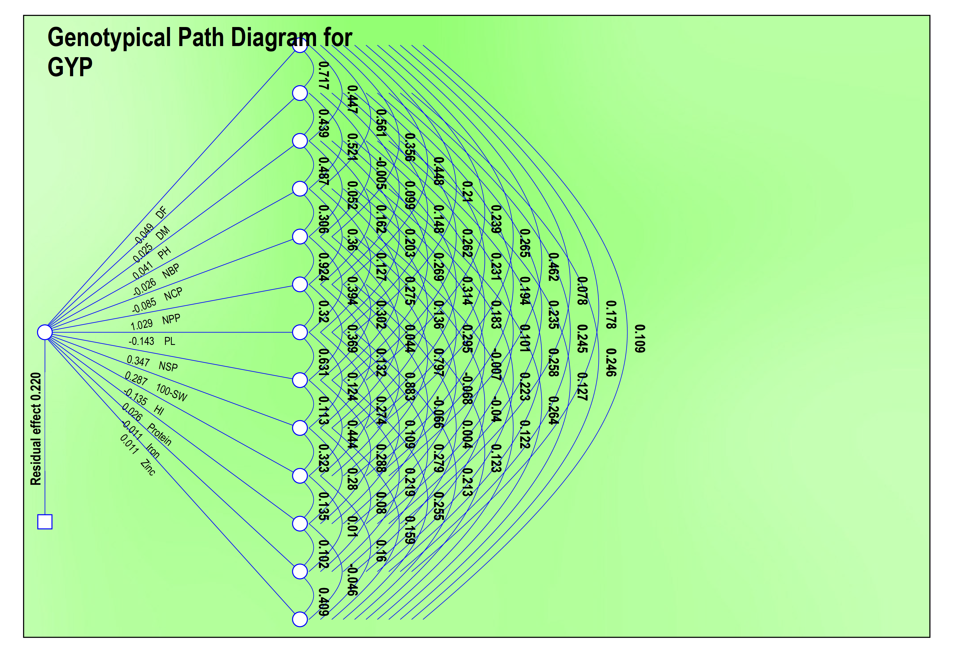

Figure 2. Phenotypical path diagram for seed yeild per plant
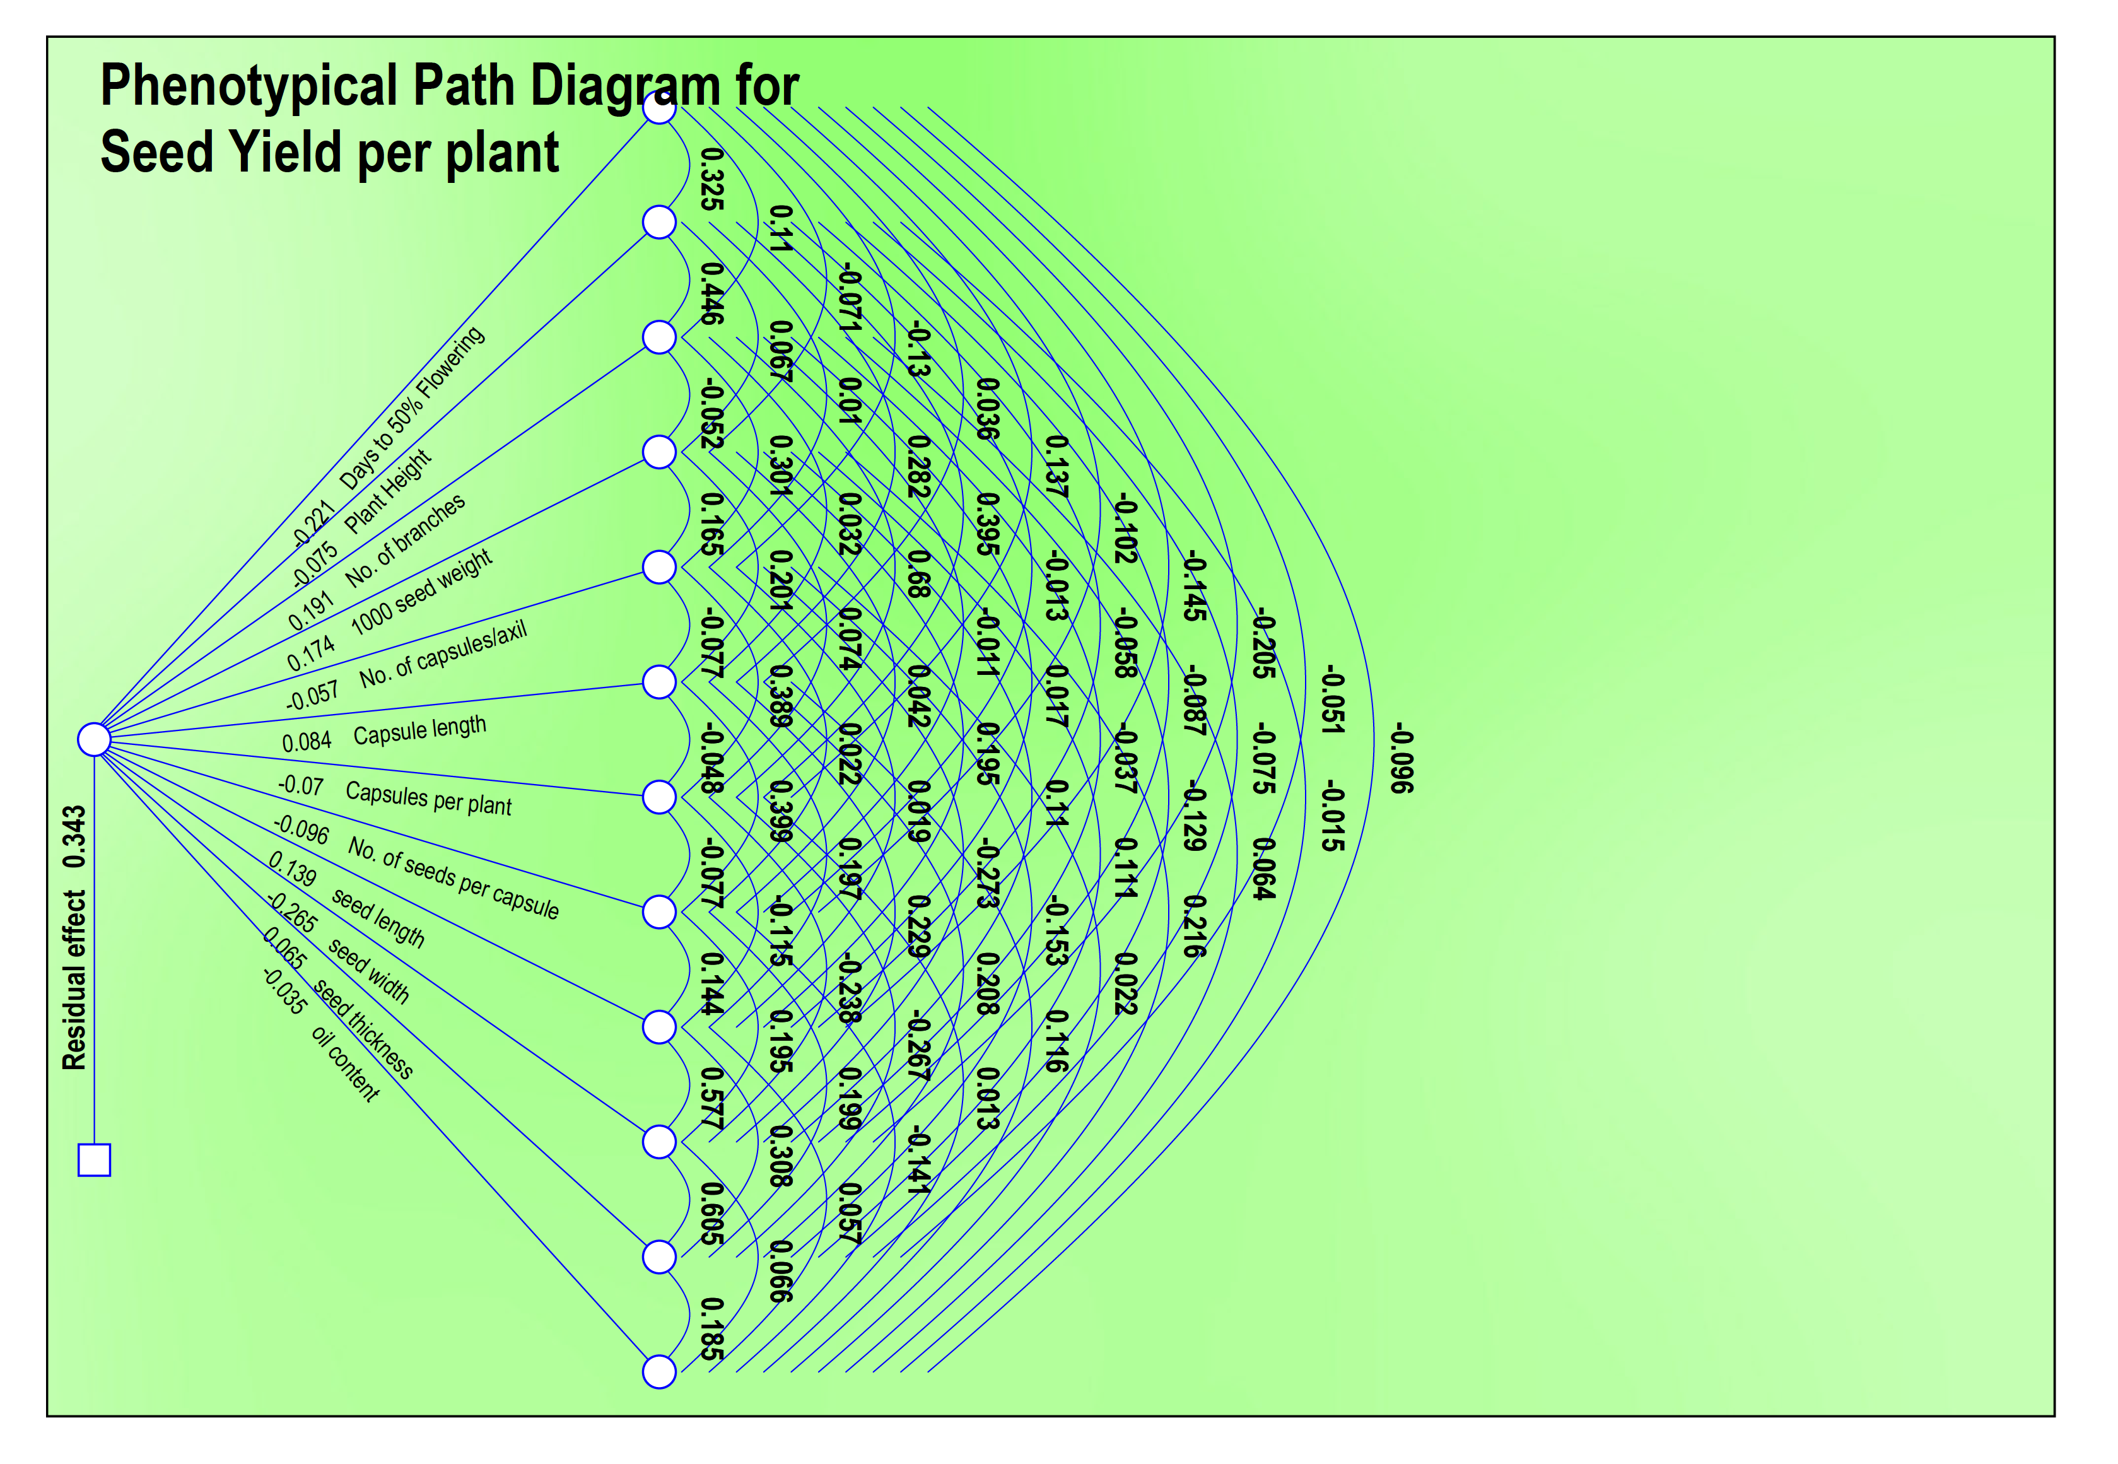
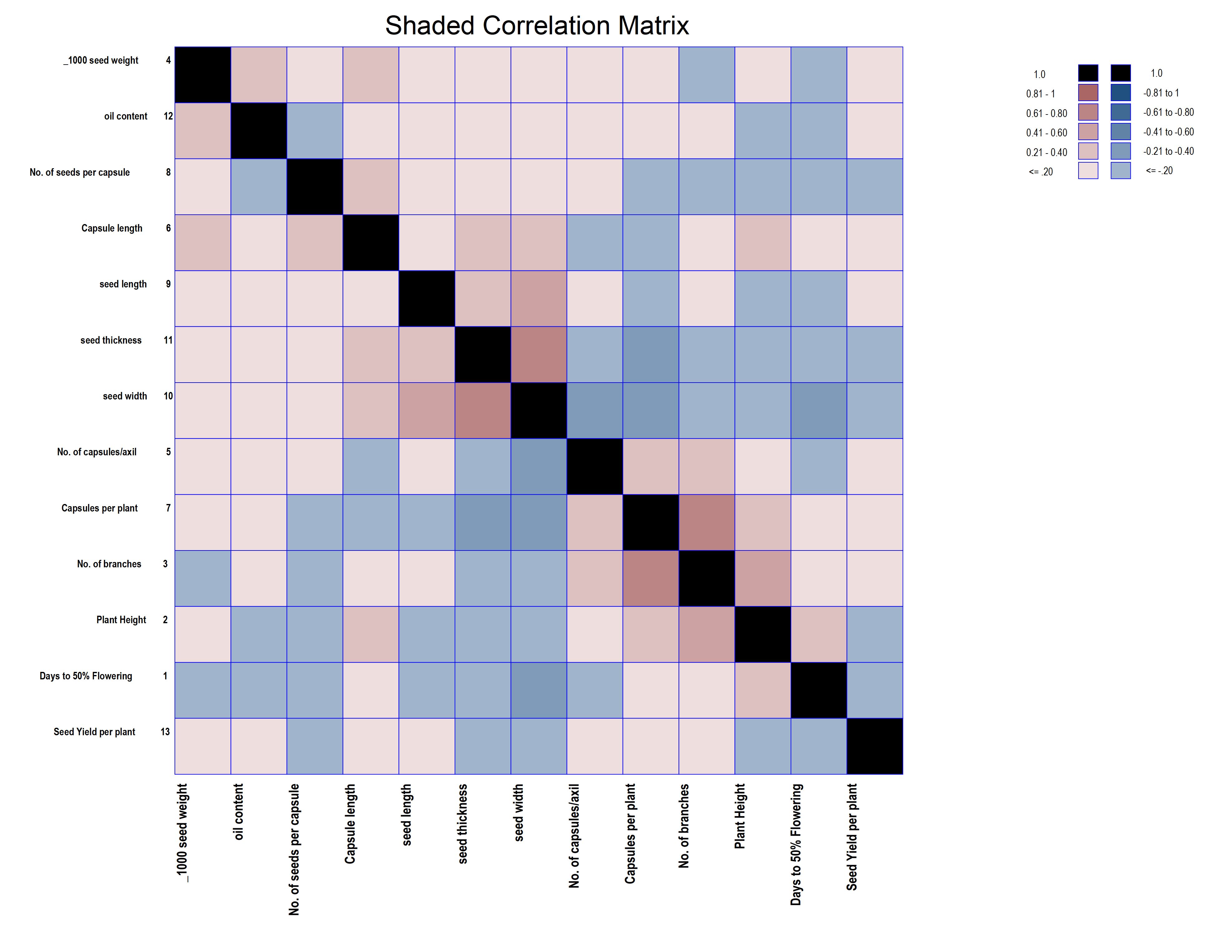

Figure 3. Shaded Correlation Matrix
Table 1 Phenotypic and genotypic correlation coefficients among fourteen characters in black gram (Vigna mungo (L.) Hepper)
 |  | DM | DF | PH  (cm) | NBP | NCP | NPP | PL  (cm) | NSP | 100- | HI  (% ) | Protein  (%) | Iron | Zn | SYPP
DF | P | 1.0000 | 0.659** | 0.392* | 0.513** | 0.313* | 0.403* | 0.2010 | 0.2182 | 0.2319 | 0.423** | 0.0704 | 0.1738 | 0.1088 | 0.439**
 | G | 1.0000 | 0.717** | 0.447** | 0.561** | 0.356* | 0.448** | 0.2103 | 0.2387 | 0.265* | 0.462** | 0.0783 | 0.1780 | 0.1093 | 0.472**
DM | P | 0.659** | 1.0000 | 0.434** | 0.503** | -0.0060 | 0.1025 | 0.1408 | 0.261* | 0.2137 | 0.1942 | 0.2298 | 0.2414 | 0.2487 | 0.2115
 | G | 0.717** | 1.0000 | 0.439** | 0.521** | -0.0048 | 0.0988 | 0.1479 | 0.262* | 0.2306 | 0.1939 | 0.2347 | 0.2454 | 0.2465 | 0.2125
PH | P | 0.392* | 0.434** | 1.0000 | 0.473** | 0.0597 | 0.1874 | 0.1723 | 0.271* | 0.306* | 0.1871 | 0.1247 | 0.2550 | 0.1190 | 0.310*
 | G | 0.447** | 0.439** | 1.0000 | 0.487** | 0.0524 | 0.1622 | 0.2031 | 0.269* | 0.314* | 0.1833 | 0.1013 | 0.258* | 0.1267 | 0.311*
NBP | P | 0.513** | 0.503** | 0.473** | 1.0000 | 0.274* | 0.356* | 0.1242 | 0.283* | 0.1205 | 0.320* | 0.0268 | 0.2074 | 0.273* | 0.391*
 | G | 0.561** | 0.521** | 0.487** | 1.0000 | 0.306* | 0.360* | 0.1275 | 0.275* | 0.1359 | 0.295* | -0.0069 | 0.2229 | 0.264* | 0.401*
NCP | P | 0.313* | 0.0060 | 0.0597 | 0.274* | 1.0000 | 0.907** | 0.379* | 0.281* | 0.0535 | 0.760** | -0.0715 | -0.0375 | 0.1089 | 0.790**
 | G | 0.356* | -0.0048 | 0.0524 | 0.306* | 1.0000 | 0.924** | 0.394* | 0.302* | 0.0439 | 0.797** | -0.0678 | -0.0401 | 0.1223 | 0.796**
NPP | P | 0.403* | 0.1025 | 0.1874 | 0.356* | 0.907** | 1.0000 | 0.290* | 0.367* | 0.1457 | 0.864** | -0.0310 | 0.0129 | 0.1181 | 0.918**
 | G | 0.448** | 0.0988 | 0.1622 | 0.360* | 0.924** | 1.0000 | 0.320* | 0.369* | 0.1321 | 0.883** | -0.0656 | 0.0037 | 0.1235 | 0.929**
PL | P | 0.2010 | 0.1408 | 0.1723 | 0.1242 | 0.379* | 0.290* | 1.0000 | 0.595** | 0.0926 | 0.269* | 0.0899 | 0.259* | 0.2212 | 0.360*
 | G | 0.2103 | 0.1479 | 0.2031 | 0.1275 | 0.394* | 0.320* | 1.0000 | 0.631** | 0.1242 | 0.274* | 0.1090 | 0.279* | 0.2128 | 0.371*
NSP | P | 0.2152 | 0.261* | 0.271* | 0.283* | 0.281* | 0.367* | 0.595** | 1.0000 | 0.1262 | 0.436** | 0.290* | 0.2191 | 0.2498 | 0.573**
 | G | 0.2387 | 0.262* | 0.269* | 0.275* | 0.302* | 0.369* | 0.631** | 1.0000 | 0.1133 | 0.444** | 0.288* | 0.2193 | 0.2553 | 0.591**
100-SW | P | 0.2319 | 0.2137 | 0.306* | 0.1205 | 0.0535 | 0.1457 | 0.0926 | 0.1262 | 1.0000 | 0.296* | 0.267* | 0.1029 | 0.1214 | 0.391*
 | G | 0.265* | 0.2306 | 0.314* | 0.1359 | 0.0439 | 0.1321 | 0.1242 | 0.1133 | 1.0000 | 0.323* | 0.280* | 0.0799 | 0.1590 | 0.408*
HI | P | 0.423** | 0.1942 | 0.1871 | 0.320* | 0.760** | 0.864** | 0.269* | 0.436** | 0.296* | 1.0000 | 0.1393 | 0.0093 | 0.1718 | 0.881**
 | G | 0.462** | 0.1939 | 0.1833 | 0.295* | 0.797** | 0.883** | 0.274* | 0.444** | 0.323* | 1.0000 | 0.1345 | 0.0101 | 0.1604 | 0.901**
Protein | P | 0.0704 | 0.2298 | 0.1247 | 0.0268 | -0.0715 | -0.0310 | 0.0899 | 0.290* | 0.267* | 0.1393 | 1.0000 | 0.0983 | -0.0332 | 0.1132
 | G | 0.0783 | 0.2347 | 0.1013 | -0.0069 | -0.0678 | -0.0656 | 0.1090 | 0.288* | 0.280* | 0.1345 | 1.0000 | 0.1017 | -0.0461 | 0.1158
Iron | P | 0.1735 | 0.2414 | 0.2550 | 0.2074 | -0.0375 | 0.0129 | 0.259* | 0.2191 | 0.1029 | 0.0093 | 0.0983 | 1.0000 | 0.391* | 0.0636
 | G | 0.1780 | 0.2454 | 0.258* | 0.2229 | -0.0401 | 0.0037 | 0.279* | 0.2193 | 0.0799 | 0.0101 | 0.1017 | 1.0000 | 0.409* | 0.0634
Zinc | P | 0.1085 | 0.2487 | 0.1190 | 0.273* | 0.1089 | 0.1181 | 0.2212 | 0.2498 | 0.1214 | 0.1718 | -0.0332 | 0.391* | 1.0000 | 0.2012
 | G | 0.1093 | 0.2465 | 0.1267 | 0.264* | 0.1223 | 0.1235 | 0.2128 | 0.2553 | 0.1590 | 0.1604 | -0.0461 | 0.409* | 1.0000 | 0.2032
GYP | P | 0.439** | 0.2115 | 0.310* | 0.391* | 0.790** | 0.918** | 0.360* | 0.573** | 0.391* | 0.881** | 0.1132 | 0.0636 | 0.2012 | 1.0000
 | G | 0.472** | 0.2125 | 0.311* | 0.401* | 0.796** | 0.929** | 0.371* | 0.591** | 0.408* | 0.901** | 0.1158 | 0.0634 | 0.2032 | 1.0000
* Significant at 5% level ** Significant at 1% level
DF- Days to 50 per cent flowering, DM-Days to maturity, PH- Plant height, NBP- Number of branches per plant, NCP- Number of clusters per plant, NPP- Number of pods per plant, PL- Panicle length, NSP- Number of seeds per plant, 100-SW- 100 Seed weight, HI-Harvest Index, Protein- Protein content, Iron- Iron content, Zn- Zinc content, SYPP- Seed yield per plant
Table 2 Direct and indirect effects of thirteen variables on seed yield of black gram (Vigna mungo (L.) Hepper)
 |  | DM | DF | PH  (cm) | NBP | NCP | NPP | PL  (cm) | NSP | 100- | HI  (% ) | Protein  (%) | Iron | Zn | SYPP
DF | P | 0.0129 | 0.0085 | 0.0051 | 0.0066 | 0.0040 | 0.0052 | 0.0026 | 0.0028 | 0.0030 | 0.0055 | 0.0009 | 0.0022 | 0.0014 | 0.439**
 | G | -0.0023 | -0.0035 | -0.0015 | -0.0018 | 0.0000 | -0.0004 | -0.0005 | -0.0009 | -0.0008 | -0.0007 | -0.0008 | -0.0008 | -0.0009 | 0.2115
DM | P | 0.0131 | 0.0145 | 0.0334 | 0.0158 | 0.0020 | 0.0063 | 0.0057 | 0.0090 | 0.0102 | 0.0062 | 0.0042 | 0.0085 | 0.0040 | 0.310*
 | G | -0.0059 | -0.0058 | -0.0054 | -0.0115 | -0.0031 | -0.0041 | -0.0014 | -0.0033 | -0.0014 | -0.0037 | -0.0003 | -0.0024 | -0.0031 | 0.391*
PH | P | -0.0013 | 0.0000 | -0.0002 | -0.0011 | -0.0041 | -0.0038 | -0.0016 | -0.0012 | -0.0002 | -0.0031 | 0.0003 | 0.0002 | -0.0005 | 0.790**
 | G | 0.2995 | 0.0762 | 0.1393 | 0.2644 | 0.6741 | 0.7432 | 0.2156 | 0.2727 | 0.1083 | 0.6421 | -0.0230 | 0.0096 | 0.0878 | 0.918**
NBP | P | -0.0120 | -0.0084 | -0.0103 | -0.0074 | -0.0226 | -0.0173 | -0.0597 | -0.0355 | -0.0055 | -0.0161 | -0.0054 | -0.0155 | -0.0132 | 0.360*
 | G | 0.0604 | 0.0721 | 0.0751 | 0.0784 | 0.0778 | 0.1016 | 0.1646 | 0.2768 | 0.0349 | 0.1208 | 0.0802 | 0.0606 | 0.0691 | 0.573**
NCP | P | 0.0526 | 0.0485 | 0.0694 | 0.0273 | 0.0121 | 0.0330 | 0.0210 | 0.0286 | 0.2268 | 0.0671 | 0.0605 | 0.0233 | 0.0275 | 0.391*
 | G | 0.0247 | 0.0113 | 0.0109 | 0.0187 | 0.0443 | 0.0504 | 0.0157 | 0.0254 | 0.0173 | 0.0583 | 0.0081 | 0.0005 | 0.0100 | 0.881**
NPP | P | -0.0005 | -0.0016 | -0.0009 | -0.0002 | 0.0005 | 0.0002 | -0.0006 | -0.0020 | -0.0018 | -0.0010 | -0.0069 | -0.0007 | 0.0002 | 0.1132
 | G | -0.0060 | -0.0084 | -0.0088 | -0.0072 | 0.0013 | -0.0004 | -0.0090 | -0.0076 | -0.0036 | -0.0003 | -0.0034 | -0.0347 | -0.0136 | 0.0636
PL | P | 0.0035 | 0.0081 | 0.0039 | 0.0088 | 0.0035 | 0.0038 | 0.0072 | 0.0081 | 0.0039 | 0.0056 | -0.0011 | 0.0127 | 0.0324 | 0.2012
 | G | 0.439** | 0.2115 | 0.310* | 0.391* | 0.790** | 0.918** | 0.360* | 0.573** | 0.391* | 0.881** | 0.1132 | 0.0636 | 0.2012 | 1.0000
NSP | P | 0.0129 | 0.0085 | 0.0051 | 0.0066 | 0.0040 | 0.0052 | 0.0026 | 0.0028 | 0.0030 | 0.0055 | 0.0009 | 0.0022 | 0.0014 | 0.439**
 | G | -0.0023 | -0.0035 | -0.0015 | -0.0018 | 0.0000 | -0.0004 | -0.0005 | -0.0009 | -0.0008 | -0.0007 | -0.0008 | -0.0008 | -0.0009 | 0.2115
100-SW | P | 0.2319 | 0.2137 | 0.306* | 0.1205 | 0.0535 | 0.1457 | 0.0926 | 0.1262 | 1.0000 | 0.296* | 0.267* | 0.1029 | 0.1214 | 0.391*
 | G | 0.265* | 0.2306 | 0.314* | 0.1359 | 0.0439 | 0.1321 | 0.1242 | 0.1133 | 1.0000 | 0.323* | 0.280* | 0.0799 | 0.1590 | 0.408*
HI | P | 0.423** | 0.1942 | 0.1871 | 0.320* | 0.760** | 0.864** | 0.269* | 0.436** | 0.296* | 1.0000 | 0.1393 | 0.0093 | 0.1718 | 0.881**
 | G | 0.462** | 0.1939 | 0.1833 | 0.295* | 0.797** | 0.883** | 0.274* | 0.444** | 0.323* | 1.0000 | 0.1345 | 0.0101 | 0.1604 | 0.901**
Protein | P | 0.0704 | 0.2298 | 0.1247 | 0.0268 | -0.0715 | -0.0310 | 0.0899 | 0.290* | 0.267* | 0.1393 | 1.0000 | 0.0983 | -0.0332 | 0.1132
 | G | 0.0783 | 0.2347 | 0.1013 | -0.0069 | -0.0678 | -0.0656 | 0.1090 | 0.288* | 0.280* | 0.1345 | 1.0000 | 0.1017 | -0.0461 | 0.1158
Iron | P | 0.1735 | 0.2414 | 0.2550 | 0.2074 | -0.0375 | 0.0129 | 0.259* | 0.2191 | 0.1029 | 0.0093 | 0.0983 | 1.0000 | 0.391* | 0.0636
 | G | 0.1780 | 0.2454 | 0.258* | 0.2229 | -0.0401 | 0.0037 | 0.279* | 0.2193 | 0.0799 | 0.0101 | 0.1017 | 1.0000 | 0.409* | 0.0634
Zinc | P | 0.1085 | 0.2487 | 0.1190 | 0.273* | 0.1089 | 0.1181 | 0.2212 | 0.2498 | 0.1214 | 0.1718 | -0.0332 | 0.391* | 1.0000 | 0.2012
 | G | 0.1093 | 0.2465 | 0.1267 | 0.264* | 0.1223 | 0.1235 | 0.2128 | 0.2553 | 0.1590 | 0.1604 | -0.0461 | 0.409* | 1.0000 | 0.2032
GYP | P | 0.439** | 0.2115 | 0.310* | 0.391* | 0.790** | 0.918** | 0.360* | 0.573** | 0.391* | 0.881** | 0.1132 | 0.0636 | 0.2012 | 1.0000
 | G | 0.472** | 0.2125 | 0.311* | 0.401* | 0.796** | 0.929** | 0.371* | 0.591** | 0.408* | 0.901** | 0.1158 | 0.0634 | 0.2032 | 1.0000
Diagonal effects-Direct effects, off-diagonal values-indirect effects * Significant at 5% level ** Significant at 1% level
DF- Days to 50 per cent flowering, DM-Days to maturity, PH- Plant height, NBP- Number of branches per plant, NCP- Number of clusters per plant, NPP- Number of pods per plant, PL- Panicle length, NSP- Number of seeds per plant, 100-SW- 100 Seed weight, HI-Harvest Index, Protein- Protein content, Iron- Iron content, Zn- Zinc content, SYPP- Seed yield per plant

