Original Research Article
Studies on biology and morphometric characteristics of invasive pest Spodoptera frugiperda (J.E.Smith) for two successive generations

ABSTRACT:
The biological and life history parameters of fall armyworm, Spodoptera frugiperda, through successive generations on maize were studied during 2021-22 under laboratory conditions at the Agricultural Research Station, Mudhol, Karnataka. The females laid an average of 1237.50 and 1150 eggs in the first and second generations, respectively. Only a trivial difference was observed between successive generations. The incubation, larval, pupal, pre-ovipositional, ovipositional, and post-ovipositional periods ranged from 2-3,15-19, 12-15, 3-4, 3-4, and 4-5 days, respectively. The total life cycle duration of males and females was recorded as 36-46 and 39-49 days, respectively, in the first generation, and 42-46 and 41-50 days, respectively, in the second generation. The findings showed that during generation I, the average length and breadth of the first instar were 1.70 mm and 0.20 mm, respectively; 2.30 mm length and 0.30 mm breadth for the second instar; 6.70 mm and 0.70 mm for the third instar; 13.90 mm and 1.90 mm for the fourth instar; 19.30 mm and 2.90 mm for the fifth instar; and 27.02 mm and 3.90 mm for the sixth instar. There was no significant difference in larval length and breadth in generation II, which ranged from 1.74 to 27.20 mm in length and 0.22 to 3.90 mm in breadth.
Keywords: Spodoptera frugiperda, successive generations, instar, longevity, oviposition etc.
- INTRODUCTION:
Maize Zea mays L. is the second most widely cultivated crop in the world and cultivated in tropics, sub-tropics to temperate climate and is a foremost crop for billions of people as food, feed and raw material for industries and is often called as “Queen of cereals”. The global consumption pattern of maize as feed accounts for 61per cent, food as 17 per cent and industry as 22 per cent. Presently, universally around 1164 MT of maize is being produced together by over 170 countries with an area of 208 million ha with an average productivity of 5.75t/ha (FAOSTAT, 2022).
India’s maize production is almost half the global production standards, and there is a great scope for improvement in the strategically important crop in the country. The area of maize cultivation has attained to 11.5 million ha with 43 MT production and average productivity of 3.7 t/ha. India represents 5.5 per cent of global maize area and 5.5 per cent of global production. Maize is cultivated all-round the country during all three seasons due to its wide adaptability. The important maize growing states are Andhra Pradesh (20.9%), Karnataka (16.5%), Rajasthan (9.9%), Maharashtra (9.1%), Bihar (8.9%), Uttar Pradesh (6.1%), Madhya Pradesh (5.7%), Himachal pradesh (4.4%). Apart from these above states the maize is also cultivated in the state of Jammu and Kashmir and North-Eastern states.
The production of maize is being challenged by many factors; insect pests are one of the major factors that lower the production of the crop. The losses in maize crop due to insect pests in maize crop ranges from 5 to 15 per cent. Around 141 insect pests cause varying degrees of damage to maize crop from sowing to harvest. Some of major insect species that cause loss to the maize crop are; maize spotted stem borer [Chilo partellus (Swinhoe)], pink stem borer [Sesamia inferens (Walker)], shoot fly (Atherigona orientalis Schiner), corn earworm (Helicoverpa armigera Hubner), termite (Odontotermes obesus Rambur) and recently introduced pest i.e., fall army worm [Spodoptera frugiperda (J.E. Smith)].
Spodoptera frugiperda (J E Smith), commonly named fall armyworm (FAW) is of serious to deal with due to its notorious and polyphagous behaviour and it is now the major insect causing substantial yield losses in maize (Assefa and Ayalew, 2019). In the recent past, it has been introduced into India which has caused wreak havoc and are prospective threat to Indian agriculture. The reason behind its rapid spread might be its well-built flight capacity which can disperse long distances annually during the summer months.
It is native to tropical and subtropical regions of the America and feeds on more than 100 plant species, including maize, rice, sorghum, millet, sugarcane, vegetable crops and cotton recently, Montezano et al. (2018) reported 353 plant species as hosts in the Americas, distributed in 76 families, mainly poaceae (106 species), asteraceae (31 species) and fabaceae (31 species). It has several generations per year and it can fly up to 100 km per/hr night. The FAW was first reported in Uganda in june 2016 in Kayunga, Kasese and Bukedea districts. This notorious pest was reported first time in the Shivamogga district of Karnataka in Southern India (Sharanabasappa et al., 2018a). At present it reported in various states of India viz., Karnataka, Tamilnadu, Maharastra, Telangana, Andhra Pradesh and Gujarat infesting maize crop (Sharanabasappa et al., 2018b). The pest has been reported on other hosts viz., sorghum, bajra (Venkateswarlu et al., 2018) and sugarcane (Chormule et al., 2019).
To avoid yield losses caused by the pest and to increase the production and productivity of maize the detailed studies are required to know its biology, feeding behaviour and growth parameters of a pest through successive generations.
- MATERIALS AND METHODS
  - Rearing technique
The initial culture of S. frugiperda eggs or larvae were collected from the unsprayed maize (GH-150125) crop grown at ARS, Mudhol farm and was maintained at ARS, Mudhol laboratory. The collected larvae were kept in individual petri plates for further development. The fresh maize leaves were cut into small bits was provided daily until pupation. After adult emergence the male and female were separated and were kept in separate cages for mating, provided with the mesh at the lid for aeration and one side of the mesh tied with muslin cloth for egg laying.
The male and female adults were fed with 10per cent honey solution soaked on sterile cotton. The moth which laid eggs were collected and the total fecundity was recorded. The eggs were then observed at 12hr interval to record the incubation period. After hatching (n = 25) individual larvae were kept in petri plates for growth parameters study.
2.2 Egg
For incubation period, 25 eggs were collected from egg mass and placed in the cage, and were observed daily. The incubation period was calculated based on the date of egg-laying to the date of egg hatching. The same observation was followed for second generation also.
  - Larva
The newly hatched larvae (n=25) were transferred individually to petri plates (15 x 100 mm) height and diameter, with the help of fine camel hair brush and were fed with fresh maize leaf bits. The larvae were kept on wet butter paper for moisture maintenance and freshness of leaves. The known quantity of fresh leaves was provided in the petri plate as day of initiation of the feeding trials. After 3 days after initiation (DAI) unfed leaf weight, larval weight and faecal matter weight were measured. The similar observations were taken on alternative days until it completes its duration. To determine the larval instars, the individual larvae were observed daily for the shedding off of exuviae and head capsule and the instar wise duration was recorded. The larval morphometrical characteristics like length and breadth were measured instar wise. The larval period was recorded based on the date of egg hatching to the date of initiation of pre-pupal stage. The same observations were followed for second generation.
  - Pupa
To know the pre-pupal period, observation was taken every day in the morning. During the larval development, the fully grown larvae stopped feeding and turned greenish in colour before entering the pre-pupal stage. The duration between formations of pre-pupae to the formation of pupae was recorded as the pre-pupal period. The time interval between formation of pupae to the emergence of an adult was considered the pupal period, pupal weight was also recorded. The same was followed for second generation also.
  - Adult
To determine the pre-oviposition, the newly emerged pairs were kept separately in rearing cage (60 cm cube with wire mesh at three sides and sliding glass on one side). The period between the emergence of adult female and commencing the egg-laying was recorded as the pre-oviposition period. The period between commencing the egg-laying and ceasing of egg-laying by an individual female was recorded as the oviposition period and the period between ceasing of egg-laying to death of female was considered as post-oviposition period.
The male and female longevity was calculated separately from the date of emergence to the death of adults. Eggs laid by a female were collected and counted daily in the morning. The total number of eggs laid during the life span of a female moth was considered as its fecundity. The duration of the entire life span was considered as the period between the date of egg-laying and the date of death of adults. . The same was carried for second generation also.

- RESULTS:
  - Development and reproductive biology of S. frugiperda on maize for two successive generations
The data regarding biology of various life stages are presented in the (Table 1). The average incubation period of S. frugiperda eggs was recorded to be of 2.36 ± 0.49 days during generation-I and 2.48 ± 0.51 days during generation- II (Plate 1).
    - Larval period
After egg hatching, first instar larvae were collected separately and reared (N = 25) in individual petri plates. The instar wise duration was recorded by looking at the shedding of exuviae and head capsules of individual larvae. Present study revealed that each larva passes through six distinct instars during its development in both the generation (Plate 2). First instar larvae varied with a mean duration of 2.24±0.44 days in generation I, whereas the second, third, fourth, fifth, and sixth instars went 2.2±0.41, 2.12±0.33, 2.28±0.46, 2.84±0.37, and 4.8±0.41 days, respectively. The similar trend was observed in the second generation and which took 2.36 ± 0.49, 2.24 ± 0.44, 2.28 ± 0.46, 2.32 ± 0.48 and 2.84 ± 0.37 and 4.83 ± 0.43 days to complete its duration from first to sixth instars. The total larval period noticed was 16.64 ± 0.57 and 16.84 ± 0.99 days in generation – I and generation - II respectively.
    - Pre - pupal period
At sixth instar there was cessation in the larval feeding. The date represented in (Table 1) revealed that, the prepupal period recorded with an average of 2.04 ± 0.20 days during generation-I and there was no difference in the average duration during generation-II (2.04 ± 0.20 days) (Plate 2).
    - Pupal period
After pre pupae, it was turned to darkish brown colour pupa. The pupal period observed with an average of 13.76 ± 1.23 days during generation-I and during generation-II the pupal period was 13.8 ± 1.29 days.
    - Pre - ovipositional period
After the pupation, the adults were emerged and the male and females were separated in separate cages and allowed for mating. They usually mated during evening or night time. The mated female was collected and transferred to separated cages for oviposition. The egg laying the duration gap was noted as pre-ovipositional which took almost 3.31 ± 0.48 and 3.38 ± 0.51 days in both the generations.
    - Ovipositional period
The mated female laid many numbers of eggs in a mass with tuft of hairs covering on them. The egg laying continued up to some certain duration and the duration was noted as ovipositional period which is represented in. The ovipositional period during generation-I was recorded with an average of 3.17 ± 0.58 days and similar trend was followed during generation- II (3.25 ± 0.62 days).
    - Post-ovipositional period
After laying of eggs there was cessation in the egg laying and after cessation the female adult survived up to certain period which was recorded as post-ovipositional period. The post-ovipositional period of 5 ± 0.43 days was recorded during generation-I and during generation-II the post-ovipositional period observed was 5.08 ± 0.51 days.
    - Sex ratio
The adults that emerged from pupae of N=25 the male and female were separated and sex ratio was calculated number of males to female, from. The sex ratio recorded during generation-I was 1.46 ± 0.04 and 1.5 ± 0.06 during generation-II.
    - Adult longevity
During generation-I the adults lived up to certain days and it was noted as adult longevity, during generation-I the male adult longevity observed was of an average 8 ± 0.63 days and during generation-II the female adult longevity was same as of generation-I i.e., 8 ± 0.63 days respectively.
    - Total life cycle
From egg laying to the natural adult mortality was noticed as total life cycle. It was observed that total life cycle recorded of 42.11 ± 2.76 days for male while female took 45 ± 2.67 days during generation -I and during generation -II the male lived with an average 43 ± 1.42 days and female lived for average 45 ± 2.67 days.
    - Fecundity
After the egg laying by female S. frugiperda during generation-I the eggs were collected daily up to cessation of egg laying and the same were counted in microscope and the fecundity was noted. The average fecundity 1237.5 ± 292.6 eggs were observed in generation-I and during generation-II the average fecundity observed was of 1350 ± 378.04.
  - Larval morphometric characteristics of S. frugiperda on maize for two successive generations
The data on morphometrics of larvae at different instars of generation-I and generation-II are presented in the (Table 2). The findings showed that during generation-I, the length and breadth of the first instar seen were on average 1.70 and 0.2 mm, 2.30 mm length and 0.30 mm breadth for second instar, 6.7 and 0.7 mm for third instar, 13.9 and 1.9 mm for the fourth instar, 19.3 and 2.9 mm for the fifth, and for the sixth instar (27.02 mm and 3.9 mm). There was not much difference with respect to length and breadth in generation-II which ranged from length of 1.74 to 27.2 mm and breadth 0.22 to 3.9 mm (Table 2).
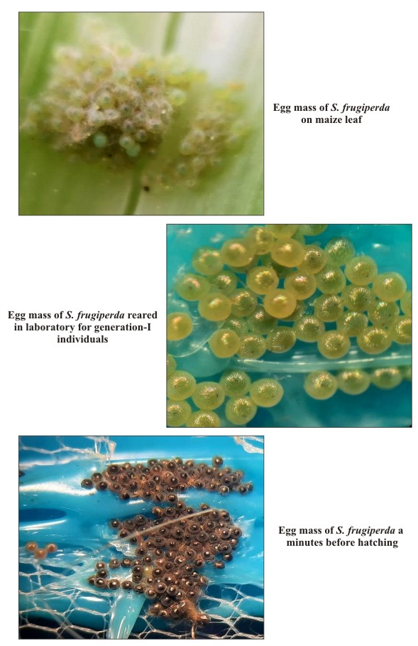
Picture 1. Egg mass of S. frugiperda reared under laboratory conditions

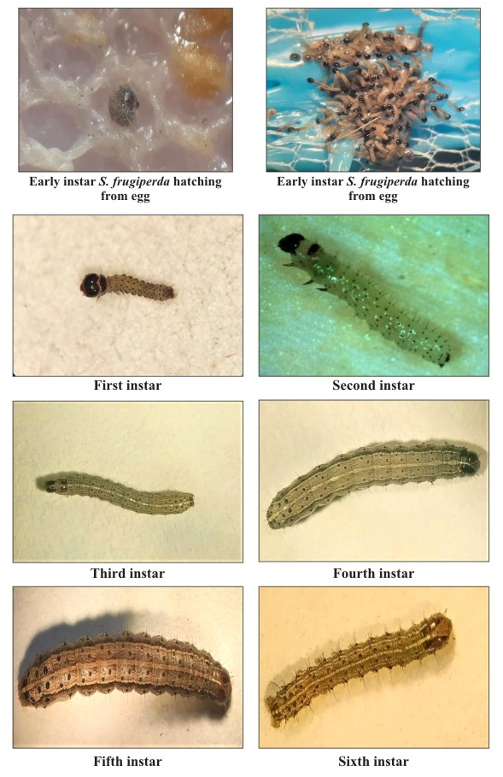
Picture 2. Different instars of S. frugiperda reared under laboratory conditions

Table 1. Development and reproductive biology of S. frugiperda on maize for two successive generations
Sl. No | Particulars | Duration (days) – generation I |  |  |  |  |  | Duration (days) – generation II
Sl. No | Particulars | Average ± S.D. | Min. | Max. |  |  |  | Average ± S.D. | Min. | Max.
1. | Incubation period | 2.36 ± 0.49 | 2 | 3 |  |  |  | 2.48 ± 0.51 | 2 | 3
2. | Larval period (1st instar) | 2.24 ± 0.44 | 2 | 3 |  |  |  | 2.36 ± 0.49 | 2 | 3
 | 2nd instar | 2.2 ± 0.41 | 2 | 3 |  |  |  | 2.24 ± 0.44 | 2 | 3
 | 3rd instar | 2.12 ± 0.33 | 2 | 3 |  |  |  | 2.28 ± 0.46 | 2 | 3
 | 4th instar | 2.28 ± 0.46 | 2 | 3 |  |  |  | 2.32 ± 0.48 | 2 | 3
 | 5th instar | 2.84 ± 0.37 | 2 | 3 |  |  |  | 2.84 ± 0.37 | 2 | 3
 | 6th instar | 4.8 ± 0.41 | 4 | 5 |  |  |  | 4.83 ± 0.43 | 4 | 5
3. | Total larval period | 16.64 ± 0.57 | 15 | 19 |  |  |  | 16.84 ± 0.99 | 15 | 19
Reproductive biology
4. | Pre- pupal period | 2.04 ± 0.20 | 2 |  | 3 |  | 2.04 ± 0.20 |  | 2 |  | 3
5. | Pupal period | 13.76 ± 1.23 | 12 |  | 15 |  | 13.8 ± 1.29 |  | 12 |  | 15
6. | Pre – ovipositional period | 3.31 ± 0.48 | 3 |  | 4 |  | 3.38 ± 0.51 |  | 3 |  | 4
7. | Ovipositional period | 3.17 ± 0.58 | 3 |  | 4 |  | 3.25 ± 0.62 |  | 3 |  | 4
8. | Post- ovipositional period | 5 ± 0.43 | 4 |  | 6 |  | 5.08 ± 0.51 |  | 4 |  | 6
9. | Sex ratio (Male: Female) | 1.46 ± 0.04 |  |  |  |  | 1.5 ± 0.06
Adult longevity
10. | Male | 8 ± 0.63 | 7 |  |  | 9 | 8 ± 0.63 |  | 7 | 9
11. | Female | 10.9 ± 0.47 | 10 |  |  | 11 | 10.93 ± 0.47 |  | 10 | 12
Total life Cycle
12. | Male | 42.11 ± 2.76 | 36 |  |  | 46 | 43 ± 1.42 |  | 42 | 46
13. | Female | 45 ± 2.67 | 39 |  |  | 49 | 45.66 ± 2.19 |  | 41 | 50
14. | Fecundity | 1237.5 ± 292.6 | 800 |  |  | 1350 | 1150 ± 378.04 |  | 800 | 1525
Values are mean ± SD from 25 replications
Number of entries (N) = 25

Table 2. Larval morphometric characteristics of S. frugiperda on maize for two successive generations
Sl. No. | Particulars | Larval morphometry  generation- I |  | Larval morphometry  generation- II
Sl. No. | Particulars | Length (mm) | Breadth (mm) | Length  (mm) | Breadth  (mm)
1. | 1st instar | 1.70 | 0.2 | 1.74 | 0.22
2. | 2nd instar | 2.30 | 0.30 | 2.4 | 0.5
3. | 3rd Instar | 6.7 | 0.7 | 6.70 | 0.70
4. | 4th instar | 13.9 | 1.9 | 13.9 | 1.9
5. | 5th instar | 19.3 | 2.9 | 19.31 | 3.00
6. | 6th instar | 27.02 | 3.9 | 27.2 | 3.9
Values are mean from 5 replications

- DISCUSSION:
  - Development and reproductive biology of S. frugiperda on maize for two successive generations
    - Incubation period
It was observed that the FAW female laid eggs in clusters and were dorso-ventrally flattened withe pale green for one day and turned to golden yellowish and ultimately turned to black before hatching. The female covered a layer of scales on the egg mass or sometimes the eggs were not covered with the layer of the scale. Similar observations were recorded by Sisodiya et al. (2018) who reported that fall armyworm eggs were deposited in layers on the underside of leaf and eggs were creamy white covered with greyish coloured scales.
The average incubation period of FAW eggs was recorded to be of 2.36 days during generation-I- and 2.48-days during generation- II. The results were valid with Sharanabasappa et al. (2018b) who found an average incubation period of 2.50±0.50 days on maize. Bhavani et al. (2019) reveales that the period of incubation ranged from 2 to 3 days with an average of 2.5 days. Whereas Reddy et al. (2020) observed 2.67±0.23 days of incubation period. Thus, the present findings are conformity to past workers.
    - Larval period
The individual larva was observed every day for the shed exuviae and even a head capsule to determine the instars. The presence of a cast-off head capsule indicated that the larvae were moulting. It was discovered during the current experiment that larvae proceeded through six instars before becoming the pupal stage. First instar (neonate) larvae were light greenish in colour with a prominent black head. First instar larval period was of minimum 2 days and maximum 3 days. The above findings are supported with Reddy et al. (2020) who reported that the first instar larval period was 2.33±0.29 with a range of 2 to 3 days.
    - Second instar
Second instar larvae of fall armyworm were a pale green body with an orange head, Present findings are tally with Malo and Hore (2020) who reported that young larvae of fall armyworm were green in colour and had an orange head. The second instar larval period varied from minimum 2 days to maximum 3 days with no significant difference in second generation. Similar observations were taken by Sharanabasappa et al. (2018b) who reported that the second instar larval period was 2 to 3 days. Ashok et al. (2020) noticed that the mean development period in the second instar was 2.12 days.
    - Third instar
The third instar larvae had a brownish-black coloured head with three dorsal and lateral white lines observed along with whitish inverted ‘Y’ on the head and spots arrangement on the body. The third instar larval period varied from 2 to 3 days with no considerable difference in 3rd instar larval period during second generation. Sharanabasappa et al. (2018b) observed that the mean development period of third instar larvae was 2.0 days.
    - Fourth instar
Fourth instar larvae had a reddish-brown head. The larvae mottled with white and the brownish body bears three white dorsal lines and an alight lateral line. There was a mark with a white inverted “Y” on frons of the larvae and the elevated distinct dark-coloured black spots (Pinacula) on the whole body which bears spines (long primary setae). The arrangement of the dorsal pinacula i.e., the black spots four in number arranged in a square on the 8th segment of the abdomen and large spots, especially on 9th segment have a typical arrangement in a trapezoidal pattern and also observed from 1st to 7th abdominal segments. Identical results are observed by Sharanabasappa et al. (2018b) and Siddhapura et al. (2021). The fourth instar larvae took minimum 2 days and maximum 3 days as its larval period the same trend was also seen during second generation.
    - Fifth instar
The fifth instar larva was observed similarly in appearance to fourth instar larva, except large in size. The fifth instar larvae completed its instar in minimum 2 days and maximum 3 days. The present findings are similar to the findings of Kalyan et al. (2020), who revealed that the development period in the fifth instar was 2.7 days.
    - Sixth instar
The sixth instar larvae took minimum 4 days and maximum 5 days and the same trend was also seen during second generation. Reddy et al. (2020) noticed that the sixth instar larval period varied from 3 to 5 days with a mean duration of 3.67±0.83 days.
    - Total larval period
The total larval period was ranged from minimum 15 to maximum 19 days and the same trend was followed during generation-II. The present investigations are supported by Kalyan et al. (2020) who revealed that, the total period of larvae was completed in a duration of mean 16.97 days. Ramya and Maheswari (2019) revealed that the larvae had six instars, and completed their development within 15 days. When the larvae were raised on sweet corn, Tiwari and Deole (2021) discovered that the total larval duration varied from 16 to 18 days, with a mean of 16.65±0.16 days.
    - Pupal period
The pupal period of FAW was of minimum 12 days and maximum 15 days across both the generation with no significant difference in duration in both generations. The pupa was reddish-brown in colour with a pair of cremasters. The present findings are more or less similar to the results of Igyuve et al. (2018) who revealed that, pupa of S. frugiperda was reddish-brown in colour. Bhavani et al. (2019) observed that, pupa of fall armyworm was reddish-brown in colour.
    - Ovipositional period
The ovipositional period of FAW was of minimum 3 days and maximum 4 days across both the generation with no difference among both generations. The results of this study are consistent with those of Sharanabasappa et al. (2018b) who found that oviposition lasted between two and three days on average, with a mean of 2.8±0.40 days.
    - Male and female adult longevity
The male adult of FAW survived for minimum of 7 days and maximum of 9 days across both the generation. And the female survived for minimum of 10 days and maximum of 11 days across both the generation. The studies on adult longevity are more or less in accordance with the report of Ashok et al. (2020) who reported that, the mean adult longevity observed was 11.10±0.99 and 12.60±1.075 days for male and female, Siddhapara et al. (2021) revealed that, the male and female adult longevity was 7.90±0.84 and 10.60±1.22 days, respectively (Fig 1).
    - Fecundity
The total fecundity of individual female FAW across its ovipositional period in laboratory condition ranged from minimum 800 and maximum 1350 eggs, with the mean fecundity of 1237.5±292.6 and during second generation also the trend was followed with the range of 800 to 1525 with the mean fecundity of 1150± 378.04. The current findings are in agreement with Montezano et al. (2019) where fall armyworm fecundity varied from 634 to 1900 eggs with an average of 1398 eggs per female. Whereas, Ramya and Maheswari (2019) found that, the fecundity of S. frugiperda was 1513 eggs per female. Gamil (2020) reported that, fecundity as 1787.5 eggs per female, thus the present results on fecundity are in confirm with the past workers.
  - Larval morphometrics characteristics of S. frugiperda on maize for two successive generations
There was no difference in the length and breadth of all instars during both generations. The first instar larvae length measured 1.7mm and 0.17 mm breadth which was almost same during second generation. The present findings are similar to the findings of Pitre and Hogg (1983) who reported 1.7mm of larval length. Similarly, Manjula et al. (2019) found 0.71mm as the length of the body which was close to the present findings. The second instar larval length and breadth measuring about 2.3mm and 0.30mm respectively. The third instar larval length and breadth was slightly increased by recording 6.67 mm length and 0.67mm breadth which was same during second generation whose length was 6.7mm and 0.7mm breadth. During fourth instar there was massive growth due to increase in feeding on food whose larval length was 13.99mm and 1.86mm breadth and during generation-II there was almost similar length of 13.99mm and 1.86mm breadth. The current outcomes are identical with the results of Ahmad et al. (2021) who brought out that, the length of the body in the fourth instar was 13.98±1.00mm. The fifth instar larval length was 19.31 mm and 2.89mm breadth and similar trend was followed during second generation. Present findings are close confirmation with Pitre and Hogg (1983) who reported that, the length of fifth instar larvae was 17.2mm. The increased length and breadth were seen in sixth instar larvae by recording 27.02mm length and 3.9mm breadth which was also similar in trend during second generation.
- Conclusion:
The studies on biology S. frugiperda for two successive generation revealed that there was no significant difference in first and second generation in developmental days i.e., from incubation to adult mortality of S. frugiperda. In first generation, the incubation period of 2.36 ± 0.49 days and larval period from first to sixth instar were 2.24 ± 0.44, 2.2 ± 0.41, 2.12 ± 0.33, 2.28 ± 0.46, 2.84 ± 0.37, 4.8 ± 0.41 days. The total larval period recording 16.64 ± 0.57 days with prepupal period of 2.04 ± 0.20 days and pupal period of 13.76 ± 1.23 days. The pre-ovipositional period was 3.31 ± 0.48 with ovipositional period of 3.17 ± 0.58 days and post-ovipositional period of 5 ± 0.43 days. It was observed that total life cycle recorded 42.11 ± 2.76 days for male while female took 45 ± 2.67 days during generation -I and during generation -II the male lived with an average 43 ± 1.42 days and female lived for average 45 ± 2.67 days with fecundity of 1237.5 ± 292.6 and 1150 ± 378.04 respectively.
The data pertaining to the larval morphometry (length and breadth) revealed that during generation-I the length and breadth of 1st instar observed was of an average 1.70 and 0.17 mm, 2nd instar (2.30 mm length and 0.30 mm), 3rd instar (6.67 and 0.67 mm), 4th instar (13.9 and 1.9 mm), 5th instar (19.31 and 2.89 mm) and 6th instar (27.02 and 3.9). There was not much difference with respect to length and breadth in generation-II which ranged from 1.74 to 27.02 mm and 0.22 to 3.85 mm in length & breadth.
- DISCLAIMER (ARTIFICIAL INTELLIGENCE)
Authors hereby by declare that NO generative AI technologies such as Large Language Models (ChatGPT, COPILOT, etc) and text-to-image generators have been used during writing or editing of this manuscript.
- COMPETING INTREST
Authors have declared that no competing interests exist.

COMPETING INTERESTS DISCLAIMER:
Authors have declared that they have no known competing financial interests OR non-financial interests OR personal relationships that could have appeared to influence the work reported in this paper.

- REFERENCES:
Ahmad T, Ali H A, Ghaffar A, Jehan K, Mustafa M U, Ali R and Ramzan M, 2021, Biomorphic Characters of Fall Armyworm, Spodoptera frugiperda (Lepidoptera: Noctuidae) on Maize in Pakistan. Egyptian Academic Journal of Biological Sciences. Agricultural Entomology, 14(2): 13-18.
Ashok K, Kennedy J S, Geethalakshmi V, Jeyakumar P, Sathiah N and Balasubramani V, 2020, Lifetable study of fall army worm Spodoptera frugiperda (J. E. Smith) on maize. Indian Journal of Entomology, 82(3): 574- 579.
Assefa F and Ayalew D, 2019, Status and control measures of fall armyworm (Spodoptera frugiperda) infestations in maize fields in Ethiopia: A review. Cogent Food and Agriculture, 5(1).
Bhavani B, Chandra Sekhar V, Kishore Varma P, Bharatha Lakshmi M, Jamuna P and Swapna B, 2019, Morphological and molecular identification of an invasive insect pest, fall army worm, Spodoptera frugiperda occurring on sugarcane in Andhra Pradesh. Indian Journal of Entomology and Zoology Studies, 7(4): 12-18.
Chormule A, Shejawal N, Sharanabasappa D, Kalleshwaraswamy C M, Asokan R and Mahadevaswamy H M, 2019, First report of the fall Armyworm, Spodoptera frugiperda (J.E. Smith) (Lepidoptera, Noctuidae) on sugarcane and other crops from Maharashtra, India. Journal of Entomology and Zoology Studies, 7(1): 114-117.
FAOSTAT (2020). World Food and Agriculture-Statistical Yearbook, Rome, p.156.
Igyuve T M, Ojo G O S, Ugbaa M S and Ochigbo A E, 2018, Fall armyworm (Spodoptera frugiperda); it’s biology, impact and control on maize production in Nigeria. Nigerian Journal of Crop Science, 5(1): 70-79.
Kalyan D, Mahla, M K, Babu S R, Kalyan R K and Swathi P, 2020, Biological Parameters of Spodoptera frugiperda (JE Smith) under Laboratory Conditions. International Journal of Current Microbiology and Applied Sciences, 9(5): 2972-2979.
Malo M and Hore J, 2020, The emerging menace of fall armyworm (Spodoptera frugiperda J.E. Smith) in maize: A call for attention and action. Journal of Entomology and Zoology Studies, 8(1): 455-465.
Montezano D G, Sosa-Gomez, D R, Specht A, Roque-Specht V F, Sousa-Silva J C, Paula-Moraes S D and Hunt T E, 2018, Host plants of Spodoptera frugiperda (Lepidoptera: Noctuidae) in the Americas. African entomology, 26(2): 286-300.
Pitre H N and Hogg D B, 1983, Development of the fall armyworm on cotton, soybean and corn. Journal of the Georgia Entomological Society, 18(2): 182- 187.
Ramya S N and Maheswari T U, 2019, Bionomics of fall armyworm Spodoptera frugiperda (J.E. Smith) on artificial diet. Indian Journal of Entomology, 81(4): 788-791.
Reddy K J M, Kumari K, Saha T and Singh S N, 2020, First record, seasonal incidence and life cycle of fall armyworm, Spodoptera frugiperda (JE Smith) in maize at Sabour, Bhagalpur, Bihar. Journal of Entomology and Zoology studies, 8(5): 1631-1635.
Sharanabasappa D, Kalleshwaraswamy C M, Asokan R, Mahadevaswamy H M, Maruthi M S, Pavithro H B, Kavita Hegde, Shivaray Navi, Prabhu S T and Georg G, 2018a, First report of fall armyworm, Spodoptera frugiperda (J.E. Smith) (Lepidoptera: Noctuidae) an alien invasive pest on maize in India. Pest Management in Horticultural Ecosystems, 24(1): 23-29.
Sharanabasappa D, Kalleshwaraswamy C M, Maruthi M and Pavithra H B, 2018b, Biology of invasive fall armyworm Spodoptera frugiperda (J.E. Smith) (Lepidoptera: Noctuidae) on maize. Indian Journal of Entomology, 80(3): 540-543.
Siddhapara M R, Patel K M and Patel A G, 2021, Biology and morphometrics of fall army worm Spodoptera frugiperda (J E smith) on Maize. Indian Journal of Entomology, 83(4): 627-629.
Tiwari S and Deole S, 2021, Studies on life cycle of fall armyworm, Spodoptera frugiperda (JE Smith) on maize at Raipur, Chhattisgarh. The Pharma Innovation Journal, 10(2): 643-646.
Venkateswarlu U, Johnson M, Narasimhulu R and Muralikrishna T, 2018, Occurrence of the fall armyworm, Spodoptera frugiperda (J.E. Smith) (Lepidoptera, Noctuidae), a new pest on bajra and sorghum in the fields of agricultural research station, Ananthapuramu, Andhra Pradesh, India. Journal of Entomology and Zoology Studies, 6(6): 811-813.

