Original Research Article

Morpho-Biochemical Characterization of Yield, Maturity and Nutritional Quality in White Maize Inbred Lines under Temperate Conditions

Abstract
Despite the nutritional importance and strong consumer preference for white maize in temperate regions, its breeding progress remains limited compared to yellow maize. Most available white maize germplasm is poorly adapted to temperate agro-climatic conditions, and the complex inheritance of kernel whiteness and grain quality traits further slows genetic improvement. Research evaluating white maize inbred lines under temperate environments is scarce, even though these regions impose unique climatic stresses that greatly influence phenotypic expression, yield stability, and overall genotype performance. Moreover, integrated studies combining agro-morphological characterization with biochemical traits (resistant starch, glycemic index, and protein content) and molecular diversity analysis are lacking. The absence of such comprehensive datasets restricts the identification of genetically diverse, nutritionally superior, and high-yielding inbred lines needed for efficient hybrid breeding. Consequently, progress toward developing early-maturing, high-yielding, and health-oriented white maize hybrids suited to temperate conditions has been slow.To address these gaps, the present investigation evaluated 100 white maize (Zea mays L.) inbred lines along with three locally adapted checks under temperate agro-climatic conditions using an Augmented Block Design during 2022 and 2023 at the Faculty of Agriculture, Wadura, SKUAST-K. The study focused on three objectives: (i) DUS characterization, (ii) agro-morphological assessment of yield and maturity-related traits, and (iii) biochemical profiling for glycemic index, protein content, and resistant starch. Comprehensive DUS evaluation revealed significant variation in plant architecture, leaf morphology, tassel traits, cob morphology, and kernel characteristics. Thirteen key quantitative traits also showed substantial variability. Multivariate analyses, including PCA and Euclidean clustering, successfully visualized genotype relationships and grouped genotypes into distinct clusters, confirming wide phenotypic divergence. Biochemical profiling further identified nutritionally superior genotypes—particularly G37, G41, G72, and G63—which exhibited low glycemic index (as low as 54.6), high protein content (up to 12.69%), and elevated resistant starch (up to 5.42%). These lines represent valuable candidates for health-focused and temperate-adapted white maize hybrid breeding programs.
Key Words: White Maize, Inbred lines, DUS, Characterization, Morphological, Biochemical, , Dendrogram and Biplot.
Introduction
Maize (Zea mays L.), widely known as the “Queen of Cereals,” is one of the most important global crops owing to its exceptional adaptability, extensive genetic variability, and high yield potential. It serves multiple roles as food, feed, fodder, and raw material for numerous industrial products. Its diverse genetic makeup and outcrossing reproductive system have made maize a central model organism for both basic genetic research and crop improvement. The well-characterized maize genome, spanning approximately 2.3–2.7 Gb and containing ~32,000 genes across 10 chromosomes (2n = 20), exhibits remarkably high allelic diversity; nearly 85% of the genome comprises transposable elements, making it almost six times larger than the rice genome (Bennetzen, 2009). Because of shared genetic and regulatory complexities with other outcrossing organisms including parallels with humans maize offers a powerful system for studying yield enhancement, disease resistance, and stress tolerance (Rafalski & Morgante, 2004; Wallace et al., 2013). Domesticated from teosinte, maize has undergone intensive selection, resulting in broad variation in agronomic, morphological, and nutritional traits. With the global population expected to reach nearly 10 billion by 2050, improving staple crops like maize is critical for food security. This need is particularly urgent in temperate regions, where short growing seasons restrict productivity. The development of early- to medium-maturing, high-yielding cultivars is essential because grain yield is a complex quantitative trait governed by morphological and phenological attributes such as plant height, ear traits, kernel number and weight, and flowering time.In breeding programs, selecting superior parents requires both genetic diversity and a clear understanding of trait relationships. However, breeders often encounter negative or unfavorable correlations among key yield components, making simultaneous improvement challenging. In maize, kernel yield depends on interactions among multiple traits that may exhibit positive, negative, or neutral correlations. Thus, identifying genotypes with favorable trait combinations is fundamental for achieving sustained yield gains. Studies have shown that early-maturity hybrids can deliver substantial yield improvements, with annual gains of ~118 kg/ha under optimal conditions and 46–63 kg/ha under stress. Therefore, developing early-maturing, genetically diverse inbred lines with strong yield-component traits represents a practical strategy for achieving stable and high productivity in temperate and resource-limited environments.
Maize grain typically contains ~72% carbohydrates, 10% protein, and 4% fat, providing an energy value of 365 kcal per 100 g. As the leading contributor to the global starch market, maize accounts for nearly 75% of worldwide starch production, followed by cassava (14%), wheat (7%), and potato (4%). The global corn starch market was valued at USD 15.73 billion in 2018 and is projected to reach USD 49.17 billion by 2032, growing at a compound annual rate of 8.55%. At the molecular level, starch consists of linear amylose and highly branched amylopectin, linked through α-(1,4) and α-(1,6) glycosidic bonds (Zhong et al., 2020). The amylose-to-amylopectin ratio strongly influences starch digestibility and physicochemical behavior. Traditional maize starch contains ~25% amylose and ~75% amylopectin (Han et al., 2021), although substantial genetic variability exists across genotypes. Based on amylose content, starch is classified into amylo-maize types V–VIII, containing approximately 50%, 60%, 70%, and 80% amylose, respectively (BeMiller, 2009).Starch digestibility is categorized into rapidly digestible starch (RDS), slowly digestible starch (SDS), and resistant starch (RS), which are hydrolyzed within <20 min, 20–120 min, and >120 min, respectively (Englyst et al., 1992). Because amylose has a compact structure that limits enzyme access, starches with higher amylose exhibit increased RS content. High-amylose maize is therefore an important dietary source of RS, which reduces glycemic index (GI). RS bypasses digestion in the small intestine and undergoes fermentation in the colon, generating short-chain fatty acids that enhance glucose metabolism and support gut health (Carciofi et al., 2012; Man et al., 2012). Increased dietary RS has been linked to reduced postprandial glycemia (Behall & Hallfrisch, 2002), lower cholesterol accumulation (Hashimoto, 2006), and reduced risk of metabolic disorders such as type 2 diabetes, coronary artery disease, stroke, and colorectal cancer (Haini et al., 2021). Therefore, increasing amylose and RS levels in staple foods represents a promising strategy to mitigate diet-related metabolic disorders (Bird & Regina, 2018).Based on endosperm color, maize is broadly categorized into yellow and white types. White maize is widely consumed as a staple food in many African countries, whereas in India yellow maize predominates, largely driven by demand from the feed and poultry industries. Research efforts have primarily focused on yellow maize, making white maize comparatively underexplored. As a result, global production of white maize declined drastically—from nearly 50% in 1920 to only 1% by 1970 (Troyer, 1999). White maize, however, remains preferred for human consumption because carotenoid degradation during cooking imparts strong odors and flavors in yellow maize (2008).Commercial quality standards for white maize demand high kernel whiteness, uniform and large grains, high specific density, a hard endosperm, and white cob color (Watson, 1988). Yet, breeding progress has been slow, partly due to the complex genetics of endosperm color, which involves interactions among genes regulating chlorophyll synthesis, vivipary, and endosperm structure (Coe et al., 1988). Crosses between white and yellow maize frequently result in undesirable pigmentation (Poneleit, 2001), limiting the use of yellow germplasm in white-maize breeding programs. Although several white-maize germplasm sources are available (Goodman & Brown, 1988), many lack adaptation to temperate environments. In the United States, a number of white-maize populations and inbreds exist (Gerdes et al., 1994; Poneleit, 2001), but hybrid development has progressed slowly because of limited demand and persistent gaps in genetic resources and research. A critical shortcoming in white-maize improvement is the limited availability of systematic evaluations that integrate agro-morphological characterization with biochemical profiling (resistant starch, glycemic index, and protein content). The absence of such comprehensive datasets restricts efforts to develop nutritionally enhanced and high-performing hybrids. White maize is heavily consumed by rural and tribal communities and in India it is preferred in states such as Jammu & Kashmir, Gujarat, parts of Himachal Pradesh, Madhya Pradesh, and Rajasthan.Thus, there is a strong need to genetically enhance white maize germplasm to develop diverse, early-maturing, high-yielding, and health-oriented hybrids with high resistant starch, low glycemic index, and adequate protein content, particularly for temperate regions where environmental constraints strongly influence genotype performance. The present study was therefore undertaken to (i) assess genetic variation among 100 white maize inbred lines through morphological and molecular markers and (ii) identify nutritionally superior inbred lines exhibiting high RS, low GI, and sufficient protein content. Such lines hold promise for improving general nutritional quality and offering health benefits to individuals with diabetes or metabolic disorders.
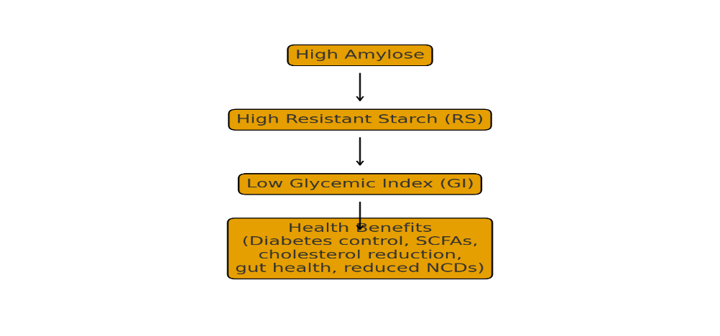
Figure 1. Flow diagram showing relationship between Amylose, Resistant Starch, Glycemic Index
Materials and Methods
The experimental trial was conducted at the Research Farm of the Division of Genetics and Plant Breeding, Faculty of Agriculture, Wadura, Sopore, over two consecutive kharif seasons (2022 and 2023) under field conditions. The site is situated at an altitude of 1584 m a.m.s.l., geographically positioned at 34°20'58"N latitude and 74°24'02"E longitude. Molecular analyses were carried out in 2024 under controlled laboratory conditions at the AICRP–NSP Laboratory, Shalimar, SKUAST-K, as well as at the Dryland Agriculture Research Station (DARS), Rangreth, SKUAST-K. A diverse panel of 100 white maize inbred lines along with three locally adapted check varieties was evaluated and maintained through bulk sibbing for two years (Table 1). For each genotype, five competitive plants were randomly selected for recording various metric traits at different vegetative and reproductive stages, and mean values were used for statistical analysis. However, days to 50% flowering and days to maturity were recorded on a plot basis.The entire test material was evaluated using an Augmented Block Design (ABD) (Federer, 1956) across the two field trials (2022 and 2023), both conducted at the same location. Each trial consisted of 10 blocks, with each block containing 10 test genotypes along with three locally adapted checks replicated across blocks. All genotypes (white maize inbred lines) were sown in rows spaced 0.10 m apart, with a plant-to-plant spacing of 0.20 m.
Protein content is determined by estimating the nitrogen content of the sample using the Kjeldahl method, and multiplying it by a conversion factor (usually 6.25), assuming that proteins contain approximately 16% nitrogen. Calculated as Nitrogen (%) = (V1​−V2​)×N×14.007×100​
W×1000
Crude Protein (%)=Nitrogen (%)×6.2 Where: (V1) = sample titration volume (mL), (V2) = blank titration volume (mL), (N) = normality of HCl, (W) = weight of sample (g).
Resistant starch was estimated by using Megazyme Resistant Starch Assay K-RSTAR1.
Calculated RS (%) = Glucose (mg)×0.9×100
Sample weight (mg)
The in vitro glycemic index simulates human digestion to estimate the rate of starch hydrolysis and glucose release. Calculate area Under the Hydrolysis Curve (AUC) for both sample and reference (glucose).Calculated as Hydrolysis Index (HI) = AUC of sample ×100​ / AUC of reference , Estimated GI = 39.71 + 0.549 × HI
AUC of reference

Table 1. List of White Maize Inbred Lines Used as Plant Material
PLANT MATERIAL
 | IC-213092 | 36. | IC-213187 | 71. | IC-254041
 | IC-213123 | 37. | IC-213188 | 72. | IC-213288
 | IC-213124 | 38. | IC-213287 | 73. | IC-213159
 | IC-213133 | 39. | IC-254010 | 74. | IC-213166
 | IC-213134 | 40. | IC-254011 | 75. | IC-213180
 | IC-213135 | 41. | IC-254012 | 76. | IC-213181
 | IC-213136 | 42. | IC-254022 | 77. | IC-213182
 | IC-213137 | 43. | IC-254023 | 78. | IC-213183
 | IC-213138 | 44. | IC-254024 | 79. | IC-253998
 | IC-213141 | 45. | IC-254027 | 80. | IC-253999
 | IC-213142 | 46. | IC-254051 | 81. | IC-2544000
 | IC-213144 | 47. | IC-254052 | 82. | IC-2544001
 | IC-213145 | 48. | IC-254053 | 83. | IC-2544002
 | IC-213289 | 49. | IC-254054 | 84. | IC-2544003
 | IC-213292 | 50. | IC-254055 | 85. | IC-253974
 | IC-213293 | 51. | IC-254056 | 86. | IC-253975
 | IC-213296 | 52. | IC-254004 | 87. | IC-253977
 | IC-213305 | 53. | IC-254005 | 88. | IC-253978
 | IC-213150 | 54. | IC-254006 | 89. | IC-253979
 | IC-213151 | 55. | IC-254007 | 90. | IC-253391
 | IC-213153 | 56. | IC-254008 | 91. | IC-253986
 | IC-213156 | 57. | IC-254009 | 92. | IC-253992
 | IC-213157 | 58. | IC-254028 | 93. | IC-253988
 | IC-213158 | 59. | IC-254029 | 94. | IC-253997
 | IC-213086 | 60. | IC-254030 | 95. | IC-253980
 | IC-213087 | 61. | IC-254031 | 96. | IC-253982
 | IC-213088 | 62. | IC-254034 | 97. | IC-253995
 | IC-213089 | 63. | IC-254035 | 98. | IC-253987
 | IC-213090 | 64. | IC-254036 | 99. | IC-213185
 | IC-213091 | 65. | IC-254037 | 100. | IC-213186
 | IC-213275 | 66. | IC-254038 | 101. | CHECK-1
 | IC-213283 | 67. | IC-254039 | 102. | CHECK-2
 | IC-213282 | 68. | IC-254040 | 103. | CHECK-3
 | IC-213279 | 69. | IC-213180
 | IC-213186 | 70. | IC-213180

Table 2. Agro-Morphological Traits and Stage of Observation in white Maize inbred lines
S.NO | Agro-Morphological Traits | Stage Of Observation
1. | Days to 50% tasseling | When 50% of plants show tassel emergence
2. | Days to 50% silking | When 50% of plants show silk emergence
3. | Anthesis-silking interval (ASI) | Difference between tasseling & silking days
4. | Days to maturity | When 80–90% plants reach physiological maturity
5. | Plant height (cm) | After maturity but before harvest
6. | Ear length (cm) | At harvest time
7. | Ear diameter (mm) | At harvest time
8. | Kernel rows per cob | At harvest time (manually count)
9. | No. of kernels per row | At harvest time (count on a cob row)
10. | Prolificacy | During/after maturity (number of ears per plant)
11. | Shelling % | After drying and shelling cobs
12. | 100-Seed Weight (g) | After harvest (air-dried or oven-dried seeds)
13. | Grain yield per plant (g) | After complete harvesting per plant

Statistical analysis
Under field conditions, the morphological data generated from the white maize inbred lines along with three checks were analyzed using an Augmented Block Design (ABD) in R software, which is widely recognized as one of the most sensitive, robust, and reliable statistical platforms. Significant differences among genotypes were determined based on critical differences (CD). Descriptive statistics—including mean, range, and coefficient of variation (CV%)—were computed from the adjusted means for each trait. Multivariate statistical methods were employed to assess trait variation and diversity patterns. Principal Component Analysis (PCA) was used to summarize the overall variability across all genotypes and traits, enabling simultaneous evaluation of multiple characters irrespective of dataset complexity. Hierarchical clustering was performed to group genotypes based on similarity or dissimilarity using Euclidean distances, and the resulting classification was represented through dendrograms.

Result and Discussion
Morphological characterization remains a fundamental approach for assessing variation and genetic diversity in plant breeding programs (Park et al., 2015; Vathana et al., 2019). Although influenced by environmental factors and often exhibiting lower polymorphism than molecular markers, it provides essential baseline information for evaluating genetic resources and understanding crop adaptation (Belalia et al., 2019; Schlichting, 1986). Distinctness, Uniformity, and Stability (DUS) characterization of 100 white maize inbred lines and three checks was conducted using the ICAR-IIMR DUS Descriptors (2021), covering traits related to plant, leaf, tassel, cob, and kernel morphology. The evaluation revealed wide variability for all recorded traits, demonstrating clear distinctiveness among genotypes and confirming the usefulness of morphological traits for classification and parental selection. Descriptive statistics for 2022 and 2023 further highlighted substantial phenotypic divergence across the inbred lines. In 2022, large ranges were observed for days to tasseling (51.33–94 days), plant height (96–254 cm), ear length (13.88–25.08 cm), kernel rows per cob (15.34–27.31), kernels per row (14.81–38), and yield per plant (68–134 g), reflecting broad genetic variability. The highest coefficients of variation were recorded for silking–tasseling interval (20.6%), ear diameter (12%), and prolificacy (11.2%). In 2023, similar patterns were recorded, with wide trait ranges and the highest CV% for silking–tasseling interval (12.2%), plant height (10.1%), and kernel rows per cob (9.6%). Across both years, the evaluated white maize inbred lines exhibited consistent variability in morphological and yield traits, highlighting their broad genetic base and potential for hybrid development. Substantial divergence was observed in flowering time, ear characteristics, and yield components, confirming the findings of Sofi et al. (2018) and Khodadadi et al. (2011) that wide phenotypic variation enhances adaptability and yield stability. High variability in key traits such as silking–tasseling interval, ear diameter, and prolificacy indicates strong genetic control and responsiveness to selection (Akinwale et al., 2017). Genotypes combining earliness, moderate plant height, longer ears, and higher kernel numbers emerged as promising parents, supporting their use in improving yield, adaptability, and stress tolerance (Kumar et al., 2020). These results are consistent with previous studies on maize genetic diversity (Beyene et al., 2005; Ranatunga et al., 2009; Shrestha et al., 2013; Iqbal et al., 2015).

Table 3. Descriptive Statistics of Agro-Morphological Traits in Maize Inbred Lines of year (2022)
S.NO | TRAITS | MEAN | MAX | MIN | RANGE | CV (%)
1. | DTT | 75.18 | 94 | 51.33 | 42.67 | 8.6
2. | DTS | 77.72 | 91.33 | 53.33 | 37.67 | 8.1
3. | STI | 2.54 | 3.33 | 1.67 | 1.66 | 20.6
4. | DTM | 134.85 | 158 | 120 | 38 | 4.7
5. | PH(cm) | 180 | 254 | 96 | 158 | 10.1
6. | EL(cm) | 18.60 | 25.08 | 13.88 | 11.2 | 8.2
7. | ED(mm) | 4.48 | 6.73 | 2.57 | 4.16 | 12
8. | RC | 21.03 | 27.31 | 15.34 | 11.97 | 9.9
9. | KR | 29.98 | 38 | 14.81 | 23.19 | 7.3
10. | PROF | 1.75 | 2.32 | 0.95 | 1.37 | 11.2
11. | SHELLING% | 72.86 | 87.67 | 51.30 | 36.37 | 3.9
12. | SW(g) | 27.87 | 36 | 17 | 19 | 7.2
13. | YIELD(g) | 94.98 | 134 | 68 | 66 | 7.1

The ANOVA results for 2022 and 2023 revealed highly significant treatment effects for most traits, confirming that genotypic differences were the major source of variation across both years. Wide variation in flowering traits, plant height, ear parameters, kernel traits, and yield demonstrated broad phenotypic expression among the inbred lines, independent of block effects. The Treatment (ignoring Blocks) component reflected overall genetic differences, while the Treatment: Test component more accurately captured variability among the test inbreds, indicating strong potential for selection and hybrid development. The Treatment: Test vs. Check comparison was also significant for several maturity, morphological, and yield traits in both years, showing that many test inbreds performed better than the checks in yield and maturity. Block effects were significant only for a few traits, suggesting minor environmental influence, while low residual variance confirmed good experimental precision. Slightly higher variability in 2022 for traits such as silking–tasseling interval, ear diameter, and prolificacy indicated broader phenotypic diversity that year, whereas 2023 showed more uniform expression for several yield-related traits, indicating stable performance and consistency among the inbreds. SEM values supported these patterns, with lower SEM for controls and higher SEM among test genotypes, particularly in 2022, indicating greater variability under that year’s environmental conditions. CD values at 5% significance were slightly higher in 2022 for some traits, further reflecting greater phenotypic variability, whereas the more consistent CD values in 2023 indicated stable trait expression. Overall, the ANOVA, SEM, and CD analyses collectively confirm the presence of substantial genetic variability, high experimental precision, and strong potential of the evaluated white maize inbred lines for effective selection, hybrid development, and yield improvement. These interpretations align with established ANOVA principles in plant breeding (Mowers et al., 2023; Vargas et al., 2015; Moore et al., 2021).

Table 4. Descriptive Statistics of Agro-Morphological Traits in Maize Inbred Lines of year (2023)
S.NO | TRAITS | MEAN | MAX | MIN | RANGE | CV(%)
1. | DTT | 72.93 | 88.77 | 41.43 | 47.34 | 8.7
2. | DTS | 75.72 | 90.77 | 51.43 | 39.34 | 8.3
3. | STI | 2.73 | 3.39 | 1.96 | 1.73 | 12.2
4. | DTM | 133.85 | 157.63 | 95.63 | 62 | 4.7
5. | PH(cm) | 184.69 | 268.48 | 122.56 | 145.92 | 10.1
6. | EL(cm) | 17.72 | 20.39 | 15.21 | 5.18 | 4.5
7. | ED(mm) | 4.46 | 5.49 | 3.71 | 1.78 | 6.0
8. | RC | 21.19 | 28.98 | 14.08 | 14.9 | 9.6
9. | KR | 28.86 | 39.11 | 19.61 | 19.5 | 5.7
10. | PROF | 1.83 | 2.51 | 1.31 | 1.2 | 5.3
11. | SHELLING% | 74.90 | 84.48 | 61.77 | 22.71 | 2.8
12. | SW(g) | 27.73 | 35.83 | 20.26 | 15.57 | 5.3
13. | YIELD(g) | 100.17 | 136.10 | 70.43 | 65.67 | 5.9
The PCA for 2022 and 2023 provided clear insights into the trait structure and variability among the white maize inbred lines. In 2022, four principal components with Eigenvalues >1 explained 74% of the total variation, with PC1 largely influenced by yield and maturity-related traits yield per plant, prolificacy, and shelling percentage indicating their major contribution to productivity. PC2 captured variation in ear diameter and kernel rows per cob, while PC3 and PC4 reflected differences in maturity duration, ear morphology, plant height, and silking–tasseling interval. Traits with vectors pointing in the same direction such as days to 50% tasseling, days to 50% silking , days to maturity, yield per plant, prolificacy, shelling percentage, kernel rows per cob, and ear diameter are positively correlated. plant height and silking –tasselling intervals vectors lie at a moderate angle from yield-related traits, suggesting a weak to moderate positive correlation with yield and maturity traits.The small angle between yield per plant, prolificacy, shelling percentage vectors indicates that these traits are closely associated and jointly contribute to overall productivity (Cattell, 1966; Franklin & Tan, 2004). In 2023, the first two components Eigenvalues >1 explained 71% of the total variation, with PC1 driven by yield-contributing traits yield per plant, kernel rows per cob, prolificacy, and kernels per row. while PC2 captured variability in plant height and flowering traits.Traits days to 50% tasseling , days to 50% silking , days to maturity, ear length , kernel rows per cob, grain yield , and shelling percentage have vectors pointing in the same direction, indicating strong positive correlation among these yield and phenolo

Table 5. Analysis of varaiance (ANOVA) for Agro-morphological Traits in Maize Inbred Lines ( Year 2022)

Source | Df | DTT | DTS | STI | DTM | PH | EL | ED | RC | KR | PROF | SHELL % | SW | YIELD
Treatment (ignoring Blocks) | 102 | 133.1** | 133.6** | 0.24 | 160.1** | 116.0 ** | 16.73** | 0.85** | 7.19 | 19.22** | 0.06 | 64.9 ** | 15.89** | 212.8**
Block (eliminating Treatments) | 9 | 86.1 | 86.4 | 0.14 | 462.8** | 517 | 6.08* | 1.83** | 9.93 | 3.13 | 0.07 | 42.6** | 7.49 | 521.7
Treatment: Check | 2 | 41.7 | 45.0 | 0.13 | 15.1 | 1206 | 1.35 | 0.08 | 0.32 | 7.42 | 0.02 | 1.2 | 2.71 | 34.2**
Treatment: Test | 99 | 130.6** | 130.7** | 0.25 | 162.2** | 1138** | 17.01** | 0.85** | 5.16 | 19.62** | 0.06 | 59.2** | 15.20** | 213.3**
Treatment: Test vs. Check | 1 | 567.7** | 597.1** | 0.37 | 242.3* | 2346** | 20.30** | 2.37* | 9.93 | 2.89 | 0.24* | 753.4** | 111.06** | 513.4**
Residuals | 18 | 43.5 | 41.3 | 0.28 | 40.9 | 347 | 2.42 | 0. 30 | 4.45 | 4.87 | 0.03 | 8.6 | 4.19 | 47.5

Table 6. Standard Error of Difference for Morphological and Yield Traits in Maize Inbred Lines (Year 2022)
Comparison | DTT | DTS | STI | DTM | PH | EL | ED | RC | KR | PROF | SHELL% | SW | YIELD
Two Control Treatments | 2.95 | 2.87 | 0.23 | 2.86 | 8.33 | 0.69 | 0.24 | 0.94 | 0.98 | 0.08 | 1.31 | 0.91 | 3.08
Two Augmented Treatments (Same Block) | 9.32 | 9.08 | 0.75 | 9.04 | 26.35 | 2.20 | 0.77 | 2.98 | 3.12 | 0.28 | 4.15 | 2.89 | 9.74
Two Augmented Treatments (Different Blocks) | 10.77 | 10.48 | 0.86 | 10.44 | 30.43 | 2.54 | 0.89 | 3.44 | 3.60 | 0.32 | 4.79 | 3.34 | 11.25
An Augmented Treatment and A Control Treatment | 7.98 | 7.77 | 0.64 | 7.74 | 22.56 | 1.88 | 0.66 | 2.55 | 2.67 | 0.24 | 3.55 | 2.47 | 8.34

Table 7. Critical Difference (CD) for Morphological and Yield Traits in Maize Inbred Lines (Year 2022)
Comparison | DTT | DTS | STI | DTM | PH | EL | ED | RC | KR | PROF | SHELL% | SW | YIELD
Two Control Treatments | 6.19 | 6.03 | 0.49 | 6.00 | 17.50 | 1.46 | 0.51 | 1.98 | 2.07 | 0.18 | 2.75 | 1.92 | 6.47
Two Augmented Treatments (Same Block) | 19.59 | 19.08 | 1.57 | 19.00 | 55.36 | 4.62 | 1.63 | 6.27 | 6.55 | 0.59 | 8.72 | 6.08 | 20.48
Two Augmented Treatments (Different Blocks) | 22.63 | 22.03 | 1.82 | 21.94 | 63.93 | 5.34 | 1.88 | 7.24 | 7.57 | 0.68 | 10.07 | 7.02 | 23.65
An Augmented Treatment and A Control Treatment | 16.78 | 16.34 | 1.34 | 16.27 | 47.41 | 3.69 | 1.39 | 5.37 | 5.61 | 0.50 | 7.47 | 5.20 | 17.54

Table 8. Analysis of varaiance (ANOVA) for Agro-morphological Traits in Maize Inbred Lines (Year 2023)
Source | Df | DTT | DTS | STI | DTM | PH | EL | ED | RC | KR | PROF | SHELL% | SW | YIELD
Treatment (ignoring Blocks) | 102 | 131.6** | 133.6 | 0.13 | 160.0** | 765.1* | 1.34* | 0.15* | 13.71** | 16.59** | 0.05** | 32.2** | 16.54** | 215.3**
Block (eliminating Treatments) | 9 | 84.3 | 86.4 | 0.13 | 469.2** | 656.7 | 0.47 | 0.21* | 15.47* | 10.86** | 0.10** | 16.6* | 8.57** | 544.2**
Treatment: Check | 2 | 44.0 | 45.0 | 0.02 | 13.7 | 1469.2 * | 3.42* | 0.11 | 1.97 | 1.87 | 0.004 | 6.5 | 0.12 | 17.1
Treatment: Test | 99 | 128.9** | 130.7** | 0.13 | 162.2** | 741.0* | 1.25 | 0.15* | 12.34** | 14.99** | 0.05** | 29.5** | 14.90** | 215.5**
Treatment: Test vs. Check | 1 | 571.6** | 597.1** | 0.25 | 237.3* | 1746.4* | 6.45* | 0.31 | 171.96** | 204.10** | 0.15** | 351.6** | 212.00** | 593.2**
Residuals | 18 | 42.3 | 41.3 | 0.28 | 41.6 | 354.8 | 0.63 | 0.07 | 4.40 | 2.91 | 0.009 | 4.6 | 2.34 | 36.3

Table 9. Standard Error of Difference for Morphological and Yield Traits in Maize Inbred Lines (Year 2023)
Comparison | DTT | DTS | STI | DTM | PH | EL | ED | RC | KR | PROF | SHELL% | SW | YIELD
Two Control Treatments | 2.90 | 2.87 | 0.14 | 2.86 | 8.42 | 0.35 | 0.12 | 0.93 | 0.76 | 0.04 | 0.96 | 0.68 | 2.69
Two Augmented Treatments (Same Block) | 9.19 | 9.08 | 0.44 | 9.11 | 26.63 | 1.12 | 0.38 | 2.96 | 2.41 | 0.14 | 3.04 | 2.16 | 8.51
Two Augmented Treatments (Different Blocks) | 10.61 | 10.48 | 0.51 | 10.53 | 30.75 | 1.30 | 0.44 | 3.42 | 2.78 | 0.16 | 3.51 | 2.49 | 9.83
An Augmented Treatment and A Control Treatment | 7.87 | 7.77 | 0.38 | 7.80 | 22.81 | 0.96 | 0.33 | 2.53 | 2.06 | 0.12 | 2.60 | 1.85 | 7.29

Table 10. Critical Difference (CD) for Morphological and Yield Traits in Maize Inbred Lines (Year 2023)

Comparison | DTT | DTS | STI | DTM | PH | EL | ED | RC | KR | PROF | SHELL% | SW | YIELD
Two Control Treatments | 6.10 | 6.03 | 0.29 | 6.05 | 17.69 | 0.74 | 0.25 | 1.97 | 1.60 | 0.09 | 2.02 | 1.43 | 5.65
Two Augmented Treatments (Same Block) | 19.31 | 19.08 | 0.93 | 19.15 | 55.96 | 2.37 | 1.81 | 6.23 | 5.06 | 0.29 | 6.38 | 4.54 | 17.89
Two Augmented Treatments (Different Blocks) | 22.30 | 22.03 | 1.07 | 22.12 | 64.62 | 2.73 | 0.93 | 7.19 | 5.85 | 0.34 | 7.37 | 5.24 | 20.66
An Augmented Treatment and A Control Treatment | 16.53 | 16.34 | 0.80 | 16.40 | 47.92 | 2.03 | 0.69 | 5.33 | 4.33 | 0.25 | 5.47 | 3.89 | 15.32

in the same direction, indicating strong positive correlation among these yield and phenological traits. Plant height, though slightly separated, remained positively associated with key yield traits.Traits likekernel rows per cob, no. of kernel rows per cob, shelling percentage and prolificacy cluster closely, implying that increases in kernel number and shelling efficiency contribute directly to grain yield. Overall, PCA across both years showed that yield and phenological traits consistently dominated the major components, confirming their central role in productivity and genetic differentiation among the inbred lines. Minor year-to-year differences—such as a stronger influence of vegetative and maturity traits in 2022—indicate stable but slightly shifting trait relationships under varying environmental conditions (Kovacic, 1994; Jolliffe, 2016; Franklin & Tan, 2004).
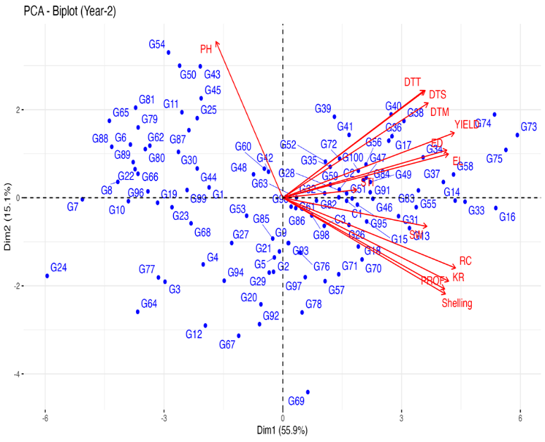
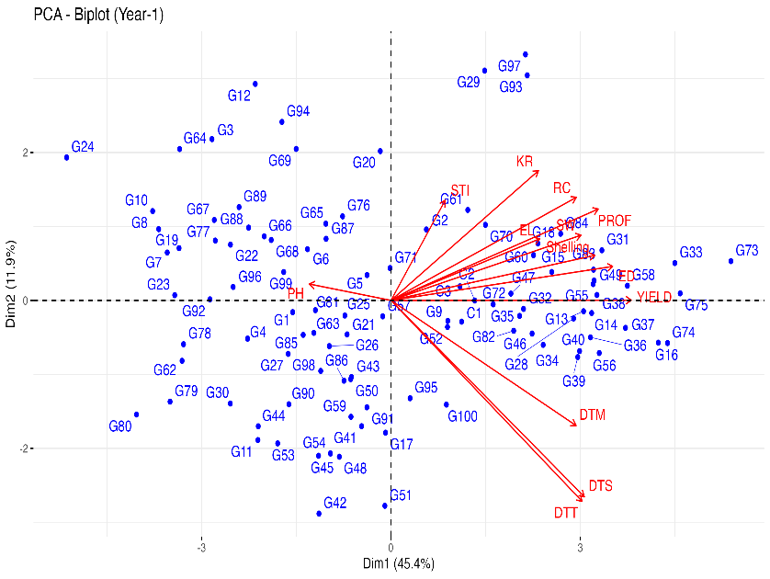

Figure 2&3 PCA biplot showing distribution of 100 maize inbred lines along with 3 checks and their relationship with morphological and yield-contributing traits (Years 2022 &2023)
Table 11. Eigen values of principal components (Year 2022)
Component | Eigen value | Variance percentage | Cumulative variance percentage
PCA.1 | 5.90 | 45.3 | 45.39
PCA.2 | 1.54 | 11.8 | 57.26
PCA.3 | 1.09 | 8.45 | 65.71
PCA.4 | 1.07 | 8.23 | 73.95
PCA.5 | 0.79 | 6.10 | 80.05
PCA.6 | 0.63 | 4.85 | 84.90
PCA.7 | 0.53 | 4.11 | 89.01
PCA.8 | 0.45 | 3.49 | 92.51
PCA.9 | 0.33 | 2.55 | 95.06
PCA.10 | 0.28 | 2.14 | 97.21
PCA.11 | 0.20 | 1.56 | 98.77
PCA.12 | 0.16 | 1.22 | 99.99
PCA.13 | 0.02 | 0.01 | 100

Table 12. Contribution (%) Of Various Traits Towards Different Principal Components (Year 2022)
S.NO | TRAITS | PCA1 | PCA2 | PCA3 | PC4 | PCA5
1. | DTT | 8.62 | 6.77 | 1.13 | 1.72 | 0.00
2. | DTS | 8.83 | 6.55 | 0.75 | 2.46 | 0.03
3. | STI | 0.69 | 14.10 | 20.67 | 35.01 | 27.47
4. | DTM | 8.09 | 3.77 | 9.47 | 0.24 | 1.19
5. | PH(cm) | 1.57 | 5.12 | 8.34 | 50.59 | 23.71
6. | EL(cm) | 5.21 | 6.47 | 37.34 | 0.13 | 7.18
7. | ED(mm) | 11.60 | 15.19 | 0.01 | 1.77 | 1.99
8. | RC | 8.11 | 14.80 | 7.31 | 1.74 | 5.11
9. | KR | 5.13 | 3.85 | 6.23 | 0.11 | 14.85
10. | PROF | 10.14 | 4.22 | 4.19 | 4.49 | 0.86
11. | SHELLING% | 9.80 | 4.32 | 2.08 | 0.06 | 17.16
12. | SW(g) | 8.52 | 7.03 | 0.39 | 1.37 | 0.17
13. | YIELD(g) | 13.63 | 7.03 | 2.01 | 0.24 | 0.23

Table 13. Eigen values of principal components (Year 2023)

Component | Eigen value | Variance percentage | Cumulative variance percentage
PCA.1 | 7.27 | 55.93 | 55.93
PCA.2 | 1.95 | 15.05 | 70.98
PCA.3 | 0.95 | 7.35 | 78.34
PCA.4 | 0.76 | 5.88 | 84.23
PCA.5 | 0.59 | 4.61 | 88.84
PCA.6 | 0.41 | 3.17 | 91.7
PCA.7 | 0.36 | 2.81 | 94.83
PCA.8 | 0.20 | 1.57 | 96.41
PCA.9 | 0.15 | 1.17 | 97.58
PCA.10 | 0.12 | 0.99 | 98.58
PCA.11 | 0.10 | 0.78 | 98.93
PCA.12 | 0.08 | 0.62 | 99.99
PCA.13 | 0.00 | 0.00 | 100.00

S.NO | TRAITS | PCA1 | PCA2 | PCA3 | PC4 | PCA5
1. | DTT | 6.97 | 12.08 | 13.24 | 16.12 | 0.01
2. | DTS | 7.09 | 12.08 | 11.52 | 17.09 | 0.02
3. | STI | 1.91 | 0.06 | 64.07 | 30.91 | 0.29
4. | DTM | 7.39 | 9.43 | 0.76 | 0.97 | 5.31
5. | PH(cm) | 1.56 | 25.65 | 3.17 | 3.35 | 34.98
6. | EL(cm) | 9.60 | 2.01 | 3.30 | 8.51 | 4.44
7. | ED(mm) | 9.41 | 2.37 | 0.96 | 10.57 | 2.27
8. | RC | 10.43 | 5.18 | 0.02 | 0.00 | 4.76
9. | KR | 9.62 | 7.31 | 0.58 | 0.07 | 0.17
10. | PROF | 9.16 | 8.75 | 0.58 | 0.68 | 3.23
11. | SHELLING% | 9.25 | 9.73 | 0.01 | 0.15 | 0.57
12. | SW(g) | 7.26 | 0.86 | 0.25 | 3.74 | 41.06
13. | YIELD(g) | 10.29 | 4.43 | 1.47 | 7.79 | 2.83
Table 14. Contribution (%) Of Various Traits Towards Different Principal Components (Year 2022)
The hierarchical cluster analysis based on morphological and yield-related traits revealed significant genetic diversity among the 100 maize inbred lines, which were grouped into four distinct clusters. Smaller intra-cluster distances compared to inter-cluster distances indicated genetic similarity within clusters and strong divergence between them. The highest inter-cluster distance (90.03) between Clusters III and IV identified these groups as the most genetically divergent, making them valuable parental candidates for heterosis breeding (Mohammadi & Prasanna, 2003; Legesse et al., 2006). Cluster mean patterns showed that Cluster IV contained high-yielding genotypes, while Cluster III represented early-maturing but lower-yielding lines, suggesting their complementary breeding potential. Overall, the hierarchical cluster analysis effectively classified the maize inbred lines into genetically distinct groups, each representing unique combinations of agronomic and physoilogical attributes The clustering results align closely with PCA outcomes, confirming the presence of considerable genetic variability among the white maize inbred lines. The pronounced divergence, particularly between Clusters III and IV, highlights strong opportunities for selecting diverse parents to enhance hybrid development and yield improvement (Adu et al., 2019; Tulu et al., 2021).

Table 15. Intra And Inter-Cluster Distance Among Clusters
Trait | Cluster 1 | Cluster 2 | Cluster 3 | Cluster 4
Cluster 1 | 33.95 | 52.35 | 57.27 | 61.87
Cluster 2 | 52.35 | 33.15 | 57.36 | 47.21
Cluster 3 | 57.27 | 57.36 | 27.89 | 90.03
Cluster 4 | 61.87 | 47.21 | 90.03 | 18.72

Table 16. Cluster Means
S.NO | Traits | Cluster 1 | Cluster 2 | Cluster 3 | Cluster 4
1. | DTT | 84.02 | 70.50 | 59.27 | 84.25
2. | DTS | 86.85 | 73.13 | 61.72 | 87.00
3. | STI | 2.68 | 2.51 | 2.36 | 2.60
4. | DTM | 143.72 | 131.23 | 118.77 | 144.35
5. | PH(cm) | 206.91 | 174.16 | 218.53 | 151.01
6. | EL(cm) | 19.07 | 17.60 | 16.90 | 20.93
7. | ED(mm) | 4.70 | 4.32 | 3.94 | 5.10
8. | RC | 21.88 | 20.80 | 18.10 | 23.53
9. | KR | 30.21 | 28.59 | 27.40 | 33.06
10. | PROF | 1.85 | 1.76 | 1.57 | 1.98
11. | SHELLING% | 75.65 | 72.76 | 67.15 | 80.28
12. | SW(g) | 28.71 | 27.50 | 23.95 | 30.58
13. | YIELD(g) | 104.90 | 93.01 | 84.54 | 114.57

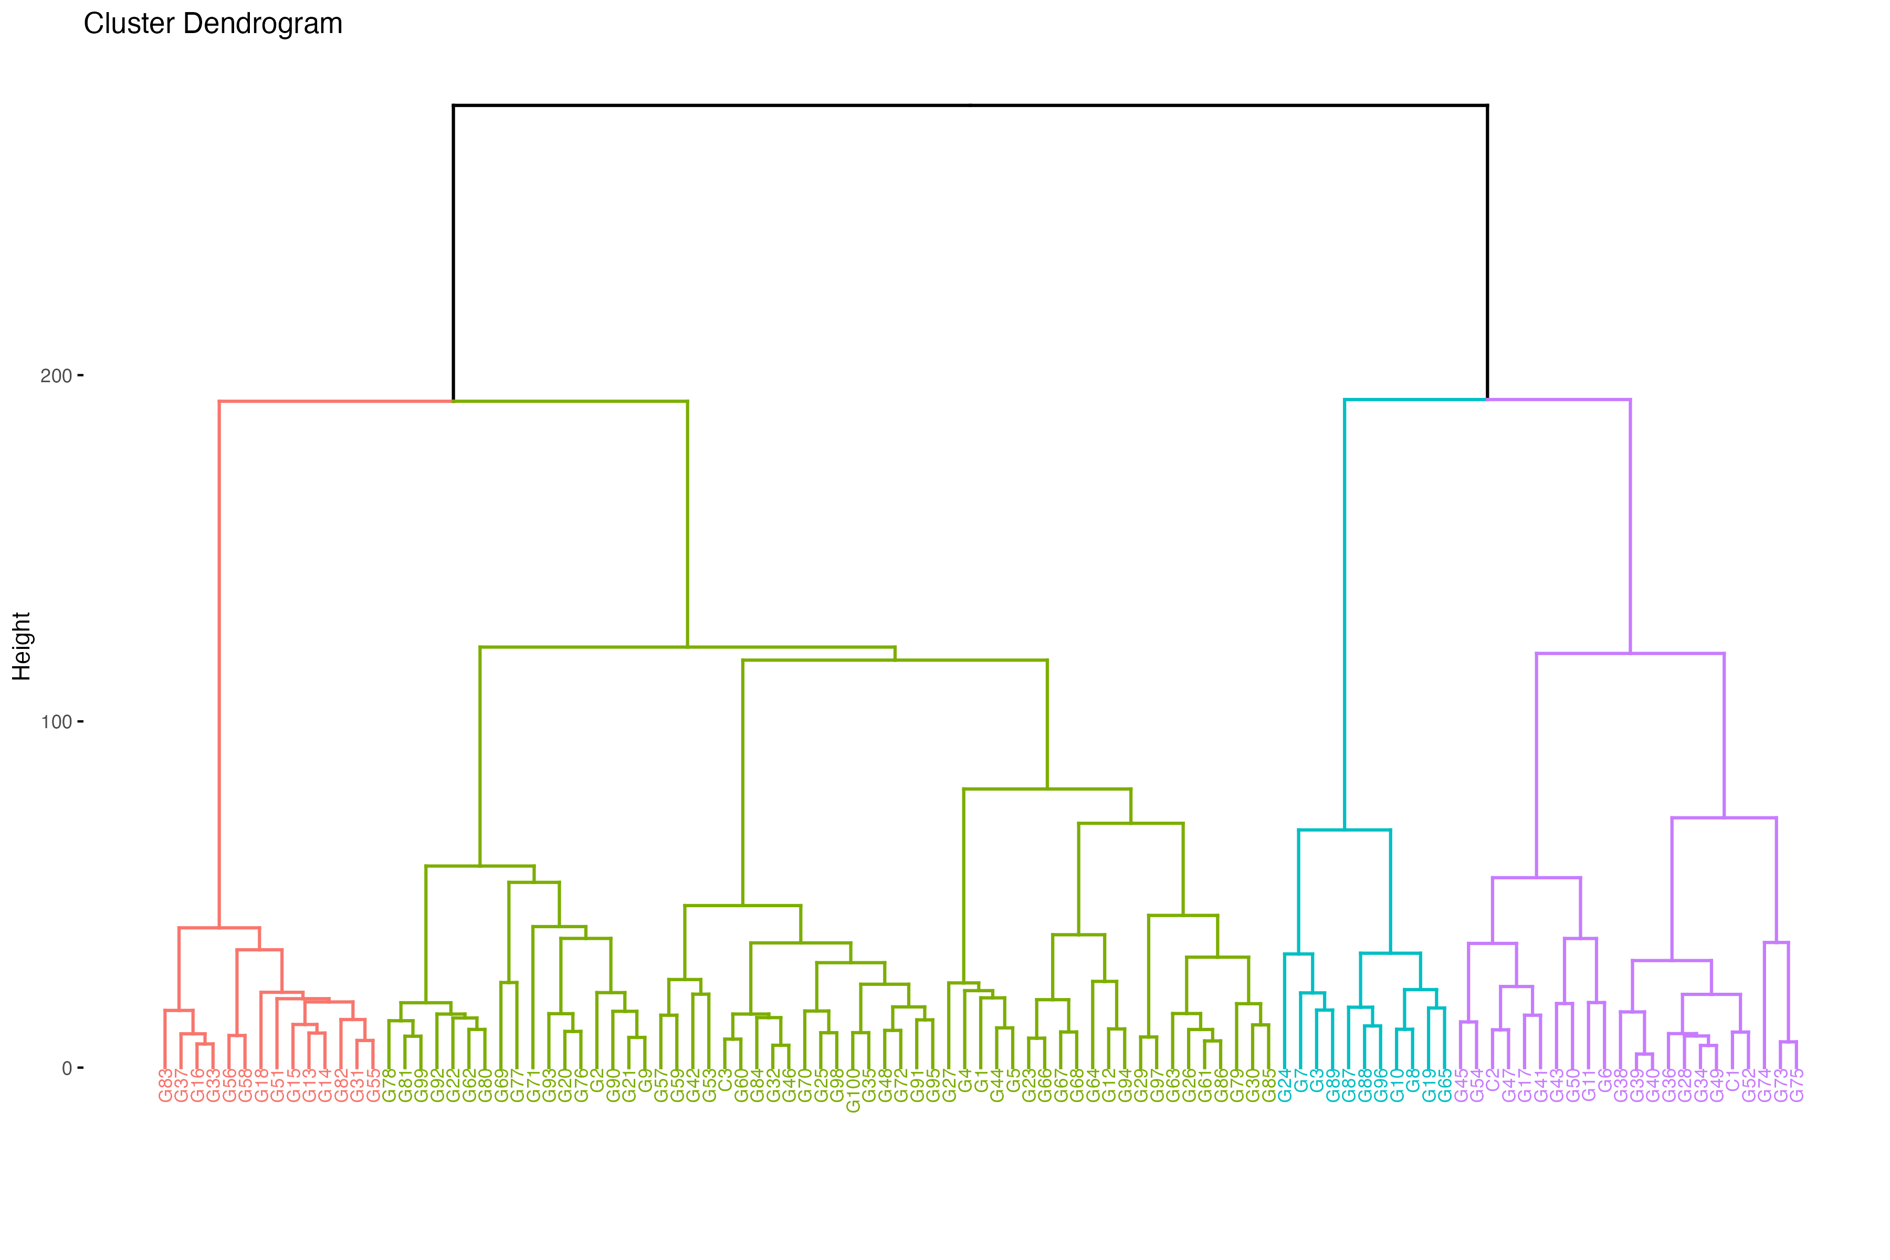

Figure 4. Cluster Dendrogram

Biochemical profiling of white maize inbred lines
Biochemical analysis of 20 selected white maize inbred lines revealed substantial variability in glycemic index (GI), protein content, and resistant starch (RS), indicating significant nutritional diversity (Bello et al., 2019; Singh et al., 2021). GI values ranged from 54.68 (G37) to 75.60 (G35), identifying both low- and high-GI genotypes. Based on standard classification, G37, G41, G72, G63, G76, G78, G77, G91, G66, and G4 exhibited low GI (< 60), suggesting suitability for developing low-GI food products for diabetic and health-conscious consumers (Liu et al., 2020). In contrast, G33, G60, G38, G15, and G35 recorded high GI (> 70), making them potentially useful for energy-dense products (Choi et al., 2018).
Protein content varied from 7.58% (G32) to 12.69% (G37), with G37, G41, G72, G63, and G76 showing higher levels (>10%), identifying them as promising sources for nutritional improvement and biofortification programs (Ojo et al., 2020). RS content ranged from 0.76% to 5.42%, with the highest values recorded in G72 (5.42%), G41 (5.25%), G37 (5.03%), and G77 (4.88%), indicating their potential for functional food applications due to the association of RS with reduced postprandial glucose response and improved gut health (Englyst & Hudson, 2013; Fuentes-Zaragoza et al., 2011).
An inverse relationship was observed between GI and both protein and RS, where genotypes with higher protein and RS generally exhibited lower GI (e.g., G37, G41, G72), highlighting the role of compositional balance in regulating starch digestibility and glycemic response (Bello et al., 2019). Overall, the observed variation offers valuable opportunities for simultaneous selection of low-GI, high-protein, and high-RS genotypes, supporting nutritional breeding and functional food development (Singh et al., 2021; Ojo et al., 2020).
Table 17. Nutritional Profiling of Selected Accessions Based on Biochemical Traits
S.NO. | Genotypes | Glycemic Index | Protein (%) | Resistant Starch (%)
1. | G37 | 53.68 | 12.69 | 5.59
2. | G41 | 54.72 | 12 | 5.25
3. | G72 | 55.36 | 11.07 | 5.12
4. | G63 | 57.6 | 10.99 | 4.55
5. | G76 | 54.9 | 10.89 | 4.63
6. | G78 | 56.2 | 10.86 | 4.71
7. | G77 | 58 | 10.77 | 4.88
8. | G91 | 59.1 | 10.63 | 4.18
9. | G66 | 55.75 | 10.58 | 4.3
10. | G4 | 57 | 10.53 | 4.4
11. | G32 | 60.1 | 7.58 | 0.76
12. | G31 | 61.25 | 8.03 | 1.68
13. | G80 | 63.8 | 8.06 | 1.9
14. | G56 | 65 | 8.23 | 2.14
15. | G27 | 66.45 | 9.08 | 2.45
16. | G33 | 68.7 | 9.13 | 2.83
17. | G60 | 70.55 | 9.38 | 3.12
18. | G38 | 72.1 | 9.39 | 3.47
19. | G15 | 74 | 9.54 | 3.79
20. | G35 | 75.6 | 9.71 | 3.06

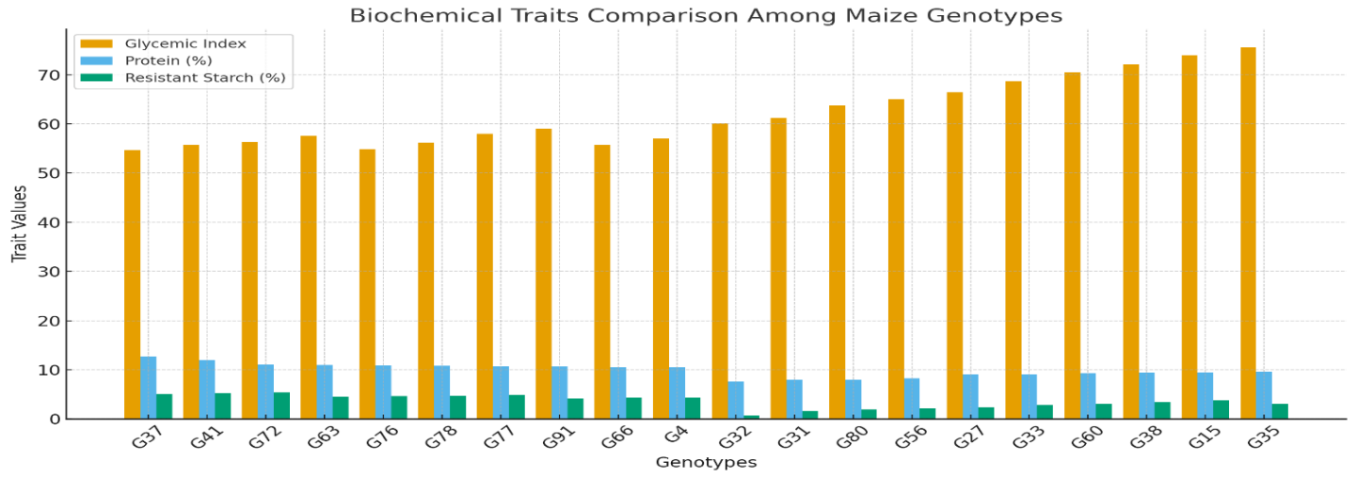
Figure 5. Bar Chart of Nutritional Profiling of Selected Accessions Based on Biochemical Traits

Conclusion
The present investigation demonstrated substantial agro-morphological, biochemical, and molecular variability among 100 white maize inbred lines evaluated under temperate agro-climatic conditions. Significant diversity was observed for key yield- and maturity-related traits, along with considerable variation in resistant starch, glycemic index, and protein content. Multivariate analyses confirmed clear genetic differentiation and enabled the grouping of genotypes into distinct heterotic clusters. The integration of morphological and biochemical results facilitated the identification of promising and genetically diverse inbred lines with desirable agronomic performance and enhanced nutritional attributes. These superior inbreds offer valuable parental resources for breeding high-yielding, early-maturing, low-GI, and high-RS white maize hybrids specifically adapted to temperate environments. Overall, the study provides a strong foundation for targeted hybrid development, heterotic group formation, and future improvement strategies aimed at strengthening white maize breeding and supporting food and nutritional security in temperate regions.

COMPETING INTERESTS DISCLAIMER:
Authors have declared that they have no known competing financial interests OR non-financial interests OR personal relationships that could have appeared to influence the work reported in this paper.

References
Adu, G. B., Badu-Apraku, B., Akromah, R., & Garcia-Oliveira, A. L. (2019). Genetic diversity and population structure of extra-early maturing quality protein maize inbreds using SNP markers. Plant Breeding, 138, 100–111.

Akinwale, R. O., Badu-Apraku, B., Fakorede. M .A. B and Vroh-Bi I. (2017). Heterotic grouping of tropical early-maturing maize inbreds and hybrid performance under stress and optimal conditions. Crop Science 57(2): 1–12.

AOAC. 2005. Official Methods of Analysis of AOAC International. 18th Edn. Association of Official Analytical Chemists, Washington DC, USA.

BeMiller, J N. (2009). Starch: Chemistry and Technology. 3rd Edn. Academic Press, London.
Behall, K.M., and Hallfrisch, J. (2002). Plasma glucose and insulin reduction after consumption of breads varying in amylose content. European Journal of Clinical Nutrition 56(9): 913–920.
Belalia, N., Benmahammed, A., Sahnoune, M and Merah, O. (2019). Morphological characterization of maize genotypes. Agronomy Research 17(5): 1973–1985..
Bennetzen, J. L. (2009). Maize genome structure and evolution. Plant Physiology 149(1): 5–12.
Beyene, Y., Botha, A.M and Myburg, A .A. (2005). Genetic diversity in maize inbreds. Euphytica 146: 1–14.
Bird, A .R and Regina, A. (2018). Resistant starch and human health: An overview. Functional Foods in Health and Disease 8(7): 357–371.
Carciofi, B .A. M, et al. (2012). Resistant starch and its effects on glucose metabolism. Journal of Agricultural and Food Chemistry 60(18): 4583–4589.
Cattell, R. B. (1966). The scree test for the number of factors. Multivariate Behavioral Research 1(2): 245–276.
Choi, H .Y., Woo, K. S., Sohn, B. H., Park, J. D., Kim, H. Y and Lee, J. S. (2018). Physicochemical and nutritional characteristics of high-amylose maize starch for food applications. Journal of Cereal Science 79: 16–23.
Coe, E.H., Neuffer, M. G and Hoisington, D .A. (1988). The genetic system. In: Corn and Corn Improvement.11: 81–258.
Englyst, H.N., Kingman, S.M and Cummings, J.H.(1992). Classification and measurement of nutritionally important starch fractions. European Journal of Clinical Nutrition.46: S33–S50.
Englyst, H. N and Hudson, G. J. (2013). Classification and measurement of nutritionally important starch fractions. European Journal of Clinical Nutrition 46: S33–S50.
Federer, W .T. (1956). Augmented designs. Hawaiian Planters’ Record 55: 191–208.
Franklin, S. B., Gibson, D. J., Robertson, P .A., Pohlmann, J .T and Fralish, J. S. (200). Parallel analysis: A method for determining significant principal components. Journal of Vegetation Science 12(1): 23–30.
Fuentes-Zaragoza, E., Riquelme-Navarrete, M. J., Sánchez-Zapata, E and Pérez-Álvarez, J. A. (2011). Resistant starch as functional ingredient: A review. Food Engineering Reviews 3(3-4): 164–176.
Gerdes, J .T, et al. (1994). Compilation of North American Maize Breeding Germplasm. Iowa State University Press, USA.
Goñi, I., García-Alonso, A and Saura-Calixto, F. (1997). A starch hydrolysis procedure to estimate glycemic index. Nutrition Research 17(3): 427–437.
Goodman, M.M and Brown, W. L. (1988). Races of corn. International Corn and Corn Improvement 9: 33–79.
Haini, N., et al. 2021. Resistant starch and metabolic disease prevention. Food Chemistry 345: 128–766.
Han, X., et al. 2021. Structural characteristics of amylose and amylopectin. International Journal of Biological Macromolecules 184: 1000–1012.
Hashimoto, S.(2006). Dietary fibre and cholesterol metabolism. Journal of Nutritional Biochemistry 17(9): 567–573.
ICAR-IIMR. (2021). Maize DUS Guidelines and Descriptor List. ICAR-Indian Institute of Maize Research, New Delhi.
Iqbal, M., Khan, S .A and Alam, M. (2015). Genetic divergence and variability studies in maize. Journal of Agricultural Sciences 7(1): 87–97.
Jolliffe, I. T. (2016). Principal Component Analysis. 2nd Edition. Springer, New York.
Khodadadi, M., Fotokian, M. H and Miransari, M. (2011). Genetic diversity in maize for agronomic traits. Crop Science 51: 544–552.
Kovačić,,Z. (1994). Application of principal component analysis in agronomic research. Agronomy Journal 86(5): 850–854.
Kumar, A., Singh, S. K., Singh, S. P, et al. (2020). Genetic variability, correlation and path analysis. International Journal of Current Microbiology and Applied Science 9(4): 2210–2216.
Liu, Q., Donner, E., Yin, Y., Huang, R. L and Fan, M .Z. (2020). The effects of starch structure on digestibility. Critical Reviews in Food Science and Nutrition 60(14): 2383–2404.
Man, S., et al. (2012). Resistant starch as a functional ingredient. Food Hydrocolloids 28: 10–21.
Megazyme.(2019). K-RSTAR Resistant Starch Assay Procedure. Megazyme International Ireland Ltd.
Moore, K. J., Dixon, P. M and Moser, L.E. (2021). Analysis of variance and experimental design. Agronomy Journal 113(6): 4753–4769.
Mowers, R. P., Borem, A., Goodman, M.M and Doebley, J. (2023). Statistical approaches. Journal of Plant Breeding and Genetics 55(1): 45–58.
Ojo, D.K., Ajala, S.O., Ibikunle, O., Ogunbodede, B. A and Adebayo, M.A. (2020). Assessment of protein and nutrient variability Maydica 65: 1–8.
Park, B. M, et al. 2015. Morphological diversity in maize breeding. Plant Genetic Resources.
Poneleit, C. G. (2001). Breeding white endosperm maize. Plant Breeding Reviews 21: 135–172.
Rafalski, A and Morgante, M. (2004). Corn and humans: parallels in genetics. Nature Reviews Genetics 5: 794–805.
Ranatunga, M. A, Lafitte, H. R and Bertram, M. G. (2009). Crop improvement for drought tolerance. Field Crops Research 112(1): 34–40.
Schlichting, C. D.(1986). Phenotypic plasticity in plants. Annual Review of Ecology and Systematics. 17: 667–693.
Shrestha, J., Prasai, H., et al. (2013). Variability for morphological and yield traits in maize. Journal of Maize Research. 2(1): 34–41.
Singh, R., Kaur, A., Singh N and Kataria M.(2021). Relationship of starch digestibility . Food Chemistry 337: 127798.
Sofi, P. A., Zargar, M. Y., Rather, A. G., et al. (2018). Assessment of genetic variability and trait association in maize. SKUAST Journal of Research 20(1): 13–22.
Troyer, A. F. (1999). Background and history of the maize crop. Crop Science 39(5): 1495–1510.
Vargas, M., Crossa, J., Reynolds, M., et al. (2015). Genotype × environment interaction .Crop Science 55(2): 505–518.
Vathana, E., et al. (2019). Characterization of maize germplasm using morphological markers.
Wallace, J. G, Bradbury, P. J., Zhang, N, et al. (2013). Association mapping. Nature Genetics. 46(1): 11–16.
Watson, S .A. (1988). Corn marketing, processing and utilization. International Corn and Corn Improvement. 881–940.
Zhong, Y., et al. (2020). Structural and physicochemical properties of maize starch. Carbohydrate Polymers 230: 115–631.

