Epigenetic Landscape of Ankylosing Spondylitis: Mechanisms, Biomarkers, and Therapeutic Implications

ABSTRACT
Ankylosing spondylitis is a chronic etiological disorder, a prototype of spondyloarthritidis that mainly result in inflammation of spine and sacroiliac joints leading to back pain, uveitis peripheral joint arthritis, stiffness whose exact cause of pathogenesis remains undiscovered though whose progression can damage vertebra promoting disability and deformities. The Disease reduces functioning ability of body including neuroskeletal, cardiovascular, muscle function loss with untreated condition leading to bamboo spine therefore pertaining to early diagnosis. Epigenetic biomarkers are studied for their role as diagnostic biomarkers for detection of ankylosing spondylitis to be an autoimmune disorder correlated with HLA B27 gene. Epigenetics including DNA methylation, histone effect and noncoding RNA expression spotlighted besides significant markers for cancer highlighting the Major role played by human leukocyte antigen HLA B27. Combining genetics with physiology and dynamics, development of diagnostic approach for the disorder was possible. The study presents achievements in the field of the disorder focusing on problematic mechanisms and issue in understanding disease progression emphasizing important role in tissue differentiation and changes in phenotype associated with epigenetic pattern. With the help of transcriptome, it is detected that the genes on promoter region that are high methylated are more likely off state however genes on promoter with less or no methylation can be on or off state depending on methylation patterns , hypermethylation or hypomethylation on DNA, and can be used as diagnostic biomarkers. Histone epigenetic markers such as H3K9AC relation to specific genes requires immunoprecipitation technique and is under research with contribution of diverse methylation rates and areas effecting expression of specific disease related alleles.
Keywords: Ankylosing spondylitis, spondyloarthritis, hypermethylation ,hypomethylation, epigenetic biomarkers , bamboo spine, sacroiliac joints
GRAPHICAL ABSTRACT
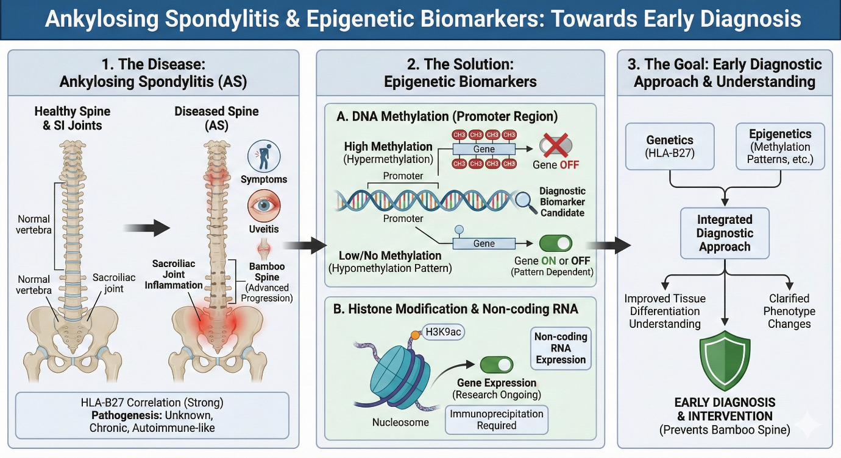
INTRODUCTION
Ankylosing spondylitis is an etiological syndrome which often bears challenges in terms of disease diagnosis and detection, progression of the disease by stages and disease activity thereby delaying and complexing the treatment. However, with knowledge to the pathogenesis of the disease at a prior basis certain specific biomarkers have been identified that have potential to independently act for defining the various phases of disease management and assessment. [1].
Ankylosing spondylitis is classified as an autoimmune perifibrocartilage disorder affecting spine and sacroiliac joints with direct influence from genetic predisposition, environmental triggers, infection and immune response alterations [2]. Genetic aspects were considered the most significant determinant for the risk of the disease however with latest research and developments in the recent years’ epigenetics have come to light with rapid simultaneous surveys being conducted for identifying the relation of DNA methylation with pathogenesis and disease progression. Several articles highlight the process of whole genomic sequence for determination of differentially methylated regions of the promoters in specific genes [3]. Role of methylases in inflammation, new bone formation Bone differentiation have been stated to further signify DNA methylation correlation to the ankylosing occurrence and development.
The combinatory role of environmental factors and genetic predisposition along with epigenetics in the pathogenesis of the disorder has been detected. Summarizing the reports led to emphasising abrupt unusual methylation and epigenetic modification at the ankylosing spondylitis associated loci including DNA methylation, long non coding mRNA expression and histone effect. [4] The HLA genes associated with progression of the disorder is the leukocyte antigen hlab27 and its subtypes with Non HLA genes involved in ubiquitination and MHC class1 presentation molecules such as ERAP1 detected for their roles. Genetic variation and epigenesist with environment influence resulted in triggered progression of ankylosing spondylitis. [5][6]
1. EPIGENETIC MARKERS SHAPING ANKYLOSING SPONDYLITIS
Epigenetic modification can be as help for accounting to the missing heritability of ankylosing spondylitis. Studies were conducted that Aimed to acquire more spondylitis related DNA methylation variation and regulatory effect on the expression of non-coding RNA s with detailed analysis of transcriptome and differential methylated areas. For the purpose, peripheral mononuclear blood cells were collected from both ankylosing effected patients and healthy controls in ratio of 30:15. Validation of methylome independently in cohort [7], casual interference test performed for detection of effect of DNA methylation on RNA expression. Set of differentially methylated areas were identified and those in association with ankylosing spondylitis disorder were validated in cohort. Highlight of t cell receptor and th17 differentiation pathway from the both individual cohorts were noted. When the methylation levels from differentially methylated positions were co related with mRNA expression genes it formed an interconnected network concentrating on the t cell receptor pathway and differentiation. The Study also spotlighted several cis acting DNA methylation element and thereby bringing out a change of expression of non-coding RNA associating with ankylosing spondylitis disease. [8][9]
Ankylosing spondylitis determined to be a prototype of spondyloarthritis , a heritable disorder characterized by inflammation of joints, spine with major involvement of axial skeleton. Besides major histocompatibility complex presenters, allele hlab27 ,other non MHC associations were detected to be involved such as interleukin 23 ,interleukin17 genes ,however most part of loci cannot be defined with their location in the non-coding areas. Besides the genetic variation accounting for heritability, a major part of loci undetectable uphold its contribution in the progression of the disease and accounting for the missing heritability. [10]
1.1 ROLE OF EPIGENETIC MECHANISMS IN ANKYLOSING SPONDYLITIS
Epigenetics Refer to modification of functional activity of DNA with change in chromatin sequence resulting in variation of gene expression without having any change in the underlying DNA sequence.[11]
TRANSCRIPTION AFFECTED BY DNA METHYLATION
Methyl groups are added by DNA methyltransferases to the 5th carbon of cytosine base of CPG in DNA. The promoter region of the CPG site is heavily methylated thereby reducing DNA availability, with no binding of transcription factors transcription for converting to mRNA does not take place, as a result no production of functional proteins. In case of ankylosing spondylitis certain genes being hypermethylated, their expression get decreased and they are turned off for example HYPERMETHYLATION of B7H3 promoter affects t cell regulation .When unmethylated the promoter region of gene are free from methyl groups thereby DNA accessibility by transcription factors is increased leading to enhanced transcription and generation of mRNA leading to formation of proteins. In case of ankylosing spondylitis interleukins and other inflammatory cytokines are released actively due to unmethylation of inflammatory genes leading to inflammation, finally promoting onset.
HISTONE MODIFICATION EFFECT
Chromatin network forms when DNA wraps around histone proteins to form nucleosomes and these nucleosomes in a beads on string structure are responsible for success of transcription. Histone tails are modified by acetylation or methylation. When acetylated histones modified, unwinding of DNA enhances transcription keeping the genes turned on. When unmodified histones are engaged in a closed network, being tightly packed prevent binding of transcription factors hampering transcription. H3K27 methylation at the repressive sites reduces transcription. In case of ankylosing spondylitis methyltransferases such as EZH2 increases methylation of H3K27ME3 thereby silencing immune genes for protection preventing generation or secretion of cytokines. JMJD3 demethylases promotes reduction of methylation thereby increased expression of genes triggering secretion of pro inflammatory cytokines, increasing inflammation produced by an outcome of helper t 17 cells expansion and unusual t cell activity.
NON CODING RNA CONTRIBUTING IN REGULATION
Micro RNA binding to mRNA prevent translation and thereby formation of protein. In case of disease MiR 29, MiR27a and MiR 17 5p effect bone remodelling, helper t 17 inflammation and immune cell activation. Circular RNA and INC RNA regulates chromatin network condensation effecting transcription, act as sponges triggering protein expression. When altered or uncontrolled expression of the non-coding RNA occurs inflammation and unusual bone metabolism is promoted.

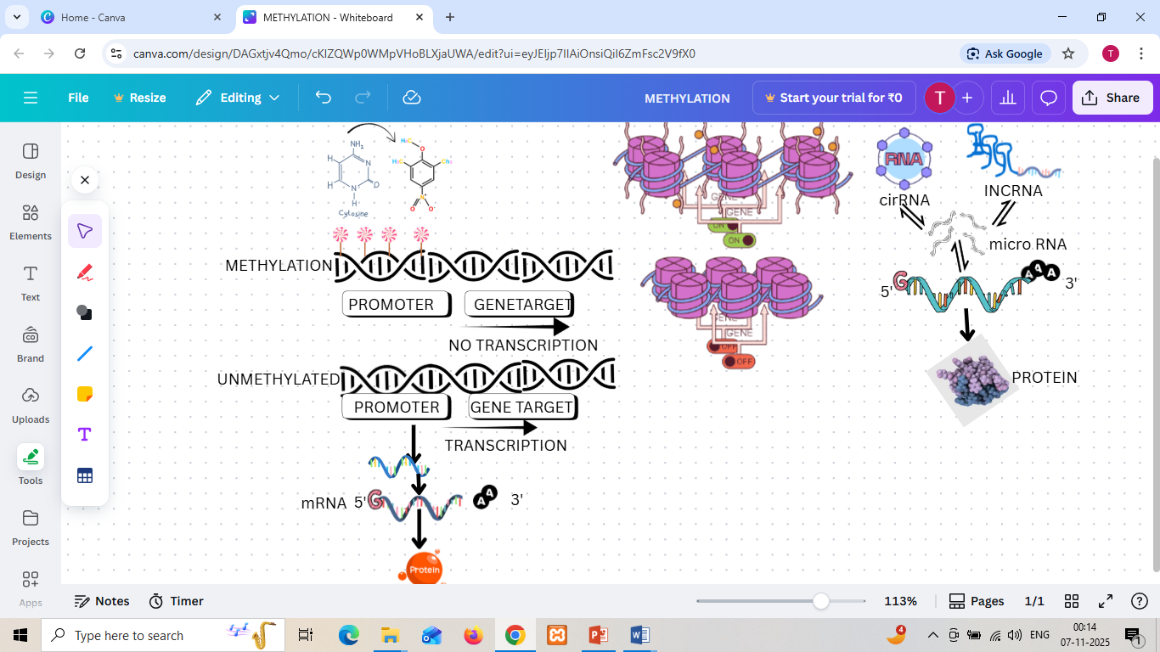

Fig 1: Epigenetic regulation by DNA methylation, Histone modification and Non-coding RNA expression promoting diseases development.
1.2 ASSESSMENT OF BIOMARKERS IN DIAGNOSIS, DISEASE MONITORING AND TREATMENT
Biomarkers provide information regarding disease stage, disease activity, prognosis and pathogenesis in ankylosing spondylitis. Metallo proteinase three reflect activity of disease and progression of inflammation through magnetic resonance imaging and helps in detecting bone formation and bone differentiation. Biomarkers simultaneously help to identify the pathophysiology of disease. From the biomarker detection of prognosis and disease it is detected that there is no formal proof about the correlation of inflammation and radiographic changes in case of ankylosing spondylitis. [12] Moreover, these can be uncoupled that is inflammation and new bone formation. Studies have reported that when patients with ankylosing spondylitis receiving anti TNF therapy were compared with patients receiving standard therapy, no significant change was observed in radiography progression. Several magnetic resonance imaging findings have detected growth of new syndesmophytes after resolving of inflammation. bone alkaline phosphatase showed significant increase depicting increased bone [13] [14]formation whereas MMP3 reduction was correlated with reduced inflammation. The genetic predispositions and factors affecting the occurrence of ankylosing spondylitis, the significant role of HLA b27 has been identified by clinical tests. For the assessment of disease activity, response to treatments serum and plasma markers have been studied by sample collection and analysis. Besides the study and examination of c reactive proteins and sedimentation rate of erythrocytes for disease activity detection several cytokine and matrix proteinase have been tested such as interleukin 17. For detection of individuals with risk of higher radiographic progression the biomarkers associated with bone metabolism, adipokines, have been examined .[15]

2 . DNA METHYLATION
DNA methylation plays crucial role in regulating transcription of gene and organization of nucleus influencing cellular function. Methylome damage result in varied gene expression rates, resulting in progression of the disease. However, several environmental factors such as cigarette smoking, diet and finally infection can be related to the disease pathogenesis. Environment can easily influence DNA methylation profile thereby forming closed connected network with gene expression.
During the study for contributory role of DNA methylation several inflammations related genes have been detected such asSOCS1. [16] Besides PCR technique few highly throughput techniques were conducted for analysis. Epignome wide study was possible for the same. Illumine 450k technique required 5 spondylitis patient and 5 healthy control , proceeding to identify a set of differentially methylated position with a specific HLA gene receiving the most significant signal. From the aforementioned method limitations such as smaller cohort size and absence of validation tools restricted the accurate use of the method for analysis of DNA methylation profiles and its correlation with expression of non-coding RNAs. [17]
Infinium methylation, a comparatively more throughput tool proved better and accurate for the analysis, detection of the regulatory effect of DNA methylation and gene expression. The integrated analysis detected genes with variation in methylation and expression levels. Peripheral blood sample collected from patients and healthy controls treated with phosphate saline buffer followed by Centrifugation at 2500rom for about 15 min to separate peripheral blood mononuclear cells. [18] DNA was extracted from the sample and total RNA were isolated from PBMS using trizol reagent. Quality, quantity of extraction , integrity analysis by agarose gel electrophoresis was conducted. DNA extracted, was stored at lower temperature for methylome analysis [19] for normal individual methylation patterns were normal by normal regulation of DNA leading to immune tolerance, gene expression preventing autoimmunity. Diseased individual highlighted the promoter regions of CpG to be methylated, producing closed chromatin , restricting binding of transcription factors to the DNA thus reducing expression of genes. [20]
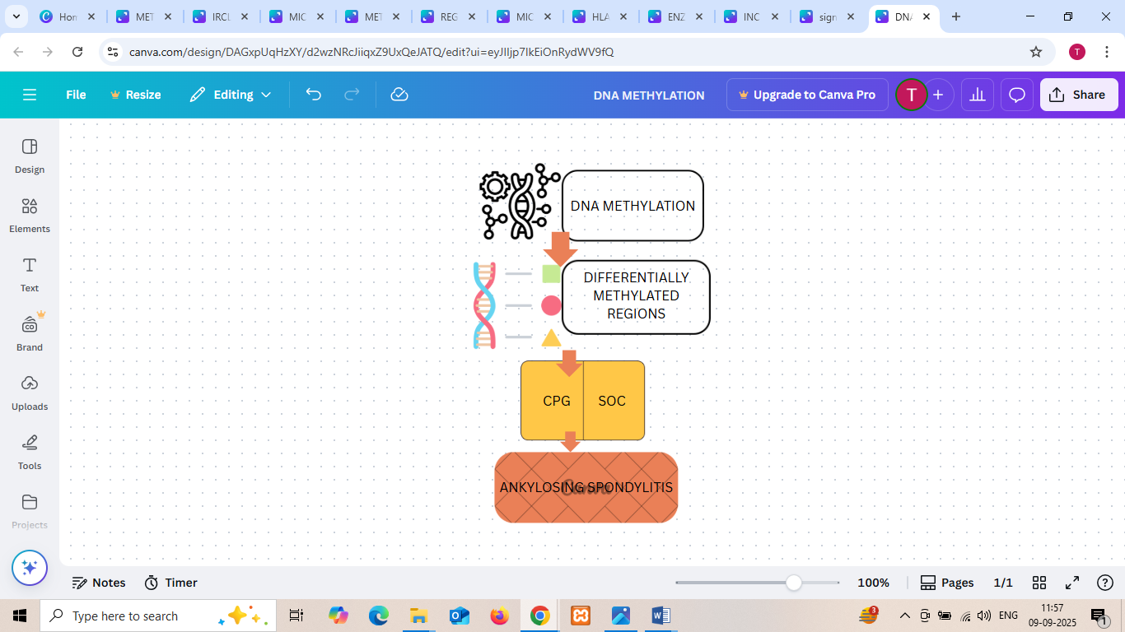
Fig 2: Schematic diagram representing link between DNA methylation and ankylosing spondylitis illustrating how DNA methylation detects differentially methylated regions in CpG and SOC.
2.1 METHYLATION OF B7H3
methylation and expression of b7h3 gene and its role in progressiveness of ankylosing spondylitis was highlighted. Peripheral blood sample from both healthy control and disease patients was withdrawn for extraction of genomic DNA and methylation analysis, done by sodium bisulphite treatment and multiplex PCR reaction. B7H3 is an immune checkpoint b7 family molecule expressed on surfaces of antigen presenting cells, osteoblasts. It promotes t cell differentiation regulation and t cell activation, effects bone remodelling, maintains relation between inflammation and immune tolerance. Methylation state observed was hypermethylation that reduced B7H3 expression promoting gene silencing. As B7H3 expression hampered it effected t cell regulation leading to enhancement of helper T17 cells activation and release of cytokines ,TNF alpha and interleukin. [21] Bone metabolism process hampered and reduced and promotion of osteoblast differentiation led to unusual bone formation. In some study reports the fact highlighted is that hypomethylation of B7H3 in certain tissues can lead to overexpression of genes promoting exceeded immune activation leading to cytokine mediated inflammation and increased bone metabolism or if B7H3 acts as inhibitor, immune suppression persists. Thereby concluding that epigenetic modification from b7h3 expression is associated with ankylosing spondylitis susceptibility proving to be a candidate diagnostic potent marker. Hypomethylated agents that can modulate methylation can restore expression of B7H3 region contributing to balanced regulation of immune system [22].
2.2 MHC HLA METHYLATION
The genetic risk factor for ankylosing spondylitis stands to be HLA B27.
Generally, hypomethylation state observed in ankylosing spondylitis leading to increased expression of HLA genes thereby contributing to enhanced generation of misfolded HLA b27 molecules causing endoplasmic reticulum stress. Triggers unfolded protein response promoting inflammation formation of surface homodimers promoting activation of NK and auto reacting cells. Hypermethylation observed in antigen presenting cells reducing antigen presentation, contributing to genetic predisposition and epigenetic interaction. Misfolded protein accumulation due to unusual methylation of HLA B27 target activation of interleukin 17/23 axis. Aberrant methylation at the loci of HLA effects the selection process of autoreactive T CELLS promoting survival of autoimmune t cells thereby affecting joints .
2.3 TCR PATHWAY GENES METHYLATION
Pathway essential for activation of t cells, regulation of immune tolerance and t cell differentiation comprise of genes CD3 subunit, NF KB, ZAP70. Regulatory t cells and helper t 17 cells balance can get disrupted by aberrant methylation, hypermethyaltion of CD247 contributing to reduced expression, misbalanced immune response and TCR signalling. FOXP3hypermethylation reduces cell function effecting immune tolerance leading to constant autoimmunity. Hypomethylation of CPG and activation of NF pathway genes CD3 AP1, NF KB genes increases expression contributing to enhanced cytokines release .TNF ALPHA, interleukin 17 23 release promotes helper T 17 differentiation driving inflammation in spine . Hypermethylation of inhibition checkpoint genes such as programmed cell death contributes to cytokine release to exceed chronic inflammation in sacroiliac joint. Biomarkers are able to distinguish ankylosing effected individuals from healthy controls by interpreting genome wide differential methylation profile.

TABLE 1: Epigenetic Alterations in Ankylosing Spondylitis featuring DNA Methylation Changes in Specific Region/Gene Sequences Contributing to Inflammation.
REGION/GENE | STATUS OF METHYLATION | AS EFFECT/NOTE
B7H3 PROMOTER | HYPERMETHYLATION REDUCING B7H3 EXPRESSION | - IMMUNE GENES OVEREXPRESSED HIGH SUSCEPTIBILITY  - ACTIVATION OF HELPER T17 CELLS-INFLAMMATION  - CANDIDATE DIAGNOSTIC POTENT MARKER
MHC REGION  HLA LOCUS | HYPOMETHYLATION OF PROMOTER-HLA B27 EXPRESSION INCREASED  HYPERMETHYLATION-ANTIGEN PRESENTATION REDUCED | - HYPOMETHYLATION-ER STRESS-MISFOLDING OF HLAB27-UNFOLDED PROTEIN RESPONSE  - FORMATION OF SURFACE HOMODIMER-PROMOTION OF ACTIVATION OF NK AND AUTOREACTING T CELLS  - ALTERATION OF ANTIGEN PRESENTATION  - CONTRIBUTES TO GENETIC PREDISPOSITION AND EPIGENETIC INTERACTION
T CELL RECEPTOR SIGNALLING PATHWAY GENES | HYPOMETHYLATION OF CpG AND ACTIVATING CD3 AP 1 NF KB GENES  HYPERMETHYLATION OF INHIBITION CHECKPOINT GENES-PD1  CYTOKINE RELEASE EXCESS-CHRONIC INFLAMMATION IN SACROILIAC JOINTS | - T17 HELPER CELLS DIFFERENTIATION  - DETECTION - GENOME WIDE DIFFERENTIAL METHYLATION PROFILE

2.4 HLA B27 MISFOLDING LEADING TO ER STRESS
HLA b27 associated with ankylosing spondylitis being an MHC CLASS 1 molecule tends to show misfolding in endoplasmic reticulum leading to endoplasmic reticulum stress due to deposition of misfolded proteins. Through use of a response by unfolded proteins UPR endoplasmic reticulum tends to restore balance. Misfolded HLA b27 activate INOSITOL REQUIRING ENZYME IRE1, located in endoplasmic reticulum that acts as sensor, splicing XBP1 in order to normalize protein fold. However constant stress promotes JNK pathway leading to cell death. Protein kinase like endoplasmic reticulum kinase PERK causes ELF2 alpha phosphorylation reducing translation to decrease stress triggering damage of cell components. Increased chaperon expression takes place by the movement of activating transcription factor ATF6, a transmembrane protein, in cleaved form to the nucleus however activation of ATF P50 increases stress by generation of reactive oxygen species leading to tissue damage and inflammation. Cell death and damage occurs by JNK pathway that promotes misfolded proteins to degrade by virtue of cells however tissue imbalance is enhanced. ROS further destructs mitochondria, cytokines production and release activated by misfolded proteins activates interleukin 17 23 pathway resulting in apoptosis of immune tolerance cells, synovial cells undergoing autophagy and disease enhancement by spine inflammation.
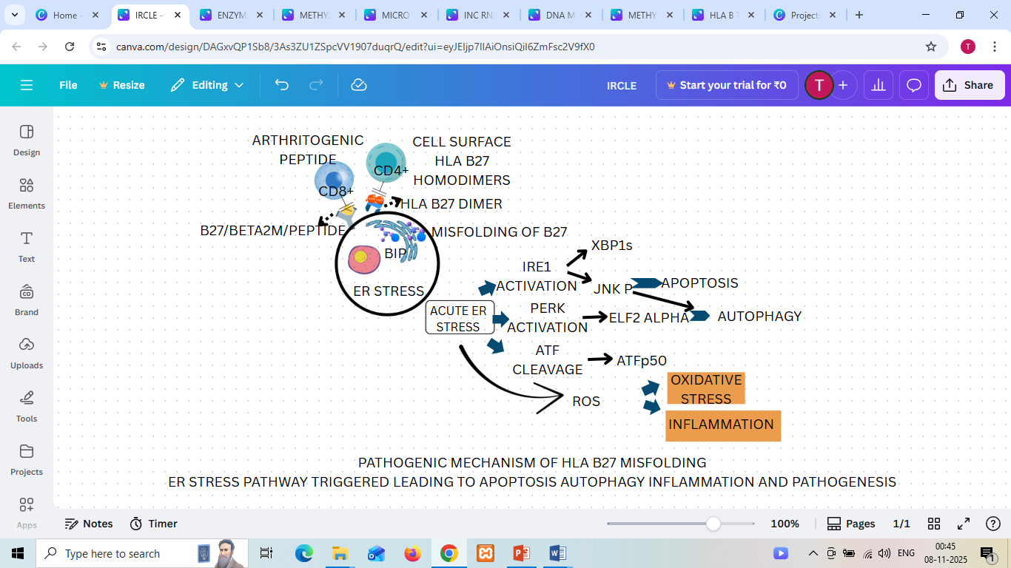
Fig 3: HLA B27 Misfolding pathogenic mechanism highlighting ER Stress triggering autophagy, inflammation and Oxidative Stress.
3. NON CODING RNA EXPRESSION CONTRIBUTING TO SPONDYLITIS
. A cytokine secreted by helper t 17 cells known as interleukin 17A has been clinically studied for detection of progression of ankylosing spondylitis. Advances have been made in understanding t cell function in progression, tested and found to be suitable for treating patients associated with ankylosing spondylitis. Non coding RNAs are sequences of RNA that do not encode for protein, they regulate both innate adaptive immune systems and directly contribute towards pathogenesis of the afor mentioned disorder. [23] Expression of non-coding RNA from t cell detected after collection of samples from both ankylosing patients and healthy controls and its relation with the pathogenesis of the disease interpreted. Unusual expressed RNAs released cytokines resulting in un usual signalling, disorganized cell proliferation and eventually cell death forming main cause for pathogenesis.
Performing RNA sequencing for detection and analysis of expression and methylation profiling by identifying differentially expressed mRNA and non-coding RNA and comparison between healthy controls and spondylitis effected patients was conducted.The standard omnibus dataset consisting of RNA expression data was used as the basis and accordingly selected differentially expressed mRNA and non-coding RNA were verified and analysis of selected different expressed RNA was conducted. [24]
The major area of focus was the t cell signalling pathway that is the significant enriched pathway of differential expressed mRNA in patients with ankylosing spondylitis. The study mainly identified the major differentially expressed mRNA and non-coding RNA responsible for contributing to disease pathogenesis. [25]
3.1 ROLE OF NON-CODING RNA AND MRNA IN ANKYLOSING SPONDYLITIS
Non coding mRNAs are transcripts that do not cod for functional proteins that are now in study w for their potential to be used as diagnostic biomarkers in disease diagnosis and prognosis. Non coding RNA such as INCRNAAK001085 INC ZINC protein have major roles in association with ankylosing spondylitis disorder. Researches discovered that mRNA such as programmed cell death1 and caspase containing protein can be main cause for pathogenesis . [26][27]
3.2 SMALL DESCRIPTION OF METHOD
Ankylosing affected patients of age 37, 36 and 40 years were tested to confirm their spondylitis symptoms and observed that they had issues such as damage of sacroiliac joints, fusion of spines and they did not receive drug or treatment for the aforementioned symptoms or damages. On the other side three patients with age 35, 36, 37 years were taken.Blood sample were collected from all the diseased and non diseased sets. isolation of total RNA from blood sample was done using trizol reagent, spectrophotometer usage to check the purity and RNA concentration followed by agarose gel electrophoresis for confirming integrity of RNA.
The study detected that IncRNA 001085 was downregulated in ankylosing patients thereby serving as potential biomarker for diagnosis proving to be a potent suppressor for ankylosing spondylitis. The result also identified role of many differently expressed mRNAs involved in ankylosing. For the purpose construction of interconnected weighted network of non-coding RNA and diffentially expressed mRNA and co expression of non-coding RNA with mRNA was performed. A set of co expressed pairs of de non coding RNA and de mRNA was established based on which the t cell receptor signalling pathway was significantly enriched. [28][29]
From the result it suggested that the differentially expressed mRNA that were enriched in t cell pathway contributed to progression of ankylosing disease some of which included inhibitor beta, activated kinase. Programmed cell death 1 expressed on the surface of peripheral t cells showed reduced expression levels in ankylosing spondylitis, primarily responsible for regulating immune function and t cell response. Downregulation of programmed cell death1 on t cells in ankylosing spondylitis stimulated t cell activity and elevated production of cytokines promoting inflammation of spine. [30][31]

FIG 4: SCHEMATIC WORKFLOW FOR RNA ANALYSIS IN ANKYLOSING SPONDYLITIS
3.3 REGULATORY ROLE OF NON-CODING RNA AND MRNA IN ANKYLOSING SPONDYLITIS
non-coding RNA serve as vital role players in the inflammation cell death bone differentiation or formation and thereby progression in ankylosing spondylitis. Non coding RNA which can be differentiated into housekeeping RNA including transfer and ribosomal RNA and regulatory RNA has gained importance and attention. From an endogenous hypothesis it states that RNA are able to form communication with each other and regulate genes post transcriptionally forming a bond to the mRNA bind site. These RNA form a closed network of compete endogenous RNA network. The interconnection of RNA network and communication and the alteration of gene expression post transcriptionally contribute to pathogenesis of ankylosing spondylitis. [32] Non coding RNA are present in cells and contribute to various physiological processes through gene expression, chromatin structure variation, epigenetic modification, they do not encode for proteins however their vitality is persistent as they are normally expressed with response to any external signal during developmental stages. With the aberrant expression they effect the transcription of genes and influence signal pathway.
MicroRNAs found in the eukaryotic organisms regulate gene expression by targeting the promoter regions of bound genes or direct targeting non protein translated site of the targeted mRNA promoting degradation of the messenger molecule thereby suppressing translation process preventing functional protein formation.
Long non coding RNA or Inc RNA based on their localization within the cell they perform their roles. Most of them pursue internal localization performing compete endogenous RNA role, binding to mRNA carrying out target mRNA degradation or mRNA translation to produce functional proteins. If cytosolic localization they focus on changing altering epigenetic state of specific genes .[33]
4. OSSIFICATION
Inflammation progression can result in ossification and pathogenesis of ankylosing spondylitis. Inflammation majorly responsible for elevated release of cytokines is responsible for differentiation of fibroblast into osteoblast with the important cytokine activation being the bone morphogenetic protein pathway. Non coding RNA regulate the differentiating fibroblast cells into osteoblast with study providing report that reduced expression of MiRs in fibroblast inhibited the differentiation into osteoblast cells whereas overexpression of MiR of fibroblast obtained from ankylosing patients ligament greatly differentiated into osteoblast cells contributing to osteogenesis ,inhibiting downstream target gene expression ( Mir150B5P and MiR 204 5P). MiR 17 5p is reported to be upregulated in case of ankylosing spondylitis. Higher expression is related with more inflammation and disease activity[34]. By targeting SMAD inhibitor it activates tumor growth factor, beta signalling, enhancing formation of new bones.
Indirect regulation by MiR 17 5p increases pathological inflammation and bone genesis. Greater cytokines release triggers immune cell activation and promotes inflammatory response (interleukin 6). [35]
INHIBITION OF DIFFERENTIATION INTO OSTEOBLAST
- NON CODING RNA REGULATION
DOWNREGULATION OF MIR EXPRESSION
- BMP PATHWAY ACTIVATION
UPREGULATION OF MIR EXPRESSION
- DIFFERENTIATION INTO OSTEOBLASTS
PROMOTION OF TGF BETA SIGNAL

- INFLAMMATION
- FIBRIOBLAST ACTIVATION CYTOKINE RELEASE

INFLAMMATION AND OSSIFICATION INCREASED

ACTIVATION OF INHIBITOR SMAD

FLOWCHART 1: DEVELOPMENT OF INFLAMMATION FINALLY LEADING TO PROGRESSION OF ANKYLOSING SPONDYLITIS
4.1 CONTRIBUTION OF IMPROPER APOPTOSIS TO PROGRESSION OF DISEASE
With maximum cell proliferation if the apoptosis of t cells or fibroblast cells is slower, it can result into progressiveness of ankylosing spondylitis. Study reports that a MiR downregulated state in t cells can be inhibited by an MiR inhibitor to reduce the proliferation of cells and apoptosis can take place. For this upregulation of the downstream target takes place by HOXB1.A report showed that long non-coding RNA and downstream target gene expression was upregulated in ankylosing spondylitis and MiR expression was downregulated.
Non coding RNA downregulation increased expression of MiR with inhibition of expression of downstream target gene thereby inhibiting the inflammation, apoptosis in chondrocytes in ankylosing spondylitis serving as spondylitis suppressor. [36]
5. OVEREXPRESSION OF INC RNA AND ANKYLOSING SPONDYLITIS
Plasma INC RNA expression was at high level in ankylosing spondylitis patients compared to healthy controls. Division of patients conducted with active ankylosing spondylitis and mild sets depending on the expression level of plasma inc RNA. Patients with higher expression of inc RNA were subjected to more duration of treatment concluding that high levels of inc RNA in plasma in active ankylosing spondylitis patients indicate higher expression of inc RNA and direct relation to active disease requiring complex treatment. [37]
5.1 SMALL REPORT HIGHLIGHT ON ROLE OF WNT PATHWAY FOR DISEASE PATHOGENESIS
Wnt pathway finds its requirement for cell fate determination, cell migration after any traumatic disease or recovery from stroke and is vitally essential for cell functions. wnt proteins with cell surface receptors form a bound complex that prevents the beta-catenin complex from promoting destruction. In the cytoplasm, stabilised beta-catenin accumulation moves to the nucleus, which leads to transcriptional activation of osteogenic genes such as RUNX. Evidence from reports detects the role of Wnt in the progression of ankylosing spondylitis pathogenesis. With a major effect on bone morphogenesis and maintenance of homeostasis, it induces mesenchymal cell differentiation into osteoblast cells. This acts as a contributory process for joint remodelling in case of ankylosing patients. [38][39]
Report showed that increased circulatory endogenous MiR29a was found high in ankylosing patients compared to healthy controls. MiR-29 is generally downregulated in ankylosing spondylitis with smaller circulating levels related directly to disease activity. Wnt pathway reduces activity of inhibitors for osteoblast differentiation leading to excessive syndesmophyte formation. It was highlighted that increased expression of the circulatory factor mediated tumour necrosis factor that induced bone loss, inhibited expression of DKK1 thereby activating the wnt signalling pathway. However it was not directly correlated to the ankylosing spondylitis functional index, moreover the expression of both the mir29 a and c were decreased, when cell differentiation took place which required treatment with DKK1. [40] Thus induction of expression of MiR depends on the wnt signal pathway during differentiation to form osteoblast cells. MiR-29 enhances the stiffness of joints and leads to unusual matrix accumulation by suppression of collagen matrix genes such as COL1A1. Increased proinflammatory cytokine release by greater expression of TNF alpha and interleukin 17. [41]
MIR 27 a
Associated with inflammatory signalling, regulation of genes that control differentiation of helper T17 cells and secretion of interleukin 17, TNF alpha. Spinal inflammation is associated with increased interleukin release and contributes to the imbalance between the TH17 and TH23 axis. MIR 27a is upregulated in peripheral blood mononuclear cells in ankylosing spondylitis patients, with studies showing its expression is related to disease progression. Upregulation of the aforementioned promotes helper T17 cell expansion, regulates RORyt transcription, contributes to disrupted balance between helper T17 cells and TREG, interleukin 17 enhancement leading to bone osteoclastogenesis, and promotion of unusual bone formation.
MiR17 5p
Ankylosing spondylitis patients report detected cytokine pathway and balance of T cell activation are directly connected to the expression of miR-17-5p that forms a part of MiR 17 cluster. Being generally in an upregulated state, it targets RORyt and STAT pathway, resulting in TREG differentiation suppression, T cell increased production, autoimmunity by balancing disruption between TREG and helper t17 enhancing the pathology of osteoblast.

TABLE 2: Micro RNA role in progression and inflammation in ankylosing spondylitis highlighting the target pathways and expressions.
MICRO RNA | EXPRESSION | TARGET PATHWAY | EFFECT
MIR 29 | DOWNREGULATED | - WNT/BETA CETENIN PATHWAY TARGETTING INHIBITORS FOR BONE DIFFERENTIATION  - PROMOTES EXCESS OSTEOGENESIS  - NF KB SIGNALLING-REGULATES TNF ALPHA IL 17 IL 23-RESULT IN CHRONIC INFLAMMATION  - MATRIX REMODELLING GENE-COL1A1 SUPPRESSION BY MIR29-UNUSUAL ACCUMULATION OF MATRIX | - INCREASED BONE ACTIVITY LEADS TO NEW BONE FORMATION  - COLLAGEN SYNTHESIS ENHANCED  - GREATER RELEASE OF PROINFLAMMATORY CYTOKINES
MIR 17 5p | UPREGULATED IN AS PATIENTS | - TUMOR GROWTH FACTOR BETA SIGNALLING-GREATER EXPRESSION OF MIR 17 5p-INCREASED ACTIVATION OF TGF BETA SIGNALLING LEADING TO OSTEOGENESIS  - WNT/BETA CATENIN:OSTEOBLAST DIFFERENTIATION AND OSSIFICATION  - CYTOKINES AND NF KB PATHWAY-EXPRESSION OF INTERLEUKIN 17 TNF ALPHA ENHANCED PROMOTING INFLAMMATION  - ENHANCEMENT OF T CELL PROLIFERATION | - INCREASED CYTOKINES RELEASED BY UPREGULAION OF TNF INTERLEUKIN EXPRESSION  - BONE ACTIVATION  - PROMOTES CHRONIC INFLAMMATION AND BONE FORMATION
MIR 27a | UPREGULATED DETECTED FROM PERIPHERAL CELL STUDIES | - WNT/BETA CATENIN-SUPPRESSED INHIBITORS  - WNT PATHWAY ACTIVITY INCREASED-BONE DIFFERENTIATION AND FORMATION  - NF KB PATHWAY-GREATER CYTOKINE PRODUCTION  - TUMOR GROWTH FACTOR BETA-CONTRIBUTION TO BONE REMODELLING | - TNF ALPHA IL 1 BETA EXPRESSION INCREASED-CYTOKINE PRODUCTION ENHANCED  - BONE ACTIVITY GREATER  - PATHOLOGICAL FORMATION OF BONES

5.2 OSTEOGENIC DIFFERENTIATION IN ANKYLOSING SPONDYLITIS RESULTING FROM INC RNAS
Mesenchymal stroma cells derived from ankylosing patients have higher differentiation potential. A sample of osteogenically differentiated mesenchymal cells was taken from both ankylosing affected patients and healthy controls, and microarray profiling was conducted. Dysregulation was found in about 600 and 500 messenger RNA and intron RNA, respectively. For confirmation of dysregulation of specific IncDTHD1, inc MPDZ and upregulation of Inc PIK3C2G 2 and inc KLF14 1, reverse transcription qPCR was done, prompting an outcome that the reduced expression or downregulation of incRNA takes place in ankylosing spondylitis. [42]
5.3 INC AK001085
For the determination of the role of long non-coding RNA in ankylosing spondylitis, serum sample after being collected from about 117 ankylosing and 7 healthy patients. Reverse transcription qPCR was done for confirmation of the expression of incRNA. The incRNA AK001085 was found to be upregulated in ankylosing patients, as its expression is normally upregulated in peripheral blood mononuclear cells of patients with ankylosing spondylitis. However, the expression rate of incRNA was not directly correlated to the ankylosing spondylitis functional d index or ankylosing spondylitis activity rate. These INC RNAs mainly use the JAK/STAT and NF KB pathway to detect activation of inflammation. Higher expression of inc was related to enhancement of disease activity and disease scores such as CRP and ESR. [43]
5.4 NKILA
Determination of plasma levels of NF KB interacting with RNA NKILA, found to be downregulated in ankylosing patients, was studied to determine its mechanism of action correlated to tumour growth factor beta and helper T17 pathway. Expression of TGF Transformation growth factor b was also directly correlated to the expression of NKILA in case of ankylosing spondylitis; in fact, TGFb induced differentiation. The helper17 cells in the presence of interleukin referred to the fact that signalling of TGF b was dependent on the expression of NKILA and thus can be used as a prognostic marker for the detection of ankylosing spondylitis.
Lower levels contribute to a stronger association with disease activity and a strong inflammatory response. Nkila forms a complex with NF-kB and prevents phosphorylation of IKB by preventing NF-kB translocation near the nucleus, suppressing proinflammatory cytokines.
Coming to a conclusion, NKILA can be Useful for monitoring disease activity and restoration with suppression of NF KB inflammation.
5.5 TUG1
Taurine upregulated gene 1 expression was determined by the collection of serum samples, performing sacroiliac biopsy in ankylosing patients and comparing with healthy controls. The TUG1 detected high expression in ankylosing patients; however, its lower expression could detect a higher risk and its association with greater disease activity, increasing the duration of treatment.
Its Expression was found to be correlated with CRP AND ESR, inflammatory markers and can be classified as Sponges micro RNA that acts as an endogenous RN activating pro-inflammatory genes. its increased expression promoted the NFKB pathway with interleukin 1, beta interleukin 16 and TNF alpha activation, enhancing osteoblast differentiation in ankylosing spondylitis. It sowed Direct contribution to TH17/TREG balance disruption and chronic inflammation in the spine and sacroiliac joint.
5.6 MATERNALLY EXPRESSED GENE 3
Meg levels were tested by the collection of serum and sacroiliac joint biopsy from ankylosing patients and healthy controls.
The results inferred information that the expression of meg3 was found to be downregulated in ankylosing spondylitis, with the patients being frequently hospitalised or requiring rehospitalisation and prolonged treatment. The downregulation of meg3 in serum and the sacroiliac joint was confirmed from the report. The levels of certain cytokines, such as IL6 and TNF, were found to be high, where meg3 was not correlated with the release of these cytokines. However, restored expression of meg 3 suppressed the release or expression of the cytokines, tumour growth factor beta signalling was reduced or suppressed when expression of maternal expressed gene 3 was excessive. The report and findings concluded that downregulation, aberration of meg3, could result in upregulation of mir146a, which could increase the release of cytokines, thereby inducing an inflammatory response. [44]
5.7 H19
Prove its Role in the pathogenesis of spondylitis by inducing an inflammatory response acting at the axis of interleukin 17 23. Samples collected from ankylosing patients and healthy controls determined the expression rate of inc h19, followed by a confirmatory qRT-PCR that determined upregulation of h19 in ankylosing spondylitis patients. H19 increased expression was directly correlated with the disease activity and non-correlated or negatively related to the ankylosing spondylitis score. This detects the direct correlation of incRNA expression in the pathogenesis of ankylosing spondylitis and is an independent marker of disease prognosis.

TABLE 3: Table summarising IncRNAs associated with the pathogenesis of ankylosing spondylitis, their expressions, target signalling pathway and effect.
INC RNA | EXPRESSION | ASSOCIATED SIGNAL PATHWAY/EFFECT | INDICATIONS
INC AK001085 | UPREGULATION IN AS PATIENT | PLAYS PROTECTIVE ROLE | - EXPRESSION CORELATED WITH ESR AND CRP ELEVATION  - WORKS MAJOR BY NF KB AND JAK/STAT SIGNAL PATHWAY  - EXPRESSION INDICATE ACTIVE INFLAMMATORY RESPONSE POTENTIAL DIAGNOSTIC MARKER
NKILA | REDUCED EXPRESSION IN AS PATIENTS COMPARED TO HEALTHY CONTROLS | TRANSFORMATION G FACTOR TGF BETA AND TH17 SIGNALLING | - IkB PHOSPHORYLATED AND DEGRADED WITHOUT NKILA  - NF KB ENTER NUCLEUS FREELY THEREBY TRANSCRIPTION OF PROINFLAMMATORY GENES TNF ALPHA IL17  - BONE EROSION UNUSUAL BONE FORMATION
TUG1 | UPREGULATED IN PBMC AND FIBROBLAST | IMMUNE SYSTEM REGULATION  LOWER EXPRESSION INDICATE GREATER RISK AND ENHANCED DISEASE ACTIVITY | - MI RNA SPONGED RELEASING TARGETS PROMOTING NF kB JAK/STAT SIGNALLING  - PROMOTE OSTEOBLAST DIFFERENTIATION  - DISEASE ACTIVITY AND PROGRESSION DETECTED
MATERNALLY EXPRESSED GENE 3 | DOWNREGULATION | TGF BETA SIGNALLING PATHWAY TUMOR SUPPRESSOR ANTI INFLAMMATORY REGULATOR  MODULATION OF TH17/TREG BALANCE | - TNF ALPHA IL17 PRO INFLAMMATORY CYTOKINES RELEASED
H19 | UPREGULATION IN AS PATIENTS | CORRELATED TO OSTEOGENESIS  RELEASE OF TARGETS(SPONGING OF MI RNAs) PROMOTING WNT/BETA CATENIN SIGNALLING | - POTENTIAL DIAGNOSTIC MARKER FOR NEW BONE FORMATION  - PROMOTION OF OSTEOGENIC DIFFERENTIATION

5.8 SMALL HIGHLIGHT ON IMMUNE RESPONSE IN ANKYLOSING SPONDYLITIS
The major and vital point of the disease ankylosing spondylitis, “inflammation, is triggered by innate immunity cells, the spotlighted pathway being the Interleukin 17/23 axis, promoting advanced inflammation, hampering bone formation. [45]
The innate immune cells can get a sense of endoplasmic reticulum stress, HLA B27 misfolding, and act by secretion of interleukins and TNF-alpha as a response.
The key role of the cells is being able to release pro-inflammatory cytokines like IL 17 AND 1L23 by acting as antigen-presenting cells. (macrophages/dendritic cells)
The release of the cytokines stimulates helper T CD4+ cells by acting as signals, followed by interleukin 23, to contribute to and promote the differentiation of helper T 17 cells. During differentiation 1L 17. A crucial cytokine is released from Th17 cells that contributes to enhancing inflammation, bone formation and joint fusion, balance of neutrophil assignment.

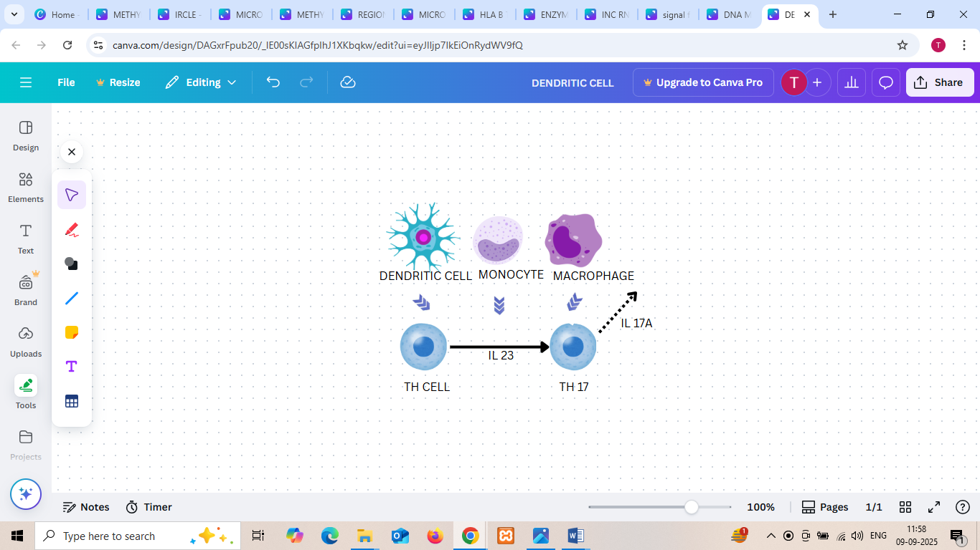
Fig 5: dendritic cells, macrophages and monocytes promoting TH17 differentiation and Interleukin17 A generation leading to bone imbalance and chronic inflammation.
Activation of T CELL correlated with disease
Antigen presentation
Dendritic cells, macrophages, and monocytes present peptides on the surface of class 1 MHC molecules to static resting T cells, which generally leads to T cell activation in a controlled manner against infection, however in case of ankylosing spondylitis due to misfolded proteins, HLA B27 or peptide loads antigen presentation is hampered due to the presentation of arthritogenic peptides leading to autoreactive cell activation.
Activation of memory T cells
When naïve t cell activated by antigen presentation, form memory T cells and in a simultaneous encounter, when relatively low antigen exposure occurs, they get hyperactivated for the next time. An altered signal from antigen exposure leads to strong reactivity of memory T cells, maintaining chronic inflammation. A large amount of cytokines are produced and released due to overactivity of T cells from APC and GALT, gut-associated lymphoid tissue, such as TNF alpha, tumour necrosis factor, interleukins 17 and 23, interleukin 1 beta, causing recruitment of neutrophils. naïve t cell differentiates into helper T17 cells and promote maintenance and stabilisation. These pro-inflammatory cytokines are responsible for bone, tendon, inflammation and stiffness. These cycles of altered and overexpression of T cells lead to chronic inflammation, joint erosion, and unusual bone formation.
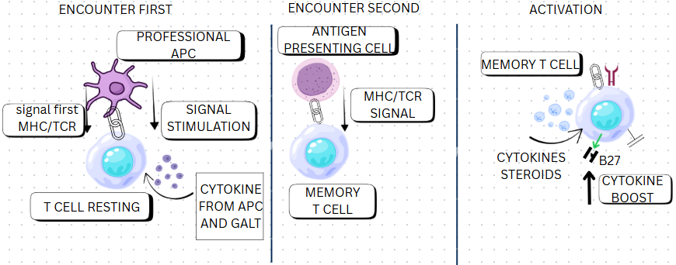
Fig 6: Immune system response modification in simultaneous encounters of resting T cells from naïve to active state, leading to a final increase of T cell activity promoting enhanced cytokine release and disease progression.
6. RECENT FINDINGS ABOUT THE CORRELATION BETWEEN HLA-B27 AND ANKYLOSING SPONDYLITIS
The ankylosing spondylitis patients carry HLAB27 gene, which is different and distinct from the healthy HLA B gene loci. it is found that CD8 TCELLS are detected in the bloodstream and inflamed tissues with their affinity towards microbial-derived peptides, inducing an autoimmune response that thereby triggers the onset of ankylosing spondylitis. The alpha and beta motifs of t cell have affinity for peptides. The distinct affinity towards protein peptide and characteristics of presentation of these T cell receptors classify them and set them as a hallmark to be associated with hlab27 diseased subtype. This can accelerate the process of discovery of specific significant potential and more accurate biomarkers for diagnosis and targeted treatment, with the ability to recognise the self or microbe-derived peptides to induce autoimmunity. Some research conducted mentions that the efficient removal of T cells in disease-associated patients carrying HLA B27 genes paves the way for treating patients, preventing further patients with genetic variants from being affected with the disease, ankylosing spondylitis.
7. RECENT STUDY ON MICRO RNA CONTRIBUTING TO DISEASE
Increased upregulation of MiR17-5p and MiR27a was detected when peripheral blood mononuclear cell sample was collected from ankylosing patients and a healthy set. Increased expression of RNA was detected in the case of disease-affected individuals. the study evidenced the role of miR-29 in bone metabolism, which reduced the expression of dkk1 thereby inducing wnt signalling pathway. The release of cytokines produce inflammation response, resulting in increased bone formation. From the study, the potential of MiR 29 as a possible prognosis marker to act independently for ankylosing spondylitis diagnosis was detected. Epigenetic regulatory enzymes can be detected as modulator for microRNA, as stated by a recent study that detected increased activity of histone deacetylase 3 and downregulation of mir130 expression in peripheral blood mononuclear cells in ankylosing patients. From chromatin immunoprecipitation assay, it is found that HDAC3 is recruited to the promoter of the gene encoding for mir30 in ankylosing patients. The knockdown of hdac3 increases the expression of mir130a and decreases the expression of TNF. The study highlights the major role of hdc3 in the regulation of expression of mir130a and its contribution I to inflammatory response in ankylosing spondylitis. [46]
8. ANKYLOSING SPONDYLITIS ASSOCIATED INFLAMMATION VIA TRIPTOLIDE
From the report identification and exploration of the effect of triptolide on differentiating Th17 cells in ankylosing spondylitis was detected. Triptolide, plant derived compound, has anti-inflammatory properties that has Major contribution via NF KB suppression.
From 10 active ankylosing spondylitis patients, peripheral blood mononuclear cells were collected, and exposure to triptolide was done. T lymphocytes were assessed by flow cytometry, and cytokine interleukin-17 detection was done by ELISA. Western blotting and quantitative RT PCR deteced and confirmed levels of mRNA and expression of proteins in K Jk JAK or stat signal pathway. A greater percentage of differentiation into interleukin-17 positive D CD4 Tcells was observed in the sample of peripheral mononuclear blood cells of active ankylosing patients compared to healthy individuals taken as controls. Therefore, a conclusion was made that triptolide reduced the expression of IL17. [47] When the peripheral blood cells culture was given 24 hours of treatment with triptolide or gsk, a great reduction in the expression of RORyt, JAK2 and STAT was significant. However, triptolide was found to increase the histones associated with trimethylation of H3K27me3 in the blood sample collected from active spondylitis patients. Enriched methylated histones due to methylation of H3K27me3 were observed at the promoter site of STAT and IL-17 gene. thereby, from the aforementioned report, the conclusion is that inhibition of differentiation of Th17 cells achieved by action of triptolide by upregulation of expression or methylation of H3K27me3 and subsequent modification of enzyme expression, such as EZH2, and methylation of H3K27me3.Triptolide can help reduce inflammation in ankylosing spondylitis, restoring epigenetic balance. [48]
.
8.1 H3K27ME3 TRIMETHYLATION CONTRIBUTING TO ANKYLOSING SPONDYLITIS
Th17 cells are regarded as major cells responsible for ankylosing spondylitis-mediated inflammation.H3K27me3 histone modification silences transcription of genes leading to differentiation of helper T17 cells. Normally, dysregulation in ankylosing spondylitis promotes loss of immune tolerance and hampers T cell activation. A sample of serum collected from about 45 ankylosing patients belonging to various stages and 10 individuals taken as controls determined levels of interleukin 17 by Elisa. Quantitative PCR was conducted for the estimation of the expression level of mRNA and protein expression of genes such as RORc and JAK2. the enzyme expression of EZH2 AND JMJD3 was also monitored simultaneously. The results reported that the expression of H3K27me3 on the peripheral blood mononuclear cells was comparatively low in active ankylosing patients than in the healthy controls. A negative correlation between H3K27me3 expression and helper T17 cells differentiation was detected from the result. The intervention of the fact was that higher enzyme level of JMJD3, an inhibitor for H3K27 demethylase and lower expression of enzyme EZH2 were found in active ankylosing spondylitis patients compared to healthy and stable controls. Thus, from the information, it can be concluded that regulatory enzymes jdmd3 and ezh2 regulate the methylation of H3K27me3, an important factor for the pathogenesis of ankylosing spondylitis, and H3K27me3 is a dynamic epigenetic modification for the progression and diagnosis of the disease. [49][50]
IMMUNITY TOLERANCE DYSREGULATED
IMPAIRED T CELL ACTIVATION

NF KB CONTRIBUTION
IN SUPPRESSED FORM
- SAMPLE OF PERPHERAL BLOOD COLLECTED FROM ANKYLOSING PATIENTS
- EXPOSURE TO TRIPTOLIDE

- FLOW CYTOMETRY
- ELISA
- RT PCR
- WESTERN BLOTTING
FOR mRNA CONFIRMATION

ANKYLOSING PATIENT BLOOD SAMPLE SHOWED GREATER DIFFERENTIATION INTO INTERLEUKIN 17
REDUCED EXPRESSION OF INTERLEUKIN DURING TRIPTOLIDE EXPOSURE

MAINTENANCE OF EPIGENETIC BALANCE AND REDUCES INFLAMMATION
REDUCED EXPRESSION OF JAK STAT PATHWAY DUE TO PROLONGED 24 HRS TRIPTOLIDE EXPOSURE

- INCREASED TRIMETHYLATION OF H3K27ME3
- MODIFICATION OF EXPRESSION OF EZH2

FIG 7: Effect of triptolide exposure on ankylosing disease progression
8.2 METHYLTRANSFERASE IN ANKYLOSING SPONDYLITIS
Enzymes adding methyl groups to histone proteins, thereby activating or repressing the expression of gene are methyltransferases that promote activation of interleukins IL23, IL 17, NF KB by silencing the anti-inflammatory pathway. Inflammation is found to be exceeded as the histones are stimulated and modified for helper T17 generation rather than T cell activation. Increased osteoblast gene activation by overexpression leads to increased bone formation in the spine. EZH2 enhancer of zest homolog, is a part of PRC, the polycomb repressive complex, which helps in the trimethylation of histone. Greater activation of EZH2 silences anti-inflammatory genes in ankylosing spondylitis and helper T 17 cell differentiation, interleukin 17 secretion is enhanced, leading to tissue damage and inflammation. Targeting enzymes such as EZH2 is being studied to check their potential in balancing restoration of immune regulation and reduction of inflammation in ankylosing spondylitis. Suppressor of variegation 3 9 homolog SUV39H1 contributes towards methylation of H3K9, promoting gene silencing, when dysregulated in ankylosing spondylitis autoimmunity, by silencing immune tolerance gene can get triggered.

8.3 DEMETHYLTRANSFERASE IN ANKYLOSING SPONDYLITIS
They are enzymes that help to remove methyl groups from histone proteins, alter chromatin structure, thereby making the DNA sequences accessible or inaccessible by transcription factors, leading to activation or silencing of genes. In case of ankylosing spondylitis, the unbalanced methylation promotes the release and expression of pro-inflammatory cytokines. Activated release of interleukins and pro-inflammatory cytokines and increased TH17 differentiation promote inflammation, aberrant demethylation related to expression of osteoblast genes, thereby leading to syndesmophyte formation. Histone markers such as H3K27me3 get unusually demthylated resulting in enhanced inflammatory cytokine release, such as interleukins and TNF alpha, and an increased gene transcription helps in osteogenesis. The excessive expression of cytokines and genes leads to immune tolerance loss. The major pathways associated are the tumour growth factor beta pathway, which is downregulated, promoting unusual bone remodelling. The interleukin 17/interleukin23 axis helps in the amplified release of interleukin 17, nuclear factor kb pathway enhances TNF-α release. [51]
For example, H3K27ME3 is demethylated by JMJD3 and UTX. Gene silencing is reduced in ankylosing spondylitis by increased activation of JMJD3, promoting constant inflammation.H3K4me1 is demethylated by LSD1, which can mainly affect differentiation of immune cells and contribute towards inflammatory gene expression.
ENZYME/HISTONE MARKER | EFFECT IN AS | IMPACT ON PATHWAY | HIGHLIGHTS
H3K27me3 | REPRESSIVE MARKER-GENE SILENCING PROMOTED DECREASE ACTIVITY OF DISEASE ABERRANT METHYLATION LEADS TO IMMUNE SYSTEM DYSREGULATION MODULATING PROINFLAMMATORY CYTOKINES EXPRESSION | PRC/EZH2 PATHWAY-GENES CONTROLLING IMMUNE TOLERANCE REPRESSED SKEWS BALANCE BETWEEN TH17 AND TREGISILENCING OF TRES PROMOTES DOMINATION OF TH17) ENHANCEMENT OF HELPERT CELL 17 DIFFERENTIATION | TRIMETHYLATION OF HEAT LYSINE 27 PROMOTION OF INFLAMMATORY RESPONSE
DEMETHYLASE(JMJD3) | OVERACTIVITY OF AS ACTIVATIONS OF INFLAMMATORY GENES TNF ALPHA CONTRIBUTE TO BONE DIFFERENTIATION | H3K27ME3 REMOVED/REDUCED EXPRESSION OF H3K27ME3-EXPRESSION OF GENES CONTRIBUTING TO INFLAMMATION BONE REMODELLING-ACTIVATION OF OSTEOBLAST RELATED RUNX AND 5MP GENES | INTERLEUKIN EXPRESSION UPREGULATED INCREASED TH17 DECREASED TREG
METHYLTRANSFERASE(EZHZ) | ADDITION OF METHYL GROUP TO M3 LYSINE 27 INCREASED ACTIVITY GREATER H3K27MES AT PROMOTER REGION OF TREG SUPPRESSING TREG FUNCTION DYSREGULATION IN AS ENHANCEMENT OF NF KB JAK/STAT PATHWAY | PRC PATHWAY PROMOTES REPRESSION OF GENE NF KB RELATED TO CYTOKINE INFLAMMATORY RESPONSE WNT/BMP PATHWAY TRIGGERING OSTEOBLAST ACTIVATION | INCREASED TH17 AND INTERLEUKIN17 DECREASED TRED-CHRONIC DISEASE ACTIVITY
TRIPTOLIDE | H3K27me3 INDUCED BY DOWNREGULATION OF INFLAMMATORY RESPONSES SUCH AS SUPPRESSION OF THE INTERLEUKIN 17 RESTORATION OF TREG/TH17 BALANCE | SUPPRESSION OF INTERLEUKIN 17 NF KB PATHWAY INHIBITION OF JAK/STAT REDUCTION OF THI DIFFERENTIATION | BENEFICIAL RESULTS OBTAINED FOR RHEUMATOID AND INFLAMMATORY BOWEL DISEASE POTENT THERAPEUTIC AGENT FOR AS

Fig 8: Histone modifications contributing to disease pathogenesis featuring the role of triptolide, methyltransferases, demethyltransferases and H3K27ME3 in the regulation of inflammatory cytokines, bone remodelling and maintenance of TREG helper T17 CELLS balance.
8.4 SHORT STUDY REPORT ON THE GENETIC BASIS FOR ANKYLOSIN SPONDYLITIS
The development of the disease comes from about 90 per cent of genetic predispositions and genetic factors, with half of the susceptibility belonging to the HLA B27 genes. However, recent reports and genetic studies also informed us about the contribution of non-HLA genes to disease. A recent study, after analysis, confirmed the chromosome sites of 3q, 6p, 10q, 19q, part of the major histocompatibility complex, to be responsible for ankylosing spondylitis. A candidate gene, interleukin 1, has been identified as the major histocompatibility complex part responsible for the disease; however, the advanced techniques will further analyse unveiled parts of the genome to discover the contribution of p other non-histocompatible genes in disease progression.
9. MHC AND ASSOCIATION OF HLA-B27 WITH ANKYLOSING SPONDYLITIS
The study aims to reveal the major histocompatibility complex genome with the main focus on the correlation of human leukocyte antigen HLA B27 with ankylosing spondylitis. The MHC contains the HLA B27 locus on the short arm of chromosome 6 at position 6p21.31 and is a densely gene-associated region spreading up to 4 megabases. One of the major roles of the HLA molecule is the modulation of immune responses to the invasion of pathogens. The HLA region, most significantly associated with some autoimmune diseases required for the clinical diagnosis of those diseases. From a twin-based study conducted to detect the susceptibility of ankylosing spondylitis due to genetic factors, it confirmed that the major heritability of ankylosing disease is associated with the HLA B27 allele. however, if about 90 patients are present with hlab27 gene, only about 1 to 5 percent hlab27 positive individuals developed the disease ankylosing spondylitis, suggesting the effect and role of other genes, whether located inside or outside HLA, to be related directly to ankylosing spondylitis.
Though the association between the HLA complex gene and ankylosing spondylitis is considered the major relation between the MHC class 1 complex and an autoimmune disease, the HLA allele account for only 16 per cent of the total genome as a risk for disease development. [52]
9.1 STUDY REPORT DETERMINING ASSOCIATION OF HLA B27 AND ANKYLOSING SPONDYLITIS
It is the antigen belonging to MHC class 1 and has direction correlation with the invasion of ankylosing spondylitis. The major purpose of the study was the detection of the distribution of the HLA B27 allele genes in patients with active spondylitis of different stages conducted in Indore. The patients diagnosed with ankylosing spondylitis were tested for the presence of HLA B27, and about 80 percent patients were tested for HLA B27 with flow cytometry, yielding a result of about 60 per cent of patients were HLA B27 positive, suggesting HLA B27 as an essential factor and diagnostic marker for ankylosing spondylitis.
9.2 DETERMINATION OF HLA B TAG SNP SCREENING AND ERAP 1 VARIATION FOR ANKYLOSING SPONDYLITIS
The purpose of the study was to test whether the screening by HLA b tag single-nucleotide polymorphism and erap1 genetic variation is efficient in screening for ankylosing spondylitis in patients, as compared equally with HLA B27 genotyping. The DNA samples from active ankylosing spondylitis patients and healthy controls were taken and analysed for single-nucleotide polymorphisms, especially those related to alpha b27, a major risk factor for ankylosing spondylitis. About 5 SNPs related to both HLA B27 and ERAP1 gene were analysed, and a Taqman assay was conducted for the detection of the polymorphisms in DNA CPG regions, which are normally regulated due to normal methylation with genes required to be expressed in switch on state, and those required to be silenced are in the off state in case of healthy individuals. Pro-inflammatory cytokine release is under control. In case of ankylosing spondylitis, immune genes are hyper- or hypomethylated, such B7H3 promoter affecting immune tolerance, and inflammatory genes are hypomethylated, increasing expression. Leading to inflammation activation, helper T17 CELL AND T CELL pathway constant, chronic inflammation in the spine, and bone remodelling is hampered. A strong correlation of HLA B27-related SNP and ankylosing spondylitis was detected, whereas ERAP1 SNP did not show a significant correlation with disease development. The selectivity and sensitivity status confirmed that these SNPs were accurate enough to detect the HLA B27 variant. Especially, rs4349859 detects the HLA B27 accuracy and can be used as a screening marker for testing and screening for variants.[53]
SNP detection analyses mutations or variations that can affect protein function, such as SNPs that can increase protein folding leading to ER stress, ERAP1 SNPs hamper peptide antigen presentation, SNP variation detects ankylosing spondylitis-related risk, promoter region SNPs can modulate gene expression level, HLA B27 misfolding alteration, or ERAP1 can lead to autoimmunity. Three-dimensional genomic detection can be possible by SNP screening, influencing enhancer promoter sequence interactions. RNA splicing or regulation by microRNA can be detected.
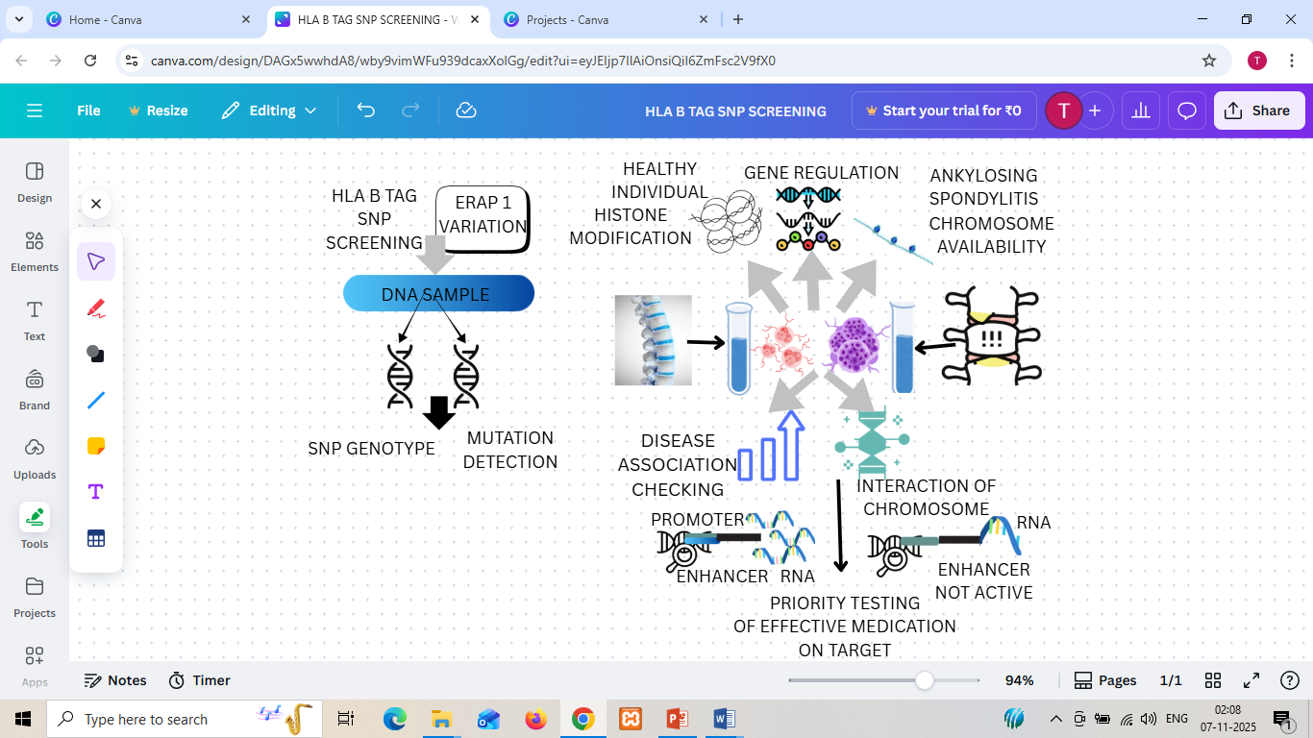
Fig 9: HLA B TAG screening and ERAP variation testing for detection of genotypic profile and mutations in ankylosing spondylitis patients and comparison chart of healthy controls with diseased humans.

DISCUSSION
With focus on the study reports from DNA methylation, it is revealed that the occurrence of hyper and hypomethylated regions at the promoter sequence of immune system genes implies that altered chromatin association with DNA nucleosome, enabled or suppressed activity of transcription factors, thereby modulating transcription and expression simultaneously leading to inflammatory responses. Additionally, detection of B7H3 with hypo-methylated promoter regions suggested the dysregulation of epigenetic markers correlated with overexpression of the immune system and aberration. H3K27ME trimethylation is found to directly regulate helper t 17 cells differentiation and is potent enough to work independently, and further alterations of histone methyltransferase, EZH2and demethylase (JMJD3) highlights dynamic nature of histone modification in the progression of disease.
Similarly, non-coding RNAs, including long non-coding RNAs and microRNAs, play an essential role in immune cell differentiation, regulation of apoptosis, and ossification. Dysregulated lncRNAs such as AK001085, NKILA, TUG1, MEG3, and H19 have been associated directly with disease activity, treatment and progression response. The regulatory networks between miRNAs (e.g., MiR-29, MiR-17, MiR-27a) and pathways such as Wnt and TGF-β/IL-17 axis indicate their importance in bone formation remodelling and inflammation.
Still, there is a need for standardisation and validation of specific clinical methods and approaches required. Technical limitations can provide incomparable reports in different studies. Frequent quality control must be conducted to identify problems such as poor quality of DNA, contaminants and inhibitors. For assays requiring bisulfite, the conversion efficiency must be carefully checked in all specimens by incorporating appropriate controls.
CONCLUSION
The aforementioned review highlights the contributory roles of epigenetic mechanisms in the progression and pathogenesis of ankylosing spondylitis. Though traditionally the major genetic factor associated with the disease considered was HLA B27, however, the symptoms of inflammation and onset of disease in individuals without the B27 HLA allele brings vital role of non-HLA genes, environmental factors and epigenetic modifications. Epigenetic markers represent a promising frontier in understanding ankylosing spondylitis progression. DNA methylation, histone modifications, and non-coding RNAs contribute to immune dysregulation, inflammation, overexpression of immune-related genes, cytokine release, abnormal bone formation, and disease progression. HLA B27 remains the strongest genetic factor; the inclusion of epigenetic biomarkers offers a more comprehensive framework for diagnosis and prognosis, disease activity monitoring, predicting treatment, and identifying accurate therapeutic potential targets. Ultimately, the combined effect of genetics, epigenetics and environmental triggers provides a holistic view of AS. Continued advanced, more complex research with larger, diverse cohorts and advanced high-throughput sequencing technologies will be essential to validate these markers and translate them into clinical diagnostic and therapeutic tools.

CONFLICT OF INTEREST
None
SUPPLEMENTARY MATERIALS
None
HIGHLIGHTS
- Etiological disorder, prototype of spondyloarthritis contributing to excessive bone stiffness, associated with genetic predisposition contributing to autoimmunity , explaining a part of susceptibility of the syndrome, with integration to environmental and epigenetic mechanisms.
- Methylation at differential rates at specific loci regions, long non coding RNA abrupt expression and histone modification effect play a combinatory role in development and progression of the disease.
- HLA B27 genes ,its subtypes and non HLA genes involved in ubiquitination , MHC 1 presentation molecules are correlated to a significant extent for disease pathogenesis.
- Consecutive hyper and hyomethylation of promoter sequences, promote DNA accessibility by transcription factors to be affected leading to contraction or relaxation of beads on string DNA contributing towards termination or onset of transcriptional events.
- Histone modification effecting immune network , hampering T cell activation, balance, auto reaction and bone remodeling, altering TREG related genes thereby enhancing expression of cytokines.

REFERENCES
1.Zhu, W.; He, X.; Cheng, K.; Zhang, L.; Chen, D.; Wang, X.; Qiu, G.; Cao, X.; Weng, X. Ankylosing Spondylitis: Etiology, Pathogenesis, and Treatments. Bone Res. 2019, 7, 22. https://doi.org/10.1038/s41413-019-0057-8
2. Proft, F.; Poddubnyy, D. Ankylosing Spondylitis and Axial Spondyloarthritis: Recent Insights and Impact of New Classification Criteria. Ther. Adv. Musculoskelet. Dis. 2018, 10 (5–6), 129–139. https://doi.org/10.1177/1759720X18773726
3. Zoghbi, H. Y.; Beaudet, A. L. Epigenetics and Human Disease. Cold Spring Harb. Perspect. Biol. 2016, 8 (2), a019497. https://doi.org/10.1101/cshperspect.a019497
4. Liao, H. T.; Tsai, C. Y.; Lai, C. C.; Hsieh, S. C.; Sun, Y. S.; Li, K. J.; Shen, C. Y.; Wu, C. H.; Lu, C. H.; Kuo, Y. M.; Li, T. H.; Chou, C. T.; Yu, C. L. The Potential Role of Genetics, Environmental Factors, and Gut Dysbiosis in the Aberrant Non-Coding RNA Expression to Mediate Inflammation and Osteoclastogenic/Osteogenic Differentiation in Ankylosing Spondylitis. Front. Cell Dev. Biol. 2022, 9, 748063. https://doi.org/10.3389/fcell.2021.748063
5. Dashti, N.; Mahmoudi, M.; Aslani, S.; Jamshidi, A. HLA-B*27 Subtypes and Their Implications in the Pathogenesis of Ankylosing Spondylitis. Gene 2018, 670, 15–21. https://doi.org/10.1016/j.gene.2018.05.092
6. Robinson, P. C.; Leo, P. J.; Pointon, J. J.; Harris, J.; Cremin, K.; Bradbury, L. A.; Wellcome Trust Case Control Consortium; Australasian Osteoporosis Genetics Consortium (AOGC); Stebbings, S.; Harrison, A. A.; Evans, D. M.; Duncan, E. L.; Wordsworth, B. P.; Brown, M. A.; Australasian Osteoporosis Genetics Consortium AOGC. The Genetic Associations of Acute Anterior Uveitis and Their Overlap with the Genetics of Ankylosing Spondylitis. Genes Immun. 2016, 17 (1), 46–51. https://doi.org/10.1038/gene.2015.49
7. Yang, H.; Chen, Y.; Xu, W.; Shao, M.; Deng, J.; Xu, S.; Gao, X.; Guan, S.; Wang, J.; Xu, S.; Shuai, Z.; Pan, F. Epigenetics of Ankylosing Spondylitis: Recent Developments. Int. J. Rheum. Dis. 2021, 24 (4), 487–493. https://doi.org/10.1111/1756-185X.14080
8. Hao, J.; Liu, Y.; Xu, J.; Wang, W.; Wen, Y.; He, A.; Fan, Q.; Guo, X.; Zhang, F. Genome-Wide DNA Methylation Profile Analysis Identifies Differentially Methylated Loci Associated with Ankylosing Spondylitis. Arthritis Res. Ther. 2017, 19 (1), 177. https://doi.org/10.1186/s13075-017-1382-1
9. Coit, P.; Kaushik, P.; Caplan, L.; Kerr, G.; Walsh, J.; Dubreuil, M.; Reimold, A.; Sawalha, A. H. Genome-Wide DNA Methylation Analysis in Ankylosing Spondylitis Identifies HLA-B*27 Dependent and Independent DNA Methylation Changes in Whole Blood. J. Autoimmun. 2019, 102, 102. https://doi.org/10.1016/j.jaut.2019.04.022
10. Ankylosing Spondylitis (Axial Spondyloarthritis). Physiopedia, February 6, 2025. Retrieved September 8, 2025, from https://www.physio-pedia.com/index.php?title=Ankylosing_Spondylitis_(Axial_Spondyloarthritis)&oldid=365773
11. Allis, C. D.; Jenuwein, T. The Molecular Hallmarks of Epigenetic Control. Nat. Rev. Genet. 2016, 17 (8), 487–500. https://doi.org/10.1038/nrg.2016.59
12. Diaconu, A.-D.; Ceasovschih, A.; Șorodoc, V.; Pomîrleanu, C.; Lionte, C.; Șorodoc, L.; Ancuța, C. Practical Significance of Biomarkers in Axial Spondyloarthritis: Updates on Diagnosis, Disease Activity, and Prognosis. Int. J. Mol. Sci. 2022, 23 (19), 11561. https://doi.org/10.3390/ijms231911561
13. Zong, H.; Xu, S.; Tong, H.; Wang, X.; Pan, M.; Teng, Y. Effect of Anti-Tumor Necrosis Factor α Treatment on Radiographic Progression in Patients with Ankylosing Spondylitis: A Systematic Review and Meta-Analysis. Mod. Rheumatol. 2019, 29, 503–509.
14. Zhang, J.; Liu, X.; Xu, W.; Dai, S. Effects of Tumor Necrosis Factor-α Inhibitors on New Bone Formation in Ankylosing Spondylitis. Joint Bone Spine 2016, 83 (3), 257–264.
15. Zhu, W.; He, X.; Cheng, K.; Zhang, L.; Chen, D.; Wang, X.; Qiu, G.; Cao, X.; Weng, X. Ankylosing Spondylitis: Etiology, Pathogenesis, and Treatments. Bone Res. 2019, 7, 22. https://doi.org/10.1038/s41413-019-0057-8
16. Dhar, G. A.; Saha, S.; Mitra, P.; Nag Chaudhuri, R. DNA Methylation and Regulation of Gene Expression: Guardian of Our Health. Nucleus 2021, 64 (3), 259–270. https://doi.org/10.1007/s13237-021-00367-y
17. Xiao, M.; Zheng, X.; Li, X.; Wu, X.; Huang, Y.; Wei, Q.; Cao, S.; Gu, J. Integrative Blood-Derived Epigenetic and Transcriptomic Analysis Reveals the Potential Regulatory Role of DNA Methylation in Ankylosing Spondylitis. Arthritis Res. Ther. 2022, 24 (1), 15. https://doi.org/10.1186/s13075-021-02697-3
18. Villicaña, S.; Bell, J. T. Genetic Impacts on DNA Methylation: Research Findings and Future Perspectives. Genome Biol. 2021, 22 (1), 127. https://doi.org/10.1186/s13059-021-02347-6
19. Bizet, M.; Defrance, M.; Calonne, E.; Bontempi, G.; Sotiriou, C.; Fuks, F.; Jeschke, J. Improving Infinium MethylationEPIC Data Processing: Re-Annotation of Enhancers and Long Noncoding RNA Genes and Benchmarking of Normalization Methods. Epigenetics 2022, 17 (13), 2434–2454. https://doi.org/10.1080/15592294.2022.2135201
20. Stefansson, O. A.; Sigurpalsdottir, B. D.; Rognvaldsson, S.; Halldorsson, G. H.; Juliusson, K.; Sveinbjornsson, G.; Gunnarsson, B.; Beyter, D.; Jonsson, H.; Gudjonsson, S. A.; Olafsdottir, T. A.; Saevarsdottir, S.; Magnusson, M. K.; Lund, S. H.; Tragante, V.; Oddsson, A.; Hardarson, M. T.; Eggertsson, H. P.; Gudmundsson, R. L.; Sverrisson, S.; et al. The Correlation between CpG Methylation and Gene Expression Is Driven by Sequence Variants. Nat. Genet. 2024, 56 (8), 1624–1631. https://doi.org/10.1038/s41588-024-01851-2
21. Aslani, S.; Mahmoudi, M.; Garshasbi, M.; Jamshidi, A. R.; Karami, J.; Nicknam, M. H. Evaluation of DNMT1 Gene Expression Profile and Methylation of Its Promoter Region in Patients with Ankylosing Spondylitis. Clin. Rheumatol. 2016, 35, 2723–2731.
22. Chen, Y.; Wu, Y.; Yang, H.; Wang, J.; Kong, J.; Yu, L.; Ni, M.; Deng, Y.; Xu, S.; Yu, H.; Shuai, Z.; Pan, F. DNA Methylation and mRNA Expression of B7-H3 Gene in Ankylosing Spondylitis: A Case-Control Study. Immunol. Investig. 2022, 51 (7), 2025–2034. https://doi.org/10.1080/08820139.2022.2095285
23. Davydova, A.; Kurochkina, Y.; Goncharova, V.; Vorobyeva, M.; Korolev, M. The Interleukin-17 Cytokine Family: Role in Development and Progression of Spondyloarthritis, Current and Potential Therapeutic Inhibitors. Biomedicines 2023, 11 (5), 1328. https://doi.org/10.3390/biomedicines11051328
24. Bie, Y.; Zheng, X.; Chen, X.; Liu, X.; Wang, L.; Sun, Y.; Kou, J. RNA Sequencing and Bioinformatics Analysis of Differentially Expressed Genes in the Peripheral Serum of Ankylosing Spondylitis Patients. J. Orthop. Surg. Res. 2023, 18 (1), 394. https://doi.org/10.1186/s13018-023-03871-w
25. Zhang, C.; Wang, C.; Jia, Z.; Tong, W.; Liu, D.; He, C.; Huang, X.; Xu, W. Differentially Expressed mRNAs, lncRNAs, and miRNAs with Associated Co-Expression and ceRNA Networks in Ankylosing Spondylitis. Oncotarget 2017, 8 (69), 113543–113557. https://doi.org/10.18632/oncotarget.22708
26. Reid, V. A.; Sedano, M.; Mangadu, T.; Gadad, S. S. Long Non-Coding RNA-Regulated Alternative Splicing Modulates Key Cancer Pathway in Lung Adenocarcinoma. Clin. Transl. Discov. 2023, 2, e184. https://doi.org/10.1002/ctd2.184
27. Abdelmonem, B. H.; Kamal, L. T.; Wardy, L. W.; Ragheb, M.; Hanna, M. M.; Elsharkawy, M.; Abdelnaser, A. Non-Coding RNAs: Emerging Biomarkers and Therapeutic Targets in Cancer and Inflammatory Diseases. Front. Oncol. 2025, 15, 1534862. https://doi.org/10.3389/fonc.2025.1534862
28. Li, X.; Chai, W.; Zhang, G.; Ni, M.; Chen, J.; Dong, J.; Zhou, Y.; Hao, L.; Bai, Y.; Wang, Y. Down-Regulation of lncRNA-AK001085 and Its Influences on the Diagnosis of Ankylosing Spondylitis. Med. Sci. Monit. 2017, 23, 11–16.
29. Xia, Y.; Chen, K.; Zhang, M.-H.; et al. MicroRNA-124 Involves in Ankylosing Spondylitis by Targeting ANTXR2. Mod. Rheumatol. 2015, 25 (5), 784–789.
30. Zhou, L.; Zhang, Y.; Xu, H.; Hu, L.; Zhang, C.; Sun, L.; Xie, Y.; Lu, H.; Zhang, Z.; Hu, W.; Lin, X. Decreased Programmed Death-1 Expression on the T Cells of Patients with Ankylosing Spondylitis. Am. J. Med. Sci. 2015, 349, 488–492.
31. Soleimanifar, N.; Assadiasl, S.; Al-Shammari, M. S.; Rostamian, A.; Sadr, M.; Shahkarami, S.; Mojtahedi, H.; Nicknam, M. H. Evaluation of PD-1 Gene Expression Profile and Methylation of the Regulatory Regions in Patients with Ankylosing Spondylitis. Iran. J. Immunol. 2024, 21 (2).
32. Fang, Y.; Liu, J. Novel Regulatory Role of Non-Coding RNAs in Ankylosing Spondylitis. Front. Immunol. 2023, 14, 1131355. https://doi.org/10.3389/fimmu.2023.1131355
33. Aillaud, M.; Schulte, L. N. Emerging Roles of Long Noncoding RNAs in the Cytoplasmic Milieu. Non-Coding RNA 2020, 6 (4), 44. https://doi.org/10.3390/ncrna6040044
34. Katagiri, T.; Watabe, T. Bone Morphogenetic Proteins. Cold Spring Harb. Perspect. Biol. 2016, 8 (6), a021899. https://doi.org/10.1101/cshperspect.a021899
35. Najm, A.; Masson, F. M.; Preuss, P.; Georges, S.; Ory, B.; Quillard, T.; Sood, S.; Goodyear, C. S.; Veale, D. J.; Fearon, U.; Le Goff, B.; Blanchard, F. MicroRNA-17-5p Reduces Inflammation and Bone Erosions in Mice with Collagen-Induced Arthritis and Directly Targets the JAK/STAT Pathway in Rheumatoid Arthritis Fibroblast-like Synoviocytes. Arthritis Rheumatol. 2020, 72 (12), 2030–2039. https://doi.org/10.1002/art.41441
36. Xing, Y.; Sun, X.; Li, F.; Jiang, X.; Jiang, A.; Li, X.; Lv, R.; Shao, L. Long Non-Coding RNA (lncRNA) HOXB-AS3 Promotes Cell Proliferation and Inhibits Apoptosis by Regulating ADAM9 Expression through Targeting miR-498-5p in Endometrial Carcinoma. J. Int. Med. Res. 2021, 49 (6), 3000605211013548. https://doi.org/10.1177/03000605211013548
37. Li, C.; Qu, W.; Yang, X. Comprehensive lncRNA and mRNA Profiles in Peripheral Blood Mononuclear Cells Derived from Ankylosing Spondylitis Patients by RNA-Sequencing Analysis. Medicine 2022, 101 (4), e27477. https://doi.org/10.1097/MD.0000000000027477
38. Xue, C.; Chu, Q.; Shi, Q.; Zeng, Y.; Lu, J.; Li, L. Wnt Signaling Pathways in Biology and Disease: Mechanisms and Therapeutic Advances. Signal Transduct. Target. Ther. 2025, 10 (1), 106. https://doi.org/10.1038/s41392-025-02142-w
39. Duan, P.; Bonewald, L. F. The Role of the Wnt/β-Catenin Signaling Pathway in Formation and Maintenance of Bone and Teeth. Int. J. Biochem. Cell Biol. 2016, 77 (Pt A), 23–29. https://doi.org/10.1016/j.biocel.2016.05.015
40. Motta, F.; Carena, M. C.; Selmi, C.; Vecellio, M. MicroRNAs in Ankylosing Spondylitis: Function, Potential and Challenges. J. Transl. Autoimmun. 2020, 3, 100050. https://doi.org/10.1016/j.jtauto.2020.100050
41. Mazziotta, C.; Lanzillotti, C.; Iaquinta, M. R.; Taraballi, F.; Torreggiani, E.; Rotondo, J. C.; Otòn-Gonzalez, L.; Mazzoni, E.; Frontini, F.; Bononi, I.; De Mattei, M.; Tognon, M.; Martini, F. MicroRNAs Modulate Signaling Pathways in Osteogenic Differentiation of Mesenchymal Stem Cells. Int. J. Mol. Sci. 2021, 22 (5), 2362. https://doi.org/10.3390/ijms22052362
42. Xie, Z.; Li, J.; Wang, P.; Li, Y.; Wu, X.; Wang, S.; Su, H.; Deng, W.; Liu, Z.; Cen, S.; Ouyang, Y.; Wu, Y.; Shen, H. Differential Expression Profiles of Long Noncoding RNA and mRNA of Osteogenically Differentiated Mesenchymal Stem Cells in Ankylosing Spondylitis. J. Rheumatol. 2016, 43, 1523–1531.
43. Li, X.; Chai, W.; Zhang, G.; Ni, M.; Chen, J.; Dong, J.; Zhou, Y.; Hao, L.; Bai, Y.; Wang, Y. Down-Regulation of lncRNA-AK001085 and Its Influences on the Diagnosis of Ankylosing Spondylitis. Med. Sci. Monit. 2017, 23, 11–16. https://doi.org/10.12659/msm.898915
44. Liu, W.; Huang, L.; Zhang, C.; Liu, Z. lncRNA MEG3 Is Downregulated in Ankylosing Spondylitis and Associated with Disease Activity, Hospitalization Time, and Disease Duration. Exp. Ther. Med. 2019, 17 (1), 291–297. https://doi.org/10.3892/etm.2018.6921

45. Jethwa, H.; Bowness, P. The Interleukin (IL)-23/IL-17 Axis in Ankylosing Spondylitis: New Advances and Potentials for Treatment. Clin. Exp. Immunol. 2016, 183 (1), 30–36. https://doi.org/10.1111/cei.12670
46. Li, J.; Xie, X.; Liu, W.; Gu, F.; Zhang, K.; Su, Z.; Wen, Q.; Sui, Z.; Zhou, P.; Yu, T. MicroRNAs as Biomarkers for the Diagnosis of Ankylosing Spondylitis: A Systematic Review and Meta-Analysis. Front. Med. 2021, 8, 701789. https://doi.org/10.3389/fmed.2021.701789
47. Xu, X. H.; Zhang, J. X.; Liu, H. X.; Zhao, Z.; Jiang, J. Y. Intervention of Inflammation Associated with Ankylosing Spondylitis by Triptolide Promotes Histone H3 Lys-27 Trimethylation. Immunopharmacol. Immunotoxicol. 2024, 46 (6), 785–792. https://doi.org/10.1080/08923973.2024.2402911
48. Ding, X.; Liu, J.; Sun, Y.; Chen, X. Triptolide Alleviates the Development of Inflammation in Ankylosing Spondylitis via the NONHSAT227927.1/JAK2/STAT3 Pathway. Exp. Ther. Med. 2023, 27 (1), 17. https://doi.org/10.3892/etm.2023.12305
49. Liu, C.; Yang, H.; Shi, W.; Wang, T.; Ruan, Q. MicroRNA-Mediated Regulation of T Helper Type 17/Regulatory T-Cell Balance in Autoimmune Disease. Immunology 2018, 155 (4), 427–434. https://doi.org/10.1111/imm.12994
50.Kouznetsova, V. L.; Tchekanov, A.; Li, X.; Yan, X.; Tsigelny, I. F. Polycomb Repressive 2 Complex—Molecular Mechanisms of Function. Protein Sci. 2019, 28 (8), 1387–1399. https://doi.org/10.1002/pro.3647
51. Javaid, N.; Choi, S. Acetylation- and Methylation-Related Epigenetic Proteins in the Context of Their Targets. Genes 2017, 8 (8), 196. https://doi.org/10.3390/genes8080196
52. Cortes, A.; Pulit, S. L.; Leo, P. J.; Pointon, J. J.; Robinson, P. C.; Weisman, M. H.; Ward, M.; Gensler, L. S.; Zhou, X.; Garchon, H. J.; Chiocchia, G.; Nossent, J.; Lie, B. A.; Førre, Ø.; Tuomilehto, J.; Laiho, K.; Bradbury, L. A.; Elewaut, D.; Burgos-Vargas, R.; Stebbings, S.; et al. Major Histocompatibility Complex Associations of Ankylosing Spondylitis Are Complex and Involve Further Epistasis with ERAP1. Nat. Commun. 2015, 6, 7146. https://doi.org/10.1038/ncomms8146
53. A Martínez-Nava, G. A.; Zamudio-Cuevas, Y.; Terrazas-Ontiveros, N. A.; Martínez-Flores, K.; Espinosa-Morales, R.; Mijares-Díaz, F.; Juárez-Barreto, S. M.; Lozada-Pérez, C.; Valdés-Flores, M.; Sánchez-Sánchez, R.; Hidalgo-Bravo, A.; Fernández-Torres, J. A Proposed HLA-B*27 Screening Method for Ankylosing Spondylitis Detection Based on Tag-Single Nucleotide Polymorphisms: A Preliminary Study. Mol. Biol. Rep. 2021, 48 (12), 7819–7829. https://doi.org/10.1007/s11033-021-06801-3

