Original Research Article
Prevalence of systemic diseases with special reference to hepatic dysfunction in geriatric dogs

.
ABSTRACT

The present study evaluated the prevalence of systemic diseases and the occurrence of hepatic dysfunction in geriatric dogs. A total of 554 geriatric dogs presented to the Veterinary Clinical Complex, Jabalpur, between July 2025 and December 2025 were included in the study. Overall, 55.05% of the dogs were affected with one or more systemic diseases. Among these, dermatological disorders were the most frequently encountered, followed by gastrointestinal diseases, while endocrine disorders showed the lowest prevalence. Systemic arterial pressure (SAP) was assessed in all dogs and hypertension was most observed in dogs suffering from renal diseases. Hepatic dysfunction was identified in 9.84% of the geriatric dogs. A higher occurrence was recorded in males (73.33%) compared to females (26.67%). Labrador Retrievers and non-descript breeds were predominantly affected. Inappetence and vomiting were the most consistent clinical manifestations in dogs with hepatic dysfunction. The study highlights the high burden of systemic disorders in geriatric dogs and underscores hepatic dysfunction as a clinically significant condition requiring routine screening and early intervention in aging canine populations.

Keywords: Geriatric dogs, systemic diseases, hepatic dysfunction
1. INTRODUCTION
Dogs are believed to be the earliest animals domesticated and used by humans since ancient times (Pati et al., 2015). Older pets account for over 40% of patients in general veterinary practice, a percentage expected to rise as canine lifespans increase, encouraging veterinarians to focus more on senior animals (Espino and Mino, 2024). The term “geriatric” in veterinary practices is used to describe animals that have reached approximately 75% of their expected lifespan (Willems et al., 2017). Notably, as the size of an animal increases, the age at which it is considered geriatric, tends to decrease (Coskan and Can, 2024). Old age or the geriatric dogs show visible physical signs, alongside haematological, biochemical and urinary alterations. These are often accompanied by structural and functional changes at the tissue or cellular level, signaling underlying disease processes. Such age-related changes are inevitable in older dogs and often indicate the onset of illness (Pati et al., 2015). The liver is a vital organ responsible for carbohydrate, protein and lipid metabolism, synthesis of plasma proteins, erythropoiesis and detoxification of endogenous and exogenous compounds. With advancing age, the liver, along with other organs, undergoes significant structural and functional alterations. Aging is associated with a progressive reduction in liver size and mass, accompanied by decreased hepatic blood flow and a decline in microsomal enzyme activity, ultimately impairing metabolic and detoxification capacity.

2. material and methods
The proposed study was conducted at the Department of Veterinary Medicine, College of Veterinary Science and Animal Husbandry, NDVSU, Jabalpur (M.P.) from July 2025 to December 2025. The screening of geriatric dogs for systemic diseases was done on the basis of history and clinical examination, blood pressure measurement, haemato-biochemical alterations, etc. Dogs were subjected to radiographic, ultrasonographic examination and electrocardiography as and when needed.
Animals
For this study, a total of 554 geriatric dogs presented at the Veterinary Clinical Complex, College of Veterinary Science and Animal Husbandry, Jabalpur (M.P.) were screened from July 2025 to December 2025. A prevalence study was conducted in geriatric dogs presented during the study period. Dogs were considered geriatric according to their body weight and age, as per the guidelines described by Willems et al. (2017), with slight modifications.
Parameters of study
A complete history of the dog i.e. age, body weight, sex, breed and duration of illness (if any), mucous membranes, dehydration status, etc., was taken. Clinical examination including rectal temperature (°F), heart rate (beats/minute) and respiratory rate (breaths/minute).
Blood pressure measurement
Blood pressure was measured in each dog under screening using an indirect method employing a Doppler ultrasonic flow detector, particularly for detecting systolic arterial pressure (Stepien et al., 2003). The measurement was performed with the animal positioned in right lateral recumbency, following a 10–15-minute acclimatization period in a quiet environment to minimize stress-induced variability.

Table 01: Geriatric age of dogs based on body weight
Geriatric age (years) | ≥12 | ≥10 | ≥8 | ≥6
Weight of dogs (Kg) | 0-9 | ≥9–23 | ≥23–55 | > 55

3. Results and discussion
3.1 Prevalence of systemic diseases in geriatric dogs
A total of 554 geriatric dogs were screened for presence of the systemic diseases and out of these 305 dogs were affected with one or more systemic diseases. Accordingly, the overall prevalence of systemic diseases in geriatric dogs at Jabalpur was 55.05 per cent (Table 02).
Table 02: Prevalence of systemic diseases in geriatric dogs
Number of dogs screened | Number of dogs affected with systemic diseases | Prevalence (%)
554 | 305 | 55.05

The prevalence of systemic diseases was found to be high in geriatric dog population with most of the dogs being affected with multiple abnormalities. No traceable literature is available regarding prevalence of systemic diseases in geriatric dogs. However, Jain et al. (2015) and Shaju et al. (2019) screened geriatric dogs presented with clinical signs of systemic diseases and reported multiple diseases.
A high prevalence of systemic diseases in geriatric dogs in the present study might be attributed to the fact that aging is a complex biological process which results in progressive reduction of dogs’ ability for maintaining homeostasis under physiological and environmental stress (Boari and Aste, 2003).
3.2 Distribution of different systemic diseases in geriatric dogs
Among 305 affected dogs, diseases were distributed according to different systems involved. The distribution varied significantly with the highest prevalence recorded in skin (14.10%) followed by gastrointestinal (11.47%), renal (10.82%), hepatic (9.84%), neoplastic (9.18%), reproductive (7.21%), auditory (6.57), musculoskeletal (6.23%), ophthalmic (5.57%), cardiovascular (3.61%), haemoparasites (3.28%), respiratory (3.28%), nervous (2.29%), endocrine (1.31%) and comorbidities (5.24%) (Table 03).
Table 03: Distribution of different systemic diseases in geriatric dogs
S. No. | Systems involved | Number of dogs affected (n=305) | Per cent  (%)
1 | Skin | 43 | 14.10
2 | Gastro-intestinal | 35 | 11.47
3 | Renal | 33 | 10.82
4 | Hepatic | 30 | 09.84
5 | Neoplastic | 28 | 09.18
6 | Reproductive | 22 | 07.21
7 | Auditory System | 20 | 06.57
8 | Musculoskeletal | 19 | 06.23
9 | Ophthalmic | 17 | 05.57
10 | Cardiovascular | 11 | 03.61
11 | Haemoparasites | 10 | 03.28
12 | Respiratory | 10 | 03.28
13 | Nervous | 07 | 02.29
14 | Endocrine | 04 | 01.31
15 | Comorbidities | 16 | 05.24
𝜒² = 89.57*

The result of present study indicated that the predominant systemic diseases in geriatric dogs included the diseases of skin, gastrointestinal tract, renal system and neoplasm. Different scientists have reported varying rates of occurrence of systemic diseases in geriatric dogs.
The findings of the present study correlate with the finding of Jain et al. (2015) who also observed a higher prevalence of gastrointestinal problems and tumors in geriatric dogs. On the contrary, Dias-Periera (2022) observed reproductive, cardiovascular and urinary systems as the most frequently involved systems in geriatric dogs. The occurrence of various diseases and disorders in geriatric dogs might be attributed to the fact that immunity of the animal lowers with the advancing age which could predispose them to various infections.
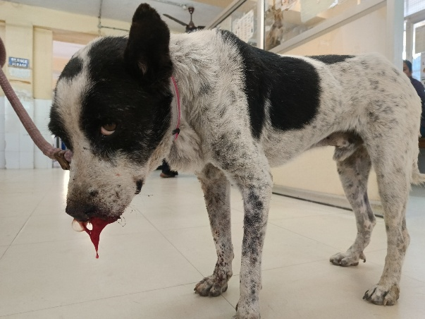
Figure 01: Geriatric non-descript dog with respiratory affection

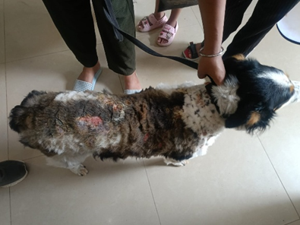
Figure 02: Skin affection in a geriatric dog
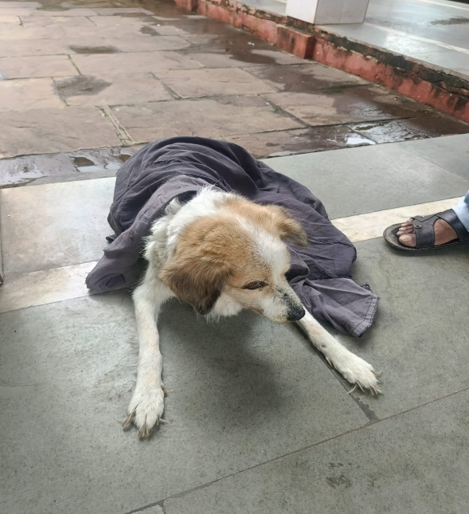
Figure 03: Partial weight-bearing lameness in a geriatric dog

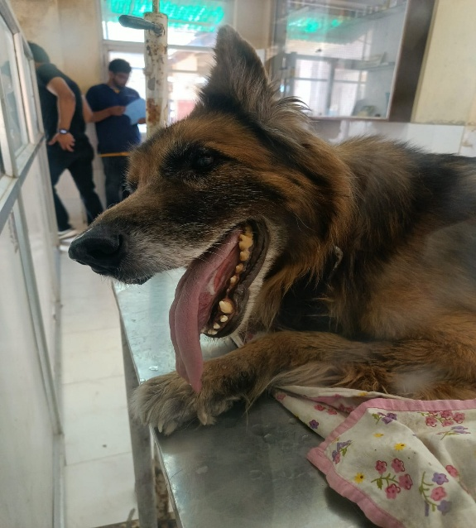
Figure 04: Head tilting as a nervous sign in a geriatric dog

3.3 Systolic arterial blood pressure (mmHg) in systemic diseases in geriatric dogs
The mean arterial blood pressure (mmHg) was recorded on the day of presentation (day 0) in all the geriatric dogs affected with systemic diseases. The highest mean systolic blood pressure was observed in geriatric dogs with renal affections (168.17 ± 5.85 mmHg), followed by cardiovascular (157.00±10.84 mmHg), endocrine (157.00±10.87 mmHg), haemoparasites (150.76±10.88 mmHg), hepatic (150.43±6.67 mmHg), ophthalmic (148.82±8.76 mmHg), nervous (146.42±14.08 mmHg), respiratory (140.33±13.18 mmHg), reproductive (138.26±5.66 mmHg), gastro-intestinal (135.28±4.51 mmHg), musculoskeletal (133.68±5.39 mmHg), neoplastic (131.07±4.56 mmHg), skin (130.83±5.22 mmHg) and auditory system diseases (129.50±4.86 mmHg) (Table 04).
The results revealed that hypertension was seen in geriatric dogs affected with renal diseases. Similar findings were observed by Ghag et al. (2016) and Tyagi et al. (2025) who observed that dogs aged above 8 years showed a higher occurrence of hypertension with secondary hypertension being the most common form especially in dogs with renal diseases. Geriatric dogs often show a higher occurrence of hypertension, which may be attributed to age-related vascular changes and the increased presence of concurrent diseases in older animals.
Table 04: Mean systolic arterial blood pressure (mmHg) in systemic diseases in geriatric dogs
S.No. | System involved | Number of dogs (n=305) | SAP (Mean±SE)
1 | Renal | 34 | 168.17±5.85
2 | Cardiovascular | 15 | 157.00±10.84
3 | Endocrine | 04 | 157.00±18.87
4 | Hemoparasites | 13 | 150.76±10.88
5 | Hepatic | 30 | 150.43±6.67
6 | Ophthalmic | 17 | 148.82±8.76
7 | Nervous | 07 | 146.42±14.08
8 | Respiratory | 12 | 140.33±13.18
9 | Reproductive | 23 | 138.26±5.66
10 | Gastro-intestinal | 35 | 135.28±4.51
11 | Musculoskeletal | 19 | 133.68±5.39
12 | Neoplastic | 29 | 131.07±4.56
13 | Skin | 47 | 130.83±5.22
14 | Auditory | 20 | 129.50±4.86

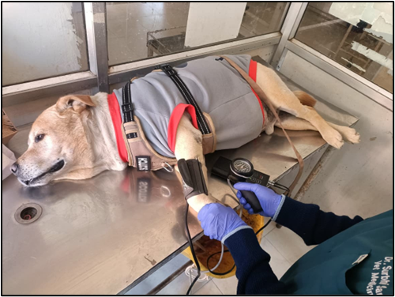
Figure 05: Blood pressure measurement of a geriatric Labrador Retriever using a Doppler ultrasonic flow detector
3.4 Occurrence of hepatic dysfunction in geriatric dogs
Among the 305 geriatric dogs diagnosed with systemic diseases, 30 exhibited clinical manifestations pertaining to hepatic dysfunction. Therefore, the overall occurrence of hepatic dysfunction in geriatric dogs was 9.84 per cent (Table 05).
Table 05: Occurrence of hepatic dysfunction in geriatric dogs
Particulars | Number of dogs screened | Number of dogs affected with hepatic dysfunction | Occurrence (%)
Total dog population | 305 | 30 | 09.84

Varying rates of occurrence of hepatic dysfunction in geriatric dogs were reported by different scientists. Jain et al. (2015) reported that liver disorders accounted for 4.48 per cent whereas, Dias-Pereira (2022) reported 28.3 per cent liver disorders in geriatric dogs. On the contrary, Ramesh et al. (2024) reported 0.99 percent geriatric dogs affected with hepatic dysfunction. Liver disorders in geriatric dogs are common and may be attributed to age-related structural and functional changes, including a reduction in hepatocyte number, an increase in binucleated hepatocytes, fatty infiltration, increased fibrous tissue deposition, decline in hepatic functional capacity and reduced bile production (Jain et al., 2015).
3.5 Sex wise distribution of hepatic dysfunction in geriatric dogs
Sex-wise distribution of hepatic dysfunction in geriatric dogs with hepatic dysfunction revealed a male predominance, with 73.33 per cent (22/30) as compared to females i.e. 26.67 per cent (Table 06).
Table 06: Sex wise distribution of hepatic dysfunction in geriatric dogs
S. No. | Sex | Number of dogs affected (n=30) | Distribution (%)
1 | Male | 22 | 73.33
2 | Female | 08 | 26.67
𝜒² = 06.53*

Sex wise distribution of hepatic dysfunction in geriatric dogs showed significant variation among males and females. The findings of the present study correlates well with the findings of Sameeksha et al. (2021) who also reported that male were affected more than females. In contrast, Puravankara et al. (2022), Verma et al. (2023) and Ramesh et al. (2024) observed that females were more affected as compared to males. Sex-related hormonal influences and comparatively lower immune resilience in male dogs may contribute to the higher prevalence observed. The greater tendency of male dogs to roam freely may result in higher exposure to infectious agents and toxic environmental factors, thereby increasing susceptibility of disease occurrence.
3.6 Breed-wise distribution of hepatic dysfunction in geriatric dogs
Breed wise distribution of hepatic dysfunction in geriatric dogs varied significantly among different breeds. The most predominated breed affected was Labrador retriever (26.67) and non-descript dogs (26.67%) followed by Pomeranian (13.33), Golden Retriever (06.67%), Doberman (06.67%), German Shepherd (06.67%), Bull Mastiff (03.33%), Dachshund (03.33%), Saint Bernard (03.33%) and Indian Spitz (03.33%) (Table 07).
Table 07: Breed-wise distribution of hepatic dysfunction in geriatric dogs
S.No. | Breed | Number of dogs affected (n=30) | Distribution (%)
1 | Labrador Retriever | 08 | 26.67
2 | Non-descript | 08 | 26.67
3 | Pomeranian | 04 | 13.33
4 | Golden Retriever | 02 | 06.67
5 | Doberman | 02 | 06.67
6 | German Shepherd | 02 | 06.67
7 | Bull Mastiff | 01 | 03.33
8 | Dachshund | 01 | 03.33
9 | Saint Bernard | 01 | 03.33
10 | Indian Spitz | 01 | 03.33
𝜒² = 23.33*

The results of the present study indicated that Labrador retrievers and no-descript breed of dogs showed significantly higher distribution of hepatic dysfunction. The findings corroborate with the findings of Sameeksha et al. (2021), Puravankara et al. (2022) and Ramesh et al. (2024) who also found Labrador retriever as most affected breed with hepatic dysfunction. This might be due to the reason that geriatric Labradors reach the age where chronic liver disease is more common. Moreover, Labradors Retrievers are genetically inclined toward altered lipid metabolism, accumulate fat easily, not just subcutaneously but within hepatocytes also. Non-descript dogs also showed a higher occurrence of liver disorders might be due to increased environmental stressors and nutritional inadequacies in non-descript dogs.
3.7 Clinical abnormalities exhibited by geriatric dogs with hepatic dysfunction
Among the geriatric dogs having hepatic dysfunction, a number of clinical abnormalities were observed. The most common clinical abnormalities exhibited by the affected dogs were inappetence or anorexia (96.67%), vomition (53.00%), polyuria (20.00%), dehydration (20.00%), weight loss (20.00%), polydipsia (16.67%), ascites (13.33%), icterus (10.00%), melena (10.00%) and abdominal pain (06.67%) (Table 08).
Table 08: Clinical abnormalities exhibited by dogs with hepatic dysfunction
S. No. | Clinical abnormalities | Number of dogs affected (n=30) | Distribution  (%)
1 | Inappetence/ Anorexia | 29 | 96.67
2 | Vomition | 16 | 53.00
3 | Polyuria | 06 | 20.00
4 | Dehydration | 06 | 20.00
5 | Weight loss | 06 | 20.00
6 | Polydipsia | 05 | 16.67
7 | Ascites | 04 | 13.33
8 | Icterus | 03 | 10.00
9 | Melena | 03 | 10.00
10 | Abdominal pain | 02 | 06.67

The clinical signs and severity of hepatic dysfunction in geriatric dogs depend on the extent to which normal liver functions are impaired. These functions include regulation of blood glucose, fat metabolism, production of clotting factors, albumin, fibrinogen, non-essential amino acids and other plasma proteins, bile production and excretion, metabolism of bilirubin and cholesterol, conversion of ammonia to urea, metabolism of polypeptide and steroid hormones. In older dogs, age-related reduction in liver functional reserve further worsens these disturbances.

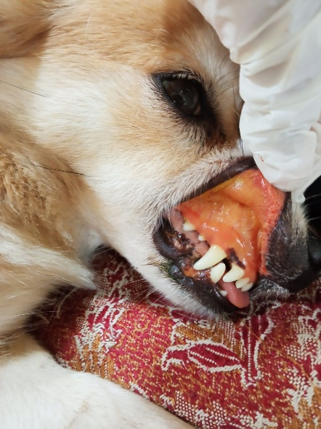
Figure 06: Icteric oral mucous membrane in a geriatric Pomeranian
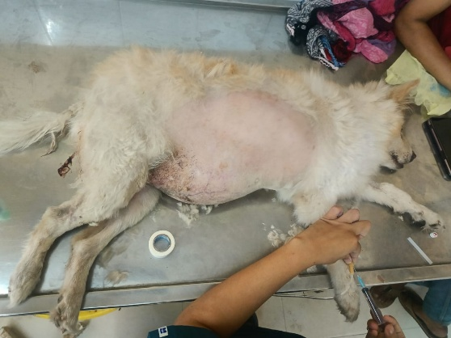
Figure 07: Abdominal distension with increased intra-abdominal fat deposition in a geriatric Pomeranian affected with hepatic dysfunction

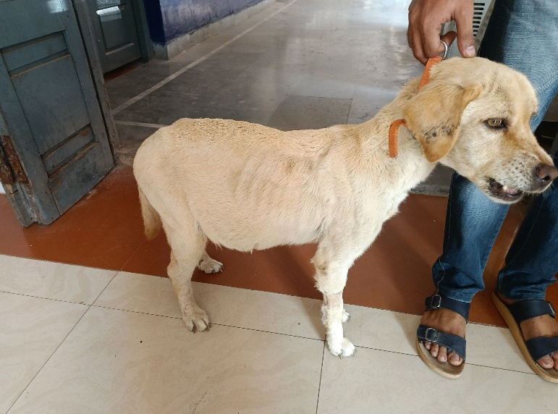
Figure 08: Weight loss due to inappetence with abdominal distension in a geriatric Labrador Retriever affected with hepatic dysfunction

Inappetence observed in geriatric dogs with hepatic dysfunction may have occurred due to impaired hepatic detoxification, digestive disturbances associated with cholestasis, release of inflammatory mediators and altered central regulation of appetite with advancing age. Vomition in hepatic dysfunction might be due to impaired hepatic detoxification leading to accumulation of toxins and bile acids, cholestasis-related gastrointestinal irritation, delayed gastric emptying and stimulation of the central vomiting center, which is more pronounced in geriatric dogs.

4. Conclusion

The study concludes that prevalence of systemic diseases in geriatric dogs might be attributed to the fact that immunity of the animal lowers with the advancing age which could predispose them to various infections. Hepatic dysfunction is commonly encountered in geriatric dogs because advancing age increases cumulative exposure to metabolic stress, drugs, infections and toxins, while simultaneously reducing hepatic regenerative capacity.

ETHICAL APPROVAL
All animal procedures carried out during the study were conducted in accordance with the guidelines of the Committee of Experimental Animal Care. The experimental protocols and animal handling techniques were duly reviewed and approved by the University Animal Care Committee.

References

Boari, A. and Aste, G. (2003). Diagnosis and management of geriatric canine endocrine disorders. Veterinary research communications, 27(1): 543-554.
Coskan, N. and Can, P. (2024). Physiotherapy and rehabilitation in geriatric dogs and cats. Turkish Journal of Veterinary Research, 8(2): 151-162.
Dias-Pereira, P. (2022). Morbidity and mortality in elderly dogs–a model for human aging. BMC veterinary research, 18(1): 457.
Espino, L. and Miño, N. (2024). Common neurologic diseases in geriatric dogs. Animals, 14(12): 1753 https://doi.org/10.3390/ani14121753.
Ghag, R.S., Alex, P.C. and Chirayath, D. (2017). Screening of geriatric dogs for chronic kidney disease and its management. Journal of Veterinary and Animal Sciences, 48(1): 70-76.
Jain, S., Patel, P.R. and Raval, S.K. (2015). A study of diseases in geriatric dogs. Indian Journal of Animal Sciences, 49(6) :866-868.
Pati, S., Panda, S.K., Acharya, A.P., Senapati, S., Behera, M. and Behera, S.S. (2015). Evaluation of geriatric changes in dogs. Veterinary World, 8(3): 273-278.
Puravankara, A., Korsapati, L., Ambica Gadige, A. and Kumar, B.D.P.K. A Study on Incidence of Hepatic Dysfunctions in Dogs. Acta Scientific Veterinary Sciences, 4(10): 33-36.
Ramesh, K., Kumar, K.S., Nagaraj, P., Kumar, B.D.P.K. and Lakshman, M. (2024) Incidence of hepatobiliary disorders in geriatric dogs. The Pharma Innovation Journal , 13(5): 134-137.
Sameeksha, C., Bhojne, G.R., Dhoot, V.M., Upadhye, S.V., Somkuwar, A.P., Khan, W.A., Panchbhai, C.K. and Dohre, K. (2021). Age, breed and genderwise prevalence of hepatic disorders in dogs of Nagpur city. International Journal of Current Microbiology and Applied Sciences, 10(02): 1685-1689.
Shaju, L.E., Sundar, S., Rao, V.V. and Kumar, A. (2019). Occurrence of certain systemic diseases in geriatric dogs. Indian Journal of Canine Practice, 11(2): 121-127.
Stepien, R.L., Rapoport, G.S., Henik, R.A., Wenholz, L. and Thomas, C.B. (2003). Comparative diagnostic test characteristics of oscillometric and doppler ultrasonographic methods in the detection of systolic hypertension in dogs. Journal of Veterinary Internal Medicine, 17(1): 65-72.
Tyagi, R., Gupta, D.K. Pradhan, S.,Tripathi, S.M., Shahi, A., Pathak, S.K., Pratap, A., Mathur, R and Sachdev, H.K. (2025). Epidemiological Assessment of Systemic Hypertension in Dogs. Journal of Advances in Biology and Biotechnology, 28(2): 339-347.
Verma, P., Arora, N., Mrigesh, M., Singh, A.K., Kalita, J.C. and Prasad, A. (2023). Prevalence, clinical manifestations and etiology of canine hepatic dysfunction in and around Pantnagar. Indian Journal of Animal Health, 62(1): 88-94.
Willems, A., Paepe, D., Marynissen, S., Smets, P., Van de Maele, I., Picavet, P. and Daminet, S. (2017). Results of screening of apparently healthy senior and geriatric dogs. Journal of Veterinary Internal Medicine, 31(1): 81-92.

