Case report
Therapeutic Management of Severe Anemia associated with Microfilariasis in a Pug: A Case Report

ABSTRACT
A 3-year-old intact male Pug weighing 10 kg was presented to the Small Animal Medicine Unit with a history of anorexia, lethargy, and irregular voiding habits. Clinical examination revealed dull mentation, lateral recumbency, and blanched conjunctival mucous membranes indicative of severe anemia. Hematological evaluation confirmed severe anemia (Hemoglobin 3.25 g/dL; PCV 8.5%) and thrombocytopenia (70×10³/μL), while peripheral blood smears revealed the presence of microfilariae consistent with Dirofilaria species. Serum biochemistry parameters were within normal limits. Due to the life-threatening nature of the anemia, a whole blood transfusion was performed. A compatible major cross-match was obtained, and the transfusion was completed uneventfully. The patient was managed with a combined therapeutic approach using a whole blood transfusion as a supportive measure and a targeted antiparasitic regimen (Ivermectin and Doxycycline) for recovery. The patient showed significant clinical improvement by Day 5. This case highlights the importance of timely blood transfusion to stabilize patients, allowing specific medical management to take effect.
KEYWORDS: Canine, Microfilariasis, Severe Anemia, Whole Blood Transfusion, Dirofilaria species.

INTRODUCTION
Canine filariasis, predominantly caused by the nematode Dirofilaria species, is a mosquito-borne disease of significant veterinary importance (Megat Abd Rani et al., 2010). While the disease is endemic in tropical and subtropical regions, its clinical presentation varies based on worm burden and host immune response. Adult worms primarily inhabit the pulmonary arteries and the right ventricle (Ettinger & Feldman, 2010), leading to classical signs such as exercise intolerance, chronic cough and weight loss.
However, in severe infestations, the disease may manifest with systemic complications beyond the respiratory system. A critical complication is the development of severe anemia and thrombocytopenia. This is often resulting from microangiopathic hemolysis or immune-mediated destruction of erythrocytes (Marokot Kaewthamasorn et al., 2008). In acute crises where the packed cell volume (PCV) drops to life-threatening levels (typically <15%), immediate blood transfusion becomes essential to restore oxygen-carrying capacity.
While blood transfusions are life-saving, they require careful donor selection, cross-matching, and rigorous monitoring. This case report documents the therapeutic management of a Pug presented with severe anemia associated with microfilariasis, describing the successful use of whole blood transfusion to stabilize the patient, enabling a successful recovery through combined medical therapy.

Case Presentation
CASE HISTORY AND CLINICAL OBSERVATIONS
A 3-year-old intact male Pug weighing 10 kg was presented to the Small Animal Medicine Unit of the Veterinary Clinical Complex, Tirunelveli. The presenting complaints included hyporexia for one week, dull mentation, and irregular bowel and bladder habits. On presentation, the animal was recumbent and exhibited extreme lethargy (Fig. 1). General physical examination revealed a dry, lusterless hair coat and distinctive pallor in the conjunctival mucous membranes, suggestive of severe anemia. Hematological analysis revealed severe normocytic, normochromic anemia with a Hemoglobin level of 3.25 g/dL and a Packed Cell Volume (PCV) of 8.5%. The total RBC count was 1.30×10⁶/μL. Peripheral blood smear evaluation showed evidence of regeneration, characterized by nucleated RBCs, polychromasia, codocytes, and leptocytes. Thrombocytopenia (Platelets: 70×10³/μL). Serum biochemistry revealed BUN and Creatinine levels within normal reference ranges (Table 1). Wet film and stained blood smear examination confirmed the presence of microfilariae, morphologically consistent with Dirofilaria species (Fig. 2). The gold standard for confirmation is the Heartworm Antigen Test (SNAP Test). However, due to resource limitations at the time of presentation, this specific antigen test was not performed. The diagnosis was established based on the strong clinical correlation, radiographic findings, and microfilarial morphology. Thoracic radiographic examination revealed a mixed alveolar pattern and enlargement of the pulmonary artery segments (Figs. 3, 4).
THERAPEUTIC MANAGEMENT
Upon diagnosis, immediate therapeutic intervention was initiated. On Day 0, the animal received a low-dose preventive administration of Ivermectin (6 mcg/kg, SC) to prevent rapid microfilarial die-off and shock. Concomitant oral therapy included Doxycycline (10 mg/kg, PO, SID) to target Wolbachia endosymbionts, Pantoprazole (1 mg/kg, PO, SID) for gastro protection, and an iron supplement to support erythropoiesis.
Due to the critical PCV (8.5%) and clinical signs of hypoxia, a whole blood transfusion was scheduled for Day 2. A healthy canine donor was selected based on standard physical and hematological screening (Fig. 5). Prior to transfusion, a major cross-match (Donor RBCs + Recipient Plasma) was performed. The slide agglutination test (Fig. 7) and microscopic evaluation revealed dispersed red blood cells (Figs. 8, 9), confirming compatibility. Whole blood (100 ml) was aseptically collected from the donor using a CPDA-1 (Citrate Phosphate Dextrose Adenine) bag (Fig. 10). The blood was transfused intravenously using a standard blood administration set with an in-line filter (Fig. 11). The rate was initially slow (6 drops/min) for the first 15 minutes to monitor for acute reactions, then gradually increased. The transfusion was completed successfully without any adverse events or transfusion reactions (Table 2). By Day 5 post-transfusion, the animal exhibited a marked improvement in mentation, activity level and appetite (Fig. 12). Post-transfusion hematology (Table 3) showed a significant improvement in hemoglobin (8.6 g/dL) and PCV (16.8%), indicating a successful therapeutic outcome.
DISCUSSION
Canine filariasis typically results in cardiopulmonary compromise; however, this case was dominated by severe anemia and thrombocytopenia. The hematological picture is consistent with mechanical fragmentation of erythrocytes (microangiopathic hemolysis) caused by the turbulence of high worm burdens, often seen in Caval Syndrome (Atkins et al., 1988; Ilić, M., et al. 2023).
The decision to transfuse was based on "physiologic triggers"—tachycardia and extreme lethargy—rather than the PCV value alone (Prittie, 2003). Fresh Whole Blood (FWB) was chosen to provide not only erythrocytes but also plasma proteins and functional platelets to address the thrombocytopenia (Lanevschi & Wardrop, 2001, Shyam Sundar Choudhary, et al. 2017).
It is crucial to delineate the roles of the interventions in the patient's recovery. The whole blood transfusion acted as a "hemodynamic bridge," correcting the life-threatening hypoxia and stabilizing the patient's vital parameters. The ultimate recovery was driven by the combined antiparasitic approach. The administration of Doxycycline targets the endosymbiont Wolbachia, which is essential for reducing the inflammatory drive and weakening the nematodes (Kramer et al., 2008), while the Ivermectin (at a safe dose of 6 mcg/kg) began the process of reducing microfilarial load without precipitating anaphylaxis. The successful outcome in this case underscores the efficacy of this combined therapeutic approach: transfusion for survival, and medical management for cure.
CONCLUSION
This case highlights the importance of including microfilariasis in the differential diagnosis for dogs presenting with severe anemia. It further demonstrates that blood transfusions are life-saving interventions in cases of critical anemia (PCV < 10%). Timely intervention with whole blood transfusion, supported by a targeted "slow-kill" antiparasitic therapy (Ivermectin and Doxycycline), resulted in a successful recovery and excellent prognosis.

Consent
Informed consent was obtained from the owner of the animal for clinical examination, diagnostic procedures, treatment, and publication of this case report
Ethical Approval
Ethical approval was not required for this case report as all diagnostic and therapeutic procedures were part of routine clinical management. The study did not involve experimental interventions.
AI Use Statement
The authors declare that artificial intelligence tools were used only to assist with language polishing, formatting, and structural organization of the manuscript. All clinical data, interpretations, and conclusions were generated by the authors, who retain full responsibility for the accuracy and integrity of the work.
REFERENCES
- Megat Abd Rani, P. A., Irwin, P. J., Gatne, M., Coleman, G. T., McInnes, L. M., & Traub, R. J. (2010). A survey of canine filarial diseases of veterinary and public health significance in India. Parasites and Vectors, 3, 30.
- Marokot Kaewthamasorn, M., Assarakorn, S., & Niwetpathomwat, A. (2008). Microfilaria caused by canine dirofilariasis (Dirofilaria immitis): an unusual clinical presence. Comparative Clinical Pathology, 17, 61–65.
- Shyam Sundar Choudhary, et al. (2017). A Review on Blood Transfusion in Small Animals: A Lifesaving Modality In Veterinary Practice. International Journal of Science, Environment and Technology, 6(1), 893–898.
- Lanevschi, A., & Wardrop, K. J. (2001). Principles of transfusion medicine in small animals. The Canadian Veterinary Journal, 42(6), 447–454.
- Ettinger, S. J., & Feldman, E. C. (2010). Textbook of Veterinary Internal Medicine (7th ed.). Saunders Elsevier.
- Atkins, C. E., Keene, B. W., & McGuirk, S. M. (1988). Pathophysiologic mechanism of cardiac dysfunction in experimentally induced heartworm caval syndrome in dogs: an echocardiographic study. American Journal of Veterinary Research, 49(3), 403–410.
- Ilić, M., et al. (2023). Association of increased osmotic fragility of red blood cells with common systemic inflammatory diseases in dogs. Pakistan Veterinary Journal, 43(3), 463-469.
- Kramer, L., et al. (2008). Wolbachia and its influence on the pathology and immunology of Dirofilaria immitisinfection. Veterinary Parasitology, 158(3), 191-195.
- Prittie, J. E. (2003). Triggers for use, optimal dosing, and problems associated with red cell transfusions. Veterinary Clinics: Small Animal Practice, 33(6), 1261-1275.
TABLE 1:- HAEMATO-BIOCHEMICAL CHANGES AT PRESENTATION
Parameter | Observed Value | Reference Value

Haematology
Haemoglobin (g/dL) | 3.25 | 12 - 19
PCV (%) | 8.5 | 35 - 57
RBC (10^6/cmm) | 1.30 | 5.0 - 7.9
WBC (/cmm) | 10,800 | 5,000 - 14,100
Platelets (/cmm) | 70,000 | 200,000 - 500,000

Serum Biochemistry
BUN (mg/dL) | 25.85 | 10 - 28
Creatinine (mg/dL) | 0.3 | 0.5 - 1.5
Calcium (mg/dL) | 10.6 | 9 - 11
Phosphorus (mg/dL) | 5.3 | 2.6 - 6
Sodium (mmol/L) | 134 | 141 - 152

TABLE 2:- TRANSFUSION MONITORING CHART
Time | Temp (⁰C) | Pulse (bpm) | Resp (bpm) | Mentation | Urticaria | Remarks
0 min | 38.6 | 73 | 28 | Calm | Nil | Start Transfusion
15 min | 38.6 | 73 | 28 | Calm | Nil | Uneventful
30 min | 38.6 | 73 | 28 | Calm | Nil | Uneventful
45 min | 38.7 | 74 | 28 | Calm | Nil | Normal
1 hr | 38.7 | 75 | 28 | Calm | Nil | Normal
1 hr 30 min | 38.7 | 76 | 30 | Calm | Nil | Normal
2 hrs | 38.6 | 75 | 28 | Calm | Nil | Completed Successfully

TABLE 3: PRE- AND POST-TRANSFUSION HEMATOLOGY
 | PRE-TRANSFUSION | POST-TRANSFUSION
Haemoglobin (g/dl) | 3.25 | 8.6
PCV % | 8.5 | 16.8
Total Proteins (g/dl) | 6 | 6.2
Platelets | 70000 | 126000
RBC (m/cmm) | 1.3 | 2.74

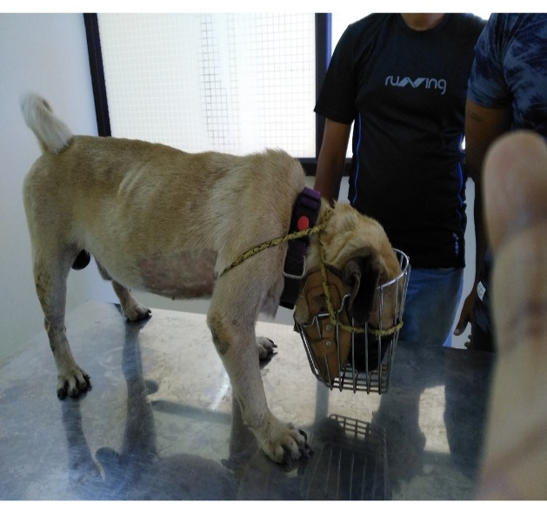 | 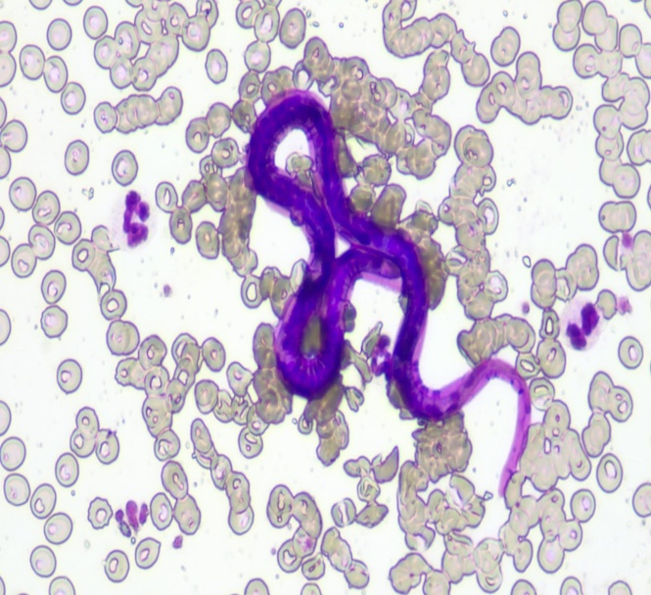
Fig.1 Animal in dull mentation on day 1 | Fig. 2 Blood smear revealing Microfilaria
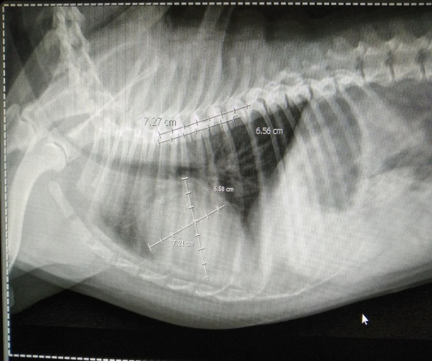 | 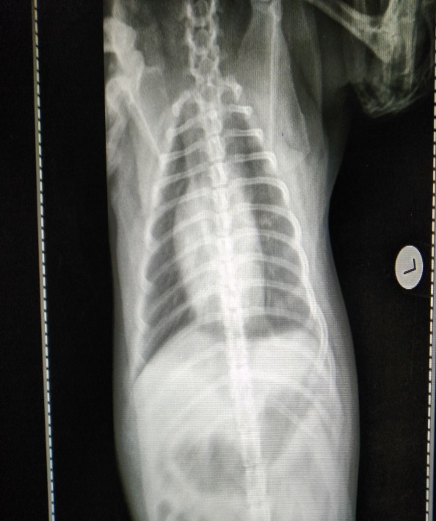
Fig.3 , 4 .Radiography revealing Pulmonary artery enlargement with mild mixed alveolar infiltration
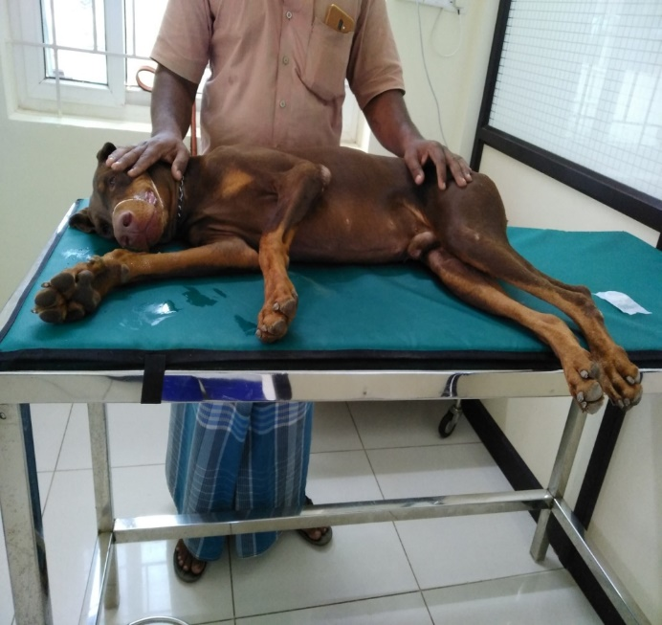 | 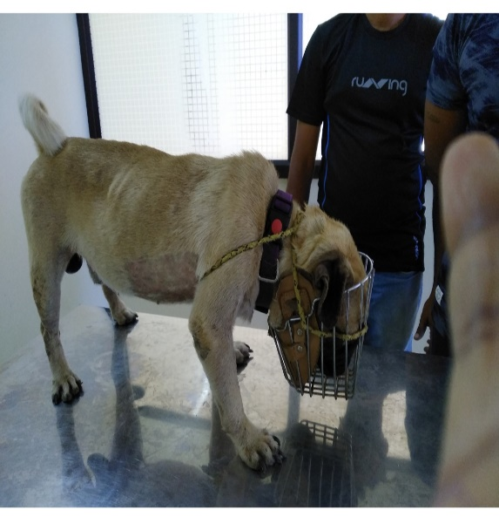
Fig.5 Donar animal | Fig.6 Recipient animal
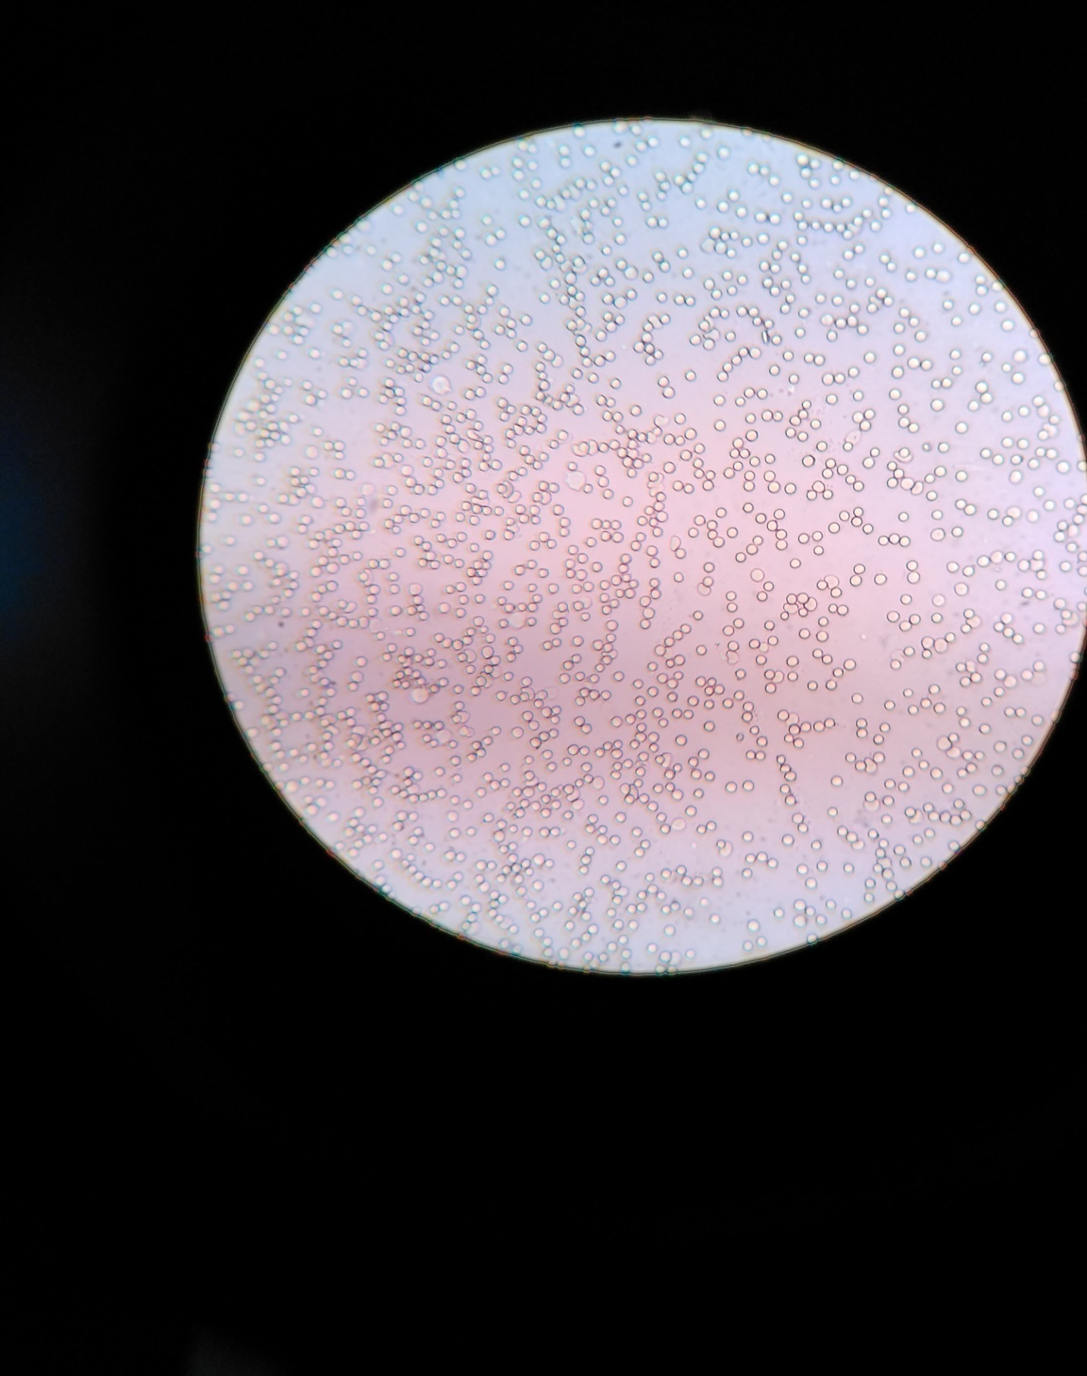 | 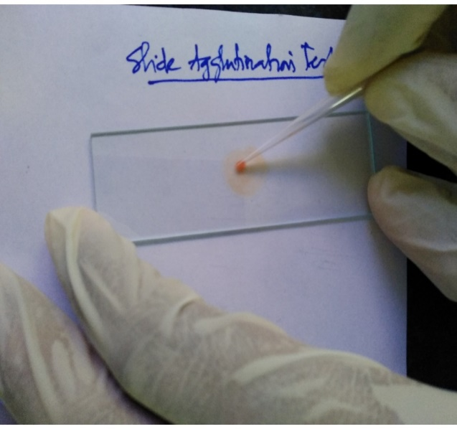
Fig.7 Slide agglutination revealing absence of agglutination
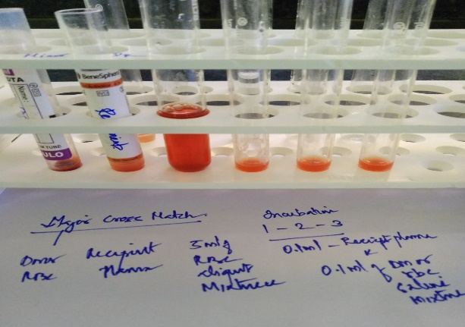 | 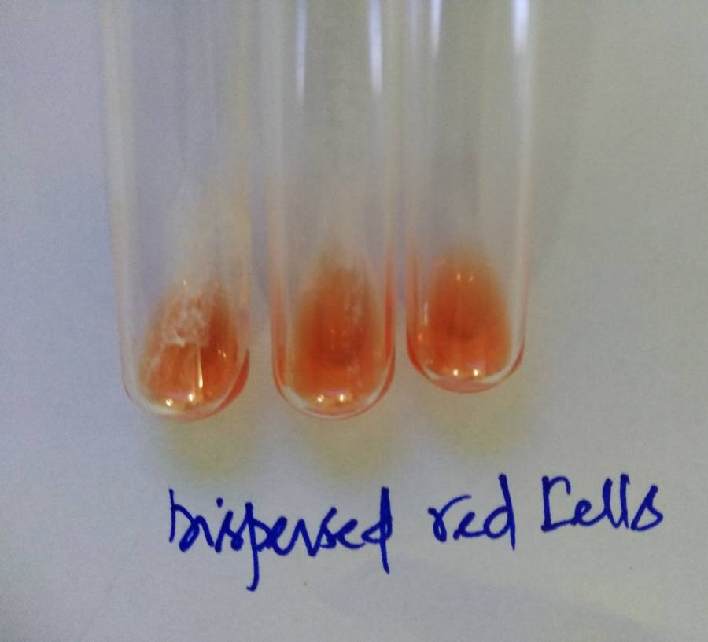
Fig.8, 9 Major cross matching showing compatibility.
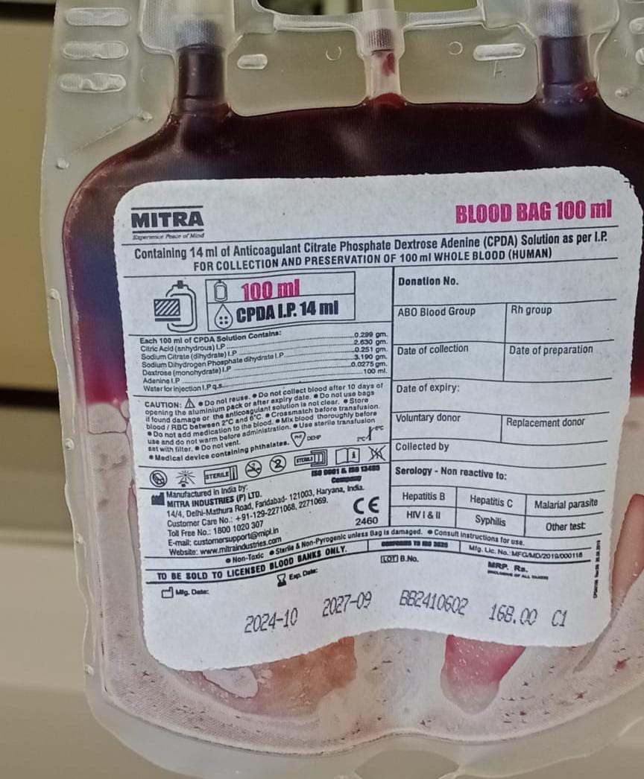 | 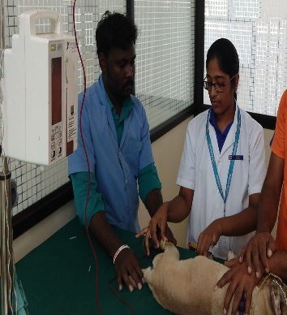
Fig. 10 CPDA-1 (Citrate Phosphate Dextrose Adenine) bag | Fig.11 Blood transfusion
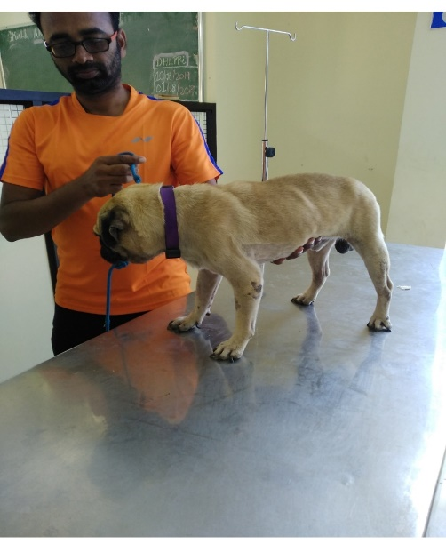
Fig.12 Day 2 post -transfusion

