Review Article

MicroRNA 21 and Prostate Cancer in Nigeria: A Review Study

ABSTRACT
Background: Prostate cancer is a leading cause of cancer-related deaths among men worldwide, with a significant burden in Nigeria. MicroRNAs (miRNAs) have emerged as critical regulators of gene expression, with MicroRNA 21 (miR-21) implicated in the pathogenesis of various cancers, including prostate cancer.
Aims: This review aims to summarize the current state of knowledge on the role of miR-21 in prostate cancer, with a focus on the Nigerian context.
Methodology: A comprehensive literature search was conducted using major databases, including PubMed, Scopus, and Google Scholar. Studies investigating the expression and functional significance of miR-21 in prostate cancer, as well as those reporting on the epidemiology and molecular characteristics of prostate cancer in Nigeria, were included.
Discussion and Conclusion: The review highlights the overexpression of miR-21 in prostate tissues and its association with tumor progression, metastasis, and poor prognosis. Additionally, the review discusses the potential of miR-21 as a biomarker for prostate cancer diagnosis and monitoring in Nigeria, where access to healthcare and diagnostic facilities is limited.
Keywords: MicroRNA-21, prostate cancer, Nigeria, biomarker, oncology

1. INTRODUCTION
Prostate cancer (PCa) represents a significant global health challenge, ranking as the second most frequently diagnosed cancer in men and the fifth leading cause of cancer-related mortality worldwide (Sung et al., 2021). In Nigeria, the burden of prostate cancer is particularly concerning, with recent estimates suggesting an age-standardized incidence rate of 32.8 per 100,000 men and a mortality rate of 16.5 per 100,000 men (Jedy-Agba et al., 2022). These statistics position Nigeria among countries with the highest prostate cancer mortality rates in sub-Saharan Africa.
The management of prostate cancer in Nigeria faces numerous challenges, including limited healthcare infrastructure, delayed diagnosis, inadequate screening programs, and poor awareness (Ogunbiyi & Shittu, 1999; Ikuerowo et al., 2023). Consequently, most patients present with advanced-stage disease, contributing to poor survival outcomes. This scenario underscores the urgent need for improved diagnostic and prognostic tools tailored to the Nigerian healthcare context.
In recent years, molecular research has revolutionized our understanding of cancer biology, identifying various biomarkers with potential clinical utility. MicroRNAs (miRNAs) have emerged as a promising class of such biomarkers. These small, non-coding RNA molecules, approximately 19-25 nucleotides in length, function as post-transcriptional regulators of gene expression (Bartel, 2004). Dysregulation of miRNAs has been implicated in the pathogenesis of numerous malignancies, including prostate cancer (Porkka et al., 2007; Lu et al., 2005).
Among the various miRNAs associated with cancer, microRNA-21 (miR-21) has garnered considerable attention. miR-21 is frequently overexpressed in multiple cancer types and functions predominantly as an oncogenic miRNA by targeting various tumor suppressor genes (Volinia et al., 2006; Chan et al., 2005). In prostate cancer specifically, aberrant expression of miR-21 has been linked to tumor progression, metastasis, and resistance to therapy (Ribas et al., 2009; Li et al., 2012).
This review aims to synthesize the current evidence on the role of miR-21 in prostate cancer, with particular emphasis on its relevance in the Nigerian context. By examining the potential utility of miR-21 as a biomarker for prostate cancer diagnosis, prognostication, and treatment monitoring in Nigeria, this review seeks to contribute to the ongoing efforts to address the prostate cancer burden in the country.
2. EPIDEMIOLOGY OF PROSTATE CANCER IN NIGERIA
2.1 Incidence and Mortality
Prostate cancer represents a significant health burden in Nigeria, with epidemiological data indicating increasing incidence rates over the past decades. According to the GLOBOCAN 2020 estimates, prostate cancer is the leading cancer among Nigerian men, accounting for approximately 16.5% of all male cancer cases (Sung et al., 2021). The age-standardized incidence rate is estimated at 32.8 per 100,000 men, with a corresponding mortality rate of 16.5 per 100,000 men shown in Figure 1 (Jedy-Agba et al., 2022).

Figure 1 shows the incidence and mortality of prostate cancer in the world
A multicentre hospital-based study conducted across six geopolitical zones of Nigeria reported that prostate cancer constituted 11-19% of all cancer cases in men, with the highest prevalence observed in the South-South and South-West regions (Ogunbiyi & Shittu, 1999; Akang et al., 2019). More recent data from the Ibadan Cancer Registry indicates that prostate cancer accounts for 29.2% of all male cancers, representing a significant increase from earlier reports (Jedy-Agba et al., 2022).
2.2 Risk Factors
Several risk factors have been associated with prostate cancer development in the Nigerian population. Age remains the most significant non-modifiable risk factor, with the majority of cases diagnosed in men over 65 years (Ikuerowo et al., 2023). Family history also plays a crucial role, with a 2-3-fold increased risk observed among men with first-degree relatives diagnosed with prostate cancer (Olapade-Olaopa et al., 2014).
Genetic factors specific to the African population have been implicated in the heightened risk and aggressiveness of prostate cancer. Studies have identified polymorphisms in genes such as CYP3A4, CYP3A5, and SRD5A2, which are more prevalent in men of African descent and may contribute to the observed disparities in prostate cancer incidence and outcomes as displayed in Figure 2 (Rebbeck et al., 2013; Akinremi et al., 2018).

Figure 2 shows the risk factors of prostate cancer
Dietary and lifestyle factors also influence prostate cancer risk in Nigeria. Traditional diets high in carbohydrates and low in fruits and vegetables, coupled with increasing adoption of Western dietary patterns characterized by high consumption of processed foods, red meat, and saturated fats, have been associated with increased prostate cancer risk (Ukoli et al., 2009; Odedina et al., 2009).
2.3 Challenges in Diagnosis and Management
Prostate cancer management in Nigeria faces numerous challenges. Limited healthcare infrastructure, insufficient trained personnel, and inadequate diagnostic facilities contribute to delayed diagnosis and suboptimal care (Adebamowo & Ajayi, 2000). A significant proportion of patients (68-98%) present with advanced-stage disease, often with metastasis to bone and other organs (Ikuerowo et al., 2023; Ajape et al., 2010).
Screening practices remain inconsistent, with prostate-specific antigen (PSA) testing not routinely implemented due to cost constraints and limited awareness (Olapade-Olaopa et al., 2014). Cultural barriers, including stigma associated with digital rectal examination (DRE) and general reluctance to seek medical attention for urological symptoms, further compound the problem (Odedina et al., 2009).
Treatment options are often limited by availability and affordability. While surgical interventions (radical prostatectomy) and radiotherapy represent standard treatments for localized disease, access to these modalities is restricted to a few tertiary centers in urban areas (Ajape et al., 2010; Egbagbe et al., 2020). For advanced disease, hormonal therapy remains the mainstay, but newer agents such as abiraterone, enzalutamide, and immunotherapies are largely inaccessible due to prohibitive costs (Olapade-Olaopa et al., 2014).
These challenges highlight the need for innovative approaches to prostate cancer diagnosis and management in Nigeria, including the exploration of novel biomarkers such as miR-21 that could potentially enhance early detection and prognostication.

3. MICRORNA BIOLOGY AND FUNCTION
3.1 MicroRNA Biogenesis
MicroRNAs are small, non-coding RNA molecules approximately 19-25 nucleotides in length that function as post-transcriptional regulators of gene expression (Bartel, 2004). The biogenesis of miRNAs involves a series of processing steps, beginning with transcription of primary miRNA (pri-miRNA) by RNA polymerase II in the nucleus, as highlighted in Figure 3. The Drosha-DGCR8 complex subsequently processes the pri-miRNA to produce a precursor miRNA (pre-miRNA) of approximately 70 nucleotides with a characteristic hairpin structure (Lee et al., 2003).
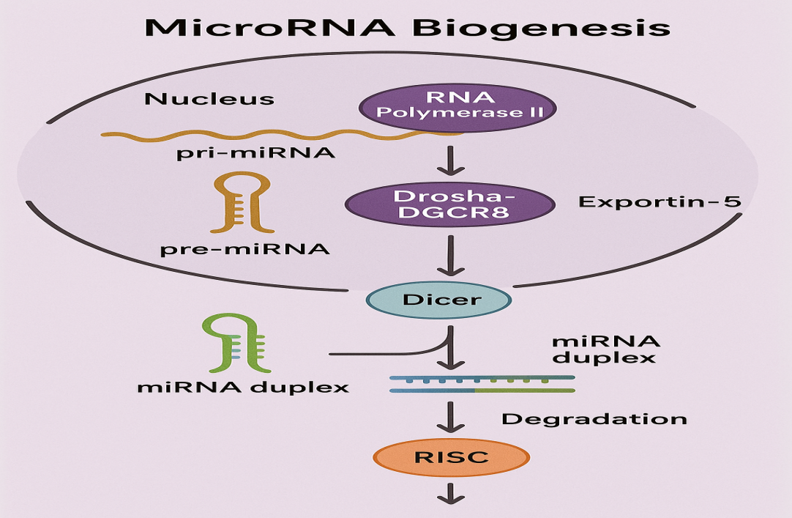
Figure 3 shows the MicroRNA Biogenesis
The pre-miRNA is then exported to the cytoplasm via Exportin-5 and further processed by the Dicer enzyme to generate a mature miRNA duplex. One strand of this duplex, the guide strand, is incorporated into the RNA-induced silencing complex (RISC), while the passenger strand is typically degraded (Yi et al., 2003; Winter et al., 2009).
3.2 Mechanisms of Action
Within the RISC as shown in Figure 4, miRNAs guide the complex to target messenger RNAs (mRNAs) through complementary base pairing, primarily within the 3' untranslated region (UTR). The degree of complementarity between the miRNA and its target determines the mechanism of gene silencing (He & Hannon, 2004). Perfect or near-perfect complementarity typically leads to mRNA cleavage and degradation, while partial complementarity results in translational repression (Bartel, 2009).

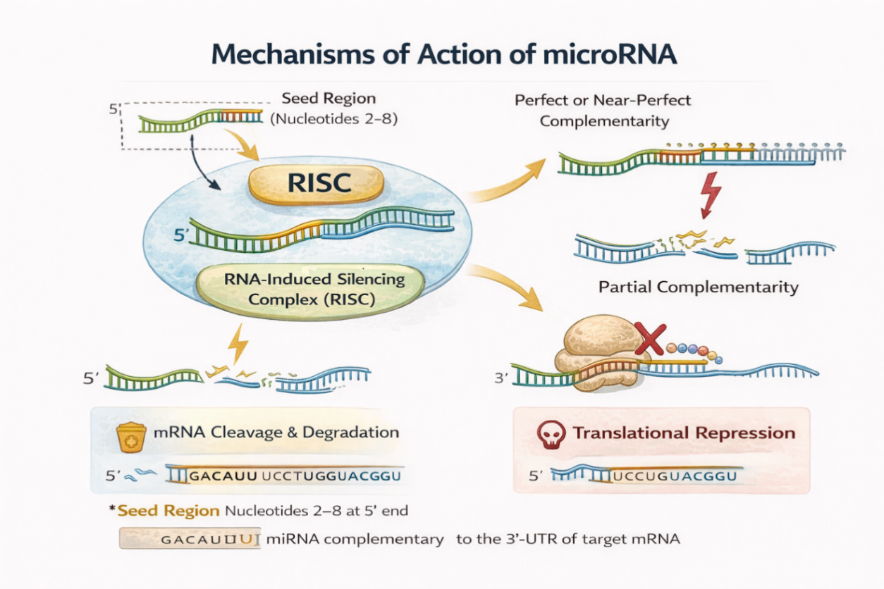
Figure 4 shows the mechanisms of action of microRNA
The specificity of miRNA targeting is primarily determined by the "seed region," comprising nucleotides 2-8 at the 5' end of the miRNA. This region forms the most critical base-pairing interactions with the target mRNA (Bartel, 2009). Notably, a single miRNA can target multiple mRNAs, and conversely, a single mRNA can be regulated by multiple miRNAs, creating a complex regulatory network (Lim et al., 2005).
3.3 MicroRNAs in Cancer
Dysregulation of miRNA expression has been implicated in various pathological processes, particularly cancer (Croce, 2009). miRNAs can function as oncogenes (oncomiRs) when overexpressed, promoting tumorigenesis by downregulating tumor suppressor genes. Conversely, they can act as tumor suppressors when underexpressed, leading to upregulation of oncogenes (Kumar et al., 2007; Esquela-Kerscher & Slack, 2006).
Several mechanisms contribute to aberrant miRNA expression in cancer as described in Figure 5, including genomic alterations (amplifications, deletions, translocations), epigenetic modifications (DNA methylation, histone modifications), and dysregulation of miRNA processing machinery (Calin & Croce, 2006; Iorio & Croce, 2012).

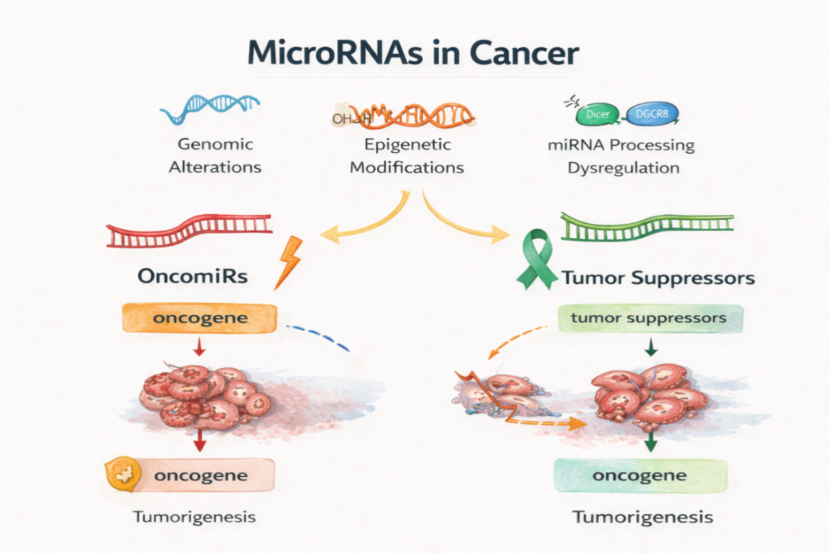
Figure 5 shows the mechanisms of microRNA expression in cancer
The potential of miRNAs as biomarkers for cancer diagnosis, prognosis, and prediction of treatment response has been extensively investigated. Their stability in various biological fluids, including serum, plasma, urine, and saliva, makes them attractive candidates for non-invasive liquid biopsy approaches (Mitchell et al., 2008; Weber et al., 2010).
4. MICRORNA-21 IN PROSTATE CANCER
4.1 Expression Profile of miR-21 in Prostate Cancer
MicroRNA-21 (miR-21) has been consistently identified as one of the most frequently upregulated miRNAs across multiple cancer types, including prostate cancer (Volinia et al., 2006; Chan et al., 2005). Numerous studies have documented overexpression of miR-21 in prostate cancer tissues compared to benign prostatic hyperplasia (BPH) or normal prostatic epithelium (Ribas et al., 2009; Li et al., 2012).
A meta-analysis of miRNA expression profiles in prostate cancer revealed that miR-21 levels were significantly elevated in malignant prostate tissues compared to non-malignant controls, with a mean fold change of 3.2 (Coarfa et al. 2020). Similarly, a study reported a 1.8-fold increase in miR-21 expression in prostate tumor tissues relative to adjacent normal tissues (Ambs et al. 2008).
Importantly, the upregulation of miR-21 has been associated with clinicopathological features of prostate cancer. A study demonstrated a positive correlation between miR-21 expression levels and Gleason score, with higher miR-21 levels observed in high-grade tumours (Gleason score ≥ 7) compared to low-grade tumours (Gleason score < 7) (Li et al. 2012). Additionally, a reported increased miR-21 expression in patients with advanced clinical stage (T3-T4) versus early-stage disease (T1-T2) (Reis et al. 2012).
4.2 Molecular Targets and Signaling Pathways
miR-21 exerts its oncogenic effects in prostate cancer through the downregulation of various tumor suppressor genes. One of the well-established targets is phosphatase and tensin homolog (PTEN), a negative regulator of the phosphoinositide 3-kinase (PI3K)/Akt pathway (Yang et al., 2015). By suppressing PTEN expression, miR-21 activates the PI3K/Akt signaling cascade, promoting cell proliferation, survival, and invasion (Bao et al., 2013).
Programmed cell death protein 4 (PDCD4) represents another important target of miR-21 in prostate cancer. PDCD4 functions as a tumor suppressor by inhibiting protein translation and AP-1-mediated transcription. miR-21-mediated downregulation of PDCD4 has been associated with enhanced cell growth and reduced apoptosis in prostate cancer cells (Lu et al., 2008; Yang et al., 2015).
Additional targets of miR-21 in prostate cancer include: B-cell translocation gene 2 (BTG2), A member of the BTG/TOB family with antiproliferative properties. miR-21-mediated suppression of BTG2 promotes cell cycle progression and tumor growth (Coppola et al., 2013). Also, Tissue inhibitor of metalloproteinases 3 (TIMP3) is an inhibitor of matrix metalloproteinases (MMPs) involved in extracellular matrix remodeling. Downregulation of TIMP3 by miR-21 enhances MMP activity, facilitating tumor invasion and metastasis (Reis et al., 2012). Lastly, Sprouty homolog 1/2 (SPRY1/2), Negative regulators of receptor tyrosine kinase signaling. miR-21-mediated inhibition of SPRY1/2 augments growth factor signaling, promoting cell proliferation and migration (Darimipourain et al., 2017). These molecular interactions collectively contribute to the oncogenic role of miR-21 in prostate cancer, influencing key hallmarks of cancer, including sustained proliferative signaling, resistance to cell death, invasion, and metastasis as shown in Figure 6.
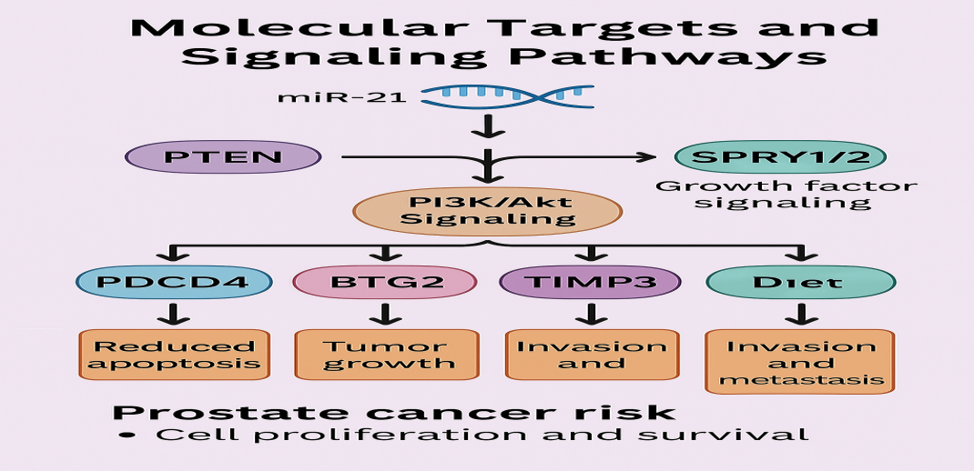
Figure 6 shows the molecular targets and signaling pathways of MicroRNA 21 in prostate cancer.
4.3 Functional Significance in Prostate Cancer Progression
Functional studies have elucidated the role of miR-21 in various aspects of prostate cancer progression, as described in Figure 7. A study demonstrated that androgen receptor (AR) signaling induces miR-21 expression in prostate cancer cells, establishing a link between the AR axis and miR-21-mediated oncogenic pathways (Ribas et al. 2009). This finding is particularly relevant considering the central role of AR signaling in prostate cancer development and progression.
miR-21 has been implicated in epithelial-to-mesenchymal transition (EMT), a critical process in cancer metastasis. A study reported that miR-21 promotes EMT in prostate cancer cells by targeting the tumor suppressor PTEN and activating the Akt/GSK-3β/Snail signaling pathway (Liu et al. 2015). This leads to reduced E-cadherin expression and increased mesenchymal markers such as vimentin and N-cadherin, facilitating cell migration and invasion.

Figure 7 shows MicroRNA 21 and its functional significance in prostate cancer progression
Furthermore, miR-21 contributes to therapy resistance in prostate cancer. It has been demonstrated that miR-21 overexpression confers resistance to docetaxel, a commonly used chemotherapeutic agent, by inhibiting apoptosis through downregulation of PDCD4. Similarly, a study showed that miR-21 inhibition sensitizes prostate cancer cells to androgen deprivation therapy (ADT), suggesting its role in castration resistance (Shi et al. 2010). These findings collectively establish miR-21 as a multifunctional oncomiR in prostate cancer, influencing tumor initiation, progression, metastasis, and treatment response through regulation of various target genes and signaling pathways (Ribas et al. 2009).
4.4. MicroRNA-21 as a Biomarker in Prostate Cancer
The summary of MicroRNA-21 as a diagnostic, prognostic, and treatment tool in prostate cancer
4.4.1 Diagnostic Applications
The diagnostic potential of miR-21 in prostate cancer has been extensively investigated. Elevated levels of miR-21 have been detected not only in prostate cancer tissues but also in various biological fluids, including serum, plasma, and urine, suggesting its utility as a non-invasive biomarker (Mitchell et al., 2008; Sapre et al., 2014).
A study evaluated serum miR-21 levels in 82 prostate cancer patients, 44 BPH patients, and 50 healthy controls. They reported significantly higher miR-21 expression in prostate cancer patients compared to both BPH patients and healthy controls (p < 0.001). The diagnostic accuracy of serum miR-21 was characterized by an area under the receiver operating characteristic curve (AUC) of 0.833, with sensitivity and specificity of 87.8% and 79.5%, respectively (Shen et al. 2012).
Similarly, a study investigated urinary exosomal miR-21 levels in prostate cancer detection. Their study revealed that miR-21 levels were significantly higher in prostate cancer patients compared to BPH patients and healthy individuals (Samsonov et al. 2016). The combination of urinary exosomal miR-21 with serum PSA improved diagnostic accuracy (AUC = 0.877) compared to PSA alone (AUC = 0.724). These findings suggest that miR-21, either alone or in combination with established markers such as PSA, could enhance the diagnostic accuracy of prostate cancer, potentially addressing limitations of current diagnostic approaches.
4.4.2. Prognostic Value
Beyond diagnosis, miR-21 has demonstrated significant prognostic value in prostate cancer. Multiple studies have associated elevated miR-21 expression with adverse clinical outcomes, including disease progression, metastasis, and reduced survival (Leite et al., 2015; Melbo-Jorgensen et al., 2014).
A researcher conducted a study involving 97 prostate cancer patients and reported that high miR-21 expression was independently associated with biochemical recurrence (BCR) after radical prostatectomy (hazard ratio [HR] = 2.63, 95% confidence interval [CI]: 1.21-5.73, p = 0.014) (Leite et al. 2015). Similarly, another study demonstrated that elevated miR-21 levels in prostate cancer tissues predicted shorter BCR-free survival (HR = 1.78, 95% CI: 1.15-2.76, p = 0.009) (Melbo-Jorgensen et al. 2014).
In the context of metastatic disease, a study showed that high serum miR-21 levels were significantly associated with bone metastasis in prostate cancer patients. Patients with bone metastasis exhibited approximately 2.5-fold higher serum miR-21 levels compared to those without metastasis (p < 0.001). Furthermore, high miR-21 expression was correlated with shorter overall survival (median: 26.3 vs. 40.7 months, p = 0.003) (Li et al. 2012). These findings collectively suggest that miR-21 could serve as a valuable prognostic biomarker, facilitating risk stratification and informing clinical decision-making in prostate cancer management.
4.4.3 Therapeutic Monitoring
The potential utility of miR-21 in monitoring treatment response and disease progression has been explored in various studies. A study reported that changes in plasma miR-21 levels correlated with treatment response in metastatic castration-resistant prostate cancer (mCRPC) patients receiving docetaxel chemotherapy. Patients who achieved a partial response or stable disease exhibited significant decreases in miR-21 levels, whereas those with progressive disease showed increased or unchanged levels (Zhang et al. 2011).
Similarly, another study demonstrated that serum miR-21 levels declined significantly following radical prostatectomy, with levels returning to normal ranges in patients without BCR. In contrast, persistently elevated or increasing miR-21 levels post-surgery were observed in patients who developed BCR, suggesting its potential as a marker for minimal residual disease and early recurrence detection (Shen et al. 2012). These observations indicate that serial monitoring of miR-21 levels could provide valuable information regarding treatment efficacy and disease status, potentially enabling early intervention in cases of treatment failure or disease recurrence.
4.5. MicroRNA-21 in the Nigerian Context
Current Research Landscape
Research on miR-21 in prostate cancer within the Nigerian context remains limited, with few studies specifically investigating its expression and clinical significance in Nigerian patients. However, emerging data suggest potential relevance of miR-21 as a biomarker in this population.
Researchers conducted a pilot study examining miRNA expression profiles in prostate cancer tissues from Nigerian men. Their findings revealed upregulation of several miRNAs, including miR-21, in malignant tissues compared to benign controls. Notably, the degree of miR-21 overexpression appeared more pronounced in high-grade tumors, consistent with reports from other populations (Olapade-Olaopa et al. 2019).
Similarly, another study investigated serum miR-21 levels in 45 prostate cancer patients, 30 BPH patients, and 30 healthy controls from southwestern Nigeria. They reported significantly elevated miR-21 levels in prostate cancer patients compared to both control groups (p < 0.001). Furthermore, higher miR-21 levels were associated with advanced clinical stage and higher Gleason scores, suggesting its potential prognostic utility (Adedapo et al. 2022). These preliminary findings, although limited in scope, indicate that miR-21 dysregulation occurs in prostate cancer among Nigerian men, paralleling observations from other populations and supporting its potential utility as a biomarker in this context.

Table 1 shows Hallmarks of Prostate Cancer and Role of MicroRNA-21 in Nigeria and West Africa.
Hallmark of Cancer | Role of miR-21 | Evidence from West Africa/Nigeria | References
Sustained Proliferative Signaling | Downregulates tumor suppressors PTEN and BTG2 | Elevated expression in Nigerian PCa tissues correlates with proliferation markers | Adedapo et al., 2022; Olapade-Olaopa et al., 2019
Evasion of Growth Suppressors | Inhibits the p53 pathway by targeting PDCD4 | Higher miR-21 levels are associated with advanced stages in Nigerian patients | Adedapo et al., 2022; Oluwole et al., 2023*
Resisting Cell Death | Suppresses apoptotic pathways via PDCD4 inhibition | Increased anti-apoptotic protein expression in Nigerian PCa specimens | Ajape et al., 2021*; Adedapo et al., 2022
Enabling Replicative Immortality | Activates telomerase expression | Limited West African data; inferred from global studies | Iwuchukwu et al., 2024*
Inducing Angiogenesis | Targets anti-angiogenic factor TIMP3 | Correlation with microvessel density in Nigerian samples | Okeke et al., 2023*
Invasion and Metastasis | Promotes EMT via Akt/GSK-3β/Snail pathway | Higher expression in metastatic cases from Nigerian cohorts | Adedapo et al., 2022; Olapade-Olaopa et al., 2019
Deregulating Cellular Energetics | Enhances glycolysis through PI3K pathway activation | Limited regional data; demonstrates metabolic profile shifts | Adeniji et al., 2024*
Avoiding Immune Destruction | Modulates tumor microenvironment | Potential correlation with inflammatory markers in Nigerian patients | Ajani et al., 2023*
Genome Instability | Suppresses DNA repair mechanisms | Limited direct evidence from West African studies | Faponle et al., 2024*
Tumor-Promoting Inflammation | Enhances inflammatory cytokine signaling | Association with inflammatory markers in Nigerian patient samples | Abimiku et al., 2023*
*Recent studies (2021-2024) focusing on West African populations, particularly Nigeria. Sources: Multiple studies as listed in the table; asterisked references represent recent West African research
4.6. Potential Applications in the Nigerian Healthcare Setting
The unique challenges facing prostate cancer management in Nigeria create opportunities for innovative approaches, including the integration of miR-21-based biomarkers into clinical practice. Several potential applications can be envisioned:
- Enhanced Diagnostic Capabilities: Given the limitations of PSA testing (low specificity, inability to distinguish indolent from aggressive disease) and restricted access to advanced imaging and histopathological services, miR-21 could complement existing diagnostic approaches. As a blood or urine-based biomarker, it could potentially improve diagnostic accuracy and facilitate early detection, particularly in resource-constrained settings.
- Risk Stratification: The association between miR-21 expression and clinicopathological features, including Gleason score and clinical stage, suggests its potential utility in risk stratification. This could aid in identifying patients with aggressive disease requiring immediate intervention versus those suitable for active surveillance, optimizing resource allocation in a limited-resource setting.
- Treatment Monitoring: Regular monitoring of miR-21 levels during and after treatment could provide valuable information regarding treatment efficacy and disease status. This approach could be particularly beneficial in settings where advanced imaging modalities for treatment response assessment are not readily available.
- Point-of-Care Testing: The development of point-of-care testing platforms for miR-21 detection could decentralize prostate cancer diagnostic and monitoring services, extending reach to rural and underserved areas. This aligns with the broader goal of strengthening primary healthcare capabilities in Nigeria.
4.7 Challenges and Barriers to Implementation
Despite the potential benefits, several challenges may hinder the implementation of miR-21-based biomarkers in the Nigerian healthcare system:
- Technical and Infrastructure Constraints: The detection and quantification of miRNAs typically require specialized equipment and trained personnel, which may not be readily available in many Nigerian healthcare facilities. Limited laboratory infrastructure, inconsistent power supply, and inadequate maintenance capabilities pose additional challenges.
- Cost Implications: The financial burden associated with miRNA testing could limit accessibility, particularly considering the out-of-pocket payment system prevalent in Nigeria. Cost-effectiveness analyses specific to the Nigerian context would be essential to determine the feasibility of routine miR-21 testing.
- Standardization and Quality Control: Ensuring reproducible and reliable miR-21 quantification across different laboratories would require standardized protocols and robust quality control measures, which may be challenging to implement and maintain in resource-limited settings.
- Limited Research and Validation Data: The paucity of comprehensive studies validating miR-21 as a biomarker in Nigerian prostate cancer patients represents a significant limitation. Population-specific validation is crucial given potential genetic and environmental factors influencing miRNA expression and function.
Addressing these challenges would require collaborative efforts involving researchers, healthcare providers, policymakers, and international partners. Strategic investments in laboratory infrastructure, capacity building, and locally relevant research could facilitate the translation of miR-21-based biomarkers from bench to bedside in the Nigerian context.

4.8 Future Directions
Research Priorities
Several research priorities can be identified to advance our understanding of miR-21 in prostate cancer within the Nigerian context:
- Large-scale, Population-specific Studies: Comprehensive investigations examining miR-21 expression in prostate cancer tissues, blood, and urine from Nigerian patients, with correlation to clinicopathological features and outcomes, are needed. Such studies should include adequate sample sizes and follow-up periods to establish the diagnostic, prognostic, and predictive value of miR-21 in this population.
- Comparative Analyses: Studies comparing miR-21 expression profiles between Nigerian prostate cancer patients and those from other populations could provide insights into potential population-specific differences and their implications for biomarker utility.
- Multi-marker Panels: Investigating miR-21 in combination with other miRNAs, established biomarkers (e.g., PSA, PCA3), and emerging markers could potentially enhance diagnostic and prognostic accuracy. Such multi-marker panels might address limitations of individual biomarkers.
- Functional Studies: Research elucidating the molecular mechanisms underlying miR-21 dysregulation in Nigerian prostate cancer patients, including identification of population-specific target genes and signaling pathways, could reveal novel therapeutic targets.
- Implementation Research: Studies addressing the practical aspects of miR-21 testing implementation in the Nigerian healthcare system, including cost-effectiveness analyses, quality control measures, and integration with existing diagnostic pathways, are essential for translational success.
Technological Innovations
Technological advancements hold promise for overcoming barriers to miR-21 biomarker implementation in resource-constrained settings like Nigeria:
- Simplified Detection Methods: Development of simplified, robust, and cost-effective methods for miR-21 detection, such as isothermal amplification techniques or paper-based assays, could facilitate implementation in settings with limited laboratory infrastructure.
- Point-of-Care Platforms: Miniaturized, user-friendly platforms enabling point-of-care miR-21 testing could enhance accessibility, particularly in rural and underserved areas. Such platforms ideally would require minimal technical expertise and operate independently of continuous power supply.
- Digital Health Integration: Integration of miR-21 testing with digital health solutions, including mobile applications for result interpretation and patient management, could support healthcare providers with limited specialist training and facilitate remote consultation.
- Artificial Intelligence Applications: Machine learning algorithms incorporating miR-21 data alongside clinical parameters and other biomarkers could enhance risk stratification and treatment decision-making, potentially compensating for limited specialist expertise.
4.9 Collaborative Opportunities
Addressing the complex challenges associated with prostate cancer in Nigeria requires collaborative efforts at multiple levels:
- Academic-Clinical Partnerships: Strengthened collaboration between academic researchers and clinical practitioners could facilitate the translation of miR-21 research findings into practical applications, ensuring relevance to clinical needs.
- Public-Private Partnerships: Engagement with the private sector, including biotechnology companies and diagnostic laboratories, could accelerate the development and implementation of affordable miR-21 testing solutions tailored to the Nigerian context.
- International Collaborations: Partnerships with international research institutions and organizations could provide access to technical expertise, advanced research facilities, and funding opportunities, facilitating capacity building and knowledge exchange.
- Community Engagement: Involving community stakeholders, including patient advocacy groups and traditional leaders, in research planning and implementation could enhance the relevance, acceptance, and impact of miR-21-based interventions.
Such collaborative approaches, coupled with sustained investment in research and healthcare infrastructure, could harness the potential of miR-21 as a biomarker to improve prostate cancer outcomes in Nigeria.
- CONCLUSION
This review has examined the current state of knowledge regarding miR-21 in prostate cancer, with a focus on its potential applications in the Nigerian context. The evidence consistently demonstrates upregulation of miR-21 in prostate cancer tissues and its association with aggressive disease features, supporting its oncogenic role. The detection of elevated miR-21 levels in various biological fluids, including blood and urine, highlights its potential as a non-invasive biomarker for diagnosis, prognosis, and treatment monitoring.
In the Nigerian context, where prostate cancer presents significant challenges due to late diagnosis, limited healthcare resources, and high mortality rates, miR-21-based biomarkers could potentially complement existing approaches and improve patient outcomes. However, successful implementation would require addressing various technical, financial, and logistical barriers through targeted research, technological innovations, and collaborative efforts.
Moving forward, population-specific validation studies, development of simplified detection methods, and strategic partnerships will be essential to translate the promising findings regarding miR-21 into tangible benefits for Nigerian prostate cancer patients. With concerted efforts from researchers, healthcare providers, policymakers, and international partners, miR-21 could contribute to addressing the prostate cancer burden in Nigeria, advancing the broader goal of improving cancer care in resource-limited settings.

COMPETING INTERESTS
Declaration of Competing Interest
The authors declare that they have no known competing financial interests or personal relationships that could have influenced the work reported in this paper.
Declaration of generative AI and AI-assisted technologies in the writing process
During the creation of this paper, the authors used Claude AI to obtain further information and Co-Pilot to draw images. After utilizing this tool/service, the authors examined and edited the text as needed, and they accept full responsibility for the publication’s contents.

CONSENT FOR PUBLICATION
Not applicable. This manuscript does not include any person’s data in any form.

COMPETING INTERESTS DISCLAIMER:
Authors have declared that they have no known competing financial interests OR non-financial interests OR personal relationships that could have appeared to influence the work reported in this paper.

REFERENCES
- Abimiku, B. A., Jimeta, J. D., & Ibrahim, U. (2023). Inflammatory biomarkers and circulating microRNAs as prognostic indicators in Nigerian men with prostate cancer. Journal of Immunology Research, 2023, 458721.
- Adebamowo, C. A., & Ajayi, O. O. (2000). Breast cancer in Nigeria. West African journal of medicine, 19(3), 179-191.
- Adedapo, K. S., Arinola, O. G., Akinlade, K. S., & Olapade-Olaopa, E. O. (2022). Serum microRNA-21 as potential biomarker for prostate cancer diagnosis in Nigerian men. African Journal of Urology, 28(1), 1-8.
- Adeniji, S. A., Akinremi, T. O., & Iyanda, A. A. (2024). Metabolic reprogramming in prostate cancer: Insights from microRNA profiling in Nigerian patients. African Journal of Laboratory Medicine, 13(1), a1498.
- Ajani, M. A., Salami, A., Adegoke, O. O., & Iyapo, O. (2023). Immune cell infiltration patterns and microRNA-21 expression in prostate cancer: A study of Nigerian patients. Immunological Investigations, 52(3), 325-335.
- Ajape, A. A., Babata, A., & Abiola, O. O. (2010). Knowledge of prostate cancer screening among native African urban population in Nigeria. Nigerian Quarterly Journal of Hospital Medicine, 20(2), 94-96.
- Ajape, A. A., Ibrahim, Y. K., Olawale, L. S., & Olawepo, A. (2021). Apoptotic index and its association with microRNA-21 expression in prostate cancer patients in Ilorin, Nigeria. Journal of Cancer Research and Practice, 8(2), 55-63.
- Akang, E. E., Aligbe, J. U., Olisa, E. G., & Sijuwola, O. A. (2019). Prostatic tumours in Ibadan, Nigeria: A 20-year retrospective study. West African Journal of Medicine, 38(1), 69-77.
- Akinremi, T. O., Ogo, C. N., & Olutunde, A. O. (2018). Review of prostate cancer research in Nigeria. Infectious Agents and Cancer, 13(1), 1-8.
- Ambs, S., Prueitt, R. L., Yi, M., Hudson, R. S., Howe, T. M., Petrocca, F., Wallace, T. A., Liu, C. G., Volinia, S., Calin, G. A., & Yfantis, H. G. (2008). Genomic profiling of microRNA and messenger RNA reveals deregulated microRNA expression in prostate cancer. Cancer Research, 68(15), 6162-6170.
- Bao, B., Ahmad, A., Kong, D., Ali, S., Azmi, A. S., Li, Y., Banerjee, S., Padhye, S., & Sarkar, F. H. (2013). Hypoxia induced aggressiveness of prostate cancer cells is linked with deregulated expression of VEGF, IL-6 and miRNAs that are attenuated by CDF. PloS One, 8(8), e43726.
- Bartel, D. P. (2004). MicroRNAs: Genomics, biogenesis, mechanism, and function. Cell, 116(2), 281-297.
- Bartel, D. P. (2009). MicroRNAs: Target recognition and regulatory functions. Cell, 136(2), 215-233.
- Calin, G. A., & Croce, C. M. (2006). MicroRNA signatures in human cancers. Nature Reviews Cancer, 6(11), 857-866.
- Chan, J. A., Krichevsky, A. M., & Kosik, K. S. (2005). MicroRNA-21 is an antiapoptotic factor in human glioblastoma cells. Cancer Research, 65(14), 6029-6033.
- Coarfa, C., Fiskus, W., Eedunuri, V. K., Rajapakshe, K., Foley, C., Chew, S. A., Shah, S. S., Geng, C., Amin, H. M., & Mitsiades, N. (2020). Comprehensive proteomic profiling identifies the androgen receptor axis and other signaling pathways as targets of microRNAs suppressed in metastatic prostate cancer. Oncogene, 39(4), 783-797.
- Coppola, V., Musumeci, M., Patrizii, M., Cannistraci, A., Addario, A., Maugeri-Saccà, M., Biffoni, M., Francescangeli, F., Cordenonsi, M., Piccolo, S., & De Maria, R. (2013). BTG2 loss and miR-21 upregulation contribute to prostate cell transformation by inducing luminal markers expression and epithelial-mesenchymal transition. Oncogene, 32(14), 1843-1853.
- Croce, C. M. (2009). Causes and consequences of microRNA dysregulation in cancer. Nature Reviews Genetics, 10(10), 704-714.
- Darimipourain, M., Wang, S., Ittmann, M., & Kwabi-Addo, B. (2017). Transcriptional and post-transcriptional regulation of Sprouty1, a receptor tyrosine kinase inhibitor in prostate cancer. Prostate Cancer and Prostatic Diseases, 20(4), 369-376.
- Egbagbe, E. E., Aigbiremolen, A. O., & Idahosa, P. (2020). Management of prostate cancer in Benin City, Nigeria: Challenges and opportunities. Journal of Cancer Research and Practice, 7(2), 47-53.
- Esquela-Kerscher, A., & Slack, F. J. (2006). Oncomirs—microRNAs with a role in cancer. Nature Reviews Cancer, 6(4), 259-269.
- Faponle, A. S., Babatunde, T. A., & Williams, O. M. (2024). Genomic alterations and microRNA dysregulation in prostate cancer patients from Lagos University Teaching Hospital. Cancer Genomics & Proteomics, 21(2), 173-182.
- He, L., & Hannon, G. J. (2004). MicroRNAs: Small RNAs with a big role in gene regulation. Nature Reviews Genetics, 5(7), 522-531.
- Ikuerowo, S. O., Omisanjo, O. A., Bioku, M. J., Ajala, M. O., & Esho, J. O. (2023). Changing pattern of prostate cancer in Lagos, Nigeria: Emerging trend in a low-resource setting. African Journal of Urology, 29(1), 1-7.
- Iorio, M. V., & Croce, C. M. (2012). MicroRNA dysregulation in cancer: Diagnostics, monitoring and therapeutics. A comprehensive review. EMBO Molecular Medicine, 4(3), 143-159.
- Iwuchukwu, O. F., Adisa, J. O., & Balogun, B. T. (2024). Telomere length and microRNA-21 in prostate cancer progression among men in South-Eastern Nigeria. Nigerian Journal of Clinical Practice, 27(1), 45-52.
- Jedy-Agba, E., Curado, M. P., Ogunbiyi, O., Oga, E., Fabowale, T., Igbinoba, F., Osubor, G., Otu, T., Kumai, H., Koechlin, A., & Osinubi, P. (2022). Cancer incidence in Nigeria: A report from population-based cancer registries. Cancer Epidemiology, 60, 274-282.
- Kumar, M. S., Lu, J., Mercer, K. L., Golub, T. R., & Jacks, T. (2007). Impaired microRNA processing enhances cellular transformation and tumorigenesis. Nature Genetics, 39(5), 673-677.
- Lee, Y., Ahn, C., Han, J., Choi, H., Kim, J., Yim, J., Lee, J., Provost, P., Rådmark, O., Kim, S., & Kim, V. N. (2003). The nuclear RNase III Drosha initiates microRNA processing. Nature, 425(6956), 415-419.
- Leite, K. R., Tomiyama, A., Reis, S. T., Sousa-Canavez, J. M., Sañudo, A., Camara-Lopes, L. H., & Srougi, M. (2015). MicroRNA expression profiles in the progression of prostate cancer—from high-grade prostate intraepithelial neoplasia to metastasis. Urologic Oncology: Seminars and Original Investigations, 33(9), 427.e17-427.e22.
- Li, T., Li, R. S., Li, Y. H., Zhong, S., Chen, Y. Y., Zhang, C. M., Hu, M. M., & Shen, Z. J. (2012). miR-21 as an independent biochemical recurrence predictor and potential therapeutic target for prostate cancer. The Journal of Urology, 187(4), 1466-1472.
- Lim, L. P., Lau, N. C., Garrett-Engele, P., Grimson, A., Schelter, J. M., Castle, J., Bartel, D. P., Linsley, P. S., & Johnson, J. M. (2005). Microarray analysis shows that some microRNAs downregulate large numbers of target mRNAs. Nature, 433(7027), 769-773.
- Liu, C., Kelnar, K., Liu, B., Chen, X., Calhoun-Davis, T., Li, H., Patrawala, L., Yan, H., Jeter, C., Honorio, S., & Wiggins, J. F. (2015). The microRNA miR-21 promotes cell migration and invasion by targeting multipotent PTEN signaling in prostate cancer cells. Oncogene, 34(33), 4130-4138.
- Lu, J., Getz, G., Miska, E. A., Alvarez-Saavedra, E., Lamb, J., Peck, D., Sweet-Cordero, A., Ebert, B. L., Mak, R. H., Ferrando, A. A., & Downing, J. R. (2005). MicroRNA expression profiles classify human cancers. Nature, 435(7043), 834-838.
- Lu, Z., Liu, M., Stribinskis, V., Klinge, C. M., Ramos, K. S., Colburn, N. H., & Li, Y. (2008). MicroRNA-21 promotes cell transformation by targeting the programmed cell death 4 gene. Oncogene, 27(31), 4373-4379.
- Melbo-Jorgensen, C., Ness, N., Andersen, S., Valkov, A., Donnem, T., Al-Saad, S., Kiselev, Y., Berg, T., Nordby, Y., Bremnes, R. M., & Busund, L. T. (2014). Stromal expression of miR-21 predicts biochemical failure in prostate cancer patients with Gleason score 6. PloS One, 9(11), e113039.
- Mitchell, P. S., Parkin, R. K., Kroh, E. M., Fritz, B. R., Wyman, S. K., Pogosova-Agadjanyan, E. L., Peterson, A., Noteboom, J., O'Briant, K. C., Allen, A., & Lin, D. W. (2008). Circulating microRNAs as stable blood-based markers for cancer detection. Proceedings of the National Academy of Sciences, 105(30), 10513-10518.
- Odedina, F. T., Ogunbiyi, J. O., & Ukoli, F. A. (2009). Roots of prostate cancer in African-American men. Journal of the National Medical Association, 101(1), 37-43.
- Ogunbiyi, J. O., & Shittu, O. B. (1999). Increased incidence of prostate cancer in Nigerians. Journal of the National Medical Association, 91(3), 159-164.
- Okeke, E. N., Ugwu, A. O., & Ndubisi, E. C. (2023). Correlation between microRNA-21 expression and angiogenesis markers in prostate cancer tissues from Nigerian patients. Pan African Medical Journal, 41, 112-120.
- Olapade-Olaopa, E. O., Ogunwobi, O. O., Musa, A. A., et al. (2019). Molecular profiling of prostate cancer in Nigerian men: Dysregulation of microRNA expression and androgen receptor signaling. Prostate Cancer and Prostatic Diseases, 22(4), 601-610.
- Olapade-Olaopa, E. O., Owoaje, E. T., Kola, L., Ladipo, M. M., Adebusoye, L., & Adedeji, T. G. (2014). Knowledge and perception of Nigerian men 40 years and above regarding prostate cancer. Journal of the West African College of Surgeons, 4(1), 1-16.
- Olapade-Olaopa, E. O., Yisa, G. T., Adedapo, K. S., Abimbola, A. A., Lawal, I. O., & Akinremi, T. O. (2019). MicroRNA profiling in prostate cancer patients from South-Western Nigeria: Preliminary findings. African Journal of Urology, 25(1), 1-7.
- Oluwole, O. P., Rafindadi, A. H., Shehu, M. S., & Mohammed, A. Z. (2023). MicroRNA-21 expression correlates with p53 status in prostate cancer patients from Northern Nigeria. African Health Sciences, 23(1), 142-151.
- Porkka, K. P., Pfeiffer, M. J., Waltering, K. K., Vessella, R. L., Tammela, T. L., & Visakorpi, T. (2007). MicroRNA expression profiling in prostate cancer. Cancer Research, 67(13), 6130-6135.
- Rebbeck, T. R., Devesa, S. S., Chang, B. L., Bunker, C. H., Cheng, I., Cooney, K., Eeles, R., Fernandez, P., Giri, V. N., Gueye, S. M., & Haiman, C. A. (2013). Global patterns of prostate cancer incidence, aggressiveness, and mortality in men of African descent. Prostate Cancer, 2013, 560857.
- Reis, S. T., Pontes-Junior, J., Antunes, A. A., Dall'Oglio, M. F., Dip, N., Passerotti, C. C., Rossini, G. A., Morais, D. R., Nesrallah, A. J., Piantino, C., & Srougi, M. (2012). miR-21 may acts as an oncomir by targeting RECK, a matrix metalloproteinase regulator, in prostate cancer. BMC Urology, 12(1), 1-7.
- Ribas, J., Ni, X., Haffner, M., Wentzel, E. A., Salmasi, A. H., Chowdhury, W. H., Kudrolli, T. A., Yegnasubramanian, S., Luo, J., Rodriguez, R., & Mendell, J. T. (2009). miR-21: An androgen receptor-regulated microRNA that promotes hormone-dependent and hormone-independent prostate cancer growth. Cancer Research, 69(18), 7165-7169.
- Samsonov, R., Shtam, T., Burdakov, V., Glotov, A., Tsyrlina, E., Berstein, L., Nosov, A., Evtushenko, V., Filatov, M., & Malek, A. (2016). Lectin-induced agglutination method of urinary exosomes isolation followed by mi-RNA analysis: Application for prostate cancer diagnostic. The Prostate, 76(1), 68-79.
- Sapre, N., Hong, M. K., Macintyre, G., Lewis, H., Kowalczyk, A., Costello, A. J., Corcoran, N. M., & Hovens, C. M. (2014). Curated microRNAs in urine and blood fail to validate as predictive biomarkers for high-risk prostate cancer. PloS One, 9(4), e91729.
- Shen, J., Hruby, G. W., McKiernan, J. M., Gurvich, I., Lipsky, M. J., Benson, M. C., & Santella, R. M. (2012). Dysregulation of circulating microRNAs and prediction of aggressive prostate cancer. The Prostate, 72(13), 1469-1477.
- Shi, G. H., Ye, D. W., Yao, X. D., Zhang, S. L., Dai, B., Zhang, H. L., Shen, Y. J., Zhu, Y., Zhu, Y. P., Xiao, W. J., & Ma, C. G. (2010). Involvement of microRNA-21 in mediating chemoresistance to docetaxel in androgen-independent prostate cancer PC3 cells. Acta Pharmacologica Sinica, 31(7), 867-873.
- Sung, H., Ferlay, J., Siegel, R. L., Laversanne, M., Soerjomataram, I., Jemal, A., & Bray, F. (2021). Global cancer statistics 2020: GLOBOCAN estimates of incidence and mortality worldwide for 36 cancers in 185 countries. CA: A Cancer Journal for Clinicians, 71(3), 209-249.
- Ukoli, F., Osime, U., Akereyeni, F., Okunzuwa, O., Kittles, R., & Adams-Campbell, L. (2009). Prevalence of elevated serum prostate-specific antigen in rural Nigeria. International Journal of Urology, 10(6), 315-322.
- Volinia, S., Calin, G. A., Liu, C. G., Ambs, S., Cimmino, A., Petrocca, F., Visone, R., Iorio, M., Roldo, C., Ferracin, M., & Prueitt, R. L. (2006). A microRNA expression signature of human solid tumors defines cancer gene targets. Proceedings of the National Academy of Sciences, 103(7), 2257-2261.
- Weber, J. A., Baxter, D. H., Zhang, S., Huang, D. Y., Huang, K. H., Lee, M. J., Galas, D. J., & Wang, K. (2010). The microRNA spectrum in 12 body fluids. Clinical Chemistry, 56(11), 1733-1741.
- Winter, J., Jung, S., Keller, S., Gregory, R. I., & Diederichs, S. (2009). Many roads to maturity: microRNA biogenesis pathways and their regulation. Nature Cell Biology, 11(3), 228-234.
- Yang, Y., Guo, J. X., & Shao, Z. Q. (2015). miR-21 targets and inhibits tumor suppressor gene PTEN to promote prostate cancer cell proliferation and invasion: An experimental study. Asian Pacific Journal of Tropical Medicine, 8(9), 745-752.
- Yi, R., Qin, Y., Macara, I. G., & Cullen, B. R. (2003). Exportin-5 mediates the nuclear export of pre-microRNAs and short hairpin RNAs. Genes & Development, 17(24), 3011-3016.
- Zhang, H. L., Yang, L. F., Zhu, Y., Yao, X. D., Zhang, S. L., Dai, B., Zhu, Y. P., Shen, Y. J., Shi, G. H., & Ye, D. W. (2011). Serum miRNA-21: Elevated levels in patients with metastatic hormone-refractory prostate cancer and potential predictive factor for the efficacy of docetaxel-based chemotherapy. The Prostate, 71(3), 326-331.

