Original Research Article
Effect of Carica Papaya (Paw-Paw) Leaf Extract on the Histology of the Pancreas in the Tramadol-Induced Male Wistar Rats

ABSTRACT
Tramadol, a synthetic opioid analgesic, is frequently misused for non-medical purposes, resulting in several adverse effects, including pancreatic toxicity. The pancreas, due to its dual exocrine and endocrine functions, is highly vulnerable to drug-induced oxidative stress and inflammation. Carica papaya leaves contain phytochemicals with antioxidant and anti-inflammatory properties that may help protect organs from such damage. This study assessed the protective effects of Carica papaya leaf extract on the pancreatic histology in tramadol-induced Wistar rats. Fifteen (15) Wistar rats (mixed gender, weighing 150-200g) were randomly divided into five groups (n=3). Group A served as the control and received distilled water. Group B received tramadol (50 mg/kg) for 14 days only. Group C received tramadol (50 mg/kg) for 14 days, followed by Vitamin C (500 mg/kg). Groups D and E received tramadol (50 mg/kg) for 14 days, followed by Carica papaya leaf extract at doses of 200 mg/kg and 400 mg/kg, respectively. The plant material was shade-dried, extracted with aqueous methods, and subjected to preliminary phytochemical screening. Acute toxicity (LD50) was determined using Lorke's method. At the end of the experiment, the pancreas was harvested for histological analysis. Phytochemical screening revealed the presence of flavonoids, alkaloids, tannins, saponins, phenols, and glycosides. The LD50 of the extract was above 5000 mg/kg, indicating it is practically non-toxic. Histological analysis showed that tramadol caused notable acinar cell degeneration, necrosis, and inflammatory infiltration. Treatment with Carica papaya leaf extract, particularly at 400 mg/kg, improved pancreatic histoarchitecture, with reduced inflammation and restoration of acinar and islet cell integrity. Carica papaya leaf extract demonstrated a significant protective potential against tramadol-induced pancreatic damage in Wistar rats. These protective effects are likely due to its rich phytochemical composition and antioxidant properties. The findings support its potential as a safe, affordable, and accessible natural therapy for drug-induced pancreatic toxicity.
Keywords: Carica Papaya, Tramadol, Pancreas, Histology, phytochemical

1.0 INTRODUCTION
The pancreas is a vital organ that performs both endocrine and exocrine functions crucial to metabolic regulation and digestion [1,2,3]. By secreting hormones such as insulin and glucagon through the islets of Langerhans, the pancreas maintains glucose homeostasis, while the exocrine acinar cells produce digestive enzymes essential for nutrient absorption [4,5,6]. Structural or functional impairment of the pancreas can therefore cause serious metabolic disturbances, including diabetes mellitus and digestive disorders. Growing exposure to xenobiotics and pharmaceutical agents has raised concerns about drug-induced pancreatic toxicity and its long-term health effects [7,8].
Tramadol is a widely used synthetic opioid analgesic prescribed for moderate to severe pain due to its perceived safety and efficacy [9,10,11]. However, prolonged or indiscriminate use of tramadol has been associated with various adverse effects involving the liver, kidneys, nervous system, and endocrine organs [12,13]. Nakhaee et al., [14] suggest that tramadol induces oxidative stress by increasing the production of reactive oxygen species and weakening natural antioxidant defences. These processes may lead to cellular degeneration, inflammation, and structural distortion in several tissues, including the pancreas, thereby impairing both its endocrine and exocrine functions. Recently, there has been increased interest in using medicinal plants as alternative or complementary therapies for managing drug-induced organ toxicity. Carica papaya (paw-paw) is a tropical plant widely used in traditional medicine across many parts of the world [15,16]. The leaves of Carica papaya are rich in bioactive phytochemicals, including flavonoids, alkaloids, phenols, saponins, and vitamins, which are reported to possess antioxidant, anti-inflammatory, antidiabetic, and cytoprotective properties [17, 18, 19]. These pharmacological activities suggest that Carica papaya leaf extract may help protect tissues against oxidative damage and restore normal cellular architecture.
Previous experimental studies have demonstrated the beneficial effects of Carica papaya leaf extract in reducing oxidative stress and histological damage in organs such as the liver and kidneys. Ajibade et al., [20] observed that the aqueous extract of C. papaya leaf ameliorated hepatic damage induced in the liver of Streptozotocin (STZ)-induced diabetic adult Wistar rats. Oji et al., [21] discovered that Carica papaya and Newbouldia laevis leaves extracts have ameliorating effects on diabetes and increased serum levels of haematological parameters and sperm quality.
Despite these reported benefits, there is a paucity of data on the histological effects of Carica papaya leaf extract on the pancreas under conditions of tramadol-induced toxicity. This study, therefore, aims to investigate the effect of Carica papaya (paw-paw) leaf extract on the histology of the pancreas in tramadol-induced male Wistar rats.
2.0 MATERIALS AND METHODS
2.1 Collection and Identification of Plant Material
Fresh leaves of Carica papaya were collected from Okigwe, Imo State, Nigeria. The collection was in the early hours of the day to minimize moisture loss and preserve phytoconstituents. Sufficient quantities of leaves were harvested to ensure a continuous supply of extract for the duration of the experiment period.
2.2 Preparation of Plant Extract
Fresh leaves of Carica papaya were collected from a healthy plant and authenticated by a qualified botanist in the Department of Botany. The leaves were thoroughly washed under running tap water to remove dirt and debris, followed by rinsing with distilled water to eliminate surface contaminants. The cleaned leaves were air-dried at room temperature in the shade for a period of 10–14 days until a constant weight was obtained, in order to preserve the bioactive constituents and prevent photodegradation.
The dried leaves were then pulverized into a fine powder using an electric blender and stored in an airtight container until extraction. A measured quantity of the powdered leaves (e.g., 200 g) was soaked in a known volume of distilled water (e.g., 1,000 mL) in a clean glass container. The mixture was stirred thoroughly and allowed to stand for 24–48 hours at room temperature with intermittent shaking to enhance the extraction of the soluble constituents.
After the maceration period, the mixture was filtered first through a clean muslin cloth and then through Whatman No. 1 filter paper to obtain a clear filtrate. The filtrate was concentrated by evaporation using a water bath maintained at 40–50°C until a semi-solid residue was obtained. The concentrated extract was allowed to cool and then stored in a sterile, airtight container at 4°C until required for experimental use. The percentage yield of the extract was calculated, and appropriate doses were prepared by reconstituting the extract in distilled water before administration to the experimental animals.
2.3 Animals Experimental Design
A total of 15 healthy adult male Wistar rats, weighing between 180–250 g, were used for this study. The animals were obtained from a standard animal house and allowed to acclimatize for two weeks before the commencement of the experiment. During the acclimatization and experimental periods, the rats were housed in clean, well-ventilated cages under standard laboratory conditions (12-hour light/dark cycle, temperature of 25 ± 2 °C) and were provided with standard rat chow and water ad libitum. All experimental procedures were carried out in accordance with established guidelines for the care and use of laboratory animals.
The rats were randomly assigned to five experimental groups, with each group containing an equal number of animals:
- Group I (Normal Control): Rats received distilled water only and served as the negative control.
- Group II (Tramadol Control): Rats were administered tramadol only to induce pancreatic toxicity (50mg/kg).
- Group III (Tramadol + Vitamin C): Rats received tramadol followed by Vitamin C.
- Group IV (Tramadol + Low Dose Extract): Rats received tramadol followed by a low dose of aqueous Carica papaya leaf extract (200mg/kg).
- Group V (Tramadol + High Dose Extract): Rats received tramadol followed by a high dose of aqueous Carica papaya leaf extract (400mg/kg).
The treatment was administered orally for 28 days using oral gavage.
2.5 Tissue Collection and Histological Processing
At the end of the experiment, the rats were sacrificed under anaesthesia and the pancreas was excised, rinsed in normal saline, and fixed in 10% buffered formalin for 24–48 hours. The tissues were then processed routinely through graded alcohol dehydration, xylene clearing, and paraffin wax embedding. Sections of 4–5 µm thickness were cut, mounted on glass slides, and stained using the Hematoxylin and Eosin (H&E) technique. The stained sections were examined under a light microscope, and photomicrographs were taken to evaluate histological changes in the pancreatic tissue.
2.6 Data analysis
Data were subjected to statistical analysis using the SPSS Statistics software (Statistical Package for Social Science) (Version 25), and relevant statistical values were obtained. Final and initial weights of each group were compared using an independent Sample T-test. One-way analysis of variance (ANOVA) was carried out, and values were presented as mean ± SEM.
3. RESULTS
Table 1: Phytochemical Composition of Carica papaya Leaves
The qualitative and quantitative phytochemical analysis of Carica papaya leaf extract revealed the presence of saponins and phenolic compounds, including the flavonoids, tannins, alkaloids, and phenols. These compounds are known to exhibit various biological effects on the body. The saponins, particularly, are known to possess anti-inflammatory and antioxidant properties. Flavonoids were present in high concentrations (++), which are known to possess anti-inflammatory and antioxidant properties. Alkaloids were moderately abundant (+) and contributed to the resolution of lipid peroxidation and fibrosis. Tannins and phenols were present in moderate quantities (++) and contribute to the solution of lipid peroxidation and fibrosis.
Table 1: Phytochemical Composition of Carica papaya Leaves
Phytochemical | Qualitative Presence | Relative Abundance (mg/g)
Flavonoid | +++ | 23.5±2.1
Alkaloid | ++ | 15.2±1.3
Tannis | ++ | 10.8±0.9
Saponin | +++ | 18.6±1.5
Phenol | ++ | 12.3±1.2
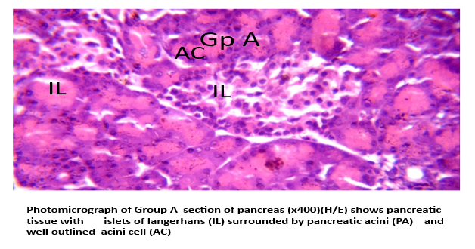
Group A: This represents a healthy pancreas. Both endocrine (islets) and exocrine (acinı) structures are intact, showing normal histo-architecture. It serves as the baseline control for comparison.

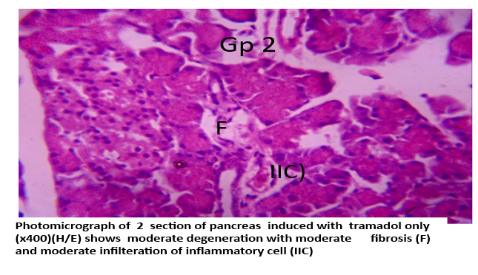
Group B: Tramadol appears to cause toxic injury to the pancreas, leading to structural damage. The fibrosis and inflammatory infiltration suggest chronic injury and inflammation with acinar degeneration, indicating impaired exocrine function.

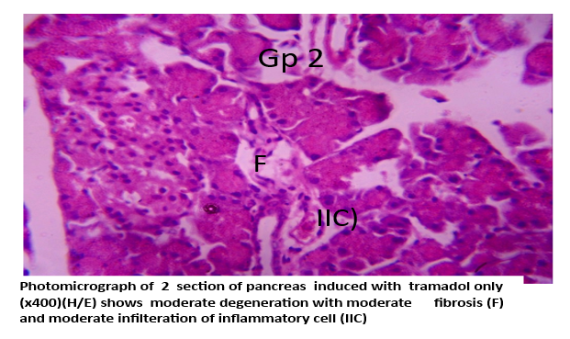
Group C: This shows potential healing and regeneration after injury. Some acini are still atrophic, but others are regaining activity, suggesting that the pancreas's intrinsic regenerative capacity has potential, though recovery is incomplete.

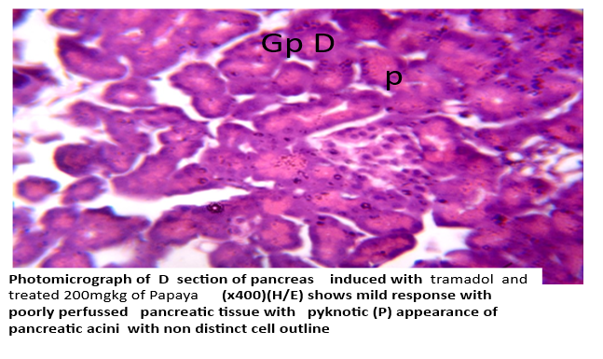
Group D: At a lower dose, Papaya extract (200 mg/kg) protective effects are minimal. There is still significant damage: hypoperfusion, necrosis (pyknosis) and structural loss. This suggests the dose is not sufficient for strong tissue protection or regeneration. The dose is not sufficient for strong tissue protection or repair.

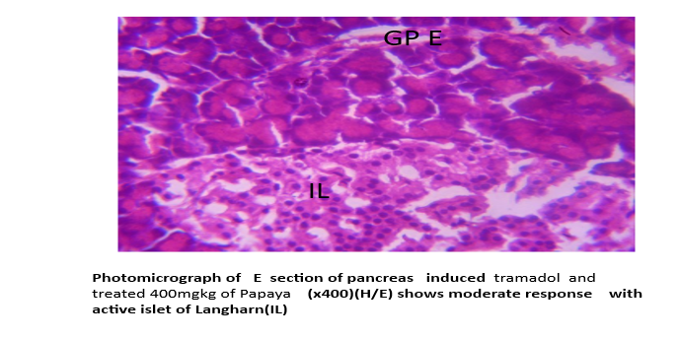
Group E: At a higher dose of Carica papaya extract (400mg/kg), there is a notable protective/regenerative effect. The endocrine cells (islets) are preserved and active, indicating restoration of pancreatic function. This suggests that papaya extract has dose-dependent protective regenerative ole against tramadol-induced pancreatic damage.

4. DISSCUSION
This study examined the protective effects of Carica papaya leaf extract on tramadol-induced pancreatic damage in male Wistar rats, using histological and statistical analyses. Results indicated that tramadol caused significant pancreatic injury, characterised by acinar cell degeneration, fibrosis, inflammation, and necrosis. Conversely, treatment with Carica papaya leaf extract resulted in dose-dependent histological improvements, with the 400 mg/kg dose achieving near-complete restoration of pancreatic architecture, comparable to Vitamin C, a standard antioxidant reference. These findings emphasise the potential of Carica papaya as a natural agent in reducing drug-induced pancreatic injury.
The tramadol-only group (Group B) exhibited severe histological lesions, including acinar cell degeneration, fibrosis, and inflammation, mirroring chronic pancreatic-like changes. Consistent with prior studies reporting tramadol's pancreatic toxicity effects, tramadol alters pancreatic metabolism via Cytochrome P450 enzymes, producing reactive Oxygen species (ROS) and free radicals, which induce oxidative stress and mitochondrial dysfunction within pancreatic tissue. The acinar cells, being highly active in protein synthesis and enzyme secretion, are particularly vulnerable and thus represent the primary site of injury upon exposure to tramadol. The histological restoration observed in Groups D(200mg/kg) and E (400 mg/kg) confirms the dose-dependent protective effect of Carica papaya on the pancreas. While the 200 mg/kg dose partially reduces inflammatory infiltrates, acinar degeneration, and stromal fibrosis, the 400 mg/kg dose nearly normalized pancreatic architecture, suggesting that higher concentrations of bioactive compounds enhance pancreas protection [22,23].
In Group C, Vitamin C, a potent antioxidant, served as the standard reference and produced histological improvements comparable to those of the 400 mg/kg papaya group. Pancreatic sections from this group showed only slight inflammatory infiltrations and near-normal acinar and islet architecture. This comparability reinforces the therapeutic potential of Carica papaya as a plant-based alternative to synthetic antioxidants in managing drug-induced pancreatic toxicity [24]. Semi-quantitative histological scoring confirmed tramadol-induced pancreatic injury and the protective effects of papaya extract. Tramadol group (B): Highest damage score (12/12), indicating severe pancreatic injury. Papaya 400 mg/kg (E) and Vitamin C (C) groups: Lowest scores (3.5/12), statistically comparable to the control group (P>0.05). Papaya 200 mg/kg (E) group: Intermediate score (7.5/12), reflecting partial protection. This statistically significant reduction in pancreatic lesions (P<0.05) validates the dose-response protective effect of papaya extract against tramadol-induced pancreatic toxicity.

CONCLUSION
Carica papaya leaf extract possesses potent pancreatic protective properties, effectively mitigating tramadol-induced pancreatic injury in Wistar rats. The protective effect is dose-dependent, with the 4sOmg/kg extract providing optimal histological recovery. The protective action of papaya is likely mediated by its antioxidant and anti-inflammatory phytochemicals, which reduce fibrosis, stimulate acinar and islet cells, and promote pancreatic tissue regeneration. These findings support Carica papaya as a promising plant-based alternative for managing drug-induced pancreatic injury.
REFERENCE
- Mostafa A, Gantsova EA, Serova OV, Mohammad T, Deyev IE. Interaction between Endocrine and Exocrine Pancreas. Journal of Evolutionary Biochemistry and Physiology. 2024 Mar;60(2):792-801.
- Sharopov S. PANCREAS: FUNCTIONS, DISORDERS, AND ITS PHYSIOLOGICAL ROLE IN MAMMALIAN ORGANISMS. Естественные науки в современном мире: теоретические и практические исследования. 2024 Dec 23;3(12):121-5.
- Elsayed Ateia, H. M., Ahmed Ahmed, S. M., Abdelrahman, S. A., & Reda, S. M. (2025). Pancreas: Anatomy, Histology and Physiology. Zagazig University Medical Journal, 31(1).
- Mann E, Sunni M, Bellin MD. Secretion of insulin in response to diet and hormones. Pancreapedia: The Exocrine Pancreas Knowledge Base. 2020 Dec 23.
- Al-Suhaimi EA, Aljfary MA, Khan FA. Endocrine pancreas and glucose metabolism. InEmerging concepts in endocrine structure and functions 2022 Apr 21 (pp. 247-285). Singapore: Springer Nature Singapore.
- Hu C, Chen Y, Yin X, Xu R, Yin C, Wang C, Zhao Y. Pancreatic endocrine and exocrine signaling and crosstalk in physiological and pathological status. Signal transduction and targeted therapy. 2025 Feb 14;10(1):39.
- Karpińska M, Czauderna M. Pancreas—its functions, disorders, and physiological impact on the mammals’ organism. Frontiers in physiology. 2022 Mar 30;13:807632.
- Sosnowski K, Nehring P, Przybyłkowski A. Pancreas and adverse drug reactions: a literature review. Drug Safety. 2022 Sep;45(9):929-39.
- Barakat A. Revisiting tramadol: a multi-modal agent for pain management. CNS drugs. 2019 May 1;33(5):481-501.
- Ogbemudia B, Qu G, Henson C, Esfandiary L, Przkora R, Victor S. Tramadol use in perioperative care and current controversies. Current Pain and Headache Reports. 2022 Mar;26(3):241-6.
- Seidmohammadi K, Haghshenas H, Moghaddam S, Kargar Jahromi H, Delam H. The Effectiveness of Tramadol in Pain Relief in Chronic Diseases: A Review Based on Clinical Trials. Journal of Pain & Palliative Care Pharmacotherapy. 2025 Jan 2;39(1):139-61.
- Nakhaee S, Hoyte C, Dart RC, Askari M, Lamarine RJ, Mehrpour O. A review on tramadol toxicity: mechanism of action, clinical presentation, and treatment. Forensic Toxicology. 2021 Jul;39(2):293-310.
- Doostmohammadi M, Rahimi HR. ADME and toxicity considerations for tramadol: from basic research to clinical implications. Expert Opinion on Drug Metabolism & Toxicology. 2020 Jul 2;16(7):627-40.
- Nakhaee S, Farrokhfall K, Miri-Moghaddam E, Foadoddini M, Askari M, Mehrpour O. The effects of quercetin on seizure, inflammation parameters and oxidative stress in acute on chronic tramadol intoxication. BMC Pharmacology and Toxicology. 2021 Oct 19;22(1):59.
- Heena D, Sunil T. Carica papaya: Potential implications in human health. Current Traditional Medicine. 2019 Dec 1;5(4):321-36.
- Iipinge LN, Gabriel NN, Iitembu JA. Pawpaw (Carica papaya) Extracts. Emerging Sustainable Aquaculture Innovations in Africa. 2023 May 11:197.
- Babalola BA, Akinwande AI, Otunba AA, Adebami GE, Babalola O, Nwufo C. Therapeutic benefits of Carica papaya: A review on its pharmacological activities and characterization of papain. Arabian Journal of Chemistry. 2024 Jan 1;17(1):105369.
- Jiao M, Liu C, Prieto MA, Lu X, Wu W, Sun J, García-Oliveira P, Tang X, Xiao J, Simal-Gandara J, Hu D. Biological functions and utilization of different part of the papaya: a review. Food Reviews International. 2023 Oct 3;39(9):6781-804.
- Shoyshob TZ, Heya IA, Afrin N, Enni MA, Asha IJ, Moni A, Hannan MA, Uddin MJ. Protective Mechanisms of Carica papaya Leaf Extract and Its Bioactive Compounds Against Dengue: Insights and Prospects. Immuno. 2024 Dec 12;4(4):629-45.
- Ajibade J, Fakunle PB, Adetunji TJ, Kehinde BD. Protective effects of aqueous extract of Carica papaya leaf on the liver of Streptozotocin (STZ)-Induced diabetic adult Wistar rats. Asian Journal of Research in Medical and Pharmaceutical Sciences. 2019 Aug 7;7(4):1-2.
- Oji IN, Ukwa AJ, Nancy NO, Jamike EC, Ugochukwu AA, Adaukwu OE. Combined Effect of Ethanolic Leaf Extracts of Carica papaya and Newbouldia laevis on Hematological Parameters and Sperm Quality of Alloxan-Induced Rats. Diabetes. 2022;11:13.
- dos Santos Freire J, dos Santos Fernandes BC, da Silva JA, da Silva Araújo JR, de Almeida PM, da Costa Júnior JS, da Silva JN, de Freitas SD, Martins FA. Phytochemical and antioxidant characterization, cytogenotoxicity and antigenotoxicity of the fractions of the ethanolic extract of in Poincianella bracteosa (Tul.) LP Queiroz. Journal of Toxicology and Environmental Health, Part A. 2020 Dec 16;83(23-24):730-47.
- Abd’quadri-Abojukoro AN, Nkadimeng SM, McGaw LJ, Nsahlai IV. Phytochemical composition and cytotoxicity of ethanolic extracts of some selected plants. Journal of Applied Animal Research. 2022 Dec 31;50(1):656-65.
- Thadani JM. Study on Therapeutic Potential of Carica papaya Leaf Extract and Single Nucleotide Polymorphism Involved in Thrombocytopenia (Doctoral dissertation, Maharaja Sayajirao University of Baroda (India)).

