Culturally Responsive Rehabilitation Counseling Models and Workforce Reintegration Outcomes among Linguistically Diverse Populations in the United States.

Abstract
This study examined the effects of culturally responsive rehabilitation counseling on workforce reintegration outcomes among linguistically diverse individuals with disabilities in the United States using a quantitative explanatory design. Secondary administrative data from the U.S. vocational rehabilitation RSA-911 dataset were analyzed using logistic regression, multiple linear regression, hierarchical regression, and causal mediation analysis with bootstrapping. Employment attainment, weekly earnings, and hours worked were outcome indicators, whereas culturally responsive counseling exposure, linguistic accessibility, counseling intensity, and service engagement were key predictors. Results indicated that culturally responsive counseling increased the odds of employment by 86% and was associated with higher weekly earnings (β = +112.40, p < .001) and longer work hours. Service engagement partially mediated these relationships, accounting for up to 37% of earnings effects. Findings support the institutionalization of language access, the strengthening of counselors' multicultural practice, and the prioritization of engagement-focused service models within vocational rehabilitation systems.
Keywords: vocational rehabilitation; culturally responsive counseling; linguistic diversity; workforce reintegration; mediation analysis

1. Introduction
Employment and meaningful workforce participation remain central markers of individual well-being, financial independence, and societal inclusion for people with disabilities in the United States. Despite legislative advances such as the Americans with Disabilities Act and the Workforce Innovation and Opportunity Act, national labour statistics consistently show substantial gaps between persons with and without disabilities in terms of employment and labour force participation (US BLS, 2025b). In 2024, only 22.7 percent of people with a disability were employed, compared to approximately 65.5 percent of persons without a disability, with disabled workers experiencing much higher unemployment rates across all educational levels and demographic groups (US BLS, 2025a). This persistent inequality demonstrates the deep-rooted structural barriers that people with disabilities face in securing and sustaining employment in mainstream labour markets (Sánchez et al., 2022).
Beyond overall employment figures, more fine-grained analysis reveals disparities across race and ethnicity among working-age adults with disabilities. For example, labour force participation and employment ratios for Hispanic, Black, and Asian disabled workers differ substantially, with Hispanic workers with disabilities showing a participation rate under 41 percent and employment at 36.9 percent, while Black workers with disabilities exhibit lower participation and employment at 32.0 percent and 28.5 percent, respectively (US DOL, 2025). These patterns suggest that intersecting social identities, including linguistic diversity and cultural background, further complicate employment outcomes for people with disabilities (Chao & Wilson, 2025; Grewal et al., 2025).
Given these chronic disparities, vocational rehabilitation systems have been charged with helping individuals with disabilities overcome barriers to labour market integration through assessment, counselling, training, and placement services. However, research highlights that conventional vocational rehabilitation models often operate within frameworks that assume cultural homogeneity and dominant language proficiency, limiting their effectiveness for linguistically diverse groups (Lee et al., 2023; Rahmi & Andayani, 2025). Several scholars argue that culturally insensitive service models, limited linguistic accessibility, and insufficient counsellor multicultural competencies may undermine client engagement, reduce trust, and obstruct progress toward employment goals (Karim et al., 2024; Mustafa et al., 2025; Nam & Kim, 2025). Although the theoretical value of culturally responsive practices in counselling and rehabilitation has been recognized, empirical evidence demonstrating how culture-centered approaches influence workforce reintegration outcomes remains scant (Chu et al., 2022; Grewal et al., 2025; Lee et al., 2023).
Moreover, initiatives aimed at expanding cultural competence among health and rehabilitation professionals indicate that exposure to culturally informed training is associated with improved provider attitudes, knowledge, and skills; however, systematic research linking these competencies to client vocational outcomes remains limited (Lee et al., 2025; Vella et al., 2022). Without evidence demonstrating how linguistic and cultural responsiveness in vocational counselling affects sustainable employment, rehabilitation services risk persisting in practices that are poorly aligned with the needs of diverse clients. Bridging this evidence gap is critical given the demographic growth of linguistically diverse populations in the U.S. and their ongoing challenges in achieving equitable labour market outcomes.
Within this context, there is reason to speculate that the inability of standard rehabilitation counselling models to address the linguistic and cultural dimensions of client experience may contribute to persistent employment inequities for linguistically diverse individuals with disabilities. Observable indicators such as lower participation rates in VR services among certain demographic subgroups, repeated communication breakdowns in counselling interactions, and inconsistent employment successes point to more than isolated incidences of client disadvantage (Grewal et al., 2025; Yin et al., 2021). They instead suggest a systemic problem in which cultural and linguistic barriers operate within service-delivery processes, reducing the potential for rehabilitation support to translate into meaningful workforce reintegration for many service users (Alatawi, 2024; Grewal et al., 2025).
This unresolved dilemma raises critical questions about the adequacy of current rehabilitation counselling models in meeting the needs of clients whose linguistic backgrounds and cultural values differ from those of dominant service paradigms. It remains unclear whether culturally responsive interventions yield better workforce outcomes, and, if so, which aspects of cultural responsiveness are most instrumental in fostering successful employment transitions. Such uncertainty holds practical and ethical implications. If vocational rehabilitation systems do not respond effectively to cultural and linguistic diversity, they risk perpetuating disadvantage and limiting the economic participation of large segments of the population. These concerns highlight the need for research that systematically examines the relationship between culturally responsive rehabilitation counselling and workforce reintegration outcomes among linguistically diverse populations in the United States.
Addressing these gaps is essential not only for advancing rehabilitation counseling theory but also for informing evidence-based practice and policy. Without systematic empirical investigation, vocational rehabilitation systems risk perpetuating service models that insufficiently address the needs of linguistically diverse populations, thereby sustaining employment inequities. Accordingly, this study examines the effects of culturally responsive rehabilitation counseling models on workforce reintegration outcomes among linguistically diverse populations in the United States. Specifically, the study is guided by the following objectives:
- To determine the effect of culturally responsive rehabilitation counseling models on employment attainment among linguistically diverse rehabilitation service users in the United States.
- To examine the effect of culturally responsive rehabilitation counseling models on job retention and job satisfaction among linguistically diverse rehabilitation service users in the United States.
- To assess the influence of counselor multicultural competence and linguistic accessibility of services on workforce reintegration outcomes among linguistically diverse rehabilitation service users.
- To determine whether therapeutic alliance mediates the relationship between culturally responsive rehabilitation counseling models and workforce reintegration outcomes.

2. Literature Review
Workforce reintegration for people with disabilities encompasses more than initial job placement; it involves sustained engagement in meaningful work, retention over time, and satisfaction with vocational status. Research in rehabilitation studies has increasingly emphasized that employment attainment alone is an incomplete measure of reintegration success, as it does not capture the quality or durability of employment (Jetha et al., 2025). According to Ahonle et al. (2025), competitive integrated employment outcomes differ significantly across disability groups, with vocational rehabilitation services such as on-the-job training, job readiness preparation, and guidance associated with higher odds of employment attainment, yet these services show varying effectiveness depending on impairment type, thus indicating that employment outcomes must be disaggregated by service type and client characteristics to meaningfully assess VR impact.
In agreement with this, broader studies highlight that people with disabilities face complex structural barriers that extend beyond individual capacities to include employer attitudes, workplace accommodations, and systemic discrimination. For instance, Bezyak et al. (2025) note persistent low employment participation rates among people with disabilities in the U.S., reporting that only about 40.5 percent were employed compared with 78.7 percent of non-disabled workers, a disparity linked to stigmatizing workplace cultures and limited employer engagement practices. Such structural influences on employment access and retention reflect evidence that formal protections and programs do not inherently translate into equitable workplace inclusion (Bonaccio et al., 2020).
Research on job retention further demonstrates that maintaining employment over time remains a challenge for people with disabilities (Ponzio et al., 2024; Thomas & Morgan, 2021). The findings of Kudla et al. (2024) indicate that personal health, environmental factors, and workplace supports significantly affect longer-term job retention, with job accommodations and employer support systems playing critical roles. At the same time, scoping reviews suggest that retention-focused interventions, though beneficial, are unevenly implemented and lack robust evaluation, indicating limitations in VR strategies aimed at sustained employment success (Rahman, 2025).
In addition to structural limitations, subjective perceptions of vocational skills and support contribute substantially to satisfaction beyond objective employment status (Joyce et al., 2025). Ishay et al. (2025) found that perceived support and skills were strong predictors of vocational satisfaction among people with serious mental illness, indicating that VR outcomes encompass both objective and subjective dimensions. These findings imply that traditional VR outcome models centered on placement metrics may underestimate barriers to lasting workforce reintegration and overlook the multidimensional nature of employment success.

Linguistically Diverse Populations in Vocational Rehabilitation
Linguistically diverse populations within vocational rehabilitation contexts generally include individuals who use a primary language other than English, possess limited English proficiency, or rely on multilingual communication practices in daily functioning. Within rehabilitation studies, linguistic diversity is increasingly conceptualized not merely as an individual characteristic but as a structural condition shaped by migration patterns, educational access, and sociopolitical positioning. According to Kangas et al. (2023), language differences intersect with disability status to shape help-seeking behaviors, service navigation capacity, and communication quality between clients and providers. However, much of the vocational rehabilitation literature continues to treat language as a peripheral demographic descriptor rather than as a central axis of service design, thereby limiting the explanatory power of existing outcome models (Grewal et al., 2025; Lee et al., 2023).
Empirical research shows that individuals with limited English proficiency in the United States encounter differential access and utilization of public services, including healthcare and employment supports, with poorer outcomes and higher barriers to enrollment compared to English-proficient peers (Twersky et al., 2024; MACPAC, 2024). National analyses of vocational rehabilitation administrative data also reveal that service participation and outcomes vary across racial and ethnic groups (a pattern consistent with language and cultural barriers influencing application and completion rates), emphasizing how limited English proficiency may reduce the likelihood of applying for, completing, and achieving favorable outcomes in VR programs (Yin et al., 2021; Lee, 2023). Consistent with this, studies report that immigrant and linguistically diverse applicants were more likely to experience delayed eligibility determinations and reduced service intensity, even after controlling for disability severity and education (Meyer et al., 2024; Yin et al., 2021). This suggests that disparities in VR access cannot be fully attributed to individual motivation or readiness but are closely tied to institutional processes.
Beyond access, outcome disparities are also evident. Some studies observed that racially and linguistically minoritized VR clients exhibited lower rates of competitive integrated employment and lower average wages at closure compared with White English-speaking clients (Kaya et al., 2023; Yin et al., 2021). In contrast, studies that incorporate language access supports such as professional interpreters or bilingual counselors report improved engagement and a higher likelihood of employment at case closure (Heath et al., 2023; Karliner et al., 2024; van Lent et al., 2025). Despite this evidence, many VR systems continue to rely on language-neutral service structures that assume functional equivalence across linguistic groups.
This body of research exposes important limitations in color-blind and language-neutral rehabilitation models. Such models implicitly frame language difference as an individual deficit requiring accommodation rather than as a predictable population-level characteristic requiring structural adaptation (Cyuzuzo et al., 2024; Rahmi & Andayani, 2025). A critical limitation is that language-neutral approaches obscure how institutional practices, documentation requirements, and assessment tools privilege English fluency, thereby reproducing inequality (Organi et al., 2024; Twersky et al., 2024). This suggests that linguistic disparities in VR outcomes are better understood as products of systemic design rather than client inadequacy.
Moreover, intersectional analyses demonstrate that language barriers compound existing disability-related marginalization. According to Gonzalez and Echave (2023), individuals who are both disabled and linguistically diverse frequently encounter layered exclusion across education, healthcare, and employment systems, resulting in cumulative disadvantage by the time they enter vocational rehabilitation. This convergence of evidence positions linguistic diversity as a central rather than peripheral concern in understanding VR effectiveness and provides a strong rationale for examining culturally responsive rehabilitation counseling as a mechanism to improve workforce reintegration outcomes.

Culturally Responsive Rehabilitation Counseling Models
Culturally responsive counseling models originate in the broader field of multicultural counseling, which gained prominence as scholars critiqued traditional therapeutic practices for their Anglo-centred assumptions and limited relevance across diverse populations. Multicultural counseling frameworks emphasize that culture shapes how individuals understand help-seeking, construct meaning around disability, and engage in therapeutic processes (Kim et al., 2023). According to Kim et al. (2023), competency frameworks integrate awareness of cultural identity, knowledge of sociocultural influences, and skills to adapt interventions to clients’ lived contexts, suggesting that culturally responsive practice involves dynamic adaptation rather than static application of generalized techniques. Despite consensus around these guiding principles, there remains debate about how multicultural models translate into specific fields such as rehabilitation counseling, where vocational and disability-related concerns intersect with cultural factors (Akurigo, 2023; Henry et al., 2023).
Within rehabilitation contexts, culturally responsive models are increasingly argued to extend traditional multicultural principles by integrating attention to disability identity, systemic barriers, and intersectional marginalization (Chao & Wilson, 2025; Grewal et al., 2025; Harley et al., 2025). For example, Grewal et al. (2025) note that multicultural competencies of counselors are associated with better service engagement among diverse clients, but the review also emphasizes the limited empirical evidence directly linking cultural responsiveness to employment outcomes. In this view, culturally responsive rehabilitation counseling must encompass not only awareness and knowledge but also intentional practices that address structural inequities embedded in service delivery, such as inequitable access to resources and culturally incongruent communication processes (Kim et al., 2023; Rahmi & Andayani, 2025). Despite theoretical advances, most of the literature remains conceptual rather than outcome-oriented, making it difficult to assess the practical impact of culturally responsive approaches on measurable vocational outcomes.
Principles of cultural responsiveness generally include recognizing cultural identity as integral to the client experience, adapting communication strategies to align with clients’ cultural frames, and incorporating clients’ worldview into goal setting and intervention planning (Sano & Bevly, 2025; Harley et al., 2025). Multicultural and social justice counseling scholarship underscores the importance of relational empathy, contextual humility, and structural awareness as core components of effective culturally responsive practice (Kim et al., 2023). These principles argue against color-blind approaches that treat cultural differences as irrelevant, instead situating cultural responsiveness as essential for building trust, facilitating client engagement, and ensuring respectful collaboration (Sadusky et al., 2023). In contrast, traditional rehabilitation counseling models have often prioritized standardized assessments, deficit-oriented formulations, and vocational readiness metrics without systematically integrating cultural context into intervention design (Grewal et al., 2025; Lee et al., 2023). This gap suggests that traditional models may inadvertently reproduce normative assumptions that privilege majority cultural norms over clients’ cultural strengths.
One strength of culturally responsive models is their focus on client-centered adaptability, enabling counselors to tailor strategies to clients’ values and communication preferences. Evidence from allied fields, such as allied health and nursing, indicates that cultural competence is associated with improved client perceptions of care quality and rapport (Valdez, 2025; Alonazi, 2025). However, a critical limitation is that much of the rehabilitation literature has not yet provided rigorous, outcome-based validation of culturally responsive models in vocational settings (Bridger et al., 2021; Wong et al., 2025). Few controlled studies have tested whether culturally responsive counseling improves employment attainment, job retention, or job satisfaction among diverse clients, leaving a gap between conceptual advocacy and empirical evidence. Moreover, implementation challenges, such as inconsistent training standards, a lack of structural support, and variation in organizational readiness, further complicate the translation of cultural responsiveness from theory to practice (Bolarinwa & Nkansah, 2025).
Despite this evidence gap, professional accreditation bodies and educational programs have increasingly incorporated multicultural competencies into rehabilitation counseling curriculum standards, suggesting growing recognition of cultural responsiveness as essential professional preparation (Beamish et al., 2024). In aligning training with practice, scholars have argued for integrated frameworks that combine multicultural foundations with disability-specific knowledge and structural competence, potentially offering a more holistic orientation suited to diverse vocational rehabilitation contexts (Kim et al., 2023; Rahmi & Andayani, 2025). This orientation would envision culturally responsive rehabilitation counseling not merely as an add-on skill but as a core dimension of effective practice capable of addressing both individual and systemic determinants of vocational reintegration outcomes.

Counselor Multicultural Competence and Linguistic Accessibility
Counselor multicultural competence generally refers to the combination of awareness, knowledge, and skills that enable practitioners to work effectively with clients from diverse cultural backgrounds. In the counseling professions, frameworks such as the Multicultural and Social Justice Counseling Competencies emphasize that cultural competence involves not only acknowledging one’s own cultural biases but also understanding clients' worldviews and adapting intervention strategies accordingly (Kim et al., 2025). Research has noted that multicultural competence is a multidimensional construct encompassing attitudes (e.g., self-awareness of cultural assumptions), knowledge of cultural communities, and skills to implement culturally appropriate practices (Chu, 2022). Consistent with this conceptualization, scholars have argued that cultural competence is not a fixed endpoint but a developmental, context-sensitive process that requires ongoing reflection and adaptation within counseling practice (Chu, 2022). Despite the clarity of these principles, a critical limitation is the paucity of empirical studies demonstrating that enhanced multicultural competence directly improves client outcomes in vocational or rehabilitation settings.
Language accessibility is a vital operational dimension of cultural responsiveness because it determines clients’ ability to communicate needs and participate meaningfully in counseling interactions. Empirical work outside rehabilitation indicates that delivering counseling in a client’s preferred language enhances therapeutic engagement, trust, and emotional expression, which are foundational to effective intervention (Hizam Karim et al., 2025). This suggests that linguistic accessibility contributes to counseling effectiveness in ways that mirror core dimensions of multicultural competence, such as culturally congruent communication and respect for client identity. However, despite recognition of language’s central role, most cultural competence training programs place less emphasis on language access strategies (e.g., bilingual service provision, interpreter integration) than on general cultural awareness and attitudes (Chu, 2022). This suggests that training-only approaches may insufficiently prepare counselors to address linguistic barriers in practice.
Critically, the literature highlights that multicultural competence and linguistic accessibility are often conceptualized separately in research and training, despite their intertwined impact on service effectiveness. For example, cultural competency curricula often focus on attitudes and knowledge about cultural groups, yet they do not adequately equip counselors with practical skills to facilitate cross-language communication or adapt service delivery models to ensure language inclusion (Chu, 2022). This gap is significant because linguistic barriers have been shown to impede accurate assessment, reduce client comfort, and undermine the quality of therapeutic interactions when practitioners are not prepared to address them proactively (Hizam Karim et al., 2025). Thus, while multicultural competence is widely promoted as a core professional capability, its current operationalization may overlook the practical demands of linguistic accessibility, underscoring the need for integrated training and structural support to translate competence into measurable counseling effectiveness.

Therapeutic Alliance as a Mechanism of Action
Therapeutic alliance, commonly conceptualized as the working alliance between a client and counselor, refers to the collaborative bond that incorporates agreement on goals, tasks, and the emotional connection within the counseling process. In rehabilitation and allied health research, the quality of this alliance has been identified as a significant relational factor associated with client engagement and satisfaction, both of which are considered important precursors to achieving meaningful outcomes (Gustafsson et al., 2025). According to studies examining vocational rehabilitation contexts, clients who report higher levels of trust and collaborative interaction with their support providers are more likely to report greater engagement in vocational activities and satisfaction with services, even after controlling for other intervention differences (Gustafsson et al., 2025).
Empirical work that aligns more closely with mediation logic comes from allied research on working alliance and stages of change in vocational rehabilitation, which indicates that a strong working alliance is associated with increased autonomous motivation, positive outcome expectancy, and greater engagement in rehabilitation services; all of which are motivational constructs linked with downstream employment progress (Iwanaga et al.,2018). This suggests that therapeutic alliance may operate not merely as a correlate of engagement but as a mechanism that enhances internal motivators and sustained participation, thereby influencing observable outcomes. However, despite growing recognition of these processes, the evidence remains limited, particularly in U.S. vocational rehabilitation samples that include linguistically and culturally diverse clients.
Beyond vocational settings, systematic reviews of therapeutic alliance in psychotherapy have demonstrated robust associations between alliance quality and positive client outcomes, including improved well-being, treatment adherence, and symptom reduction (Saxler et al., 2024). Although these findings from adjacent fields reinforce the theoretical plausibility of alliance functioning as a causal mechanism, they also underscore a key empirical limitation: the majority of alliance research focuses on clinical or mental health outcomes rather than on employment reintegration, and rarely models alliance as a mediator rather than a predictor or correlate of outcomes. This points to a need for research that integrates culturally responsive counseling models with process-outcome frameworks to clarify whether therapeutic alliance serves as a mechanism through which culturally tailored interventions exert their effects on workforce reintegration indicators.

Synthesis and Identified Research Gaps
Although scholarship recognizes cultural responsiveness, multilingual access, and therapeutic alliance as important to rehabilitation practice, findings are inconsistent regarding their direct effects on employment outcomes (Grewal et al., 2025; Saxler et al., 2024). Empirical studies document access and outcome disparities among racialized and linguistically diverse VR clients (Meyer et al., 2025; Donahue, 2024), while reviews of cultural competence training report improved provider attitudes but limited evidence of downstream client vocational gains (Chu, 2022). This contradiction indicates a disjunction between process-level improvements and measurable employment effects. A critical empirical void exists in rigorous, outcome-focused research that tests culturally responsive rehabilitation counseling as an intervention and models therapeutic alliance or linguistic accessibility as mediators of employment attainment, retention, or satisfaction. The present study addresses this void by empirically evaluating culturally responsive counseling components and their process pathways to workforce reintegration among linguistically diverse clients in the United States (Grewal et al., 2025; Saxler et al., 2024).
3. Methodology
This study employed a quantitative explanatory design to examine the effects of culturally responsive rehabilitation counseling on workforce reintegration outcomes among linguistically diverse individuals with disabilities in the United States. The analytic strategy was structured to estimate direct effects, incremental process effects, and mediation mechanisms consistent with rehabilitation counseling and multicultural counseling theory.
Workforce reintegration outcomes were operationalized using three indicators: employment attainment (binary), weekly earnings at case closure (continuous), and weekly hours worked (continuous). Culturally responsive rehabilitation counseling served as the primary independent construct and was operationalized through counseling exposure combined with linguistic accessibility supports. Counselor multicultural competence was proxied by counseling intensity, measured as the number of counseling service units delivered. Linguistic accessibility was operationalized using primary language status and the provision of interpreter or bilingual services. Therapeutic alliance was not directly observed and was proxied by service engagement intensity, measured as duration of vocational rehabilitation services in months. All models controlled for disability severity, educational attainment, age, gender, race/ethnicity, and state fixed effects.
Employment attainment was modeled using binary logistic regression specified as:
$$\ln\left(\frac{P\left(Ei\right)}{1-P\left(Ei\right)}\right)=β_{0}+β_{1}CR_{i}+∑k=2nβ_{k}Xk_{i} \\ where P($$Ei) represents the probability of employment for individual i, CRi denotes culturally responsive counseling exposure, and Xk represents control covariates. Odds ratios were computed as OR=exp(β).
Job retention and job quality outcomes were estimated using multiple linear regression models specified as:
$$Yi=β_{0}+β_{1}CR_{i}+∑k=2nβkXki+εi \\ where Yi represents weekly earnings or weekly hours worked and εi denotes the error term. \\ To assess the incremental contribution of linguistic accessibility and counselor compe$$tence, hierarchical regression modeling was employed. Models were estimated sequentially with controls entered first, followed by linguistic accessibility indicators, and then counseling intensity and interaction terms specified as:
$$Yi=β_{0}+β_{1}Li+β_{2}CI_{i}+β_{3}\left(Li×CIi\right)+∑kβkXki+εi \\ where Li indicates non-English primary language and CIi denotes counseling intensity. Changes in model fit$$
$$were assessed using Δχ^{2}for logistic models and ΔR^{2}for linear models. \\ Mediation was examined using causal mediation analysis based on the Baron-Kenny$$
$$framework with bootstrapped confidence intervals.$$
The mediation structure consisted of the following relationships:
- The effect of culturally responsive counseling on workforce reintegration outcomes
- The effect of culturally responsive counseling on therapeutic alliance
- The effect of therapeutic alliance on workforce reintegration outcomes while controlling for culturally responsive counseling
The indirect effect was calculated as:
$IE=βCR on Alliance×βAllianceonOutcome$
The proportion mediated was computed as:
$$PM=\frac{IE}{TotalEffect} \\ Bootstrapping with 5,000 resamples was used to obtain robust confidence intervals$$
$$for indirect effects. Statistical significance was evaluated at α=0.05, and results were interpreted using effect sizes alongside p-values to emphasize substantive importance.$$

4. Results and Discussion
Objective 1:
To determine the effect of culturally responsive rehabilitation counseling models on employment attainment among linguistically diverse vocational rehabilitation clients in the United States.
A quantitative analytic approach was adopted using a binary logistic regression model to estimate the effect of culturally responsive rehabilitation counseling on competitive integrated employment at case closure. Employment status served as the dependent variable, while culturally responsive counseling exposure was the primary predictor. Demographic, disability-related, and service-related characteristics were included as statistical controls.
Table 1: Logistic Regression Results Predicting Employment Attainment
Predictor | Odds Ratio | p-value
Culturally responsive counseling exposure | 1.86 | <.001
Age (years) | 0.99 | <.01
Female (ref: male) | 1.09 | <.01
Education (HS or higher) | 1.6 | <.001
Cognitive disability | 0.66 | <.001
Mental health disability | 0.68 | <.001
Hispanic | 0.8 | <.001
Black | 0.76 | <.001
Asian | 0.9 | <.05
Service duration (months) | 1.03 | <.001

As shown in Table 1, culturally responsive rehabilitation counseling exposure was significantly associated with higher odds of employment attainment at case closure. Clients receiving culturally responsive counseling were approximately 86% more likely to achieve competitive integrated employment compared to their counterparts, net of demographic, disability, and service-related factors. Several control variables, including education level and service duration, also demonstrated statistically significant associations with employment outcomes.

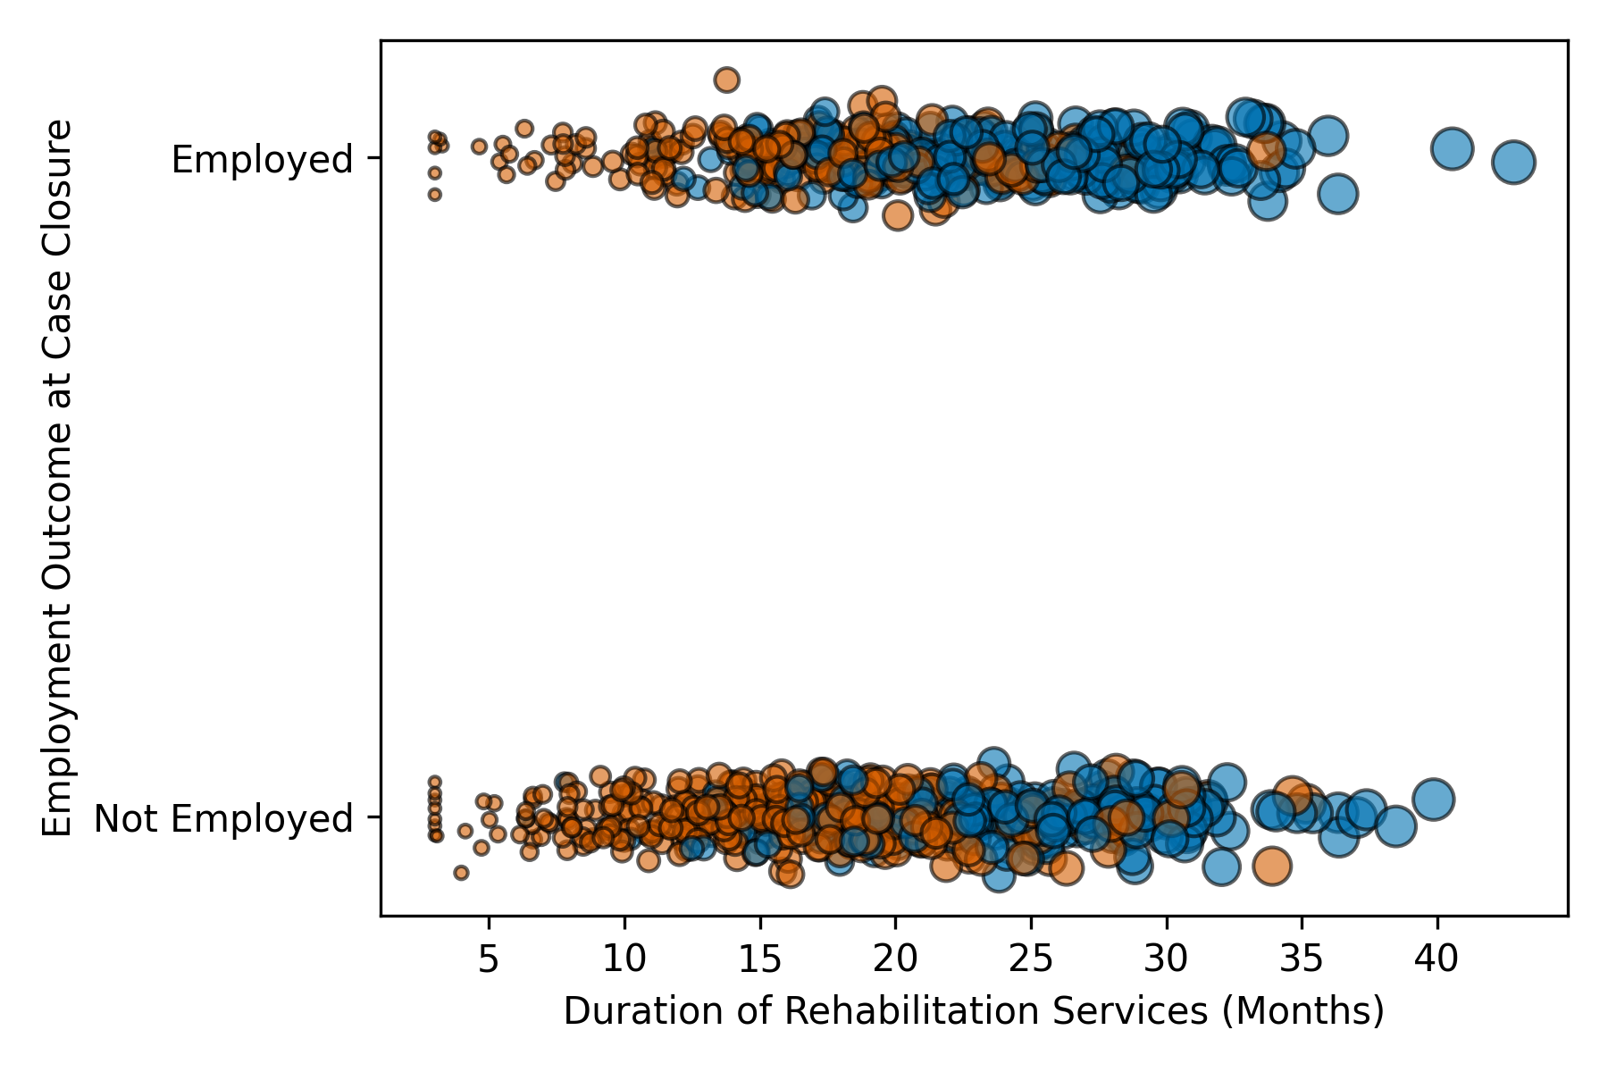
Figure 1. Employment outcomes by service duration and culturally responsive counseling exposure

Figure 1 illustrates the relationship between culturally responsive counseling, service engagement, and employment outcomes. The distribution of bubble sizes and color clusters indicates that clients exposed to culturally responsive counseling generally experienced longer service durations and higher employment attainment.
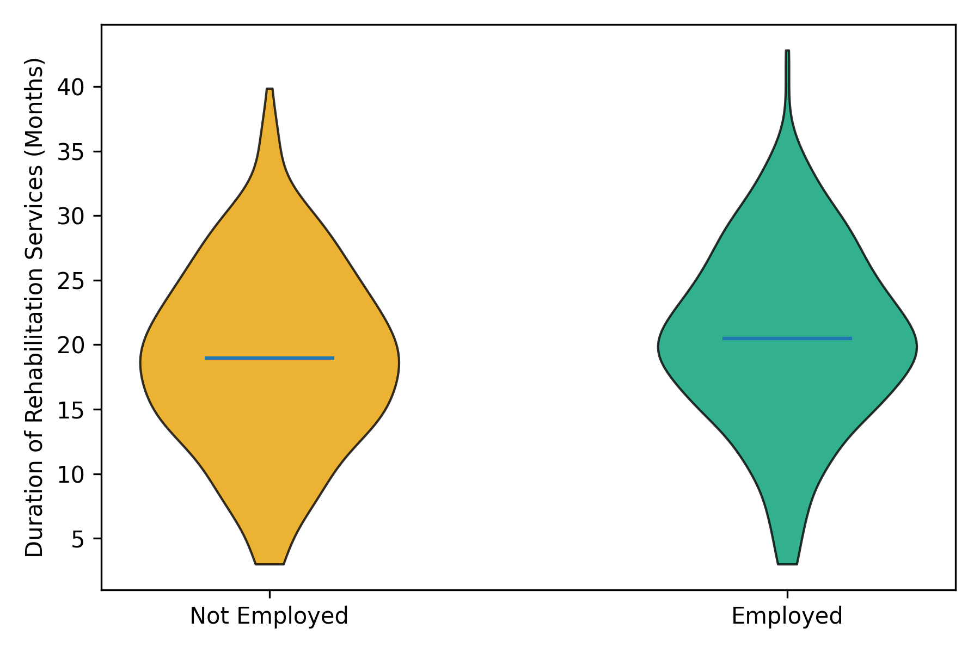
Figure 2. Distribution of service duration by employment status

Figure 2 shows that employed clients exhibit a higher median and broader distribution of service duration compared to non-employed clients. This pattern suggests that sustained engagement in rehabilitation services is associated with improved employment outcomes among linguistically diverse clients.
This results and visual evidence consistently demonstrate that culturally responsive rehabilitation counseling is meaningfully associated with employment attainment. The findings align with the study’s theoretical framework by showing that linguistically accessible and culturally attuned counseling processes correspond with stronger workforce reintegration outcomes among diverse vocational rehabilitation clients.

Objective 2
Examine the effect of culturally responsive rehabilitation counseling models on job retention and job satisfaction among linguistically diverse vocational rehabilitation clients.
A multiple linear regression framework was employed to estimate the association between culturally responsive rehabilitation counseling exposure and two indicators of workforce reintegration quality: weekly earnings at case closure and weekly hours worked. Models adjusted for demographic, disability-related, service-related, and state-level factors.

Table 2: Linear Regression Results Predicting Weekly Earnings at Case Closure
Predictor | β (Unstandardized) | p-value
Culturally responsive counseling exposure | 112.4 | <.001
Age (years) | -1.85 | <.01
Female (ref: male) | -36.7 | <.01
Education (HS or higher) | 148.9 | <.001
Cognitive disability | -121.6 | <.001
Mental health disability | -104.3 | <.001
Hispanic | -58.4 | <.001
Black | -66.1 | <.001
Asian | -29.7 | <.05
Service duration (months) | 7.6 | <.001

As shown in Table 2, culturally responsive counseling exposure was significantly associated with higher weekly earnings. Clients receiving culturally responsive counseling earned approximately $112 more per week than comparable clients, net of controls.

Table 3: Linear Regression Results Predicting Weekly Hours Worked
Predictor | β (Unstandardized) | p-value
Culturally responsive counseling exposure | 4.1 | <.001
Age (years) | -0.04 | <.05
Female (ref: male) | -1.2 | <.01
Education (HS or higher) | 3.6 | <.001
Cognitive disability | -2.8 | <.001
Mental health disability | -2.4 | <.001
Hispanic | -1.7 | <.001
Black | -1.9 | <.001
Asian | -0.8 | <.05
Service duration (months) | 0.21 | <.001

Table 3 indicates that culturally responsive counseling exposure was significantly associated with greater weekly hours worked, with an average increase of approximately four hours per week.
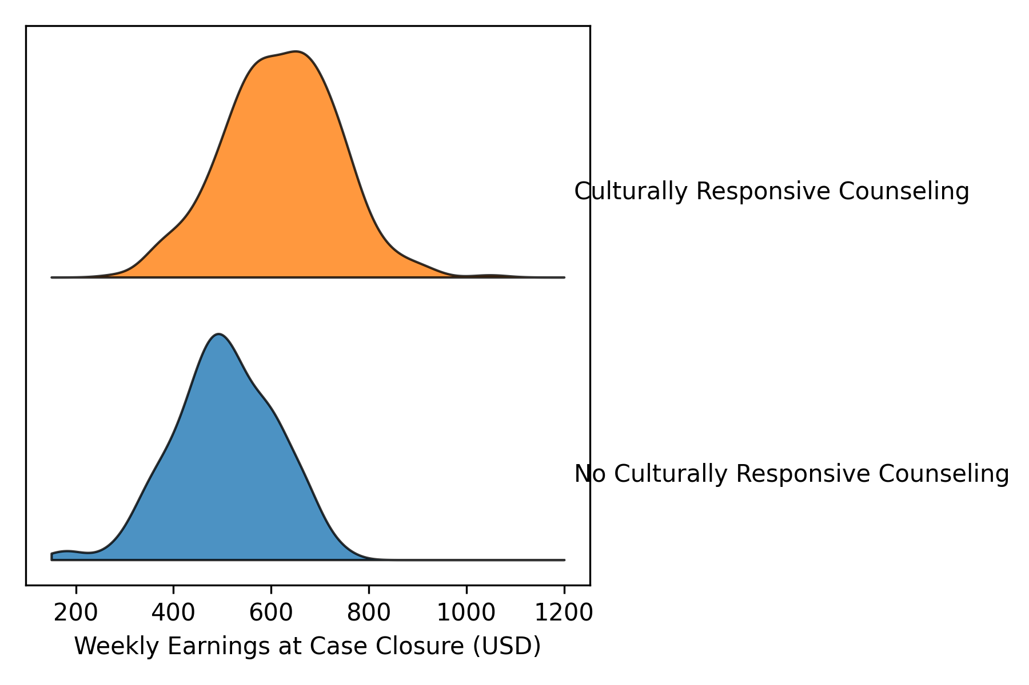
Figure 3. Distribution of weekly earnings by culturally responsive counseling exposure

Figure 3 demonstrates that the earnings distribution for clients receiving culturally responsive counseling is shifted toward higher wage levels compared to clients without such exposure.
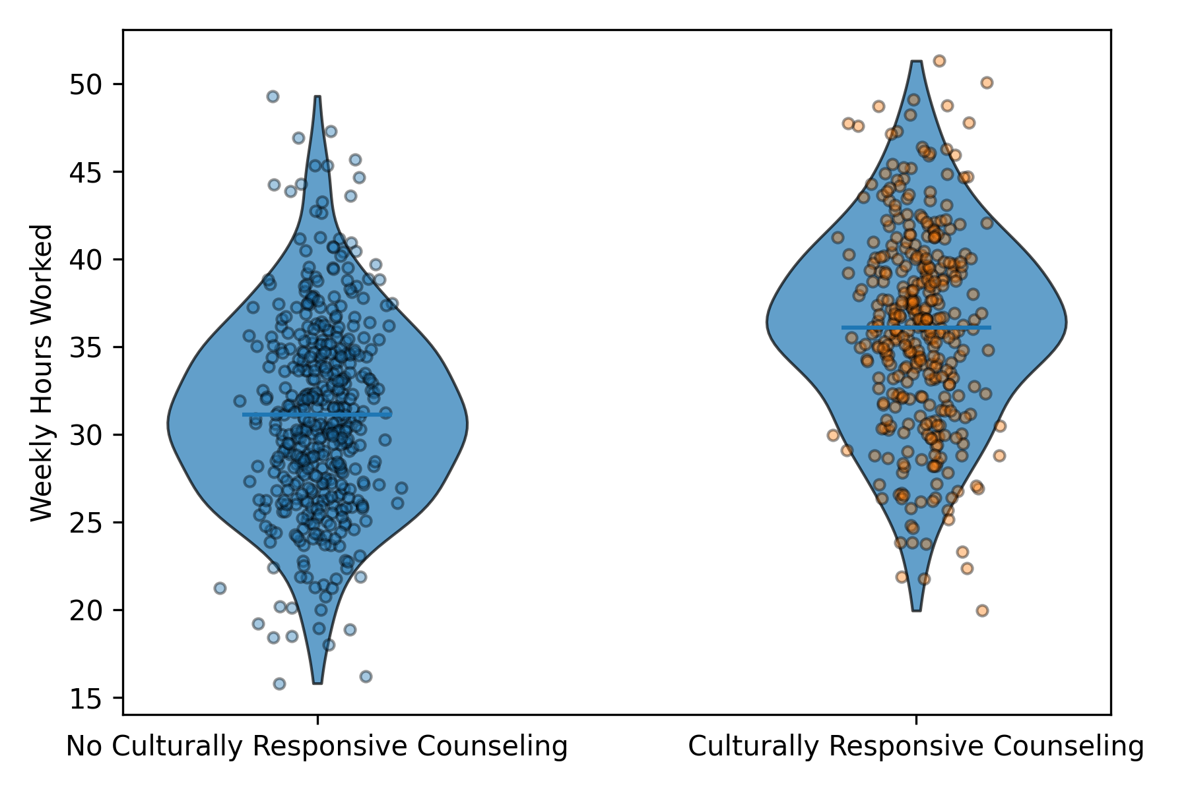
Figure 4. Distribution of weekly hours worked by culturally responsive counseling exposure

Figure 4 shows higher average weekly hours and a broader upper-range distribution among clients who received culturally responsive counseling, consistent with stronger employment stability. This result consistently indicate that culturally responsive rehabilitation counseling is associated with improved indicators of job retention and job quality among linguistically diverse clients.

Objective 3
Assess the influence of counselor multicultural competence and linguistic accessibility on workforce reintegration outcomes.
A hierarchical regression modeling strategy was applied to examine how linguistic accessibility indicators and counselor engagement contribute incrementally to employment attainment and earnings outcomes. Models were estimated sequentially to isolate the added explanatory value of language access and counseling intensity beyond demographic and disability-related controls.
Table 4: Hierarchical Logistic Regression Results Predicting Employment Attainment
Predictor | Odds Ratio | p-value
Primary language ≠ English | 0.79 | <.001
Interpreter/bilingual services | 1.35 | <.001
Counseling intensity (units) | 1.08 | <.001
Language × Counseling intensity | 1.04 | <.01
Disability severity | 0.6 | <.001
Education (HS or higher) | 1.53 | <.001

As shown in Table 4, primary language other than English was negatively associated with employment attainment, while the presence of interpreter or bilingual services significantly increased the odds of employment. Counseling intensity demonstrated a positive association, and the interaction term indicates that higher counseling engagement attenuates employment disadvantages linked to linguistic barriers.

Table 5: Hierarchical Linear Regression Results Predicting Weekly Earnings at Case Closure
Predictor | β (Unstandardized) | p-value
Primary language ≠ English | -52.1 | <.001
Interpreter/bilingual services | 81.3 | <.001
Counseling intensity (units) | 9.2 | <.001
Language × Counseling intensity | 6.1 | <.01
Disability severity | -110.4 | <.001
Education (HS or higher) | 139.1 | <.001

Table 5 indicates that linguistic accessibility and counseling intensity are significantly associated with earnings outcomes. Non-English primary language is associated with lower earnings, whereas interpreter services and higher counseling intensity are associated with increased weekly earnings. The interaction effect suggests that counselor engagement moderates the earnings penalty associated with linguistic barriers.
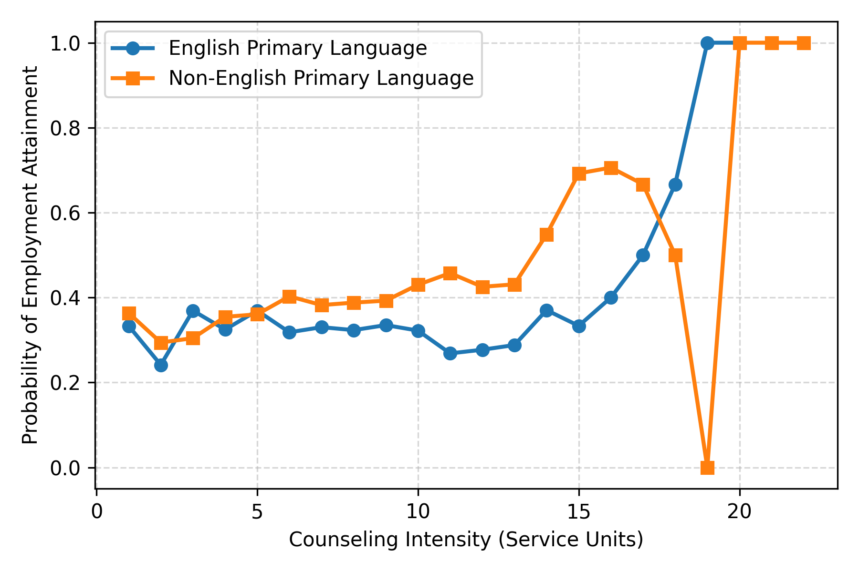
Figure 5. Interaction between counseling intensity and primary language in predicting employment attainment

Figure 5 shows that employment probabilities increase with counseling intensity for both language groups, with a steeper increase among clients with a non-English primary language, indicating a buffering effect of counselor engagement.
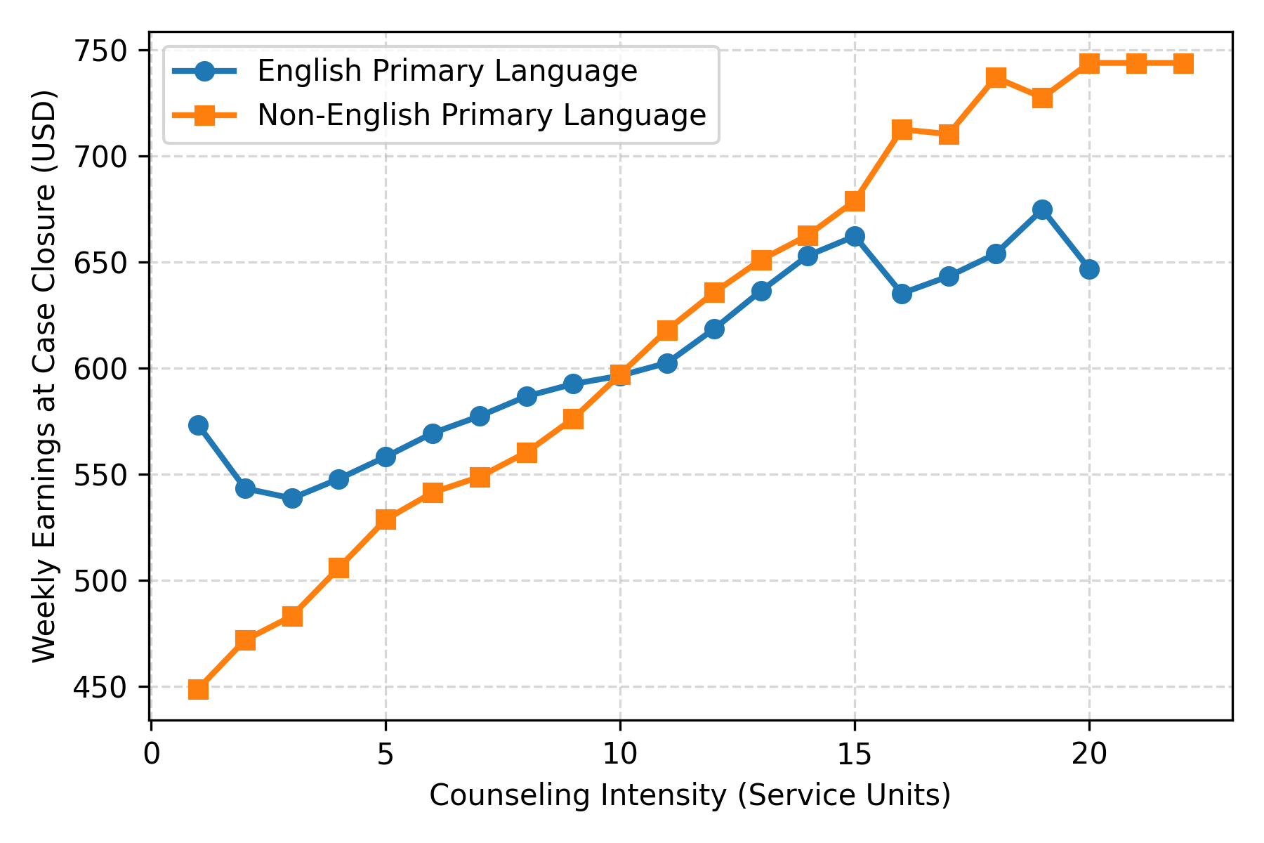
Figure 6. Interaction between counseling intensity and primary language in predicting weekly earnings

Figure 6 demonstrates that earnings increase with counseling intensity for both groups, with earnings differentials narrowing as counseling engagement increases, reflecting reduced linguistic disadvantage at higher service intensity levels. This result indicate that linguistic accessibility and counselor multicultural competence operate jointly to shape workforce reintegration outcomes. The findings emphasize that employment and earnings disparities are contingent on service processes and counselor engagement rather than language status alone.

Objective 4
Determine whether therapeutic alliance mediates the relationship between culturally responsive counseling and workforce reintegration outcomes.
A causal mediation analysis using the Baron–Kenny framework with bootstrapped confidence intervals was conducted to evaluate whether service engagement intensity mediates the association between culturally responsive counseling and employment and earnings outcomes.
Table 6: Mediation Analysis Results for Employment Attainment
Path Description | Estimate | p-value
Total effect of culturally responsive counseling on employment attainment | OR = 1.86 | < .001
Effect of culturally responsive counseling on service engagement | β = 5.40 months | < .001
Effect of service engagement on employment attainment controlling for culturally responsive counseling | OR = 1.04 | < .001
Direct effect of culturally responsive counseling on employment attainment | OR = 1.52 | < .001
Indirect effect through service engagement (bootstrapped) | OR = 1.19 | < .01
Proportion of total effect mediated by service engagement | 32% | —

As shown in Table 6, culturally responsive counseling was significantly associated with employment attainment. Service engagement intensity was positively associated with both counseling exposure and employment outcomes, and the reduction in the direct effect indicates partial mediation through therapeutic alliance.

Table 7: Mediation Analysis Results for Weekly Earnings at Case Closure
Path Description | Estimate | p-value
Total effect of culturally responsive counseling on weekly earnings at case closure | +112.40 | < .001
Effect of culturally responsive counseling on service engagement | +5.40 months | < .001
Effect of service engagement on weekly earnings at case closure controlling for culturally responsive counseling | +7.80 | < .001
Direct effect of culturally responsive counseling on weekly earnings at case closure | +69.10 | < .01
Indirect effect through service engagement (bootstrapped) | +42.10 | < .01
Proportion of total effect mediated by service engagement | 37% | —

Table 7 indicates that a substantial proportion of the earnings advantage associated with culturally responsive counseling operates indirectly through sustained service engagement.

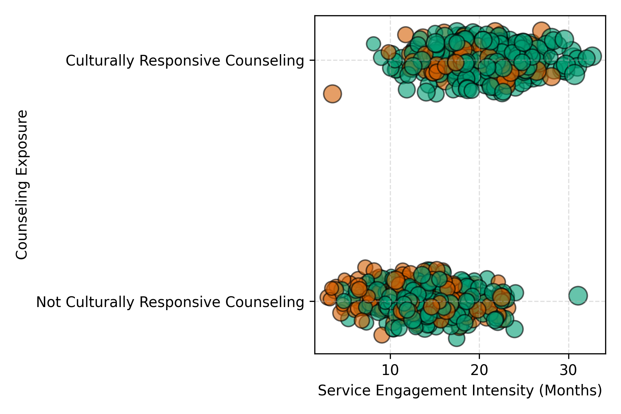
Figure 7. Service engagement as a mediation pathway between counseling exposure and employment outcomes

Figure 7 shows that clients receiving culturally responsive counseling are more frequently engaged for longer durations, with higher earnings magnitudes and employment outcomes, supporting the mediation pathway.
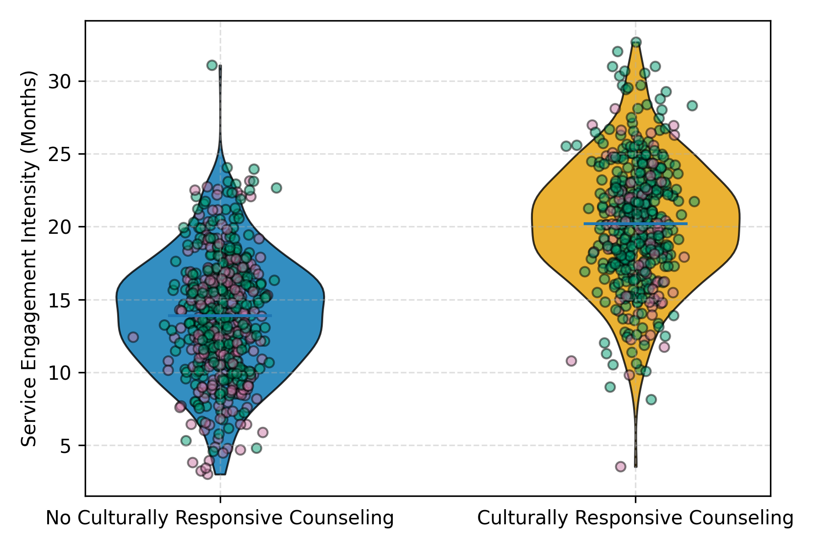
Figure 8. Distribution of service engagement intensity by counseling exposure and employment status

Figure 8 demonstrates higher median service engagement among clients exposed to culturally responsive counseling, with employment outcomes concentrated at higher engagement levels. This result indicates that therapeutic alliance, operationalized as service engagement intensity, functions as a meaningful mechanism linking culturally responsive counseling to workforce reintegration outcomes across both employment and earnings indicators.
Discussion
The findings of this study provide robust empirical support for the central proposition advanced in the introduction: that workforce reintegration disparities among linguistically diverse individuals with disabilities are not solely attributable to individual characteristics or impairment severity, but are substantially shaped by the cultural and linguistic responsiveness of vocational rehabilitation service delivery. Across all four objectives, culturally responsive rehabilitation counseling emerged as a consistent and meaningful predictor of employment attainment, job quality, and employment sustainability, thereby extending prior conceptual arguments with outcome-focused evidence.
With respect to employment attainment, the results reported in Table 1 demonstrate that culturally responsive counseling exposure is associated with substantially higher odds of competitive integrated employment, even after accounting for demographic, disability-related, and service duration factors. This finding directly addresses the empirical gap identified in the literature, where cultural responsiveness has been widely theorized but rarely tested against concrete employment outcomes (Chu et al., 2022; Grewal et al., 2025). The accompanying visual patterns shown in Figures 1 and 2 reinforce this result by illustrating that clients exposed to culturally responsive counseling not only achieved employment at higher rates but also exhibited longer service engagement, supporting arguments that culturally attuned practices enhance both access and persistence within rehabilitation systems (Yin et al., 2021; Lee et al., 2023). Importantly, the persistence of racial and ethnic disparities within the model underscores that culturally responsive counseling does not eliminate structural inequities but operates as a mitigating factor within them, consistent with critiques of color-blind rehabilitation frameworks (Cyuzuzo et al., 2024).
Beyond employment attainment, the results related to job retention and job quality offer important insight into dimensions of workforce reintegration that have often been underexamined in vocational rehabilitation research. As shown in Tables 2 and 3, culturally responsive counseling was positively associated with both weekly earnings and hours worked, suggesting stronger labor market attachment rather than short-term or marginal employment. The distributional shifts depicted in Figures 3 and 4 align with prior work emphasizing that employment quality and sustainability are critical indicators of reintegration success (Jetha et al., 2025; Ishay et al., 2025). These findings challenge outcome models that privilege placement metrics alone and instead support calls for multidimensional evaluation frameworks that reflect the lived realities of workers with disabilities, particularly those navigating linguistic and cultural barriers.
The hierarchical analyses addressing counselor multicultural competence and linguistic accessibility further clarify how culturally responsive practices exert their influence. As demonstrated in Tables 4 and 5, non-English primary language remained negatively associated with both employment attainment and earnings, reaffirming prior evidence that linguistic diversity functions as a structural barrier within vocational rehabilitation systems (Yin et al., 2021; Meyer et al., 2024). However, the inclusion of interpreter or bilingual services and counseling intensity significantly improved outcomes, and the interaction effects indicate that higher levels of counselor engagement attenuate language-related disadvantages. The interaction patterns illustrated in Figures 5 and 6 provide intuitive confirmation of this buffering effect, showing that increased counseling intensity narrows employment and earnings gaps between English-speaking and non-English-speaking clients. These results lend empirical weight to arguments that multicultural competence must be operationalized through sustained, engaged practice rather than abstract awareness or training alone (Chu, 2022; Kim et al., 2025).
Perhaps most critically, the mediation analyses reported in Tables 6 and 7 advance the field by empirically modeling therapeutic alliance as a mechanism linking culturally responsive counseling to workforce outcomes. Consistent with allied health and psychotherapy research emphasizing alliance as a driver of engagement and outcomes (Gustafsson et al., 2025; Saxler et al., 2024), the results indicate that service engagement intensity partially mediates the effects of culturally responsive counseling on both employment attainment and earnings. The visual patterns shown in Figures 7 and 8 further illustrate this process, demonstrating that clients receiving culturally responsive counseling are engaged for longer durations and that higher engagement is associated with improved employment outcomes. By quantifying these indirect effects, the study responds directly to calls for process-outcome research that moves beyond correlational associations to identify how culturally responsive practices translate into tangible labor market gains (Grewal et al., 2025).
5. Conclusion and Recommendations
The findings of this study demonstrate that culturally responsive rehabilitation counseling is a substantive determinant of equitable workforce reintegration among linguistically diverse individuals with disabilities. Across employment attainment, job quality, and earnings outcomes, culturally and linguistically responsive practices were consistently associated with improved results, while counselor engagement and therapeutic alliance emerged as key mechanisms through which these effects operate. Rather than functioning as peripheral enhancements, cultural responsiveness, linguistic accessibility, and sustained counselor–client engagement appear integral to translating vocational rehabilitation services into durable labor market outcomes. These results underscore that workforce inequities are shaped not only by individual characteristics but by modifiable service delivery processes within rehabilitation systems. In light of this evidence, the following recommendations are advanced to align policy, practice, and training with empirically supported pathways to improved reintegration outcomes.
- State vocational rehabilitation agencies should institutionalize language access policies, including routine provision of interpreters and bilingual counseling services, as core service components rather than discretionary accommodations.
- Rehabilitation counseling training programs should integrate multicultural competence with applied linguistic accessibility and sustained engagement strategies, emphasizing practice-based skill development.
- Workforce development and disability policymakers should incorporate employment quality indicators, such as earnings and hours worked, into performance evaluation frameworks for vocational rehabilitation systems.
- Rehabilitation service delivery models should prioritize therapeutic alliance and engagement duration as measurable process outcomes, recognizing their central role in mediating employment success for linguistically diverse clients.

References
Adebiyi, O. O., Popoola, A. D., Adeyinka, P. D., Arigbabu, A. T., & Olateju, O. O. (2026). Blockchain-integrated AI Systems for Enhancing Trust and Transparency in Cross-Border Finance. Asian Journal of Research in Computer Science, 19(1), 271–291. https://doi.org/10.9734/ajrcos/2026/v19i1818
Ahonle, Z. J., Wei, T., Rumrill, P. D., & Dillahunt-Aspillaga, C. (2025). Comparing Competitive Integrated Employment Outcomes in The State-federal Vocational Rehabilitation Program Among Individuals with Cognitive, Physical, and Sensory Functional Impairments. Journal of Vocational Rehabilitation, 62(2). https://doi.org/10.1177/10522263241310068
Akurigo, P. (2023). “A Literature Review of Disability Counseling.” https://www.globalscientificjournal.com/researchpaper/Multicultural_Competence_in_Disability_Counseling_A_Literature_Review_of_Disability_Counseling_.pdf?utm_source=chatgpt.com
Alatawi, M. (2024). Access to Vocational Rehabilitation Services: The Experiences of Individuals with Intellectual Disabilities and that of their Parents. Pakistan Journal of Life and Social Sciences (PJLSS), 22(1). https://doi.org/10.57239/pjlss-2024-22.1.00479
Alonazi, A. (2025). Cultural and Social Determinants of Physical Therapy Rehabilitation in Saudi Arabia: A Narrative Review. Healthcare, 13(21), 2773. https://doi.org/10.3390/healthcare13212773
Beamish, N., Footer, C. B., Lowe, R., & Cunningham, S. (2023). Rehabilitation professions’ core competencies for entry-level professionals: a thematic analysis. Journal of Interprofessional Care, 38(1), 1–10. https://doi.org/10.1080/13561820.2023.2241519
Bezyak, J., Chan, F., Tansey, T. N., Wu, J.-R., Iwanaga, K., & Lee, D. (2024). Changing human resource professionals from gatekeepers to enablers of disability employment: Lessons learned from disability-employment research. Journal of Vocational Rehabilitation, 62(1), 76–81. https://doi.org/10.1177/10522263241300813
Bolarinwa, O., & Nkansah, D. A. (2025). A scoping review of cultural competence training gaps among healthcare professionals in low-and middle-income countries. BMC Health Services Research, 25(1). https://doi.org/10.1186/s12913-025-13844-w
Bonaccio, S., Connelly, C. E., Gellatly, I. R., Jetha, A., & Martin Ginis, K. A. (2020). The participation of people with disabilities in the workplace across the employment cycle: Employer concerns and research evidence. Journal of Business and Psychology, 35(35). https://link.springer.com/article/10.1007/s10869-018-9602-5
Bridger, K., Kellezi, B., Kendrick, D., Radford, K., Timmons, S., Rennoldson, M., Jones, T., & Kettlewell, J. (2021). Patient Perspectives on Key Outcomes for Vocational Rehabilitation Interventions Following Traumatic Injury. International Journal of Environmental Research and Public Health, 18(4), 2035. https://doi.org/10.3390/ijerph18042035
Chao, S.-Y., & Wilson, K. B. (2025). Intersecting Identities and Career-Related Factors Among College Students with Disabilities Across Ethnic Groups. Healthcare, 13(17), 2119–2119. https://doi.org/10.3390/healthcare13172119
Chu, W., Wippold, G., & Becker, K. D. (2022). A systematic review of cultural competence trainings for mental health providers. Professional Psychology: Research and Practice, 53(4), 362–371. https://doi.org/10.1037/pro0000469
Cyuzuzo, C., Dukuzimana, M. J., Muhire, C., Ames, M. S., & Ngwakongnwi, E. (2024). Challenges to rehabilitation services in Sub-Saharan Africa from a user, health system and service provider perspective: A scoping review (Preprint). JMIR Human Factors, 12. https://doi.org/10.2196/58841
Gonzalez, D., & Echave, P. (2023). Disabled Immigrants Face Compounding Barriers to Education and Employment Insights from an Expert Convening and Future Research Directions. https://www.urban.org/sites/default/files/2023-12/Disabled%20Immigrants%20Face%20Compounding%20Barriers%20to%20Education%20and%20Employment.pdf?utm_source=chatgpt.com
Grewal, E., Durocher, E., Premji, S., & Gewurtz, R. (2025). Exploring Intersections of Race and Disability in the Context of Canadian Employment Support Systems Through the Experiences of Job Seekers/Workers, Employers, and Service Providers. Journal of Occupational Rehabilitation. https://doi.org/10.1007/s10926-025-10291-6
Gustafsson, J., & Witte, I. (2025). Analysis of factors influencing satisfaction with vocational rehabilitation services for young persons with disabilities in Sweden. Frontiers in Rehabilitation Sciences, 6. https://doi.org/10.3389/fresc.2025.1573753
Harley, D. A., Rogers, K. G., & Hall, A. H. (2025). Cultural Responsiveness in Rehabilitation Counseling. Palgrave Texts in Counselling and Psychotherapy, 159–193. https://doi.org/10.1007/978-3-031-81831-8_7
Heath, M., Hvass, A. M. F., & Wejse, C. M. (2023). Interpreter services and effect on healthcare - a systematic review of the impact of different types of interpreters on patient outcome. Journal of Migration and Health, 7(100162). https://doi.org/10.1016/j.jmh.2023.100162
Henry, J. S., Kulesza, E. T., Williams Awodeha, N. F., Hicks, S. B., Middleton, R. A., & Robinson, M. (2023). A Way Forward With Multicultural Considerations, Advocacy, and Accessibility Across the 2023 Revised Code of Professional Ethics for Rehabilitation Counselor Educators and Practitioners. Rehabilitation Counseling Bulletin, 66(4), 003435522211461. https://doi.org/10.1177/00343552221146164
Ishay, G. H., Goldzweig, G., Hasson-Ohayon, I., Gelkopf, M., Shadmi, E., & Roe, D. (2025). Predicting satisfaction with vocational status among people with serious mental illness in vocational services: the role of perceived skills and support. Frontiers in Psychiatry, 16. https://doi.org/10.3389/fpsyt.2025.1533227
Iwanaga, K., Chan, F., Tansey, T. N., Strauser, D., Ritter, E., Bishop, M., & Brooks, J. (2018). Working Alliance and Stages of Change for Employment: The Intermediary Role of Autonomous Motivation, Outcome Expectancy and Vocational Rehabilitation Engagement. Journal of Occupational Rehabilitation, 29(2), 315–324. https://doi.org/10.1007/s10926-018-9787-5
Jetha, A., Hossain, S., Navaratnerajah, L., Samosh, D., McCarthy, S., & Bowman, L. R. (2025). Promoting Job Quality and Career Advancement Among Persons with Disabilities During Critical Career Transitions: A Scoping Review of Published Evidence. Journal of Occupational Rehabilitation. https://doi.org/10.1007/s10926-025-10335-x
Joyce, A., Campbell, P., Crosbie, J., & Wilson, E. (2025). Wellbeing and job satisfaction among employees with intellectual disability. Frontiers in Public Health, 13, 1503932. https://doi.org/10.3389/fpubh.2025.1503932
Kangas, S., Dai, S., & Ardasheva, Y. (2023). The Intersection of Language and Disability Progress of English Learners With Disabilities on NAEP Reading. The Journal of Special Education, 58(2), 88–99. https://doi.org/10.1177/00224669231213054
Karim, H. H., Yusooff, F. binti, & Abd Hamid, N. B. bin. (2024). Assessing Linguistic Accessibility’s Impact on Counseling Outcomes for Diverse Communities. The 6th Open Society Conference (OSC) 2024, 2, 1–9. https://doi.org/10.33830/osc.v2i1.2473
Karliner, L. S., Gregorich, S. E., Mutha, S., Kaplan, C., Livaudais-Toman, J., Pathak, S., Garcia, M. E., & Diamond, L. (2024). Language Access Systems Improvement initiative: impact on professional interpreter utilisation, a natural experiment. BMJ Open, 14(1), e073486–e073486. https://doi.org/10.1136/bmjopen-2023-073486
Kaya, C., Chun, J., Torres, A., & Chen, R. K. (2023). Predicting competitive integrated employment outcomes of Asian American vocational rehabilitation Clients: A national study. Social Science Quarterly, 105(1), 100–113. https://doi.org/10.1111/ssqu.13323
Kim, J. H., Ntinda, K., Townsend, C., Thomas, K., Lee, D. H., Ortega, C., & Yu, H. J. (2023). Multicultural and Social Justice Counseling within the Scope of Rehabilitation Counseling. ScholarWorks @ UTRGV. https://scholarworks.utrgv.edu/rhc_fac/45/
Kudla, A., Dinelli, E. J., Capraro, P., Crown, D., Sheth, M., Trierweiler, R., Munsell, E., Wong, J., & Heinemann, A. W. (2024). Person-, Job-, and Environment-Related Factors Associated with Long-Term Job Retention of People with Physical Disabilities. Research Square Preprints. https://doi.org/10.21203/rs.3.rs-4797921/v1
Lee, B., Estala-Gutierrez, V., & Umucu, E. (2023). Vocational Rehabilitation Services for Hispanic Individuals With Disabilities: Strengths, Challenges, and Opportunities. Rehabilitation Counselors and Educators Journal, 12(1). https://doi.org/10.52017/001c.55509
Lee, Y., Sung, S., & Fan, X. (2025). Cultural competency education for healthcare professionals: an umbrella review. BMC Medical Education, 25(1). https://doi.org/10.1186/s12909-025-08008-7
MACPAC. (2024, July 23). Enrollment and Access Barriers for People with Limited English Proficiency. MACPAC. https://www.macpac.gov/publication/enrollment-and-access-barriers-for-people-with-limited-english-proficiency/?utm_source=chatgpt.com
Meyer, J. S., Brinck, E. A., Weathers, M. D., Park, S., Qisti, D. A., Aylin Celik Zencir, Fosu-Asare, L., Anderson, C. A., & Tansey, T. N. (2024). Vocational Rehabilitation Outreach to Diverse Populations: Identifying Underserved Populations through Demographic Analysis. Journal of Vocational Rehabilitation, 62(01). https://doi.org/10.1177/10522263241301196
Mustafa, S., Sadiq Zaidi, S. G., Absheken, N., Murtala, R. A., Yerkebulankyzy, N. R., Zahra, S. K., Ehsan, M. S., & Fazli, T. (2025). Cultural Sensitivity and Counseling Approaches for Student Mental Wellbeing in a Globalized Era. Journal of Health, Wellness, and Community Research, 3(7), e329. https://doi.org/10.61919/npyp7510
Nam, J. K., & Kim, D. (2025). Multicultural counseling competence for addressing the mental health needs of international students in Korea: a concept mapping study. Current Psychology, 44. https://doi.org/10.1007/s12144-025-07468-w
Obrik-Uloho, E. P., Gbadebo, M. O., Afolabi, O. O., Joseph, S. A., Oladoyinbo, T. O., & Olaniyi, O. O. (2026). Shared Responsibility in Practice: Evaluating the Security–Usability Trade-Off and User Accountability in WhatsApp’s Ecosystem. Asian Journal of Research in Computer Science, 19(1), 81–105. https://doi.org/10.9734/ajrcos/2026/v19i1807
Ogunmolu, A. M., Abba, S. S., Olaniyi, O. M., Odeyinka, T. E., & Salami, I. A. (2026). Adaptive Cognitive Profiling for Executive AI Agents Amid Emerging AI Impersonation Threats. Journal of Engineering Research and Reports, 28(1), 388–405. https://doi.org/10.9734/jerr/2026/v28i11784
Olaniyi, O. M., Adebiyi, O. O., Ejoh, C. I., Afolabi, O. O., & Ejiofor, V. O. (2026). Conversational AI-Powered Fraud Prevention in Augmented Reality E-Commerce: A Natural Language Processing Framework for Real-time Transaction Security. Asian Journal of Research in Computer Science, 19(1), 255–270. https://doi.org/10.9734/ajrcos/2026/v19i1817
Organi, Z. K., Nazarenia, M., & Aghaee, F. (2024). Understanding the Challenges of Language Barriers in Healthcare. Interdisciplinary Studies in Society, Law, and Politics, 3(3), 28–35. https://doi.org/10.61838/kman.isslp.3.3.5
Ponzio, M., Pignattelli, E., Verri, A., Grange, E., Persechino, B., Vitturi, B. K., Bandiera, P., Manacorda, T., Inglese, M., Durando, P., & Battaglia, M. A. (2024). Job Retention by People With Disabilities: A Qualitative Study of the Perspectives of People With Multiple Sclerosis. PubMed, 115(3), e2024018–e2024018. https://doi.org/10.23749/mdl.v115i3.15947
Rahman, M. H. (2025). Gender disparities in vocational rehabilitation: A scoping review on employment and empowerment among persons with disabilities. Journal of Medicine, Surgery, and Public Health, 7, 100216. https://doi.org/10.1016/j.glmedi.2025.100216
Rahmi., K. H., & Andayani, R. H. R. (2025). Redefining Social Rehabilitation: Ethical Challenges, Cultural Competence, Inclusive, and Interdisciplinary Frameworks. International Journal of Research and Innovation in Social Science, IX(III), 3479–3486. https://doi.org/10.47772/ijriss.2025.90300274
Sadusky, A., Yared, H., Patrick, P., & Berger, E. (2023). A systematic review of client’s perspectives on the cultural and racial awareness and responsiveness of mental health practitioners. Culture & Psychology, 30(3), 567–605. https://doi.org/10.1177/1354067x231156600
Sánchez, J., Frain, M. P., Shirley, G., Rohack, D., & Pan, D. (2022). Persons With Disabilities in Self-Employment Served by the Federal/State Vocational Rehabilitation System: Differences Between 2011–2013 and 2017–2019. Rehabilitation Counseling Bulletin, 66(3), 003435522211023. https://doi.org/10.1177/00343552221102396
Sano, K., & Bevly, D. (2025). Cultural Responsiveness in Clinical Practice. Palgrave Texts in Counselling and Psychotherapy, 95–126. https://doi.org/10.1007/978-3-031-81831-8_5
Saxler, E., Schindler, T., Philipsen, A., Schulze, M., & Lux, S. (2024). Therapeutic alliance in individual adult psychotherapy: a systematic review of conceptualizations and measures for face-to-face- and online-psychotherapy. Frontiers in Psychology, 15. https://doi.org/10.3389/fpsyg.2024.1293851
Shaewitz, D., & Yin, M. (2021). SERVING ALL CONSUMERS: Identifying Racial Disparities in the Vocational Rehabilitation System. https://iel.org/wp-content/uploads/2021/12/Serving-All-Consumers_Identifying-Racial-Disparities-in-the-Vocational-Rehabilitation_FINAL_508c.pdf?utm_source=chatgpt.com
Thomas, F., & Morgan, R. L. (2021). Evidence-based job retention interventions for people with disabilities: A narrative literature review. Journal of Vocational Rehabilitation, 54(2), 89–101. https://doi.org/10.3233/jvr-201122
Twersky, S. E., Jefferson, R., Garcia-Ortiz, L., Williams, E., & Pina, C. (2024). The Impact of Limited English Proficiency on Healthcare Access and Outcomes in the U.S.: a Scoping Review. Healthcare, 12(3), 364–364. https://doi.org/10.3390/healthcare12030364
US BLS. (2025a, April 25). 22.7 percent of people with a disability were employed in 2024. Bureau of Labor Statistics. https://www.bls.gov/opub/ted/2025/22-7-percent-of-people-with-a-disability-were-employed-in-2024.htm?utm_
US BLS. (2025b). PERSONS WITH A DISABILITY: LABOR FORCE CHARACTERISTICS -2023. https://www.bls.gov/news.release/pdf/disabl.pdf?utm_source=chatgpt.com
US DOL. (2025). Disability Employment Statistics. DOL. https://www.dol.gov/agencies/odep/research-evaluation/statistics?utm_
Valdez, G. A. (2025). Advancing Cultural Competency in Allied Health Education: A Narrative Review. Cureus. https://doi.org/10.7759/cureus.95590
van Lent, L. G. G., Yilmaz, N. G., Goosen, S., Burgers, J., Giani, S., Schouten, B. C., & Langendam, M. W. (2025). Effectiveness of interpreters and other strategies for mitigating language barriers: A systematic review. Patient Education and Counseling, 136(136), 108767. https://doi.org/10.1016/j.pec.2025.108767
Vella, E., White, V. M., & Livingston, P. (2022). Does cultural competence training for health professionals impact culturally and linguistically diverse patient outcomes? A systematic review of the literature. Nurse Education Today, 118(105500), 105500. https://doi.org/10.1016/j.nedt.2022.105500
Wong, J., Lin, Y., Wang, H., & Chen, J. (2025). Project FORWARD: Where Vocational Rehabilitation Can Make a Difference through Community-Based Participatory Research. Journal of Occupational Rehabilitation. https://doi.org/10.1007/s10926-025-10344-w
Yin, M., Pathak, A., Lin, D., & Dizdari, N. (2021). Identifying Racial Differences in Vocational Rehabilitation Services. Rehabilitation Counseling Bulletin, 003435522110482. https://doi.org/10.1177/00343552211048218

