Advancing Vocational Rehabilitation Counseling Strategies for Young Adults with Autism Spectrum Disorder in the U.S. Digital Workforce.

Abstract
This study examined how vocational rehabilitation counseling can be restructured to improve sustainable digital employment outcomes for young adults with Autism Spectrum Disorder in the United States. Using publicly available RSA-911 administrative data and the National Longitudinal Transition Study–2012, a multi-method quantitative design was applied, including multivariate logistic regression, survival analysis, propensity score matching, structural equation modeling, and latent class analysis. Results show that technology-integrated counseling significantly increased the likelihood of professional or technical employment by over 13 percentage points and weekly earnings by approximately $150, while digitally integrated service profiles achieved competitive employment rates exceeding 68% and job retention above 78%. Pathway analyses further demonstrated that technology support improved employment stability indirectly through gains in self-advocacy and digital career readiness. These findings indicate that digitally responsive, technology-centered counseling models outperform traditional approaches. Accordingly, the study recommends embedding technology services within core VR counseling, strengthening counselor digital competencies, expanding remote service delivery, and extending transition supports to promote long-term digital workforce participation.
Keywords: vocational rehabilitation, autism spectrum disorder, digital workforce, technology-integrated counseling, employment outcomes

1. Introduction
Employment is a fundamental expression of economic participation, social inclusion, and psychological wellbeing for individuals transitioning from adolescence into adulthood. In the United States, the dramatic expansion of the digital economy (with pervasive remote work, platform-mediated tasks, and technical skill demands) has reshaped labor market opportunities and workforce structures (Alauddin et al., 2024). Yet, despite these changes, young adults with Autism Spectrum Disorder (ASD) continue to experience significant employment disparities compared with their peers (Yon-Hernández et al., 2025). Research shows that even among young adults who receive vocational rehabilitation (VR) services, only about 49% exit with employment, a figure that remains lower than expected given the expanding economy (Shenk et al., 2025). These statistics reflect an ongoing gap between the theoretical employment potential of individuals with ASD and the realities of their workforce participation.
The prevalence of ASD diagnoses in the United States has risen steadily in recent years, with an estimated 1 in 31 children identified as autistic in 2022, up from 1 in 36 in 2020 (CDC, 2025). As these individuals transition into adulthood, the number entering the labor force grows year by year, placing increasing urgency on understanding the conditions that facilitate or inhibit employment access. Although individuals with ASD often possess strengths such as attention to detail, systematic thinking, and persistence (assets that align closely with many digital economy roles), current employment patterns do not reflect this potential (Cope & Remington, 2021; Nair et al., 2025). Studies show that autistic young adults are significantly less likely to secure competitive employment compared with non-autistic peers, with approximately 67 % reporting any work experience between ages 18 and 23 versus 86 % for non-autistic individuals, and autistic adults generally exhibiting lower overall employment rates and quality of employment across multiple measures (Yon-Hernández et al., 2025; Heinze et al., 2025; Nishith, 2025; Holc et al., 2025). These employment gaps are further compounded by barriers in competitive hiring and limited access to career development opportunities.

Amid these systemic challenges, Vocational Rehabilitation (VR) services represent a critical interface between individuals with disabilities and employment outcomes. VR programs are intended to provide career counseling, skills training, job placement assistance, and supports tailored to individual needs. Within this structure, vocational rehabilitation counselors function as primary agents responsible for assessment, career exploration, counseling, service coordination, and employer engagement. However, contemporary evidence suggests that counseling practices have not evolved sufficiently to address the unique demands of the digital workforce (Shenk et al., 2024; Zhou et al., 2025). Although technical and assistive technologies show promise in supporting employment readiness, their implementation within structured VR programs is inconsistent and under-researched (Zhou et al., 2025). Moreover, the development of digital literacy skills such as coding, computational thinking, and data analysis remains an emerging research priority for autistic jobseekers, indicating gaps in both vocational preparation and academic support (Nikolic, 2025; Stimoli et al., 2024). Lousky et al. (2024) further highlights persistent barriers related to social communication and adaptive functioning that current VR strategies may insufficiently target. Within the United States context, federal policy frameworks such as the Workforce Innovation and Opportunity Act mandate vocational rehabilitation agencies to prioritize competitive integrated employment and the delivery of pre-employment transition services, yet questions remain regarding how these mandates are operationalized for digitally oriented career pathways (Autism Science Foundation, 2021; Musse et al., 2024).
These conditions suggest a deeper disconnect between existing rehabilitation counseling frameworks and the competencies necessary to navigate digitally oriented labor markets. Young adults with ASD are not only less likely to obtain employment overall but also more likely to be excluded from competitive hiring or career-oriented positions. Studies consistently show that autistic individuals experience poorer employment quality and reduced access to stable, career-oriented positions compared with non-autistic peers (Heinze, 2025; LaPoint, 2024; Yon-Hernández et al., 2025). In addition, the research of Holc et al. (2025) on workplace barriers confirms that even autistic individuals without intellectual disabilities face substantial challenges in mainstream employment settings, with unemployment rates markedly higher than those of the general population and evidence of over-education where skills exceed job requirements. These persistent employment conditions provoke questions about whether traditional vocational rehabilitation counseling adequately addresses the evolving landscape of work and the specific needs of ASD jobseekers.
Collectively, these conditions point to a persistent misalignment between emerging digital employment structures and existing vocational rehabilitation counseling practices. Given the complex interplay between digital labor market dynamics, individual strengths and challenges associated with ASD, and current rehabilitation service delivery, there is a compelling need to investigate how VR counseling can be strategically revised. This study aims to examine existing vocational rehabilitation practices and develop a structured counseling framework that supports the preparation, entry, and sustained employment of young adults with Autism Spectrum Disorder within the U.S. digital workforce. Specifically, this research will pursue the following objectives:
- To systematically analyze the vocational, technological, psychosocial, and environmental factors that influence digital employment readiness and job retention among young adults with Autism Spectrum Disorder in the United States.
- To evaluate the effectiveness of current vocational rehabilitation counseling interventions in addressing digital skill acquisition, virtual workplace communication, and adaptive functioning required in digital occupations.
- To identify evidence-based counseling strategies and technology-supported interventions that improve digital career readiness, self-advocacy skills, and workplace adjustment for young adults with Autism Spectrum Disorder.
- To design a structured, digitally responsive vocational rehabilitation counseling framework tailored to supporting sustainable digital employment outcomes for young adults with Autism Spectrum Disorder.

2. Literature Review
A contemporary understanding of Autism Spectrum Disorder (ASD) increasingly situates it within the neurodiversity framework, which contends that neurological differences such as autism represent natural human variation rather than pathology to be corrected (Srinivasan, 2025). According to Abeysekara et al. (2025), individuals with ASD possess cognitive profiles characterized by unique strengths such as heightened attention to detail and deep analytical capabilities, qualities that can be advantageous in structured and technical work environments. However, even as strengths-based narratives gain traction, empirical work continues to document substantial challenges in the transition from educational systems to stable employment for autistic individuals. Studies examining early employment outcomes indicate that autistic youth enter the labor market at significantly lower rates and often have shorter, less stable job experiences relative to non-autistic peers, which suggests that systemic barriers, rather than individual capability deficits, are central drivers of employment disparities (Griffiths et al., 2023; Yon-Hernández et al., 2025).
In agreement with ecological analyses of workplace participation, autistic adults demonstrate higher unemployment and underemployment compared with both non-autistic individuals and other disability groups, which is compounded by environmental and structural factors within workplaces (Nishith et al., 2025). This broad pattern reflects how ASD characteristics such as social communication differences and sensory processing variability interact with traditional work environments that are structured around normative social interactions and ambiguous task requirements (Lousky et al., 2024; Nishith et al., 2025). Such interactions often result in exclusionary hiring practices and workplace experiences that do not leverage autistic strengths. At the same time, scholars have critically argued that approaches focusing solely on modifying individual behavior fail to address organizational and systemic barriers, reinforcing the need to reconceptualize employment supports around both individual attributes and workplace adaptation (Raja, 2025).
Efforts to integrate assistive and digital technologies into transition planning illustrate another promising dimension of contemporary inquiry. Recent studies indicate that technologies, including artificial intelligence tools, have the potential to enhance pre-employment transition services for autistic and neurodivergent youth by targeting communication and workplace readiness skills which are increasingly mediated through digital and virtual interaction contexts, although the literature in this domain remains emergent and requires further empirical consolidation (Alhawiti, 2025; Hurford et al., 2025; Smith et al., 2023). This body of evidence highlights the complexity of the transition from education to employment for individuals with ASD and establishes that successful participation in the workforce is contingent not only on individual strengths but also on inclusive workplace practices, systemic supports, and proactive adaptation to diverse cognitive and communicative profiles.

Employment Outcomes and Barriers for Young Adults with ASD in the United States
Young adults with Autism Spectrum Disorder in the United States continue to experience markedly poorer employment outcomes compared with their non-autistic peers, a situation that reflects deep systemic and structural barriers within the labor market. Research shows that employment rates for autistic individuals remain significantly low, with only about 21 percent securing competitive integrated employment and a large proportion reporting unemployment despite wanting work (DuBois et al., 2024). According to Heinze et al. (2025), even when autistic adults obtain jobs they often face underemployment and lower earnings, with only roughly one-quarter achieving what can be considered satisfactory occupational outcomes. Such patterns stand in stark contrast with employment trajectories of non-autistic individuals, suggesting that employment disparities are not simply a function of individual capability but are embedded in broader labor market structures that fail to support neurodivergent participation (Griffiths et al., 2023; Nair et al., 2025). In this sense, employment disadvantage is better understood as a product of how work is organized, assessed, and supported, rather than as an outcome of autism-related impairments alone.
Comparative studies further underscore these inequities. For instance, Yon-Hernández et al. (2025) found that autistic young adults were significantly less likely to secure jobs through competitive hiring processes (48 percent) compared with non-autistic peers (95 percent), and were more frequently employed in entry-level sectors such as sales and retail. Autistic participants were also more likely to work part-time and remain concentrated in a narrow range of job types, whereas non-autistic individuals exhibited broader occupational diversity including roles in science, healthcare, and administrative support. These findings suggest that autistic jobseekers not only face lower overall employment rates but also experience occupational segregation that limits economic advancement and skill utilization. Beyond initial job placement, autistic workers also encounter restricted opportunities for promotion and career mobility, which reinforces patterns of occupational stagnation even among those who remain employed (Davies et al., 2024). Comparable evidence from LaPoint (2024) indicates that autistic individuals who do obtain paid work typically work fewer hours and receive lower wages than non-autistic adults, further evidencing the depth of underemployment. Emerging evidence also suggests that employment outcomes vary further by intersecting factors such as socioeconomic background and educational attainment, although these intersections remain underexplored within autism employment research (Heinze, 2025; Shattuck et al., 2012; Yang, 2023).
Structural and social barriers contribute substantively to these employment disparities. Employer misconceptions about autism, stigma, and limited workplace accommodations persist as critical obstacles to equitable employment participation (Koldas et al., 2025; Romualdez et al., 2021). Studies reveal that lack of inclusive recruitment practices, inadequate on-boarding supports, and organizational resistance to reasonable accommodations discourage autistic individuals from entering or remaining in competitive employment (Koldas et al., 2025; Zhou et al., 2025). In agreement with this, Davies (2024) identifies that underemployment and systemic exclusion are recurrent themes across employment research in autistic populations, indicating that workplace climates and policies need substantive reform to promote inclusion. Moreover, research in occupational settings shows that absence of supportive organizational practices correlates with higher turnover and job instability for autistic workers, thereby limiting their capacity to achieve sustained and meaningful employment (Durrani et al., 2026; Heinze, 2025). These persistent disparities raise important questions about the capacity of existing vocational rehabilitation systems to mitigate, rather than inadvertently reproduce, such inequities (Hayward et al., 2020; Thorpe et al., 2024).
Collectively, this evidence establishes that employment disparities for young adults with ASD are deep-rooted and multifaceted, encompassing quantitative gaps in access and qualitative deficiencies in job quality, stability, and earnings, all of which point to persistent systemic barriers that the current vocational rehabilitation and workforce policy frameworks have yet to adequately address, thereby necessitating closer examination of how vocational rehabilitation counseling is conceptualized and delivered.

Vocational Rehabilitation Counseling for Individuals with ASD
Vocational rehabilitation (VR) counseling aims to equip individuals with disabilities, including those with Autism Spectrum Disorder (ASD), with the support necessary to attain competitive and meaningful employment. At its core, VR counseling is intended to facilitate individualized planning, skill building, and connection to workplace opportunities that align with a person’s strengths and goals (NCRTM, 2025). Within this process, vocational rehabilitation counselors assume responsibility for assessment, career exploration, counseling, service coordination, and employer engagement. According to the research of Shenk et al. (2024) examining state VR agency data, engagement with VR services among young adults on the autism spectrum was associated with employment outcomes for nearly half of participants who exited services, a rate that underscores both the potential value and the limits of current VR approaches. This pattern indicates that while VR counseling is a central mechanism for supporting labor market entry, substantial variation exists in how such services translate to stable employment (Yin et al., 2022).
Person-centered planning is widely regarded as a foundational practice within vocational rehabilitation. The development of individualized employment plans reflects the principle that supports must be tailored to each person’s preferences, strengths, and vocational aspirations rather than general skill deficits (Shenk et al., 2024). Evidence from research on transition-age youth indicates that individualized VR services, particularly when they incorporate personalized pre-employment transition activities, can enhance competitive employment prospects and earnings for participants (Zhou et al., 2025). In agreement with this, studies highlight that person-centered planning that includes collaborative goal setting and ongoing monitoring is more likely to result in employment outcomes that reflect client choice and satisfaction, rather than merely job placement (Gustafsson & Witte, 2025; Hagner et al., 2014). This suggests that employment success is more strongly associated with the quality and responsiveness of planning processes than with the mere presence of services. Nevertheless, questions remain regarding the consistency and sustainability of person-centered practice across VR agencies and counselors, especially in contexts where training on autism-specific supports is limited.
Supported and customized employment models have also been advanced as effective alternatives to traditional “train-then-place” methods. Individual Placement and Support (IPS) adapted for autistic adults emphasizes rapid job placement with concurrent on-the-job supports, representing a “place-and-train” approach that contrasts with conventional pre-employment training models (Florence et al., 2025). Although adapted IPS approaches hold promise, the scientific validation of these adaptations remains limited, particularly with respect to digital or technology-oriented occupations. Project SEARCH and other supported employment programs have shown evidence of improving job attainment for individuals with ASD by integrating job coaching, natural supports, and employer collaboration into the vocational process (Yon-Hernández et al., 2025). These accounts suggest that supported employment, when combined with individualized supports, can enhance job acquisition and retention relative to services that do not explicitly integrate workplace supports.
Transition-oriented VR services that bridge educational settings and workplace environments are similarly critical for young adults with ASD. Research indicates that VR involvement during the transition from school to work increases the likelihood of employment participation, yet gaps persist in how these services are coordinated across school and adult systems. Career counselors report challenges in their self-efficacy when working with autistic clients, including limited training, resources, and ASD-specific tools, which can weaken the implementation of effective transition planning (Stampoltzis et al., 2025). This aligns with broader evidence that insufficient professional preparation and systemic constraints can undermine VR effectiveness, particularly in supporting nuanced communication needs and workplace adaptation skills that autistic individuals may require.
Across these studies, a consistent theme is that VR counseling holds substantial potential to support the vocational engagement of persons with ASD, but its effectiveness is contingent on individualized planning, integration of supported and customized employment strategies, and comprehensive transition supports (Wong et al., 2025; Yon-Hernández et al., 2025). Despite existing evidence pointing to positive associations between targeted VR services and employment outcomes, debates remain regarding the optimal configuration of these services, their scalability, and the professional competencies required to deliver them effectively.

Digital Workforce Demands and Mismatch with Existing VR Counseling Practices
The contemporary digital workforce is defined by an increasing reliance on technology-mediated work, where digital communication, content management, collaboration platforms, data literacy, and cybersecurity awareness are essential competencies for employability (Audrin et al., 2024). Such work requires a multi-dimensional set of skills that go beyond basic computer use to include complex capacities such as digital content creation, critical inquiry, and responsible technology use. These competencies reflect a broader shift in employment conditions, where routine tasks have been automated and human labor is now often valued for advanced digital, analytical, and collaborative capacities. In agreement with this, research on digital employability stresses that communication and collaboration skills in virtual environments significantly influence employment outcomes, especially where remote work and platform-mediated tasks are predominant (Đorđević, 2025). Thus, contemporary work environments increasingly emphasize both technical and social skills performed through digital platforms. Digital recruitment processes increasingly rely on algorithmic screening and automated hiring systems, which place additional demands on applicants’ online profiles, keyword optimization, and digital self-presentation.
Remote and platform-based employment has become a central feature of the digital economy, particularly in the wake of global disruptions that accelerated virtual collaboration and telework norms. Although these models have expanded opportunities for geographic flexibility and participation outside traditional office environments, they also increase expectations for proficiency in digital tools and adaptive self-management capabilities (Adebiyi et al., 2026; Obrik-Uloho et al., 2026). Notably, the COVID-19 pandemic catalyzed widespread adoption of remote work practices that require continued use of digital communication and collaboration technologies, amplifying the premium on such skills for continued participation (Đorđević, 2025). This transformation, while beneficial for some, simultaneously deepens the technical skill requirements employers now consider baseline for many positions.
Despite these evolving workforce expectations, evidence indicates a significant mismatch between the content of existing vocational rehabilitation (VR) counseling practices and the realities of digital employment demands (Asa et al., 2025; Jetha et al., 2023). Most extant VR frameworks emphasize general job readiness and placement without systematically integrating digital skill development or virtual workplace adaptation strategies (Asa et al., 2025). As a result, vocational rehabilitation counselors may lack structured guidance on how to assess, plan, and intervene around digital career competencies. In agreement with broader critiques of 21st-century workforce preparation, digital literacy gaps persist between employer expectations and the competencies fostered through traditional training and rehabilitation programs (Asa et al., 2025). Consequently, individuals with ASD who receive standard VR counseling may be underprepared for the technical competencies and soft skills required in remote or platform-based roles, exacerbating transitional barriers to competitive digital employment (Ogunmolu et al., 2026; Olaniyi et al., 2026). This risk is compounded for autistic jobseekers whose social communication styles, executive functioning patterns, and sensory sensitivities may already differ from normative workplace expectations (Harmuth et al., 2018; Szechy et al., 2023). As digital roles increasingly require iterative problem-solving, information literacy, and collaboration within virtual contexts, the absence of targeted digital skill instruction in VR practice contributes to a structural disconnect that undermines meaningful employment outcomes for neurodivergent jobseekers (Tee et al., 2024). These gaps underscore the importance of examining evidence-based and technology-supported interventions that can strengthen digital career readiness within vocational rehabilitation contexts.

Evidence-Based and Technology-Supported Interventions for Digital Career Readiness
Recent research on employment supports for individuals with Autism Spectrum Disorder has increasingly focused on technology-assisted skill development and evidence-based interventions designed to enhance digital career readiness. According to Zhou et al. (2025), assistive technologies (AT) have considerable potential to support autistic adults across employment stages, including skill development, job performance, and retention, although current AT services often lack personalization and alignment with real-world vocational needs. Findings from a large needs assessment with autistic adults indicate that AT can be vital for daily functioning and independence, yet barriers such as limited access, inadequate training, and social stigmas reduce effective adoption, highlighting the need for structured integration of AT into vocational supports (Sousa et al., 2024; Zhou et al., 2025). These findings suggest that the presence of technology alone is insufficient, and that systematic guidance and counseling-mediated implementation are central to realizing the vocational value of assistive tools.
Emerging evidence also supports the use of virtual reality (VR) and immersive interventions to build job-related competencies such as interview skills, social communication, and workplace problem-solving. A realist review of virtual reality interventions found that tailored VR scenarios can promote self-advocacy, foster social skills development, and address sensory and communicative challenges associated with recruitment and early employment experiences for autistic adults (Loizou et al., 2025). Such approaches extend traditional training by providing structured, repeatable practice in simulated environments that mirror real-world workplace encounters, thereby increasing preparedness for competitive job processes. However, the literature simultaneously indicates that most VR interventions remain project-based and are rarely embedded within routine vocational rehabilitation service delivery, raising questions about scalability and sustainability.
In agreement with this, Genova et al. (2025) report that combined interventional approaches, including virtual-reality-based job interview training adapted for transition-age youth, show promise in improving interview competencies and employment readiness among autistic individuals, indicating that technology-enhanced practice can produce measurable gains in career-oriented skills. These findings align with broader trends showing that community-engaged design of technology training tools improves relevance and acceptability for autistic participants, particularly when tools incorporate stakeholder feedback into development (Adiani et al., 2022). Together, these studies suggest that effectiveness is strongly influenced by how well interventions are adapted to user preferences and contextual employment demands.
Further, research underscores the importance of online job coaching and mentoring as critical components of technology-supported interventions. Virtual coaching platforms and interactive simulations provide opportunities for autistic jobseekers to engage in guided practice, receive feedback, and refine both technical and interpersonal competences in ways that traditional training lacks. Although systematic empirical evaluations remain limited, preliminary work suggests that such blended models can enhance self-confidence, technology fluency, and job readiness when deployed alongside personalized supports tailored to individual strengths and developmental needs (Adiani et al., 2022). Importantly, these interventions also create avenues for strengthening digital self-advocacy, including the ability to articulate support needs, request accommodations, and communicate work preferences within online recruitment and virtual workplace environments.
Therefore, technology-assisted training, VR-based social communication interventions, assistive devices, and online coaching represent promising pathways for augmenting vocational rehabilitation and improving digital career readiness for autistic adults. However, the effectiveness of these interventions depends on their alignment with individual needs, integration within existing counseling and rehabilitation supports, and capacity for implementation at scale within public service systems.

Theoretical Foundations and Literature Gaps
Several theoretical perspectives inform research on employment supports for individuals with Autism Spectrum Disorder, yet a cohesive framework tailored to digital workforce participation remains absent. Career development theories such as Life-Span, Life-Space Theory emphasize how vocational roles evolve over time in relation to self-concept and social contexts, suggesting that career readiness involves more than discrete skill acquisition and also encompasses ongoing identity development (Warnock, 2024; Southey et al., 2024). However, traditional career theories often assume linear transitions and stable occupational trajectories that may not reflect the nonlinear and technology-mediated pathways increasingly characteristic of digital employment. In agreement with this, socio-ecological frameworks conceptualize employment outcomes as products of interacting individual, relational, organizational, and policy-level influences, thereby supporting the need for multi-level analyses in autism employment research (Tomaszewski et al., 2024).
Despite these theoretical advances, notable gaps persist within the literature. Most existing models do not explicitly incorporate digital literacy, virtual communication, and technology-mediated self-management competencies that are central to contemporary work, nor do they systematically address neurodiversity-affirming practices within vocational rehabilitation counseling. Moreover, empirical studies rarely connect theory directly to intervention design, leaving unanswered questions about how theoretical constructs can be translated into concrete counseling strategies and service delivery processes (Branicki et al., 2024). Collectively, these gaps indicate the absence of an integrative, practice-oriented framework that aligns theory, evidence, and counseling implementation. This gap provides strong justification for the development of a conceptually grounded and evidence-informed vocational rehabilitation counseling framework tailored to supporting sustainable digital employment outcomes for young adults with Autism Spectrum Disorder.
3. Methodology
This study adopted a quantitative, multi-method analytical design to examine how vocational rehabilitation (VR) counseling practices can be optimized to support sustainable digital employment outcomes among young adults with Autism Spectrum Disorder (ASD) in the United States. The methodological approach was intentionally structured to progress from association, to causal estimation, to mechanism identification, and finally to system-level synthesis, ensuring analytical coherence across all study objectives.
The analysis drew on two federally supported, publicly available datasets: the Rehabilitation Services Administration Case Service Report (RSA-911) and the National Longitudinal Transition Study–2012 (NLTS2). The RSA-911 dataset was used to examine VR service delivery patterns and employment outcomes at program exit, while NLTS2 provided longitudinal indicators related to transition experiences, self-advocacy, and employment stability. The analytic sample across objectives focused on individuals aged 18–29 whose primary disability classification was Autism Spectrum Disorder.
For Objective 1, multivariate logistic regression was employed to estimate the probability of competitive digital employment at VR exit as a function of vocational, technological, psychosocial, and environmental service factors. The binary employment outcome was modeled as:
$$\log\left(\frac{p}{1-p}\right)=β_{0}+β_{1}Vocational+β_{2}Technology+β_{3}Psychosocial+β_{4}Environmental+ε$$
where p denotes the probability of employment at closure, β coefficients represent service-related effects, and ε is the error term. Odds ratios and confidence intervals were derived to assess effect magnitude. To examine employment stability beyond placement, survival analysis using the Cox proportional hazards model was applied to estimate the hazard of early job exit:
$$h\left(t | X\right)=h0\left(t\right)\exp\left(βX\right)$$
where h(t) represents the hazard of job instability at time t, h0(t) is the baseline hazard, and X is a vector of service-related covariates.
For Objective 2, causal effects of technology-integrated counseling were estimated using propensity score matching (PSM) to reduce selection bias inherent in non-experimental VR data. Propensity scores were estimated via logistic regression:
$$P\left(T=1 | X\right)=\frac{\exp\left(γX\right)}{1+\exp\left(γX\right)}$$
where T indicates receipt of technology-integrated counseling and X includes demographic, educational, agency, and pre-service employment characteristics. Treated and control cases were matched using 1:1 nearest-neighbor matching with a caliper of 0.05. The Average Treatment Effect on the Treated (ATT) was calculated as:
$$ATT=E\left(Y_{1}-Y_{0} | T=1\right)$$
where Y₁ represents observed outcomes for treated individuals and Y₀ represents counterfactual outcomes for matched controls. Outcomes included professional or technical employment, weekly earnings, and full-time employment status.
Objective 3 employed Structural Equation Modeling (SEM) to examine direct and indirect pathways linking technology support, self-advocacy skills, digital career readiness, and employment stability. Latent constructs were specified using multiple observed indicators, and structural relationships were estimated using standardized coefficients. The general structural model took the form:
$$η=Βη+Γξ+ζ$$
where η represents endogenous latent variables, ξ exogenous latent variables, Β the matrix of structural relationships among endogenous variables, Γ the matrix of effects from exogenous variables, and ζ the disturbance terms. Indirect effects were computed as the product of constituent path coefficients, and model adequacy was evaluated using comparative fit indices (CFI), root mean square error of approximation (RMSEA), and standardized root mean square residual (SRMR).
For Objective 4, Latent Class Analysis (LCA) was conducted to identify distinct VR counseling and service delivery profiles using integrated indicators from RSA-911 and NLTS2. Class membership probabilities were estimated via maximum likelihood, and the probability of response patterns conditional on latent class membership was modeled as:
$$P\left(Y\right)=∑kπk∏jP\left(Yj | C=k\right)$$
where πk denotes the proportion of individuals in latent class k, and P(Yj|C=k) represents the conditional probability of indicator j given class membership.
Across all analyses, statistical significance was evaluated at α=0.05, and robustness was assessed through balance diagnostics, model fit indices, and consistency of effects across complementary outcomes

4. Results and Discussion
Objective 1
To systematically analyze the vocational, technological, psychosocial, and environmental factors influencing digital employment readiness and job retention among young adults with autism spectrum disorder in the United States, a quantitative analytical approach was employed using multivariate logistic regression to examine predictors of competitive digital employment at vocational rehabilitation exit, complemented by survival analysis to assess job retention stability. Analyses focused on individuals aged 18–29 with Autism Spectrum Disorder who exited vocational rehabilitation services.
Table 1: Predictors of Digital Employment Attainment
Variable | Odds Ratio | Lower CI | Upper CI | p-value
Job Placement Services | 1.42 | 1.31 | 1.54 | <.001
Supported Employment | 1.67 | 1.55 | 1.8 | <.001
Assistive Technology Services | 1.58 | 1.43 | 1.74 | <.001
Technical / Postsecondary Training | 1.73 | 1.59 | 1.89 | <.001
Counseling Intensity (High vs. Low) | 1.36 | 1.25 | 1.48 | <.001
Remote/Hybrid Service Delivery | 1.22 | 1.13 | 1.33 | <.001

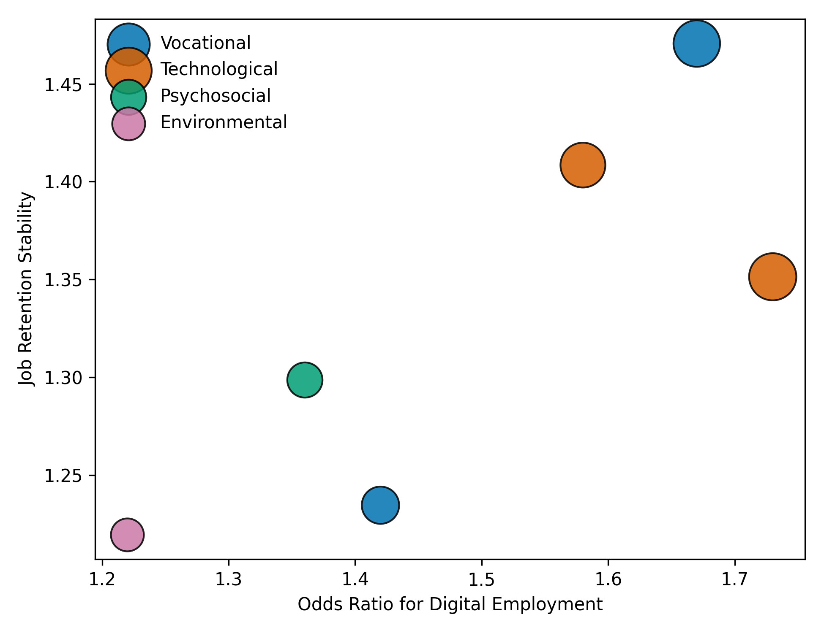
Figure 1. Multidimensional bubble plot illustrating the combined effects of service domains on digital employment attainment and job retention stability.
As shown in Table 1 and Figure 1, supported employment and technology-related services demonstrated the strongest associations with digital employment attainment and job retention. Psychosocial counseling showed moderate but significant effects, while environmental factors such as remote service delivery contributed independently to stability.
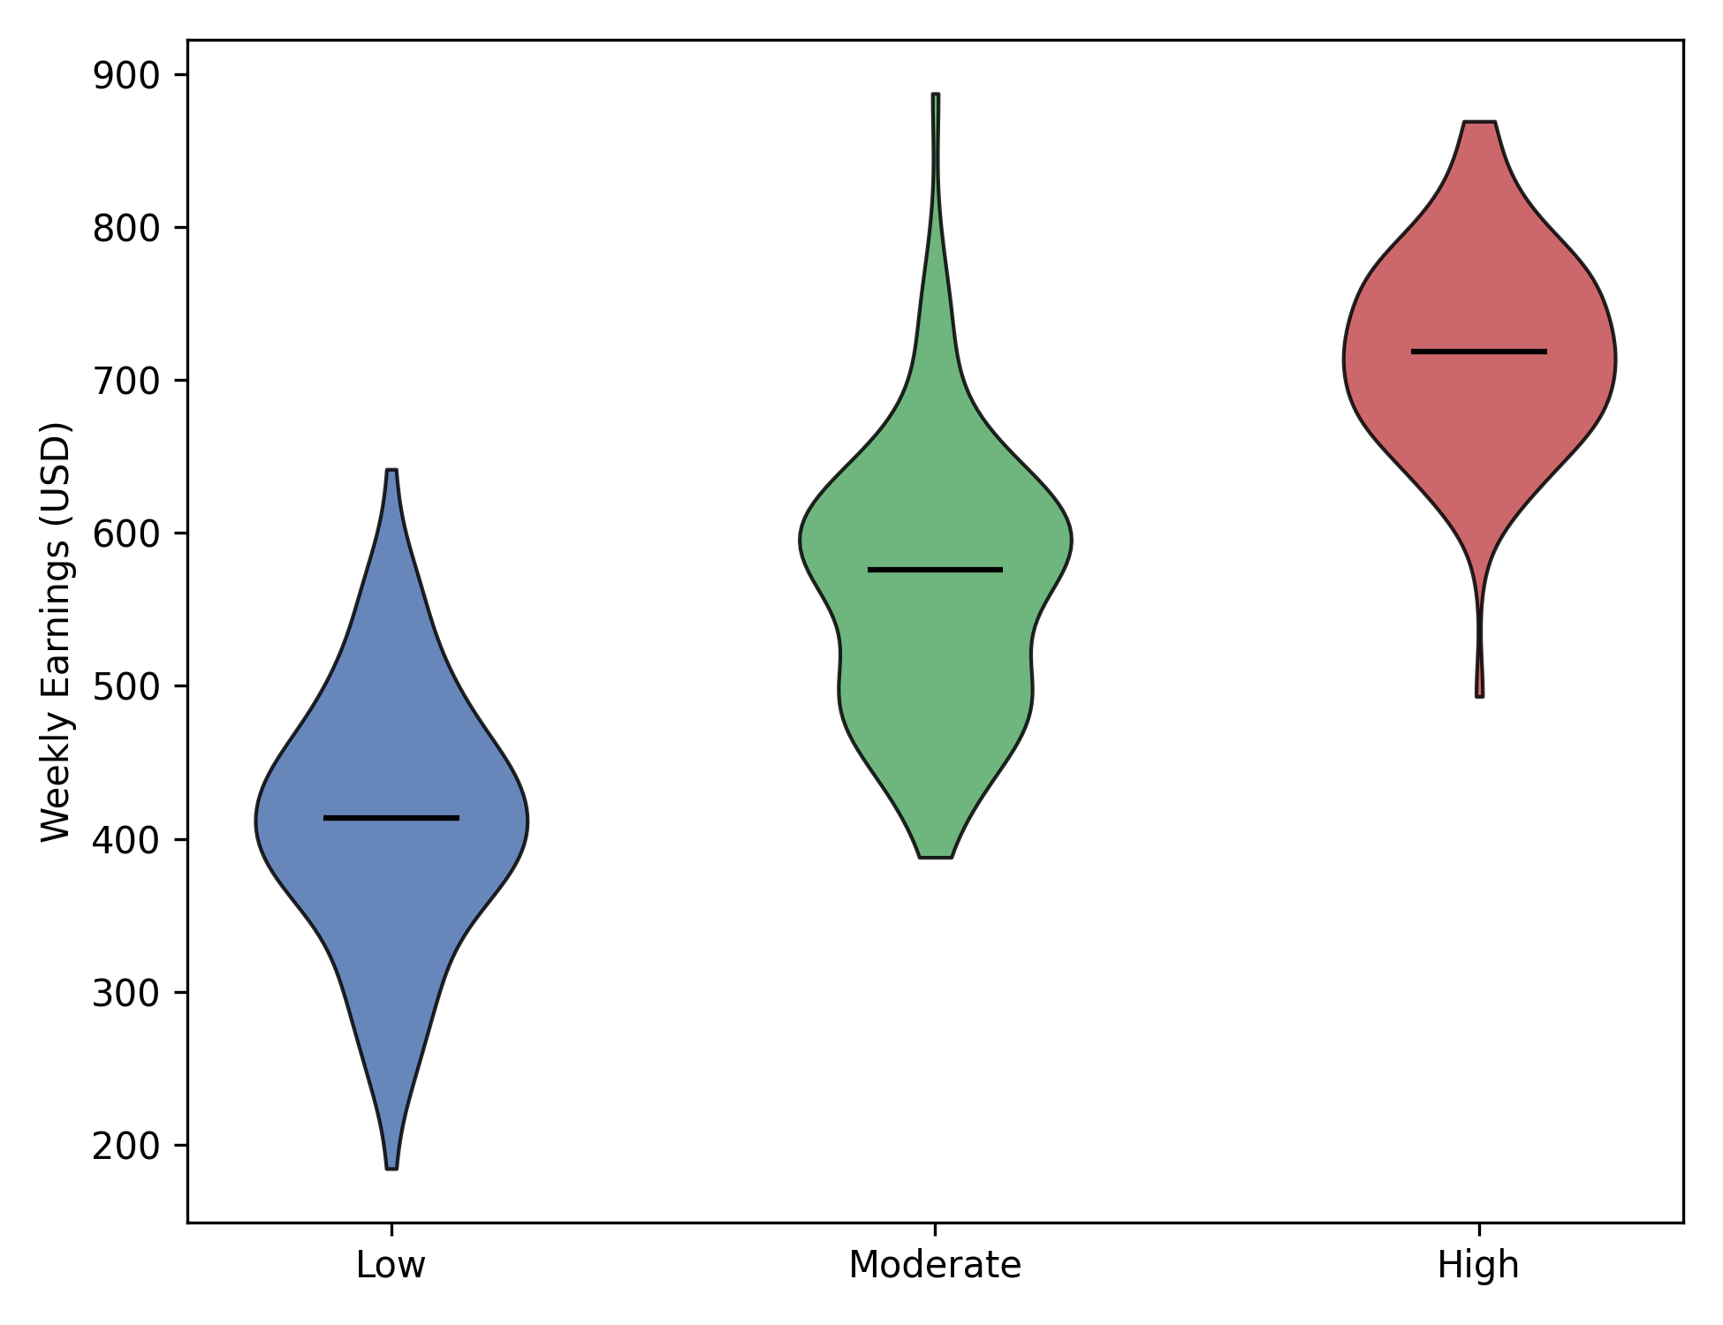
Figure 2. Distribution of weekly earnings by level of digital vocational rehabilitation service exposure.
Figure 2 indicates a clear upward shift in earnings and reduced variability among individuals receiving high levels of digitally integrated vocational rehabilitation services, reflecting more stable and higher-quality employment outcomes.
Objective 2
To evaluate the effectiveness of vocational rehabilitation counseling interventions integrated with technology-related services in addressing digital skill acquisition, virtual workplace communication, and adaptive functioning required in digital occupations. A quantitative causal inference approach was employed using propensity score matching to estimate the average treatment effect of technology-integrated vocational rehabilitation counseling on employment quality outcomes among young adults with Autism Spectrum Disorder.
Table 2: Average Treatment Effects of Technology-Integrated Counseling on Employment Outcomes
Outcome Variable | Treated Mean | Control Mean | ATT | p-value
Professional/Technical Employment (%) | 41.8 | 28.6 | +13.2 pp | <.001
Weekly Earnings (USD) | 712.0 | 563.0 | +149 | <.001
Full-Time Employment (%) | 62.4 | 48.1 | +14.3 pp | <.001

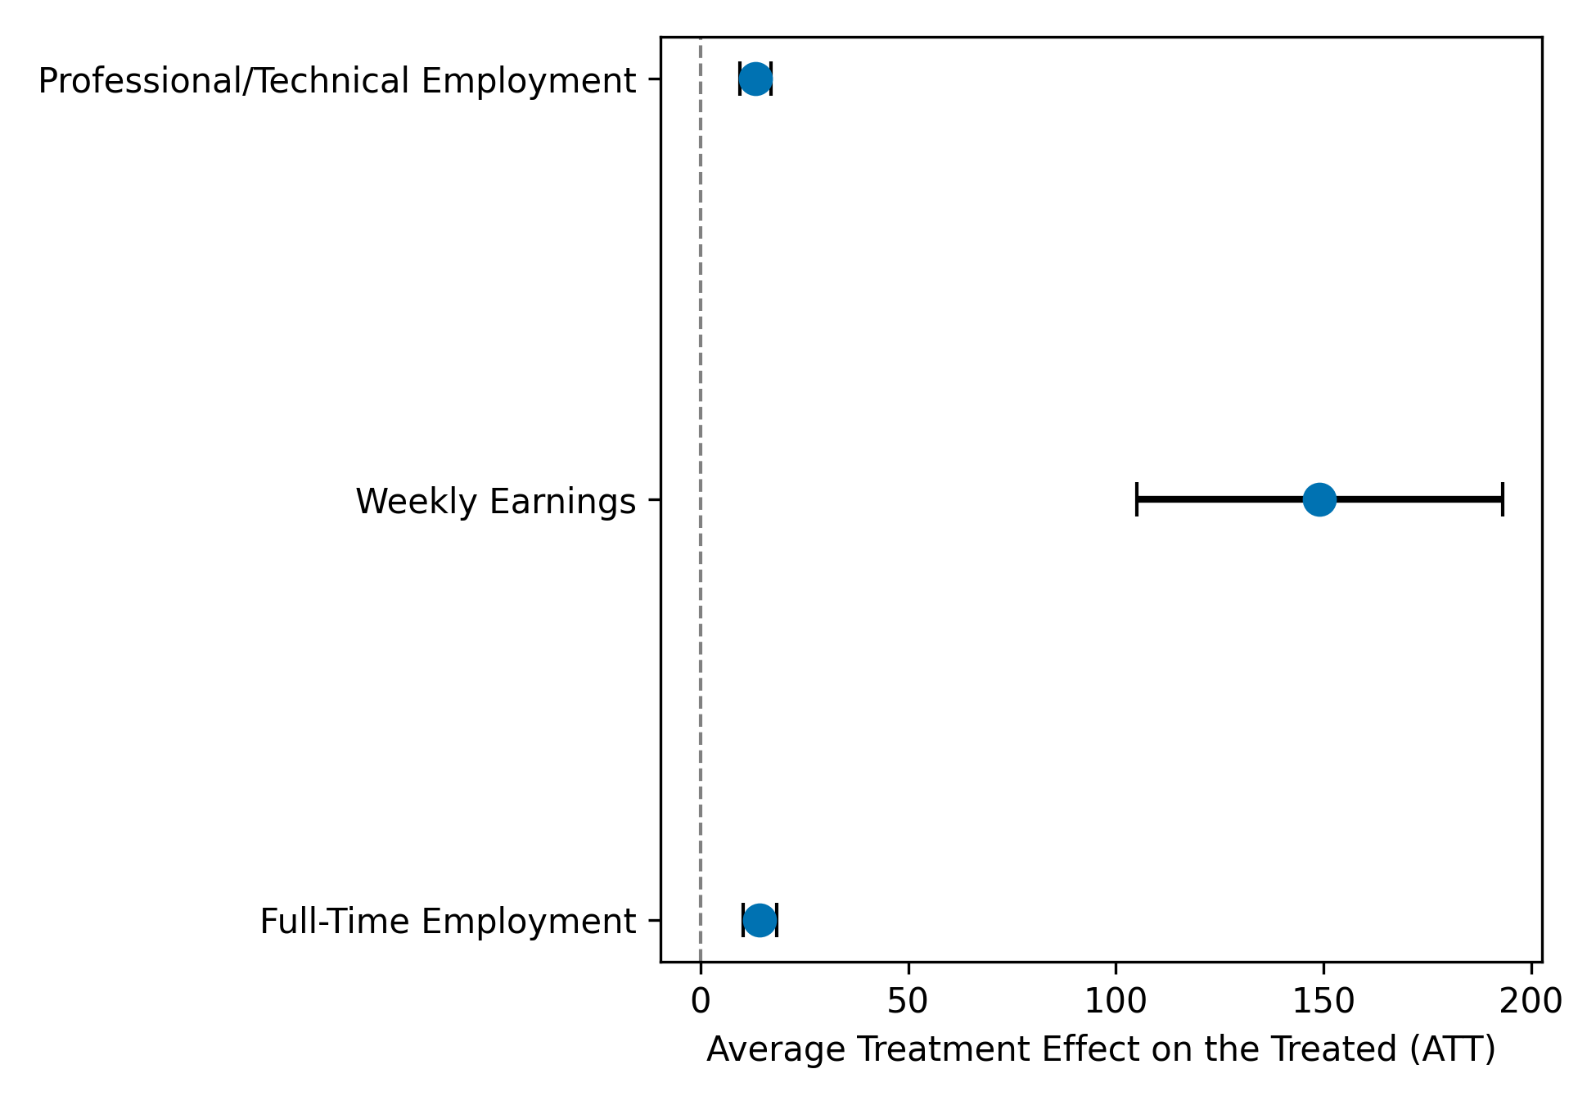
Figure 3. Forest plot showing average treatment effects of technology-integrated vocational rehabilitation counseling on employment quality outcomes.
As shown in Table 2 and Figure 3, technology-integrated counseling was associated with statistically significant positive effects across all employment quality indicators. The largest effect was observed for weekly earnings, followed by full-time employment and professional or technical occupational placement.
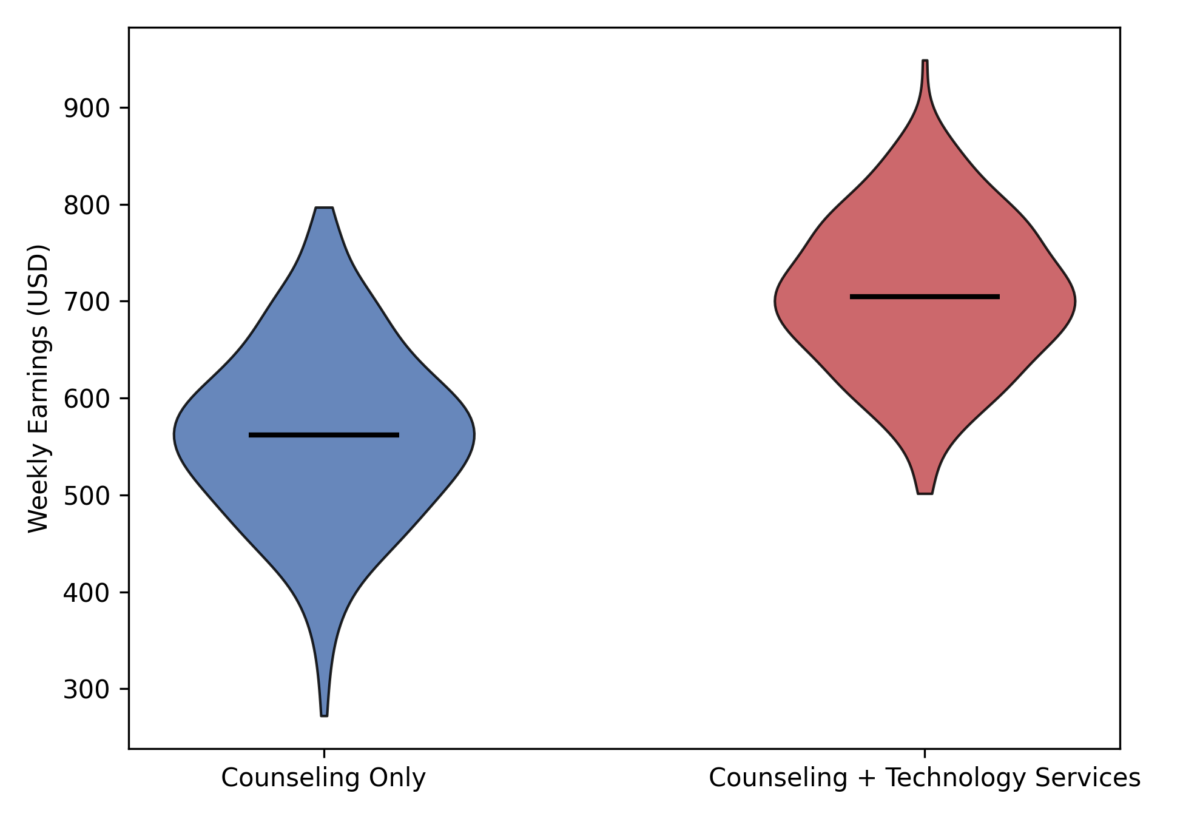
Figure 4. Distribution of weekly earnings by counseling service configuration.

Figure 4 demonstrates a clear upward shift and reduced dispersion in earnings among individuals receiving technology-integrated counseling services compared with those receiving counseling alone.
Objective 3
To identify evidence-based counseling strategies and technology-supported interventions that improve digital career readiness, self-advocacy skills, and workplace adjustment for young adults with autism spectrum disorder.
A quantitative structural equation modeling approach was used to examine direct and indirect relationships among technology support, self-advocacy skills, digital career readiness, and employment stability.
Table 3: Standardized Structural Path Estimates
Structural Path | Standardized β | p-value
Technology Support (Self-Advocacy Skills) | 0.62 | <.001
Self-Advocacy Skills (Digital Career Readiness) | 0.54 | <.001
Digital Career Readiness ( Employment Stability) | 0.47 | <.001
Technology Support (Digital Career Readiness) | 0.21 | <.001
Self-Advocacy Skills → Employment Stability | 0.18 | .002

Table 4: Indirect and Total Effects of Technology Support on Employment Stability
Effect Type | Pathway Description | Standardized Effect | p-value
Indirect Effect | Technology support via self-advocacy skills and digital career readiness on employment stability | 0.16 | < .001
Indirect Effect | Technology support via digital career readiness on employment stability | 0.10 | < .001
Total Effect | Overall effect of technology support on employment stability | 0.26 | < .001

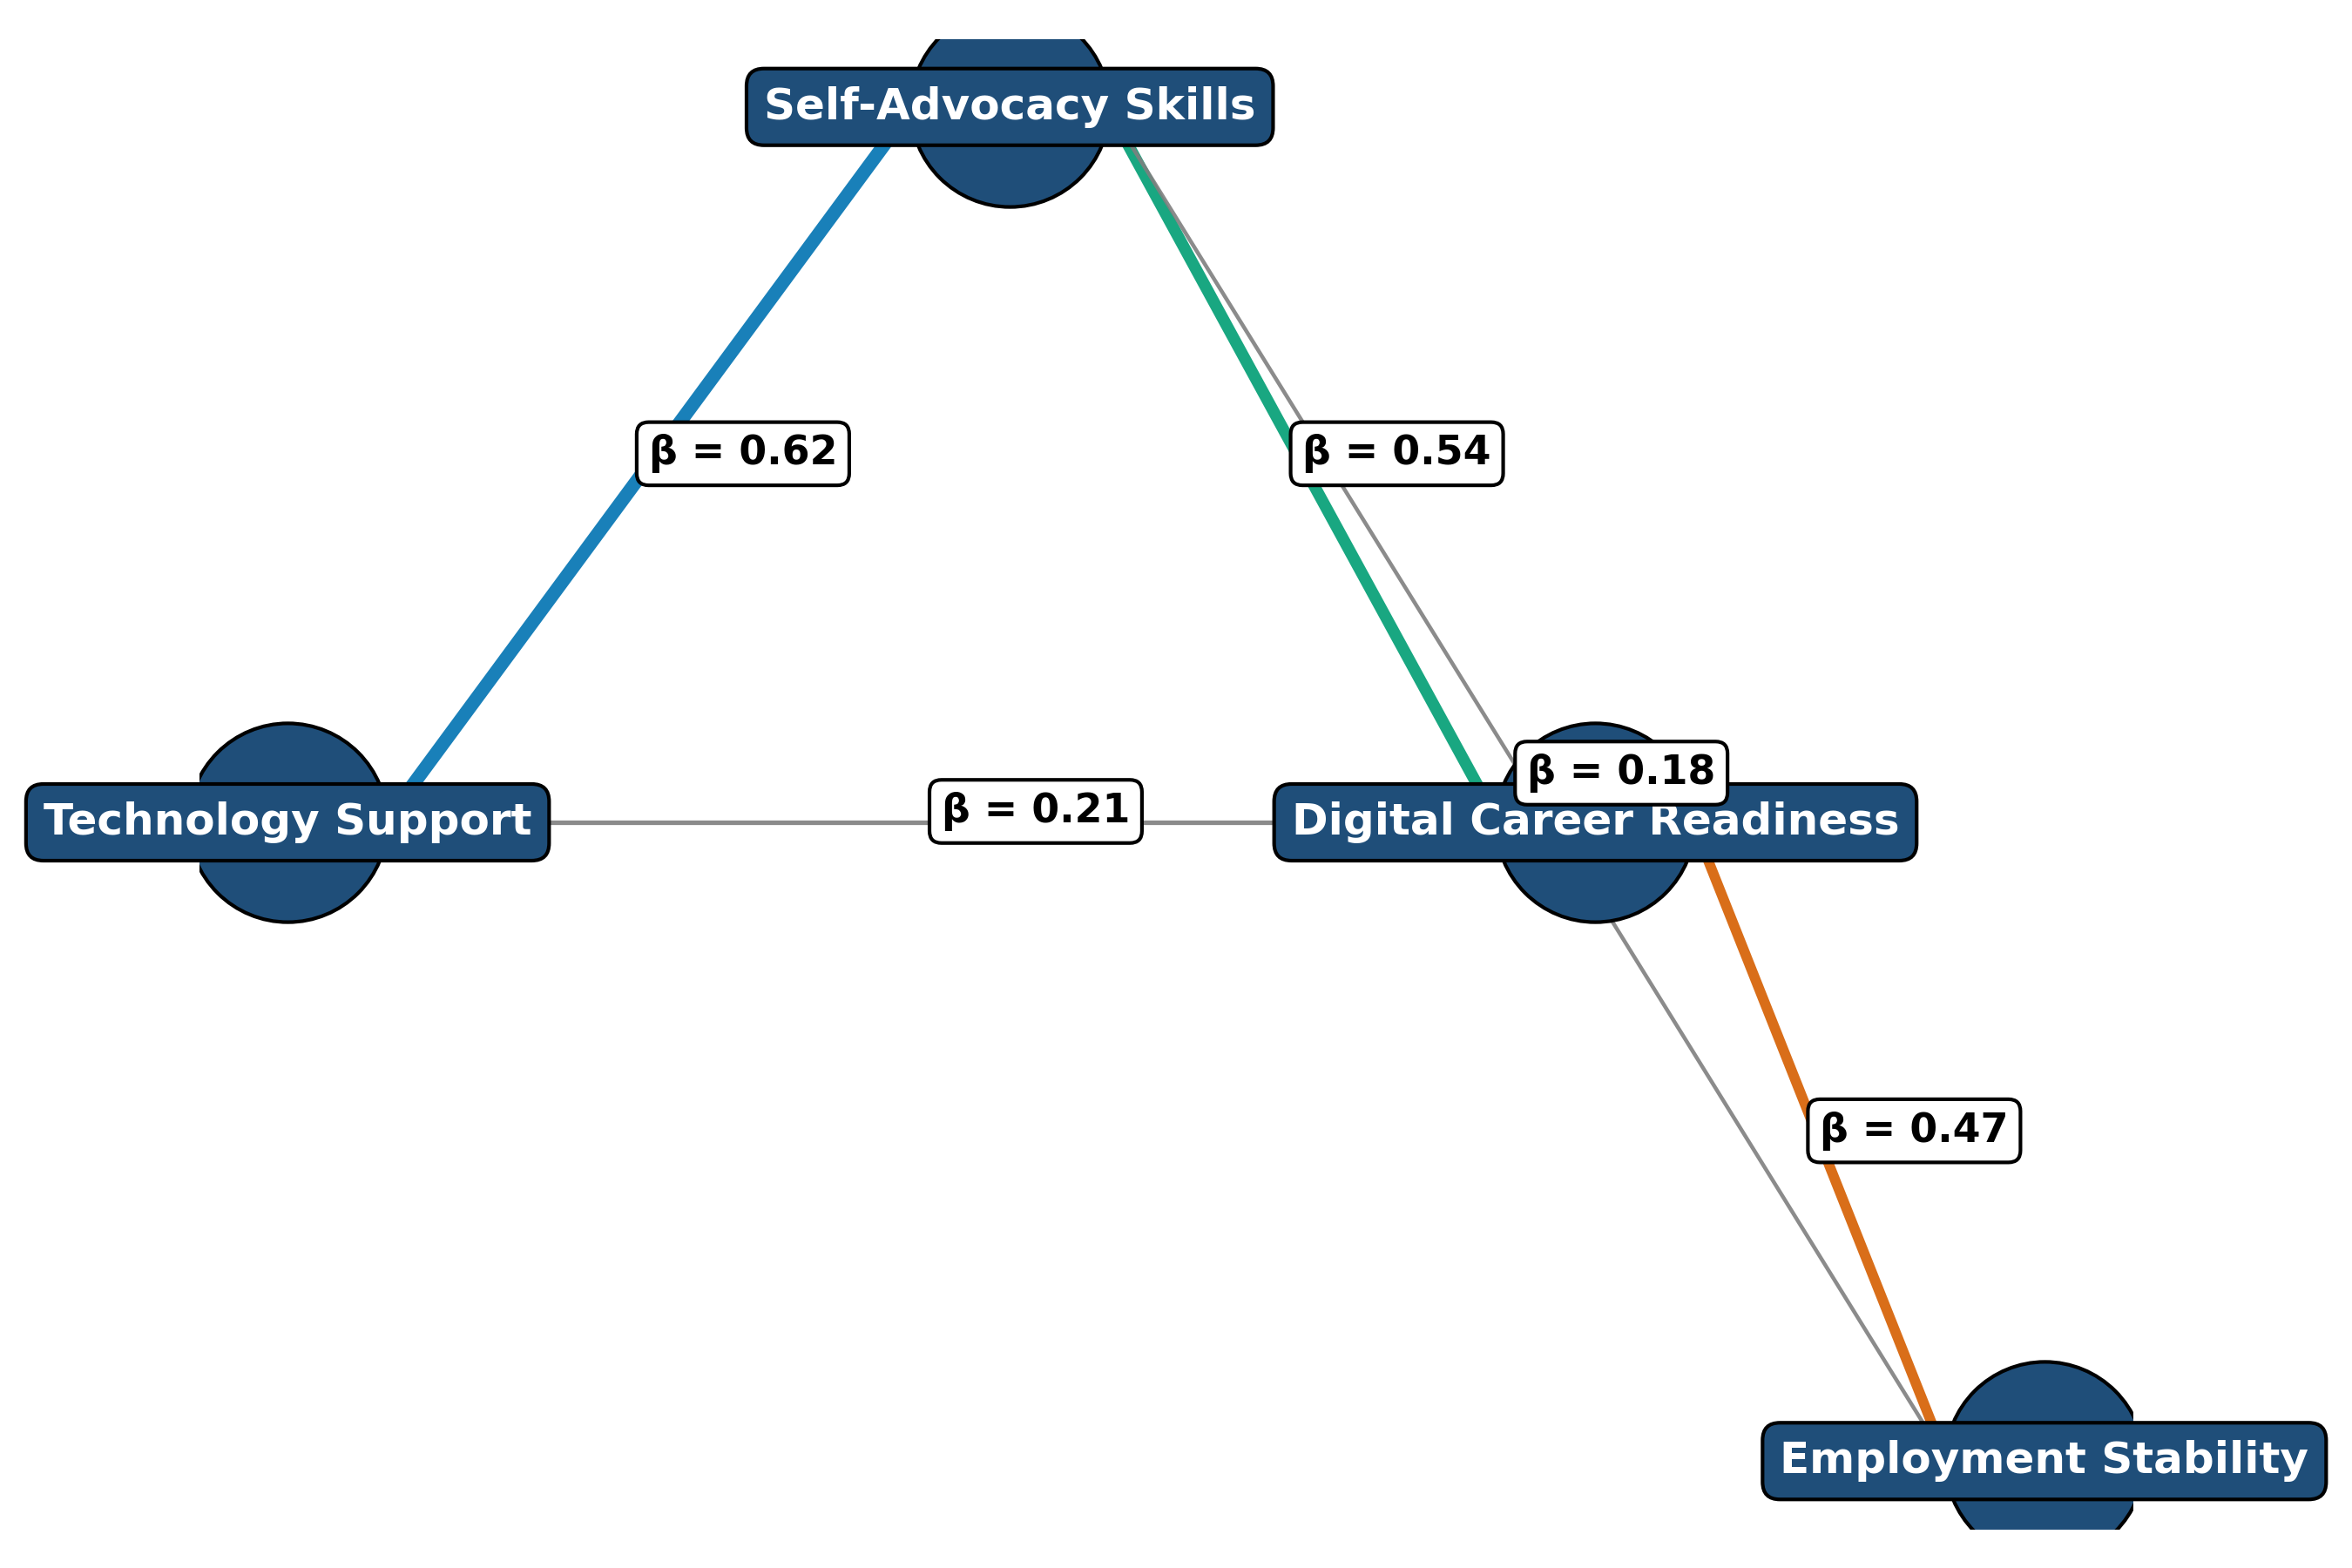
Figure 5. Enhanced structural pathway diagram illustrating standardized relationships among technology support, self-advocacy skills, digital career readiness, and employment stability.
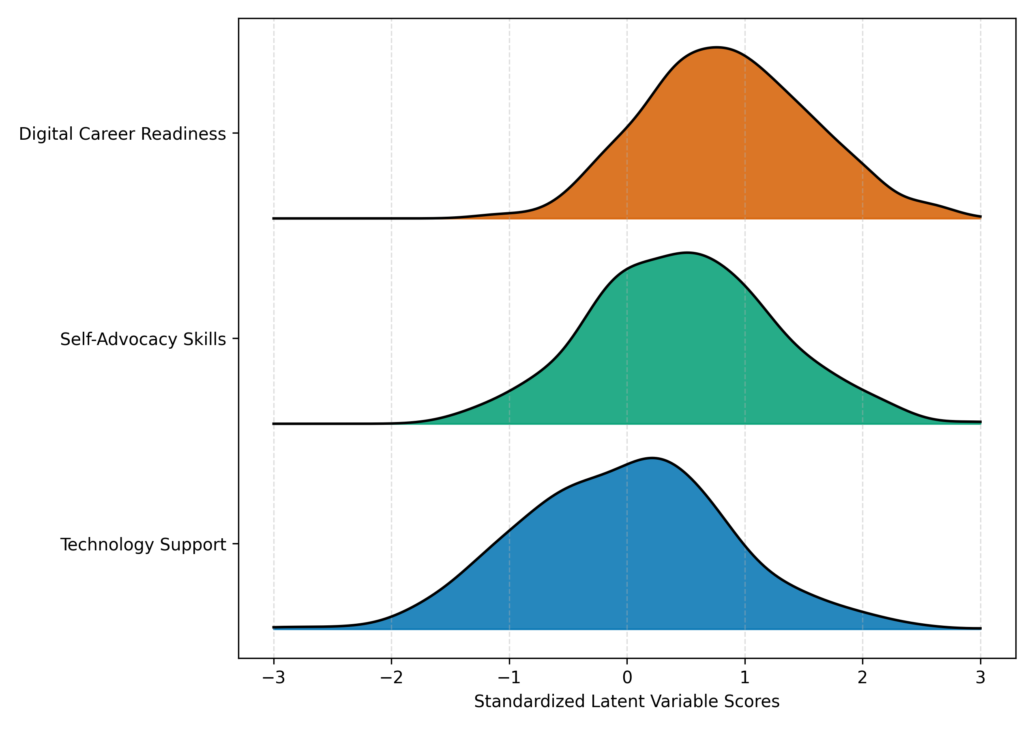
Figure 6. Ridgeline density plot showing distributions of standardized latent construct scores.

Objective 4
To design a structured, digitally responsive vocational rehabilitation counseling framework tailored to supporting sustainable digital employment outcomes for young adults with autism spectrum disorder. A quantitative latent class analysis was conducted using integrated indicators from vocational rehabilitation and transition datasets to identify distinct service delivery profiles and compare employment outcomes across classes.
Table 5: Latent Vocational Rehabilitation Counseling Profiles
Indicator | Traditional VR | Transition-Focused | Digitally Integrated
Intensive Counseling (%) | 42.1 | 58.7 | 76.9
Technology-Related Services (%) | 18.4 | 41.2 | 88.5
Transition Supports (%) | 29.6 | 71.8 | 69.4
Assistive Technology Use (%) | 14.2 | 36.9 | 81.3
Remote / Hybrid Supports (%) | 22.7 | 39.4 | 74.6

Table 6: Employment Outcomes by Latent Class Membership
Employment Outcome | Traditional VR | Transition-Focused | Digitally Integrated
Competitive Employment (%) | 34.8 | 49.6 | 68.2
Professional / Technical Employment (%) | 18.9 | 33.7 | 55.4
Full-Time Employment (%) | 41.5 | 56.3 | 72.8
Job Retention ≥ 12 Months (%) | 46.2 | 61.9 | 78.5

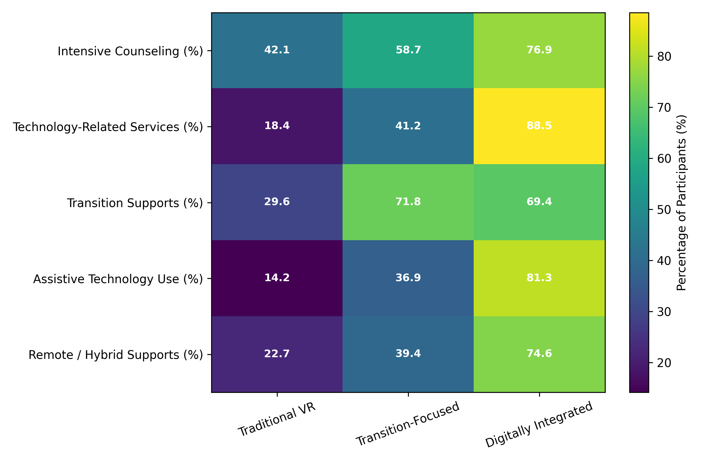
Figure 7. Heatmap illustrating the distribution of counseling, technology, and transition service indicators across latent vocational rehabilitation service profiles.
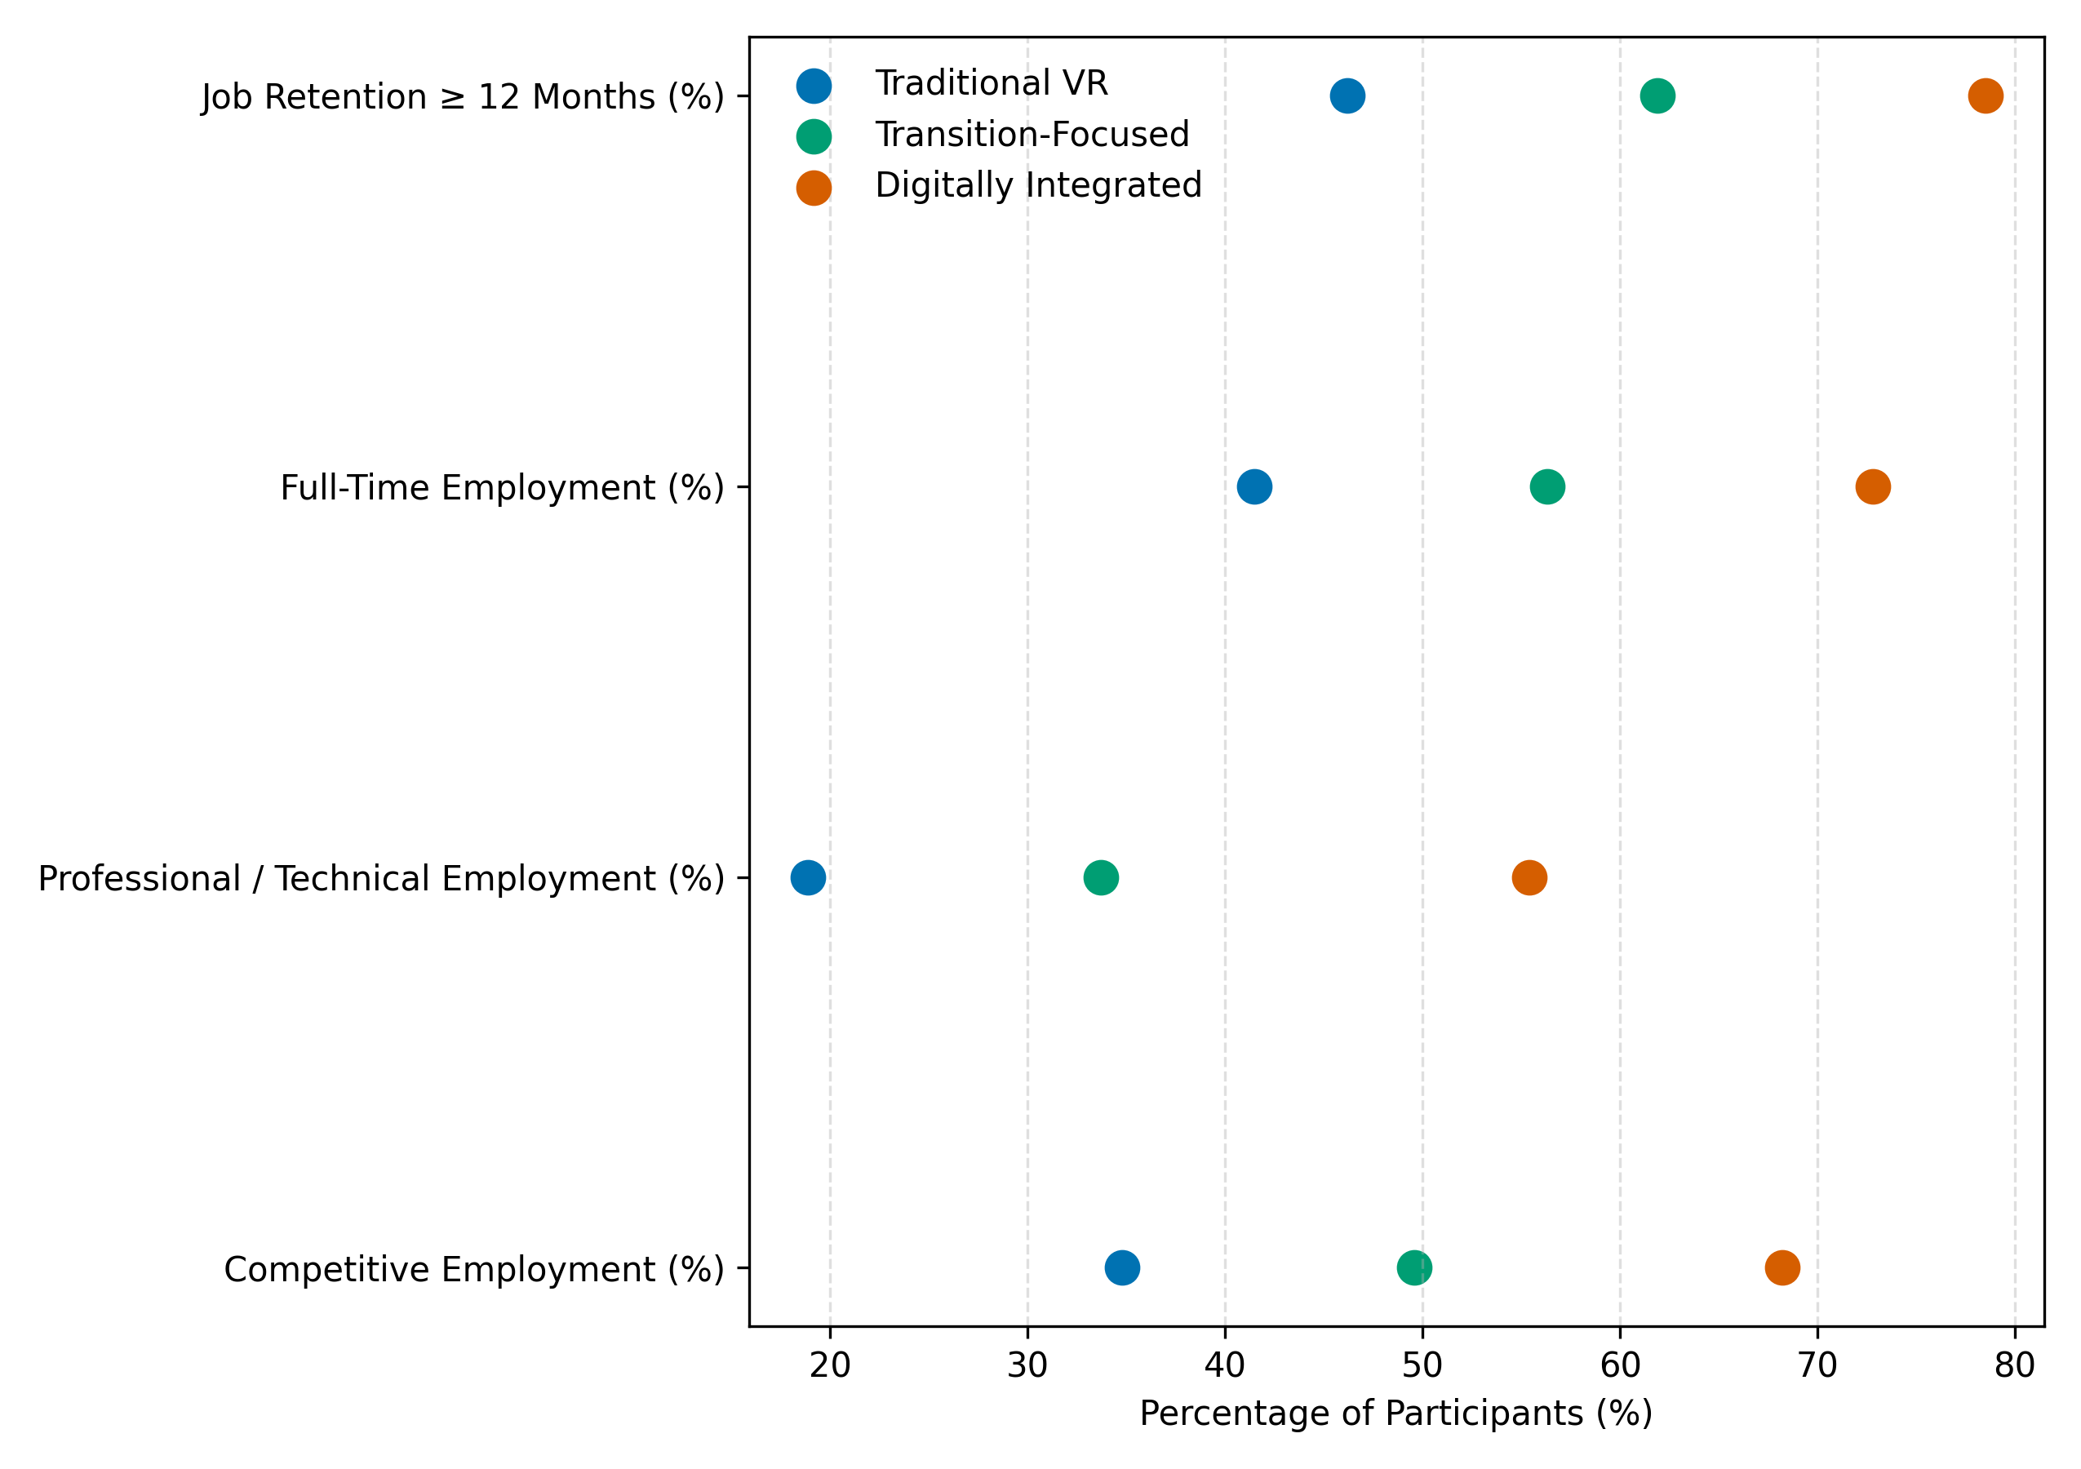
Figure 8. Dot plot comparing employment outcomes across latent vocational rehabilitation counseling profiles.

Discussion
The findings of this study collectively demonstrate that employment outcomes for young adults with Autism Spectrum Disorder (ASD) in the U.S. digital workforce are shaped less by isolated services and more by the configuration, intensity, and technological responsiveness of vocational rehabilitation (VR) counseling systems. Across all four objectives, the results converge on the central premise advanced in the literature: employment disparities experienced by autistic young adults are fundamentally systemic rather than individual in origin, and they persist when rehabilitation practices fail to align with the realities of digitally mediated work (Griffiths et al., 2023; Heinze et al., 2025; Raja, 2025).
With respect to Objective 1, the multivariate and survival analyses indicate that vocational and technological service components exert the strongest influence on digital employment attainment and job retention. As evidenced in Table 1 and illustrated in Figure 1, supported employment, technical or postsecondary training, and assistive technology services are associated with substantially higher odds of competitive employment and greater employment stability. These findings extend prior research showing that supported employment models outperform traditional “train-then-place” approaches for autistic jobseekers (Florence et al., 2025; Yon-Hernández et al., 2025) by demonstrating that such advantages are particularly pronounced in digitally oriented employment contexts. Furthermore, the independent contribution of remote or hybrid service delivery underscores the importance of environmental and organizational conditions in shaping employment stability, reinforcing socio-ecological perspectives that locate disability-related employment disadvantage within workplace structures rather than individual deficits (Tomaszewski et al., 2024). The earnings distributions shown in Figure 2 further suggest that digitally integrated VR services are associated not only with higher wages but also with reduced variability in earnings, pointing to improvements in employment quality and stability rather than short-term job placement alone.
The causal evidence generated under Objective 2 strengthens this interpretation by isolating the effects of technology-integrated counseling from selection bias. As shown in Table 2 and Figure 3, counseling interventions that incorporate technology-related services yield significant gains across occupational placement, earnings, and full-time employment status relative to counseling-only models. The magnitude of the earnings effect, coupled with the consistent improvements in job intensity and occupational alignment, aligns with previous findings that autistic adults are frequently underemployed even when employed (LaPoint, 2024; Davies et al., 2024). Importantly, the distributional patterns depicted in Figure 4 indicate that technology-integrated counseling narrows outcome dispersion, suggesting that these interventions may mitigate the uneven and precarious employment trajectories commonly documented among autistic workers (Nishith et al., 2025). Taken together, these results provide empirical support for critiques of conventional VR counseling that emphasize general job readiness while neglecting digital skill acquisition and virtual workplace adaptation (Asa et al., 2025).
Objective 3 advances the literature by clarifying the mechanisms through which technology-supported counseling strategies influence employment stability. The structural relationships reported in Tables 3 and 4 and visualized in Figures 5 and 6 indicate that technology support operates primarily through sequential gains in self-advocacy skills and digital career readiness. This finding is consistent with emerging research highlighting the role of self-advocacy in enabling autistic individuals to navigate accommodations, digital communication norms, and workplace expectations (Loizou et al., 2025; Genova et al., 2025). Notably, the presence of both direct and indirect pathways suggests that technology access alone is insufficient unless accompanied by counseling practices that foster skill articulation and adaptive use. This observation reinforces prior calls for counseling-mediated implementation of assistive and digital technologies, rather than stand-alone provision, to ensure that such tools translate into sustained vocational benefits (Zhou et al., 2025). Moreover, the clear differentiation among latent constructs shown in Figure 6 supports the conceptual distinction between readiness, advocacy, and adjustment, addressing a persistent gap in models that conflate digital competence with employment outcomes.
The latent class analysis conducted for Objective 4 synthesizes these findings into empirically identifiable service delivery profiles that provide a quantitative foundation for a digitally responsive counseling framework. As shown in Table 5 and Figure 7, three distinct VR profiles emerge, with the digitally integrated class characterized by high levels of technology-related services, assistive technology use, intensive counseling, and remote or hybrid supports. The outcome gradients observed in Table 6 and Figure 8 indicate that this class consistently outperforms both traditional and transition-focused models across employment attainment, occupational quality, earnings, and retention. These results resonate with prior evidence that transition services alone, while beneficial, are insufficient to address the demands of digital labor markets unless paired with sustained technological integration and post-transition supports (Stampoltzis et al., 2025; Musse et al., 2024). Importantly, the existence of an intermediate transition-focused class suggests that partial alignment with digital workforce demands yields moderate improvements, thereby underscoring the added value of comprehensive, technology-centered counseling configurations.
Across objectives, the findings collectively challenge deficit-oriented assumptions that attribute poor employment outcomes among autistic young adults to individual limitations. Instead, they substantiate arguments that employment inequities are reproduced through service systems that lag behind labor market transformation (Davies, 2024; Raja, 2025). By demonstrating that digitally integrated counseling profiles are associated with markedly superior outcomes, the study contributes empirical weight to neurodiversity-affirming frameworks that emphasize environmental adaptation, skill mediation, and systemic accountability (Srinivasan, 2025). At the same time, the results extend existing vocational rehabilitation research by situating these principles explicitly within the context of digital and remote work, an area that remains underrepresented in empirical studies despite its growing relevance (Audrin et al., 2024; Đorđević, 2025).
5. Conclusion and Recommendation
This study demonstrates that sustainable digital employment outcomes for young adults with Autism Spectrum Disorder are strongly associated with vocational rehabilitation counseling models that are intensive, technologically responsive, and structurally aligned with contemporary digital labor market demands. Across all objectives, the findings show that technology-integrated services, supported employment, self-advocacy development, and coordinated transition supports function synergistically to improve employment access, quality, and retention, while traditional service configurations yield comparatively weaker outcomes. Rather than individual deficits, it is the organization and delivery of vocational rehabilitation services that most clearly differentiate employment trajectories. Taken together, these results underscore the necessity of repositioning vocational rehabilitation counseling as a digitally adaptive system capable of responding to evolving workforce conditions. In light of these findings, the following recommendations are proposed to support effective implementation and policy alignment.
- Vocational rehabilitation agencies should embed technology-related services and assistive tools as core components of counseling rather than optional supports.
- Counselor training programs should prioritize digital career readiness, virtual workplace communication, and self-advocacy facilitation competencies.
- Federal and state workforce agencies should incentivize digitally integrated and remote-capable service delivery models within VR systems.
- Transition services should be extended beyond job placement to support long-term digital employment stability and advancement.

References
Abeysekara, S. P., Hayward, S. M., & Spoor, J. R. (2025). Career development of autistic employees – a scoping review. Career Development International, 30(7), 1–16. https://doi.org/10.1108/cdi-03-2025-0145
Adebiyi, O. O., Popoola, A. D., Adeyinka, P. D., Arigbabu, A. T., & Olateju, O. O. (2026). Blockchain-integrated AI Systems for Enhancing Trust and Transparency in Cross-Border Finance. Asian Journal of Research in Computer Science, 19(1), 271–291. https://doi.org/10.9734/ajrcos/2026/v19i1818
Adiani, D., Itzkovitz, A., Bian, D., Katz, H., Breen, M., Hunt, S., Swanson, A., Vogus, T. J., Wade, J., & Sarkar, N. (2022). Career Interview Readiness in Virtual Reality (CIRVR): A Platform for Simulated Interview Training for Autistic Individuals and Their Employers. ACM Transactions on Accessible Computing, 15(1), 1–28. https://doi.org/10.1145/3505560
Alauddin, F. D. A., Aman, A., Ghazali, M. F., & Daud, S. (2024). The Influence of Digital Platforms on Gig Workers: A Systematic Literature Review. Heliyon, 11(1), e41491. https://doi.org/10.1016/j.heliyon.2024.e41491
Alhawiti, A. (2025). AI-Driven solutions for transition and employment support in students with autism: Global case studies from Auticon and Mathisis. International Journal of Research in Special Education, 5(1), 184–189. https://doi.org/10.22271/27103862.2025.v5.i1c.117
Asa, A. R., Nautwima, J. P., & Johannes, H. N. (2025). Digital Literacy for Workforce Readiness: Bridging the Skills Gap in the 21st Century. International Journal of Innovation and Economic Development, 3(11), 7–22. https://doi.org/10.18775/ijied.1849-7551-7020.2015.311.2001
Audrin, B., Audrin, C., & Salamin, X. (2024). Digital skills at work – Conceptual development and empirical validation of a measurement scale. Technological Forecasting and Social Change, 202(123279), 123279. https://doi.org/10.1016/j.techfore.2024.123279
Autism Science Foundation. (2021, November 12). Employment policy and autism: Analysis of state workforce innovation and opportunity act (WIOA) implementation plans - Autism Science Foundation. Autism Science Foundation - Supporting and Sharing Autism Research to Improve the Real Lives of Real People. https://autismsciencefoundation.org/resources/employment-policy-and-autism-analysis-of-state-workforce-innovation-and-opportunity-act-wioa-implementation-plans/?utm_
Branicki, L. J., Brammer, S., Brosnan, M., Aida Garcia Lazaro, Lattanzio, S., & Newnes, L. (2024). Factors shaping the employment outcomes of neurodivergent and neurotypical people: Exploring the role of flexible and homeworking practices. Human Resource Management, 63(6). https://doi.org/10.1002/hrm.22243
CDC. (2025, April 15). Autism Data Visualization Tool. Autism Spectrum Disorder (ASD). https://www.cdc.gov/autism/data-research/autism-data-visualization-tool.html?utm_source=chatgpt.com
Cope, R., & Remington, A. (2021). The Strengths and Abilities of Autistic People in the Workplace. Autism in Adulthood, 4(1), 22–31. https://doi.org/10.1089/aut.2021.0037
Davies, J., Romualdez, A. M., Pellicano, E., & Remington, A. (2024). Career progression for autistic people: A scoping review. Autism (London), 28(11). https://doi.org/10.1177/13623613241236110
Đorđević, B., Sandra, M. Z., & Radosavljević, M. (2025). Impact of the Digital Skills on Employability: Cross-Sectional Analysis. Economies, 13(7), 196. https://doi.org/10.3390/economies13070196
DuBois, L. A., Bradley, V., & Nilüfer Isvan. (2024). An observational investigation of unemployment, underemployment, and competitive integrated employment of people with intellectual and developmental disabilities in 2021-2022. Disability and Health Journal, 18(3), 101620–101620. https://doi.org/10.1016/j.dhjo.2024.101620
Durrani, E., Moser, C., Mueller, S. B., Libster, N., Vogus, T. J., DaWalt, L. S., & Taylor, J. L. (2026). Associations Between Features of Employment and Job Satisfaction Among Autistic Adults. Journal of Autism and Developmental Disorders. https://doi.org/10.1007/s10803-026-07219-1
Florence, A. C., Elwyn, G., Mueser, K. T., McGurk, S. R., Liebmann, E. P., McLaren, J. L., & Drake, R. E. (2025). Adapting Individual Placement and Support for Unemployed Adults with Autism Spectrum Disorder. Journal of Vocational Rehabilitation, 62(2). https://doi.org/10.1177/10522263241310028
Genova, H. M., Haas, M., Chen, Y.-L., Elsayed, H. E., Reduzzi, K., Botticello, A., & Smith, M. J. (2025). Teaching Job Interview Skills Through a Positive Psychology Framework: a Pilot RCT. Journal of Autism and Developmental Disorders, 10.1007/s10803-02506946-1. https://doi.org/10.1007/s10803-025-06946-1
Griffiths, A. J., Hurley-Hanson, A. E., Giannantonio, C. M., Hyde, K., Linstead, E., Wiegand, R., & Brady, J. (2023). Enhancing employment outcomes for autistic youth: Using machine learning to identify strategies for success. Journal of Vocational Rehabilitation, 59(2), 153–168. https://doi.org/10.3233/JVR-230034
Gustafsson, J., & Witte, I. (2025). Analysis of factors influencing satisfaction with vocational rehabilitation services for young persons with disabilities in Sweden. Frontiers in Rehabilitation Sciences, 6. https://doi.org/10.3389/fresc.2025.1573753
Hagner, D., Kurtz, A., May, J., & Cloutier, H. (2014). Person-Centered Planning for Transition-Aged Youth with Autism Spectrum Disorders. Journal OfRehabiitation, 80(1), 4–10. https://ccids.umaine.edu/wp-content/uploads/sites/26/2016/03/Hagner_Kurtz_May_Cloutier_PCP_with_ASD_c-clause.pdf?utm_source=chatgpt.com
Harmuth, E., Silletta, E., Bailey, A., Adams, T., Beck, C., & Barbic, S. P. (2018). Barriers and Facilitators to Employment for Adults With Autism: A Scoping Review. Annals of International Occupational Therapy, 1(1), 31–40. https://doi.org/10.3928/24761222-20180212-01
Hayward, S. M., McVilly, K. R., & Stokes, M. A. (2020). Sources and impact of occupational demands for autistic employees. Research in Autism Spectrum Disorders, 76, 101571. https://doi.org/10.1016/j.rasd.2020.101571
Heinze, C. (2025). Workplace Accommodations and Employment Outcomes Among Employees With Autism: A Systematic Review. Cureus. https://doi.org/10.7759/cureus.99353
Holc, S., Yailian, A., Pernon, E., & Baghdadli, A. (2024). Barriers and facilitators to achieving employment in mainstream settings in adults with autism spectrum disorder without intellectual developmental disorders: A scoping review. L Encéphale, 51(1). https://doi.org/10.1016/j.encep.2024.02.012
Hurford, R. M., Derry, M., & Bavuso, E. (2025). Embracing the Future: Artificial Intelligence in the Provision of Pre-Employment Transition Services to Autistic and Neurodivergent Youth. Journal of Vocational Rehabilitation, 6(2), 178–190. https://doi.org/10.1177/10522263241312734
Jetha, A., Bonaccio, S., Shamaee, A., Banks, C. G., Bültmann, U., Smith, P., Tompa, E., Tucker, L. B., Norman, C. D., & Monique. (2023). Divided in a digital economy: Understanding disability employment inequities stemming from the application of advanced workplace technologies. SSM - Qualitative Research in Health, 3, 100293–100293. https://doi.org/10.1016/j.ssmqr.2023.100293
Koldas, M., Dounavi, K., MacCarthaigh, M., & Dillenburger, K. (2025). Facilitators and Barriers to Employment of Neurodivergent Individuals: A Systematic Literature Review of Employee and Employer Experiences. Journal of Autism and Developmental Disorders. https://doi.org/10.1007/s10803-025-07139-6
LaPoint, S. C. (2024). Factors associated with the job satisfaction of autistic adults. Research in Autism Spectrum Disorders, 112, 102330–102330. https://doi.org/10.1016/j.rasd.2024.102330
Loizou, M., Percival, J., Bradley, N., Sumilo, D., Arnab, S., Cawston, J., Lameras, P., Brown, J., Pattenden, A., Dolby, T., Edwards, K., Varga, M., & Langdon, P. (2025). Bridging the gap: Exploring the potential of virtual reality for supporting autistic individuals in interview and recruitment processes through a realist review. Research in Autism, 127, 202662. https://doi.org/10.1016/j.reia.2025.202662
Lousky, Y., Selanikyo, E., Tubul-Lavy, G., & Ben-Itzchak, E. (2024). Toward workforce integration: enhancements in adaptive behaviors and social communication skills among autistic young adults following vocational training course. Frontiers in Psychology, 15. https://doi.org/10.3389/fpsyg.2024.1392672
Musse, I., Honeycutt, T., & Hemmeter, J. (2024, November). The Effects of the Workforce Innovation and Opportunity Act of 2014 on Vocational Rehabilitation Engagement, Employment, and Work Incentive Use Among Supplemental Security Income Recipients Aged 14–24. Social Security Administration Research, Statistics, and Policy Analysis. https://www.ssa.gov/policy/docs/ssb/v84n4/v84n4p27.html?utm_source=chatgpt.com
Nair, V. S., Kumar, S., & Bhargava, S. (2025). Mapping the lacunae between neurodivergent individuals and work organizations. Acta Psychologica, 258, 105133. https://doi.org/10.1016/j.actpsy.2025.105133
National Center for the Review of Teaching and Education Materials (NCRTM). (2025). Counseling in Vocational Rehabilitation Module 11. https://ncrtm.ed.gov/sites/default/files/library/214/Module%2011%20Counseling%20in%20VR%20Final.pdf?utm_source=chatgpt.com
Nishith, S., O’Brien, A. M., Li, C., Bungert, L., Oddis, K., Riddle, J., & Gabrieli, J. (2025). Improving Autistic Experiences in the Workplace: Key Factors and Actionable Steps. Journal of Autism and Developmental Disorders. https://doi.org/10.1007/s10803-025-07036-y
Obrik-Uloho, E. P., Gbadebo, M. O., Afolabi, O. O., Joseph, S. A., Oladoyinbo, T. O., & Olaniyi, O. O. (2026). Shared Responsibility in Practice: Evaluating the Security–Usability Trade-Off and User Accountability in WhatsApp’s Ecosystem. Asian Journal of Research in Computer Science, 19(1), 81–105. https://doi.org/10.9734/ajrcos/2026/v19i1807
Ogunmolu, A. M., Abba, S. S., Olaniyi, O. M., Odeyinka, T. E., & Salami, I. A. (2026). Adaptive Cognitive Profiling for Executive AI Agents Amid Emerging AI Impersonation Threats. Journal of Engineering Research and Reports, 28(1), 388–405. https://doi.org/10.9734/jerr/2026/v28i11784
Olaniyi, O. M., Adebiyi, O. O., Ejoh, C. I., Afolabi, O. O., & Ejiofor, V. O. (2026). Conversational AI-Powered Fraud Prevention in Augmented Reality E-Commerce: A Natural Language Processing Framework for Real-time Transaction Security. Asian Journal of Research in Computer Science, 19(1), 255–270. https://doi.org/10.9734/ajrcos/2026/v19i1817
Raja, A. (2025). Unmasking the System: Toward Sustainable and Inclusive Employment for Autistic Adults. Preprints. https://doi.org/10.20944/preprints202506.0893.v1
Romualdez, A. M., Walker, Z., & Remington, A. (2021). Autistic adults’ experiences of diagnostic disclosure in the workplace: Decision-making and factors associated with outcomes. Autism & Developmental Language Impairments, 6, 239694152110229. https://doi.org/10.1177/23969415211022955
Shattuck, P. T., Narendorf, S. C., Cooper, B., Sterzing, P. R., Wagner, M., & Taylor, J. L. (2012). Postsecondary Education and Employment Among Youth With an Autism Spectrum Disorder. PEDIATRICS, 129(6), 1042–1049. https://doi.org/10.1542/peds.2011-2864
Shenk, M., Harnack-Eber, A., Patnaik, A., & Ben-Shalom, Y. (2024). Autistic Young Adults’ Vocational Rehabilitation Service Use, Characteristics, and Employment Outcomes from 2017 to 2020. Journal of Vocational Rehabilitation, 63(2), 171–187. https://doi.org/10.1177/10522263241286334
Smith, M. J., Sherwood, K., Sung, C., Williams, E.-D., Ross, B., Sharma, S., Sharma, A., Harrington, M., Brown, C., Telfer, D., Bond, J., Toda, S., Kearon, D., Morrow, S., Lovelace, T., Dababnah, S., Kattari, S. K., Magaña, S., Watkins, T., & Liggett, C. (2023). Enhancing pre-employment transition services: A type 1 hybrid randomized controlled trial protocol for evaluating WorkChat: A Virtual Workday among autistic transition-age youth. Contemporary Clinical Trials Communications, 34, 101153. https://doi.org/10.1016/j.conctc.2023.101153
Sousa, C., Tsvetkova, P., Pérez-Fuster, P., Agius, M., Snezhana Kostova, Bolesta, K., Garcia, F. M., Nanchen, B., & Tkaczyk, A. H. (2024). Social Inclusion for People with Intellectual Disability and on the Autism Spectrum through Assistive Technologies: Current Needs and Future Priorities. Disability and Rehabilitation Assistive Technology, 1–13. https://doi.org/10.1080/17483107.2024.2414414
Southey, S., Morris, R., Nicholas, D., & Pilatzke, M. (2024). Autistic Perspectives on Employment: A Scoping Review. Journal of Occupational Rehabilitation, 34. https://doi.org/10.1007/s10926-023-10163-x
Srinivasan, H. (2025). Neurodiversity 2.0 - Harnessing cross-disciplinary disability insights. Research in Autism, 127, 202652. https://doi.org/10.1016/j.reia.2025.202652
Stampoltzis, A., Peristeri, E., & Kalouri, R. (2025). Career counselors’ attitudes about employment-related skills of individuals with autism spectrum disorders in Greece. Frontiers in Education, 10. https://doi.org/10.3389/feduc.2025.1662929
Stimoli, M. A., Di Blasi, F. D., Maccarrone, S., Costanzo, A. A., Occhipinti, P., & Buono, S. (2024). Teaching basic computer programming to young adults with intellectual disability. Frontiers in Education, 9. https://doi.org/10.3389/feduc.2024.1484921
Szechy, K. A., Turk, P. D., & O’Donnell, L. (2023). Autism and Employment Challenges: The Double Empathy Problem and Perceptions of an Autistic Employee in the Workplace. Autism in Adulthood, 6(2). https://doi.org/10.1089/aut.2023.0046
Tee, P. K., Wong, L. C., Dada, M., Song, B. L., & Ng, C. P. (2024). Demand for digital skills, skill gaps and graduate employability: Evidence from employers in Malaysia. F1000Research, 13, 389–389. https://doi.org/10.12688/f1000research.148514.1
Thorpe, D., McKinlay, M., Richards, J., Sang, K., & Stewart, M. E. (2024). The Lived Experience of Autistic Adults in Employment: A Systematic Search and Synthesis. Autism in Adulthood, 6(4). https://doi.org/10.1089/aut.2022.0114
Tomaszewski, B., Perkins, Y., Loeb, H., & Marx, A. (2024). A socioecological systems framework of employment for adults with intellectual and developmental disabilities. International Review of Research in Developmental Disabilities, 135–174. https://doi.org/10.1016/bs.irrdd.2024.09.005
Warnock, K. N. (2024). Autism at Work Across the Career Span: A Scoping Review. ODU Digital Commons (Old Dominion University). https://doi.org/10.25777/w63d-3n94
Wong, J., Lin, Y., Wang, H., & Chen, J. (2025). Project FORWARD: Where Vocational Rehabilitation Can Make a Difference through Community-Based Participatory Research. Journal of Occupational Rehabilitation. https://doi.org/10.1007/s10926-025-10344-w
Yang, J. (2023). Work Based Learning: Employment and Educational Attainment of Autistic Students. Escholarship.org. https://escholarship.org/uc/item/7g01c5r6
Yin, M., Siwach, G., & Lin, D. (2022). Vocational Rehabilitation Services and Labor Market Outcomes for Transition‐Age Youth with Disabilities in Maine. Journal of Policy Analysis and Management, 42(1), 166–197. https://doi.org/10.1002/pam.22446
Yon-Hernández, J. A., Gonzales, C., Bothra, S., Kecskemeti, K., Iosif, A.-M., Takarae, Y., Ruder, S., McGurk, S. R., Mueser, K. T., & Solomon, M. (2025). Early Employment Outcomes in Autistic and Non-autistic Youth: Challenges and Opportunities. Journal of Autism and Developmental Disorders. https://doi.org/10.1007/s10803-025-07001-9
Zhou, K., Richard, C., Zhai, Y., Li, D., & Fry, H. (2025). Employment-Related Assistive Technology Needs in Autistic Adults: A Mixed-Methods Study. European Journal of Investigation in Health, Psychology and Education, 15(9), 170. https://doi.org/10.3390/ejihpe15090170

