Case report

NON-PUERPERAL UTERINE INVERSION SECONDARY TO SUBMUCOUS UTERINE FIBROID: SURGICAL MANAGEMENT AND OUTCOME USING A COMBINED ABDOMINAL AND VAGINAL APPROACH

Abstract
Background: Non-puerperal uterine inversion (NPUI) is undoubtedly a rare phenomenon in which if an early diagnosis is to be made, a clinician must have a high index of suspicion. It is also important to be familiar with the different surgical techniques involved in its management. This report gives an account of a case of NPUI managed by a combined abdominal and vaginal approach.
Case Presentation: The patient was a 39-years old woman whose last childbirth was 7 years ago. She presented with heavy menstrual bleeding of a year duration and watery, copious, and foul-smelling vaginal discharge of 7 days duration. On examination, the inverted uterus protruded from the introitus with a solitary gangrenous fibroid mass attached to its fundal region. An excision of the mass was done via a vaginal approach with subsequent failed attempts to revert the uterus. Thus, the uterus was amputated per vagina and its appendages approached per abdomen. The histology report revealed gangrenous leiomyoma with no evidence of malignancy.
Discussion: Appropriate history with astute pelvic examination is important in the diagnosis of uterine inversion. This could be aided with pelvic ultrasonography, especially those with Doppler techniques, which together with magnetic resonance imaging, have characteristic features. Definitive treatment involves reverting the uterus to its normal position and either preserve fertility or perform a hysterectomy if the family size is complete.
Keywords: Gangrenous leiomyoma, Haultain’s procedure, Huntington’s procedure, Kustner technique, Non-puerperal uterine inversion, Spinelli technique, Submucous leiomyoma.

Introduction
The clinical entity termed uterine inversion is characterized by the uterine fundus invagination into the endometrial cavity, to or traversing the cervix.^{[1,2]} With a frequency of 1 in 3,500 deliveries, puerperal uterine inversion is an uncommon complication of childbirth and even rarer is non-puerperal uterine inversion which is nearly invariably linked to uterine masses, with the most common cause being submucosal leiomyoma.^{[1,3]}
Uterine inversion can be managed surgically using a variety of methods. Because non-puerperal uterine inversion is a rare clinical encounter, some instances will need to be addressed without prior knowledge.^{[3]} To make a diagnosis, one must have a high index of suspicion and a thorough awareness of the fundamentals of the proposed surgical procedures is needed for effective management.^{[1,4]}
Case presentation
A 39-years old P2+0 (2A) who was referred to our gynaecology emergency unit on account of endometrial polyp and uterine inversion with a packed cell volume of 19%. She presented with heavy menstruation of 1 year and vaginal discharge of 7 days. Menstruated for 10 days, used an average of 8 pads per day and there was associated passage of large clots. She had dizziness and generalized body weakness and reported discomfort during sexual intercourse, intermenstrual and post-coital bleeding. Also had a history of abdominal swelling six (6) months prior to presentation which gradually reduced.
The vaginal discharge was watery, copious, and foul smelling with associated mass protrusion from the vagina. There was no difficulty with voiding. Two months before presentation, she visited a local private health facility where a pelvic ultrasound scan was done with findings of submucous uterine fibroid. She declined admission for myomectomy and re-presented to the same facility a day before she was referred. She has had 2 vaginal hospital-supervised deliveries at term with no complications. Her last childbirth was 7 years prior to presentation.
On examination, she was not in any obvious distress but was pale, and tachycardic with a pulse rate of 112bpm. She was normotensive with a blood pressure of 100/70mmHg. No mass was palpable per abdomen. Pelvic examination revealed an irregular beefy mass which was about 20 x 10cm protruding through the introitus. The mass had two distinct parts, with the lower part being the uterus which appeared as a globular mass with a firm consistency, pale, and smooth surface. The upper part was oval with an irregular surface and widespread areas of necrotic tissues with copious bloody and foul-smelling vaginal discharge. Access could not be gained to the cervix as the mass was not reducible and this precluded bimanual examination.

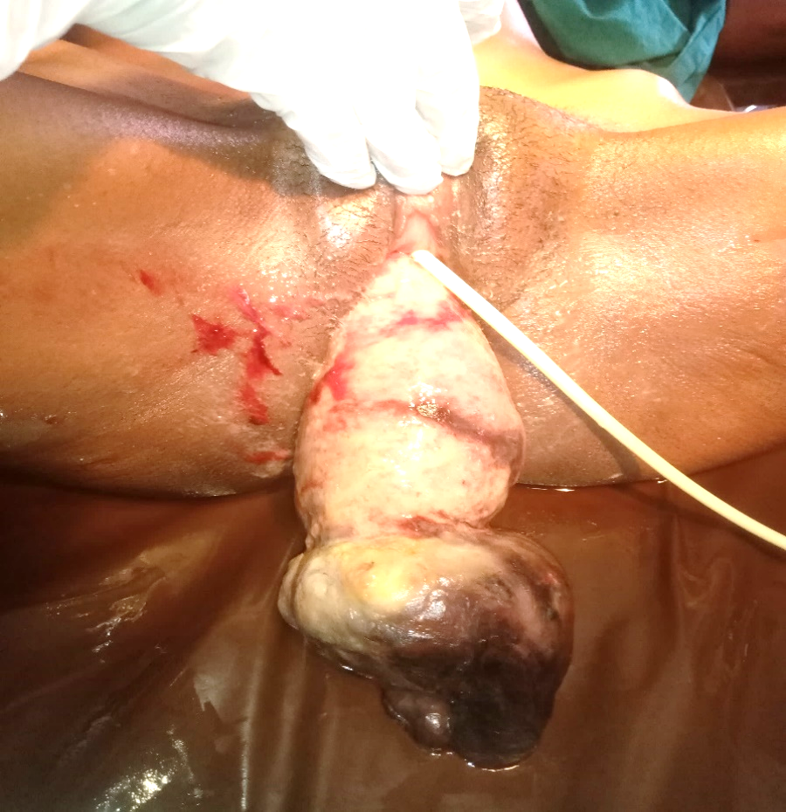
Figure 1: Inverted uterus with exposed endometrial lining (black arrow) and submucous gangrenous leiomyoma attached to the fundus (red arrow)

Repeat packed cell volume was 20%. Pelvic ultrasound revealed an absent uterus in the pelvic cavity and there were no intra or retroperitoneal mass lesions seen. Other requested investigations were within normal limits. A provisional diagnosis of non-puerperal uterine inversion secondary to submucous uterine fibroid with necrotic changes, complicated by symptomatic anaemia was made. The packed cell volume was optimized and informed consent was obtained for surgery.
A combined abdominal and vaginal approach was used. Access was gained into the pelvic cavity and the uterus was found to be absent. However, there was a constriction ring seen, and proximal to it, the distal portions of the fallopian tubes and ovaries. The round ligament, ovarian ligament, and infundibulopelvic ligaments were also seen to be pulled into the region of the constriction ring. Following a thorough examination under anaesthesia, the submucous fibroid mass was excised – this was done to reduce the size of the prolapsed mass to enable easy manual replacement of the uterus into the pelvic cavity.
An attempt was made to reposition the uterus to its normal anatomic position by gradual upward pulling on the round ligament (Huntington’s procedure), but this was not successful. Haultain’s procedure was then performed wherein the constriction ring was grasped with Allis forceps and an incision was made on it following which a finger was inserted through the incision and an attempt was made to push the inverted fundus back to its normal position- this was not successful. The assistant surgeon also attempted to push the fundus of the uterus through the vaginal but without success.
The uterus was clamped through the vagina at the level of the uterine arteries, excised, and repaired with Vicryl 2 and hemostasis was ensured. Per abdomen, the appendages were clamped and replaced with sutures and the anterior abdominal walls closed in layers. The estimated blood loss was 900ml and her post-operative packed cell volume on post-operative day 2 was 22% on account of which she had 3 units of blood transfused. She was discharged on post-operative day 10 following a good recovery. She had her first follow-up visit two weeks following discharge and the second visit at six weeks. There were no complications identified. She had good wound healing, and there were no urinary symptoms. No apical, anterior, or posterior vaginal wall prolapse.
The histology report showed features consistent with gangrenous leiomyoma, with no evidence of malignancy seen. She was discharged from the clinic at the second follow-up visit.
Discussion
Uterine inversion is rare but may sometimes occur in the third stage of labour in about 1 in 2000 to 1 in 50,000 parturients, especially when the third stage of labour is poorly managed.^{[5]} Non-puerperal uterine inversion is particularly rarer and is usually precipitated by tumours sited at the uterine fundus exerting a traction force to cause the inversion.^{[6]}. These tumours could either be benign or malignant.^{[7]} Although tumours involved are mostly benign, there are increasing evidences that non-puerperal uterine inversions are associated with malignancy than initially reported and this association was seen to be up to15 to 30% in a recent review.^{[8]}
Hippocrates was the first to recognize uterine inversion as an entity.^{[7]} Generally speaking, non-puerperal uterine inversion is mostly seen in women above the age of 45 years. Its actual incidence is not known, although a total number of 170 cases were reported between 1940 – 2017 following a review of published papers.^{[1]} NPUI represents 16% of uterine inversions and less than 200 cases are reported in the literature.^{[8]}
The aetiology of uterine inversion is not clearly defined but appears to be multifactorial. Risk factors that promote the occurrence of NPUI are conditions that are found to increase intra-abdominal pressure including sneezing, coughing or urinary retention leading to straining.^{[7]}
Uterine inversion can be classified into four (4) stages; Stage I – the inverted uterus remains in the uterine cavity; Stage II – complete inversion of the fundus through the cervix; Stage III – the inverted fundus protrudes through the vulva; Stage IV – inversion of the uterus and vaginal wall through the vulva.^{[2,6,8]}
To make a diagnosis of NPUI, a strong index of suspicion is required.^{[1,9]} The patients usually present with mass prolapse through the vagina associated with vaginal bleeding. Also common are presentations with foul-smelling vaginal discharge and varying degrees of anaemia. Other presenting complaints include pelvic discomfort, worsening dysmenorrhea, dyspareunia, menorrhagia, vaginal fullness or pressure, and acute urinary retention. Hypovolemic shock has been reported in cases of NPUI secondary to uterine fibroid with associated heavy bleeding per vagina.^{[7]}
If not properly evaluated, patients presenting with NPUI could be missed especially those with mild forms and other cases would only be found during surgery.^{[1]} Abdominal examination reveals the absence of the uterus in its normal anatomic position while vaginal examination shows a mass protrusion from the vagina. If bimanual examination is possible, a finding of fundal depression could be elicited.
Pelvic ultrasound scan is usually the first-line imaging technique however, MRI is the best imaging modality as it is useful in making the diagnosis and characterizing the uterine mass.^{[1,7]} The ultrasound scan reveals an indentation of the uterine fundus and a depressed longitudinal groove extending from the fundus to the centre of the inverted uterus.^{[10]} This could also be enhanced by incorporating the use of Doppler, which outlines the course of the uterine arteries; showing a U-turn sign, wherein the arteries come to lie central as different from the usual lateral location along the body of the uterus. The MRI aside from revealing the anatomy of the uterus, also helps in the identification of structures like the fallopian tube and ovarian ligaments which could be seen obtruding from the centre of the uterus. MRI is however not widely available in most regions of the developing countries.^{[7]}
The treatment of NPUI depends on its aetiology (benign or malignant) and patient’s desire for fertility.^{[7]} Hysterectomy was the treatment of choice in most reported cases because of the possibility of uterine malignancy coupled with the fact that most women in the affected age group have completed their family sizes or are past the reproductive age group. Before hysterectomy, the uterus should be replaced to its normal anatomical position.^{[1,3]} If fertility is desired, the possibility of malignancy should be excluded and surgical repositioning of the uterus attempted before or after removal of uterine mass if there is any.
Several surgical procedures for replacing the uterus into its normal position have been popularized. Huntington’s procedure is the first-line technique before hysterectomy. It is an abdominal procedure which involves gradually pulling on the round ligaments upwards to revert the uterus. Other techniques which are also gaining popularity include Haultain’s technique which is also an abdominal procedure and Kustner and Spinelli techniques which are procedures done per vagina.^{[1–3]}
In this case report, Huntington and Haultain’s procedures were attempted without any success following the excision of the uterine submucous mass. Thus, the inverted uterus was amputated at the level of the uterine arteries, hemostasis ensured, and the uterine appendages were clamped and replaced with sutures per abdomen. It is now been advocated that a combination of abdominal and vaginal approaches be used in the management of patients with NPUI, especially when the accompanying uterine mass is huge.^{[8]}
Conclusion
The condition NPUI is a rare clinical entity which can elude a non-suspecting clinician only to be diagnosed at surgery in certain case. Thus, a high index of suspicion is required to make an early diagnosis and this should be the case in any woman, especially those above 45 years of age presenting with mass prolapse and bleeding per vagina. Diagnosis can be made clinically with a good history and astute abdominal and vaginal examinations, although, this can be enhanced by investigations including pelvic ultrasonography and MRI especially in stable patients which do not need immediate surgery. Definitive treatment involves varying techniques to restore the anatomy of the uterus with subsequent hysterectomy if future fertility is not desired or in the presence of a uterine malignancy.

COMPETING INTERESTS DISCLAIMER:
Authors have declared that they have no known competing financial interests OR non-financial interests OR personal relationships that could have appeared to influence the work reported in this paper.

REFERENCES
1. Abubeker FA, Misgina M, Ebabu A, Fekade E, Gashawbeza B. Management of Nonpuerperal Uterine Inversion Using a Combined Vaginal and Abdominal Approach. Case Reports in Obstetrics and Gynecology. 2020;2020.
2. Ziki E, Madombi S, Chidhakwa C, Madziyire MG, Zakazaka N. Reduction of subacute uterine inversion by Haultain’s method: A case report. South African Journal of Obstetrics and Gynaecology. 2017;23(3):78–9.
3. Abid S, Dhaou GB, Abdelmoula G, Smida AB, Abdesslem MRB, Mrad O, et al. Complete non-puerperal uterine inversion caused by uterine hemangioma: about a case report. The Pan African Medical Journal. 2022;42.
4. Otieno VT, Simon B. Unusual Case of Acute Non-Puerperal Uterine Inversion in Rural Kenya: A Diagnostic Dilemma. Women’s Health Bulletin. 2023;10(2):143–5.
5. Kumari S, Singh V, Ray A, Swain A. Post-partum complete acute uterine inversion: A coordinated multi-disciplinary approach ameliorates an obstetric nightmare, a case report. Journal of Family Medicine and Primary Care. 2022;11(2):793.
6. Li F, Liang Y, Luo M, Cheng Y. A rare case of endometrial polyp complicated with uterine inversion: A case report and clinical management. Open Medicine. 2022;17(1):550–5.
7. Herath RP, Patabendige M, Rashid M, Wijesinghe PS. Nonpuerperal uterine inversion: what the gynaecologists need to know? Obstetrics and Gynecology International. 2020;2020.
8. Niang MM, Samb F, Cisse CT. Subacute Non-Puerperal Uterine Inversion: A Rare Complication of Uterine Myoma. J Med Res Surg. 2022;3(S2):1–3.
9. Umeononihu OS, Adinma JI, Obiechina NJ, Eleje GU, Mbachu II. Uterine leiomyoma associated non-puerperal uterine inversion misdiagnosed as advanced cervical cancer: A case report. International journal of surgery case reports. 2013;4(11):1000–3.
10. Kesrouani A, Cortbaoui E, Khaddage A, Ghossein M, Nemr E, Ghossain M. Characteristics and outcome in non-puerperal uterine inversion. Cureus. 2021;13(2).

