Original Research Article

Diagnostic Practices and Adequacy of Antimalarial Prescriptions for Uncomplicated Malaria in Buea, Cameroon

.
ABSTRACT

Background: In Cameroon, artemisinin-based combination therapy (ACT) and parasitological confirmation before treatment are the national standards for managing uncomplicated malaria. However, effective implementation at the point of care is critical for patient outcomes and preventing drug resistance. This study evaluated the real-world clinical diagnostic approaches and the adequacy of antimalarial prescriptions for simple malaria in the Buea Health District (BHD).
Methods: A cross-sectional study was conducted from February to April 2017 in 31 public and private health facilities in the BHD. Data were collected from 251 patients presenting with fever or a history of fever who were diagnosed with simple malaria. Variables included patient demographics, symptoms, diagnostic test results (RDT/microscopy), and details of the prescribed antimalarial. Prescription adequacy was assessed against national guidelines.
Results: The majority of patients were female (56.6%) with a mean age of 18.8 years. Fever (81.3%) and headache (86.1%) were the most common symptoms. Most patients (93.2%) underwent a parasitological test, with microscopy being the most frequent. Overall, 46.2% had a positive thick blood smear and 22.3% a positive RDT. Artemisinin-based combination therapy was prescribed in 93.1% of cases, with Artemether-Lumefantrine (AL) being the most common (53.4%), followed by Artesunate-Amodiaquine (ASAQ) (36.8%). However, a significant portion of ACT treatments (35.5%) were initiated before laboratory confirmation. Documentation of prescription details was high for galenic form and duration (93.2%) but lower for posology (84.1%). Crucially, only 42.6% of all malaria cases were managed in full adherence to national guidelines.
Conclusion: While diagnostic testing and ACT use for simple malaria are high in the BHD, a substantial gap remains between practice and policy. The prevalent use of presumptive treatment and the suboptimal overall adherence to guidelines highlight the need for targeted interventions, including continued prescriber training and strengthened supply chain management, to optimize malaria case management and preserve ACT efficacy.

Keywords: Malaria, uncomplicated, diagnostic tests, drug prescriptions, artemisinin-based combination therapy, Cameroon.

1. INTRODUCTION

Malaria remains a leading cause of morbidity and mortality in sub-Saharan Africa, disproportionately affecting vulnerable populations such as children under five and pregnant women, and imposing a significant economic burden on households and health systems (World Health Organization [WHO], 2023). In Cameroon, the disease is hyperendemic, accounting for a substantial proportion of outpatient visits and hospital admissions, which often leads to catastrophic health expenditures for families (Nsai et al., 2021; PMI, 2024). The clinical trajectory for patients is frequently complicated by delayed care, misdiagnosis, and inappropriate treatment, underscoring the critical need for optimized case management at the point of service (Okebe et al., 2022).
The global strategy for effective malaria control hinges on two pillars: prompt, accurate diagnosis and the administration of highly effective treatment. In response to widespread resistance to monotherapies, Cameroon adopted Artemisinin-based Combination Therapy (ACT) as the first-line treatment for uncomplicated malaria, in line with WHO recommendations (WHO, 2015). The national policy specifically prioritizes Artesunate-Amodiaquine (ASAQ) and Artemether-Lumefantrine (AL). Concurrently, the paradigm has shifted from presumptive treatment based on clinical symptoms to the mandatory parasitological confirmation of all suspected cases using either rapid diagnostic tests (RDTs) or microscopy (WHO, 2015, 2023). This "test-and-treat" approach is fundamental to ensuring that patients receive correct and timely therapy, prevents the misuse of antimalarials for non-malarial fevers, and safeguards the efficacy of ACTs by reducing unnecessary drug pressure (Boyce et al., 2022).
However, a persistent chasm exists between national policy and clinical practice. Studies across Cameroon have documented ongoing challenges, including stock-outs of RDTs and ACTs, prescriber reliance on clinical judgment over test results, and the use of non-recommended antimalarials, including injectables for simple cases (Antonio-Nkondjio et al., 2019; Mangham-Jefferies et al., 2014). A recent study within the Buea Health District specifically highlighted prescriber-related factors, such as knowledge gaps and diagnostic decision-making processes, that influence case management (Nnoko et al., 2025). For the patient, these system and provider-level failures can result in out-of-pocket costs for ineffective drugs, delayed appropriate care, exposure to adverse drug events, and ultimately, poorer health outcomes. The quality of the patient's journey—from the initial diagnostic test to the clarity of prescription instructions—is a crucial determinant of treatment adherence and clinical recovery (Biswas et al., 2021). This is especially urgent in the context of emerging artemisinin resistance in Africa (Balikagala et al., 2021).
While the study by Nnoko et al. (2025) provided valuable insights from the prescriber's perspective in the Buea Health District, a complementary, patient-centered analysis is needed to complete the picture. Understanding the actual diagnostic and treatment experiences of febrile patients is essential to identify the real-world bottlenecks that impede effective care.
Therefore, this study aimed to evaluate the management of simple malaria in the Buea Health District from the patient's vantage point. It specifically assessed the clinical diagnostic pathways patients underwent and the adequacy of the antimalarial prescriptions they received, benchmarking these practices against national guidelines to identify critical gaps and inform targeted quality improvement interventions.

2. material and methods

2.1 Study Design and Setting
A cross-sectional, health facility-based study was conducted between February and April 2022 in the Buea Health District (BHD) of the South-West Region of Cameroon. The study was carried out in 31 health facilities (15 public and 16 private) to capture a representative snapshot of care across the district's diverse healthcare providers.
2.2 Study Population and Sampling
The study focused on two key groups: The primary population consisted of patients presenting at participating health facilities with fever or a history of fever in the previous 48 hours, who received a presumptive or confirmed diagnosis of simple malaria. Inclusion criteria required residency in the endemic area for over six months. Patients were consecutively recruited. The sample size was calculated using the Cochran formula with a 95% confidence level (Z=1.96), an expected malaria prevalence of 30% (P=0.30) (Apinjoh et al., 2007), and a 5% margin of error (d=0.05), yielding a minimum target of 323 patients. The final analysis included 251 patients who met all criteria.
To provide context for the patient data, all consenting physicians, nurses, and midwives actively consulting in the selected facilities were enrolled (n=63), as previously reported by Nnoko et al. (2025).
2.3 Data Collection
Data were collected using pre-tested, structured questionnaires. For the patient-focused analysis, data were extracted from clinical records and through interaction with patients or their guardians. Key variables collected included: Socio-demographic characteristics (age, sex), presenting signs and symptoms documented at consultation, type of diagnostic test requested (if any) and its result (RDT or microscopy), comprehensive details of the prescribed antimalarial (drug name, galenic form, dosage, posology, and treatment duration), and timing of treatment relative to diagnostic testing.
2.4 Data Analysis
Data were entered into Microsoft Excel 2013 and analyzed using SPSS software. Descriptive statistics (frequencies, percentages, means, and standard deviations) were used to summarize patient demographics, diagnostic pathways, and treatment profiles. The analysis focused on patient-centered outcome measures: (1) the proportion of febrile patients who underwent parasitological testing (testing rate), (2) the proportion of test-positive patients treated with a recommended ACT (ACT prescription rate), and (3) the overall adequacy of the prescription, determined by comparing the drug, dosage, form, and treatment duration against the Cameroonian National Malaria Control Programme guidelines.
2.5 Ethical Considerations
Ethical approval was obtained from the Institutional Review Board of the University of Douala. Administrative authorization was secured from the Regional Delegation of Public Health. Written informed consent was obtained from all prescribers and from patients or the guardians of minors prior to enrolment. All data were anonymized to ensure participant confidentiality.
3. results and discussion

3.1 Characteristics of patients
The Figure reveals a gender disparity in patient demographics across healthcare sectors in Buea District. In both the public and private sectors, female patients outnumber males, with the private sector showing the most pronounced imbalance with Female constituting 64.2% against 35.8% male (Figure 1). The public sector is more balanced but still female-dominant at 54.5% (Figure 1). Overall, when combining both sectors, females represent 56.6% of the total patient population (Figure 1).
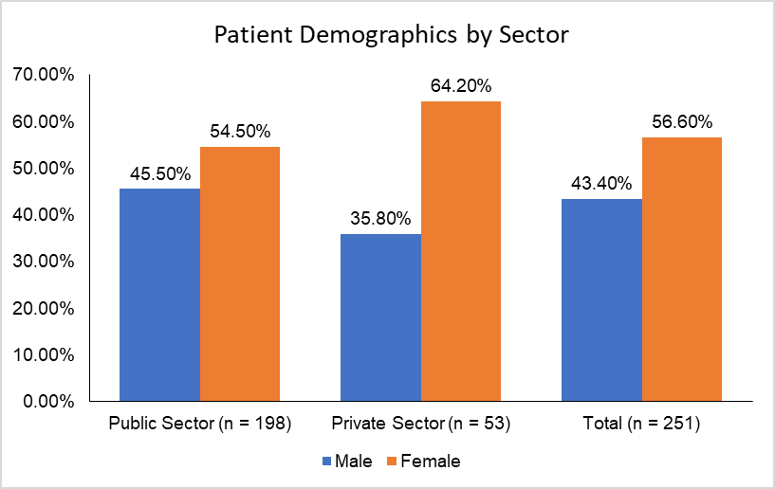
Figure 1: Demographic characteristic of malaria patient in the Buea Health District
3.2 Symptoms or signs presented by patients
In the Buea Health District, malaria patients predominantly presented with fever (81.3%) and headache (86.1%), confirming these as hallmark symptoms across both public and private health facilities (Table 1). Joint pain was moderately common (42.2%), while gastrointestinal symptoms like vomiting (9.6%), anorexia (15.5%), and diarrhoea (19.1%) appeared with lower frequency (Table 1). Notably, symptoms such as nausea (2.8%), asthenia (1.2%), and dizziness (1.2%) were rare, and insomnia and dyspnea were entirely absent (Table 1). The private sector showed slightly higher proportions for vomiting, anorexia, and diarrhoea (Table 1). Overall, the symptom profile aligns with classical malaria presentations, with some variability that may reflect co-infections or individual health-seeking behaviours.
Table 1: Sign and Symptoms of patients at the Buea health district
Symptom | Public Health (n = 198) | Private Health (n = 53) | Total (n = 251)
Fever | 161 (81.3%) | 44 (83.0%) | 204 (81.3%)
Headache | 171 (86.4%) | 45 (84.9%) | 216 (86.1%)
Joint pain | 86 (43.4%) | 20 (37.7%) | 106 (42.2%)
Nausea | 6 (3.0%) | 1 (1.9%) | 7 (2.8%)
Vomiting | 18 (9.1%) | 6 (11.3%) | 24 (9.6%)
Asthenia | 3 (1.5%) | 0 (0.0%) | 3 (1.2%)
Anorexia | 28 (14.1%) | 11 (20.8%) | 39 (15.5%)
Diarrhea | 36 (18.2%) | 12 (22.6%) | 48 (19.1%)
Cough | 31 (15.7%) | 8 (15.1%) | 39 (15.5%)
Catarrh | 8 (4.0%) | 2 (3.8%) | 10 (4.0%)
Odynophagia | 7 (3.5%) | 1 (1.9%) | 8 (3.2%)
Abdominal pain | 26 (13.1%) | 7 (13.2%) | 33 (13.1%)
Dizziness | 3 (1.5%) | 0 (0.0%) | 3 (1.2%)
Insomnia | 0 (0.0%) | 0 (0.0%) | 0 (0.0%)
Dyspnea | 0 (0.0%) | 0 (0.0%) | 0 (0.0%)
Chills | 5 (2.5%) | 0 (0.0%) | 5 (2.0%)
Sweat | 1 (0.5%) | 0 (0.0%) | 1 (0.4%)
Chest pain | 1 (0.5%) | 0 (0.0%) | 1 (0.4%)
*Others | 6 (3.0%) | 4 (7.5%) | 10 (4.0%)

In the Buea Health District, the clinical diagnosis of malaria overwhelmingly centers on simple malaria, which accounts for 70.5% of all cases, indicating it is the most commonly identified and likely the most straight forward to manage (Figure 2). A notable proportion of patients (28.7%) were diagnosed with simple malaria accompanied by other conditions (Figure 2). In contrast, diagnoses of clinical malaria and poorly treated malaria were rare each (0.4%), and suspected malaria was entirely absent from the dataset (Figure 2). This distribution highlights a diagnostic focus on uncomplicated malaria presentations, with limited recognition or documentation of atypical or mismanaged cases, which may reflect either effective early detection or gaps in diagnostic sensitivity.
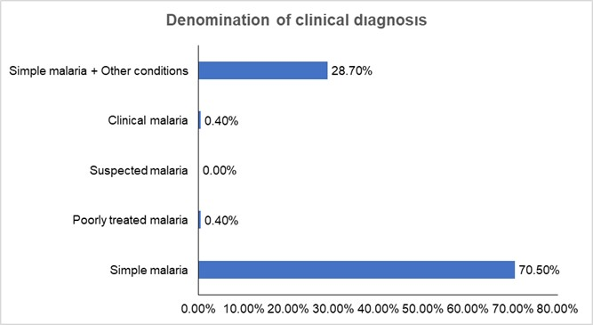
Figure 2: Denomination of clinical diagnosis
3.3 Diagnosis base on laboratory result
In the Buea Health District, clinical and biological laboratory results show high testing coverage across both public and private sectors, with 93.2% of patients undergoing diagnostic tests (Figure 3). Public health facilities (93.4%) slightly outperform private ones (92.5%) in test completion and in requesting tests (71.2% and 68.5% respectively) (Figure 3). Positive thick blood smear results dominate (46.2%) overall, especially in public facilities (48.7%), indicating a high burden of confirmed malaria cases (Figure 3). Rapid Diagnostic Tests (RDTs) also show notable positivity (22.3%), with public health again leading (23.7%) (Figure 3). Interestingly, negative results for both smear and RDT are minimal, reinforcing the clinical suspicion of malaria in most cases.
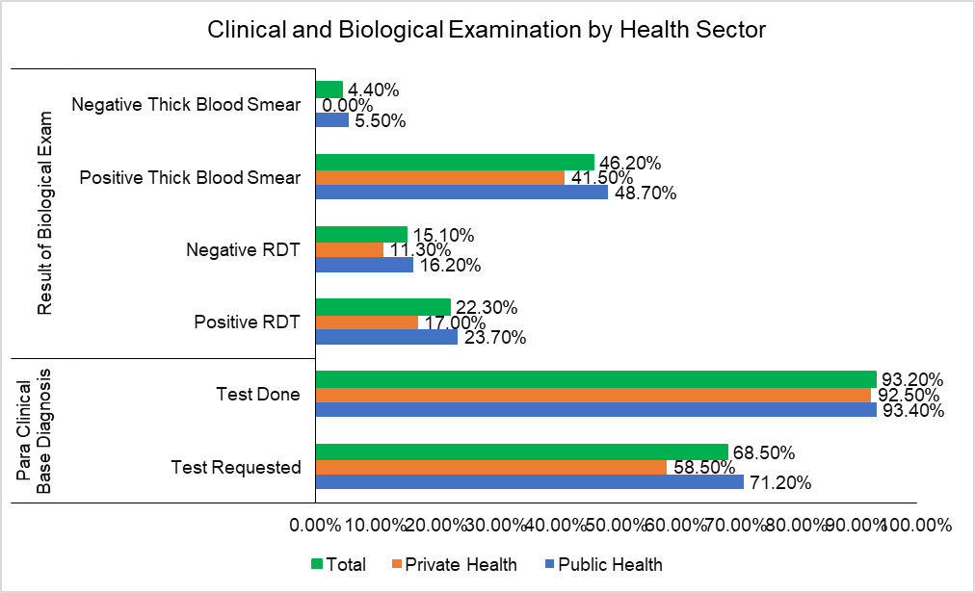
Figure 3: Clinical and biological examination by health sectors in Buea health district
3.4 Antimalaria use in treatment of simple malaria
Figure 4 illustrates antimalarial treatment practices show a strong reliance on Artemisinin-based Combination Therapy (ACT), which was administered in 92.43% of cases. Notably, over half of these treatments (56.97%) were given after diagnostic results, while a significant portion (35.46%) were initiated before results (Figure 4). Artemether/Lumefantrine (AL) was the most commonly used ACT regimen (21.91%), with slightly more cases treated before results (12.30%) than after (9.61%) (Figure 4). Other regimens like ASAQ and DHA/PQP were used sparingly, and monotherapies appeared in mixed combinations but at low frequencies (Figure 4).
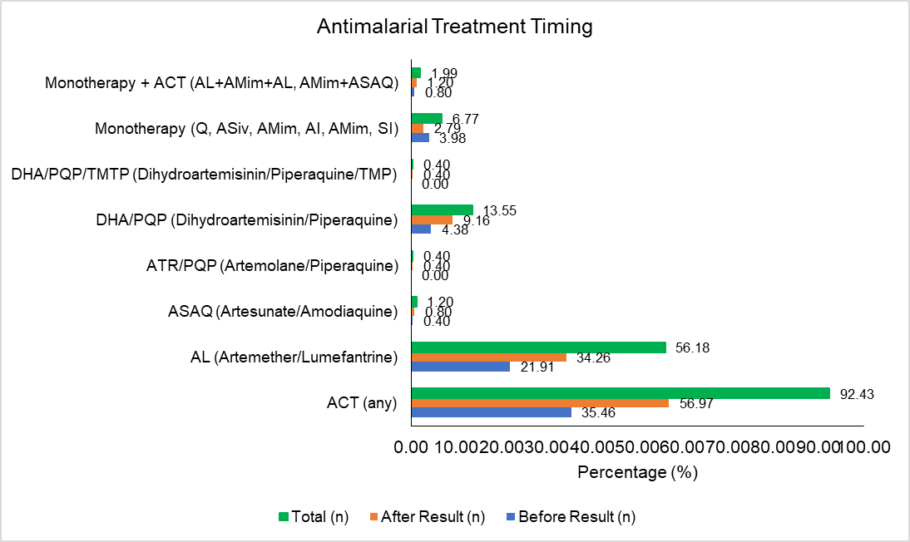
Figure 4: Antimalaria use in treatment of simple malaria
3.5 Adequate prescription in function of antimalarial prescribe
Table 2 presents the distribution of Artemisinin-based Combination Therapy (ACT) prescriptions across five key treatment parameters. Overall, ACTs were prescribed in 93.2% of cases, with consistent documentation of galenic form, dosage, quantity, and treatment duration (Table 2). Among specific ACTs, artemether-lumefantrine (AL) was the most frequently prescribed (53.4%), followed by artesunate-amodiaquine (ASAQ) at 36.8%. Less commonly used combinations included DHA/PQP (5.6%), DHA/PQP/TMTP and ATR/PQP (0.9%) each, while AS/MQ was not prescribed at all (Table 2). Notably, posology was slightly less consistently recorded (84.1%) compared to other parameters (Table 2). A small proportion of prescriptions involved non-standard or adjunct formulations such as injectable artesunate (ASiv), amodiaquine syrup (AMim), or oral quinine (Oral Q), with treatment duration documented in 7.3% of these cases (Table 2).
Table 2: Adequate prescription in respect to antimalarial prescribe
Variables | Galenic Form (n, %) | Dosage (n, %) | Quantity (n, %) | Posology (n, %) | Treatment Duration (n, %)
ACT Prescribe | 234 (93.2) | 234 (93.2) | 234 (93.2) | 211 (84.1) | 234 (93.2)
AL | 126 (53.4) | 126 (53.8) | 126 (53.8) | 108 (51.2) | 126 (53.8)
ASAQ | 89 (36.8) | 89 (38.0) | 89 (38.0) | 86 (40.8) | 89 (38.0)
DHA/PQP | 13 (5.6) | 13 (5.6) | 13 (5.6) | 13 (6.2) | 13 (5.6)
DHA/PQP/TMTP | 2 (0.9) | 2 (0.9) | 2 (0.9) | 2 (0.9) | 2 (0.9)
AS/MQ | 0 | 0 | 0 | 0 | 0
ATR/PQP | 2 (0.9) | 2 (0.9) | 2 (0.9) | 2 (0.9) | 2 (0.9)
AL+AMim, ASAQ+AMim | 0 | 0 | 0 | 0 | 2 (0.9)
ASiv, AMim or sirop, Oral Q | 7 (3.0) | 16 (6.8) | 16 (6.8) | 15 (7.1) | 17 (7.3)
AL: artemether/lumefantrine, ASAQ: artesunate/amodiaquine, DHA/PQP: dihydroartemisinin/piperaquine, ATR/PQP: arterolane/piperaquine, AS/MFQ: artesunate/mefloquine, AS/SP: artesunate/sulfadoxine/pyrimethamine, ASiv: Intravenous artesunate, AMim: Intramuscular artemether
3.6 Rationalization of ACT: Global evaluation on prescription
Figure 5 reveals critical gaps in malaria diagnosis and treatment adequacy. Despite 95.1% of patients undergoing biological examination and 81.3% presenting with fever, and only 25.8% had a positive rapid diagnostic test (RDT). None of those with positive RDT or thick blood smear results were placed on treatment. However, among those treated, the quality of care was relatively high: 100% received adequate treatment duration and galenic form appropriate for age, 94.6% had correct posology, and 86% were correctly treated with ACT (Figure 5). Prescription rationalization stood at 42.6% (Figure 5).
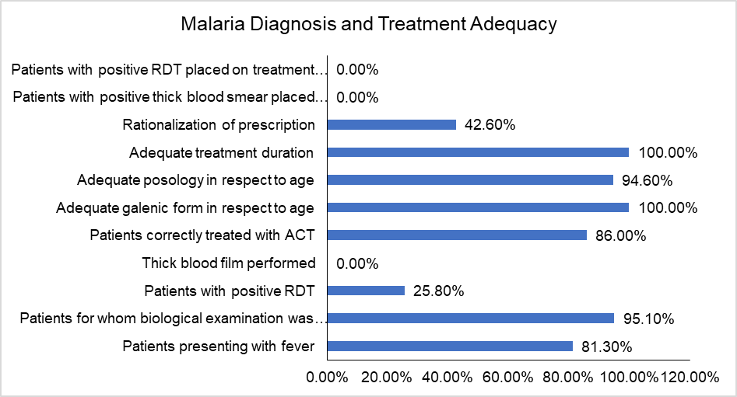
Figure 5: The rationalize use of anti-malaria
4. DISCUSSION
The observed gender disparity in patient demographics in the Buea District, with females predominating in both public and private healthcare sectors, aligns with broader trends documented in healthcare utilization studies. Pineault et al. (2017), Chapnkem, (2019) and Tessema et al. (2022) reported that females generally exhibit higher healthcare-seeking behaviour compared to males, a phenomenon reported across diverse settings including sub-Saharan Africa and other developing regions. This may be attributed to women's increased health service needs related to reproductive and maternal health, as well as greater health awareness and preventive care utilization.
Moreover, the pronounced female dominance in the private sector may reflect socio-economic and cultural factors influencing healthcare preferences and access, where women might prioritize or have more urgent health needs met through private facilities (Tessema et al., 2022). Despite women facing barriers such as cost and access, they still constitute a larger share of patients, which has implications for healthcare planning and resource allocation to ensure gender-sensitive service delivery. The overall female representation corroborates findings from studies of Pineault et al. (2017) and Daher et al. (2021) reporting consistent female predominance in patient populations, highlighting the importance of integrating gender considerations for equitable healthcare provision.
The symptom profile of malaria patients in the Buea Health District, dominated by fever and headache, is consistent with classical presentations of Plasmodium falciparum infection, which remains the most prevalent species in Cameroon and sub-Saharan Africa (PMI, 2024). These hallmark symptoms are widely documented as primary indicators of uncomplicated malaria and are often the basis for presumptive diagnosis in endemic regions (Tessema et al., 2022).
The moderate occurrence of joint pain and the lower prevalence of gastrointestinal symptoms such as vomiting, anorexia, and diarrhoea reflect the variable clinical spectrum of malaria, which may be influenced by host immunity, age, and co-existing infections (Dondorp et al., 2020). The slightly higher rates of gastrointestinal symptoms in private facilities may suggest differences in patient profiles, reporting practices, or health-seeking behaviour, as private clinics often attract individuals with more persistent or atypical symptoms (Chapnkem, 2019). The rarity of symptoms like nausea, asthenia, and dizziness, and the complete absence of insomnia and dyspnoea, further supports the predominance of uncomplicated malaria cases in this setting. These findings reinforce the importance of symptom-based screening while highlighting the need for differential diagnosis to capture atypical or overlapping presentations.
The predominance of simple malaria diagnoses reflects a diagnostic landscape heavily oriented toward uncomplicated presentations, consistent with national patterns where Plasmodium falciparum remains the dominant species and uncomplicated malaria is most frequently encountered and managed (PMI, 2024). The additional 28.7% of cases involving simple malaria with comorbid conditions suggests a clinical overlap with other endemic illnesses, yet the rarity of clinical malaria and poorly treated malaria, and the complete absence of suspected malaria, may signal either successful early case detection or limitations in diagnostic sensitivity and documentation practices. This trend aligns with findings from the NIS, NMCP and ICF, (2023) which reported that less than 30% of febrile children nationally were tested for malaria, indicating a reliance on clinical judgment over parasitological confirmation in many settings.
Moreover, stratification data supported by WHO and PMI show that Buea falls within a medium-risk zone, where diagnostic emphasis may prioritize rapid management of uncomplicated cases to reduce morbidity, in line with the Health Sector Strategy (2016–2027) and PMI’s End Malaria Faster framework. However, the underrepresentation of atypical or mismanaged malaria cases may obscure the true burden of diagnostic challenges, especially given evidence of declining therapeutic efficacy and emerging resistance mutations in P. falciparum across Cameroon (Antonio-Nkondjio et al., 2019). These findings underscore the need for enhanced diagnostic protocols and surveillance to capture the full spectrum of malaria presentations and improve case management fidelity.
The clinical and laboratory data from the Buea health district, reflect a robust malaria testing regime, with an overall patient testing coverage spanning both public and private healthcare sectors. Public facilities showed marginally better performance than private ones in test completion rates and in initiating diagnostic tests. This finding is similar with the findings of Jerene et al. (2012) and Argaw et al. (2015) who reported that malaria-endemic settings where public health systems typically ensure more consistent testing coverage. The dominance of positive thick blood smear results, particularly in public health centers, signifies a substantial burden of confirmed malaria, consistent with high prevalence rates reported in Cameroon and comparable regions (Karunamoorthi, 2009; Missoup et al., 2025).
Rapid Diagnostic Tests (RDTs) also yielded significant positivity, with public facilities again leading, aligning with documented high accuracy and reliability of publicly procured RDTs in Cameroon, although variable by transmission intensity and facility (Hopkins et al., 2017; Ali et al., 2021). The minimal proportion of negative smear and RDT results strongly supports the clinical suspicion of malaria in suspected cases and underlines the effectiveness of diagnostic targeting, a critical factor in reducing over-treatment and improving case management (Ige et al., 2014; Mortazavi et al., 2025). This high diagnostic coverage and positivity emphasize the persistent malaria burden in the Buea Health District and underscore the crucial role of both thick smear microscopy and RDTs in malaria surveillance and control efforts.
Antimalarial treatment practices in the Buea Health District reveal a predominant reliance on Artemisinin-based Combination Therapy (ACT), administered in most of cases, which is aligned with World Health Organization (WHO) recommendations for the treatment of uncomplicated Plasmodium falciparum malaria (WHO, 2018). More than half of these treatments were given post-diagnostic confirmation, reflecting adherence to test-based case management, while a considerable amount was initiated before results, indicating some empirical treatment due to clinical urgency or suspicion.
Artemether-Lumefantrine (AL) was the most widely used ACT, with a slightly higher proportion treated prior to diagnostic confirmation than after, consistent with the reults of Teklemariam et al. (2017) and Kamya et al. (2025) who established efficacy, rapid parasite clearance, and extensive first-line use in sub-Saharan Africa. Other regimens like Artesunate-Amodiaquine (ASAQ) and Dihydroartemisinin-Piperaquine (DHA/PQP) were used sparingly, in accordance with regional treatment preferences and availability (Zongo et al., 2020). ACT prescriptions were thoroughly documented regarding galenic form, dosage, quantity, and treatment duration, although posology documentation lagged slightly, a common challenge in clinical settings (Zongo et al., 2020). Adjunct therapies such as injectable artesunate, amodiaquine syrup, and oral quinine appeared infrequently, highlighting some deviations or supplementary treatments. However, among those treated, care quality was commendable: all received appropriate treatment duration and galenic form, had correct posology, and were treated with ACT, although prescription rationalization was less. These findings illustrate strong adherence to ACT treatment protocols in Buea but also underscore the urgent need to improve linkage between diagnosis and treatment to optimize malaria case management and reduce unnecessary drug use (Teklemariam et al., 2017; Zongo et al., 2020).
5. Conclusion

Malaria case management in the Buea Health District shows strong diagnostic coverage and widespread use of recommended treatments, particularly artemisinin-based combination therapies. Clinical presentations were consistent with classical malaria symptoms, and laboratory testing was routinely implemented across both public and private sectors. However, gaps remain between diagnostic confirmation and treatment initiation, with some confirmed cases not receiving therapy. While treatment quality was generally high among those treated, documentation inconsistencies and limited prescription rationalization suggest areas for improvement. These findings highlight the need for better alignment between diagnostic outcomes and therapeutic decisions to enhance malaria control and patient care effectiveness.

Ethical approval (where ever applicable)

The study was conducted in strict adherence to ethical principles. Written informed consent (or assent for minors with guardian consent) was obtained from all participants after a detailed explanation of the study's purpose, procedures, benefits, and risks. All data collected were kept confidential; participant identifiers were removed and replaced with codes known only to the research team. The data were used solely for the purpose of this research and were securely stored and destroyed upon the study's completion.

COMPETING INTERESTS DISCLAIMER:
Authors have declared that they have no known competing financial interests OR non-financial interests OR personal relationships that could have appeared to influence the work reported in this paper.

References

Ali I.M., Nji A.M., Bonkum J.C., Moyeh M.N., Carole G.K., Efon, A., Dabou S., Tchuenkam V.P.K., Tah C., Kengne J.-P.C., Achu D.F., Bigoga J.D., Mbacham W.F. (2021). Diagnostic Accuracy of CareStart™ Malaria HRP2 and SD Bioline Pf/PAN for Malaria in Febrile Outpatients in Varying Malaria Transmission Settings in Cameroon. Diagnostics, 11:1556. https://doi.org/10.3390/diagnostics11091556
Antonio-Nkondjio, C., Ndo, C., Njiokou, F., Bigoga J.D., Awono-Ambene P., Etang J., Ekobo A.S., Wondji C.S. (2019). Review of malaria situation in Cameroon: technical viewpoint on challenges and prospects for disease elimination. Parasites Vectors 12, 501 (2019). https://doi.org/10.1186/s13071-019-3753-8
Apinjoh, T. O., Mbunwe, E., Yafi, C., Besingi, R., Awah, N., Anchang-Kimbi, J., & Achidi, E. A. (2008). Febrile status, malaria parasitaemia and gastrointestinal helminthiasis in school children resident at different altitudes in south-western Cameroon. Annals of Tropical Medicine & Parasitology, 102(2), 103–118. https://doi.org/10.1179/136485908X252287
Argaw MD (2015). Knowledge and practice on malaria diagnosis and treatment among healthcare providers working in private health facilities in Ethiopia: A cross-sectional facility-based survey. Malaria World Journal, 6(10): 1-8. https://doi.org/10.5281/zenodo.10870388
Balikagala, B., Fukuda, N., Ikeda, M., Katuro, O. T., Tachibana, S. I., Yamauchi, M., … & Mita, T. (2021). Evidence of artemisinin-resistant malaria in Africa. New England Journal of Medicine, 385(13), 1163–1171. https://doi.org/10.1056/NEJMoa2101746
Biswas, S., Banerjee, S., & Kaur, P. (2021). Determinants of patient adherence to antimalarial medicines: A systematic review of evidence from sub-Saharan Africa. Journal of Multidisciplinary Healthcare, 14, 99–115. https://doi.org/10.2147/JMDH.S291944
Boyce, M. R., & O’Meara, W. P. (2017). Use of malaria RDTs in various health contexts across sub-Saharan Africa: a systematic review. BMC Public Health, 17, 470. https://doi.org/10.1186/s12889-017-4398-1
Chapnkem W.C. (2019). Perceptions of Access to Healthcare in Cameroon by Women of Childbearing Age. PhD thesis. Walden University
Hopkins H., Bruxvoort K.J., Cairns M.E., Chandler C.I.R., Leurent B., Evelyn K Ansah E.K., Baiden F., Kimberly A Baltzell et al. (2017). Impact of introduction of rapid diagnostic tests for malaria on antibiotic prescribing: analysis of observational and randomised studies in public and private healthcare settings. BMJ, 356:j1054 http://dx.doi.org/10.1136/bmj.j1054
Jerene D., Fentie G., Teka M., Girma S., Chibsa S., Teka H., Reithinger R. (2012). The role of private health facilities in the provision of malaria case management and prevention services in four zones of Oromia Regional State, Ethiopia. International Health, 4(1):70–73. https://doi.org/10.1016/j.inhe.2011.11.001
Kamya M.R., Nankabirwa J.I., Ebong C., Asua V., Kiggundu M., Orena S., Okitwi M., Tukwasibwe S., Agaba B., Kyabayinze D et al. (2025). Efficacies of artemether–lumefantrine, artesunate–amodiaquine, dihydroartemisinin–piperaquine, and artesunate–pyronaridine for the treatment of uncomplicated Plasmodium falciparum malaria in children aged 6 months to 10 years in Uganda: a randomised, open-label, phase 4 clinical trial. The Lancet Infectious Diseases, 19. https://doi.org/10.1016/S1473-3099(25)00407-4
Karunamoorthia K. & Bekele M. (2009). Prevalence of malaria from peripheral blood smears examination: A1-year retrospective study from the Serbo Health Center, Kersa Woreda, Ethiopia. Journal of Infection and Public Health, 2:171—176
Mangham-Jefferies, L., Hanson, K., Mbacham, W., Onwujekwe, O., & Wiseman, V. (2014). Mind the gap: knowledge and practice of providers treating uncomplicated malaria at public and mission health facilities, pharmacies and drug stores in Cameroon and Nigeria. Health Policy and Planning, 30(9), 1129–1141. https://doi.org/10.1093/heapol/czu118
Marilyne Daher M., Al Rifai M., Kherallah R.Y., Rodriguez F., Mahtta D., Michos E.D., Khan S.U., Petersen L.A., Virani S.S. (2021). Gender disparities in difficulty accessing healthcare and cost-related medication non-adherence: The CDC behavioural risk factor surveillance system (BRFSS) survey. Preventive Medicine, 153:106779. https://doi.org/10.1016/j.ypmed.2021.106779
Missoup V.O., Suh P.F., Ndjebakal C.N., Tagne D., Poumachu Y., Joko S., Djilla A.K., Njiokou F., Mbacham W., Wondji C. & Ndo C. (2025). Malaria infection prevalence and diagnostic performance of the Abbott Bioline Malaria Ag P.f/Pan rapid test in rural populations of Central Cameroon. Scientific Reports, 15:27930. https://doi.org/10.1038/s41598-025-13688-8
Mortazavi SE, Lugaajju A, Ivarsson A-C, Karlsson Söbirk S, Norrgren H and Persson KEM (2025) High rate of false positive malaria rapid diagnostic tests in a district hospital in Uganda. Front. Malar. 3:1545825. https://doi.org/10.3389/fmala.2025.1545825
National Institute of Statistics (NIS), National Malaria Control Programme (NMCP), and ICF. 2023. Cameroon Malaria Indicator Survey 2022. Key Indicators Report. Yaounde, Cameroon, and Rockville, Maryland, USA: NIS, NMCP, and ICF.
Nnoko, S. A., Bate, D. O., Abuuchiche, F. B. I., Enow, N. B. E., Ntungwe, E. S., & Eboumbou, M. C. (2025). Assessment of Prescribers’ Knowledge, Diagnostic Decision-Making, and Rational Antimalarial Drug Use in the Management of Uncomplicated Malaria in the Buea Health District, Cameroon. Journal of Advances in Medical and Pharmaceutical Sciences, 27(11), 116–133. https://doi.org/10.9734/jamps/2025/v27i11832
Nsai, S. F., Tchouaket, E. N., & Ama Moor, V. J. (2021). The economic burden of malaria in Cameroon: A systematic review. PLOS ONE, 16(11), e0258749. https://doi.org/10.1371/journal.pone.0258749
Okebe, J., Mwesigwa, J., & Mokuolu, O. A. (2022). The socioeconomic burden of malaria in children: A systematic review and meta-analysis. BMJ Global Health, 7(3), e007532. https://doi.org/10.1136/bmjgh-2021-007532
Pineault R., Da Silva R.B., Provost S., Fournier M., Alexandre Prud’homme A., Levesque J.F. (2017). Do Gender-Predominant Primary Health Care Organizations Have an Impact on Patient Experience of Care, Use of Services, and Unmet Needs? The Journal of Health Care Organization, Provision, and Financing Volume 54: 1 –9. https://doi.org/10.1177/0046958017709688
PMI Cameroon Malaria Profile (2024). Available: https://mesamalaria.org/wp-content/uploads/2025/04/CAMEROON_Malaria_Profile_PMI_FY_2024.pdf Accessed 03/10/2025
Teklemariam M., Assefa A., Kassa M., Mohammed H., Mamo H. (2017). Therapeutic efficacy of artemether-lumefantrine against uncomplicated Plasmodium falciparum malaria in a high-transmission area in northwest Ethiopia. PLoS ONE12(4): e0176004. https://doi.org/10.1371/journal.pone.0176004
Tessema ZT, Worku MG, Tesema GA, Alamneh T.S., Teshale A.B., Yeshaw Y., Alem A.Z., Ayalew H.G., Liyew A.M. (2022). Determinants of accessing healthcare in Sub- Saharan Africa: a mixed- effect analysis of recent Demographic and Health Surveys from 36 countries. BMJ Open, 12: e054397. https://doi.org/10.1136/bmjopen-2021-054397
World Health Organization (2025). WHO guidelines for malaria, 13 August 2025. World Health Organization. http://dx.doi.org/https://doi.org/10.2471/B09514. License: CC BY-NC-SA 3.0 IGO
World Health Organization. (2015). Guidelines for the treatment of malaria (3rd ed.). WHO Press. ISBN: 9789241549127. Available at: WHO publication
World Health Organization. (2023). World malaria report 2023. WHO Press. Available at: WHO malaria report 2023
Zongo I., Compaoré Y.D., Nikiéma F., Zongo M., Barry N., Somé F.A., Kaboré N., Ouédraogo J.B. (2020). Efficacy of artemether-lumefantrine and artesunate-amodiaquine as first line therapy of uncomplicated malaria in Burkina Faso, 11 years after policy change, Pan African Medical Journal, 35:68 https://doi.org/10.11604/pamj.2020.35.68.20849

Reference to Web-resource or Electronic articles.
Hugo, J. T., & Mondal, S. C. (2006). Parallels between tissue repair and embryo morphogenesis: A conceptual framework. Global Health, 16, 4. https://doi.org/10.1186/1744-8603-1-14

Anonymous. (2006). Parallels between tissue repair and embryo morphogenesis: A conceptual framework. Globalization and Health, 16(4). http://www.globalizationandhealth.com/content/1/1/14

