Case Report
Management of Symptomatic Internal Resorption with Contemporary Endodontic Approaches: A Case Report

ABSTRACT
Although rare, internal resorption is a pathology that can severely compromise the structural integrity of a tooth if not diagnosed early and treated appropriately. In this case report, symptomatic internal resorption detected in the mandibular right second premolar of an 18-year-old patient was managed with endodontic treatment performed under magnification using a dental microscope. Following clinical and radiographic evaluations, the tooth diagnosed with internal resorption underwent thorough canal disinfection under the dental microscope. The resorptive defect was carefully filled with mineral trioxide aggregate (MTA) using the micro-apical placement (MAP) system. Root canal obturation was completed with a thermoplastic gutta-percha technique. Post-treatment, the patient’s symptoms completely resolved, and one-year follow-up radiographs revealed no pathological findings in the periapical tissues. This case demonstrates that endodontic treatment performed under a dental microscope, using MTA placed with the MAP system and thermoplastic obturation techniques, can achieve successful clinical and radiographic outcomes in cases of symptomatic internal resorption.
Keywords: Internal resorption, dental microscope, MTA, thermoplastic gutta-percha, endodontic treatment

INTRODUCTION
Internal resorption is a rare pathology characterized by the resorptive destruction of dentin resulting from inflammation of the pulpal tissue. Although most cases are asymptomatic, progression of the lesion may lead to pain, structural weakening of the tooth, and, if left untreated, tooth loss (1).
Radiographically, internal resorption appears as well-defined, oval or round radiolucent areas within the root canal system, and distinguishing it from external resorption is critical for appropriate treatment planning. Misdiagnosis can lead to inadequate treatment approaches and adversely affect prognosis (2). In this context, the use of a dental microscope allows direct visualization of the resorptive areas, enhancing diagnostic accuracy and enabling a more controlled treatment process (3).
The primary goal in the treatment of internal resorption is to halt the resorptive process, disinfect the canal system effectively, and hermetically seal the resorptive defect. For this purpose, mineral trioxide aggregate (MTA) is widely preferred in cases of internal resorption due to its biocompatibility, high sealing ability, and capacity to promote hard tissue formation (4).
Due to the irregular anatomy of resorptive defects, the root canal obturation technique is also a critical factor affecting treatment success. Thermoplastic gutta-percha techniques provide better adaptation to complex canal anatomies, improving the homogeneity of the filling and reducing the risk of microleakage (5).
The aim of this case report is to present the treatment of a tooth diagnosed with symptomatic internal resorption using MTA and thermoplastic gutta-percha techniques under a dental microscope, along with the clinical and radiographic outcomes after one year of follow-up.

CASE REPORT
An 18-year-old systemically healthy female patient presented to our clinic with a complaint of pain in the region of the mandibular right second premolar. The patient’s medical history revealed no previous endodontic treatment on the affected tooth. Clinical examination revealed percussion sensitivity on tooth #45, while palpation and periodontal probing showed no pathological findings.
Periapical radiography revealed a well-defined radiolucent area within the root canal system of tooth #45, consistent with internal resorption (Figure 1). Based on the clinical and radiographic findings, endodontic treatment was planned. Prior to the procedure, the patient was informed about the treatment, and both verbal and written informed consent were obtained.
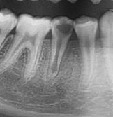
Figure 1. Preoperative periapical radiograph of tooth #45 showing a well-defined radiolucent area within the root canal system, consistent with internal resorption.
After administration of local anesthesia and isolation with a rubber dam, the access cavity was prepared under magnification using a dental microscope. Working length was determined, followed by canal preparation and irrigation with sodium hypochlorite and EDTA solutions. To seal the resorptive defect, the root canal system was carefully dried, and mineral trioxide aggregate (NeoPUTTY MTA) was placed in the resorptive area in a controlled manner using the micro-apical placement (MAP) system (Figure 2). A temporary restoration was placed, and the tooth was left for three days to allow MTA to set.
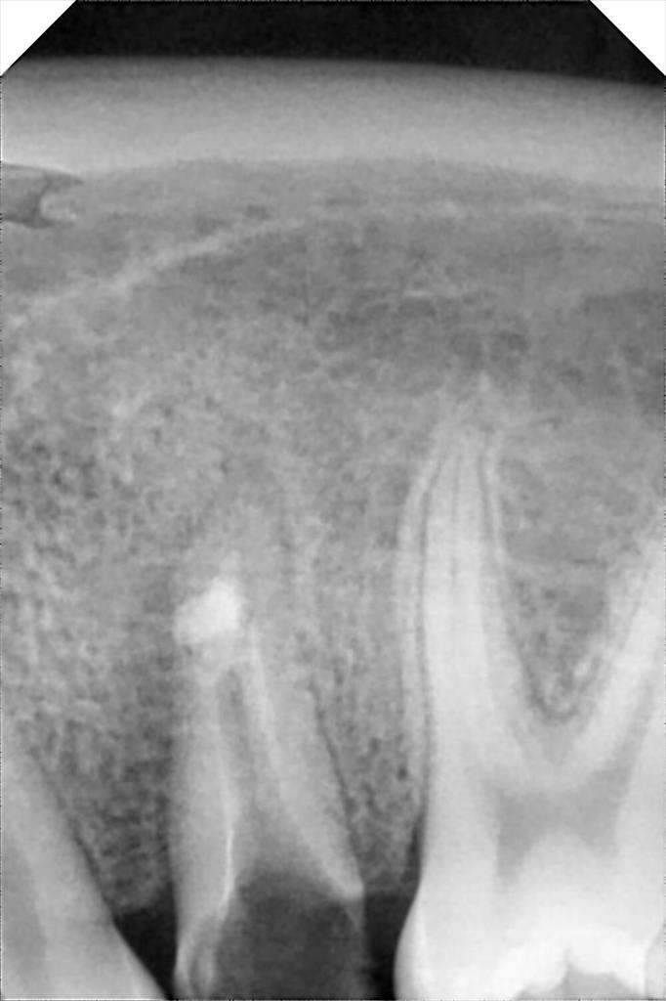
Figure 2. Placement of mineral trioxide aggregate (NeoPUTTY MTA) in the resorptive defect using the micro-apical placement (MAP) system under dental microscope magnification.

At the follow-up session three days later, the setting of MTA was confirmed under the dental microscope. The root canal obturation was then completed using a thermoplastic gutta-percha technique, and the tooth was restored with an appropriate coronal restoration. Post-treatment radiography demonstrated a homogeneous root canal filling and hermetic sealing of the resorptive defect (Figure 3).
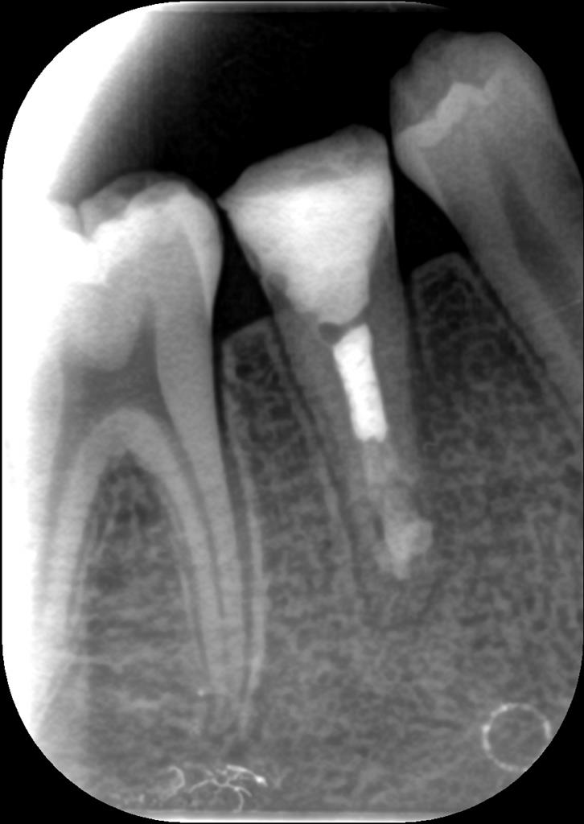
Figure 3. Postoperative periapical radiograph showing a homogeneous root canal filling and hermetic sealing of the resorptive defect.

The patient reported complete resolution of pain after treatment. At one-year clinical and radiographic follow-up, no symptoms were observed, periapical tissues showed no pathological findings, and the treatment outcome was maintained (Figure 4).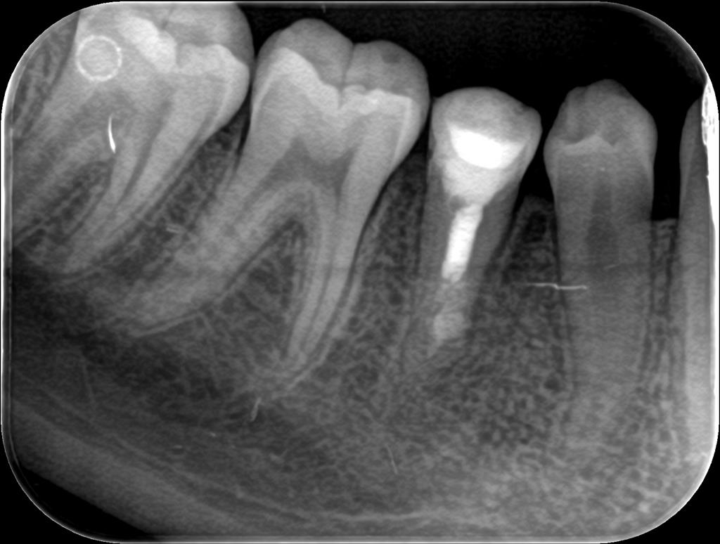
Figure 4. One-year follow-up periapical radiograph demonstrating maintained obturation integrity and absence of periapical pathology.

DISCUSSION
Internal resorption is a rare but clinically significant pathology characterized by resorptive destruction of dentin due to inflammatory processes in the pulpal tissue. Although most cases are asymptomatic, advanced lesions may present with pain and structural weakening of the tooth, and prognosis can be adversely affected if early diagnosis is not established (6). Therefore, accurate diagnosis and appropriate treatment are critical in cases of internal resorption.
Radiographically, internal resorption appears as well-defined radiolucent areas within the root canal system, which is an important feature for distinguishing it from external resorption. However, differentiating between these two types of resorption is not always straightforward, and misdiagnosis may lead to inappropriate treatment planning (7). In this case, clinical and radiographic findings supported the diagnosis of internal resorption, and endodontic treatment was planned.
The primary goal in treating internal resorption is to halt the resorptive process and achieve a hermetic seal of the resorptive defect. For this purpose, mineral trioxide aggregate (MTA) is widely used in internal resorption cases due to its biocompatibility, high sealing ability, and capacity to promote hard tissue formation (8). In the present case, MTA was selected to seal the resorptive defect, allowing sufficient time for the material to set.
The irregular anatomy of resorptive defects can make it challenging to achieve a homogeneous root canal filling. Therefore, the obturation technique is a key factor directly affecting treatment success. Thermoplastic gutta-percha techniques offer better adaptation to complex canal anatomies, providing advantages in filling resorptive areas (9). In this case, following MTA placement, the root canal obturation was completed using a thermoplastic gutta-percha technique to enhance the homogeneity and seal of the filling.
Several case reports in the literature have documented successful treatment of internal resorption (10,11). In this case, the complete resolution of symptoms and the absence of pathological findings on one-year clinical and radiographic follow-up support the effectiveness of the applied treatment approach. Nevertheless, it should be noted that long-term follow-up is essential for evaluating the prognosis of internal resorption cases.

CONCLUSION
Early diagnosis and appropriate endodontic management of internal resorption are crucial to preserve the functional integrity of the tooth. In this case, a tooth diagnosed with symptomatic internal resorption was successfully treated with MTA placement followed by thermoplastic gutta-percha obturation, achieving favorable clinical and radiographic outcomes. The complete resolution of symptoms and absence of pathological findings during one-year follow-up further support the effectiveness of this treatment approach. However, long-term clinical and radiographic follow-up remains necessary to assess prognosis in such cases.

REFERENCES
1. Gadzhula N, Povsheniuk A, Cherepakha O. DIAGNOSIS OF INTERNAL ROOT RESORPTION: CLINICAL MANIFESTATIONS AND RADIOLOGICAL FEATURES. East Ukr Med J. 31 Mart 2024;12(1):106-15.
2. Sharki A, Ali A. Root Resorption in the Permanent Teeth. A Review. Cumhur Dent J. 29 Eylül 2023;26(3):321-7.
3. Low JF, Dom TNM, Baharin SA. Magnification in endodontics: A review of its application and acceptance among dental practitioners. Eur J Dent. Ekim 2018;12(04):610-6.
4. Mittal N, Dhakad C, Sharma S, Singh D. Management of Internal Root Resorption With Mineral Trioxide Aggregate in Mandibular Molar: A Case Report. Cureus. 17(11):e96174.
5. Sadat SMAE, Chew HP, Fok A, Elashiry MM, ElShenawy AM, Saber S. Quality of different obturation techniques to fill perforating internal root resorption: a micro-computed tomographic study. BMC Oral Health. 13 Temmuz 2024;24(1):784.
6. Patel S, Saberi N, Pimental T, Teng P. Present status and future directions: Root resorption. Int Endod J. Ekim 2022;55(Suppl 4):892-921.
7. Hellyer P. Root resorption. Br Dent J. 01 Nisan 2023;234(7):517-517.
8. Pereira da Costa R, Quaresma SA, Lopes FC, Camargo R, Domingos Pires M, Ginjeira A, vd. Management of a perforating internal root resorption using mineral trioxide aggregate: a case report with 5-year follow-up. Aust Endod J J Aust Soc Endodontology Inc. Aralık 2020;46(3):452-7.
9. Yazdi KA, Aminsobhani M, Alemi P. Comparing the Ability of Different Materials and Techniques in Filling Artificial Internal Resorption Cavities. Eur Endod J. 13 Aralık 2018;4(1):21-7.
10. Dianat O, Zadsirjan S, Jabbari S, Ghorbanzadeh S. Treatment of Perforating Internal Root Resorption with MTA and Management of Discoloration Caused By MTA: A Case Report. Sch J Dent Sci. Haziran 2016;3(6):180-3.
11. Mirzaie A, Zargar N, Shahhosseini R. Hybrid Approach to Manage Inflammatory Internal Root Resorption: A Case Report. Iran Endod J. 2025;20(1):e18.

