Case Report
SHIFTING THE PARADIGM: RARE MANDIBULAR OCCURRENCE OF PSAMMOMATOID JUVENILE OSSIFYING FIBROMA

ABSTRACT: Juvenile ossifying fibroma (JOF) is a rare, benign fibro-osseous neoplasm characterized by aggressive local behaviour and a tendency for rapid growth. It is distinguished from other fibro-osseous lesions primarily by its early age of onset, distinct clinical presentation, and locally invasive nature. Ossifying fibroma is classified into conventional ossifying fibroma and juvenile ossifying fibroma, the latter comprising two histopathological variants: psammomatoid juvenile ossifying fibroma (PsJOF) and trabecular juvenile ossifying fibroma.
Psammomatoid juvenile ossifying fibroma most frequently involves the craniofacial skeleton, with approximately 70% of cases occurring in the paranasal sinuses, 20% in the maxilla, and only 10% affecting the mandible.
Clinically, PsJOF is notable for its aggressive growth pattern and propensity to invade adjacent anatomical structures. It predominantly affects children and young adults and commonly arises in the paranasal sinuses, orbit, and frontoethmoidal complex. Mandibular involvement is rare and poses diagnostic and therapeutic challenges. Histologically, PsJOF is characterized by numerous small, round ossicles resembling psammoma bodies embedded within a cellular fibrous stroma, whereas the trabecular variant exhibits irregular trabeculae of fibrillary osteoid and woven bone.
The present report describes an unusual case of psammomatoid juvenile ossifying fibroma occurring in the mandible, emphasizing its clinical presentation, radiographic features, and surgical management, and contributes to the limited literature on this uncommon location.
Keywords: Fibro-osseous lesion, juvenile, ossifying fibroma, psammomata (MANDIBLE)

INTRODUCTION
Ossifying fibroma is a benign fibro-osseous lesion characterized by replacement of normal bone with fibrous tissue containing mineralized material. Juvenile ossifying fibroma (JOF) represents an uncommon variant with aggressive behavior and a predilection for children and adolescents.¹
JOF has been described by several synonymous terms and primarily involves the craniofacial skeleton, especially the paranasal sinuses, maxilla, ethmoid, and frontal bones.²–⁴ The psammomatoid variant (PsJOF) predominantly affects extragnathic craniofacial bones, while mandibular involvement is rare, accounting for approximately 10% of reported cases.³–⁶
Compared with conventional ossifying fibroma, JOF exhibits rapid growth, cortical expansion, and a higher recurrence rate, warranting its recognition as a distinct clinicopathologic entity. El-Mofty classified JOF into trabecular and psammomatoid subtypes based on histopathologic and anatomical differences.¹
The present report describes a rare case of psammomatoid juvenile ossifying fibroma involving the mandible, emphasizing its clinical presentation, radiographic features, and management.³–¹⁵

CASE PRESENTATION
A 16-year-old male patient presented with c/c of swelling in the lower left jaw since 6 months. Initially swelling was painless and gradually increase in size with left facial asymmetry. Pt gave history of swelling two years back following tooth extractions (34, 75, 36, 37) and gingival surgery. The swelling recurred to present size became painful to pressure, and persisted with numbness. There was no history of trauma, pain, any discharge.
Diagnostic Assessment
For radiological evaluation, CBCT was done. Axial section revealed mixed lesion with somewhat scalloped irregular borders.
buccal and lingula cortical plate expansion and perforation with maximum anteroposterior dimension of 75.7 mm(fig6). In curved planar reconstruction showed mixed radiolucent radiopaque lesion in left mandible extending from 33 to 38 teeth region, inferior displacement of IANC and lower cortical plate thinning (7). In Sagittal section showed aggressive mixed lesion with multiple interspersed septae (9).
Biopsy was done. Histopathology report showed cellular fibroblastic stroma containing spherical and curved irregular strands of trabeculae, spheroidal ossicles resembling psammoma-like bodies.

Surgical Intervention
After final diagnosis surgical removal of lesion was done.
Follow-Up
Patient gave follow-up after 20 days

EXTRAORAL EXAMINATION: Extraorally facial asymmetry due to a diffuse swelling was present on the left lower side of face, approximately (5.5 × 4 cm) in size, extending anteroposteriorly 2 cm away from the midline on left side until 2cm behind left angle of mandible. superoinferiorly from a line mid point of ala-tragus line to lower border of mandible. On palpation swelling was firm to bony hard and tender.
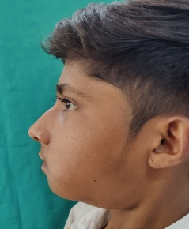
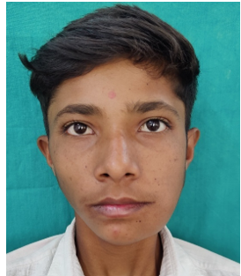

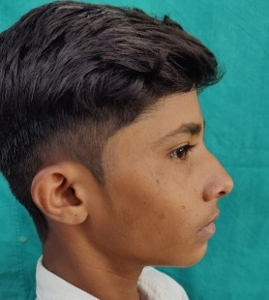
fig.1 Right side of the face fig2.showing facial asymmetry fig3. Swelling in left side

INTRAORAL EXAMINATION: gingival enlargement from teeth 33 to 38 was noted, obliterating the buccal vestibule. Hard-tissue examination revealed Missing teeth included 34, 35, 36;. Teeth 31, 32, 41, and 42 showed grade I mobility. Provisional diagnosis peripheral ossifying fibroma was made. Differential diagnosis given was unicystic ameloblastoma, ameloblastic fibroma, calcifying epithelial odontogenic tumor, ossifying fibroma and odontogenic myxoma.
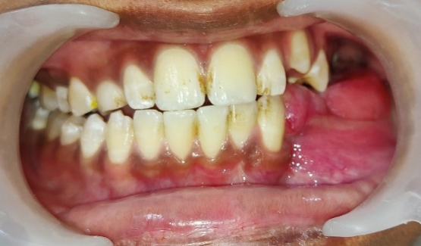
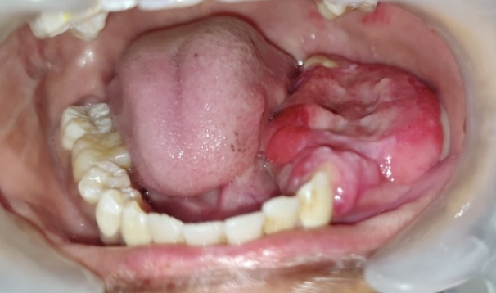
Fig.5 intraoral photograph showing buccal vestibule obliteration
Fig.4 intraoral photograph showing gingival enlargement

CBCT EXAMINATION: revealed a well-defined mixed-density lesion (45.6 × 30.5 × 27.8 mm) in the left mandible, associated with impacted 34. On CBCT report shows multilocular, internal septa, cortical expansion and erosion, IAN displacement, and adjacent tooth resorption.
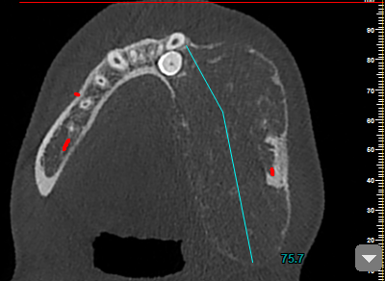
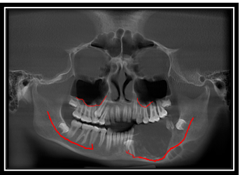
Fig.6: axial section showing buccal Fig.7: curved planar OPG reconstruction
and lingual cortical plate expansion showing thinning of lower cortical
with perforation plate thinning of lower cortical plate
and IANC displacement

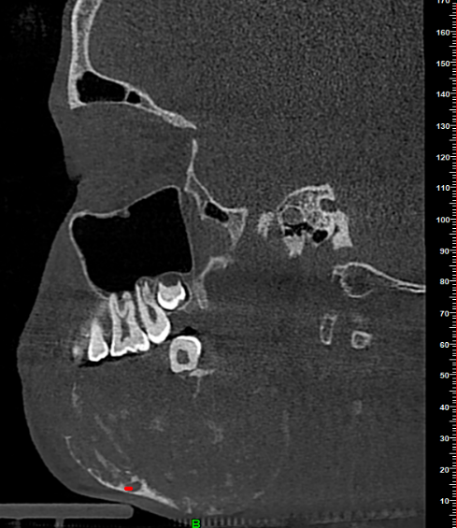
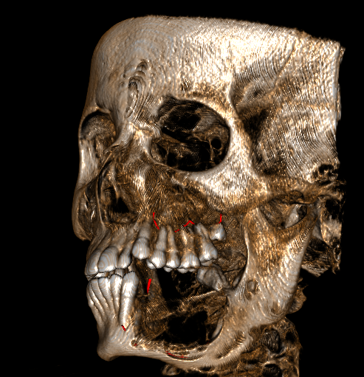

Fig.8: CBCT showing
scan showing perforation Fig.9: sagittal section showing mixed
lesion with multiple interspersed septa

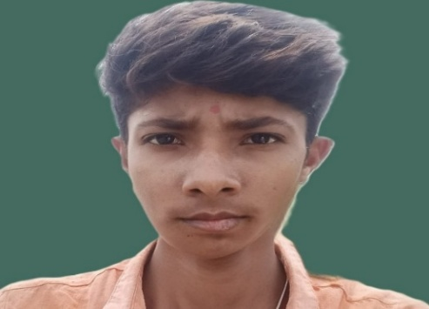
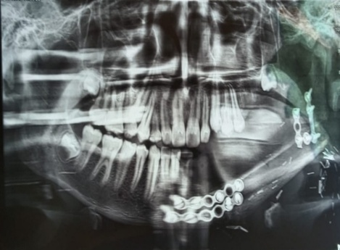

Fig.10 post operative curved planar fig.11 post operative photograph
reconstruction

DISCUSSION
Ossifying fibroma is an uncommon benign primary bone neoplasm first described in the late nineteenth century, with the term “ossifying fibroma” being formally established in the early twentieth century. When this lesion occurs in the pediatric population, it is designated juvenile ossifying fibroma due to its aggressive growth pattern and distinct biological behavior.¹,⁹,¹²
The psammomatoid variant of juvenile ossifying fibroma was initially described as an osteoid fibroma with atypical ossification involving the frontal sinus and was later designated as psammomatoid juvenile ossifying fibroma. Based on histopathological characteristics, El-Mofty classified JOF into trabecular and psammomatoid variants, recognizing them as two distinct clinicopathologic entities.¹
Epidemiologically, PsJOF shows a slight male predominance. Approximately 70% of cases occur in the paranasal sinuses, followed by 20% in the maxilla, while mandibular involvement remains uncommon, accounting for nearly 10% of reported cases.³–⁶,¹³ These lesions often demonstrate slow, asymptomatic growth initially and become clinically apparent only after attaining considerable size. Despite their benign nature, PsJOF lesions are locally aggressive and exhibit a relatively high recurrence rate, reported between 30% and 56%, particularly following incomplete excision.⁵,⁷,¹⁵
Histopathologically, PsJOF is characterized by numerous psammoma-like ossicles—round eosinophilic calcified structures with a basophilic center—embedded within a highly cellular fibrous stroma composed of spindle-shaped cells arranged in fascicular, whorled, or storiform patterns.¹,²,⁸,⁹
Management of PsJOF remains primarily surgical. Small, well-localized lesions may be managed by enucleation and curettage, whereas larger, recurrent, or locally invasive lesions require more aggressive surgical resection. Immediate reconstruction is generally discouraged due to the high recurrence rate. Conservative excision is considered appropriate when the mandibular inferior border is intact, neural involvement is absent, and local extension is limited. Long-term clinical and radiographic follow-up is essential to detect recurrence early.³–⁷,¹²,¹⁵

CONCLUSION
Juvenile psammomatoid ossifying fibroma (JPOF) is a rare, rapidly progressive osteolytic lesion that is often misdiagnosed, especially when it occurs outside the paranasal sinuses, as in mandibular cases. It requires complete surgical excision, as incomplete removal can lead to recurrence. Because of its locally aggressive behavior and high recurrence potential, long-term follow-up is essential. Accurate diagnosis relies on careful clinical, radiographic, and histopathologic evaluation to address its diagnostic and therapeutic challenges.

COMPETING INTERESTS DISCLAIMER:
Authors have declared that they have no known competing financial interests OR non-financial interests OR personal relationships that could have appeared to influence the work reported in this paper.

REFERENCES
- El-Mofty S. Psammomatoid and trabecular juvenile ossifying fibroma of the craniofacial skeleton: two distinct clinicopathologic entities. Oral Surg Oral Med Oral Pathol Oral Radiol Endod. 2002;93:296-304.
- Saiz-Pardo-Pinos AJ, Olmedo-Gaya MV, Prados-Sánchez E, Vallecillo-Capilla M. Juvenile ossifying fibroma: a case study. Med Oral Patol Oral Cir Bucal. 2004;9:454-8.
- Toro C, Milles W, Zerman N. Aggressive ossifying fibroma with massive mandibular involvement: differential diagnosis and management. Int J Pediatr Otorhinolaryngol. 2006;70:167-72.
- Park S, Lee BJ, Lee JH. Juvenile ossifying fibroma: a clinicopathologic study of 8 cases. Korean J Pathol. 2007;41:373-9.
- Smith SF, Newman L, Walker DM, Papadopoulos H. Juvenile aggressive psammomatoid ossifying fibroma: case report and literature review. J Oral Maxillofac Surg. 2009;67:200-6.
- Keles B, Duran M, Uyar Y. Juvenile ossifying fibroma of the mandible: a case report. J Oral Maxillofac Res. 2010;1:e5.
- Abuzinada S, Alyamani A. Management of juvenile ossifying fibroma in the maxilla and mandible. J Maxillofac Oral Surg. 2010;9:91-5.
- Sarode SC, Sarode GS, Waknis P, Patil A. Juvenile psammomatoid ossifying fibroma: review of literature. Oral Oncol. 2011;47:1110-6.
- Brannon RB, Fowler CB. Benign fibro-osseous lesions: a review of current concepts. Adv Anat Pathol. 2001;8:126-43.
- Shah A, Lone P, Latoo S. Psammomatoid juvenile ossifying fibroma of the jaw bones: case report. J Oral Maxillofac Pathol. 2011;15:326-9.
- Ruwandi HG, Weerasinghe N, Wijesuriya PC, Jayasooriya PR. Juvenile ossifying fibroma: clinico-pathological analysis. J Diagn Pathol. 2016;11:14-21.
- • Makek M. Clinical pathology of fibro-osseous lesions of the facial skeleton. Karger. 1983.
- Aoun G, Sharrouf W. Psammomatoid and trabecular juvenile ossifying fibromas: review of clinical features. J Adv Med Med Res. 2022;34:456-60.
- MacDonald-Jankowski DS. Fibro-osseous lesions of the face and jaws. Clin Radiol. 2004;59:11-25.
- Liu Y, Wang H, You M. Juvenile psammomatoid ossifying fibroma: systematic review. Head Neck Pathol. 2022;16:589-600.

