Original Research Article
Grain morphological traits confer tolerance to bruchid (Callosobruchus maculatus) infestation of stored green gram

ABSTRACT
Post-harvest losses due to bruchid (Callosobruchus maculatus) infestation in green gram production remain a challenge. The relative tolerance of five green gram (Vigna radiata L. Wilezek) varieties was evaluated against bruchids under ambient temperature conditions in a laboratory. The green gram varieties were two old varieties: N26 and KS20; and three new varieties: Karembo, Biashara and Ndengu-Tosha. A completely randomized design with four replications was used in the laboratory. Callosobruchus maculatus was isolated from infested green gram grain and multiplied on clean grain for artificial infestation. Data was subjected to analysis of variance at P = 0.05 using GenStat 15th Edition statistical software. The treatment means were separated using the Fisher’s Protected Least Significant Difference at 5% probability level. Data was further subjected to simple linear regression analysis to determine relationships among variables. Seed morphological traits mainly seed coat thickness, and seed size were associated with reduced oviposition, bruchid mortality, and number of holes on the grain. Correlation analysis revealed a positive relationship between seed color and egged grain (0.40 ≤ R² ≤ 0.63). Ndengu Tosha and Karembo varieties with higher hue angles supported fewer live bruchids, suggesting reduced suitability for oviposital preference. The findings highlight the potential of varietal selection as a sustainable strategy for minimizing postharvest losses in green gram. Future research should focus on developing new varieties with grain traits that tolerate bruchid attack.

Keywords: Varieties, resistance, bruchid, post-harvest, grains

1. INTRODUCTION
Post-harvest losses due to insect pests pose a significant challenge to legume production worldwide, particularly in developing countries where storage facilities are often limited (Kalpna et al., 2022; Kumar et al., 2023) . Bruchid beetles (Callosobruchus maculatus) are regarded as the most destructive pests to stored green gram (Vigna radiata L.) (Soujanya et al., 2024). Green gram is a very important legume crop which is vulnerable due to its soft seed coat and high protein content, making it more preferable by bruchid beetles (Yewale et al., 2020). Bruchids cause approximately 90% of post-harvest losses within three to six months of stored green gram grains in Kenya (Soujanya et al., 2024). These losses reduce the quality and quantity of the grains through seed perforations, weight loss, reduced viability (Kalpna et al., 2022).
Green gram is a leguminous annual crop mainly grown in the semi-arid regions of Kenya, where it contributes significantly to household nutrition, food security, and farm income (Hakim et al., 2022; Kuria et al., 2025). The crop is valued for its carbohydrates (62%), protein (31%), fibers (4%), vitamins, amino acids, minerals, short maturity period, and ability to thrive under low-input conditions (Yumbya et al., 2024; Mugo et al., 2020). The long root system enables it to draw water from deeper depths to maintain crop yields (Mulwa et al., 2023). Drought tolerance allows this crop to survive in diverse agro-ecological zones (Wangui, 2021). Despite its economic importance, green gram production and storage are severely constrained by postharvest losses caused by bruchids (Yewale et al., 2020).
Breeding and selection of bruchid resistant varieties offer a sustainable and safe strategy for minimizing postharvest losses (Soujanya et al., 2024). Data on green gram varietal resistance to bruchid infestation among commonly cultivated green gram varieties in Kenya is limited, and the associated mechanisms of resistance are only partially understood. A focused evaluation of the varieties KS20, N26, Ndengu Tosha, Karembo, and Biashara under uniform conditions would contribute valuable knowledge for breeding programs and farmer advisories. Green gram breeding efforts have previously concentrated on drought tolerance, early maturity, high-yielding varieties, and little has been done on bruchid resistance due to poor seed systems (Mulwa, 2022). Several studies have demonstrated that seed morphological traits such as ovipositional preference, seed coat hardness, thickness, size, and color play an important role in mediating bruchid resistance (Yewale et al., 2020). However, tolerance levels vary significantly across green gram varieties, and effective evaluation under controlled conditions is necessary to identify varieties with proper morphological and biological characteristics for stable resistance. Identification of resistant green gram varieties, therefore, provides a critical avenue for reducing dependence on synthetic pesticides.

In Kenya, there are five main green gram varieties, which comprise two old releases of the 1990’s (N26 and KS20), which were developed and released when pest infestation was low, and hence, very little research had been done on green gram breeding (Mulwa,2022; Yumbya et al., 2025). Three modern selections of 2017 (Karembo, Biashara, and Ndengu Tosha) were released by the Kenya Agricultural and Livestock Research Organization, having developed when pressure for pest and disease incidences was very high (Mulwa,2022). However, there is limited research on the susceptibility of different green gram varieties to bruchid infestation and their effectiveness in reducing post-harvest losses in stored green gram grains. This necessitated the need for research on seed varieties that could overcome the serious challenges of pest incidences and low productivity (Mulwa et al., 2023).
Traditional control methods of using pesticides are expensive and pose environmental and health risk and may perhaps lead to pest resistance (Yewale et al., 2020). As a result, breeding and identification of bruchid-tolerant/resistant green gram varieties offer sustainable, cost-effective, and environmentally sound alternative (Tutlani et al., 2022). Genetic variability for bruchid resistance exists among green gram varieties that can be exploited through breeding (Pawara et al., 2019). Breeding program depends on both abiotic and biotic factors in green gram development stages, which are very essential in the identification of tolerant traits in each stage (Mulwa, 2022). Substantial green gram genetic gain has been in high yield, pests and disease resistance, and drought tolerance (Gosal and Wani, 2020). Green gram breeding in Kenya has been done to produce the latest varieties of Biashara, Karembo, and Ndengu Tosha, which are high-yielding, disease tolerance, and mature early but losses due to insect pest damage still continue to thrive (Mulwa et al., 2023).
Plant breeders face the technical challenge of achieving bruchid resistance while maintaining desirable agronomic traits (Kalpna et al., 2022). Understanding the relationships among morphological traits, bruchid biological responses, and resulting grain quality indicators is crucial for developing targeted breeding and management strategies. Mwangi et al. (2020) investigated Kenyan green gram varieties and confirmed that N26 and Biashara, exhibited partial resistance, marked by delayed adult emergence and reduced egg hatchability. Variety Ndengu Tosha is widely promoted in Kenya for its high yield and disease tolerance while Karembo and KS20 are popular for their adaptability and market preference by farmers but are vulnerable to bruchid infestations (Karimi et al., 2019). Development of resistant varieties against bruchid is the essential step towards the sustainable protection of stored grains, which has not been validated previously (Harshitha et al., 2022). The findings will support the selection of varieties suitable for areas prone to bruchid infestation and contribute to improved postharvest management and food security in green gram production systems. Hence, this current study aimed to evaluate the relative tolerance of bruchids by screening selected green gram varieties. The study hypothesized that selection for drought tolerance of green gram varieties in Kenya could simultaneously improve bruchid resistance/tolerance

2. material and methods

2.1 Experiment site and green gram varieties used
Two grain storage incubation cycles were conducted during 2023-2024 under the ambient conditions at the Entomology laboratory located at latitude 1° 15´ 25´´S, longitude 36° 44´06´´E and 1876 m altitude in the University of Nairobi, Kenya. The laboratory conditions were maintained at 28 ± 2 °C and 70-90% relative humidity, which are optimal for Callosobruchus maculatus development. The treatments comprised of five green gram varieties which were two old releases (N26 and KS20) and three modern selections (Karembo, Biashara and Ndengu Tosha) which were sourced from small scale farmers. All seed samples were physically sorted to remove broken grains, debris, and pest infested seeds.

2.2 Source and rearing of bruchids
Ten kilograms of infested composite green gram grains were sourced and multiplied on clean green gram grains for artificial infestation and used for harvesting of experiment insects. A sample of the Callosobruchus maculatus present in the grains was identified and isolated using key morphological traits of the species. Fifty adult bruchids were reared and multiplied into 1 kg capacity plastic rearing jars with clean healthy susceptible green gram grains.
The jars were covered with muslin cloth and fastened with rubber bands allowing free air circulation for insect survival. The jars were kept undisturbed in the laboratory conditions on a raised platform at temperature of 30 ± 1ºC and relative humidity at 70 ± 2%. Close monitoring was done, after 7 days all mature bruchids were discarded from the jars after ovipositing to allow the laid eggs to hatch into freshly emerged adult beetles which were used for the experiment. The culture was refreshed every 30 days to maintain vigor and avoid inbreeding.

2.3 Experiment design and set up
A completely randomized design with four replications was used where sorted green gram grains were stored in a deep freezer at -17 ºC and 70-100% relative humidity. Later, they were conditioned to 25 ºC room temperature for experiment use. The study ran for six months in two incubation cycles where twenty transparent 1 kg bottle jars received 200 g of clean green gram grains. Thirty live bruchids of three weeks’ age were introduced into each jar, covered with a muslin cloth and secured with rubber bands for oviposition. These jars together with their contents were finally kept and maintained at a temperature of 30 ºC and relative humidity of 80 ± 10%.

2.4 Data collection
Seed morphological characteristics were measured prior to infestation such as seed size, 100-seed weight, seed coat thickness and seed coat color. Infestations and damage assessments were made fortnightly from the onset of the incubation cycle such as grain weight loss, number of egged grains, number of holes on grains and bruchid mortality recorded at each sampling stage.

2.4.1 Change in seed coat color
Seed coat color was determined and recorded using a portable digital color meter (Model TES 135A, Taiwan, China) which was calibrated according to manufacturer’s instructions. The color meter was first switched on and zeroed using a black background. Five grams of each variety were used for color determination where observations made and returned to the source for subsequent experiment use. The degree of seed color change was calculated and expressed as hue angle where color wheel was used to compare the calculated hue angle with the color of the grains. Two values were noted as a* and b*. Using the two values, the hue angle (Hº) was calculated as:
Hue angle (Hº) = tan⁻¹(b/a) ………………………………………………..Equation 1

Where, (a*, b*) coordinates are positive.
Hue angle (Hº) = tan⁻¹(b/a) + 180…………………………………………….Equation 2
Where, (a*, b*) are positive and negative respectively.

2.4.2 Seed size
Ten green gram grains were randomly picked and counted from each variety to determine their sizes by use of a vernier caliper. The mean seed length and width were determined at the beginning of the experiment to establish whether there was any correlation between seed size and other parameters.

2.4.3 Loss in seed weight
The grain weight loss in storage is caused by either weight or moisture loss. The grain weight loss is as a result of insect feeding on the grain leading to grain breakage and holes while moisture loss is brought by evaporation as the grain equilibrates with environmental conditions (Walker et al., 2018). Six samples of 100 green gram grains were randomly picked and weighed using a digital electronic weighing balance (MH-696, China). The weight was recorded and later compared with the magnitude of infestation of the grains by bruchids. The used sample was returned to respective jars for subsequent experimental use. The percent grain weight loss was calculated in Equation 3 (Girish et al., 1975).

$$Weight loss \%= \frac{(Initial seed weight-Final seed weight)}{Initial seed weight}x 100$$ | ……Equation 3

2.4.4 Seed coat thickness
Six grains of each variety were randomly sampled for determination of seed coat thickness. Initial length and width of each was determined using a vernier caliper. The whole seed cover was then removed by use of a scalpel. Final length and width of the seed was then recorded where seed thickness was calculated by subtracting the final from initial readings in millimeters (mm) then divided by two.

2.4.5 Number of holes on grains
Infestation level was evaluated as shown in Equation 4 (Howe, 1971).

$Infestation \left(\%\right)= \frac{Number of grains with emerged holes}{Total number of grains observed}x 100$ ………..………… | Equation 4

2.4.6 Number of egged green gram grains
The oviposition rate was recorded by counting the number of eggs in the collected representative sample and expressed as number of eggs laid per female per day (Odjo et al., 2020). This was calculated as oviposition rate as determined in Equation 5 (Howe, 1971):

$Oviposition rate= \frac{Total eggs}{Number of females/day}$ …………….………......Equation 5

2.5 Data analysis
Before statistical analyses, Shapiro-Wilk test was used to check for data normality and conformation to the requirements of Analysis of Variance (ANOVA). The collected data were subjected to ANOVA at 5% probability using GenStat 15th Edition. The treatment means among all treatments were compared and separated using the Fisher’s Protected Least Significant Difference at 5% probability level. Data were further subjected to simple linear regression analysis to determine relationships among variables.

3. results and discussion

3.1 Seed morphological traits
Significant variations were measured in the morphology of the seed of the studied varieties (Table 1). The older varieties (N26 and KS20) were typically smaller than the newer counterparts. Variety KS20 had a dull green colour while the rest of the varieties were shinny green. Karembo and Ndengu Tosha, both recently released varieties, had thicker seed coats compared with the other varieties.

Table 1. Morphological traits of the seed of the five green gram varieties used in the study
Experiment | Variety | Seed  weight (g) | Seed  color (Hº) | Seed coat  thickness (mm) | Seed  size (mm²)
Experiment 1 | N26 | 5.13 ± 0.034 d | 92.5 ± 1.58 abc | 0.094 ± 0.0040 c | 16.37 ± 0.397 c
 | KS20 | 6.14 ± 0.091 c | 88.2 ± 2.15 c | 0.076 ± 0.0048 e | 19.73 ± 0.362 b
 | Biashara | 7.20 ± 0.092 a | 90.3 ± 2.06 bc | 0.091 ± 0.0043 d | 22.32 ± 0.476 a
 | Karembo | 6.56 ± 0.063 b | 93.9 ± 1.27 ab | 0.108 ± 0.0017 b | 20.27 ± 0.474 b
 | N. Tosha | 6.50 ± 0.063 b | 94.3 ± 1.31 a | 0.117 ± 0.0024 a | 20.60 ± 0.419 b
LSD |  | 0.145 | 3.21 | 0.007 | 0.64
P value |  | <.001 | <.001 | <.001 | <.001
Experiment 2 | N26 | 5.43 ± 0.064 d | 87.15 ± 1.58 a | 0.10 ± 0.0041 b | 17.88 ± 0.214 e
 | KS20 | 6.21 ± 0.093 c | 87.19 ± 1.99 a | 0.07 ± 0.0049 d | 21.24 ± 0.154 d
 | Biashara | 6.81 ± 0.083 a | 87.87 ± 1.89 a | 0.08 ± 0.0039 c | 25.07 ± 0.115 a
 | Karembo | 6.56 ± 0.058 b | 90.45 ± 1.34 a | 0.11 ± 0.0017 ab | 22.98 ± 0.122 b
 | N. Tosha | 6.54 ± 0.042 b | 91.09 ± 1.43 a | 0.12 ± 0.0023 a | 22.03 ± 0.128 c
LSD |  | 0.140 | 3.331 | 0.007 | 0.632
P value |  | <.001 | <.001 | <.001 | <.001
Values are means ± standard error of mean. Means followed by the same letter in a column are not significantly different at 5% probability level, LSD = least significant difference.

3.2 Change in seed coat color
Seed color of different green gram varieties, expressed as hue angle, decreased gradually across all varieties over the storage period (Figure 1). The three newly released varieties exhibited relatively higher initial hue angles of which are normally shiny green compared to the least recorded by KS20 which is normally dull green showed more pronounced seed coat discolouration. The higher hue angles observed in Ndengu Tosha, Karembo, and Biashara retained a greener and more uniform seed coat.

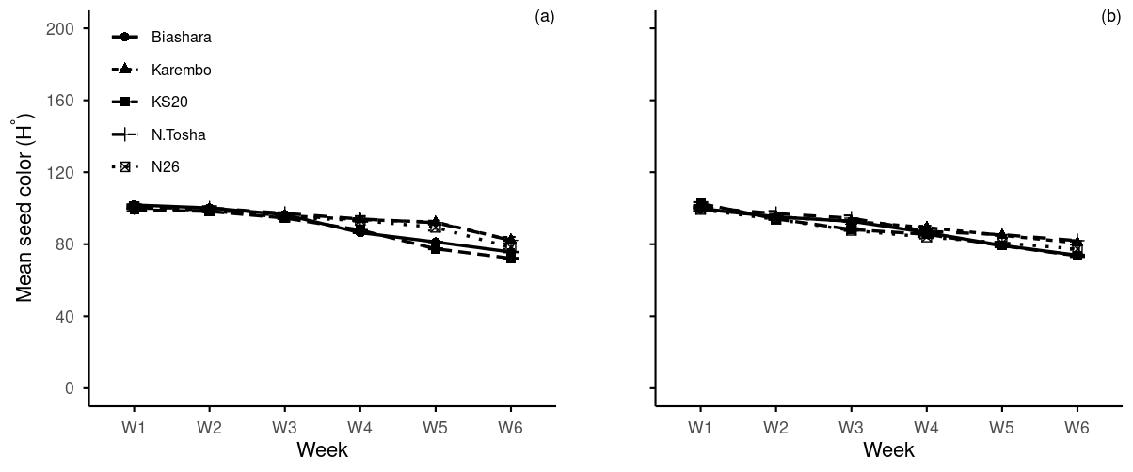Figure 1. Changes in seed coat colour (hue) of five green gram varieties under bruchid infestation during the first incubation cycle (a) and the second incubation cycle (b)

3.3 Loss in seed weight
The percentage cumulative seed weight loss increased progressively in all varieties across the storage period. The rate of weight loss significantly (P ≤ 0.05) differed among varieties, with more tolerant new varieties showing a slower rate of increase compared to the highly susceptible varieties. Results in Figure 2 show variety KS20 consistently exhibited the highest weight loss over the storage period.

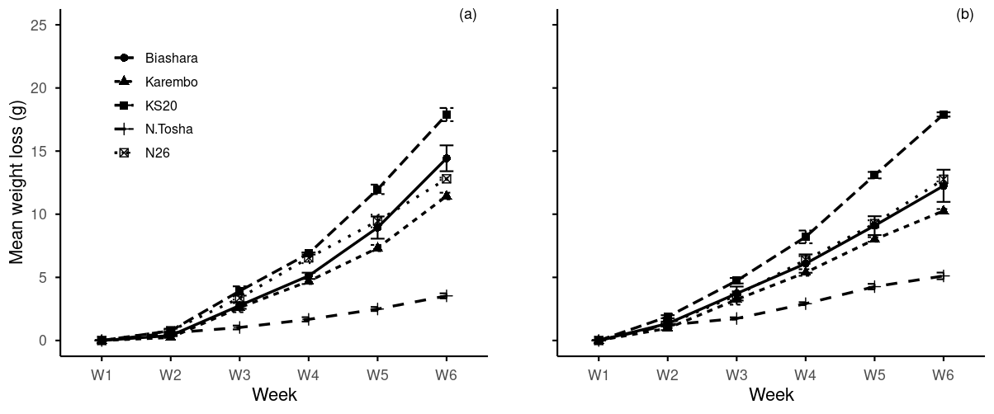Figure 2. Mean loss in seed weight of five green gram varieties during the first incubation cycle (a) and the second incubation cycle (b) under bruchid infestation

3.4 Bruchid mortality
Karembo and Ndengu Tosha recorded significantly (P ≤ 0.05) low bruchid mortality while Biashara showed the highest count. At the end of the storage period, Karembo and Ndengu Tosha recorded the lowest bruchid mortality due to population decline after peak infestation. Biashara exhibited a steady increase in bruchid mortality over time while Ndengu Tosha significantly (P ≤ 0.05) maintained a consistently minimal dead bruchid count throughout the storage period (Figure 3).

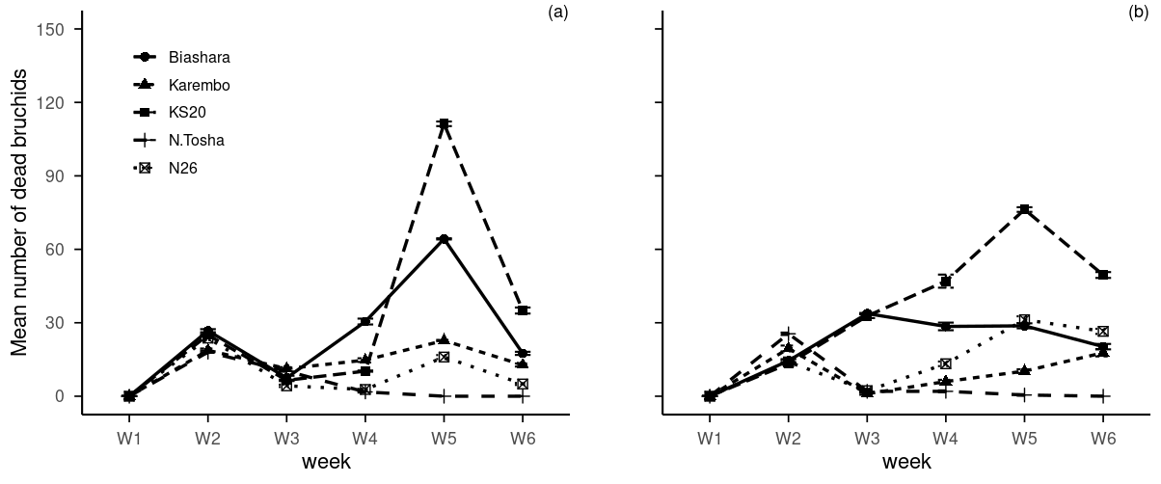Figure 3. Mean number of dead bruchids on five green gram varieties during the first incubation cycle (a) and the second incubation cycle (b)

3.5 Number of egged green gram grains
Ovipositional behavior of bruchids differed significantly at (P ≤ 0.05) among the green gram varieties (Figure 4). During the storage period, bruchids marginally oviposited on Ndengu Tosha and N26. At the end of storage period, Biashara and KS20 had recorded a higher oviposition while Ndengu Tosha variety recorded the least oviposition hence was the least preferred variety by bruchids (Figure 4).

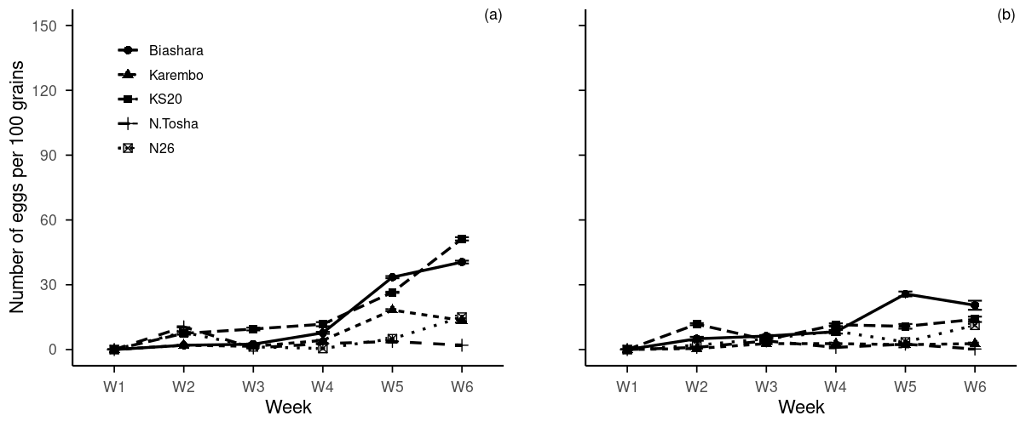Figure 4. Mean number of egged grains on five green gram varieties during the first incubation cycle (a) and the second incubation cycle (b)

3.6 Number of holes on grain
Results in Figure 5 shows that the number of holes per 100 grains varied significantly among the four green gram varieties. KS20 recorded the highest number of holes per 100 grains, indicating greater susceptibility to damage. In contrast, Ndengu Tosha registered the least number of holes demonstrating superior resistance. The remaining varieties exhibited intermediate levels of grain damage. These differences highlight varietal variation in resistance to grain perforation.

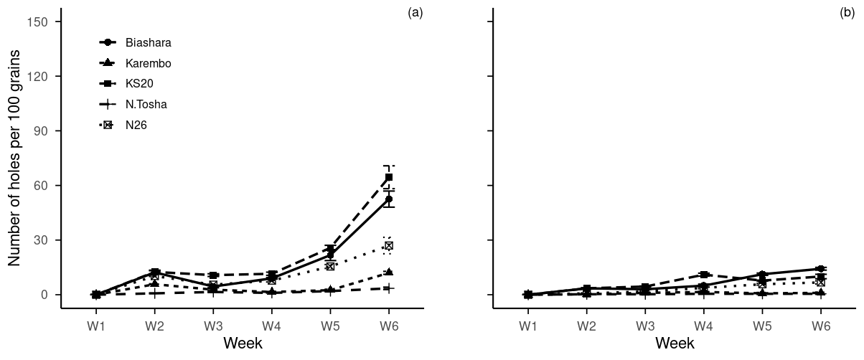
Figure 5. Mean number of holes on five green gram varieties during the first incubation cycle (a) and the second incubation cycle (b)

3.7 Relationship between green gram grain parameters
In first incubation cycle, data revealed negative and weak association between live bruchids with seed color and seed coat thickness 0.08 ≤ R² ≤ 0.32 (Figure 6). Similarly, in second incubation cycle, data showed negative and weak association between number of egged grains with seed color and seed coat thickness 0.13 ≤ R² ≤ 0.40. In both cycles, live bruchids and seed color had a weak positive relationship 0.13 ≤ R² ≤ 0.32 (Figure 3.6). There was a strong positive relationship in first incubation cycle between seed color and egged grain (R² = 0.63) but a weaker association was observed in second incubation cycle (R² = 0.40) (Figure 6).
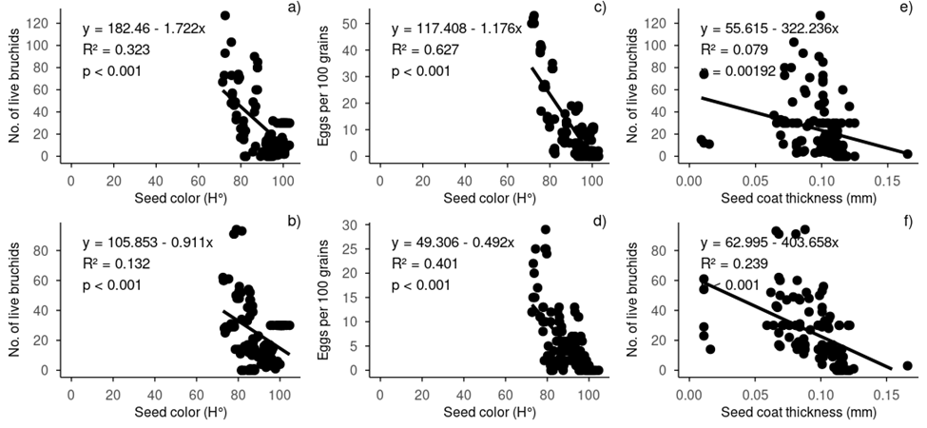
Figure 6. Correlation between live bruchids and seed color (a), egged seeds versus seed color (c), and seed coat thickness versus live bruchids (e) in first incubation cycle and association between live bruchids and seed color (b), egged seeds versus seed color (d), and seed coat thickness versus live bruchids (f) in second incubation cycle. Lines are least square regressions. N = 15
4. Discussion
Bruchid infestation causes severe physical damage during storage to green gram reducing its nutritional quality and its viability (Usha et al., 2018; Yewale et al., 2020). The study confirmed that variation in seed morphological characteristics significantly influenced the relative tolerance of green gram varieties to bruchids. Varieties with smaller seeds, harder seed coats, and dull colors recorded lower infestation, consistent with other studies where seed hardness restricted bruchid penetration (Mwangi et al. 2020).

4.1 Change in seed coat color
A decline in hue angle was observed across all varieties following bruchid infestation, indicating progressive seed coat discoloration. However, KS20 and N26 varieties exhibited significantly lower hue values, reflecting pronounced browning and higher levels of damage. In contrast, Ndengu Tosha, Karembo and Biashara maintained higher hue angles, suggesting better preservation of seed coat color and exhibited high tolerance to bruchid infestation. Transition from green to yellow signified infestation, aging, and degradation of the green gram quality as similarly reported by Mwangi et al., (2020). Kusolwa and Misangu (2017) reported that bruchids feed or lay eggs on dull coloured grains and avoid shiny coloured ones. The dull green color as indicated by the hue angle values was attributed to the biochemical changes and damage caused by the larvae feeding inside the grains (Muchomba et al., 2023).

4.2 Seed coat thickness
The present study indicated that Ndengu Tosha variety exhibited the highest seed coat thickness (0.13-0.20 mm) which led to greater resistance to bruchid infestation compared to a thinner seed coat of both Biashara and KS20 varieties. Similar findings were previously reported by Pawara et al., (2019) and Holay et al., (2018). Seed coat plays a crucial role in the biological activities of Callosobruchus maculatus and seed infestation which is an important morphological trait for breeding bruchid-resistant green gram (Pawara et al., 2019).

4.3 Loss in seed weight
Weight is a crucial factor that significantly affects the quality and economic value of agricultural produce (Kalpna et al., 2022). In this study, a progressive weight loss on grain across all varieties highlighted the cumulative effect of bruchid infestation over the storage period. These findings exhibited that the highest weight loss was recorded in susceptible varieties KS20 followed by Biashara, whereas the least was recorded in resistant varieties Ndengu Tosha and Karembo which maintained higher structural integrity. Significant differences in seed weight loss across varieties were linked to larval feeding intensity of consuming the endosperm and leaving hollowed-out seed coats. Tolerant varieties showed minimal weight loss, aligning with Kalpna et. al. (2022) who observed reduced dry matter removal in resistant legumes. These results corroborate with the findings of Bharathi et al. (2024) who assessed population development and seed damage by Callosobruchus chinensis on eight different host grains.

4.4 Bruchid mortality
Bruchid mortality was evaluated on the basis of emergence which is manipulated by the round exit holes carrying a flap formed during the exit of the insect (Tripathi et al., 2020). In this study, it was observed that susceptible varieties (KS20 and Biashara) provided easier access to food sources hence where a higher population buildup was experienced. Resistant varieties (Ndengu Tosha and Karembo), although harbored bruchids, significant differences in low infestation resulted in a low rate of mortality. Higher bruchid mortality in tolerant varieties under this study suggests biochemical resistance mechanisms such as phenolic inhibitors and anti-nutritional compounds reducing significant pest activity throughout the storage period as reported by Bharathi et al. (2024).

4.5 Number of holes on grain
Seed resistance is better indicated by the number of emergence holes than that of laid eggs per seed (Gopal et al., 2023). The bruchids larvae penetrated more into the seed of KS20 and Biashara, developed inside them and excavated an emergence tunnel to the seed surface, forming a translucent window in the seed coat for adult emergence. The findings suggested that superior varieties (Ndengu Tosha and Karembo), which exhibited the significantly lowest number of holes on grain were found to be resistant (Pawara et al., 2019).

4.6 Number of egged green gram grains
Bruchids oviposital preference is guided by surface characteristics such as seed size, colour, seed coat texture, nutritional value and odour of grains emanating from its chemical composition (Tripathi et al., 2020; Soumia et al., 2017). In this study, no variety was immune to oviposition, and the highest number of eggs was observed in susceptible seeds of KS20 followed by Biashara. The findings of this study corroborate with the results of Swamy et al. (2019) on chickpea varieties and Gopal et al. (2023) who worked on green gram varieties. However, earlier studies suggested that oviposition preference is more strongly influenced by host availability and susceptibility, which should not be assessed solely based on oviposition.

4.7 Relationships
Correlation analyses showed negative and weak association between live bruchids with seed color and seed coat thickness, consistent with Somta et al., (2007). There was a strong positive relationship in second incubation cycle between egged seeds and seed color. Variation in the number of live bruchids among green gram varieties was associated with differences in seed coat color, indicating that hue angle contributes to relative tolerance. Varieties (Ndengu Tosha and Karembo) with higher hue angles (lighter seed coats) supported fewer live bruchids, suggesting reduced suitability for oviposital preference. Seed color has been linked to presence of phenolic compounds which may discourage feeding thus affect insect survival (Somta et al., 2007). These results suggest that seed color has an indirect association with biochemical defense mechanisms rather than color alone.
Seed coat thickness showed a weak negative association with the number of live bruchids, underscoring its importance as a physical resistance mechanism. Varieties with thicker seed coats like Ndengu Tosha recorded lower bruchid survival probably due to restricted larval penetration. Thick seed coats can impede egg hatching entry, prolong larval development and increase early mortality (Pawara et al., 2019). The findings are consistent with earlier reports identifying seed coat thickness as a key determinant of resistance to bruchid in grain legumes (Somta et al., 2007). This trait represents a stable and reliable morphological trait for improving bruchid tolerance in green gram breeding program.
The present study demonstrates that tolerance to bruchids in green gram is governed by combined effects of physical and biochemical seed traits. Among the evaluated traits seed coat thickness emerged as the most influential factor limiting bruchid survival, while seed color and seed size contributed indirectly. Breeding strategies that prioritize thicker seed coats and seed color attributes could enhance post-harvest resistance without compromising agronomic performance. Incorporating these traits into varietal selection offers a low cost approach to reducing bruchid damage to green gram grains.

5. Conclusion
This study demonstrated significant variation in the relative tolerance of selected green gram varieties to bruchid infestation. The findings indicate that the two new varieties, Ndengu Tosha and Karembo reveal high resistance to bruchid attack, while others are more susceptible. Seed morphological traits mainly seed coat thickness, and seed size were associated with reduced oviposition, bruchid mortality, and number of holes on the grain. Tolerant varieties consistently exhibited fewer eggs, higher bruchid mortality, limited seed coat color change, and significantly lower grain weight loss compared to susceptible varieties. The findings confirm that both physical and biochemical characteristics play important roles in mediating resistance and can be effectively used as selection criteria in breeding programs aimed at developing bruchid‐tolerant green gram varieties.
These results highlight the importance of incorporating varietal resistance into postharvest management strategies and the need for continued research on the genetic material and physiological basis of bruchid tolerance in green gram. Identification and promotion of resistant green gram varieties will contribute to reduction of postharvest losses, improve on grain quality and increase income of small scale farmers who depend on green gram as a key source of food and income. Future research should focus on developing new varieties with enhanced resistance to bruchid infestation and validate performance of resistant varieties under different environment conditions.

COMPETING INTERESTS DISCLAIMER:
Authors have declared that they have no known competing financial interests OR non-financial interests OR personal relationships that could have appeared to influence the work reported in this paper.

References
Bharathi, Y., Akil kumar, D., Padmasree, A., Pradeep, T., Pallavi M., Sujatha, P, Razia Sultana., Jaganmohan Rao P., and Ramesh M. (2024). Effects of packaging material and moisture contents on pulse beetle infestation under different storage conditions in chickpea. Journal of experimental agriculture international 46 (7):232-244. https://doi.org/10.9734/jeai/2024/v46i72578
Girish, G.K., Kumar, A. and Jain, S.K. (1975). Part II assessment of the quality loss in wheat damaged by Trogoderma granarium everts during storage. Bulletin Grain Technology. 13(2): 26-32
Gopal, M., Kavitha, S., and Maheswari, G. (2023). Screening of relative susceptibility of different pulses to the pulse beetle, Callosobruchus maculatus fab.(Coleoptera: Bruchidae). Researchgate.Net, 6 (October), 9–11.
Hakim, R. O., Kinama, J. M., Kitonyo, O. M., and Cheminingw`a, G. N. (2022). Effect of tillage method and mulch application on growth and yield of green gram in semi arid Kenya.
Harshitha, G. P., Jayamani, P., Manimegalai, S., and Muthuswamy, A. (2022). Host plant resistance for bruchids in pre-breeding lines of green gram [Vigna radiata (L.) Wilczek]. Legume research-An international journal. https://doi.org/10.18805/lr-4702
Holay, P. P., Patil, S. K., Kulkarni, S. R., and Lokhande, P. K. (2018). Physio-chemical parameters of pigeonpea seed affecting the infestation of pulse beetle, Callosobruchus maculatus (Fabricius). 7(5), 484–487.
Howe, R.W. (1971). A parameter for expressing the suitability of an environment for insect development. Journal of Stored Product Research. 7(3): 63-65.
Kalpna, Hajam, Y. A., and Kumar, R. (2022). Management of stored grain pest with special reference to Callosobruchus maculatus, a major pest of cowpea: A review. In Heliyon (Vol. 8, Issue 1). Elsevier Ltd. https://doi.org/10.1016/j.heliyon.2021.e08703
Karimi, R., Nair, R., Ledesma, D., Mutisya, D., & Muthoni, L. (2019). Performance and participatory evaluation of green gram genotypes in the semi-arid environments of Eastern Kenya. East African Agricultural and Forestry Journal, 83(2), 119–136. https://doi.org/10.1080/00128325.2019.1599491
Kumar Chaman, Singh P.K, Kumar Panjak, Yadar Munna and Kumar Amrendra. 2023. Evaluation of Mung bean [(Vigna radiata) (L.)Wilzeck] genotypes against pulse beetle in stored grains. International Journal of Plant and Soil Science 35 (21):418–423. https://doi.org/10.9734/ijpss/2023/v35i213992.
Kuria Stanley Gikonyo, Gathungu Geofrey Kingori, and Muraya Moses Mahugu. 2025. Interaction of rhizobium inoculation, phosphorus application and planting density affects green gram yield and economic benefit. International Journal of Plant and Soil Science 37 (11):133–149. https://doi.org/10.9734/ijpss/2025/v37i115830.
Kusolwa, P. M., and Misangu, R. N. (2027). Impact of storage environment on bruchid infestation in legume seeds. Journal of Stored Products Research, 72,58-64.https://doi.org/10.16/j.jspr.2017.04.002
Muchomba, M. K., Muindi, E. M., and Mulinge, J. M. (2023). Overview of Green Gram (Vigna radiata L.) Crop, Its Economic Importance, Ecological Requirements and Production Constraints in Kenya. Journal of Agriculture and Ecology Research International, 24(2), 1–11. https://doi.org/10.9734/jaeri/2023/v24i2520
Mugo, J. W., Opijah, F. J., Ngaina, J., Karanja, F., & Mburu, M. (2020). Suitability of green gram production in Kenya under present and future climate scenarios using Bias-Corrected Cordex RCA4 Models. Agricultural Sciences, 11(10), 882–896. https://doi.org/10.4236/as.2020.1110057
Mulwa, G. K. (2022). Varietal resistance and use of crude plant extracts in the management of field of field pests in green gram (Vigna radiata) in Machakos County, Kenya. University of Nairobi, M.Sc., thesis, University of Nairobi, Kenya
Mulwa, G. K., Kitonyo, O. M., and Nderitu, J. H. (2023). Earliness and crop morphological traits modulate field pest infestation in green gram. Journal of Economic Entomology. https://doi.org/10.1093/jee/toac205
Mwangi, P.W., Maina, M.C., and Kinyua, M.G (2020). Evaluation of green gram landraces for resistance to bruchid beetles in Kenya. East African Agricultural and Forestry Journal, 84 (2), 25-34. https://doi.org/10.1080/00128325.2020.1811559
Odjo, S., Burgueño, J., Rivers, A., and Verhulst, N. (2020). Hermetic storage technologies reduce maize pest damage in smallholder farming systems in Mexico. Journal of Stored Products Research, 88. https://doi.org/10.1016/j.jspr.2020.101664
Pawara, N. R., Bantewad, S. D., and Patil, D. K. (2019). Assessment of different interspecific progenies of mungbean against pulse beetle, Callosobruchus chinensis Linn. and It’s influence of seed physical characteristics on infestation. Journal of Entomology and Zoology Studies, 7(1), 1335–1344.
Somta, P., Chankaew, S., Rungnoi, O. and Srinives, P (2007). Genetic analysis of bruchid resistance in mungbean (Vigna radiata L.Wilczek). Field Crops Research, 103(2),146-151. https://doi.org/10.1016/j.fcr.2007.05.001
Soujanya, Y., Sukrutha, B., Akkareddy, S., Kayam, D., Reddy, V. L. N., and Prasanthi, L. (2024). Assessment of molecular diversity and mapping of bruchid tolerance loci in green gram [Vigna radiata (L.) Wilczek]. An international journal of Legume research. https://doi.org/10.18805/lr-5214
Soumia, P. S., Srivastava, C., Pandi, G. G. P., and Subramanian, S. (2017). Varietal preference of pulse beetle, Callosobruchus maculatus (F.) in greengram. Indian Journal of Entomology, 79(1), 86. https://doi.org/10.5958/0974-8172.2017.00019.0
Swamy, Gopala S., Kamakshi, N., and John Wesley, B. (2019). Relative susceptibility of chickpea varieties to pulse bruchid, Callosobruchus maculatus (F.).Journal of Entomology and Zoology Studies, 7(3), 442–446.
Tripathi, K., Prasad, T. V., Bhardwaj, R., Jha, S. K., Semwal, D. P., Gore, P. G., Sharma, P. K., and Bhalla, S. (2020). Evaluation of diverse germplasm of cowpea [Vigna unguiculata (L.) Walp.] against bruchid [Callosobruchus maculatus (Fab.)] and correlation with physical and biochemical parameters of seed. Plant Genetic Resources: Characterisation and Utilisation, 18(3), 120–129. https://doi.org/10.1017/S1479262120000180
Tutlani, A., Jaiswal, P., and Janeja, H. S. (2022). Abiotic and biotic stresses and their effect on Vigna radiata L.The Pharma Innovation Journal, 11(5), 230–237. http://www.thepharmajournal.com
Usha, R., Singh, P. S., Singh, S. K., and Saxena, R. P. N. (2018). Screening of Green gram genotypes against Callosobruchus maculatus ( F.) under laboratory conditions. Annals of Agricultural Sciences. 26(1) pp.1-2.
Walker, S., Jaime, R., Kagot, V., and Probst, C. (2018). Comparative effects of hermetic and traditional storage devices on maize grain: Mycotoxin development, insect infestation and grain quality. Journal of Stored Products Research, 77, 34–44. https://doi.org/10.1016/j.jspr.2018.02.002
Wangui, J. (2021). Modelling green gram production in Kenya under the current and future climate. M.Sc. thesis, University of Nairobi, Kenya
Yewale, P., Kadam, U., and US, D. (2020). Evaluation of bio-chemical constituents in green gram associated with resistance to Callosobruchus maculatus during storage. Journal of Pharmacognosy and Phytochemistry, 9(5), 2145–2148. https://doi.org/10.22271/phyto.2020.v9.i5ad.12665
Yumbya, B. M., Kitonyo, O. M., and Kinama, J. M. (2024). Effect of intercrop arrangement on growth, yield, and resource use efficiency of selected green gram varieties and sorghum in Southeastern Kenya. M.Sc. thesis, University of Nairobi, Kenya.
Yumbya, B. M., Kitonyo, O. M., and Kinama, J. M. (2025). Green gram and sorghum yield as affected by diverse intercrop planting configurations. Australian Journal of Crop Science, 19(06):680-688. https://doi.org/10.21475/ajcs.25.19.06.p332

