Kl b98 India stands as the fifth-largest global producer of apples, with Jammu and Kashmir emerging as the foremost contributor,
accounting for over 77% of the nation’s production. Despite this, the industry faces significant challenges, including disease
outbreaks, pest infestations, and market fluctuations. Notably, apple scab, caused by Venturia inaequalis, poses a substantial
threat to apple crops. In chemical management strategy, sterol demethylation inhibitor (DMI) fungicides, such as
difenoconazole, myclobutanil, hexaconazole, and flusilazole, are commonly utilized to combat apple scab. However, recent
reports regarding the development of resistance against difenoconazole in Venturia inaequalis has necessitated the
assessment of baseline sensitivity test against difenoconazole in Kashmir. The fungicide was tested at five different
concentrations (viz., 0, 0.01, 0.1, 1.0 and 10 µg/ml) against thirty V. inaequalis isolates that were unexposed to any fungicide. At
a concentration of 0.1 ìg/ml, relative growth response ranging from 28.9 per cent (Vi26) to 61.3 per cent (Vi10) was observed.
The mean ED50 value was calculated to be 0.141 ìg/ml and a dose of 0.15 ìg/ml was selected as discriminatory dose for
assessment of resistance in exposed population. Resistance factor was calculated to be 4.32 inferring wider range of
sensitivities to difenaconazole
India stands as the fifth-largest global producer of apples, with Jammu and Kashmir emerging as the foremost contributor,
accounting for over 77% of the nation’s production. Despite this, the industry faces significant challenges, including disease
outbreaks, pest infestations, and market fluctuations. Notably, apple scab, caused by Venturia inaequalis, poses a substantial
threat to apple crops. In chemical management strategy, sterol demethylation inhibitor (DMI) fungicides, such as
difenoconazole, myclobutanil, hexaconazole, and flusilazole, are commonly utilized to combat apple scab. However, recent
reports regarding the development of resistance against difenoconazole in Venturia inaequalis has necessitated the
assessment of baseline sensitivity test against difenoconazole in Kashmir. The fungicide was tested at five different
concentrations (viz., 0, 0.01, 0.1, 1.0 and 10 µg/ml) against thirty V. inaequalis isolates that were unexposed to any fungicide. At
a concentration of 0.1 ìg/ml, relative growth response ranging from 28.9 per cent (Vi26) to 61.3 per cent (Vi10) was observed.
The mean ED50 value was calculated to be 0.141 ìg/ml and a dose of 0.15 ìg/ml was selected as discriminatory dose for
assessment of resistance in exposed population. Resistance factor was calculated to be 4.32 inferring wider range of
sensitivities to difenaconazole
India stands as the fifth-largest global producer of apples, with Jammu and Kashmir emerging as the foremost contributor,
accounting for over 77% of the nation’s production. Despite this, the industry faces significant challenges, including disease
outbreaks, pest infestations, and market fluctuations. Notably, apple scab, caused by Venturia inaequalis, poses a substantial
threat to apple crops. In chemical management strategy, sterol demethylation inhibitor (DMI) fungicides, such as
difenoconazole, myclobutanil, hexaconazole, and flusilazole, are commonly utilized to combat apple scab. However, recent
reports regarding the development of resistance against difenoconazole in Venturia inaequalis has necessitated the
assessment of baseline sensitivity test against difenoconazole in Kashmir. The fungicide was tested at five different
concentrations (viz., 0, 0.01, 0.1, 1.0 and 10 µg/ml) against thirty V. inaequalis isolates that were unexposed to any fungicide. At
a concentration of 0.1 ìg/ml, relative growth response ranging from 28.9 per cent (Vi26) to 61.3 per cent (Vi10) was observed.
The mean ED50 value was calculated to be 0.141 ìg/ml and a dose of 0.15 ìg/ml was selected as discriminatory dose for
assessment of resistance in exposed population. Resistance factor was calculated to be 4.32 inferring wider range of
sensitivities to difenaconazole
Original Research Article
Baseline Sensitivity Profiling of Alternaria mali Populations to Tebuconazole, a Demethylation Inhibitor Fungicide

ABSTRACT
In Jammu and Kashmir, apple farming has evolved into an industry, contributing around 65% of the country's total production and serving as a cornerstone of the state's economy. However, several diseases caused by fungal pathogens significantly reduce crop yield and quality. Demethylation inhibitor fungicides viz., tebuconazole, difenoconazole, myclobutanil, hexaconazole and flusilazole are a key group of systemic fungicides recommended for use on apples in the Valley to manage Alternaria mali by inhibiting the synthesis of ergosterol, a critical component of cell and mitochondrial membranes in the pathogen. However the possibility of these fungicides to rapidly acquire resistance and the recent finding of decreased Tebuconazole sensitivity in Alternaria mali emphasizes the need for Alternaria mali to be tested against tebuconazole in the the valley. Thirty baseline isolates of Alternaria mali were tested at six different concentrations of tebuconazole (0.0001, 0.001, 0.01, 0.1, 1.0, and 10 µg/ml) using mycelial growth assays. The mean EC₅₀ value for Tebuconazole was determined to be 0.15µg/ml, and a dose of 0.20 µg/ml was chosen as the discriminatory dose for assessment of resistance in exposed population.
Keywords: Alternaria mali; baseline; demethylation; resistance development; tebuconazole
- INTRODUCTION
Apple (Malus spp., family Rosaceae) is the most widely cultivated temperate fruit globally.
India ranks 5th in apple production, with Jammu and Kashmir (J&K) contributing approximately 85% of the country's output (Anonymous, 2023a; Anonymous, 2023b). The productivity in Kashmir reached 12.47 tonnes per hectare in 2021, highlighting the region’s significance in national apple cultivation. Apples are rich in antioxidants, flavonoids, dietary fiber, and essential nutrients. Apple production and quality are significantly affected by fungal, bacterial, and viral diseases, with fungi being the most common cause (Grove et al., 2003; Nabi et al., 2020). However, apple production in J&K faces substantial losses due to various fungal diseases, among which Alternaria leaf blotch, caused by Alternaria mali, has emerged as a major threat. Once considered a minor disease, Alternaria mali gained prominence after a devastating epidemic in 2013, which caused yield losses of 40-60% (Anonymous, 2013). The disease is now recognized as a major foliar concern, particularly under changing climate conditions and intensive agrochemical use (Shahzad et al., 2002; Kishore and Sharma, 2005). Symptoms appear by mid-May as light brown leaf spots that coalesce into greyish lesions (Shahzad, 2003), causing defoliation, reduced tree vigor, and lower yields (Sharma, 2000). Mature fruit show sunken brown spots (Persley & Horlock, 2009) and the pathogen's conidia are ovoid with short, swollen beaks and transverse septa (Roberts, 1924). Effective management of A. mali primarily depends on the timely application of synthetic fungicides. Among these, tebuconazole, a systemic fungicide from the demethylation inhibitor (DMI) group, has been extensively recommended in apple orchards of Kashmir, to inhibits fungal ergosterol biosynthesis by targeting the C14-demethylase enzyme in the sterol biosynthesis pathway, ultimately leading to cell membrane disruption and fungal death. It exhibits both preventive and curative activity and is commonly applied during key infection periods. Despite its efficacy, the repeated use of tebuconazole poses a risk for the selection of resistant strains. The Fungicide Resistance Action Committee (FRAC) classifies DMIs, including tebuconazole, as moderate- to high-risk fungicides in terms of resistance development. Evidence of reduced sensitivity to DMI fungicides, including difenoconazole and myclobutanil, has already been reported in Alternaria mali populations from apple orchards in Kashmir (Fatima and Qazi, 2008; Nabi et al., 2022). However, to date, no comprehensive data exist on the sensitivity of Alternaria mali to tebuconazole, especially in the context of resistance development following prolonged exposure. This knowledge gap is significant, especially given the widespread and repeated use of tebuconazole in Kashmir’s orchards. To ensure the continued efficacy of DMI fungicides and support resistance management, baseline sensitivity studies and resistance monitoring using In-vitro approaches are essential. In-vitro assays such as mycelial growth inhibition provide quantitative insights into fungicide effectiveness. In this context, the present study evaluates the sensitivity of Alternaria mali to tebuconazole under In-vitro conditions to determine whether resistance is emerging in apple-growing regions of Kashmir.
- MATERIALS AND METHODS
2.1 Collection of diseased samples and Isolation of Alternaria mali isolates
2.1.1 In vitro baseline sensitivity assessment
The baseline population, consisting of thirty isolates of Alternaria mali, was collected from the Pattan region in Baramulla district (Table-1). This area, located at the top of the terrain, had never been exposed to fungicides due to its unique geographical features. To confirm the pathogenicity of the baseline isolates of Alternaria mali, Koch postulates was employed by detached leaf inoculation method under aseptic lab conditions using spore suspension solution (Plate-1). These isolates were evaluated against DMI fungicide, Tebuconazole using in-vitro assays to assess effects on mycelial growth. The baseline sensitivity levels of the pathogen populations were evaluated at six concentrations viz., 10.0, 1.0, 0.1, 0.01, 0.001 and 0.0001 µg ml⁻¹ of this fungicide using poison food technique (Nene and Thapliyal, 2002). Baseline sensitivity levels of the pathogen (Alternaria mali) to Tebuconazole was determined using conventional mycelial growth assays. Tebuconazole was dissolved in water and dispensed into lukewarm sterilized PDA. A 0.1% stock solution (1000 μg/ml) was prepared and the required test concentrations were obtained by serial dilution. Mycelial discs of 5mm diameter of each pathogen isolate were placed at the centre of Petri plates containing PDA medium amended with required fungicide concentrations with three replications and control plates (without fungicide) for each isolate. Inoculated Petri-plates were incubated at 25ºC and the radial growth was measured after 5 days.
Table 1. Details of the Isolates of Alternaria mali isolates collected from baseline orchards of district Baramullah (Pattan).
District | Location | Isolate code | No. of isolates
Baramulla | (Pattan) | BP1-BP30 | 30

Plate 1. Pathogenicity Assessment of Alternaria mali isolates on Apple Leaves (Detached Leaf Assay)

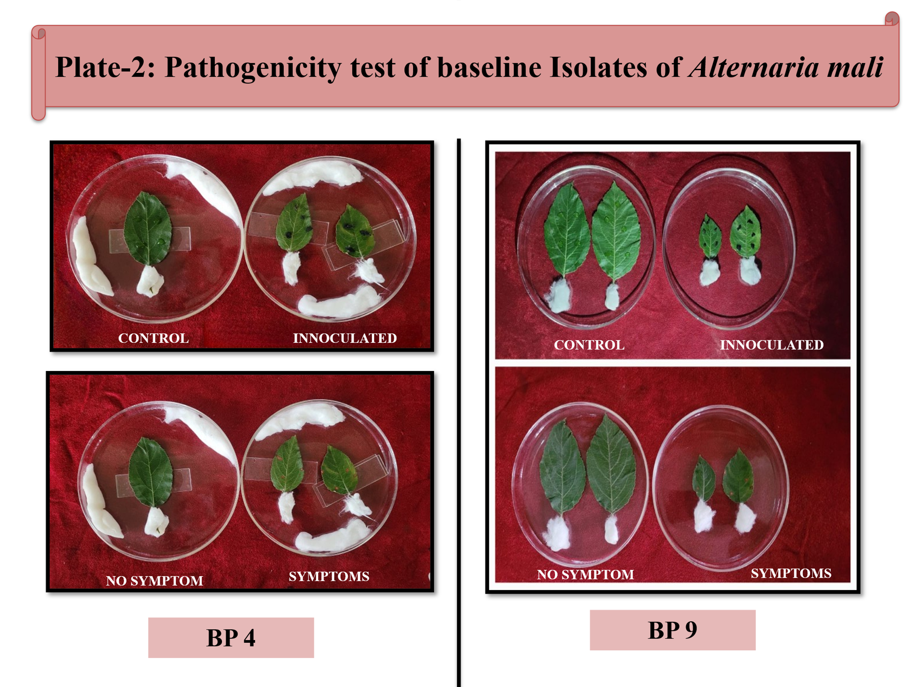
2.1.2 Data analysis
Percent relative growth (RG) for each isolate was calculated according to Chapman et al. (2011) using the following formula:
Mean radial growth on un-amended medium ​
RG (%) = ×100
Mean radial growth on fungicide-amended medium

- RESULTS AND DISCUSSION
Apple diseases, including those caused by Alternaria mali, are major threats to apple orchards and typically require 6-12 fungicide sprays per season for its management. In Kashmir, control of this disease depends mainly on protectant fungicides such as mancozeb, captan and dodine, along with curative fungicides, particularly DMIs and strobilurins. Among these, DMIs are widely used because of their broad-spectrum efficacy against several apple foliar diseases. Their intensive and prolonged use over the past two decades, together with reports of reduced field sensitivity, has raised concerns about the possible development of fungicide resistance in Alternaria mali. Therefore, the present study was undertaken to assess the baseline sensitivity of 30 Alternaria mali isolates and to calculate the mean ED₅₀ value for determining a discriminatory dose for resistance monitoring in exposed populations. In the present study, baseline isolates of Alternaria mali exhibited variable sensitivity to tebuconazole across different concentrations (Table-2). The EC₅₀ values ranged from 0.017 to 0.371 μg ml⁻¹, with the lowest value (0.017 μg ml⁻¹) recorded for isolate BP7 and the highest (0.371 μg ml⁻¹) for isolate BP11 (Table-3; Fig. 1). The mean EC₅₀ value was 0.15 μg ml⁻¹, which is comparable to the mean ED₅₀ value of 0.141 μg ml⁻¹ reported by Mubashir et al. (2023) for 30 baseline isolates of Venturia inaequalis against the DMI fungicide difenoconazole. However, the mean EC₅₀ obtained in the present study was slightly higher than the value of 0.07 μg ml⁻¹ reported by Koller et al. (1991) for 300 baseline isolates of V. inaequalis from New York, which may be attributed to the large temporal gap between the two studies (1991-2025). Similarly, Nabi et al. (2022) reported a mean EC₅₀ value of 0.02 μg ml⁻¹ for difenoconazole against 30 baseline isolates of V. inaequalis. A concentration of 0.20 μg ml⁻¹ was selected as the discriminatory dose for assessing resistance in the exposed population (Table-4).
Table 2. In vitro response of thirty Alternaria mali isolates to six concentrations of tebuconazole
Isolates  Conc. (µg ml⁻¹) | Percent relative growth at different concentrations (RG)
Isolates  Conc. (µg ml⁻¹) | 10 | 1 | 0.1 | 0.01 | 0.001 | 0.0001
BP1 | 31.03 | 41.38 | 58.62 | 67.24 | 75.86 | 93.1
BP2 | 15.6 | 24.4 | 42.2 | 77.8 | 86.7 | 95.6
BP3 | 7.7 | 28.2 | 74.4 | 79.5 | 84.6 | 94.9
BP4 | 2.2 | 41.3 | 50.0 | 63.0 | 82.6 | 87.0
BP5 | 1.89 | 49.06 | 73.58 | 81.13 | 88.68 | 94.34
BP6 | 12.7 | 36.6 | 54.9 | 64.8 | 67.6 | 88.7
BP7 | 5.3 | 15.8 | 44.7 | 55.3 | 63.2 | 89.5
BP8 | 34.9 | 34.9 | 53.5 | 65.1 | 72.1 | 81.4
BP9 | 17.1 | 26.8 | 42.7 | 47.6 | 53.7 | 65.9
BP10 | 11.8 | 14.7 | 61.8 | 64.7 | 79.4 | 91.2
BP11 | 21.1 | 50.9 | 64.9 | 75.4 | 77.2 | 91.2
BP12 | 8.2 | 24.5 | 79.6 | 81.6 | 87.8 | 95.9
BP13 | 18.8 | 40.6 | 53.1 | 68.8 | 78.1 | 84.4
BP14 | 25.5 | 30.9 | 50.9 | 63.6 | 76.4 | 87.3
BP15 | 12.1 | 33.3 | 51.5 | 78.8 | 87.9 | 93.9
BP16 | 21.7 | 46.7 | 53.3 | 65.0 | 68.3 | 73.3
BP17 | 8.0 | 16.0 | 52.0 | 72.0 | 80.0 | 92.0
BP18 | 16.7 | 26.2 | 52.4 | 61.9 | 76.2 | 85.7
BP19 | 19.1 | 25.5 | 63.8 | 66.0 | 68.1 | 78.7
BP20 | 8.1 | 29.7 | 37.8 | 78.4 | 83.8 | 91.9
BP21 | 5.1 | 30.8 | 64.1 | 74.4 | 76.9 | 89.7
BP22 | 7.5 | 12.5 | 42.5 | 77.5 | 85.0 | 87.5
BP23 | 11.9 | 26.2 | 59.5 | 69.0 | 76.2 | 85.7
BP24 | 8.1 | 24.3 | 75.7 | 83.8 | 86.5 | 89.2
BP25 | 6.3 | 29.2 | 60.4 | 70.8 | 79.2 | 91.7
BP26 | 13.7 | 43.1 | 52.9 | 62.7 | 78.4 | 92.2
BP27 | 25.6 | 37.2 | 53.5 | 65.1 | 81.4 | 86.0
BP28 | 28.3 | 35.8 | 45.3 | 52.8 | 60.4 | 92.5
BP29 | 10.2 | 44.9 | 55.1 | 65.3 | 73.5 | 83.7
BP30 | 18.8 | 40.6 | 53.1 | 68.8 | 78.1 | 84.4

Table 3. EC₅₀ values for thirty baseline isolates of Alternaria mali against Tebuconazole

Isolate | EC₅₀ (µg ml⁻¹) | Isolate | EC₅₀ (µg ml⁻¹)
BP1 | 0.268 | BP16 | 0.098
BP2 | 0.087 | BP17 | 0.048
BP3 | 0.145 | BP18 | 0.052
BP4 | 0.059 | BP19 | 0.062
BP5 | 0.239 | BP20 | 0.104
BP6 | 0.064 | BP21 | 0.083
BP7 | 0.017 | BP22 | 0.041
BP8 | 0.154 | BP23 | 0.065
BP9 | 0.198 | BP24 | 0.143
BP10 | 0.143 | BP25 | 0.075
BP11 | 0.371 | BP26 | 0.099
BP12 | 0.165 | BP27 | 0.104
BP13 | 0.115 | BP28 | 0.052
BP14 | 0.087 | BP29 | 0.081
BP15 | 0.115 | BP30 | 0.115

Table 4. Baseline sensitivity characteristics of thirty Alternaria mali isolates against Tebuconazole
Fungicide | Min EC 50  (μg/ml) | Max EC 50  (μg/ml) | Mean EC 50  (μg/ml) | Discriminatory  Dose (μg/ml)
Tebuconazole | 0.017 | 0.371 | 0.15 | 0.20

Fig. 1. Histogram showing diverse responses of Alternaria mali baseline isolates to various concentrations of tebuconazole.
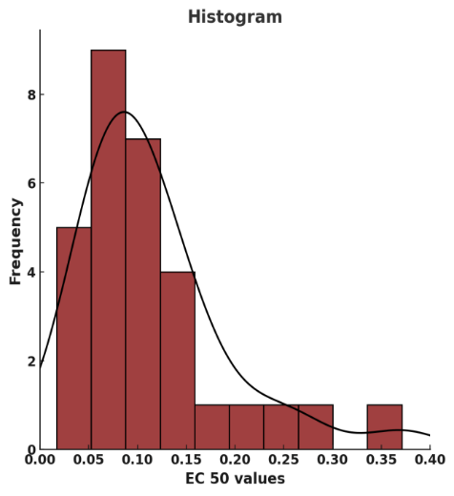

- CONCLUSION
The study determined the baseline sensitivity of Alternaria mali to tebuconazole using thirty representative isolates. EC₅₀ values ranged from 0.017 to 0.371 μg ml⁻¹ with a mean of 0.15 μg ml⁻¹ indicating variability in sensitivity within the population. These results suggest that tebuconazole remains effective against Alternaria mali under current conditions in Kashmir. A discriminatory concentration of 0.20 μg ml⁻¹ was established for resistance monitoring. This benchmark will aid in detecting shifts in sensitivity in field populations and supports the judicious use of DMI fungicides within integrated disease management programs to delay resistance development.
COMPETING INTERESTS
Authors have declared that no competing interests exist.
COMPETING INTERESTS DISCLAIMER:
Authors have declared that they have no known competing financial interests OR non-financial interests OR personal relationships that could have appeared to influence the work reported in this paper.

REFERENCES
Anonymous. (2013). Spurious pesticides, bad weather spoil 60 percent of apple production. The Daily Kashmir Times, September 22, 2013.
Anonymous. (2023a). Food and Agriculture Organisation. Retrieved from http://faostat3.fao.org
Anonymous. (2023b). Digest of Statistics. Government of Jammu and Kashmir.
Anonymous. (2006). FRAC list of plant pathogenic organisms resistant to disease control agents (p. 51).
Chapman, K. S., Sundin, G. W., & Beckerman, J. L. (2011). Identification of resistance to multiple fungicides in field populations of Venturia inaequalis. Plant Disease, 95, 921-926.
Fatima, N., & Qazi, N. A. (2008). Sensitivity of Alternaria mali to difenconazole in Kashmir valley. Journal of Mycology and Plant Pathology, 38(3), 556-558.
Grove, G., Eastwell, K., Jones, A. L., & Sutton, T. B. (2003). Diseases of apple. In Apples: Botany, production and uses (pp. 459-488).
Kishore, K., & Sharma, I. M. (2005). Nursery management of leaf blotch disease of apple seedlings. Plant Disease Research, 20, 29-31.
Koller, W., Wilcox, W. F., Barnard, J., Jones, A. L., & Braun, P. G. (1997). Detection and quantification of resistance of Venturia inaequalis populations to sterol demethylation inhibitors. Phytopathology, 87, 184-190.
Mubashir, S. S., Bhat, Z. A., & Bhat, M. A. (2023). Baseline sensitivities of Venturia inaequalis populations to difenoconazole, a sterol demethylation inhibitor fungicide. Frontiers in Crop Improvement, 11, 2965-2968.
Nabi, A., Ahmad, M., Shah, M. D., Padder, B. A., Dar, M. S., & Banday, S. (2022). First report of myclobutanil resistance and shift in sensitivity to difenoconazole and flusilazole in north-western Himalayan Venturia inaequalis populations. Australasian Plant Pathology, 52, 13-22.
Nabi, S. U., Baranwal, V. K., Yadav, M. K., & Rao, G. P. (2020). Association of Apple necrotic mosaic virus (ApNMV) with mosaic disease in commercially grown cultivars of apple (Malus domestica Borkh) in India. 3 Biotech, 10(3), 122.
Nene, Y. L., & Thapliyal, P. N. (2002). Fungicides in plant disease control (3rd ed.). Oxford and IBH Publishing Co. Pvt. Ltd., New Delhi.
Pasche, J. S., Wharam, C. M., & Gudmestad, N. C. (2002). Shift in sensitivity of Alternaria solani (potato early blight) to strobilurin fungicides. In Proceedings of the Brighton Crop Protection Conference: Pests and Diseases (Vol. 2, pp. 841-846). Nottingham, UK: Mafor Print.
Pasche, J. S., Wharam, C. M., & Gudmestad, N. C. (2004). Shift in sensitivity of Alternaria solani in response to QoI fungicides. Plant Disease, 88, 181-187.
Persley, D., & Horlock, C. M. (2009). Apple and pear. In T. Cooke, D. Persley, & S. House (Eds.), Diseases of fruit crops in Australia (pp. 31-32). CSIRO Publishing, Collingwood, Victoria, Australia.
Roberts, J. W. (1924). Morphological characters of Alternaria mali Roberts. Journal of Agricultural Research, 27, 699-708.
Shahzad, A. (2003). Studies on Alternaria leaf blotch of apple in Kashmir (Ph.D. Thesis). Post Graduate Faculty, SKUAST-Kashmir, Shalimar, J&K, India.
Shahzad, A., Bhat, G. N., & Mir, N. A. (2002). Alternaria mali-A new pathogen of apple in Kashmir. SKUAST Journal of Research, 4, 96–98.
Sharma, J. N. (2000). Marssonina blotch: A new disease of apple and its control. Indian Journal of Plant Protection, 28, 100-101.

outbreaks, pest infestations, and market fluctuations. Notably, apple scab, caused by Venturia inaequalis, poses a substantial
threat to apple crops. In chemical management strategy, sterol demethylation inhibitor (DMI) fungicides, such as
difenoconazole, myclobutanil, hexaconazole, and flusilazole, are commonly utilized to combat apple scab. However, recent
reports regarding the development of resistance against difenoconazole in Venturia inaequalis has necessitated the
assessment of baseline sensitivity test against difenoconazole in Kashmir. The fungicide was tested at five different
concentrations (viz., 0, 0.01, 0.1, 1.0 and 10 µg/ml) against thirty V. inaequalis isolates that were unexposed to any fungicide. At
a concentration of 0.1 ìg/ml, relative growth response ranging from 28.9 per cent (Vi26) to 61.3 per cent (Vi10) was observed.
The mean ED50 value was calculated to be 0.141 ìg/ml and a dose of 0.15 ìg/ml was selected as discriminatory dose for
assessment of resistance in exposed population. Resistance factor was calculated to be 4.32 inferring wider range of
sensitivities to difenaconazole
India stands as the fifth-largest global producer of apples, with Jammu and Kashmir emerging as the foremost contributor,
accounting for over 77% of the nation’s production. Despite this, the industry faces significant challenges, including disease
outbreaks, pest infestations, and market fluctuations. Notably, apple scab, caused by Venturia inaequalis, poses a substantial
threat to apple crops. In chemical management strategy, sterol demethylation inhibitor (DMI) fungicides, such as
difenoconazole, myclobutanil, hexaconazole, and flusilazole, are commonly utilized to combat apple scab. However, recent
reports regarding the development of resistance against difenoconazole in Venturia inaequalis has necessitated the
assessment of baseline sensitivity test against difenoconazole in Kashmir. The fungicide was tested at five different
concentrations (viz., 0, 0.01, 0.1, 1.0 and 10 µg/ml) against thirty V. inaequalis isolates that were unexposed to any fungicide. At
a concentration of 0.1 ìg/ml, relative growth response ranging from 28.9 per cent (Vi26) to 61.3 per cent (Vi10) was observed.
The mean ED50 value was calculated to be 0.141 ìg/ml and a dose of 0.15 ìg/ml was selected as discriminatory dose for
assessment of resistance in exposed population. Resistance factor was calculated to be 4.32 inferring wider range of
sensitivities to difenaconazole
India stands as the fifth-largest global producer of apples, with Jammu and Kashmir emerging as the foremost contributor,
accounting for over 77% of the nation’s production. Despite this, the industry faces significant challenges, including disease
outbreaks, pest infestations, and market fluctuations. Notably, apple scab, caused by Venturia inaequalis, poses a substantial
threat to apple crops. In chemical management strategy, sterol demethylation inhibitor (DMI) fungicides, such as
difenoconazole, myclobutanil, hexaconazole, and flusilazole, are commonly utilized to combat apple scab. However, recent
reports regarding the development of resistance against difenoconazole in Venturia inaequalis has necessitated the
assessment of baseline sensitivity test against difenoconazole in Kashmir. The fungicide was tested at five different
concentrations (viz., 0, 0.01, 0.1, 1.0 and 10 µg/ml) against thirty V. inaequalis isolates that were unexposed to any fungicide. At
a concentration of 0.1 ìg/ml, relative growth response ranging from 28.9 per cent (Vi26) to 61.3 per cent (Vi10) was observed.
The mean ED50 value was calculated to be 0.141 ìg/ml and a dose of 0.15 ìg/ml was selected as discriminatory dose for
assessment of resistance in exposed population. Resistance factor was calculated to be 4.32 inferring wider range of
sensitivities to difenaconazole

