Inner Retinitis as a Distinctive Finding of Mediterranean Spotted Fever: A Case Report

ABSTRACT
Aims: To highlight the role of characteristic inner retinitis identified by multimodal imaging as a crucial diagnostic marker for Mediterranean Spotted Fever (MSF), particularly when early serology is negative.
Case Study: A 45-year-old male presented with a one-week history of febrile rash and acute bilateral vision loss. Clinical examination revealed a maculopapular rash but no inoculation eschar. Ophthalmic evaluation, including SS-OCT and FA, demonstrated bilateral multifocal inner retinitis, vasculitis, and macular edema. Despite initial negative Rickettsia conorii serology, treatment with doxycycline and corticosteroids was initiated based on the typical ocular pattern.
Discussion: The anatomical localization of retinitis to the inner layers on OCT serves as a "clinical biopsy" of rickettsial angiotropism. This bridges the diagnostic gap during the first week of infection.
Conclusion: Systematic fundoscopic examination should be part of the routine evaluation for MSF, as inner retinitis is a hallmark that facilitates prompt therapy and excellent visual outcomes.
Keywords:
Mediterranean spotted fever, Rickettsia conorii, febrile rash, inoculation eschar, inner retinitis, retinal vasculitis, indirect immunofluorescence antibody assay, systematic fundoscopic examination
1. INTRODUCTION
Mediterranean spotted fever (MSF), caused by Rickettsia conorii, is endemic to Morocco and the Mediterranean basin [1,2]. While the classic triad includes fever, rash, and a black eschar, ocular involvement is frequent but often underdiagnosed [2,3,4]. Posterior segment manifestations, particularly inner retinitis, are characteristic of the acute phase [2,3,4,5,6,7]. This report illustrates how distinctive ocular findings can secure a diagnosis in atypical cases awaiting serological confirmation.
2. PRESENTATION OF CASE
A 45-year-old indigenous Moroccan male residing in a rural environment presented with rapidly progressive bilateral decrease in visual acuity, more pronounced in the right eye. One week prior to the onset of visual symptoms, he experienced a febrile rash accompanied by general malaise, nausea, and diarrhea. The rash initially appeared as a macular eruption on the trunk two days after the onset of fever, later becoming maculopapular and generalized, involving the palms and soles while sparing the face. The patient had no significant past medical or surgical history and reported taking no medications other than paracetamol prior to the onset of ocular lesions. Ophthalmological examination revealed a best corrected visual acuity of 20/130 in the right eye and 20/40 in the left eye, 1+ anterior chamber cells, mild hyalitis, and normal intraocular pressure. Fundus examination identified bilateral multifocal retinitis characterized by numerous small, superficial, white infiltrates resembling cotton-wool spots, distributed throughout the posterior pole and near retinal periphery (Fig. 1 A). A few dot-blot and flame-shaped retinal hemorrhages were observed adjacent to these patches bilaterally. Fluorescein Angiography (FA) showed early hypofluorescence of the retinitis lesions with a gradual increase in fluorescence. There was also focal staining of adjacent vessel walls, indicating retinal capillaritis, and late optic disc staining and leakage (Fig. 1 B). Swept-source optical coherence tomography (SS-OCT) demonstrated cystoid macular edema (CME) involving the outer retinal layers, more pronounced in the right eye (Fig. 2). The CME was characterized by the presence of hyperreflective dot-like lesions within the fluid-filled cystoid spaces and was accompanied by an underlying serous retinal detachment (SRD) (Fig. 2). SS-OCT revealed also numerous punctate opacities within the vitreous, consistent with inflammatory cells, with some deposited on the retinal surface (Fig. 2). B-scan OCT scanning through the retinitis lesions demonstrated focal hyperreflectivity and thickening confined exclusively to the inner retinal layers (Fig. 2). General examination revealed a generalized maculopapular rash sparing the face. IFA assay of the patient's serum, collected on the 8th day of illness, revealed IgM and IgG antibody titers to Rickettsia conorii antigen below 1:64, which was interpreted as a negative result in our endemic context. Laboratory tests for HIV, syphilis, tuberculosis, Lyme disease, Bartonella, and toxoplasmosis were also negative. Although the initial rickettsiosis serology was negative, the presence of typical inner retinitis combined with a suggestive febrile rash provided strong grounds to maintain a high suspicion for acute MSF and initiate treatment. The patient received doxycycline 100 mg twice daily for a fifteen-day course. Oral prednisolone, 1 mg/kg/day, was initiated 48 hours after doxycycline, with a two-month taper. At four weeks post-treatment, the patient showed significant clinical improvement, achieving 20/20 visual acuity in both eyes, with substantial macular edema regression and resolution of retinitis lesions without scarring (Fig. 3 A & B). However, OCT revealed retinal multifocal retinal thinning involving the inner retinal layers secondary to resolved retinal infiltrates (Fig. 4 A), while OCT-angiography (OCT-A) showed multiple extrafoveal regions of capillary loss in both the superficial and deep capillary plexuses of the macula (Fig. 4 B). Finally, IFA assay on convalescent serum demonstrated seroconversion, with a fourfold increase in IgM and IgG antibody titers, retrospectively confirming the diagnosis of MSF.
3. DISCUSSION
MSF is an emerging tick-borne rickettsiosis endemic in Morocco and the Mediterranean basin, caused by Rickettsia conorii, an obligate intracellular gram-negative bacterium, transmitted by the arthropod vector Rhipicephalus sanguineus, commonly known as the brown dog tick. The classical triad of symptoms characterizing MSF includes fever, a generalized maculopapular rash sparing the face, and an inoculation eschar (black spot) at the site of the tick bite [1, 2]. The diagnosis of rickettsial infection is usually based on clinical features, supported by epidemiological data and confirmed by positive indirect immunofluorescence test results demonstrating either a high initial antibody titer or a fourfold increase in convalescent serum titer [8].
Ocular involvement in MSF is frequent but often asymptomatic, leading to underdiagnosis [2,3,4]. While all ocular structures can be affected, posterior segment manifestations, including retinitis, mild vitritis, retinal vasculitis, CME, SRD, and papillitis, are more common and typically occur during the acute phase of illness, either uni- or bilaterally [2,3,4,5]. The retinitis associated with acute MSF typically involves the inner retinal layers and manifests as pseudo-cotton-wool spots, predominantly located in the posterior pole in proximity of retinal vessels, and frequently accompanied by adjacent vasculitis and retinal hemorrhages lesions [2,3,4,5,6,7]. On FA, the retinal infiltrates exhibit early hypofluorescence with progressive staining, while OCT reveals focal hyperreflective thickening within the inner retina [2, 6]. This typical presentation of retinitis was pivotal in the diagnosis of acute MSF in our patient who lacked early serological evidence. This is particularly relevant as IFA assay, the standard serodiagnostic test for MSF, typically yields negative results until the second week of clinical illness [1,2,4].
Apart from rickettsiosis, focal or multifocal retinitis can arise from a wide range of ocular and systemic inflammatory or infectious diseases [8]. In our patient's differential diagnosis, we considered various etiologies, including autoimmune conditions like Behçet's disease and sarcoidosis, as well as infectious causes such as toxoplasmosis, tuberculosis, syphilis, bartonellosis, Lyme disease, HIV, and herpetic diseases. Most of these were effectively ruled out in our patient by a combination of epidemiological data, detailed history, systemic examination, and targeted biological/serological testing. Although herpes serologies were not performed, the OCT in our case uniquely showed exclusively internal retinal involvement, which differs from the full-thickness retinal involvement typically seen in herpetic retinitis [6].
The pathogenesis of retinitis in MSF remains debated. Typically adjacent to retinal vasculitis, these lesions might arise from direct bacterial invasion and multiplication within the inner retina, supported by the known rickettsial angiotropism [2,3,6]. Alternatively, the deposition of immune complexes and inflammatory cells in the retina may lead to the formation of white infiltrates [2,3,5,6]. Considering potentially combined mechanisms, oral antibiotics such as doxycycline should be initiated to address the active infectious component before considering corticosteroids in select cases for inflammation management, consistent with our approach [2,6].
Retinitis and other posterior segment manifestations in acute MSF are commonly self-limited, resolving within 3-10 weeks with generally good visual outcomes [2, 4, 8], consistent with our patient's recovery. The absence of obvious chorioretinal scars after retinitis foci disappear suggests that rickettsial retinal infiltration typically spares the outer retina, retinal pigment epithelium (RPE), and choroid [2,7]. However, OCT may reveal retinal nerve fiber defects and focal inner retinal layer thinning following resolution [2]. Rickettsial retinal vasculitis can result in microvascular occlusions, with areas of capillary non-perfusion demonstrable on OCT-A [2]. These outcome aspects are effectively illustrated in our case.
While limited to a single observation, our case, documented through multimodal imaging, underscores that identifying characteristic inner retinitis can bridge the diagnostic gap during the first week of MSF when serology is typically negative. These findings align with the observations of Khairallah et al., who identified typical retinitis in 42.5% of confirmed MSF cases and concluded that these fundus abnormalities are a hallmark of the disease that should be incorporated into formal diagnostic criteria [4].
4. CONCLUSION
Inner retinitis is a distinctive hallmark of MSF. Systematic fundoscopic examination is essential for patients with febrile rash in endemic areas to bridge the diagnostic gap and ensure prompt initiation of appropriate therapy.

ABBREVIATIONS:
MSF: Mediterranean spotted fever
FA: Fluorescein angiography
OCT: Optical coherence tomography
SS-OCT: Swept-source optical coherence tomography
OCT-A: Optical coherence tomography-angiography
IFA: Indirect immunofluorescence antibody
IgM: Immunoglobulin M
IgG: Immunoglobulin G
CME: Cystoid macular edema
SRF: Serous retinal detachment
RPE: Retinal pigment epithelium

CONSENT
The patient has provided written informed consent for the publication of this case report and accompanying images.

REFERENCES
1.Spernovasilis N, Markaki I, Papadakis M, Mazonakis N, Ierodiakonou D. Mediterranean spotted fever: current knowledge and recent advances. Trop Med Infect Dis. 2021,6:172
2.Abroug N, Nabi W, Amor HB, Khochtali S, Attia S, Jelliti B, Khairallah M. Rickettsial disease: an underestimated cause of posterior uveitis. Saudi J Ophthalmol. 2022,36:374-9
3.Khairallah M, Ladjimi A, Chakroun M, Messaoud R, Yahia S. Posterior segment manifestations of Rickettsia conorii infection. Ophthalmology. 2004,111:529-34
4Khairallah M, Yahia SB, Jelliti B, Ben Romdhane F, Loussaief C, Attia S, Toumi A, Messaoud R, Chakroun M. Diagnostic value of ocular examination in Mediterranean spotted fever. Clin Microbiol Infect. 2009,1:273-4
5.Ganekal S, Singnal K, Rajappa S, Hegde S. Ocular manifestation of rickettsial disease in south indian population. Indian J Ophthalmol. 2021,69:1167-71
6.Chawla R, Pundlik GA, Chaudhry R, Thakur C. Rickettsial retinitis: direct bacterial infection or an immune-mediated response? Indian J Ophthalmol. 2017,65:1038-41
7.Kahloun R, Gargouri S, Abroug N, Sellami D, Ben Yahia S, Feki J, Khairallah M. Visual loss associated with rickettsial disease. Ocul Immunol Inflamm. 2014,22:373-8
8.Khairallah M, Jelliti B, Jenzeri S. Emergent infectious uveitis. Middle East Afr J Ophthalmol. 2009,16:225-38

LEGENDS:
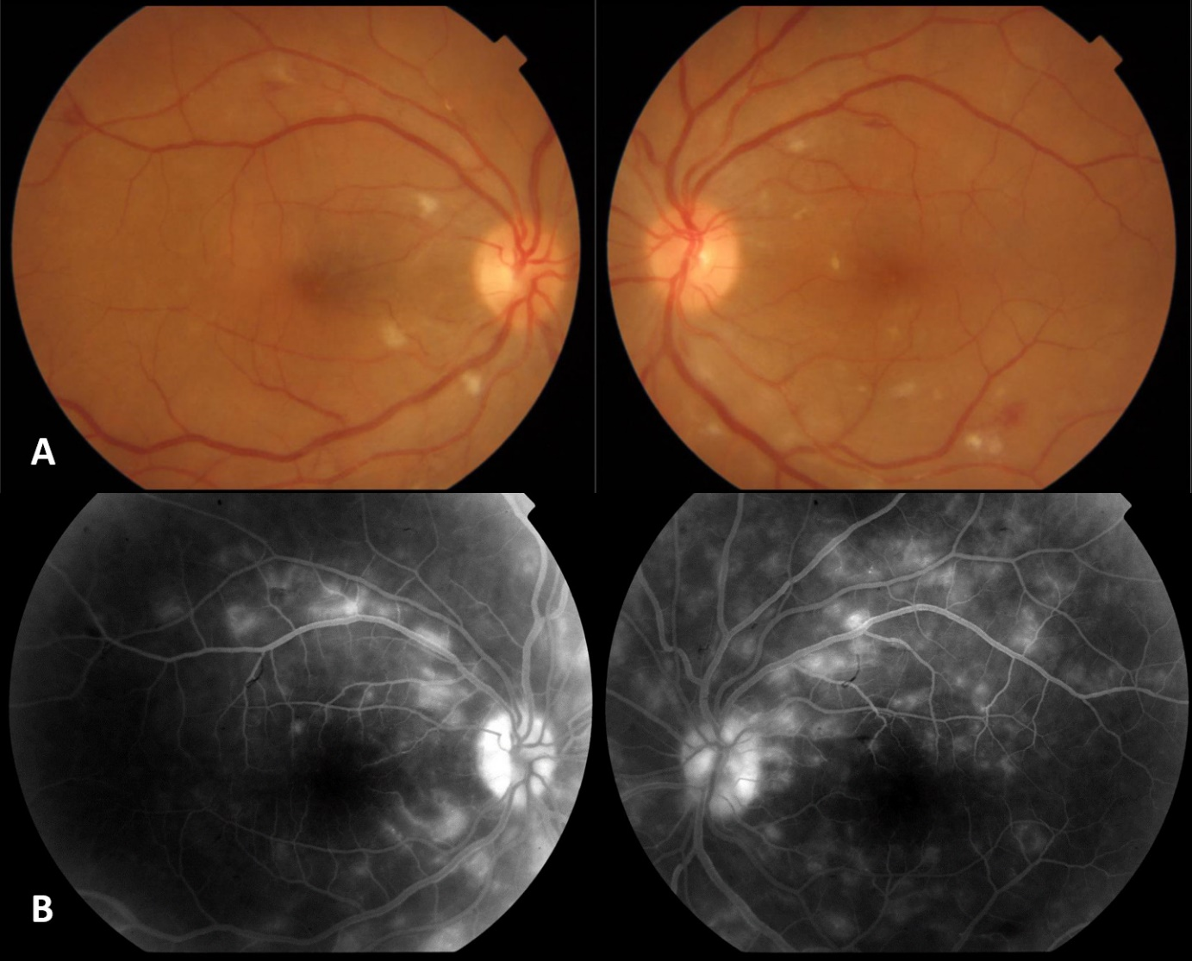
Figure 1: Color fundus retinography (A) and fluoresceine angiography (B) from the acute phase of illness:
A. Bilateral multifocal retinitis, with numerous small, superficial, white cotton-wool spot-like retinal infiltrates distributed throughout the posterior pole and near retinal periphery, accompanied by a few dot-blot and flame-shaped retinal hemorrhages adjacent to the retinitis foci.
B. Hyperfluorescence of retinitis lesions, focal staining of adjacent vessel walls, retinal capillaritis and optic disc leakage.
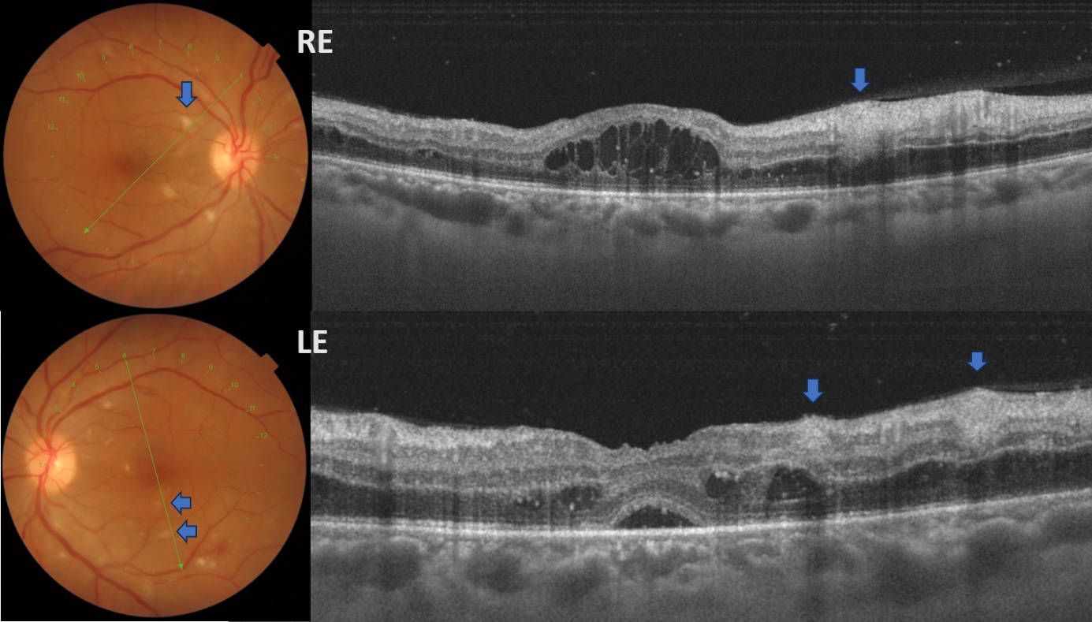
Figure 2: OCT B-scan through the fovea, with precise localization of the B-scan line on retinography:
Macular cystoid edema involving the outer retinal layers, more pronounced in the right eye, characterized by the presence of hyperreflective dot-like lesions distributed within the fluid-filled cystoid spaces, and accompanied by an underlying serous retinal detachment. B-scan imaging through the retinitis lesions showed focal hyperreflectivity and thickening within the inner retinal layers (B: blue arrows). Note the presence of numerous punctate opacities within the vitreous, consistent with inflammatory cells, some deposited on the retinal surface.
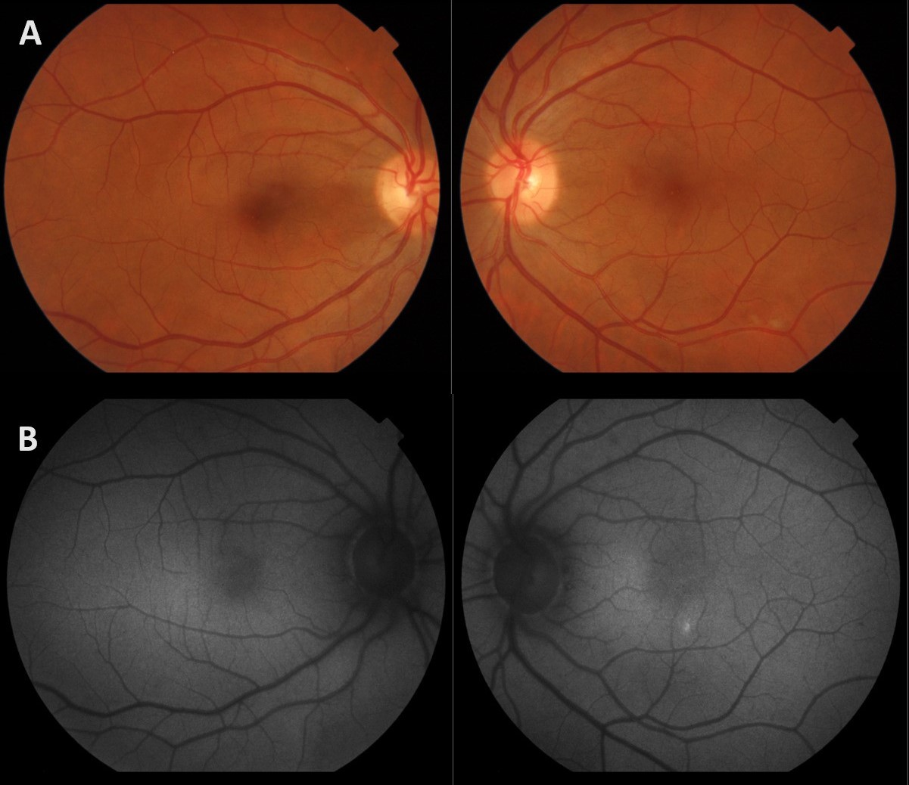
Figure 3: Post-treatment fundus imaging, including color retinography (A) and blue-light autofluorescence (B):
Resolution of the retinitis lesions with absence of obvious residual retinal or pigment epithelium scars
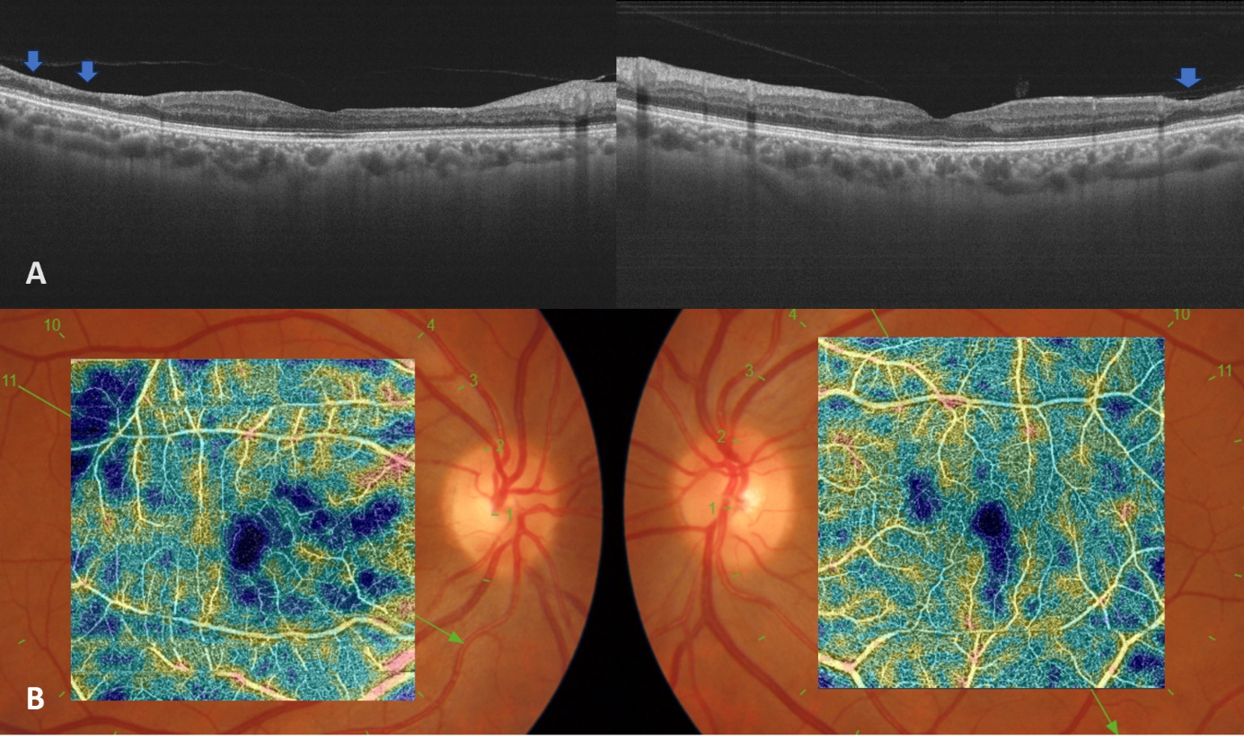
Figure 4: Post-treatment widefield macular OCT (A) and 6 mm X 6 mm composite macular OCT-A (B):
A. Multifocal retinal thinning involving the inner retinal layers secondary to resolved retinal infiltrates
B. Persistent flow deficit areas (blue areas) in the superficial and deep capillary plexuses

