Case report

A CASE STUDY ON TURNER’S SYNDROME

.
ABSTRACT
Introduction:
Turner syndrome is a rare chromosomal disorder in females caused by complete or partial absence of one X chromosome. It presents with short stature, gonadal dysgenesis, primary amenorrhea, and is often associated with endocrine and autoimmune disorders, leading to delayed diagnosis.
CasePresentation:
A 17-year-old female presented with fever, cough with expectoration, facial puffiness, and decreased appetite. She had a history of primary amenorrhea. Clinical evaluation revealed anemia, hypotension, and hormonal abnormalities with low FSH and LH levels. Imaging showed bilateral lung opacities and absence of the uterus on ultrasonography. Ultrasonography of the neck revealed Hashimoto’s thyroiditis, supporting an autoimmune association. She was treated with antibiotics and supportive therapy.
Discussion:
The case highlights the varied presentation of Turner syndrome and the importance of recognizing primary amenorrhea and autoimmune manifestations for early diagnosis.
Conclusion:
Early identification and multidisciplinary management of Turner syndrome improve outcomes and quality of life.

Keywords: Turner syndrome, Primary amenorrhea, Autoimmune thyroiditis, Case study, Gonadal dysgenesis.

1. INTRODUCTION

Turner syndrome is a rare condition characterized by female hypergonadotropic hypogonadism, infertility, short stature, endocrine and metabolic disorders, an increased risk of autoimmune disease, as well as other medical conditions such as cardiovascular disease, The condition, which is associated with a completely or partially missing X chromosome, was first described ~100 years ago by three independent clinicians, Seresevskij, Ullrich and Turner.^{[1]} TS is primarily caused by the complete or partial loss of one X chromosome, with the most common karyotype being 45.^{[2]}

Epidemiology-
It is the only viable monosomy syndrome in humans, with an incidence of approximately 1 in 4,000 to 1 in 2,500 live female births.^{[2]}

Etiology–
Turner syndrome is caused by complete or partial absence of one X chromosome in a phenotypic female, leading to abnormal growth and gonadal development.
Main etiological factors:
- Chromosomal nondisjunction- During meiosis or early mitosis (sporadic, not inherited)
- Cytogenetic abnormalities- Monosomy X (45,X) – most common, Mosaicism (e.g., 45,X/46,XX or 45,X/46,XY) and Structural abnormalities of the X chromosome
- Gene haploinsufficiency- Loss of genes that escape X-inactivation, Especially SHOX gene (Xp22) → short stature and skeletal abnormalities
- Ovarian determinant gene loss- Deletions involving POF1 (Xq26–q28) and POF2 (Xq13.3–q21.1), Disruption of genes such as FMR1 and BMP15 → leads to gonadal failure and primary amenorrhea ^{[3]}

Pathophysiology–^{[1]}
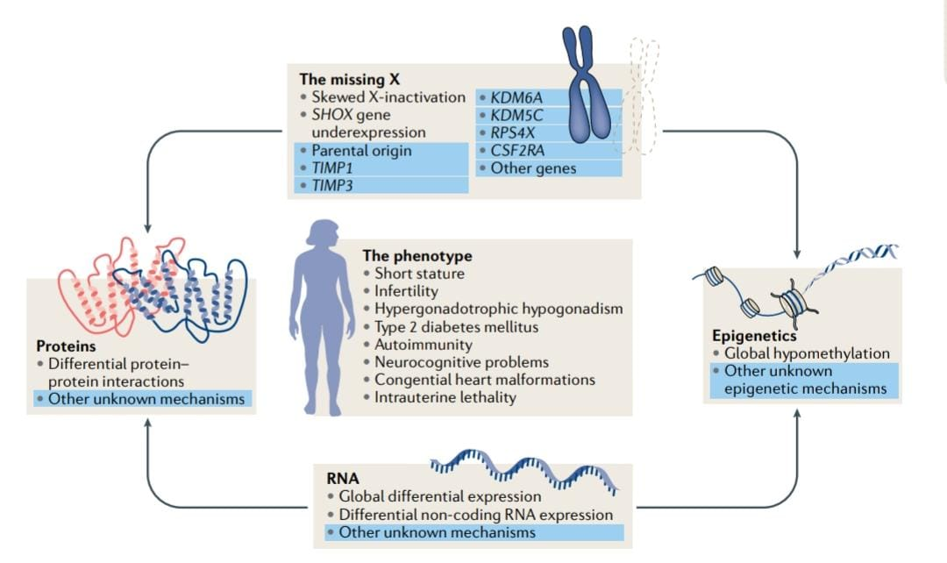
Fig 01 – Pathophysiology of Turner’s Syndrome
Clinical manifestation^{[4]} –
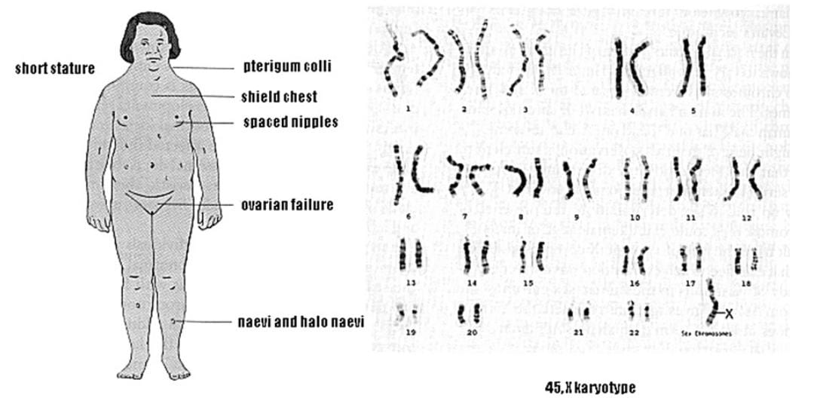
Fig 02 - Clinical manifestation of Turner’s Syndrome

Diagnosis–
- Cytogenetic confirmation- Presence of complete or partial loss of one X chromosome, Confirmed by karyotype analysis, Common karyotypes [45,X (monosomy X), Mosaicism (e.g., 45,X/46,XX or 45,X/46,XY)and Structural abnormalities (ring X, isochromosome X, Xp or Xq deletions)], At least 30 metaphase cells should be analyzed, Buccal smear is insufficient and If karyotype is normal but suspicion remains → FISH for low-level mosaicism
- Phenotypic features consistent with Turner syndrome- Short stature, Gonadal dysgenesis or ovarian insufficiency, Female phenotype (males should never be diagnosed with TS), May present as:Neonatal lymphedema, webbed neck, Childhood short stature, Adolescent primary amenorrhea or pubertal delay.
- Special diagnostic considerations- If Y chromosome material is suspected → perform FISH or DNA studies and Presence of Y material carries a risk of gonadoblastoma (~12%), requiring prophylactic gonadectomy.^{[5]}

Treatment–
TS is a multifaceted condition that affects multiple organ systems in females, necessitating a multidisciplinary approach to patient care
- Growth Promotion- Growth Hormone (GH) therapy- Started in early childhood when growth failure is evidentand improves growth velocity and increases final adult height
- Puberty Induction & Maintenance- Estrogen replacement therapy- Initiated around 11–12 years of age and induces secondary sexual characteristics and pubertal development, Progesterone- Added after estrogen-induced uterine development or onset of breakthrough bleeding and maintains regular menstrual cycles
- Gonadal & Fertility Management- Most patients have ovarian failure and Fertility options
- Prevention of Osteoporosis- Adequate estrogen replacement, Calcium and vitamin D supplementation and Weight-bearing exercises
- Management of Associated Conditions- Cardiac anomalies → regular cardiology follow-up, Renal anomalies → renal evaluation, Thyroid disorders → regular thyroid screening, Hearing and vision problems → periodic assessment and Metabolic issues (obesity, diabetes, hypertension) → lifestyle modification and medical management
- Psychosocial Support- Educational and psychological support and Counseling for self-esteem, social skills, and transition to adult care ^{[6]}

2. CASE PRESENTATION-
A 17-year-old female patient was admitted to vijayanagara institute of medical science (VIMS), Ballari (Karnataka) with chief complaints of cough with expectoration since 15 days, fever since 15 days – mild to moderate grade and raise of temperature in the evening, decreased appetite since 15 days and facial puffiness since 5 days.
Social history – No habits.
Past history – H/O Primary Amenorrhea and K/C/O Admission for similar complaints 1 year back.
Family history – Nothing significant.
On Examination -
The patient’s blood pressure was recorded at 90/60 mmHg, and the pulse rate was 130 beats per minute. Oxygen saturation was 90% on room air. The random blood glucose level was 118 mg/dL. The patient was conscious and oriented. On respiratory examination, bilateral normal vesicular breath sounds were present. Cardiovascular examination revealed normal S1 and S2 heart sounds. Per abdominal examination showed a soft and non-tender abdomen.

PARAMETERS | RESULT (23-12-25) | RESULT (24-12-25) | RESULT (25-12-25) | REFERENCE RANGE
Haemoglobin | 7.8 |  |  | 13-18gm/dl
WBC | 11410 |  |  | 4000-11000 cells/cumm
Platelet | 5.39 |  |  | 1.5-4.5 lacs/cumm
Blood Urea | 20 |  |  | 15-45mg/dl
Serum creatinine | 0.7 |  |  | 0.7-1.4mg/dl
Total bilirubin |  | 0.6 |  | 0.1-1 mg/dl
SGPT/ALT |  | 17 |  | 0-35 U/L
SGOT/AST |  | 27 |  | 0-35 U/L
Alkaline Phosphatase (ALP) |  | 233 |  | 30-120 U/L
Total protein |  | 7.1 |  | 6-8.3 g/dl
Albumin |  | 3.5 |  | 3.2-5.4 g/dl
CRP | 76.4 |  |  | 0-6 mg/dl
FSH (Follicle Stimulating Hormone) |  |  | 1.99 | 4-10 IU/mL
LH (Luteinizing Hormone) |  |  | 0.43 | 2-12 IU/mL
Cortisol |  |  | 25.1 | 5-25 microgram/dl
FT₃ |  |  | 2.28 | 2.0-4.4 pg/ml
TSH |  |  | 1.81 | 0.4-4.0 mIU/L
FT₄ |  |  | 0.67 | 0.8-1.8 ng/dl
Urine albumin | Traces
Urine microscopy | 1-2 pus cells
LDH | 680 |  |  | 140-280 U/L
Serum folic acid | 8.46 |  |  | 2.5-20 ng/ml
Serum ferritin | 2455 |  |  | 11-307 ng/ml
Vitamin B₁₂ | 523 |  |  | 211-911 pg/ml
Table 1. Laboratory examination of the patient
- Other investigations – Chest X – ray :- B/L Non-homogenous opacities, USG abdomen & pelvis :- Uterus absent, Peripheral smear study :- Microcytic Hypochromic and USG neck :- Hashimoto’s Thyroiditis.

SL.NO | NAME OF MEDICATIONS | DOSE | ROUTE | FREQUENCY
01 | INJ. CEFTRIAXONE | 1 gm | IV | BID FOR 3 DAYS
02 | INJ. PANTOPRAZOLE | 40 mg | IV | OD FOR 3 DAYS
03 | INJ. ONDANSETRON | 4 mg | IV | BID FOR 3 DAYS
04 | INJ. PARACETAMOL | 100 ml | IV | TID FOR 3 DAYS
05 | TAB. DOXYCYCLINE | 100 mg | PO | BID FOR 3 DAYS
06 | TAB. IRON FOLIC ACID | 333 mg | PO | BID FOR 3 DAYS
07 | TAB. FOLIC ACID | 5 mg | PO | OD FOR 3 DAYS
08 | INJ. MULTIVITAMIN | 1 PINT NS | IV | OD ON 3rd DAY
Table 2. Treatment regimen in hospital

3. discussion
Turner's syndrome is a rare chromosomal disorder commonly occuring in females, which is under diagnosed due to its variety of signs and symptoms. In lots of cases, patient had a known history of primary amenorrhea which is one of the significant symptom of Turner's syndrome along with other symptoms of infection. Lab investigation showed anemia, elevated CRP along with hormonal abnormalities including low FSH and LH levels indicating gonadal abnormalities. On USG scanning it is revealed absence of uterus supporting diagnosis of gonadal dysgenesis associated with Turner's syndrome. Hashimoto's thyroiditis shows presence of risk of auto immune disorder in patients with Turner's syndrome. Elevated ferritin and LDH levels shows underlying inflammation or infection. As a clinical pharmacist point of view, this case emphasizes importance of multi disciplinary management. Pharmacist can play an important role in identification of DRP's, monitoring hormonal replacement therapy, ensuring adherence and providing patient councelling about long term follow up and lifestyle modification

4. Conclusion
Turner syndrome is an uncommon condition in females and may not be recognized early because its signs can be subtle and vary from person to person. This case emphasizes the importance of careful clinical assessment and appropriate investigations when a patient presents with short stature and delayed pubertal development. Early diagnosis helps in starting timely treatment, such as growth hormone and estrogen therapy, which can improve physical development and reduce long-term complications. Regular follow-up and coordinated care from multiple specialties are essential to address associated health issues and to improve the patient’s overall well-being and quality of life.

CONSENT
As per international standards or university standards, patient(s) written consent has been collected and preserved by the author(s).

ETHICAL APPROVAL
It is not applicable.

DISCLAIMER (ARTIFICIAL INTELLIGENCE)
Author(s) hereby declare that NO generative AI technologies such as Large Language Models (ChatGPT, COPILOT, etc) and text-to-image generators have been used during writing or editing of this manuscript.

COMPETING INTERESTS
Authors have declared that no competing interests exists.

COMPETING INTERESTS DISCLAIMER:
Authors have declared that they have no known competing financial interests OR non-financial interests OR personal relationships that could have appeared to influence the work reported in this paper.

References
- Gravholt CH, Viuff MH, Brun S, Stochholm K, Andersen NH. Turner syndrome: mechanisms and management. Nat Rev Endocrinol. 2019;15(10):601–614.
- Ding F, Xu J, Xiong J, Li Q, Cheng Z, Deng L. Epidemiological analysis of Turner syndrome in children aged 0–14 years: global, regional, and national perspectives (1990–2021). Front Endocrinol (Lausanne). 2025;16:1552300.
- Zhong Q, Layman LC. Genetic considerations in the patient with Turner syndrome—45,X with or without mosaicism. Fertil Steril. 2012;98(4):775–779.
- Lleo A, Moroni L, Caliari L, Invernizzi P. Autoimmunity and Turner’s syndrome. Autoimmun Rev. 2012;11(8):A538–A543. doi:10.1016/j.autrev.2011.11.015.
- Loscalzo ML. Turner syndrome. Pediatr Rev. 2008;29(7):219–227.
- Khan N, Farooqui A, Ishrat R. Turner syndrome: where are we? Orphanet J Rare Dis. 2024;19:314.

