Original Research Article

A Boosted Regression Tree Approach to Modeling Coilia dussumieri Distribution in Relation to Environmental Variables off Mumbai

ABSTRACT
India is a major player in global fisheries, with Coilia dussumieri being a significant species. This study investigates the spatiotemporal distribution of C. dussumieri along the Mumbai coast, focusing on the influence of environmental factors. Data on fish catch and environmental variables (SST, salinity, pH, SSH, current speed, and chlorophyll-a) were collected during fortnightly surveys. The association between these factors and Catch Per Unit Effort (CPUE) was modelled using Boosted Regression Trees (BRT). Results revealed that salinity, chlorophyll-a, and SST were the most influential factors, with optimal ranges observed for each. The model demonstrated a non-linear and interactive effect of salinity and chlorophyll-a on CPUE. A greater percentage of juveniles were found in the catch, according to an analysis of length-frequency data, underscoring the need of taking juvenile populations into account when developing management plans. This work provides significant insight on the ecological needs of C. dussumieri and highlights the necessity of managing fisheries using an ecosystem-based strategy that takes environmental factors and juvenile population dynamics into account.
Keywords: Coilia dussumeiri, Juvenile population, CPUE, length-frequency.
1. INTRODUCTION
The world's third-largest fish producer is India. With its rich history and expertise, the marine fishing industry in India is one of the biggest employers. The goldspotted grenadier anchovy, or Coilia dussumieri, is a ray-finned fish species that belongs to the Engraulidae family. It is found in estuaries and marine seas that border India, Bangladesh, and Myanmar. Furthermore, it is distributed from Java and the Malay Peninsula to the southern part of Thailand (Akhter et al., 2024). Common forage fish found in tropical and subtropical seas are anchovies. Known as gold-spotted grenadier anchovies in England, Mandeli in Bombay and Gujarat, and "Oluua maach" in Bangladesh's coastal regions (Amin and Zafar, 2004). On the coasts of Bombay, Maharashtra, and Gujarat, it is captured alongside a range of other fish by the Indigenous Dolnets (fixed bagnets) and set bag net (S.B.N.) in India (Fernandez and Devaraj, 1989) and in the northeast by trawl fishery (CMFRI, 2024), individual fish might spawn only twice yearly (Fernandez and Devaraj, 1989). In 2023, an estimated 3.53 million tonnes of marine fish were landed off the coast of mainland India. The anchovies group accounted for 153,000 tonnes, which is 4.33% of the total landings. Within the Clupeids fishery, Coilia sp. was the main species, contributing 22.75%. Specifically, the catch of Coilia sp. was 33,555 tonnes in 2023. Mechanized, motorized, and non-motorized fishing crafts are the three types of fishing crafts that together account for the overall amount of effort required to fish. 2.8 million tonnes (79%), 0.71 million tonnes (20%), and 0.03 million tonnes (1%), respectively, were their contributions to the total marine landings (CMFRI, 2024). Assessing the spatial distribution of fish catches is an essential part of managing organisms that are at risk (Hildalgo et al., 2011; Campbell, 2015; Thorson et al., 2015; Ramteke et al., 2020). Understanding adaptation behavior as a result to short and long-term environmental changes helps to address the issue of spatiotemporal movement, which is essential for effective stock assessment, and a lack of knowledge may contribute to a sudden collapse of over-exploited fisheries resources (Ramteke et al., 2020). Thus, the development of fisheries management should be grounded in an understanding of how environmental factors influence the spatiotemporal distribution of fish. It is also important to consider the presence of juveniles in Dolnet catches along the Maharashtra coast. We revealed the response characteristics and influence mechanisms of SST, salinity, pH, SSH, current speed, and chla, which are typical environmental factors in Mumbai coastal water.
2. MATERIAL AND METHODS
environmental factors' effects on temporal dispersion in order to get fish catch data from Mumbai's coastal regions, a biweekly independent fisheries resource survey was conducted from December 2022 to May 2023 utilizing M.F.V NARMADA (IV), I CAR-Central Institute of Fisheries Education, Mumbai (Fig. 1). During the survey, identical net setting and hauling procedure was implemented, using 35 m Dolnet of 10 mm mesh size cod end. Following their collection, the fish samples were taken to the lab for species-level identification. Weight and length were measured to the closest 0.01 g and 1 mm, respectively. Utilizing data from the E.U. Copernicus Marine Service (2024 and 2016), this study examines the association between catch per unit effort (CPUE) and sea surface temperature (SST), salinity, pH, sea surface height (SSH), chlorophyll-a (Chla), and current speed (CS). An analysis using boosted regression trees (BRT) to determine environmental variables' impact on the spatiotemporal distribution of fish Coilia dussumieri. By fitting many models and integrating them for prediction, BRT is one of various methods that seek to enhance the performance of a single model. BRT employs two algorithms: boosting constructs and combines a set of models, and regression trees from the classification and regression tree (decision tree) groups of models.
3. RESULT
The spatial and temporal variability of SST is evident across seasons and years. Their distribution along a coastal region for different seasons (Pre-monsoon, Monsoon, and Post-monsoon) in 2021 and 2022(Fig 1). The SST is represented using a color gradient, ranging from 5.4 °C (blue) to 39.9 °C (red). The spatial and temporal analysis of Sea Surface Temperature (SST) revealed distinct seasonal patterns along the coastal region. SST peaked during the monsoon season (reaching up to 39.9 °C) in coastal areas, reflecting higher thermal energy accumulation. Pre-monsoon and post-monsoon periods exhibited relatively cooler SST values, suggesting seasonal cooling and stabilization of thermal dynamics.
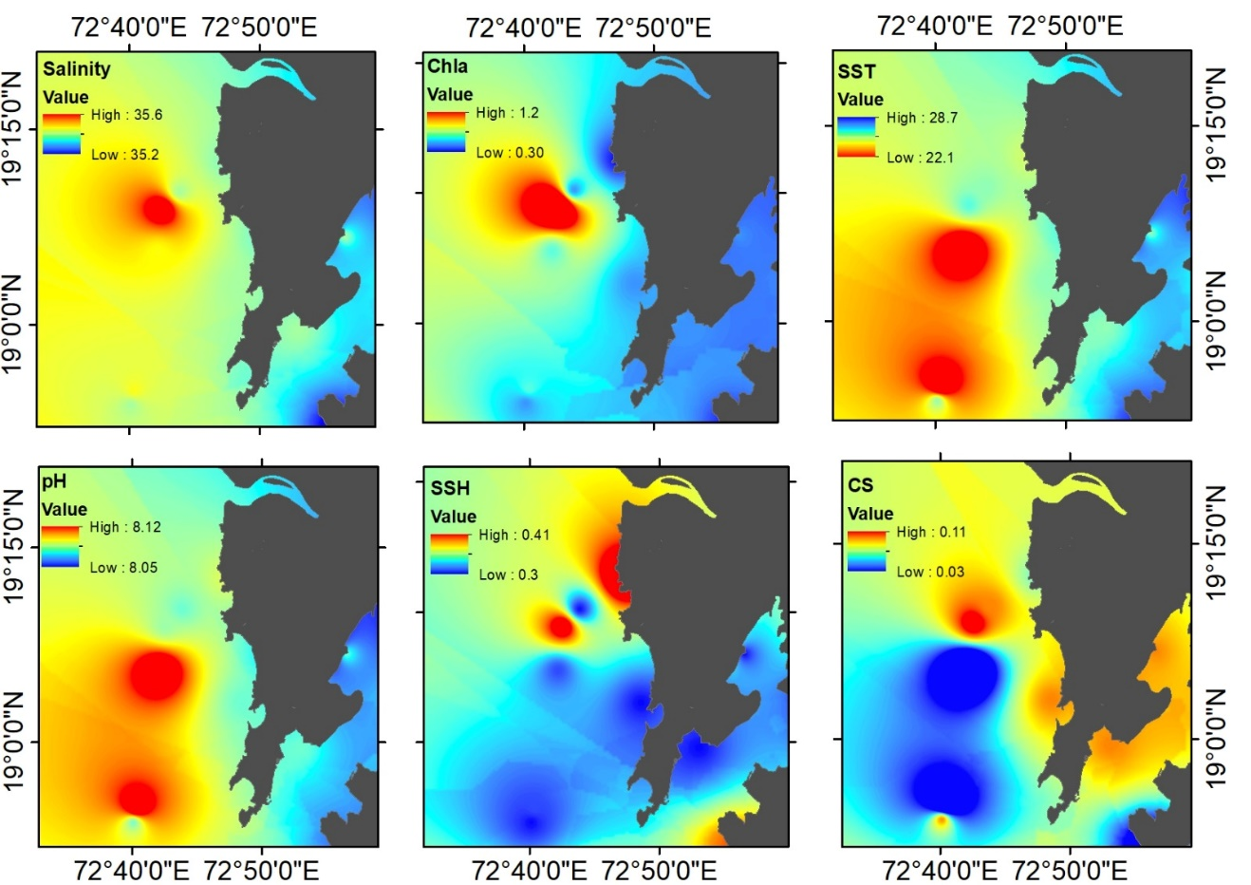
Fig 1:- Seasonal and inter-annual variability in environmental condition along Mumbai coastal regions

The plots (Fig 2) show the relationship between Catch Per Unit Effort (CPUE) on the y-axis and various environmental factors on the x-axis. Each plot represents a different factor impacting CPUE. description of each parameter is as follows: The relationship between salinity and CPUE (36.9%) shows a marked increase in catch rates at a salinity level of around 35.5, indicating a strong positive correlation. Higher salinity levels above this threshold appear to enhance CPUE, suggesting that specific salinity conditions are crucial for improving catch rates. For chlorophyll-a (34.6%), a significant rise in CPUE is observed when its concentration reaches around 1.0. This trend implies that increased chlorophyll levels are associated with higher catch rates, likely due to its role in supporting primary productivity in the water, which can attract fish. Sea surface temperature (SST, 13.7%) demonstrates an optimal range for CPUE, with a notable increase in catch rates between SST values of 25 and 26 °C. However, as the temperature rises to 27 °C, CPUE drops significantly, indicating that temperatures around 25-26 °C may be most favourable for maximizing catch efficiency. Regarding pH (5.4%), CPUE experiences a sharp rise around a pH level of 8.08, suggesting a peak in catch rates at this specific pH range. This highlights that water pH can also influence catch rates, with near-neutral to slightly alkaline conditions seeming to support higher CPUE. Sea surface height (SSH, 4.7%) shows a decline in CPUE at SSH values around 0.4 but a sharp increase at approximately 0.45. This relationship indicates that certain sea surface heights are beneficial for catch rates, possibly due to the influence of water column stability or nutrient distribution. Lastly, the current speed (CS, 4.7%) shows a sharp decline in CPUE around a speed of 0.10 m/s. This suggests that lower current speeds might be more conducive to successful catches, as higher speeds could impact fish behavior or distribution, thereby reducing catch rates. Each environmental factor's relationship with CPUE is illustrated by a solid black line and a red dashed line, highlighting specific thresholds where CPUE changes significantly (Fig2). The percentages indicate the contribution of each variable to the CPUE model.
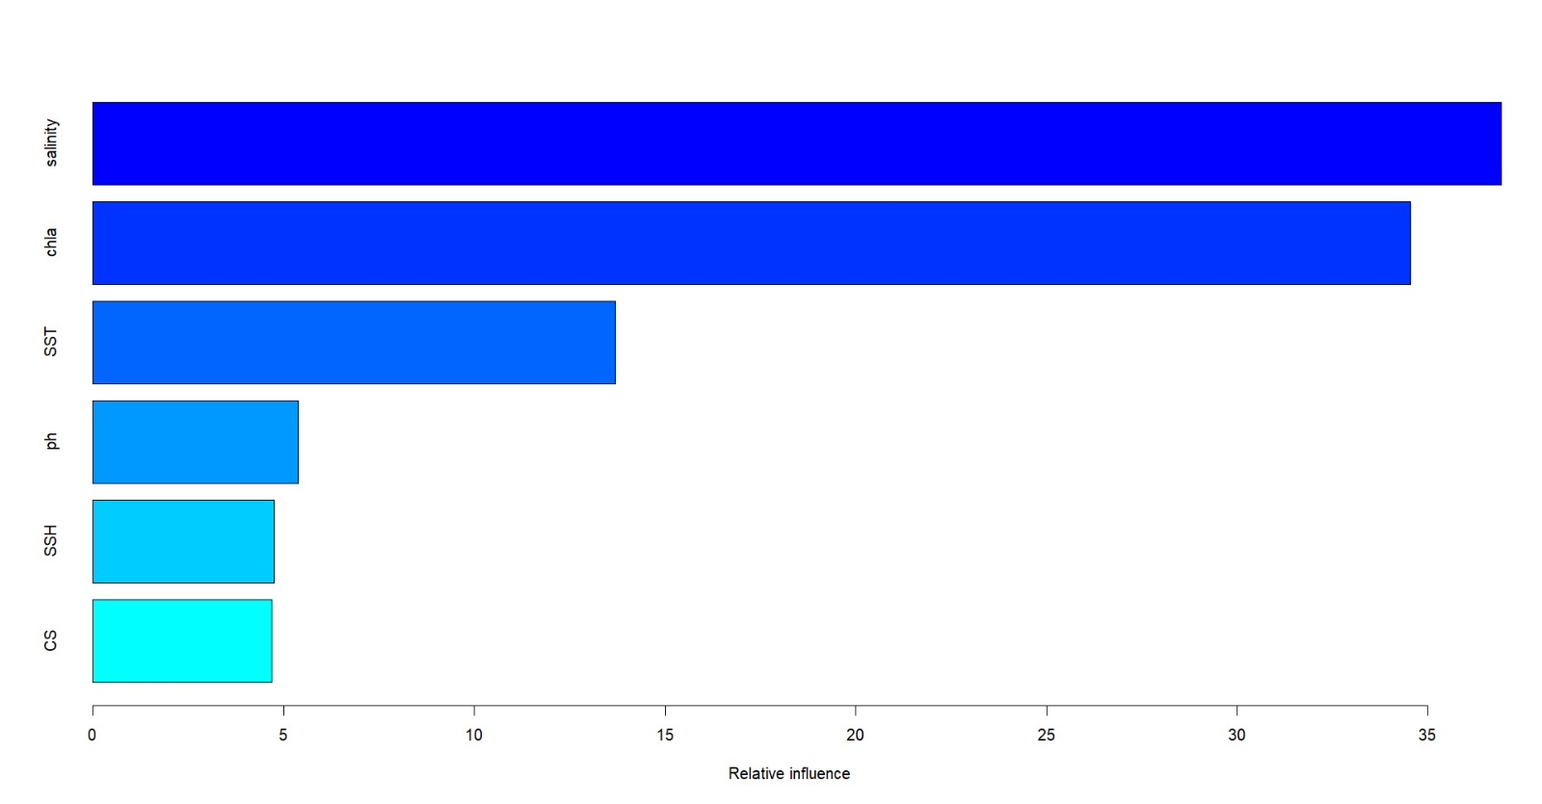
Fig 2:- The BRT model's environmental predictors' relative importance, with Variable Importance (VI) scores summing up to 100

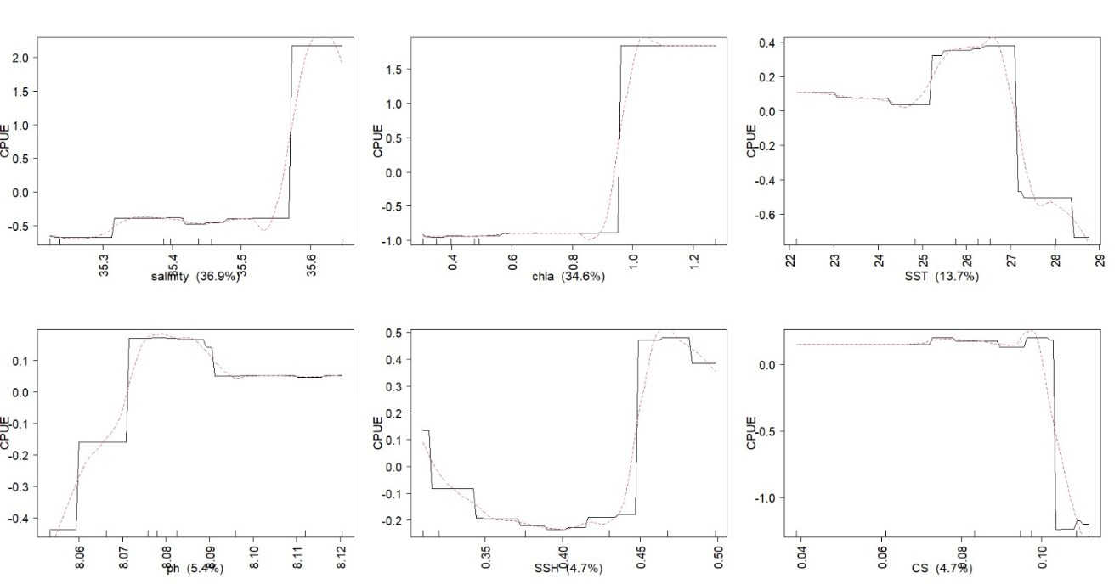
Fig 3:- Illustrating key environmental predictor variables related to fishing effort for Coilia dussumieri

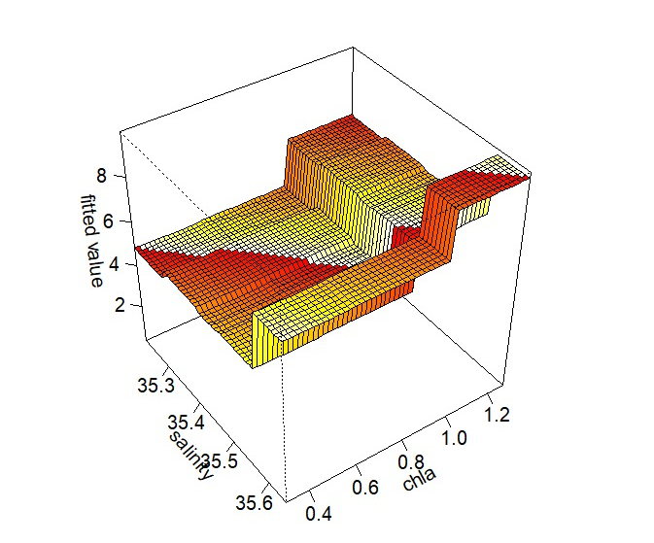
Fig 4:- The impact of salinity and chlorophyll-a (Chla) on the likelihood of catching Coilia dussumieri is depicted by the connected partial dependency charts for these variables.
Relationships fitted by the Boosted Regression Tree models are displayed as univariate functions (Fig. 4). BRT models were utilized to explore the interaction between salinity and chlorophyll-a (Chla) concentration in predicting the Catch Per Unit Effort (CPUE) of Coilia dussumieri. The 3D response surface illustrates that CPUE is minimal at low salinity (35.3) and low chla concentrations (below 0.4). However, a marked increase in CPUE is observed as either salinity or chla rises, indicating a synergistic effect between these environmental variables. The length distribution data for Coilia dussumieri shows a clear distinction between juveniles and adults, with individuals measuring 130 mm or above classified as adults, and those below this length as juveniles. In the adult (46.8%) histogram (Fig 5), most individuals fall within the 130–170 mm range, peaking around 130–140 mm and tapering off at higher lengths, indicating a higher frequency of adults just above the maturity threshold. In contrast, the juvenile histogram shows a concentration of individuals within the 60–120 mm range, with frequencies peaking around 90–100 mm, which highlights a typical juvenile (53.2%) size distribution (Fig 5) below the maturity length. The length distribution data for Coilia dussumieri indicates a larger juvenile population compared to adults. This pattern reflects a population structure with a higher proportion of juveniles, providing insights into the growth stages and demographic makeup of Coilia dussumieri in the sampled population.
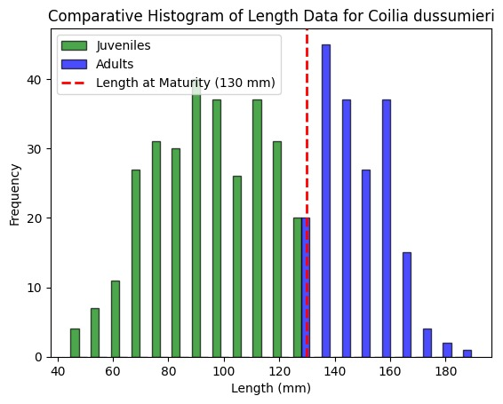
Fig 5:- Comparative histogram of length data for Coilia dussumeiri

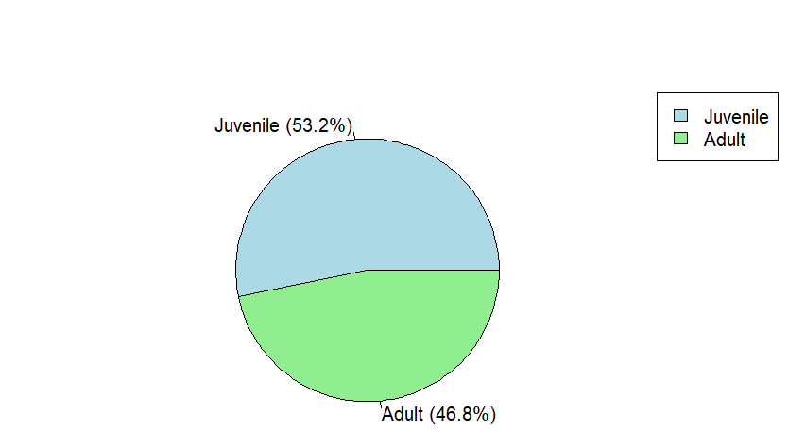
Fig 6:- Coilia Dussumeiri catch composition as adult and juvenile

4. DISCUSSION
Golden anchovies play an important part in Indian coastal fisheries, however they are mostly found in the northwestern and northeastern areas. Their distribution pattern is comparable to that of other resources, such as Bombay duck and Acetes. Boosted Regression Trees (BRT) have been used to predict species distributions with great success (Elith et al., 2008; Leathwick et al., 2006; Oppel et al., 2012; Ramteke et al., 2020). Temperature affects fish differently based on their habitat, feeding habits, and physiological characteristics (Volkoff and Rønnestad, 2020). Fish demonstrate diverse habitats, feeding behaviors, and physiological characteristics, making the influence of temperature on them both complex and species-specific (Volkoff and Rønnestad, 2020). BRT models in this study indicate that optimal salinity and productivity conditions are critical for increasing catch rates. Similarly, Karankumar et al. (2020) showed through BRT models that environmental variables significantly affect the catch rate of Johnius belangeri. Studies by Pont et al. (2005), Ansari et al. (1995) Grenouillet et al. (2004) Fernandes and Achuthankutty (2010), and Khaled et al. (2023) further demonstrated a strong link between sea surface temperature (SST) and chlorophyll-a (Chla) and their influence on fish production in certain fishing zones in the Red Sea, Egypt. When environmental variables exceed certain thresholds, their influence stabilizes or declines, underlining the non-linear and complex interactions observed in this study. Annan et al. (2024), also explored how changes in ecological and environmental factors affect sardine populations. These findings give information on Coilia dussumieri ecological preferences, which will assist influence fisheries management techniques that seek to maximize catch per unit effort (CPUE) by identifying favorable environmental circumstances. Ramteke et al. (2020) underlined that combining ecological data with statistical models can give more detailed insights into spatiotemporal distribution patterns.
The use of an ecosystem-based approach has substantially expanded the scope of fisheries management, demanding the incorporation of new forms of data and advanced quantitative methodologies into management systems (Collie et al., 2016). Environmental variables significantly influence fish dispersion (Galaiduk et al., 2022). Satellite remote sensing has developed as an important tool for ocean research (Fan et al., 2005), providing huge volumes of data on both biotic and abiotic parameters (e.g., chlorophyll, primary production) and sea surface height. This technology enables rapid, large-scale, long-term, and synchronized observation, making data acquisition efficient (Strong and Elliott, 2017; Zhang et al., 2019). Forecasting changes to fishing sites and evaluating fishery resources depend on an understanding of the relationship between environmental and fisheries data, such as catch and survey records. Fisheries and the environment have complex, non-linear, and non-additive relationships, according to research (Stenseth et al., 2002; DingsØr et al., 2007). Commercially significant fish species use coastal waters as breeding, feeding, and nursery grounds, making them extremely productive and rich in fish resources. Small pelagic fish dominate these shallow waters, a pattern that has also been documented in other places. For example, Fu et al. (2019) discovered that juvenile fish constituted 85.86% of the population in the northwestern Beibu Gulf's coastal waters. Similarly, Yin et al. (2023) observed that coastal fish populations are primarily composed of smaller individuals.
5. CONCLUSION
The findings from this research provide valuable insights into the ecological requirements of C. dussumieri in the Mumbai region. The identified environmental drivers can inform targeted fishing strategies and contribute to the development of ecosystem-based management plans for this important fishery resource. Long-term monitoring of fish populations and environmental conditions, high-resolution spatial data and modeling to comprehend fine-scale distribution patterns, and thorough life history studies of C. dussumieri in this area—including growth, reproduction, and migration patterns—should be the main areas of future research. These studies are crucial for efficient management. By incorporating these findings and future research into fisheries management strategies, we can ensure the sustainable exploitation of C. dussumieri resources in the Mumbai coastal ecosystem.

COMPETING INTERESTS
The author declares there is no competing interests. All the authors are agreed to publish this manuscript.
REFERENCE
Akhter, M., Hasan, M.M., Khan, A.B.S., Ullah, M.R., Bosu, A., Yasmin, F., Haque, M.A., Islam, M.A. and Mahmud, Y., Reproductive biology and feeding habit of Coilia dussumieri Valenciennes, 1848 (Actinopteri: Engraulidae): a review, Int. J. Sci. Technol. Res. Arch., 2024, vol. 6, pp. 051-056.

Amin, S.N. and Zafar, M., Studies on age, growth and virtual population analysis of Coilia dussumieri from the neritic water of Bangladesh, J. Biol. Sci., 2004, vol. 4, pp. 342-344.

Annan, A., Kindong, R., Sarr, O. and Tian, S., Distribution and CPUE standardization of European Pilchard (Sardina pilchardus) in the Northwest African upwelling waters under varying climatic conditions, J. Coastal Conserv., 2024, vol. 28, pp. 1-13.

Ansari, Z.A., Chatterji, A., Ingole, B.S., Sreepada, R.A., Rivonkar, C.U. and Parulekar, A.H., Community structure and seasonal variation of an inshore demersal fish community at Goa, West Coast of India, Estuar. Coast. Shelf Sci., 1995, vol. 41, pp. 593-610.

Campbell, R.A., Constructing stock abundance indices from catch and effort data: some nuts and bolts, Fish. Res., 2015, vol. 161, pp. 109-130, doi:10.48670/moi-00016.

CMFRI, Annual Report 2023, Central Marine Fisheries Research Institute, Kochi, 2024, 286 p.

Collie, J.S., Botsford, L.W., Hastings, A., Kaplan, I.C., Largier, J.L., Livingston, P.A., Plagányi, É., Rose, K.A., Wells, B.K. and Werner, F.E., Ecosystem models for fisheries management: finding the sweet spot, Fish and Fish., 2016, vol. 17, pp. 101-125.

Copernicus Marine Service, Global Ocean Biogeochemistry Analysis and Forecast, 2016, Available from: https://doi.org/10.48670/moi-00015 (Accessed Dec 12, 2024).

Copernicus Marine Service, Global Ocean Physics Analysis and Forecast, 2024, Available from: https://doi.org/10.48670/moi-00016 (Accessed Dec 12, 2024).

Dingsør, G.E., Ciannelli, L., Chan, K.S., Ottersen, G. and Stenseth, N.C., Density dependence and density independence during the early life stages of four marine fish stocks, Ecol., 2007, vol. 88, pp. 625-634.

Elith, J., Leathwick, J.R. and Hastie, T., A working guide to boosted regression trees, J. Anim. Ecol., 2008, vol. 77, pp. 802-813.

Fan, W., Zhu, S. and Shen, J., An application of satellite remote sensing-derived marine environmental factors to marine fisheries: a review, Mar. Sci., 2005, vol. 29, pp. 67-72.

Fernandes, B. and Achuthankutty, C.T., Seasonal variation in fishery diversity of some wetlands of the Salcete Taluka, Goa, India, Indian J. Mar. Sci., 2010, vol. 39, pp. 238-247.

Fernandez, I. and Devaraj, M., Reproductive biology of the gold spotted grenadier anchovy, Coilia dussumieri (Cuvier and Valenciennes), along the North West coast of India, Indian J. Fish, 1989, vol. 36, pp. 11-18.

Fu, X.L., Xu, Z.L., Que, J.L. and Yan, T.L., Temporal-spatial distribution characteristics of fish stocks in north-west coastal waters of Beibu Gulf, Fish Sci., 2019, vol. 38, pp. 10-18.

Galaiduk, R., Radford, B., Case, M., Bond, T., Taylor, M., Cooper, T., Smith, L. and McLean, D., Regional patterns in demersal fish assemblages among subsea pipelines and natural habitats across north-west Australia, Front. Mar. Sci., 2022, vol. 9, pp. 979987.

Grenouillet, G., Pont, D. and Herisse, C., Within-basin fish assemblage structure: the relative influence of habitat versus stream spatial position on local species richness, Can. J. Fish Aquat. Sci., 2004, vol. 61, pp. 93-102.

Hildalgo, M.T., Rouyer, J.C., Molinero, J.C., Massuti, E., Moranta, B., Guijarro, J. and Stenseth, N.C., Synergistic effects of fishing induced demographic changes and climate variation on fish population dynamics, Mar. Ecol. Prog. Ser., 2011, vol. 426, pp. 1-12.

Khaled, M.A., Al-Jamali, F.H., Said, R.E., Mohammad, A.S., Ahmed, M.H. and Ahmed, H.O., Analysis of SST and Chl-a data from MODIS-Aqua in the Major Egyptian Fishing Zones of the Red Sea, Egyptian J. Aquat. Res., 2023, vol. 49, pp. 520-529.

Leathwick, J.R., Elith, J., Francis, M.P., Hastie, T. and Taylor, P., Variation in demersal fish species richness in the oceans surrounding New Zealand: an analysis using boosted regression trees, Mar. Ecol. Prog. Ser., 2006, vol. 321, pp. 267-281.

Oppel, S., Meirinho, A., Ramirez, I., Gardner, B., O’Connell, A.F., Miller, P.I. and Louzao, M.M., Comparison of five modelling techniques to predict the spatial distribution and abundance of seabirds, Biol. Conserv., 2012, vol. 156, pp. 94-104.

Pont, D., Hugueny, B. and Oberdorff, T., Modelling habitat requirement of European fishes: do species have similar responses to local and regional environmental constraints, Can. J. Fish Aquat. Sci., 2005, vol. 62, pp. 163-173.

Ramteke, K.K., Shenoy, L., Nayak, B.B., Deshmukhe, G., Inamdar, A.B. and Singh, V.V., Environmental variables and spatiotemporal occurrence of Johnius belangerii (Cuvier, 1830) Belanger's Croaker: an analysis using boosted regression trees, J. Indian Fish Assoc., n.d., vol. 47.

Stenseth, N.C., Mysterud, A., Ottersen, G., Hurrell, J.W., Chan, K.S. and Lima, M., Ecological effects of climate fluctuations, Science, 2002, vol. 297, pp. 1292-1296.

Strong, J.A. and Elliott, M., The value of remote sensing techniques in supporting effective extrapolation across multiple marine spatial scales, Mar. Pollut. Bull., 2017, vol. 116, pp. 405-419.

Thorson, J.T., Shelton, A.O., Ward, E.J. and Skaug, H.J., Geostatistical delta generalized linear mixed models improve precision for estimated abundance indices for West Coast ground fishes, ICES J. Mar. Sci., 2015, vol. 72, pp. 1297-1310.

Volkoff, H. and Rønnestad, I., Effects of temperature on feeding and digestive processes in fish, Temperature, 2020, vol. 7, pp. 307-320.

Yin, X., Yang, D., Zhao, L., Zhong, R. and Du, R., Fishery resource evaluation with hydroacoustic and remote sensing in Yangjiang coastal waters in summer, Remote Sens., 2023, vol. 15, pp. 543.

Zhang, X., Li, Z., Li, D. and He, Y., Marine environment distinctions and change the law based on recognition remote sensing technology, J. Coastal Res., 2019, vol. 94, pp. 107-111.

