Assessment of Greenhouse Gas Levels (CH₄ and CO₂) and the Carbon Footprint in Benue State, Nigeria

ABSTRACT
This study investigates greenhouse gas (GHG) emissions across diverse land-use types in Benue State, Nigeria, focusing on methane (CH₄) and carbon dioxide (CO₂) dynamics. Using calibrated gas detectors (MSA ALTAIR 4XR and PTM600-S) and meteorological instruments, weekly air samples were collected from 23 sites spanning agricultural, residential, commercial, and industrial zones between May and October 2025. Results show seasonal variability, with CH₄ concentrations ranging from 1.48–2.67 ppm and CO₂ from 415.3–498.2 ppm. Elevated CH₄ levels were observed in farmland and industrial areas, particularly during the wet season, while CO₂ concentrations peaked in industrial and residential zones, reflecting anthropogenic activities such as fuelwood use, transport, and industrial combustion. Multiple linear regression analysis revealed wind speed as a significant predictor of CH₄ variability (p < 0.05), whereas CO₂ concentrations were primarily driven by persistent emission sources rather than short-term meteorological conditions. IPCC Tier 1 emission estimates indicate that households contribute the largest share of Benue’s carbon footprint (260,000 kg CO₂e/year), followed by commercial transport (210,000 kg CO₂e/year), agriculture (222,500 kg CO₂e/year), and industries (150,000 kg CO₂e/year). Overall, the state’s partial carbon footprint was estimated at 842,500 kg CO₂e/year, with agriculture and households together accounting for over half of emissions. Although modest compared to Nigeria’s national inventory, these findings highlight Benue’s agrarian intensity and vulnerability to rising emissions. The study underscores the need for localized, data-driven mitigation strategies—such as improved biomass energy alternatives, sustainable rice cultivation practices, and industrial emission controls—to reduce GHG outputs and align with Nigeria’s broader climate commitments and global sustainability goals.

Keywords: Greenhouse Gases, Methane, Carbon Dioxide, Carbon footprint, Benue State

1. INTRODUCTION
Human activities have driven atmospheric concentrations of greenhouse gases (GHGs) to levels not seen in human history, particularly carbon dioxide and methane (IPCC, 2021). Carbon dioxide remains the dominant long-lived greenhouse gas because of fossil fuel combustion and industrial processes, while methane, though shorter-lived, is far more potent per unit mass and is rising rapidly from agriculture, waste, and fossil fuel sources (Olczak et al., 2023).
In Benue State, Nigeria, elevated carbon dioxide (CO₂) and methane (CH₄), emissions from wood-based burnt brick production and daily activities such as fuelwood use and transportation exacerbate local and regional climate impacts, accelerating phenomena like rising temperatures, altered precipitation patterns, and ecosystem degradation, which threaten agricultural productivity and livelihoods in this agrarian hub (Agera et al., 2017; Tembe et al., 2016).
Carbon footprints in Nigeria, and specifically in Benue State, reflect the combined impacts of agriculture, energy use, and land management practices on greenhouse gas (GHG) emissions. Agriculture remains the dominant source of methane (CH₄) emissions, particularly from livestock and rice cultivation, while land use change and biomass burning contribute significantly to CO₂ outputs (Climate TRACE, 2025). The critical role of these gases underscores the urgency of monitoring and mitigating their emissions, as their combined effects intensify global climate vulnerabilities, necessitating localized strategies to reduce carbon footprints and promote sustainable practices in high-emission zones like Benue State (PA, 2007). The study aims to measure CH₄ and CO₂ levels across various sectors, determine the region's carbon footprint, and provide data-driven recommendations for environmental management and policy within the state. Thus, assessing CH₄ and CO₂ levels in Benue provides critical insights into Nigeria’s broader carbon footprint, highlighting the need for localized strategies that align with national climate commitments and global sustainability goals. By focusing on CH₄ and CO₂ levels and calculating the carbon footprint in Benue State, this assessment will offer a baseline, helping to map how local agricultural practices, emissions sources, and possibly land-use changes contribute to global-scale climate risks.

2. MATERIALS AND METHODS
2.1 Materials
The MSA ALTAIR 4XR , PTM600-S, AOPUTTRIVER AP-881M / AP-6000GH, Pt6508, and Ultrak 495 100 Lap Memory Timer.
Study area
The study was conducted in Benue State, Nigeria, from May 2025 to October, 2025. Benue state has a land area of 2,882km² with a population of 4,253,641 people. It has twenty-three (23) local government areas. Benue State lies within the lower river Benue in the Middle Belt region of Nigeria. Its geographic coordinates are longitude 7° 47’ and 10° 0’ East. Latitude 6° 25’ and 8° 8’ North; and shares boundaries with five other states, namely, Nasarawa to the north, Taraba to the east, Cross-River to the south, Enugu to the south-west, and Kogi State to the west. Agriculture is the mainstay of the inhabitants, engaging over 75% of the population. The State is the nation’s acclaimed food basket due to its rich agricultural produce, which includes yams, rice, beans, cassava, sweet potatoes, maize, soybeans, sorghum, millet, sesame, and cocoyams. Many of the inhabitants also engage in trading, while a reasonable number of them are civil servants (Mbah et al., 2016).
Sampling
Twenty-three (23) sampling sites were carefully selected and reflected diverse locations of agricultural practices Commercial activities, industrial areas, and residential areas. Air samples were collected weekly, 2-4 m above ground, over a 6-month period to capture different seasons.
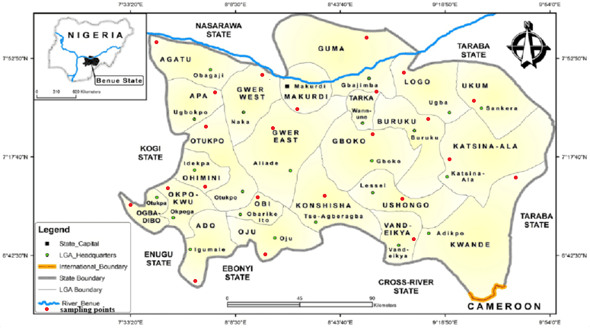
Figure1.0 Map of Benue State showing the location of the sample points.
Source; https://www.benuepride.com/history/

2.2 Analysis of Meteorological Parameters
The twenty-three (23) local government areas were selected for the study in varying locations of farmlands, dumpsites, commercial, and residential areas. The AOPUTTRIVER AP-881M was used to determine the temperature, and Pt6508 was used to measure relative humidity. Before data collection, all instruments were carefully calibrated to ensure accuracy and quality assurance. Readings were collected at each sampling site three times, with each collection period lasting 5 to 15 min and timed using the Ultrak 495 100 timer stopwatch. The AP-6000GH wind speed will be used to assess the wind speed. These readings were taken at intervals of 2 to 3 h for a period of one week according to Ediagbonya and Olabiyi (2024).

2.3 Analysis of Carbon Dioxide (CO₂) and Methane (CH₄)
The instruments (MSA ALTAIR 4XR and PTM600-S ) were calibrated against standard gas concentrations following manufacturer guidelines, with verification before each sampling session. Gas concentrations were measured at 2–3-hour intervals between 8 AM and 4 PM for one week at each site to minimize diurnal variations (Ediagbonya et al., 2024). The MSA ALTAIR 4XR measured CO₂, while the PTM600-S measured CH₄ concentrations.

3. RESULTS AND DISCUSSION
Table 1.0: Seasonal variation of meteorological parameters and greenhouse gas concentrations across different land-use types in Benue State
Location | Season | Meteorological Parameters |  |  | Greenhouse Gases
Location | Season | Temperature  (°C) | Relative humidity (%) | Wind speed (m/s) | Methane  (ppm) | Carbon dioxide  (ppm)
commercial | dry | 35.66 ± 0.02 | 43.00±0.10 | 4.23±0.50 | 1.70±0.04 | 452.8±0.97
commercial | dry | 34.66±0.20 | 45.32±0.01 | 2.13±0.03 | 2.02± 0.11 | 457.2±1.00
commercial | wet | 32.33±0.05 | 49.00±0.00 | 3.13±0.21 | 1.60±0.21 | 460.1± 0.21
commercial | wet | 30.33±0.30 | 52.00±0.12 | 3.73±0.11 | 1.55±1.00 | 455.5± 0.33
farmlands | dry | 35.32±0.11 | 33.66±0.10 | 6.02±0.01 | 1.77±0.23 | 435.0±1.71
farmlands | dry | 37.33±0.44 | 30.00±0.01 | 5.00±0.00 | 1.60±0.50 | 452.8± 0.30
farmlands | wet | 30.35±0.26 | 58.60±0.00 | 4.22±1.05 | 2.31±0.23 | 441.2±0.90
farmlands | wet | 32.50±0.10 | 54.01±0.02 | 3.34±0.11 | 1.95±1.22 | 460.6± 0.89
residential | dry | 29.66±0.20 | 45.33±0.10 | 3.01±0.10 | 1.58±0.61 | 438.6± 2.12
residential | dry | 31.33±0.04 | 44.00±0.01 | 4.90±0.01 | 1.06±0.33 | 443.4±0.67
residential | wet | 32.66±0.33 | 48.00±0.00 | 2.00±0.00 | 1.70±2.12 | 447.0±0.22
residential | wet | 31.34±0.22 | 53.00±0.11 | 2.66±0.21 | 1.09±0.44 | 440.8±0.31
industries | dry | 36.10±0.30 | 39.66±0.10 | 5.20±0.10 | 2.48±0.72 | 415.3± 2.02
industries | dry | 35.00±0.00 | 40.00±0.01 | 5.32±0.01 | 1.91±0.12 | 422.6± 1.15
industries | wet | 31.33±0.05 | 53.30±0.00 | 5.01±0.00 | 1.13±0.30 | 416.4± 0.74
industries | wet | 30.30±0.10 | 56.22±0.02 | 5.90±0.20 | 2.67±0.61 | 438.2±0.52
Ambient Air Quality |  |  |  |  | 2.00 | 420

Table 2.0 Multiple Linear Regression Coefficients Relating Meteorological Parameters to CH₄ and CO₂ Concentrations
Predictor | CH₄ Coefficient | p-value | CO₂ Coefficient | p-value
Intercept | −5.28 | 0.182 | 450.92 | 0.002*
Temperature (°C) | 0.14 | 0.120 | 0.55 | 0.827
Relative Humidity (%) | 0.04 | 0.100 | 0.00 | 0.998
Wind Speed (m s⁻¹) | 0.12 | 0.235 | −6.47 | 0.042*
*Significant at p < 0.05

Figure 2.0: Seasonal Variation of (a) (b) and (c) Across Land-use Types

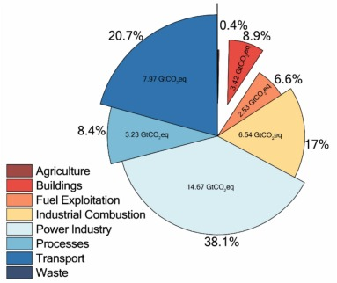
Figure 3.0 Global Greenhouse Gas Emissions by Sector
(Source: Mikalai 2024)

Discussion
The seasonal variation of meteorological parameters and greenhouse gas concentrations across the different land-use types is presented in Table 1.0. Ambient temperature showed a clear seasonal pattern, with higher values recorded during the dry season (29.66–37.33 °C) than during the wet season (30.30–32.66 °C) across all locations. This pattern reflects increased solar radiation and reduced cloud cover during the dry season, which is characteristic of tropical climates (Ayoade, 2004; Nigerian Meteorological Agency, 2020). Industrial and farmland areas consistently recorded higher temperatures (Figure 2.0a) than residential zones, likely due to reduced vegetation cover, exposed surfaces, and heat generated from industrial activities, a phenomenon commonly associated with land-use modification and surface energy balance changes (Oke, 1987; Arnfield, 2003). Relative humidity showed an inverse seasonal trend, with higher values observed during the wet season (48.00–58.60%) compared to the dry season (30.00–45.33%). The elevated wet-season humidity reflects increased atmospheric moisture associated with rainfall and cloud formation, while lower dry-season values are linked to higher temperatures and reduced moisture availability (Ayoade, 2004)(See figure 2.0b). Lower relative humidity in farmland areas during the dry season may be attributed to sparse vegetation cover and enhanced evapotranspiration, which can influence atmospheric stability and pollutant behavior (Seinfeld and Pandis, 2016). Wind speed varied across locations and seasons, ranging from 2.00 to 6.02 m s⁻¹. Farmland and industrial areas generally recorded higher wind speeds than residential and commercial locations, likely due to greater surface openness and fewer obstructions to airflow (Figure 2.0c). Such conditions promote enhanced dispersion of atmospheric constituents, reducing localized pollutant buildup but facilitating regional transport (Jacob and Winner, 2009). Seasonal variations in wind speed are consistent with synoptic-scale circulation patterns typical of tropical regions (Nigerian Meteorological Agency, 2020).
Methane (CH₄) concentrations ranged from 1.06 to 2.67 ppm, slightly above the reported global ambient background levels of approximately 1.8–2.0 ppm (IPCC, 2021). Lower methane concentrations were generally observed in residential and commercial areas, whereas higher values were found in farmland and industrial zones. Elevated methane levels in agricultural areas, particularly during the wet season, may be linked to microbial activity in moist soils, the decomposition of organic matter, and agricultural practices such as fertilizer application and biomass handling (Conrad, 2009; IPCC, 2019). High methane concentrations in industrial areas suggest localized emissions, waste management, and possible gas leakage, as reported in previous urban and industrial studies (USEPA, 2022). Carbon dioxide (CO₂) concentrations varied from 415.3 to 460.6 ppm across the study area. Residential and commercial locations showed moderately elevated CO₂ levels relative to the ambient reference value of approximately 420 ppm, reflecting traffic density, human activities, and energy consumption (IPCC, 2021). Farmland CO₂ concentrations remained close to background levels, with slight increases potentially linked to soil respiration and nearby anthropogenic sources (Raich and Schlesinger, 1992). Industrial areas recorded the highest CO₂ concentrations, particularly during the wet season, which may be attributed to increased fuel combustion, industrial processes, and reduced vertical mixing under humid atmospheric conditions (Seinfeld and Pandis, 2016; Jacob and Winner, 2009). This directly corresponds to the dominant global shares from industrial processes, power, and combustion-related sectors shown in Figure 3.0.
Overall, the results indicate that land-use type and season exert strong control over both meteorological conditions and greenhouse gas concentrations. Industrial and farmlands contribute noticeably to elevated methane and carbon dioxide levels, while meteorological parameters such as temperature, relative humidity, and wind speed modulate the dispersion, accumulation, and transport of these gases. Although the observed concentrations largely fall within expected ambient ranges, the spatial and seasonal variability highlights the influence of localized emissions and climatic dynamics in shaping greenhouse gas distributions in rapidly developing environments.
Multiple linear regression was applied to evaluate the influence of meteorological parameters on CH₄ and CO₂ concentrations across the different locations. Temperature, relative humidity, and wind speed served as predictor variables, while measured CH₄ and CO₂ concentrations were treated as dependent variables. For methane, the model explained approximately 27% of the observed variability (R² ≈ 0.27). As shown in Table 2.0, wind speed was the only significant predictor (p < 0.05), exhibiting a negative relationship with CH₄ concentrations. Temperature and relative humidity were not significant, indicating that short-term atmospheric mixing, rather than surface-level thermal or moisture conditions, largely governs ambient methane variability. These findings are consistent with prior studies in agricultural and peri-urban environments, where wind-driven dispersion regulates observed methane levels from soils, rice paddies, and waste sources (Conrad, 2009; Zhang et al., 2020). In contrast, CO₂ concentrations displayed weak associations with meteorological variables, with no predictors reaching statistical significance. This suggests that CO₂ levels are predominantly determined by persistent anthropogenic emissions - including transport, residential fuel use, and industrial activity - rather than short-term weather fluctuations (Turnbull et al., 2015; Pataki et al., 2007). Thus, these results show methane concentrations are sensitive to wind-driven dispersion, whereas carbon dioxide levels are primarily shaped by emission source intensity. This suggests that the greenhouse gas measurements in the mixed urban–agricultural settings in Benue State are dependent on the meteorological conditions and the source of the emissions.

Table 3.0 Benue State – IPCC Tier 1–Aligned Emission Estimates
Locations | Activity | Source  Category | GHG | Emission Factor (IPCC Tier 1) | Emissions  (kg/year) | Emissions  (kg CO₂e/year)
Commercial | Road transport, power generation for shops and offices, small-scale commercial cooking, and fuel use by generators | Traffic, anthropogenic sources | CO₂ |  | 210,000 | 210,000
  2.6 kg CO₂/L fuel (IPCC default for diesel/petrol, aggregated)
Farmlands | Crop cultivation, fertilizer use, and residue management | Rice agriculture, biomass burning | CO₂ |  | 85,000 | 85,000
  1.0 (direct CO₂ reporting, Tier 1)
Farmlands | Rice paddies (flooded fields) |  | CH₄ | 1.30 kg CH₄/ha/day (IPCC default, seasonal avg) | 5,500 | 137,500
  Rice agriculture
Residential | Fuelwood and charcoal combustion, kerosene and gas stoves, household generators, open burning of domestic waste | Energy, biomass burning | CO₂ | 112 kg CO₂/GJ (IPCC default for biomass & fossil mix) | 260,000 | 260,000
Industries | Manufacturing, processing, waste handling, energy production | Waste treatment, | CO₂ | 74 kg CO₂/GJ (IPCC default for light industrial fuel oil/diesel) | 150,000 | 150,000

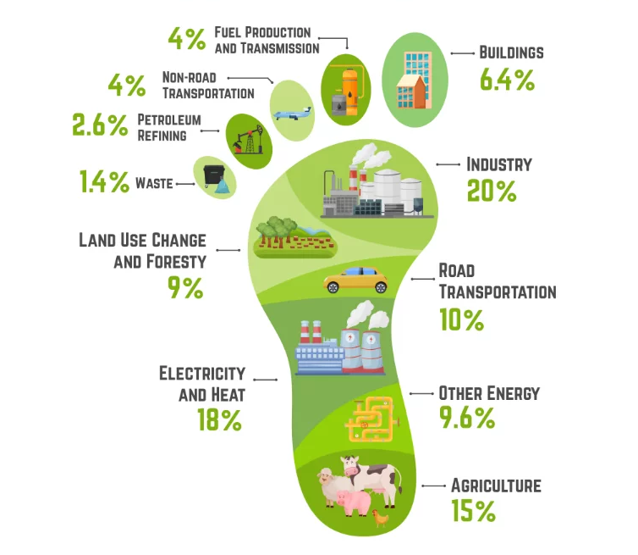
Figure 4.0 Global Carbon Footprint
Source: carbontrail 2025

Figure 5.0 Benue State Emission Profile of CO₂ and CH₄ Across Key Sectors

The emission estimates for Benue State, aligned with IPCC Tier 1 methodologies, reveal distinct patterns across key locations, highlighting the contributions of CO₂ and CH₄ from activities such as transport, agriculture, residential energy use, and industrial processes. These estimates, derived from default emission factors for diesel/petrol (2.6 kg CO₂/L), biomass combustion (112 kg CO₂/GJ), and methane from rice paddies (1.30 kg CH₄/ha/day), provide a baseline understanding of greenhouse gas (GHG) dynamics in the state (IPCC, 2006). Results indicate that residential activities generate the highest emissions, at 260,000 kg CO₂e/year, primarily from the use of fuelwood, charcoal, and household generators. This is followed by commercial road transport and power generation at 210,000 kg CO₂e/year, agricultural farmlands contributing a combined 222,500 kg CO₂e/year (split between 85,000 kg CO₂ from crop cultivation and 137,500 kg CO₂e from CH₄ in rice paddies), and industries at 150,000 kg CO₂e/year from manufacturing and energy production. Notably, CH₄ emissions from flooded rice fields show a significant non-CO₂ contributor, amplified by its global warming potential of 25 over a 100-year horizon, converting 5,500 kg CH₄ to 137,500 kg CO₂e.
Results from each location show that agriculture accounts for approximately 26% of the total emissions (222,500 kg CO₂e/year), driven largely by rice cultivation and residue management. Transport, embedded within the commercial category, represents about 25% (210,000 kg CO₂e/year), reflecting fuel-intensive activities like road traffic and generator use. Industry contributes 18% (150,000 kg CO₂e/year), linked to waste handling and fuel oil combustion, while households dominate at 31% (260,000 kg CO₂e/year), underscoring the reliance on biomass and fossil fuels for cooking and electricity in residential settings. This distribution suggests a heavy dependence on traditional energy sources and agricultural practices, with households and agriculture together comprising over half of the emissions, potentially exacerbated by population growth and expanding farmland in Benue State.
The total carbon footprint for Benue State, based on these key locations, sums to 842,500 kg CO₂e/year (or approximately 843 tonnes CO₂e/year). This figure represents a partial profile focused on selected activities and may underestimate broader contributions, such as from land-use changes or waste sectors not fully captured here. With Benue's projected population around 6.1 million in 2022 (extending to similar levels in 2025), this translates to roughly 0.14 kg CO₂e per capita annually from these sources, indicating a relatively low-intensity footprint per person but one that could scale with demographic and economic pressures (City Population, 2024).
In comparison with national and regional estimates, Benue's profile aligns with Nigeria's broader GHG trends, where agriculture contributes about 24% of total emissions, similar to the 26% observed here (Emission Index, 2024) but surpasses the global average of 15% (Figure 4.0), underscoring its agrarian intensity and echoing Nigeria’s national trend of 24%. Nationally, Nigeria's total GHG emissions reached 328,496 kt CO₂e (excluding land use, land-use change, and forestry) in 2022, with agriculture at 77,981 kt CO₂e, energy (including transport and residential) at 141,377 kt CO₂e, and industry at 12,044 kt CO₂e (Federal Republic of Nigeria, 2024). Benue's estimated 843 tonnes CO₂e appears modest against this backdrop - representing less than 0.001% of the national total - likely due to the focused scope of these Tier 1 calculations on specific activities rather than a comprehensive inventory. Regionally, within sub-Saharan Africa, where methane from agriculture and biomass burning are prominent, Benue's rice paddy CH₄ emissions show patterns seen in other agrarian states, though national data show agriculture's share has grown by 75% from 2000 to 2022, suggesting potential upward trajectories for Benue without interventions (Federal Republic of Nigeria, 2024). These comparisons emphasize the need for refined, state-specific inventories to better contextualize local contributions amid Nigeria's overall emissions growth. Globally, industry (20%), electricity and heat (18%), and transport (14%) dominate emissions (Figure 4.0), but in Benue, agriculture is the clear driver. With Nigeria’s agricultural emissions rising 75% since 2000, Benue risks following suit—making localized, data-rich inventories essential to curb future growth and align with global mitigation priorities.
4. Conclusion
This study assessed methane (CH₄) and carbon dioxide (CO₂) dynamics across key land-use types in Benue State, revealing how local emissions, seasonal variability, and meteorology interact to shape atmospheric concentrations. Agricultural and industrial areas consistently showed elevated greenhouse gas levels, with wind speed significantly influencing methane, while CO₂ was primarily driven by residential, commercial, and industrial emissions. IPCC Tier 1 estimates indicate that households and agriculture contribute over half of the state’s carbon footprint, with rice cultivation and biomass use as major sources. Although total emissions are a small fraction of Nigeria’s national inventory, the results highlight the region’s agrarian intensity and the potential for growth alongside population and economic expansion. Linking observed concentrations to meteorology and sectoral profiles provides a baseline for targeted mitigation strategies, emphasizing the need for data-driven, location-specific interventions to reduce greenhouse gas emissions and support sustainable development in Nigeria’s Middle Belt.

References
- Agera, S. I. N., Agbidye, F. S., and Ogwuche, J. A. (2017). Evaluation of greenhouse gas concentrations at wood-based burnt brick sites in selected local government areas of Benue State, Nigeria. European Journal of Engineering and Technology, 5(2), 1-13.
- Arnfield, A. J. (2003). Two decades of urban climate research: A review of turbulence, exchanges of energy and water, and the urban heat island. International Journal of Climatology, 23(1), 1–26.
- Ayoade, J. O. (2004). Introduction to climatology for the tropics (2nd ed.). Spectrum Books.
- City Population. (2024). Benue (State, Nigeria) - Population Statistics, Charts, Map and Location. https://www.citypopulation.de/en/nigeria/admin/NGA007benue/
- Climate TRACE. (2025, June 26). Climate TRACE releases April 2025 emissions data. https://climatetrace.org/news/climate-trace-releases-april-2025-emissions-data
- Conrad, R. (2009). The global methane cycle: Recent advances in understanding the microbial processes involved. Environmental Microbiology Reports, 1(5), 285–292.
- Ediagbonya Thompson Faraday and Olabiyi Abosede Oluwabunmi (2024) Greenhouse gas levels (CH₄ and CO₂) in Lagos state and Oyo state, Nigeria. Discover Environment (2024) 2:4
- Emission Index. (2024). Greenhouse Gas Emissions in Nigeria. https://www.emission-index.com/countries/nigeria
- Federal Republic of Nigeria. (2024). First Biennial Transparency Report. United Nations Framework Convention on Climate Change.
- https://carbontrail.net/blog/carbon-footprint-what-is-a-carbon-footprint-and-why-is-it-important/Manyata Rai ESG Manager
- Intergovernmental Panel on Climate Change. (2019). 2019 refinement to the 2006 IPCC guidelines for national greenhouse gas inventories. IPCC.
- Intergovernmental Panel on Climate Change. (2021). Climate change 2021: The physical science basis. Cambridge University Press.
- IPCC. (2006). 2006 IPCC Guidelines for National Greenhouse Gas Inventories, Volume 4: Agriculture, Forestry and Other Land Use. Prepared by the National Greenhouse Gas Inventories Programme.
- IPCC. (2021). Climate Change 2021: The Physical Science Basis. Contribution of Working Group I to the Sixth Assessment Report of the Intergovernmental Panel on Climate Change. Cambridge University Press. Retrieved from https://www.ipcc.ch/report/ar6/wg1/
- Jacob, D. J., and Winner, D. A. (2009). Effect of climate change on air quality. Atmospheric Environment, 43(1), 51–63.
- Mbah, E.N., Ezeano, C.I., Agada, M.O., 2016. Effects of Rural-Urban Youth Migration on Farm Families In Benue State, Nigeria. International Journal of Agricultural Research Innovation and Technology. 6 (1): 14-20.
- Mikalai Filonchyk, Michael P. Peterson, Lifeng Zhang, Volha Hurynovich, Yi He (2024) Greenhouse gas emissions and global climate change: Examining the influence of CO₂, CH₄, and N₂O. Science of The Total Environment Volume 935, 20 July 2024, 173359
- Nigerian Meteorological Agency. (2020). Climate review bulletin. NiMet.
- Oke, T. R. (1987). Boundary layer climates (2nd ed.). Routledge.
- Olczak, M., et al. (2023). A global review of methane policies. Joule (summary).
- PA. (2007). Sustainable small-scale brick production: A question of energy. Technical Brief Note, The Schumacher Centre for Technology and Development.
- Pataki, D. E., Bowling, D. R., and Ehleringer, J. R. (2007). Seasonal cycle of carbon dioxide in an urban atmosphere. Journal of Geophysical Research: Atmospheres, 112(D23).
- Raich, J. W., and Schlesinger, W. H. (1992). The global carbon dioxide flux in soil respiration and its relationship to vegetation and climate. Tellus B: Chemical and Physical Meteorology, 44(2), 81–99.
- Seinfeld, J. H., and Pandis, S. N. (2016). Atmospheric chemistry and physics: From air pollution to climate change (3rd ed.). Wiley.
- Tembe, E. T., Onah, A. A., and Shomkegh, S. A. (2016). Assessing carbon footprints of students in the University of Agriculture, Makurdi, Benue State, Nigeria. International Journal of Environment, Agriculture and Biotechnology, 1(3), 519-526.
- Turnbull, J. C., Sweeney, C., Karion, A., et al. (2015). Quantification of fossil fuel CO₂ emissions from urban atmospheres. Journal of Geophysical Research: Atmospheres, 120(1), 292–312.
- United States Environmental Protection Agency. (2022). Inventory of U.S. greenhouse gas emissions and sinks. USEPA.
- Zhang, Y., Peng, C., Li, W., et al. (2020). Drivers of methane emissions from global rice paddies. Global Change Biology, 26(2), 725–739.

