Employment Generation as a Direct-Use Ecosystem Service of Kawal Tiger Reserve, Telangana, India

ABSTRACT
Aims: The present study aimed to assess employment generation as a direct-use ecosystem service of the Kawal Tiger Reserve (KTR), Telangana, India, and to examine its role in supporting local livelihoods and strengthening conservation outcomes across forest divisions.
Study Design: Descriptive, cross-sectional study based on records analysis and field verification.
Place and Duration of Study: The study was conducted in the Asifabad, Jannaram, Khanapur, and Utnoor FDPT forest divisions of the Kawal Tiger Reserve, Telangana, India, during 2023–2025.
Methodology: Employment data were obtained through systematic analysis of Telangana Forest Department administrative records, supplemented by field-level verification and structured interactions with divisional and range-level officials. Employment was classified into functional categories including forest protection and patrolling, anti-poaching, wildlife monitoring, administrative and technical support, vehicle operations, and ecotourism services. Division-wise and category-wise employment distribution was analysed to assess spatial variation and livelihood significance.
Results: Kawal Tiger Reserve generated direct employment for 239 individuals, with the Khanapur Division contributing the highest share, followed by Jannaram, Utnoor FDPT, and Asifabad divisions. Labour-intensive roles dominated the employment structure, particularly base camp watchers (163; 68.2%), along with drivers, data entry operators, anti-poaching squad members, animal trackers, and ecotourism drivers. The majority of employment opportunities were accessible to local and forest-dependent communities, indicating a strong conservation–livelihood linkage.
Conclusion: Employment generation represents a significant socio-economic benefit of the Kawal Tiger Reserve, contributing to livelihood security, reducing dependence on extractive forest use, and strengthening community participation in conservation. Recognising employment as a core conservation outcome can enhance inclusive and sustainable protected area management.
Keywords: Kawal Tiger Reserve; employment generation; ecosystem services; conservation livelihoods; forest-dependent communities.

1. Introduction:
Protected areas (PAs) and parks constitute institutionalized conservation mechanisms aimed at safeguarding biological diversity. Historically, conservation initiatives were largely motivated by aesthetic values and perception of nature; however, they have since evolved into a global imperative, with all nations sharing responsibility for maintaining ecological integrity and planetary sustainability (Pujar and Mishra, 2025; Singh and Singh, 2004). Although protected areas have been effective in reducing or mitigating biodiversity loss through a fortress conservation paradigm, this approach has frequently resulted in social and economic costs being disproportionately borne by marginalized rural communities, often leading to their exclusion from conservation processes and benefits (Rai et al., 2021). In recent decades, there has been increasing recognition that protected areas should extend beyond strict biodiversity protection to also support socio-economic sustainability by integrating conservation objectives with the livelihood needs of communities residing within and adjacent to these landscapes (Pujar and Mishra, 2020). Accordingly, protected areas are now acknowledged not only for their role in biodiversity conservation but also for their contributions to human well-being through livelihood diversification and employment generation (Pullin et al., 2013).
Globally, conservation landscapes such as national parks and tiger reserves generate employment through a wide range of activities, including forest protection, wildlife monitoring, habitat management, ecotourism, and related administrative and management functions (Kumar et al., 2020). Such conservation-associated employment opportunities are particularly significant in developing countries, where protected areas are often situated in remote regions characterised by limited alternative livelihood options. In these contexts, employment generation constitutes an important direct-use ecosystem service, linking ecological conservation objectives with local socio-economic development (Leung et al., 2018).
In India, tiger reserves represent some of the most intensively managed categories of protected areas, necessitating substantial human labour inputs for activities such as patrolling, anti-poaching operations, fire prevention, wildlife monitoring, and visitor management (Prakash, 2022). Historically, conservation policies in India have been criticised for restricting access to forest resources and imposing livelihood constraints on forest-dependent communities (Yadav et al., 2023). In response, contemporary conservation strategies increasingly emphasise livelihood integration, based on the recognition that long-term conservation success is contingent upon sustained community support. Employment generation through protected area management has therefore emerged as a key mechanism for reducing dependence on extractive forest resource use, enhancing compliance with conservation regulations, and strengthening positive relationships between local communities and conservation institutions (Ward et al., 2018).
The Kawal Tiger Reserve (KTR) in Telangana provides an important case study for examining the interlinkages between conservation and livelihoods. Situated in the Central Indian Deccan Plateau and inhabited by several forest-dependent tribal communities, KTR faces persistent challenges related to human–forest interactions, livelihood insecurity, and conservation pressures. Employment opportunities generated through forest protection, anti-poaching activities, ecotourism services, and administrative operations play a critical role in supporting local livelihoods while simultaneously reinforcing conservation outcomes.
Despite increasing recognition of employment generation as a key benefit of protected areas, empirical, division-wise assessments of employment generation within tiger reserves remain limited, particularly in the Indian context. Existing studies have largely focused on tourism-related employment or broad livelihood impacts, with relatively little attention given to the structure, composition, and spatial distribution of direct employment generated through reserve management. In this context, the present study evaluates employment generation as a direct-use ecosystem service of Kawal Tiger Reserve by analysing its magnitude, composition, and distribution across forest divisions, and by assessing its implications for local livelihoods and conservation effectiveness.
2. Materials and Methods:
2.1 Study area:
The present study was conducted in the Kawal Tiger Reserve (KTR), situated in the northern part of Telangana State on the Central Indian Deccan Plateau. The reserve extends across the districts of Mancherial, Komaram Bheem–Asifabad, Nirmal, and Adilabad. Kawal Tiger Reserve covers a total geographical area of 2015.44 km², comprising a core area of 892.23 km² and a buffer area of 1123.21 km². Administratively, the reserve is divided into four forest divisions, namely Asifabad, Jannaram, Khanapur, and Utnoor FDPT (Fig. 1).
Physiographically, KTR is characterized by an undulating landscape with gentle hills, plateaus, valleys, and seasonal streams. The reserve forms an important part of the Godavari River catchment system, being drained by major tributaries such as the Peddavagu and Pranahita rivers. This diverse terrain and hydrological network support rich biodiversity, making Kawal Tiger Reserve one of the ecologically significant landscapes of the region.
Socio-economically, the Kawal Tiger Reserve (KTR) is inhabited by a considerable population of forest-dependent communities, with a significant presence of indigenous tribal groups such as the Gonds, Kolams, Naikpods, and Lambadas. These communities have traditionally relied on forest resources for their subsistence and livelihoods, primarily through the collection of non-timber forest products (NTFPs), subsistence agriculture, wage labour, and seasonal employment.
Limited access to productive agricultural land, low household income levels, and high dependence on government welfare and public employment schemes characterize the socio-economic conditions of the region. As a result, conservation-linked employment opportunities, including those generated through forest protection, eco-development initiatives, and protected area management activities, play a crucial role in supporting local livelihoods. Such employment not only contributes significantly to household income security but also helps in reducing anthropogenic pressure on forest resources, thereby strengthening community participation in conservation efforts within the Kawal Tiger Reserve.
2.2. Methodology
Employment generation in the Kawal Tiger Reserve (KTR) was assessed using a structured institutional survey and records-based analysis within the Telangana Forest Department for the period 2023–2025. Given the finite and well-defined nature of sanctioned conservation-related positions in the reserve, a complete enumeration approach was adopted. Employment data were compiled from official records of forest department.
Information on the number of employees, cadre, functional role was collected using a structured questionnaire. Employment opportunities were categorized into forest protection and patrolling, fire prevention and control, wildlife rescue and monitoring, administrative and technical support, vehicle operation and logistics, and ecotourism-related services, with particular emphasis on positions accessible to local and forest-fringe communities. This approach enabled a comprehensive assessment of conservation-linked employment generated through protected area management in Kawal Tiger Reserve, consistent with methodologies adopted in similar protected area studies (Verma et al., 2019; Soman, 2022).
2.3. Analysis
Data were analyzed using descriptive statistical techniques, including percentage share and division-wise comparison of employment categories. The distribution of employment was examined across the administrative divisions of Kawal Tiger Reserve and across different functional roles to assess spatial variation in conservation-linked employment and its livelihood significance for local and forest-fringe communities. The results were systematically compiled and presented in appropriate tabular formats to facilitate clear interpretation and comparison.
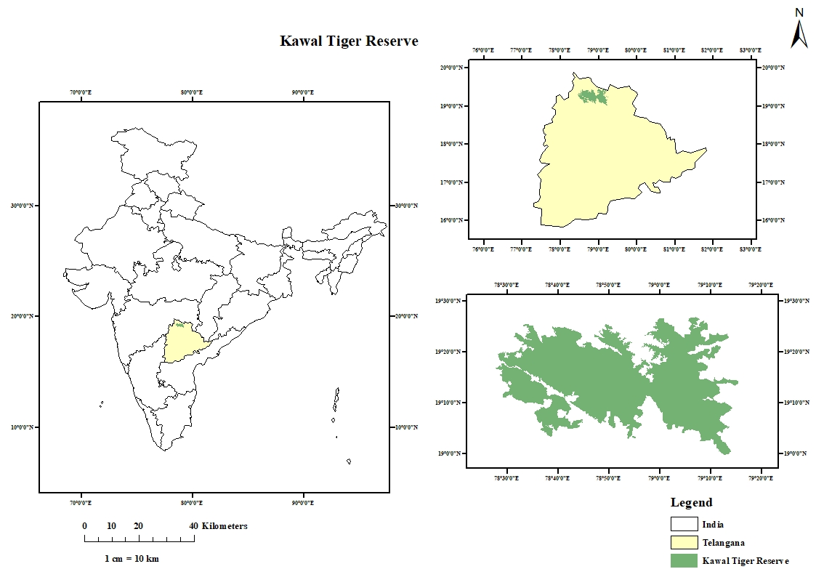
Fig.1. Location Map of Kawal Tiger Reserve (Study Area)
3. Results and Discussion
3.1 Employment Generation as a Direct-Use Ecosystem Service in Kawal Tiger Reserve
Employment generation emerged as a significant direct-use ecosystem service of the Kawal Tiger Reserve (KTR), reflecting the labor-intensive nature of tiger reserve management in a remote forested landscape. Based on verified Forest Department records for the period 2023–2025, KTR generated 239 direct conservation-linked employment opportunities. Employment was distributed across forest protection, wildlife monitoring, anti-poaching, administration, logistics, and ecotourism-related activities, highlighting the strong linkage between conservation management and rural livelihoods.
Frontline and field-oriented roles dominated the employment structure, accounting for the majority of positions. Base camp watchers alone constituted 163 employees (68.2%), underscoring the centrality of continuous patrolling, habitat protection, and surveillance in KTR. Other important categories included drivers, data entry operators (DEOs), anti-poaching squad members, animal trackers, and ecotourism drivers.
3.2 Division-wise Employment Structure and Functional Roles
3.2.1 Asifabad Division
The Asifabad Division generated employment for 29 individuals (Table 1). Employment was strongly skewed toward frontline wildlife protection, with base camp watchers (15) and animal trackers (10) together accounting for over 86% of the workforce. Supporting roles such as drivers and DEOs were limited, indicating a management emphasis on field-based surveillance and habitat protection rather than administrative expansion. This protection-oriented employment structure mirrors patterns observed in high-priority protection zones of other tiger reserves.
Table 1. Employment generation details of Asifabad Division, KTR
Sl. No | Type of Employment | Number of workers
 | Base camp watchers | 15
 | Animal Trackers | 10
 | Drivers | 2
 | DEO’s | 2
 | Total | 29

3.2.2 Jannaram Division
The Jannaram Division employed 75 personnel (Table 2). Base camp watchers formed the largest segment (50 employees; 66.7%), followed by drivers, DEOs, and ecotourism safari drivers. The presence of ecotourism drivers, rescue van staff, gate watchers, and check-post personnel indicates a more diversified employment profile integrating protection, visitor management, emergency response, and tourism support. Such integrated employment structures have been shown to enhance livelihood diversification and institutional visibility of conservation benefits.
Table 2. Employment generation details of Jannaram Division, KTR
Sl. No | Type of Employment | Number of workers
1 | Base camp watchers | 50
2 | At Check Posts | 4
3 | TCF Employees (EEC Watcher) | 1
4 | Eco-tourism Drivers (Safari Drivers) | 5
5 | Rescue Van Drivers | 1
6 | DPO's | 1
7 | DEO's | 4
8 | Drivers | 6
9 | Gate Watcher at Safari Gate | 1
10 | DRC cartmen | 1
11 | Asst. DRC cartmen | 1
 | Total | 75

3.2.3 Khanapur Division
The Khanapur Division emerged as the largest employment provider within KTR, engaging 92 workers (Table 3). Base camp watchers dominated employment (65 employees; 70.7%), followed by anti-poaching squad members (10) and drivers. The relatively large workforce reflects the division’s extensive patrolling requirements and enforcement intensity. The presence of TCF employees, DPOs, and DEOs further strengthened administrative and monitoring capacity.
Table 3. Employment generation details of Khanapur Division, KTR
Sl. No | Type of Employment | Number of workers
 | Base camp watchers | 65
 | Anti-poaching squad | 10
 | At check posts | 3
 | TCF Employees | 2
 | DPO’s | 1
 | DEO’s | 6
 | Drivers | 5
 | Total | 92

3.2.4 Utnoor FDPT Division
The Utnoor FDPT Division provided employment to 43 workers (Table 4). Base camp watchers (33 employees) constituted the overwhelming majority of the workforce, highlighting their indispensable role in day-to-day field operations. Check-point staff, drivers, and DEOs supported protection, monitoring, and administrative functions. The employment pattern indicates a strong dependence on sustained frontline staffing to ensure effective protection and surveillance.
Table 4. Employment generation details of Utnoor FDPT, KTR
Sl. No | Type of Employment | Number of workers
 | Base camp watchers | 33
 | At check points | 2
 | DEO’s | 4
 | Drivers | 3
 | Watcher | 1
 | Total | 43

3.3 Consolidated Economic Value of Employment in Kawal Tiger Reserve
When aggregated across all divisions, KTR directly employed 239 individuals (Table 5). The employment structure was heavily dominated by base camp watchers (163 employees), followed by drivers (16), DEOs (16), anti-poaching squad members (10), animal trackers (10), and ecotourism drivers (5). This distribution highlights the protection-centric nature of tiger reserve management.
Importantly, most employment categories require limited formal education and are therefore highly accessible to local and forest-dependent communities, reinforcing livelihood security and reducing dependence on extractive forest use. Conservation-linked employment in KTR contributes not only to household income but also to broader socio-ecological outcomes, including enhanced community participation, reduced anthropogenic pressure, and improved conservation compliance.
Table 5. Consolidated employment generation details of KTR
Sl. No | Type of employment | Number of employees
1 | Base camp watchers | 163
2 | Animal trackers | 10
3 | Drivers | 16
4 | DEO's | 16
5 | DPO's | 2
6 | At check points | 6
7 | At check posts | 3
8 | TCF employees | 3
9 | Anti-poaching squad | 10
10 | Watcher | 1
11 | Eco-tourism drivers | 5
12 | Rescue van driver | 1
13 | Gate watcher | 1
14 | DRC cartmen | 1
15 | Asst. DRC cartmen | 1
Total |  | 239

Overall, the results demonstrate that employment generation constitutes a core conservation outcome of Kawal Tiger Reserve, rather than a peripheral benefit, underscoring its importance within the ecosystem services framework and protected area governance.
These findings corroborate evidence from India and other tropical countries that conservation-linked employment enhances local support for protected areas when livelihood benefits are visible and equitably distributed (De Zoysa, 2022; Verma et al., 2019; Bhushan et al., 2024).
The employment generated by Kawal Tiger Reserve (KTR) contributes not only to household income but also to broader socio-ecological outcomes within the reserve landscape. Regular wage employment through forest protection, anti-poaching activities, wildlife monitoring, and ecotourism services reduces local dependence on extractive forest uses such as fuelwood collection, grazing, and illicit non-timber forest product (NTFP) harvesting. This indirect conservation benefit is well documented in community-based conservation literature and highlights the role of employment as a mechanism for reducing anthropogenic pressure on forest resources (Alam & Nayak, 2025).
In addition to income support, conservation-linked employment in KTR enhances conservation awareness, skill development, and institutional trust between the Forest Department and local communities. Frontline workers, including base camp watchers, animal trackers, and anti-poaching staff, function as crucial intermediaries between management authorities and forest-fringe villages. Through daily interactions, they facilitate conflict resolution, improve communication, and promote compliance with conservation regulations. Such social capital formation represents a critical yet often under-valued ecosystem service provided by protected areas (De Zoysa, 2022).
The results underscore that employment generation in KTR should be recognised as a core conservation outcome, rather than a peripheral or incidental benefit of protected area management. Strengthening local recruitment, expanding ecotourism-based livelihood opportunities, and ensuring equitable and fair wage structures can further enhance the socio-economic legitimacy of Kawal Tiger Reserve. Integrating employment-related indicators into management effectiveness evaluation frameworks would enable a more holistic assessment of tiger reserves, aligning biodiversity conservation objectives with broader sustainable development goals.
4. Conclusion:
The study demonstrates that employment generation is a key direct-use ecosystem service of Kawal Tiger Reserve (KTR), reflecting the strong link between biodiversity conservation and livelihood support for local communities. KTR provided direct conservation-linked employment to 239 individuals, with most opportunities concentrated in frontline roles such as base camp watchers, animal trackers, anti-poaching staff, and support services. This highlights the labor-intensive nature of tiger reserve management and the critical role of human resources in forest protection and wildlife conservation.
Employment distribution varied across divisions, influenced by protection intensity and management priorities. Most jobs require limited formal education, making them accessible to forest-fringe and tribal communities and contributing to livelihood security. Beyond income generation, conservation-linked employment reduces dependence on extractive forest use, enhances conservation awareness, and strengthens trust between the Forest Department and local communities. Overall, the findings emphasize that employment generation should be recognized as a core conservation outcome, supporting both ecological sustainability and socio-economic development in Kawal Tiger Reserve.

References:
Alam, R., & Nayak, D. (2025). Developing local support for wildlife conservation through community-based ecotourism: a study of Jim Corbett Tiger Reserve, India. Tourism Planning & Development, 22(2), 182-206.
Bhushan, S., Dincă, I., & Shikha, S. (2024). Evaluating local livelihoods, sustainable forest management, and the potential for ecotourism development in Kaimur Wildlife Sanctuary, India. Frontiers in Forests and Global Change, 7, 1491917.
Kumar, A., Yadav, R., Patil, M., Kumar, P., Zhang, L., Kaur, A., ... & Singh, A. N. (2020). Sustainable management of national parks and protected areas for conserving biodiversity in India. In Advances in forest management under global change. IntechOpen.
Leung, Y. F., Spenceley, A., Hvenegaard, G., Buckley, R., & Groves, C. (2018). Tourism and visitor management in protected areas: Guidelines for sustainability (Vol. 27). Gland, Switzerland: IuCN.
Prakash, A. S. (2022). Wildlife crime prevention measures undertaken in a protected area: a study among conservation stakeholders in the Mudumalai Tiger Reserve, Western Ghats (India) (Doctoral dissertation, University of Madras (India)).
Pujar, S. C., & Mishra, N. (2021). Ecotourism industry in India: a review of current practices and prospects. Anatolia, 32(2), 289-302.
Pujar, S. C., & Mishra, N. R. (2025). Beyond the forests: ecotourism and sustainable livelihoods in Karnataka’s protected landscapes. Current Issues in Tourism, 28(15), 2519-2536.
Pullin, A. S., Bangpan, M., Dalrymple, S., Dickson, K., Haddaway, N. R., Healey, J. R., ... & Oliver, S. (2013). Human well-being impacts of terrestrial protected areas. Environmental Evidence, 2(1), 19.
Rai, N. D., Devy, M. S., Ganesh, T., Ganesan, R., Setty, S. R., Hiremath, A. J., ... & Rajan, P. D. (2021). Beyond fortress conservation: the long-term integration of natural and social science research for an inclusive conservation practice in India. Biological Conservation, 254, 108888.
Singh, T. V., & Singh, S. (2004). On bringing people and park together through ecotourism: The Nanda Devi National Park, India. Asia Pacific Journal of Tourism Research, 9(1), 43-55.
Soman, D. (2022). Assessment of Ecosystem Services from Parambikulam Tiger Reserve. Cochin University of Science and Technology. Kochi, Kerala.176p
Verma, M., Tiwari, C., Anand, S., Edgaonkar, A., David, A., Kadekodi, G., ... & Thatey, Z. (2019). Economic valuation of tiger reserves in India: phase II. Indian Institute of Forest Management, Bhopal, India, 296.
Ward, C., Stringer, L. C., & Holmes, G. (2018). Protected area co-management and perceived livelihood impacts. Journal of Environmental Management, 228, 1-12.
Yadav, S. P., Tiwari, V. R., Mallick, A., Garawad, R., Talukdar, G., Sultan, S., ... & Das, A. (2023). Management Effectiveness Evaluation of Tiger Reserves in India, Fifth Cycle, 2022. Wildlife Institute of India, Dehradun and National Tiger Conservation Authority, Government of India.
Zoysa, M. D. (2022). Forest-based ecotourism in Sri Lanka: a review on state of governance, livelihoods, and forest conservation outcomes. Journal of Sustainable Forestry, 41(3-5), 413-439.

