Water resource Management and Flood Risk Forecasting in the Diani Watershed

Abstract
The objective of this study is to estimate return periods and quantiles of extreme rainfall and discharge in order to analyze the relationship between these two variables in the Diani watershed in Guinea's Forest Region. The methodological approach consists of finding a statistical distribution of maximum annual rainfall and discharge from 1995 to 2024 by fitting them to the Gumbel distribution of extreme values. The parameters of the Gumbel extreme value distribution were estimated using the weighted moment method. The results show that the data studied fit the Gumbel extreme value distribution well. Furthermore, the annual maxima of precipitation and stream flow have return periods of 6, 12, 20, and 60 years, respectively. These return periods correspond to abnormal, highly abnormal, and exceptional events. The rainfall and flow quantiles corresponding to these events are 85.8, 99.1, 108.6, and 128.6 mm for the N’Zérékoré station; and 96.1, 113.8, 126.4, and 153.2 mm for the Macenta station, with flow rates of 195.6, 227.3, 249.9, and 297.7 m³/s respectively. Unpredictable extreme rainfall can lead to flooding, which could have serious economic and social consequences in the Diani watershed. The correlation coefficient between rainfall and flow rate is -0.041 at the N’Zérékoré station and 0.013 at the Macenta station. Indeed, these results show that there is no significant relationship between rainfall (N’Zérékoré, Macenta) and flow rates in the Diani River watershed.
Keywords: Management, water resources, forecasting, risks, floods, watershed
1. Introduction
The rational management of water resources at the scale of watersheds in general and ecosystems in particular requires a good knowledge of the variability of rainfall and hydrological regimes, especially during periods of crisis linked to flood or low water events (Bai et al., 2020). In the dry tropical regions of West Africa, the development of water resources for agriculture and livestock farming through small-scale hydro-agricultural developments requires a good understanding of rainfall and hydrological patterns, and in particular the characteristics of exceptional floods, to prevent the risks of destruction of hydraulic structures and crops.

The potential consequences of climate change include, among other things, an increase in extreme events or hydrometeorological situations which, until now, have manifested as heavy rainfall or prolonged periods of drought. The overall variation in rainfall, excess and poor temporal or spatio-temporal distribution over several years has significant repercussions on hydrological and agronomic levels, but also on economic, social and even political levels (Bergstrand et al., 2014). One of the most damaging consequences for the economy is the invalidity of hydrological standards used to design structures. It is therefore necessary to find a method for analyzing maximum rainfall and precipitation levels in order to have reliable management tools.

Furthermore, a good knowledge of rainfall and hydrological regimes makes it possible to better estimate annual volumetric inputs in order to better size storage facilities and determine their potential to contribute to development and to meet the needs of populations (Aghakouchak et al., 2020).

Based on the principle that a natural risk is managed better when one has prepared for it, it is necessary, in order to prevent any hydrometeorological crisis situation, to seek to better understand and quantify the rainfall and hydrological regimes of small watersheds; this allows for a better estimation of the rainfall and hydrological parameters of these watersheds which have sufficient rainfall and hydrological data. Therefore, with a view to helping basin managers in Forest Guinea to have a better understanding of extreme hydrometeorological events at the scale of Diani, this work proposes to analyze maximum flows and rainfall, to evaluate the relationship between rainfall and characteristic flows of the basin and, finally, to formulate a model allowing the estimation of return times and quantiles of maximum flows and rainfall.
2. Materials and Methods
2.1. Study Setting and Data
The Diani River watershed, located in the Forest Region of Guinea (between 7°30' - 9°30' North and 8°0' - 10°30' West), is a major ecosystem covering approximately 5,200 km² (Fig. 1). It is one of the most important watercourses in the region, essential for local hydrography. It originates in the Ziama Classified Forest (Macenta Prefecture), forms the boundary between the Macenta and N'Zérékoré Prefectures, and forms the border between Guinea and Liberia for 50 km. The basin has a reliable gauging station at the Diani Bridge, used for observations. It is subject to tropical rainfall patterns that influence its flow. The area is characterized by mountainous landscapes (Nimba Mountains, Guinean Ridge) upstream, with dense forest ecosystems. The Diani basin is crucial for water supply, agriculture, and the ecological balance of the Forest Region of Guinea. The data used in this research are based on annual rainfall and stream flow data. Rainfall data were provided by the National Meteorological Agency of Conakry and cover the period from 1995 to 2024 for two synoptic stations (Macenta and N’Zérékoré). Stream flow data were obtained from the National Directorate of Hydraulics of Conakry and also cover the same period (Piou Dobo et al., 2025).
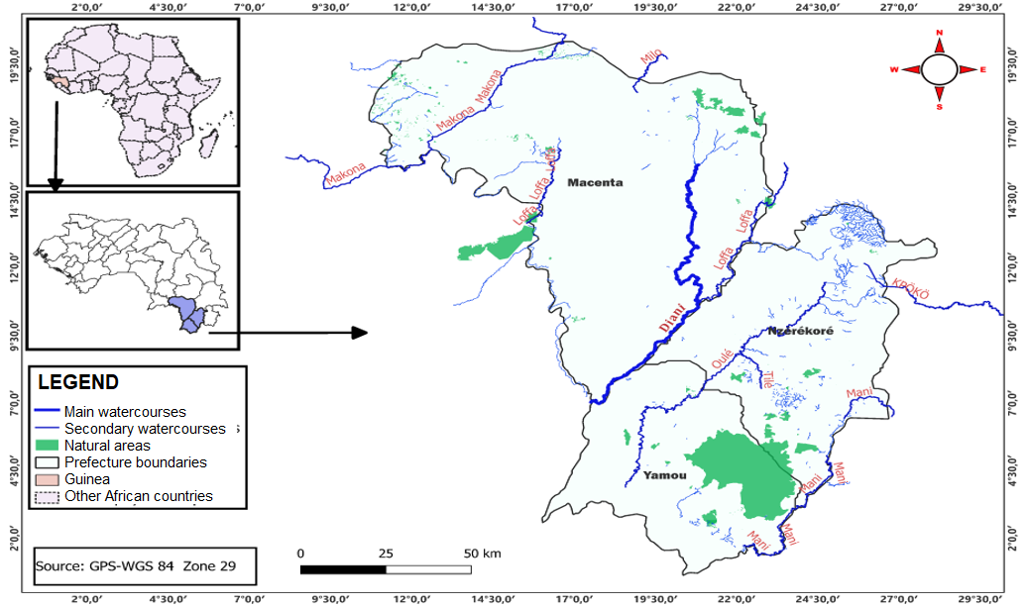
Fig. 1. Location map of the Diani watershed (Source: M. Sidiki Traore)
2.2. Analysis Methodology
The availability of accurate estimates of extreme hydrometeorological events (such as floods and low water levels) is essential for the successful execution of various engineering activities, including the design of hydraulic structures, water and habitat quality management, and flood prevention. To improve these estimates, numerous methodologies have been developed in recent years (Piou Dobo et al..., 2025). In this study, a fitting law, namely the Gumbel distribution, is used. This distribution was selected based on the work of several authors (Kundzewicz et al..., 2014; Amani Michel et al…, 2018; Belkacem Abdous et al..., 2008; Gue, A., & Afouda, A. 2015 and Goula et al…, 2007;).

Calculation of empirical frequencies
In the tropical zone, Hazen's formula has been used by most authors (Relwindé Abdoul et al…, 2021; H., De Longueville, F., & Ozer, P. 2015). It is based on ranking a sample of maximum rainfall of size n in ascending order. The expression for the empirical or experimental non-exceedance frequency of Hazen for a value x of rank r is calculated by the equation 1.

$$f\left(x\right)=\frac{r-0,5}{n} (1)$$

Characterization of Return Times
The return period (or return time) characterizes the statistical time between two occurrences of a natural event of a given intensity. This term is widely used to characterize natural hazards. The estimation of different return times for an event is defined as the inverse of the probability of that event exceeding its intensity. It is given by the formula 2.

$$T=\frac{1}{1-F(x)} (2)$$
Where, T: return period (years) and F: non-exceedance frequency.
A rainfall event is classified as highly exceptional if its return period is over 100 years; exceptional if the return period is between 30 and 100 years; highly abnormal if the return period is between 10 and 30 years; and abnormal if the return period is between 1 and 6 years (Haan and Ferreira 2006; Bergstrand et al., 2014; Fougeres et Soulier 2010; Belkacem et al.., 2008; M. Schlather et Tawn 2003; Kévin Dubois et al., 2024).

Pearson Correlation Test
The correlation coefficient, often denoted (r), measures the strength and direction of a linear relationship between two quantitative variables. It ranges from -1 to 1. For two variables (X) and (Y), the Pearson correlation coefficient is calculated using the following formula 3.

$$r=\frac{\sum{(X-\overline{X})(Y-\overline{Y})}}{\sqrt{\sum{{(X-\overline{X})}^{2}×\sum{({Y-\overline{Y})}^{2}}}}} (3)$$

Where X̅ and Y̅ represent the means of X and Y
(r = 1): perfect positive correlation. When (X) increases, (Y) increases proportionally.
(r = -1): perfect negative correlation. When (X) increases, (Y) decreases proportionally.
(r = 0): no linear correlation. Changes in (X) have no predictable effect on (Y).

3. Results and discussion
3.1. Estimation of extreme flood flows/precipitation for different return times using Gumbel law
The application of the statistical method (Gumbel law) to hydroclimatic data allowed us to estimate different return times for extreme precipitation and flow events, the results of which are grouped in the table below.

Table 1. Extreme events for different return times
Years | Flow rate [m/s3] | Time [year] | Rainfall [mm]
Years | Flow rate [m/s3] | Time [year] | N’Zérékoré | Time [year] | Macenta | Time [year]
1995 | 88,0 | 1,1 | 68,1 | 2,1 | 77 | 1,8
1996 | 186,2 | 6,7 | 37 | 1,3 | 42,2 | 1,3
1997 | 172,9 | 5,5 | 67,7 | 1,9 | 81,4 | 2,2
1998 | 159,6 | 4,0 | 95,4 | 20,0 | 113,3 | 20,0
1999 | 127,4 | 1,5 | 64 | 1,7 | 69,5 | 1,7
2000 | 138,0 | 2,4 | 61,6 | 1,5 | 67 | 1,5
2001 | 120,2 | 1,2 | 40,4 | 1,3 | 34,5 | 1,3
2002 | 137,4 | 2,1 | 33,9 | 1,2 | 30,6 | 1,2
2003 | 126,1 | 1,4 | 30,1 | 1,1 | 21,2 | 1,0
2004 | 128,3 | 1,6 | 29,4 | 1,0 | 24,9 | 1,1
2005 | 168,2 | 4,6 | 32,5 | 1,1 | 32,6 | 1,2
2006 | 131,0 | 1,8 | 33,9 | 1,2 | 29,6 | 1,1
2007 | 206,0 | 12,0 | 30,3 | 1,1 | 26,6 | 1,1
2008 | 347,1 | 60,0 | 69,5 | 2,2 | 77,6 | 1,9
2009 | 275,3 | 20,0 | 75,7 | 2,6 | 100,9 | 4,6
2010 | 203,6 | 8,6 | 77,3 | 2,4 | 85,7 | 2,4
2011 | 131,9 | 1,9 | 51,1 | 1,4 | 49 | 1,4
2012 | 60,1 | 1,0 | 60,3 | 1,5 | 69 | 1,6
2013 | 94,3 | 1,1 | 62,7 | 1,6 | 58,5 | 1,5
2014 | 119,4 | 1,2 | 91,5 | 8,6 | 99,3 | 3,2
2015 | 144,4 | 3,5 | 82,5 | 3,2 | 95,7 | 2,9
2016 | 138,7 | 2,9 | 78,7 | 2,9 | 104,4 | 5,5
2017 | 137,4 | 2,2 | 64,4 | 1,8 | 80 | 2,1
2018 | 138,6 | 2,6 | 93,6 | 12,0 | 86,5 | 2,6
2019 | 140,1 | 3,2 | 85,8 | 3,5 | 103,6 | 5,5
2020 | 123,9 | 1,3 | 86,7 | 4,0 | 99,6 | 3,5
2021 | 99,4 | 1,1 | 86,7 | 4,6 | 110,3 | 12,0
2022 | 127,7 | 1,5 | 100,6 | 60,0 | 100,2 | 4,0
2023 | 120,4 | 1,3 | 88 | 5,5 | 113,9 | 60,0
2024 | 130,1 | 1,7 | 90,5 | 6,7 | 106 | 8,6

Analysis of extreme events for different return periods (Table 1) using Gumbel law shows that :
- Return periods between 30- and 100-years mark exceptional events and include the 2008 flood flow with a flow rate of 347.1 m3/s and the extreme rainfall of 2022 and 2023 in N’Zérékoré and Macenta respectively, with amounts of 100.6 mm and 113.9 mm, for which the return period is 60 years;
- Return periods falling within the range of 10 to 30 years constitute highly abnormal events and concern the flood flows of 2007 and 2009, with flow rates of 206.0 m³/s and 275.3 m³/s respectively, for return periods of 12 and 20 years; the extreme rainfall of 1998 for the two stations (N’Zérékoré and Macenta) with respective amounts of 95.4 mm and 113.3 mm for a return period of 20 years. There are also the rainfall events of 2018 and 2021 with respective amounts of 93.6 mm for the N’Zérékoré station and 110.3 mm for the Macenta station, with a return period of 12 years;
- Return periods between 1 and 6 constitute abnormal events and concern the remaining years in Table 1, with the exception of 1996 and 2008, whose flow rates are 186.2 m³/s and 203.6 m³/s, respectively, with return periods of 6.7 years and 8.6 years. In addition, the rainfall in N’Zérékoré for the years 2014 and 2024, which have return periods of 8.6 and 6.7 years, and that of Macenta, with a return period of 8.6 years corresponding to the year 2024, are included.

3.2. Adjustment of Maximum Annual Rainfall/Flow Rates According to the Gumbel Distribution
The graphs of maximum annual rainfall and flow rate as a function of the Gumbel centered variables (Fig. 2) yield the following equation, whose parameters, estimated by the method of moments, are: a = 55.31 and b = 17.94 for rainfall in N’Zérékoré and a = 55.29 and b = 23.96 for Macenta; for flow rates, a = 122.66 and b = 42.84. All the estimated rainfall/flow rate intensities closely follow the linear curves and fall within the confidence intervals. This demonstrates that the Gumbel distribution accurately estimates the extreme values ​​of observed annual rainfall/flow rates.

In other words, the method of moments consists of equating the characteristics of the (empirical) distribution of samples with the theoretical characteristics of the law. The characteristics used to describe a distribution are the moments, the best known of which are the mean and the variance.
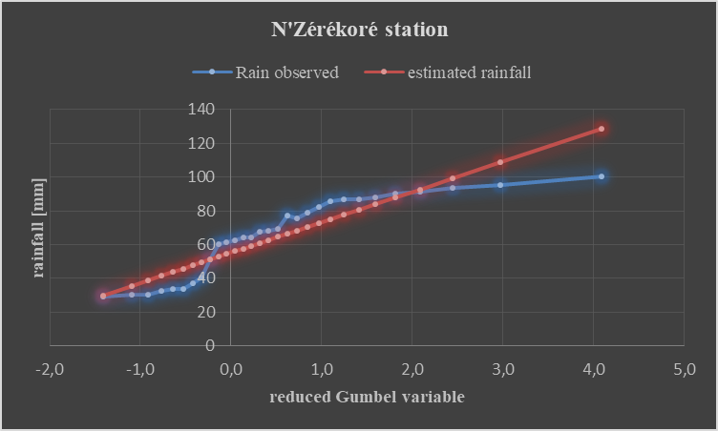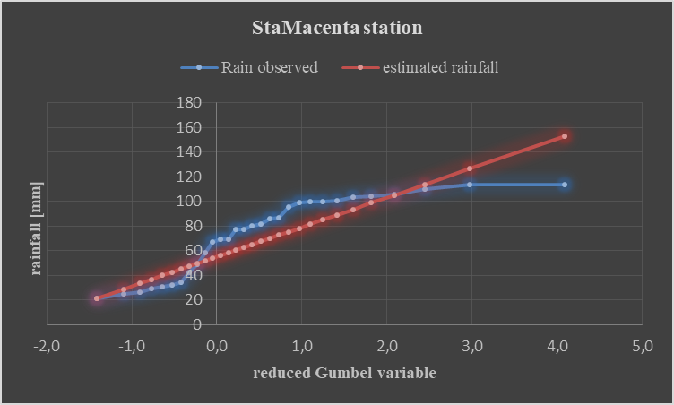
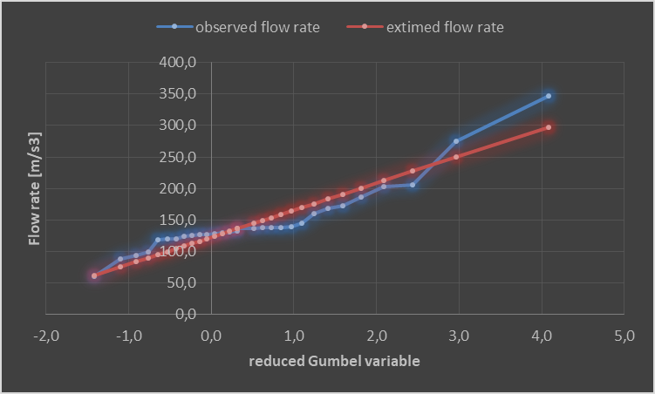
Fig. 2. Gumbel Law Precipitation/Runoff Fitting Model
3.3. Estimation of Quantiles Corresponding to Return Times of Stream flow and Precipitation Observed in the Watershed
The results in figure 3 reveal that the 6-year return period corresponds to rainfall quantiles of 85.8 mm and 96.1 mm for the N’Zérékoré and Macenta stations, respectively, with a flow rate of 195.6 m³/s marking abnormal rainfall events. The 12- and 20-year return periods coincide with rainfall quantiles of 99.1 mm and 108.6 mm for the N’Zérékoré station and 113.8 mm and 126.4 mm for the Macenta station, with respective flow rates of 227.3 m³/s and 249.9 m³/s.

These return periods correspond to highly abnormal rainfall events. Finally, the 60-year return period, which defines exceptional rainfall events, corresponds to rainfall quantiles of 128.6 mm and 153.2 mm for N’Zérékoré and Macenta, with a flow rate of 297.7 m³/s.
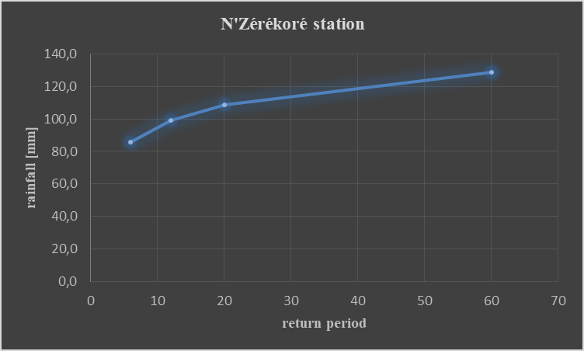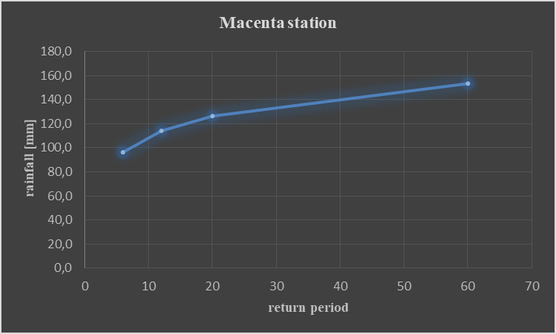
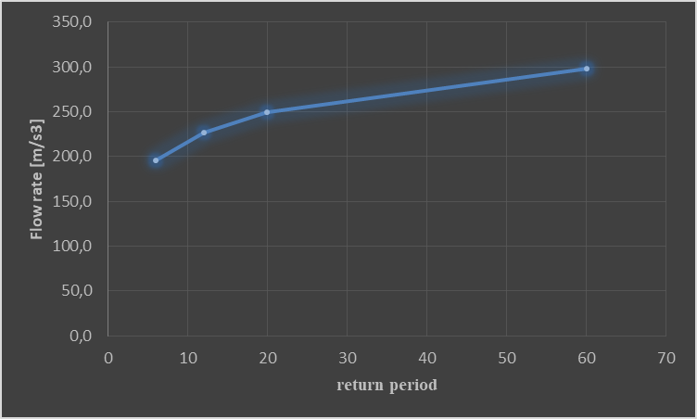
Fig. 3. Return period of annual rainfall quantiles and maximum flow rates
Moreover, these different analyses describe the intensity of annual rainfall and maximum flows according to an annual periodicity and can lead to a recurrence of water levels in the basin.
3.4. Statistical Dependence between Rainfall and Annual Flow in the Watershed
To better understand the influence of rainfall on flow, a correlation test was applied, as illustrated by the two graphs (Fig. 4). The results of the analysis show that the cloud points are dispersed in the same way along both linear trends. The correlation coefficient between rainfall and flow is -0.041 at the N’Zérékoré station and 0.013 at the Macenta station. Furthermore, we also observe that the linear trend at the N’Zérékoré station is slightly downward than that at Macenta.
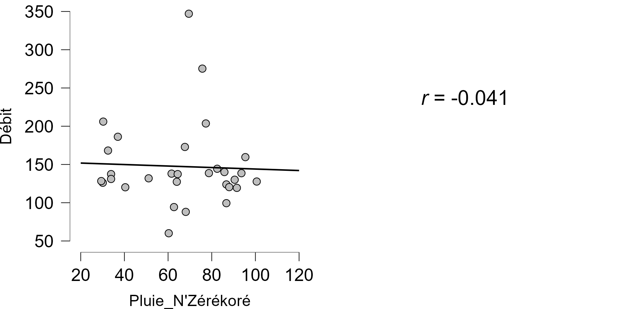
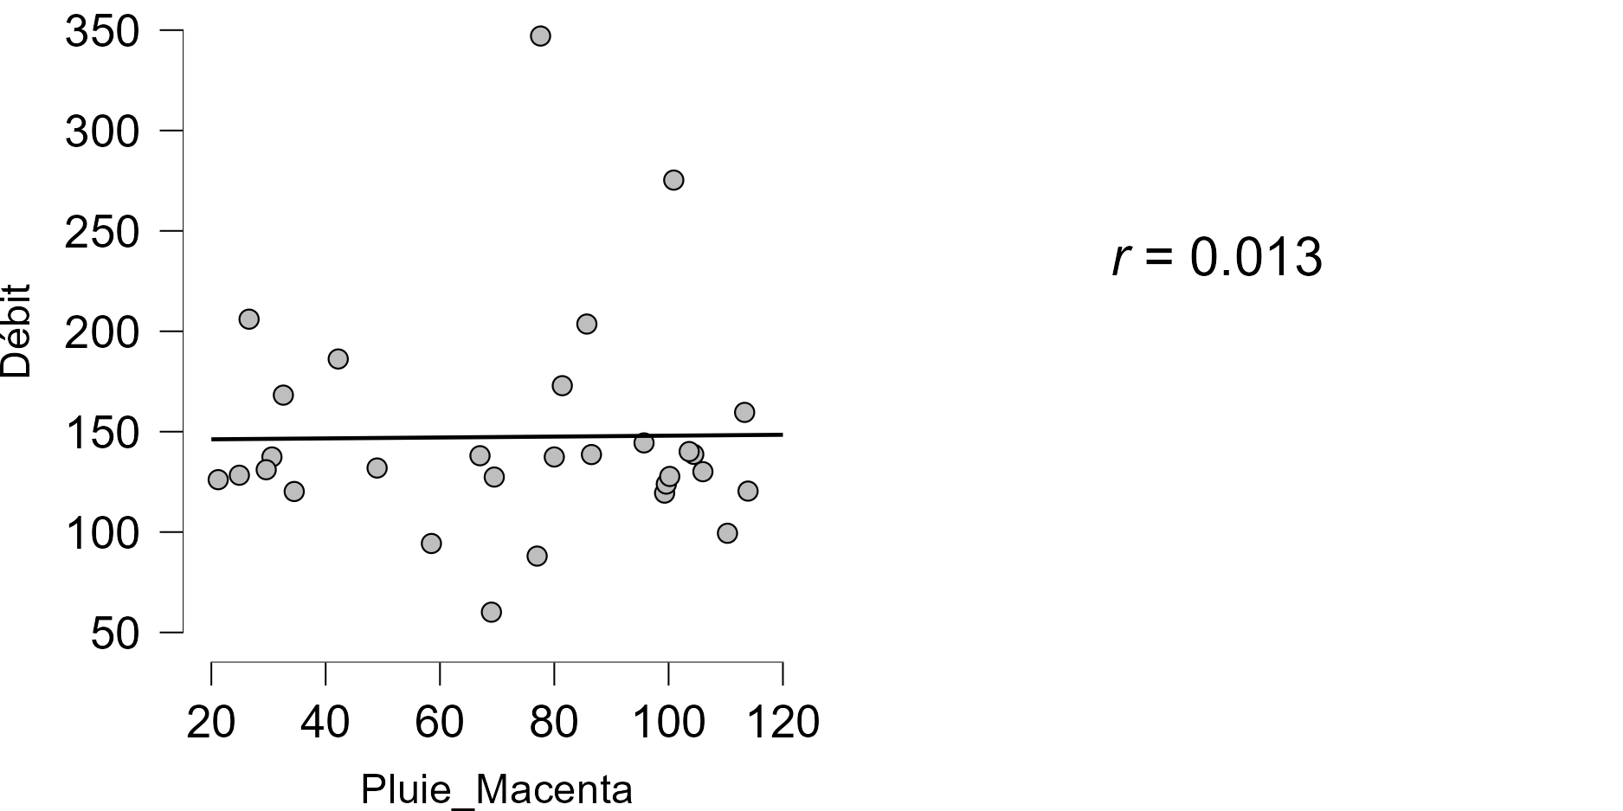
Fig. 4. Relationship between precipitation and flow rate in the watershed
The summary of the correlation test statistics is presented in Table 2 below.
Table 2. Statistical dependence results between rainfall and stream flow in the watershed
 |  |  | R de Pearson | p | Covariance
Pluie_N'Zérékoré | - | Débit | -0.041 | .830 | -51.650
 |  |  | R de Pearson | p | Covariance
Pluie_Macenta | - | Débit | 0.013 | .947 | 21.253

The interpretation of the correlation between rainfall and flow rates (Table 2) when examining the values ​​of r, p, and covariance is as follows:
At the N’Zérékoré station:
r value = -0.041
This indicates a very weak negative correlation between the two variables (rainfall and flow rate). In other words, there is almost no linear relationship between the amount of rainfall at the N’Zérékoré station and the observed flow rate in the watershed.
p value = 0.830
This value is well above the usual threshold of 0.05. This means that there is insufficient evidence to reject the null hypothesis, which states that there is no correlation between the two variables. In other words, the observed relationship (or lack thereof) could be due to chance, and there is no statistically significant link between rainfall and flow rate.
Covariance = -51.650
A negative covariance indicates a tendency for one variable to decrease when it increases. However, the covariance value alone cannot be interpreted in isolation. It must be interpreted in conjunction with the correlation coefficient and the p-value.
At the Macenta station
r value = 0.013
This value indicates a very weak positive correlation between the two variables (rainfall and flow rate). In other words, there is almost no linear relationship between the amount of rainfall at Macenta and the observed flow rate. A value close to 0 suggests that there is no clear trend in the data.

p value = 0.947
This value is well above the usual threshold of 0.05. This means that there is insufficient evidence to reject the null hypothesis, which states that there is no correlation between the two variables. In other words, the observed relationship (or lack thereof) could be due to chance, and there is no statistically significant link between rainfall at the Macenta station and the catchment flow rate.

Covariance = 21.253
Positive covariance indicates a tendency for one variable (e.g., rainfall) to increase, while the other variable (river flow) also tends to increase. However, as with negative covariance, the value itself does not provide a clear interpretation. Positive covariance must be interpreted in conjunction with the correlation coefficient and p-value. Indeed, the results show no significant relationship between rainfall (N’Zérékoré, Macenta) and river flow in the Diani River basin.
4. Conclusion
The analysis of the results obtained from applying Gumbel law to hydroclimatic data led to several conclusions regarding flood flows and extreme rainfall in the Diani River watershed. The results highlight several categories of extreme events based on return periods:

- The 2008 flood flow (347.1 m³/s) and the extreme rainfall of 2022 and 2023 (100.6 mm for N’Zérékoré and 113.9 mm for Macenta, respectively) are significant, indicating events of notable rarity.

- The flood flows of 2007 (206.0 m³/s) and 2009 (275.3 m³/s), as well as the rainfall of 1998 (95.4 mm in N’Zérékoré and 113.3 mm in Macenta), fall into this category. Furthermore, the rainfall of 2018 (93.6 mm) and 2021 (110.3 mm) also show 12-year return periods.

- The other years, with the exception of 1996 and 2008, show relatively short return periods, indicating a higher frequency of these events.

Fittings using the Gumbel distribution demonstrate that the extreme values ​​of annual rainfall and stream flow are well modeled by this distribution. The equations on the right, with well-defined coefficients, indicate a good fit between empirical and theoretical data, reinforcing the validity of the method of moments used. The return periods for the rainfall and stream flow quantiles show trends similar to the previous results, with significant quantiles for abnormal (6-year) and highly abnormal (12- and 20-year) rainfall events. This underscores the importance of these events in water resource management and flood prevention.

Correlation tests indicate a very weak relationship between rainfall and river flow, both in N’Zérékoré and Macenta. Correlation coefficients and p-values ​​show that there is no statistically significant link between these variables, suggesting that other factors may influence river flow in the watershed. These results can serve as a basis for future actions aimed at better understanding and managing the risks associated with flooding and climate variability.

Disclaimer (Artificial Intelligence)
Author(s) hereby declares that NO generative AI technologies such as Large Language Models (ChatGPT, COPILOT, etc) and text-to-image generators have been used during writing or editing of this manuscript.

Competing Interests
Authors have declared that no competing interests exist.

References
A.-L. Fougeres et P. Soulier (2010). Limit conditional distributions for bivariate vectors with polar representation”. https://hal.science/hal-00373049/document
Aghakouchak, A., Chiang, F., Huning, L. S., Love, C. A., Mallakpour, I., Mazdiyasni, O., Moftakhari, H., Papalexiou, S. M., Ragno, E., and Sadegh, M. (2020): Climate Extremes and Compound Hazards in a Warming World, Annu. Rev. Earth Pl. Sc., 48, 519–548. https://doi.org/10.1146/annurev-earth-071719-055228.
Amani Michel Kouassi, Relwindé Abdoul-Karim Nassa, Koffi Eugène Kouakou, Koffi Fernand Kouame and Jean Biemi. Statistical modeling of maximum annual rainfall in the Abidjan district (southern Côte d'Ivoire). https://doi.org/10.7202/1051697ar
Bai, X., Jiang, H., Li, C., and Huang, L. (2020). Joint probability distribution of coastal winds and waves using a log-transformed kernel density estimation and mixed copula approach, Ocean Eng., 216, 107937. https://doi.org/10.1016/j.oceaneng.2020.107937.
Belkacem Abdous. Anne-Laure Fougères. Kilani Ghoudi. Philippe Soulier (2008). Estimation of bivariate excess probabilities for elliptical models. Bernoulli 14 (4) 1065 - 1088, November https://doi.org/10.3150/08-BEJ140
Bergstrand, M., Asp, S. S., and Lindström, G. (2014). Nationwide hydrological statistics for Sweden with high resolution using the hydrological model S-HYPE, Hydrol. Res., 45, 349–356. https://doi.org/10.2166/nh.2013.010.
Goula, B.T.A., Konan, B., Brou, Y., Savane, I., Vamoryba, F. and Srohourou, B. (2007) Estimation of exceptional daily rainfall in tropical zones: The case of Ivory Coast by comparison of the Lognormal and Gumbel distributions. Hydrological Sciences Journal, 1, 49-67. https://doi.org/10.1623/hysj.52.1.49
Gue, A., & Afouda, A. (2015). Frequency analysis and new mapping of annual maxima of daily rainfall in Benin. International Journal of Biological and Chemical Sciences, 9(1), 121–133. https://doi.org/10.4314/ijbcs.v9i1.
De Longueville, H., F., & Ozer, P. (2015). Extreme rainfall and flooding in Ouagadougou: When urban development is poorly managed. https://hdl.handle.net/2268/197339
Haan, L. and Ferreira, A. (2006) Extreme Value Theory: An Introduction. Springer Series in Operations Research and Financial Engineering. Springer. http://dx.doi.org/10.1007/0-387-34471-3
Kévin Dubois, Morten Andreas Dahl Larsen, Martin Drews, Erik Nilsson, and Anna Rutgersson. Influence of data source and copula statistics on estimates of compound flood extremes in a river mouth environment. Natural Hazards and Earth System Sciences. https://doi.org/10.5194/os-20-21-2024, 2024
Kundzewicz, Z. W., Kanae, S., Seneviratne, S. I., Handmer, J., Nicholls, N., Peduzzi, P., Mechler, R., Bouwer, L. M., Arnell, N., Mach, K., Muir-Wood, R., Brakenridge, G. R., Kron, W., Benito, G., Honda, Y., Takahashi, K., Sherstyukov, B. (2014): Flood risk and climate change: global and regional perspectives. - Hydrological Sciences Journal, 59, 1, 1-28. DOI: 10.1080/02626667.2013.857411
M. Schlather et J. A. Tawn (2003). A dependence measure for multivariate and spatial extreme values: Properties and inference. DOI: 10.1093/biomet/90.1.139
Piou Dobo Guilavogui, Ibrahima Kalil Kante, Magbini Tokpa Mamy Indicators of Spatio-Temporal Changes in Rainfall in Forest Guinea. Atmospheric and Climate Sciences, (2025). 15(2), 462-475. https://doi.org/10.4236/acs.2025.152024.
Piou Dobo Guilavogui, Magbini Tokpa Mamy, Binko Mamady Toure, Idrissa Diaby (2025). Determination of Flood Risk Thresholds and Analysis of Rainfall Frequency in the Diani Watershed, Forest Guinea. Atmospheric and Climate Sciences, 15(3), 681-695. https://doi.org/10.4236/acs.2025.153034

