Energy Transportation, Traffic-Induced Particles Emissions and Predicted Health Risks in an Urban Center - Thiès, Senegal

.
ABSTRACT

African cities are growing at a fast pace. The demographic growth, ~2% per annum, is a key driving factor of the accelerated urbanization (~4% rate). In developing cities, proliferation of small businesses is seen on major roads, where imported vehicles with old and inefficient internal combustion engines move and emit large quantities of pollutants. In the center of Thiès (Senegal), a route of about 10 km long was considered to evaluate concentrations of suspended particles. A portable optical particle counter, a Particle Plus 8301-AQM1 was used to measure particles concentrations at a few sites, and health risk assessment was performed. Average PM_{2.5} concentration exceeded the threshold value (15 µg.m⁻³) by 2 up to 5 folds, and that of PM₁₀ (45 µg.m⁻³), from 5 up to 16 folds. Particles size distribution showed high coarse fraction, 86% (53% for PM₅₋₁₀ and 33% for PM_{2.5-5}) and 14% for fine particles (11%, 2% and 1% for PM_{1-2.5}, PM_{0.5-1}, and PM_{0.5}, respectively). Hazard quotient (HQ) varied between 1.7 – 4.0 for PM_{2.5} and in the range 4.2 – 12.4 for PM₁₀ showing that those working or living on near roads could develop non-carcinogenic diseases. At all sites, Life Cancer Risk (LCR) was above 10⁻⁴, meaning existing probability that those exposed to the recorded level of PM_{2.5} could develop cancer diseases. The study concludes that governments in African developing nations along with local authorities should inform city dwellers and develop policy to tackle air pollution in urban areas.

Keywords: Road traffic, Particulate matter, Air pollution, Probabilistic health risk assessment

1. INTRODUCTION

Transport is an important part of the economy and could account for up to 20% of the GDP in some countries. Transport is crucial as it serves for the transport of goods and mobility. Africa continues to lag in the global economy, one of the reasons being its undeveloped transport infrastructure and history(Adeoye Babatunde, 2019). Road transport as seen in other parts of the world, dominates the transport sector. However, despite the development seen in most places, Africa is still the region with the lowest road density, and a large proportion of existing facilities are unpaved – less than 30%(Lane-Visser et al., 2025). Here are some common road transport sub-modes: (1) Walk - Most Africans do not have a purchase power which can allow them to pay for a trip in a taxi or a bus and therefore would walk; 2) Horse carriages - In many places, and especially in remote areas, horses or donkeys are used as means of transportation attached or no to a mechanical structure; 3) Motorcycles – Motorbikes with different names, ‘boda-bodas’ (East Africa), ‘benskin’ (Cameroon), ‘jakarta’ (Senegal), and ‘zem’ (Benin) are common in many African cities and provide quick transport, especially in congested areas with limited road infrastructure. They are imported from Asia and their number is constantly increasing; 4) Taxi cabs - Shared taxis are prevalent in various African countries for local transportation. They have seen strong competition coming from various platforms such as Yango, Uber or Bolt.; 5) Minibuses - These are small, privately owned minibuses, serving as a primary mode of transportation for short to medium distances. They are very popular is some countries: ‘ndiaga ndiaye’, ‘car rapid’ (in Senegal), ‘trotros’ (Ghana), ‘danfos’ (Nigeria), ‘daladala’ (in Tanzania).; 6) Buses: This category includes minibuses and large coaches widely used for public transportation in many African cities and towns; and 7) Trucks and pickups - They are primary mode of transport for goods and commodities within regions and countries. In Africa, the motorisation is still very low – only 2.5% of population own a car, and the car ownership rate is below 40 per 1000 inhabitants(Lane-Visser et al., 2025). In Senegal for instance, the car ownership rate is 50 per 1000(Tchanche, 2017). By 2021, the total number of automotive vehicles was approx. 1.6 billion, of which approx. 60 - 72 million were in Africa and mainly distributed between Nigeria, Algeria, Libya, Egypt, Morocco and South Africa(Lane-Visser et al., 2025).
Road transport is a major energy consumer and relies mainly on fossil fuels (diesel and gasoline). The energy demand in the transport sector is growing fast due to urbanization and mobility(Lokonon and Satoguina, 2023). Although, the car fleet is reduced in comparison to other regions of the world, it is constantly increasing with second handed old vehicles imported from Europe, Middle East and America. A surge of two-wheelers vehicles imported from Asia, is observed almost everywhere. Electric and hydrogen powered vehicles have entered the market some 20 years ago, and the demand for electric vehicles is increasing globally, but they are not yet popular in Africa, as the required infrastructure is still missing. The low electrification rate combined with poor electrical grids are still important hurdles to the wide adoption of electric mobility. Nevertheless, efforts are being seen in south Africa, Morocco, Rwanda, Cameroon, Kenya, Senegal, Uganda, and Egypt where new mobility policies are directed towards electrified transport(Lane-Visser et al., 2025). In Senegal and Morocco for instance, BRTs (Bus Rapid Transit) have been installed with electrified buses. In Kenya and Uganda, Roam Electric and Kiira Motors are now manufacturing electric buses and motorcycles. Increasing urbanization and mobility, growing fuel consumption, growing number of imported second hand vehicles, an automotive industry at an infancy stage and low electrification rates in Africa, lead to a future where internal combustion engines will continue to dominate.
Since the 1970s, an acceleration of urbanization is witnessed in Africa, with increasing number of megacities(Abera et al., 2020). The demographic growth, close to 2.5% per annum and the industrialization are key driving factors of this urbanization(Alvarez et al., 2020). However, this development is followed by challenges: lack of power supply, lack of sustainable waste management system, lack of transport infrastructure, youth unemployment, degradation of the environment…(Abera et al., 2020). Urban air pollution and heat waves are consequences of the uncontrolled and accelerated development observed. In urban areas, road traffic is an important source of air pollutants produced by numerous ways: roads degradation, unpaved roads, tyres degradation, exhaust fumes, oil and fuel leaks, debris from crashes, and breaks (Inchaouh and Tahiri, 2017; Inchaouh and Tchanche, 2024). Traffic related pollution is worsened by factors such as low road density, old car fleet, traffic congestion, unsustainable urban planning, poor quality fuels, and proliferation of two-wheeled vehicles(Abera et al., 2020). Although, being a major source of pollution, traffic-induced pollution has not attracted a lot of attention in Africa(Houngbégnon, Atindegla, et al., 2020). A few studies explored traffic related air pollution and its health impacts in Cotonou(Houngbégnon et al., 2022; Houngbégnon, Lawin, et al., 2020). Higher concentrations of fine particles, in the range 100 – 500 µg.m⁻³ with seasonal variations were observed(Houngbégnon et al., 2019). Furthermore, authors found that 72.68% in a cohort of 194 workers located near busy roads were experiencing respiratory symptoms, namely: cough, itchy nose, spits from the chest, whistles, and breathlessness (Houngbégnon, Lawin, et al., 2020). In Dakar, a cross-sectional study among bus drivers, showed that 57.9% of bus drivers had a chronic cough, 65.7% had recurrent cold, 38.8% had asthma and 30.3% had COPD(Sylla et al., 2018). Another study carried out among vendors located on near roads aimed at evaluating their exposure to allergic rhinitis and atmospheric pollution showed a 43% prevalence of allergic rhinitis(Sylla, Faye, Fall, Lo, et al., 2017). An embedded air quality monitor on the roof of a vehicle and moved across Dakar revealed high particles mass concentrations above 80 µg.m⁻³ for both PM_{2.5} and PM₁₀(Gueye et al., 2024). Spatiotemporal variations were observed and, high particles mass concentrations coincide with peak hours (10:00 - 11:00 am and 4:00 – 5:00 pm). In Abidjan at a traffic site, VOCs concentrations were measured and associated health risks assessed(Bahino et al., 2025). Results showed high concentrations of total VOCs (85.45 µg.m⁻³) and a predominance of BTEX compounds (benzene, toluene, ethylbenzene, xylenes). Probabilistic non-carcinogenic risk was relatively low, but the life cancer risk exceeded acceptable limits. Cordell et al. carried out a comparative study on volatile organic compounds composition in Lagos and Nairobi(Cordell et al., 2021). Very high levels of traffic-related VOCs were found in both cities, all investigated roadside sites exceeding the EU limit value for benzene (5 µg.m⁻³) by between 3 and 7.5 times. Assuming an 8-h exposure to benzene, the inhaled dose of VOCs of those exposed was 144 µg at the roadside (33 µg at the background site) in Nairobi and 161 µg in Lagos (28 µg at the background).
Air pollutants have been identified as particulate matter of different sizes (UFP: ultrafine particles, FP: fine particles and CP: coarse particles), gases (NOx: nitrous oxides, O₃: ozone, SO₂: sulphur dioxide, CO: carbon monoxide) and VOCs (volatile organic compounds)(Alvarez et al., 2020; Bernasconi et al., 2022). Air pollution is a silent killer and is associated with diseases such as metal fume fever, hypertension, cancer, respiratory illnesses, diabetes, stroke, and asthma(Katoto et al., 2019; Lawin et al., 2018; Schraufnagel, 2020). Air pollution is the second largest risk factor of deaths after high blood pressure and is responsible of about 8.1 million deaths per year(Health Effects Institute, 2024). Africa is one of the most affected regions and bears the highest death toll, with more than 1 million deaths per year(Fisher et al., 2021). The study presented here, focuses on particulate matter emitted by internal combustion engines and other sources in an urbanized area. It aims to determine concentrations and distribution of suspended particles emitted by vehicles in the centre of Thiès, Senegal and derive health risk associated to those levels of concentration for those exposed to such as workers and city dwellers.

2. methods AND experimental SETUP

2.1 The Study Area
This study was carried out between March - May 2024 in Thiès, a city located in the western region of Senegal, 61 km far from Dakar. Thiès region is comprised of three subdivisions (Thiès, Mbour and Tivaouane) and is home to about 2.5 million inhabitants (14% of the total population of Senegal), of which 900,000 live in the regional capital, of the same name(Diouf et al., 2025). It is a fast-growing city with a population density of 469 inhabitants per km2 and limited infrastructure. A few industries are found here, and the unemployment rate is around 23%. Thiès has a tropical climate with an average monthly temperature of 32 °C, January being the coolest month while October/November is the hottest period of the year(Diouf et al., 2025). The annual rainfall is around 500 mm, and the rainy period lasts from June to October while the rest of the year is rainless. The rainy season is also the muggy period with high humidity rates. The average wind speed varies between 3 and 6 m.s⁻¹, the windiest period being November through April. Most of time, wind blows from the north, except during the rainy season, during which it blows from the south-west.

2.2 The Experimental Setup

In the center of Thiès, a busy itinerary was chosen, that goes from the Nguinth junction (North) to Sindia junction (Figure 1a). A portable air quality monitor was deployed at 10 selected locations to measure the mass concentration levels of particulate matter (Figure 1b). We used a Particle Plus 8301-AQM1 Series handheld optical particle counter which measures particulate matter mass concentrations on several bins: 0.5, 1, 2.5, 5 and 10 µm. The field campaign took place from the 16th to the 31st of May 2024. The instrument was installed at 1.5 m height from the floor on a pole. Data was recorded at different sites during one day from 10 am till 9 pm with 1 min timestep.

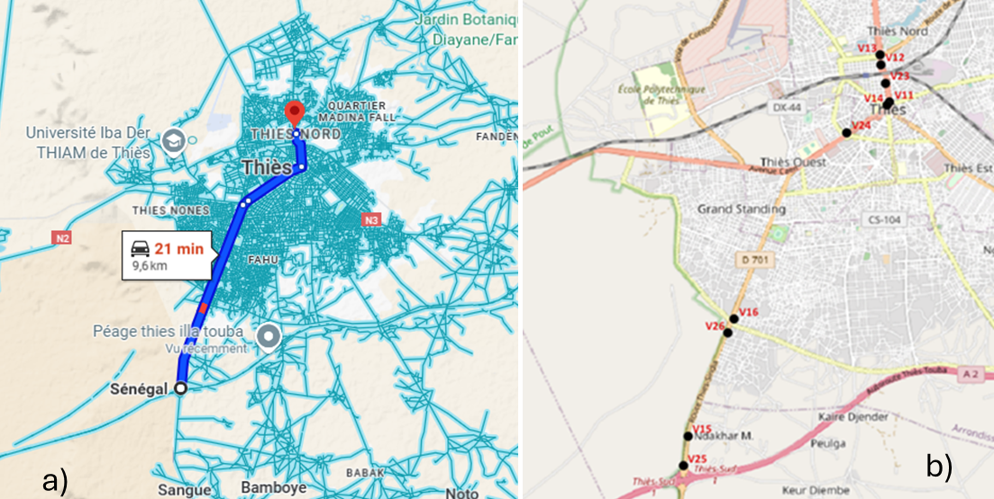

Fig. 1. Study area and measurement sites
a) The center of the city of Thiès, and b) the investigated road and measurement points

2.3 Probabilistic Health Risk Assessment

Human exposure to particulate matter can occur through several routes(Morakinyo et al., 2021). Depending on the routes used by particles to enter the body, we then distinguish inhalation exposure (particles transit through the respiratory tract), ingestion exposure (particles transits happen through the mouth and digestive tract), percutaneous exposure (particles get in contact with the body skin), and ocular exposure (here the deposition happens in the eyes). However, the main route for particles remains the inhalation. Looking into the exposure duration, two types of exposures can occur: short-term (hours to days) and long-term (or chronic exposure, months to years). In this study, we focused on chronic exposure of workers whose workplace or stalls are on near roads. They are primarily exposed to particles emitted by mobile sources such as vehicles and motorbikes. The potential inhaled dose (D, in µg) of particles due to their exposure can be evaluated using EQ. 1(Faria et al., 2020; Woo et al., 2020):
$D=C_{a}I_{r}t_{de}$ (1)
C_{a}(µg.m⁻³) is the particles mass concentration, $I_{r}$(m³.day⁻¹ or m³.hr⁻¹) is the inhalation rate, $t_{de}$ (hr) is the daily exposure duration. The inhalation rate for an adult is 21.4 m³/day or 0.89 m³/hr(Morakinyo et al., 2021). The daily exposure duration was estimated at 8 hours per day (10 am – 6 pm).

The risk quotient or hazard quotient (HQ (-)) is calculated for a specific particle size inhaled, if the average daily inhaled dose ($ADD$, µg/kg.day) and the reference dose ($D_{ref}$, µg/kg.day) are known. It is the ratio between both parameters as given in EQ. 2(Abidin et al., 2025; De Oliveira et al., 2012; Morakinyo et al., 2021; Phairuang et al., 2021). An HQ value above 1 proves that health risk exists, the exposed person could contract non-carcinogenic diseases and therefore this risk should be controlled or managed(Ihsan et al., 2023).

$HQ=\frac{ADD}{D_{ref}}$ (2)
$D_{ref}=C_{a,ref}.I_{r}/M$ (3)
$ADD=\frac{C_{a}.I_{r}.f_{a.}f_{r}.t_{de}.{f_{e}.t}_{e}}{M.t_{avg}}$ (4)

$C_{a,ref}$ (µg.m⁻³) is the reference particles mass concentration, $f_{r}$ is the factor of retention, $f_{a}$ is the factor of absorption, $f_{e}$ is the exposure frequency (days/year), $t_{e}$ is the exposure duration (years), M (kg) is the body mass weight, and $t_{avg}$ is the average timing. In this study, $f_{a}$ and $f_{r}$ were kept equal to 1, which is the worst-case scenario. The exposure frequency ($f_{e}$) is determined by subtracting public holidays (~20 days) and Sundays (52 days), and we end up with 293 days. The average timing for a non-carcinogenic risk is $t_{avg}=365 days*t_{e}$ and the exposure duration, for adults is 30 years(Morakinyo et al., 2021). The body weight (M) varies from one country to another and is 69.28 kg in Senegal(Duboz et al., 2017). The reference dose ($D_{ref}$) is the daily inhaled dose to a non-carcinogenic hazard that has no detrimental effect even if exposure occurs over the lifetime(Ihsan et al., 2023). It depends on the age of the exposed individual and the season(De Oliveira et al., 2012). In the context of Senegal as in other Sahelian countries, the rainy season is usually short or totally absent. In the Thiès region, the raining season lasts less than 2 months and covers August and September. At first approximation, this period was neglected. Reference concentrations of 5 and 15 µg.m⁻³ for PM_{2.5} and PM_{10,} respectively, were used(De Oliveira et al., 2012).These values correspond annual threshold particles mass concentrations as set by the WHO(World Health Organization, 2021).

The Life Cancer Risk (LCR) or probabilistic risk of developing cancer over a lifetime can be evaluated if the Adjusted Particles Concentration ($C_{a_adj}$) and the Inhalation Unit Risk (IUR) are known. It is given by EQ. 5(Thabethe et al., 2025). A LCR below 10⁻⁶ is considered negligible risk and an LCR above 10⁻⁴ signals a significant risk.
$LCR=C_{a_adj}.IUR$ (5)
$C_{a_adj}=\frac{C_{a}.f_{a.}f_{r}t_{de}.{f_{e}.t}_{e}}{t_{avgc}}$ (6)

The IUR for PM_{2.5} is 0.008 (µg.m⁻³)⁻¹,. No IUR was found in the literature for PM₁₀(Thabethe et al., 2025). The average timing becomes $t_{avgc}=365 \left(days\right).t_{life }(years).24(hours)$, in case of carcinogenic risk, where $t_{life}$ is the life expectancy set here at 65 years.

3. results AND DISCUSSION

3.1 Particles Mass Concentration
Recorded values of particles mass concentrations at different sites (v11-16, v23-26) were that of: PM_{0.5}, PM₁, PM_{2.5}, PM₅ and PM₁₀. Tables 1 and 2 show fine and coarse particles mass concentrations. PM_{0.5}, mean value varies between 1.51 and 5.68 µg.m⁻³, while min and max values were 0.86 and 39.99 µg.m⁻³, respectively. PM₁, mean value varies between 4.98 and 14.76 µg.m⁻³, while min and max were 3.42 and 98.46 µg.m⁻³, respectively. PM_{2.5}, mean value varies between 31.84 and 75.90 µg.m⁻³, and min/max are 16.94 and 188.38 µg.m⁻³, respectively. PM₅, mean concentration value varies between 151.65 and 249.34 µg.m⁻³, while min and max are 55.58 and 978.67 µg.m⁻³, respectively. PM₁₀, mean values vary between 234.94 and 697.73 µg.m⁻³, while min and max values are 71.25 and 3872.16 µg.m⁻³, respectively.

Table 1. Fine particles mass concentration at different sites (in µg.m⁻³)

 | PM_{0.5} |  |  |  | PM₁ |  |  |  | PM_{2.5}
Sites | Mean | SD | Min | Max | Mean | SD | Min | Max | Mean | SD | Min | Max
V11 | 4.65 | 3.64 | 1.12 | 25.52 | 11.35 | 5.15 | 5.83 | 37.36 | 54.28 | 10.23 | 40.74 | 127.90
V12 | 4.15 | 3.07 | 1.03 | 25.07 | 9.91 | 5.09 | 3.57 | 48.61 | 51.90 | 16.11 | 21.43 | 136.10
V13 | 5.68 | 4.95 | 1.43 | 38.73 | 13.55 | 6.46 | 7.32 | 54.75 | 64.15 | 9.66 | 46.91 | 118.46
V14 | 5.25 | 4.08 | 2.39 | 33.89 | 14.27 | 5.78 | 9.56 | 58.48 | 75.90 | 8.58 | 63.83 | 121.48
V15 | 1.97 | 1.42 | 1.37 | 22.57 | 8.39 | 2.69 | 5.61 | 49.05 | 58.98 | 12.88 | 34.28 | 141.70
V16 | 1.51 | 0.72 | 0.90 | 8.48 | 4.98 | 1.30 | 3.44 | 21.18 | 33.25 | 10.73 | 19.50 | 187.84
V23 | 2.79 | 1.67 | 1.28 | 20.32 | 9.09 | 2.29 | 6.67 | 34.70 | 46.75 | 5.16 | 40.43 | 84.76
V24 | 4.67 | 5.13 | 2.03 | 39.99 | 14.76 | 11.81 | 8.80 | 98.46 | 66.35 | 19.92 | 49.77 | 188.38
V25 | 2.93 | 1.90 | 1.52 | 19.12 | 9.44 | 2.49 | 4.36 | 33.48 | 50.39 | 8.31 | 21.15 | 84.37
V26 | 1.58 | 0.88 | 0.86 | 10.76 | 5.12 | 1.38 | 3.42 | 16.77 | 31.84 | 11.10 | 16.94 | 108

Table 2. Coarse particles mass concentration at different sites (in µg.m⁻³)

 | PM₅ |  |  |  | PM₁₀
Sites | Mean | SD | Min | Max | Mean | SD | Min | Max
V11 | 164.94 | 30.17 | 119.42 | 401.94 | 315.09 | 83.97 | 195.57 | 1117.63
V12 | 249.34 | 106.38 | 71.24 | 858.46 | 697.73 | 343.10 | 150.82 | 2726.50
V13 | 211.54 | 37.41 | 141.58 | 438.38 | 465.29 | 114.86 | 252.28 | 1139.11
V14 | 224.26 | 53.94 | 157.21 | 461.90 | 438.81 | 160.30 | 240.48 | 1157.52
V15 | 205.13 | 71.58 | 103.21 | 926.14 | 420.46 | 247.09 | 128.74 | 3018.81
V16 | 165.07 | 88.57 | 55.71 | 996.86 | 470.05 | 334.35 | 122.99 | 3338.03
V23 | 165.92 | 33.41 | 121.59 | 458.57 | 334.97 | 104.38 | 195.51 | 1241.20
V24 | 220.28 | 56.91 | 149.30 | 580.18 | 430.93 | 161.48 | 242.81 | 2021.17
V25 | 151.65 | 35.22 | 63.83 | 358.74 | 234.94 | 98.53 | 71.25 | 828.87
V26 | 167.01 | 105.82 | 55.58 | 978.67 | 466.00 | 412.68 | 106.87 | 3872.16

Distribution of particles mass concentrations at different sites can be seen in Figure 2. It is recalled here that only PM_{2.5} and PM₁₀ are integrated in the criteria pollutants list. Higher mass concentration is found for PM₁₀ while the lowest is for PM_{0.5.} Concentrations variations differ from one site to another for all particles sizes. For criteria pollutants, the set threshold values as contained in the WHO guidelines are 15 µg.m⁻³ for PM_{2.5} and 45 µg.m⁻³ for PM₁₀. As can be seen on Figure 2c and Figure 2e, at all sites, those limits are exceeded for almost all sites. Considering the average values in Tables 1 and 2, PM_{2.5} and PM₁₀ concentrations exceed the limits by 2 to 5 folds, and by 5 up to 16 folds, respectively. Although particles of submicron sizes (less than 1 µm) have devastating effects on human body, there is still no guideline for this category. In this study, we couldn’t investigate the ultrafine particles, i.e. particle of less than 0.1 µm due the limited capability of the instrument which could only count PM_{0.5.} Sites v11, v12, v13, v14 and v24 have high quasi-ultrafine particles concentrations, in comparison to v15, v16 and v26 (Figure 2a). V16 is the site with lowest concentration. If we consider a threshold value of 5 µg/m³, then v16 will be considered as the less polluted site, where most probably the traffic is less heavy and thus vehicles emissions are low. Differences observed with PM_{0.5} are valid for PM₁, sites with highest and lowest concentrations being the same (Figure 2b). Applying an arbitrary threshold value of 10 µg/m³, PM₁ mass concentrations at v16 and v26 appear to be below. Therefore, it can be considered that the contribution of PM_{0.5} to PM₁ is important and mass concentrations of both particles’ sizes will be highly correlated. As for PM_{2.5}, v24 presents highest value (188.38 µg.m⁻³) and highest mean value is found at v14 (75.90 µg.m⁻³). All displayed values are above the WHO limit. Standard deviation varies between 5 and 20 µg.m⁻³, meaning moderate variability in recorded values.

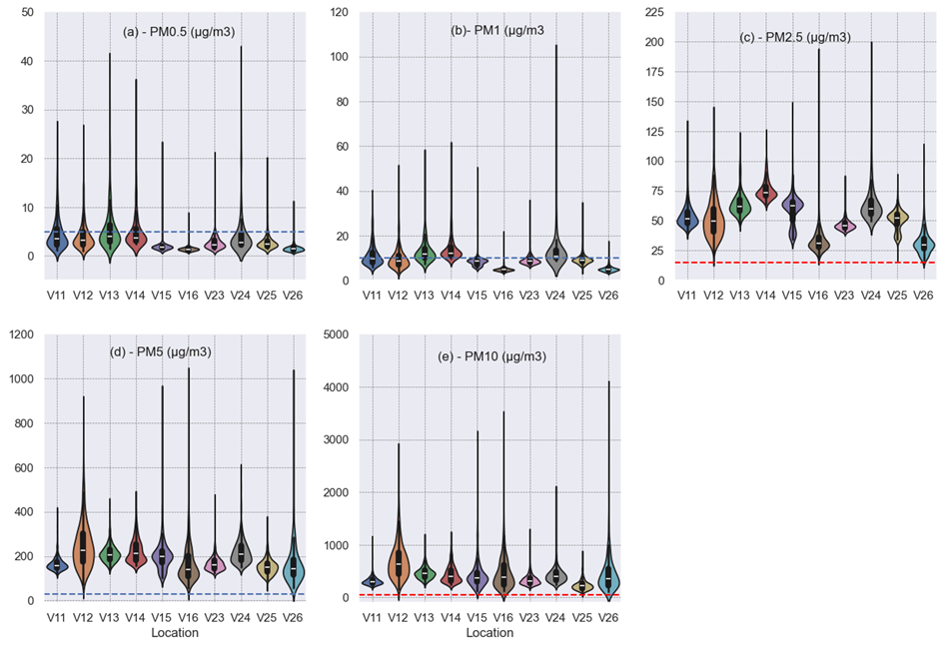
Fig. 2. Particles mass concentrations distributions at different sites
a) PM_{0.5} Mass concentration, b) PM₁ Mass concentration, c) PM_{2.5} Mass concentration, d) PM₅ Mass concentration, e) PM₁₀ Mass concentration

Figures 2d and 2e present distributions of coarse particles mass concentrations on which PM₅ and PM₁₀ exhibit similar variations. Sites which display highest PM₅ concentrations are v15, v16 and v26, and those with lowest values are v16, v25 and v26. Sites with highest PM₁₀ concentrations are v15, v16 and v26, and those with lowest values are v15, v16, v25 and v26. It is therefore anticipated that values for PM₅ and PM₁₀, will be strongly correlated. For PM₅, lowest mean values are found at sites v25 (151.65 µg.m⁻³) and v11 (164.94 µg.m⁻³) and highest mean values at sites v12 (249.34 µg.m⁻³) and v14 (224.26 µg.m⁻³). Applying an arbitrary TV of 30 µg.m⁻³, concentrations values at all sites are well above by several folds. V24 has the highest recorded value (188.38 µg.m⁻³) and highest mean value is found at site v14 (75.90 µg.m⁻³). For PM₁₀, lowest mean mass concentrations values are found at sites v25 (234.94 µg.m⁻³) and v11 (315.09 µg.m⁻³) and highest mean values at sites v12 (697.73 µg.m⁻³) and v26 (466 µg.m⁻³). Comparing the recorded values to the WHO limit of 45 µg.m⁻³, all sites exceeded by several folds, from 2 up to 86 folds.

3.2 Particles Size Distribution
Particles size fractions are shown in Figure 3. Size fractions were put in different groups: $d≤0.5 µm$ (PM_{0.5}), $0.5 µm<d≤1 µm$ (PM_{0.5-1}), $1 µm<d≤2.5 µm$ (PM_{1-2.5}), $2.5 µm<d≤5 µm$ (PM_{2.5-5}), and $5 µm<d≤10 µm$ (PM₅₋₁₀). Figure 3 shows the mean mass concentration contributions at different sites. Considering PM₁₀, site v12 appears to be the most polluted (698 µg.m⁻³), while the least polluted is site v25 (235 µg.m⁻³) and the average for all sites is 427.43 µg.m⁻³. Figure 3b and 3c show that coarse particles dominate by far. PM₅₋₁₀ represents around 53% of total mass on average, but following sites are below that percentage: v25 (35.45%), v14 (49%) and v24 (49%) while those with higher mass fractions are v12 (64.26%), v16 (64.88%) and v26 (64.16%). The lowest mass fraction is found at site v25 (less than 35.45%). PM_{2.5-5} represents around 33% of total mass and sites with highest fractions are v25 (43%), v23 (36%) and v24 (36%), while lowest mass fractions are found at site v16 (28%) and v12 (28.30%). Fine particles represent on average 14% of total mass, distributed as follows: PM_{1-2.5}(11%) PM_{0.5-1}(2%) and PM_{0.5}(1%). Highest PM_{1-2.5} fractions are found at site v25 (17.43%) and lowest at v26 (5.73%). Highest PM_{0.5-1} fractions are found at site v25 (2.77%) and lowest at v16 (0.74%). Highest PM_{0.5} fractions are found at site v11 (1.48%) and lowest at v16 (0.38%). Fine particles fraction is between 7-21%, PM₁ fraction in the range 1-4% and PM_{0.5} fraction in between 0.30 – 1.50%.

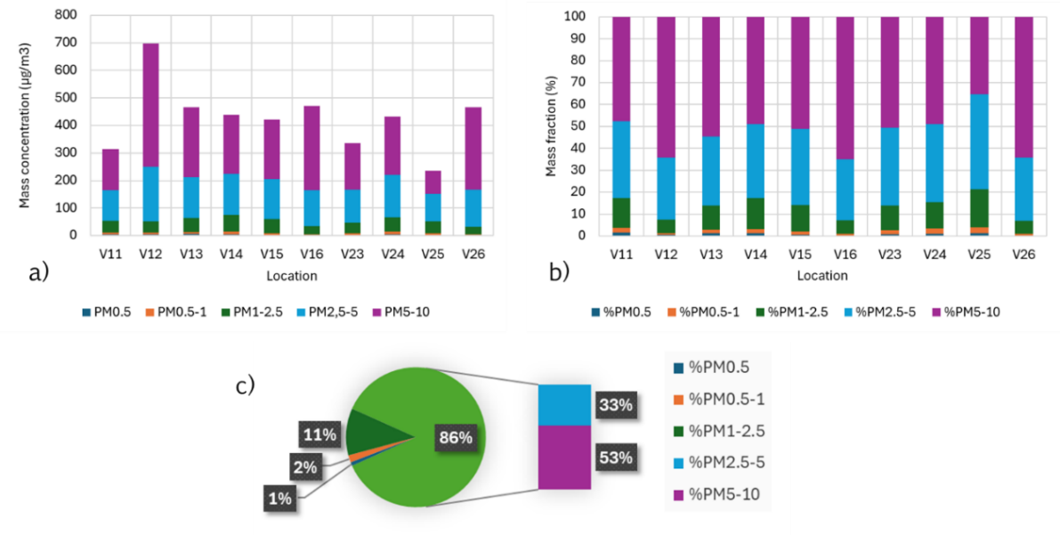

Fig. 3. Particles size distribution
a) Particles size mass contributions, b) Particles size mass fraction, c) Average mass fraction

Ultrafine particles with aerodynamic diameter below 100 nm, have the capability to move through the airways and reach the alveoli. Here, we consider PM_{0.5} (< 500 nm) to be an acceptable approach to UFPs, as they also have the capability to go deeper into the lungs(Bernasconi et al., 2022). PM_{0.5} fraction time series in coarse mode can be seen in Figure 4. In Figures 4a, 4b and 4c, the PM_{0.5} mass fraction fluctuates between 0.5 and 3% most of time without any clear trend. Steady variations are observed during the recording period, and peak fraction is below 8%. This increase in fraction could be due to the increase in traffic density. Sites v11, 13 and 14 are in areas with heavy traffic and densely populated with commercial buildings. It is the heart of the city. Figure 4d, 4e and 4f show low PM_{0.5} fractions except for v25, but similar trends can be observed. Sites v16 and 26 show PM_{0.5} fraction frequently below 1% while at site v25, fraction is higher. All three sites exhibit similar variations with peaks in the morning (~100 min), an increase after 300 min and maximum in the afternoon (~400 - 500 min). They also show small standard deviation (< 2 µg.m⁻³). It can be concluded that smaller and tiny particles (nm size), generated par internal combustion engines persist in the atmosphere in dense areas but are easily swept by wind in open spaces (no buildings).

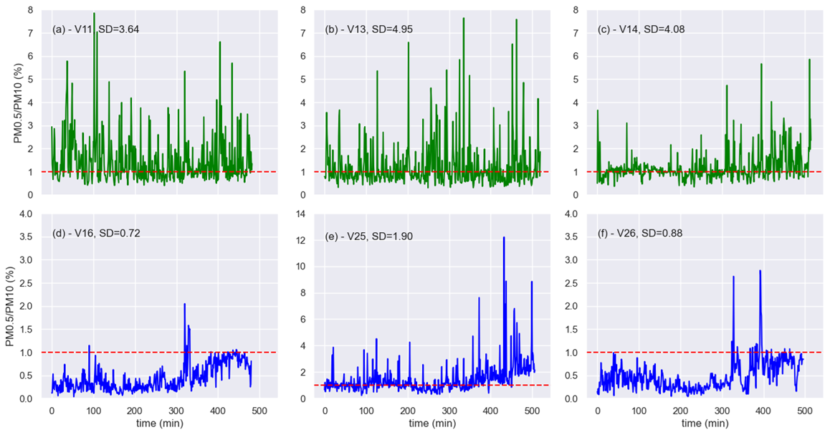

Fig. 4. Submicron particles fraction and timeseries
PM_{0.5}/PM₁₀ (%) at different locations

3.3 Particles Mass Concentration Correlation

A mass correlation between two particles sizes indicates how they both evolve with time at a specific site. Correlation matrixes are shown for all sites in Figure 5. In coarse mode, PM₅ and PM₁₀ mass concentrations are strongly correlated, (~0.95). Correlation coefficient between PM_{2.5} and PM₁₀ is in the range 0.46-0.90, for PM₁ and PM₁₀ in the range 0.24-0.51, and between PM_{0.5} and PM₁₀, it is between 0.23 and 0.51 and falls to zero at some sites (v15, v16, v25 and v26). At the later sites, correlation coefficients between PM_{0.5} and PM₁₀ on one side, and with PM₅ on the other side are very weak (<0.30). Very weak correlation would mean very small and/or random contribution. In fine mode, the correlation between PM_{2.5} and PM₁ is either fair or strong (0.55-0.95), and between and PM_{2.5} and PM_{0.5} varies from very weak to very strong (0.14-0.91); very weak correlation (0.14 – 0.26) at sites v15, v16, v25 and v26 and fair to strong correlation (0.56 – 0.91) at sites v11, 12, 13, 14, 23 and 24.

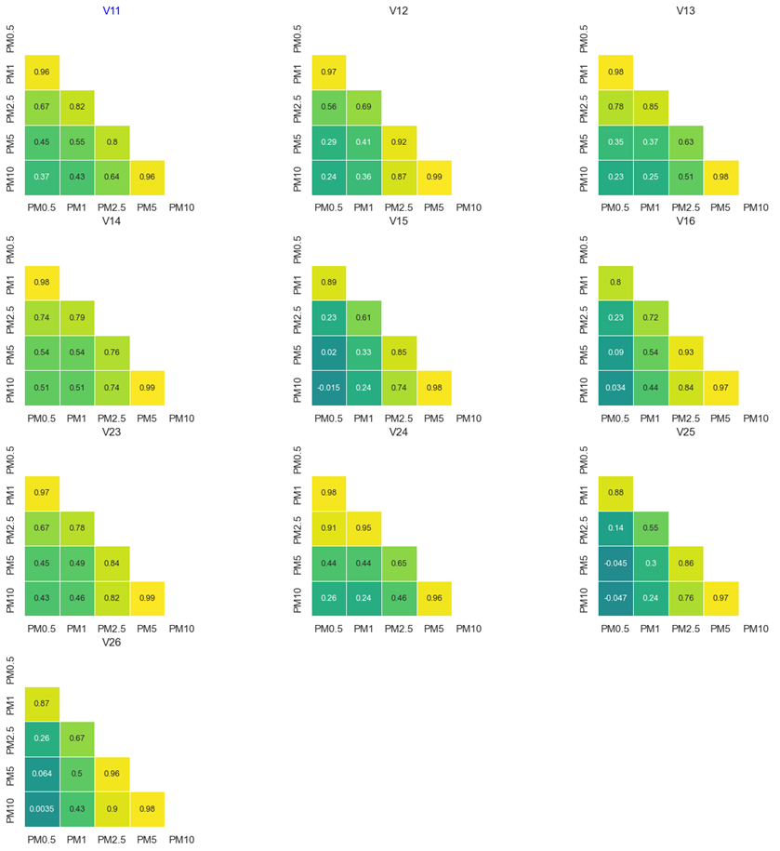

Fig. 5. Correlation map
Correlation matrices (r (PM_{x}, PM_{y})) at different measurement points (V11-v26)

3.4 Exposure and Potential Health Risk

Potential inhaled doses, average daily dose, health quotient and Life cancer risk could be derived from recorded particles concentrations and displayed in Table 3. The minimum potential inhaled dose of PM_{2.5}, recorded was 227 µg at location v26 while the maximum value recorded was 540 µg at location v14. The min potential inhaled dose of PM₁₀ is 1.7 mg at location v25 while the max is 5 mg at location v12. Average daily dose of PM_{2.5} varies in the range 2.6 – 6.3 µg/day.kg, while it varies between 19.4 – 57.6 µg/day.kg for PM10. HQ varies between 1.7 (v26) - 4 (v14) for PM_{2.5} and 4.2 (v25) – 12.4 (v12) for PM₁₀. Life cancer risk for PM_{2.5} varies between 3.1 x 10⁻² - 7.5 x10⁻² well above the acceptable level. Therefore, it can be concluded that workers located on near roads in the Thiès as well as those living in the vicinity of those busy roads are at risk and could potentially develop diseases related to particulate matter inhalation.

Table 3. Potential health impact of inhaled doses of fine and coarse particles

 | D (µg) |  | ADD (µg/kg.day) |  | HQ (-) |  | LCR (-)
Sites | PM_{2.5} | PM₁₀ | PM_{2.5} | PM₁₀ | PM_{2.5} | PM₁₀ | PM_{2.5}
V11 | 386.488 | 2243.457 | 4.478 | 25.995 | 2.900 | 5.610 | 0.054
V12 | 369.495 | 4967.812 | 4.281 | 57.561 | 2.772 | 12.423 | 0.051
V13 | 456.753 | 3312.850 | 5.292 | 38.386 | 3.427 | 8.285 | 0.063
V14 | 540.411 | 3124.311 | 6.262 | 36.201 | 4.054 | 7.813 | 0.075
V15 | 419.955 | 2993.704 | 4.866 | 34.688 | 3.151 | 7.486 | 0.058
V16 | 236.773 | 3346.733 | 2.743 | 38.778 | 1.776 | 8.369 | 0.033
V23 | 332.887 | 2384.969 | 3.857 | 27.634 | 2.497 | 5.964 | 0.046
V24 | 472.438 | 3068.222 | 5.474 | 35.551 | 3.544 | 7.673 | 0.066
V25 | 358.787 | 1672.759 | 4.157 | 19.382 | 2.692 | 4.183 | 0.050
V26 | 226.717 | 3317.922 | 2.627 | 38.444 | 1.701 | 8.297 | 0.031
Min | 226.717 | 1672.759 | 2.627 | 19.382 | 1.701 | 4.183 | 0.031
Max | 540.411 | 4967.812 | 6.262 | 57.561 | 4.054 | 12.423 | 0.075

4. discussion

Road Traffic is an important contributor to particulate matter emissions in urban areas. The combustion of fossil fuels releases particles of different sizes that could be harmful to those exposed to or located on nearby roads. Concentrations of criteria pollutants, PM_{2.5} and PM₁₀, exceeded by far the threshold values (15 and 45 µg.m⁻³, respectively). Average PM_{2.5} concentration exceeded by 2 up to 5 folds, and that of PM₁₀, from 5 up to 16 folds. It can be concluded that workers and those living on roadsides in Thiès are exposed to high particles concentrations. Table 4 gives pollutants mass concentration in African cities. All these studies lead to the same conclusion: high and underestimated level of pollution in low-and-middle income countries. Many studies are carried out using portable instruments, as is the case here. Mbog at al., Ngangmo et al. and Mezoue et al. in Douala (Cameroon) used an OC300 Gas and Dust Particle Laser Detector(Mbog et al., 2023; Mezoue et al., 2023; Ngangmo et al., 2023), Yirdaw et al. and Moges et al. used an Aeroqual Series 300/500 in Hawassa and Addis Ababa, Ethiopia(Yirdaw et al., 2024), while in Cotonou (Benin), Houngbéngnon et al. used a Quest 3M(Houngbégnon et al., 2019). Gueye et al.(Gueye et al., 2024) in Dakar (Senegal), used own designed low-cost instrument for high resolution measurement. Most of these studies on traffic-related pollution are based on short-term measurements, from hours up to a few weeks. Even though the time duration would be short, daily patterns and seasonal variations are observed. Daily patterns show two peaks, one in the morning and another one in the evening(Gueye et al., 2024; Mezoue et al., 2023). However, this pattern seems not to apply to busy roadways in highly urbanized areas with buildings that tend to trap particles and keep them in suspension for long periods of time. Seasonal variations show the influence of the climate and weather parameters on particles formation and concentration. In Cotonou, it was shown that not only the climate matters but also the measurement site. A Quest3M deployed at crossroads and along the way displayed average fine particles concentration of 463.25±66.21 μg.m⁻³ at crossroads and 264.75±50.97 μg.m⁻³ alongside the road during the raining period, while it was 232.75±97.29 μg.m⁻³ at crossroads and 123.31±63.79 μg.m⁻³ elsewhere(Houngbégnon et al., 2019). The itinerary considered in this study was a paved road. However, as shown in some studies, the pavement of the road is also an important factor, unpaved roads generating more pollution (esp. particles) than paved ones(Yirdaw et al., 2024). During the measurement, congestion was found most frequently at sites v11-14 and 23 in the north, and it is known as an aggravating factor for air pollution(Moges and Alemu, 2024).

Table 4. Pollutants concentrations in several African countries

Pollutants | Mass Concentration (μg.m⁻³) | City (country) | Ref.
PM_{0.5}, PM₁, PM_{2.5}, PM₅, PM₁₀ | PM_{2.5} (32-76)  PM₁₀ (235–698) | Thiès (Senegal) | -present
PM_{2.5,} PM₁₀ | PM_{2.5} (82–113)  PM₁₀ (155–200) | Douala (Cameroun) | (Ngangmo et al., 2024)
VOCs | 85.45 | Abidjan (C. d’Ivoire) | (Bahino et al., 2025)
TVOC | 543±158 (Lagos)  462±247 (Nairobi) | Lagos (Nigeria),  Nairobi (Kenya) | (Cordell et al., 2021)
PM_{2.5} | 100-500 | Cotonou (Benin) | (Houngbégnon et al., 2019)
PM₁, PM_{2.5},  PM_{5,} PM₁₀ | PM₁ (35.69-68.08)  _{PM2.5} (50.72-99.13)  PM₅ (54.11-11.22)  PM₁₀ (57.97-119.25) | Douala (Cameroon) | (Mbog et al., 2023)
PM_{2.5,} PM₁₀, NO₂ | PM_{2.5} (161.6±26.1)  PM₁₀ (178.7±20.3)  NO₂ (86.4±14.4) | Hawassa (Ethiopia) | (Yirdaw et al., 2024)
PM_{2.5}, PM₁₀ | > 80 | Dakar (Sénégal) | (Gueye et al., 2024)
CO, PM_{2.5,} PM₁₀, SO₂ | CO (1007-12,010)  PM_{2.5} (33-328)  PM₁₀ (52-383)  SO₂ (16-460) | Addis Ababa (Ethiopia) | (Moges and Alemu, 2024)

High pollutant concentration leads to high absorbed dose, and to high risk and can be understood from EQs 1-4. Although all those living on near roads will be at risk, those living near unpaved, busy and/or congested roads and at intersections will be the most affected. In this study, HQ values varied between 1.7 – 4.0 for PM_{2.5} and 4.2 – 12.4 for PM₁₀ proving that all those working or living near that itinerary were at risk and could develop non-carcinogenic diseases such as asthma, type 2 diabetes, hypertension and respiratory illnesses. Similar results were obtained by Bahino et al.(Bahino et al., 2025). There is a paucity of studies related to the health effects associated with traffic-induced pollution in Africa(Houngbégnon, Atindegla, et al., 2020; Sylla, Faye, Fall, and TAL-DIA, 2017). Nevertheless, existing studies are already showing how severely could Africans be affected in megacities. For instance, a cross-sectional study among bus drivers showed that 57.9% had chronic cough, 65.7% had recurrent cold and 38.8% had asthma and 30.3% had COPD(Sylla et al., 2018). Another study involving vendors located on near roads showed a 43% prevalence of allergic rhinitis(Sylla, Faye, Fall, Lo, et al., 2017). Respiratory symptoms such as cough, itchy nose, sore throat, and cold seem to be prevalent in those working on near roads(Houngbégnon, Lawin, et al., 2020).

The present study has reached conclusions like existing ones: the underestimated level of pollution and its consequences, esp. on health. Even though the analysis is based on short-term measurements, the results are consistent with what is witnessed and with similar studies. More studies with advanced techniques (aethalometer, gas chromatography, chemical speciation and source apportionment, etc.) will be necessary to in-depth analysis and better understand of the sources, the patterns and the spatial variations. It is here concluded urgent and synergized actions (continuous monitoring, energy transition in the transport sector, strict control of fuels, modernization of infrastructure.) to reduce emissions from transport sector in urban areas.

4. Conclusion

Particulate matter emitted from traffic in the urban center of Thiès, Senegal was investigated. A health risk assessment and exposure of those working and/or those living on near roads were performed. Particles mass concentrations were found very high in the area investigated and could lead to high risk of developing diseases such as asthma and other respiratory illnesses. It is highly recommended that measures being taken by local authorities and communities to protect those working and/or living on near roads. Awareness campaigns could be organized, and efficient strategies drawn to inform the population and protect them from adverse effects of atmospheric pollution. Further research work would be needed on chemical speciation, source apportionment and other pollutants such as volatile organic compounds (VOCs), carbon monoxide (CO), nitrous oxides (NOx) and ozone (O₃), to perform a complete health impact assessment and avoid cumulative effects on the population.

References

Abera, A., Friberg, J., Isaxon, C., Jerrett, M., Malmqvist, E., Sjöström, C., … Vargas, A. M. (2020). Air Quality in Africa: Public Health Implications. Annual Review of Public Health, 42, 193–210. https://doi.org/10.1146/annurev-publhealth-100119-113802
Abidin, A. U., Munawaroh, A. L., Rosinta, A., Sulistiyani, A. T., Ardianta, I., Iresha, F. M. (2025). Environmental health risks and impacts of PM2.5 exposure on human health in residential areas, Bantul, Yogyakarta, Indonesia. Toxicology Reports, 14, 1–10. https://doi.org/10.1016/j.toxrep.2025.101949
Adeoye Babatunde, A. (2019). Colonial Transport System in Africa : Motives , Challenges and Impact. African Journal of History and Archeology, 4(1), 14–26.
Alvarez, C. M., Hourcade, R., Lefebvre, B., Pilot, E. (2020). A scoping review on air quality monitoring, policy and health in west african cities. International Journal of Environmental Research and Public Health, 17(23), 1–28. https://doi.org/10.3390/ijerph17239151
Bahino, J., Dominutti, P., Keita, S., Doumbia, M., Adon, M., Colomb, A., … Yoboue, V. (2025). Diurnal Variation and Health Risk Assessment of Anthropogenic VOCs Concentrations in Abidjan, Côte d’Ivoire: a Comparative Study of Traffic and Domestic Fire Sites. Aerosol and Air Quality Research, 25(8), 1–16. https://doi.org/10.1007/s44408-025-00049-3
Bernasconi, S., Angelucci, A., Aliverti, A. (2022). A Scoping Review on Wearable Devices for Environmental Monitoring and Their Application for Health and Wellness. Sensors, 22(16), 1–20. https://doi.org/10.3390/s22165994
Cordell, R. L., Panchal, R., Bernard, E., Gatari, M., Waiguru, E., Ng’ang’a, M., … Vande Hey, J. D. (2021). Volatile organic compound composition of urban air in nairobi, kenya and lagos, nigeria. Atmosphere, 12(10), 1–26. https://doi.org/10.3390/atmos12101329
De Oliveira, B. F. A., Ignotti, E., Artaxo, P., Do Nascimento Saldiva, P. H., Junger, W. L., Hacon, S. (2012). Risk assessment of PM2.5 to child residents in Brazilian Amazon region with biofuel production. Environmental Health: A Global Access Science Source, 11(1), 1–11. https://doi.org/10.1186/1476-069X-11-64
Diouf, A., Cisse, M., Malou, J. R., Senghor, E. H. O. (2025). Situation économique et sociale de Thiès. Dakar. Retrieved from www.ansd.sn
Duboz, P., Cohen, E., Macia, E., Cohen, E., Gueye, L., Boetsch, G. (2017). Prevalence of obesity and body size perceptions in urban and rural Senegal: New insight on the epidemiological transition in West Africa. Cardiovascular Journal of Africa, 28(5), 324–330. https://doi.org/10.5830/CVJA-2017-034
Fisher, S., Bellinger, D. C., Cropper, M. L., Kumar, P., Binagwaho, A., Koudenoukpo, J. B., … Landrigan, P. J. (2021). Air pollution and development in Africa: impacts on health, the economy, and human capital. The Lancet Planetary Health, 5(10), 681–688. https://doi.org/10.1016/S2542-5196(21)00201-1
Gueye, A., Drame, M. S., Niang, S. A. A. (2024). A low-cost IoT-based real-time pollution monitoring system using ESP8266 NodeMCU. Measurement and Control, 58(10), 1–9. https://doi.org/10.1177/00202940241306690
Health Effects Institute. (2024). State of Global Air 2024, Special Report. Boston.
Houngbégnon, P., Atindegla, E., Lawin, H., Agueh, V. (2020). Estimating Exposure to Traffic-Related Air Pollution and Its Consequences on Respiratory Health in Population Working or Living along the Trunk Road: A Systematic Review. Open Journal of Air Pollution, 9(4), 61–76. https://doi.org/10.4236/ojap.2020.94005
Houngbégnon, P., Ayivi-Vinz, G., Lawin, H., Houessionon, K., Tanimomon, F., Kêdoté, M., … Agueh, V. (2019). Exposure to PM2.5 Related to Road Traffic: Comparison between Crossroads and Outside of Crossroads at Cotonou, Benin. Open Journal of Air Pollution, 8(4), 108–117. https://doi.org/10.4236/ojap.2019.84006
Houngbégnon, P., Kêdoté, M., Atindégla, E., Tanimomon, F., Kpozéhouen, A., Sossa, J., … Fobil, J. (2022). Is There an Association between the Type of Activities and Respiratory Disorders among e-Waste Workers? Case of Two Major Cities in West Africa. Occupational Diseases and Environmental Medicine, 10(2), 78–90. https://doi.org/10.4236/odem.2022.102007
Houngbégnon, P., Lawin, H., Kêdoté, M., Amadou, A., Atindegla, E., Fayomi, B., … Agueh, V. (2020). Respiratory Symptoms Associated with Workplaces Located along a Road with High-Traffic at Cotonou, Benin. Open Journal of Respiratory Diseases, 10(2), 32–42. https://doi.org/10.4236/ojrd.2020.102004
Ihsan, I. M., Oktivia, R., Anjani, R., Zahroh, N. F. (2023). Health risk assessment of PM2.5and PM10in KST BJ Habibie, South Tangerang, Indonesia. In IOP Conference Series: Earth and Environmental Science (Vol. 1201, pp. 1–10). Institute of Physics. https://doi.org/10.1088/1755-1315/1201/1/012033
Inchaouh, M., Tahiri, M. (2017). Air pollution due to road transportation in Morocco : evolution and impacts. Journal of Multdisciplinary Engineering Science and Technology (JMEST), 4(6), 7547–7552.
Inchaouh, M., Tchanche, B. (2024). Traffic-Related Air Pollution in Africa: Emissions, Sources and Health Impacts. In International Seminar - Air Quality and IoT-based Air Sensors, 7-8 November. online.
Katoto, P. D. M. C., Byamungu, L., Brand, A. S., Mokaya, J., Strijdom, H., Goswami, N., … Nemery, B. (2019). Ambient air pollution and health in Sub-Saharan Africa: Current evidence, perspectives and a call to action. Environmental Research, 173(February), 174–188. https://doi.org/10.1016/j.envres.2019.03.029
Lane-Visser, T., Vanderschuren, M., Greenwood, C., Aboo, S. (2025). Powering the African transport system – moving ahead. Transportation Research Procedia, 89, 364–382. https://doi.org/10.1016/j.trpro.2025.05.068
Lawin, H., Fanou, L. A., Hinson, A. V., Stolbrink, M., Houngbegnon, P., Kedote, N. M., … Mortimer, K. (2018). Health risks associated with occupational exposure to ambient air pollution in commercial drivers: A systematic review. International Journal of Environmental Research and Public Health, 15(9). https://doi.org/10.3390/ijerph15092039
Lokonon, B. O. K., Satoguina, H. (2023, May 31). Urbanization and transport energy consumption in African countries. https://doi.org/10.21203/rs.3.rs-2794033/v1
Mbog, S. M., Adiang Mezoue, C., Cédric Ngangmo, Y., Bitondo, D., Martin Mouangue, R. (2023). Monitoring and Control of Particulate Matter in Urban Area in Douala-Cameroon Town. Advances in Meteorology, 1–6. https://doi.org/10.1155/2023/9967687
Mezoue, C. A., Ngangmo, Y. C., Choudhary, A., Monkam, D. (2023). Measurement of fine particle concentrations and estimation of air quality index (AQI) over northeast Douala, Cameroon. Environmental Monitoring and Assessment, 195(8), 1–19. https://doi.org/10.1007/s10661-023-11582-2
Moges, G. T., Alemu, G. T. (2024). Contribution of congested traffic flow condition to air pollution at intersections in Addis Ababa, Ethiopia. Heliyon, 10(17), 1–14. https://doi.org/10.1016/j.heliyon.2024.e36477
Morakinyo, O. M., Mukhola, M. S., Mokgobu, M. I. (2021). Health risk analysis of elemental components of an industrially emitted respirable particulate matter in an urban area. International Journal of Environmental Research and Public Health, 18(7), 1–13. https://doi.org/10.3390/ijerph18073653
Ngangmo, Y. C., Adiang Mezoue, C., Meukaleuni, C., Wandjie, B. B. S., Monkam, D. (2024). Assessment of Traffic‐Related Ambient Air Particulate Matter (PM) Levels in Douala, Cameroon. Advances in Meteorology, 2024(1), 1–24. https://doi.org/10.1155/2024/1787640
Ngangmo, Y. C., Mezoue, C. A., Ellah, C. R. E., Mbog, S. M., Fantah, C. A. C., Dantse, Y. M. (2023). Monitoring and Control of Particle Matter Concentration’s Traffic-Related Air Pollution Using Low-Cost Mobile Sensors at Six Intersections in Yaoundé, Cameroon. International Journal of Environment and Climate Change, 13(10), 1376–1389. https://doi.org/10.9734/ijecc/2023/v13i102790
Phairuang, W., Suwattiga, P., Hongtieab, S., Inerb, M., Furuuchi, M., Hata, M. (2021). Characteristics, sources, and health risks of ambient nanoparticles (PM0.1) bound metal in Bangkok, Thailand. Atmospheric Environment: X, 12, 1–9. https://doi.org/10.1016/j.aeaoa.2021.100141
Schraufnagel, D. E. (2020, March 1). The health effects of ultrafine particles. Experimental and Molecular Medicine. Springer Nature. https://doi.org/10.1038/s12276-020-0403-3
Sylla, F. K., Faye, A., Diaw, M., Fall, M., Tal-Dia, A. (2018). Traffic Air Pollution and Respiratory Health: A Cross-Sectional Study among Bus Drivers in Dakar (Senegal). Open Journal of Epidemiology, 8(1), 1–13. https://doi.org/10.4236/ojepi.2018.81001
Sylla, F. K., Faye, A., Fall, M., Lo, M., Diokhané, A., Touré, N. O., TAL-DIA, A. (2017). Near-Road Exposure to Air Pollution and Allergic Rhinitis: A Cross-Sectional Study among Vendors in Dakar, Senegal. Occupational Diseases and Environmental Medicine, 5(4), 106–120. https://doi.org/10.4236/odem.2017.54010
Sylla, F. K., Faye, A., Fall, M., TAL-DIA, A. (2017). Air Pollution Related to Traffic and Chronic Respiratory Diseases (Asthma and COPD) in Africa. Health, 9(10), 1378–1389. https://doi.org/10.4236/health.2017.910101
Tchanche, B. (2017). Energy consumption analysis of the transportation sector of Senegal. AIMS Energy, 5(6), 912–929. https://doi.org/10.3934/energy.2017.6.912
Thabethe, N. D. L., Makonese, T., Masekameni, D., Brouwer, D. (2025). Probabilistic human health risk assessment of PM2.5 exposure in communities affected by local sources and gold mine tailings. Frontiers in Public Health, 13. https://doi.org/10.3389/fpubh.2025.1515009
Woo, J., Rudasingwa, G., Kim, S. (2020). Assessment of daily personal PM2.5 exposure level according to four major activities among children. Applied Sciences (Switzerland), 10(1). https://doi.org/10.3390/app10010159
World Health Organization. (2021). WHO global air quality guidelines. Particulate matter (PM2.5 and PM10), ozone, nitrogen dioxide, sulfur dioxide and carbon monoxide. Geneva.
Yirdaw, A. A., Ejeso, A., Mokie Belayneh, S., Yohannes, L., Bezie, A. E., Beyene, E. M. (2024). Concentration of traffic air pollutants and influencing metrological factors in Hawassa City roadways, Ethiopia. Frontiers in Public Health, 12, 1–10. https://doi.org/10.3389/fpubh.2024.1510194

