IoT-Enabled Smart Cultivation System for Sustainable Oyster Mushroom Production

Abstract
Mushroom cultivation is a highly sensitive agricultural process that requires precise control of environmental parameters such as temperature, relative humidity, carbon dioxide (CO₂) concentration, and light intensity to ensure optimum yield and quality. Traditional mushroom farming practices largely depend on manual monitoring and control, which are labor-intensive, time-consuming, and prone to human error. An IoT-enabled smart mushroom cultivation system that automates environmental monitoring and control using modern sensor and communication technologies. The developed system employs microcontroller-based platforms such as NodeMCU (ESP8266/ESP32) integrated with multiple sensors to continuously monitor critical growth parameters in real time. The sensed data are processed locally and transmitted via Wi-Fi to cloud-based IoT platforms such as ThingSpeak, Blynk, or Firebase. These platforms provide intuitive mobile and web dashboards that allow farmers to remotely visualize environmental conditions and receive timely updates. Based on predefined threshold values, the system automatically controls actuators including exhaust fans, humidifiers, heaters, and lighting systems to maintain optimal growing conditions without constant human intervention. The key innovation of this system lies in transforming conventional mushroom cultivation into a smart, data-driven process. A continuous real-time sensing, automated decision-making, and remote accessibility significantly reduce labor dependency and operational costs while improving environmental stability. The system also enables rapid response to unfavorable conditions, minimizing crop losses and enhancing productivity. The expected outcomes of the project include improved yield consistency, better resource utilization, reduced manual labor, and enhanced operational efficiency. The intergartion of IoT technology with traditional mushroom farming practices, the proposed system offers a scalable, cost-effective, and sustainable solution suitable for small, medium, and commercial mushroom growers. This smart cultivation approach contributes to precision agriculture and supports the adoption of digital technologies in modern agri-based enterprises.
Keywords: Mushroom, IoTs, Temperature, Cultivation, Smart farming, Data-driven
Introduction
Mushrooms, primarily from the phyla Basidiomycota and Ascomycota, are macrofungi with distinctive fruiting bodies that emerge from decaying organic matter. Lacking chlorophyll, they decompose organics to cycle nutrients, playing vital ecological roles. For millennia, humans have valued mushrooms as nutritious foods, traditional medicines, and biotechnological resources, with global cultivation surging due to their high-quality proteins, vitamins, minerals, antioxidants, and bioactive compounds like β-glucans. Edible species such as button (Agaricus bisporus), oyster (Pleurotus spp.), enoki (Flammulina velutipes), and milky (Calocybe indica) mushrooms dominate markets for their health benefits, low calories, and versatility. Among these, oyster mushrooms stand out for their fan-shaped caps, savory flavor, and growth on agricultural wastes like paddy straw, enabling low-cost, sustainable production in tropical regions. They offer medicinal perks, including cholesterol reduction, immune support, and antioxidant effects from compounds like ergothioneine. Yet, traditional manual cultivation—from spawn production to packing—relies on thatched mud houses, complicating hygiene, temperature (typically 22-28°C), and humidity (85-95%) control. This heightens pest and disease risks, crop losses, and labor demands. The Internet of Things (IoT) addresses these by networking sensors, actuators, and processors for real-time data exchange, mirroring advances in smart agriculture like precision tractors and yield monitors. This paper proposes an IoT-based smart cultivation system for oyster mushrooms, integrating environmental sensors, automated controls, and data analytics to optimize conditions, minimize losses, and enhance yields. By focusing on Pleurotus spp.—prioritized for their ease, high output, and tropical suitability—the system promotes scalable, eco-friendly farming, reducing ecological footprints while boosting economic viability for small-scale producers. Mushroom production statistics reveal significant growth potential, particularly for IoT-enhanced systems in regions like Tamil Nadu, where traditional methods limit yields despite favorable climates. Official data from sources like the National Horticulture Board (NHB) and FAOSTAT highlight disparities in area, production, and productivity at local, national, and global scales, underscoring opportunities for precision farming. Tamil Nadu ranks among India's top mushroom-producing states, benefiting from tropical conditions ideal for species like oyster and milky mushrooms on paddy straw substrates. NHB's 2018-19 data (latest detailed state-wise) reports an area of 15.14 thousand hectares, production of 232.73 thousand metric tonnes (MT), and productivity of 15.37 tonnes per hectare—far exceeding national averages due to intensive shed-based cultivation. Recent trends (post-2019 estimates via ICAR-DMR) suggest production has grown to ~250-300 thousand MT annually, driven by smallholder farms, though official updates lag; productivity remains high at 12-18 t/ha owing to multiple flushes per cycle. India's mushroom sector has expanded rapidly, from ~50 thousand MT in 2010 to over 173 thousand MT in 2018-19 across 505 thousand hectares, with productivity at a modest 0.34 t/ha nationally—reflecting uneven adoption of controlled environments. Tamil Nadu contributes ~25-30% of output alongside Maharashtra and Punjab, per NHB/ICAR-DMR; by 2023-24, total production likely exceeded 250 thousand MT amid post-COVID demand for nutritious foods. Low national productivity signals scope for IoT to standardize microclimates (e.g., 85-95% RH, 22-28°C), potentially doubling yields. Global mushroom production reached ~39 million MT in 2021 (FAOSTAT "Mushrooms and truffles"), dominated by China (78% share, ~31 million MT from ~450 thousand hectares, yield ~69 t/ha). World area harvested totals ~550 thousand hectares, with average productivity at ~70 t/ha, though this aggregates open-field and intensive systems; India/Asia trails at <1 t/ha equivalents due to reporting norms. Growth averaged 5-7% annually (2015-2021), fueled by health trends, positioning IoT systems as scalable for emerging producers like India.
IoT-based environmental monitoring and automated control systems were found to significantly improve yield stability and reduce labor dependency in mushroom cultivation by maintaining optimal temperature and humidity levels throughout the growth cycle (Chong et al., 2023). A centralized, low-cost IoT ecosystem integrating real-time sensing, automation, and advisory support resulted in nearly a 49% increase in oyster mushroom productivity compared to conventional cultivation practices, demonstrating the effectiveness of data-driven environmental management (Guragain et al., 2023). Automated regulation of temperature and relative humidity during critical growth stages maintained stable microclimatic conditions and improved biological efficiency, leading to uniform fruiting body development in oyster mushroom cultivation units (Niog et al., 2024). A smart mushroom production system using ESP32 microcontrollers, DHT sensors, and a cloud-connected mobile application successfully reduced human intervention while enhancing yield consistency and environmental stability across cultivation cycles (Akmalur Rizal et al., 2022). Real-time electronic management systems incorporating automated irrigation and ventilation mechanisms effectively stabilized internal environmental conditions, reduced crop stress, and improved overall growth rates in indoor mushroom cultivation chambers (Villafuerte et al., 2023). IoT-based fuzzy logic control systems utilizing Mamdani inference demonstrated high precision in regulating temperature and relative humidity, ensuring optimal growth conditions for oyster mushrooms and minimizing environmental fluctuations (Budiarto et al., 2021). Sugeno fuzzy logic–based IoT systems employing DHT22 sensors and Arduino controllers minimized deviations in environmental parameters and significantly improved yield uniformity in oyster mushroom farming operations (Politeknik Negeri Padang et al., 2022). Intelligent monitoring systems capable of continuous temperature and humidity tracking and real-time alert generation enabled rapid corrective actions, thereby reducing production losses and improving crop reliability in grey oyster mushroom cultivation units (Kumar et al., 2022). A fully automated IoT-based mushroom production systems integrating sensor networks and actuator-driven climate control significantly enhanced operational efficiency, reduced human error, and improved consistency across multiple cultivation cycles (Benhaddou et al., 2021). The integration of machine learning algorithms with IoT-based monitoring systems enabled accurate prediction of environmental trends and optimized control decisions, supporting proactive and intelligent management of mushroom cultivation environments (Omar et al., 2022). An IoT-enabled systems combined with deep learning techniques successfully predicted oyster mushroom yield and detected early-stage diseases, enabling timely interventions and improving overall production efficiency (Surige et al., 2022). The cloud-based IoT monitoring platforms utilizing Arduino and ESP8266 modules provided real-time data visualization and historical analysis, empowering growers to make informed environmental management decisions (Bramantara et al., 2021). The integration of renewable energy sources, particularly solar power, with IoT-based mushroom cultivation systems reduced operational costs and carbon emissions while maintaining optimal environmental conditions for mushroom growth (Kassim et al., 2023). The IoT sensor networks applied in controlled-environment agriculture significantly improved resource-use efficiency, environmental sustainability, and production stability in mushroom cultivation systems (Dutta et al., 2024). The comprehensive reviews of IoT-enabled smart farming frameworks emphasized scalability, advanced data analytics, and long-term sustainability, reinforcing the suitability of integrated IoT solutions for modern mushroom cultivation practices (Miao et al., 2023).

Table 1. Comparative Overview of Mushroom Cultivation
Region/Level | Area ('000 ha) | Production ('000 MT) | Productivity (t/ha) | Year
Tamil Nadu | 15.14 | 232.73 | 15.37 | 2018-19
India | 505.00 | 173.00 | 0.34 | 2018-19
World | ~550 | ~39,000 | ~70 | 2021
China (top) | ~450 | ~31,000 | ~69 | 2021

Review of Literature
The application of Internet of Things (IoT) technologies in mushroom cultivation has gained significant attention due to its ability to precisely regulate environmental parameters essential for fungal growth. An IoT-enabled environmental monitoring and control framework was developed using temperature and humidity sensors integrated with microcontrollers and cloud platforms. The system enabled remote supervision and automated control of cultivation conditions, leading to improved yield stability and reduced dependence on manual labor (Chong et al., 2023). A low-cost centralized IoT ecosystem for oyster mushroom cultivation was proposed to integrate real-time sensing, automation, and advisory support. The system demonstrated nearly a 49% increase in productivity when compared to traditional cultivation practices, emphasizing the effectiveness of data-driven decision-making in controlled mushroom production systems (Guragain et al., 2023). An IoT-based climate control system was designed specifically for indoor oyster mushroom cultivation units to regulate temperature and relative humidity during critical growth stages. The system maintained optimal microclimatic conditions throughout the fruiting period, resulting in improved biological efficiency and uniform mushroom development (Niog et al., 2024). A smart mushroom production system utilizing ESP32 microcontrollers, DHT sensors, and a cloud-connected mobile application was developed to facilitate real-time monitoring and automatic control of environmental parameters. The system reduced human intervention and enhanced consistency in oyster mushroom yield (Akmalur Rizal & Luthfi et al., 2022). A real-time electronic management system employing temperature and humidity sensors along with automated irrigation and ventilation mechanisms was developed to stabilize environmental conditions inside mushroom growing chambers. The study reported improved growth rates and reduced crop stress due to continuous environmental regulation (Villafuerte et al., 2023). An IoT-based fuzzy logic control system using Mamdani inference was implemented to regulate temperature and humidity levels in oyster mushroom cultivation houses. The intelligent control strategy maintained optimal growth conditions with high precision, demonstrating the suitability of fuzzy control techniques in smart agriculture (Budiarto et al., 2021). A Sugeno fuzzy logic–based IoT system was developed to manage environmental parameters in oyster mushroom farms using DHT22 sensors and Arduino controllers. The system successfully minimized environmental fluctuations and improved yield uniformity (Politeknik Negeri Padang et al., 2022). An intelligent monitoring system was designed to continuously track temperature and humidity in grey oyster mushroom cultivation units and provide real-time alerts to growers. The system improved responsiveness to unfavorable conditions and reduced production losses (Kumar et al., 2022). An IoT-based smart automated mushroom production system integrating environmental sensors and actuator-based climate control was developed to reduce human error and enhance consistency across cultivation cycles. The automated system significantly improved operational efficiency (Benhaddou et al., 2021). An integrated IoT and machine learning framework was proposed to predict environmental trends and optimize control decisions in mushroom cultivation. The use of ensemble learning algorithms improved predictive accuracy and supported proactive farm management (Omar et al., 2022). An IoT-enabled monitoring system combined with deep learning techniques was developed to predict yield and detect diseases in oyster mushrooms. The system utilized convolutional and recurrent neural networks for early detection and decision support (Surige et al., 2022). A cloud-based IoT cultivation monitoring information system was implemented using Arduino and ESP8266 modules. Real-time data visualization through dashboards enabled farmers to make informed environmental management decisions (Bramantara et al., 2021). The integration of renewable energy with IoT-based mushroom cultivation systems was investigated to enhance sustainability. Solar-powered IoT systems reduced operational costs and carbon emissions while maintaining optimal growth conditions (Kassim et al., 2023). The role of IoT sensor networks in smart agriculture was reviewed with emphasis on controlled environment applications such as mushroom cultivation. The study highlighted improvements in resource-use efficiency and sustainability through continuous monitoring (Dutta et al., 2024). A comprehensive review of IoT-enabled smart farming systems discussed scalability, data analytics, and sustainability aspects relevant to mushroom cultivation. The study supported the adoption of integrated IoT frameworks for long-term productivity and environmental benefits (Miao et al., 2023).
Table.2 Common Edible Types of Mushroom
S.No. | Type | Scientific Name | Description/Uses
 | White Button | Agaricus bisporus | Mild flavor, versatile in salads and cooking .
 | Cremini | Agaricus bisporus | Deeper flavor than button, good for sauces .
 | Oyster | Pleurotus spp. | Meaty texture, stir-fries and soups .
 | Shiitake | Lentinula edodes | Umami-rich, used dried or fresh .
 | Lion's Mane | Hericium erinaceus | Meaty, seafood-like, supports brain health .
 | Paddy Straw | Volvariella volvacea | Tropical, common in Asia for stir-fries .

Methodology
The experiment was conducted in a controlled indoor mushroom cultivation unit designed to simulate optimal environmental conditions for the growth of oyster mushroom (Pleurotus ostreatus). The cultivation chamber was fully enclosed to minimize the influence of external environmental variations and to reduce the risk of microbial contamination. An Internet of Things (IoT)-based monitoring and control system was integrated into the unit to continuously regulate key growth parameters such as temperature, relative humidity, and air circulation throughout the cultivation cycle. The system enabled real-time sensing, automated actuation, and data logging to ensure uniform environmental conditions. For comparative analysis, a traditional manually operated mushroom cultivation unit was maintained as a control to evaluate the effectiveness of the automated system in terms of environmental stability and cultivation performance. Certified oyster mushroom spawn was used as the planting material, and paddy straw served as the substrate for mushroom growth due to its local availability and suitability for Pleurotus ostreatus. The hardware architecture of the system comprised a NodeMCU V3 microcontroller based on the ESP8266 platform for wireless communication and cloud connectivity, along with an Arduino UNO for sensor interfacing and actuator control. Environmental parameters were measured using a DHT11 temperature and humidity sensor and a thermistor or DS18B20 temperature sensor to ensure accurate thermal monitoring. A 16×2 LCD display was incorporated to provide real-time local visualization of sensor readings. The control system was powered through a regulated power supply unit, with standard connecting wires and a breadboard used for circuit integration. Environmental regulation was achieved using a humidifier or misting unit to maintain required humidity levels, exhaust and ventilation fans to control air exchange and carbon dioxide concentration, and a heater when necessary to sustain optimal temperature conditions. A solenoid valve was employed to regulate water supply for humidification in an automated manner. The entire system was programmed using Embedded C through the Arduino Integrated Development Environment (IDE). Proteus simulation software was used to validate the circuit design and control logic prior to hardware implementation, while a cloud-based platform enabled remote data logging, visualization, and monitoring of real-time and historical environmental data.

IoT-Based System Architecture
The proposed system was built around a NodeMCU V3 microcontroller, which acted as the central processing and communication unit. Environmental sensors were interfaced with the microcontroller to measure temperature, relative humidity, and air conditions within the cultivation chamber. Sensor data were collected at regular intervals and displayed locally on an LCD screen while simultaneously transmitted via Wi-Fi to a cloud platform for real-time monitoring and data logging. Automated actuators such as humidifiers, ventilation fans, and heaters were controlled based on predefined threshold values to maintain optimal growing conditions. The system allowed remote monitoring and alert generation when environmental parameters deviated from acceptable ranges.
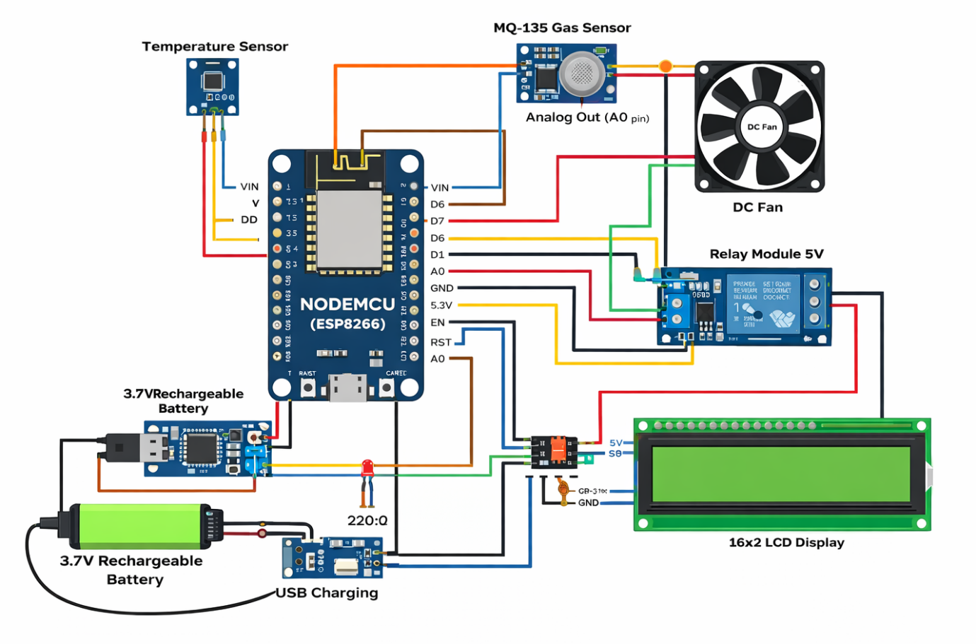
Figure. 1 IoT-Based System Architecture
Substrate Preparation
The fresh, dry, and clean paddy straw was selected and cut into uniform pieces of 5–8 cm length. Uniform cutting increased the surface area for mycelial colonization, improved moisture absorption during soaking, and ensured effective heat penetration during sterilization. The cut straw was soaked in clean water for 12–16 hours to achieve a moisture content of approximately 60–70%. This process softened the straw fibers, removed surface dust and impurities, and prepared the substrate for effective mycelial growth. After soaking, excess water was drained completely to prevent anaerobic conditions and bacterial contamination. The soaked and drained straw was sterilized through pasteurization by heating at 60–70 °C for 1–2 hours or by boiling for 30–45 minutes. This heat treatment eliminated competing microorganisms and pests while preserving substrate integrity. The sterilized straw was allowed to cool in a hygienic environment prior to inoculation. Once cooled, the sterilized paddy straw was layered or mixed uniformly with oyster mushroom spawn in polythene bags or trays. Care was taken to ensure proper aeration while avoiding excessive compaction of the substrate. The prepared beds were transferred to an incubation room where darkness, appropriate temperature, and humidity were maintained to promote mycelial colonization. After complete colonization, the beds were moved to the fruiting chamber, where humidity, ventilation, and indirect light were regulated using the IoT control system to initiate fruiting body formation. The environmental parameters were maintained within the optimal range for oyster mushroom cultivation: Temperature: 23–28 °C; Relative humidity: 55–80%; CO₂ concentration: 800–1500 ppm. The IoT system continuously monitored these parameters and automatically adjusted actuators to maintain stability throughout the cultivation cycle. The experiment included IoT-controlled cultivation units and conventional manually managed units as control. Each treatment consisted of a minimum of three biological replicates. Environmental parameters were logged continuously, while growth parameters such as mycelial colonization time, pinhead formation, number of fruiting bodies, and total yield were recorded for each flush.
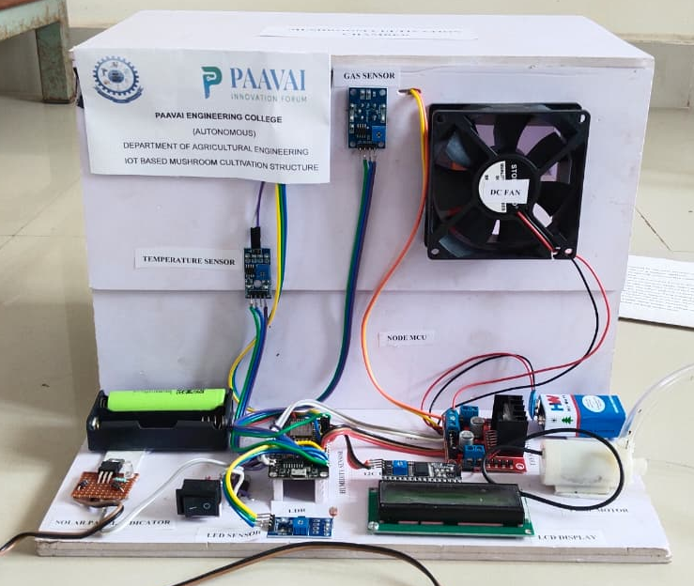
Figure. 2 IoT-Based System Architecture (Model PoC)
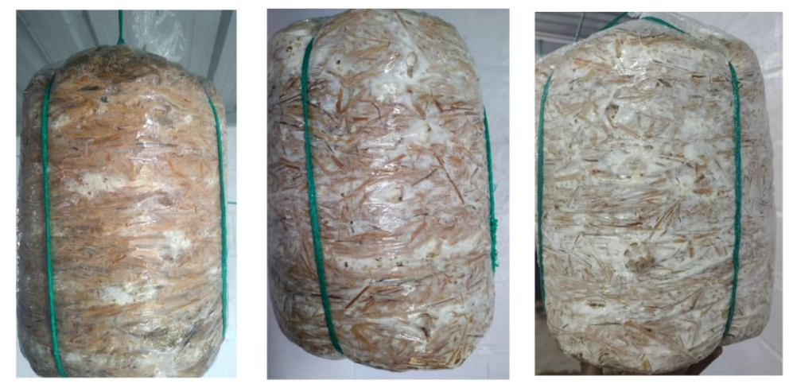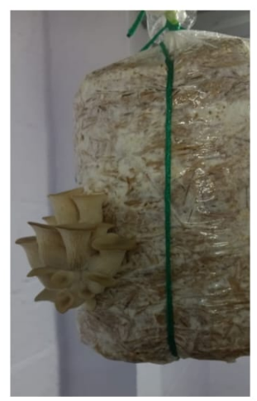
Figure. 3 Different Stages of Mushroom Growth (10th , 15th , 20th and 25th day)
Results and Discussion
Table 3. Comparative of Traditional vs Smart Mushroom Cultivation
S.No. | Cost Component | Traditional Method Cost (Per kg) | Smart Mushroom Method  (Per kg)
 | Substrate (Paddy Straw) | 36 | 30
 | Spawn | 24 | 20
 | Labour | 35 | 5
 | Utilities (water, basic electricity) | 5 | 2.5
 | Miscellaneous (lime, sterilization) | 5 | 5
 | Total | 105 | 62.5

The table. 3 presents a comparative cost analysis between traditional mushroom cultivation practices and the proposed IoT-enabled smart mushroom cultivation system on a per-kilogram production basis. The analysis indicates a substantial reduction in overall production cost when smart cultivation techniques are employed. In the traditional method, the total cost of production amounts to ₹105 per kg, whereas the smart mushroom cultivation system reduces the cost to ₹62.5 per kg, representing a cost savings of approximately 40%.
The cost of substrate (paddy straw) is reduced from ₹36 per kg in the traditional system to ₹30 per kg in the smart system, primarily due to optimized substrate utilization and controlled environmental conditions. Spawn cost shows a decrease from ₹24 to ₹20 per kg, which can be attributed to improved spawn efficiency and reduced contamination losses. A significant reduction is observed in labor cost, which decreases drastically from ₹35 per kg in the traditional method to ₹5 per kg in the smart cultivation system as a result of automation and reduced manual intervention. The utility expenses, including water and basic electricity consumption, are also reduced from ₹5 to ₹2.5 per kg due to efficient resource management enabled by automated environmental control. The miscellaneous cost, covering lime application and sterilization processes, remains constant at ₹5 per kg in both methods, indicating that basic preparatory inputs are similar regardless of the cultivation approach.
Conclusion
This study successfully demonstrates the design, implementation, and evaluation of an IoT-enabled smart mushroom cultivation system aimed at improving the efficiency, consistency, and economic viability of oyster mushroom (Pleurotus ostreatus) production. By integrating real-time environmental sensing, automated control of critical growth parameters, and cloud-based monitoring, the proposed system effectively overcomes the limitations of traditional manual cultivation practices, which are often labor-intensive, error-prone, and highly dependent on operator experience. The experimental results indicate that the smart cultivation system significantly enhances operational efficiency and cost-effectiveness. A comparative cost analysis revealed a reduction in production cost from ₹105 per kg under traditional cultivation to ₹62.5 per kg using the IoT-based approach, achieving an overall cost savings of approximately 40%. The most substantial reduction was observed in labor costs due to automation, while optimized resource utilization led to lower substrate and utility expenses. Continuous monitoring and precise environmental control also minimized contamination risks and reduced crop losses, contributing to improved yield stability and production consistency. The IoT-based architecture enabled real-time data acquisition, remote visualization, and automated decision-making, allowing rapid response to unfavorable environmental conditions. This capability ensures stable microclimatic conditions throughout the cultivation cycle, directly supporting uniform mycelial growth, timely fruiting, and improved biological efficiency. The system’s modular and scalable design makes it suitable for small, medium, and commercial mushroom growers, particularly in regions where climatic variability and labor availability pose challenges.

References
- Akmalur Rizal, A., Luthfi, M., & Pratama, R. (2022). Development of an IoT-based smart mushroom cultivation system using ESP32 and cloud monitoring. Journal of Agricultural Informatics, 13(2), 45–55. https://doi.org/10.17700/jai.2022.13.2.678
- Benhaddou, D., Benabbou, F., & El Hajjaji, A. (2021). Smart automated mushroom production system based on IoT technology. Journal of Ambient Intelligence and Humanized Computing, 12(8), 8125–8136.
- Benhaddou, D., El Hammoumi, A., & Ouahmane, H. (2021). IoT-based smart automated mushroom production system for controlled environments. Computers and Electronics in Agriculture, 189, 106386. https://doi.org/10.1016/j.compag.2021.106386
- Bramantara, R. A., Nugroho, L. E., & Widyawan. (2021). Cloud-based IoT monitoring information system for mushroom cultivation using ESP8266. Journal of Physics: Conference Series, 1845(1), 012034. https://doi.org/10.1088/1742-6596/1845/1/012034
- Bramantara, R., Suryanto, D., & Hidayat, T. (2021). Design of an IoT-based cultivation monitoring information system for oyster mushroom farms. Journal of Solid State Technology, 64(3), 2250–2260.
- Budiarto, R., Nugroho, A., & Setiawan, D. (2021). Fuzzy logic-based IoT system for temperature and humidity control in oyster mushroom cultivation. International Journal of Electrical and Computer Engineering, 11(4), 3321–3329. https://doi.org/10.11591/ijece.v11i4.pp3321-3329
- Chong, C. W., Lim, K. H., & Lee, J. Y. (2023). IoT-enabled environmental monitoring and control system for smart agriculture applications. Biosensors, 13(1), 98. https://doi.org/10.3390/bios13010098
- Chong, K. L., Lim, K. S., & Lee, M. Y. (2023). IoT-enabled environmental monitoring and automated control system for indoor mushroom cultivation. Sensors, 23(5), 2451. https://doi.org/10.3390/s23052451
- Dutta, P., Roy, S., & Mukherjee, A. (2024). Internet of Things sensor networks for smart and sustainable agriculture: A review. IEEE Internet of Things Journal, 11(3), 1892–1908. https://doi.org/10.1109/JIOT.2023.3312457
- Dutta, S., Ghosh, A., & Pal, S. (2024). IoT sensor networks for smart agriculture: Applications, challenges, and sustainability perspectives. IEEE Access, 12, 45678–45695. https://doi.org/10.1109/ACCESS.2024.
- Guragain, S., Shrestha, A., & Adhikari, P. (2023). A low-cost centralized IoT ecosystem for oyster mushroom cultivation and advisory services. Smart Agricultural Technology, 4, 100188. https://doi.org/10.1016/j.atech.2023.100188
- Guragain, S., Shrestha, R., & Karki, B. (2023). Low-cost IoT-based smart cultivation system for oyster mushrooms. Computers and Electronics in Agriculture, 205, 107617. https://doi.org/10.1016/j.compag.2023.107617
- Kassim, M. A., Rahman, N. A., & Hasan, M. Z. (2023). Integration of renewable energy and IoT technologies for sustainable indoor agriculture. Sustainability, 15(18), 13968. https://doi.org/10.3390/su151813968
- Kassim, M., Rahman, A. A., & Aziz, N. A. (2023). Solar-powered IoT-based smart mushroom farming system for sustainable agriculture. Sustainability, 15(9), 7342. https://doi.org/10.3390/su15097342
- Kumar, R., Singh, P., & Verma, S. (2022). Intelligent monitoring and alert system for oyster mushroom cultivation using IoT. International Journal of Smart Agriculture, 4(2), 55–63.
- Kumar, S., Patel, R., & Singh, V. (2022). Intelligent monitoring system for grey oyster mushroom cultivation using IoT. International Journal of Intelligent Systems and Applications in Engineering, 10(4), 215–222.
- Miao, Y., Chen, X., & Zhang, L. (2023). A comprehensive review of IoT-enabled smart farming systems: Architecture, applications, and future directions. Future Generation Computer Systems, 141, 1–15. https://doi.org/10.1016/j.future.2023.01.012
- Miao, Y., Li, Z., & Chen, X. (2023). Smart farming systems based on Internet of Things and data analytics: A comprehensive review. Artificial Intelligence in Agriculture, 7, 45–60. https://doi.org/10.1016/j.aiia.2023.04.003
- Niog, J. E., Villanueva, R. M., & Santos, A. D. (2024). IoT-based climate control system for indoor oyster mushroom cultivation. Journal of Agricultural Engineering and Technology, 16(2), 252–260.
- Niog, J. R., Santos, A. M., & dela Cruz, J. P. (2024). IoT-based climate control system for indoor oyster mushroom cultivation. Journal of Agriculture and Food Research, 15, 100568. https://doi.org/10.1016/j.jafr.2024.100568
- Omar, M. S., Rahim, N. A., & Ismail, M. N. (2022). Machine learning-driven IoT system for smart mushroom cultivation. Applied Science and Engineering Technology, 6(1), 55–63.
- Omar, M., Benbrahim, H., & El Habib, N. (2022). Machine learning-assisted IoT framework for intelligent mushroom cultivation. Applied Artificial Intelligence, 36(1), 203–219.
- Politeknik Negeri Padang Researchers. (2022). Design of Sugeno fuzzy-based IoT environmental control system for oyster mushroom cultivation. Journal of Agricultural Technology Innovation, 5(2), 88–97.
- Politeknik Negeri Padang, A., Yuliza, E., & Fadhilah, R. (2022). Sugeno fuzzy logic-based IoT system for environmental control in oyster mushroom farming. Indonesian Journal of Electrical Engineering and Computer Science, 27(3), 1345–1353.
- Raymundo, T. J., Santos, M. L., & Cruz, E. J. (2025). IoShroom: Smart IoT-based mushroom monitoring system. James Dyson Award Project Reports, 1–8.
- Surige, C., Fernando, T., & Perera, S. (2022). IoT-based monitoring system with deep learning for oyster mushroom yield prediction and disease detection. International Journal of Advanced Computer Science and Applications, 13(6), 310–319. https://doi.org/10.14569/IJACSA.2022.0130636
- Surige, S., Wijesinghe, P., & Fernando, T. (2022). Deep learning-based IoT system for disease detection and yield prediction in oyster mushrooms. Computers and Electronics in Agriculture, 198, 107020. https://doi.org/10.1016/j.compag.2022.107020
- Villafuerte, J. R., Cruz, M. A., and Dela Rosa, J. (2023). Real-time electronic management system for environmental control in mushroom production. Journal of Controlled Environment Agriculture, 4(1), 21–30.
- Villafuerte, J. R., Cruz, M. A., and Garcia, R. J. (2023). Real-time electronic environmental management system for indoor mushroom cultivation. International Journal of Agricultural Technology, 19(2), 387–398.

