Economic impact studies in AICRP on Agrometeorology-National Innovations on Climate Resilient Agriculture (NICRA-AICRPAM) project in domain districts of Chhattisgarh

Abstract :
Farmers need to be made aware of weather contingencies and harmful weather occurrences or extreme weather events viz., drought, flood, intense cyclones and heat waves which occur quite often. A significant restriction for successful farm planning operations is observed due to the lack of reliable and timely agrometeorological advice. The study was conducted to assess economic impact in AICRP on Agrometeorology National Initiative on Climate Resilient Agriculture (NICRA-AICRPAM) project in Mahasamund district and other domain districts of Chhattisgarh like Bemetara, Koriya and Kanker (Chhattisgarh state). The study was conducted under NICRA-AICRPAM project entitled “National Innovations on Climate Resilient Agriculture” sponsored by CRIDA (ICAR), Hyderabad. Project has been implemented in Department of Agrometeorology, Indira Gandhi Krishi Vishwavidyalaya, Raipur, (C.G.) since 2011. AICRPAM-NICRA has started the Micro-level Agromet Advisory Service (MAAS) cooperative centers across the country. Micro-level advisory based on weather forecast is the newer dimension of the AAS in the country. Studies on economic impact of these micro-level advisories are uncommon. Therefore, the present study was conducted using the field survey to assess the farmer’s perception and economic impact of micro-level AAS. NICRA Advisories are displayed on white boards in domain villages for having a look by farmers. These messages were also disseminated through Ministry of Agriculture and Farmers’ Welfare m-kisan portal. Results of economic impact revealed that the total benefit in 7 years by 4928 farmers who followed MAAS is Rs. 4.829 crore.
Key words: Agromet Advisory Service, weather forecast, economic impact.
Introduction :
Weather is one of the important factors which affect crop growth and production. Among different weather parameters, rainfall and temperature affect crop growth and production significantly (Fisher et al., 2017). The complete avoidance of all farm losses due to weather factors is not possible but it can be minimized to some extent by making adjustments through timely and accurate information of weather forecast. By recommending appropriate management techniques based on weather conditions, weather forecasts and weather-based agro advisories assist in boosting the farmers' economic benefit. Lack of timely and reliable agrometeorological information is a serious limitation for effective farm planning operations (Prasada Rao and Manikandan, 2008). Weather forecasts are essential for taking decisions regarding crop choice, crop variety, sowing/ harvesting dates and judicial management of agricultural operations such as seedbed preparations, ploughing, irrigation scheduling and application of fertilizers, pesticide, herbicide and harvesting. In addition, timely weather information enables the farmers to plan their farm operations in a way that not only minimizes the cost and crop losses but also help in maximizing yield gains. Each phase of agricultural activity from preparatory tillage to plant growth, harvest and storage is influenced by weather directly or indirectly (Bhatia, 1999).
India Meteorological Department (IMD) and Indian Council of Agriculture Research (ICAR) in collaboration with different stakeholders form the basis of AICRP on Agrometeorology -National Initiative on Climate Resilient Agriculture (NICRA-AICRPAM) project in Mahasamund district of Chhattisgarh and other NICRA domain districts in Chhattisgarh state. In this project, medium range weather forecast based crop and location specific agromet advisory is provided at district and block level on every Tuesday and Friday to assist farmers in taking better crop/livestock management decisions. Weather forecasts in all temporal ranges are desirable for effective planning and management of agricultural practices. An agriculturally relevant forecast is not only useful for efficient management of farm inputs but also leads to precise impact assessment (Gadgil, 1989). The development of response strategy can help farmers to realize the potential benefits of using weather-based agrometeorological information in minimizing the losses due to adverse weather conditions, thereby improving yield, quantity and quality of agricultural productions. In fact, short and medium-range weather forecasts and contingent plans play a significant role in making short term adjustments in daily agricultural operations as well as operational management.
Agromet Advisory Service (AAS) is a vital tool which provides valuable information for all agriculture operations from land preparation to harvesting based on weather forecast. The main aim of agromet advisory is to minimize the impact of adverse weather conditions and to make use of crop-weather relationship to boost agricultural production. Such service can improve decision making of farmers and sharpen their management of agricultural risks. Micro-level Agro-advisory Services (MAAS) is effective communication media for transfer of technology (Gandhi et al, 2018). Weather-based agromet advisory services are critical for weather-tuned farm operations. Hence there is a need for making the farmers realize the utility of agromet advisories in management of day-to-day farm activities and thereby reducing the loss and enhancing the production (Rathore and Chattopadhyay, 2016).
Chhattisgarh state is covers total geographical area of about 13.5 million hectares. This state has three agro-climatic zones viz., Chhattisgarh plains, Bastar plateau and Northern hills reg. Its climate is mainly of dry sub-humid type. Under wide range of farming situations and soil conditions, except upland light soil, rice is widely accepted and grown by the farmers depending upon their socio-economic conditions during kharif season and also as summer crop in some regions. While, in rabi, there are fewer options for the stakeholders and farmers to take profitable and/or suitable crops. Under these circumstances, they generally follow rice – wheat, rice – mustard and rice – winter vegetables under partially or assured irrigation and rice- fallow, rice – utera (Lathyrus, chickpea and linseed) under rainfed situation.

Weather forecasts in all temporal ranges are desirable for effective planning and management of agricultural practices. The development of response strategy can help farmers to realize the potential benefits of using weather-based agrometeorological information in minimizing the losses due to adverse weather conditions, thereby improving yield, quantity and quality of agricultural productions. In fact, short and medium-range weather forecasts play a significant role in making short term adjustments in daily agricultural operations as well as preparation of contingent plan. Weather information is translated into farm level action oriented advice by the agricultural scientists at AgroMeteorological Field Units.

NICRA-AICRPAM (National innovations on Climate Resilent Agriculture) project funded by CRIDA, Hyderabad (ICAR) started in the year 2011 for benefiting the farming community based on block level forecasting, current crop situation and past week meteorological conditions. It has been emphasized that there is need of stepping up efforts to provide reliable data on weather to the farmers as this is the most important parameter that determines the quality and quantity of agricultural production. Bi-weekly Agro-met Advisory bulletins are being prepared and issued to different NGEOs, progressive farmers, print and electronic media for their uses and onward transmission. Weather based agricultural operations for different crops are mainly incorporated in these bulletins along with specific recommendations to monitor the disease and pest occurrence and their control. Issue of agromet advisories well in advance has facilitated farmers in better operational management and also resort to intercultural operations to conserve soil moisture and take-up foliar application of nutrients to correct any deficiency.
Methodology :
Personal Interview :- Mahasamund district of Chhattisgarh state was the study's location. Similarly these studies in other domain districts were undertaken. Creation of questionaire was done for interviewing the farmers. There are mix of small, marginal and progressive farmers in the selection.
Calculating Cost Benefit Ratio :- Net benefit divided by cost of cultivation.( cost benefit ratio is directly proportional to the net return)
AgroAdvisory :- Micro-regional advisories (MAAS) are prepared based on blocklevel 5-day-forecast available in IMD website www.imd.gov.in, feedback received from FIFs about current weather conditions (Fig. 1). Text messaging are being issued to the farmers of Mahasamund district in collaboration with Agricultural Department and KVK Mahasamund. ATMA project farmers and domain villages farmers of Malidih and Jhalkhamharia are covered in this NICRA project micro-level advisories dissemination. Flow chart for MAAS preparation and dissemination is shown in Fig. 1
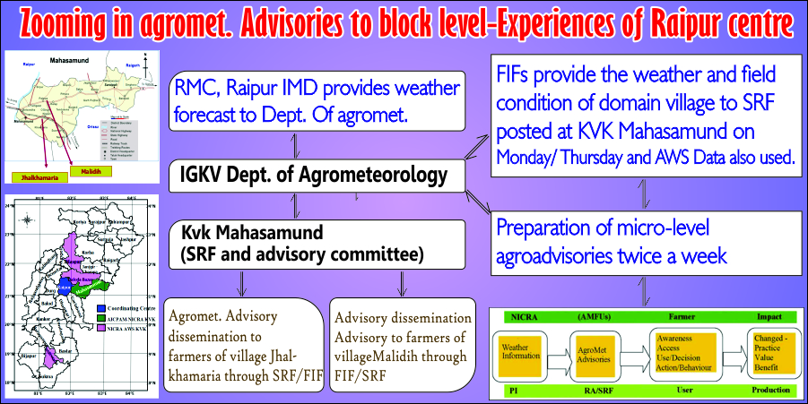

Fig. 1: Flow chart for Micro-level Agro-advisory services dissemination
Background of Chhattisgarh state and NICRA-AICRPAM district:
Chhattisgarh state, situated in Eastern India, is located between 17º 46’ N and 24º 5’ N latitudes and 84º 15’ E and 84º 24’ E longitudes. AICRPAM-NICRA Mahasamund district is spread out in an area of 4790 Sq. Kms in the Central-East of Chhattisgarh State (Fig. 2). The district lies between 20°47' to 21°31'30'' latitude and 82°00' to 83°15'45'' longitude, surrounded by districts of Raigarh and Raipur of Chhattisgarh State and Nawapara and Bargarh of Odisha. Mahasamund district was chosen as NICRA district for the study on climate resilience on agriculture and also to examine the farmer's adaptability.

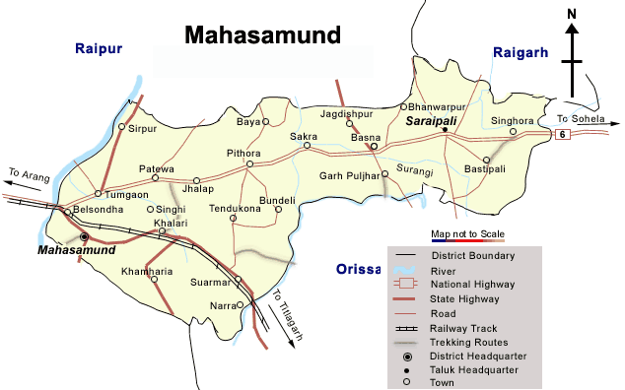
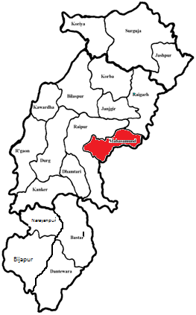

CG state Mahasamund district
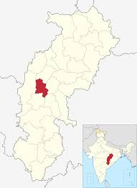
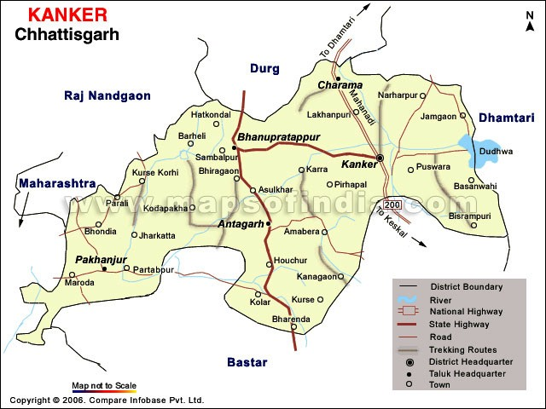

Bemetara (TDC district) Kanker (AICRP_DA district)
Fig. 2: Location map of Chhattisgarh and NICRA districts (Mahasamund, Kanker and Bemetara)
Mahasamund district located in eastern part of the state about 55 km from University H.Q. is selected as the study area for demonstration of technologies under climate resilience. The KVK situated at Mahasamund has been part of these NICRA-AICRPAM activities. Being mainly a mono-cropped region, rice is the main cereal crop of the district during kharif season. Nearly 88.61 per cent area is allocated under paddy crop in kharif season. The total area under different crops in kharif and Rabi season is observed as 83.91 per cent and 7.57 per cent respectively. Remaining 8.51 per cent of the total cropped area is allocated during summer season in the district. The area under rice crop is observed to be as 74.35+7.47= 81.82 percent of the total cropped area of the district. The remaining area is allocated under other crops like urd, groundnut, wheat, and gram etc in different season. Urd is second most important crop of the region during kharif season which occupies 3.64 per cent area of the gross cropped area. However, several other crops are also being grown in kharif as well as during rabi season in this district, although the area under cultivation is very less. Land utilization pattern of Chhattisgarh and NICRA domain districts in Chhattisgarh has been shown in Table-1.
Table-1(a,b,c): Land utilization pattern of Chhattisgarh and NICRA domain district in Chhattisgarh (area in hectares)
Table 1a
S.No | Particulars | CG state (ha.) | Mahasa-mund  (ha.)
01 | Total Geographical Area | 14090272 | 496301 (3.52 %)
02 | Area Under Forest | 6607429 | 141019 (2.13)
03 | Land Under Non-Agriculture use | 743920 | 37281 (5.01)
04 | Permanent Pasture and Grazing | 892817 | 30707 (3.4)
05 | Cultivable Waste Land | 382973 | 5210 (1.36%)
06 | Fallow land (old fallow+current fallow) | 535429 | 14953 (2.79%)
07 | Net Cropped Area | 4630966 | 261091 (5.63%)
08 | Gross Cropped Area | 5703845 | 304401 (5.33%)
09 | Cropping intensity (%) | 123.17 | 116.5
Source: Directorate of economics and statistics department, Mahasamund, 2021-2022
Note: Figure in parenthesis indicates percentages of total geographical pattern of the state
Table 1b
S.No | Particulars | CG state (ha.) | Kanker  (ha.)
01 | Total Geographical Area | 14090272 | 643268 (4.56 %)
02 | Area Under Forest | 6607429 | 278019 (4.20)
03 | Land Under Non-Agriculture use | 743920 | 31709 (4.26)
04 | Permanent Pasture and Grazing | 892817 | 67116 (7.5)
05 | Cultivable Waste Land | 382973 | 37487 (9.7%)
06 | Fallow land (old fallow+current fallow) | 535429 | 24078 (4.49%)
07 | Net Cropped Area | 4630966 | 185505 (4.0%)
08 | Gross Cropped Area | 5703845 | 203631 (3.57%)
09 | Cropping intensity (%) | 123.17 | 109.77
Source: Directorate of economics and statistics department, Kanker, 2021-2022

Table 1c
S.No | Particulars | CG state (ha.) | Bemetara  (ha.)
01 | Total Geographical Area | 14090272 | 285481 (2.02 %)
02 | Area Under Forest | 6607429 | -
03 | Land Under Non-Agriculture use | 743920 | 24951 (3.35)
04 | Permanent Pasture and Grazing | 892817 | 23537 (2.6)
05 | Cultivable Waste Land | 382973 | 4126 (1.07 %)
06 | Fallow land (old fallow+current fallow) | 535429 | 6882 (1.28%)
07 | Net Cropped Area | 4630966 | 225965 (4.87%)
08 | Gross Cropped Area | 5703845 | 400638 (3.57%)
09 | Cropping intensity (%) | 123.17 | 177.3
Source: Directorate of economics and statistics department, Bemetara, 2021-2022
Note: Figure in parenthesis indicates percentages of total geographical pattern of the state.

The selected villages in 2018 were as follows (Table-2).

Table-2: Domain villages in different NICRA-districts of CG

AICRPAM Center | Name of NICRA - KVK | District | Block/ Tehsil/ Mandal | Name of NICRA Village(s)
Raipur | KVK, Mahasamund | Mahasamund | Mahasamund | Jhalkhamharia, Lafinkhurd
Raipur | KVK, Kanker | Kanker | Kanker | Kapsi, Sureli
Raipur | KVK, Bemetara | Bemetara | Bemetara | Jhal

Results and Discussion
Economic impact of Micro-level AAS:

Early season extended range forecasts on heavy rains has helped in the formation of raised beds and furrows techniques at the time of sowing particularly in Soybean. Therefore, weather information and weather based agro-advisories has largely helped wide network of farmers in cost cutting and productivity increase. Utility of weather forecasting in achieving sustainable agriculture is discussed here and some case studies are discussed for Raipur centre covering Chhattisgarh Plains Agro-climatic zone. Further measures adopted by the farmers based on medium range weather forecasting support have been suggested as roadmap towards better crop production based on operational farm management.

The main objective of text messaging for the farmers is faster dissemination and real time providing of micro-level advisories in gist through ICT including weather based agricultural operations for different crops. Micro-regional advisories are prepared based on blocklevel 5-day-forecast available in IMD website www.imd.gov.in, feedback received from respective KVKs about current weather conditions. Text messaging are being issued to the farmers of Mahasamund block of same district through m-kisan portal of Dept. of Agriculture, Co-operation and Farmers' Welface (DAC&FW) website. Farmers under ATMA project of NICRA district and domain villages farmers of Jhalkhamharia (Mahasamund block) are covered in this NICRA project for issuing micro-level advisories dissemination. Working on the same line, MAAS are being issued for the farmers of Kanker district based on respective block-level forecast. Similarly for Baikunthpur (District Koriya) MAAS were issued upto 2018. With effect from 2019 Bemetara district, MAAS are being issued.

Micro-regional advisories are prepared based on blocklevel 5-day-forecast available in IMD website www.imd.gov.in, feedback received from FIFs about current weather conditions. Text messaging are being issued to the farmers of Mahasamund district in collaboration with Agricultural department and KVK Mahasamund. ATMA project farmers and domain villages farmers of Malidih and Jhalkhamharia are covered in this NICRA project micro-level advisories dissemination. Farmers are gaining significantly by utilization of weather based agro-advisoies and saving weather sensitive inputs viz. fertilizers, pesticides etc. Bulk messaging is being done by Kisan portal. About 124 farmers of Malidih and Jhalkhamaria villages are selected for dissemination. In co-ordination with DDA Mahasamund (ATMA farmers) -5901 farmers are covered in Mahasamund district in blocks Baghbahra (1198) farmers, Mahasamund (1435 farmers), Basna (1227 farmers), Pithora (1135 farmers) and Saraipali (906 farmers) through bulk messaging. NICRA Advisories are displayed on white boards in both the villages for having a look by farmers.

One economic impact study was carried out under the guidance of former PI, NICRA-AICRPAM in domain villages of Malidih and Jhalkhamaria, district Mahasamund. The results and economic gains were found to quite encouraging showing the importance of MAAS (Table-3).

Table-3: Impact of weather based Agro Advisory on crops at adopted village 2013.
Crops | Total No.  Of  Farmers | Total Area (ha) | Average yield (Qt./ha) |  | Per cent increase in the yield over farmers practice
Crops | Total No.  Of  Farmers | Total Area (ha) | With Agro Advisory | Without Agro Advisory | Per cent increase in the yield over farmers practice
Wheat | 5 | 2.5 | 22.69 | 18.75 | 21.01
Gram | 4 | 3.4 | 15.86 | 12.21 | 29.89
Summer paddy | 6 | 4.4 | 48.67 | 42.45 | 13.99

Looking into the success rate and timely adoption of MAAS by the farmers in NICRA domain villages, an effort has been made to quantify the economic gains (Table-4)

Table-4: Success rate of agromet advisories and saving due to timely adoption (NICRA-AICRPAM Raipur centre)
Year | AAS issued | Successful AAS | Percent | Amount saved / earned (Rs.) | Number of sample farmers | Amount saved / earned (Rs./ farmer)
2012 | 58 | 42 | 72.4 % | 237418 | 124 | 1914
2013 | 74 | 52 | 70.3% | 2510180 | 230 | 10913
2014 | 80 | 35 | 43.7% | 1560382 | 230 | 6784
2015 | 72 | 45 | 62.5% | 114200 | 115 | 993
2016 | 74 | 52 | 70.3% | 399165 | 115 | 3471
2017 | 67 | 50 | 74.6% | 655774 | 217 | 3022
2018 | 101 | 68 | 67.3% | 2724138 | 368 | 7402
Total / average | 526 | 344 | 65.4% | 8201257 | 1399 | 4928*
Cumulative benefit from the project since 2012 from villages viz.,
Malidih, Jhalkhamharia and Lafin Khurd (Mahasamund)/ Jhal (Bemetara)/ Sureli, Kapsi (Kanker)/Selka (Koriya)=
Net profit from MAAS: 4928*7 years*1400 adopted farmers=Rs. 4.829 crore

Note: 1*. Indicates average values
2. Number of adopted farmers were totalled from all the three villages for 7 years
3. The cumulative benefit from the project does not include the horizontal spread

Conclusion :

Based on the analysis, it has been found that the majority of the farmers expressed positive opinion on the weather forecast and agro advisory service provided under AICRPAM-NICRA for enhancing the net profit and by reducing the cost of cultivation in Malidih and Jhalkhamaria villages of Mahasamund district. The total benefit in 7 years for three districts in CG state by 4928 farmers who follow MAAS is Rs. 4.829 crore. Further, effort is being made in the scheme to provide information regarding weather forecast and agromet advisories through recent ICT technologies. The economic impact study revealed that there were considerable benefits to farmers who adopted real time weather and need based weather advisories regularly issued by AICRPAM centre as compared to non-adopted farmers. The study also revealed that micro-level AAS played imperative role in improving the productivity and farm incomes of those who adopted the MAAS. It needs further detailed investigation for underlying causes of not adopting the service. Farming experience, education, land holding size and income were found to be most important factors influencing the farmers.

References :

Bhatia, P.C. (1999). Crops and weather resources. In : 50 years of Natural Resource Management Research. G. B. Singh. and B. R. Sharma,(eds.) ICAR Publication, New Delhi, Pp 49-62.

Fisher M, Abate T, Lunduka RW, Asnake W, Alemayehu Y, Madulu RB. Drought tolerant maize for farmer adaptation to drought in sub-Saharan Africa: determinants of adoption in eastern and southern Africa. Climate Change. 2015;133:283-99.

Gadgil, S., 1989, Monsoon variability and its relationship with agricultural strategies. Paper presented at Int. symp. Climate variability and food security in developing countries. Held at New Delhi during February 5-7, 1987. pp. 249–267.

Gandhi, G.S., Chaudhary, J.L. and Sahu, K.K., 2018. Farmers feedback about the agro-met advisory services (AAS) at Mahasamund district of Chhattisgarh. Journal of Pharmacognosy and Phytochemistry, 7(5), pp.2522-2524.
Prasada Rao, G.S.L.H.V. and Manikandan, N. (2008). Economic impact of agrometeorological advisory services over central zone of Kerala. J. Agrometeorol., (SI): 230-234.
Rathore, L.S. and Chattopadhyay, N. (2016). Weather and climate services for farmers in India, WMO Bulletin, 65 (2).

