Original Research Article

Assessment of the typology and management of solid waste from collective catering establishments in Abidjan, Côte d'Ivoire

.
ABSTRACT

Aims: Waste from collective catering establishments is attracting increasing attention due to the associated risks of food contamination resulting from poor waste management. This study aims to analyses the waste management practices of such establishments in Yopougon-Port-Bouët 2, Abidjan, Côte d'Ivoire.
Place and Duration of Study: The research was conducted from June to August 2025 in Yopougon-Port-Bouët 2, Abidjan, Côte d'Ivoire.
Methodology: Data collection consisted of field observations and a survey. The sample size of the survey population was determined using simple random sampling (SRS).
Results: A total of 123 collective catering establishments were identified based on field visits and a survey of owners. These included 43 greasy spoons, 41 garbadrômes, 36 coffee kiosks and 3 ice cream parlors. Garbadrômes and coffee kiosks are mainly run by men, while greasy spoons and ice cream parlors are run by women. The waste encountered consists of food scraps, plastics (e.g. plastic film and rubber), fine particles (e.g. ash and sand), cardboard (e.g. cardboard packaging) and other types of waste (e.g. glass, gravel and cans). In most collective catering establishments (89.4%), this waste is packaged in barrels (buckets, cut cans) and bags (plastic bags or sacks). However, 10.6% of collective catering establishments do not package the waste they produce. Public bins and pre-collection services are the preferred options for disposing of waste produced by these establishments. Nevertheless, dumping waste in illegal dumps remains common practice, affecting 4.9% of restaurants (2.4% of garbadrômes, 7% of greasy spoons and 5.6% of kiosks). Only 15.5% of restaurants carry out waste sorting (12.2% of garbadrômes, 14% of greasy spoons, 16.7% of kiosks and 66.7% of ice cream parlors), and this consists of empty bottles, cans and food scraps for recycling.
Conclusion: Therefore, it seems necessary for the authorities at the National Institute of Public Health to raise awareness among restaurants about waste management, especially since waste remains on site for at least three days in most restaurants.

Keywords: Abidjan, Cote d’Ivoire, Collective restaurants, Illegal dumps, Waste management

1. INTRODUCTION

In most urban areas around the world, increasing urbanization and industrialization, coupled with the growth of tourism and travel, have led to a significant increase in collective catering. It is becoming increasingly common for people to be away from home for reasons such as medical care, social events, training or work. This provides an opportunity for them to consume food prepared by others. However, collective catering establishments produce large quantities of solid waste, which, if not managed properly, can pose health risks to consumers (FAO, 2014; ADEME, 2016). Collective catering waste refers to all waste resulting from meals and their preparation in company, school, hospital and out-of-home restaurants, including food waste, paper/cardboard, plastic, wood, metal and glass. Due to the risks of food contamination associated with poor management, this type of waste is attracting increasing attention from researchers and organisations (FAO, 2014; Filimonau et al., 2019; Filimonau and De Coteau, 2019).
There are three main types of food contamination: contamination by germs, chemicals and radiation. However, contamination by germs is given considerable attention in both literature and practice (FAO/WHO, 2018; Mutsch, 2018). Foodborne illness typically manifests as digestive issues accompanied by abdominal pain, diarrhea and occasionally vomiting, following the ingestion of food containing pathogenic microorganisms or toxic substances (Choquet et al., 2012). These illnesses can be caused by bacteria, viruses, parasites or fungi, which proliferate in unhygienic environments. This is why food business operators are subject to various mandatory and voluntary standards, such as laws and regulations and ISO certification, in the field of food safety, in order to protect consumer health (AFNOR, 2002 & 2003).
In Côte d'Ivoire, responsibility for food hygiene regulations (Article 1 of Decree No. 79-573 of 4 July 1979) has been transferred from the Ministry of Agriculture to the Ministry of Health and Public Hygiene. Health inspection regulations are the responsibility of the National Institute of Public Health (NIPH) under Decree No. 91-656 of 9 October 1991 relating to its establishment and organisation. However, collective catering establishments in the country are not subject to adequate health surveillance due to the high cost of conventional control methods, and above all due to unregulated facilities escaping the control of the public health authorities (Ebouo, 2011). This could explain the recent cases of food poisoning in villages such as Ahounienfoutou, Gourominankro and Mignoré, which are located in the Bongouanou, Yamoussoukro and Vavoua departments, respectively (Kouadio, 2021). Based on this observation, scientific studies have been undertaken, such as those by Ebouo (2011), Koffi-Nevry and Gohou (2012), and Kouamé et al. (2020). However, no study has yet focused on waste management in collective restaurants in urban areas, particularly in high-density areas such as Abidjan, the country's economic capital.
Against this backdrop, the present study seeks to analyze the management of solid waste produced by collective restaurants in the Port-Bouët 2 neighborhood of the Yopougon municipality. Specifically, the study seeks to: (i) count the number of collective restaurants in Port-Bouët 2; (ii) determine the types of solid waste produced by collective catering activities; and (iii) describe the waste management methods used in these restaurants. As the first study of its kind to analyze waste management in restaurants, it could encourage decision-makers, particularly public health authorities, to address the environmental impact of collective restaurants, especially in densely populated urban areas in developing countries.

2. material and methods
2.1 Description of the study area

This study was conducted in the Porbouët 2 neighborhood of Yopougon, which is one of the municipalities of Abidjan — the largest city in Côte d'Ivoire. Porbouët 2 is located slightly closer to the center of the municipality (see Fig. 1). The neighborhood’s high residential mobility is due to rapid population growth and urbanization. Its population grew from 50,816 in 1998 to 72,722 in 2010 and then to 126,237 during the most recent general population census in 2021 (Bakary and Ake-Awomon, 2022). Porbouët 2 is one of the municipality's oldest urban centers, and its landscape is characterized by low-rise housing that is constantly evolving.

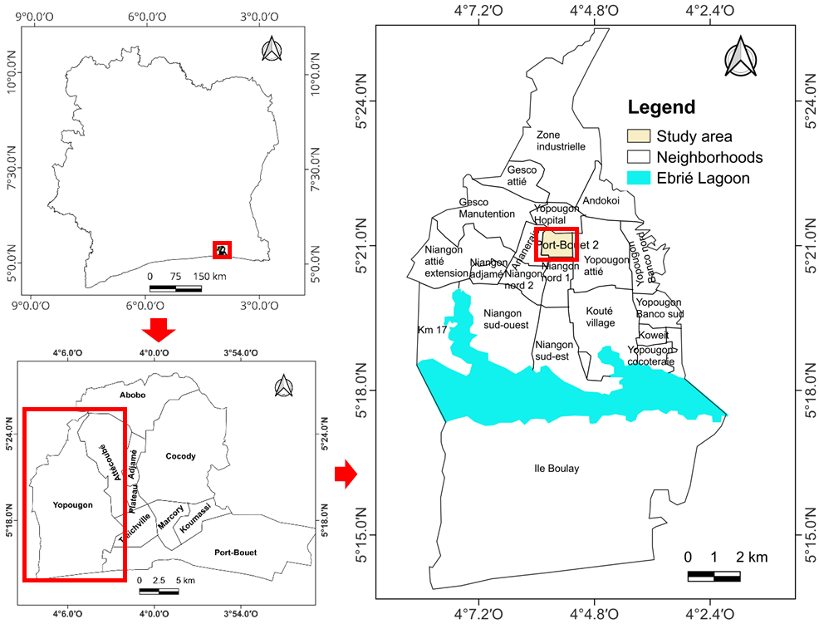
Fig. 1. Location map of the study area
2.2 Data Collection
Data was collected through a survey of restaurant managers, field observations, and waste segregation in these establishments. These activities were carried out simultaneously during visits to all the restaurants in the Porbouët 2 neighborhood, in order to obtain more representative data for this study.
The survey gathered information on the types of institutional catering establishments and the types of waste produced. It also gathered information on how waste is packaged in restaurant areas, how frequently it is collected for disposal, where it is disposed of and how managers sort it.
Field observations, carried out using cameras, illustrated the situation in collective restaurant spaces. These included the different types of restaurant, the containers used for waste packaging, and the locations where waste was disposed of.
The aim regarding the segregation of waste was to create an inventory of waste types generated in restaurant areas, based on the presence or absence of waste categories defined by MODECOM (1993) and ADEME (2006), as shown in Table A1.

2.2 Data Analysis
The data collected from the questionnaire were grouped by variable (type of restaurant, owners' level of education, types of waste produced, waste packaging and disposal methods, etc.). The relative percentage of each variable was then calculated in relation to the number of managers of each type of restaurant surveyed, using the following formula:

$$F=\frac{X}{Y} x 100 (Eq.1)$$
Where:
F: Frequency (%);
X: Number of the modality considered;
Y: Total workforce of the modality considered.

However, for this study, the data were first processed at the level of all collective catering establishments and then the proportions were defined at the level of each individual establishment. Therefore, the total number of respondents varied depending on whether the analysis was conducted for all restaurants or for each individual restaurant.

3. results and discussion

3.1. Typology of collective catering establishments and associated operators
A total of 123 collective catering establishments were counted in the Port-Bouët 2 neighborhood. These included 43 greasy spoons (35%), 41 garbadrômes (33.3%), 36 coffee kiosks (29.3%) and three ice cream parlors (2.4%). The proportion of greasy spoons is highest, followed by garbadrômes, coffee kiosks and ice cream parlors. Fig. 2 illustrates the types of collective catering encountered during the survey in Port-Bouët 2. The predominance of greasy spoons, which are small, inexpensive restaurants offering unrefined, mediocre-quality dishes, can be explained by the economic status of the population, whose activities are dominated by the informal economy (Bakary and Ake-Awomon, 2022). The popularity of garbadrômes can be attributed to the fact that these small restaurants are popular in Côte d'Ivoire and specialize in selling "attiéké-poisson" or "garba" (i.e. cassava semolina and fried tuna). These establishments are often informal and very affordable, and are popular for their friendliness and authenticity. However, their hygiene standards are sometimes basic (Sedia et al., 2020; Koffi, 2021). Most local restaurants are informal, accounting for around 98% of the total. This is reflected in the number of greasy spoons, garbadrômes and coffee kiosks, which indicates the population's purchasing power. According to Akindès (1991), the main reason for this preference for informal dining is the opportunity to eat food that is culturally adapted to the population's tastes at moderate prices, or even on credit.

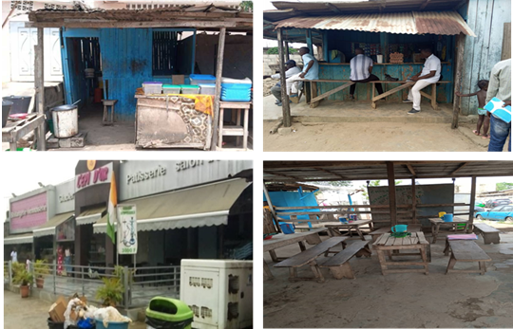
B
D
C
A
Fig. 2. Collective catering establishments visited during the survey in the Port-Bouët 2 neighborhood. A = Garbadrôme, B = Coffee kiosk, C = Ice cream parlor, D = Greasy spoon.

An analysis of the educational level of restaurant owners reveals that many have not received much schooling (see Table 1). While 43.9% of owners have received an education, 56.1% have not. However, the catering sector remains male-dominated, with men accounting for 63.4% of owners compared to 36.6% of women. This can be explained by the fact that the catering sector is rooted in the informal economy and has traditionally served as a refuge for the uneducated or those who have dropped out of school, most of whom are men (Assué and Gnepehi, 2023). The relatively high proportion of educated owners (43.9%) and women (36.6%) suggests a general awareness of the sector's profitability. Nevertheless, these findings differ from those of Kombieni (2020), who found that, in Abomey-Calavi, Benin, 87.18% of vendors were women, primarily young girls (83.18%), and 91% were illiterate. This difference is likely linked to societal factors that give women a greater role in Benin than in Côte d'Ivoire.
Examining each type of collective catering establishment (see Table 1), it can be observed that, unlike greasy spoons and ice cream parlors, which are predominantly owned by individuals with a formal education, garbadrômes and coffee kiosks are primarily operated by individuals without a formal education. The high level of education among ice cream parlor owners could be explained by the growing number of pastry training centers, which provide ice cream parlors with a sufficient number of skilled workers (Kone et al., 2016). Furthermore, while the majority of garbadrôme and coffee kiosk owners are male (100% and 94.4% respectively), the majority of greasy spoon and ice cream parlor owners are female (95% and 66.7% respectively). This can be attributed to the arduous nature of the work in garbadrômes and kiosks, as well as the precarious and less secure nature of the work environments. Indeed, working in garbadrômes (i.e. selling cassava semolina with fried tuna) and in coffee kiosks involves long hours, often starting at dawn, and constant exposure to the heat of stoves, as well as prolonged standing. In addition, these points of sale are often set up informally on public land. A lack of adequate sanitary facilities, vulnerability to bad weather, and the risk of eviction create an unstable and sometimes dangerous working environment (Dakouri et al., 2019; Koffi, 2021).

Table 1. Gender and educational level of managers in collective catering establishments
Socio-professional characteristics |  | Catering services |  |  |  | Total
 |  | Garbadrôme | Coffee kiosk | Ice cream parlor | Greasy spoon | Total
 |  | n = 41 | n = 36 | n = 3 | n = 43 | n = 123
Gender | Male | 100% | 94.4% | 33.33 | 5% | 63.4%
Gender | Female | 0% | 5.6% | 66.67 | 95% | 36.6%
Education level | Tertiary/Higher: | 0% | 0% | 0% | 2% | 0.8%
Education level | Secondary | 4.9% | 8.3% | 66.7% | 28% | 15.4%
Education level | Primary | 14.6% | 27.8% | 33.3% | 40% | 27.6%
Education level | No formal | 80.5% | 63.9% | 0% | 30% | 56.1%

3.2. Solid waste produced in collective catering establishments
The waste produced by collective catering establishments in the Port Bouët 2 neighborhood consists of food scraps, plastic waste (e.g. plastic film and rubber), fine particles (e.g. ash, dust and sand), cardboard waste (e.g. cardboard packaging), and other types of waste (e.g. glass, gravel and stones). (Table 2). The diversity of waste produced by collective catering establishments can be explained by the combination of preparation, service and cleaning activities. This waste undoubtedly originates from delivery packaging, maintenance residues, unsold items and leftovers, and requires more efficient management (ADEME, 2016). Food scraps and plastics were generated at most of the sites visited: 72.4% and 61.8% of establishments, respectively. Conversely, fine particles, cardboard and other waste are produced less frequently, accounting for 9–13% of establishments in the neighborhood. The lower production of fine particles and cardboard in some establishments is mainly due to the use of reusable containers or plates and reduced packaging use in restaurants in our region. However, plastics taken away by customers from eating establishments create sanitation problems elsewhere, as they are mostly discarded in people's homes (Adjalo et al., 2020).
However, all the waste recorded in the study area is produced by all collective catering establishments, with the exception of ice cream parlors (see Fig. 3). The latter do not produce fine particles, cardboard, or other types of waste. This difference can be explained by the fact that ice cream parlors use different preparation and cooking methods than garbadrômes and coffee kiosks, which use charcoal or even firewood, thereby limiting the production of solid waste such as ashes. In addition, in ice cream parlors, most packaging is taken away by customers and the premises are cleaned with a mop, which limits the presence of fine particles such as dust and sand. This reflects a greater focus on hygiene and cleanliness in ice cream parlors, in line with good hygiene practices for food preparation and sale (FAO, 2007; Yavo, 2020).

Table 2. Types of waste produced by collective catering establishments
Types of waste | Number of catering establishments involved | Percentage
Food waste | 89 | 72,4%
Plastics | 76 | 61,8%
Fine particles | 16 | 13%
Cardboard | 13 | 10,6%
Others | 12 | 9,8%

Fig. 3. The proportion of collective catering establishments concerned based on the waste encountered.

3.3. Methods of managing solid waste in collective catering establishments
In most collective catering establishments in Port Bouët 2 (89.4%), waste is packaged in barrels (such as buckets or cut cans), bags (such as plastic bags or sacks), or cardboard boxes (see Fig. 4 and Table 3). It should be noted that 10.6% of establishments do not package the waste produced in their sales areas. This includes 7.3% of rubbish dumps, 2.8% of kiosks and 20.9% of greasy spoons (see Table 3). Not all ice cream shops in the area package their waste in old buckets and basic bags like other restaurants do. This is certainly linked to the fact that this type of establishment is inspected most frequently by the authorities, who ensure compliance with the Framework Law No. 96/766 of 3 October 1996 on the Ivorian Environmental Code. These measures stipulate that waste must be placed in sealed waste containers in order to avoid contamination of food and the environment, as can be seen in Fig. 3C for ice cream vendors. However, contrary to the requirements in the FAO (2007) training manual on good hygiene practices in the preparation and sale of street food, the bins are overflowing, uncovered and appear not to be maintained daily. This can encourage the proliferation of rodents, especially since waste remains in most restaurants for more than three days before being removed (see Table 3) (Choquet et al., 2012). Furthermore, the use of basic containers, such as old bags, by other restaurants (61% of greasy spoons and 52.8% of coffee kiosks) reflects the informal nature of these establishments (Ebouo, 2011; Kouame et al., 2020).
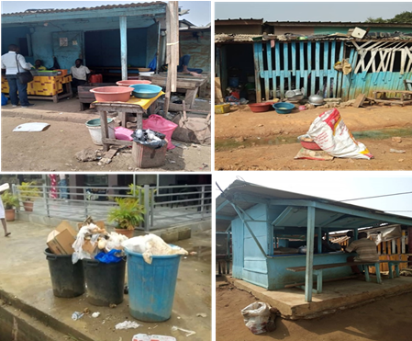
D
C
A
B
Fig. 4. Waste packaging in the collective restaurants surveyed (A = Garbadrômes, B = Greasy spoons, C = Ice cream parlors, and D = Coffee kiosks).

In Port-Bouet 2, public bins and pre-collection services are the preferred options for disposing of waste produced in restaurants (see Table 3). 95.1% use these services to dispose of their waste. However, 4.9% dispose of their waste at illegal dumpsites (see Fig. 5). Ice cream parlors are the only establishments that do not use illegal dumps, as these are monitored. Another possible explanation relates to the level of education of ice cream parlor owners. In greasy spoons and garbadrômes, waste is preferably disposed of in public bins, while coffee kiosks most commonly use pre-collection services. This suggests that some establishments have access to storage bins provided by licensed operators for household waste collection, while others do not. According to Diabagate and Konan (2018), when public household waste management services are unable to remove all the waste produced by households, an informal or community-based system is set up to do so. These pre-collectors (neighborhood committees, associations, micro-enterprises, etc.) compensate for the shortcomings of local authorities, such as a lack of bins, particularly in neighborhoods that are inaccessible to conventional household waste collection vehicles (Kouadio, 2014).

Table 3. Waste management methods used by collective catering establishments, from packaging and sorting to collection frequency and final disposal.
Waste management |  | Catering services |  |  |  | Total
 |  | Garbadrôme | Coffee kiosk | Ice cream parlor | Greasy spoon | Total
 |  | n = 41 | n = 36 | n = 3 | n = 43 | n = 123
Packaging of waste | barrels | 31.7 | 30.6 | 66.7 | 41.9 | 35.8
Packaging of waste | bags | 61 | 52.8 | 0 | 37.2 | 48.8
Packaging of waste | Cardboard boxes | 0 | 13.9 | 33.3 | 0 | 4.9
Packaging of waste | Not packaged | 7.3 | 2.8 | 0 | 20.9 | 10.6
Waste Disposal Methods | Public bins | 51.2 | 33.3 | 100 | 62.8 | 51.2
Waste Disposal Methods | Pre-collection services | 46.3 | 61.1 | 0 | 30.2 | 43.9
Waste Disposal Methods | Illegal dumping | 2.5 | 5.6 | 0 | 7 | 4.9
Waste sorting practice | Yes | 12.2 | 16.7 | 66.7 | 14 | 15.5
Waste sorting practice | No | 87.8 | 83.3 | 33.3 | 86 | 84.5
Frequency of waste collection (days) | [1 ; 3[ | 2.4 | 0 | 0 | 9.3 | 4.1
Frequency of waste collection (days) | [3 ; 6[ | 39 | 30.6 | 33.3 | 58.1 | 43.1
Frequency of waste collection (days) | [6 ; plus [ | 58.5 | 69.4 | 66.7 | 32.6 | 52.8

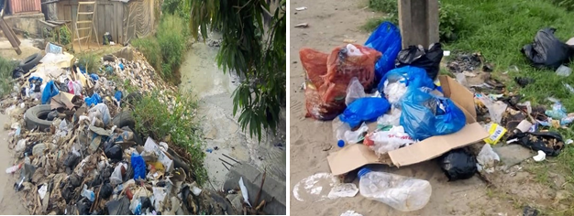
B
A
Fig. 5. Illustration of illegal dumping sites near cafeterias in the Port-Bouët 2 neighborhood, A = waste dumped in a storm drain, B = waste dumped in the street.

With regard to waste sorting (see Table 3), it should be noted that only 15.5% of collective catering establishments in the surveyed area sort waste, compared to 84.5% that do not. This includes five garbadrômes, six greasy spoons, two ice cream parlors and six coffee kiosks, representing 12.2%, 14%, 66.7% and 16.7% of the surveyed establishments, respectively. Ice cream parlors are therefore the most likely to sort waste in their establishments. This suggests that the population has little knowledge of waste recovery (Bangoura, 2017). Nevertheless, the 15.5% of restaurants in Port-Bouët 2 that sort waste collect empty water and soft drink bottles for reuse, empty aluminum cans for recycling (to make pots and pans) and food scraps for use in livestock farming or for domestic animals (as seen in Table A2). The use of food scraps for animal feed was also observed by Coulibaly et al. (2021). They observed that unsold products from agro-industrial companies SOCOCE, COQUIVOIRE and SCB are used to feed animals at Abidjan Zoo in Côte d'Ivoire.

4. Conclusion
This study provided an overview of the various collective catering establishments in Yopougon Port-Bouët 2 and their waste management practices. Overall, establishments in this neighborhood do not have standard, hygienic rubbish bins. Analysis of waste management also revealed that it does not comply with hygiene standards. Food can therefore become contaminated by waste or by the person handling or emptying the bin. As restaurants in Yopougon Port-Bouët 2 are very busy places, it is necessary for each establishment to have an internal waste management plan. Restaurant owners must be trained to ensure that the products they sell do not become a source of disease. Sorting waste at source could present an opportunity for some restaurants, provided the owners are trained to do so.

Consent
All contributing authors read and approved the final manuscript for publication.

References
ADEME (2006). National campaign for the characterization of household waste; Choice of categories and subcategories for the analysis of waste composition. ADEME, France, 55 p.
ADEME (2016). Reducing food waste in collective catering. French Environment and Energy Management Agency (ADEME), France, 16 p.
AFNOR (2002). EC Regulation No. 178/2002 of the European Parliament and of the Council of January 28, 2002 laying down the general principles and requirements of food law. Official Journal of the European Communities, 42 p.
AFNOR (2003). Codex Alimentarius: Hazard Analysis Critical Control Point (HACCP) system and guidelines for its application. Appendix to CAC/RCP 1. 1969 Rev, 4 p.
Assué, Y.J. & Gnepehi, D. G. G. (2023). The Informal Sector as an Alternative to Youth Underemployment in the Toumodi Sub-Prefecture. ESI Preprints, 402-419. https://doi.org/10.19044/esipreprint.4
Bakary, N. M. & Ake-Awomon, D. F. (2022). Demographic Pressure and Health of the Populations of the Port-Bouet 2 Neighbourhood In The Commune Of Yopougon (Cote D'ivoire). Journal of Research in Humanities and Social Science, 10 (12), 324-328
Bangoura M. R., 2017: Management of household solid waste and socio-spatial segregation in the city of Conakry (Guinea). Doctoral thesis, University of Toulouse, France, 10 p.
Choquet, C., Bernard, J., Berthoumieu, A. & Colosi, L. (2012). Abdominal pain masking an extra-digestive pathology. Emergencies 22:1-11.
Coulibaly S. L., Akpo, K. S., Koua-Koffi, N. A. A., Digbe, D. B. & Coulibaly, L. (2021). Recovery of Unsold Food from Three Agri-Food Industries (SOCOCE, COQUIVOIRE and SCB) for the Feeding of the Abidjan Zoo Animals. Journal of Agricultural Chemistry and Environment, 10, 415-427.
Adjalo, D. K., Houedakor K. Z. & Zinsou-Klassou K. (2020). Use of plastic packaging in street food and sanitation of West African cities: the example of Lomé in Togo. International Journal of Biological and Chemical Sciences, 14(5), 1646-1656.
Dakouri, G. D. F., Boka, A. C., Ehon, A. F. C. & Tape B. J. (2019). Socio-economic characteristics of Garba vendors and environmental status of Garbadromes in Yopougon (Abidjan-Côte d’Ivoire). Annales de l’Université de Moundou, Series A - Faculty of Letters, Arts and Human Sciences, 6(1), 125-145.
Diabagate S. & Konan K. P., (2018). Management of household waste in the city of Bouaké, sources of socio-spatial and environmental inequalities. Revue Espace, Territoires, Sociétés et Santé, 1(2), 126-142.
Ebouo, N. J-M. (2011). Descriptive study of food hygiene at the restaurant of the National Institute of Public Hygiene. Doctoral Thesis, Felix Houphouët Boigny University, Cocody, Abidjan, Côte d’Ivoire, 228 p.
FAO (2007). Good Hygiene Practices in the Preparation and Sale of Street Foods in Africa: Training Tools. FAO, 1-176.
FAO (2014). Global Initiative on Food Losses and Waste Reduction. FAO, Rome, Italy, 6 p.
FAO/WHO (2018). Risk Communication Manual Applied to Food Safety, Rome, 108 p.
Filimonau, V. & De Coteau, D. A. (2019). Food waste management in hospitality operations: a critical review. Tourism Manag. 71, 234-245.
Filimonau, V., Fidan, H., Alexieva, I., Dragoev, S. & Marinova, D. D. (2019). Restaurant food waste and the determinants of its effective management in Bulgaria: an exploratory case study of restaurants in Plovdiv. Tourism Manag. Perspect., 32, 100577.
Kombieni H. A. (2020). Popular catering: an example of informal economic activities in the district of Hevie (Abomey Calavi municipality), ACAREF REVIEWS, 101-123.
Koffi A. L. J. (2021). Consumption of "garba" in Côte d'Ivoire: between health risks and the construction of social ties. European Scientific Journal, ESJ, 17(19), 230. https://doi.org/10.19044/esj.2021.v17n19p230
Koffi-Nevry, R. & Gohou, G. (2012). Food hygiene and sustainable development: impact of the invisible world (microscopic) on poverty reduction, 20 p.
Kone, K. S., Koffi, K. A. & Ehui, P. J. (2016). Youth and professional integration in Côte d'Ivoire: vocational training put to the test of integration practices, International Review of Educational Sciences and Technologies, 6, 75-110.
Kouadio, J. M. K. (2014). Urban dynamics and sustainable management strategy for household waste in the Autonomous District of Abidjan (Côte d'Ivoire): the case of the municipalities of Cocody and Marcory. Master's Thesis, International Institute for Water and Environment, Ouagadougou, Burkina Faso, 64 p.
Kouame, Y. A., Konan, A. S. Kouassi, K. & Koffi, G. R. (2020). Urban food system and health in Africa. Volume 2 (Food consumption and health vulnerabilities). Space, Territories, Societies and Health Review, 3 (5), 2-11.
Framework Law No. 96/766 of October 3, 1996 establishing the Environmental Code of the Republic of Côte d'Ivoire. 20 p.
Marine K. N.A. (2021). Social Practices and Food Hygiene Deficit in the Grand Market of Treichville and the Adjame Market Forum (Côte d'Ivoire). European Scientific Journal, 17(9), 71-88.
MODECOM (1993). Method for Characterizing Household Waste / 2nd edition, ADEME editions, Paris.
Mutsch L. (2018). Microbiological criteria applicable to foodstuffs Guidelines for interpretation, Food Safety Division, Thomas Edison, Luxembourg, 157 p.
Sédia, N. A. G., Konan A.G. & Akindes F. (2020). “Chapter 10 - Attiéké-garba, “good” to eat and to think about. "Challenging hygiene standards and social distinction in the Ivorian urban context." Eating in the City, edited by Nicolas Bricas et al., Éditions Quæ, 2020, pp. 132-142. https://books.openedition.org/quae/33137.
Yavo D. B. A. (2020). The lack of food hygiene: a risk factor for the health of tourists in Grand-Bassam restaurants. SLC, no. 14, pp. 194-209.
APPENDIX

- Table A1: Solid waste components
No. | Waste Components | Contents
1 | Putrescible materials | Food waste, other putrescible
2 | Papers | Newspapers, magazines, reviews
3 | Cardboard | Cardboard boxes, Cardboard packaging
4 | Composites | Composite packaging
5 | Textiles | Sanitary textiles, clothes, lingerie etc.
6 | Plastics | Plastic films, rubber, plastic bag,  plastic boxes for various products, etc.
7 | Unclassified fuels | Wood, coal, other fuels, garden waste
8 | Glass | Glass packaging, jars, colorful and colorless glasses
9 | Metals | Iron metals, cans and aluminum materials, Other metal packaging, Other metal waste
10 | Unclassified incombustibles | Pebbles
11 | Hazardous waste | Sanitary waste, baby diapers, batteries and accumulators
12 | Fine elements/ particles | Sand, soil, dust, ash

Table A2: Waste sorting practices in various collective catering establishments. * Indicates waste sorting or recovery in the corresponding establishment.
Waste sorted or recycled | Catering services
Waste sorted or recycled | Garbadrômes | Greasy spoon | Ice cream parlor | Coffee kiosk
Empty bottles |  | * | * | *
Empty cans |  | * | * | *
Food scraps | * | *

