Trend analysis of rainfall over different regions of Aurangabad District using
Non-Parametric Mann-Kendall test

Abstract
The analysis of rainfall trends across various stations in the Aurangabad district is essential for understanding regional climate patterns and their implications for agriculture and water resource management. This study employs both descriptive statistics and the Mann-Kendall trend analysis to examine the rainfall data across multiple stations, including Sillod, Vaijapur, Soageon, Phulambri, and others. Descriptive statistics were used to assess central tendency, variability, and distribution shape, revealing notable differences in average rainfall (mean ranging from 587.96 mm at Sillod to 741.29 mm at Khuldabad) and variability (standard deviations from 174.97 mm at Phulambri to 216.25 mm at Paithan). The analysis also highlighted differences in distribution shapes, with stations like Paithan exhibiting higher kurtosis, indicating more extreme rainfall values. The Mann-Kendall trend analysis, applied to seasonal and annual data, provided insights into temporal trends across stations. The results revealed that Sillod exhibited a statistically significant increasing trend, with a z-score of 2.55 and a p-value of 0.01, suggesting a clear upward trend in rainfall over time. Conversely, other stations like Vaijapur, Soageon, Paithan, and Gangapur showed weaker or insignificant trends. In the Rabi and Summer seasons, most stations displayed minimal or no statistically significant trends. The annual data similarly revealed that Sillod had a significant increasing trend, while the other stations showed relatively stable rainfall patterns. These findings underscore the heterogeneous rainfall patterns across Aurangabad, with some stations experiencing significant changes over time, while others remain relatively stable, providing valuable insights for local agricultural planning and water resource management.
Keywords: Rainfall, Mann Kendall, Descriptive statistics.
Introduction
Climate change is considered one of the most significant natural processes occurring on Earth (Yadav & Singh, 2023) (Li et al., 2019). Continuous monitoring of rainfall patterns is vital to comprehensively understand climate variability; however, investigating regional precipitation variability is complex due to the potential for erratic and substantial spatiotemporal variations within the same region (Srivastava et al., 2021) (Waseem et al., 2020). In recent years, trend analysis of precipitation time series has garnered substantial attention from scientists worldwide, as it is essential for evaluating the interactions between different components of the hydrological cycle, as well as for assessing water demand, sustainable agriculture, water resources management, and mitigating floods and droughts (Pelosi et al., 2022) (Wang et al., 2020) (Menenti et al., 2021).
Precipitation is a critical component of the hydrological cycle and plays a crucial role in determining water resource availability. Understanding precipitation trends and variability is essential for evaluating the interactions between different components of the hydrological cycle, and for informing assessments of water demand, sustainable agriculture, water resources management, and the mitigation of floods and droughts (Srivastava et al., 2021) (Ali et al., 2021) (Song et al., 2020) (Waseem et al., 2020). The importance of understanding rainfall trends is critical for the future of agriculture, as awareness of trends and variability can contribute to supplying supplemental water for crops during critical growth stages (Bhatti et al., 2023) (Ali et al., 2021). Trend analysis methods and variability indexing approaches are commonly employed for the spatiotemporal analysis of precipitation dynamics at regional and global scales (Nema et al., 2016) (Ahmad et al., 2014) (Waseem et al., 2020).
Trend analysis is a powerful statistical technique used to identify long-term patterns and changes in various environmental variables, including rainfall (Waseem et al., 2020) (Ahmad et al., 2014). Researchers have widely utilized trend-capturing tools such as the Mann-Kendall test, innovative trend analysis, and Sen's slope to detect the presence of monotonic trends in time series data, while also providing information on the magnitude and direction of the trends (Vivekanandan, 2007) (Patakamuri et al., 2020). The purpose of this research is to conduct a comprehensive trend analysis of precipitation data across the Maharashtra region of India, with a focus on understanding the potential impacts of climate change on water resources and agriculture.
The study will analyze long-term rainfall data from multiple meteorological stations across Maharashtra, using the Mann-Kendall test. This non-parametric method is widely used to detect the presence of monotonic trends in time series data, while also providing information on the magnitude and direction of the trend. The results of the trend analysis will be used to identify regions within Maharashtra that have experienced significant
Materials and methods

Descriptive Statistics of the Rainfall data
The study employed descriptive statistics to summarise the rainfall data collected from various stations across the Aurangabad district(Table 1.). The rainfall data was downloaded from the IMD website for a period of 1970-2023. To assess the central tendency, the mean rainfall value was calculated for each station. This metric represents the average rainfall for the period under consideration, providing an overall measure of the typical rainfall condition at each location. By comparing the mean values across stations, differences in average rainfall patterns can be observed, highlighting spatial variations within the district.
To evaluate the variability in the data, the standard deviation was computed for each station. This statistic quantifies the spread or dispersion of the rainfall data around the mean. A higher standard deviation indicates greater variability in rainfall, suggesting that a station experiences more fluctuating rainfall patterns, while a lower standard deviation signifies more consistent and stable rainfall conditions. This measure helps in understanding the degree to which rainfall patterns deviate from the average at each location.
In addition to the central tendency and variability, the minimum and maximum values were calculated to examine the range of rainfall values recorded at each station. These values highlight the extremes in rainfall, providing insights into the conditions during the highest and lowest rainfall events. The spread between the minimum and maximum values also serves to show the extent of the variation in rainfall over the observed period.
Finally, the kurtosis value was calculated to understand the shape of the rainfall distribution at each station. Kurtosis measures the "tailedness" of the distribution. A negative kurtosis indicates a flatter distribution with fewer outliers, suggesting that the data are more uniformly distributed around the mean, while a positive kurtosis indicates a distribution with heavier tails and more extreme values, implying the presence of outliers or extreme rainfall events. This helps in understanding whether rainfall data at a station follows a more normal distribution or if there are more extreme rainfall occurrences. Collectively, these descriptive statistics provide a comprehensive overview of the rainfall patterns across different stations in the Aurangabad district, revealing important aspects of central tendency, variability, and distribution shape.
Mann Kendall test
Mann Kendall test is the rank based nonparametric test and recently used by several researchers to detect trends in precipitation and other climatic parameters(Kamal & Pachauri, 2019; Mohammed et al., 2019; Ahmad et al., 2014 and Ahmad et al., 2015). It is based on the test statics S defined as:

$S=\sum_{i=1}^{n-1}{\sum_{j=i+1}^{n}{sign\left(x_{j}-x_{i}\right)}}$ (1)
Where, x₁, x₂…. x_{n} represent n data points where x_{j} and x_{i} are the annual values in years j and i, j>i respectively.
A very high positive value of S is an indicator of an increasing trend, and a very low negative value indicates a decreasing trend.

$sign\left(x_{i}-x_{i}\right)= f\left(x\right)=\left\{\begin{aligned}+1, & x_{j}>x_{i} \\ 0, { x}_{j}=x_{i} \\ -1, &{ x}_{j}<x_{i}\end{aligned}\right.$ (2)

Where n is the sample size. The statistics S is approximately normally distributed when n ≥ 8, with the mean and the variance, respectively.
E(s) = 0
$V\left(s\right)= \frac{n\left(n-1\right)\left(2n+5\right)-\sum_{i=1}^{n}{t_{i }i\left(i-1\right)(2i+5)}}{18}$ (3)
where t_{i} is the number of ties of extent i(Zero difference between compared values). The standardized statistics (Z) for one-tailed test is calculated as follows:
$Z= f\left(x\right)=\left\{\begin{aligned}\frac{S-1}{\sqrt{Var(s})} S>0 \\ 0 S=0 \\ &\frac{S+1}{\sqrt{Var(s}) } S≥0\end{aligned}\right.$ (4)
The hypothesis that there has not trend will be rejected if,

$\left|Z\right|> Z_{1-\frac{α}{2}}$ (5)

Z_{(1-α/2)} is the value read from a standard normal distribution table with α being the significance level of the test. At the 99 per cent significance level, the null hypothesis of no trend is rejected if |Z_{MK}|>2.575; at 95 per cent significance level, the null hypothesis of no trend is rejected if |Z_{MK}|>1.96; and at 90% significance level, the null hypothesis of no trend is rejected if |Z_{MK}|> 1.645.

Results and discussion
Descriptive statistics of the annual rainfall over different taluks of Aurangabad district
The statistical analysis reveals notable variations across the stations concerning central tendency, variability, and distribution shape (Table 1). The mean values range from 587.96 at Sillod to 741.29 at Khuldabad, indicating differences in the average measurements across the stations. This disparity is further reflected in the data's variability, with standard deviations ranging from 174.97 at Phulambri to 216.25 at Paithan, suggesting that Paithan exhibits the highest variability, while Phulambri shows relatively more stable data. Additionally, the minimum and maximum values display considerable spread, with stations like Paithan and Khuldabad exhibiting more extreme values, pointing to a wider range of conditions. Interestingly, the kurtosis values indicate the shape of the distributions; negative kurtosis at stations like Sillod, Vaijapur, and Soageon suggests flatter distributions with fewer outliers, while Paithan's positive kurtosis value indicates a distribution with heavier tails, meaning it has more extreme values or outliers. Overall, these statistical measures provide a comprehensive understanding of the data, highlighting the diverse characteristics of each station, with some stations displaying more extreme conditions and others showing more consistent patterns.

Table 1. Descriptive statistics of Annual Rainfall over different regions of Aurangabad district
Station | Mean | Median | SD | Min | Max | Kurtosis
Aurangabad | 733.12 | 709.61 | 209.01 | 256.05 | 1347.80 | 0.69
Sillod | 587.96 | 564.69 | 182.97 | 213.88 | 1039.46 | -0.41
Vaijapur | 683.78 | 673.01 | 186.59 | 293.84 | 1125.31 | -0.62
Soageon | 705.60 | 730.76 | 185.89 | 363.21 | 1153.89 | -0.62
Gangapur | 681.67 | 676.60 | 204.68 | 304.11 | 1216.58 | 0.14
Kannad | 710.77 | 700.76 | 192.32 | 337.98 | 1123.08 | -0.54
Phulambri | 704.41 | 695.02 | 174.97 | 292.92 | 1154.14 | -0.16
Khuldabad | 741.29 | 751.22 | 192.08 | 255.26 | 1305.38 | 0.56
Paithan | 686.70 | 671.59 | 216.25 | 280.26 | 1390.50 | 1.10

Trend analysis of the Kharif rainfall over the Aurangabad district of Maharashtra
The results of the Mann-Kendall trend analysis across various stations in Aurangabad district reveal a nuanced pattern of temporal trends, with varying degrees of trend strength at each location (Table 2. And Fig 1). Sillod emerges as the station with the most pronounced and statistically significant trend. This is evidenced by its z-score of 2.55, indicating a strong positive deviation from the null hypothesis of no trend, and a robust test statistic of 104, suggesting a substantial dataset contributing to the trend analysis. Furthermore, Sillod exhibits the highest Tau value of 0.38, denoting a moderately strong positive association between the variables, further supporting the presence of a meaningful trend. The p-value for Sillod is 0.01, well below the typical significance threshold of 0.05, confirming that the observed trend is statistically significant and unlikely to be due to chance. These findings collectively point to a clear, increasing trend over time at Sillod.
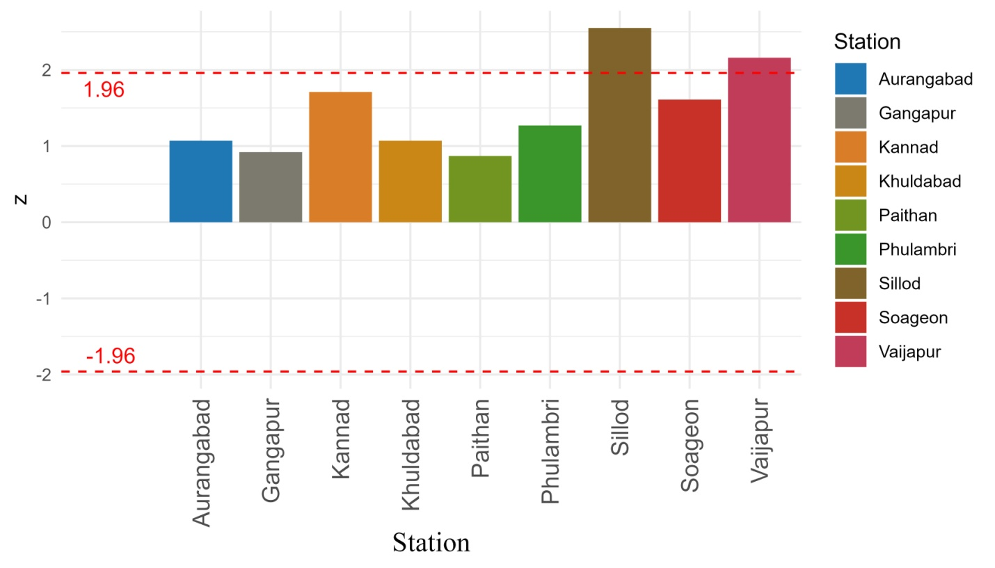
Fig 1. Mann Kendall Z score values of Kharif season precipitation data over different station of Aurangabad district
In contrast, Vaijapur and Soageon, while still exhibiting increasing trends, demonstrate weaker associations. Vaijapur has a z-score of 2.16, indicating a noticeable positive trend, but its Tau value of 0.32 and p-value of 0.03 suggest that, although significant, the trend is not as pronounced as that observed in Sillod. Soageon, with a z-score of 1.61 and a Tau value of 0.24, indicates a moderate trend, though its p-value of 0.11 places it just outside the typical significance threshold, indicating a less statistically reliable trend compared to Vaijapur. On the other hand, Paithan and Gangapur show minimal or no significant trends. Paithan, with a z-score of 0.87 and Tau value of 0.13, presents a very weak increasing trend, and its p-value of 0.39 suggests that the observed trend is not statistically significant. Similarly, Gangapur, with a z-score of 0.92 and Tau of 0.14, also exhibits a weak trend, and its p-value of 0.36 further supports the conclusion that the trend is not statistically

Table 2. Mann kendall trend analysis statistics for Kharif season
Station | z | S | Tau | pvalue
Aurangabad | 1.07 | 44.00 | 0.16 | 0.29
Sillod | 2.55 | 104.00 | 0.38 | 0.01*
Vaijapur | 2.16 | 88.00 | 0.32 | 0.03*
Soageon | 1.61 | 66.00 | 0.24 | 0.11
Gangapur | 0.92 | 38.00 | 0.14 | 0.36
Kannad | 1.71 | 70.00 | 0.25 | 0.09
Phulambri | 1.27 | 52.00 | 0.19 | 0.21
Khuldabad | 1.07 | 44.00 | 0.16 | 0.29
Paithan | 0.87 | 36.00 | 0.13 | 0.39
* represents a statistical significant at 95 %
Trend analysis of the Rabi rainfall over the Aurangabad district of Maharashtra
The Mann-Kendall test for trend analysis, conducted on the Rabi season data reveals a range of trend behaviours (Table 3 and Fig. 2). Many stations exhibit minimal or no statistically significant trends. Aurangabad, with a z-score of -0.61, indicates a slight decreasing trend, but its p-value of 0.55 suggests this trend is not statistically significant, implying the observed decrease could be due to random variability rather than a true underlying trend. Similarly, Gangapur and Phulambri, with z-scores of -0.11 and -0.10 respectively, also display weak decreasing trends, but their high p-values of 0.92 indicate these trends are highly unlikely to be meaningful, as they exceed the typical significance threshold of 0.05.
The remaining stations, such as Sillod, Vaijapur, Soageon, Kannad, Khuldabad, and Paithan, all show very small increasing trends, though these are weak and statistically insignificant. Sillod, Vaijapur, and Soageon exhibit z-scores of 0.29, 0.22, and 0.28, respectively, with corresponding p-values of 0.77, 0.83, and 0.78, suggesting any observed increases are not statistically significant. Kannad and Khuldabad, with z-scores of 0.16 and -0.41, also display weak trends, with p-values of 0.87 and 0.68, reinforcing the lack of statistical significance. Finally, Paithan, with a z-score of -0.16 and a p-value of 0.87, shows a very slight decreasing trend, which, like the other stations, is not statistically significant.

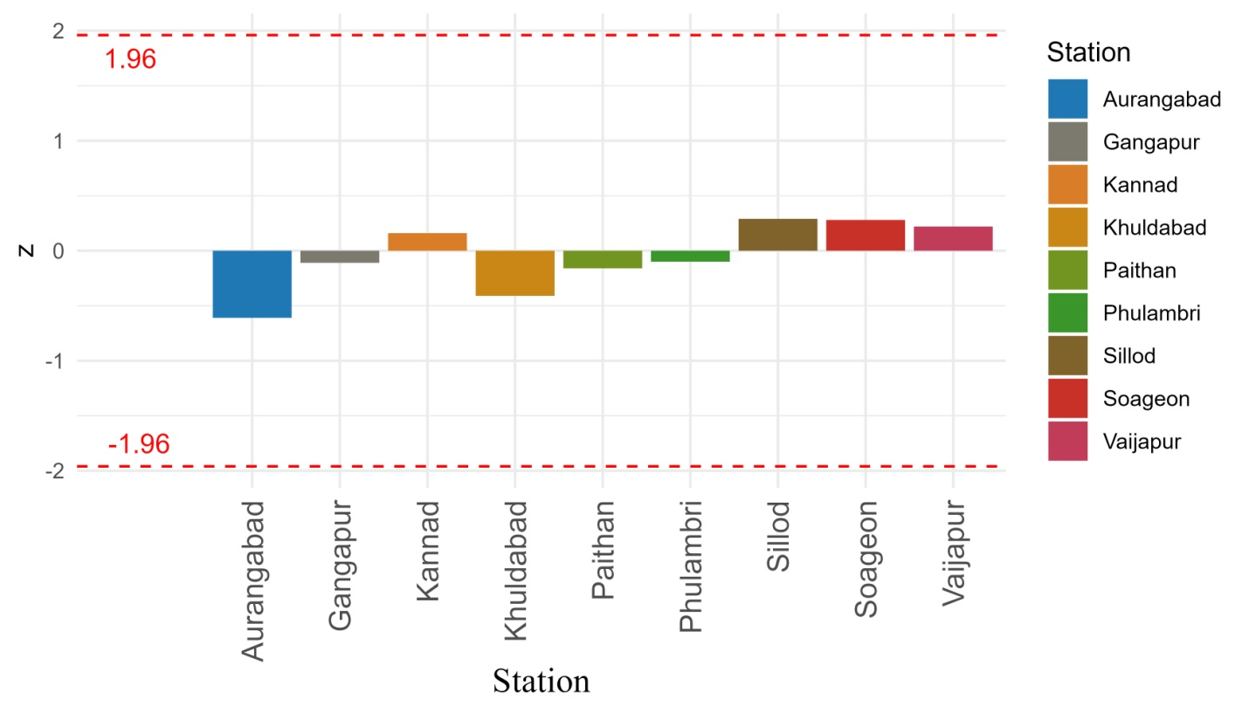
Fig 2. Mann Kendall Z score values of Rabi season precipitation data over different station of Aurangabad district
Table 3. Mann kendall trend analysis statistics for Rabi season.
Station | z | S | Tau | pvalue
Aurangabad | -0.61 | -82.00 | -0.06 | 0.55
Sillod | 0.29 | 40.00 | 0.03 | 0.77
Vaijapur | 0.22 | 30.00 | 0.02 | 0.83
Soageon | 0.28 | 39.00 | 0.03 | 0.78
Gangapur | -0.11 | -15.00 | -0.01 | 0.92
Kannad | 0.16 | 22.00 | 0.02 | 0.87
Phulambri | -0.10 | -14.00 | -0.01 | 0.92
Khuldabad | -0.41 | -56.00 | -0.04 | 0.68
Paithan | -0.16 | -22.00 | -0.02 | 0.87

Trend analysis of the summer rainfall over the Aurangabad district of Maharashtra
The Mann-Kendall analysis of trends across multiple stations (Table 4 and Fig. 3) during the summer season reveals minimal and statistically insignificant patterns. At Aurangabad, the z-score of -0.26 and the p-value of 0.79 suggest a slight decreasing trend, but the p-value being much higher than the typical 0.05 significance level indicates the trend is not statistically significant, implying it may be due to random variability. Similarly, Phulambri exhibits a very weak decreasing trend (z-score of -0.42, p-value of 0.68), which, like Aurangabad, is not significant, reinforcing the absence of a true downward trend at this station.
Regarding the other stations, Sillod and Vaijapur show very slight increasing trends (z-scores of 0.28 and 0.71, respectively), but their p-values of 0.78 and 0.48 indicate these trends are not statistically significant. Gangapur and Kannad display almost no trend at all, with z-scores near zero (0.00 and 0.05) and p-values of 1.00 and 0.96, respectively, signifying no meaningful trend. Khuldabad also exhibits a weak decreasing trend (z-score of -0.55, p-value of 0.58), which is not statistically significant.
Among the stations, Soageon stands out with a higher z-score of 1.52 and a Tau value of 0.15, suggesting a modest increasing trend. However, the p-value of 0.13 still exceeds the commonly accepted 0.05 threshold, indicating this trend is not statistically significant. Finally, Paithan shows a decreasing trend with a z-score of -0.65, but its p-value of 0.51 falls outside the statistical significance level.
Table 4. Mann kendall trend analysis statistics for summer season.
Station | z | S | Tau | pvalue
Aurangabad | -0.26 | -36.00 | -0.03 | 0.79
Sillod | 0.28 | 38.00 | 0.03 | 0.78
Vaijapur | 0.71 | 96.00 | 0.07 | 0.48
Soageon | 1.52 | 204.00 | 0.15 | 0.13
Gangapur | 0.00 | 1.00 | 0.00 | 1.00
Kannad | 0.05 | 7.00 | 0.01 | 0.96
Phulambri | -0.42 | -57.00 | -0.04 | 0.68
Khuldabad | -0.55 | -75.00 | -0.05 | 0.58
Paithan | -0.65 | -88.00 | -0.06 | 0.51
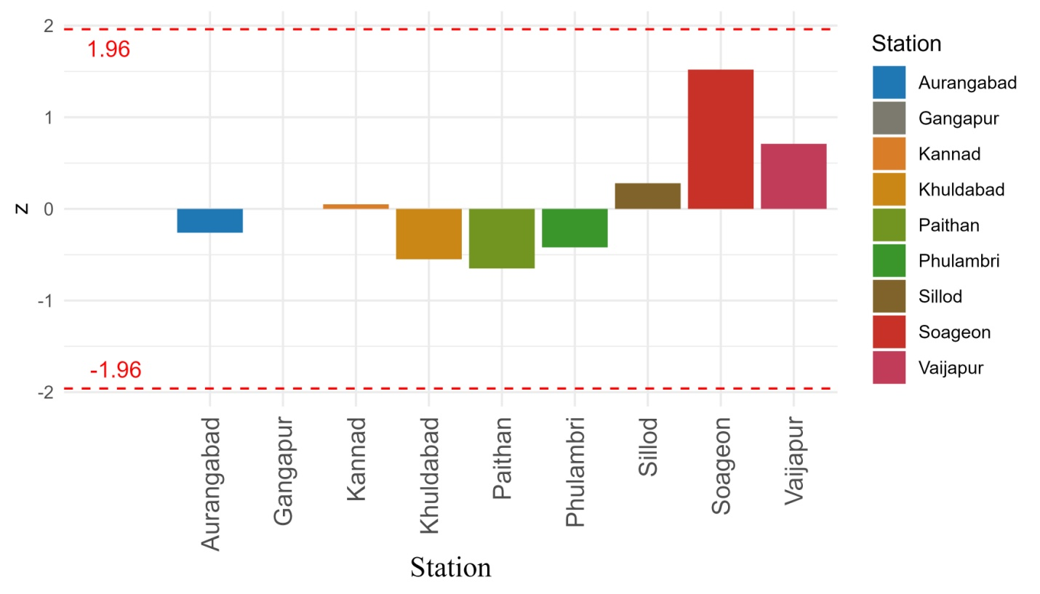
Fig. 3. Mann Kendall Z score values of summer season precipitation data over different station of Aurangabad district
Trend analysis of the Annual rainfall over the Aurangabad district of Maharashtra
The Mann-Kendall trend analysis performed on the annual data across various stations reveals a range of trend patterns (Table 5). A statistically significant increasing trend was observed at the Sillod station, while the other stations displayed weak or insignificant trends. At Sillod, the z-score of 2.30 and a p-value of 0.02 indicate a clear positive change over the study period, which is further corroborated by the moderate upward trend indicated by the Tau value of 0.22. In contrast, stations such as Aurangabad, Gangapur, Phulambri, Khuldabad, and Paithan exhibited weak or no significant trends. Aurangabad, with a z-score of 0.12 and a p-value of 0.90, showed no discernible trend, and similar insignificant trends were observed at Gangapur (z = -0.31, p = 0.75), Phulambri (z = -0.39, p = 0.70), and Khuldabad (z = 0.03, p = 0.98), suggesting relative stability in the data at these stations over the annual period. Stations like Vaijapur (z = 1.30, p = 0.19), Soageon (z = 1.46, p = 0.14), and Kannad (z = 1.09, p = 0.28) displayed modest trends, but the lack of statistical significance (p > 0.05) and the relatively low Tau values (0.12, 0.14, and 0.10, respectively) indicate weak or negligible trends in their data.
Table 5. Mann kendall trend analysis statistics for Annual Time-series
Station | z | S | Tau | pvalue
Aurangabad | 0.12 | 17.00 | 0.01 | 0.90
Sillod | 2.30 | 309.00 | 0.22 | 0.02
Vaijapur | 1.30 | 175.00 | 0.12 | 0.19
Soageon | 1.46 | 197.00 | 0.14 | 0.14
Gangapur | -0.31 | -43.00 | -0.03 | 0.75
Kannad | 1.09 | 147.00 | 0.10 | 0.28
Phulambri | -0.39 | -53.00 | -0.04 | 0.70
Khuldabad | 0.03 | 5.00 | 0.00 | 0.98
Paithan | -0.21 | -29.00 | -0.02 | 0.83

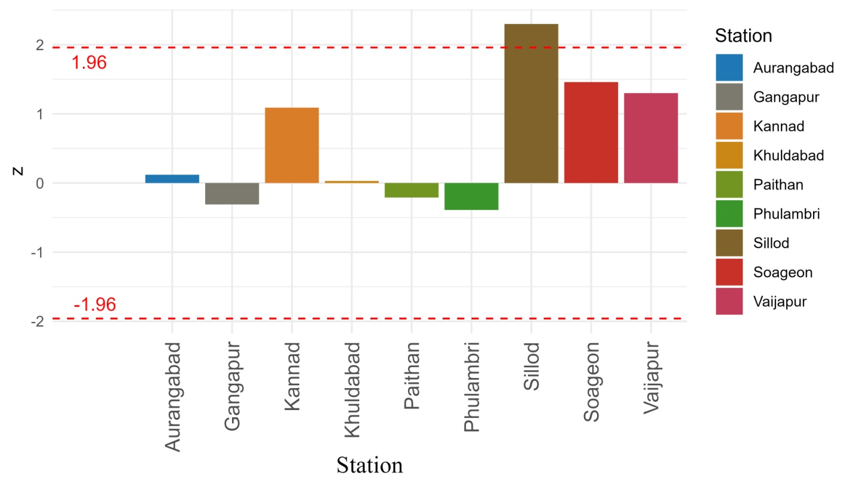
Fig. 4. Mann Kendall Z score values of Annual precipitation data over different station of Aurangabad district

Conclusions
In conclusion, the trend analysis across the Aurangabad district for Kharif, Rabi, Summer, and Annual rainfall seasons using the Mann-Kendall test reveals a mix of significant and insignificant trends. While Sillod consistently displays significant increasing trends across all seasons, particularly in the Kharif and Annual data, most other stations, such as Vaijapur, Soageon, Gangapur, Phulambri, and Paithan, exhibit weak or statistically insignificant trends, indicating stability with occasional fluctuations. The Rabi and Summer seasons, in particular, show no meaningful trends, as confirmed by high p-values across the stations. The central tendency and variability analysis further supports this stability, with stations like Khuldabad and Paithan showcasing high mean values and variability, while Sillod demonstrates consistent positive changes. In light of these findings, agricultural practices in the district may need to adapt to the observed stability, especially in areas like Sillod, where increasing trends in rainfall could benefit crop planning, irrigation schedules, and water resource management. For stations with weak or no significant trends, strategies such as rainwater harvesting, drought-resistant crops, and improved soil moisture management could be more effective in ensuring sustained productivity, particularly during variable seasons. Overall, while some stations exhibit notable trends, the data across the district is predominantly stable, with Sillod emerging as a key station displaying a consistent positive trend in rainfall over the study period, suggesting a potential opportunity for targeted agricultural interventions.
References
Ahmad, I., De-shan, T., Wang, T., Wang, M., & Wagan, B. (2015). Precipitation Trends over Time Using Mann-Kendall and Spearman’s rho Tests in Swat River Basin, Pakistan. Advances in Meteorology (Vol. 2015, p. 1). Hindawi Publishing Corporation. https://doi.org/10.1155/2015/431860
Ahmad, I., Tang, D. S., Wang, M., & Hashim, S. (2014). Trend Analysis on Precipitation Time Series Data in Munda Catchment, Pakistan. Applied Mechanics and Materials (Vol. 692, p. 97). Trans Tech Publications. https://doi.org/10.4028/www.scientific.net/amm.692.97
Ali, G., Sajjad, M., Kanwal, S., Xiao, T., Khalid, S., Shoaib, F., & Gul, H. N. (2021). Spatial–temporal characterization of rainfall in Pakistan during the past half-century (1961–2020).Scientific Reports (Vol. 11, Issue 1). Nature Portfolio. https://doi.org/10.1038/s41598-021-86412-x
Bhatti, U. A., Masud, M., Bazai, S. U., & Tang, H. (2023). Editorial: Investigating AI-based smart precision agriculture techniques. Frontiers in Plant Science (Vol. 14). Frontiers Media. https://doi.org/10.3389/fpls.2023.1237783
Kamal, N., & Pachauri, S. (2019). Mann-Kendall, and Sen’s Slope Estimators for Precipitation Trend Analysis in North-Eastern States of India. International Journal of Computer Applications (Vol. 177, Issue 11, p. 7). https://doi.org/10.5120/ijca2019919453
Li, C., Zhang, H., Gong, X., Wei, X., & Yang, J. (2019). Precipitation Trends and Alteration in Wei River Basin: Implication for Water Resources Management in the Transitional Zone between Plain and Loess Plateau, China. Water (Vol. 11, Issue 11, p. 2407). Multidisciplinary Digital Publishing Institute. https://doi.org/10.3390/w11112407
Menenti, M., Li, X., Li, J., Yang, K., Pellicciotti, F., Mancini, M., Shi, J., Escorihuela, M., Zheng, C., Chen, Q., Lu, J., Zhou, J., Hu, G., Ren, S., Zhang, J., Liu, Q., Qiu, Y., Huang, C., Zhou, J., … Paolini, G. (2021). Multi-Source Hydrological Data Products to Monitor High Asian River Basins and Regional Water Security. Remote Sensing (Vol. 13, Issue 24, p. 5122). Multidisciplinary Digital Publishing Institute. https://doi.org/10.3390/rs13245122
Mohammed, Y., Yimer, F., Tadesse, M., & Tesfaye, K. (2019). Variability and trends of rainfall extreme events in north east highlands of Ethiopia. International Journal of Hydrology (Vol. 2, Issue 5). MedCrave Group. https://doi.org/10.15406/ijh.2018.02.00131
Nema, S., Awasthi, M. K., & Nema, R. K. (2016). Trend Analysis of Annual and Seasonal Rainfall in Tawa command Area. International Journal of Environment Agriculture and Biotechnology (Vol. 1, Issue 4, p. 952). Infogain Publication. https://doi.org/10.22161/ijeab/1.4.46
Patakamuri, S. K., Muthiah, K., & Sridhar, V. (2020). Long-Term Homogeneity, Trend, and Change-Point Analysis of Rainfall in the Arid District of Ananthapuramu, Andhra Pradesh State, India. In S. K. Patakamuri, K. Muthiah, & V. Sridhar, Water (Vol. 12, Issue 1, p. 211). Multidisciplinary Digital Publishing Institute. https://doi.org/10.3390/w12010211
Pelosi, A., Belfiore, O. R., D’Urso, G., & Chirico, G. B. (2022). Assessing Crop Water Requirement and Yield by Combining ERA5-Land Reanalysis Data with CM-SAF Satellite-Based Radiation Data and Sentinel-2 Satellite Imagery. Remote Sensing (Vol. 14, Issue 24, p. 6233). Multidisciplinary Digital Publishing Institute. https://doi.org/10.3390/rs14246233
Song, Z., Xia, J., She, D., Zhang, L., Hu, C., & Zhao, L. (2020). The development of a Nonstationary Standardized Precipitation Index using climate covariates: A case study in the middle and lower reaches of Yangtze River Basin, China. Journal of Hydrology (Vol. 588, p. 125115). Elsevier BV. https://doi.org/10.1016/j.jhydrol.2020.125115
Srivastava, P. K., Pradhan, R. K., Petropoulos, G. P., Pandey, V., Gupta, M., Yaduvanshi, A., Jaafar, W. Z. W., Mall, R. K., & Sahai, A. K. (2021). Long-Term Trend Analysis of Precipitation and Extreme Events over Kosi River Basin in India. Multidisciplinary Digital Publishing Institute. https://doi.org/10.3390/w13121695
Vivekanandan, N. (2007). A Comparative Study of Rainfall Estimates Using Six Statistical Distributions. In N. Vivekanandan, AIP conference proceedings. American Institute of Physics. https://doi.org/10.1063/1.2767017
Wang, F., Wang, Z., Yang, H., Di, D., Zhao, Y., Liang, Q., & Hussain, Z. (2020). Comprehensive evaluation of hydrological drought and its relationships with meteorological drought in the Yellow River basin, China. Journal of Hydrology (Vol. 584, p. 124751). Elsevier BV. https://doi.org/10.1016/j.jhydrol.2020.124751
Waseem, M., Ahmad, I., Mujtaba, A., Tayyab, M., Chen, S., Lü, H., & Dong, X. (2020). Spatiotemporal Dynamics of Precipitation in Southwest Arid-Agriculture Zones of Pakistan. Sustainability (Vol. 12, Issue 6, p. 2305). Multidisciplinary Digital Publishing Institute. https://doi.org/10.3390/su12062305
Yadav, A. N., & Singh, V. (2023). Long-term climatic trends in rainfall pattern analysis over Madhya Pradesh. In A. N. Yadav & V. Singh, International Journal of Geography Geology and Environment (Vol. 5, Issue 1, p. 32). https://doi.org/10.22271/27067483.2023.v5.i1a.139

