Rainfall Variability and Drought Characteristics in the Mysuru Region of Karnataka: Implications for Agriculture

Abstract

Aim:
The study aimed to analyze long-term rainfall variability, drought characteristics, and rainfall trends in the Mysuru region of Karnataka and to understand their implications for agricultural sustainability in a semi-arid environment. A long-term observational and statistical study design was adopted using historical rainfall data and standard drought and trend analysis techniques. The study was conducted for the Mysuru region of Karnataka, India, using 58 years (1968–2025) of observed rainfall data collected from the Weather Observatory of the Agrometeorological Field Unit (AMFU), Organic Farming Research Station (OFRS), Naganahalli, Mysuru.
Annual rainfall data were analyzed using descriptive statistics to assess interannual variability. Rainfall anomalies were evaluated using the Rainfall Anomaly Index (RAI), and drought severity was assessed using the Standardized Precipitation Index (SPI-12). Long-term rainfall trends were examined using non-parametric Mann–Kendall test and Sen’s slope estimator.
The long-term mean annual rainfall of the region was approximately 730 mm, with annual rainfall ranging from about 244 mm to 1381 mm, indicating high interannual variability. About 30–35% of the years were classified as deficit rainfall years, confirming the drought-prone nature of the region. RAI analysis showed frequent negative anomalies. SPI-12 analysis indicated repeated moderate to severe drought events, with SPI values falling below −1.0 in several years and below −1.5 during severe drought periods. Trend analysis revealed no statistically significant long-term trend, with Sen’s slope indicating a marginal change close to zero. The study concludes that agricultural risk in the Mysuru region is primarily driven by rainfall variability and drought recurrence rather than changes in mean rainfall. Strengthening climate-resilient agricultural practices, drought preparedness, soil and water conservation, and weather-based agro-advisory services is essential for sustainable agriculture in the region.

Keywords
Rainfall variability; Drought analysis; Rainfall Anomaly Index; Standardized Precipitation Index; Mann–Kendall test; Sen’s slope; Agriculture; Mysuru

1. Introduction
Rainfall is the most critical climatic factor governing agricultural productivity, water resource availability, and livelihood security in tropical and semi-arid regions. In India, nearly 55–60 per cent of cultivated land remains rainfed, making agriculture highly sensitive to variations in rainfall amount, timing, and distribution (Gadgil, 2003; Reddy, 2012). Any deviation from normal rainfall conditions often leads to droughts, crop failure, soil degradation, and economic stress among farming communities (Wilhite and Glantz, 1985; Wilhite, 2000).
Climate change studies indicate that rainfall behaviour over the Indian subcontinent is increasingly characterized by enhanced variability and a rise in extreme events, rather than uniform changes in mean rainfall (IPCC, 2014; IPCC, 2021). Several researchers have reported an increase in the frequency of intense rainfall events and droughts across different regions of India, even where long-term annual rainfall trends remain statistically insignificant (Guhathakurta and Rajeevan, 2008; Dash and Mamgain, 2011; Kothawale and Rajeevan, 2017). Recent studies further highlight increasing rainfall variability and drought risk at sub-regional and station scales, emphasizing the importance of localized climate analysis for adaptation planning (Pai et al., 2014; Rao et al., 2016).
Drought is among the most devastating climatic hazards affecting agriculture, resulting in soil moisture stress, reduced crop growth, groundwater depletion, fodder scarcity, and increased vulnerability of small and marginal farmers (Sivakumar and Stefanski, 2011; FAO, 2017). Conversely, extreme rainfall events can cause flooding, soil erosion, nutrient leaching, crop lodging, and post-harvest losses (Fischer et al., 2005; Trenberth, 2011). Variability in monsoon rainfall has also been linked to large-scale climate drivers such as ENSO and the Indian Ocean Dipole, which further amplify rainfall uncertainty over southern India (Rajeevan et al., 2012; Roxy et al., 2015).
The Mysuru region of Karnataka lies in the Southern Dry Zone, characterized by moderate annual rainfall and high interannual variability. Agriculture in this region is predominantly rainfed, with finger millet (ragi), maize, pulses, paddy, and horticultural crops forming the major cropping systems. Farmers frequently experience delayed onset of the southwest monsoon, prolonged dry spells, and occasional extreme rainfall events, resulting in unstable crop yields and reduced farm income (Gadgil and Rao, 2000; Subash and Gangwar, 2014).
Assessment of long-term rainfall variability and drought characteristics at the local scale is therefore essential for effective agricultural and water resource management. While regional and national-level studies provide broad insights into monsoon behaviour (Sikka and Gadgil, 1980; Gadgil, 2003), station-level analyses are more useful for location-specific agro-advisory services and climate-resilient planning. Indices such as the Rainfall Anomaly Index (RAI) and the Standardized Precipitation Index (SPI) are widely used to characterize rainfall anomalies and drought severity (van Rooy, 1965; McKee et al., 1993; WMO, 2012). Several studies have demonstrated the effectiveness of SPI in assessing agricultural drought impacts in rainfed regions of India (Mishra and Singh, 2010; Kumar et al., 2016). Similarly, non-parametric statistical tests such as the Mann–Kendall test and Sen’s slope estimator have been widely applied to detect long-term trends in hydro-climatic data due to their robustness against non-normality and outliers (Mann, 1945; Kendall, 1975; Sen, 1968; Burn and Elnur, 2002).
Despite the availability of long-term rainfall records from agrometeorological observatories in Karnataka, comprehensive studies integrating rainfall variability, drought indices, and trend analysis at the station level remain limited for the Mysuru region. The present study addresses this gap by utilizing long-term observational rainfall data from the Agrometeorological Field Unit (AMFU), Naganahalli, Mysuru, to provide a detailed assessment of rainfall behaviour and its implications for agricultural sustainability. In this context, the present study aims to
(i) analyze long-term interannual rainfall variability in the Mysuru region;
(ii) assess rainfall anomalies and drought characteristics using RAI and SPI;
(iii) detect long-term rainfall trends using the Mann–Kendall test and Sen’s slope estimator; and
(iv) interpret the implications of rainfall variability and droughts for agricultural planning and resilience.

2. Materials and Methods

2.1 Study Area
The study was conducted for the Mysuru region of Karnataka, which falls under the Southern Dry Zone (Agro-climatic Zone–6). The region is characterized by semi-arid climatic conditions with moderate annual rainfall and high interannual variability. Agriculture in the region is predominantly rainfed, with major crops including finger millet (ragi), maize, pulses, paddy, and horticultural crops. Rainfall variability strongly influences crop productivity and water availability in this region.

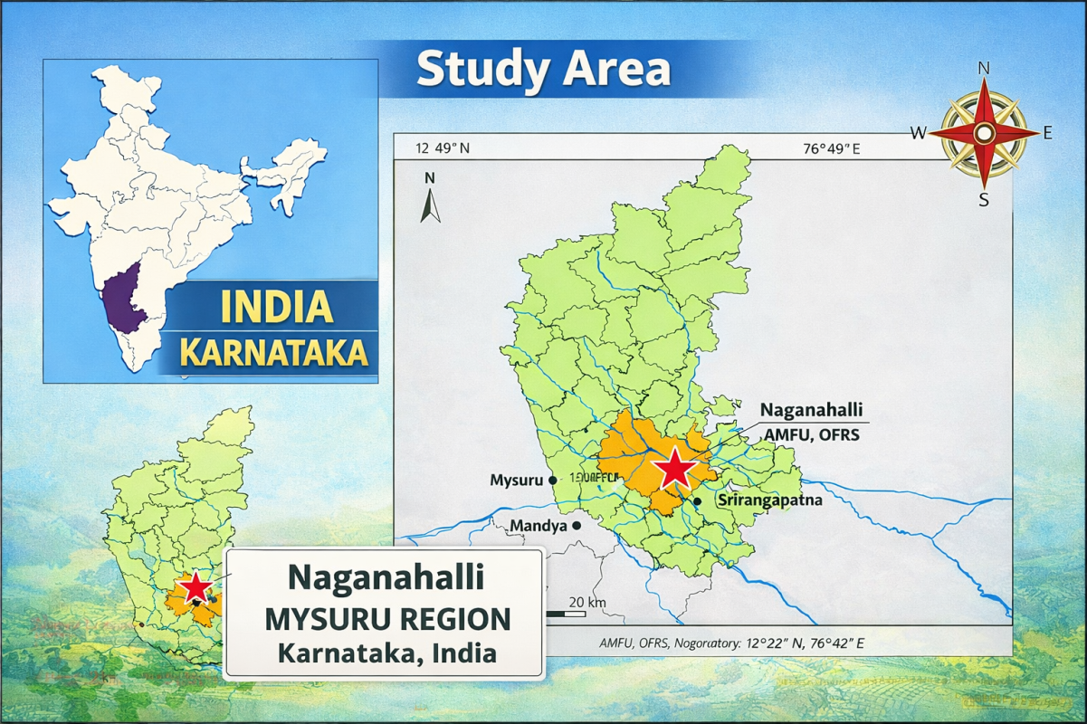
picture 1- Study area

2.2 Source of Rainfall Data
The study utilized 58 years (1968–2025) of observed rainfall data collected from the Weather Observatory of the Agrometeorological Field Unit (AMFU), Organic Farming Research Station (OFRS), Naganahalli, Mysuru. The observatory follows standard procedures for rainfall measurement using a non-recording rain gauge. The dataset consists of annual rainfall totals derived from daily observations.

2.3 Data Processing and Descriptive Analysis
The rainfall data were checked for consistency and completeness before analysis. Annual rainfall totals were computed by summing daily rainfall values for each year. The long-term mean annual rainfall (μ) was calculated using:
$$μ= \frac{1}{N}\sum_{i=1}^{N}{R_{i}}$$
where:
- R_{i} = annual rainfall for the i^{th} year (mm)
- N = number of years (58)
Descriptive statistics such as minimum, maximum, mean, and range were used to assess interannual rainfall variability.

2.4 Classification of Rainfall Years
Rainfall years were classified into deficit, normal, and excess categories based on deviation from the long-term mean annual rainfall, following the criteria of the India Meteorological Department (IMD):
- Deficit year: Annual rainfall < 80% of long-term mean
- Normal year: Annual rainfall between 80% and 120% of long-term mean
- Excess year: Annual rainfall > 120% of long-term mean
Percentage deviation (D) from the long-term mean was calculated as:
$$D\%= \frac{μR_{i}-μ }{μ}×100$$
where:
- Ri= annual rainfall of the ith year (mm)
- μ = long-term mean annual rainfall (mm)

2.5 Rainfall Anomaly Index (RAI)
The Rainfall Anomaly Index (RAI) was used to identify dry and wet years based on rainfall deviations from the long-term mean. RAI was calculated using the following expressions (van Rooy, 1965):

For positive anomalies (wet years):
$$RAI=3\left(\frac{R_{i}​-μ}{{\overline{M}}_{10}-μ}\right)$$

For negative anomalies (dry years):
$$RAI=-3\left(\frac{μ-R_{i}}{μ-{\overline{X}}_{10}}\right)$$
where:
- R_{i}​ = annual rainfall for the ith year (mm)
- μ = long-term mean annual rainfall (mm)
- $\overline{M}$₁₀ ​ = mean of the ten highest annual rainfall values
- $\overline{X}$₁₀ ​ = mean of the ten lowest annual rainfall values
Positive RAI values indicate wet years, while negative RAI values indicate dry years.

2.6 Standardized Precipitation Index (SPI)
The Standardized Precipitation Index (SPI) was used to assess drought severity and persistence. SPI was computed at a 12-month time scale (SPI-12), which is suitable for evaluating long-term moisture conditions affecting agriculture and water resources.
SPI was calculated as:
$$SPI= \frac{R_{i}- μ​ }{σ}$$
where:
- Ri​ = annual rainfall for the i^{th} year (mm)
- μ = long-term mean rainfall (mm)
- σ = standard deviation of annual rainfall (mm)
SPI values were classified as follows:
- SPI ≥ 0.0 : No drought / wet condition
- −1.0 ≤ SPI < 0.0 : Mild drought
- −1.5 ≤ SPI < −1.0 : Moderate drought
- SPI < −1.5 : Severe drought

2.7 Mann–Kendall Trend Test
The Mann–Kendall (MK) test, a non-parametric statistical test, was used to detect monotonic trends in annual rainfall time series. The MK test statistic (SSS) was computed as:
S=i=1∑n−1​j=i+1∑n​sign(Rj​−Ri​)
$$S= \sum_{i=1}^{n-1}{\sum_{j=i+1}^{n}{sign(R_{j}}}-R_{i})$$
where:
$$Sign\left(R_{j}-R_{i}\right)=\left\{\begin{aligned}+1, Rj​-Ri​>0 \\ 0, Rj​-Ri​=0 \\ -1, Rj​-Ri​<0 \end{aligned}\right.$$
The standardized test statistic (Z) was calculated to determine the significance of the trend.

2.8 Sen’s Slope Estimator
The magnitude of rainfall trend was estimated using Sen’s slope estimator, calculated as the median of all pairwise slopes:
$$Qi= \frac{R_{j}- R_{k}}{j-k}$$
where:
- Rj​ and Rk​ = rainfall values at times j and k (j > k)
A positive Sen’s slope indicates an increasing trend, while a negative value indicates a decreasing trend.

2.9 Agricultural Interpretation Framework
Rainfall variability, drought years, and extreme rainfall years identified through the above analyses were interpreted in relation to agricultural operations such as sowing, transplanting, flowering, and harvesting. The potential impacts on crop performance, soil erosion, nutrient loss, pest and disease incidence, and water availability were assessed to derive agricultural implications.

3. Results and Discussion
This section presents the results obtained from the statistical analyses described in Section 2 (Materials and Methods) and discusses their implications in the context of rainfall variability, drought characteristics, and agricultural sustainability in the Mysuru region. The results are organized sequentially following the analytical framework adopted in the study, beginning with interannual rainfall variability, followed by rainfall anomaly analysis, drought assessment using SPI, and trend analysis using non-parametric methods. All interpretations are supported by graphical representation for clarity.

3.1 Interannual Variability of Annual Rainfall
Interannual variability of annual rainfall in the Mysuru region during the period 1968–2025 is illustrated in Figure 1. The figure shows substantial year-to-year fluctuations in annual rainfall around the long-term mean, indicating high variability in rainfall distribution. Annual rainfall varied widely, with several years recording rainfall far below the mean and a few years experiencing exceptionally high rainfall.
The presence of frequent low rainfall years highlights the unreliability of rainfall in the region. At the same time, the occurrence of extreme rainfall peaks indicates sporadic wet years, which contribute significantly to the overall variability. Such wide fluctuations suggest that rainfall behaviour in the Mysuru region is highly erratic rather than stable.
High interannual rainfall variability, as observed in Figure 1, is a characteristic feature of semi-arid regions and poses serious challenges to rainfed agriculture. Years with rainfall well below the long-term mean are likely to experience delayed sowing, poor crop establishment, and moisture stress during critical crop growth stages. Conversely, years with exceptionally high rainfall may lead to surface runoff, soil erosion, nutrient leaching, and crop damage.

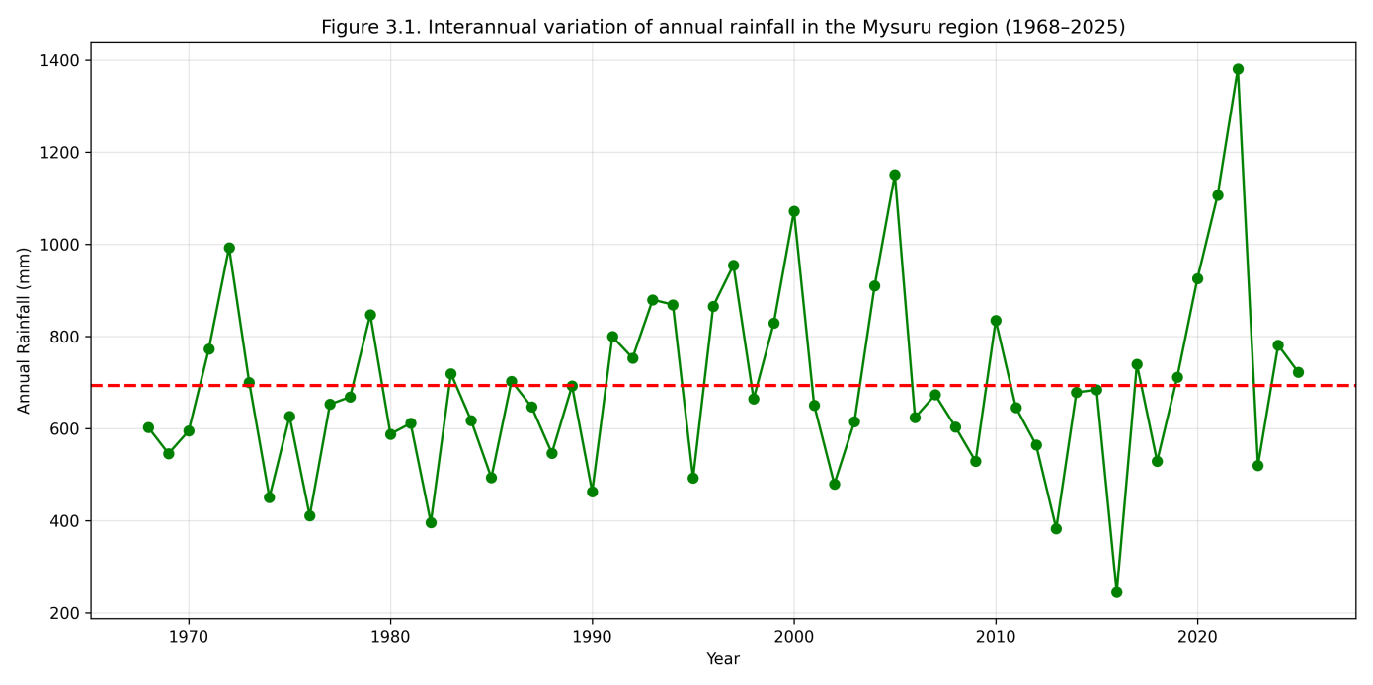
Figure.1. Interannual variation of annual rainfall in the Mysuru region during 1968–2025.
The absence of a consistent pattern in rainfall distribution suggests that farmers cannot rely on average rainfall conditions for agricultural planning. Instead, agricultural systems in the Mysuru region must be designed to cope with both rainfall deficit and excess. Similar findings of high rainfall variability without a consistent long-term pattern have been reported for other semi-arid regions of India (Gadgil, 2003; Guhathakurta and Rajeevan, 2008; Subash and Gangwar, 2014).
Overall, the pronounced interannual variability observed in this study emphasizes the importance of rainfall variability analysis as a foundation for drought assessment and climate-resilient agricultural planning.

3.1.1 Rainfall Anomaly Index (RAI)
Rainfall anomaly analysis using the Rainfall Anomaly Index (RAI) is presented in Figure 2. The RAI values exhibited substantial interannual variability with both positive and negative anomalies during the study period. Several years recorded negative RAI values, indicating dry conditions, while a few years showed strong positive anomalies, representing wet years.
The frequent occurrence of negative RAI values confirms the dominance of dry years in the Mysuru region. Extreme negative anomalies correspond to years of severe rainfall deficit, whereas extreme positive anomalies indicate excess rainfall years.
The RAI-based assessment provides clear evidence of alternating dry and wet phases, with a greater frequency of dry anomalies. This pattern explains the recurrent drought situations experienced in the region and reinforces the findings of interannual rainfall variability. The consistency between RAI results and rainfall classification further validates the robustness of the rainfall analysis.
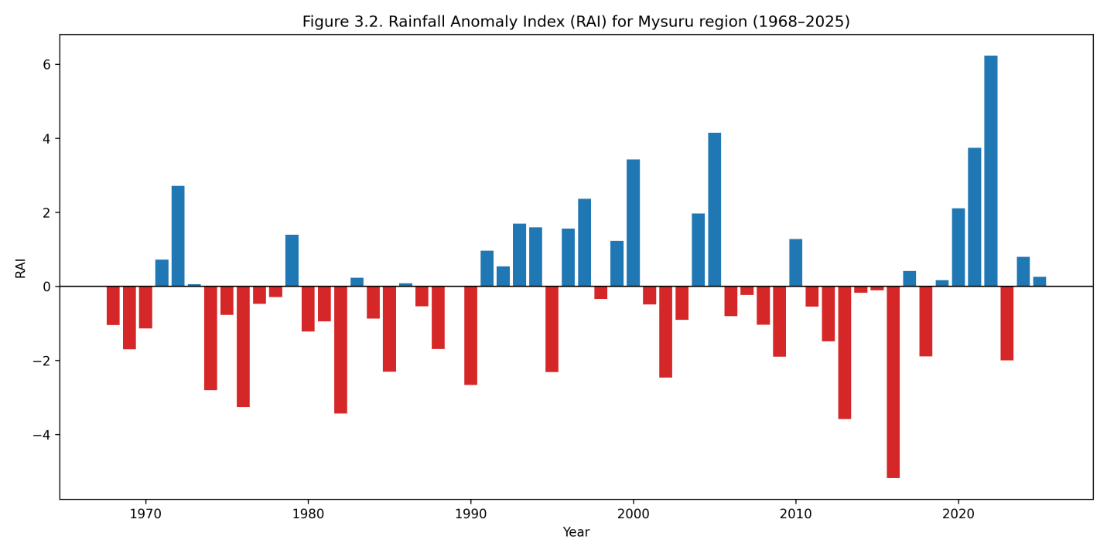
Similar patterns of frequent negative rainfall anomalies in semi-arid regions have been reported by van Rooy (1965), Gadgil (2003), and Subash and Gangwar (2014), emphasizing the vulnerability of rainfed agriculture to rainfall anomalies.
Figure 2. Rainfall Anomaly Index (RAI) for Mysuru region (1968–2025)
3.2 Classification of Rainfall Years
The classification of rainfall years based on deviation from the long-term mean rainfall is presented in Figure 3. The results indicate that the Mysuru region experienced a considerable number of deficit rainfall years during the study period, interspersed with normal and occasional excess rainfall years.
Normal rainfall years constituted a major proportion of the record; however, deficit years occurred frequently and were distributed throughout the entire study period. Excess rainfall years were relatively fewer but were characterized by substantially higher rainfall amounts compared to the long-term mean.
The frequent occurrence of deficit rainfall years confirms the drought-prone nature of the Mysuru region. Even though normal rainfall years were more common, the presence of repeated deficit years explains the recurring moisture stress conditions faced by rainfed crops.
Excess rainfall years, though less frequent, are equally important as they are associated with intense rainfall events, which may lead to soil erosion, nutrient leaching, and crop damage. The alternating pattern of deficit and excess rainfall years highlights the high climatic uncertainty prevailing in the region.
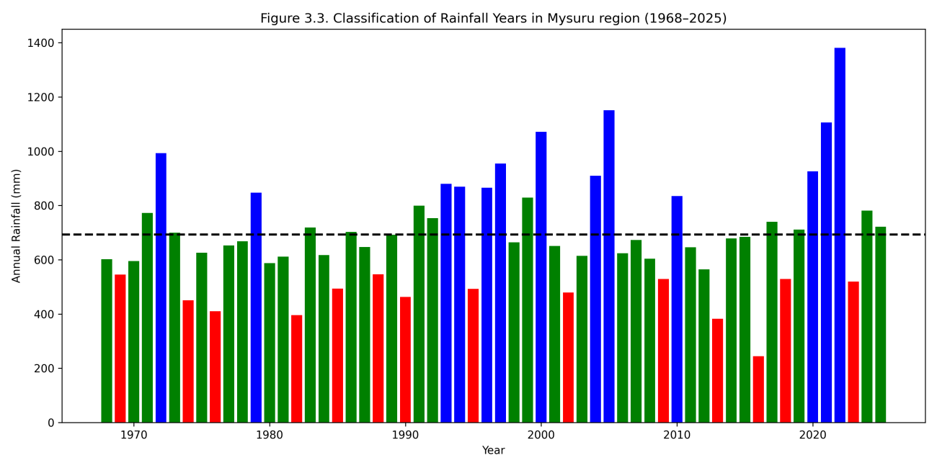
Similar rainfall classification patterns have been reported for other semi-arid regions of India, emphasizing the need for agricultural planning that accounts for both drought and excess rainfall risks (Guhathakurta and Rajeevan, 2008; Subash and Gangwar, 2014).

Figure 3. Classification of rainfall years in the Mysuru region during 1968–2025
Figure details
- Green bars → Normal rainfall years (80–120% of mean)
- Red bars → Deficit rainfall years (<80% of mean)
- Blue bars → Excess rainfall years (>120% of mean)
- Dashed line → Long-term mean annual rainfall
3.3 SPI-based Drought Characteristics
The SPI-12 based drought characteristics for the Mysuru region are illustrated in Figure 4. The SPI values exhibited pronounced interannual variability, with frequent negative values indicating recurring drought conditions during the study period.
Several years recorded SPI values below −1.0, representing moderate drought conditions, while a few years showed SPI values below −1.5, indicating severe drought events. The distribution of negative SPI values throughout the study period suggests that drought occurrence in the region is not confined to a specific decade but is a persistent climatic feature.
The SPI-based analysis provides a refined assessment of drought severity and persistence compared to total annual rainfall alone. The frequent occurrence of negative SPI values highlights the high vulnerability of the Mysuru region to meteorological droughts, particularly affecting rainfed agriculture.
Consecutive years with negative SPI values indicate drought persistence, which can severely reduce soil moisture availability, groundwater recharge, and fodder resources. Such prolonged moisture stress adversely affects crop productivity and increases the risk of crop failure.
Similar SPI-based drought patterns have been reported in other semi-arid regions of India, emphasizing the usefulness of SPI as a robust drought monitoring tool (McKee et al., 1993; WMO, 2012; Jain et al., 2013).
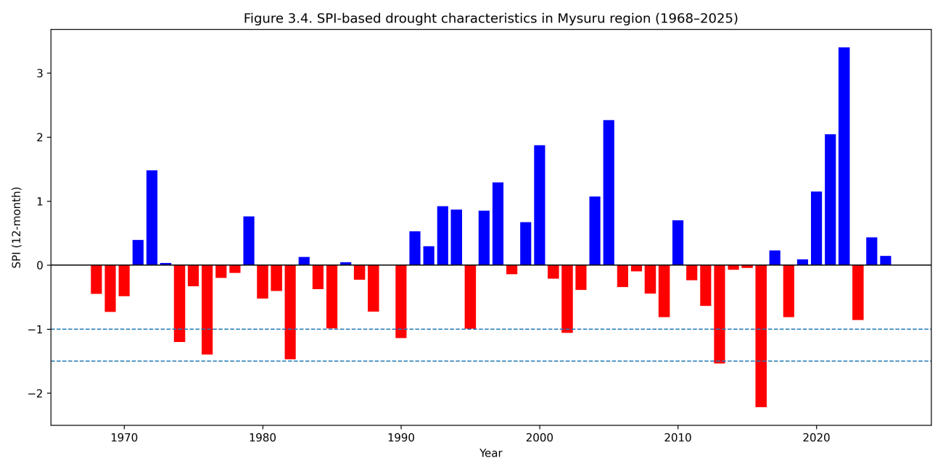
Figure 4. SPI-12 based drought characteristics in the Mysuru region during 1968–2025
Figure details (self-explanatory)
- Blue bars → Wet / non-drought years (SPI ≥ 0)
- Red bars → Drought years (SPI < 0)
- Dashed lines →
  - SPI = −1.0 → Moderate drought threshold
  - SPI = −1.5 → Severe drought threshold
3.4 Rainfall Trend Analysis
The long-term trend in annual rainfall for the Mysuru region during 1968–2025 is presented in Figure 5. The rainfall series exhibits substantial interannual variability with pronounced fluctuations throughout the study period. The fitted trend line indicates a very weak trend in annual rainfall over time.
The Mann–Kendall test results revealed that the observed trend was statistically non-significant, indicating the absence of a consistent monotonic increase or decrease in annual rainfall during the study period. The Sen’s slope estimator further confirmed the weak magnitude of the trend.
The absence of a statistically significant long-term trend suggests that changes in rainfall behaviour in the Mysuru region are not reflected through changes in total annual rainfall amounts. Instead, climatic variability is primarily manifested through frequent droughts and extreme rainfall events, as observed in the earlier analyses.
This finding has important implications for agricultural planning, as it indicates that farmers cannot depend on increasing rainfall to offset drought risk. Instead, agricultural systems must adapt to continued rainfall uncertainty and variability. Similar results have been reported for several regions of India, where rainfall variability and extremes dominate over long-term trends (Guhathakurta and Rajeevan, 2008; Kothawale and Rajeevan, 2017).
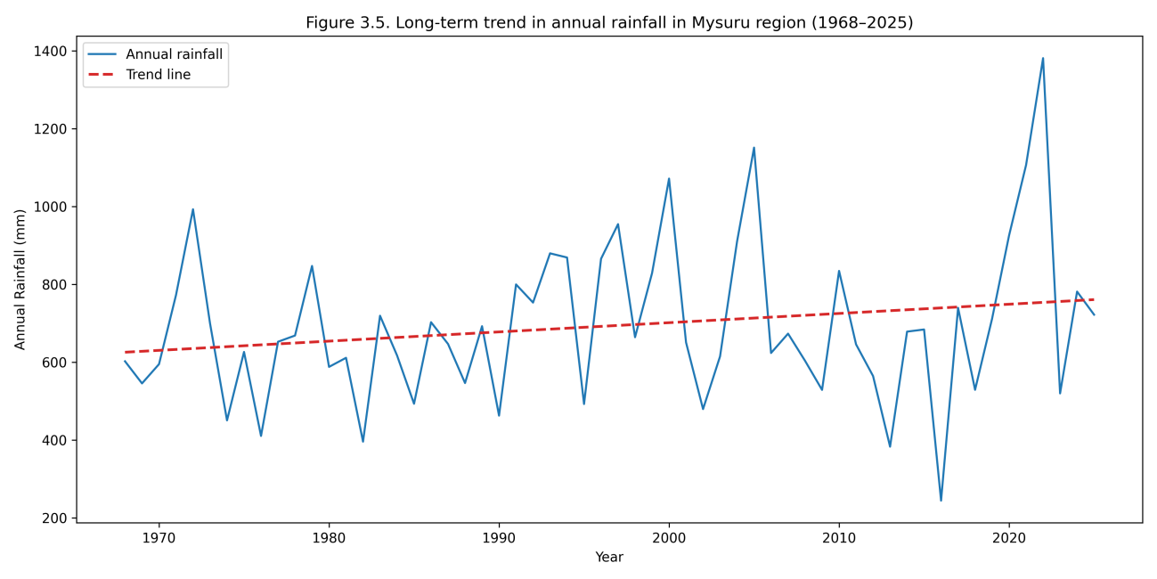
Figure 5. Long-term trend in annual rainfall in the Mysuru region during 1968–2025
Figure details
- Blue line → Observed annual rainfall
- Red dashed line → Long-term trend line (visual representation of Sen’s slope)

3.5 Agricultural Implications of Rainfall Variability and Drought
The results obtained from rainfall variability analysis, rainfall anomaly assessment, SPI-based drought analysis, and trend detection collectively indicate that agriculture in the Mysuru region is exposed to high climatic risk. The pronounced interannual variability in rainfall, frequent deficit years, and recurring droughts identified through SPI and RAI analyses directly influence agricultural operations and productivity.
Years characterized by below-normal rainfall and negative SPI values are likely to experience delayed sowing, poor crop establishment, and moisture stress during critical crop growth stages such as tillering, flowering, and grain filling. Rainfed crops such as finger millet, maize, and pulses are particularly vulnerable under such conditions. Recurrent droughts and drought persistence reduce soil moisture availability, limit groundwater recharge, and adversely affect fodder availability for livestock.
Conversely, excess rainfall years, although fewer in number, pose a different set of challenges. Intense rainfall events during these years can result in surface runoff, soil erosion, nutrient leaching, and crop lodging. In low-lying areas, excess rainfall may also cause waterlogging, leading to root damage and increased susceptibility to pests and diseases. Such impacts are especially critical for transplanted crops like paddy and for horticultural crops.
The absence of a significant long-term trend in annual rainfall further suggests that rainfall uncertainty is likely to persist in the future, emphasizing the need for agricultural systems that are resilient to both drought and excess rainfall. The findings underscore the importance of adopting climate-resilient agricultural practices, including flexible sowing windows, drought-tolerant crop varieties, improved soil and water conservation measures, rainwater harvesting, and efficient drainage management.
Overall, the agricultural implications derived from the rainfall analysis highlight the necessity of integrating climate information into farm-level decision-making and strengthening weather-based agro-advisory services to enhance agricultural sustainability in the Mysuru region.

4. Conclusions
The present study analyzed 58 years (1968–2025) of observed rainfall data from the Weather Observatory of the Agrometeorological Field Unit (AMFU), Organic Farming Research Station (OFRS), Naganahalli, Mysuru, to assess rainfall variability, drought characteristics, and long-term rainfall trends and their implications for agriculture.
The analysis showed that rainfall in the Mysuru region is highly variable, with frequent deviations from the long-term mean annual rainfall. Rainfall anomaly analysis using the Rainfall Anomaly Index (RAI) confirmed the recurrent occurrence of dry and wet anomalies, indicating unstable rainfall conditions. Classification of rainfall years revealed a high frequency of deficit rainfall years, establishing the drought-prone nature of the region.
The SPI-12 based drought assessment indicated frequent moderate to severe drought events, including instances of drought persistence, which adversely affect soil moisture availability, groundwater recharge, and fodder resources. Trend analysis using the Mann–Kendall test and Sen’s slope estimator showed no statistically significant long-term trend in annual rainfall, suggesting that climatic risk in the region is driven mainly by rainfall variability and extremes rather than changes in mean rainfall.
Overall, the findings highlight the need for climate-resilient and risk-based agricultural planning, including adoption of drought-tolerant crops, improved soil and water conservation practices, rainwater harvesting, and strengthened weather-based agro-advisory services to enhance agricultural sustainability in the Mysuru region.

5. Policy Implications and Recommendations
The findings of the present study have important implications for agricultural policy, water resource management, and climate adaptation planning in the Mysuru region. The dominance of rainfall variability, frequent drought occurrence, and occasional extreme rainfall events indicates that agricultural planning based solely on average rainfall conditions is inadequate.
Given the recurrent deficit rainfall years and moderate to severe droughts identified through SPI and RAI analyses, drought should be treated as a regular climatic risk rather than an occasional event. Policies should therefore prioritize institutionalized drought preparedness, including early warning systems, contingency crop planning, and location-specific weather-based agro-advisory services.
The absence of a significant long-term trend in annual rainfall highlights the need to focus policy interventions on managing rainfall variability and extremes. Promotion of drought-tolerant and short-duration crop varieties, flexible sowing windows, and crop diversification should be encouraged to reduce climate risk. Strengthening soil and water conservation measures, such as rainwater harvesting, farm ponds, and watershed development, is essential to enhance water availability during dry periods and efficiently utilize excess rainfall.
Overall, integrating climate information into agricultural decision-making and strengthening extension support will be critical for improving the resilience and sustainability of agriculture in the Mysuru region under variable climatic conditions.

References
- Burn, D. H., & Elnur, M. A. H. (2002). Detection of hydrologic trends and variability. Journal of Hydrology, 255, 107–122.
- Dash, S. K., & Mamgain, A. (2011). Changes in the frequency of different categories of temperature and precipitation extremes in India. Journal of Geophysical Research: Atmospheres, 116, D18111.
- FAO. (2017). Climate-smart agriculture sourcebook. Food and Agriculture Organization of the United Nations, Rome.
- Fischer, G., Shah, M., Tubiello, F. N., & van Velhuizen, H. (2005). Socio-economic and climate change impacts on agriculture. Climatic Change, 70, 319–350.
- Gadgil, S. (2003). The Indian monsoon and its variability. Annual Review of Earth and Planetary Sciences, 31, 429–467.
- Gadgil, S., & Rao, P. R. S. (2000). Farming strategies for a variable climate: A challenge. Current Science, 78(10), 1203–1215.
- Guhathakurta, P., & Rajeevan, M. (2008). Trends in rainfall pattern over India. International Journal of Climatology, 28, 1453–1469.
- IPCC. (2014). Climate Change 2014: Impacts, Adaptation and Vulnerability. Cambridge University Press, Cambridge.
- IPCC. (2021). Climate Change 2021: The Physical Science Basis. Cambridge University Press, Cambridge.
- Jain, S. K., Kumar, V., & Saharia, M. (2013). Analysis of rainfall and temperature trends in northeast India. International Journal of Climatology, 33, 968–978.
- Kendall, M. G. (1975). Rank Correlation Methods (4th ed.). Charles Griffin, London.
- Kothawale, D. R., & Rajeevan, M. (2017). Variability and trends in extreme rainfall events over India. Climate Dynamics, 48, 135–152.
- Kumar, V., Jain, S. K., & Singh, Y. (2016). Analysis of long-term rainfall trends in India. Hydrological Sciences Journal, 61(12), 2113–2124.
- Mann, H. B. (1945). Nonparametric tests against trend. Econometrica, 13, 245–259.
- McKee, T. B., Doesken, N. J., & Kleist, J. (1993). The relationship of drought frequency and duration to time scales. Proceedings of the 8th Conference on Applied Climatology, American Meteorological Society, 179–184.
- Mishra, A. K., & Singh, V. P. (2010). A review of drought concepts. Journal of Hydrology, 391, 202–216.
- Pai, D. S., Sridhar, L., Badwaik, M. R., & Rajeevan, M. (2014). Analysis of the daily rainfall events over India. Theoretical and Applied Climatology, 118, 593–607.
- Rajeevan, M., Unnikrishnan, C. K., & Preethi, B. (2012). Evaluation of multi-model seasonal forecasts. Climate Dynamics, 39, 287–303.
- Rao, K. K., Patwardhan, S. K., Kulkarni, A., Kamala, K., Sabade, S. S., & Kumar, K. K. (2016). Projected changes in rainfall extremes. Current Science, 110(7), 1215–1226.
- Reddy, S. R. (2012). Principles of Crop Production (4th ed.). Kalyani Publishers, New Delhi.
- Roxy, M. K., Tanimoto, Y., Preethi, B., Terray, P., & Krishnan, R. (2015). Intraseasonal SST–precipitation relationship. Climate Dynamics, 45, 2327–2341.
- Sen, P. K. (1968). Estimates of the regression coefficient based on Kendall’s tau. Journal of the American Statistical Association, 63, 1379–1389.
- Sikka, D. R., & Gadgil, S. (1980). On the maximum cloud zone and the ITCZ over India during the southwest monsoon. Monthly Weather Review, 108, 1840–1853.
- Sivakumar, M. V. K., & Stefanski, R. (2011). Climate change in agriculture. Climatic Change, 109, 13–16.
- Subash, N., & Gangwar, B. (2014). Statistical analysis of rainfall variability and trends. Journal of Agrometeorology, 16(1), 45–52.
- Trenberth, K. E. (2011). Changes in precipitation with climate change. Climate Research, 47, 123–138.
- van Rooy, M. P. (1965). A rainfall anomaly index independent of time and space. Notos, 14, 43–48.
- Wilhite, D. A. (2000). Drought as a natural hazard: Concepts and definitions. In Drought: A Global Assessment (Vol. 1). Routledge, London.
- Wilhite, D. A., & Glantz, M. H. (1985). Understanding the drought phenomenon: The role of definitions. Water International, 10, 111–120.
- World Meteorological Organization (WMO). (2012). Standardized Precipitation Index User Guide. WMO-No. 1090, Geneva.

