Original Research Article

Impact of Co-Contaminants (Microplastics and Others) on Heavy Metal/Metalloid Toxicity and Accumulation in Crop

Abstract
Ecosystem and environmental degradation have been escalated, resulting in significant contamination of agricultural soils with heavy metals, metalloids, and co-contaminants such as microplastics. This chapter examines the influence of co-contaminants, particularly microplastics, on the toxicity and accumulation of heavy metals and metalloids in crops. Heavy metal contamination, including cadmium (Cd), arsenic (As), and lead (Pb), presents significant risks to plant development, agricultural productivity, and food safety. The presence of co-contaminants, such as microplastics, further complicates the problem by interacting with heavy metals, altering their behavior and enhancing their absorption by plants. The chapter analyzes current studies on the effects of microplastics, in conjunction with toxic metals, on plant health. Microplastics may facilitate the absorption of heavy metals by plant roots, modify soil properties, or enhance the bioavailability of specific metals, hence increasing their accessibility to plants. This combination often results in heightened toxicity, oxidative stress, and alterations in plant metabolism. This chapter examines how the interplay of microplastics and heavy metals might intensify detrimental effects on crops, leading to elevated metal accumulation in consumable plant tissues and heightened risks to human health. The chapter underscores the importance of including heavy metals and microplastics in environmental and agricultural research by examining their synergistic effects. It promotes comprehensive research and the advancement of sustainable agriculture techniques to protect crops from the cumulative threats posed by these pollutants, ensuring safer and healthier food production for future generations.
Keywords: Ecosystem, pollutants, microplastics, Heavy Metals, Toxicity, Oxidative stress

Introduction
Environmental pollution has significantly escalated in recent decades, posing substantial threats to ecosystems, human health, and agricultural productivity (Wang et al., 2024). Among the numerous pollutants impacting the environment, heavy metals and microplastics have emerged as some of the most concerning, particularly in agricultural soils (Bian et al., 2024). Heavy metals such as cadmium (Cd), arsenic (As), and lead (Pb) are well-documented for their toxicity to plants, animals, and humans (Balali-Mood et al., 2021). These metals, often resulting from industrial activities, contaminated water sources, and improper waste disposal, have become persistent pollutants within agricultural ecosystems (Briffa et al., 2020). The toxic nature of these metals, coupled with their ability to accumulate in soil and plant tissues, presents considerable risks not only to plant growth but also to food safety (Table 1) (Angon et al., 2024). Heavy metal contamination in agricultural soils is a growing concern, as these pollutants can bioaccumulate over time, entering the food chain and ultimately affecting human health (Briffa et al., 2020). This poses serious health risks, including kidney damage, bone loss, and even cancer. Similarly, arsenic, which can be found in contaminated water used for irrigation, can lead to chronic health issues such as skin lesions, lung cancer, and cardiovascular diseases. Furthermore, lead exposure can impair neurological development, especially in children, leading to learning disabilities and behavioral issues (Balali-Mood et al., 2021). Therefore, comprehending the mechanisms by which heavy metals interact with plants and influence human health is essential for alleviating their detrimental impacts on the ecosystem and public welfare.
In addition to heavy metals, microplastics (MPs) have become an omnipresent environmental pollutant due to their widespread use and improper disposal (Figure 1). Microplastics, small plastic particles typically less than 5mm in size, are now recognized as a major environmental contaminant (Pothiraj et al., 2023). Their environmental durability is concerning because to their resistance to degradation and potential accumulation in many ecosystems, including agricultural soils. The introduction of microplastics into the soil primarily occurs through the use of plastic mulches in farming, the application of sewage sludge, and atmospheric deposition (Sajjad et al., 2022). These particles can alter the physical properties of the soil, affecting its structure, water retention, and nutrient availability. Moreover, microplastics can impact soil microbial communities, which play a vital role in nutrient cycling and plant health. Once in the soil, microplastics can alter its physical properties, affect microbial communities, and interact with other pollutants, including heavy metals, which can increase the bioavailability of these metals to plants (Aralappanavar et al., 2024). The combined effect of microplastics and heavy metals in agricultural soils is a growing area of research, as the interaction between these two pollutants may exacerbate the toxicity and bioaccumulation of heavy metals in crops (An et al., 2024). Microplastics can adsorb heavy metals on their surfaces, thereby increasing the concentration of metals in the soil and making them more available for uptake by plant roots (Lin et al., 2024). Additionally, microplastics can affect soil structure, water retention, and nutrient availability, which may further influence metal mobility and plant health (Chang et al., 2024). This chapter aims to explore the synergistic synergistic interactions between microplastics and heavy metals on plant health, focusing on metal toxicity, oxidative stress, and the accumulation of metals in edible plant tissues, which has significant implications for food safety and human health.

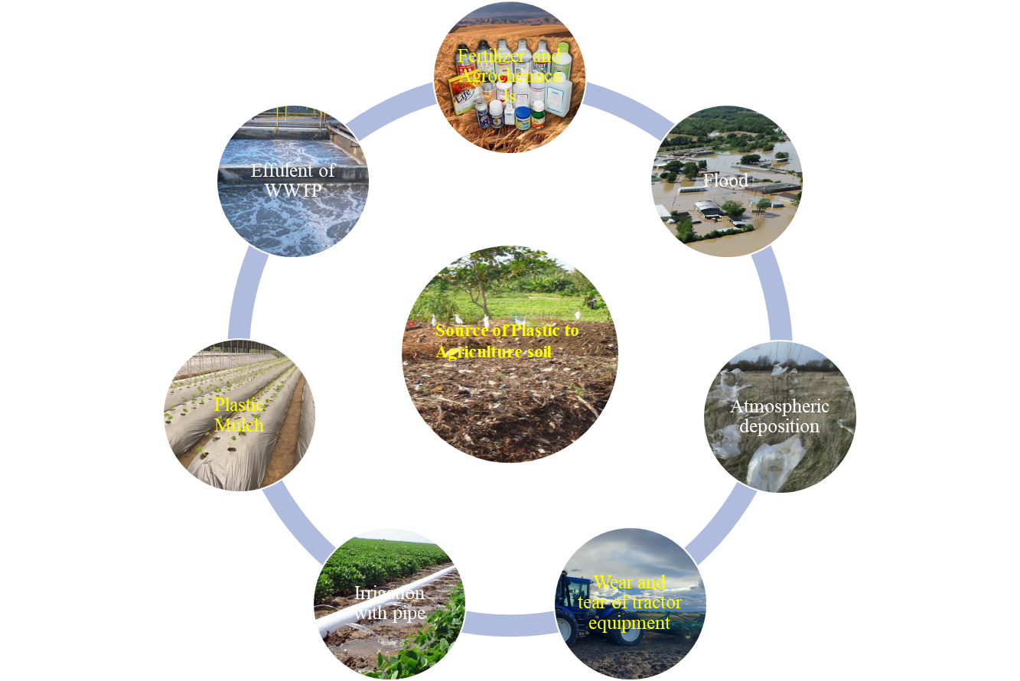
Figure 1: Sources and Pathways of Microplastic Pollution in Agriculture
Table 1: Sources and Toxicity of Common Heavy Metals in Agriculture
Heavy Metal | Major Sources | Toxic Effects on Plants | Toxic Effects on Humans | Reference
Arsenic (As) | Contaminated irrigation water, pesticides, industrial discharge | Inhibits root growth, stunted plant development, reduced photosynthesis | Carcinogenic, skin lesions, lung cancer, neurological damage | (Balali-Mood et al., 2021)
Cadmium (Cd) | Fertilizers, sewage sludge, industrial waste | Root and shoot damage, chlorosis, reduced chlorophyll content | Kidney damage, cancer, developmental issues | (Briffa et al., 2020)
Lead (Pb) | Industrial pollution, vehicle emissions, contaminated water | Stunted growth, reduced seed germination, poor nutrient uptake | Neurological disorders, developmental issues in children | (Angon et al., 2024)
Mercury (Hg) | Industrial discharge, fossil fuel combustion | Inhibits enzymatic activity, oxidative stress | Neurological disorders, kidney damage | (Balali-Mood et al., 2021)
Chromium (Cr) | Industrial effluents, contaminated water | Reduced root growth, leaf chlorosis, impaired photosynthesis | Carcinogenic, respiratory issues, liver damage | (Wang et al., 2024)
Nickel (Ni) | Contaminated irrigation water, fertilizers | Reduced seed germination, chlorosis, altered root development | Respiratory issues, kidney damage, skin allergies | (Bian et al., 2024)
Copper (Cu) | Agricultural fungicides, contaminated water, industrial emissions | Inhibited root growth, chlorosis, oxidative stress | Liver and kidney damage, gastrointestinal issues | (Pothiraj et al., 2023)
Zinc (Zn) | Agricultural fertilizers, mining, industrial waste | Inhibited seedling growth, stunted root and shoot development | Nausea, vomiting, abdominal pain, neurological issues | (Sajjad et al., 2022)
Cobalt (Co) | Fertilizers, industrial effluents | Leaf chlorosis, reduced root growth | Cardiovascular problems, thyroid dysfunction | (Lin et al., 2024)
Manganese (Mn) | Industrial emissions, fertilizers, sewage sludge | Reduced photosynthesis, leaf spotting, root toxicity | Neurological disorders, cognitive issues, respiratory distress | (Wang et al., 2024)

Heavy Metals and Their Impact on Crop Health
Heavy metals are toxic, non-biodegradable substances that persist in soil and accumulate over time, becoming a long-term threat to crops and the environment. These metals disrupt essential metabolic processes, hinder plant growth, and cause symptoms such as stunted growth, leaf chlorosis, wilting, reduced root elongation, and even plant death (Angon et al., 2024). Lead is known to inhibit root growth and reduce photosynthetic activity of plants by disrupting chlorophyll production (M. Gupta et al., 2024). High levels of lead can result in yellowing leaves and reduced photosynthetic rates, resulting in stunted growth and decreased overall plant health (Giannakoula et al., 2021). Cadmium, another heavy metal found in contaminated soils, is particularly dangerous due to its carcinogenic properties and ability to gather in the edible parts of crops. It disrupts essential cellular processes, causing oxidative stress within plant cells, leading to stunted growth, poor seed quality, and reduced crop yield (Genchi et al., 2020). Arsenic is another toxic heavy metal found in contaminated groundwater, particularly in regions where irrigation practices involve the use of water contaminated with industrial or agricultural runoff (Bhat et al., 2024). It interferes with the plant's ability to perform cellular respiration, leading to reduced growth, poor seed development, and, in some cases, complete crop failure (A. Gupta et al., 2022). Mercury, another dangerous heavy metal, is notorious for its toxicity to plants and its ability to accumulate in the soil and water systems (Balali-Mood et al., 2021). It impairs root function, disrupts water and nutrient uptake, and damages the plant's vascular system (Chakraborty & Choudhury, 2023; Patra & Sharma, 2000). The presence of heavy metals in agricultural soils not only affects plant health but also has far-reaching consequences for food safety and human health (Angon et al., 2024). The accumulation of these metals in the edible parts of crops poses serious risks to humans, as they can enter the food chain when contaminated crops are consumed (Rai et al., 2019). Over time, the consumption of food contaminated with heavy metals can lead to chronic health conditions such as cancer, neurological disorders, and organ damage (Mitra et al., 2022). g (Sánchez-Castro et al., 2023). Regular soil testing and safer agricultural practices can help minimize the risk of heavy metal contamination in food crops. In conclusion, the presence of heavy metals in agricultural soils poses a significant threat to both plant health and human well-being. These metals disrupt vital metabolic processes, reduce crop yield, and accumulate in edible plant tissues, leading to serious health risks for consumers. Comprehensive strategies to mitigate their impact are needed to ensure a healthier, more sustainable food system for future generations.

Microplastics: An Emerging Threat to Soil and Crop Health
Microplastics, originating from plastic debris, industrial waste, synthetic fibers, and other plastic products, are increasingly found in various environmental media, including soil, water bodies, and air (Kye et al., 2023). Soils, being a major repository of microplastics, are increasingly contaminated, leading to environmental concerns such as altered soil structure, impaired water retention, and disruptions to soil microbial communities (Chang et al., 2024). Microplastics enter soils through various pathways, including atmospheric fallout, agricultural activities, wastewater sludge application, and runoff from plastic waste (Zhu et al., 2023). The accumulation of microplastics in soil is not only due to their persistence but also because they can interact with other pollutants, such as heavy metals, herbicides, and pesticides, potentially exacerbating their negative effects on soil and crop health (Hasan & Tarannum, 2025). Microplastics can adsorb and concentrate various pollutants, including heavy metals, acting as vectors for their transport and uptake by plants. This can increase the toxicity of these metals to plants and lead to their accumulation in edible plant tissues (Hasan et al., 2024). The presence of microplastics in agricultural soils may also alter soil physical properties, leading to indirect effects on crop health. These changes can reduce soil porosity, water infiltration, root penetration, and nutrient uptake, affecting crop yields and quality (Mondol et al., 2024). The interaction between microplastics, soil health, and plant health is complex and requires further investigation. Microplastics in soils pose a significant threat to soil and crop health, as they can enter the food chain through contaminated crops. These microplastics can accumulate in edible plant tissues, potentially leading to adverse health effects, including physical harm to human tissues, inflammation, and diseases like cancer and gastrointestinal disorders (Li et al., 2024). As plastic use increases worldwide, the accumulation of microplastics in the environment is expected to worsen. To mitigate this impact, sustainable agricultural practices should be adopted, minimizing plastic waste and promoting the use of biodegradable materials. Further research is needed to assess the long-term effects of microplastics on soil health, plant growth, and food safety. Innovative techniques for remediating microplastic-contaminated soils, such as bioremediation or phytoremediation, may offer potential solutions. Collaborative efforts from researchers, policymakers, and agricultural stakeholders are crucial in addressing this emerging issue and ensuring the long-term health and sustainability of agricultural systems.

Mechanisms of Interaction Between Microplastics and Heavy Metals
Microplastics and heavy metals in soil interact in a complicated way that is impacted by both chemical and environmental factors. Microplastics, due to their large surface area and chemical reactivity, are effective at adsorbing pollutants like cadmium, lead, arsenic, and mercury, increasing their bioavailability in the soil (Zhang et al., 2025). This concentration of pollutants in plant roots increases the risk of metal accumulation in crop tissues (Rai et al., 2019).
The physical properties of soil, such as porosity, aggregation, and water retention capacity, also play a role in the interaction. Microplastics have the ability to alter the structure of soil, which increases heavy metal mobility and leaching into deeper soil layers. Additionally, microplastics can cause soil compaction, hindering root growth and nutrient uptake (Hasan & Tarannum, 2025).
The chemical properties of the soil, particularly its pH, can also be influenced by microplastics (Mondol et al., 2024). Changes in pH can affect the solubility of heavy metals, making them more bioavailable to plants (Adamczyk-Szabela & Wolf, 2022). The presence of microplastics may also alter the composition and activity of soil microorganisms, which play a critical role in nutrient cycling and metal transformation (Aralappanavar et al., 2024). The interaction between microplastics and heavy metals can lead to the formation of microplastic-metal complexes, which may exhibit different toxicological properties than the metals alone (Khalid et al., 2021). These complexes could potentially alter the way metals interact with plants and soil microorganisms, potentially leading to novel and unforeseen effects on soil and crop health. To mitigate the risks associated with microplastic contamination in agricultural systems, sustainable agricultural practices should be developed that reduce plastic pollution, minimize heavy metal use, and promote alternative materials that do not contribute to microplastic pollution (Bhattacharjee et al., 2025). Further research into the mechanisms of microplastic-metal interactions and the development of remediation strategies will be crucial for protecting soil and crop health and ensuring food safety for future generations.

Impact on Plant Health and Growth
Microplastics and heavy metal co-contamination pose a growing threat to plant health, ecosystem stability, and food security (Bhattacharjee et al., 2025). Microplastics, enter ecosystems through human activities like plastic waste, sewage discharge, and industrial processes, accumulating in soils, water, and air. Heavy metals are introduced through industrial runoff, mining, agricultural practices, and waste disposal, further stressing plant systems (Qaiser et al., 2023). Both microplastics and heavy metals significantly impact plant growth, development, and physiological functions. Microplastics interfere with water and nutrient uptake by plant roots, leading to reduced root length and biomass (Jia et al., 2023). They also block soil pores, reducing aeration and impeding root respiration, resulting in stunted growth and poor productivity (Sajjad et al., 2022). High concentrations of heavy metals can accumulate in plant tissues, disrupting cellular processes, damaging enzymes, and interfering with metabolic functions (Yuan et al., 2024). The co-presence of microplastics and heavy metals exacerbates these effects, as microplastics may act as carriers or vectors for metal contamination, facilitating the uptake of heavy metals into plant tissues (Roy et al., 2024). The combined exposure to both pollutants triggers oxidative stress in plants, leading to reactive oxygen species (ROS) that damage cellular structures, impairing photosynthesis, respiration, and overall plant vitality (Guo et al., 2023). Heavy metals may also alter the soil microbial community, disrupting symbiotic relationships between plants and beneficial microbes like mycorrhizae, exacerbating nutrient deficiencies (Angon et al., 2024). Contamination of plants with microplastics and heavy metals has far-reaching ecological and human health implications, as these pollutants enter the food chain through the consumption of contaminated plant products. In agricultural settings, the accumulation of pollutants can reduce crop yields and quality, posing threats to food security and economic stability.

Implications for Food Safety and Human Health
The accumulation of heavy metals in crops can have devastating effects on human health, including neurological disorders, developmental delays, and neurodegenerative conditions (Mitra et al., 2022). They are particularly damaging to the kidneys, with cadmium and arsenic being nephrotoxic and causing renal damage that can progress to kidney failure in severe cases (Figure 2) (Moody et al., 2018). Standard crops like rice, wheat, and vegetables are fundamental to global diets, particularly in regions where they form a significant portion of daily food intake (Dwivedi et al., 2017). Contamination of these crops increases the risk of chronic health effects, as consumers regularly ingest these metals through contaminated food (Rai et al., 2019). Microplastics, which have become pervasive in the environment due to plastic pollution, are often present in soils and water sources, where they interact with crops (Figure 2). The presence of microplastics in crops facilitates the uptake and accumulation of heavy metals in edible plant parts, acting as carriers for these metals (Wu et al., 2024). This synergistic effect significantly increases the risks associated with consuming contaminated crops, as it amplifies the bioavailability of toxic metals in the food chain (Shetty et al., 2025). The implications for food safety are profound, as the presence of microplastics in agricultural products further compromises the safety and nutritional quality of food (De-la-Torre, 2020). Microplastics, being non-biodegradable and resistant to environmental degradation, persist in the food chain and can accumulate in human tissues, potentially leading to long-term health issues. Evidence suggests that microplastics may cause inflammation, disrupt gut microbiota, and lead to the accumulation of harmful chemicals in human tissues, which could potentially contribute to various diseases, including autoimmune disorders, gastrointestinal issues, and reproductive toxicity (Li et al., 2023). To mitigate the risks posed to food safety, it is crucial to address environmental sources of contamination, such as industrial discharges, improper waste disposal, and the excessive use of plastic products. Additionally, agricultural practices should be modified to minimize the use of contaminated water, reduce the application of fertilizers and pesticides that contribute to metal pollution, and explore methods of soil remediation to remove accumulated heavy metals.

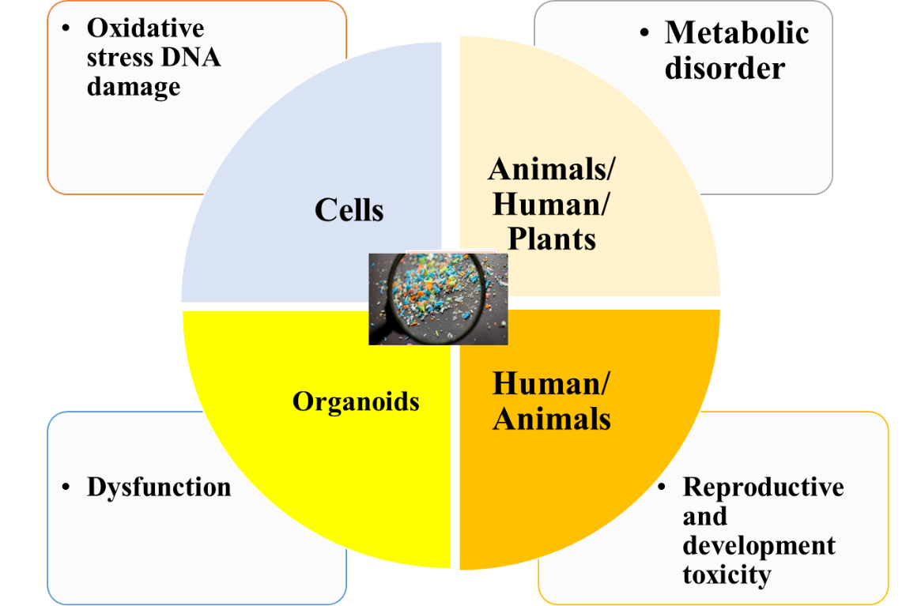
Figure 2. Toxicity mechanism of microplastics

Mitigation Strategies
Microplastic and heavy metal co-contamination pose significant environmental risks, necessitating a comprehensive approach that includes improved waste management practices, soil remediation techniques, sustainable agricultural practices, and the development of microplastic-free alternatives (Matavos-Aramyan, 2024). Improved waste management involves reducing plastic waste through better recycling, waste segregation, and disposal practices (Evode et al., 2021). This entails funding waste-to-energy projects, developing recycling facilities, and encouraging the adoption of plastic substitutes. Governments and communities should support public education initiatives aimed at cutting back on plastic use, improving recycling, and minimizing plastic waste at its source (Knoblauch & Mederake, 2021). Soil remediation techniques, such as phytoremediation and soil washing, are designed to reduce the concentration of contaminants in contaminated soils (Kafle et al., 2022). These techniques, along with regular monitoring of soil health, can significantly reduce the concentrations of heavy metals in agricultural areas, reducing risks to plant health and human consumption (Alengebawy et al., 2021). Sustainable agricultural practices, such as organic farming methods and agroforestry, can also help mitigate the co-contamination of microplastics and heavy metals in agricultural systems. The development of microplastic-free alternatives, such as biodegradable mulch films made from plant-based materials, can provide a sustainable solution to the issue of microplastic pollution (Huang et al., 2023). Research into biodegradable alternatives can help reduce the long-term accumulation of microplastics in the soil and reduce the plastic footprint in agricultural systems. Governments should incentivize the adoption of biodegradable alternatives by offering subsidies or tax breaks to farmers who switch to more sustainable practices. A multi-pronged approach to reducing microplastic and heavy metal co-contamination must also include public awareness and education. Public awareness campaigns can encourage individuals and organizations to make informed decisions about their consumption patterns, waste management practices, and support for environmentally-friendly policies. Farmers should be educated on the benefits of adopting organic farming practices, using biodegradable materials, and applying soil remediation techniques. Providing resources and financial incentives to support the transition to more sustainable agricultural practices is crucial to ensuring the widespread adoption of these mitigation strategies. Governments should implement regulations requiring industries to reduce their carbon footprint, including the use of sustainable packaging and waste management systems. International cooperation is also key in addressing the global issue of microplastic and heavy metal contamination. In conclusion, mitigating the risks associated with microplastic and heavy metal co-contamination requires a combination of improved waste management, soil remediation techniques, sustainable agricultural practices, the development of biodegradable alternatives, and increased public awareness. By adopting these strategies, it is possible to reduce the environmental and health impacts of these pollutants, ensuring safer, more sustainable agricultural practices, and protecting public health for future generations.

Conclusion
Microplastic and heavy metal co-contamination pose significant environmental risks. To mitigate these risks, a comprehensive approach is needed, including improved waste management practices, soil remediation techniques, sustainable agricultural practices, and the development of microplastic-free alternatives. Improved waste management involves reducing plastic waste through recycling, waste segregation, and disposal practices. This entails funding waste-to-energy projects, developing recycling facilities, and encouraging the adoption of plastic substitutes. Campaigns for public education on cutting back on plastic use, improving recycling, and minimizing plastic waste at its source are crucial. Soil remediation techniques, such as phytoremediation and soil washing, can reduce the concentration of contaminants in contaminated soils. Organic farming methods, which use natural inputs like compost, organic fertilizers, and crop rotation, can help reduce the risk of soil and water contamination with toxic heavy metals. Agroecological practices like agroforestry can also create more resilient and sustainable agricultural systems. The development of microplastic-free alternatives, such as biodegradable mulch films and plant-based biodegradable pesticides, can help reduce the plastic footprint in agricultural systems. Collaborations between researchers, policymakers, and the agricultural industry can create new, more sustainable materials that provide the same benefits as plastics without environmental harms. Policies and regulations to limit the use of non-biodegradable plastics in agriculture are also crucial. Public awareness and education about the risks of plastic pollution and heavy metal contamination are essential for driving change. Public awareness campaigns encourage individuals and organizations to make informed decisions about their consumption patterns, waste management practices, and support for environmentally-friendly policies. Governments should implement regulations requiring industries to reduce their carbon footprint, including the use of sustainable packaging and waste management systems. International cooperation is also key in addressing the global issue of microplastic and heavy metal contamination.

References
Adamczyk-Szabela, D., & Wolf, W. M. (2022). The Impact of Soil pH on Heavy Metals Uptake and Photosynthesis Efficiency in Melissa officinalis, Taraxacum officinalis, Ocimum basilicum. Molecules, 27(15), 4671. https://doi.org/10.3390/molecules27154671
Alengebawy, A., Abdelkhalek, S. T., Qureshi, S. R., & Wang, M.-Q. (2021). Heavy Metals and Pesticides Toxicity in Agricultural Soil and Plants: Ecological Risks and Human Health Implications. Toxics, 9(3), 42. https://doi.org/10.3390/toxics9030042
Angon, P. B., Islam, Md. S., KC, S., Das, A., Anjum, N., Poudel, A., & Suchi, S. A. (2024). Sources, effects and present perspectives of heavy metals contamination: Soil, plants and human food chain. Heliyon, 10(7), e28357. https://doi.org/10.1016/j.heliyon.2024.e28357
An, Q., Wen, C., & Yan, C. (2024). Meta-analysis reveals the combined effects of microplastics and heavy metal on plants. Journal of Hazardous Materials, 476, 135028. https://doi.org/10.1016/j.jhazmat.2024.135028
Aralappanavar, V. K., Mukhopadhyay, R., Yu, Y., Liu, J., Bhatnagar, A., Praveena, S. M., Li, Y., Paller, M., Adyel, T. M., Rinklebe, J., Bolan, N. S., & Sarkar, B. (2024). Effects of microplastics on soil microorganisms and microbial functions in nutrients and carbon cycling – A review. Science of The Total Environment, 924, 171435. https://doi.org/10.1016/j.scitotenv.2024.171435
Balali-Mood, M., Naseri, K., Tahergorabi, Z., Khazdair, M. R., & Sadeghi, M. (2021). Toxic Mechanisms of Five Heavy Metals: Mercury, Lead, Chromium, Cadmium, and Arsenic. Frontiers in Pharmacology, 12. https://doi.org/10.3389/fphar.2021.643972
Bhat, A., Ravi, K., Tian, F., & Singh, B. (2024). Arsenic Contamination Needs Serious Attention: An Opinion and Global Scenario. Pollutants, 4(2), 196–211. https://doi.org/10.3390/pollutants4020013
Bhattacharjee, U., Baruah, K. N., & Shah, M. P. (2025). Exploring sustainable strategies for mitigating microplastic contamination in soil, water, and the food chain: A comprehensive analysis. Environmental Chemistry and Ecotoxicology, 7, 453–461. https://doi.org/10.1016/j.enceco.2025.02.010
Bian, J., Peng, N., Zhou, Z., Yang, J., & Wang, X. (2024). A critical review of co-pollution of microplastics and heavy metals in agricultural soil environments. Ecotoxicology and Environmental Safety, 286, 117248. https://doi.org/10.1016/j.ecoenv.2024.117248
Briffa, J., Sinagra, E., & Blundell, R. (2020). Heavy metal pollution in the environment and their toxicological effects on humans. Heliyon, 6(9), e04691. https://doi.org/10.1016/j.heliyon.2020.e04691
Chakraborty, D., & Choudhury, B. (2023). TOXIC EFFECTS OF MERCURY ON CROP PLANTS AND ITS PHYSIOLOGICAL AND BIOCHEMICAL RESPONSES - A REVIEW. International Journal of Advanced Research, 11(02), 168–174. https://doi.org/10.21474/IJAR01/16236
Chang, N., Chen, L., Wang, N., Cui, Q., Qiu, T., Zhao, S., He, H., Zeng, Y., Dai, W., Duan, C., & Fang, L. (2024). Unveiling the impacts of microplastic pollution on soil health: A comprehensive review. Science of The Total Environment, 951, 175643. https://doi.org/10.1016/j.scitotenv.2024.175643
De-la-Torre, G. E. (2020). Microplastics: an emerging threat to food security and human health. Journal of Food Science and Technology, 57(5), 1601–1608. https://doi.org/10.1007/s13197-019-04138-1
Dwivedi, S. L., Lammerts van Bueren, E. T., Ceccarelli, S., Grando, S., Upadhyaya, H. D., & Ortiz, R. (2017). Diversifying Food Systems in the Pursuit of Sustainable Food Production and Healthy Diets. Trends in Plant Science, 22(10), 842–856. https://doi.org/10.1016/j.tplants.2017.06.011
Evode, N., Qamar, S. A., Bilal, M., Barceló, D., & Iqbal, H. M. N. (2021). Plastic waste and its management strategies for environmental sustainability. Case Studies in Chemical and Environmental Engineering, 4, 100142. https://doi.org/10.1016/j.cscee.2021.100142
Genchi, G., Sinicropi, M. S., Lauria, G., Carocci, A., & Catalano, A. (2020). The Effects of Cadmium Toxicity. International Journal of Environmental Research and Public Health, 17(11), 3782. https://doi.org/10.3390/ijerph17113782
Giannakoula, A., Therios, I., & Chatzissavvidis, C. (2021). Effect of Lead and Copper on Photosynthetic Apparatus in Citrus (Citrus aurantium L.) Plants. The Role of Antioxidants in Oxidative Damage as a Response to Heavy Metal Stress. Plants, 10(1), 155. https://doi.org/10.3390/plants10010155
Guo, W., Xing, Y., Luo, X., Li, F., Ren, M., & Liang, Y. (2023). Reactive Oxygen Species: A Crosslink between Plant and Human Eukaryotic Cell Systems. International Journal of Molecular Sciences, 24(17), 13052. https://doi.org/10.3390/ijms241713052
Gupta, A., Dubey, P., Kumar, M., Roy, A., Sharma, D., Khan, M. M., Bajpai, A. B., Shukla, R. P., Pathak, N., & Hasanuzzaman, M. (2022). Consequences of Arsenic Contamination on Plants and Mycoremediation-Mediated Arsenic Stress Tolerance for Sustainable Agriculture. Plants, 11(23), 3220. https://doi.org/10.3390/plants11233220
Gupta, M., Dwivedi, V., Kumar, S., Patel, A., Niazi, P., & Yadav, V. K. (2024). Lead toxicity in plants: mechanistic insights into toxicity, physiological responses of plants and mitigation strategies. Plant Signaling & Behavior, 19(1). https://doi.org/10.1080/15592324.2024.2365576
Hasan, M. M., & Tarannum, M. N. (2025). Adverse impacts of microplastics on soil physicochemical properties and crop health in agricultural systems. Journal of Hazardous Materials Advances, 17, 100528. https://doi.org/10.1016/j.hazadv.2024.100528
Hasan, M. M., Tarannum, M. N., Rafiqul Bari, G. A. K. M., Swapon, A. R., Kabir, M. S., Ahmmed, S., & Daraj Uddin Prodhan, Md. (2024). Impact of microplastics on terrestrial ecosystems: A plant-centric perspective. Environmental Pollution and Management, 1, 223–234. https://doi.org/10.1016/j.epm.2024.11.002
Huang, F., Zhang, Q., Wang, L., Zhang, C., & Zhang, Y. (2023). Are biodegradable mulch films a sustainable solution to microplastic mulch film pollution? A biogeochemical perspective. Journal of Hazardous Materials, 459, 132024. https://doi.org/10.1016/j.jhazmat.2023.132024
Jia, L., Liu, L., Zhang, Y., Fu, W., Liu, X., Wang, Q., Tanveer, M., & Huang, L. (2023). Microplastic stress in plants: effects on plant growth and their remediations. Frontiers in Plant Science, 14. https://doi.org/10.3389/fpls.2023.1226484
Kafle, A., Timilsina, A., Gautam, A., Adhikari, K., Bhattarai, A., & Aryal, N. (2022). Phytoremediation: Mechanisms, plant selection and enhancement by natural and synthetic agents. Environmental Advances, 8, 100203. https://doi.org/10.1016/j.envadv.2022.100203
Khalid, N., Aqeel, M., Noman, A., Khan, S. M., & Akhter, N. (2021). Interactions and effects of microplastics with heavy metals in aquatic and terrestrial environments. Environmental Pollution, 290, 118104. https://doi.org/10.1016/j.envpol.2021.118104
Knoblauch, D., & Mederake, L. (2021). Government policies combatting plastic pollution. Current Opinion in Toxicology, 28, 87–96. https://doi.org/10.1016/j.cotox.2021.10.003
Kye, H., Kim, J., Ju, S., Lee, J., Lim, C., & Yoon, Y. (2023). Microplastics in water systems: A review of their impacts on the environment and their potential hazards. Heliyon, 9(3), e14359. https://doi.org/10.1016/j.heliyon.2023.e14359
Lin, H., Cui, G., Jin, Q., Liu, J., & Dong, Y. (2024). Effects of microplastics on the uptake and accumulation of heavy metals in plants: A review. Journal of Environmental Chemical Engineering, 12(1), 111812. https://doi.org/10.1016/j.jece.2023.111812
Li, Y., Chen, L., Zhou, N., Chen, Y., Ling, Z., & Xiang, P. (2024). Microplastics in the human body: A comprehensive review of exposure, distribution, migration mechanisms, and toxicity. Science of The Total Environment, 946, 174215. https://doi.org/10.1016/j.scitotenv.2024.174215
Li, Y., Tao, L., Wang, Q., Wang, F., Li, G., & Song, M. (2023). Potential Health Impact of Microplastics: A Review of Environmental Distribution, Human Exposure, and Toxic Effects. Environment & Health, 1(4), 249–257. https://doi.org/10.1021/envhealth.3c00052
Matavos-Aramyan, S. (2024). Addressing the microplastic crisis: A multifaceted approach to removal and regulation. Environmental Advances, 17, 100579. https://doi.org/10.1016/j.envadv.2024.100579
Mitra, S., Chakraborty, A. J., Tareq, A. M., Emran, T. Bin, Nainu, F., Khusro, A., Idris, A. M., Khandaker, M. U., Osman, H., Alhumaydhi, F. A., & Simal-Gandara, J. (2022). Impact of heavy metals on the environment and human health: Novel therapeutic insights to counter the toxicity. Journal of King Saud University - Science, 34(3), 101865. https://doi.org/10.1016/j.jksus.2022.101865
Mondol, M., Angon, P. B., & Roy, A. (2024). Effects of microplastics on soil physical, chemical and biological properties. Natural Hazards Research. https://doi.org/10.1016/j.nhres.2024.02.002
Moody, E. C., Coca, S. G., & Sanders, A. P. (2018). Toxic Metals and Chronic Kidney Disease: a Systematic Review of Recent Literature. Current Environmental Health Reports, 5(4), 453–463. https://doi.org/10.1007/s40572-018-0212-1
Patra, M., & Sharma, A. (2000). Mercury toxicity in plants. The Botanical Review, 66(3), 379–422. https://doi.org/10.1007/BF02868923
Pothiraj, C., Amutha Gokul, T., Ramesh Kumar, K., Ramasubramanian, A., Palanichamy, A., Venkatachalam, K., Pastorino, P., Barcelò, D., Balaji, P., & Faggio, C. (2023). Vulnerability of microplastics on marine environment: A review. Ecological Indicators, 155, 111058. https://doi.org/10.1016/j.ecolind.2023.111058
Qaiser, Z., Aqeel, M., Sarfraz, W., Fatima Rizvi, Z., Noman, A., Naeem, S., & Khalid, N. (2023). Microplastics in wastewaters and their potential effects on aquatic and terrestrial biota. Case Studies in Chemical and Environmental Engineering, 8, 100536. https://doi.org/10.1016/j.cscee.2023.100536
Rai, P. K., Lee, S. S., Zhang, M., Tsang, Y. F., & Kim, K.-H. (2019). Heavy metals in food crops: Health risks, fate, mechanisms, and management. Environment International, 125, 365–385. https://doi.org/10.1016/j.envint.2019.01.067
Roy, R., Hossain, A., Sultana, S., Deb, B., Ahmod, Md. M., & Sarker, T. (2024). Microplastics increase cadmium absorption and impair nutrient uptake and growth in red amaranth (Amaranthus tricolor L.) in the presence of cadmium and biochar. BMC Plant Biology, 24(1), 608. https://doi.org/10.1186/s12870-024-05312-0
Sajjad, M., Huang, Q., Khan, S., Khan, M. A., Liu, Y., Wang, J., Lian, F., Wang, Q., & Guo, G. (2022). Microplastics in the soil environment: A critical review. Environmental Technology & Innovation, 27, 102408. https://doi.org/10.1016/j.eti.2022.102408
Sánchez-Castro, I., Molina, L., Prieto-Fernández, M.-Á., & Segura, A. (2023). Past, present and future trends in the remediation of heavy-metal contaminated soil - Remediation techniques applied in real soil-contamination events. Heliyon, 9(6), e16692. https://doi.org/10.1016/j.heliyon.2023.e16692
Shetty, B. R., Jagadeesha, P. B., & Salmataj, S. A. (2025). Heavy metal contamination and its impact on the food chain: exposure, bioaccumulation, and risk assessment. CyTA - Journal of Food, 23(1). https://doi.org/10.1080/19476337.2024.2438726
Wang, F., Xiang, L., Sze-Yin Leung, K., Elsner, M., Zhang, Y., Guo, Y., Pan, B., Sun, H., An, T., Ying, G., Brooks, B. W., Hou, D., Helbling, D. E., Sun, J., Qiu, H., Vogel, T. M., Zhang, W., Gao, Y., Simpson, M. J., … Tiedje, J. M. (2024). Emerging contaminants: A One Health perspective. The Innovation, 5(4), 100612. https://doi.org/10.1016/j.xinn.2024.100612
Wu, X., Lin, L., Lin, Z., Deng, X., Li, W., He, T., Zhang, J., Wang, Y., Chen, L., Lei, Z., Liu, C., & Xu, Z. (2024). Influencing mechanisms of microplastics existence on soil heavy metals accumulated by plants. Science of The Total Environment, 926, 171878. https://doi.org/10.1016/j.scitotenv.2024.171878
Yuan, Z., Cai, S., Yan, C., Rao, S., Cheng, S., Xu, F., & Liu, X. (2024). Research Progress on the Physiological Mechanism by Which Selenium Alleviates Heavy Metal Stress in Plants: A Review. Agronomy, 14(8), 1787. https://doi.org/10.3390/agronomy14081787
Zhang, Y., Li, D., Hui, K., Wang, H., Yuan, Y., Fang, F., Jiang, Y., Xi, B., & Tan, W. (2025). The combined microplastics and heavy metals contamination between the soil and aquatic media: A review. Journal of Environmental Chemical Engineering, 13(2), 115806. https://doi.org/10.1016/j.jece.2025.115806
Zhu, J., Dong, G., Feng, F., Ye, J., Liao, C.-H., Wu, C.-H., & Chen, S.-C. (2023). Microplastics in the soil environment: Focusing on the sources, its transformation and change in morphology. Science of The Total Environment, 896, 165291. https://doi.org/10.1016/j.scitotenv.2023.165291

