Impact of Climate Change on Vegetation in High Altitudes of North Western Himalaya: A case study of Pinus wallichiana from Pangi Valley, Himachal Pradesh

Abstract
Climate change is one of biggest challenge to the world in 21st century. Climate is changing from Last Glacier Maxima (LGM), but after industrialization the rate of climate change has rapidly increased. Increase in CO₂ level from 280 PPm (1960) to 495 PPm (2019) and global average surface temperature from 0.6 to 0.9⁰ C (1.1 to 1.6° F) between 1906 and 2005, double increase in temperature for last 50 years and the rise in global average surface temperature (1.5⁰C) have caused rapid increase in the rate of climate change. The sub-alpine and alpine regions are very sensitive, and are also experiencing even greater increase in temperature. Therefore, the present study is an attempt to assess the Pinus wallichiana population in Pangi Valley of Himachal Pradesh, North Western Himalaya in relation to climate change. Circumference at Breast Height (CBH) class was taken as a criterion to assess the shift in Pinus wallichiana population along an altitudinal gradient. The study resulted the decrease in size class from temperate to sub – alpine region. Even, saplings and seedlings were recorded in the lower fringes of alpine region. The statistical analysis indicated that the seedlings of Pinus wallichiana showed maximum positive significant correlation with altitude (r= 0.321), indicating thereby, with increase in altitude the seedlings density also increased. Saplings of Pinus wallichiana also showed maximum positive significant correlation with altitude (r= 0.302), indicating thereby, with increase in altitude the saplings density also increased. Trees density in size class 100-150cm of Pinus wallichiana showed maximum negative significant correlation along an altitudinal gradient (r= -0.377), indicating thereby, with increase in altitude, the density of trees with diameter 100-150cm decreased. Seedlings of Pinus wallichiana showed maximum positive significant correlation with saplings (r= 0.962), indicating thereby, saplings density was dependent on seedlings density.The study also revealed that the survival rate decreased with the increasing altitude. The study clearly revealed the altitudinal shift of Pinus wallichiana in Pangi valley. This could be due to less snow fall, rainfall and increase in maximum and minimum temperatures in Pangi valley, and can be related with the climate change. Regular monitoring of the temperate, sub – alpine and alpine vegetation in Pangi valley in relation to climate change is suggested to understand the vegetation dynamics and impact of climate change on vegetation and also on other natural resources.
Keywords: Population Assessment, Density, CBH Class, Correlations, Altitudinal Gradient, Temperate, Sub – alpine, Climate Change, Survival
1. Introduction
Eighteen thousand years ago, whole of the earth was covered by glaciers named as last glacier maxima (LGM) (CLIMAP Project Members, 1976). The climate change was very slow process during the period of last glacier maxima but after industrialization a rapid increase shown in the rate of temperature. CO₂ level has increased (280 PPm 1960) to (425.55 PPm 2024) (Mona Loa Observatory, 2024). Global average surface earth temperature increased up to (0.6 to 0.9° Celsius and 1.1 to 1.6° F) 1906 & 2005 and rate increased nearly doubled within last 50 years period (NASA, 2010) and 1.5° Celsius rose after industrialization. Alpines are phasing a signiﬁcant change in climatic condition over the past century and temperature increased up to 2⁰C between 1901 and 2000 (Beniston et al., 1997); (Jones & Moberg, 2003 reported 0.7⁰C increase in global average temperatures). In running century, alpine warming is projected to continue (IPCC, 2024), and prediction of average surface temperature may increase in the European countries mid-latitude of mountainous region about +2.9⁰C and +5.3⁰C at 2085 (Nogues-Bravo et al., 2007). A high mountain region of high latitudes is experiencing a greater increase in temperature in last 50 years. Increasing anthropogenic activities and rapid change in climatic variables shown the global and in particular, distribution with altitude of plant species communities is changing and subsequent reaction for climate sensitive species and communities are expected to shift towards high altitude (Walther, 2005). The cold alpine is a harsh ecosystem which observed as sensitive to climate change and global warming, because harsh alpine biodiversity adapted in low temperature (Korner, 1999) conditions. The global warming in alpine region results in the melting of snow covers (Valt &Cianfarra, 2010; Paul et al., 2004). The species in high altitude regions are experiencing to the higher level of threats (Anthelme et al., 2014; Walck et al., 1997; Engler et al., 2011; Pautasso et al., 2010; Hedhly et al., 2009). The climate change is directly accountable for changes in pattern of distribution, phenology and physiology of plant species (Grabher et al., 1994; Sandvik et al., 2004; Dalgleish et al., 2010; Lloret et al., 2004; Fay & Schultz, 2009; Dong et al., 2010; Walck et al., 2011). The altitudinal shift of diversity is an indicator of global warming (Lenoir et al., 2008). The dispersal of seed in greater altitude and their viability of germination and establishment in new region of high altitude are the main indicators of climate warming (Parolo & Rossi, 2008; Vittoz et al., 2009). The fresh seeds are collected from higher alpine region required higher temperature for their germination (Amen, 1966, Billings & Mooney, 1968). A few investigations on impact of climate change on biodiversity has been done in worldwide (Payette & Lavoie, 1994; Walther et al., 2005; Keller et al., 2000; Jentsch et al., 2003; Peñuelas and Boada, 2003; Gehrig‐Fasel., 2007; Jonas et al., 2008; Wallentin et al., 2008; Parolo and Rossi, 2008; Xu et al., 2009; Rammiget al., 2010; Lenoir et al., 2008; Khan et al., 2012; Gottfried, 2012; Jump et al., 2012; Felde et al., 2012; Brandt et al., 2013; Rigling, 2013; Anthelme et al., 2014; Riddle et al., 2014; Rashid et al., 2015; Schickhoffet al., 2016; Chakraborty et al., 2018; Dahal et al., 2021; Panda, 2022; Wani et al., 2023;Bandyopadhyay et al., 2023, etc.). A very few studies are available in the IHR on the impact of climate change on shifting of vegetation (Chettri et al., 2010; Telwala et al., 2013; Negi et al., 2012 & 2017; Misra et al., 2020; Tripathi, et al., 2022; Chauhan et al., 2022,etc.). Few investigations have been done on vulnerability assessment, structural and compositional changes of floristic diversity due to impact of climate change (Maikhuri et al., 2003;Sharma & Samant, 2013; Chakraborty, 2018;Bodh, 2018; Lal & Samant, 2019; Devi et al., 2019, Singh & Samant, 2020: Samant, 2021; Singh, 2022; Barman et al., 2021, etc.). The vegetation of Pangi valley is mainly temperate forests, deciduous broad leaved forests, scrubs and herbs of alpine region supporting a larger number of climate sensitive biodiversity. The recent study has been focused on the Shifting of vegetation due to climate change and survival rate and stress tolerance assessment of seedlings and saplings in alpine region of Pangi valley, District Chamba, Himachal Pradesh.

2. Material and Methods
2.1. Study Area
Present investigation was conducted during 2016-2022 in the Pangi valley which lies between 33⁰04’56’’N latitude to 76⁰20’11’’E longitude. The study area covers 1601 km²and falls between 2,100-6,200 m amsl. The valley is sandwiched between Pir Panjal and Great Himalayan or Jhanskar Ranges. The valley is featured with deep river valleys and steep mountains slope and exhibits temperate, sub-alpine and alpine vegetation. About 68% area falls in sub-alpine and alpine zones and remains snow bound during winter season. The temperature drops below the freezing point at -20⁰C and the maximum temperature recorded is about 35⁰ C in summer. Annual rain fall is recorded around 200-400mm/year. The valley supports rich storehouse of biodiversity classified into coniferous evergreen temperate forests and deciduous broad leaved forests, scrubs and herbs of alpine region supporting a larger number of sensitive biodiversity elements. The Pangi is a remotest valley under the sub-division of District Chamba, well known as the most beautiful high altitude area in the North-west Himalaya. The Chenab is one of the high-density water rivers flowing in narrow gorge and deep in the valley. It originates from Chander Tal of Lahaul-Spiti district and enters in the valley at Karhu Nala. The valley is classified in Purthi, Sach Killar, Kumar-Parmar and Sechu Nala Forest Divisions and known for its beautiful natural, unique, diverse habitats, harsh climatic conditions and rich biodiversity. The valley is closed during winter season (November to April) due to heavy snow fall. The vegetation of the valley is mainly temperate forests, deciduous broad leaved forests and scrubs and herbs of alpine region supporting a larger number of sensitive biodiversity elements. The vegetation of this harsh and cold climatic condition is sensitive to climate change.
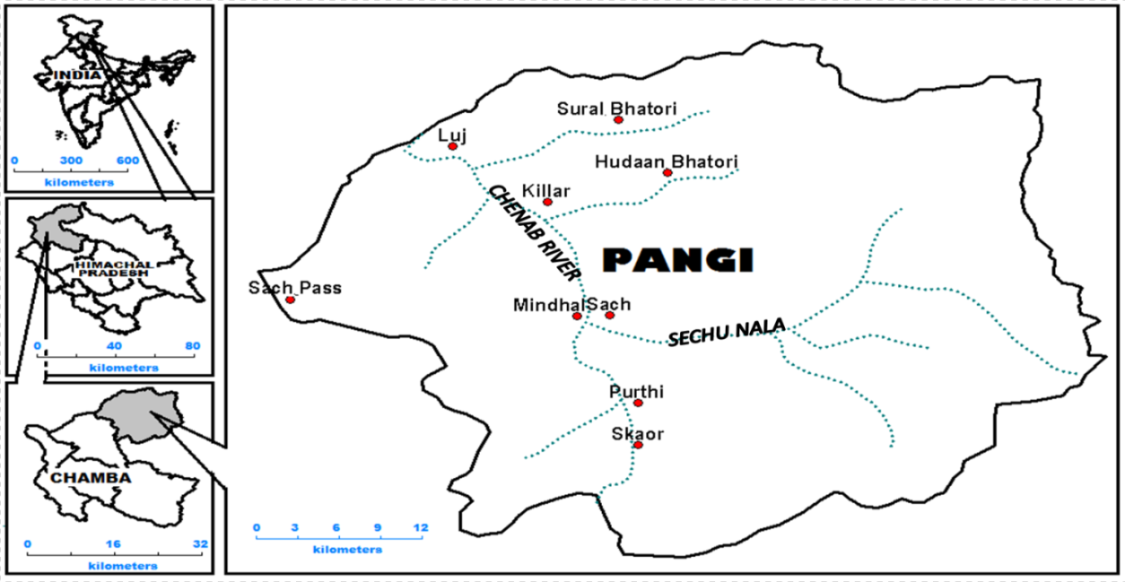
Fig. 1.Map of Study area
2.2. Surveys and Samplings Method
The Pinus wallichiana species were assessed during 2015 to 2022. 41 plots of 50x50m were laid in each and every site. Within each site, trees (cbh>31.5cm), Saplings (10.5-31.4cm) and saplings (cbh<10.5 cm) were sampled by randomly placed 10 quadrats of 10x10m (Saxena & Singh, 1982; Samant, 2021; Joshi & Samant, 2004; Dhar et al., 1997). Shifting of vegetation was assessed on the basis of sizeclass distribution of species in different size classes with respect to altitude following Shrestha & Ghimire (2007); Rocky &Mligo (2012); Bodh (2018), Devi et al. (2019); Barman et al. (2020); Samant(2021); Singh (2022); etc.). The assessmentof survival rate and stress tolerance of seedlings and saplings in alpine regionis based on dry needles stage (%) and number of dead seedlings and saplings present in each quadrat.
3. Results
3.1. Density of Pinus wallichiana trees
Considering the altitude, maximum total trees density, 37 Ind/2500m² was found at 3269m, followed by 30 Ind/2500m² at 2761m, 27 Ind/2500m² at 3233m, 26 Ind/2500m² at 3150m, 25 Ind/2500m² at 3415m, 24 Ind/2500m² at 3005m, 23 Ind/2500m² at 3192m, 21 Ind/2500m² at 2973m, 20 Ind/2500m² at 3090m, 19 Ind/2500m² at 2195m, and 3457m, each and minimum trees density 0.00 Ind/2500m² at 3750m, 3881m and 3936m, each (Table 1 and Fig.2).

3.2. Size Class Wise (CBH) Density of Pinus wallichiana
Along an altitudinal gradient, the maximum density, 10 Ind/2500m² was found in size class (>200cm) at 3005m, followed by 08 Ind/2500m² at 3005m, 06 Ind/2500m² at 3233m, 05 Ind/2500m² at 2973m and none of mature trees were found in the size class (>200cm) between 3491m and 3936m (Table 1 and Fig.2).
In size-class, 151 -200cm.maximum density, 14 Ind/2500m² was found at 3150m, followed by 11 Ind/2500m² at 3192m and 3230m, each, 07 Ind/2500m² at 3065m, 06 Ind/2500m² at 2963m, 2973m and 3191m, each and none of the individuals were found in the size class (>150-200cm) between 3555m and 3936m (Table 1 and Fig.2).
In size-class,101 -150cm, maximum density, 09 Ind/2500m²was found at 2761m, followed by 08 Ind/2500² at 3192m, 06 Ind/2500m² at 3191m, and 3457m, each, and 05 Ind/2500m² at 3195m, 2915m, 3150m, 3279m and 3451m, each and none of the individuals were found in the size class (>100-150cm) from altitude of 3491m to 3936m (Table 1 and Fig.2).
In size-class, 31.5-100cm, maximum density, 26 Ind/2500m² was found in size class (31.5-100cm)at 3279m, followed by 21 Ind/2500m² at 3415m, 19 Ind/2500m² at 3233m, 13 Ind/2500m² at 2761m, 11 Ind/2500m² at 3457m, 09 Ind/2500m² at 3005m and 3090m, each, 08 Ind/2500m² at 2915m, 06 Ind/2500m² at 2973m, 3192m and 3474m, each and none of the individuals were found in the size class (>34.5-100cm) between 3750m and 3936m (Table 1 and Fig.2).

3.3. Saplings density of Pinus wallichiana
Maximum saplings density, 63 Ind/2500m² was found between the size class (10.6-31.4cm)at 3600m, followed by 55 Ind/2500m² at 3455m, 23 Ind/2500m² at 3090m and 3233m, each, 20 Ind/2500m² at 3415m, 16 Ind/2500m² at 3555m and 3583m, each, 15 Ind/2500m² at 3285m, 14 Ind/2500m² at 3230m, 13 Ind/2500m² at 2963m, 12 Ind/2500m² at 3150m, 3279m and 3936m, each (Table 1 and Fig.2).

3.4. Seedlings density of Pinus wallichiana
Maximum seedlings density, 66 Ind/2500m² was found between the size class 0.00 and10.5cmat 3600m, followed by 64 Ind/2500m² at 3455m, 31 Ind/2500m² at 3233m,28 Ind/2500m² at 3233m,25 Ind/2500m² at 3583m,22 Ind/2500m² at 3090m, 21 Ind/2500m² at 3124m, 18 Ind/2500m² at 3230m and 3555m, each,15 Ind/2500m² at 3150m, 3279m and 3639m, each,13 Ind/2500m² at 3191m, 11 Ind/2500m² at 2963m, 3034m and 3065m, each (Table 1 and Fig.2).

Table 1. Size-class wise density of Pinus wallichiana along an altitudinal gradient in Pangi valley
Site  No. | Altitude  (m) | Density (Ind/2500²) in size-class (cm)
Site  No. | Altitude  (m) | I  (0-10.5)  Seedlings | II  (10.6-31.4)  Saplings | III  (31.5-100) | IV  (101-150) | V  (151-200cm) | VI  (>200cm)
1 | 3936 | 15 | 12 | 0 | 0 | 0 | 0
2 | 3881 | 2 | 0 | 0 | 0 | 0 | 0
3 | 3750 | 10 | 8 | 0 | 0 | 0 | 0
4 | 3701 | 7 | 3 | 3 | 0 | 0 | 0
5 | 3600 | 66 | 63 | 2 | 0 | 0 | 0
6 | 3583 | 25 | 16 | 7 | 0 | 0 | 0
7 | 3555 | 18 | 16 | 2 | 0 | 0 | 0
8 | 3491 | 7 | 5 | 1 | 0 | 3 | 0
9 | 3486 | 8 | 4 | 3 | 1 | 1 | 2
10 | 3474 | 10 | 6 | 6 | 3 | 2 | 0
11 | 3457 | 7 | 4 | 11 | 6 | 1 | 1
12 | 3455 | 64 | 55 | 1 | 1 | 0 | 0
13 | 3451 | 3 | 2 | 3 | 5 | 4 | 4
14 | 3415 | 21 | 20 | 21 | 4 | 0 | 0
15 | 3285 | 28 | 15 | 1 | 0 | 0 | 0
16 | 3279 | 15 | 12 | 26 | 5 | 4 | 2
17 | 3272 | 5 | 6 | 5 | 1 | 0 | 1
18 | 3258 | 7 | 4 | 1 | 3 | 5 | 1
19 | 3233 | 31 | 23 | 19 | 0 | 2 | 6
20 | 3230 | 18 | 14 | 2 | 2 | 11 | 3
21 | 3203 | 3 | 8 | 1 | 2 | 0 | 2
22 | 3192 | 5 | 8 | 6 | 2 | 2 | 1
23 | 3192 | 0 | 0 | 3 | 8 | 11 | 1
24 | 3191 | 13 | 6 | 3 | 6 | 6 | 0
25 | 3150 | 15 | 12 | 7 | 5 | 14 | 0
26 | 3124 | 21 | 7 | 5 | 2 | 1 | 2
27 | 3090 | 22 | 23 | 9 | 4 | 3 | 4
28 | 3065 | 11 | 10 | 3 | 6 | 7 | 0
29 | 3034 | 11 | 8 | 0 | 0 | 0 | 1
30 | 3005 | 6 | 4 | 9 | 4 | 1 | 10
31 | 2973 | 3 | 5 | 6 | 4 | 6 | 5
32 | 2963 | 11 | 13 | 2 | 5 | 6 | 0
33 | 2926 | 4 | 6 | 2 | 1 | 0 | 1
34 | 2915 | 8 | 6 | 8 | 5 | 2 | 3
35 | 2791 | 2 | 2 | 0 | 2 | 1 | 2
36 | 2761 | 0 | 0 | 13 | 9 | 5 | 3
37 | 2640 | 7 | 2 | 1 | 1 | 1 | 4
38 | 2352 | 9 | 2 | 1 | 0 | 4 | 2
39 | 2228 | 0 | 1 | 0 | 0 | 0 | 0
40 | 2251 | 2 | 3 | 2 | 1 | 0 | 0
41 | 2195 | 8 | 5 | 3 | 5 | 3 | 8

Fig.2. Seedlings, saplings and trees density (Ind/2500²m) along an altitudinal gradient
4. Survival (%)of seedlings
Total 15 Ind/2500m² seedlings density was found at 3936m. Of the total, maximum 09 Ind/2500m² (>70%) were found in dry stage, followed by 04 Ind/2500m² (60-70%), minimum 02 Ind/2500m² (50-60%), and none of the seedlings were found between 40% and 50% and <35% dry needles stage.
At 3881m, total 02 Ind/2500m² seedlings density was found. Of the total, maximum 02 Ind/2500m² (>70%) were found in dry needles stage and none of seedlings were found under 60-70%, 50-60%, 40-50% and <35% dry needles stage.
At 3750m, total 10 Ind/2500m² seedlings density was found. Of the total, maximum 04 Ind/2500m² (>70%) were found in dry needles stage, followed by 03 Ind/2500m² (60-70%), 02 Ind/2500m² (50-60%), and minimum 01 Ind/2500m²(40-50%) was found in dry needles stage, and none of the seedlings were found in<35% dry needles stage.
At 3701m, total 07 Ind/2500m² seedlings density was found. Of the total, maximum 04 Ind/2500m² (>70%) were found in dry stage, followed by 02 Ind/2500m² (60-70%), 01 Ind/2500m² (50-60%), and none of the seedlings were found in 40-50% and <35% needles dry stage.
At 3600m, total 66 Ind/2500m² seedlingsdensity was found. Of the total, maximum 29 Ind/2500m² (<35%) were found in dry needles stage, followed by 14 Ind/2500m²in 40-50% dry needles stage, 11 Ind/2500m² in 50-60% dry needles stage, 07 Ind/2500m²in 60-70% dry needles stage), respectively, and minimum 04 Ind/2500m² (>70%) dry needles stage.
At 3583m, total 25 Ind/2500m² seedlings density was found. Of the total, maximum 13 Ind/2500m² were found in <35% (Survived) needles dryness stage, followed by 05 Ind/2500m² in 40-50% dry needles stage, 03 Ind/2500m² in 50-60% dry needles stage, 02 Ind/2500m² in 60-70% dry needles stage and minimum 02 Ind/2500m² in>70% dry needles stage.
At 3555m, total 18 Ind/2500m² seedlings density was found. Of the total, maximum 10 Ind/2500m² (<35% survival) were found in dry needles stage, followed by 04 Ind/2500m² in 40-50% dry needles stage, 03 Ind/2500m² in 50-60% dry needles stage and minimum 01 Ind/2500m² in 60-70% dry needles stage and none of seedlings in >70% (Dead) dry needles stage.

Table 2. Survival rate (%) of seedlings along an altitudinal gradient in Pangi valley
Site No. | Altitude (m) | Seedlings
Site No. | Altitude (m) | Total | Dry Needles Stage (%)
Site No. | Altitude (m) | Total | Survived (<35) | 40-50 | 50-60 | 60-70 | >70 (Dead)
1. | 3936 | 15 | 0 | 0 | 02 | 04 | 09
2. | 3881 | 2 | 0 | 0 | 0 | 0 | 02
3. | 3750 | 10 | 0 | 01 | 02 | 03 | 04
4. | 3701 | 7 | 0 | 0 | 01 | 02 | 04
5. | 3600 | 66 | 29 | 14 | 11 | 07 | 05
6. | 3583 | 25 | 13 | 5 | 3 | 2 | 2
7. | 3555 | 18 | 10 | 4 | 3 | 1 | 0

5. Survival (%) of saplings
At 3936m, total 12 Ind/2500m² saplings density was found. Of the total, maximum 07 Ind/2500m² were found in >70% (Dead) dry needles stage, followed by 03 Ind/2500m² in60-70%, and minimum 01 Ind/2500m² in 50-60% dry needles stage and none of saplings were found under 40-50% and <35% dry needles stage.
At 3881m, none of the saplings were found in the altitude of 3881m. At 3750m, total 08 Ind/2500m² saplings density was found. Of the total, maximum 04 Ind/2500m² were found in >70% (Dead) dry needles stage, followed by 02 Ind/2500m² in 60-70% and 50-60%, each dry needles stage, minimum 01 Ind/2500m² in 40-50% dry needles stage and none of the saplings were found under <35% dry needles stage.
At 3701m, total 03 Ind/2500m² saplings density was found. Of the total, maximum 01 Ind/2500m² was found in >70% (Dead) dry needles stage, followed by 01 Ind/2500m² in 60-70%, and minimum 01 Ind/2500m² in 50-60% dry needles stage and none of the saplings were found under 40-50% and <35% dry needles stage.
At 3600m, total 63 Ind/2500m² saplings density was found. Of the total, maximum 36 Ind/2500m² were found in <35% (Survived) dry needles stage, followed by 11 Ind/2500m² in 40-50%, 08 Ind/2500m² in 50-60%, 05 Ind/2500m² in 60-70%, and minimum 03 Ind/2500m² in >70% dry needles stage.
At 3583m, total 16 Ind/2500m² saplings density was found. Of the total, maximum 11 Ind/2500m² were found in <35% (Survived) dry needles stage, followed by 02 Ind/2500m² in 40-50%, 01 Ind/2500m², each in 50-60%, 60-70% and >70% dry needles stage.
At 3555m, total 16 Ind/2500m² saplings density was found. Of the total, maximum 12Ind/2500m² were found in <35 (Survived) dry needles stage, followed by 02 Ind/2500m² in 40-50%, 01 Ind/2500m², each in 50-60% and 60-70% dry needles stage and none of saplings were found in >70% (Dead) dry needles stage.

Table 3. Survival rate (%) of saplings along an altitudinal gradient in Pangi valley
Site No. | Altitude (m) | Saplings
Site No. | Altitude (m) | Total | Dry Needles Stage (%)
Site No. | Altitude (m) | Total | Survived (<35) | 40-50 | 50-60 | 60-70 | >70 (Dead)
1. | 3936 | 12 | 0 | 0 | 01 | 03 | 07
2. | 3881 | 0 | 0 | 0 | 0 | 0 | 0
3. | 3750 | 8 | 0 | 01 | 02 | 02 | 04
4. | 3701 | 3 | 0 | 0 | 01 | 01 | 01
5. | 3600 | 63 | 36 | 11 | 08 | 05 | 03
6. | 3583 | 16 | 11 | 02 | 01 | 01 | 01
7. | 3555 | 16 | 12 | 02 | 01 | 1 | 0

A synoptic view showing shifting of Pinus wallichiana in Pangi valley
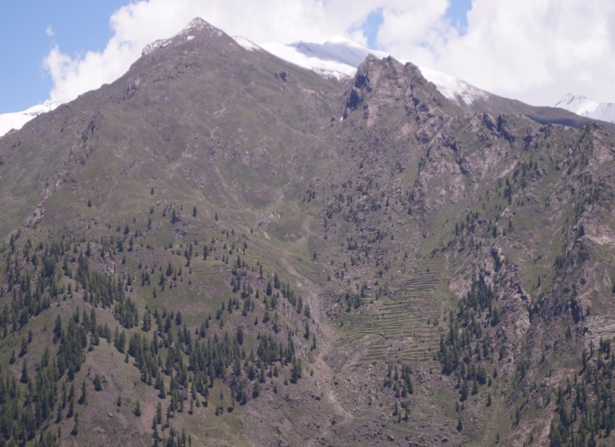 | 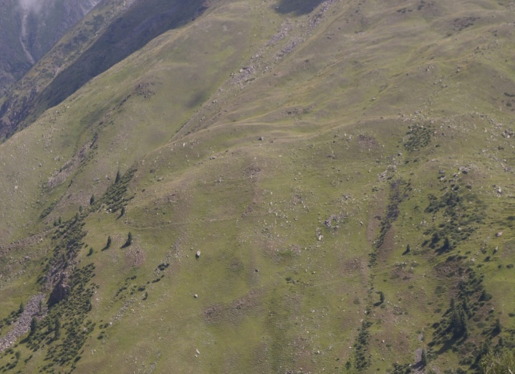
Altitudinal shift of Pinus wallichiana at Kuthal Dhar (3936m) | Altitudinal shift ofPinus wallichiana saplings and seedlings at Chasak-Bhatori Dhar (3750m)
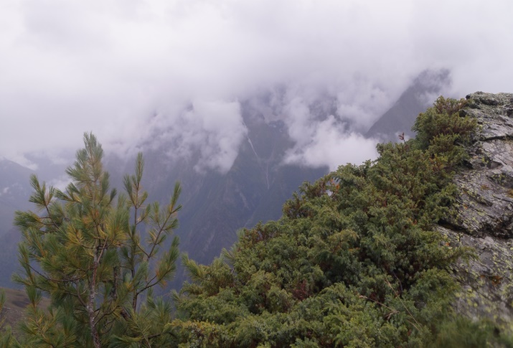 | 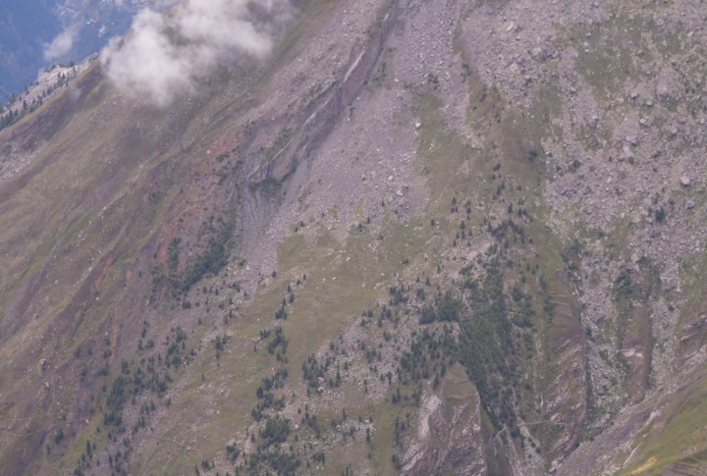
Pinus wallichiana saplings at Kuthal Dhar (3936m) | Altitudinal shift ofPinus wallichiana saplings and seedlings at Kumar Dhar (3750m)
Fig.3. Synoptic view showing shifting of Pinus wallichiana in Pangi valley
Discussion
Himalayan region, particularly the sub – alpine and alpine zones are very sensitive to climate change. These regions experiencing greater increases in temperature especially in the last half century due to increase in anthropogenic activities and changing climatic conditions. The increase in maximumand minimum temperatures in these zones has caused receding of glaciers, altitudinal shift of seedlings and saplings of trees, compositional changes of vegetation, decrease in snow fall and rainfall, conversion of stone housesinto cement houses, introduction of hand pumps in the temperate zone, change in the biological cycle of flowering plants. (Maikhuri et al., 2003;Sharma & Samant, 2013; Chakraborty, 2018; Bodh, 2018; Lal & Samant, 2019; Devi et al., 2019, Singh & Samant, 2020: Samant, 2021; Singh, 2022; Barman et al., 2021, etc.). Altitudinal distribution of plant communities is likely to change and a subsequent reaction of climate sensitive species and ecosystems are expected to shift towards high altitude (Walther, 2005). The trees density was found between 2195 and 3701m. In the altitudes between 3701 and 3936m, only fresh seedlings and saplings were found and none of trees were found. Fresh and newly established seedlings and saplings at 3701m and 3936m indicate the shifting of Pinus wallichiana due to favorable climatic condition in the high altitude of Pangi valley, Himachal Pradesh. The density in size class (>200cm) of Pinus wallichiana was found between the altitude of 2195 and 3491m showing that, with increase in altitude, the diameter of trees is decreasing. The density in size class (>100cm) of Pinus wallichiana was found between the altitude of 2195 and 3555m also showing that with increase in altitude, the diameter of trees is decreasing. Decrease in diameter of trees with increasing altitude shows clear shift indicating establishment of Pinus wallichiana community in the higher elevations of the Pangi Valley. Seedlings of Pinus wallichiana showsmaximum positive significant correlation with altitude (r= 0.321), indicating thereby, with increase in altitude the seedlings density also increases. Saplings of Pinus wallichiana also showed maximum positive significant correlation with altitude (r= 0.302), indicating thereby, with increase in altitude, the saplings density also increased. Both seedlings and saplings increased with the increasing altitude showing the altitudinal shift of Pinus wallichiana. Trees density in size class 100-150cm of Pinus wallichiana revealed maximum negative significant correlation with altitude (r= -0.377), indicating thereby, with increase in altitude the density of trees with diameter 100-150cm was decreased. Seedlings of Pinus wallichiana showed maximum positive significant correlation with Saplings (r= 0.962), indicating thereby, saplings density was dependent on seedlings density (Walther et al., 2005; Wipf et al., 2006; Shevtsova et al., 2009; Chettri et al., 2010; Telwala et al., 2013; Negi et al., 2012; Rigling et al., 2013; Riddle et al., 2014; Negi et al., 2017; Misra et al., 2020; Singh & Samant, 2020: Samant, 2021; Tripathi, et al., 2022; Chauhan et al., 2022,Kumar et al., 2022). Similar trends have been also found in other parts of the Indian Himalayan Region (Sharma & Samant, 2013; Bodh, 2018; Lal & Samant, 2019; Devi et al., 2019, Singh & Samant, 2020: Samant, 2021; Singh, 2022; Barman et al., 2021)
Total 15 Ind/2500m² seedlings density of P. wallichiana were found at 3936m. Of the total, Maximum 09 Ind/2500m² were found in >70% (Dead) dry needles stage, followed by 04 Ind/2500m² in 60-70%, and minimum 02 Ind/2500m² in 50-60% dry needles stage and none of the seedlings were found under 40-50% and <35% dry needles stage. The dry needles was increased with increasing altitude and number of dead seedlings and saplings also increased with increasing altitude, which showed that in higher elevations, seedlings and saplings were under stress and striving hard to adapt in harsh and cold climatic conditions, also survival rate decrease with increasing altitude. The upward shift of plants species in alpine habitats is clearly results of the climate warming (Lenoir et al., 2008). The seed dispersal, germination and establishment in fresh site at higher altitude are the main vehicles for plant migration (Parolo and Rossi, 2008; Vittoz et al., 2009). The regeneration of dispersed seeds depends upon favorable climatic condition which plays a crucial role in the responses of alpine species to climate change. Studies revealed that, the seeds collected from arctic and alpine region required relatively high temperatures for their viability and germination (Amen, 1966; Bliss, 1958; Billings and Mooney, 1968) is directly indicates the vegetation of mountainous region in high altitude is shifting due to climate change. Similar trends have been also found in other parts of the Indian Himalayan Region (Sharma & Samant, 2013; Bodh, 2018; Lal & Samant, 2019; Devi et al., 2019, Singh & Samant, 2020: Samant, 2021; Singh, 2022; Barman et al., 2021).

Fig 4-Correlation (0.01 to 0.05 level of significance)

References
Amen, R.D. 1966. The extent and role of seed dormancy in alpine plants. The Quarterly Review of Biology 41: 271–281.
Anthelme, F., Cavieres, L.A. and Dangles, O., 2014. Facilitation among plants in alpine environments in the face of climate change. Frontiers in plant science, 5, p.387.
Barman, T., Samant, S.S. and Singh, A., 2021. Structural diversity and regeneration pattern of forest communities in Parbati Valley, North Western Himalaya, India: Implications for conservation. Indian Journal of Ecology, 48(2), pp.332-348.
Bandyopadhyay, D., Mukherjee, S., Singh, G. and Coomes, D., 2023. The rapid vegetation line shift in response to glacial dynamics and climate variability in Himalaya between 2000 and 2014. Environmental Monitoring and Assessment, 195(1), p.70.
Beniston, M., Diaz, H.F. and Bradley, R.S., 1997. Climatic change at high elevation sites: an overview. Climatic change, 36(3-4), pp.233-251.
Billings, W.D. and Mooney, H.A., 1968. The ecology of arctic and alpine plants. Biological reviews, 43(4), pp.481-529.
Bodh., M., 2018. Study on floristic diversity assessment, monitoring and prioritization in Great Himalayan National Park, North Western Himalaya for management implications. PhD thesis submitted to Kumaun University, Nainital.
Brandt, J.S., Haynes, M.A., Kuemmerle, T., Waller, D.M. and Radeloff, V.C., 2013. Regime shift on the roof of the world: Alpine meadows converting to shrublands in the southern Himalayas. Biological Conservation, 158, pp.116-127.
Chauhan, N., von Wehrden, H. and Joshi, P.K., 2022. Socio-environmental vulnerability of agriculture communities to climate change in Western Himalaya: A household-level review. In Challenges of Disasters in Asia (pp. 123-145). Springer, Singapore.
Chettri, N., Sharma, E., Shakya, B., Thapa, R., Bajracharya, B., Uddin, K., Choudhury, D. and Oli, K.P., 2010. Biodiversity in the Eastern Himalayas: Status, trends and vulnerability to climate change. International Centre for Integrated Mountain Development (ICIMOD).
Chakraborty, A., Saha, S., Sachdeva, K. and Joshi, P.K., 2018. Vulnerability of forests in the Himalayan region to climate change impacts and anthropogenic disturbances: a systematic review. Regional Environmental Change, 18, pp.1783-1799.
IPCC Report, 2024. Assessment Report of the Intergovernmental Panel on Climate Change.
CLIMAP Project Members, 1976. The surface of the ice-age earth. Science, pp.1131-1137.
Dalgleish, H.J., Koons, D.N. and Adler, P.B., 2010. Can life‐history traits predict the response of forb populations to changes in climate variability?. Journal of Ecology, 98(1), pp.209-217.
Devi, K., Samant, S.S., Puri, S. and Lal, M., 2019. Diversity, structure and regeneration pattern of tree communities in kanawar wildlife sanctuary of Himachal Pradesh, north west Himalaya, India. Indian Journal of Ecology, 46(1), pp.94-103.
Dhar, U., Samant, S.S., Rawal, R.S. and Sharma, S. 1997. Studies on biota and resource use pattern of the natives within Askot Wildlife Sanctuary of Kumaun Himalaya. Tiger Paper 24 (4): 12-18.
Dahal, K.R., Dahal, P., Adhikari, R.K., Naukkarinen, V., Panday, D., Bista, N., Helenius, J. and Marambe, B., 2022. Climate change impacts and adaptation in a hill farming system of the Himalayan region: climatic trends, farmers’ perceptions and practices. Climate, 11(1), p.11.
Dong, W., Jiang, Y. and Yang, S., 2010. Response of the starting dates and the lengths of seasons in Mainland China to global warming. Climatic Change, 99(1-2), pp.81-91.
Engler, R., Randin, C.F., Thuiller, W., Dullinger, S., Zimmermann, N.E., Araújo, M.B., Pearman, P.B., Le Lay, G., Piedallu, C., Albert, C.H. and Choler, P., 2011. 21st century climate change threatens mountain flora unequally across Europe. Global Change Biology, 17(7), pp.2330-2341.
Felde, V.A., Kapfer, J. and Grytnes, J.A., 2012. Upward shift in elevational plant species ranges in Sikkilsdalen, central Norway. Ecography, 35(10), pp.922-932.
Fay, P.A. and Schultz, M.J., 2009. Germination, survival, and growth of grass and forb seedlings: effects of soil moisture variability. Acta Oecologica, 35(5), pp.679-684.
Gehrig‐Fasel, J., Guisan, A. and Zimmermann, N.E., 2007. Tree line shifts in the Swiss Alps: climate change or land abandonment?. Journal of vegetation science, 18(4), pp.571-582.
Gottfried, M., Pauli, H., Futschik, A., Akhalkatsi, M., Barančok, P., Alonso, J.L.B., Coldea, G., Dick, J., Erschbamer, B., Kazakis, G. and Krajči, J., 2012. Continent-wide response of mountain vegetation to climate change. Nature climate change, 2(2), p.111.
Grabherr, G., Gottfried, M. and Pauli, H., 1994. Climate effects on mountain plants. Nature, 369(6480), p.448.
Hedhly, A., Hormaza, J.I. and Herrero, M., 2009. Global warming and sexual plant reproduction. Trends in plant science, 14(1), pp.30-36.
Jentsch, A. and Beierkuhnlein, C., 2003. Global climate change and local disturbance regimes as interacting drivers for shifting altitudinal vegetation patterns (GlobaleKlimaveränderungen und lokaleStörungsregimealsinteragierendeSteuergrößensichverschiebenderhöhenzonalerVegetationsmuster). Erdkunde, pp.216-231.
Jonas, T., Rixen, C., Sturm, M. and Stoeckli, V., 2008. How alpine plant growth is linked to snow cover and climate variability. Journal of Geophysical Research: Biogeosciences, 113(G3).
Jones, P.D. and Moberg, A., 2003. Hemispheric and large-scale surface air temperature variations: An extensive revision and an update to 2001. Journal of climate, 16(2), pp.206-223.
Joshi, H.C. and Samant, S.S., 2004. Assessment of forest vegetation and conservation priorities of communities in part of Nanda Devi Biosphere Reserve, West Himalaya. Part I. The International Journal of Sustainable Development & World Ecology, 11(3), pp.326-336.
Jump, A.S., Huang, T.J. and Chou, C.H., 2012. Rapid altitudinal migration of mountain plants in Taiwan and its implications for high altitude biodiversity. Ecography, 35(3), pp.204-210.
Körner, C. and Kèorner, C., 1999. Alpine plant life: functional plant ecology of high mountain ecosystems.
Keller, F., Kienast, F. and Beniston, M., 2000. Evidence of response of vegetation to environmental change on high-elevation sites in the Swiss Alps. Regional Environmental Change, 1, pp.70-77.
Khan, S.M., Page, S., Ahmad, H.A.B.I.B., Shaheen, H.A.M.A.Y.U.N. and Harper, D.M., 2012. Vegetation dynamics in the Western Himalayas, diversity indices and climate change. Sci., Tech. and Dev, 31(3), pp.232-243.
Lal, M. and Samant, S.S., 2019. Compositional and structural diversity of forest vegetation in Kais Wildlife Sanctuary, North Western Himalaya: conservation implications. Journal of Biodiversity, 10(1-2), pp.1-14.
Lenoir, J., Gégout, J.C., Marquet, P.A., De Ruffray, P. and Brisse, H., 2008. A significant upward shift in plant species optimum elevation during the 20th century. science, 320(5884), pp.1768-1771.
Lloret, F., Penuelas, J. and Estiarte, M., 2004. Experimental evidence of reduced diversity of seedlings due to climate modification in a Mediterranean‐type community. Global Change Biology, 10(2), pp.248-258.
Maikhuri, R.K., Rao, K.S., Patnaik, S., Saxena, K.G. and Ramakrishnan, P.S., 2003. Assessment of vulnerability of forests, meadows and mountain ecosystems due to climate change. Envis Bulletin, 11(2), pp.1-9.
Misra, K.G., Singh, V., Yadava, A.K., Misra, S. and Yadav, R.R., 2020. Treeline migration and settlement recorded by Himalayan pencil cedar tree-rings in the highest alpine zone of western Himalaya, India. Current Science, 118(2), pp.192-195.
Negi, G.C.S., Samal, P.K., Kuniyal, J.C., Kothyari, B.P., Sharma, R.K. and Dhyani, P.P., 2012. Impact of climate change on the western Himalayan mountain ecosystems: an overview. Tropical ecology, 53(3), pp.345-356.
Negi, V.S., Maikhuri, R.K., Pharswan, D., Thakur, S. and Dhyani, P.P., 2017. Climate change impact in the Western Himalaya: people’s perception and adaptive strategies. Journal of Mountain Science, 14(2), pp.403-416.
Nogués-Bravo, D., Araújo, M.B., Errea, M.P. and Martinez-Rica, J.P., 2007. Exposure of global mountain systems to climate warming during the 21st Century. Global environmental change, 17(3-4), pp.420-428.
Parolo, G. and Rossi, G., 2008. Upward migration of vascular plants following a climate warming trend in the Alps. Basic and Applied Ecology, 9(2), pp.100-107.
Paul, F., Kääb, A., Maisch, M., Kellenberger, T. and Haeberli, W., 2004. Rapid disintegration of Alpine glaciers observed with satellite data. Geophysical research letters, 31(21).
Payette, S. and Lavoie, C., 1994. The arctic tree line as a record of past and recent climatic changes. Environmental Reviews, 2(1), pp.78-90.
Panda, K.C., Singh, R.M., Singh, V.K., Singla, S. and Paramaguru, P.K., 2023. Impact of climate change induced future rainfall variation on dynamics of arid-humid zone transition in the western province of India. Journal of Environmental Management, 325, p.116646.
Pautasso, M., Dehnen‐Schmutz, K., Holdenrieder, O., Pietravalle, S., Salama, N., Jeger, M.J., Lange, E. and Hehl‐Lange, S., 2010. Plant health and global change–some implications for landscape management. Biological Reviews, 85(4), pp.729-755.
Penuelas, J. and Boada, M., 2003. A global change‐induced biome shift in the Montseny mountains (NE Spain). Global change biology, 9(2), pp.131-140.
Rammiget, A., Jonas, T., Zimmermann, N.E. and Rixen, C., 2010. Changes in alpine plant growth under future climate conditions. Biogeosciences, 7(6), pp.2013-2024.
Riddle, J., Pederson, N., Stella, J.C. and Leopold, D.J., 2014. Shifting climate sensitivity and contrasting growth trends in Juniperus species growing together at opposite range margins. Tree-ring research, 70(2), pp.101-111.
Rigling, A., Bigler, C., Eilmann, B., Feldmeyer‐Christe, E., Gimmi, U., Ginzler, C., Graf, U., Mayer, P., Vacchiano, G., Weber, P. and Wohlgemuth, T., 2013. Driving factors of a vegetation shift from Scots pine to pubescent oak in dry Alpine forests. Global Change Biology, 19(1), pp.229-240.
Rocky, J. and Mligo, C. 2012. Regeneration pattern and class size distribution of indigenous woody species in exotic plantation in Pugu Forest Reserve, Tanzania. International Journal of Biodiversity and Conservation. Vol.4 (1), pp. 1-14.
Samant, S.S., 2021. Floristic diversity of the Himalaya in relation to climate change: status, values and conservation. Journal of Graphic Era University, pp.31-54.
Sandvik, S.M., Heegaard, E., Elven, R. and Vandvik, V., 2004. Responses of alpine snowbed vegetation to long-term experimental warming. Ecoscience, 11(2), pp.150-159.
Saxena, A.K. and Singh, J.S. 1982. A phytosociological analysis of woody species in forest communities of a part of Kumaun Himalaya. Vegetatio 50:3-22.
Sharma, A. and Samant, S.S., 2013. Diversity, structure and composition of forest communities in Hirb and Shoja catchments of Himachal Pradesh, North West Himalaya, India. Int. J. Bot, 9(1), pp.50-54.
Shevtsova, A., Graae, B.J., Jochum, T., Milbau, A.N.N., Kockelbergh, F., Beyens, L. and Nijs, I., 2009. Critical periods for impact of climate warming on early seedling establishment in subarctic tundra. Global Change Biology, 15(11), pp.2662-2680.
Shrestha, B. B., Ghimire, B., Lekhak, H. D., & Jha, P. K. (2007). Regeneration of treeline birch (Betula utilis D. Don) forest in a trans-Himalayan dry valley in central Nepal. Mountain Research and Development, 27(3), 259-267.
Singh, A. and Samant, S.S., 2020. Population and Community Structure Pattern of Juniperouspolycarpos K. Koch with Climate Change Effect in the Cold Desert Trans Himalayan Region, India. Arid Ecosystems, 10(1), pp.17-26.
Singh, A., 2022. Vulnerability assessment of floristic diversity in sub alpine and alpine ecosystem in Great Himalayan National Park, North Western Himalaya. PhD thesis submitted to Kumaun University, Nainital.
Tripathi, A.K., Pandey, P.C., Sharma, J.K., Triantakonstantis, D. and Srivastava, P.K., 2022. Climate change and its impact on forest of Indian Himalayan region: A review. Climate Change: Impacts, Responses and Sustainability in the Indian Himalaya, pp.207-222.
Telwala, Y., Brook, B.W., Manish, K. and Pandit, M.K., 2013. Climate-Induced Elevational Range Shifts and Increase in Plant Species Richness in a Himalayan.
Valt, M. and Cianfarra, P., 2010. Recent snow cover variability in the Italian Alps. Cold Regions Science and Technology, 64(2), pp.146-157.
Vittoz, P., Dussex, N., Wassef, J. and Guisan, A., 2009. Diaspore traits discriminate good from weak colonisers on high-elevation summits. Basic and Applied Ecology, 10(6), pp.508-515.
Walther, G.R., Beißner, S. and Burga, C.A., 2005. Trends in the upward shift of alpine plants. Journal of Vegetation Science, 16(5), pp.541-548.
Walck, J.L., Hidayati, S.N., Dixon, K.W., Thompson, K.E.N. and Poschlod, P., 2011. Climate change and plant regeneration from seed. Global Change Biology, 17(6), pp.2145-2161.
Hameed, I., Saraf, S.A., Raja, T.A. and Wani, F.J., 2023. Impact of Climate Change on Farmer’s Vulnerability in Different Altitude Regions of Anantnag District of Kashmir, Indian Himalayas. International Journal of Environment and Climate Change, 13(12), pp.1260-1273.
Wallentin, G., Tappeiner, U., Strobl, J. and Tasser, E., 2008. Understanding alpine tree line dynamics: An individual-based model. Ecological Modelling, 218(3-4), pp.235-246.
Wipf, S., Rixen, C. and Mulder, C.P., 2006. Advanced snowmelt causes shift towards positive neighbour interactions in a subarctic tundra community. Global Change Biology, 12(8), pp.1496-1506.
Xu, J., Grumbine, R.E., Shrestha, A., Eriksson, M., Yang, X., Wang, Y.U.N. and Wilkes, A., 2009. The melting Himalayas: cascading effects of climate change on water, biodiversity, and livelihoods. Conservation Biology, 23(3), pp.520-530.

