Health risks associated with waste management activities at the Gbégamey Waste Transfer Center, Cotonou, southern Benin

Abstract
Introduction: Waste management is a major environmental and health challenge on a global scale. The objective of this study is to assess the health risks associated with household waste management activities on the health of workers at the Gbégamey transfer center.
Methods: This was a descriptive cross-sectional study conducted among workers at the transfer center over a period from June 12 to 27, 2025. A non-probabilistic and exhaustive sampling method was used. Data were collected using a structured interview guide and an observation grid. Excel software was used to create tables and graphs.
Results: males were predominant (63.16%). The majority of participants were SGDS-SA operators (79%). The main tasks performed by workers at the transfer center are picking up, transferring, collecting and covering containers, spreading and weighing waste, and maintaining the center. These activities expose workers to heat, noise, dust, odors, irritating gases, stress, and accident risks, sometimes at very high levels of criticality.
Conclusion: Waste management, although essential to urban sanitation, exposes workers at the Gbégamey transfer center to numerous health risks, requiring appropriate preventive measures.
Keywords: management, waste, health risks, prevention.

Introduction
Waste management is a major environmental and health challenge on a global scale. It is exacerbated by rapid urbanization and global population growth. Every year, an estimated 2.01 billion tons of municipal solid waste are generated worldwide, with a projection of 3.40 billion tons by 2050 if drastic measures are not taken [1]. This global issue has potential repercussions for human health and the environment [2].
In West Africa, studies highlight the significant health risks associated with waste management activities. According to a study conducted in Abidjan, Côte d'Ivoire, in 2012, household waste management workers are frequently exposed to various diseases [3]. A study conducted in Dakar in 2017 revealed low use of personal protective equipment (PPE) by workers in the waste management sector [4]. These regional findings underscore the urgent need for adequate protective measures for these professional populations.
In Benin, waste management is a major public health issue, particularly in urban centers where population growth is accompanied by a significant increase in the volume of waste produced. Benin's framework law on the environment establishes the fundamental principles of environmental protection, including pollution prevention, promotion of sanitation, and restoration of degraded sites. All of Benin's urban centers produce approximately 1,317 tons of waste per day, of which 258,420 tons (approximately 708 tons/day) come from households in Cotonou each year [5].
Transfer centers such as the Société de Gestion des Déchets et de la Salubrité (SGDS SA) in Gbégamey play a key role in the waste management chain. Workers are exposed to a multitude of risks, which causes concern among operators, particularly with regard to risks associated with waste that may be contaminated or may pierce or cut through gloves and work clothes (e.g., sharp metal objects or syringe needles, which pose a risk of contamination by bacteria or viruses such as HIV) [6]. This exposure increases their vulnerability to infectious, respiratory, and even chronic diseases. It is therefore necessary to gain an understanding of the risks faced by workers at these centers. Hence the present study, which aims to assess the health risks associated with household waste management activities on the health of workers at the SGDS-SA transfer center in Gbégamey.

Methods
It was a descriptive cross-sectional study. Data collection took place from June 12 to 27, 2025, at the waste transfer station of Gbégamey.
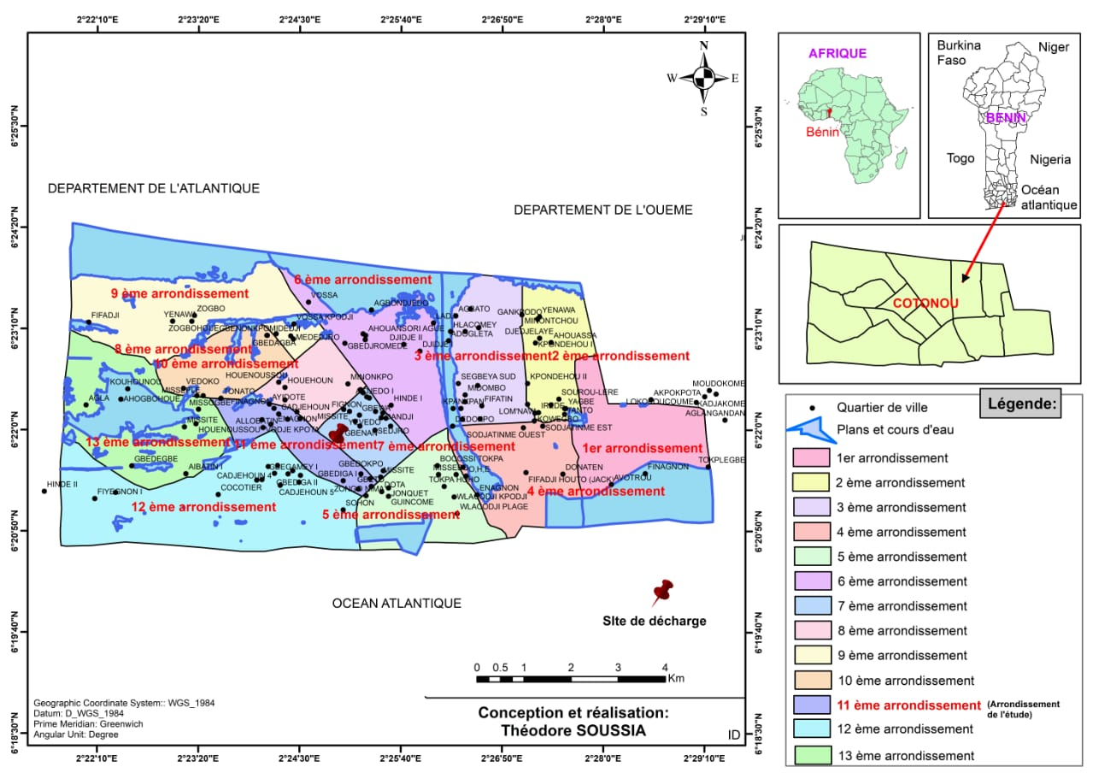
Figure 1 : waste transfer center of Gbégamey in 2025.
Source : designed and produced by SOUSSIA Théodore.
The target population for this study consisted of workers at the Gbégamey waste transfer station.
The inclusion criteria were:
- being a worker at the Gbégamey waste transfer station;
- having given free and informed consent;
- being present at the Gbégamey waste transfer station during the study period.
The exclusion criteria were:
- not completing participation in the survey;
- being assigned to another task during data collection.
To conduct the study, a non-probability, exhaustive sampling method was used to select 19 workers.
The technique used to collect data from respondents was based on an ergonomic approach. Observation allowed us to investigate the distribution of workstations, their locations, workspaces, storage areas, and the movement of people. Interviews were conducted with workers at the transfer center using a structured interview guide.
Verbal and informed consent was obtained from each participant prior to data collection. All data collected on the subjects surveyed was kept strictly confidential. The data was collected using Google Forms and then extracted into Excel. It was used solely for the purposes of this study. Microsoft Excel 2016 software was used to generate the graphs and tables.
Interpretation of risks identified at the Gbégamey transfer center
The risk assessment scale and Farmer's diagram (see appendix) were used to interprete the risks identified. Criticality was assessed using the formula : C= P x G (P = probability, G = severity, C = criticality).

RESULTS
Gender and age of workers at the Gbégamey transfer center
Analysis of the gender variable reveals that the sample consists of 63.16% males and 36.84% females.
Table I shows the distribution of workers at the transfer center by age group.
Table I : Distribution of workers surveyed at the Gbégamey transfer center by age group in 2025.
Age groups (years) | Staffs
[20 - 30[ | 07
[30 - 40[ | 09
[40 - 50[ | 02
[50 - 60[ | 01
Total | 19
Source: Field survey data, June 2025.
Most of the workers surveyed were between 30 and 40 years old.
Length of service of workers at the Gbégamey transfer centre

Figure 2 : Distribution of workers by seniority at the transfer centre of Gbégamey in 2025.
Source : Field survey data, June 2025.
Most of the workers surveyed had between 1 and 2 years of professional experience.

Level of education of workers at the transfer centre

Figure 3 : Distribution of workers at the Gbégamey transfer centre by level of education in 2025.
Source : Field survey data, June 2025.
All workers surveyed were educated.
Function performed by workers surveyed at the transfer centre

Figure 4 : Distribution of workers according to their role at the Gbégamey transfer center in 2025.
Source : Field survey data, June 2025.
The majority of workers surveyed were SGDS-SA operators, accounting for 79%.
Workplace safety training
Most of the workers surveyed, 16 out of 19, received workplace safety training, but only occasionally at the transfer center.

Household waste management activities
Main activities performed at the transfer center

Figure 5 : Main activities carried out at the Gbégamey transfer centre in 2025
Source : Field survey data, June 2025.
Sweeping is the only activity at the Gbégamey transfer centre cited by a minority (10.53%).
Duration of workers' contact with waste
Table II shows the daily duration of workers' contact with waste at the centre.
Table II : Duration of workers' contact with waste per day at the Gbégamey transfer centre in 2025.
Contact duration | Sttafs
Eight hours | 18
Less than eight hours | 1
Total | 19
Source : Field survey data, June 2025.
Workers are in contact with waste for eight hours a day.

Types of waste handled at the centre

The breakdown of the types of waste handled by workers is shown in Table III.
Table III : Distribution of workers according to the type of waste handled at the Gbégamey transfer centre in 2025
Types | Proportions
Household waste | 19/19
Plastic waste | 17/19
Organic waste | 17/19
Industrial waste | 14/19
Biomedical waste | 1/19
Source : Field survey data, June 2025.
That household waste is the most frequently handled type of waste.

Identification of health risks associated with waste management activities at the Gbégamey transfer center

Physical risks

Table IV shows workers' exposure to various physical hazards.
Table IV : Distribution of workers according to exposure to physical risks at the Gbégamey waste transfer center in 2025.
Physical risks | Answers | Proportions
Excessive heat nuisance | Yes | 19/19
Excessive heat nuisance | No | 0/19
Insufficient light nuisance | Yes | 0/19
Insufficient light nuisance | No | 19/19
Excessive noise nuisance from trucks | Yes | 6/19
Excessive noise nuisance from trucks | No | 13/19
Source : Field survey data, June 2025.
All workers surveyed, i.e., 19 out of 19, felt that excessive heat was a nuisance on site. In addition, all workers, i.e., 11 out of 11, were exposed to prolonged heat.
Chemical risks
Workers' exposure to chemical risks is summarized in the table V.
Table V: Distribution of workers according to exposure to chemical risks at the Gbégamey transfer center in 2025.
Chemical risks | Answers | Proportions
Persistent unpleasant odors | Yes | 19/19
Persistent unpleasant odors | No | 0/19
Gases irritating to the upper respiratory tract (ammonia, acetic acid) | Yes | 19/19
 | No | 0/19
Source : Field survey data, June 2025.
All of the workers surveyed, were exposed to persistent unpleasant odors and gases that irritated the upper respiratory tract.
Physical and chemical risks
Table VI shows workers' exposure to physical and chemical risks associated with activities at the Gbégamey waste transfer center.
Table VI: Distribution of workers according to exposure to physical and chemical risks at the Gbégamey transfer center in 2025.
Physical and chemical hazards | Answers | Proportions
Mineral dust (sand, cement) | Yes | 2/19
Mineral dust (sand, cement) | No | 17/19
Plant dust (wood, leaves) | Yes | 1/19
Plant dust (wood, leaves) | No | 18/19
Dust from waste materials | Yes | 18/19
Dust from waste materials | No | 1/19
Source : Field survey data, June 2025.
The majority of workers, 18 out of 19, were exposed to high levels of dust from waste.
Biological risks
The table VII shows the main biological risks to which workers are exposed.
Table VII: Distribution of workers according to exposure to biological risks at the Gbégamey waste transfer center in 2025.
Biological risks | Answers | Proportions
Exposure to blood or bodily fluids | Yes | 19/19
Exposure to blood or bodily fluids | No | 0/19
Injury from sharp or pointed objects (needles, broken glass) | Yes | 09/19
Injury from sharp or pointed objects (needles, broken glass) | No | 10/19
Source : Field survey data, June 2025.
All workers surveyed, i.e., 19 out of 19, were exposed to blood or bodily fluids. In addition, 9 out of 19 workers had suffered injuries from sharp or pointed objects.
Socio-human risks
Workers' exposure to socio-human risks is summarized in the following table
Table VIII: Distribution of workers according to exposure to socio-human risks at the Gbégamey waste transfer center in 2025.
Socio-human risks | Answers | Proportions
Team component | One | 1/19
Team component | 2 to 5 people | 919
Team component | 6 to 10 people | 8/19
Team component | More than 10 people | 1
Frequent conflicts | Yes | 6/19
Frequent conflicts | No | 13/19
Stress related to working conditions | Yes | 7/19
Stress related to working conditions | No | 12/19
Excessive pressure to perform tasks | Yes | 9/19
Excessive pressure to perform tasks | No | 10/19
Source : Field survey data, June 2025.
Seven out of 19 workers reported feeling stress related to working conditions.
Occupational illnesses
During the survey, 10/19 workers reported suffering from skin irritation; 9 /19 reported frequent headaches; 18/19 complained of muscle pain; and 16 /19 reported excessive fatigue.
Results for workers observed according to the wearing of personal protective equipment and the availability of hygiene facilities at the Gbégamey waste transfer center in 2025.
More than half of the workers observed do not wear protective gloves or masks, 7/11 and 6 out of 11 respectively. There is also a total absence of protective eyewear among all workers observed, 11/11.

Physical risks
Excessive heat hazard:
Probability (P): 4 (Very likely); all workers were exposed (19/19).
Severity (S): 3 (Serious); can cause heatstroke, dehydration, and aggravate cardiovascular problems.
Criticality (C) = 4 x 3 = 12: the criticality level of excessive heat stress is very high.
Excessive noise from trucks:
Probability (P): 2 (Unlikely); one-third of workers were exposed.
Severity (S): 3 (Serious); chronic exposure can lead to long-term hearing loss and stress.
Criticality (C) = 2 x 3 = 6: the criticality level of excessive truck noise is high.
Chemical risks
Persistent unpleasant odors:
Probability (P): 4 (Very likely); all workers were exposed (19/19).
Severity (S): 2 (Superficial); mainly discomfort such as nausea or headaches, but generally without serious long-term consequences.
Criticality (C) = 4 x 2 = 8: the criticality level of persistent unpleasant odors is high.
Gases irritating to the upper respiratory tract:
Probability (P): 4 (Very likely); all workers were exposed (19/19).
Severity (S): 4 (Very severe); can cause severe irritation, chemical burns to the mucous membranes, and long-term lung damage.
Criticality (C) = 4 x 4 = 16: the criticality level of irritant gases for the upper respiratory tract is very high.
Physical and chemical risks
Dust from waste:
Probability (P): 4 (Very likely); almost all workers have been exposed.
Severity (S): 3 (Serious); inhalation can cause respiratory problems, allergies, and pneumoconiosis (lung disease).
Criticality (C) = 4 x 3 = 12: the criticality level of dust from waste is very high.
Biological risks
Exposure to blood or bodily fluids:
Probability (P): 4 (Very likely); all workers were exposed.
Severity (S): 4 (Very severe); this can lead to the transmission of infectious diseases such as hepatitis B or HIV.
Criticality (C) = 4 x 4 = 16: the criticality level of exposure to blood or bodily fluids is very high.
Sharp or pointed object injuries:
Probability (P): 3 (Probable); nearly half of workers have been exposed.
Severity (S): 3 (Serious); injuries from sharp or pointed objects can lead to tetanus and the transmission of pathogens through the blood.
Criticality (C) = 3 x 3 = 09: the criticality level of injuries from sharp or pointed objects is high.
Socio-human risks
Existence of stress related to working conditions:
Probability (P): 3 (Probable); 7 out of 19 workers reported suffering from it.
Severity (S): 3 (Serious); chronic stress can lead to physical and mental health problems, decreased productivity, and burnout.
Criticality (C) = 3 x 3 = 9: the criticality level of the existence of stress related to working conditions is high.
Prevention and safety measures proposed by the subjects surveyed

Figure 6 : Distribution of workers according to the prevention and safety measures proposed at the waste transfer center in 2025
Source : Field survey data, June 2025.
Increased training on workplace safety and improved infrastructure at the center are the risk prevention measures proposed by the workers surveyed, with 18 out of 19 workers and 16 out of 19 workers respectively.
Discussion
The household waste management activities identified at the Gbégamey waste transfer center, such as collection, transshipment, bagging, spreading, site maintenance, and weighing of waste, are comparable to those described in the journals. Kouadio et al. in 2021, in their study in Bondoukou, Côte d'Ivoire, on the health risks of waste collectors, emphasize that the main activities at transfer sites include collection, sorting, temporary storage, compaction, and transfer of waste to final landfills or treatment centers [7]. This convergence confirms that the operations at the Gbégamey center are in line with the standard processes of household solid waste transfer centers in the subregion.
This study reported exposure to unpleasant odors and irritating gases (19/19) as well as dust from waste (18/19). These results are consistent with those of Asampong et al. in 2018 in Ghana, who observed that inhalation of dust and toxic gases (methane, ammonia) in transfer centers contributes to an increase in chronic respiratory diseases [8]. This observation is important and aligns with our results, suggesting a link between these exposures and frequent headaches (9/19) and potentially other respiratory problems among workers in Gbégamey.
Stress (7/19) and excessive pressure (9/19) experienced by workers in Gbégamey are also psychosocial risk factors identified in the sector. Medina, in his 2020 publication on waste picker cooperatives in developing countries, emphasizes that workers in the informal waste sector also suffer from stress, social stigma, and job insecurity, factors that exacerbate their vulnerability [9]. Although this study focuses on a formal sector (SGDS-SA), the demanding and often devalued nature of waste work can generate similar stress, illustrating that these risks are not limited to the informal sector.
Our results reveal insufficient use of personal protective equipment by workers: only 7 out of 11 wear gloves; 6 out of 11 use masks and none wear protective eyewear. This worrying situation was also observed in Dakar in 2017 by Ndiaye et al., who highlighted the low use of personal protective equipment (PPE), with only 30% of workers using gloves and less than 10% wearing masks, significantly increasing their vulnerability to occupational risks [10].
CONCLUSION
Waste management, although essential to urban sanitation, exposes workers at the Gbégamey waste transfer center to numerous health risks. They are exposed to physical, chemical, physicochemical, biological, and socio-human risks that raise public health concerns.

COMPETING INTERESTS DISCLAIMER:
Authors have declared that they have no known competing financial interests OR non-financial interests OR personal relationships that could have appeared to influence the work reported in this paper.

REFERENCES

1. World Bank. What a Waste 2.0: A Global Snapshot of Solid Waste Management to 2050. Washington: World Bank; 2018.
2. de-Souza S. Work environment and burnout among nurses working in the intensive care unit of the CNHU-HKM in 2023. Cotonou-Benin: INMeS-Cotonou.
3. Koné S., Assi S. B., Yapi A., and Dosso M. Prevalence of diseases and risk factors among household waste collectors in Abidjan. J Environ Public Health. 2012;1(1):27-33.
4. Diop S., Cissé N., Diagne D., Ndiaye N., and Gaye I. Evaluation of the use of personal protective equipment among urban solid waste collection workers in Dakar. Sci Health Dev. 2017;1(1):1-8.
5. Ministry of Living Environment and Sustainable Development. National Solid Waste Management Plan of Benin. 2017.
6. Boudra L. Sorting of household waste. Gender inequalities and occupational health. Work Gender Societies [Internet]. March 30, 2020 [cited November 22, 2024];43(1):67-83. Available from: https://shs.cairn.info/revue-travail-genre-et-societes-2020-1-page-67
7. Kouadio K.L., et al. Occupational health risks among waste collectors in West Africa. J Environ Health. 2021;83(5):25-30.
8. Asampong E, et al. Occupational health and safety among waste sector workers in Ghana. BMC Public Health. 2018;18:1-9.
9. Medina M. Waste picker cooperatives in developing countries. Waste Management. 2020;105:1-8.
10. Ndiaye M, et al. Occupational health and safety of waste sector workers in Dakar. African Health Sciences. 2017;17(3):749-57.

Annexe : Outils d’évaluation des risques identifiés
Table IX : Echelle d’évaluation des risques
P = Probabilité | G = Gravité | C = Criticité (PXG) | F = Fréquence d’exposition
4 : Très probable | 4 : Très grave | 12 à 16 : Très élevée | 4 : Fréquente
3 : Probable | 3 : Grave | 6 à 9 : Elevée | 3 : occasionnelle
2 : Peu probable | 2 : Superficielle | 3 à 4 : Moyenne | 2 : Peu fréquente
1 : Très improbable | 1 : Bénigne | 1 à 2: Faible | 1 : Rare

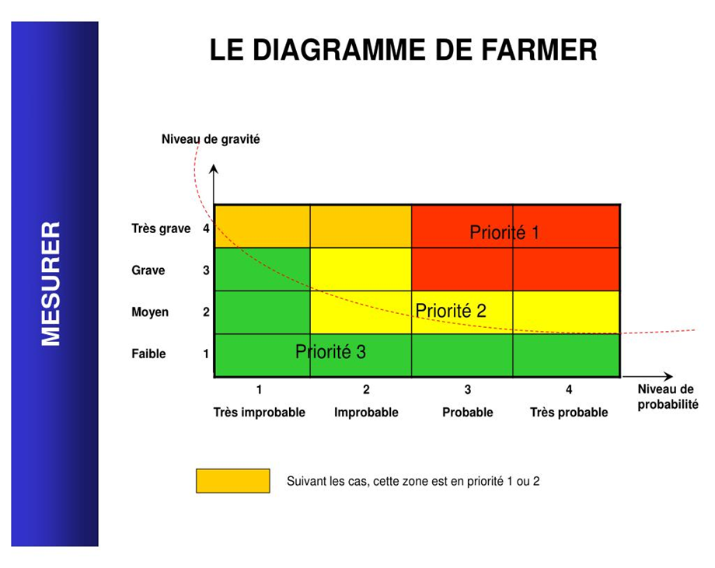
Figure 7 : Le diagramme de Farmer
Le diagramme de Farmer représente de façon synthétique le risque et les plus importants concepts associés. Il se présente comme un cadran d’un espace à deux dimensions qui sont la ‘’Probabilité’’ et la ‘’Gravité’’ ; un point de cet espace représente un évènement.

Figure 8 : Transbordement et étalement des déchets dans l’espace quai du centre de transfertLe diagramme de Farmer représente de façon synthétique le risque et les plus importants concepts associés. Il se présente comme un cadran d’un espace à deux dimensions qui sont la ‘’Probabilité’’ et la ‘’Gravité’’ ; un point de cet espace représente un évènement.

