The Growing Effects of Climate Change and its Environmental and Social Consequences in Nigeria

Abstract
Our planet, Earth, faces a challenge. Climate change, driven by increasing greenhouse gas emissions, poses this challenge, with Nigeria—a leading oil producer and a major gas-flaring country—experiencing severe impacts. This paper examines the growing effects of climate change on Nigeria’s environment and society, focusing not only on agriculture as most previous studies have done but also on health, water resources, energy, transportation, and tourism. Nigeria’s fertile land and economy are increasingly weakened by climate-induced disruptions such as erratic rainfall, rising temperatures, and extreme weather events which undermine agricultural productivity, worsen rural poverty, and strain the country’s fragile economy. Public health is at risk as well, with rising sea levels and temperature variations causing increased diseases and compromised water quality. Current mitigation strategies are inadequate to achieve long-term positive outcomes. Thus, urgent and more effective climate strategies are essential to preserve Nigeria’s future, protect its vital resources, and ensure socio-economic stability.
Keywords: Climate Change, Environmental, Socioeconomic, Greenhouse Gases, Agriculture, Health, Water Resources, Energy, Poverty, Tourism, Flooding

- Introduction
Climate change refers to an increase in the average global temperature. It refers to the long-term warming of the planet, which is caused by the increasing levels of greenhouse gases in the Earth’s atmosphere. These gases are released into the environment as a result of man’s day-to-day activities. Activities such as deforestation, burning of fossil fuels, industrial processes, and so on. These gases such as carbon dioxide and methane trap heat from the sun and prevent it from being released back into space, leading to a rise in global temperatures, and causing a surge of environmental and social effects.
Over the years, climate change has been at the forefront of public concern across the globe and the undeniable effects of climate change have been witnessed in many forms, some more drastic than others. As climate change has gained prominence on the global stage, its varied impacts have become increasingly evident. From more frequent and severe weather events to disruptions in ecosystems and economies, the repercussions of climate change are extensive and complex. Nigeria, a major oil producer and one of the world’s top gas-flaring countries, faces particularly severe consequences due to its environmental and socio-economic context [14-16].
In this paper, I emphasize the growing effects of climate change and its environmental and social consequences in Nigeria, examining its impact on key areas such as agriculture, health, water resources, energy, transportation, and tourism. Nigeria’s fertile land and resource-rich economy are under significant threat from climate-induced disruptions, including erratic rainfall patterns, rising temperatures, and extreme weather events. These changes not only undermine agricultural productivity but also exacerbate rural poverty and strain the nation’s fragile economy. Additionally, public health is compromised through increased disease incidence and deteriorating water quality [17-20].
Some previous studies that have examined a similar theme posed in this paper include Kanu and Onyekwere (2023) examine the impact of climate change on food security. The Food and Agriculture Organization (FAO) (2015) identifies that climate change affects agricultural productivity through shifts in temperature and rainfall, with additional indirect effects from changes in pollinators, pests, and disease vectors, as further explored by Hilda (2019) and Ali et al. (2019). Atitsogbey et al. (2018) document the negative impacts on food security in Ghana, and Zakari et al. (2014) analyze the relationship between crop yields and climatic factors in Nigeria. Despite significant efforts to address food insecurity, FAO (2015) and Concern Worldwide (2019) highlight that many remain chronically undernourished, with FAO (2008) predicting worsening conditions for the poor, especially in rural areas dependent on subsistence farming. Offor (2009), Umunnakwe et al. (2015), and Chidiebere-Mark (2019) reveal various local adaptation strategies, while Ekpenyong et al. (2015), Idumah et al. (2016), and Pendino (2017) confirms the adverse effects of climate change on agricultural productivity and food security in Nigeria. Additional evidence from Odoemela and Ajuka (2012), Duru and Obiechefu (2013), and Okorie et al. (2019) highlight the negative impact of climate variability on food security as studies by FAO, IFAD, UNICEF, WFP, and WHO (2021) have consistently linked climate change with increased global food insecurity.
Overall, past studies have focused significantly on agriculture, but this paper discusses, in broader contexts, Nigeria’s vulnerabilities and emphasizes the urgent need for a comprehensive climate action roadmap, a well-structured one that will not accidentally stifle the country’s already fragile economy. Understanding these impacts will help in developing effective strategies to mitigate and even adapt to climate change, ensuring the preservation of Nigeria’s resources and socio-economic stability.
- Effects of Climate Change and their Societal Consequences in Nigeria
Nigeria is a country well known for its fertile soil and abundance of mineral resources. Having a land with such fertility has encouraged farming practices since the days of old. It has also become a source of livelihood for many. The agricultural sector of the country contributes a high percentage of the National Gross Profit (NGP). It can also be said that the agricultural sector of Nigeria serves as a backbone for the economy. When disturbing issues like persistent droughts and flooding, off-season rains, and dry spells arise due to climate change, the rate at which crops are produced and the stipulated time for harvest are also affected.
  - Agriculture
The key climate change factors affecting Nigeria’s agriculture include increased precipitation variability, rising surface temperatures, and more frequent extreme weather events. While there are some strategies to mitigate these effects, they are not permanent solutions. This in turn causes a decline in the productivity of the agricultural sector. A comparative analysis is shown in Figure 1 below. Consequently, the government will be affected when the already fragile economy comes crumbling down as a result of insufficient funding. Thus, addressing climate change is crucial for ensuring Nigeria’s food security and overall economic buoyancy given the importance of this sector in development and job creation, see Figure 2.

Figure 1: Agricultural Productivity of Nigeria Relative to Selected Countries
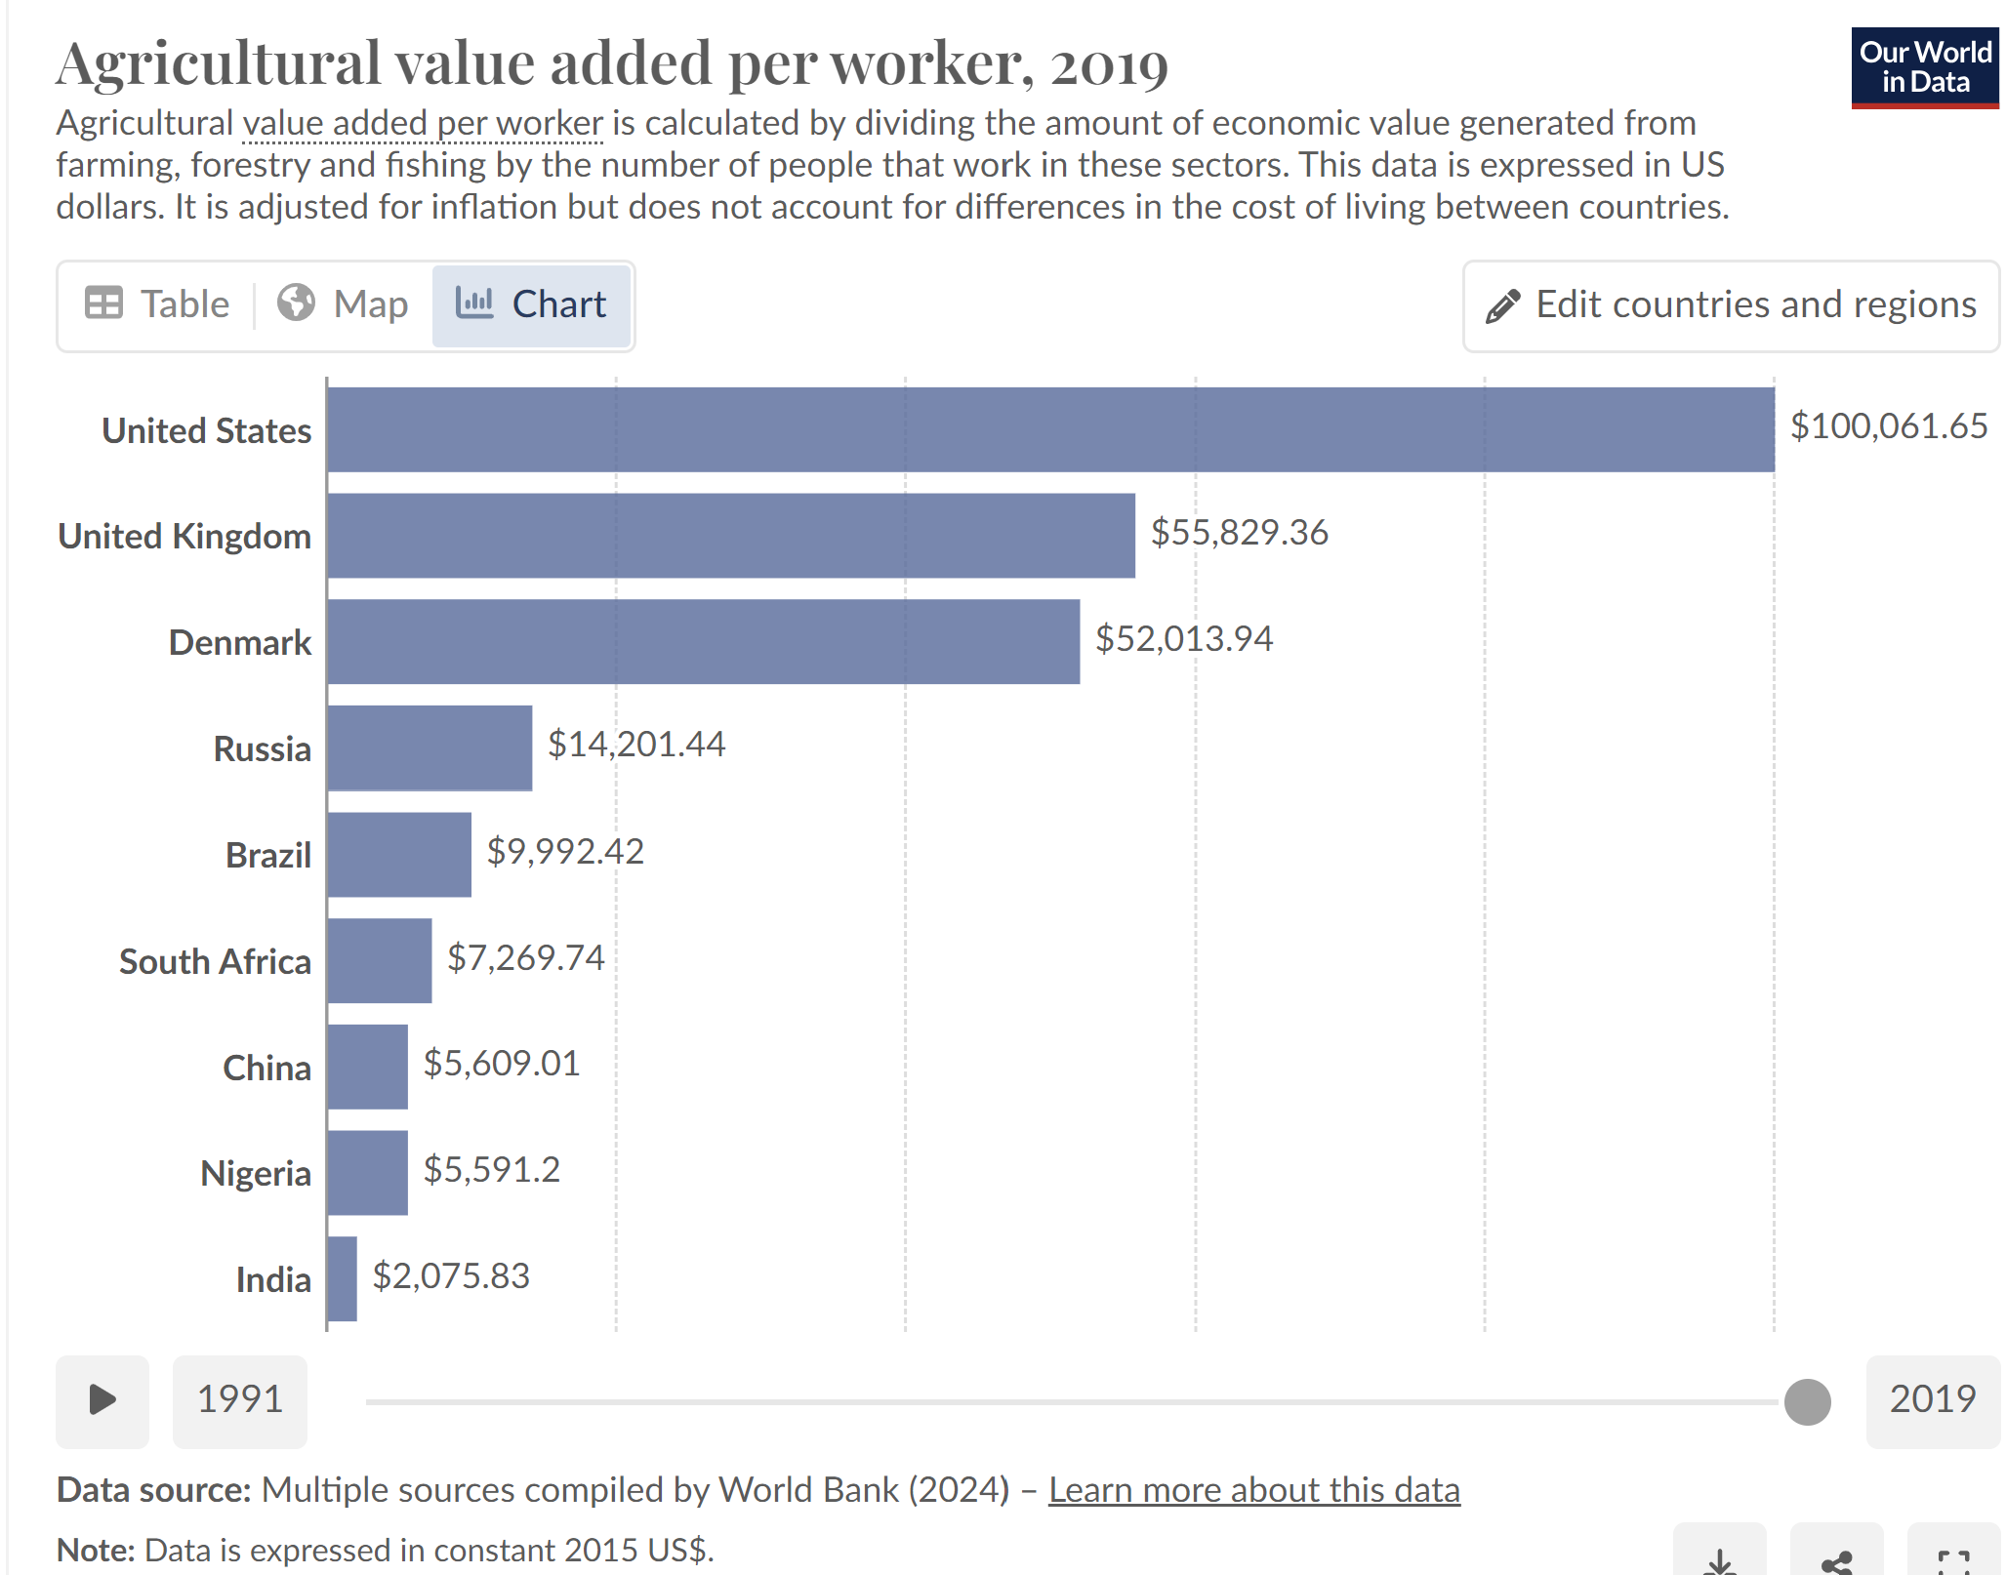
Source: https://ourworldindata.org/africa-yields-problem
Figure 2: Agriculture as a Job Creator and Economic Booster in Nigeria
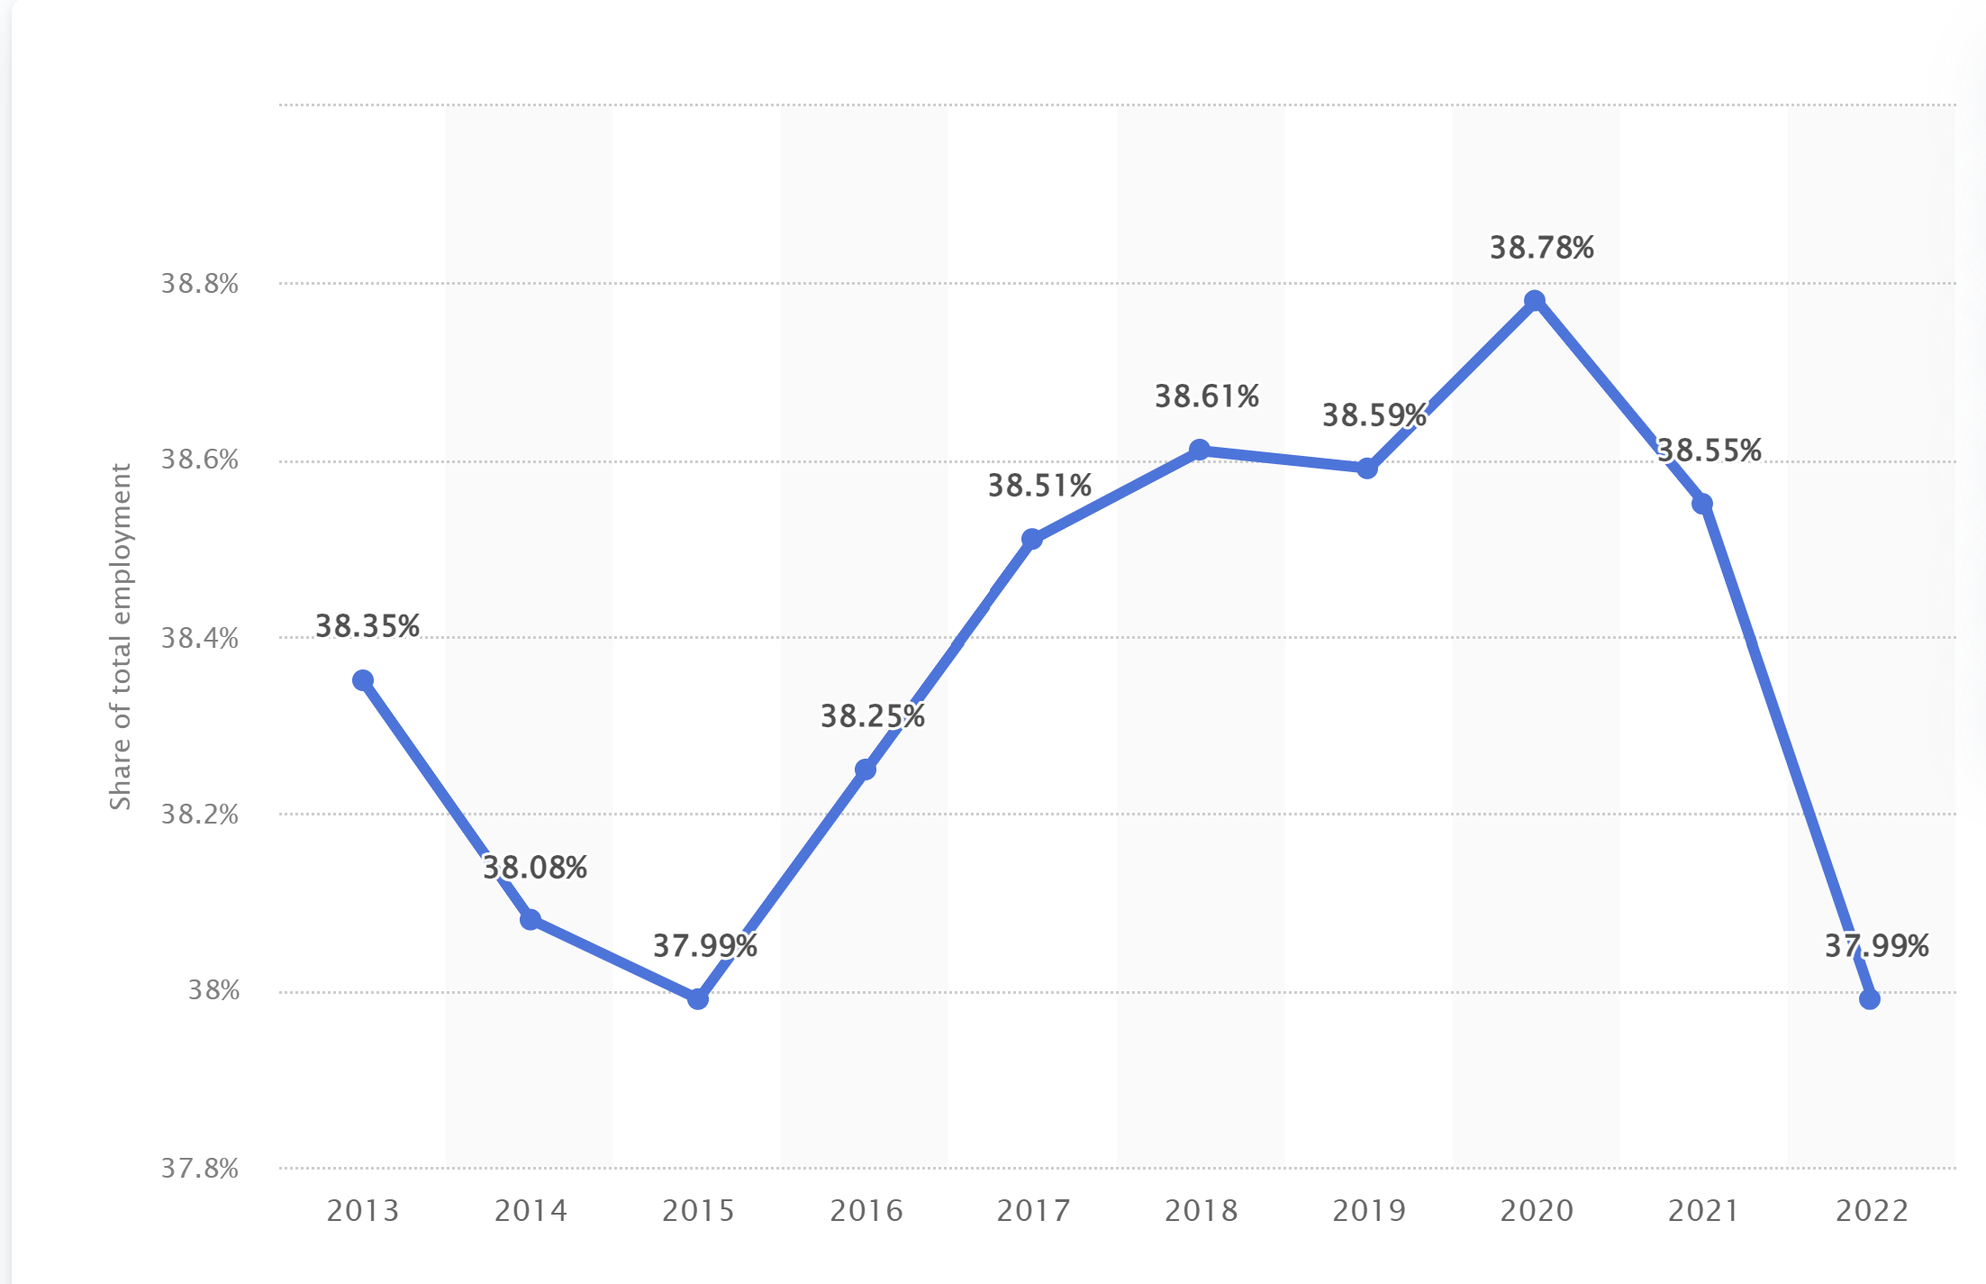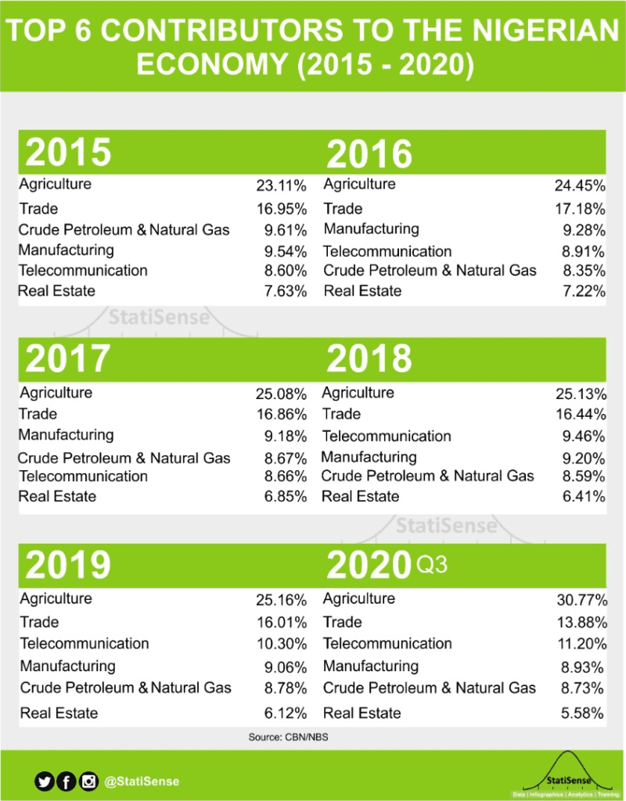
Source: https://www.statisense.co/infographics/gdp/3-top-contributing-sectors-to-the-nigerian-economy and https://www.statista.com/statistics/1288871/agriculture-sector-share-in-employment-in-nigeria/

  - Energy
According to a study conducted by the World Bank in 2007, it is shown that Nigeria is the eighth largest oil supplier in the world, tho Chatbot ugh bottlenecks in production and production unaccountability due to persistent oil thefts have shrunk the official output production figures over time.
Figure 3: Oil Production of Nigeria and Other Major Producers
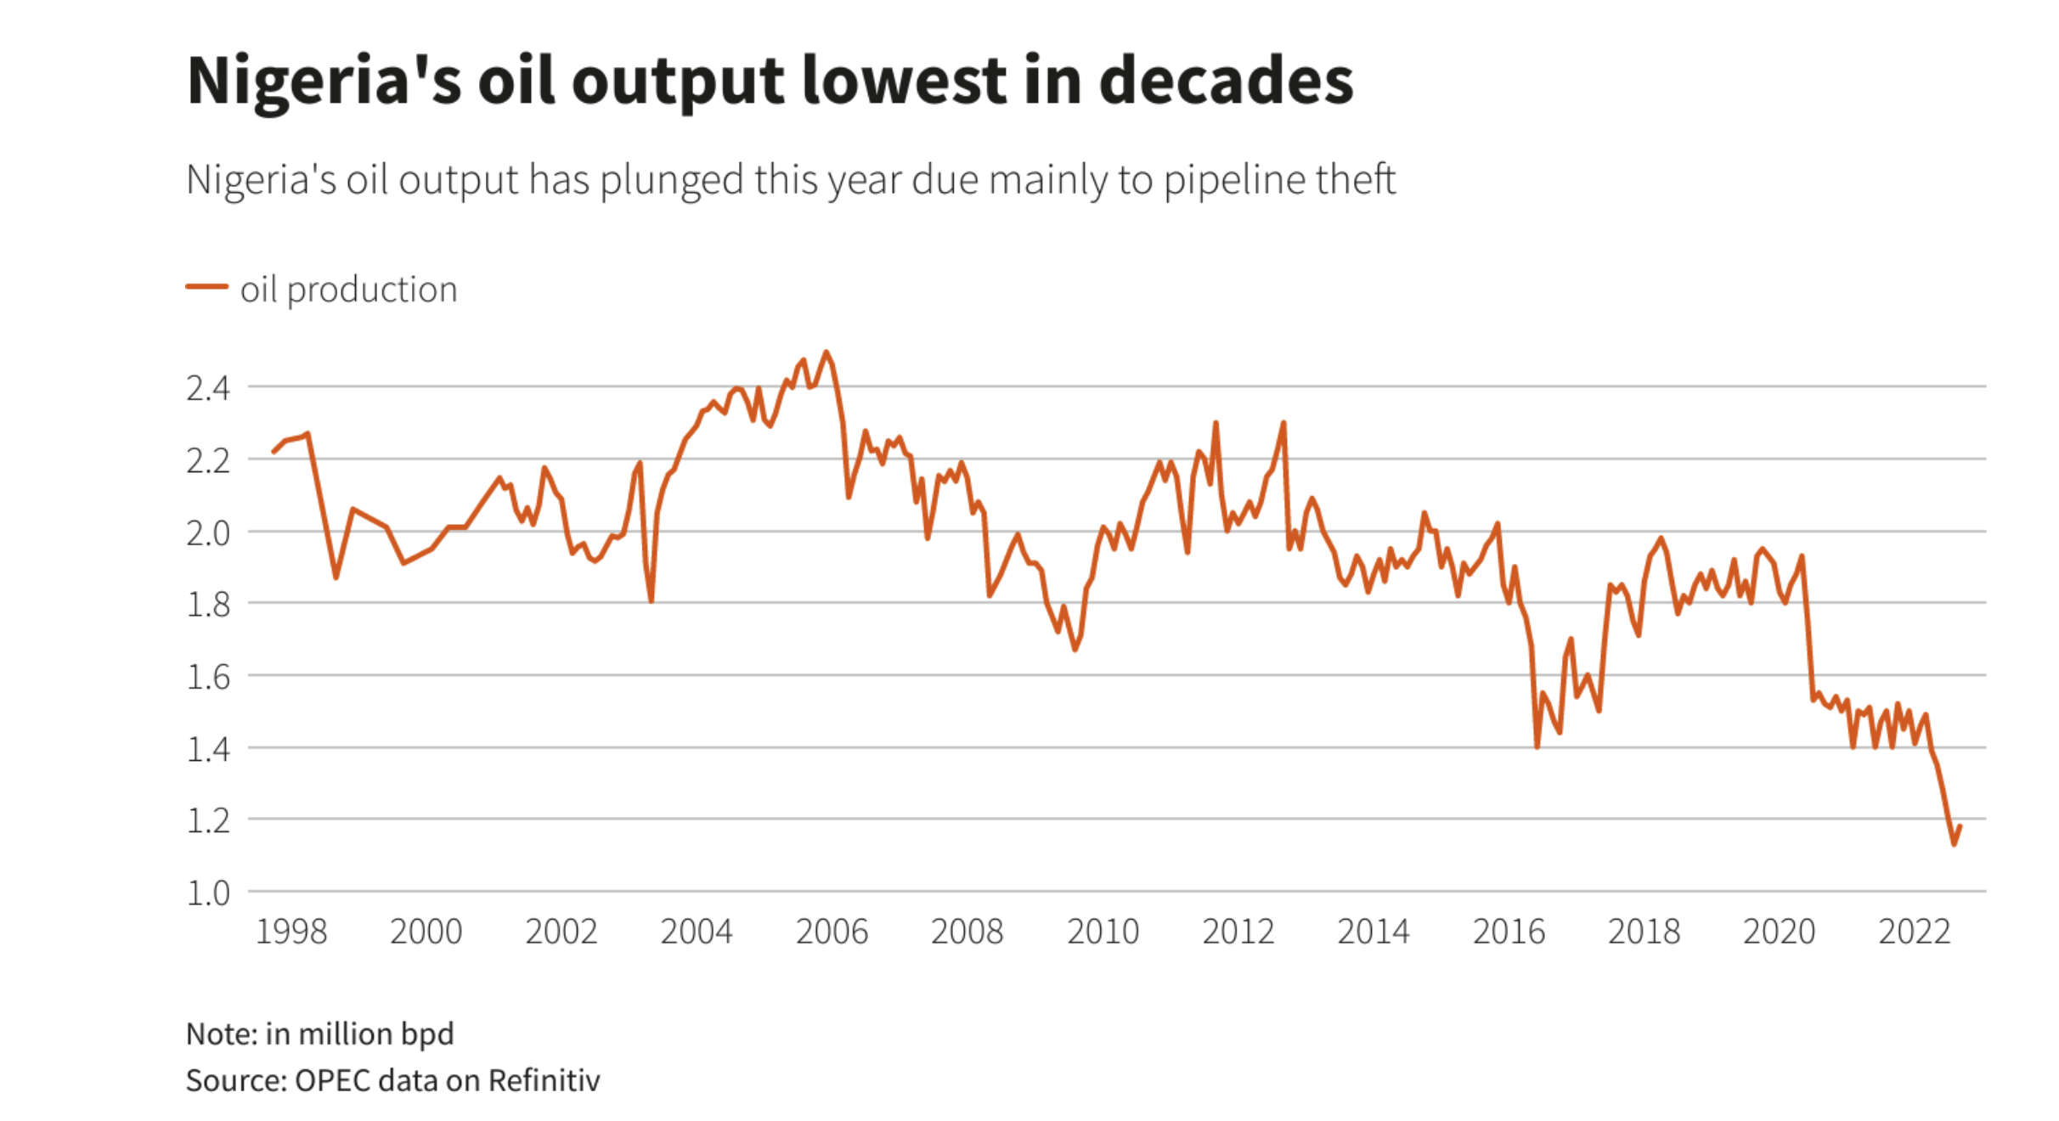
Source: https://www.worldometers.info/oil/oil-production-by-country/ and https://www.reuters.com/business/energy/nigerias-oil-output-drops-below-1-mln-bpd-2022-09-09/

The country’s abundance of mineral resources like coal, bitumen, petroleum, natural gas, and so on, is well known. Developed countries, far and wide, come to Nigeria in need of these resources and Nigeria delivers to them. It is one of the reasons why the country is regarded as the “giant” of Africa, despite the undeniable underdevelopment in many other sectors. As a major producer of oil and gas, there is a need for a functioning industrial sector, capable of producing oil at the rate at which it is being demanded. According to statistics given by the United Nations Organization, Nigeria alone, accounts for roughly one-sixth of the worldwide gas flaring, which means about 400 million tons of carbon dioxide is spewed into the atmosphere through industrial activities in Nigeria. This makes the country a notable producer of greenhouse gases that destroy the climate and also labels the country as an encourager of climate change, even if it is not a deliberate act.

Figure 4: Africa Bitumen Market, Revenue Share (%) By Country (Left), and Coal Production (Middle and Right)
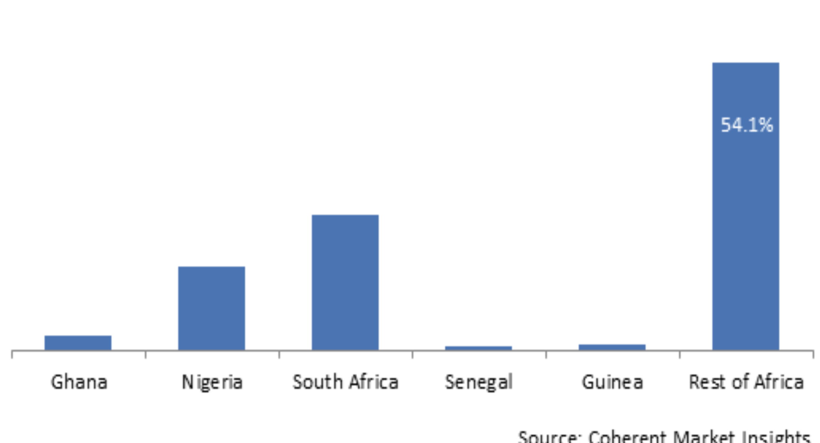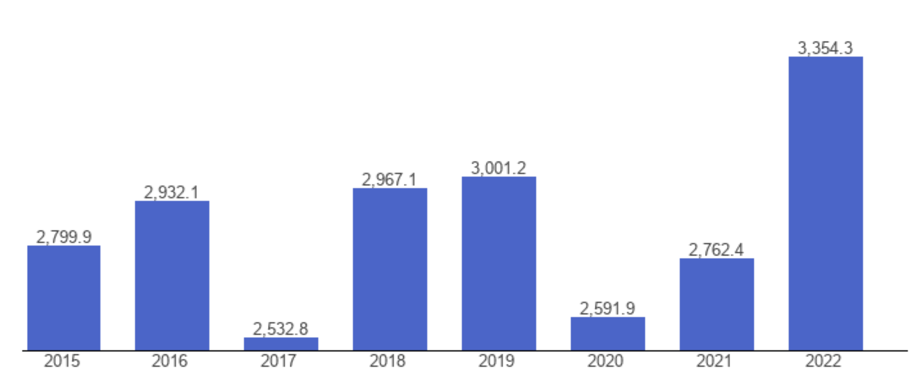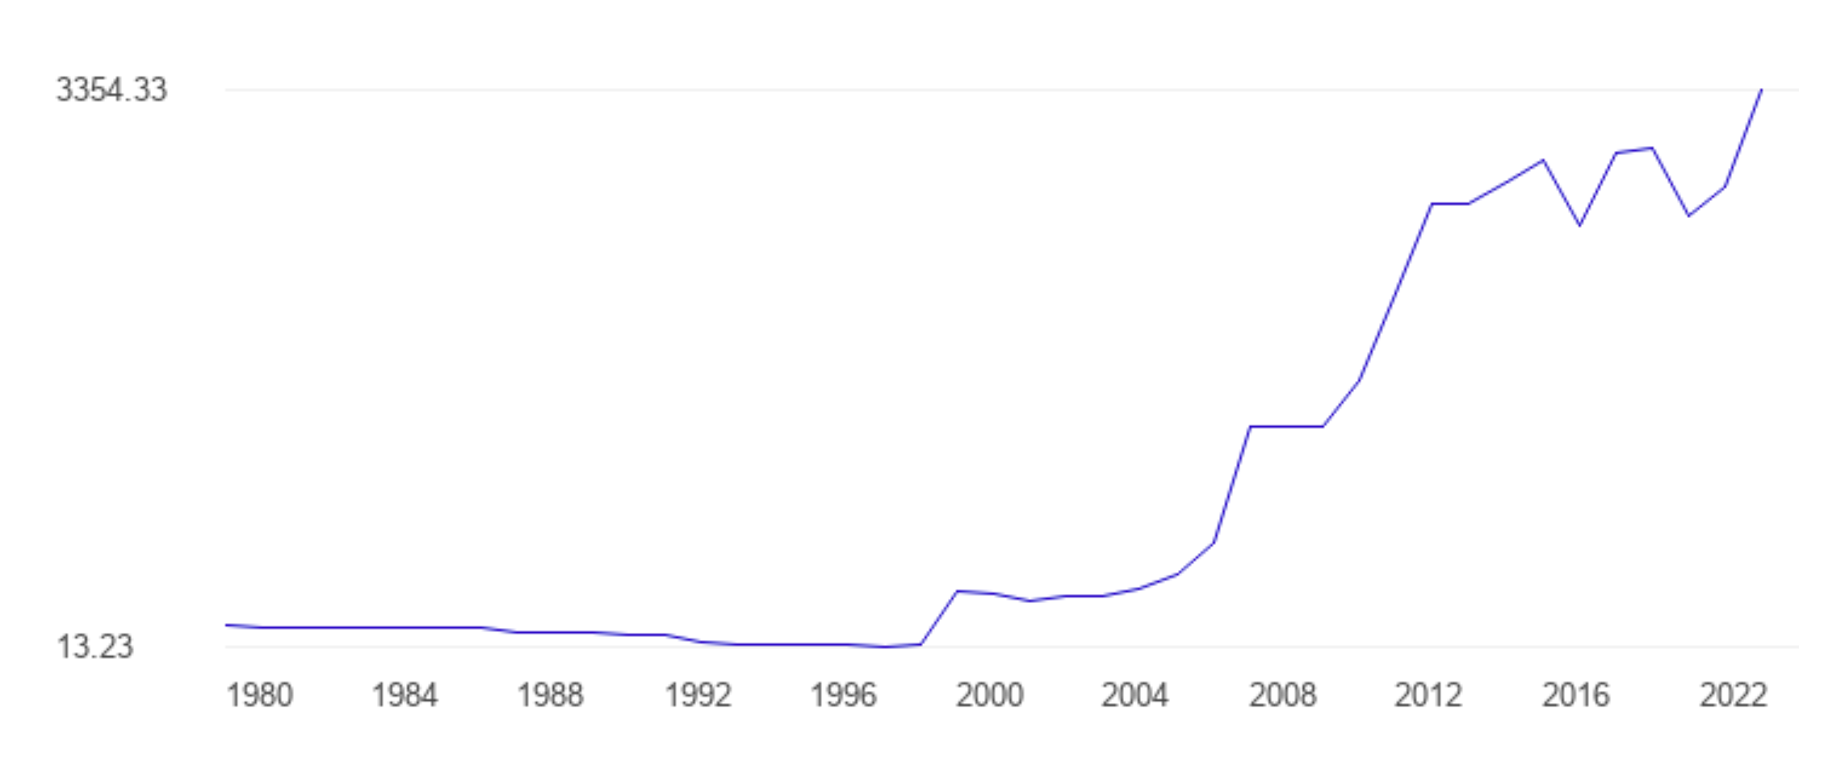
Source: https://www.theglobaleconomy.com/Nigeria/coal_production/ and https://www.coherentmarketinsights.com/market-insight/africa-bitumen-market-4899

  - Poverty
No doubt, Climate Change is an undeniable global problem but for developed countries, a better coping mechanism can be established due to high adaptation techniques and technologies, effective research-proven policies, mechanized agricultural system, and wealthy economic status. It helps to reduce the harsh effects felt due to climate change. For developing and sub-standardized countries like Nigeria, the effects of climate change are felt more, so much more that the IPCC Assessment report[4th edition], emphasizes how brutally Africa will experience climate change as the years go by. An example of the biting effect of climate change in Nigeria is the exacerbation of rural poverty due to a failing economy. This occurs because the agricultural sector, a sector that provides a means of livelihood for the common man and also provides employment for some youths, has been deeply affected in terms of growth and expansion, as explained previously in this essay.
  - Health
Another sector affected by climate change is the health sector. Climate change affects human health directly and indirectly in many ways. Factors like variations from acceptable temperature, rising sea levels, and increasing frequencies have great implications on human health in the areas of injury, illness, morbidity, and mortality. The abnormal rise of sea levels is known to be a result of climate change. It is only a matter of time before flooding of coastal areas occurs, this likely increases the vulnerability of the poor to sicknesses like malaria, typhoid, cholera, and pneumonia. Also, temperature and rainfall dynamics may increase the distribution of disease vectors such as dengue, malaria and the incidence of diarrheal disease. As it stands, climate change increases the rate of threats to human health, thereby affecting their productivity.

  - Water and Flooding
Climate change also affects the nature and characteristics of freshwater resources on which Nigeria depends for its freshwater. Changes in weather and climate have been known to influence water resources a great deal. The impact felt varies between ecozones experiencing problems of problems of too much water (floods) to little or no water source at all (drought). It also leads to problems like reduced water quality, saltwater intrusion, sea level rise, and contaminated or diseased water system which in turn leads to the death of aquatic life. As per a study conducted on the impact of climate change in Nigeria by the Nigerian Environment Study/Action Team (NEST), it is observed that various regions of the coastal parts of Nigeria experience adverse effects of climate change more than any other parts of the country.
In Akwa Ibom state, a coastal city in Nigeria, heavy rainfall is being experienced which leads to constant flooding of homes, the disappearance of local streams, and heavy erosion damages. Nigeria’s coastal cities are currently faced with the threat of inundation due to the constant rise in sea level, along the coastal axis. For every 1m rise in sea level, up to 600km² of land would be at risk of erosion. The periodic overflow of the Atlantic Ocean across Bar Beach is an indication of a phenomenon that may accelerate as climate change intensifies and the sea level rises even further. Cities on the coastal side of Nigeria sleep with one eye open during the rainy seasons. The constant fear of flash floods that result in loss of lives and property does not allow us to rest easy. This fear is not easy to live with but has become a thing of normality for citizens living in such areas. This is because successive governments have paid limited attention to the matter. The citizens have therefore succumbed to their fate and have learnt to live with this problem, even if it may one day lead to their deaths.

  - Clean Energy
Climate change has also affected the energy generation and supply in Nigeria. How? One may ask. Although not directly, climate change has influenced the generation of energy in Nigeria. It is a fact that energy services are necessary inputs for every nation’s development and growth. No economy can sufficiently thrive without adequate access to clean, reliable, and adequate energy. Nigeria is a country blessed with many sources of energy, sources as thermal, hydro, solar, and oil resources. Yet, Nigeria is termed as an energy-poor country. The major source of generating electricity in Nigeria is hydroelectric power(HEP). In a recent report from BNRCC(Building Nigeria’s Response to Climate Change), it is asserted that hydroelectric power is the energy source most likely to be affected by climate change as it is sensitive to the timing and the geographical pattern of precipitation as well as temperature.

  - Roads and Transportation
Nigeria’s transport system will not be exempted from the list of sectors faced with the effects of global warming and climate change. As a result of sea level rise, constant floods, and erosion, costly changes need to be implemented on ports, roads, and railways in order to preserve them. Constant rainfall and erosion are known to cause potholes on roads, and this may lead to accidents if not curbed. Rail tracks also begin to rust when exposed to rain frequently. This could result in fatal accidents too if not handled. Along the coast where erosion is frequently experienced and more drastic, roads with improper drainage systems could remain covered with intruding seawater. This renders the roads inaccessible for some time until the water is evaporated or pumped out. During this season, few roads that remain accessible are always faced with the issue of traffic congestion. Armed robbers and kidnappers make use of this opportunity and perform all sorts of vices on road users. This increases the crime rate in such areas as well. This is another effect caused by climate change.
  - Tourism
Tourism, especially beach-based, will be faced with the fear of extinction with the rate at which the sea is rising. Unpreventable backwash of seas poses a huge threat to areas like Lagos Island and Lagos Bar Beach. There is also the fear of losing the cultural heritage. People migrate to other countries in search of better standards of living. They leave behind their home and culture and take up new ones when they get there. The cultural practices and heritage of their homeland are abandoned, and growing children have no clue about their culture. These are some of the many socio-economic effects caused by climate change. Climate change is an undeniable environmental threat, and its effects cannot be overemphasized. The government should pay more heed to this and proffer solutions to help combat climate change if not completely eradicate it. Lives are being lost and infrastructure and properties are also being damaged. Solutions should be proffered to these problems and actions should be taken immediately to help minimize the growing effects of climate change in Nigeria.
- Conclusion
Nigeria, a major oil producer and one of the world’s top gas-flaring countries, is not spared of the challenge and far-reaching consequences of climate change. At its core, climate change is driven by rising greenhouse emissions. It poses significant environmental and social challenges globally, with severe implications for Nigeria. This paper explores the growing effects of climate change on Nigeria's environment and society, emphasizing its impact not only on agriculture but also on health, water resources, energy, transportation, and tourism. Nigeria's fertile soil and resource-rich landscape, crucial for its agricultural sector and economic stability, are increasingly threatened by climate-induced issues such as erratic rainfall, temperature rises, and extreme weather events. These changes disrupt crop production, exacerbate rural poverty, and strain the nation’s already fragile economy. Additionally, climate change impacts public health, with rising sea levels and temperature shifts contributing to increased disease incidence and compromised water quality. Urgent action is needed to address these challenges, as current mitigation strategies are insufficient for ensuring long-term positive impact. Effective climate action is essential to safeguard Nigeria's future and preserve its vital resources and socio-economic stability.
Nigeria needs several targeted actions to address the multifaceted impacts of climate change. The first step to becoming climate-resilient is to introduce drought-resistant crops, improve soil management, and invest in irrigation systems to cope with erratic rainfall and temperature fluctuations. Second, improving water management infrastructure is vital to addressing flooding as well as drought, including rainwater harvesting, efficient irrigation, and improved sanitation to safeguard water quality. Developing early warning systems for climate-sensitive diseases and strengthening public health systems are necessary for managing climate-induced health risks. In addition, the transition to sustainable energy solutions will reduce reliance on fossil fuels; expanding renewable energy sources such as solar and wind, as well as modernizing the energy sector will reduce greenhouse gas emissions. Lastly, coastal areas must be protected, and infrastructure must be made more resilient. Constructing coastal defenses, upgrading infrastructure to withstand climate impacts, and enforcing climate-resilient building codes will help mitigate the effects of sea level rise and erosion that have affected the Southeast and South-south regions of the country. Collectively, these measures will contribute to mitigating the adverse effects of climate change and support Nigeria in its quest for advancement.

- References
- Ali et al. (2019) - Ali, R., Ali, R., Sundas, S. M., Xiling, Z., Xuekun, Z., Yan, L., & Jinsong, X. (2019). Impact of Climate Change on Crops Adaptation and Strategies to Tackle Its Outcome: A Review.
- Atitsogbey et al. (2018) - Atitsogbey, P., Steiner-Asiedu, M., Nti, C., & Ansong, R. (2018). The impact of climate change on household food security in the Bongo District of the Upper East Region of Ghana. Ghana Journal of Agricultural Science.
- Zakari et al. (2014) - Zakari, D. M., Mohammed, A. B., Medugu, N. I., & Sandra, I. (2014). Impact of climate change on yam production in Abuja, Nigeria. International Journal of Science, Environment and Technology, 3 (2), 458-472.
- FAO (2008) - Food and Agricultural Organization (FAO) (2008). Climate change adaptation and mitigation in the food and agricultural sector.
- FAO (2015) - Food and Agricultural Organization (FAO) (2015). Climate change and food security: risks and responses.
- FAO et al. (2021) - Food and Agricultural Organization (FAO), International Fund for Agricultural Development (IFAD), United Nations Children's Fund (UNICEF), World Food Programme (WFP), & World Health Organization (WHO) (2021). The State of Food Security and Nutrition in the World 2021. Transforming food systems for food security, improved nutrition, and affordable healthy diets for all. Rome: FAO.
- Ekpenyong & Ogbuagu (2015) - Ekpenyong, I. U., & Ogbuagu, M. I. (2015). Climate change and agricultural productivity in Nigeria: An econometric analysis.
- Idumah et al. (2016) - Idumah, F. O., Mangodo, C., Ighodaro, U. B., & Owombo, P. T. (2016). Climate change and food production in Nigeria: Implication for food security in Nigeria. Journal of Agricultural Science, 8(2), 74.
- Odoemelam & Ajuka (2012) - Odoemelam, L. E., & Ajuka, N. (2012). Effect of climate change on household food security in Ideato North Local Government Area of Imo State, Nigeria. Journal of Agriculture and Social Research (JASR), 12 (2).
- Duru & Obiechefu (2013) - Duru, P. N., & Obiechefu, H. (2013). Climate Change and Food Security in Ikeduru Local Government Area Imo State, Nigeria: The Way Forward. International Journal of Science and Research (IJSR).
- Okorie et al. (2019) - Okorie, F. C., Njoku, J. D., Iwuji, M., & Onweremmadu, E. U. (2019). Climate change and food crop production in Imo State Nigeria: An analysis of the 30-year period. African Journal of Behavioural Sciences, 9 (2).
- Umunnakwe et al. (2015) - Umunnakwe, P. C., Ozor, N., & Nnadi, F. (2015). Indigenous Practices for Climate Change Adaptation among Rural Households in Imo State, Nigeria. Current Journal of Applied Science and Technology, 8 (1), 67-79.
- Concern Worldwide (2019) - Concern Worldwide (2019). How climate change threatens food security - and why we're all at risk.
- Nguyen TT, Grote U, Neubacher F, Do MH, Paudel GP. Security risks from climate change and environmental degradation: Implications for sustainable land use transformation in the Global South. Current Opinion in Environmental Sustainability. 2023 Aug 1;63:101322.
- Leichenko R, O'Brien K. Climate and society: Transforming the future. John Wiley & Sons; 2024 May 13.
- Chien F, Chau KY, Sadiq M. Impact of climate mitigation technology and natural resource management on climate change in China. Resources Policy. 2023 Mar 1;81:103367.
- Farghali M, Osman AI, Chen Z, Abdelhaleem A, Ihara I, Mohamed IM, Yap PS, Rooney DW. Social, environmental, and economic consequences of integrating renewable energies in the electricity sector: a review. Environmental Chemistry Letters. 2023 Jun;21(3):1381-418.
- Chien F, Chau KY, Sadiq M. Impact of climate mitigation technology and natural resource management on climate change in China. Resources Policy. 2023 Mar 1;81:103367.
- Muruganandam M, Rajamanickam S, Sivarethinamohan S, Reddy MK, Velusamy P, Gomathi R, Ravindiran G, Gurugubelli TR, Munisamy SK. Impact of climate change and anthropogenic activities on aquatic ecosystem–A review. Environmental Research. 2023 Oct 2:117233.
- Roy P, Pal SC, Chakrabortty R, Chowdhuri I, Saha A, Shit M. Effects of climate change and sea-level rise on coastal habitat: Vulnerability assessment, adaptation strategies and policy recommendations. Journal of Environmental Management. 2023 Mar 15;330:117187.

