P-SELECTIN MARKER IN VENOUS THROMBOEMBOLISM

ABSTRACT

Venous thrombosis is a life threatening disease associated with high morbidity and mortality. Predisposing factors of venous thrombosis associated with obesity, age, varicose veins etc. There is a interaction between the thrombosis and inflammation. P selectin unregulated glycoprotein, ability to bind to the ligand of leucocytes and platelets. Modulation contributes of initial thrombus, plays an important role in development and progression of thromobocytic events and may acts as a biomarker for venousthromboembolism

INTRODUCTION:

Venous thromboembolism (VTE) is a common condition that occurs when a blood clot forms in a vein. VTE encompasses both deep vein thrombosis (DVT) and pulmonary embolism (PE). DVT has been associated with the blood clot formation in a deep vein of the lower limb and in the upper limbs, particularly in presence of a large intravenous central line in the vein. Pulmonary embolism occurs when a clot lyses and passes to the lungs. In patients with acute symptomatic pulmonary embolism (PE), the presence of lower limb deep vein thrombosis (DVT) has been associated with a higher mortality rate.¹

RISK FACTORS:
The combination of acquired and genetic risk factors acts as an etiological factors of VTE. Several factors such as venous wall injury, stasis, and hypercoagulability are the three main pathophysiological factors that, either alone or in combination, contribute to the development of venous thrombosis.²
Occurrence of DVT has been noted high in patients with acquired risk factors, undergoing major abdominal and orthopedic surgeries.³ As well it has been associated with the abdominal neoplasm. Women with inherited thrombophilia disorders, such as activated protein C resistance deficiencies of protein C, protein S, and antithrombin III, have a significantly higher hereditary risk of pregnancy-related venous thromboembolism than women without these disorders.⁴

While VTE is linked to antithrombin deficiency, protein C deficiency, factor V Leiden, and prothrombin G20210A mutation, these thrombotic risk factors are not frequently present in chronic Thromboembolic Pulmonary Hypertension patients.⁵ Femoral neuropathy, the neurological side effect of VTE, is caused by retroperitoneal hemorrhage and typically follows pelvic and lower extremity trauma, though it can also be a side effect of antithrombotic medications. Patients with VTE undergoing nephrectomy have been associated with high mortality rate.⁶

PATHOGENESIS:
The presence of Virchow's triad abnormalities in blood flow, blood vessel wall, and blood clotting components are necessary for thrombus formation. Venous obstruction may result from intravascular compression from previous thrombosis, external compression from enlarged lymph nodes or presence of tumors.⁷ Evolution of venous thrombosis originates at venous valves involving low blood flow locations leading to tiny fibrin deposits at the vessel walls and these deposit areas expand leading to the obstructing the blood flow ultimately triggering the coagulation cascades. Similarly, endothelial damage following surgery or trauma can also contributes to the venous thrombosis.
Antithrombotic proteins including thrombomodulin and endothelial protein C receptor (EPCR), which are located locally on the valves, are susceptible to hypoxia and inflammation. Hypoxia and an increased hematocrit have been associated with valvular sinus stasis, resulting in a hyper coagulable micro environment.⁸

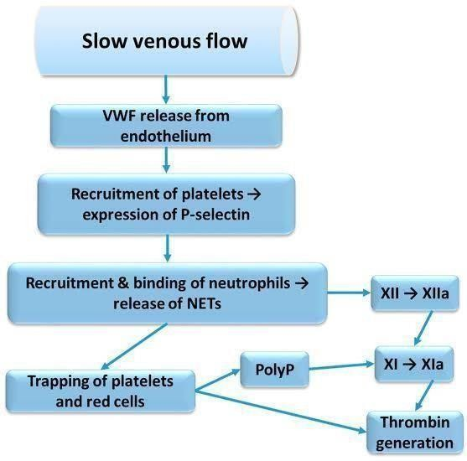

Figure 1: The image shows a flowchart illustrating the process of thrombosis.⁷

CLINICAL FEATURES:

Signs of DVT on physical examination include tenderness, warmth, erythema, cyanosis, edema, palpable thrombotic vein and superficial venous dilatation. If the upper portion of the calf becomes uncomfortable due to abrupt dorsiflexion of the ankle joint while the knee is flexed to 30°; this is known as the Homans sign. Coughing or sneezing that worsens pain along a thrombotic vein is known as the Louvel sign. When a sphygmomanometer cuff is inflated around each calf, the Lowenberg sign shows that pain is felt in the affected calf at a lower pressure than in the unaffected one.⁹ The clinical features of PE include shortness of breath and chest pain (commonly pleuritic) and DVT includes leg pain, unilateral swelling, leg-related sleep problems, skin discoloration, cosmetic appearance, activity limitation and emotional distress.¹⁰

COMPLICATIONS: Venous thromboembolism (VTE) complications include post-thrombotic syndrome (PTS), a chronic illness that develops after deep vein thrombosis (DVT) and pulmonary hypertension, commonly referred to as chronic thromboembolic pulmonary hypertension (CTEPH), which can be caused by unresolved pulmonary emboli. Signs and symptoms of post-thrombotic syndrome can vary from patient to patient, and proximal DVT is more likely to develop post thrombotic syndrome than calf or popliteal vein DVTs.¹¹

DIAGNOSIS: The initial diagnostic step for determining of VTE is the clinical probability assessment.
Clinical assessment: For suspected DVT, the Wells score has been well established.¹²
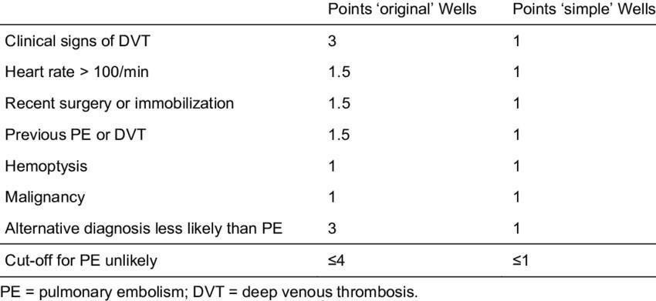
Table 1- The clinical probability assessment model
Based on the clinical model, the pre-test probability may be predicted for patients with clinical features based on this clinical model. The chance of DVT is probable if the score is ≥2, PE is likely if the score is ≥4, and PE is unlikely if the score is ≥4.
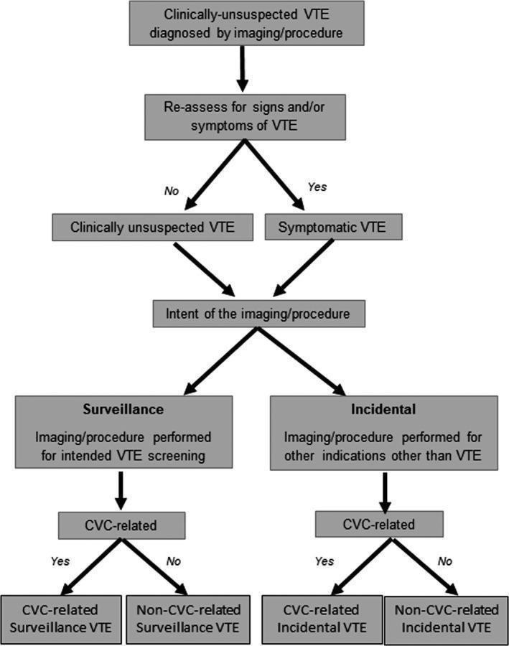

FIGURE 2: Diagnosis and management of clinically unsuspected venous thromboembolism¹³

PROBLEMS WITH CURRENT DIAGNOSTICS:
Contrast venography is no longer suitable as the first diagnostic test for the assessment of symptoms that point to acute DVT since it is invasive and requires contrast material. Even in high-risk individuals, DVT cannot be accurately identified based only on the history and physical examination, according to numerous clinical studies.¹⁴ Erythema, warmth, discomfort, swelling, or tenderness are frequently absent in patients with lower extremity DVT. For instance, when five clinical investigations were evaluated, the specificity ranged from 3 to 87% and the sensitivity of calf pain for acute DVT varied from 66 to 91%.¹⁴ The most accurate methods for diagnosing PE are computed tomography pulmonary angiography and ventilation-perfusion scans; however, ultrasonography is utilized to diagnose lower or upper extremity DVT. In order to confirm clinical decision guidelines for patients with suspected recurrent VTE, proper diagnostic marker is need of the hour.

PLETHYSMOGRAPHY:
The recording of changes in limb size caused by tissue fluid or pooled blood in the veins is known as plethysmography. There are several techniques to carry out this measurement: electrical impedance, strain gauge, and photoplethysmography.¹⁵ D dimer tests and plethysmography are screening tests for deep vein thrombosis.
Final examinations for deep vein thrombosis is definitively diagnosed with investigations that visualize the thrombus. Magnetic resonance imaging, computed tomography, contrast venography, and ultrasonography are some of these tests. Contrast venography has been the gold standard for diagnosing deep vein thrombosis.¹⁶ However, there is a slight danger of an allergic reaction or venous thrombosis, this treatment is invasive, and it is not always technically feasible.¹⁵

WHOLE-EXOME SEQUENCING:
In families with an unexplained propensity for venous thromboembolism (VTE), whole-exome sequencing (WES) may promote the identification of low-frequency variations in genes known to contribute to hemostasis or linked to symptoms associated with VTE.¹⁷ (CRP Leu61Pro, F2 Asn514Lys, SERPINA1 Arg63Cys, THBS1 Asp901Glu, VWF Arg1399His, and PLAT Arg164Trp). The acute phase and fibrinogen complex related interactions have been further enhanced by the common functional variations such as FGB Arg478Lys and IL1AAla114Ser, which were very significant even in the absence of fibrinogen beta and interleukin 1 alpha proteins.

D-DIMER ASSAY:
D-dimer, a fibrin-specific breakdown product that identifies crosslinked fibrin from endogenous fibrinolysis and consequently deep vein thrombosis (DVT) is measured in this experiment. Numerous investigations have demonstrated that this assay is a relatively sensitive but nonspecific marker for DVT with a strong negative predictive value.¹⁸
There are several d-dimer assays used in clinical settings. The SimpliRED whole blood agglutination test and the laboratory-based VIDAS enzyme linked immunosorbent assay (ELISA) are two of the most predominant assays followed world over.¹⁵ The SimpliRED test is appropriate for near-patient testing and yields a qualitative answer (positive or negative) in ten minutes. Recently, an immunochromatography d-dimer test (Simplify) that is appropriate for near-patient testing was also introduced; however, no published studies have assessed the test’s utility¹⁵

LIMITATIONS OF D-DIMER:
Plasma D-dimer levels can be raised by pregnancy, aging, trauma, cancer, inflammation, and a number of other clinical conditions. However, in patients with acute VTE, D-dimer levels may not rise for a number of reasons (impaired fibrinolytic activity, use of heparin or oral anticoagulants, onset of symptoms more than two weeks prior to blood sampling). These elements contribute to the high sensitivity but low specificity of D-dimer testing for acute VT diagnosis.¹⁹

P SELECTIN:
Cell-cell interactions mediating leukocyte trafficking, thrombogenesis and inflammation are crucial for the host defense mechanism.²⁰ the types of cellular adhesion molecules known as selectins (CD62) are known to bind to complex sugar (carbohydrate) patterns across the cell membrane. The majority of leukocytes express L-selectin; platelets and endothelial cells express P-selectin;

P-selectin is known to be the primary indicator of platelet activation and may have a role in thrombosis, inflammation, proliferation, and adherence of cancer cells.²¹Additionally, it facilitates the adherence of cancer cells to stimulated endothelial cells and the heterotypic aggregation of activated platelets to cancer cells. The significance of P selectin-mediated cell adhesive contacts in the pathophysiology of inflammation, thrombosis, cancer growth, and metastasis has been well illustrated using P-selectin mutant mice.²²

ROLE OF P SELECTIN IN THROMBOSIS:
This type-1 transmembrane protein is encoded by the human Selectin-P (SELP) gene. It is produced by megakaryocytes and endothelial cells, and endothelial cells package it. Weibel-Palade bodies and platelet alpha granules. The majority of leukocytes include P selectin glycoprotein ligand-1 (PSGL-1), which is the primary ligand for P-selectin. Additionally, P-selectin binds platelet glycoprotein (Gp) 1b, which promotes adhesion and rolling of leukocytes and platelets. ²³ In addition, P-selectin promotes tissue factor expression on monocytes and causes the production of procoagulant microparticles. These two activities increase thrombosis. In individuals with unprovoked VTEP, PSGL-1 plus micro vesicles, which come from monocytes and endothelial cells, are increased. Platelet-derived PSGLselectin expression also stabilizes the initial glycoprotein. Large, stable platelet aggregates are formed as a result of IIb/IIIa-fibrinogen interactions.

P SELECTIN MARKER IN VENOUS THROMBOEMBOLISM:

Numerous studies have assessed its soluble form as a biomarker for VTE, despite the fact that the membrane-associated P-selectin is the primary contributor to the pathophysiology of DVT. In situations when sP-selectin is present as a monomer that is insufficient to interact with its functional ligands, membrane P-selectin forms dimers or oligomers to boost leukocyte membrane binding, resulting in significant inflammatory and thrombotic reactions. The primary source of sP-selectin is the proteolytic cleavage of transmembrane P-selectin, which is released from endothelial cells and activated platelets. Elevations of sP-selectin have been linked to VTE and, when compared to D-dimer, have been suggested as a biomarker with superior diagnostic performance.
In a prospective experiment, sP-selectin >90 ng/ml showed a 100% positive predictive value for the diagnosis of DVT when paired with a Wells Score ≥2. Low probability of sP-selectin levels of less than 60 ng/ml. Given that obesity is a risk factor for VTE, a recent study raises the possibility that sP-selectin contributes to VTE in obese people.²⁴
P-selectin inhibition reduced vein wall fibrosis. P-selectin might be helpful in identifying individuals for whom anticoagulation is recommended and could play a part in the early risk stratification of VTE.²⁵ Compared to patients without a VTE recurrence, those who experienced one showed noticeably greater levels of sP-selectin.²⁶

PREVENTION AND TREATMENT:

Numerous conventional and novel anticoagulant generations are the primary components of the pharmaceutical methods. Various coagulation cascade phases are the focus of different pharmacological therapies for VTE. Vitamin K antagonists, low-molecular-weight heparin, and unfractionated heparin are examples of traditional anticoagulants that target distinct stages. Even so, certain coagulation pathways are targeted by the current generation of anticoagulants, such as fondaparinux, rivaroxaban, apixaban, dabigatran etexilate, and rNAPc2 (recombinant nematode anticoagulant protein c2).
Vitamin K antagonists, low molecular weight heparin, and unfractionated heparin (UFH) are examples of conventional anticoagulants used to treat VTE. Novel Anticoagulants for the Management of VTE These anticoagulants target particular coagulation cascade phases, including thrombin, activated protein C, soluble thrombomodulin, factor VIIa/tissue factor, and factor Xa. They may be a viable substitute for warfarin, Nematode Anticoagulant Protein c2 (NAPc2), Fondaparinux, Rivaroxaban, Apixaban, and Dabigatran Etexilate, as they have demonstrated efficacy in phase II and III trials for the long-term therapy of VTE.²⁷

Mechanical approaches, which are non-pharmacological therapies, such as inferior vena cava filters, intermittent pneumatic compression devices, and graduated compression stockings, have the benefit of managing VTE without posing a risk of bleeding. Compression stockings that are graduated by applying more pressure at the ankle than farther up the leg, graduated compression stockings lessen blood pooling in the deep veins, which can speed up blood flow to the heart. Compression bandages or medical compression stockings are advised for patients with acute proximal DVT treated with LMWH in order to aid in their recovery from discomfort and swelling.²⁸ Devices for Intermitted Pneumatic Compression in order to encourage venous return, intermittent pneumatic compression devices use cyclic inflation and deflation.

CONCLUSION:
Venous thromboembolism is not a rare and is associated with high rates of morbidity and mortality. It occurs when there is formation of blood clot in a vein. It includes two entities deep vein thrombosis and pulmonary embolism. Venous wall injury, stasis, and hypercoagulability are the three main pathophysiological factors that contribute to venous thromboembolism which constitute the Virchow’s triad. Weil’s score and D dimer assay are the main tools used in screening and diagnosis of venous thromboembolism. Definitive investigations include contrast venography, ultrasonography, computed tomography, and magnetic resonance imaging.

P selectin is under extensive research to be included as a biomarker as it has been noted to acts a biomarker showed a 100% positive predictive value for the diagnosis of DVT when paired with a Wells Score ≥2. Further research to evaluate the role of P selectin as a marker for early detection of venous thrombosis is a necessary event to be carried out in larger population to establish as a novel marker for detection of venous thrombosis.
REFERENCES:

- Dubois-Silva, Álvaro et al. “Deep vein thrombosis symptoms and 30-day mortality in acute pulmonary embolism.” European journal of internal medicine vol. 108 (2023): 43- 51.
- Virchow R. Cellular pathology. As based upon physiological and pathological histology. Lecture XVI--Atheromatous affection of arteries. 1858. Nutr Rev. 1989;47(1):23-25.
- Clagett GPAnderson FA JrHeit J et al. Prevention of venous thromboembolism. Chest. 1995; 108(suppl) 312S- 334S
- Kahn, S R. “The clinical diagnosis of deep venous thrombosis: integrating incidence, risk factors, and symptoms and signs.” Archives of internal medicine vol. 158,21 (1998): 2315-23
- Torbicki, Adam et al. “Guidelines on the diagnosis and management of acute pulmonary embolism: the Task Force for the Diagnosis and Management of Acute Pulmonary Embolism of the European Society of Cardiology (ESC).” European heart journal vol. 29,18 (2008): 2276-315
- The Impact of Venous Thromboembolism on Mortality and Morbidity During Nephrectomy for Renal Mass. Urology. 2022; 168:122-128
- Turpie, Alexander G G et al. “Venous thromboembolism: pathophysiology, clinical features, and prevention.” BMJ (Clinical research ed.) vol. 325,7369 (2002): 887-90.
- Moheimani, Fatemeh, and Denise E Jackson. “Venous thromboembolism: classification, risk factors, diagnosis, and management.” ISRN hematology vol. 2011 (2011): 124610. Bonderman, D et al. “Risk factors for chronic thromboembolic pulmonary hypertension.”
The European respiratory journal vol. 33,2 (2009): 325-31.
- Leclerc JRIllescas FJarzem P Diagnosis of deep vein thrombosis. Leclerc JRed. Venous Thromboembolic Disorders. Philadelphia, Pa Lea & Febiger1991;176- 228
- Hudgens, Stacie A et al. “Deep vein thrombosis: validation of a patient-reported leg symptom index.” Health and quality of life outcomes vol. 1 76. 15 Dec. 2003,
- Labropoulos, Nicos et al. “The effect of venous thrombus location and extent on the development of post-thrombotic signs and symptoms.” Journal of vascular surgery vol. 48,2 (2008): 407-12
- Gibson NS, Sohne M, Kruip MJ, et al. Further validation and simplification of the Wells clinical decision rule in pulmonary embolism. Thromb Haemost. 2008;99(1):229-234
- Caprini, Joseph A et al. “Laboratory markers in the diagnosis of venous thromboembolism.” Circulation vol. 109, 12 Suppl 1 (2004): I4-8
- Tovey C, Wyatt S. Diagnosis, investigation, and management of deep vein thrombosis. BMJ. 2003;326(7400):1180-1184.
- Tapson VF, Carroll BA, Davidson BL, et al. The diagnostic approach to acute venous thromboembolism. Clinical practice guideline. American Thoracic Society. Am J Respir Crit Care Med. 1999;160(3):1043-1066.
- Wang, Gang et al. “C-reactive protein is a predictor for lower-extremity deep venous thrombosis in patients with primary intracerebral hemorrhage.” European journal of medical research vol. 29, 1 311. 6 Jun. 2024
- Betensky M, Kulkarni K, Rizzi M, et al. Recommendations for standardized definitions, clinical assessment, and future research in pediatric clinically unsuspected venous thromboembolism: Communication from the ISTH SSC subcommittee on pediatric and neonatal thrombosis and hemostasis. J Thromb Haemost.2022;20(7):1729-1734
- Purdy M, Obi A, Myers D, Wakefield T. P- and E- selectin in venous thrombosis and non- venous pathologies. J Thromb Haemost. 2022;20(5):1056-1066.
- Laird CT, Hassanein W, O'Neill NA, et al. P- and E-selectin receptor antagonism prevents human leukocyte adhesion to activated porcine endothelial monolayers and attenuates porcine endothelial damage. Xenotransplantation. 2018;25(2): e12381
- Turkoz Y, Evereklioglu C, Ozkiriş A, et al. Serum levels of soluble P- selectin are increased and associated with disease activity in patients with Behçet's syndrome. Mediators Inflamm. 2005;2005(4):237-241.
- Geng JG, Chen M, Chou KC. P-selectin cell adhesion molecule in inflammation, thrombosis, cancer growth and metastasis. Curr Med Chem. 2004;11(16):2153-2160.
- Pabinger I, Ay C. Biomarkers and venous thromboembolism. Arterioscler Thromb Vasc Biol. 2009;29(3):332-336
- McManus RJ, Fitzmaurice DA, Murray E, Taylor C. Thromboembolism. BMJ Clin Evid. 2011; 2011:0208. Published 2011 Mar 8.
- Castellon Rubio VE, Segura PP, Munoz A, Farre AL, Ruiz LC, Lorente JA. High plasma levels of soluble P‐Selectin and factor VIII predict venous thromboembolism in non‐small cell lung cancer patients: the Thrombo‐Nsclc risk score. Thromb Res. 2020;
196:349‐354.
- Lunghi B, Ziliotto N, Balestra D, Rossi L, Della Valle P, Pignatelli P, Pinotti M, D’Angelo A, Marchetti G, Bernardi F. Whole-Exome Sequencing in a Family with an Unexplained Tendency for Venous Thromboembolism: Multicomponent Prediction of Low-Frequency Variant Deleteriousness and of Individual Protein Interaction. International Journal of Molecular Sciences. 2023; 24(18):13809.
- Imberti D. D-dimer testing: advantages and limitations in emergency medicine for managing acute venous thromboembolism. Intern Emerg Med. 2007;2(1):70-71
- Cohen AT, Imfeld S, Rider T. Phase III trials of new oral anticoagulants in the acute treatment and secondary prevention of VTE: comparison and critique of study methodology and results. Adv Ther. 2014;31(5):473-493.
- Thieme D, Linnemann B, Mühlberg K, Noppeney T, Kreutz M, Thieme M. Compression Therapy in Acute Deep Venous Thrombosis of the Lower Limb and for the Prevention of Post-Thrombotic Syndrome—a Review Based on a Structured Literature Search. Dtsch Arztebl Int. 2024;121(6):188-194.
- Yang J, Furie BC, Furie B. The biology of P-selectin glycoprotein ligand-1: its role as a selectin counterreceptor in leukocyte-endothelial and leukocyte-platelet interaction. Thromb Haemost. 1999;81(1):1-7.
- Schneck, Michael J. “Neurologic complications of venous thromboembolism.” Handbook of clinical neurology vol. 177 (2021): 261-26

