Impact of Thermal and Membrane Processing on the Biochemical Quality of Pretreated Pomegranate and Pineapple Juices

----------------------------------------------------------------------------------------------------------------------------
Abstract
Pomegranate (Punica granatum L., Punicaceae) and Pineapple (Ananas comosus L., Merril) are the most popular tropical non-citrus fruits, mainly because of their attractive aroma, refreshing flavour and favourable brix/acid ratio. Their juices have been used in fruit based beverages individually or combined with other fruit juices. The research was carried out on the physicochemical analysis of thermal and membrane processed pomegranate and pineapple juices upon storage. Pretreatment of pomegranate and pineapple juices was performed using egg albumin and observed that 2 g/L concentration gave effective removal of colloidal substances of both juices. Storage study on pretreated and clarified juices involving biochemical analysis revealed that among all the treatments for pomegranate juice, the treatments with improved quality were in the order of thermal treatment and added preservative; 0.1 µm, 15 psi (1.0342 bar), 30 Lph and thermal treatment; 70 kDa, 15 psi (1.0342 bar), 30 Lph and thermal treatment; 44 kDa, 15 psi (1.0342 bar), 40 Lph and thermal treatment; 10 kDa, 15 psi (1.0342 bar), 40 Lph and thermal treatment; Thermal treatment; 44 kDa, 15 psi (1.0342 bar), 40 Lph and added preservative. Similarly, the treatments with better quality for pineapple juices were in the order of thermal treatment and added preservative; 70 kDa, 15 psi (1.0342 bar), 30 Lph and thermal treatment; 44 kDa, 15 psi (1.0342 bar), 40 Lph and thermal treatment; Thermal treatment; 44 kDa, 15 psi (1.0342 bar), 40 Lph and preservative added; 70 kDa, 15 psi (1.0342 bar), 30 Lph and added preservative. The biochemical analysis of pomegranate juice during storage of 180 days recorded for TSS, colour intensity, browning index, turbidity, titrable acidity, pH and viscosity as 9.914%, 5.659, 3.121, 0.478%, 0.695%, 4.68 and 2.12 cP, respectively. Similarly, the biochemical analysis values for pineapple juice during storage were recorded for TSS, colour intensity, browning index, turbidity, titrable acidity, pH and viscosity as 12.782%, 5.562, 5.27, 0.702%, 0.769%, 4.79 and 3.098 cP, respectively.

Keywords: Biochemical quality, Viscosity, Membrane clarification, Thermal treatment, Preservative, Egg albumin
---------------------------------------------------------------------------------------------------------
INTRODUCTION
There is a worldwide increasing tendency for the consumption of tropical fruits, juices and fruit drinks due to the interest in ready to consume healthy products. Fruit juices are liquid foods that provide vitamins, sugars, mineral compounds and water. Consumers have individual preferences for specific appearance, consistency and flavor characteristics. Pomegranate (Punica granatum L., Punicaceae) and pineapple (Ananas comosus L., Merril) are the most popular tropical non-citrus fruits, mainly because of their attractive aroma, refreshing flavour and Brix/acid ratio. Their juices have been used in fruit based beverages individually, in the form of mixture or combined with other fruit juices. As an ingredient, the concentrated juice from pomegranate and pineapple, blends well with other aromas of fruits resulting in a pleasant product with a competitive market price. Pomegranate, mainly produced in the middle east, have a number of nutritional and health benefits and is a potential source of anthocyanins, ellagic acid, phytoestrogenic flavonoids, tannins and organic acids, some of which are antioxidants. Further, as reported in biological studies, pomegranate juice is rich in anti-atherosclerotic and anti-atherogenic compounds which have been shown to reduce blood pressure and low density lipoprotein oxidation (Aviram and Dornfeld, 2001). Pineapple juice is a popular product with increasing demand in many countries. Thailand is one of the biggest countries for the production of pineapple and exports more than a half the total of world volume annually. Pineapple juice is marketed world-wide because of its attractive aroma, flavour and other beneficial components. Nutritional compounds in pineapple juice for human health are generally identified as phytochemicals, such as vitamin C, carotenoid, flavanoid and phenolic compounds (Laorko et al., 2010). These components not only reduce the risk of oxidative damage related to the presence of free radicals, but also, the risk of contracting different types of cancer and cardiovascular and neurological diseases. Due to these characteristics and increasing public awareness about nutritional food, the demand for the pineapple and pomegranate fruits has significantly increased in the last years. Consequently, many industries producing pineapple and pomegranate fruit juices as well as pharmaceutical companies extracting health beneficial compounds from the fruits have been developed.
Pineapple and pomegranate juices in its original state have a turbid appearance that makes it hard to preserve during the storage. Since the main problem with juices is stability, there is a need for research to solve this problem besides preservation of color. According to the literature, the present methods used for polyphenol elimination to produce stable juice involve liquid extraction with organic solvents (Samreen et al., 2020).
However, these methods require high temperature to increase the extraction rate and yield, but, may denature the polyphenols leading to undesirable byproducts. Therefore, MF and UF as modern methods are used to reduce juice turbidity. MF and UF are non- thermal and low cost separation technologies for juices emerging in recent years. UF and MF have been applied in vegetal juices, pulps and wine industries, reducing many steps of the conventional clarification. Also, pectinolytic enzymes can be reduced and sometimes can even be eliminated (Samreen et al., 2020).
Purpose of this study is to evaluate the effects of clarification treatments combined with membrane filtration on organic acid compositions, phenolic compounds and on some other quality parameters including color and turbidity of pineapple and pomegranate juice. MF/UF process alone has no observable effect on the phenolic compounds and organic acid compositions of both juices. Although effects of some clarifying agents on some quality characteristics of fruit juices such as pH, turbidity, total color density, total phenolic substances and anthocyanins have been reported previously, membrane filtration has been replacing conventional treatments for clarifying fruit juices with the advantages of elimination of clarifying agents together with their associated problems and production with a continuous simplified process. By MF/UF treatment, all proteins larger than the membrane molecular weight cutoff (MWCO) can be removed (Samreen et al., 2020).
Keeping in view of the above points, a study was undertaken on processing of pineapple and pomegranate juices with combination of thermal, chemical and membrane clarification techniques. Also, the processed juices were subjected to storage and the physicochemical characteristics of both juices were analyzed and presented.
MATERIAL AND METHODS
Fully matured pomegranate and pineapple fruits were selected and cleaned to remove extraneous material. The juices were extracted and subjected to different processing treatments.

Pretreatment on aggregation and clarification of pomegranate and pineapple juices
The pretreatment was performed using a fining agent called egg albumin. The juice was subjected to four concentration levels i.e., 0.25, 0.5, 1 and 2 g/L and effect of pretreatment was analyzed through biochemical analysis. After the collection of juice, the egg albumin powder was added and mixed thoroughly. The juice samples were muslin cloth filtered and centrifuged at 4000 rpm (2147 g) for 5 min (Domingues et al., 2011). The supernatant was used for biochemical quality analysis to determine the effect of pretreatment. The concentration of egg albumin which resulted in better clarification was determined by biochemical quality analysis. This concentration was subsequently used for pretreatment of pineapple juice in all the experiments. The pretreatment was performed to remove the colloidal substances present in the juices. Colloids can decrease the permeate flux during filtration of the juice due to presence of pectinases, cellulase, hemicellulase, xylanase, carbohydrase, glucanase or arabinose. Removal of aggregates of these species via pretreatment may increase the permeate flux due to the reduction in the size of the particles and the subsequent decrease in viscosity (Valero et al., 2014).
Membrane clarification of pineapple and pomegranate juices
Membrane processing of pineapple and pomegranate juices was carried out in the membrane module setup with different hollow fibre cartridges. The container was filled with 250 mL of juice. The operation was done in total recycle mode. The suction, retentate, by-pass lines were kept in feed solution and continuous operation was carried out. The permeate was collected at permeate line separately. After each run, the set up was flushed with distilled water and then cleaned with 0.1 N hydrochloric acid (HCl) for 30 mins in total recycle mode according to the washing protocol given by the manufacturer. After thorough washing, the permeability of the cartridges was analysed to measure the change in permeability of the hollow fibres. All the experiments were conducted in triplicate at room temperatures (30±2 °C). After every experiment, the membranes were cleaned properly and stored in the 1% formalin solution for future use.
The permeate flux was calculated as
J*= ($\frac{1}{A}$)×($\frac{dv}{dt}$) ……6
Where, J*= Permeate flux (L/h m²)
A= Area of the membrane (m²)
dv= Volume of flow rate (L)
dt= Time of flow rate (h)
The permeate collected was stored in glass bottles. The experiments were performed according to the different conditions laid down in the table 1 and analysed to obtain high permeate flux.
Table 1 Operating variables for microfiltration and ultrafiltration of pineapple and pomegranate juices

Operating variables
Membrane poresizes: | MF - 0.1 and 0.2 µm  UF – 120, 70, 44 and 10 kDa
Transmembrane pressures (TMP): | 0.3447 bar (5 psi), 0.6894 bar  (10 psi), 1.0342 bar (15 psi)  and 1.3789 bar (20 psi)
Crossflow Velocities/ Feed flow rates: | 0.024 m/s (20 Lph), 0.037 m/s (30 Lph) and 0.049 m/s (40 Lph)

Preservation of pineapple and pomegranate juices using membrane and thermal processes with and without added preservative
The juices processed by different membrane pore sizes, transmembrane pressures and feed flow rates were collected and biochemical analysis was conducted. The best juices analyzed statistically were subjected to different treatments such as only membrane processed; membrane processed and thermal treated; membrane processed and added preservative. The preservative used was sodium benzoate at the rate of 175 ppm. Some of the pineapple and pomegranate juice samples after pretreatment were subjected to thermal treatment directly without membrane clarification. Pasteurization was performed by heating the pineapple juice at 97 °C for 5 min, to inactivate the pectinase enzyme (Goh et al., 2012). Similarly, thermal treatment of pomegranate juice was performed at 75 °C for 15 min (Paul et al., 2012). The temperature and time combination was decided based upon the literature as the particular treatments were proved to be best. Among thermally treated juices some juices were added with preservative. Control samples of both pretreated juices were subjected to shelflife studies. The samples were refrigerated for shelflife study and analysis was carried out at regular intervals of time.
Total soluble solids (TSS) of juice were measured by Refractometer (ATAGO make, range 58-90%) and expressed in terms of % Brix. The juice recovery per 100g of fruit was estimated. The pH measurement was performed using a digital pH meter (Systronics digital pH meter 355). The colour intensity was measured using a Systronics PC based Double Beam Spectrophotometer at absorbance of 510 nm. Similarly, Browning index was expressed as the ratio of 420 nm to 520 nm using Systronics PC based Double Beam Spectrophotometer (Valero et al 2014). The turbidity and color was also measured using Systronics PC based Double Beam Spectrophotometer at absorbance of 700 nm and 420 nm respectively. The turbidity values of both juices were measured according to the procedure given by Valero et al (2014). Titrable acidity of both juices is determined by the procedure of AOAC (2005).
Titrable acidity is expressed as the amount of free acid mainly as anhydrous citric acid present in fruit, conveniently in g acid per 100 g or 100 ml.
% acidity = $\frac{a ×b ×c×d×100}{e×w ×1000}$ ……..1
where, a = titre value (volume of 0.1N NaOH)
b = Normality of the alkali (0.1N)
c = volume made up
d = equivalent weight of the acid
w = weight or volume of sample taken (g or ml)
e = aliquot
Viscosity of the fruit juice was determined by using Digital Viscometer (Brookfield, Model: DV1MLV).
RESULTS AND DISCUSSIONS
The best samples of both pomegranate and pineapple juices pretreated with egg albumin and membrane processed were subjected to only thermal treatment and no added preservative; no thermal treatment and added preservative; no thermal and no added preservative. Control samples which were only pretreated with egg albumin and muslin cloth filtered were also included in storage study. Some of the control samples were subjected to thermal treatment; thermal treatment and added preservative. The various treatments and samples of both pomegranate and pineapple juices were subjected to storage study of 180 days (Fig. 1 and Fig. 2). All the samples were also subjected to biochemical analysis.
. 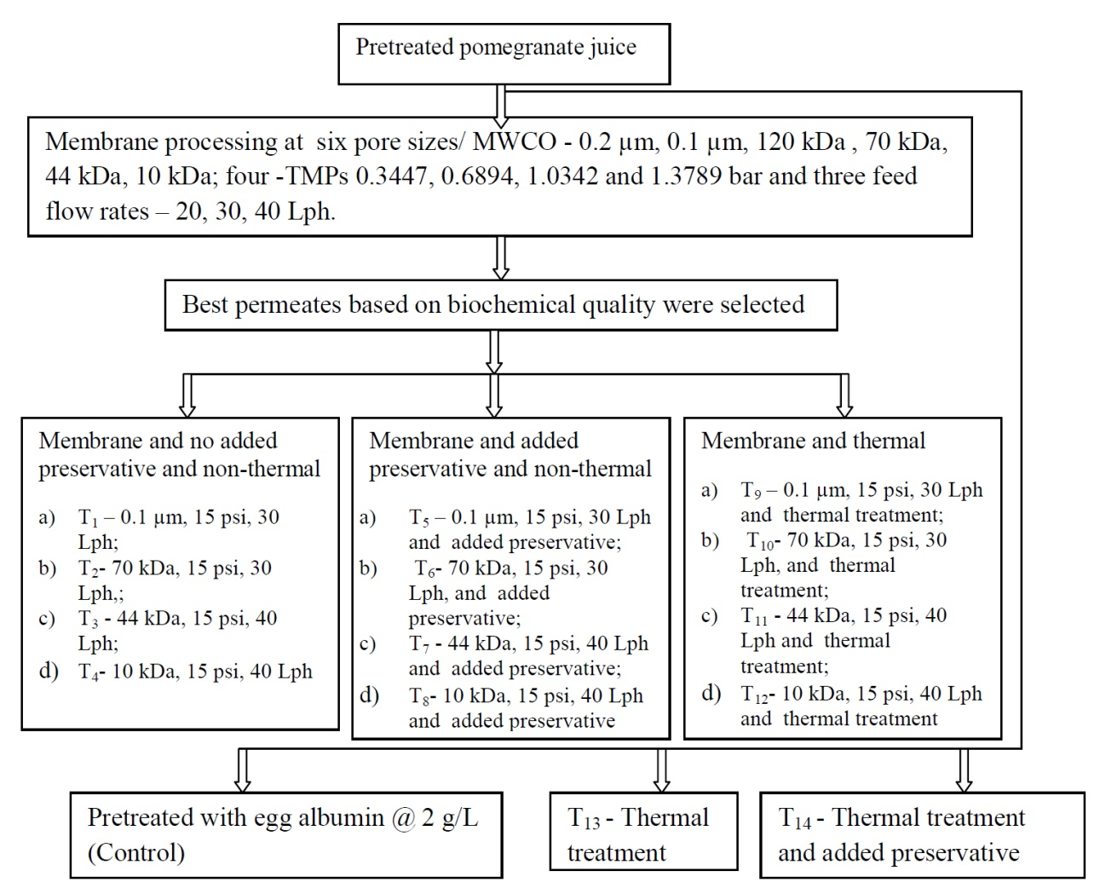
Fig. 1 Flow chart of different samples for storage studies of pomegranate juice
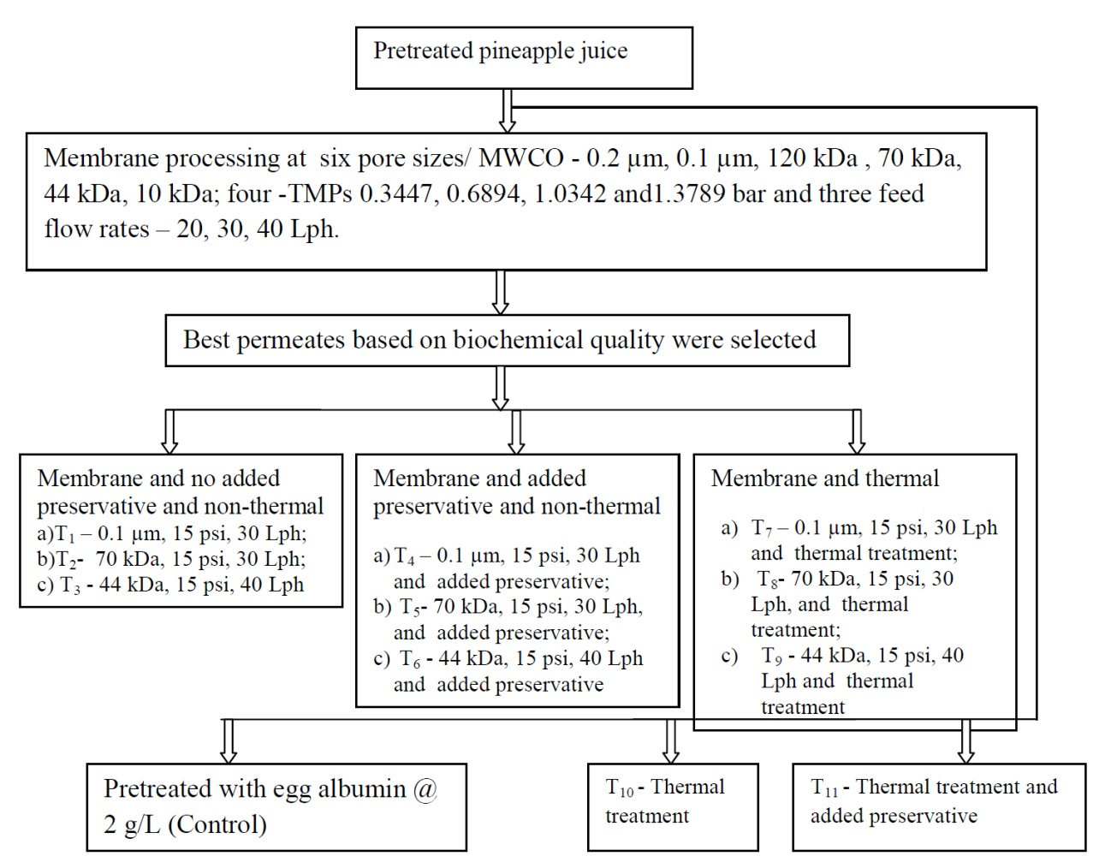
Fig. 2 Flow chart of different samples for storage studies of pineapple juice

1. Variation in total soluble solids
The different changes in the TSS of both the juices were analysed (Fig. 3). The combination effects of different treatments with storage period were analysed statistically.
TSS increased as the duration of storage increased (Salari et al., 2012) for both pomegranate and pineapple juices. It was observed that there was significant difference (P<0.01) among all the treatment combinations. The TSS of pineapple juice was relatively higher than pomegranate juice. The control samples recorded the highest increase in TSS of 20.2 % and 23.845 % for pomegranate and pineapple juice, respectively on 180 days of storage. The lowest increase in TSS was observed for the treatments of T₁₂; 10 kDa, 15 psi, 40 Lph and thermal treatment and T₉; 0.1 µm, 15 psi, 30 Lph and thermal treatment for pomegranate and pineapple juices, respectively on 180th day of storage (Table 2 and Table 3). The other treatments for pomegranate juice which were on par with T₁₂ were T₈; 10 kDa, 15 psi (1.0342 bar), 40 Lph and added preservative, T₁₁; 44 kDa, 15 psi, 40 Lph and thermal treatment, T₇; 44 kDa, 15 psi, 40 Lph and added preservative and T₃; 44 kDa, 15 psi, 40 Lph with 10.051, 10.502, 10.639 %and 10.775 %Brix, respectively. The other treatments for pineapple juice which were on par with T₉ were T₃; 44 kDa, 15 psi, 40 Lph and T₆; 70 kDa, 15 psi, 30 Lph and added preservative with 12.782 % and 13.123 %, respectively. It is observed that membrane processed followed by thermal and chemical treated juices exhibited relatively little change in TSS suggesting that membrane processing helps in minimizing increase in TSS till 180 days of storage. The values of TSS of pomegranate juice for thermal processed samples with and without chemical preservative (T₁₃ and T₁₄) were 19.618 % and 17.701 %, respectively on 180th day of storage.
There was a gradual increase in TSS of the juice during storage. This might be because the juice was only pretreated with egg albumin and not membrane processed due to which some of the heavy colloidal substances might have contributed to TSS increase. Similar trends were observed with pineapple juice but the TSS was comparatively higher than pomegranate juice as the juice was relatively pulpy. The reason for increase of TSS was because of conversion of acid to sugars. This is in accordance with the gradual decrease in titratable acidity in both the juices. Similar trends were observed by Bakaramahire et al. (2007); Salari et al. (2012) for pomegranate juice; Islam et al. (2014) for pineapple juice.
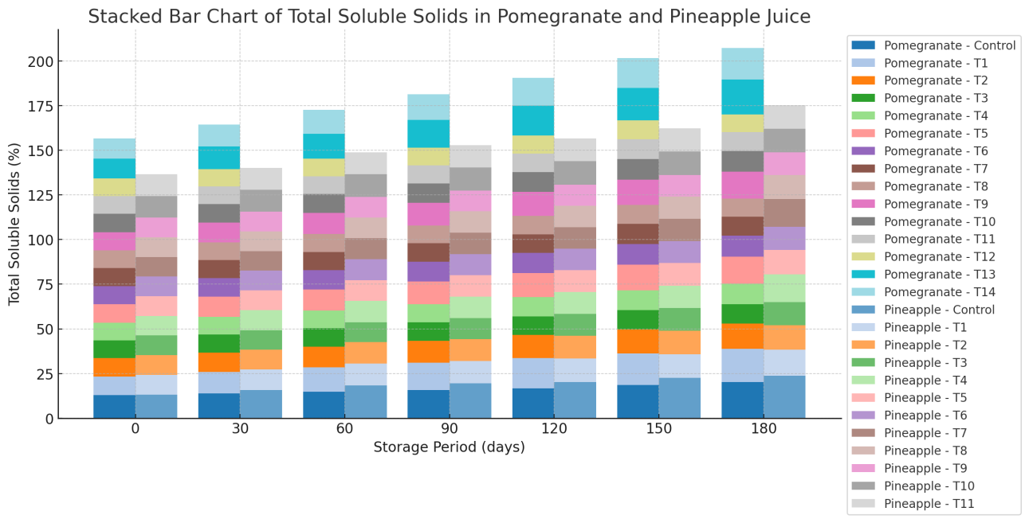
Fig. 3 Variation of TSS in different treatments of pomegranate and pineapple juices during storage

2. Variation in colour intensity
The variations in the colour intensity of both the juices were determined and presented (Fig. 4). The combination effects of different treatments with storage period were analysed. Colour intensity decreased for all the samples of both pomegranate and pineapple fruit juices during storage. Similar observations were made for colour intensity during storage of pomegranate juice by Mirsaeedghazi et al. (2010). The highest decrease in colour intensity was observed for control samples of both the juices. However, the values of colour intensity recorded to be relatively low for pomegranate juice than the pineapple juice. The decrease in colour intensity observed to be less for T₁₄; Thermal treatment (97 °C, 5 min) and added preservative and T₁₁; Thermal treated (70 °C, 15 min) and added preservative i.e., 5.659 and 5.562 for pomegranate and pineapple juice, respectively on 180th day of storage. The different treatments which were on par with the T₁₄ of pomegranate juice were T₉; 0.1 µm, 15 psi, 30 Lph and thermal treatment (97 °C, 5 min), T₅; 0.1 µm, 15 psi, 30 Lph and added preservative, T₁; 0.1 µm, 15 psi (1.0342 bar), 30 Lph, T₁₃; Thermal treatment (97 °C, 5 min) T₁₀; 70 kDa, 15 psi, 30 Lph and thermal treatment (97 °C, 5 min) T₆; 70 kDa, 15 psi (1.0342 bar), 30 Lph and added preservative, and with colour intensities of 4.505, 4.380, 4.252, 4.057, 3.354 and 3.229, respectively. Similarly, treatments T_{7;} 0.1 µm, 15 psi (1.0342 bar), 30 Lph and thermal treated (70 °C, 15 min), T₄; 0.1 µm, 15 psi, 30 Lph and preservative added, T_{8;} 70 kDa, 15 psi (1.0342 bar), 30 Lph and thermal treated (70 °C,15 min) T_{5;} 70 kDa, 15 psi, 30 Lph and added preservative, and T₉; 44 kDa, 15 psi, 40 Lph and thermal treated (70 °C, 15 min) with colour intensity values 5.021, 4.896, 4.688, 4.563, and 4.481, respectively for pineapple juice were found to be on par with best treatment T₁₁. Colour intensity values decreased in all the treatments because the samples were pretreated and membrane processed that lowered the intensity of colour in both juices. The elements that could impart the colour of both the juices might have been retained.
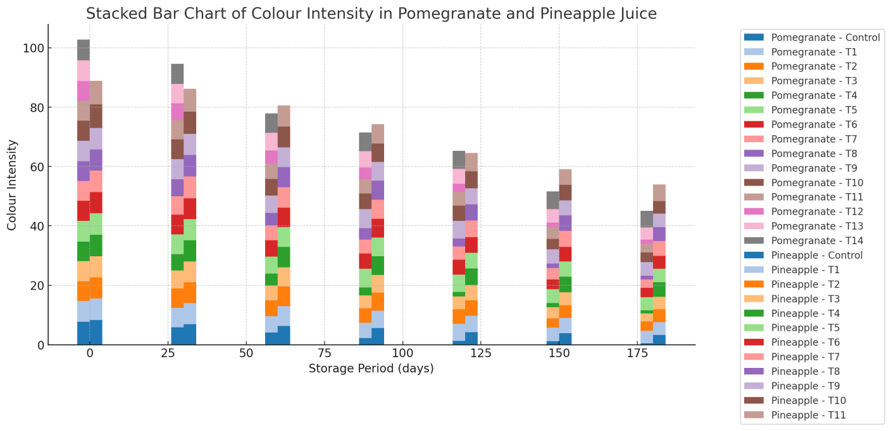
Fig. 4 Variation of colour intensity in different treatments of pomegranate and pineapple juices during storage

3. Variation in browning index
The different changes in the browning index of both the juices were analysed and presented (Fig. 5). It was observed that there was significant difference (p<0.01) among the results of all the treatments.
The browning index increased for all the treatments of both pomegranate and pineapple juices during storage. The browning index observed to be high for the control treatment samples after 180th day of storage in both pomegranate and pineapple juices. The lowest browning indices were observed in treatments T₁₄; Thermal treated (97 °C, 5 min) and added preservative and T₁₃; Thermal treated (97 °C, 5 min) for pomegranate juice and also T₁₁; Thermal treated (70 °C, 15 min) and added preservative for pineapple juice. It can be observed that thermal treated and added preservative sample displayed reduction in browning index for both juices on storage. The next lower browning index values for pomegranate juice was recorded for T₁₂; 10 kDa, 15 psi (1.0342 bar), 40 Lph and thermal treated (97 °C, 5 min), T₈; 10 kDa, 15 psi (1.0342 bar), 40 Lph and added preservative and T₄; 10 kDa, 15 psi (1.0342 bar), 40 Lph with values of 8.3112, 8.4322 and 8.594, respectively. Similarly, for pineapple juice the next lower values recorded for T₉; 44 kDa, 15 psi (1.0342 bar), 40 Lph and thermal treated (70 °C, 15 min), T₈; 70 kDa, 15 psi, 30 Lph and thermal treated (70 °C,15 min),T₆; 44 kDa, 15 psi (1.0342 bar), 40 Lph and added preservative, T₅; 70 kDa, 15 psi (1.0342 bar), 30 Lph and added preservative, T₁₀; Thermal treated (70 °C, 15 min) and T₃; 44 kDa, 15 psi (1.0342 bar), 40 Lph as 6.48, 6.645, 6.601, 6.766, 6.777 and 6.957, respectively. The browning index values were observed to be less because they were egg albumin pretreated and membrane processed by which the agents which caused the browning would have been retained. Similar results were made by Valero et al. (2014). It was also observed that there was significant increase (p<0.01) among all the combination treatments of both pomegranate and pineapple juices.
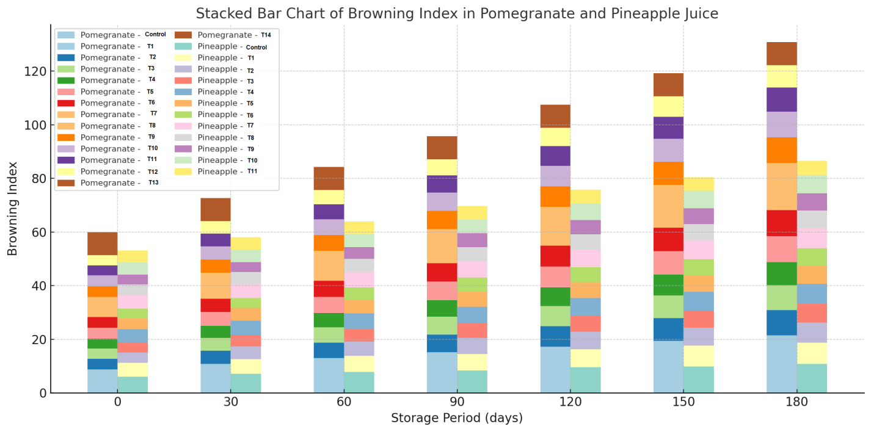
Fig. 5 Variation of Browning index in different treatments of pomegranate and pineapple juices during storage

4. Variation in turbidity
Turbidity is the presence of cloudiness in the juice. It should be very less in the juices to increase the stability of juices during storage. The solids present in the juice should be suspended and the juice should be clear for longer durations. The different changes in the turbidity of both the juices were analysed and presented (Fig. 6). The turbidity values of both the pomegranate and pineapple juice increased during storage. The lowest values of turbidity were recorded for T₁₂; 10 kDa, 15 psi, 40 Lph and thermal treatment for pomegranate juice with 0.478. The lowest value of turbidity recorded for T₁₁; Thermal treatment (70 °C, 15 min) and added preservative for pineapple juice with 0.702. The turbidity values recorded to be high for pineapple juice than pomegranate juice because of its high TSS and pulpy nature. The other treatments for pomegranate juice which recorded low turbidity were T₄; 10 kDa, 15 psi (1.0342 bar), 40 Lph, T₈; 10 kDa, 15 psi, 40 Lph and added preservative, T₇; 44 kDa, 15 psi (1.0342 bar), 40 Lph and added preservative and T₁₁; 44 kDa, 15 psi (1.0342 bar), 40 Lph and thermal treatment (97 °C, 5 min) of 0.481, 0.481, 0.508 and 0.506, respectively on 180th day of storage. Similarly, the treatments of pineapple juice which recorded low turbidity were T₉; 44 kDa, 15 psi, 40 Lph and thermal treatment (70 °C, 15 min), T₆; 44 kDa, 15 psi (1.0342 bar), 40 Lph and added preservative, T₃; 44 kDa, 15 psi (1.0342 bar), 40 Lph, T₈; 70 kDa, 15 psi (1.0342 bar), 30 Lph and thermal treatment (70 °C, 15 min) and of 0.747, 0.749, 0.778, and 0.788, respectively. The increase in turbidity was less for tighter membranes i.e., 44 kDa and 10 kDa. It is because as the samples were pretreated with egg albumin and then membrane processed with very tighter membranes, the colloidal substances which could turbid the juice would have been removed by clarification. Oliveira et al., (2012) reported that there was reduction in turbidity of passion fruit juice while clarification with microfiltration. Similar trends were observed by Brujin et al. (2002) while clarification of apple juice. Carneiro et al. (2002) reported that the pulp content of pineapple juice reduced during MF. This might be the reason for the decrease in turbidity.

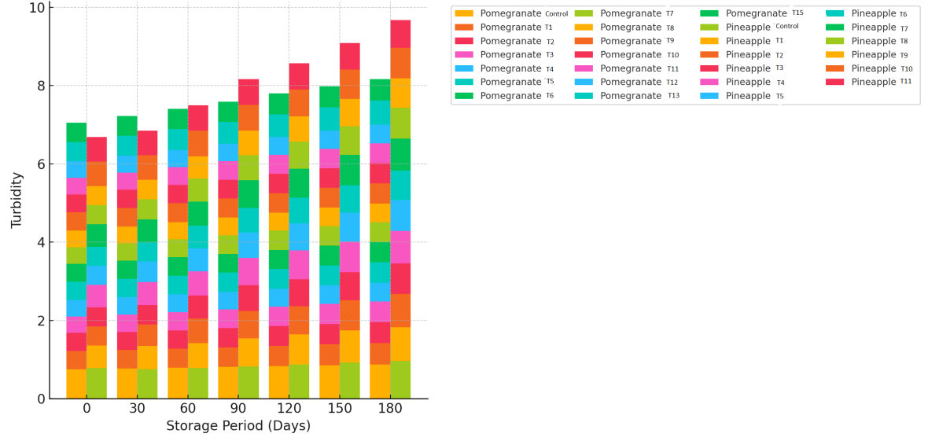
Fig. 6 Variation of Turbidity in different treatments of pomegranate and pineapple juices during storage

5. Variation in titrable acidity
Titrable acidity explains about the acidity present in both pomegranate and pineapple juices. The different changes in the titrable acidity of both the juices were analysed and presented (Fig. 7). Titrable acidity of all the treatments of both pomegranate and pineapple decreased during storage. The highest decrease in titrable acidity was observed in the control samples of both the juices. The highest value of titrable acidity was 0.695% for T₁₄; Thermal treatment (97 °C, 5 min) and preservative added for pomegranate juice and 0.769% for T₇; 0.1 µm, 15 psi, 30 Lph and thermal treatment (70 °C, 15 min) for the pineapple juice on 180th day of storage. The range of titrable acidity for T₁₄ of pomegranate juice was observed as 0.803% to 0.695 %. Similarly for T₇ sample of pineapple juice the acidity was in the range of 1.925% to 0.769%. The acidity values were high for pineapple juice than pomegranate juice. The other treatments of pomegranate juice which recorded for high titrable acidity at the end of the storage was T₁₀; 70 kDa, 15 psi (1.0342 bar), 30 Lph and thermal treatment (97 °C, 5 min), T₁₁; 44 kDa, 15 psi, 40 Lph and thermal treatment (97 °C, 5 min), T₁₂; 10 kDa, 15 psi (1.0342 bar), 40 Lph and thermal treatment (97 °C, 5 min) and T₉; 0.1 µm, 15 psi (1.0342 bar), 30 Lph and thermal treatment (97 °C, 5 min) of 0.303%, 0.251%, 0.249% and 0.248% respectively. Similarly, the samples of pineapple juice which recorded high titrable acidity at the end of storage were T₈; 70 kDa, 15 psi (1.0342 bar), 30 Lph and thermal treatment (70 °C, 15 min), T₁₁; Thermal treatment (70 °C, 15 min) and preservative added, T₄; 0.1 µm, 15 psi (1.0342 bar), 30 Lph and added preservative, T₅; 70 kDa, 15 psi (1.0342 bar), 30 Lph and added preservative T₁₀; Thermal treatment (70 °C, 15 min) and of 0.760 %, 0.703 % ,0.624 %, 0.615 % and 0.611 % and respectively. Zaman et al. (2016) reported that there was decrease in the titrable acidity when the pineapple and mango juices were blended. This was because of the conversion of acid into salts and sugar from juice particles.
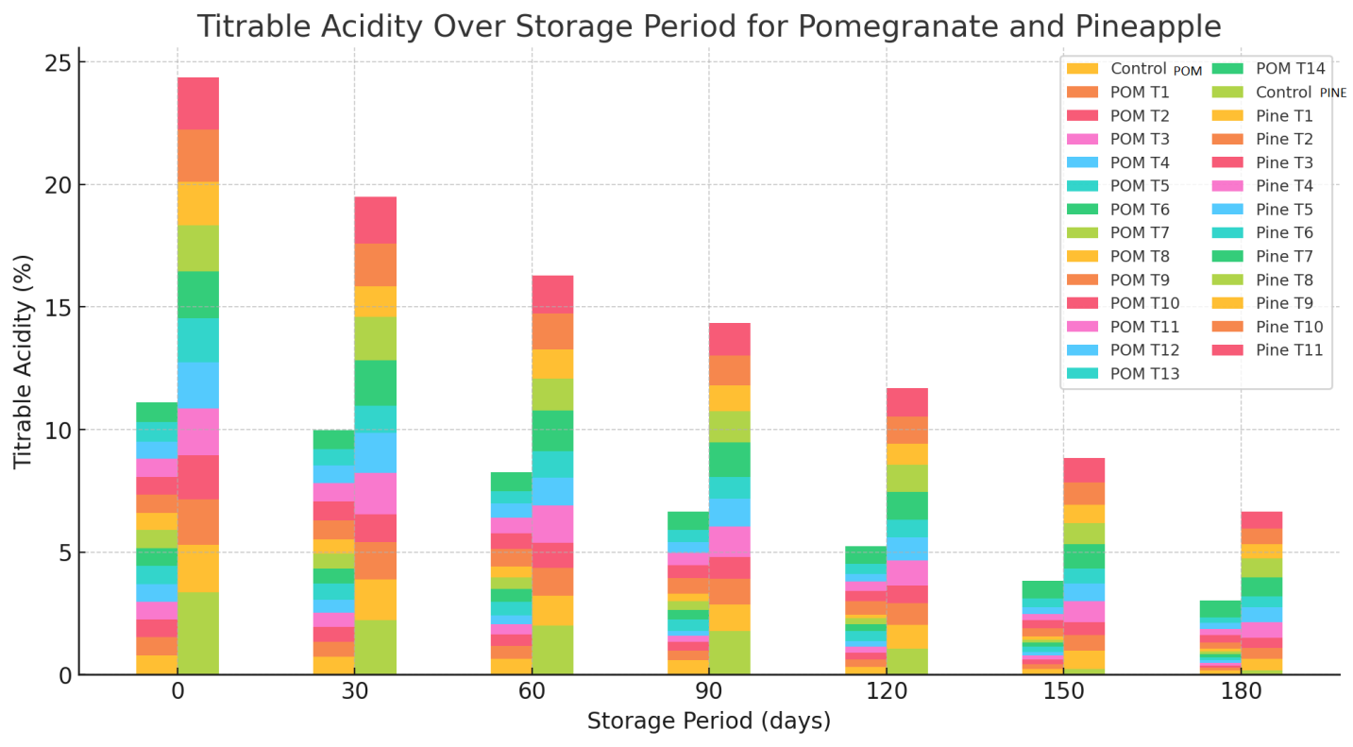
Fig. 7 Variation of Titrable acidity in different treatments of pomegranate and pineapple juices during storage

6. Variation in pH
The different changes in the pH of both the juices were analysed and presented (Fig. 8). As the titrable acidity of the juice decreased, the pH values of the juice increased. The lowest pH values recorded for T₁₃; Thermal treatment (97 °C, 5 min) and T₁₄; Thermal treatment (97 °C, 5 min) and added preservative for pomegranate juice and T₇; 0.1 µm, 15 psi, 30 Lph and thermal treatment (70 °C, 15 min) for pineapple juice. The range of values of pH of pomegranate juice for T₁₃ and T₁₄ were 4.62 to 4.8 and 4.62 to 4.68, respectively during storage. The range of values of pH of pineapple juice for T₇ treatment was 4.717 to 4.79 during storage. The highest increase in pH values obtained for control samples of both pomegranate and pineapple juices. Pomegranate juice recorded high pH than the pineapple juice on the 180th day of storage. The other treatments of pomegranate juice which recorded low pH values were T₉; 0.1 µm, 15 psi (1.0342 bar), 30 Lph and thermal treatment (97 °C, 5 min), T₅; 0.1 µm, 15 psi (1.0342 bar), 30 Lph and preservative added, T₁₀; 70 kDa, 15 psi (1.0342 bar), 30 Lph and thermal treatment (97 °C, 5 min), T₆; 70 kDa, 15 psi (1.0342 bar), 30 Lph and preservative added, T₁₁; 44 kDa, 15 psi (1.0342 bar), 40 Lph and thermal treatment (97 °C, 5 min) and T₇; 44 kDa, 15 psi, 40 Lph and added preservative of 5.11, 5.12, 5.26, 5.27, 5.39 and 5.4, respectively. Similarly, the low pH values recorded for the pineapple juice were T₄; 0.1 µm, 15 psi, 30 Lph and added preservative, T₈; 70 kDa, 15 psi, 30 Lph and thermal treatment (70 °C,15 min), T₉; 44 kDa, 15 psi (1.0342 bar), 40 Lph and thermal treatment (70 °C, 15 min), T₆; 44 kDa, 15 psi (1.0342 bar), 40 Lph and added preservative and T₁₁; Thermal treatment (70 °C, 15 min) and added preservative were 4.8, 4.88, 4.89, 4.9 and 4.9, respectively. The best results obtained for the combination treatments of membrane processed, thermal and added preservative. Similar results were recorded by Hounhouigan et al, (2014), Islam et al. (2013).
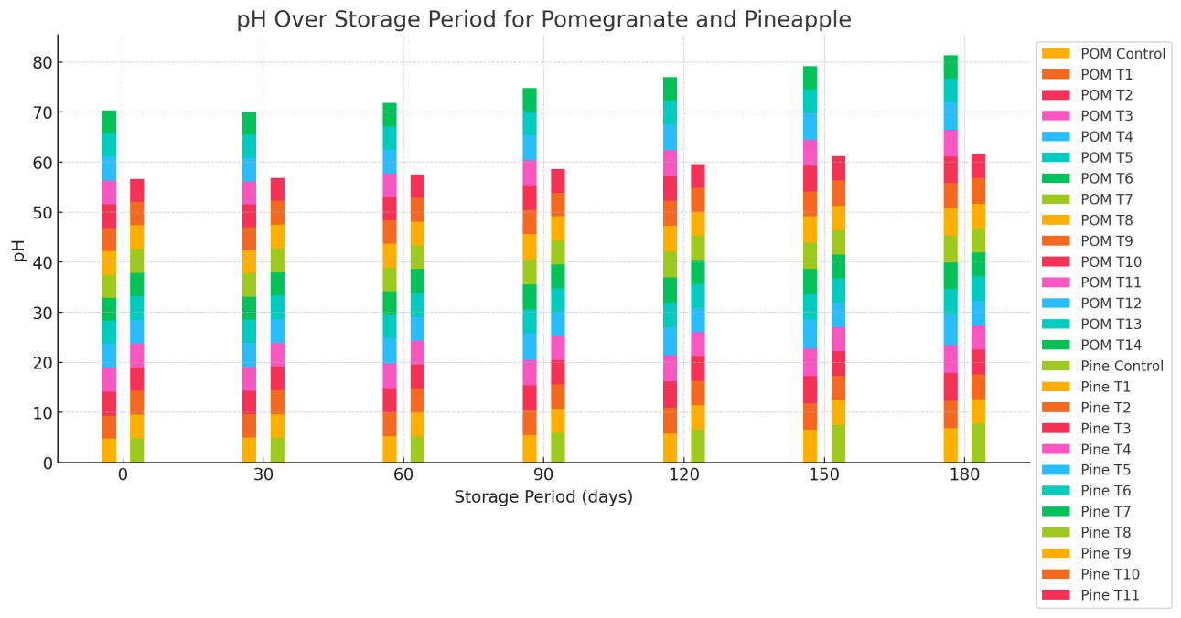
Fig. 8 Variation of pH in different treatments of pomegranate and pineapple juices during storage

7. Variation in viscosity
Viscosity although a rheological property in a strict sense has been included in biochemical properties for ease of presentation and discussion in this thesis. Viscosity is important component for the stability of juices. Increase in viscosity of juice makes the juice turbid where the juices stability and clarity are lost. The different changes in the viscosity of both the juices were analysed and presented (Fig. 9). The viscosity values recoded to be high for pineapple juice than pomegranate juice. The viscosity gradually increased for both the juice during storage. The treatments with lowest viscosity recorded for T₁₂; 10 kDa, 15 psi (1.0342 bar), 40 Lph and thermal treatment (97 °C, 5 min) for pomegranate juice and T₉; 44 kDa, 15 psi (1.0342 bar), 40 Lph and thermal treatment (70 °C, 15 min) for pineapple juice. The range of viscosity values recorded for treatment T₁₂ as 1.28 to 2.12 cP. Similarly, the values of viscosity obtained for T₉ treatment of pineapple juice were in the range of 1.247 to 3.098 cP. The pineapple juice recorded higher viscosity than pomegranate juice on 180th day of storage. The other treatments of pomegranate juice which recorded low viscosity were T₈; 10 kDa, 15 psi (1.0342 bar), 40 Lph and added preservative, T₄; 10 kDa, 15 psi (1.0342 bar), 40 Lph, , T₁₁; 44 kDa, 15 psi, 40 Lph and thermal treatment (97 °C, 5 min), T₇; 44 kDa, 15 psi (1.0342 bar), 40 Lph and added preservative, T₁₄; Thermal treatment (97 °C, 5 min) and added preservative and T₃; 44 kDa, 15 psi (1.0342 bar), 40 Lph, and were 2.14, 2.17, 2.27, 2.29, 2.3 and 2.32 cP respectively. Similarly, the treatments of pineapple juice which recorded the lowest viscosity values were T₆; 44 kDa, 15 psi(1.0342 bar), 40 Lph and added preservative, T₁₁; Thermal treatment (70 °C, 15 min) and added preservative, T₁₀; Thermal treatment (70 °C, 15 min), T₃; 44 kDa, 15 psi (1.0342 bar), 40 Lph, and T₈; 70 kDa, 15 psi (1.0342 bar), 30 Lph and thermal treatment (70 °C,15 min) of 3.118, 3.201, 3.252, 3.315 and 3.387 cP respectively. The low viscosity observed because the pulp content of juices might have removed while pretreatment with egg albumin and membrane processing. Egg albumin is a flocculating agent with a positive charge on its surface and attracts tannins (negatively charged). When neutralization occurs the turbid particles agglomerate and settle out and removed. Carneiro et al. (2002) reported that the clarified juice with microfiltration presented a great reduction in the viscosity value due to the removal of pulp and macromolecules from the single strength juice. This was in agreement with the present study.
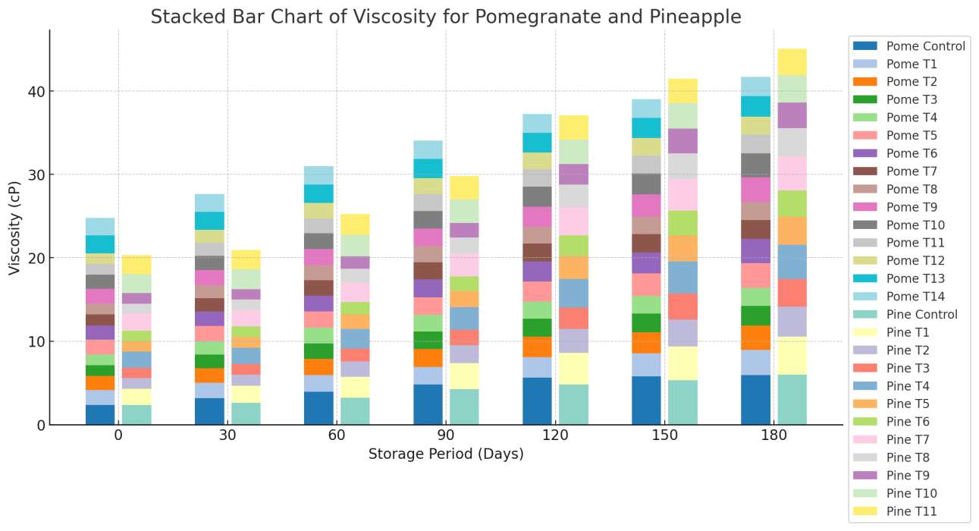
Fig. 9 Variation of viscosity in different treatments of pomegranate and pineapple juices during storage

Conclusions
Pomegranate and pineapple fruits of high grade variety were selected, cleaned, and juice was extracted. Pomegranate and pineapple juices pretreated with egg albumin and membrane processed were subjected to only thermal treatment and no added preservative; no thermal treatment and added preservative; no thermal and no added preservative were analyzed for different physicochemical properties. Control samples which were only pretreated with egg albumin and muslin cloth filtered were also included in storage study. The characteristics were analyzed in triplicate and found that they were in permissible limits. Storage study of biochemical analysis revealed that the best treatments in that order obtained for pomegranate juice were thermal treatment and added preservative (T₁₄); 0.1 µm, 15 psi (1.0342 bar), 30 Lph and thermal treatment (T₉); 70 kDa, 15 psi (1.0342 bar), 30 Lph and thermal treatment (T₁₀); 44 kDa, 15 psi (1.0342 bar), 40 Lph and thermal treatment (T₁₁); 10 kDa, 15 psi (1.0342 bar), 40 Lph and thermal treatment (T₁₂); thermal treatment (T₁₃) and 44 kDa, 15 psi, 40 Lph and added preservative (T₇) in that order. A treatment was considered best based on their biochemical composition after processing. The biochemical analysis of pomegranate juice during storage of 180 days recorded for TSS, colour intensity, browning index, turbidity, titrable acidity, pH and viscosity as 9.914%, 5.659, 3.121, 0.478%, 0.695%, 4.68 and 2.12 cP, respectively. Similarly, the biochemical analysis values for pineapple juice during storage were recorded for TSS, colour intensity, browning index, turbidity, titrable acidity, pH and viscosity as 12.782%, 5.562, 5.27, 0.702%, 0.769%, 4.79 and 3.098 cP, respectively.

References
AOAC. 2005. Official Methods of Analysis of AOAC International 18th Edition, USA.
Aviram, M and Dornfeld, L. 2001. Pomegranate juice consumption inhibits serum angiotensin converting enzyme activity and reduces systolic blood pressure. Atherosclerosis. 158(1): 195-198.
Bakaramahire, S.D. 2007. Studies on extraction, packaging and storage of pomegranate (Punica granatum L.) juice cv. Mridula. M.Sc Thesis, Mahatma Phule Krishi Vidyapeeth, Rahuri, Maharashtra. India.
Bruijn, J.D., Venegas, A and Borquez, R. 2002. Influence of crossflow ultrafiltration on membrane fouling and apple juice quality. Desalination. 148(1-3): 131-136.
Carneiro, L., Sa, I.D.S, Gomes, F.D.S, Matta, V.M and Cabral, L.M.C. 2002. Cold sterilization and clarification of pineapple juice by tangential microfiltration. Desalination. 148(1-3):93-98.
Domingues, R.C., Junior, S.B., Silva, R.B., Madrona, G.S., Cardoso, V.L and Reis, M.H. 2011. Evaluation of enzymatic pretreatment of passion fruit juice. Chemical Engineering Transactions. 24:517-522.
Goh, S.G., Noranizan, M., Sobhi, B., Sew, C.C and Leong, C.M. 2012. Effect of thermal and ultraviolet treatments on the stability of antioxidant compounds in single strength pineapple juice throughout refrigerated storage. International Food Research Journal. 19 (3): 1131-1136.
Hounhouigan, M.H., Linnemann, A.R., Ingenbleek, P.T., Soumanou, M.M., Trijp, H.C.V and Boekel, M.A.V 2014. Effect of physical damage and storage of pineapple fruits on their suitability for juice production. Journal of Food Quality. 37(4): 268-273.
Islam, M.A., Ahmad, I., Ahmed, S and Sarker, A. 2014. Biochemical composition and shelf life study of mixed fruit juice from orange & pineapple. Journal of Environmental Science and Natural Resources. 7(1): 227-232.
Islam, M., Khan, M.Z.H., Sarkar, M.A.R., Absar, N and Sarkar, S.K. 2013. Changes in acidity, TSS, and sugar content at different storage periods of the postharvest mango (Mangifera indica L.) influenced by Bavistin DF. International Journal of Food Science, 2013: 1-8.
Laorko, A., Li, Z., Tongchitpakdee, S., Chantachum, S and Youravong, W. 2010. Effect of membrane property and operating conditions on phytochemical properties and permeate flux during clarification of pineapple juice. Journal of Food Engineering. 100(3): 514-521.
Mirsaeedghazi, H., Djomeh, Z.E., Mousavi, S.M., Aroujalian, A and Navidbakhsh, M. 2010. Clarification of pomegranate juice by microfiltration with PVDF membranes. Desalination. 264(3): 243-248.
Oliveira, R.C.D, Doce, R.C. and de Barros, S.T.D. 2012. Clarification of passion fruit juice by micro filtration: Analyses of operating parameters, study of membrane fouling and juice quality. Journal of Food Engineering. 111(2): 432-439.
Paul, R and Ghosh, U. 2012. Effect of thermal treatment on ascorbic acid content of pomegranate juice Indian Journal of Biotechnology. 11: 309-313.
Salari, H., Sreenivas, K.N., Shankarappa, T.H., Krishna, H.C and Gowda, A.P.M. 2012. Physico-chemical and sensory parameters of muskmelon blended pomegranate squash and syrup. Environment and Ecology. 30(3C): 1052-1057.
Samreen, Satyanarayana, Ch.V.V., Edukondalu, L., Beera, V and Rao, V.S. 2020. Physicochemical characteristics of pomegranate and pineapple juice. Indian Journal of Ecology. 47 Special Issue (11): 60-63.
Valero, M., Vegara, S., Martí, N. and Saura, D. 2014. Clarification of pomegranate juice at industrial scale. Journal of Food Processing and Technology. 5(5):1-6.
Zaman, A.K.,Shamsudin, R and Adzahan, N.M. 2016. Effect of blending ratio on quality of fresh pineapple (Ananas comosus L.) and mango (Mangifera indica L.) juice blends. International Food Research Journal. 23(Suppl):S101-S106.

