Review Article

The Role of Thiophene as a π-Spacer in Dye-Sensitized Solar Cells: A Critical Review

.
ABSTRACT

Introduction: Over the past three decades, extensive research has been devoted to developing non-metallic organic dyes for dye-sensitized solar cells (DSSCs). Among the components of DSSCs, dyes play a pivotal role, and organic dyes have emerged as the most promising candidates due to their high performance, ease of synthesis, stability, tunability, cost-effectiveness, and eco-friendliness. Notably, the highest-performing DSSCs reported to date utilize metal-free organic dyes.
Method: A systematic review of published literature was used to obtain data on these dye-sensitized solar cells.
Results: Experimental and computational studies indicate that thiophene π-spacers play a critical role in DSSC performance, having a far greater impact on efficiency than other heterocyclic π-spacers.
Conclusion: This review demonstrates that the use of thiophene π-spacers in DSSCs significantly improves efficiency compared to furan or phenyl rings. Oligothiophene-based π-conjugated spacers, which exhibit broad and intense absorption, show higher efficiencies than monothiophene-based spacers, underscoring their enhanced light-harvesting performance.

Keywords: [Dye Sensitized solar cells, Scarce metal dyes, Donor-π-Acceptor dyes, Thiophene spacer, Fused ring spacer]

1. INTRODUCTION

The growing global energy demand has led to increased exploitation of non-renewable resources like fossil fuels, causing ecological imbalance [Maddah et al., 2020]. Due to persistent energy shortages, there is an urgent need to develop alternative energy sources. Among the options explored by the worldwide research community, solar power stands out as the most feasible solution. Researchers have focused extensively on solar energy due to its sustainable advantages, including global accessibility and environmental friendliness. Over the past three decades, significant advancements have been made in various techniques and architectures to harness solar energy effectively [Pourasl et al., 2023]. Furthermore, Governments, businesses, and individuals have responded to this challenge by investing heavily in clean energy initiatives. For instance, the European Union (EU) has set a target for renewable energy to account for at least 27% of its final energy consumption by 2030 [Pourasl et al., 2023]. Similarly, the United States has invested more than $90 billion in clean energy development through the Recovery Act [Pourasl et al.]. These efforts reflect how the imminent depletion of conventional energy resources has spurred the advancement of renewable energy technologies. Among renewable energy technologies, photovoltaic systems are especially appealing for the direct conversion of sunlight into high-quality electrical energy, however, high production and environmental costs limit conventional silicon-based solar cells primarily to the terrestrial PV market.

Among these, dye-sensitized solar cells (DSSCs) have emerged as a rapidly developing technology due to their flexibility, transparency, high power-conversion efficiencies (PCEs) under artificial light, and low manufacturing costs. The dye-sensitized solar cell (DSC), also called the Grätzel cell, was first realized in 1991 by Michael Grätzel and his research group, marking a significant milestone in photovoltaic research [O'Regan et al., 1991]. DSSCs are devices that transform visible light into electricity and have attracted attention as simple and efficient photovoltaic cells. These attributes position DSSCs as one of the most promising solutions for future green energy demands and a low-carbon economy [Francis et al., 2021]. Dye-sensitized solar cells (DSSCs) are currently among the most promising alternatives to traditional silicon-based photovoltaic technologies [Carella et al., 2018].

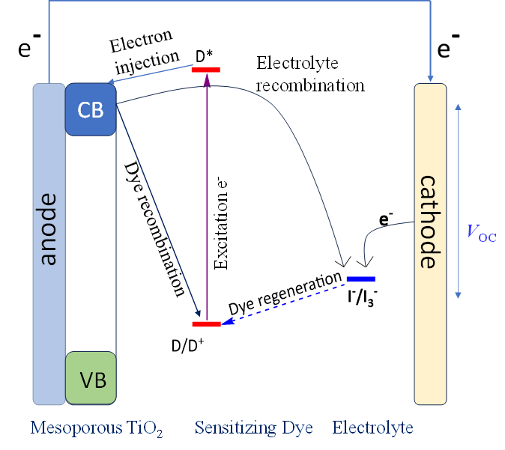
Fig. 1. Operating principle of DSSCs.

DSSCs are made of two electrodes separated by an electrolyte. One electrode is coated with platinum or graphite, while the other is a dye-sensitized wide–band-gap semiconductor such as titanium dioxide. When sunlight strikes the dye, it absorbs photons, becomes photoactivated, and initiates charge transfer processes (Fig. 1) [Korir et al., 2024]. In these devices, light is absorbed by the dye which is coated on the nanocrystalline semiconductor surface (typically TiO₂) (Fig. 1) [Bera et al., 2021]. The excited electrons from the dye then inject into the conduction band (CB) of the TiO₂ semiconductor, generating an electric current (Fig. 1) [Prakash et al., 2021]. Subsequently, the oxidized dye is reduced by electron transfer from the electrolyte, which is commonly based on the I⁻/I₃⁻ redox couple in an organic solvent [Bergeron et al., 2005]. Liquid electrolytes are among the most extensively investigated systems in the field of dye-sensitized solar cells (DSSCs). They are typically composed of three main components: a solvent, a redox mediator (ionic conductor), and various additives. During DSSC operation, the electrolyte solution plays a crucial role in dye regeneration and hole transport [Wu et al., 2015]. Various organic solvents, such as ethanol, acetonitrile, organic nitriles, and carbonates, have been employed in electrolyte solutions for DSSCs (Yu et al., 2011). Acetonitrile (AN) is widely regarded as the optimal solvent for fundamental studies focused on maximizing cell efficiency, however, its low boiling point (82 °C) makes it unsuitable for long-term device stability studies (Hagfeldt et al., 2010).
The intense research focus on Ru(II) polypyridyl complexes in DSSCs arises from their exceptional photophysical and redox properties, making them the most widely studied class of organometallic photosensitizers (Reynal et al., 2011; Qin et al., 2012). Since 1979, Ru carboxylate complexes have been studied as sensitizers for wide bandgap semiconductors (Anderson et al., 1979; Desilvestro et al., 1985). Alongside Ru complexes, porphyrin-based dyes have emerged as the second principal class of metal-containing sensitizers used in DSSCs. The field of porphyrin DSSC photosensitizers was significantly advanced by a milestone paper reported in 2011 (Yella et al., 2011). A significant breakthrough was realized through the replacement of the classical iodide/triiodide redox couple with a Co(II/III) tris(bipyridyl) complex in the electrolyte solution, resulting in an increase in power conversion efficiency from 7.6% to 11.9%. A power conversion efficiency of 12.75% was achieved using a cobalt-based electrolyte in combination with a newly developed push–pull porphyrin sensitizer, introduced in 2014 and characterized by a strong electron-withdrawing group (Yella et al., 2014).
Metal-free organic dyes represent the third major class of DSSC photosensitizers and, relative to ruthenium-based systems, allow easier structural tuning using established dye chemistry approaches, resulting in highly variable optical properties and broad spectral absorption. Notably, metal-free organic dyes offer distinct advantages, such as easily tunable molecular structures, compatibility with various redox couples, and record-high efficiencies. The donor–π–acceptor (D–π–A) architecture has been widely employed in DSSCs, utilizing a diverse range of organic scaffolds to achieve device efficiencies exceeding 10% in many cases. Among the various donor units, triphenylamine (TPA) and its derivatives have emerged as the most extensively studied [Ahmad et al., 2013]. TPA was first introduced as a photosensitizer in 2004 in a conventional DSSC employing an iodine-based electrolyte, where it delivered a promising power conversion efficiency of 5.30% [Kitamura et al., 2004]. Commonly used electron donors include triphenylamine, indoline, perylenes, and coumarin, while carbazole, phenothiazine, and diphenylamine have also been explored in organic sensitizers sharing the same electron acceptor and π-spacer [Rahman et al., 2023]. Conjugated linkers are typically formed by chains of methene units or aryl (Ar) compounds such as thiophene. Rhodanine-3-acetic acid and cyanoacrylic acid are widely used electron acceptors that also function as anchoring groups, with hydroxamate, silanol, and phosphonic acid serving as additional anchoring moieties [Chang et al., 2013].
For efficient operation of dye-sensitized solar cells (DSSCs), specific energy level alignments are required [Srivastava et al., 2025]. First, the lowest unoccupied molecular orbital (LUMO) energy level of the dye should be higher than the conduction band (CB) of TiO₂ (approximately −4.1 eV) to facilitate effective electron injection [Gad et al., 2020]. Second, the highest occupied molecular orbital (HOMO) energy level must be lower than the redox potential of the I⁻/I₃⁻ electrolyte system (around −4.80 eV) to ensure successful regeneration of the dye by the electrolyte [Masud et al., 2023; Vaissie et al., 2015]. The performance of organic dye-based DSSCs is strongly influenced by the molecular design of the dye. By strategically modifying the donor, acceptor, or π-spacer groups, it is possible to finely tune the dye's HOMO and LUMO energy levels, absorption characteristics, and electronic excitation energies [Harris et al., 2023]. For optimal device efficiency, several key requirements must be met (i) strong electronic coupling between the dye’s LUMO and the conduction band (CB) of TiO₂ to promote efficient electron injection [Biswas et al., 2014] (ii) broad and intense absorption in the visible to near-infrared (NIR) region, accompanied by high molar extinction coefficients for effective light harvesting and (iii) A sufficient driving force to enable rapid electron injection into TiO₂. Together, these factors critically determine the overall efficiency of DSSCs employing organic dyes [Novir et al., 2015]. Significant efforts have been devoted to enhancing DSSC efficiency through novel molecular architectures, including D–D–π–A and D–A–π–A systems. Building on this strategy, our group previously developed four D–π–A-type metal-free organic sensitizers (D1–D4) featuring phenanthroimidazole as the donor and cyanoacrylic acid or rhodanine-3-acetic acid as acceptors. These dyes achieved remarkable power conversion efficiencies (PCEs) of up to 10.2% when co-adsorbed with chenodeoxycholic acid (CDCA) [Almenningen et al., 2021].
During the last ten years, major advances in dye-sensitized solar cells (DSCs) have driven their progress toward sustainable applications, with continued efforts leading to high efficiencies under both outdoor and indoor conditions. Recent research efforts have primarily focused on enhancing both the stability and efficiency of metal-free organic dyes, with the current record efficiency reaching 14.7%. Common molecular scaffolds for these dyes include triarylamines, phenothiazines, and polythiophenes [Mishra et al., 2021; Sheibani et al., 2016]. Among these, phenothiazine and its oxygen analog phenoxazine represent early metal-free dye structures, with significant research dedicated to investigating π-spacers featuring isomerizable double bonds [Tian et al., 2007; Tian et al., 2009]. Notably, this class of sensitizers has demonstrated exceptional performance in DSSCs employing aqueous electrolytes, as evidenced by Lin et al. [Lin et al., 2015]. While two recent reviews have comprehensively covered the phenothiazine dye scaffold the fundamental challenge remains improving molecular light-harvesting capabilities [Luo et al., 2016; Huang et al., 2016]. Key strategies for achieving this include extending absorption into the infrared region through the strategic incorporation of π-spacers and auxiliary donor units.

2.METHODOLOGY
A comprehensive literature review was performed on non-metallic organic dyes used in dye-sensitized solar cells (DSSCs), with a specific focus on the influence of thiophene π-spacer groups on DSSC efficiency. The literature search was refined using the keywords donor–π–acceptor dyes, thiophene spacer, and fused ring spacer, applied individually and in combination across the search engines Google, Google Scholar, and PubMed.
3. RESULTS AND DISCUSSION
3.1 The importance of π-spacer group:
The photovoltaic performance of dye-sensitized solar cells can be precisely tuned through strategic modification of the dye sensitizer's molecular architecture, while maintaining all other device components constant. The π-bridge group plays a vital role in enhancing the performance of dye-sensitized solar cells (DSSCs). It significantly influences the HOMO and LUMO energy levels, thereby affecting the absorption spectrum, which is critical for efficient light harvesting. Moreover, the planar structure of the π-bridge promotes effective electronic communication between donor and acceptor units, facilitating intra-molecular charge transfer. Numerous π-bridge structures have been developed and studied from both experimental and theoretical perspectives to optimize these properties [Sharma et al., 2018].

3.2 Thiophene and its derivative acts as efficient spacer group:
Three novel D–π–A organic sensitizers (SGT-121, SGT-123, and SGT-125) based on thieno[3,2-b][1]benzothiophene (TBT) and incorporating a thiophene π-spacer have been synthesized by Kim et al. for application in dye-sensitized solar cells (DSSCs) (Fig. 2). In these sensitizers, TBT serves as a newly introduced fused π-bridge unit, offering excellent co-planarity due to its effective linkage between the thiophene moiety and the phenyl ring of the triphenylamine donor group. To enhance light absorption capabilities, various thiophene derivatives were introduced as π-spacers between the TBT π-bridge and the acceptor unit. These included thiophene (T, SGT-121), bithiophene (BT, SGT-123), and thienothio[3,2-b]thiophene (TT, SGT-125) moieties. The incorporation of these thiophene-based π-spacers led to a notable improvement in photovoltaic performance particularly in terms of photocurrent density (J_{sc}) and open-circuit voltage (V_{oc})compared to SGT-127, which lacks a thiophene spacer (Table 1). These findings highlight the crucial role of thiophene π-spacers in enhancing the photovoltaic performance of D–π–A type organic sensitizers [Eom et al., 2015].

Fig. 2: Geometries of SGT-(121-123) dyes.

In another study, Raposo et al. explored the effect of π-spacers on dye performance in DSSCs. To investigate the effect of structural modifications—such as varying π-spacers and electron-withdrawing groups—on the optical (linear and nonlinear) and electronic properties of the molecules, they prepared a series of push–pull heterocyclic N,N-diphenylhydrazones. These comparative studies demonstrate that the bithiophene π-bridge enhances the electron-donor effect more effectively than thienothiophene. Additionally, while the dicyanovinyl acceptor group is less conjugated than cyanoacetic acid and acts as a weaker electron-withdrawing moiety, it induces less distortion in the heterocyclic system—a potentially advantageous feature. They found that compound 5b, which features a bithiophene π-spacer, demonstrates the highest conversion efficiency (3.01%) as a sensitizer for nanocrystalline TiO₂ in DSSCs (Fig.3, Table 1). This enhanced performance is attributed to the dye's reduced electronic band gap and extended π-conjugation [Fernandes et al., 2018].

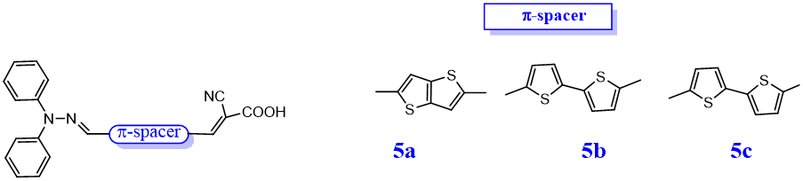

Fig. 3: Geometries of 5a, 5b and 5c dyes.

A new class of triazatruxene-based organic dyes has been designed and synthesized by Zhu et al. for dye-sensitized solar cells (DSSCs). These dyes feature a donor-π-acceptor (D-π-A) structure, and their photoelectronic properties can be systematically tuned by modifying the π-conjugated linkers. Thiophene, furan, and benzene were selected as π-conjugated linkers, yielding the corresponding sensitizers TD1, TD2, and TD3, respectively (Fig. 4). Among the synthesized dyes, TD1 exhibited the best performance, achieving a power conversion efficiency (PCE) of 6.10% when paired with thiophene as the π-linker and cyanoacrylic acid as the electron acceptor (Table 1). These findings demonstrate that triazatruxene-based sensitizers with thiophene spacer group exhibit remarkably high photocurrent density, positioning them as promising candidates for high-performance DSSCs [Qian et al., 2013].
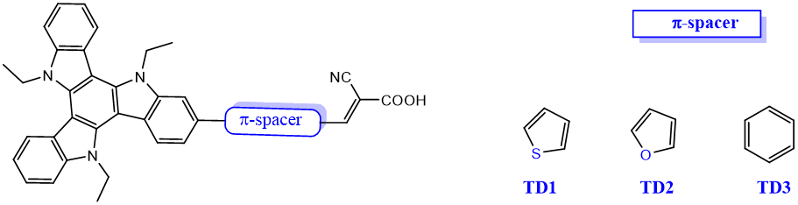
Fig. 4. Geometries of TD1, TD2, and TD3 dyes.
A series of novel D−D−π−A organic sensitizers (UB1, UB2 and UB3) were designed for DSSCs, featuring ((3,6-di-tert-butylcarbazol-9-yl)phenyl)-N-dodecylaniline as the donor-donor (D−D) moiety, oligothiophene π-conjugated spacers, and cyanoacrylic acid as the electron acceptor (A) (Fig. 5). They observed that organic dyes based on a double-donor moiety are promising candidates for enhancing the performance of DSSCs. DSSCs employing these dyes exhibit power conversion efficiencies ranging from 3.52% to 5.12% under AM 1.5G illumination (Table 1). Among these dyes, UB3 demonstrates the best performance, achieving a maximal IPCE of 83%, along with a Jsc of 10.89 mA cm⁻², V_{oc} of 0.70 V, and FF of 0.67, resulting in an overall efficiency of 5.12% which is 90% of the efficiency of the reference N3-based cell [Namuangruk et al., 2012].

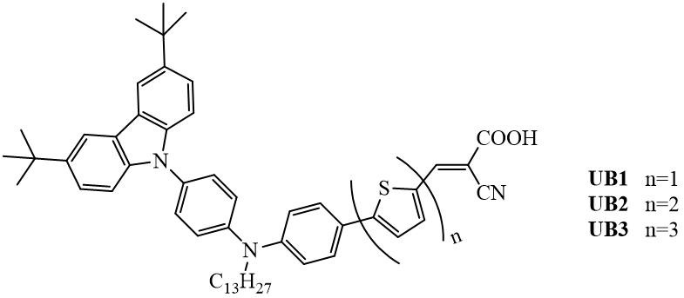
Fig. 5. Geometries of UB1, UB2, and UB3 dyes.
Thomas et al. further investigated the effect of the number of thiophene units, successfully synthesizing five novel organic dyes with a carbazole/3,6-di(tert-butyl)carbazole donor, 2,7-carbazole linker, and cyanoacrylic acid acceptor [Venkateswararao et al., 2014]. They observed that introducing additional thiophene units in the conjugation pathway progressively shifted the absorption band to longer wavelengths while enhancing the molar extinction coefficient. The power conversion efficiencies showed the following progression: device 5<9a<10a (Fig. 6).

Fig. 6: Geometries of 5, 9a, and 10a dyes.
A new series of isomeric D–A–π–A sensitizers, denoted as NPTn (n = 1–5), were synthesized incorporating 2H-[1,2,3]triazolo[4,5-c]pyridine (PT) as an auxiliary acceptor (Fig. 7). The molecular design features either triphenylamine or N,N-bis(4-(hexyloxy)phenyl)aniline as the donor unit, with furan, thiophene, phenyl, or 3-hexylthiophene serving as the π-conjugated spacer. The terminal 2-cyanoacrylic acid functions as both the primary electron acceptor and anchoring group. Analysis of intramolecular charge transfer (ICT) from the triphenylamine donor to the cyanoacetic acid acceptor showed that sensitizers NPT1 and NPT2 exhibited bathochromically shifted λ_{max} values compared to their structural analog NPT3 [Chaurasia et al., 2015].

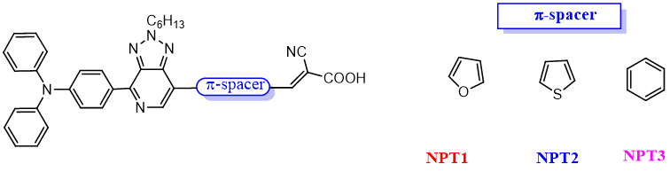
Fig. 7. Geometries of NPTn dyes.

Table 1. Photovoltaic parameters of the studied based DSSCs

Sensitizer | J_{sc}  (mA cm⁻²) | V_{oc}  (mV) | FF | PCE  (%) | Electrolyte | Ref.
SGT-121 | 14.00 | 809 | 72.71 | 8.24 | Co^{II}/ Co^{III} | Eom et al., 2015
SGT-123 | 16.16 | 830 | 72.09 | 9.69 | Co^{II}/ Co^{III} | Eom et al., 2015
SGT-125 | 14.74 | 773 | 71.86 | 8.20 | Co^{II}/ Co^{III} | Eom et al., 2015
SGT-127 | 8.67 | 707 | 70.45 | 4.32 | Co^{II}/ Co^{III} | Eom et al., 2015
5a | 6.41 | 640 | 0.67 | 2.98 | I—/I₃— | Fernandes et al., 2018
5b | 6.77 | 610 | 0.67 | 3.01 | I—/I₃— | Fernandes et al., 2018
7c | 2.01 | 540 | 0.62 | 0.72 | I—/I₃— | Fernandes et al., 2018
TD1 | 14.7 | 670 | 0.62 | 6.10 | I—/I₃— | Qian et al., 2013
TD2 | 13.6 | 654 | 0.62 | 5.50 | I—/I₃— | Qian et al., 2013
TD3 | 11.6 | 686 | 0.64 | 5.11 | I—/I₃— | Qian et al., 2013
UB1 | 7.19 | 730 | 0.67 | 3.52 | I—/I₃— | Namuangruk et al., 2012
UB2 | 8.88 | 700 | 0.66 | 4.10 | I—/I₃— | Namuangruk et al., 2012
UB3 | 10.89 | 700 | 0.67 | 5.12 | I—/I₃— | Namuangruk et al., 2012
5 | 2.79 | 555 | 0.64 | 0.99 | I—/I₃— | Venkateswararao et al., 2014
9a | 9.98 | 635 | 0.66 | 4.22 | I—/I₃— | Venkateswararao et al., 2014
10a | 15.78 | 601 | 0.64 | 6.04 | I—/I₃— | Venkateswararao et al., 2014
NPT1 | 14.60 | 699 | 0.71 | 7.22 | I—/I₃— | Chaurasia et al., 2015
NPT2 | 13.97 | 665 | 0.71 | 6.64 | I—/I₃— | Chaurasia et al., 2015
NPT3 | 10.24 | 697 | 0.69 | 4.92 | I—/I₃— | Chaurasia et al., 2015
A6 | 18.63 | 647 | 0.68 | 8.21 | I—/I₃— | Zhou et al., 2021
A8 | 10.26 | 731 | 0.71 | 5.36 | I—/I₃— | Zhou et al., 2021
A9 | 16.60 | 717 | 0.68 | 8.14 | I—/I₃— | Zhou et al., 2021

An et al. subsequently reported three innovative D–π–A sensitizers (A6-A9) based on a propeller-shaped DPDT core, where strategic modifications to the π-conjugation systems enabled systematic evaluation of molecular design principles in DSSCs (Fig. 8) [Zhou et al., 2021]. They performed the systematic investigation of the sensitizers' photophysical, electrochemical, and photovoltaic properties which revealed the significant terminal fragment effects in DSSCs. The di-anchoring sensitizer A6 achieved better power conversion efficiency (PCE = 8.21%) to its mono-anchoring counterpart AZ6, while exhibiting superior short-circuit current density (J_{SC}). The π-spacer group effect was systematically evaluated, revealing that the thiophene-based spacer (A6) enhanced photovoltage by 70 mV compared to its phenyl counterpart (A9). The thiophene-containing dye achieved a power conversion efficiency of 8.14%, representing a 52% improvement over the meta-cyanoacrylic acid-functionalized phenyl-spacer derivative A8 (PCE = 5.36%).
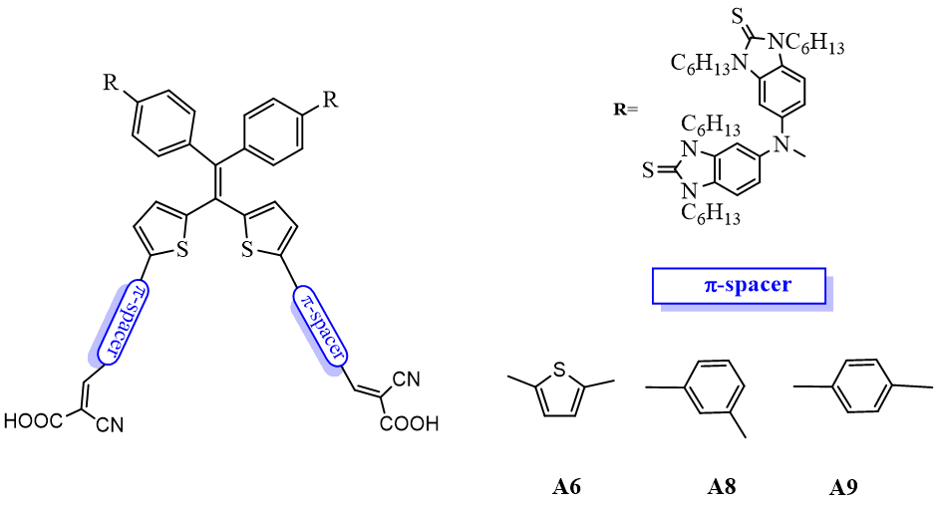

Fig. 8. Geometries of (A6-A9) dyes.

4. CONCLUSION
In response to the growing global demand for renewable and sustainable energy, dye-sensitized solar cells (DSSCs) have emerged as a viable alternative to conventional photovoltaic technologies due to their low cost, adaptability, and competitive efficiency. Ruthenium-based dyes are presently considered the most efficient sensitizers for dye-sensitized solar cells (DSSCs), achieving power conversion efficiencies in the range of 10–11%. Nevertheless, the high cost associated with these dyes has motivated significant interest in the development of metal-free organic photosensitizers as cost-effective alternatives. The performance of DSSCs is largely governed by the sensitizer, which facilitates efficient solar-to-electrical energy conversion. This review examines coumarins, an important class of aromatic organic compounds, as sensitizing agents in DSSCs. Emphasis is placed on their synthetic approaches, photophysical and electronic characteristics, and their effectiveness in enhancing photovoltaic performance. Furthermore, molecular engineering strategies aimed at improving coumarin-based sensitizers—including structural tuning and synergistic integration with other materials—are critically analyzed. By highlighting current limitations and future opportunities, this review seeks to support the continued development of high-performance and commercially viable DSSCs. This paper highlights the significance of using thiophene π-spacers in DSSCs. Various studies have demonstrated that replacing furan or phenyl rings with thiophene leads to significantly improved efficiencies. Moreover, oligothiophene-based π-conjugated spacers exhibit higher efficiency than monothiophene-based spacers. Oligothiophene-based π-conjugated spacers typically exhibit broad and intense absorption, enhancing their light-harvesting capabilities. Several thiophene π-spacers-based sensitizers have been reported to have high DSSC performance.

DISCLAIMER (ARTIFICIAL INTELLIGENCE)
The authors confirm that this manuscript was written and edited without the assistance of generative AI technologies, including large language models (ChatGPT, Copilot) or text-to-image generators.

COMPETING INTERESTS
Authors have declared that no competing interests exist.

REFERENCES

Maddah, H. A., Berry, V., & Behura, S. K. (2020). Biomolecular Photosensitizers for Dye-Sensitized Solar Cells: Recent Developments and Critical Insights. Renewable and Sustainable Energy Reviews, 121, 109678.
Pourasl, H. H., Barenji, R. V., & Khojastehnezhad, V. M. (2023). Solar Energy Status in the World: A Comprehensive Review. Energy Reports, 10, 3474−349.
O'Regan, B., & Grätzel, M. (1991). A low-cost, high-efficiency solar cell based on dye-sensitized colloidal TiO₂ films. Nature, 353, 737–740.

Francis, O. I., & Ikenna, A. (2021). Review of Dye-Sensitized Solar Cell (DSSCs) Development. Nat. Sci. (Irvine), 13 (12), 496−509.

Carella, A., Borbone, F., & Centore, R. (2018). Research Progress on Photosensitizers for DSSC. Frontiers in Chemistry, 6.
Korir, K. B., Kibet, K. J., & Ngari, M. S. (2024). A review on the current status of dye‐sensitized solar cells: Toward sustainable energy, Energy Sci. Eng. 12, 3188–3226.
Bera, S., Sengupta, D., Roy, S., & Mukherjee, K. (2021) Research into Dye-Sensitized Solar Cells: A Review Highlighting Progress in India. J. Phys. Energy, 3, 032013.
Prakash, P., & Janarthanan, B. (2023). Review on the Progress of Light Harvesting Natural Pigments as DSSC Sensitizers with High Potency. Inorg. Chem. Commun., 152, 110638.
Bergeron, B. V., Marton, A., Oskam, G., & Meyer, G. J. (2005). Dye-Sensitized SnO₂ Electrodes with Iodide and Pseudohalide Redox Mediators. J. Phys. Chem. B,109 (2), 937−943.
Wu, J., Lan, Z., Lin, J., Huang, M., Huang, Y., Fan, L., et al. (2015). Electrolytes in dye-sensitized solar cells. Chem. Rev. 115, 2136–2173.
Yu, Z., Vlachopoulos, N., Gorlov, M., and Kloo, L. (2011). Liquid electrolytes for dye-sensitized solar cells. Dalt. Trans. 40, 10289–10303.
Hagfeldt, A., Boschloo, G., Sun, L., Kloo, L., and Pettersson, H. (2010). Dye sensitized solar cells. Chem. Rev. 110, 6595–6663.
Reynal, A., and Palomares, E. (2011). Ruthenium polypyridyl sensitisers in dye solar cells based on mesoporous TiO₂. Eur. J. Inorg. Chem. 2011, 4509–4526.
Qin, Y., and Peng, Q. (2012). Ruthenium sensitizers and their applications in dye sensitized solar cells. Int. J. Photoenergy, 2012, 1–21.
Anderson, S., Constable, E. C., Dare-Edwards, M. P., Goodenough, J. B., Hamnett, A., Seddon, K. R., et al. (1979). Chemical modification of a titanium (IV) oxide electrode to give stable dye sensitisation without a supersensitiser [4]. Nature, 280, 571–573.
Desilvestro, J., Grätzel, M., Kavan, L., Moser, J., and Augustynski, J. (1985). Highly efficient sensitization of titanium dioxide. J. Am. Chem. Soc. 107, 2988–2990.
Yella, A., Lee, H. W., Tsao, H. N., Yi, C., Chandiran, A. K., Nazeeruddin, M. K., et al. (2011). Porphyrin-sensitized solar cells with cobalt (II/III)-based redox electrolyte exceed 12 percent efficiency. Science 334, 629–634.
Yella, A., Mai, C. L., Zakeeruddin, S.M., Chang, S. N., Hsieh, C. H., Yeh, C. Y., et al. (2014). Molecular engineering of push-pull porphyrin dyes for highly efficient dye-sensitized solar cells: the role of benzene spacers. Angew. Chem. Int. Ed. 53, 2973–2977.
Ahmad, S., Guillén, E., Kavan, L., Grätzel, M., and Nazeeruddin, M. K. (2013). Metal free sensitizer and catalyst for dye sensitized solar cells. Energy Environ. Sci. 6, 3439–3466.
Kitamura, T., Ikeda, M., Shigaki, K., Inoue, T., Anderson, N. A., Ai, X., et al. (2004). Phenyl-conjugated oligoene sensitizers for TiO₂ solar cells. Chem. Mater. 16, 1806–1812.
Rahman, S., Haleem, A., Siddiq, M., Hussain, M. K., Qamar, S., Hameed, S., and Waris, M. (2023). Research on dye sensitized solar cells: recent advancement toward the various constituents of dye sensitized solar cells for efficiency enhancement and future prospects. RSC Adv., 13, 19508–19529.
Chang, D. M., Kwon, D. Y., and Kim, Y. S. (2013). Heteroleptic Dual Acceptor Organic Dyes with Rhodanine-3-Acetic Acid and Cyanoacrylic Acid, Mol. Cryst. Liq. Cryst., 585, 100–106.
Srivastava, K. V., Srivastava, P., Srivastava, A., Maurya, R. K., Singha, Y. P. and Srivastava, A. (2025). 1D TiO₂ photoanodes: a game-changer for high efficiency dye-sensitized solar cells, RSC Adv., 15, 4789.
Gad, E. A. M., Kamar, E. M., and Mousa, M. A. (2020). Experimental and computational study on electronic and photovoltaic properties of chromen-2-one-based organic dyes used for dye-sensitized solar cells, Egyptian Journal of Petroleum, 29, 203–209.
Masud and Kim, H. K. (2023). Redox Shuttle-Based Electrolytes for Dye-Sensitized Solar Cells: Comprehensive Guidance, Recent Progress, and Future Perspective, ACS Omega, 8, 6139−6163.
Vaissie, V., Frost, J. M., Barnes, P. R. F., and Nelson J. (2015). Influence of Intermolecular Interactions on the Reorganization Energy of Charge Transfer between Surface-Attached Dye Molecules, J. Phys. Chem. C, 119, 43, 24337–24341.
Harris, S. J., McAdam, C. J., Wagner, P., Mapley, J. I., Gordon, K. C. (2023). Systematic Tuning of Electronic Ground and Excited States in Donor–Acceptor Dyes; Steps toward Designer Compounds for Modern Technologies, J. Phys. Chem. A, 127, 25, 5312–5323,
Biswas, A. K., Barik, S., Sen, A., Das, A., & Ganguly, B. (2014). Design of efficient metal-free organic dyes having an azacyclazine scaffold as the donor fragment for dye-sensitized solar cells, J. Phys. Chem. C 118, 36, 20763–20771.
Novir, S. B., & Hashemianzadeh, S. M. (2015). Density functional theory study of new azo dyes with different π-spacers for dye-sensitized solar cells, Spectrochimica Acta Part A: Molecular and Biomolecular Spectroscopy, 143, 20–34.
Almenningen, D. M., Hansen, H. E., Vold, M. F., Buene, A. F., Venkatraman, V., Sunde, S., Hoff, B. H.,&Gautun, O. R. (2021). Effect of thiophene-based π-spacers on N-arylphenothiazine dyes for dye-sensitized solar cells, Dyes and Pigments, 185, 108951.
Mishra, A., Fischer, M. K.,&Baüerle, P. (2009). Metal-free organic dyes for dye-sensitized solar cells: from structure: property relationships to design rules. Angew. Chem. Int. Ed, 48, 2474–99.
Sheibani, E., Zhang, L., Liu, P., Xu, B., Mijangos, E., & Boschloo, G. (2016). A study of oligothiophene-acceptor dyes in p-type dye-sensitized solar cells. RSC. Adv. 6, 18165–77.
Tian, H., Yang, X., Chen, R., Pan, Y., Li, L., & Hagfeldt, A. (2007). Phenothiazine derivatives for efficient organic dye-sensitized solar cells. Chem. Commun., 3741–3.
Tian, H., Yang, X., Cong, J., Chen, R., Liu, J.,&Hao, Y. (2009). Tuning of phenoxazine chromophores for efficient organic dye-sensitized solar cells. Chem Commun., 6288–90.
Lin, R. Y-Y., Wu, F-L., Li, C-T., Chen, P-Y., Ho, K-C., & Lin, J. T. (2015). High-performance aqueous/organic dye-sensitized solar cells based on sensitizers containing triethylene oxide methyl ether. Chem. Sus. Chem., 8, 2503–13.
Luo, J-S., Wan, Z-Q., & Jia, C-Y. (2016). Recent advances in phenothiazine-based dyes for dye sensitized solar cells. Chin. Chem. Lett., 27, 1304–18.
Huang, Z-S., Meier, H., & Cao, D. (2016). Phenothiazine-based dyes for efficient dye-sensitized solar cells. J. Mater. Chem. C 4, 2404–26.
Sharma, K., Sharma, V., & Sharma S. S. (2018). Dye-Sensitized Solar Cells: Fundamentals and Current Status. Nanoscale Research Letters, 13, 381.
Eom, Y. K., Kang, S. H., Choi, I. T., Kim, E., Kim, J., Ju, M. J., & Kim, H. K. (2015). New Thieno[3,2-b][1]benzothiophene-Based Organic Sensitizers Containing π-Extended Thiophene Spacers for Efficient Dye-Sensitized Solar Cells. RSC Adv., 5, 80859-80870.
Fernandes, S. S. M., Belsley, M., Pereira, A. I., Ivanou, D., Mendes, A., Justino, L. L. G., Burrows, H. D., & Raposo, M. M. M. (2018). Push−Pull N,N‑Diphenylhydrazones Bearing Bithiophene or Thienothiophene Spacers as Nonlinear Optical Second Harmonic Generators and as Photosensitizers for Nanocrystalline TiO₂ Dye-Sensitized Solar Cells. ACS Omega, 3, 12893−12904.
Qian, X., Zhu, Y-Z., Song, J., Gao, X-P., & Zheng, J-Y. (2013). New Donor-π-Acceptor Type Triazatruxene Derivatives for Highly Efficient Dye-Sensitized Solar Cells, Organic Letters, 15, 23, 6034-6037.
Namuangruk, S., Fukuda, R., Ehara, M., Meeprasert, J., Khanasa, T., Morada, S., Kaewin, T., Jungsuttiwong, S., Sudyoadsuk, T., & Promarak, V. (2012). D−D−π−A-Type Organic Dyes for Dye-Sensitized Solar Cells with a Potential for Direct Electron Injection and a High Extinction Coefficient: Synthesis, Characterization, and Theoretical Investigation, J. Phys. Chem. C, 116, 25653−25663.
Venkateswararao, A., Thomas, K. R. J., Lee, C-P., Li, C-T., & Ho, K-C. (2014).Organic Dyes Containing Carbazole as Donor and π‑Linker: Optical, Electrochemical, and Photovoltaic Properties, ACS Appl. Mater. Interfaces, 6, 2528−2539.
Chaurasia, S., Ni, J-S., Hung, W-I., & Lin, J-T. (2015).2H-[1,2,3]Triazolo[4,5-c]pyridine (PT) Cored Organic Dyes Achieving a High Efficiency: a Systematic Study of the Effect of Different Donors and π-Spacers, ACS Appl. Mater. Interfaces, 7, 39, 22046-22057.
Zhou, P., Lin, B., Chen, R., Liang, J., An, Z., Weng, Q., Chen, X., & Chena, P. (2021). Organic double D–π–A sensitizers based on 2,2/-(2,2 diphenylethene-1,1-diyl)dithiophene: π-conjugation fragment effect on the photovoltaic properties, Mater. Adv., 2, 6641–6646.

