Numerical simulation of a flooding phenomenon: application of Saint-Venant's equations and trigonometry

Abstract : This paper presents a numerical simulation of a flooding phenomenon based on one-dimensional Saint-Venant equations. The modeling uses trigonometric tools, particularly sinusoidal functions, to represent water level profiles and analyze spatial variations in flow. The numerical solution is obtained using the finite volume method, with β-Rusanov and HLL schemes for flow approximation. The numerical results show convergence towards a state of hydraulic equilibrium, characterized by an increase in water height and a decrease in velocity, confirming the effectiveness of the proposed approach for the qualitative analysis of flooding phenomena in a simplified setting.

Keywords : Flooding; Saint-Venant equation; Trigonometry; Finite volume method; Numerical simulation.

- Introduction
A flood is an overflow of water that covers normally dry areas, often caused by a problem with water drainage or by rivers overflowing following heavy rainfall [1]. Globally, several million people live under the threat of flooding. Floods are one of the main disaster risks facing the world. Understanding and predicting these phenomena is therefore essential to improving risk management and protecting populations. To this end, mathematical modeling and numerical simulation are essential tools for analyzing, predicting, and limiting the effects of flooding.
In fluid dynamics, there is a system of partial differential equations (PDEs) called the Saint-Venant system, which plays a central role in the study of free surface flows. It describes the dynamic behavior of water, taking into account the topography of the terrain, slopes, and forces at work. Nowadays, it is widely used to describe many physical phenomena such as: runoff, oceanography, environmental protection, environmental pollution, climate change, dam failure, tide calculation, flood study, sedimentology, and flooding [2,3,4,5,6,7]. Trigonometry therefore plays an essential role in the representation of trigonometric profiles and in the calculation of slopes, water heights, and angles of inclination using trigonometric functions (sine, cosine, tangent, and cotangent), which are key elements in flow dynamics. It is also used in many scientific fields such as mechanics, acoustics, geography, geodesy, optics, physics, electricity, electronics, etc.
Despite its widespread use, the Saint-Venant system has two major drawbacks : on the one hand, taking into account topography, friction, and infiltration rates makes numerical resolution complex; on the other hand, there is no analytical solution. To overcome these difficulties, we approach the solution using numerical methods. One of the methods commonly used to approximate the solution of the Saint-Venant system is the finite volume method. The main advantage of this method is that it ensures mass continuity, which is an important property that must be respected in all fluid flow calculations.
The objective of this work is to implement a numerical simulation of flooding by combining the homogeneous Saint-Venant equations and trigonometric tools in order to analyze the evolution of water levels and flow velocities in a given domain with boundary conditions. This approach aims to provide a scientific basis for understanding the phenomenon and improving flood risk prevention and management strategies with limited resources.
This paper consists of six sections.
In the second section, we present the one-dimensional Saint-Venant system without source term and its conservative form.
The third section is devoted to the numerical solution of the system with the presentation of the finite volume method [8,9] and the interfacial flow calculation schemes, namely β-Rusanov and HLL [10,11,12].
In the fourth section, we numerically simulate a flooding phenomenon on flat, smooth terrain with no infiltration rate and zero water at the outlet of the domain to obtain a wall condition at the boundary downstream of the flow.
In the fifth section, we conduct a comparative discussion of the results.
- One-dimensional Saint-Venant system without source term

The Saint-Venant equations are differential equations that describe free surface flows. These equations can be used to simulate changes in water depth and velocity over time and space based on the principles of conservation of mass and conservation of momentum.
The one-dimensional homogeneous Saint-Venant system is given by :

$\left\{\begin{aligned}\frac{∂h}{∂t}+\frac{∂hu}{∂x}=0 \\ \frac{∂hu}{∂t}+\frac{∂}{∂x}\left(hu^{2}+\frac{gh^{2}}{2}\right)=0; \end{aligned}\right.$ (1.1)
with
- $h\left(x,t\right)$ represents the water height at point$x$ at time $t;$
- $u\left(x,t\right)$ is the water velocity at the point $x$ at time $t;$
- $g$ is the gravitational constant.
This system can be written in the following conservative form:
$\frac{∂U}{∂t}+\frac{∂f(U)}{∂x}=0;$ (1.2)
with $U=\left({h \atop hu}\right)=\left({h \atop q}\right)$ and $f\left(U\right)=\left({hu \atop hu^{2}+\frac{gh^{2}}{2}}\right)=\left({q \atop \frac{q^{2}}{h}+\frac{gh^{2}}{2}}\right)$;
where $q\left(x,t\right)=h\left(x,t\right)u\left(x,t\right)$ is the momentum.
Barré de Saint-Venant obtained the nonlinear system (1.1) by integrating the three-dimensional Navier-Stokes equations vertically, making a number of assumptions and physical approximations [13].
- Numerical Resolution
  - Finite volume method
The principle of the finite volume method is to divide the calculation domain into a number of elementary volumes called “cells or meshes” without face discontinuities, which are polygons whose shape and number of sides can vary depending on the mesh [14]. Next, the partial differential equations are integrated over each cell to obtain discretized equations. The main advantage of this method is that it guarantees the conservation of flux across the faces between two successive cells.
The $U$ solution to problem (1.1) is approximated by the approximate values
$U_{i}^{n}≅\frac{1}{Δx}\int_{x_{i-\frac{1}{2}}}^{x_{i+\frac{1}{2}}}{U(x,t^{n})dx}$, $i=1,⋯,N$, representing the average of $U$ in the mesh
$M_{i}=\left[x_{i-\frac{1}{2}};x_{i+\frac{1}{2}}\right]$ at time $t^{n}=nΔt$ with $n∈N$ and $∆t$ is the time step. The meshes $M_{i}$ are centered at $x_{i}=\frac{x_{i-\frac{1}{2}}+x_{i+\frac{1}{2}}}{2}$, such that the spatial step $∆x=\left|M_{i}\right|$.
By integrating $(1.2$) over $\left[t^{n};t^{n+1}\right]×M_{i}$, we obtain :
$U_{i}^{n+1}-U_{i}^{n}+\frac{∆t}{∆x}\left(F(U_{i}^{n},U_{i+1}^{n})-F(U_{i-1}^{n},U_{i}^{n})\right)=0$ (1.3)
with
$$F\left(U_{i}^{n},U_{i+1}^{n}\right)=F_{i+\frac{1}{2}}^{n}≃\frac{1}{Δt}\int_{t^{n}}^{t^{n+1}}{f\left(U\left(x_{i+\frac{1}{2}},t\right)\right)dt}$$
and
$$F\left(U_{i-1}^{n},U_{i}^{n}\right)=F_{i-\frac{1}{2}}^{n}≃\frac{1}{Δt}\int_{t^{n}}^{t^{n+1}}{f\left(U\left(x_{i-\frac{1}{2}},t\right)\right)dt}$$

represent approximations of normal flows, i.e., numerical flows on the two interfaces of mesh $M_{i}$ at time $t^{n}.$
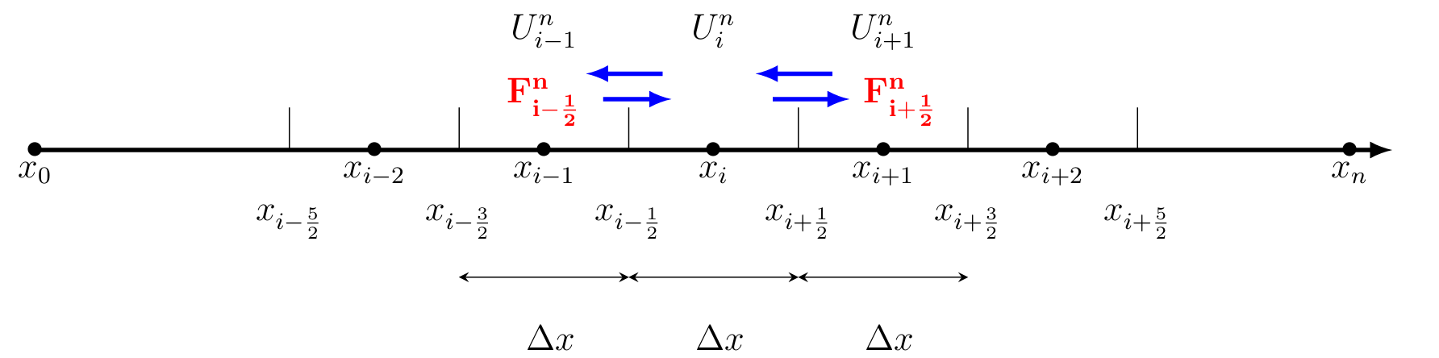
Figure 1 : Domain mesh 1D
$F_{i+\frac{1 }{2}}^{n}$ and $F_{i-\frac{1}{2}}^{n}$ are the flows opposite the small volume centered at $x_{i}$ and of length $Δx$.
  - Flux approximation
Several methods exist in literature to approximate the flux, in the present work, we use the simpler and thus more popular : the HLL flux and the new variant of Rusanov scheme, to know the $β$−Rusanov scheme.
    - $β$−Rusanov scheme
Let us note $U_{L}^{*}$and $U_{R}^{*}$ the data in the two neighboring cells, then the $β$−Rusanov flux [10] is gives by :
$F\left(U_{L}^{*},U_{R}^{*}\right)=\frac{F\left(U_{L}^{*}\right)+F(U_{R}^{*})}{2}-c\frac{U_{R}^{*}-U_{L}^{*}}{2}$ (1.4)
Where $c$ is the maximum wave velocity by calculating the maximum eigenvalue of the local Jacobian matrix of the cell and the new reconstructed data are obtained by :
$U_{R}^{*}=U_{R}-\frac{β}{2}\left(U_{R}-U_{L}\right)$ and $U_{R}^{*}=U_{L}+\frac{β}{2}\left(U_{R}-U_{L}\right)$
with $β$ a real such as $\left|β\right|<1$. $c=\max_{k∈\left\{1;2\right\}}\left(\left|λ_{k}\left(U_{L}\right)\right|,\left|λ_{k}\left(U_{R}\right)\right|\right)$ and $λ_{k}=u±\sqrt{gh}$ are eigenvalue of the matrix : $\frac{∂F}{∂U}=\left(\begin{matrix}0 & 1 \\ gh-u^{2} & 2u\end{matrix}\right)$ .
    - HLL scheme
The HLL (Harten, Lax et Van Leer) flux [11] is written as:
$$F\left(U_{L},U_{R}\right)=\left\{\begin{aligned}F\left(U_{L}\right) if 0≤ c_{1} \\ \frac{c_{2}F\left(U_{L}\right)-c_{1}F\left(U_{R}\right)}{c_{2}-c_{1}}-\frac{c_{1}c_{2}\left(U_{R}-U_{L}\right)}{c_{2}-c_{1}} if c_{1}<0<c_{2} \\ F\left(U_{R}\right) if c_{2}≤0\end{aligned}\right.$$
With $c_{1}=\inf_{U=U_{L},U_{R}}\left(\inf_{k∈\{1;2\}}{λ_{k}}\left(U\right)\right)$ and $c_{2}=\sup_{U=U_{L},U_{R}}\left(\sup_{k∈\{1;2\}}{λ_{k}}\left(U\right)\right)$
- Numerical simulation of a flooding phenomenon
The domain is $\left[0;L\right]=\left[0;14000\right]$, it is subdivided into $N=50$ meshes with Dirichlet boundary conditions :
$\left\{\begin{aligned}h\left(x,0\right)=50-\frac{x}{350}+10\sin\left(π\left(\frac{x}{3500}+\frac{1}{2}\right)\right), q\left(x,0\right)=0 \\ h\left(0,t\right)=64+4\sin\left(π\left(\frac{t}{21600}+\frac{1}{2}\right)\right), q\left(L,t\right)=0\end{aligned}\right.$
We used the Fortran language to obtain the following speed and height profiles :
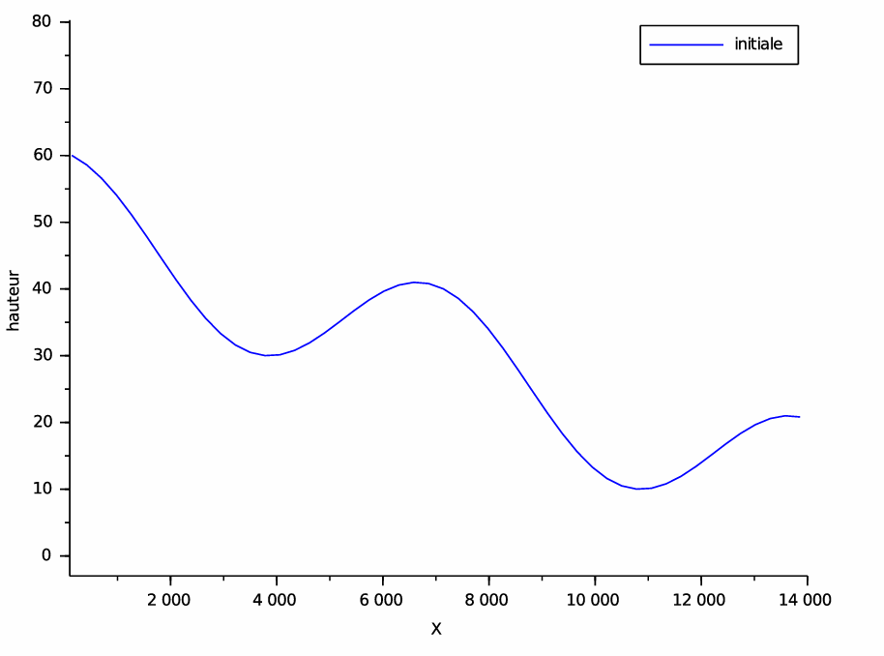
Figure 2 : Height profile at t = 0 s

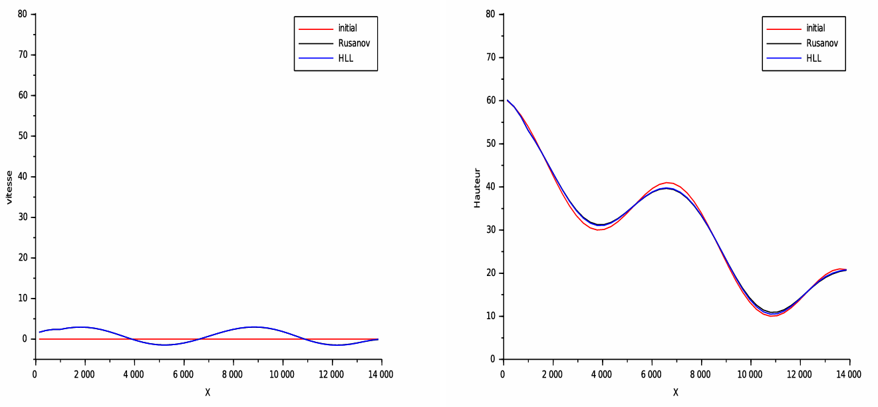
Figure 3 : Profile of solutions calculated at t=0,02 s

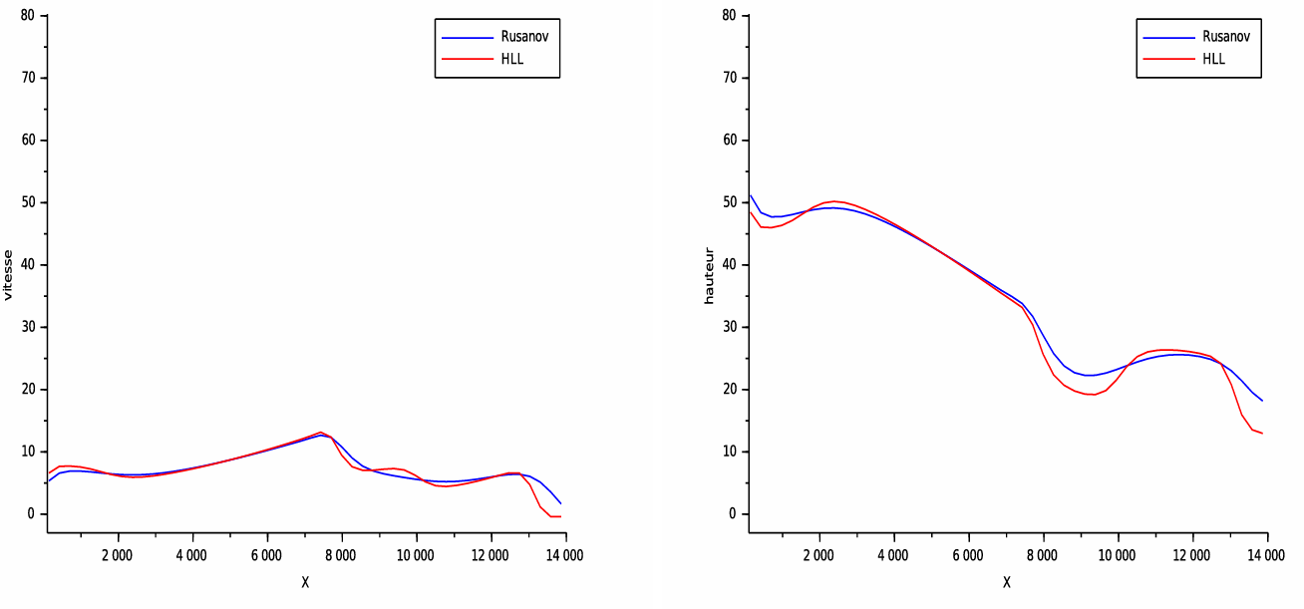
Figure 4 : Profile of solutions calculated at t=0,12 s
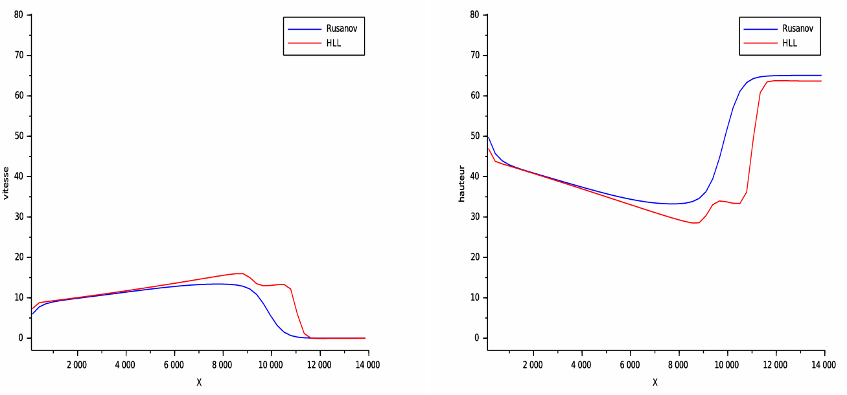
Figure 5 : Profile of solutions calculated at t=0,15 s

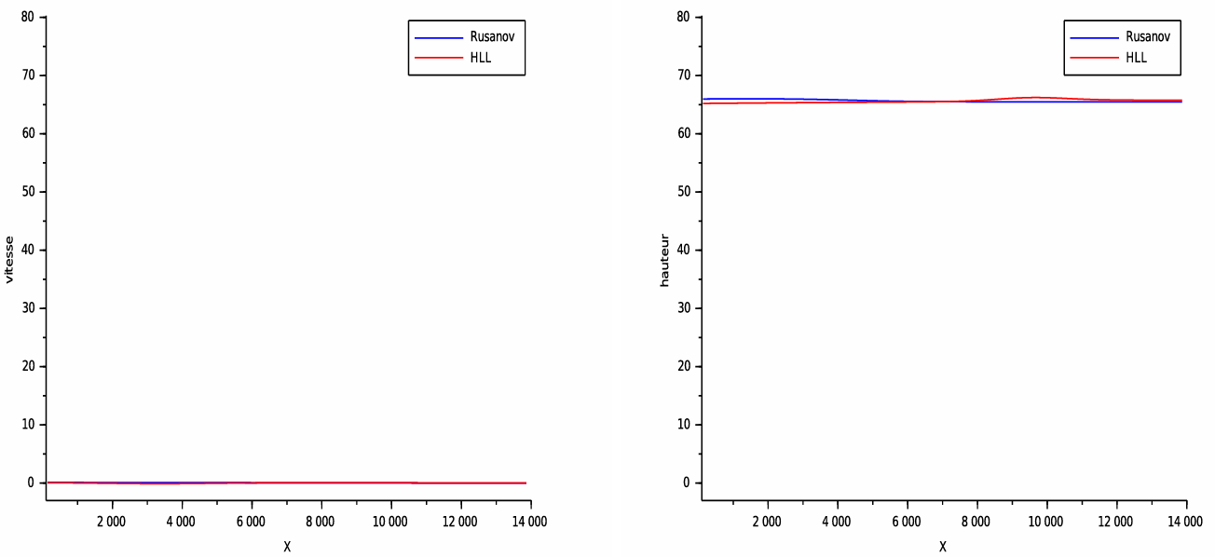
Figure 6 : Profile of solutions calculated at t=0,24s

Analysis of results
The objective of this numerical test is to simulate a flooding phenomenon on flat, hard ground using trigonometric functions.
In Fig. 2, we see a sinusoidal water height at the initial moment. Under the effect of gravity, we observe variations in both speed and water height in Figs. 3 and 4.
Following the closure (zero flow at the downstream boundary of the flow) imposed at the edges of the study domain, we observe a return of the water height for both schemes: this is the beginning of the equilibrium state.
At time t=0.24 s, both models reach equilibrium. We observe that the water height increases constantly during this time and the velocity decreases until it stabilizes. We can also see the speed of the β-Rusanov model compared to the HLL model, with a very significant difference.
- Discussions
  - Discussion of results
Numerical simulations obtained from one-dimensional Saint-Venant equations show a consistent evolution of water height and flow velocity. The initial sinusoidal profile, defined using trigonometric functions, generates pressure gradients responsible for the movement of water under the effect of gravity.
The imposition of a downstream wall boundary condition causes a gradual accumulation of water and a return of waves upstream, reflecting the establishment of a state of hydraulic equilibrium. Over time, the water height increases while the velocity decreases until it tends toward zero values.
A comparison of the numerical models shows that the β-Rusanov model converges more quickly than the HLL model due to its more diffusive nature. These results confirm the ability of the finite volume method to qualitatively reproduce the phenomenon of flooding in a simplified setting.
  - Comparative discussion with the literature
The results obtained are consistent with those reported in the literature on the modeling of free surface flows using Saint-Venant equations. Several studies have shown that finite volume methods can accurately represent wave propagation and the evolution toward hydraulic equilibrium in idealized one-dimensional configurations.
Work such as that of Navarro et al. and Caleffi et al. also highlights the importance of boundary conditions in water accumulation and the formation of steady states, phenomena observed in this study. Furthermore, the superior speed of the β-Rusanov scheme compared to the HLL scheme is consistent with the results in the literature, particularly those reported by Kader et al., where the more diffusive nature of the scheme promotes rapid stabilization of the solution.
However, unlike some more advanced work incorporating topography, friction, or two-dimensional models, the present study is limited to a simplified framework. Nevertheless, this approach remains relevant for a qualitative and educational analysis of the phenomenon of flooding, and provides a solid basis for future extensions to more realistic models.

- Conclusion
In this study, we examined the phenomenon of flooding using a numerical simulation approach based on Saint-Venant's equations and trigonometry to represent water height and velocity.
The results obtained show that numerical simulation is an effective tool for understanding flood dynamics and anticipating areas at risk. It also offers interesting prospects for decision support in land use planning and water resource management.

COMPETING INTERESTS DISCLAIMER:
Authors have declared that they have no known competing financial interests OR non-financial interests OR personal relationships that could have appeared to influence the work reported in this paper.

References

[1] Christophe Ancey, Hydraulique à surface libre, EPFL, ENAC/IIC/LHE, Ecublens, Lausanne, Suisse, CH-1015.
[2] Benkhaldoun F., Elmahi I., Seaid M. (2006). Well-balanced finite volume schemes for pollutant transport on unstructured meshes, Journal of Computational Physics, 226 (1) :180-203.
[3] Caleffi V., Valiani A., Zanni A. (2003). Finite volume method for simulating extreme flood events in natural channels, Journal of Hydraulic Research, (2) :167-177.
[4] Derakhshan H., Bistkonj M. Z. (2013). A new the two dimensional model for pollutant Transport in Ajichai River, Journal of Hydraulic Structures, 1 (2) : 44-54.
[5]. El Bouajaji M. (2010). Modélisation des écoulements à surface libre : étude du ruissellement d’eau de pluie, Stage de Master 2, calcul scientifique et visualisation, Université Louis Pasteur Strasbroug.
[6] Marche F. Autour des équations de Saint-Venant et applications à l’océanographie côtière, Université de Bordereau 1.
[7] Navarro G., Fras P., Villanueva A. I. (1999). Dam-break flow simulation : some results for one-dimensional models of real cases, Journal of Hydrology, 216(3-4) :227-247.
[8] Mohamed K., Seaid M., Zahri M. (2013). A finite volume method for sca lar conservation laws with stochastic time-space dependent flux func tions, Journal of Computational and Applied Mathematics, 237 : 614–632.
[9] Leveque R. J. Finite volume methods for hyperbolic problems, Cambridge University Press, Cambridge, UK. 2002.
[10] Kader M. Y. A., Badé R., Saley B. (2022). A new variant of Rusanov scheme : $β-$Rusanov for numerical resolution of shallow water flows, Int. J. of Appl. Math, 35(4) : 585-600.
[11] Chen G., Noelle S. (2017). A new hydrostatic reconstruction scheme based on subcell reconstructions, SIAM J. Numer. Anal, 55(2) : 758–784.
[12] Duran A., Liang Q., Marche F. (2013). On the well-balanced numerical discretization of shallow water equations on instructured meshes, Journal of Computational Physics, 235 : 565-585.
[13] Shi Y. (2006). Résolution numérique des équations de Saint-Venant par la technique de projection en utilisant une méthode des volumes finis dans un maillage non structuré, Thèse de Doctorat. Université de Caen.
[14] Hervouet J. M., (2007). Hydrodynamics of free surface flows modelling with the f inite element method, John Wiley et Sons, Ldt.

