Methodological approach for the design of a solar equipment waste management system in a country: application to the case of Benin

Abstract
The rapid expansion of photovoltaic (PV) systems in developing countries is leading to a growing accumulation of solar equipment waste (DES), while dedicated management infrastructures remain largely underdeveloped. This study proposes an original and generalizable methodological framework for the technical design, spatial optimization, and financial assessment of a national solar equipment waste management system. The approach combines (i) the estimation of end-of-life quantities of solar panels, batteries, and control equipment based on installed capacities and lifetimes, (ii) a spatial optimization model to determine the optimal number and location of collection centers using geographic information systems and cost minimization principles, and (iii) a comprehensive financial analysis to assess economic viability.
The methodology is applied to the case of Benin, where the country is subdivided into multiple zoning configurations and the number of collection centers is varied to minimize total investment and transportation costs. Results indicate that an optimal configuration of three collection centers, located in Ten-Dora/Sinendé, Dassa-Zoumè, and Tori-Bossito, ensures efficient national coverage. The financial evaluation shows that, under an appropriate financing scheme combining public subsidies and bank loans, the project is economically viable, with a positive Net Present Value, a Profitability Index greater than unity, a Discounted Payback Period of less than five years, and an Internal Rate of Return exceeding the discount rate. The proposed framework provides a robust decision-support tool for policymakers and investors aiming to develop sustainable solar waste management systems in developing countries.
.
Keywords : Waste of photovoltaic solar equipment (DES), optimal sizing, developing countries, financial analysis, sustainable management.
Symbol | Designation | Unit
$$d_{i}$$ | Distance between a collection center and a municipality | km
$$x_{i}$$ | Longitude of a town or center | ° or rad
$$y_{i}$$ | Latitude of a municipality or center | ° or rad
$$q_{i}$$ | Quantity of solar equipment waste in a municipality | t (tonne)
D | Equipment lifespan | years
R | Earth's radius | km
DRCI | Capital Recovery Timeframe | years
SHOT | Internal Rate of Return | %
VAN | Net Present Value | FCFA
$$FNT$$ | Net Cash Flow | FCFA
$$IP$$ | Profitability index | -
$$m$$ | Number of Departments in the country | Unit
$$c$$ | Number of municipalities in the country | Unit
$$P_{i}$$ | Power output of installed or distributed solar equipment | W
$$N_{i}$$ | Number of solar equipment installed or distributed | Unit
$$a_{réf}$$ | Reference years | -
$$n_{prè}$$ | Number of years prior $a_{réf}$to be taken into account for the summary | Years
$$n_{post}$$ | Number of years later $a_{réf}$to be taken into account for the summary. | Years
$$H_{e}$$ | Height of the stacks of DES in collection centers for | m
$$τ_{espace_sup}$$ | Portion of the additional space required representing circulation and organizational spaces | %
$$C_{0}$$ | Construction cost of $m^{2}$the storage center | FCFA
$$C_{essence}$$ | Cost per liter of gasoline | FCFA
$${C_{terrain}}_{i}$$ | Costs of $m^{2}$bare land per municipality or department | FCFA
$$q_{spec}$$ | Vehicle storage capacity | t (tonne)
$$C_{spec}$$ | Specific fuel consumption of vehicles | l /100 km
$τ_{maintenance}$ | An additional portion of transport costs represents vehicle maintenance costs. | %

Introduction
The growing need for clean and sustainable energy has driven nations around the world towards renewable energy sources and technologies (solar, wind, hydro, etc.), particularly solar technology, which has gained a prominent place in national policies for universal access to clean and sustainable energy over the years. This is reflected in the remarkable growth of installed photovoltaic capacity from 83.3 GW to 402.3 GW (from 2016 to 2023) internationally.
With a limited lifespan, the equipment used in photovoltaic systems becomes Waste Solar Equipment (WSE) after a few years of use if it is not subject to formal and standardized management. Unfortunately, some of this waste is very dangerous for humans (respiratory illnesses, kidney damage, neurological disorders and, in some cases, cancer, etc.) and the environment (soil and water pollution) [1] .
Given that energy needs are growing, the amount of this waste generated will increase over the years, and measures must be taken to manage it. This need is more evident in developing countries, such as those in West Africa, where there are few policies specifically addressing the management of hazardous waste and where waste is managed informally or not at all.
Even though there are private structures in West Africa that are involved in the management of DES , such as ASRI in Togo, LAGAZEL in Burkina Faso, Hinckley and ACELERON in Nigeria, etc., they are still very few in number compared to the quantity of current and especially future waste.
Govindan et al. (2015) [2] proposed optimization models to improve the location of collection centers and reduce logistical costs in the management of electronic waste, including waste from solar equipment. The study addresses batteries, circuit boards, photovoltaic modules, and metallic components. It relies on mathematical programming and multi-objective optimization approaches applied to emerging countries and provides a generic framework applicable to electronic waste management (EDM) systems. However, the models are primarily suited to structured industrial contexts and do not adequately account for rural dispersion and informality.
Latunussa et al. (2016) [3] assessed the environmental impact of an innovative recycling process for crystalline photovoltaic panels using a complete life cycle analysis. The waste considered included PV modules, glass, aluminum, cables, and junction boxes. The study, conducted in Europe (Italy), shows that optimized recycling significantly reduces environmental impacts. It provides a methodological benchmark for the sustainability of PV recycling. However, it does not offer an economic analysis and does not incorporate the constraints of developing countries.
Khoshfetrat et al. (2021) [5] propose a multi-criteria approach integrating environmental, economic, and social dimensions for the management of electronic waste, including solar waste. The waste analyzed includes solar panels, batteries, electronic equipment, and solar lamps. Applied to Iran, it uses the AHP and TOPSIS methods to prioritize management options. The approach is relevant for strategic decision-making, but it does not provide a detailed financial analysis or operational sizing of the infrastructure.
Granata et al. (2022) [6] assessed the techno-economic viability of photovoltaic panel recycling processes. Their study focused on silicon, glass, aluminum, copper, and silver waste. Applied to Italy, the study demonstrates that profitability is highly dependent on the volumes processed and economies of scale. It provides useful break-even points for the design of industrial units. However, the assumptions are based on a mature European market, which is not very representative of the African context.
In light of the above, it is readily apparent that the West African sub-region continues to face a significant deficit in formal, integrated, and sustainable waste management systems , including the absence of appropriate regulatory frameworks, dedicated funding, and coordinated mechanisms. To bridge this gap, this study aims to propose a methodology for the technical design, sizing, optimal location of collection centers, and financial analysis of a waste management system applicable to a given region. The method is then applied to the context of Benin.

Materials and methodologies

Material
To achieve our objectives, we primarily used data collected on solar installations in Benin (year, installed capacity, location, etc.) and data collected on the quantities of solar equipment waste generated by an installation based on its capacity and type. This data is presented in the following tables:
Table 1 : Quantities of Waste Solar Equipment generated by micro and large solar power plants [6]
Equipment | Features | Units | Solar power plants
Solar panels | Lifetime | Years | 25
Solar panels | Weight per MW installed | t solar panels/MW | 56
Batteries | Lifetime | Years | 5
Batteries | Battery weight | t batteries/MW installed | 67
Energy conversion and control equipment | Inverter lifespan | Years | 10
Energy conversion and control equipment | Inverter weight | t inverters/MW installed | 1.7
Energy conversion and control equipment | Transformer weights | t transformers/MW installed | 4.8

Table 2 : solar kits [6]
Equipment | Features | Units | solar pico lamp | SC1 and SML SSDs | SC4 SSD | Solar streetlights
Solar panels | Lifetime | Years | 10 | 10 | 10 | 20
Solar panels | Weight per MWc installed | kg /kit | 0.305 | 1.5 | 6 | 12.5
Batteries | Lifetime | Years | 4 | 4 | 4 | 5
Batteries | Battery weight | kg /kit | 0.847 | 1.32 | 17.5 | 11
Energy conversion and control equipment | Inverter lifespan | Years | 6 | 6 | 6 | 10
Energy conversion and control equipment | Weight of control equipment | kg /kit | 0.025 | 0.78 | 0.8 | 1.5

To process and analyze this data, we used two software programs: Excel from the Microsoft Office suite and version 3.34.12 of QGIS.

Method for annual estimation of DES
Current and future quantities of hazardous waste (HW) were estimated based on installations carried out and documented in Benin. Using information relating to the main installations (date or year of installation, beneficiary municipality, installed capacity, equipment lifespan, etc.), the potential annual quantities of HW were assessed as follows:
- The quantity of solar equipment waste generated by a given type of installation at a date t is equal to the sum of the quantities of equipment installed and put into service at date (t – D) with D being the lifespan of this equipment.
- In the techno-economic analysis of projects, the economic lifespan of solar installations is generally considered to be equal to the lifespan of the equipment with the longest lifespan. Therefore, the lifespan of the solar projects in this study is equal to the lifespan of the PV solar panels.
- For equipment whose lifespan is shorter than that of the project, this equipment is replaced the number $N,$of times necessary for the project to reach the end of its life.
Let's choose a specific area/ country (e.g., Benin) and a period of analysis $\left[t_{o} t\right]$. We want to calculate the total quantity $Q_{{DES}_{k}}\left(t_{o},t\right)$of type k waste available at time t, considering the total number ( $N_{projects})$of projects, both ongoing and completed, in the area and during the period). Given that the equipment has a lifespan D, and that a quantity ( $Q_{kj})$of the equipment) has been installed in each project j, then the total quantity $Q_{{DES}_{k}}\left(t_{o},t\right)$of type k waste available at time t is given by the following formula:

$$Q_{{DES}_{k}}\left(t_{o},t\right)=\sum_{j=1}^{N_{projects}}{Q_{kj}∙n_{kj}(to,t)}$$ | (Eq. 1 )

With $n_{kj}\left(to,t\right),$the number of equipment end-of-life times k, in project j, given by the following formula:
$$n_{kj}(to,t)=\max\left(0, \left\lfloor \frac{t-t_{oj}}{D}\right\rfloor -\left\lfloor \frac{max⁡(t_{o},t_{oj})-t_{oj}}{D}\right\rfloor \right)$$ | (Eq. 2 )

Here, $t_{oj}$represents the project start date j.

Method for determining the number of collection centers needed and their locations
The goal here is to determine the optimal number of solar electronic waste (SED) collection centers for a given country. This number must minimize the overall investment, which is considered an economic function. The overall investment here is the sum of the investments required to establish the optimal number of collection centers. To determine this optimal number, several zones are created within the country or study area. Each zone subdivides the country into a specific number of areas. Each area represents a group of contiguous municipalities.
For each zoning area, consisting of m sets of municipalities or m zones, the number of collection centers varies from 1 to $m$. For each center or zone, the investment and transportation costs for waste from the different municipalities are calculated. As the number of centers increases, investment costs increase while transportation costs decrease. The goal is to find the number of collection centers for which the sum of investment, operating, and transportation costs is lowest. This number represents the optimal number of collection centers.
The following lines provide a little more detail on the methodology:
- In a zoning system, the maximum (m) possible number of zones is simply the maximum number of municipalities in the country. The minimum number of zones is 1;
- For each zoning, a number of collection centers is assigned, ranging from 1 to m, where m represents the number of zones (set of municipalities) in the zoning.
- Using investigations (documentary research, resource persons from ministries, databases) carried out on solar installations in the country , we determine by zone the total cumulative quantities of DES generated and/or that will be generated by these installations over the life of the projects or analysis period.
- Next, knowing the GPS location $(x_{i}, y_{i})$of the geographic center of each municipality i and the quantities of DES that can be generated in these municipalities, we determine the ideal location $\left(x_{g}, y_{g}\right)$of the collection center to reduce transport costs.
- The coordinates of the collection center of an area is the barycenter of the centers of the municipalities, each weighted by the estimated quantities of DES there.
$$x_{g}=\frac{\sum_{i}{x_{i}×q_{i}}}{\sum_{i}{q_{i}}}$$ | (Eq. 3 )

$$y_{g}=\frac{\sum_{i}{y_{i}×q_{i}}}{\sum_{i}{q_{i}}}$$ | (Eq. 4 )

With
- $x_{i}$ And $y_{i}$: the geographical coordinates (latitude and longitude in degrees) of the centers of the different municipalities in the area;
- $q_{i}$: the quantity of waste in municipality i in tonnes ;
- $x_{g}$ And $y_{g}$the geographic coordinates in degrees of the collection center.
Given the location $\left(x_{g},y_{g}\right)$of the collection center within the designated area, the geographic coordinates of the municipal centers in the same area, and the quantities of DES per municipality, the necessary storage area, and therefore the size of the collection center, can be determined. To do this, the following steps are required:
- Determine the maximum amount of DES that can be collected in a year , in the area using estimates while taking into account a maximum collection rate $τ_{max}$depending on the constraints present;
- Determine the volume required for storing this quantity of DES after determining the density in tonnes per $m^{3}$waste from solar equipment;
- Determine the required floor area after setting the height of the DES stacks and taking into account circulation and organization spaces ( $τ_{espace_sup}$space required for additional storage).
- Taking into account the value of bare land in the area and the economies of scale factor, the investment costs (purchase of land and construction of the center) are determined.
Using the e-REFERENCE PRICE DIRECTORY of Benin version 2024 [7] and some civil engineering experts, the cost of construction per m² of collection center was estimated.
It is important to note the need to consider economies of scale, which reflect the relationship between size and cost, indicating that while economies of scale are real, they decrease with increasing size. In our case, that of determining the construction costs of collection centers,$α=0,9$ [8] , the investment costs by $m^{2}$collection centers, is determined as follows, for each case.
$$C_{i}{=C}_{0}×{\left(\frac{S_{i}}{S_{0}}\right)}^{0,9}$$ | (Eq. 5 )

With,
$C_{i}$: the construction cost of one square meter ^{of} the surface collection center$S_{i}$
$C_{0}$: the cost of constructing one m² of collection center for an area $S_{o}$.
$S_{i}$: the area of the collection center i
$S_{0}$: the area of a reference collection center whose construction cost is known.
Collection costs are determined based on the location of the collection center. Indeed, knowing the geographical coordinates of the collection centers and the centers of the municipalities served, the distance between a collection center and a given municipality i can be determined using the following expression [9] :
$$d_{i}=R×\arccos\left(\sin\left(y_{g}\right)×\sin\left(y_{i}\right)+\cos\left(y_{g}\right)×\cos\left(y_{i}\right)×\cos\left(x_{i}-x_{g}\right)\right)$$ | (Eq. 6 )

With
- $R$: the average radius of the Earth ( $R=6371 km$)
- $x_{g}$ And $y_{g}$the geographical coordinates in radians of the collection center.
Knowing:
- Specific fuel consumption $C_{spec}$(l/100 km) of vehicles transporting DES , their storage capacity$q_{spec}$ in tonnes;
- The specific cost, $C_{oil}$, of fuel in FCFA /l ;
- The quantities $q_{i}$in tonnes of DES per municipality;
- The distances $d_{i}$in km that separate the collection centers from the municipalities ;
- The additional share that maintenance costs represent in transport costs $τ_{maintenance}$;
Transportation costs can be easily determined${Coût_{transport}}_{i}$ DES from each municipality at the collection point using the following mathematical expression:
$${Coût_{transport}}_{i}=\sum{d_{i}×C_{spec}×C_{oil}×\left\lceil \frac{q_{i}}{q_{spec}}\right\rceil }×2×\left(1+τ_{maintenance}\right)$$ | (Eq. 7 )
Finally, we sum the investment and transport costs for each case , compare the results and choose the optimal number of collection centers, the number for which the sum of costs is the smallest.
The following flowchart summarizes the methodology presented:
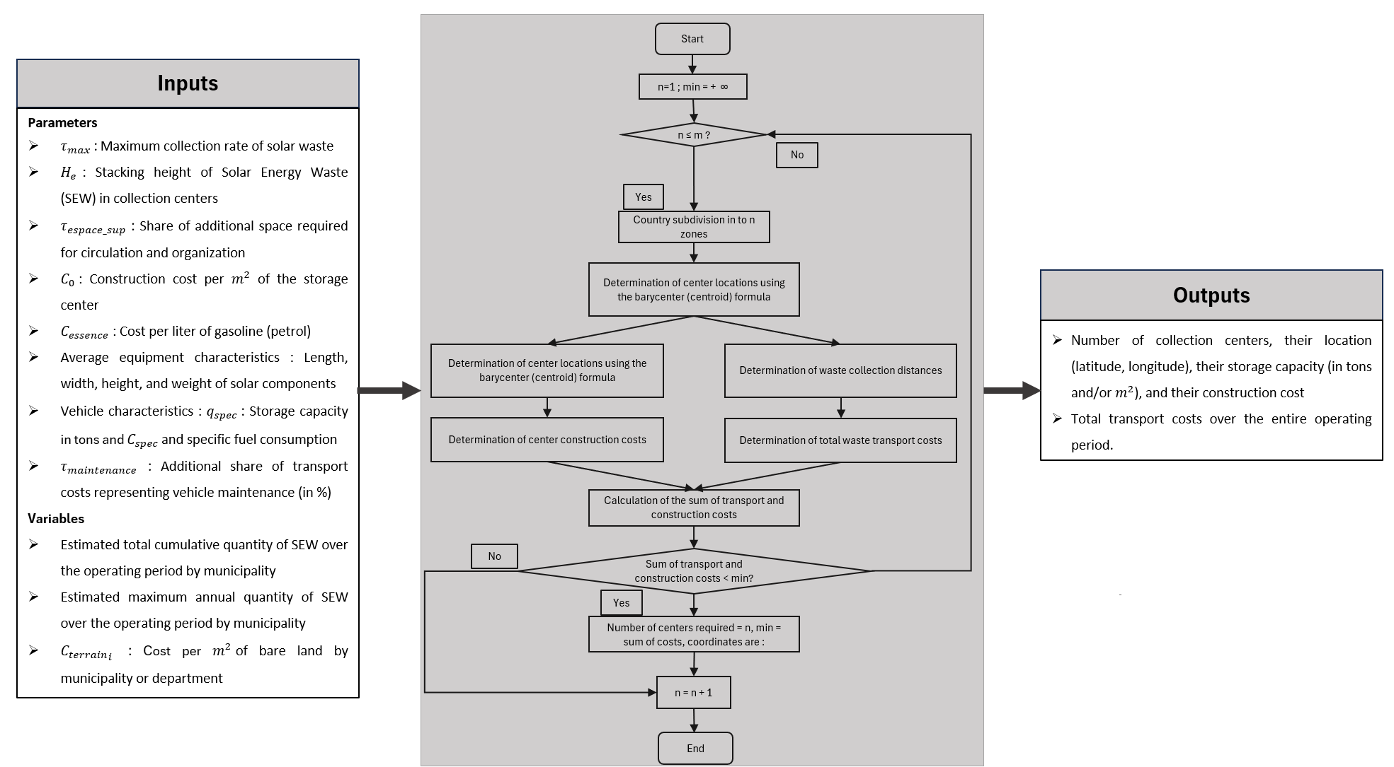
Figure 1: Method for determining the number of collection centers needed and their locations
In this study, where we focus on the case of Benin, the following table summarizes the different parameters and assumptions used in the methodology.
Table 3: Parameters and assumptions used in the methodology for determining the number of collection centers
 | Parameters | Value
 | Maximum annual collection rate (%) | 60
 | Height of DES stacks (m) | 1.5
 | τ _(upper space) (%) | 50
 | Construction cost (FCFA/m²) | 175 000
 | Cost of a liter of gasoline (FCFA) | 700
Average characteristics of solar equipment [10] | Length (Solar panels, batteries, inverters) (m) | 1.658/0.503 5/0.508
Average characteristics of solar equipment [10] | Width (m) | 1.002/1.955/0.410
Average characteristics of solar equipment [10] | Height (m) | 0.035/0.240/0.207
Average characteristics of solar equipment [10] | Weight (kg) | 19,575/44,250/23,690
Characteristics of transport vehicles | Tricycle storage capacity , Van storage capacity (tonne) | 0.8  12
Characteristics of transport vehicles | Specific fuel consumption ( l/100 km) | 3.5 and 15
 | τ _maintenance (%) | 30
Reference years | Reference years | 2025
Reference years | Number $n_{prè}$of years prior $a_{réf}$to be taken into account for the summary (years) | 10
Reference years | Number $n_{post}$of years $a_{réf}$to be taken into account for the summary (years) | 0

Financial analysis method
After estimating the cash flows of the projects, including self-financing capacity, changes in working capital requirements, fixed assets and terminal values, as well as the discount rate and the cost of investment, the financial evaluation relies on several criteria. These criteria are the Net Present Value ( NPV ) , the Profitability Index ( PI ) , the Payback Period ( PP ) , and the Internal Rate of Return ( IRR ) [11] . The formulas necessary for the calculation can be found in the literature [12] .
In the following table, we present the financial assumption data used for our case study, which is Benin:
Table 4 : Financial Assumptions
Financial data | Unit | Value
Discount rate (%) |  | 10.4
Loan interest rate | % | 12
Repayment period | Years | 12
Deferred payment requested | Years | 3
Income taxes | % | 30
Average prices of new control equipment [10] | FCFA/tonne | 37 500 000
Average prices of new solar batteries [10] | FCFA/tonne | 4 519 700
Average prices of new solar panels [10] | FCFA/tonne | 3 400 000

Results and discussion of the application of the method to the case of Benin

Parameters and assumptions of the Beninese context
Before presenting the results obtained following the application of the methodology to the case of Benin, we will briefly present the waste management system in general. This system is based on a literature review of the different waste management methods in the sub-region and on the current waste management system in Benin.
- End-of-life panels are collected from users (by tricycle or van), then sorted and stored in collection centers. They are then resold to private companies at 10 % of their new price.
- Lead-acid batteries are regenerated (cost: 35 % of the new price [13] ) locally (in Cotonou), with a success rate of 70 % . They are then resold to private companies at 65 % of the new price.
- Lithium batteries, at the end of their life, while awaiting a regeneration center in Porto-Novo [14] , are resold to private companies outside the country at 12 % of the new price if they are non-recoverable.
- The control and conversion equipment (inverter, regulators, etc.) is at 80 % repaired by local technicians (cost: 30 % of the new price [15] ), then resold to private companies. The 20 The remaining % are also resold or exported to 12 % of the new price.
- Overall, end-of-life equipment (ELE) is purchased from the original users, at 10 % of their new price [16] . Also, all regenerated or repaired products are sold through a single point of sale located in Cotonou.

DES estimation .
After a review of solar installations in Benin, annual estimates are made based on installations carried out between 2014 and 2020. The following table summarizes these installations.

Table 5 : Summary of projects included in DES estimates
Projects | Year of completion
Distributions of 70 000 solar kits [17], [18], [19] | From 2015 to 2020
Installation of solar streetlights through the PRODERE 1, PILAKS-PV, PROVES Projects [17], [20], [21] | From 2014 to 2020
Installation of 80 micro solar power plants with capacities ranging from 15 to 45 kWp through the PROVES and PRODERE 1 projects [21], [22] | From 2017 to 2018

The results obtained are presented in the following graphs:
The first graph below shows estimates of solar panel waste. It should be noted that the lifespan of solar panels is estimated at 10 years for kits.

Figure 2 : Estimates of solar panel waste.

The following figure presents estimates of battery waste:

Figure 3: Battery waste estimates
The following graph presents estimates of waste from control equipment:

Figure 4 : Estimates of waste from control equipment.
Using Excel and QGIS software, DES estimates were made by municipality and by department. The results are presented in the following figures.
The first two figures present the quantities of DES in tonnes per department and per municipality in a global way (all solar equipment).
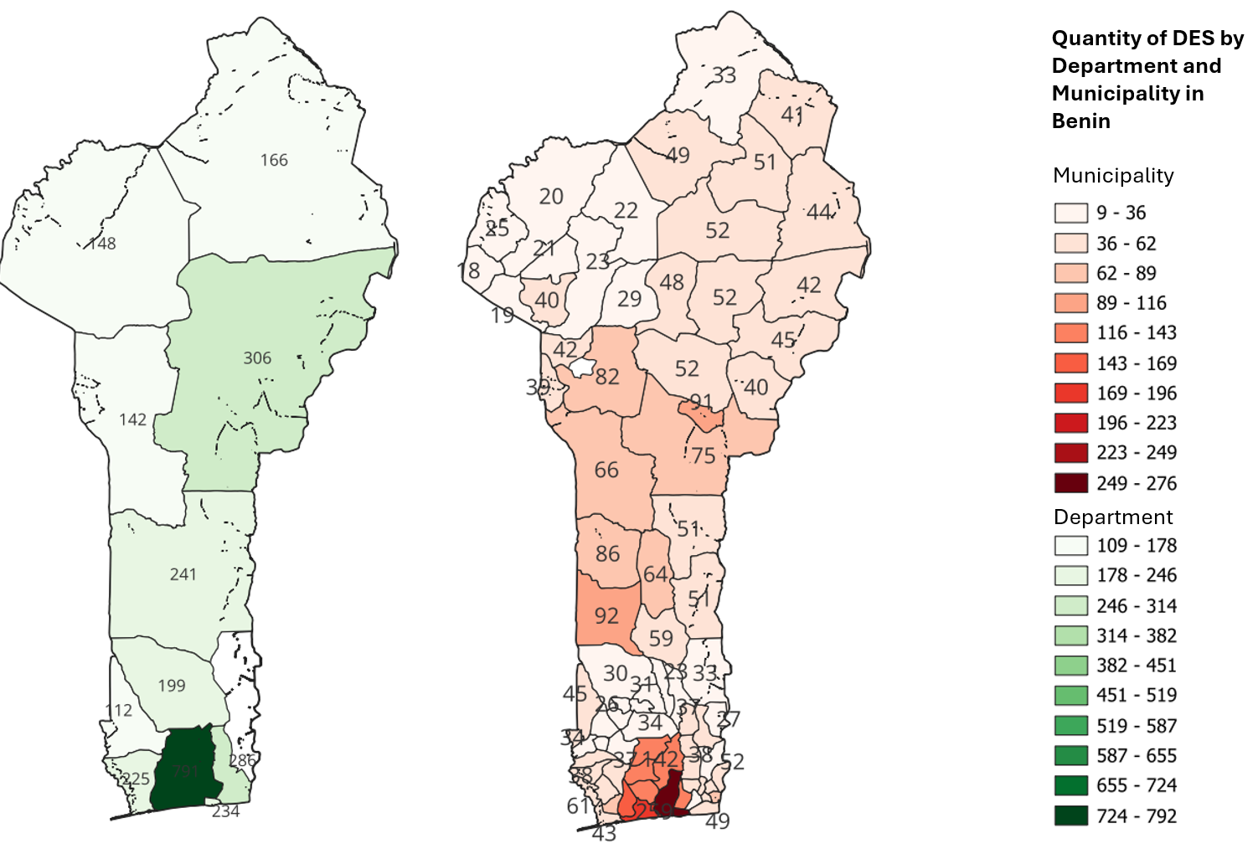
Figure 5 : Overall estimates of DES by department and by municipality
The following figures show the quantities of DES per municipality and per type of equipment.
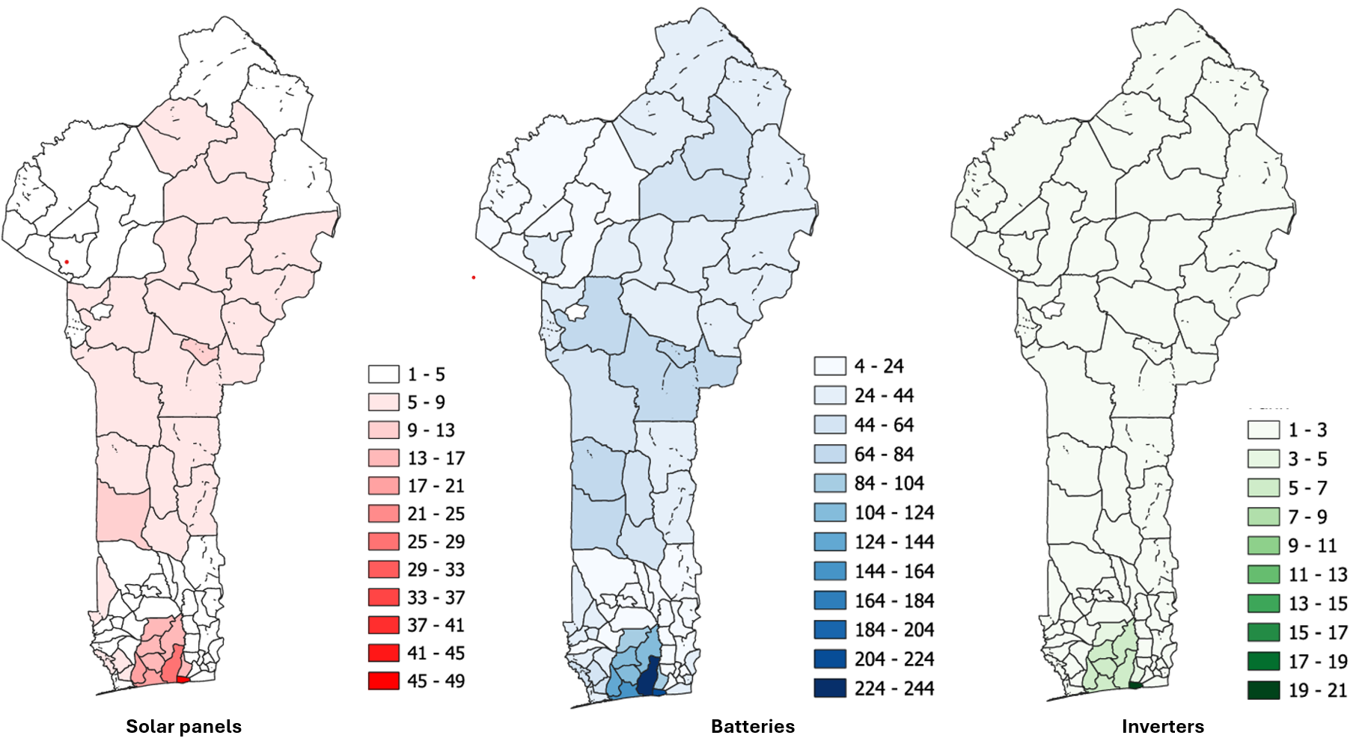
Figure 6 : Estimates of DES in tonnes per municipality and per type of equipment
These figures clearly show that the largest quantities of DES are generated in the South, more particularly in the departments of the Atlantic and the Littoral.
The following figure and table show the variation in the sum of costs as a function of the number of collection centers to be set up.
Table 6 : Variation in the sum of investment and transport costs as a function of the number of centers
Case | Number of collection centers | Totals in FCFA
Case 1 | 1 | 70 785 086 F CFA
Case 2 | 2 | 60 718 164 F CFA
Case 3 | 3 | 59 105 483 F CFA
Case 4 | 4 | 59 514 601 F CFA
Case 5 | 5 | 62 580 295 F CFA
Case 6 | 6 | 64 331 396 F CFA
Case 7 | 7 | 66 780 312 F CFA
Case 8 | 8 | 66 240 301 F CFA
Case 9 | 9 | 69 639 821 F CFA
Case 10 | 10 | 69 742 851 F CFA
Case 11 | 11 | 72 748 100 F CFA
Case 12 | 12 | 75 348 841 F CFA

To highlight the minimum more quickly, the data from the table has been represented in the form of the histogram below.
Figure 7 : Variation in the sum of investment and transport costs as a function of the number of centers.
Analyzing this graph, we observe that by varying the number of collection centers from 1 to 12, the sum of investment and transportation costs is minimal when the number of collection centers is equal to 3. Therefore, the optimal number of collection centers is 3. Thus, the country is divided into three zones: North, Central, and South, as shown in the following figure. This figure also represents the locations of the collection centers.
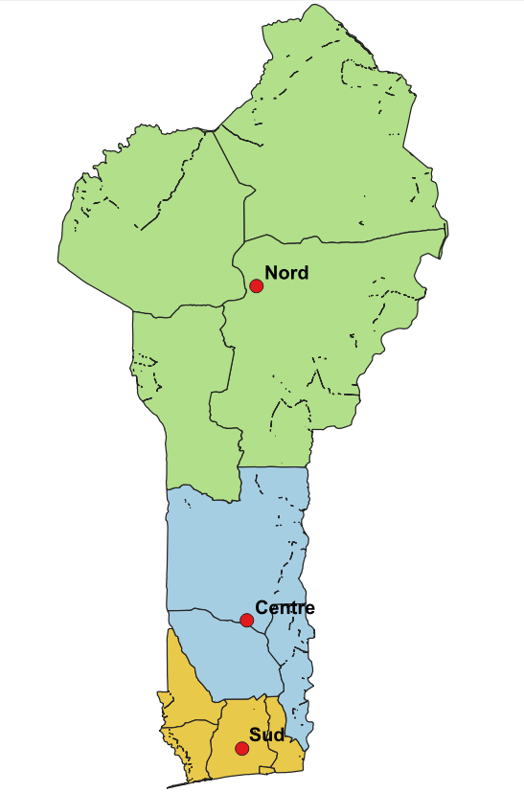
Figure 8 : Zoning according to 03 of collection centers and optimal location of collection centers
The coordinates of these centers are provided in the following table:
Table 7 : Coordinates of these collection centers
Center | Municipality | Latitude | Longitude
North | Ten-Dora, Sinendé | 10.2006001 | 2.34162998
Center | Dassa zoumè | 7,560 428 86 | 2,266 098 2
South | Tori- Bossito | 6.55269905 | 2.22365265

Financial analysis of the project

Estimates of ESD on an annual basis by zone and by type of equipment
Following the division of the country into 3 zones, estimates of the DES ( Developmental and Social Expenditure) levels were made. The results are presented in the following graphs:
The first one presents estimates of solar panel waste by area and by year.

Figure 9 : Estimates in tonnes of solar panel waste by area.
The second section presents estimates of battery waste by area and by year.

Figure 10 : Estimates in tonnes of battery waste by area.
The third section presents estimates of waste from control equipment (inverters and regulators).

Figure 11 : Estimates in tonnes of waste from control equipment.
In designing the Business Model, we assumed that the quantities of DES generated before 2025 are not yet managed and represent a significant source of raw materials for operations. Therefore, using 2025 as the baseline year for the start of operations, we combined the quantities estimated before 2025 and added them to the estimated quantities for 2025. The sum of these quantities is thus estimated as the amount of DES to be managed in 2025 at the start of operations. These estimates are presented in the following graph:

Figure 12 : Estimates in tonnes of DES by zone on an annual basis.
By observing the graph above, we note a peak in generated DES every five years. However, collection centers are designed to process DES annually, and given the limited distribution capacity of regenerated or refurbished solar equipment, it is difficult to manage such quantities in a single year of operation. Therefore, we have organized DES management activities into five-year campaigns. During each campaign, the estimated quantities from the previous five years are managed. The following graph shows the estimated quantities of DES to be managed each five years.

Figure 13 : Estimates in tonnes of cumulative DES every 5 years
These quantities are then distributed equally over the 5 years of activity, i.e. 20% each year.

Figure 14 : Distribution of DES over the years of activity (in tonnes )

Financial profitability analysis
Given the annual quantities of DES to be managed and the designed management system, the financial analysis of the system involves determining the criteria discussed in the methodology section. Determining these criteria requires calculating CAPEX and OPEX, as well as annual revenues. The results obtained are presented in the following table:
Table 8 : Financial indicators of project profitability
Item | Year 0 | Year 1 | Year 2 | Year 3 | Year 4 | Year 5
Net Profit |  | 108,940,941 | 115,888,454 | 115,888,454 | 81,964,903 | 81,964,903
Depreciation Allowances |  | 25,757,081 | 25,757,081 | 25,757,081 | 25,757,081 | 25,757,081
Cash Flow from Operations (CFO) |  | 134,698,022 | 141,645,535 | 141,645,535 | 107,721,984 | 107,721,984
Investments | 446,174,505 | – | – | – | – | –
Total Investments | 446,174,505 | – | – | – | – | –
Net Cash Flow | −446,174,505 | 134,698,022 | 141,645,535 | 141,645,535 | 107,721,984 | 107,721,984
Discounted Net Cash Flow | −446,174,505 | 122,009,078 | 116,215,684 | 105,267,830 | 72,515,033 | 65,683,907
Cumulative Discounted Net Cash Flow | −446,174,505 | −324,165,427 | −207,949,743 | −102,681,913 | −30,166,880 | 35,517,026
Equity | 446,174,505
NPV (Net Present Value) | 304,447,352
PI (Profitability Index) | 1.68
DPP (Discounted Payback Period) | 4 years 5 months
IRR (Internal Rate of Return) | 17%

The estimated capital expenditure (CAPEX) of the project amounts to 991,498,900 FCFA. Under realistic assumptions and in the absence of any public subsidy or bank loan, the project proves to be financially unviable, yielding a negative Net Present Value (NPV) of −119,738,002 FCFA and a discounted payback period exceeding 11 years. This outcome remains reasonable given the substantial level of upfront investment required.
A sensitivity analysis was subsequently conducted to identify the minimum financial conditions required for profitability, focusing on the respective roles of bank financing and public or development-partner subsidies. The results indicate that a viable financing strategy can be achieved through a combination of 35% of the CAPEX financed by a bank loan at an interest rate of 9%, together with a 20% capital subsidy.
Under this financing structure, the resulting cash flow statement is presented in Table 8. The project then achieves a positive NPV of approximately 304 million FCFA and an Internal Rate of Return (IRR) of 17%, clearly exceeding the discount rate.
Given the significant positive environmental, economic, and social impacts that such a project can generate across multiple countries, it is essential to undertake targeted advocacy efforts to facilitate access to appropriate financial support instruments. Such mechanisms are crucial to encourage private investors to engage in the development and deployment of this type of capital-intensive yet high-impact infrastructure.

Conclusion
This study developed and applied a comprehensive methodological framework for the design and financial evaluation of a solar equipment waste management system at the national scale, addressing a critical and rapidly emerging challenge associated with the expansion of photovoltaic technologies in developing countries. By integrating waste flow estimation, spatial optimization of collection centers, and financial analysis, the proposed approach offers a structured and reproducible tool for decision-making in contexts where data availability and infrastructure remain limited.
The application to the case of Benin demonstrates that solar equipment waste generation is spatially heterogeneous and strongly concentrated in the southern regions of the country. Through a systematic cost-minimization process, the optimal configuration was identified as three collection centers strategically located to balance investment and transportation costs. This configuration significantly improves logistical efficiency while ensuring nationwide coverage.
From a financial perspective, the analysis highlights that, given the high capital intensity of such infrastructure, the project is not financially viable without external support. However, a mixed financing strategy combining a moderate share of bank loans and a capital subsidy enables the project to achieve strong financial performance, with a positive Net Present Value, a reasonable payback period, and an Internal Rate of Return well above the discount rate. These results underline the decisive role of public and development-partner support in de-risking investments in environmentally critical infrastructure.
Beyond the case of Benin, the proposed methodology is transferable to other developing countries facing similar challenges related to the end-of-life management of solar equipment. The findings support the need for dedicated regulatory frameworks, targeted financial incentives, and coordinated planning mechanisms to foster private sector engagement. Ultimately, the implementation of such systems can significantly contribute to environmental protection, resource recovery, job creation, and the long-term sustainability of the solar energy sector.

COMPETING INTERESTS DISCLAIMER:
Authors have declared that they have no known competing financial interests OR non-financial interests OR personal relationships that could have appeared to influence the work reported in this paper.

Reference
[1] V. Forti and C. P. Baldé, “Global monitoring of waste electrical and electronic equipment for 2020”.
[2] “Reverse logistics and closed-loop supply chain: A comprehensive review to explore the future”, Eur. J. Oper. Res., vol. 240, no. 3, pp. 603–626, Feb. 2015, doi: 10.1016/j.ejor.2014.07.012.
[3] C. E. L. Latunussa, F. Ardente, G. A. Blengini, and L. Mancini, “Life Cycle Assessment of an innovative recycling process for crystalline silicon photovoltaic panels”, Sol. Energy Mater. Sol. Cells, vol. 156, pp. 101–111, Nov. 2016, doi: 10.1016/j.solmat.2016.03.020.
[4] A. Ahmadi, S. M. Khoshfetrat, Z. Mirzaeizadeh, S. Kabiri, J. Rezaie, and K. Omidfar, “Electrochemical immunosensor for determination of cardiac troponin I using two-dimensional metal-organic framework/Fe3O4–COOH nanosheet composites loaded with thionine and pCTAB/DES modified electrode”, Talanta, vol. 237, p. 122911, Jan. 2022, doi: 10.1016/j.talanta.2021.122911.
[5] G. Granata, P. Altimari, F. Pagnanelli, and J. De Greef, “Recycling of solar photovoltaic panels: Techno-economic assessment in waste management perspective”, J. Clean. Prod., vol. 363, p. 132384, Aug. 2022, doi: 10.1016/j.jclepro.2022.132384. [6] Endev, “Situation assessment report for the proposal of an organizational strategy for the solar waste management sector in Senegal.” June 2021. [Online]. Available at: https://bdd.pseau.org/outils/ouvrages/dalberg_giz_rapport_d_etat_des_lieux_proposition_d_une_strategie_d_organisation_pour_la_filiere_de_gestion_des_dechets_solaires_au_senegal_2021.pdf
[7] “RPR 2024.pdf”. Accessed: January 11, 2025. [Online]. Available at: https://controlefinancier.bj/public/uploads/files/RPR/RPR%20%202024.pdf
[8] “Economies of scale - Persée”. Accessed: January 26, 2025. [Online]. Available at: https://www.persee.fr/doc/comm_0588-8018_1985_num_42_1_1629
[9] “Distance_longitude_latitude.pdf”. Accessed: January 26, 2025. [Online]. Available at: https://geodesie.ign.fr/contenu/fichiers/Distance_longitude_latitude.pdf
[10] “Solar autonomy expert: solar kit, photovoltaic panel, battery and regulator”, Solaris - Solar autonomy expert. Accessed: May 19, 2025. [Online]. Available at: https://www.solaris-store.com/
[11] F. Delahaye-Duprat and J. Delahaye, Corporate Finance, 7th ed. Levallois-Perret: Malakoff: Francis Lefebvre Dunod Editions, 2018.
[12] D. SEWANOUDE, “Course Manual on Economic and Financial Analysis of Projects”. GME/EPAC, 2019. [Online]. Available at: https://consult.africa/wp-content/uploads/2024/09/manuel_ecofin_fr.pdf
[13] Laurent, “We are regenerating in COTONOU!”, Battery Regeneration. Accessed: January 10, 2025. [Online]. Available at: https://batteryregeneration.net/on-regenere-a-cotonou/
[14] “1_PREZ_PANEL-1_ETAT-DES-LIEUX-SECTEUR_VF2.pdf”. Accessed: August 21, 2024. [Online]. Available at: https://www.lagazel.com/wp-content/uploads/2022/03/1_PREZ_PANEL-1_ETAT-DES-LIEUX-SECTEUR_VF2.pdf
[15] “Solusol by Reno.energy – Inverter and photovoltaic panel repair”, Solusol by Reno.energy. Accessed: May 19, 2025. [Online]. Available at: https://www.solusol.be/reparation-onduleur-photovoltaique/
[16] “evaluation-monetaire-des-externalites-environnementales-des-dechets-d-equipements-electroniques-et-electriques-deee-dans-la-ville-de-cotonou-324-.pdf”. Accessed: July 18, 2024. [Online]. Available at: https://dge.finances.bj/storage/4b7b64a5b6ec71d7b45e5e77c1e7f13a/evaluation-monetaire-des-externalites-environnementales-des-dechets-d-equipements-electroniques-et-electriques-deee-dans-la-ville-de-cotonou-324-.pdf
[17] K. Houessionon, “State of affairs of the management of electronic waste from solar photovoltaic technology in the Republic of Benin,” 2022.
[18] “Rapport_d’etat_des_lieux_solaire_EnDevPED_Sénégal.pdf”.
[19] “Analyse_du_marche_des_systemes_solaires_EnD”.
[20] I. I. Ahmed, “Techno-economic feasibility study for the establishment of a regeneration chain for lead-acid solar stationary batteries in the West African sub-region: the case of Benin,” [Online]. Available at: https://www.afriquescience.net/admin/postpdfs/e89eeca7017dc969b7f675d16e0cfae81712852660.pdf
[21] K. G. M. Yêhouénou, “Energy transition in Benin: what contribution from solar photovoltaics?”, [Online]. Available at: https://theses.hal.science/tel-03194597
[22] “Synthèse rapport provisoire 2 ESEIM.pdf”.

