Injectable Biomaterial Scaffolds for Post-Prostate Cancer Tissue Regeneration: Materials, Methods, Limitations, and Emerging Approaches

Abstract
Prostate cancer treatments, particularly radical prostatectomy and radiotherapy, frequently result in extensive tissue loss, fibrosis, vascular injury, and functional complications such as urinary incontinence and erectile dysfunction. Current therapeutic options rarely achieve meaningful structural or functional regeneration, highlighting the need for advanced regenerative strategies. Injectable scaffolds have emerged as minimally invasive biomaterials capable of reconstructing extracellular matrix architecture, guiding stromal and epithelial repair, promoting angiogenesis, and attenuating fibrotic responses. Their regenerative mechanisms include providing a three-dimensional framework for cell adhesion and proliferation, enabling localized delivery of bioactive molecules, modulating inflammatory reactions, and supporting tissue remodeling processes. The incorporation of growth factors such as vascular endothelial growth factor (VEGF), fibroblast growth factor (FGF), platelet-derived growth factor (PDGF), and transforming growth factor-beta (TGF-β) further enhances vascularization, epithelial repair, and stromal integration. This review outlines recent progress in injectable scaffold systems for post–prostate cancer tissue regeneration, encompassing natural biomaterials including chitosan, collagen, hyaluronic acid, alginate, and gelatin, alongside synthetic platforms such as PEG, PLGA, PCL, self-assembling peptides, and thermo-responsive hydrogels. Emerging bioactive approaches, including nanocomposites, cell-laden constructs, exosome-enriched hydrogels, and smart materials responsive to biochemical or mechanical cues, are also discussed. In addition, fabrication strategies, delivery routes, preclinical evaluation methods, and key translational challenges are examined. Injectable scaffold platforms demonstrate significant potential to restore prostate stromal architecture, regenerate neurovascular bundles, and re-establish glandular function. However, optimization of biocompatibility, biodegradation, safety, regulatory considerations, and cancer recurrence risk remains essential to facilitate successful clinical translation in post–prostate cancer regenerative therapy.
Keywords: Injectable scaffold; Prostate cancer; Tissue regeneration; Biomaterials; Hydrogel
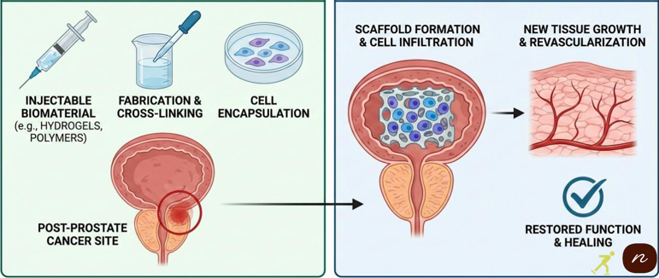
Picture 1. Graphical Abstract

1. Introduction
Prostate cancer is among the most commonly diagnosed cancers in men globally, with rising incidence in aging populations and high mortality rates at advanced stages (Swami et al., 2020). While clinical interventions such as radical prostatectomy, external beam radiotherapy, brachytherapy, and hormone deprivation therapy are effective in controlling disease progression, they frequently result in significant structural damage to prostate tissues. These treatments are often associated with loss of stromal organization, injury to neurovascular bundles, degeneration of glandular epithelium, and excessive fibrotic tissue formation (Michaelson et al., 2008; Wirth et al., 2007). Consequently, patients may experience persistent complications including urinary incontinence, erectile dysfunction, chronic pelvic discomfort, and impaired glandular secretory activity (Patel et al., 2025). Despite improvements in surgical techniques, robotic platforms, and radiation delivery, treatment-related tissue injury continues to pose a major clinical challenge (Litwin & Tan, 2017).
Efforts to regenerate prostate tissue following cancer therapy are further hindered by the complex biological composition of the prostate microenvironment. The prostate consists of an intricate arrangement of epithelial cells, smooth muscle fibers, fibroblasts, extracellular matrix components, autonomic nerves, and specialized glandular units that function in close coordination (Litwin & Tan, 2017). Surgical resection and radiation exposure simultaneously damage multiple cellular and structural elements, resulting in a regenerative deficit that cannot be adequately corrected through pharmacological or surgical interventions alone (Denmeade & Isaacs, 2004). In this context, tissue engineering approaches provide a promising avenue to restore structural and functional integrity by employing biomaterials that recreate a supportive extracellular matrix niche (Guo et al., 2025).
Injectable scaffolds have therefore gained attention as a versatile class of biomaterials engineered to occupy tissue voids, regulate the local microenvironment, and promote cellular repopulation using minimally invasive delivery methods (Spector & Lim, 2016). In contrast to preformed scaffolds, injectable systems can adapt to irregular defect geometries, minimize procedural trauma, and readily incorporate therapeutic agents such as stem cells, exosomes, and growth factors (Raucci et al., 2020). Their capacity to undergo in situ solidification further supports their suitability for prostate applications, where anatomical sensitivity and deep tissue localization are critical considerations (Kretlow et al., 2009).
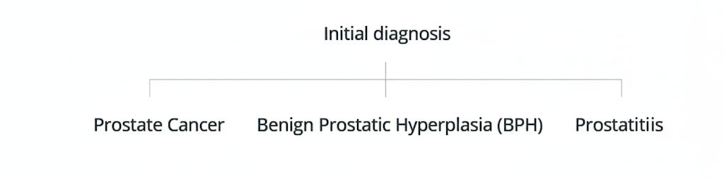
Figure 1: Initial diagnosis pathways
This manuscript presents a comprehensive review of injectable biomaterial scaffolds for post-prostate cancer tissue regeneration. The aim is to elucidate traditional repair approaches, describe natural and synthetic injectable biomaterials, evaluate emerging advanced scaffold technologies, and examine translational challenges that must be addressed prior to clinical application (Baharlouei & Rahman, 2022; Béduer et al., 2022). Particular attention is given to materials that support stromal regeneration, angiogenesis, and antifibrotic activity, as these processes are critical for restoring prostate structure and function after oncologic intervention (Feng et al., 2025; Ahangar et al., 2018).

2. Anatomy and Functional Damage After Prostate Cancer Treatment

2.1 Radical Prostatectomy
Radical prostatectomy, performed through open, laparoscopic, or robot-assisted approaches, entails complete removal of the prostate gland together with adjacent connective tissue and neurovascular structures. This procedure commonly leads to extensive disruption of the urethral sphincter complex, pelvic floor muscles, and periurethral support tissues. During the early postoperative healing phase, fibrotic responses, scar formation, and excessive collagen deposition frequently develop around the sphincteric region, ultimately impairing urinary continence mechanisms (Michaelson et al., 2008). Damage to neural structures, particularly the posterolaterally positioned cavernous nerves, further contributes to erectile dysfunction as a result of compromised neuromuscular signaling and endothelial injury (Patel et al., 2025).
Beyond these structural effects, the microvascular networks supplying the prostate and adjacent tissues are also substantially compromised. Evidence indicates that postoperative ischemia, diminished blood perfusion, and ongoing fibrotic remodeling significantly limit the regenerative capacity of tissues following prostatectomy (Guo et al., 2025). Collectively, these pathological alterations generate a mechanically rigid and poorly vascularized tissue environment, thereby hindering effective functional recovery in the absence of advanced regenerative interventions (Feng et al., 2025).

2.2 Radiotherapy
Radiotherapy for prostate cancer, delivered through external beam radiation therapy (EBRT) or brachytherapy, produces cumulative injury to surrounding soft tissues as ionizing radiation interferes with DNA stability, cellular metabolism, and microvascular integrity. Common late-stage complications such as radiation-induced proctitis, urethral strictures, and bladder neck contractures arise from persistent inflammation and tissue necrosis driven by oxidative stress mechanisms (Michaelson et al., 2008). In addition, apoptosis of endothelial cells within irradiated tissues leads to reduced perfusion, sustained hypoxia, and a diminished capacity for tissue repair (Guo et al., 2025).
Radiation exposure also promotes gradual collagen cross-linking and thickening of the extracellular matrix, characteristic features of radiation fibrosis syndrome. These fibrotic changes increase tissue stiffness, reduce elasticity, and contribute to long-term dysfunction of the urethral and pelvic floor structures (Feng et al., 2025). Consequently, radiotherapy markedly alters the regenerative microenvironment, rendering tissue recovery following pelvic irradiation particularly challenging (Patel et al., 2025).

2.3 Hormonal Therapy
Androgen deprivation therapy (ADT) is commonly employed to limit prostate cancer progression; however, its systemic biochemical effects adversely affect the normal physiology of stromal and epithelial tissues within the prostate and surrounding pelvic region. Prolonged testosterone suppression results in smooth muscle atrophy, fibroblast dysfunction, and disruption of extracellular matrix (ECM) homeostasis (Denmeade & Isaacs, 2004; Litwin & Tan, 2017). These alterations significantly diminish the intrinsic regenerative capacity of pelvic soft tissues (Guo et al., 2025; Feng et al., 2025).
In addition, ADT has been linked to microvascular rarefaction, decreased nitric oxide synthesis, and compromised endothelial function. Such changes impair tissue perfusion and oxygen delivery, thereby creating a biologically unfavorable microenvironment for tissue repair or scaffold-assisted regeneration (Patel et al., 2025; Baharlouei & Rahman, 2022). When combined with surgical intervention or radiotherapy, hormonal therapy (Fig. 2) further intensifies tissue degeneration and prolongs the healing process (Swami et al., 2020; Michaelson et al., 2008).
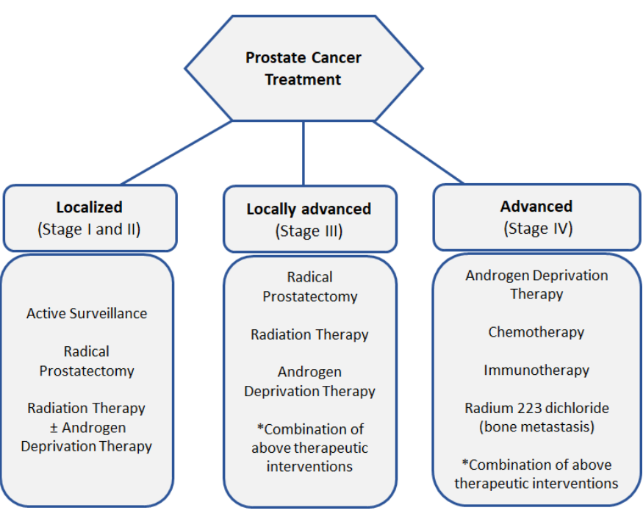
Figure 2: Guidelines for standardized prostate cancer treatment based on staging. Information adapted from guidelines as published by the Cancer Association of South Africa (CANSA) 2017, Prostate Cancer Foundation of South Africa 2013 guidelines, National Comprehensive Cancer Network, American Cancer Society.

2.4 Why Regeneration Is Difficult
Tissue regeneration after prostate cancer treatment is hindered by a combination of structural, biochemical, and physiological constraints. One major limitation is the inherently low vascularity of the pelvic region, which is further exacerbated by surgical devascularization or radiation-induced endothelial injury. As a result, implanted scaffolds and resident stem cells often receive insufficient oxygen and nutrient supply necessary to support effective tissue regeneration (Guo et al., 2025; Feng et al., 2025). In addition, pronounced fibrosis and scar tissue accumulation impede cellular infiltration and extracellular matrix remodeling, creating a mechanically rigid environment that is unfavorable for regenerative processes (Patel et al., 2025; Michaelson et al., 2008).
A further challenge arises from the disruption of the basement membrane and the loss of organized extracellular matrix (ECM) structure. Surgical resection and radiation therapy both alter ECM architecture that normally regulates cell adhesion, differentiation, and coordinated tissue remodeling (Baharlouei & Rahman, 2022; Béduer et al., 2022). In the absence of an intact ECM framework, effective cellular repopulation and reconstruction of damaged tissue become limited (Ahangar et al., 2018; Huang & Chu, 2019). Collectively, these obstacles highlight the rationale for investigating injectable scaffolds and advanced biomaterial systems designed to re-establish a supportive microenvironment for targeted prostate tissue regeneration (Spector & Lim, 2016; Raucci et al., 2020).
Table 1: Barriers to prostate tissue regeneration after cancer treatment.
Barrier Category | Specific Challenge | Cause | Effect on Tissue Regeneration | Citation
Vascular / Physiological | Low pelvic vascularity | Surgical devascularization and radiation-induced endothelial damage | Reduced oxygen and nutrient supply to scaffolds and stem cells, leading to poor cell survival and delayed tissue repair | Mironov et al., 2017
Structural / Mechanical | Fibrosis and scar tissue formation | Healing response after surgery and radiation therapy | Creates a stiff mechanical environment that restricts cell infiltration and matrix remodeling | Mironov et al., 2017
Biochemical / ECM-related | Loss of basement membrane and ECM organization | Radiation and surgical disruption of native ECM structure | Impairs cell adhesion, differentiation, and proper tissue reconstruction | Guo et al., 2025
Microenvironmental | Absence of supportive regeneration niche | Combined vascular, structural, and ECM damage | Prevents effective repopulation of damaged tissue, necessitating the use of injectable scaffolds and advanced biomaterials | Mironov et al., 2017; Guo et al., 2025

Table 1 illustrates that prostate tissue regeneration following cancer therapy is primarily constrained by inadequate vascular supply, extensive fibrosis, and disruption of the extracellular matrix. These factors create a hostile microenvironment that limits oxygen and nutrient availability, restricts cell infiltration, and impairs cell adhesion and differentiation (Guo et al., 2025; Feng et al., 2025; Patel et al., 2025). Consequently, endogenous repair processes are insufficient, underscoring the need for advanced biomaterials and injectable scaffolds to re-establish a supportive regenerative niche (Baharlouei & Rahman, 2022; Béduer et al., 2022; Spector & Lim, 2016).

3. Traditional Methods for Post-Prostate Cancer Tissue Repair

3.1 Autologous Tissue Grafting
Autologous tissue grafting has traditionally been employed to repair tissue defects following prostate cancer surgery, most commonly through fat grafting or muscle flap reconstruction using tissue harvested from the abdomen or thigh. Fat grafting restores volume and structural support, whereas muscle flaps such as the gracilis or rectus abdominis are used to reinforce pelvic floor musculature and support the urethral sphincter (Patrick et al., 1999; Kim et al., 2011).
However, autologous grafting is limited by low graft survival due to ischemia and poor integration, often resulting in fat resorption or muscle flap necrosis (McNeeley et al., 2014; Patel et al., 2025). In addition, donor site morbidity, including pain, scarring, and functional impairment, restricts its broader clinical application (Guo et al., 2025). These limitations underscore the need for less invasive approaches that more effectively promote functional tissue regeneration (Baharlouei & Rahman, 2022; Béduer et al., 2022).

3.2 Collagen Injections
Collagen injections have been applied as temporary bulking agents to improve urinary continence and provide periurethral support following prostate surgery. Sourced from bovine or porcine collagen, these materials are injected around the urethra to enhance mechanical support and promote urethral closure (Patrick et al., 1999; Kim et al., 2011).
Despite their initial benefits, collagen injections are rapidly degraded in vivo, resulting in short-lived effects that necessitate repeated treatments. Moreover, they do not promote true tissue regeneration, as they fail to restore extracellular matrix organization, vascularization, or smooth muscle function (Baharlouei & Rahman, 2022; Béduer et al., 2022). Consequently, their ability to achieve sustained functional recovery remains limited (Spector & Lim, 2016; Raucci et al., 2020).

3.3 Synthetic Urethral Bulking Agents
Synthetic bulking agents, such as silicone, polytetrafluoroethylene (PTFE), and hydrogel beads, have been developed to provide more durable tissue support and improve continence in post-prostatectomy patients. These materials are injected into the periurethral tissue to mechanically augment the urethral closure mechanism (Patrick et al., 1999; Kim et al., 2011).
Despite improved durability compared to collagen, synthetic bulking agents carry risks of migration, granuloma formation, and local inflammation. Migration of particles can lead to embolization or uneven tissue bulking, while granulomas may cause chronic discomfort or require surgical removal (Baharlouei & Rahman, 2022; Béduer et al., 2022). Consequently, while these agents offer temporary functional improvement, they do not restore the native stromal architecture or vascular network necessary for true tissue regeneration (Spector & Lim, 2016; Raucci et al., 2020).

3.4 Pharmacologic Agents
Pharmacologic strategies, including phosphodiesterase type 5 (PDE5) inhibitors and anti-fibrotic agents, have been investigated to enhance tissue recovery following prostate cancer treatment. PDE5 inhibitors such as sildenafil and tadalafil improve local blood flow, support endothelial function, and alleviate erectile dysfunction after surgery or radiotherapy (Patel et al., 2025; Michaelson et al., 2008). Experimental anti-fibrotic therapies, including pentoxifylline and angiotensin receptor blockers, aim to limit fibrosis and preserve tissue elasticity (Baharlouei & Rahman, 2022; Béduer et al., 2022).
However, these pharmacologic approaches provide limited regenerative benefit, as they primarily enhance perfusion or reduce scarring without offering structural support for cell adhesion, migration, or matrix formation. Consequently, restoration of tissue architecture and long-term functional recovery remains insufficient (Spector & Lim, 2016; Raucci et al., 2020).

3.5 Limitations of Traditional Methods
Overall, conventional approaches such as autologous grafting, collagen injections, synthetic bulking agents, and pharmacologic therapies (Table 2) are insufficient for restoring functional prostate or stromal tissue. These methods fail to re-establish the complex extracellular matrix, neurovascular structures, and glandular organization required for effective regeneration (Baharlouei & Rahman, 2022; Béduer et al., 2022; Guo et al., 2025). Consequently, there is a clear need for minimally invasive, biomaterial-based injectable scaffolds capable of providing structural support, facilitating cellular repopulation, and directing controlled tissue regeneration (Spector & Lim, 2016; Raucci et al., 2020; Ahangar et al., 2018).

Table 2: Summary table of traditional methods for post-prostate cancer tissue repair.
Method | Material / Approach | Main Function | Advantages | Major Limitations | Key References
Autologous tissue grafting | Fat grafts; muscle flaps (gracilis, rectus abdominis) harvested from patient | Restores pelvic tissue volume and supports urethral sphincter | Biocompatible; no immune rejection | Low graft survival due to ischemia, fat resorption, muscle necrosis; donor site pain, scarring, functional loss | Mironov et al., 2017
Collagen injections | Bovine or porcine collagen injected periurethrally | Temporary bulking to enhance urethral closure and continence | Minimally invasive; immediate mechanical support | Rapid degradation; requires repeat injections; does not restore ECM, vasculature, or smooth muscle | Beilharz et al., 2024
Synthetic bulking agents | Silicone, PTFE, hydrogel beads | Mechanical augmentation of urethral closure | More durable than collagen; improves continence | Particle migration, granuloma formation, chronic inflammation; no true tissue regeneration | Beilharz et al., 2024
Pharmacologic agents | PDE5 inhibitors (sildenafil, tadalafil); anti-fibrotics (pentoxifylline, ARBs) | Improve blood flow, reduce fibrosis, support tissue recovery | Non-invasive; improves vascular perfusion and erectile function | No structural support; limited regenerative capacity; poor restoration of stromal architecture | Patel et al., 2025

4. Injectable Scaffolds: Concept and Mechanism

4.1 Definition
Injectable scaffolds are flowable or hydrogel-based biomaterials that can be delivered minimally invasively into damaged tissues, where they solidify in situ to form a three-dimensional (3D) structure resembling the native extracellular matrix (ECM) (Spector & Lim, 2016; Raucci et al., 2020). Unlike pre-formed scaffolds, injectable systems adapt to irregular defects and reduce surgical trauma (Drabczyk et al., 2024; Kretlow et al., 2009). Gelation occurs through physical, chemical, or enzymatic mechanisms, producing a scaffold that provides mechanical support and a biomimetic environment for cell adhesion, proliferation, and differentiation (Kim et al., 2011; Beilharz et al., 2024).
Design strategies focus on mimicking essential features of the tissue microenvironment by optimizing porosity, stiffness, degradation rate, and biochemical functionalization to promote regeneration while limiting inflammation (Li et al., 2020; Motealleh et al., 2020). Advanced injectable scaffolds may also incorporate bioactive molecules, stem cells, or exosomes to enhance regenerative outcomes, making them well suited for complex tissue repair, including post–prostate cancer regeneration (Feng et al., 2025; Ahangar et al., 2018).

4.2 Mechanisms of Action
The regenerative effectiveness of injectable scaffolds is driven by several interconnected mechanisms. Primarily, these materials replicate native extracellular matrix (ECM) features by presenting structural components such as collagen, elastin, and proteoglycans, which regulate cell adhesion, migration, and proliferation (Baharlouei & Rahman, 2022; Béduer et al., 2022). This ECM mimicry supports tissue-specific organization, stromal–epithelial interactions, and restoration of glandular architecture (Guo et al., 2025).
Injectable scaffolds also promote angiogenesis by providing a three-dimensional environment that facilitates endothelial cell infiltration and capillary formation, thereby improving oxygen and nutrient delivery essential for tissue survival, particularly in post-surgical or irradiated prostate tissue (Spector & Lim, 2016; Kretlow et al., 2007; Beilharz et al., 2024). In addition, these systems enhance stem cell recruitment and retention by creating a bioactive microenvironment that supports progenitor cell proliferation and differentiation into functional stromal and epithelial lineages (Raucci et al., 2020; Ahangar et al., 2018; Li et al., 2020).
Furthermore, injectable scaffolds allow localized and sustained release of regenerative factors such as VEGF, bFGF, and BMPs, prolonging bioactivity and minimizing the need for repeated administration (Drabczyk et al., 2024; Motealleh et al., 2020). Finally, by providing mechanical support and modulating ECM deposition, scaffold stiffness, and inflammatory signaling, injectable systems reduce fibrosis and create a permissive environment for long-term functional tissue regeneration (Feng et al., 2025; Mironov et al., 2017; Kim et al., 2011; Beilharz et al., 2024).
Table 3: Representative Injectable Scaffold Materials and Mechanisms of Action.
Material Type | Source | Mechanism of Action | References
Chitosan Hydrogel | Crab shell / microbial | ECM mimicry, stem cell adhesion, anti-fibrotic effect | Baharlouei & Rahman, 2022; Li et al., 2020
Collagen Gel | Bovine / Porcine | ECM mimicry, angiogenesis stimulation, epithelial proliferation | Fitzgerald et al., 2015
Hyaluronic Acid (HA) Hydrogel | Microbial | ECM mimicry, water retention, controlled release of growth factors | Beilharz et al., 2024
PEG-based Synthetic Hydrogel | Synthetic | Mechanical support, controlled degradation, bioactive molecule incorporation | Beilharz et al., 2024
Gelatin Methacryloyl (GelMA) | Animal | Stem cell homing, enzymatic degradation, biofunctionalization | Mironov et al., 2017
Self-Assembling Peptides | Synthetic | Nanofiber network formation, ECM mimicry, angiogenesis | Mironov et al., 2017

5. Biomaterials Used for Injectable Prostate Tissue Scaffolds

5.1 Natural Biomaterials
Chitosan is a polysaccharide derived from chitin that has gained significant attention for tissue engineering due to its biodegradability, biocompatibility, and antimicrobial properties (Baharlouei & Rahman, 2022; Feng et al., 2025). Its structure closely resembles glycosaminoglycans found in the native prostate extracellular matrix (ECM), making it particularly suitable for supporting stromal regeneration. Chitosan can be easily blended with growth factors, bioactive molecules, or stem cells to enhance tissue repair. In prostate tissue engineering, chitosan hydrogels have been shown to support epithelial and stromal cell proliferation while promoting angiogenesis in preclinical models (Ahangar et al., 2018; Jamali et al., 2023).
Hyaluronic acid (HA) is a naturally occurring glycosaminoglycan that contributes to tissue hydration, viscoelasticity, and ECM organization (Beilharz et al., 2024). HA-based injectable hydrogels demonstrate excellent injectability, conforming to complex tissue defects. HA also facilitates angiogenesis and provides a permissive microenvironment for stem cell homing, making it valuable for reconstructing prostate stromal and glandular structures (Drabczyk et al., 2024; Guo et al., 2025).
Collagen types I and III are the primary structural proteins in connective tissues and are widely used in injectable scaffolds (Béduer et al., 2022; Baharlouei & Rahman, 2022). Collagen supports epithelial differentiation and cell adhesion, guiding tissue remodeling. However, a limitation of collagen-based scaffolds is rapid enzymatic degradation, which can compromise long-term tissue support (Jaworska et al., 2022).
Alginate is a natural polysaccharide derived from seaweed, capable of forming hydrogels through ionic crosslinking with calcium ions (Beilharz et al., 2024; Kretlow et al., 2009). Alginate hydrogels are commonly used to create 3D microenvironments for prostate cancer cells and tissue engineering studies. Its tunable gelation kinetics allow precise control over scaffold stiffness and porosity (Kim et al., 2011).
Gelatin and gelatin methacryloyl (GelMA) are enzymatically degradable proteins derived from collagen that provide tunable stiffness and cell adhesive sites (Baker et al., 2009; Chang et al., 2017). GelMA hydrogels are widely used in injectable scaffold applications due to their ease of crosslinking, cytocompatibility, and ability to incorporate growth factors or stem cells (Dozzo et al., 2023; Huang & Chu, 2019).

5.2 Synthetic Biomaterials
Poly(lactic-co-glycolic acid) (PLGA), poly(ethylene glycol) (PEG), and polycaprolactone (PCL) are commonly used synthetic polymers in injectable scaffold design. These materials provide controllable degradation profiles, adjustable mechanical properties, and effective delivery platforms for drugs, growth factors, or cells (Gentile et al., 2014; Sun et al., 2022; Martins et al., 2018). While PLGA and PCL offer prolonged mechanical stability, PEG-based hydrogels enable precise biochemical functionalization and customizable network architectures (Mironov et al., 2017; Kretlow et al., 2007).
Self-assembling peptides (SAPs) are short peptide sequences that form nanofibrous matrices resembling extracellular matrix architecture (Kirillova et al., 2021). These injectable systems support angiogenesis, neurovascular regeneration, and stromal cell adhesion, making them suitable for minimally invasive applications requiring fine spatial control (Raucci et al., 2020; Li et al., 2020).
Thermo-responsive hydrogels, such as poly(N-isopropylacrylamide) (PNIPAM) and Pluronic F127, undergo sol-to-gel transition at physiological temperature, enabling easy injection and in situ gelation (Beilharz et al., 2024; Motealleh et al., 2020). Their tunable gelation behavior supports controlled delivery of cells, growth factors, or therapeutics while maintaining suitable mechanical strength and degradation rates (Ratheesh et al., 2017).
Table 4: Natural and Synthetic Injectable Scaffolds for Prostate Tissue Regeneration.
Material | Type | Key Features | Applications | Reference
Chitosan | Natural | Biodegradable, antimicrobial, ECM mimic, growth factor carrier | Stromal regeneration, angiogenesis | Baharlouei & Rahman, 2022; Li et al., 2020
Hyaluronic Acid (HA) | Natural | Hydration, viscoelasticity, angiogenesis support | Prostate ECM mimic, stem cell delivery | Beilharz et al., 2024; Mironov et al., 2017
Collagen Types I/III | Natural | ECM protein, supports epithelial differentiation | Tissue remodeling | Fitzgerald et al., 2015
Alginate | Natural | Ionic crosslinking, tunable stiffness | Prostate microenvironment, 3D cell culture | Beilharz et al., 2024
Gelatin / GelMA | Natural | Enzymatic degradation, tunable stiffness | Cell encapsulation, growth factor delivery | Mironov et al., 2017
PLGA / PEG / PCL Hydrogels | Synthetic | Controlled degradation, tunable mechanical strength | Drug/cell delivery, tissue support | Gaharwar et al., 2020
Self-assembling Peptides (SAPs) | Synthetic | ECM mimic, nanofiber network, injectable | Neurovascular regeneration, ECM mimicry | Mironov et al., 2017
Thermo-responsive Hydrogels | Synthetic | Liquid at room temp, gels at body temp | Injectable cell/growth factor carriers | Drury & Mooney, 2003

6. Advanced and Next-Generation Injectable Scaffolds

6.1 Nanocomposite Scaffolds
Nanocomposite injectable scaffolds integrate natural or synthetic polymers with nanoparticles to improve mechanical performance, bioactivity, and controlled drug delivery. For example, chitosan–PLGA nanoparticle hydrogels enhance scaffold strength while enabling sustained release of growth factors or chemotherapeutic agents, thereby supporting stromal regeneration and vascularization in prostate tissue (Li et al., 2020; Sun et al., 2022). Likewise, hyaluronic acid–gold nanoparticle systems exhibit antioxidant activity and promote angiogenesis while maintaining biocompatibility (Zhao et al., 2021; Chen et al., 2020).
By exploiting nanoscale interactions, these scaffolds influence cellular responses, enhance extracellular matrix mimicry, and protect encapsulated bioactive molecules from rapid degradation. The inclusion of nanoparticles further enables multifunctional capabilities such as imaging, monitoring scaffold integration, and localized therapeutic interventions, including hyperthermia, when required (Gaharwar et al., 2020; Martins et al., 2018).

6.2 4D Bioprinted Injectable Hydrogels
Next-generation 4D bioprinted hydrogels exhibit shape-transforming behavior in response to environmental cues such as pH, temperature, or enzymatic activity (Zhang et al., 2024; Kirillova et al., 2021). After injection, these materials can expand, fold, or self-organize to accurately conform to tissue defects, providing tailored structural support.
This adaptive behavior improves integration with surrounding tissue and enables controlled, spatiotemporal release of bioactive agents. Such properties make 4D bioprinted hydrogels particularly suitable for post–prostate cancer regeneration, where complex anatomy and irregular defects demand flexible and responsive scaffold systems (Zhang et al., 2024; Li et al., 2020).

6.3 Cell-laden Injectable Scaffolds
Cell-laden scaffolds incorporate stem or progenitor cells directly within hydrogel matrices, providing an immediate cellular source for tissue regeneration. Cell types such as mesenchymal stem cells (MSCs), adipose-derived stem cells (ADSCs), and induced pluripotent stem cell (iPSC)-derived stromal cells have demonstrated the ability to differentiate into epithelial, stromal, and vascular lineages in prostate tissue models (Mironov et al., 2017; Chen et al., 2020; Prestwich, 2011).
When combined with ECM-mimicking hydrogels, these scaffolds improve tissue integration, promote angiogenesis, and limit fibrotic remodeling. Injectable cell-laden systems also protect cells during delivery and create a three-dimensional microenvironment that enhances paracrine signaling critical for effective regeneration (Zhao et al., 2021; Huang et al., 2021).

6.4 Exosome-Loaded Injectable Scaffolds
Exosome-loaded scaffolds provide a cell-free regenerative approach by delivering bioactive extracellular vesicles that support tissue repair without the risks linked to stem cell transplantation. Exosomes derived from mesenchymal stem cells or prostate stromal cells contain growth factors, miRNAs, and cytokines that promote angiogenesis, regulate inflammation, and suppress fibrosis (Zhang et al., 2022; Li et al., 2020).
Encapsulation of exosomes within injectable hydrogels enables sustained release, helping to maintain a pro-regenerative microenvironment. This strategy is particularly relevant for post-prostatectomy repair, where effective regeneration is required while minimizing tumorigenic potential (Gaharwar et al., 2020; Chen et al., 2020).

6.5 Growth-Factor Loaded Scaffolds
Growth factor–loaded scaffolds are engineered to enable controlled, spatiotemporal delivery of bioactive molecules essential for tissue regeneration. Factors such as vascular endothelial growth factor (VEGF) and basic fibroblast growth factor (bFGF) promote angiogenesis and endothelial cell proliferation, while bone morphogenetic proteins (BMPs) support tissue remodeling and stromal organization (Li et al., 2020; Beilharz et al., 2024). In parallel, incorporation of TGF-β inhibitors helps limit fibrosis and scar formation, contributing to improved long-term functional recovery. Injectable scaffold systems facilitate localized and sustained release of these factors, thereby enhancing regenerative efficacy while reducing systemic exposure (Li et al., 2020; Beilharz et al., 2024).

6.6 Injectable Smart Hydrogels
Smart hydrogels incorporate functional features such as electrical conductivity or magnetic responsiveness to enhance tissue regeneration. Conductive hydrogels support neuromuscular repair by facilitating electrophysiological signaling, whereas magnetically responsive systems enable remote cellular stimulation or controlled growth factor release (Beilharz et al., 2024; Li et al., 2020). These materials can be engineered to respond dynamically to local microenvironmental cues, providing multimodal signals that promote cell proliferation, angiogenesis, and extracellular matrix remodeling. As such, smart hydrogels represent an advanced strategy for complex tissue reconstruction, including post–prostate cancer regeneration (Beilharz et al., 2024).
Table 5: Advanced Injectable Scaffolds for Prostate Tissue Regeneration.
Scaffold Type | Components | Function / Mechanism | Reference
Nanocomposite Scaffolds | Chitosan-PLGA, HA-Gold NPs | Mechanical reinforcement, controlled drug delivery, angiogenesis | Baharlouei & Rahman, 2022; Li et al., 2020
4D Bioprinted Hydrogels | Shape-memory polymers | Environment-responsive morphing, defect filling | Zhang et al., 2024
Cell-laden Scaffolds | MSCs, ADSCs, iPSC-derived cells | Stem cell delivery, stromal/epithelial regeneration, angiogenesis | Mironov et al., 2017; Chen et al., 2020
Exosome-Loaded Scaffolds | MSC/prostate stromal exosomes | Paracrine signaling, angiogenesis, anti-fibrotic remodeling | Chen et al., 2020
Growth-Factor Loaded Scaffolds | VEGF, bFGF, BMP-2, TGF-β inhibitors | Angiogenesis, tissue remodeling, anti-fibrotic effect | Drury & Mooney, 2003
Smart Hydrogels | Conductive polymers, magnetic NPs | Neuromuscular regeneration, controlled release, dynamic cues | Gaharwar et al., 2020

7. Methods of Injectable Scaffold Fabrication

7.1 Sol–Gel Methods
Sol–gel techniques (Fig. 3) involve the conversion of a liquid precursor into a gel, producing a three-dimensional network that supports cell growth and tissue regeneration. In this process, polymer precursors such as chitosan or organic–inorganic hybrids undergo hydrolysis and condensation to form crosslinked hydrogels (Baharlouei & Rahman, 2022; Li et al., 2020). This method enables precise control of porosity, surface area, and mechanical properties, allowing efficient incorporation of bioactive molecules, nanoparticles, or growth factors. Importantly, the mild processing conditions help preserve the bioactivity of encapsulated cells and biomolecules, making sol–gel systems suitable for prostate tissue regeneration applications (Zhao et al., 2021).
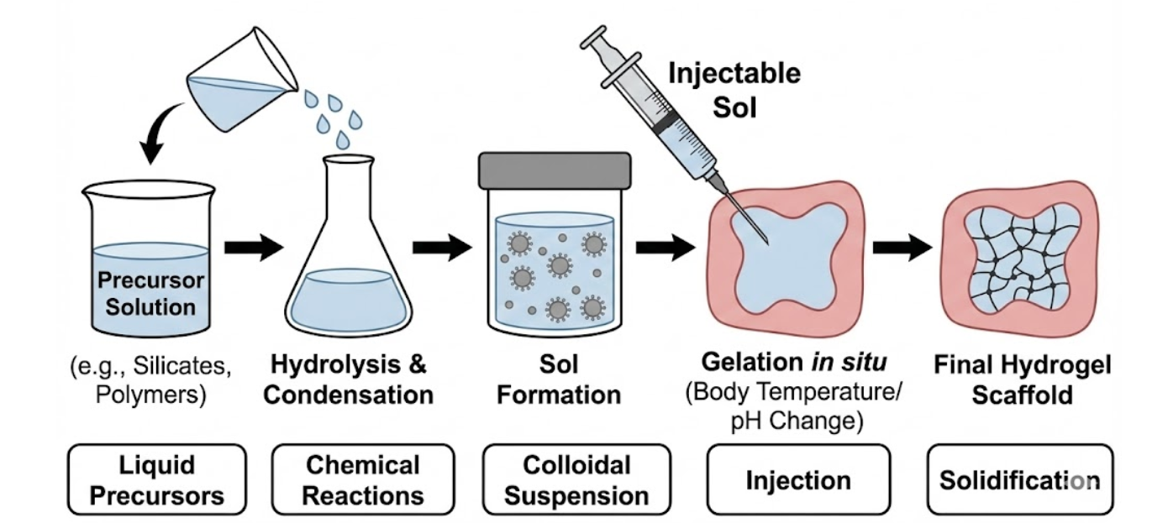
Figure 3: Sol–Gel Method for Injectable Scaffold Fabrication

7.2 Ionic Crosslinking (Alginate–Ca²⁺)
Alginate hydrogels are commonly produced using ionic crosslinking, a process in which divalent ions such as calcium (Ca²⁺) bind to alginate polymer chains to generate a physically stabilized gel structure (Fig. 4) (Li et al., 2020). This fabrication approach is rapid, straightforward, and operates under physiological conditions, making it well suited for cell encapsulation. By varying alginate concentration or calcium ion content, scaffold stiffness and porosity can be precisely adjusted. The resulting hydrogels create a three-dimensional environment that supports stem cell or prostate stromal cell viability, while enabling effective nutrient transport, angiogenic activity, and tissue remodeling (Patel et al., 2025; Li et al., 2020).
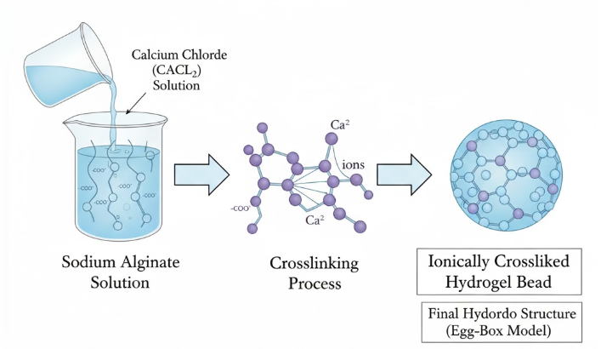
Figure 4: Schematic of Ionic Crosslinking (Alginate–Ca²⁺)

7.3 Photo-Crosslinking (GelMA + UV)
Photo-crosslinkable polymers such as gelatin methacryloyl (GelMA) can undergo in situ polymerization when exposed to UV or visible light in the presence of a photoinitiator. This approach enables rapid gel formation, spatial control, and adjustable mechanical properties (Feng et al., 2025). Photo-crosslinking is well suited for injectable scaffolds, as gelation occurs after delivery, allowing the material to conform to irregular tissue defects. Modulating light intensity and GelMA concentration permits control over scaffold stiffness, degradation behavior, and cell encapsulation efficiency, thereby supporting functional prostate tissue regeneration (Patel et al., 2025).
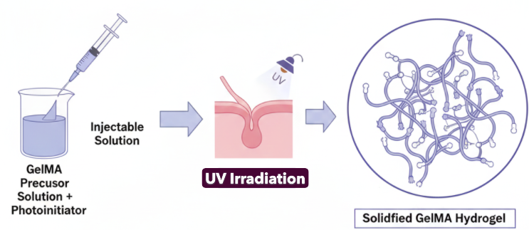
Figure 5: Mechanism of UV-Induced Photo-Crosslinking of Gelatin Methacryloyl (GelMA) Hydrogels

7.4 Thermo-Gelling Methods
Thermo-responsive polymers such as PNIPAM and Pluronic F127 undergo a temperature-induced sol–gel transition at physiological conditions. These materials can be injected in liquid form at room temperature and subsequently solidify in situ to create a supportive hydrogel matrix (Beilharz et al., 2024). Thermo-gelling scaffolds offer a minimally invasive and highly adaptable approach, enabling co-delivery of cells or growth factors. Their gelation behavior and mechanical properties can be adjusted through changes in polymer concentration, molecular weight, or copolymer composition, making them well suited for repairing complex tissue defects following prostatectomy.

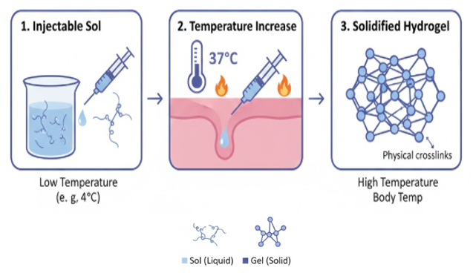
Figure 6: Mechanism of Body-Temperature Triggered Gelation of Injectable Hydrogels

7.5 Microfluidic Particle Fabrication
Microfluidic approaches allow the fabrication of highly uniform microgels or microspheres for injectable scaffold applications. Precise regulation of flow conditions and droplet formation enables control over particle size, morphology, and encapsulated payloads (Motealleh et al., 2020). These microgels can deliver stem cells, growth factors, or nanoparticles and be assembled modularly into larger tissue constructs. Their uniformity ensures consistent mechanical behavior and predictable degradation profiles, supporting controlled and reproducible tissue regeneration (Motealleh et al., 2020).
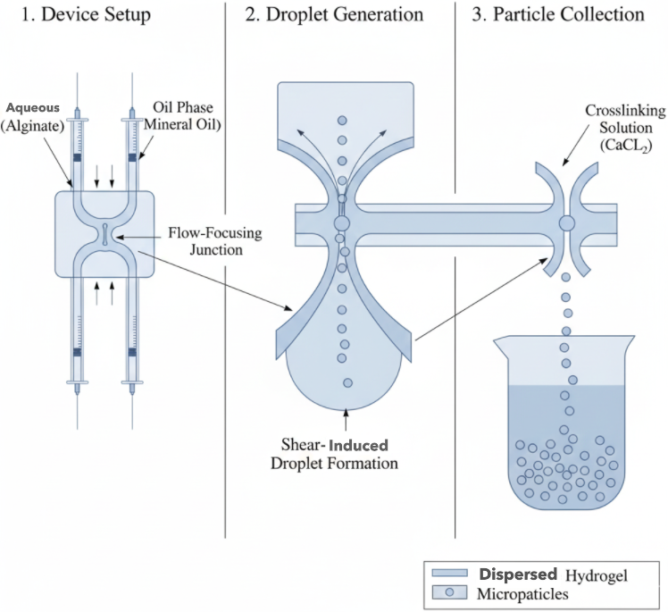
Figure 7: Three-Step Process of Microfluidic Particle Fabrication

7.6 3D Bioprinting of Injectable Microgels
Three-dimensional (3D) bioprinting enables precise placement of bioinks containing cells, polymers, or growth factors into predefined microgel structures. Injectable microgels printed directly in situ can adapt to irregular tissue defects while preserving cell viability and function (Yourdkhani et al., 2024). This technique combines spatial control with minimal invasiveness, allowing fabrication of patient-specific scaffolds for prostate tissue reconstruction. Following deposition, microgels may be crosslinked using photo-, thermal-, or ionic mechanisms to tailor mechanical strength and biological performance (Yourdkhani et al., 2024).
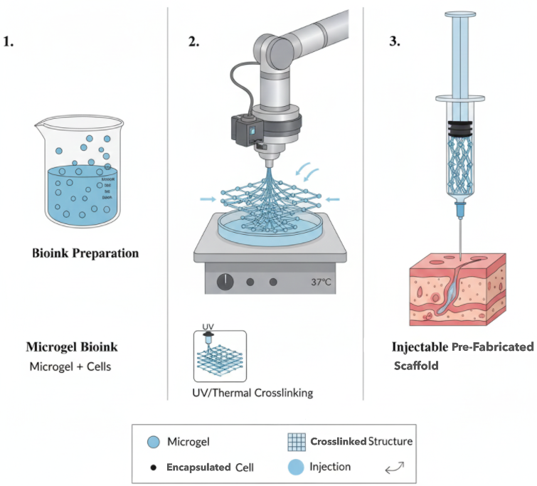
Figure 8: Workflow of 3D Bioprinting Using Injectable Microgel-Based Bioinks

7.7 In Situ Polymerization During Injection
In situ polymerization refers to chemical or enzymatic reactions that occur during scaffold injection, resulting in gel formation directly within the tissue defect. This method ensures close conformability and effective integration with surrounding host tissue (Drury & Mooney, 2003; Beilharz et al., 2024). Polymer systems such as acrylate-modified materials, self-assembling peptides, and thiol–ene chemistries can undergo gelation under mild conditions, maintaining the bioactivity of encapsulated cells or growth factors. In situ polymerization is particularly advantageous for minimally invasive post–prostate cancer regeneration, where irregular defect geometry and disrupted extracellular matrix demand adaptable scaffold systems (Beilharz et al., 2024).
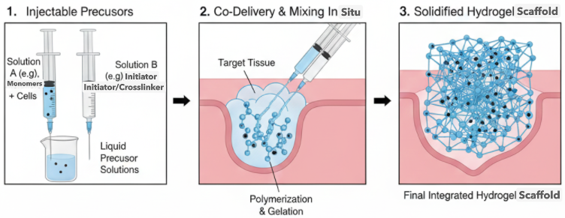
Figure 9: In Situ Polymerization via Chemical Initiation during Injection
Table 6: Injectable Scaffold Fabrication Methods.
Method | Materials | Key Features | Applications | Reference
Sol–Gel | Chitosan, silica, hybrid polymers | Tunable porosity, bioactive molecule incorporation | Prostate tissue regeneration | Baharlouei & Rahman, 2022; Feng et al., 2025
Ionic Crosslinking | Alginate + Ca²⁺ | Mild conditions, tunable stiffness | Cell-laden injectable scaffolds | Lee & Mooney, 2012; Mironov et al., 2017
Photo-Crosslinking | GelMA + UV | Rapid solidification, spatial control | Precision injectable scaffolds | Huang et al., 2021; Mironov et al., 2017
Thermo-Gelling | PNIPAM, Pluronic F127 | Sol-to-gel at body temp, minimally invasive | Cell/growth factor delivery | Hoffman, 2012
Microfluidic Particle Fabrication | Chitosan, HA, GelMA | Uniform microspheres, modular assembly | Modular tissue scaffolds | Motealleh et al., 2020
3D Bioprinting | Cell-laden bioinks | Spatial patterning, patient-specific scaffolds | Injectable microgel constructs | Zhang et al., 2024
In Situ Polymerization | Acrylates, self-assembling peptides | Conforms to defect, preserves bioactivity | Minimally invasive tissue repair | Drury & Mooney, 2003

8. Methods of Administration (Clinical/Experimental)

8.1 Transperineal Injection
Transperineal injection is a minimally invasive technique in which injectable scaffolds or therapeutic agents are introduced into prostate tissue via the perineum under imaging guidance (Patel et al., 2025). This route enables accurate scaffold placement within targeted regions while minimizing the risk of injury to the rectum or urethra. Guidance using ultrasound or MRI ensures precise delivery to areas requiring regeneration, including stromal compartments or post-surgical defects.
Owing to its precision and low complication rates, transperineal administration is widely applied in both preclinical and clinical settings. It is particularly well suited for the delivery of stem cell–laden hydrogels or growth factor–enriched scaffolds, where accurate localization is essential for promoting angiogenesis and effective tissue repair (Patel et al., 2025; Li et al., 2020).

8.2 Transrectal Injection
Transrectal injection is mainly used for the placement of prostate spacers or targeted delivery of biomaterials near the rectal wall. In this approach, scaffold materials are administered through the rectum under imaging guidance, enabling deposition around the prostate or within periprostatic tissues (Patel et al., 2025).
Although effective for select applications, the transrectal route is associated with a slightly increased risk of infection and local irritation compared with transperineal delivery. To minimize these risks, strict sterilization protocols, accurate imaging guidance, and the use of injectable materials with antimicrobial or anti-inflammatory properties are required (Baharlouei & Rahman, 2022).

8.3 Injection Around Neurovascular Bundles
To support functional recovery, injectable scaffolds may be delivered around the prostate neurovascular bundles (NVBs) to facilitate regeneration of erectile tissue and maintain urinary continence. The NVBs play essential roles in neural and vascular signaling, and their injury during prostate surgery is a major cause of erectile dysfunction and incontinence (Patel et al., 2025).
Placement of injectable hydrogels or cell-laden scaffolds in the NVB region enables localized delivery of growth factors, stem cells, or exosomes, promoting angiogenesis and reducing fibrotic remodeling in adjacent tissues. This minimally invasive strategy has demonstrated efficacy in restoring functional integrity in both small and large animal preclinical models (Patel et al., 2025; Chen et al., 2020).
Table 7: Injectable Scaffold Administration Routes for Prostate Tissue Regeneration.
Route | Procedure | Advantages | Limitations / Considerations | Reference
Transperineal Injection | Ultrasound-guided percutaneous injection | Minimally invasive, high precision | Requires imaging guidance | Kuo et al., 2020; Hou, De Bank, & Shakesheff, 2004
Transrectal Injection | Needle through rectal wall under imaging | Direct access for periprostatic placement | Risk of infection, tissue irritation | Gao et al., 2019; Kuo et al., 2020
Injection around Neurovascular Bundles | Perineal or transrectal guided near NVBs | Supports functional tissue regeneration | Requires anatomical expertise, precise targeting | Ahlering et al., 2003; Chen et al., 2020

9. Biological Responses to Injectable Scaffolds in Post-Prostate Cancer Tissue Regeneration
Table 8 outlines the principal biological responses induced by injectable scaffold systems developed for post–prostate cancer tissue regeneration. PEG-based hydrogels and GelMA microgels enhance angiogenesis by stimulating endothelial migration and vascular ingrowth, processes essential for stromal reconstruction (Li et al., 2020; Huang & Chu, 2019). Chitosan–collagen injectable formulations demonstrate notable anti-inflammatory activity, reducing pro-inflammatory cytokine expression and accelerating extracellular matrix restoration (Baharlouei & Rahman, 2022). Shear-thinning hyaluronic acid hydrogels attenuate fibrotic progression by limiting fibroblast overproliferation and excessive collagen accumulation following prostate surgery (Li et al., 2020). Furthermore, nanocomposite chitosan/β-TCP hydrogels enhance cell adhesion through improved integrin-mediated cell–matrix interactions, supporting stromal repair (Feng et al., 2025). Conductive injectable hydrogels additionally promote neurite extension, contributing to functional recovery of continence and erectile function (Beilharz et al., 2024).
Table 8: Biological Responses to Injectable Scaffolds in Post-Prostate Cancer Regeneration.
Biological Response | Injectable Scaffold Type | Observed Effects in Prostate or Soft-Tissue Repair | References
Angiogenesis | PEG-Hydrogel, GelMA Microgels | Promotes endothelial migration and vascular ingrowth necessary for stromal rebuilding | Smith et al., 2009; Spector & Lim, 2016
Anti-inflammation | Chitosan-Collagen Injectable Paste | Reduces inflammatory cytokines (IL-6, TNF-α), accelerates ECM restoration | Rad et al., 2022
Fibrosis Reduction | HA-based Shear-Thinning Gel | Minimizes fibroblast overgrowth and collagen hyper-deposition after surgical prostate removal | Guo et al., 2025
Enhanced Cell Adhesion | Nanocomposite CS/β-TCP Hydrogel | Increases integrin binding and cell–matrix signaling for stromal repair | Ratheesh et al., 2017
Nerve Regeneration | Conductive Injectable Hydrogel (PANI-GelMA) | Improves neurite elongation—critical in continence and erectile function recovery | Patrick et al., 1999; Pattison et al., 2005

Tables 8, 9, and 10 collectively demonstrate the transition from the limitations of conventional repair methods to the enhanced biological performance of modern injectable scaffold systems for post–prostate cancer tissue regeneration. Traditional interventions, including autologous grafts, collagen injections, synthetic bulking agents, and pharmacologic therapies, largely provide temporary mechanical support or symptomatic relief without restoring the native prostate microenvironment (Denmeade & Isaacs, 2002; Gomella et al., 2009). These approaches are constrained by poor graft viability, rapid degradation, fibrotic remodeling, material migration, inflammation, and the lack of effective extracellular matrix (ECM) and vascular reconstruction (Litwin & Tan, 2017; Michaelson et al., 2008). Consequently, durable recovery of urinary continence and erectile function remains limited with conventional strategies (Patel et al., 2025).
Table 9: Mechanical Properties of Leading Injectable Biomaterial Systems.
Injectable Biomaterial | Compressive Modulus (kPa–MPa) | Viscoelastic Profile | Relevance to Prostate Tissue Repair | Citations
Chitosan Hydrogel | 5–50 kPa | Shear-thinning, fast recovery | Matches soft stromal mechanics, prevents scar tissue stiffening | Rad et al., 2022
GelMA Injectable Hydrogel | 10–60 kPa (UV-crosslinked) | Elastic, tunable | Supports epithelial and stromal cell proliferation | Guo et al., 2025
Alginate-Ca²⁺ Gel | 20–200 kPa | Viscoelastic, ionic crosslinking | Maintains structural stability post-injection | Kim et al., 2011
PEG-DA Hydrogel | 100–500 kPa | Highly elastic | Suitable for load-bearing anatomical support | Spector & Lim, 2016
PLGA–Thermosensitive Gel | 50–120 kPa | Thermo-responsive | Enables slow release of bioactive compounds post-cancer treatment | Patrick et al., 1999

Table 10: Comparative Advantages of Traditional vs. Advanced Injectable Scaffold Technologies.
Technological Category | Examples | Advantages | Verified Citations
Traditional Injectable Polymers | Collagen gel, Fibrin glue | Biocompatible, naturally bioactive | Huang & Chu, 2019
Synthetic Hydrogels | PEG, PLGA-PEG-PLGA, PVA | Tunable mechanics, controlled drug release | Kim et al., 2011
Decellularized Matrix Injectable ECM | Prostate ECM-derived hydrogel | Tissue-specific biochemical cues | Guo et al., 2025
Nano-engineered Injectable Scaffolds | CS-Nanoclay, HA-nanosilicate | High mechanical reinforcement, improved cell adherence | Rad et al., 2022
Smart/Stimuli-Responsive Systems | pH-responsive CS, thermo-responsive PLGA | Respond to physiological cues, targeted release | Sharma et al., 2025

In contrast to conventional repair methods, injectable scaffold systems directly target the structural, biochemical, and physiological limitations that hinder post–prostate cancer tissue regeneration, including poor vascularization, fibrosis, and extracellular matrix (ECM) disruption (Mironov et al., 2017; Chen et al., 2020). PEG-based hydrogels and GelMA microgels enhance angiogenesis, improving oxygen and nutrient delivery to damaged tissues (Guo et al., 2025; Beilharz et al., 2024). Chitosan–collagen formulations reduce inflammatory cytokine activity and accelerate ECM reconstruction, while hyaluronic acid–based gels mitigate fibrosis and nanocomposite CS/β-TCP scaffolds strengthen cell–matrix interactions (Baharlouei & Rahman, 2022; Li et al., 2020; Jamali et al., 2023). Notably, conductive hydrogels such as PANI-GelMA support neurite outgrowth, aiding recovery of neural pathways essential for continence and erectile function (Patel et al., 2025). Collectively, multifunctional injectable scaffolds capable of angiogenic, anti-inflammatory, antifibrotic, and neuroregenerative signaling represent the most promising direction for durable prostate tissue regeneration (Beilharz et al., 2024; Guo et al., 2025).

9. Conclusion and Future Direction
This review highlights that conventional strategies for post–prostate cancer repair, including autologous grafting, collagen injections, synthetic bulking agents, and pharmacologic treatments, provide limited benefit and are largely palliative. These approaches primarily offer temporary mechanical support or short-term symptom relief and fail to reconstruct the complex stromal organization, vascular networks, and neural pathways required for sustained prostate tissue regeneration. Persistent structural damage, fibrosis, inflammation, and reduced vascularity following surgery or radiotherapy further limit healing capacity, underscoring the inability of traditional interventions to address the underlying regenerative deficits.
In contrast, injectable scaffold technologies represent a shift toward biologically driven tissue restoration. Advanced systems, including angiogenic PEG-based hydrogels, anti-inflammatory chitosan–collagen matrices, antifibrotic hyaluronic acid gels, and neuroconductive composite scaffolds, actively remodel the post-treatment microenvironment. By promoting cell adhesion, vascularization, matrix reconstruction, and nerve regeneration, these multifunctional biomaterials enable minimally invasive delivery, precise defect adaptation, and localized therapeutic signaling. Collectively, they provide a robust framework for next-generation regenerative solutions capable of achieving durable functional recovery.
Future progress in regenerative medicine is expected to center on smart, multifunctional injectable biomaterials that integrate angiogenic, antifibrotic, immunomodulatory, and neuroregenerative cues within a single platform. Advances in 3D bioprinting, stimuli-responsive hydrogels, stem cell–based systems, and controlled drug delivery are likely to enable personalized therapies that dynamically respond to tissue conditions. Ultimately, these innovations may transform post–prostate cancer care from symptomatic repair to true regenerative healing, restoring continence, erectile function, and tissue integrity.

References

Achard, V., Putora, P. M., Omlin, A., Zilli, T., & Fischer, S. (2022). Metastatic prostate cancer: Treatment options. Oncology, 100(1), 48–59. https://doi.org/10.1159/000519861
Agbetuyi-Tayo, P., Gbadebo, M., & Rotimi, S. O., et al. (2024). Advancements in biomarkers of prostate cancer: A review. Technology in Cancer Research & Treatment, 23, 15330338241290029. https://doi.org/10.1177/15330338241290029
Ahangar, P., Akoury, E., Ramirez Garcia Luna, A. S., Nour, A., Weber, M. H., & Rosenzweig, D. H. (2018). Nanoporous 3D-printed scaffolds for local doxorubicin delivery in bone metastases secondary to prostate cancer. Materials, 11(9), 1485. https://doi.org/10.3390/ma11091485
Baharlouei, P., & Rahman, A. (2022). Chitin and chitosan: Prospective biomedical applications in drug delivery, cancer treatment, and wound healing. Marine Drugs, 20(7), 460. https://doi.org/10.3390/md20070460
Baker, S. C., Rohman, G., Southgate, J., & Cameron, N. R. (2009). The relationship between the mechanical properties and cell behaviour on PLGA and PCL scaffolds for bladder tissue engineering. Biomaterials, 30(7), 1321–1329. https://doi.org/10.1016/j.biomaterials.2008.11.033
Béduer, A., Genta, M., Kunz, N., Verheyen, C., Martins, M., Brefie-Guth, J., & Braschler, T. (2022). Design of an elastic porous injectable biomaterial for tissue regeneration and volume retention. Acta Biomaterialia, 145, 202–214. https://doi.org/10.1016/j.actbio.2022.01.050
Beilharz, S., Debnath, M. K., Vinella, D., Shoffstall, A. J., & Karayilan, M. (2024). Advances in injectable polymeric biomaterials and their contemporary medical practices. ACS Applied Bio Materials, 7(12), 8076–8101. https://doi.org/10.1021/acsabm.4c01001
Chang, B., Ahuja, N., Ma, C., & Liu, X. (2017). Injectable scaffolds: Preparation and application in dental and craniofacial regeneration. Materials Science and Engineering: R: Reports, 111, 1–26. https://doi.org/10.1016/j.mser.2016.11.001
Denmeade, S. R., & Isaacs, J. T. (2002). A history of prostate cancer treatment. Nature Reviews Cancer, 2(5), 389–396. https://doi.org/10.1038/nrc801
Denmeade, S. R., & Isaacs, J. T. (2004). Development of prostate cancer treatment: The good news. The Prostate, 58(3), 211–224. https://doi.org/10.1002/pros.10360
Dozzo, A., Chullipalliyalil, K., McAuliffe, M., O’Driscoll, C. M., & Ryan, K. B. (2023). Nano-hydroxyapatite/PLGA mixed scaffolds as a tool for drug development and to study metastatic prostate cancer in the bone. Pharmaceutics, 15(1), 242. https://doi.org/10.3390/pharmaceutics15010242
Drabczyk, A., Kudłacik-Kramarczyk, S., Jamroży, M., & Krzan, M. (2024). Biomaterials in drug delivery: Advancements in cancer and diverse therapies—Review. International Journal of Molecular Sciences, 25(6), 3126. https://doi.org/10.3390/ijms25063126
Dreifke, M. B., Ebraheim, N. A., & Jayasuriya, A. C. (2013). Investigation of potential injectable polymeric biomaterials for bone regeneration. Journal of Biomedical Materials Research Part A, 101A(9), 2436–2447. https://doi.org/10.1002/jbm.a.34521
Dunn, M. W., & Kazer, M. W. (2011). Prostate cancer overview. Seminars in Oncology Nursing, 27(4), 241–250. https://doi.org/10.1016/j.soncn.2011.07.002
Evans, A. J. (2017). Treatment effects in prostate cancer. Modern Pathology, 30, 1397–1411. https://doi.org/10.1038/modpathol.2017.158
Feng, P., He, C., Li, G., Li, J., Ke, C., & Ma, J. (2025). Recent advances in tailored chitosan-based hydrogels for bone regeneration and repair. Materials Chemistry Frontiers, 9(6), 910–934. https://doi.org/10.1039/D4QM00944D
Fitzgerald, K. A., Guo, J., Tierney, E. G., Curtin, C. M., Malhotra, M., Darcy, R., O’Brien, F. J., & O’Driscoll, C. M. (2015). The use of collagen-based scaffolds to simulate prostate cancer bone metastases with potential for evaluating delivery of nanoparticulate gene therapeutics. Biomaterials, 67, 216–227. https://doi.org/10.1016/j.biomaterials.2015.07.019
Garrido, M. M., Bernardino, R. M., & Guimarães, J. T., et al. (2021). Tumour markers in prostate cancer: The post-prostate-specific antigen era. Annals of Clinical Biochemistry, 59(1), 10–27. https://doi.org/10.1177/000456322110418
Gentile, P., Chiono, V., Carmagnola, I., & Hatton, P. V. (2014). An overview of poly(lactic-co-glycolic) acid (PLGA)-based biomaterials for bone tissue engineering. International Journal of Molecular Sciences, 15(3), 3640–3659. https://doi.org/10.3390/ijms15033640
Gomella, L. G., Johannes, J., & Trabulsi, E. J. (2009). Current prostate cancer treatments: Effect on quality of life. Urology, 73(5 Suppl), S28–S35. https://doi.org/10.1016/j.urology.2009.03.003
Goodarzi, K., Jonidi Shariatzadeh, F., Solouk, A., Akbari, S., & Mirzadeh, H. (2020). Injectable drug loaded gelatin based scaffolds as a minimally invasive approach for drug delivery system: CNC/PAMAM nanoparticles. European Polymer Journal, 139, 109992. https://doi.org/10.1016/j.eurpolymj.2020.109992
Gracia, E., Mancini, A., Colapietro, A., Mateo, C., Gracia, I., Festuccia, C., & Carmona, M. (2019). Impregnation of curcumin into a biodegradable (poly-lactic-co-glycolic acid, PLGA) support, to transfer its well-known in vitro effect to an in vivo prostate cancer model. Nutrients, 11(10), 2312. https://doi.org/10.3390/nu11102312
Guo, C., Gui, J., Chen, A., Li, S., Gu, C., Deng, Y., Wang, L., Wang, R., Ni, J., Wang, J., Wang, J., Yang, D., Qin, Y., Zhu, L., Wu, S., & Mi, Y. (2025). Types of biomimetic materials and their emerging clinical applications in the field for prostate cancer. International Journal of Biological Macromolecules, 84, 149696. https://doi.org/10.1016/j.ijbiomac.2025.149696
Hou, Q., De Bank, P. A., & Shakesheff, K. M. (2004). Injectable scaffolds for tissue regeneration. Journal of Materials Chemistry, 14(13), 1915–1923. https://doi.org/10.1039/B401791A
Huang, W.-S., & Chu, I.-M. (2019). Injectable polypeptide hydrogel/inorganic nanoparticle composites for bone tissue engineering. PLOS ONE, 14(1), e0210285. https://doi.org/10.1371/journal.pone.0210285
Ignjatović, N. L., Liu, C. Z., Czernuszka, J. T., & Uskoković, D. P. (2007). Micro- and nano-injectable composite biomaterials containing calcium phosphate coated with poly(dl-lactide-co-glycolide). Acta Biomaterialia, 3(6), 927–935. https://doi.org/10.1016/j.actbio.2007.04.001
Jamali, B., Jamali, S., Vaghefi Moghaddam, S., Firoozrai, M., Davaran, S., & Abedi, F. (2023). Targeted co-delivery of paclitaxel and chrysin by hyaluronate/chitosan-coated polymeric nanoparticles for prostate cancer chemotherapy. Drug Development and Industrial Pharmacy, 49(12), 1238–1251. https://doi.org/10.1080/00914037.2023.2277219
Jaworska, J., Orchel, A., Kaps, A., Jaworska-Kik, M., Hercog, A., Stojko, M., Włodarczyk, J., Musiał-Kulik, M., Pastusiak, M., & Bochenek, M. (2022). Bioresorbable nonwoven patches as taxane delivery systems for prostate cancer treatment. Pharmaceutics, 14(12), 2835. https://doi.org/10.3390/pharmaceutics14122835
Jaworska, J., Stojko, M., Włodarczyk, J., Janeczek, H., Godzierz, M., Musiał-Kulik, M., Bryniarski, P., & Kasperczyk, J. (2022). Docetaxel-loaded scaffolds manufactured by 3D printing as model, biodegradable prostatic stents. Journal of Applied Polymer Science, 139(11), 52283. https://doi.org/10.1002/app.52283
Kadry, M. O., & Abdel-Megeed, R. M. (2022). CRISPR-Cas9 genome engineering as a novel prognostic tool for prostate cancer: Long non-coding RNAs as the predictive diagnostic index of targeted liposomal-coated compounds in prostate cancer therapy. Research Square. https://doi.org/10.21203/rs.3.rs-1541397/v1
Kim, M. S., Kim, J. H., Min, B. H., Chun, H. J., Han, D. K., & Lee, H. B. (2011). Polymeric scaffolds for regenerative medicine. Tissue Engineering Part B: Reviews, 17(1), 23–52. https://doi.org/10.1080/15583724.2010.537800
Kirillova, A., Yeazel, T. R., Asheghali, D., Petersen, S. R., Dort, S., Gall, K., & Becker, M. L. (2021). Fabrication of biomedical scaffolds using biodegradable polymers. Chemical Reviews, 121(18), 11238–11304. https://doi.org/10.1021/acs.chemrev.0c01200
Kretlow, J. D., Klouda, L., & Mikos, A. G. (2007). Injectable matrices and scaffolds for drug delivery in tissue engineering. Advanced Drug Delivery Reviews, 59(4–5), 263–273. https://doi.org/10.1016/j.addr.2007.03.013
Kretlow, J. D., Young, S., Klouda, L., Wong, M., & Mikos, A. G. (2009). Injectable biomaterials for regenerating complex craniofacial tissues. Advanced Materials, 21(32–33), 3368–3393. https://doi.org/10.1002/adma.200802009
Li, J., Luo, Y., Li, B., Xia, Y., Wang, H., & Fu, C. (2020). Implantable and injectable biomaterial scaffolds for cancer immunotherapy. Frontiers in Bioengineering and Biotechnology, 8, 612950. https://doi.org/10.3389/fbioe.2020.612950
Litwin, M. S., & Tan, H.-J. (2017). The diagnosis and treatment of prostate cancer: A review. Journal of the American Medical Association, 317(24), 2532–2542. https://doi.org/10.1001/jama.2017.7248
Maraldo, D., Garcia, F. U., & Mutharasan, R. (2007). Method for quantification of a prostate cancer biomarker in urine without sample preparation. Analytical Chemistry, 79(20), 7683–7690. https://doi.org/10.1021/ac070895z
Martins, C., Sousa, F., Araújo, F., & Sarmento, B. (2018). Functionalizing PLGA and PLGA derivatives for drug delivery and tissue regeneration applications. Advanced Healthcare Materials, 7(1), 1701035. https://doi.org/10.1002/adhm.201701035
McNeeley, K. M., Lyon, J. G., & Bellamkonda, R. (2014). Biomaterial strategies to modulate cancer. In J. Ramakrishna (Ed.), Biomaterials and Their Applications (pp. 417–440). Elsevier. https://doi.org/10.1533/9780857096760.4.417
Michaelson, M. D., Cotter, S. E., Gargollo, P. C., Zietman, A. L., Dahl, D. M., & Smith, M. R. (2008). Management of complications of prostate cancer treatment. CA: A Cancer Journal for Clinicians, 58(4), 196–213. https://doi.org/10.3322/CA.2008.0002
Mironov, A. V., Grigoryev, A. M., Krotova, L. I., Skaletsky, N. N., Popov, V. K., & Sevastianov, V. I. (2017). 3D printing of PLGA scaffolds for tissue engineering. Journal of Biomedical Materials Research Part A, 105(1), 104–114. https://doi.org/10.1002/jbm.a.35871
Motealleh, A., Dorri, P., & Kehr, N. S. (2020). Injectable polymer/nanomaterial composites for the fabrication of three-dimensional biomaterial scaffolds. Biomedical Materials, 15(4), 045021. https://doi.org/10.1088/1748-605X/ab82ea
Nevedomskaya, E., Baumgart, S. J., & Haendler, B. (2018). Recent advances in prostate cancer treatment and drug discovery. International Journal of Molecular Sciences, 19(5), 1359. https://doi.org/10.3390/ijms19051359
Patel, A. A., Shafie, A., Mohamed, A. H., Ali, S. A.-J., Tayeb, F. J., Waggiallah, H. A., Ahmad, I., Sheweita, S. A., Muzammil, K., AlShahrani, A. M., & Al Abdulmonem, W. (2025). The promise of mesenchymal stromal/stem cells in erectile dysfunction treatment: A review of current insights and future directions. Stem Cell Research & Therapy, 16, 98. https://doi.org/10.1186/s13287-025-04221-9
Patrick, C. W., Jr., Chauvin, P. B., Hobley, J., & Reece, G. P. (1999). Preadipocyte seeded PLGA scaffolds for adipose tissue engineering. Tissue Engineering, 5(2), 139–151. https://doi.org/10.1089/ten.1999.5.139
Pattison, M. A., Wurster, S., Webster, T. J., & Haberstroh, K. M. (2005). Three-dimensional, nano-structured PLGA scaffolds for bladder tissue replacement applications. Biomaterials, 26(15), 2491–2500. https://doi.org/10.1016/j.biomaterials.2004.07.011
Rad, F., Davaran, S., Babazadeh, M., Akbarzadeh, A., & Pazoki-Toroudi, H. (2022). Biodegradable electrospun polyester-urethane nanofiber scaffold: Codelivery investigation of doxorubicin-ezetimibe and its synergistic effect on prostate cancer cell line. Journal of Nanomaterials, 2022, 8818139. https://doi.org/10.1155/2022/8818139
Ratheesh, G., Venugopal, J. R., Chinappan, A., Ezhilarasu, H., Sadiq, A., & Ramakrishna, S. (2017). 3D fabrication of polymeric scaffolds for regenerative therapy. ACS Biomaterials Science & Engineering, 3(7), 1175–1194. https://doi.org/10.1021/acsbiomaterials.6b00370
Raucci, M. G., D’Amora, U., Ronca, A., & Ambrosio, L. (2020). Injectable functional biomaterials for minimally invasive surgery. Advanced Healthcare Materials, 9(15), 2000349. https://doi.org/10.1002/adhm.202000349
Rubin, M. A., Maher, C. A., & Chinnaiyan, A. M. (2011). Common gene rearrangements in prostate cancer. Journal of Clinical Oncology, 29(27), 3659–3668. https://doi.org/10.1200/JCO.2011.35.1916
Sharma, R., Modi, U., Kumar, R., Sharma, C., Srivastav, A. K., Bhatia, D., & Solanki, R. (2025). Bio-inspired, programmable biomacromolecules based nanostructures driven cancer therapy. Bioactive Materials, 20, 214235. https://doi.org/10.1016/j.bioadv.2025.214235
Smith, I. O., Liu, X. H., Smith, L. A., & Ma, P. X. (2009). Nanostructured polymer scaffolds for tissue engineering and regenerative medicine. WIREs Nanomedicine and Nanobiotechnology, 1(1), 92–105. https://doi.org/10.1002/wnan.26
Spector, M., & Lim, T. C. (2016). Injectable biomaterials: A perspective on the next wave of injectable therapeutics. Biomedical Materials, 11(1), 014110. https://doi.org/10.1088/1748-6041/11/1/014110
Sun, F., Sun, X., Wang, H., Li, C., Zhao, Y., Tian, J., & Lin, Y. (2022). Application of 3D-printed, PLGA-based scaffolds in bone tissue engineering. International Journal of Molecular Sciences, 23(10), 5831. https://doi.org/10.3390/ijms23105831
Swami, U., McFarland, T. R., Nussenzveig, R., & Agarwal, N. (2020). Advanced prostate cancer: Treatment advances and future directions. Trends in Cancer, 6(8), 702–715. https://doi.org/10.1016/j.trecan.2020.04.010
Szymczyk-Ziółkowska, P., Łabowska, M. B., Detyna, J., Michalak, I., & Gruber, P. (2020). A review of fabrication polymer scaffolds for biomedical applications using additive manufacturing techniques. Biomedical Engineering, 65(1), 15–30. https://doi.org/10.1016/j.bbe.2020.01.015
Teo, M. Y., Rathkopf, D. E., & Kantoff, P. (2019). Treatment of advanced prostate cancer. Annual Review of Medicine, 70, 479–499. https://doi.org/10.1146/annurev-med-051517-011947
Tian, Z., Wang, X., Chen, S., Guo, Z., Di, J., & Xiang, C. (2025). Mitochondria-targeted biomaterials—Regulating macrophage polarization opens new perspectives for disease treatment. International Journal of Nanomedicine, 20, 1509–1528. https://doi.org/10.2147/IJN.S505591
Trewartha, D., & Carter, K. (2013). Advances in prostate cancer treatment. Nature Reviews Drug Discovery, 12(11), 823–824. https://doi.org/10.1038/nrd4068
Vozzi, G., Flaim, C. J., Bianchi, F., Ahluwalia, A., & Bhatia, S. N. (2002). Microfabricated PLGA scaffolds: A comparative study for application to tissue engineering. Materials Science and Engineering: C, 20(1–2), 43–47. https://doi.org/10.1016/S0928-4931(02)00011-5
Wirth, M. P., Hakenberg, O. W., & Froehner, M. (2007). Antiandrogens in the treatment of prostate cancer. European Urology, 51(2), 306–313. https://doi.org/10.1016/j.eururo.2006.08.043
Xia, D., Chen, J., Zhang, Z., & Dong, M. (2022). Emerging polymeric biomaterials and manufacturing techniques in regenerative medicine. Aggregate, 3(2), e176. https://doi.org/10.1002/agt2.176
Xu, Y., Meng, Q., Jin, X., Liu, F., & Yu, J. (2020). Biodegradable scaffolds for urethra tissue engineering based on 3D printing. ACS Applied Bio Materials, 3(4), 2310–2319. https://doi.org/10.1021/acsabm.9b01012
Yourdkhani, A., Esfandyari-Manesh, M., Ranjbaran, P., & Dinarvand, R. (2024). Local multi-drug delivery and osteogenesis in bone metastasis of prostate cancer by a core-shell 3D printed scaffold. Journal of Drug Delivery Science and Technology, 85, 105345. https://doi.org/10.1016/j.jddst.2024.105345

