Review Article

Next Generation Smart Textiles: An Emerging Microbiome-Based Strategy for Skin Health and Wound Management

.
ABSTRACT

Background: Next-generation smart textiles represent an advanced class of fabric-based systems designed to actively support skin health and wound management. Unlike conventional textiles and passive wound dressings, these materials integrate sensing elements, responsive biomaterials, and embedded technologies that enable continuous monitoring of key parameters such as temperature, pH, moisture, pressure, and biochemical indicators. This real-time feedback allows early detection of infection, accurate assessment of healing progression, and adaptive therapeutic responses, particularly in the management of chronic and complex wounds. A key aspect of these smart textiles is the incorporation of microorganisms and microbe-derived materials. Components such as bacterial cellulose, probiotic systems, fungal mycelium, and microbial enzymes provide biocompatibility, high moisture retention, antimicrobial activity, and environmental sustainability. These biologically active elements interact with the skin microenvironment and microbiome, supporting barrier integrity, immune regulation, and infection control while reducing dependence on conventional chemical treatments. The development of smart textiles relies on advanced materials and fabrication strategies, including conductive fibers, nanomaterials, responsive polymers, and textile-compatible electronics. Techniques such as weaving and knitting with conductive yarns, surface coating, printing, and additive manufacturing enable the integration of sensors, energy systems, and communication modules without compromising comfort and flexibility. Applications extend beyond wound dressings to wearable platforms for skin protection, pressure ulcer prevention, remote health monitoring, and telemedicine-supported care. Despite their significant potential, challenges remain related to durability, washability, energy management, cost, data security, and environmental impact. Ongoing research is focused on creating multifunctional, self-powered, and personalized smart textile systems, with emerging interest in artificial intelligence integration and living microbial interfaces.
Conclusion:These advances position smart textiles as transformative tools for improving skin health outcomes and modern wound care.
Keywords: Artificial intelligence; Emerging biotechnology; Skin microbiome; Smart textiles; Public Health; Wound management

1. INTRODUCTION

Textiles are integral to human life and skin health, with widespread applications in clothing, protection, and medical care (Ma et al., 2024). Traditional textiles are mainly produced from natural fibers such as cotton, wool, and silk, which offer comfort and breathability but possess limited functional capabilities. Advances in materials science have led to modern textiles with enhanced features, including ultraviolet (UV) protection, moisture management, and antimicrobial properties, aimed at improving comfort, safety, and health (Zhi et al., 2023; Xia et al., 2024). The integration of flexible electronics has further driven the evolution of smart textiles, enabling fabrics to incorporate sensing and therapeutic functions (Wu et al., 2025).
Smart textiles include innovations such as electronic skin (e-skin), intelligent garments, and smart wound dressings, all of which provide functionalities far beyond those of conventional fabrics. These systems can continuously monitor physiological parameters such as temperature, heart rate, humidity, and skin-related biomarkers (Yang et al., 2024; Zhang et al., 2024; Zhi et al., 2024). In wound care, smart dressings can assess healing through measurements of pH, moisture, and temperature and, in advanced designs, respond to inflammation or tissue regeneration by releasing therapeutic agents to accelerate repair (Jiang et al., 2023; Kaewpradub et al., 2024; Kim et al., 2024; Li et al., 2025). These capabilities support personalized medicine and long-term management of chronic conditions, contributing to the rapid growth of the global smart textile market (Bothare, 2024).
The development of smart textiles for skin health and wound management requires an in-depth understanding of the skin microenvironment, particularly the skin microbiome. This diverse microbial community exists in a symbiotic relationship with the host and plays essential roles in maintaining barrier integrity, immune regulation, and disease prevention (Bay et al., 2022; Kashaf et al., 2022; Larson et al., 2022; Liu et al., 2023; Tchoupa et al., 2023). Disruption of microbial balance is linked to skin disorders such as atopic dermatitis, which is associated with reduced microbial diversity and over colonization by Staphylococcus aureus (Jo et al., 2021; Masiuk et al., 2021; Lu & Stappenbeck, 2022; Liu et al., 2025). Emerging microbiome-based therapies highlight the importance of maintaining microbial homeostasis in skin-focused technologies (Thyssen et al., 2020; Nakatsuji et al., 2021; Bieber, 2022).
Microorganisms are increasingly recognized as key components of next-generation smart textiles. As living matrices, they enable innovative approaches to textile substrates, biosensing, therapeutic delivery, and bioenergy harvesting (Wu et al., 2025). Microbial materials such as bacterial cellulose offer flexibility, biocompatibility, and biodegradability suitable for wearable applications (Hua et al., 2021; Manan et al., 2022). In addition, microorganisms and their metabolites support non-invasive biosensing through analysis of sweat and other biofluids, while certain species can utilize skin-derived compounds as energy sources, enabling self-powered
smart textile systems (Keasling et al., 2021; Sempionatto et al., 2022; Garland et al., 2023; Brasier et al., 2024). This review highlights the concept of smart textiles, the microbiology in smart textiles, materials, structural design and fabrication methods for smart textiles, applications of smart textiles for skin health and wound management, next-generation smart textiles and enabling technologies for the integration of functional microorganisms, advanced technologies for next-generation smart textiles, challenges and future perspectives for smart wound textiles.

2.1 Smart Textiles and Advanced Wound Dressing
Wound healing is a complex biological process that often requires more than traditional passive dressings, which primarily serve to cover and protect injuries but lack the ability to interact with or respond to changing wound conditions (Li et al., 2023). As the understanding of wound microenvironments has advanced, researchers have developed advanced and smart wound dressings that actively sense physiological indicators such as pH, temperature, moisture, oxygen, and biochemical markers and can adjust therapeutic outputs accordingly. These responsive systems aim to overcome the limitations of conventional dressings by enabling real-time assessment and adaptive treatment to accelerate healing and reduce complications like infection and chronic inflammation (Li et al., 2023). Smart wound dressings are engineered using stimuli-responsive biomaterials and integrated sensing technologies that detect changes in wound biomarkers and trigger targeted actions. For instance, pH-sensitive or temperature-responsive materials can signal infection, while integrated biosensors can track healing progression continuously rather than relying on intermittent clinical observations (Li et al., 2023). Some systems combine these capabilities with controlled drug delivery, enabling on-demand release of antimicrobials, growth factors, or anti-inflammatory agents in response to specific wound cues (Liu & Ge, 2025).
The emergence of smart textiles has further expanded the functionality of wound care materials. Smart textiles embed flexible electronic components, biosensors, and advanced biomaterials into fabric substrates that conform to the body and maintain mechanical comfort (Niculescu & Grumezescu, 2022). These textiles enable continuous, non-invasive monitoring of wound environments and can integrate wireless communication for remote data transmission, supporting personalized patient care. Moreover, textile-based dressings can be designed with nanofiber scaffolds that mimic the extracellular matrix, promoting cell migration, moisture balance, and gas exchange; key factors in effective wound healing (Niculescu & Grumezescu, 2022).
Next-generation smart wound dressings are increasingly incorporating electrospun nanofibers, flexible sensors, and responsive drug release mechanisms to create multifunctional platforms that go beyond simple coverage to diagnose, monitor, and treat wounds simultaneously. These innovations reflect a broader shift toward integrating materials science, wearable electronics, and biomarker sensing in wound care, enhancing the precision and effectiveness of therapeutic interventions (Palani et al., 2025).
Despite these advances, challenges remain in translating smart dressings and textiles into widespread clinical use, including ensuring long-term biocompatibility, sensor reliability in complex wound environments, manufacturing scalability, and regulatory approval. Ongoing research continues to address these gaps, with the goal of creating all-in-one wound care systems that support real-time healing optimization and improve patient outcomes across acute and chronic wound scenarios (Liu & Ge, 2025).

3.1. Types of Microorganism Incorporated in Textiles
In the emerging field of smart textiles for skin health and wound management, microorganisms are increasingly incorporated either directly as living or functional biological components or indirectly through their metabolic products and biomaterials. These bio-integrated systems leverage the unique properties of microbes to add functionality beyond traditional antimicrobial finishing; moving toward interactive, responsive, and regenerative textile platforms (Fernandes et al., 2024).
One major category involves bacterial systems, particularly those that produce functional biopolymers. Bacterial cellulose is a prime example; produced by species such as Komagataeibacter sp., Gluconacetobacter xylinus and other cellulose-producing bacteria (Wu et al., 2025). This biopolymer forms a highly crystalline, nanofibrillar network with excellent water retention, mechanical strength, and biocompatibility, making it suitable for wound dressings and wearable substrates that mimic natural tissue environments (Fernandes et al., 2024). Bacterial cellulose has been studied extensively for its application in biomedical textiles, including wound healing and skin substitutes, and more recent work highlights its potential in biofabricated textile structures and composite materials for functional apparel and healthcare applications (Fernandes et al., 2024).
Beyond pure cellulose, probiotic bacteria have also been explored within textile matrices to confer active biological functionality. For instance, probiotic cellulose composites embedding Lactobacillus species maintain metabolic activity within the cellulose network and significantly inhibit pathogenic bacteria such as Staphylococcus aureus and Pseudomonas aeruginosa, which are common agents in wound infections (Sabio et al., 2021). This represents a move toward microbiome-responsive textile dressings that combine structural properties with active microbial defense mechanisms (Sabio et al., 2021).
In addition to bacterial products, fungal organisms and their derivatives contribute to bio-textile innovations. Filamentous fungi and their hyphal networks (mycelium) can be cultivated into dense, interwoven mats that form structured biocomposite materials with potential as biodegradable, renewable textile substrates due to their self-assembling growth and adaptability to different production conditions (Romero-Cedillo et al., 2025). Research has shown that mycelium can grow on textile fibres such as cotton and polyester, acting as a natural binder and creating lightweight biocomposites with mechanical integrity, suggesting new avenues for microbe-integrated textiles (Saini et al., 2023). More broadly, mycelium-based composites from filamentous fungi are widely explored as sustainable, degradable alternatives to conventional materials across product sectors, including textile applications (Cerimi et al., 2019). These capabilities position fungal mycelium as a promising biobased material for next-generation smart textile systems that align with circular economy and sustainability goals (Fraunhofer-Gesellschaft, 2024)
Although less common in therapeutic textiles, microorganisms used for enzymatic functions also play an important role in textile processing. Microbial cellulases, particularly those produced by the fungus Trichoderma reesei, are widely applied in textile finishing to modify fiber surfaces, improving fabric properties such as softness, surface smoothness, and colour brightness (Khan, 2025). These enzymes are central to processes like biopolishing and bio‑finishing, where they hydrolyze protruding cellulose microfibrils on natural‑fiber fabrics (e.g., cotton, linen, viscose), resulting in a smoother hand feel, reduced pilling, and enhanced brightness and moisture absorbency without harsh chemical treatments. This biological modification underscores an indirect but functionally significant role of microbial enzymes in enhancing textile performance and quality (Khan, 2025).
Also noteworthy are microbial communities engineered for additional functionalities, such as dye production or interactive responses in biodesign-inspired textiles (Wu et al., 2025). Recent work has shown how engineered co-cultures of bacteria can synthesize and deposit pigments into cellulose matrices, enabling textile colouration during fiber formation, and pointing toward future directions where living microbes could confer adaptive colours or biofeedback functions (Wakley, 2025).
Finally, while not themselves living components of finished textiles, microbe-derived compounds such as probiotics, enzymes, and biosurfactants are increasingly microencapsulated or chemically bonded within textile coatings to deliver targeted benefits like odour control, antimicrobial action, and enzymatic odour or waste breakdown (Lim et al., 2022). These strategies underscore the broad spectrum of microorganism-related elements, from living materials to bioactive metabolites that enrich smart textile functionality for skin health and wound management (Broadhead et al., 2021).

3.2. Materials and Structural Design for Smart Textiles
Smart textiles are engineered fabrics that integrate materials, structures, and embedded technologies to perform sensing, actuation, communication, and therapeutic functions beyond those of conventional textiles (Guennes et al., 2025). Unlike traditional fabrics, smart textiles are designed not just for coverage and comfort but to interact dynamically with the environment or the wearer, transforming physical or biochemical stimuli into measurable or adaptive responses. These capabilities arise from careful selection of materials and structural designs that support flexibility, durability, and multi-functionality while maintaining textile comfort and wearability (Guennes et al., 2025).
3.2.1 Materials
Smart textiles often incorporate conductive fibers, conductive polymers, nano-materials, natural polymers and composites that enable electrical pathways and sensing functions within fabrics. Conductive materials such as metal‑based filaments (e.g., silver, copper), carbon‑based materials (graphene, carbon nanotubes), natural polymers (e.g., collagen, cellulose, wool, silk etc), and inherently conductive polymers (polypynole, polyanicine) are used to form conductive yarns or coatings that support signal transmission, power distribution, and sensor integration without significantly compromising fabric flexibility (Guennes et al., 2025).
3.2.2 Structural design
The structural design of smart textiles encompasses multiple hierarchical levels; fibers, yarns, fabrics, and finished garments each contributing to the overall performance (Guennes et al., 2025). Conductive or functional components can be integrated at different stages of textile structuring, including fiber spinning, yarn extrusion, weaving, knitting, coating, printing, or embroidery, depending on the desired balance between functionality and textile properties. For instance, conductive threads may be woven or knitted into fabric to create flexible interconnects and sensor networks, while conductive inks can be printed onto surfaces to form patterned electronic circuits (Guennes et al., 2025).
Nanomaterials, such as carbon nanotubes and metal nanoparticles, enhance smart textile performance by providing improved electrical conductivity, mechanical strength, and multifunctional properties (e.g., thermal, optical, or biochemical sensing). These materials can be incorporated into fibers or applied as surface coatings, resulting in fabrics that are lightweight, stretchable, and capable of advanced sensing and actuation (Robaiyat, 2025).

In addition to conductive and nanostructured components, smart textiles may incorporate responsive materials such as hydrogels, shape‑memory polymers, and chromic materials that change properties in response to external stimuli (e.g., temperature, moisture, pH). Such materials allow textiles to adapt their structure or release therapeutic agents when specific conditions are detected, expanding functionality into areas like wound management and physiological regulation (Guennes et al., 2025).
The integration of miniaturized electronics; including sensors, actuators, microcontrollers, and power supplies into textile matrices requires careful design to ensure flexibility, washability, and reliability. These components may be embedded directly into fibers or attached to fabric surfaces through flexible interconnects, enabling continuous data acquisition and real‑time responses tailored to user or environmental conditions (Guennes et al., 2025).
Smart textile design reflects an interdisciplinary convergence of textile engineering, materials science, nanotechnology, and electronics, where strategic material choices and hierarchical structural design enable next‑generation wearable systems. These systems maintain the comfort and flexibility of traditional textiles while delivering advanced functionalities for health monitoring, therapeutic intervention, and personalized user experiences (Guennes et al., 2025).

3.3. Fabrication Methods for Smart Textiles
Fabrication of smart textiles involves integrating functional components and electronic capabilities into textile structures while preserving comfort, flexibility, and durability (Júnior et al., 2022). Traditional textile manufacturing processes are adapted and combined with advanced material deposition and integration methods to embed sensors, conductive pathways, energy devices, and functional coatings into fabrics for wearable applications such as health monitoring, communication, and therapeutic support. These methods can be broadly grouped into those applied during fiber pre-yarn production, during fabric formation, and as post‑processing treatments (Júnior et al., 2022).
i). One primary approach is the use of conductive and functional fibers and yarns produced with integrated conductive elements during fiber spinning or extrusion. Conductive yarns can be manufactured by incorporating metal filaments (e.g., silver‑coated fibers), carbon nanomaterials, or conductive polymers into conventional textile fibers, enabling electrical conductivity within the fabric structure. These conductive fibers serve as the backbone for embedded circuits and sensor networks and are often produced through specialized spinning or coating processes that ensure uniform conductivity while maintaining flexibility (Islam et al., 2025).
ii). Weaving and knitting are foundational textile fabrication techniques adapted for smart textiles by integrating conductive and functional yarns directly into fabric structures as they are formed. Weaving interlaces warp and weft yarns to generate textile surfaces capable of incorporating conductive paths, while knitting creates loops of yarn that can embed sensors and conductive elements throughout the textile’s architecture. These methods enable large‑area smart fabrics with distributed sensing and actuation capabilities embedded at the fiber level (Júnior et al., 2022).
iii). In addition to traditional fabric formation, surface coating and printing techniques are widely used to impart functionality onto finished textiles. Dip coating and spray coating deposit thin layers of conductive materials such as MXenes, conductive polymers (e.g., Poly(3,4-ethylenedioxythiophene):poly(styrenesulfonate)), or metal nanoparticles onto fabric surfaces, enabling high conductivity and multifunctionality (Dejene, 2025). Screen printing and inkjet printing of conductive inks allow for precise patterning of electronic circuits and sensor layouts directly on textiles, supporting scalable production of patterned smart textiles for sensing, data transmission, or energy harvesting (Dejene, 2025).
iv). Advanced fabrication strategies also include 3D printing and additive manufacturing directly onto textiles, producing freeform electronic components and interconnects on fabric surfaces with high spatial resolution. These techniques expand design flexibility and enable bespoke smart textile architectures that fulfill specific sensing, actuation, and electronic integration requirements (Dejene, 2025).
Post‑processing treatments such as plasma treatment and chemical finishing enhance adhesion between functional coatings and textile substrates or improve interfacial bonding for embedded electronic components. Meticulous finishing steps also ensure durability, washability, and mechanical stability of smart textile systems under real‑world use conditions (Júnior et al., 2022). Together, these fabrication techniques reflect the interdisciplinary nature of smart textile development, blending traditional textile science with advanced materials engineering and electronics integration to produce wearable systems with enhanced functionality for personalized health, sensing, and adaptive responses.

3.4. Some Skin-Related Smart Textiles, Components and their Applications in Skin Health and Wound Management
Smart textiles for skin health and wound management are fabric-based systems engineered to monitor physiological parameters, promote healing, and deliver therapeutic functions. These textiles integrate flexible sensors, biosensing elements, and responsive dressings into conformable substrates that maintain comfort with the skin while providing real-time feedback and therapeutic action (Derakhshandeh et al., 2018). Some examples of these smart textiles applied in skin health and wound management are presented in Table 1, Figures 1 and 2.
Smart textiles in skin health and wound management merge materials science, biosensing, and digital connectivity to create next-generation medical textiles that monitor, respond, and aid healing in real time. This emerging field holds promise for improving chronic wound care, accelerating healing, and reducing healthcare burdens through continuous monitoring and adaptive therapeutic delivery (Derakhshandeh et al., 2018; Medica Times, 2025).

Table 1. Smart textiles in skin health and wound management
Smart Textile / Device | Core Components | Function/Application | Example
Smart pH-Monitoring Bandages | pH sensors on flexible substrate | Detect wound pH to assess infection and healing progress | Integration of potentiometric sensors on bandages (Derakhshandeh et al., 2018)
Temperature and Oxygen Sensors | Flexible thermal/oxygen-sensing layers | Monitor wound temperature (infection indicator) and tissue oxygenation | Microfabricated sensors on nanofiber substrates (Derakhshandeh et al., 2018)
Moisture-Sensitive RFID Bandages | Moisture sensors + RFID/NFC tag | Wireless monitoring of wound exudate and moisture levels | Textile moisture sensor for wireless wound care (Tessarolo et al., 2021)
Hydrogel Smart Dressings | Hydrogel matrices with drug carriers | Maintain ideal moisture, release therapeutic agents, promote cell activity | Hydrogel wound dressings with dynamic responses (Liu & Ge, 2025)
Wearable Biosensor Patches | Flexible sensing electronics | Real-time monitoring of inflammation or biological signals | Wearable wound patch technologies (Medica Times, 2025)
*RFID:Radio-Frequency Identification ; NFC: Near-Field Communication modules

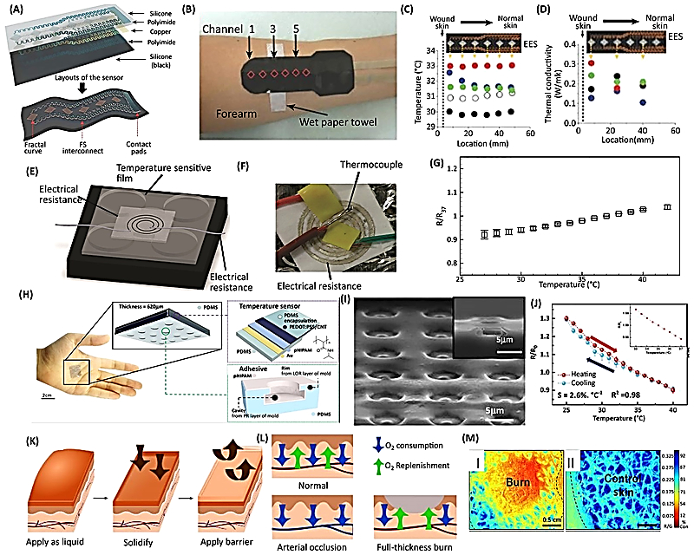

Fig.1. Wound dressings for monitoring skin temperature and oxygenation. (a) Microfabrication schematic of a flexible temperature sensor. (b) Bandage maintaining conformal contact with skin. (c,d) Measured cutaneous temperature and thermal conductivity. (e) Temperature sensor on elastic nanofibrous substrate. (f) Screen-printed silver ink sensor. (g,j) Relative resistance changes with temperature. (h) Wearable sensor on skin and layer schematic. (i) Scanning Electron Microscope (SEM) image of octopus-inspired surface for enhanced adhesion. (k) Liquid-based bandage oxygen sensing schematic. (l) Tissue oxygenation in various wound types. (m) Oxygen consumption in burn (I) and healthy tissue (II), with blue indicating higher and red lower consumption
Source: Derakhshandeh et al. (2018)

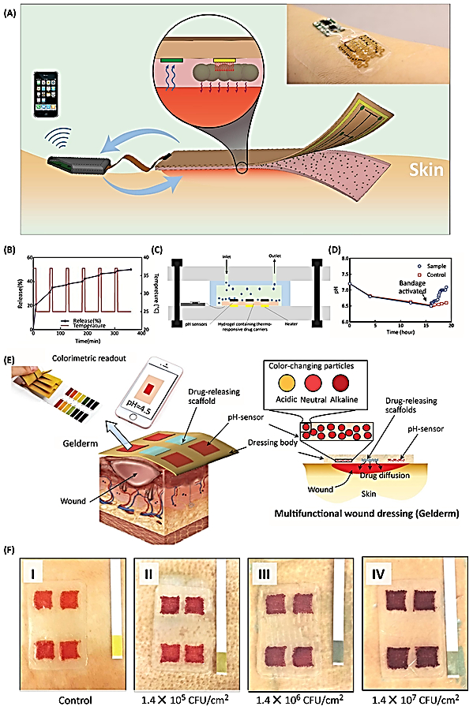

Fig.2. Smart and automated bandages for chronic wound treatment. (a) Multi-layer dressing schematic and image showing pH sensing and antibiotic release via an integrated heater with on-board data processing. (b) Cyclic heater activation and corresponding drug release. (c) In vitro bioreactor model for Staphylococcus aureus culture interfaced with the bandage. (d) Continuous pH monitoring triggers antibiotic release, restoring bioreactor pH. (e) Semi-automated bandage with colorimetric pH sensor and drug delivery. (f) Bacterial growth changes bandage color, darkening as colony forming unit (CFU) increases
Source: Derakhshandeh et al. (2018)

4.1. Next-Generation Smart Textiles
Next-generation smart textiles are advanced fabric systems that go beyond traditional passive materials to provide interactive, adaptive, and multifunctional capabilities. These textiles merge traditional textile structures with embedded sensors, actuators, and electronics, allowing them to sense, respond, and communicate data related to the wearer’s physiological or environmental conditions (Ahmed et al., 2024). This technological evolution is driven by the convergence of textile engineering, electronics, nanotechnology, and wireless communication, enabling wearable systems that support health, performance, and comfort in daily life (Ahmed et al., 2024).
Smart textiles are increasingly designed for healthcare applications, where embedded sensors can monitor vital signs such as heart rate, body temperature, respiratory rate, and other biometric data directly from clothing or wearable patches. For instance, textile-based wearable sensors allow continuous physiological monitoring without the discomfort and limitations of traditional rigid devices, opening opportunities for remote patient tracking and early detection of health deterioration (Medica Times, 2025).
A distinctive feature of next-generation smart textiles is their integration of conductive materials and electronic elements at the fiber or fabric level. Conductive fibers made from silver, carbon, copper, or conductive polymers form pathways that enable data transmission and power distribution throughout the textile, while flexible sensors and communication modules are embedded to collect and transmit data in real time. These integrated systems support functions such as electrocardiogram (ECG) monitoring and pressure sensing directly in garments (Yadav & Yadav, 2025).
Next-generation designs also emphasize self-powered and energy-autonomous systems, where textiles harvest energy from body movements, heat, or ambient sources to power embedded devices. This reduces reliance on traditional batteries, improving wearability for long-term use in health monitoring and remote healthcare solutions (Muritala, 2025).

Also, in next-generation smart textiles, microorganisms are incorporated to serve several interrelated functions. First, they contribute to bio-electrochemical energy harvesting; electroactive microbes can metabolize organic components in sweat or other body fluids and transfer electrons to conductive textile electrodes, forming the basis of textile-embedded microbial fuel cells that can offer sustainable low-power sources for wearable electronics (Wu et al., 2025). Second, microbes act as bio-sensing agents, where changes in microbial metabolic products or bio-electric signals can be correlated with physiological or environmental biomarkers (Wu et al., 2025). Third, living microbial elements can enhance antimicrobial defenses by producing natural antimicrobial peptides or by competitively excluding pathogens on textile surfaces, which is particularly valuable in wound care applications and clinical garments.

4.1.1. Enabling Technologies for Functional Microbial Integration

4.1.1.1. Synthetic biology for tailored microbial functions
Synthetic biology empowers researchers to genetically program microbes so that they can perform highly specific functions when embedded in textiles (Wu et al., 2025). Using tools such as CRISPR and engineered genetic circuits, microorganisms can be designed to sense environmental cues (e.g., changes in pH or sweat metabolites) and respond by synthesizing antimicrobial compounds, anti-inflammatory agents, or other therapeutic factors directly at the textile interface (Wu et al., 2025). For example, bio-compatible promoters such as Lactobacillus-compatible promoters driven gene expression. This senses abnormal skin pH or over proliferation of pathogenic bacteria, then triggers production of anti-microbial agents or protective factors to restore skin balance (Lim et al., 2022). In addition, engineered microbes can enhance the production of functional biomaterials like bacterial cellulose or collagen precursors that support skin repair or hydration. These synthetic biology strategies thus expand the biological capabilities of smart textiles far beyond traditional materials and sensors (Figure 3) (Wu et al., 2025).

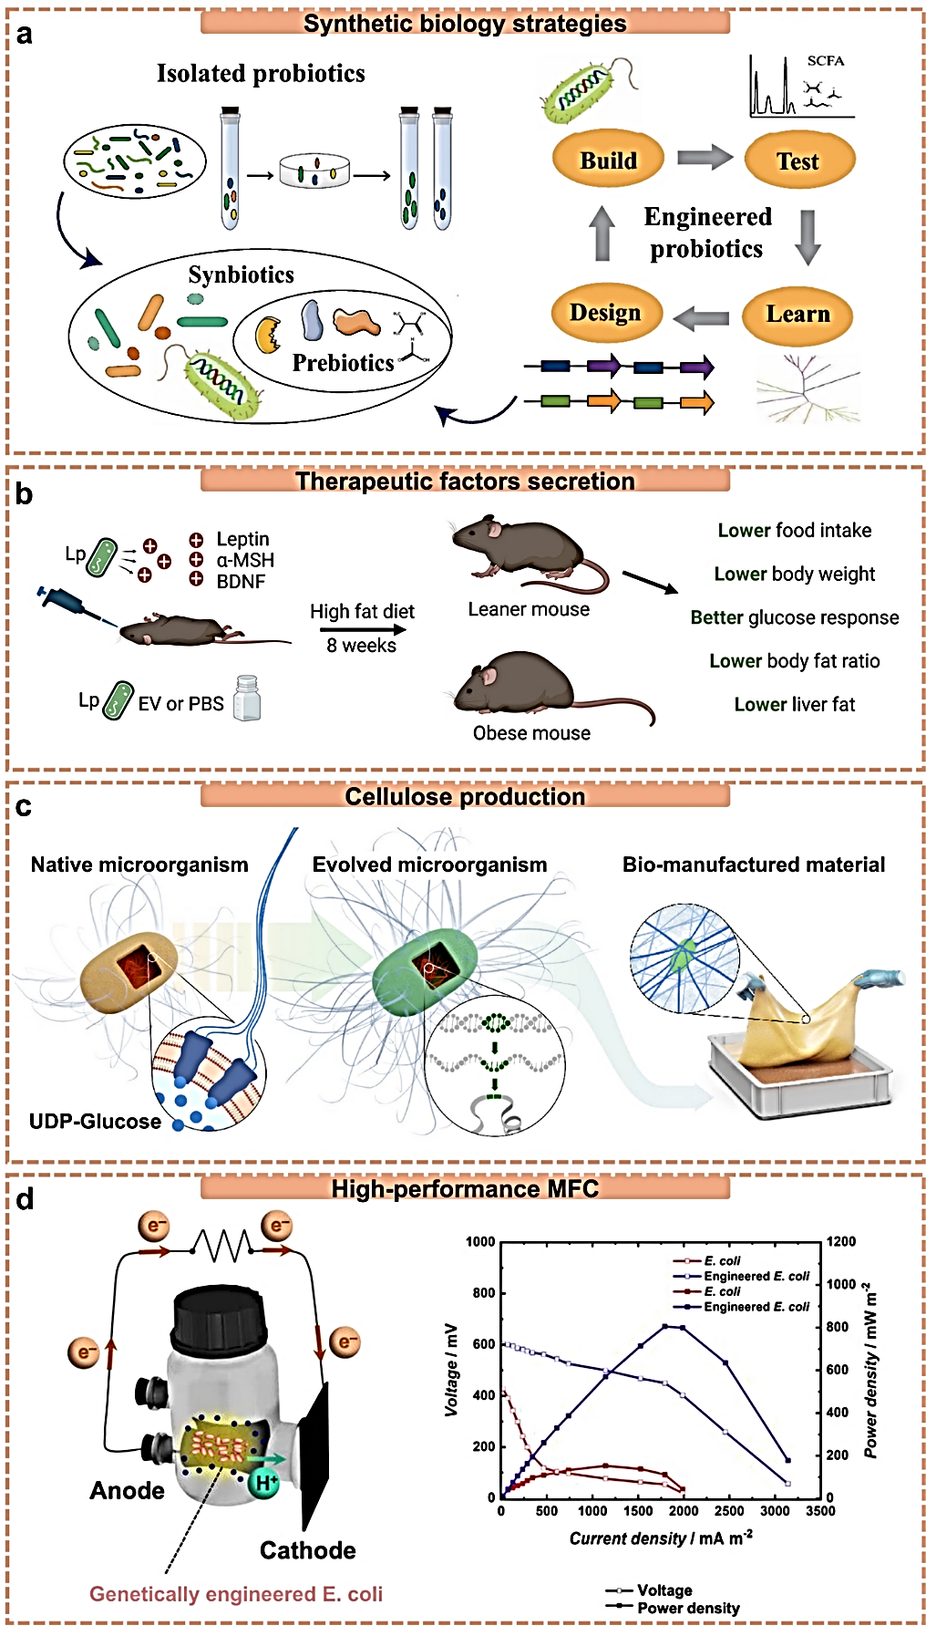
Fig.3. Synthetic biology strategies for microbes in smart textiles. (a) Synthetic biology processes for functionally engineered microbes. (b) Engineered microbes secreting therapeutic or growth factors for health management. (c) Enhanced cellulose production using engineered bacteria. (d) Engineered bacteria for high-performance microbial fuel cells
Source: Wu et al. (2025).

4.1.1.2 Microencapsulation Technology
One major challenge in integrating living microbes into textiles is their stability and durability under real-world conditions, such as laundering, mechanical stress, and environmental exposure (Wu et al., 2025). Microencapsulation addresses this by encasing microbes or bioactive agents within protective micro/nano-scale carriers made from polymers, lipids, or inorganic matrices (Wu et al., 2025). These microcapsules can protect microbes from deactivation due to heat, UV exposure, or detergents, and enable controlled release when triggered by specific stimuli such as pH changes, moisture, or body temperature. Through techniques like coating, impregnation, and fiber blending, microencapsulation immobilizes and allows bioactive microbes to remain viable and functional over extended periods (Boh-Podgornik et al., 2021; Wu et al., 2025). For instance, encapsulation of Bacillus subtilis, known for its potential to synthesize natural antimicrobial peptides into textiles to prevent its premature release and ensure durable antimicrobial protection (Puan et al., 2023; Wu et al., 2025). Illustration of the microencapsulation design strategies are displayed in Figure 4.

4.2. Considerations for Advanced Design
Realizing the potential of microbe-enabled smart textiles requires integrative system designs that unify flexible electronics, microbial functionality, and adaptive material properties (Wu et al., 2025). Artificial intelligence (AI) and machine learning are emerging as essential tools for optimizing microbial strain selection, predicting textile–microbe interactions, and enabling real-time adaptive regulation of microbe-textile systems based on wearer data (Wu et al., 2025). These advanced computational approaches help maximize microbial viability, personalize responses, and enhance overall system intelligence (Wu et al., 2025).
As this field progresses, the integration of microorganisms via microencapsulation, and synthetic biology, promises to shift smart textiles from passive wearables to active, responsive systems that not only monitor health but also participate in therapeutic interventions and environmental adaptations (Wu et al., 2025). However, challenges remain in terms of biosafety, regulatory approval, large-scale manufacturing, and long-term stability under everyday use conditions (Wu et al., 2025).

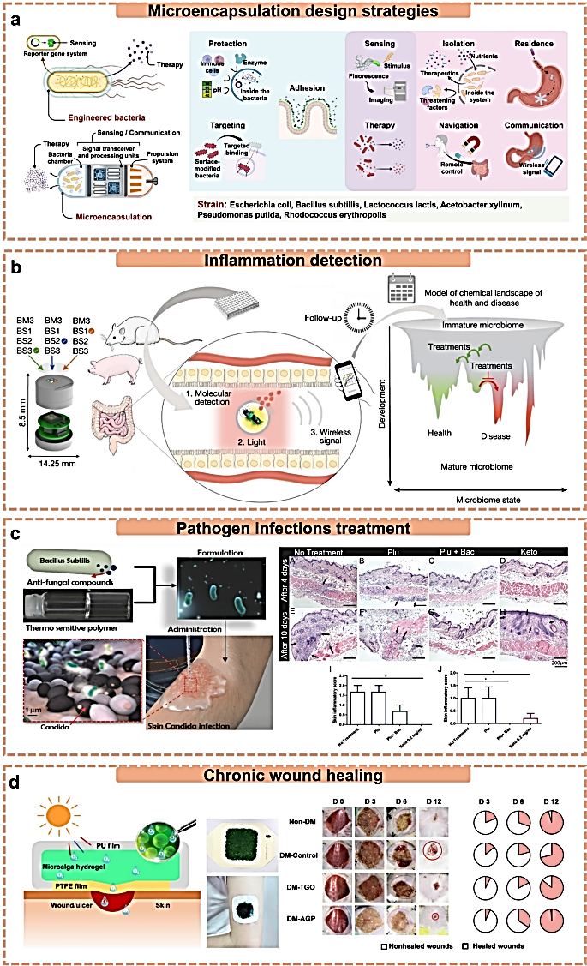

Fig.4. Microencapsulation of microbes for integration into smart textiles and related applications. (a) Design strategies for microbial microencapsulation. (b) Probiotic bacteria-encapsulated biosensor for in situ inflammation detection. (c) Encapsulated microbes for pathogen infection treatment. (d) Chronic wound therapy using oxygen generation from encapsulated bacteria
Source: Wu et al. (2025).

4.2.1 Advanced Technologies for Next-Generation Smart Textiles
Next-generation smart textiles (i.e interactive and smart) are being enabled by a suite of advanced technologies that extend textile utility beyond passive functions to active sensing, energy harvesting, communication, and responsive actuation (Castano & Flatau, 2014; Syduzzaman et al., 2015). At the core of these innovations are novel materials and integrated systems that allow textiles to perceive, process, and respond to environmental and physiological stimuli in real time.
i). A key technological focus is on developing fabrics that not only detect signals but also support energy autonomy and computational capabilities embedded directly in wearable structures. (Ahmed et al., 2024). Advanced conductive materials, including nanomaterials and functional composites, form the foundation of next-generation smart textiles. Materials such as carbon nanotubes (CNTs), graphene, MXenes (two-dimensional transition metal carbides or nitrides), and conductive polymers are widely explored for their superior electrical, mechanical, and multifunctional properties (Sajovic et al., 2022). These nanomaterials enable enhanced electrical conductivity, mechanical flexibility, and strain sensing, and serve as building blocks for integrated textile sensors, energy storage, and power generation systems. For example, MXene-enhanced fibers have been used to support wearable energy storage, power harvesting, and multifunctional sensing in flexible textile platforms (Sajovic et al., 2022).

ii). Wireless connectivity and IoT integration further extend the capabilities of smart textiles by enabling real-time data transmission and interaction with external systems. Smart fabrics connected through Bluetooth, Wi-Fi, or near-field communication support remote health monitoring and seamless integration with mobile or cloud platforms, making wearable textiles part of the broader Internet of Things (IoT) ecosystem. This IoT convergence allows for continuous collection, analysis, and actionable feedback from textile-embedded sensors (Wang et al., 2025).

iii). Intelligent design and system integration including modular electronics, flexible circuitry, and embedded computation are pushing smart textiles toward on-body processing and adaptive behaviours. For example, scientists have developed flexible fibers with integrated microcontrollers, sensors, communication modules, and power management that can perform real-time recognition and distributed computation when woven into garments (Cheng et al., 2025). Similarly, the concept of on-body edge computing using e-textile programmable logic arrays allows sensor data to be processed directly on the garment, improving local computation and decision-making capabilities without external hardware (Cleary et al., 2021). These approaches are key to realizing truly autonomous and smart wearable textiles capable of real-time decision making and interaction (Cleary et al., 2021).

4.3. Challenges and Limitations
Despite the promising potential of next-generation smart textiles, several technical, economic, and social challenges remain that limit their widespread adoption, especially in skin health and wound management contexts.

i). Durability and Washability
One of the major technical limitations of smart textiles is ensuring long-term mechanical and functional durability in real-world use. Embedded electronic components and sensors can degrade under repeated mechanical stress, environmental exposure (e.g., humidity, sweat), and laundering cycles, leading to loss of performance or failure. Ensuring that sensor contacts, conductive pathways, and flexible components remain intact after movement, washing, and abrasion is a significant challenge for everyday wearables (Yang et al., 2023).

ii). Cost and Scalability
The specialized materials and fabrication techniques required for smart textiles often lead to high production costs, which can limit accessibility and consumer adoption. Moreover, scaling up from prototype stages to mass manufacturing poses economic and technical hurdles, as traditional textile production lines must be adapted for electronics integration (Yadav & Yadav, 2025).

iii). Consumer Acceptance and Aesthetics
User adoption also depends on comfort, aesthetics, and perceived value. Smart textiles that are bulky, heavy, or difficult to maintain may face resistance from consumers who prioritize comfort and style in wearable products (Textile School, 2025).

iv). Technical Complexity and Integration
Integrating electronics, sensors, and computational units into soft fabrics without compromising their flexibility, breathability, and tactile comfort remains technically challenging. Creating robust connections between rigid electronic modules and flexible textile substrates is complex, and the absence of standardized manufacturing and testing processes further complicates scalability (Textile Topher, 2024).

v). Data Privacy and Security
Smart textiles that collect, process, and transmit personal health data raise significant privacy and cybersecurity concerns. Secure handling of sensitive biometric information is critical, especially in healthcare applications. Without robust standards and encryption protocols, wearable textiles risk exposing user data to breaches or misuse (Textile School, 2025).

vi). Environmental and Sustainability Concerns
Smart textiles often combine textile polymers with metals, semiconductors, and other materials that complicate end-of-life recycling and waste management. The difficulty in separating electronic components from textile substrates raises environmental sustainability challenges, particularly regarding e-waste (Ahmed et al., 2024).

4.4 Future Perspectives for Smart Wound Textiles
The future of smart wound textiles lies in multifunctional, autonomous, and highly personalized systems that go well beyond traditional passive dressings. Current research and market trends indicate that advanced wound care will be driven by continuous monitoring, real‑time feedback, integrated therapeutic delivery, and seamless integration with telemedicine platforms (Kumar et al., 2025). These developments aim to improve healing outcomes, reduce complications, and support patient comfort and convenience (Kumar et al., 2025).
i). Artifical Intelligence (AI)-enhanced smart wound dressings that combine biosensors with machine learning algorithms to not only monitor wound parameters (e.g., pH, temperature, moisture, oxygenation) but also predict healing trajectories and guide tailored therapeutic interventions. Embedding AI capabilities into polymeric and electrospun nanofiber scaffolds can enable data‑driven wound assessment and personalized treatment optimization. This approach is particularly relevant for chronic wounds associated with diabetes, vascular disease, and immune dysfunction (Palani et al., 2025).
ii). Development of closed‑loop systems that unify sensing, drug delivery, and electrical or mechanical stimulation in a single dressing. These all‑in‑one smart bandages can respond to detected changes in the wound microenvironment such as signs of infection by releasing antimicrobials or growth factors and delivering therapeutic stimuli like electrical signals that accelerate tissue repair, all in real time (Dejene, 2025).
iii). The next wave of innovation is likely to include microbe‑integrated smart textiles, where engineered microorganisms contribute actively to microenvironmental regulation, antimicrobial defense, or even bioelectricity generation within the dressing itself. By harnessing microbial functions such as metabolite production or engineered metabolic circuits, these textiles could dynamically adapt to changes in wound biochemistry without relying solely on embedded electronics (Wu et al., 2025).
iv). Three dimensional (3D) printing and additive manufacturing are poised to revolutionize the customization and scalability of smart wound textiles. Through precisely controlled scaffold fabrication, biomaterials combined with cellular components, growth factors, or structural guides can be tailored to patient‑specific wound geometry and tissue types, supporting personalized healing strategies that match individual therapeutic needs (Soylu et al., 2025).
v). Regulatory and market forces will shape the adoption trajectory of smart wound textiles. Advances in safety evaluation, data security protocols, and healthcare integration standards will be essential to ensure clinical acceptance and widespread use, while continued investment in digital health and medical device innovation will drive commercialization and scalability (Next Move Strategy Consulting, 2025).

Future smart wound textiles are expected to evolve into highly interconnected, intelligent, and adaptive platforms that support monitoring, prediction, and intervention in wound care. These technologies promise not only to improve healing outcomes and reduce healthcare burdens but also to integrate seamlessly into personalized and remote healthcare ecosystems (Palani et al., 2025).

Conclusion
Next-generation smart textiles are revolutionizing skin health and wound care by integrating real-time monitoring, adaptive therapy, and advanced materials, including microorganism-based components. They offer personalized and efficient healing, but challenges such as durability, power supply, cost, and data security remain. Future developments will focus on autonomous, multifunctional, and AI-integrated textiles that support remote healthcare and improve patient outcomes

Disclaimer (Artificial Intelligence)

Author(s) hereby declare that NO generative AI technologies such as Large Language Models (ChatGPT, COPILOT, etc.) and text-to-image generators have been used during the writing or editing of this manuscript.

Competing Interests

Author has declared that no competing interests exist.

REFERENCES

Ahmed, A., Hasan, E. U., & Hasseni, S. (2024). Smart and sustainable: A global review of smart textiles, IoT integration, and human-centric design. Sensors, 25(23), 7267.
Bay, L., & Ring, H. C. (2022). Human skin microbiota in health and disease: The cutaneous communities’ interplay in equilibrium and dysbiosis. APMIS, 130, 706.
Bieber, T. (2022). Atopic dermatitis: An expanding therapeutic pipeline for a complex disease. Nature Reviews Drug Discovery, 21, 21.
Boh-Podgornik, B., Šandrić, S., & Kert, M. (2021). Microencapsulation for functional textile coatings with emphasis on biodegradability—a systematic review. Coatings, 11(11), 1371.
Bothare, V. (2024). Smart textile market size, share & trends analysis report by type (passive textiles, active textiles, ultra smart textiles), by function (sensing, energy harvesting, luminescence & aesthetics, thermo-electricity), by end-user (healthcare, military & defense, sports & fitness, fashion and entertainment, automotive, architecture) and by region (North America, Europe, APAC, Middle East and Africa, LATAM) forecasts, 2025–2033.
Brasier, N., Wang, J., Gao, W., Sempionatto, J. R., Dincer, C., Ates, H. C., & Goldhahn, J. (2024). Applied body-fluid analysis by wearable devices. Nature, 636, 57.
Broadhead, R., Craeye, L., & Callewaert, C. (2021). The future of functional clothing for an improved skin and textile microbiome relationship. Microorganisms, 9(6), 1192.
Castano, L.M., & Flatau, A.B. (2014). Smart fabric sensors and e-textile technologies: a review. Smart Materials and Structures, 23(5).
Cerimi, K., Akkaya, K. C., Pohl, C., Schmidt, B., & Neubauer, P. (2019). Fungi as source for new bio-based materials: A patent review. Fungal Biology and Biotechnology, 6, 17.
Cheng, Q., Li, J., & Zhang, Q. (2025). Fibre computer enables more accurate recognition of human activity. Nano-Micro Letters, 17(1), 286.
Cleary, F., Henshall, D. C., & Balasubramaniam, S. (2021). On-body edge computing through e-textile programmable logic array. Frontiers in Communications and Networks, 2, 688419.
Dejene, B. K. (2025). The future of fabric: A comprehensive review of self-powered smart textiles and their emerging applications. Energy Reports, 14, 898–943.
Derakhshandeh, H., Kashaf, S. S., Aghabaglou, F., Ghanavati, I., & Tamayol, A. (2018). Smart bandages: The future of wound care. Trends in Biotechnology, 36(12), 1259–1274.
Fernandes, A. M., Silva, T. L., & Silva, C. J. (2024). Bacterial cellulose: A new biomaterial for the textile industry. Next Sustainability, 6, 100211.
Fraunhofer Gesellschaft. (2024). Fungal mycelium as the basis for sustainable products. Fraunhofer Institute for Applied Polymer Research IAP. Retrieved from https://www.fraunhofer.de/en/press/research-news/2024/september-2024/fungal-mycelium-as-the-basis-for-sustainable-products.html
Garland, N. T., Kaveti, R., & Bandodkar, A. J. (2023). Biofluid-activated biofuel cells, batteries, and supercapacitors: A comprehensive review. Advanced Materials, 35(52), 2303197.
Guennes, M., Cunha, J., & Cabral, I. (2025). Smart textile design: A systematic review of materials and technologies for textile interaction and user experience evaluation methods. Technologies, 13(6), 251.
Hua, J., Liu, C., Ng, P. F., & Fei, B. (2021). Bacterial cellulose reinforced double-network hydrogels for shape memory strand. Carbohydrate Polymers, 259, 117737.
Islam, T., Repon, M. R., Salma, U. K., Haji, A., Hosen, M. I., Rahman, M., & Islam, M. T. (2025). A roadmap study of wearable electronic textile materials: A comprehensive review. Advanced Composites and Hybrid Materials, 8(6), 431.
Jiang, Y., Trotsyuk, A. A., & Bao, Z. (2023). Healing chronic wounds with a wireless smart bandage with integrated sensors and stimulators. Nature Biotechnology, 41(5), 622–623.
Jo, J. H., Harkins, C. P., Schwardt, N. H., Portillo, J. A., Program NCS, Zimmerman, M. D., & Kong, H. H. (2021). Alterations of human skin microbiome and expansion of antimicrobial resistance after systemic antibiotics. Science Translational Medicine, 13, eabd8077.
Júnior, H. L., Neves, R. M., Monticeli, F. M., & Dall Agnol, L. (2022). Smart fabric textiles: Recent advances and challenges. Textiles, 2(4), 582–605.
Kaewpradub, K., Veenuttranon, K., Jantapaso, H., Mittraparp Arthorn, P., & Jeerapan, I. (2024). A fully-printed wearable bandage-based electrochemical sensor with pH correction for wound infection monitoring. Nano-Micro Letters, 17, 71.
Kashaf, S. S., Proctor, D. M., Deming, C., Saary, P., Holzer, M., NISC Comparative Sequencing Program, & Almeida, A. (2022). Integrating cultivation and metagenomics for a multi-kingdom view of skin microbiome diversity and functions. Nature Microbiology, 7, 169.
Keasling, J., Martin, H. G., Lee, T. S., Mukhopadhyay, A., Singer, S. W., & Sundstrom, E. (2021). Microbial production of advanced biofuels. Nature Reviews Microbiology, 19, 701.
Khan, M. F. (2025). Recent advances in microbial enzyme applications for sustainable textile processing and waste management. Science, 7(2), 46.
Kim, H., Kim, J. H., Jeong, M., Lee, D., Kim, J., Lee, M., & Lee, J. (2024). Bioelectronic sutures with electrochemical pH-sensing for long-term monitoring of the wound healing progress. Advanced Functional Materials, 34, 2402501.
Kumar, M., Sethi, P., Shiekmydeen, J., Rastogi, S., Mahmood, S., Chopra, S., Thomas, S., Kumar, D., & Bhatia, A. (20250. A recent review on smart sensor-integrated wound dressings: Real-time monitoring and on-demand therapeutic delivery. International Journal of Biology and Macromolecules, 313, 144251. doi:10.1016/j.ijbiomac.2025.144251.
Larson, P. J., Zhou, W., Santiago, A., Driscoll, S., Fleming, E., Voigt, A. Y., & Robison, J. T. (2022). Associations of the skin, oral and gut microbiome with aging, frailty and infection risk reservoirs in older adults. Nature Aging, 2, 941.
Li, H., Zhang, L., Liang, B., Xue, H., Cao, H., Li, Z., & Li, Y. (2025). Smart antibacterial coatings with on-demand drug release and real-time monitoring. Advanced Functional Materials, 35, 2411985.
Li, M., Xia, W., Khoong, Y. M., Huang, L., Huang, X., Liang, H., & Zan, T. (2023). Smart and versatile biomaterials for cutaneous wound healing. Biomaterials Research, 27(1), 87.
Lim, H.W., Huang, Y.H., Kyeong, G., Park, M., & Lim, C.J. (2022). Comparative insights into the skin beneficial properties of probiotic Lactobacillus isolates of skin. Biomedical Resource International, 2022:7728789
Liu, Q., Ranallo, R., Rios, C., Grice, E. A., Moon, K., & Gallo, R. L. (2023). Crosstalk between skin microbiota and immune system in health and disease. Nature Immunology, 24, 895.
Liu, Y., & Ge, L. (2025). Smart biomaterials in wound healing: Advances, challenges, and future directions in intelligent dressing design. Bioengineering, 12(11), 1178.
Liu, Y., & Ge, L. (2025). Smart biomaterials in wound healing: Advances, challenges, and future directions in intelligent dressing design. Bioengineering, 12(11), 1178.
Lu, Q., & Stappenbeck, T. S. (2022). Local barriers configure systemic communications between the host and microbiota. Science, 376, 950.
Ma, R., Li, D., Xu, C., Yang, J., Huang, J., & Guo, Z. (2024). Fabricated advanced textile for personal thermal management, intelligent health monitoring and energy harvesting. Advances in Colloid and Interface Science, 332, 103252.
Manan, S., Ullah, M. W., UlIslam, M., Shi, Z., Gauthier, M., & Yang, G. (2022). Bacterial cellulose: Molecular regulation of biosynthesis, supramolecular assembly, and tailored structural and functional properties. Progress in Materials Science, 129, 100972.
Masiuk, H., Wcislek, A., & Jursa-Kulesza, J. (2021). Determination of nasal carriage and skin colonization, antimicrobial susceptibility and genetic relatedness of Staphylococcus aureus isolated from patients with atopic dermatitis in Szczecin, Poland. BMC Infectious Diseases, 21, 701.
Medica Times. (2025). Smart textile for healthcare and their applications. Medica Times. Retrieved January 19, 2026, from https://medicatimes.com/news-about-smart-textile-for-healthcare-and-their-applications/
Muritala, A. (2025). Intelligent textiles and wearable tech: How smart fabrics are powering the future of wellness. Retrieved from https://www.fibre2fashion.com/industry-article/10573/intelligent-textiles-and-wearable-tech-how-smart-fabrics-are-powering-the-future-of-wellness
Nakatsuji, T., Hata, T. R., Tong, Y., Cheng, J. Y., Shafiq, F., Butcher, A. M., & Gallo, R. L. (2021). Development of a human skin commensal microbe for bacteriotherapy of atopic dermatitis and use in a phase 1 randomized clinical trial. Nature Medicine, 27, 700.
Next Move Strategy Consulting. (2025). Smart bandage market share & analysis | Forecast 2025–2030. Retrieved from https://www.nextmsc.com/report/smart-bandage-market-3445
Niculescu, A. G., & Grumezescu, A. M. (2022). An up-to-date review of biomaterials application in wound management. Polymers, 14(3), 421.
Palani, N., Mendonce, K. C., Syed Altaf, R. R., Mohan, A., Surya, P., P. M., & Rajadesingu, S. (2025). Next-generation smart wound dressings: AI integration, biosensors, and electrospun nanofibers for chronic wound therapy. Journal of Biomaterials Science, Polymer Edition, 1–51.
Palani, N., Mendonce, K. C., Syed Altaf, R. R., Mohan, A., Surya, P., P. M., & Rajadesingu, S. (2025). Next-generation smart wound dressings: AI integration, biosensors, and electrospun nanofibers for chronic wound therapy. Journal of Biomaterials Science, Polymer Edition, 1–51.
Puan, S.L., Erriah, P., Baharudin, M.M.A., Yahaya, N.M., Kamil, W., Ali, M.S.M., Ahmad, S.A., Oslan, S.N., Lim, S., & Sabri, S. (2023). Antimicrobial peptides from Bacillus spp. And strategies to enhance their yield. Applied Microbiology and Biotechnology, 107, 5569.
Robaiyat, M. A. (2025). Advancement in smart textile (Preprint). Preprints.org.
Romero-Cedillo, R. K., Robledo-Leal, E. R., Aguilar-Marcelino, L., Acosta-Urdapilleta, M. D. L., & Téllez-Téllez, M. (2025). Production of mycelium mats for textile applications. Journal of Fungi, 11(10), 700.
Sabio, L., González, A., Ramírez-Rodríguez, G. B., Gutiérrez-Fernández, J., Bañuelo, O., Olivares, M., & Dominguez-Vera, J. M. (2021). Probiotic cellulose: Antibiotic-free biomaterials with enhanced antibacterial activity. Acta Biomaterialia, 124, 244–253.
Saini, R., Kaur, G., & Brar, S. K. (2023). Textile residue-based mycelium biocomposites from Pleurotus ostreatus. Mycology, 15(4), 683–689.
Sajovic, I., Kert, M., & Boh Podgornik, B. (2022). Smart textiles: A review and bibliometric mapping. Applied Sciences, 13(18), 10489.
Sempionatto, J. R., Lasalde Ramirez, J. A., Mahato, K., Wang, J., & Gao, W. (2022). Wearable chemical sensors for biomarker discovery in the omics era. Nature Reviews Chemistry, 6, 899.
Soylu, Z., Oktay, B., Erarslan, A., & Ahlatcıoğlu Özerol, E. (2025). Multifunctional polymeric wound dressings. Polymer Bulletin, 1–59.
Syduzzaman, M.D., Patwary, S.U., Farhana, K., & Ahmed, S. (2015). Journal of Textile Science and Engineering, 5(1), 1-7.
Tchoupa, A. K., Kretschmer, D., Schittek, B., & Peschel, A. (2023). The epidermal lipid barrier in microbiome-skin interaction. Trends in Microbiology, 31, 723.
Tessarolo, M., Possanzini, L., Gualandi, I., Mariani, F., Torchia, L. D., Arcangeli, D., Melandri, F., Scavetta, E., & Fraboni, B. (2021). Wireless textile moisture sensor for wound care. Frontiers in Physics, 9, 722173.
Textile School. (2025). Smart textiles and wearable technology. Retrieved from https://www.textileschool.com/9943/smart-textiles-and-wearable-technology/?
Textile Topher. (2024). Integrating technology | Smart textiles. Retrieved from https://smarttextiles.com/integrating-technology/?
Thyssen, J. P., Vestergaard, C., Deleuran, M., de Bruin Weller, M. S., Bieber, T., Taieb, A., & Wollenberg, A. (2020). European task force on atopic dermatitis (ETFAD): Treatment targets and treatable traits in atopic dermatitis. Journal of the European Academy of Dermatology and Venereology, 34, e839.
Wakley, M. (2025). Scientists invent way to use E. coli to create and dye rainbow colored fabric in the lab. Live Science. Retrieved from https://www.livescience.com/chemistry/scientists-invent-way-to-use-e-coli-to-create-and-dye-rainbow-colored-fabric-in-the-lab
Wang, Y., Sun, C., & Ahmed, D. (2025). A smart acoustic textile for health monitoring. Nature Electronics, 8(6), 485–495.
Wu, H., Ming, Y., Shi, S., Zhi, C., Chen, D., Hu, X., & Fei, B. (2025). Smart textiles with living interfaces: Microbiome–electronics integration for advanced skin health management. Advanced Fiber Materials, 1–39.
Xia, G., Bian, X., Wang, Y., Lam, Y., Zhao, Y., Fan, S., & Xin, J. H. (2024). Janus outdoor protective clothing with unidirectional moisture transfer, antibacterial, and mosquito repellent properties. Chemical Engineering Journal, 490, 151826.
Yadav, A., & Yadav, K. (2025). Transforming healthcare and fitness with AI powered next-generation smart clothing. Discover Electrochemistry, 2(1), 2.
Yang, K. A., S., Isaia, B., Callaway, A., & Beeby, S. (2023). E-textiles for sports and fitness sensing: Current state, challenges, and future opportunities. Sensors, 24(4), 1058.
Yang, X., Chen, W., Fan, Q., Chen, J., Chen, Y., Lai, F., & Liu, H. (2024). Electronic skin for health monitoring systems: Properties, functions, and applications. Advanced Materials, 36, e2402542.
Zhang, J., Xu, B., Chen, K., Li, Y., Li, G., & Liu, Z. (2024). Revolutionizing digital healthcare networks with wearable strain sensors using sustainable fibers. Sustainable Materials, 4, e207.
Zhi, C., Shi, S., Meng, S., Wu, H., Si, Y., Zhang, K., & Hu, J. (2023). A biocompatible and antibacterial all-textile structured triboelectric nanogenerator for self-powered tactile sensing. Nano Energy, 115, 108734.
Zhi, C., Shi, S., Wu, H., Si, Y., Zhang, S., Lei, L., & Hu, J. (2024). Emerging trends of nanofibrous piezoelectric and triboelectric applications: Mechanisms, electroactive materials, and designed architectures. Advanced Materials, 36, e2401264.

