Original Research Article

High-frequency somatic embryogenesis and molecular validation of genetic fidelity in Kaempferia marginata Carey ex Roscoe: An endangered medicinal plant

ABSTRACT:
Kaempferia marginata Carey ex Roscoe is a valuable medicinal plant currently threatened by over-exploitation and habitat loss. We established an efficient protocol for in vitro micropropagation via somatic embryogenesis and assessed the genetic stability of the regenerants. Rhizome buds were cultured on Murashige and Skoog (MS) medium supplemented with various concentrations of auxins and cytokinins. The highest frequency of callus induction (87.00 ± 0.10%) and subsequent shoot regeneration (7.5 ± 0.16 shoots/explant) was achieved on MS medium supplemented with 2.0 mg L⁻¹ α-naphthalene acetic acid (NAA). Histological analysis confirmed the ontogeny of somatic embryos progressing from globular to torpedo stages. For multiplication, a combination of 4.0 mgL⁻¹ 6-benzylaminopurine (BAP) and 1.0 mg L⁻¹ NAA yielded the maximum number of shoots (16.35 ± 0.22) within 4 weeks. Genetic fidelity of the micro propagated plantlets was validated using RAPD and ISSR markers. Screening with 25 RAPD and 11 ISSR primers generated reproducible profiles that were monomorphic across all regenerants and the mother plant, confirming true-to-type clonal propagation. This protocol offers a reliable method for the large-scale production of genetically uniform K. marginata for conservation and commercial utilization.

Keywords: Genetic fidelity, Kaempferia marginata, ISSR, RAPD, Somatic embryogenesis, Micropropagation.

1.INTRODUCTION
Kaempferia marginata Carey ex Roscoe (Zingiberaceae) is an aromatic, perennial, rhizomatous herb widely distributed in China, India (specifically the Northeastern region), Myanmar, and Thailand. It shares a similar growth habit with Kaempferia galanga and is highly valued in traditional medicine. The rhizomes possess ethnomedicinal importance for treating allergies, fever, swellings, toothache, and gastric ailments. Phytochemical investigations have revealed that the genus Kaempferia is rich in bioactive constituents, including cyclohexane oxide derivatives, cinnamates, flavonoids, and diterpenes

such as sandaracopimaradiene, which exhibit significant anti-inflammatory, antimicrobial, and antioxidant activities (Thongnest et al., 2005; Madaka & Tewtrakul, 2011; Elshamy et al., 2023).
Despite its therapeutic potential, natural populations of K. marginata are under severe threat. The species is heavily exploited for pharmaceutical purposes, and its natural habitat in Manipur is degrading due to "Jhum" (shifting) cultivation and lack of organized farming practices (Kishor, 2012). Natural propagation via rhizomes is slow, season-dependent, and prone to soil-borne pathogens, necessitating the development of efficient biotechnological interventions for conservation and mass production.
While in vitro micropropagation protocols utilizing organogenesis have been reported for related species such as K. galanga (Lakshmi & Mythili, 2003) and K. parviflora (Rahman et al., 2023), reports on somatic embryogenesis for K. marginata remain limited. Somatic embryogenesis is often preferred over organogenesis for large-scale propagation as it offers higher multiplication rates and the potential for producing synthetic seeds (Jayanthi & Mandal, 2001; Tokuhara & Mii, 2001).
However, the maintenance of genetic uniformity is a critical prerequisite for the commercial application of tissue culture-derived plants. Long-term in vitro culture can induce somaclonal variation, which is undesirable for conservation and pharmaceutical quality control. Molecular markers, particularly Random Amplified Polymorphic DNA (RAPD) and Inter Simple Sequence Repeats (ISSR), are established tools for assessing genetic fidelity due to their simplicity, cost-effectiveness, and ability to detect variation across the genome (Williams et al., 1990; Zietkiewicz et al., 1994; Sahoo et al., 2023).
In view of the above, this study was undertaken to standardize a high-frequency somatic embryogenesis protocol for K. marginata and to validate the genetic fidelity of the regenerated plantlets using RAPD and ISSR markers.

2. MATERIALS AND METHODS

2.1 PLANT MATERIAL AND SURFACE STERILIZATION:
Rhizomes of K. marginata were collected from the hills in the sub-tropical forest of Keithelmanbi in the western periphery of Imphal Valley of Manipur, India (23˚50’ –25˚42’ N and 92˚58’ – 94˚45’ E). The rhizomes were incubated in autoclaved sand at 27±2°C under a 16h light/8h dark photoperiod. After two weeks, sprouting buds were excised and washed under running tap water for 20 minutes to remove contaminants. The explants were treated with Labklin detergent (SD Fine-Chem Ltd., Mumbai) for 15 minutes, rinsed thoroughly, and surface sterilized with 0.2% mercuric chloride (HgCl₂) for 15 minutes inside a laminar airflow cabinet. Finally, explants were rinsed five times with sterile double-distilled water, and the outer leaf sheaths were removed before inoculation.

2.2 CULTURE MEDIA AND CONDITIONS:
Explants were inoculated on Murashige and Skoog (MS) basal medium (1962) supplemented with 30 gLˉ¹ sucrose (HiMedia, Mumbai, India) and 8.0 gLˉ¹ agar (HiMedia, Mumbai, India). The medium was fortified with varying concentrations of plant growth regulators (PGRs-Sigma, St. Louis, USA): 1.0-4.0mgLˉ¹ 6-benzyl-amino-purine (BAP), 0.5-2.5 mgLˉ¹ α- naphthalene acetic acid (NAA), 1.0-4.0 mgLˉ¹ kinetin, 0.5-2.5 mgLˉ¹ indole acetic acid (IAA), 0.5-2.5 mgLˉ¹ 2,4- Dichlorophenoxyacetic acid (2,4-D). The pH was adjusted to 5.8 prior to autoclaving at 121 °C for 20 minutes. Cultures were maintained at 25±2°C under a 16-hour photoperiod.

2.3 CALLUS INDUCTION AND SOMATIC EMBRYOGENESIS:
Shoot-tip segments (1–2 mm) were cultured on MS medium supplemented with NAA, 2,4-D, or IAA (0.5-2.5 mgLˉ¹) for callus initiation. Callus formation was recorded after 8 weeks. For somatic embryo maturation and shoot regeneration, calli were subcultured onto MS medium containing combinations of BAP, NAA, and Kinetin. Subculturing was performed every 4 weeks.

2.4 SHOOT MULTIPLICATION:
Regenerated microshoots (5–7 cm) were separated and transferred to fresh MS medium supplemented with optimal concentrations of BAP and NAA for further multiplication.

2.5 MOLECULAR PROFILING:
Genomic DNA was extracted from young leaves of the mother plant and 15 randomly selected regenerants using the CTAB method (Doyle & Doyle, 1987). DNA quality was checked on 0.8% agarose gel and quantified using a Nanodrop Spectrophotometer (ND2000).

2.5.1 RAPD ANALYSIS:
PCR amplification was performed using 25 random decamer primers (Operon Technologies, USA) (Table 3). The reaction mixture (25 µl) contained 50 ng template DNA, 10X PCR buffer, 1.5 mM MgCl₂, 200µM dNTPs, 10 picomol primer, and 1 U Taq polymerase. Thermal cycling conditions: 94ºC for 5 min, followed by 35 cycles of 94ºC (1 min), 37ºC (1 min), and 72ºC (2 min), with a final extension at 72ºC for 7 min.

2.5.2 ISSR ANALYSIS:
A total of 20 ISSR primers were screened, of which 11 produced clear, scorable bands. PCR components were identical to RAPD, but annealing temperatures were optimized for each primer (Table 4). Amplified products were resolved on 1.8% agarose gels stained with ethidium bromide (0.5µg/ml) and visualized under a Gel Documentation system.

2.6 STATISTICAL ANALYSIS:
Experiments followed a completely randomized design (CRD) with 20 replicates per treatment. Data were analysed using ANOVA, and means were separated using Tukey’s test at p < 0.05 (SPSS v.17).

3. RESULTS AND DISCUSSION

3.1 IN VITRO EMBRYOGENESIS AND PROPAGATION:
Callus initiation occurred within 15 days of inoculation. Among the auxins tested, NAA was significantly more effective than 2,4-D or IAA (Table 1). The highest callus induction frequency (87.00 ± 0.10%) was obtained on MS medium supplemented with 2.0 mg L⁻¹ NAA. The resulting callus was friable and pale yellow.
Histological analysis confirmed the formation of somatic embryos from the peripheral layers of the callus. These embryos exhibited progressive development from globular to heart-shaped and torpedo stages (Fig. 1c–f) before maturing into plantlets.
While 2,4-D is often the primary inducer in many species, our results align with findings in Trachyspermum ammi (Sehgal & Abbas, 1994) and Cassava (Sofiari et al., 1998), where NAA promoted efficient somatic embryogenesis. Wakhlu and Sharma (1998) also reported the efficacy of NAA alone for embryo induction. The rapid uptake and metabolism of NAA may explain the efficient embryo maturation observed here, avoiding the inhibitory carry-over effects often associated with 2,4-D (Zimmermann, 1993; Martin, 2003).

3.2 SHOOT MULTIPLICATION:
Somatic embryos converted into vigorous shoots upon transfer to regeneration media. The maximum number of shoots (16.35 ± 0.22) was obtained on MS medium fortified with 4.0 mgL⁻¹ BAP and 1.0 mg L⁻¹ NAA within 4 weeks (Table 2).
This synergistic effect of BAP and NAA is consistent with protocols for Curcuma spp. (Balachandran et al., 1990; Sunitibala et al., 2001), Zingiber officinale (Hosoki & Sagawa, 1977), and Alpinia calcarata (Agretious et al., 1996). Higher cytokinin concentrations combined with lower auxin levels effectively promoted shoot multiplication and simultaneous rooting, as also observed in Curcuma longa (Misra et al., 2004; Vidya et al., 2005).
3.3 ASSESSMENT OF GENETIC FIDELITY:
To ensure the suitability of this protocol for conservation, genetic stability was assessed using RAPD and ISSR markers.

3.3.1 RAPD ANALYSIS:
Out of 25 primers, 15 produced reproducible bands. A total of 84 bands were generated, ranging from 300 to 1800 bp. All 84 bands were monomorphic across the mother plant and the regenerants (Fig. 2a; Table 3).

3.3.2 ISSR ANALYSIS:
The 11 selected primers yielded 76 scorable bands. Similar to RAPD, the ISSR profiles were identical (monomorphic) for all samples (Fig. 2b; Table 4).

The absence of polymorphic bands indicates that no somaclonal variation occurred during the culture process. These results agree with Sahoo et al. (2023) and other studies on Populus (Rani et al., 1995), Pinus thunbergii (Goto et al. 1998), Almond (Martins et al., 2004), and Swertia chirayita (Joshi & Dhawan, 2007), which demonstrated high genetic stability using similar markers. The high fidelity observed is likely due to the use of optimized auxin concentrations and the organized somatic embryogenesis pathway, which generally maintains higher genetic integrity than organogenesis via undifferentiated callus.

Table 1. Effects of different growth regulator combinations in MS medium on callus induction from rhizome buds
Growth regulator (mgL⁻¹) |  |  | Percent of callusing response | Mean no. of shoots formed
NAA | 2,4 – D | IAA | Percent of callusing response | Mean no. of shoots formed
0.5 | - | - | 51.50±0.09e | 0.00e
1.0 | - | - | 56.23±0.12e | 1.09±0.19d
1.5 | - | - | 69.13±0.05d | 3.14±0.21b
2.0 | - | - | 87.00±0.10a | 7.50±0.16a
2.5 | - | - | 60.45±0.24d | 0.00e
- | 0.5 | - | 62.27±0.18d | 0.00e
- | 1.0 | - | 80.19±0.08b | 2.21±0.05c
- | 1.5 | - | 73.33±0.13c | 1.27±0.13d
- | 2.0 | - | 55.05±0.09e | 0.00e
- | 2.5 | - | 49.45±0.14e | 0.00e
- | - | 0.5 | 58.09±0.05e | 0.00e
- | - | 1.0 | 71.15±0.12c | 0.00e
- | - | 1.5 | 78.37±0.01b | 3.20±0.11b
- | - | 2.0 | 63.50±0.10d | 1.15±0.21d
- | - | 2.5 | 60.35±0.19d | 0.00e

Table 2. Effects of different growth regulator combinations in MS medium on shoot regeneration from rhizome buds
Growth regulator (mgL⁻¹) |  |  | Frequency of shoot regeneration (%) | Mean number of shoots / explants
NAA | BAP | Kinetin | Frequency of shoot regeneration (%) | Mean number of shoots / explants
1.0 | 2.0 | - | 61.50±0.22b | 12.30±0.12b
1.0 | 4.0 | - | 81.75±0.14a | 16.35±0.22a
1.0 | 6.0 | - | 46.00±0.01c | 9.20±0.09d
1.0 | 8.0 | - | 40.75±0.19d | 8.15±0.08e
1.0 | - | 2.0 | 56.25±0.23b | 11.25±0.09c
1.0 | - | 4.0 | 51.25±0.11c | 10.25±0.10c
1.0 | - | 6.0 | 41.25±0.21d | 8.25±0.14e
1.0 | - | 8.0 | 36.50±0.06e | 7.30±0.14f

Table 3. List of RAPD primers used in the present study

Sl no. | Primer | Sequence 5’-3’ | Total no. of bands | Total no. of monomorphic bands
1 | OPA-01 | CAGGCCCTTC | 4 | 4
2 | OPA-12 | TCGGCGATAG | 7 | 7
3 | OPA-14 | TCTGTGCTGG | 2 | 2
4 | OPA-18 | AGGTGACCGT | 8 | 8
5 | OPB-01 | GTTTCGCTCC | 6 | 6
6 | OPB-07 | GGTGACGCAG | 7 | 7
7 | OPC-05 | GATGACCGCC | 4 | 4
8 | OPC-07 | GTCCCGACGA | 5 | 5
9 | OPC-09 | CTCACCGTCC | 8 | 8
10 | OPC-11 | AAAGCTGCGG | 4 | 4
11 | OPC-13 | AAGCCTCGTC | 5 | 5
12 | OPD-20 | ACCCGGTCAC | 9 | 9
13 | OPD-18 | GAGAGCCAAC | 7 | 7
14 | OPAM-01 | TCACGTACGG | 4 | 4
15 | OPAM-18 | ACGGGACTCT | 4 | 4
Total |  |  | 84 | 84

Table 4. List of ISSR primers used in the present study

Sl no. | Primer Name | Sequence 5’-3’ | Ann. Temp (°C) | Total no. of bands | Total no. of monomorphic bands
1 | ISSR-6 | CACACACACACAAG | 45 | 10 | 10
2 | UBC-811 | GAGAGAGAGAGAGAGAC | 50 | 11 | 11
3 | IG-10 | AGAGAGAGAGAGAGAGC | 56.4 | 13 | 13
4 | ISSR 10/15 | CCCGTGTGTGTGTGT | 52.2 | 3 | 3
5 | IG-19 | TGGAACACACACACACAC | 55.1 | 5 | 5
6 | IG-09 | AGAGAGAGAGAGAGAGT | 52.2 | 6 | 6
7 | IG-14 | GAGAGAGAGAGAGAGAT | 50.1 | 5 | 5
8 | IG-05 | GACAGACAGACAGACA | 49 | 6 | 6
9 | ISSCR-16 | GAGAGAGAGAGAGAGAGAT | 57 | 5 | 5
10 | ISSCR-10 | GAGAGAGAGAGACC | 45.6 | 2 | 2
11 | UBC-826 | ACACACACACACACACC | 50 | 10 | 10
Total |  |  |  | 76 | 76

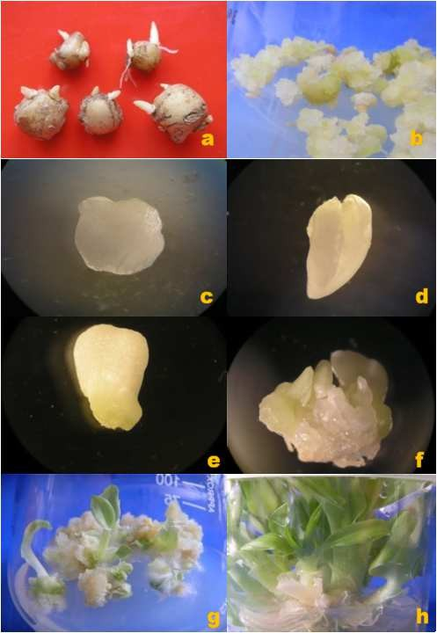
Figure1. (a) Healthy explants, (b) Induction of callus (c) Globular stage (d) Heart shape stage (e) Torpedo stage (f) Regenerating microshoot (g) Regeneration of shoots from callus and (h) Multiple shoots formation
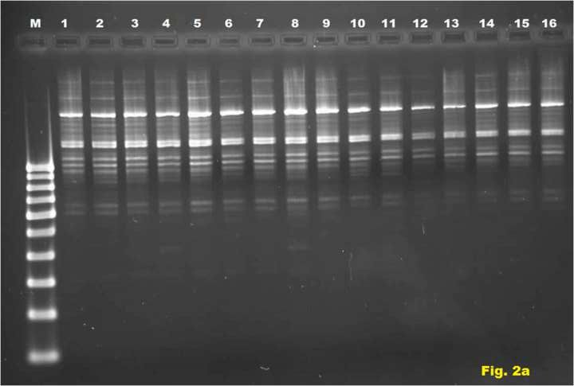

Figure 2a) RAPD profile of micropropagated Kaempferia marginata using OPAM-01. M-Marker: 1- Mother plant: 2 to 16- Regenerants from callus.
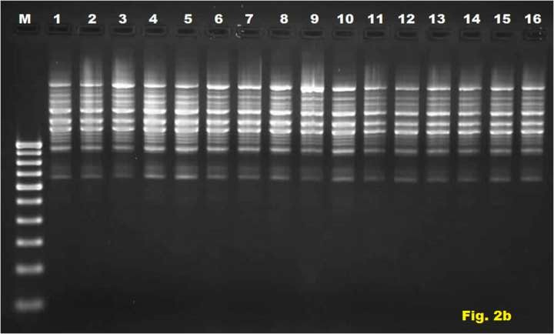

Figure 2b) ISSR profile of micropropagated Kaempferia marginata using IG-12. M-Marker: 1- Mother plant: 2 to 16- Regenerants from callus.

4. CONCLUSION
In conclusion, the present study establishes a highly efficient and reproducible protocol for the micropropagation of the endangered medicinal plant Kaempferia marginata via somatic embryogenesis. The results demonstrate that MS medium supplemented with 2.0 mg L⁻¹ NAA is optimal for the induction of embryogenic callus, while a combination of 4.0 mgL⁻¹ BAP and 1.0 mg L⁻¹ NAA maximizes shoot multiplication [(16.35 ± 0.22) shoots/explant]. Crucially, the molecular assessment using RAPD and ISSR markers confirmed that the regenerated plantlets are genetically identical to the mother plant, exhibiting 100% monomorphism. This lack of somaclonal variation validates the protocol's suitability for commercial applications where clonal fidelity is paramount. Consequently, this method provides a potent tool for the mass propagation of true-to-type elite clones, facilitating both the sustainable supply of pharmaceutical raw materials and the conservation of this valuable germplasm in its natural habitat.

COMPETING INTERESTS DISCLAIMER:
Authors have declared that they have no known competing financial interests OR non-financial interests OR personal relationships that could have appeared to influence the work reported in this paper.

REFERENCES
Agretious, T. K., Martin, K. P., & Hariharan, M. (1996). In vitro clonal multiplication of Alpinia calcarata Roscoe. Phytomorphology, 46, 133–138.
Balachandran, S. M., Bhat, S. R., & Chandel, K. P. S. (1990). In vitro clonal multiplication of turmeric (Curcuma spp.) and ginger (Zingiber officinale Rosc.). Plant Cell Reports, 8, 521–524.
Doyle, J. J., & Doyle, J. L. (1987). A rapid DNA isolation procedure for small quantities of fresh leaf tissue. Phytochemical Bulletin, 19, 11–15.
Elshamy, A. I., Singh, A., Singh, N., Singh, S., Srivastava, R. P., Singh, L., Verma, P. C., Devkota, H. P., Rahman, L., Rajak, B. K., Singh, A., & Saxena, G. (2023). The industrially important genus Kaempferia: An ethnopharmacological review. Frontiers in Pharmacology, 14, 1099523.
Goto, S., Thakur, R. C., & Ishii, K. (1998). Determination of genetic stability in long-term micropropagated shoots of Pinus thunbergii Parl. using RAPD markers. Plant Cell Reports, 18, 193–197.
Hosoki, T., & Sagawa, Y. (1977). Clonal propagation of Ginger (Zingiber officinale Rosc.) through tissue culture. Horticultural Science, 12, 451–452.
Jayanthi, M., & Mandal, P. K. (2001). Plant regeneration through somatic embryogenesis and rapid analysis of regenerated plants in Tylophora indica (Burm. F. Merril). In Vitro Cellular & Developmental Biology - Plant, 37, 576–580.
Joshi, P., & Dhawan, V. (2007). Assessment of genetic fidelity of micropropagated Swertia chirayita plantlets by ISSR marker assay. Biologia Plantarum, 51, 22–26.
Kishor, R. (2012). Rediscovery of Kaempferia marginata (Zingiberaceae) after a lapse of 100 years from India. Rheedea, 22, 28–31.
Lakshmi, M., & Mythili, S. (2003). Somatic embryogenesis and regeneration of callus cultures of Kaempferia galanga – medicinal plant. Journal of Medicinal and Aromatic Plants, 25, 947–951.
Madaka, F., & Tewtrakul, S. (2011). Anti-allergic activity of some selected plants in the genus Boesenbergia and Kaempferia. Songklanakarin Journal of Science and Technology, 33, 301–304.
Martin, K. P. (2003). Plant regeneration through somatic embryogenesis on Holostemma adakodien, a rare medicinal plant. Plant Cell, Tissue and Organ Culture, 72, 79–82.
Martins, M., Sarmento, D., & Oliveira, M. M. (2004). Genetic stability of micropropagated almond plantlets, as assessed by RAPD and ISSR markers. Plant Cell Reports, 23, 492–496.
Misra, P., Datta, S. K., Johri, J. K., Singh, H. B., & Srivastava, A. (2004). An improved method for in vitro largescale propagation of Piper betle L. Journal of Plant Biochemistry and Biotechnology, 13, 161–164.
Murashige, T., & Skoog, F. (1962). A revised medium for rapid growth and bioassays with tobacco tissue cultures. Physiologia Plantarum, 15, 473–479.
Rahman, Z. A., Ahmad, N. A. S., Basirun, N. N. A., & Othman, A. N. (2023). Regeneration of Kaempferia parviflora from Meristem through Somatic Embryogenesis. European Journal of Applied Sciences, 11, 84–93.
Rani, V., Parida, A., & Raina, S. N. (1995). Random amplified polymorphic DNA (RAPD) markers for genetic analysis in micropropagated plants of Populus deltoides Marsh. Plant Cell Reports, 14, 459–462.
Sahoo, S., Panda, S. P., Nayak, S., & Kar, B. (2023). Molecular profiling of therapeutically important Alpinia and Kaempferia species using RAPD, ISSR, and SSR markers. Vegetos, 36, 1–12.
Sehgal, C. B., & Syed Abbas, N. (1994). Somatic embryogenesis and plant regeneration from hypocotyl tissue of Trachyspermum ammi (L.) Sprague. Phytomorphology, 44, 265–271.
Sofiari, E., Raemakers, C., Bergervoet, J., Jacobsen, E., & Visser, R. (1998). Plant regeneration from protoplasts isolated from friable embryogenic callus of cassava. Plant Cell Reports, 18, 159–165.
Sunitibala, H., Damayanti, M., & Sharma, G. J. (2001). In vitro propagation and rhizome formation in Curcuma longa Linn. Cytobios, 105, 71–82.
Thongnest, S., Mahidol, C., Sutthivaiyakit, S., & Ruchirawat, S. (2005). Oxygenated Pimarane Diterpenes from Kaempferia marginata. Journal of Natural Products, 68, 1632–1636.
Tokuhara, K., & Mii, M. (2001). Induction of embryogenic callus and cell suspension culture from shoot tips excised from flower stalk buds in Phalaenopsis (Orchidaceae). In Vitro Cellular & Developmental Biology - Plant, 37, 457–461.
Vidya, S. M., Krishna, V., Manjunatha, B. K., & Shankarmurthy, K. (2005). Micropropagation of Entada pursaetha DC- An endangered medicinal plant of Western Ghats. Indian Journal of Biotechnology, 4, 561–564.
Wakhlu, A. K., & Sharma, R. K. (1998). Micropropagation of Heracleum candicans Wall: a rare medicinal herb. In Vitro Cellular & Developmental Biology - Plant, 35, 79–80.
Williams, J. G. K., Kubelik, A. R., Livak, K. J., Rafalski, J. A., & Tingey, S. V. (1990). DNA polymorphisms amplified by arbitrary primers are useful as genetic markers. Nucleic Acids Research, 18, 6531–6535.
Zietkiewicz, E., Rafalski, A., & Labuda, D. (1994). Genomic fingerprinting by simple sequence repeat (SSR)-anchored polymerase chain reaction amplification. Genomics, 20, 176–183.
Zimmermann, J. L. (1993). Somatic embryogenesis: A model for early development in higher plants. Plant Cell, 5, 1411–1423.

