Original Research Article

Characterization of partially purified trypsin and chymotrypsin inhibitor of Vigna pilosa

Abstract
Vigna pilosa is a crop plant belonging to the family Leguuminosae. A proteinacious inhibitor of trypsin (VPTI) and chymotrypsin (VPCI) was isolated from Vigna pilosa seeds. Protein was extracted in 0.1 M Tris–Cl buffer (pH-8.0) and subjected to precipitation using 60% ammonium sulphate, dialyzed against 0.1 M phosphate buffer and eluted on DEAE cellulose column chromatography. Fold purification obtained was 16.79 for VPTI and 12.99 for VPCI. Purified sample was analyzed on gelatin embedded native PAGE for isoform detectetion. Two isoforms of VPTI were observed. SDS-PAGE analysis of Vigna pilosa protease inhibitor (VPPI) showed closely related two polypeptide bands of ~20 and ~19.5 kDa. Solution assay with BApNa and BTpNa at 38 μg and 55 μg of inhibitor concentration showed 50% inhibition of VPTI and VPCI respectively. Both the inhibitors showed activity between pH ranges 6.5 to 7.5. It lost its complete activity when heated at 100°C for 50 minute.
Keywords plant seed inhibitor, protease inhibitor, trypsin inhibitor, chymotrypsin inhibitor Vigna pilosa.
1. Introduction
Trypsin inhibitors are small proteins found in variety of seeds especially in food legumes. They interact with their target enzyme by contact with the active site of the enzyme resulting in the enzyme inhibitor complex that is incapable of enzymatic activity (Norton, 1991) Legumes mostly contain Bowman-Birk and Kunitz type of inhibitors (Shewry, 1999; Francisco, 2004). Bowman-Birk inhibitors are serine proteinase inhibitors. They are single polypeptide interact independently but simultaneously with two proteases, which may be same or different (Birk 1985, Raj et al., 2002). The plant Kunitz inhibitors are one or two polypeptide chains and low cysteine content. The members of this family are mostly active against trypsin, chymotrypsin and substilisin (Laing and McManus, 2002; Park, 2005). Formally trypsin inhibitors are often associated with its negative effect as an antinutritional factor but now it is known that they are helpful for human health due to its anticarcinogenic, anti-inflammatory activity, antiulcer activity (Kumar & Gowda, 2013).
Vigna pilosa is a crop plant belongs to the family Leguminasae. It is perennial climbing herb belongs to subgenus Dolicho vigna. In India it has restricted distribution in Western ghat, where it locally known as alsunda. Trypsin and chymotrypsin inhibitor were found in many species of the Vigna.
2. Materials and Methods
Plant material Seeds of ripened fruit of Vigna pilosa, were procured from local stores.
Chemicals The chemicals used in the present investigation were procured from the following sources. Bovine serum albumin (BSA), acrylamide, N-N'-methylene bis-acrylamide, coomassie brilliant blue (CBB) , N-N, N'-N'-tetramethylethylenediamine, 1, 2-diaminoethane (TEMED), ammonium per sulfate (APS), ammonium sulfate, sodium chloride, sodium dihydrogen orthophosphate, disodium hydrogen orthophosphate, sodium hydroxide, ethylene diamine tetra acetic acid (EDTA), Glycine, Sodium dodecyl sulfate (SDS), were purchased from Himedia laboratories Pvt.Ltd. Mumbai India. Bovine pancreatic trypsin (2 × crystallized, type III, EC 3.4.21.4), ∝-N-benzoyl-DL-arginine-p-nitroanilide (BApNA), ∝-N-benzoyl-DL-tyrosine-p-nitroanilide (BTpNA), purification material DEAE cellulose were purchased from Sigma Chemical Co., St. Louis. MO, USA. SDS-PAGE medium and low range molecular weight markers were procured from Merck Bioscience, Bangalore, India.
Protein extraction and partial purification
The seeds were cleaned, dehusked, crushed and the powder was defatted with hexane. The defatted powder was stored at 4°C for further use. A 10% (w/v) suspension in 0.1 M Tris–Cl Buffer (pH-8.0) was extracted overnight at 4°C with continuous stirring. Next day, it was centrifuged at 14,000 rpm for 30 min. Crude extract was saturated for 40 to 60 % (NH₄)₂SO₄ precipitation by addition of finely ground solid (NH₄)₂SO₄ at 4 °C. The solution was allowed to stand overnight in cold for complete precipitation of the proteins. The precipitate was collected by centrifugation at 10, 000 ⋅ g for 30 min at 4 °C. The precipitate obtained was dissolved in minimal quantity of water and dialyzed extensively against 0.1 M phosphate buffer (2 ⋅ 1000 mL). The protein content was determined using BSA (250µg/mL) as a standard protein (Lowry et al., 1951).
DEAE cellulose column chromatography
The active protease inhibitor fraction obtained after dialysis was further purified by ion-exchange chromatography. The DEAE cellulose column was prepared according to protocol designed by manufacturer (Sigma Chemical Co., St. Louis. MO, USA) with minor changes. The column was carefully packed without any air bubble and was equilibrated with phosphate buffer (0.02M) pH 7.8. Dialyzed protein sample was applied to the pre-equilibrated column. After the complete entry of sample in to the column, the column was eluted with phosphate buffer (0.02M) pH 7.8 with a flow rate of 1ml/min. using step wise gradient of sodium chloride. The protein content of each fraction was estimated by measuring the absorbance at 280 nm. Then the fractions were assayed for trypsin and chymotrypsin inhibitory activity. Peak fraction from the column were pooled and dialyzed against the phosphate buffer (0.02M) pH 7.8. The yield and fold of purification was calculated.
Assay method
The trypsin and chymotrypsin inhibitory activity were spectrophotometrically measured by assaying amidolytic activity for trypsin and chymotrypsin in the absence and presence of a known quantity of inhibitor using the chromogenic substrates BApNA and BTpNa, respectively (Kakade et al., 1969; Kumar & Gowda, 2013). All the spectrophotometric measurements were performed on a UV-visible spectrophotometer (Shimadzu, Model -UV-1800).
Assay of trypsin and trypsin inhibitor activity
Trypsin was assayed using the substrate BApNA. 40 mg of BApNA was dissolved in 2 mL dimethylsulfoxide (DMSO) and then diluted (1:100) in 50 mM Tris-HCl buffer, pH 8.2 containing 20 mM CaCl₂, prior to enzyme assay. The assay reaction consisted of 0.5 mL of trypsin solution (50 ⎧g of trypsin in 1 mM HCl), 0.5 mL of water and 1.25 mL of the substrate. The reaction was carried out at 37 °C for 10 min and the reaction arrested by adding 0.25 mL of 30 % acetic acid. The absorbance of p-nitroanilide liberated was measured at 410 nm against an appropriate blank.
Trypsin and trypsin inhibitory unit
One trypsin (TU) unit is arbitrarily defined as an increase in absorbance of 0.01 at 410 nm under conditions of assay. The trypsin inhibitory unit (TIU) is defined as the number of trypsin units inhibited under the same conditions (Kakade et al., 1969).
Assay of chymotrypsin and chymotrypsin inhibitory activity
The stock of BTpNA (20 mM) was prepared by dissolving 16.2 mg in 2 mL of DMSO and then made up to 100 mL with 80 mM Tris-HCl buffer, pH 7.8 containing 100 mM CaCl₂ and 20 % DMSO (v/v). 0.5 mL chymotrypsin solution was added to 0.5 mL of distilled water and incubated with 1.25 mL of substrate at 37 °C for 10 min. The reaction was stopped by adding 0.25 mL of 30 % acetic acid and the liberated product, p-nitroanilide measured at 410 nm.
Chymotrypsin and chymotrypsin inhibitory unit
One chymotrypsin (CU) unit is arbitrarily defined as an increase in absorbance of 0.01 at 410 nm under assay conditions. The chymotrypsin inhibitory unit (CIU) is defined as the number of chymotrypsin units inhibited under the same conditions.
Polyacrylamide gel electrophoresis
Vertical slab gel electrophoresis was carried out in a GENEI mini model electrophoresis unit, at 25 ± 2 °C. The gel was scanned in BioRads Gel DocTM EZ imager and analyzed in image lab software.
Gelatin embedded PAGE for trypsin and chymotrypsin inhibitory activity staining
Gelatin–PAGE (Felicioli et al., 1997) was performed by adding gelatin (1 %, w/v final concentration) to the acrylamide gel. Following electrophoresis, the gel was washed with distilled water for three times and then incubated at 37°C in 0.1 M Tris-HCl buffer (pH 8.0) containing trypsin (40 ⎧g/mL) for 1 h. After gelatin hydrolysis, the gel was washed with distilled water and stained with CBB and destained. The presence of the trypsin inhibitor was detected as a dark blue band in a clear background due to the complex of the unhydrolyzed gelatin with the stain.
SDS-Polyacrylamide gel electrophoresis (SDS-PAGE)
SDS-PAGE (10%T, 2.7%C) at alkaline pH (8.3) was carried out by running the gel at constant current (50 volts) until the tracking dye reached the anode tank buffer (Laemmli, 1970).
3. Results and Discussion
Partial purification of inhibitor
The inhibitory activity of the crude extract indicates that the Vigna seeds contain proteinacious trypsin inhibitors. Therefore to identify the inhibitory protein, partial purification was carried out by using DEAE cellulose column. The bound protein was eluted as a single peak with phosphate buffer pH 7.8. The advantage of using this step was the exclusive binding of only the inhibitor forms and removal of other contaminants. Incresed NaCl concentration induced dissociation results in the release of inhibitor from DEAE cellulose. Specific inhibitory activity of purified VPTI was 1074 TIU/mL and VPCI was 534.8 CIU/mL. The purification is summarised in (Table 1) .The inhibitory protein bonded to DEAE coloumn at pH 7.8 showed that the net charge on protein is anionic.
Isoform detection
The purified inhibitor was electrophoresed on native PAGE as described earlier, and detected by staining with CBB. Native PAGE followed by incubation independently with bovine trypsin and chymotrypsin showed that V. pilosa inhibitor inhibit trypsin and chymotrypsin enzyme (Fig. 3). It also showed that V. pilosa seeds contain multiple forms VPTI inhibitors.
Molecular weight determination
The purified VPPI showed closely related two indistinct bands having same staining intensity under reducing condition in SDS PAGE (Fig. 5). It shows that the inhibitor present in doublet form indicating presence of two polypeptide chains that share the same amino acid but they are differ in certain key positions. It also showed that out of total loaded protein in well, 52% retained in upper band while 48% in lower band. The gel analysed in image lab showed that the VPPI were separated in between the R_{f} value of 0.4-0.6. The apparent molecular weights of the two isoinhibitors were ~20kDa and ~19.5kDa. (Fig. 4).
Stoichiometry
The stoichiometry of inhibition for the partially purified inhibitor against bovine pancreatic trypsin and chymotrypsin were assessed using BApNA and BTpNA respectively. Increasing concentrations of inhibitor were incubated with a fixed concentration of the enzyme. The plot of [I] Vs % residual activity was used to evaluate the stoichiometry. For 50% inhibition of trypsin, 38μg of VPTI and for chymotrypsin 55 μg of VPCI were needed.
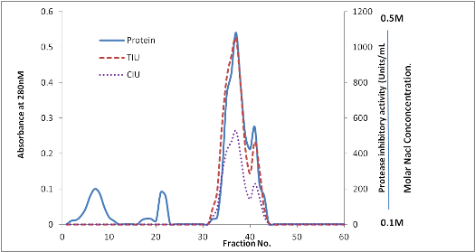
Fig. 1 DEAE cellulose chromatographic profile of VPPI

Sr.No. | Sample Name | Protein  mg/mL | Inhibitory Activity (IU/mL) | Specific Activity (TIU /mg) | TIU/ CIU | Yield of protein (%) | Fold Purification
01 | Crude extract | 3.4 | TIU 218  CIU 140 | TIU 64.11  CIU 41.17 | 1.55 | 100 | 1  1
02 | Dialysis | 1.8 | TIU 640  CIU 380 | TIU 355.5  CIU 211.1 | 1.68 | 52.94 | 5.54  5.12
03 | DEAE Cellulose chromatogarphy Pulled extract | 1.234 | TIU1326  CIU 660 | TIU 1074  CIU 534.8 | 2.00 | 36.29 | 16.76  12.99

Table 1 Summary of the purification of VPPI

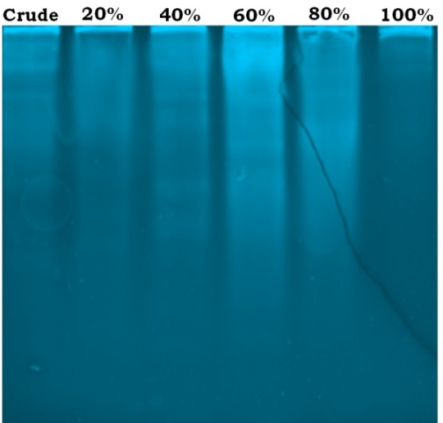
Fig. 2 Native-PAGE (10% T, 2.7% C) profile of Ammonium sulphate precipitate fractions of VPPI inhibitor showing trypsin inhibitory activity.

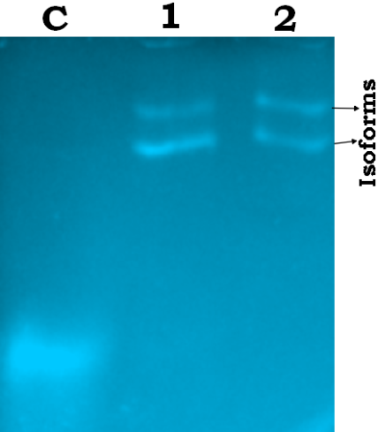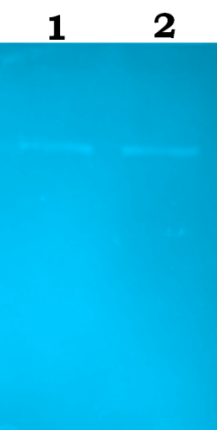
a b
Fig. 3 Native-PAGE (10% T, 2.7% C) profile of VPPI showing trypsin inhibitory activity a and chymotrypsin inhibitory activity b.

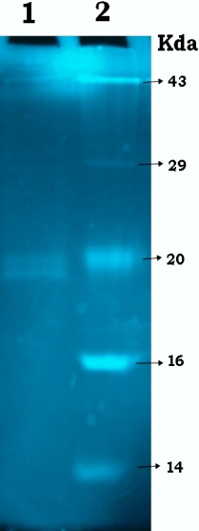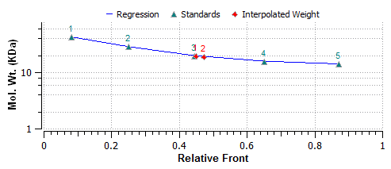
Fig. 4 SDS-PAGE (10%T, 2.7%C) profile of purified inhibitor lane1: VPPI
lane 2: molecular weight markers. (Small size)

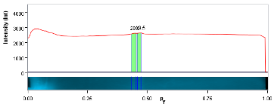
a
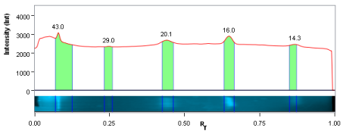
b
Fig. 5 SDS –PAGE lane profile of VPPI (a-lane 1, b-lane 2)

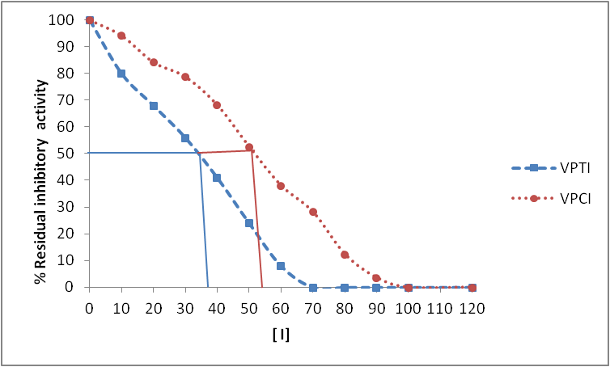
Fig. 6 Determination of IC₅₀ value for trypsin and chymotrypsin inhibition.

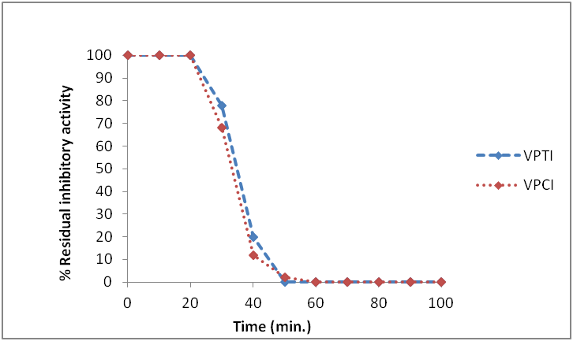
Fig. 7 Determination of thermo stability for trypsin and chymotrypsin inhibition.

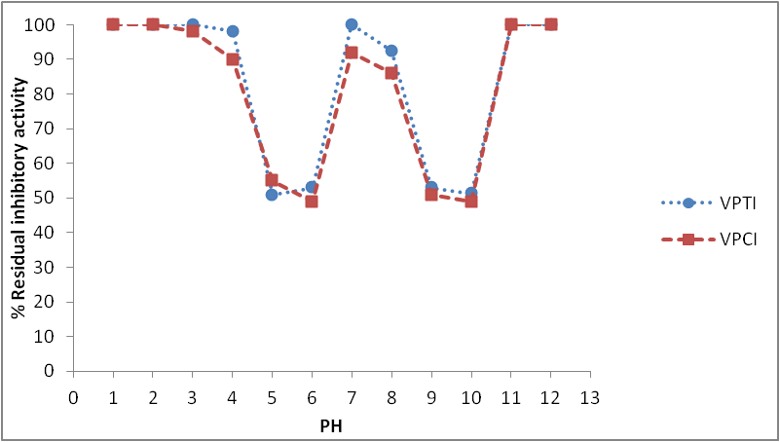
Fig. 8 Effect of pH on trypsin and chymotrypsin inhibition.

Conclusion
The result indicates that the Vigna pilosa seeds contain proteinacious-protease inhibitors. The protein precipitated at 60% ammonium sulphate concentration has highest protease inhibitory activity (Fig. 2). Gelatin embedded native PAGE of purified VPPI incubated independently with either trypsin or chymotrypsin showed a single protein species with similar mobility (fig. 3) indicating that VPPI inhibiting both the enzymes. It also shows that the seeds contain multiple forms of VPTI. The apparent molecular weight of VPPI was evaluated by SDS-PAGE. The molecular weights of two isoforms of VPTI as determined by SDS-PAGE were 20 and 19.5 kDa (Fig. 4). 70 μg of partially purified protein (VPTI) causes 100% of trypsin inhibition while 100 μg (VPCI) causes 100% chymotrypsin inhibition. Thermal stability of V. pilosa inhibitor was assessed to check whether it can withstand high temperatures. Preliminary results suggest that the trypsin inhibitor was not stable to heat.

References
Birk Y, (1985)The Bowman-Birk inhibitor. Trypsin- and chymotrypsin-inhibitor from soybeans. Int J Pept Protein Res. 1985 Feb; 25(2):113-31.
Christeller J T, (2005) Evolutionary mechanisms acting on Proteinase inhibitor variability. J. FEBS 272: 5710 – 5722.
Felicioli R, Garzelli B, Vaccari L, Melfi D & Balestreri E, (1997) Activity staining of protein inhibitors of protease on gelatin-containing polyacrylamide gel electrophoresis. Anal. Biochem. 244, 176–179.
Kakade M L, Simons N & Liener I E, (1969). An evolution of natural vs. synthetic substrate for measuring the antitryptic activity of soybean samples. Cereal Chem.46, 518–526.
Kumar V and Gowda L R, (2013) Production of horsegram (Dolichos biflorus) Bowman–Birk inhibitor by an intein mediated protein purification system. Protein Expression and Purification 89 (2013) 16-24
Laemmli U K, (1970) Cleavage of structural proteins during the assembly of the head of bacteriophage T4. Nature. 227, 680–685.
Laing W, McManus MT (2002) Proteinase inhibitors. In MT McManus, WA Laing, AC Allan, eds, Protein- Protein Interactions in Plant Biology. CRC Press, Boca Raton, FL, pp 77-119
Lowry O H, Rosebrough N J, Farr A L, and Randall R J, (1951) Protein Measurement with the Folin Phenol Reagent. J. Biol. Chem. 193:265-275
Norton, G. 1991. Proteinase inhibitors. In F.J.P. D’Mello, C.M. Duffus, & J.H. Duffus, eds. Toxic Substances in Crop Plants, pp. 68-106. The Royal Society of Chemistry, Thomas Graham House, Science Park, Cambridge CB4 4WF, Cambridge.
Park Y, Choi BH, Kwak JS, Kang CW, Lim HT, Cheong HS, Hahm KS (2005) Kunitz-type serine protease inhibitor from potato (Solanum tuberosum L. cv. Jopung). J. Agric. Food. Chem., 53: 6491-6496.
Raj S S, Kibushi E, Kurasawa T, Suzuki A, Yamane T, Odani S, Iwasaki Y, Ashida T (2002) Crystal structures of bovine trypsin and wheat germ trypsin inhibitor (I-2b) complex (2:1) at 2.3 a resolution. J. Biochem., 132(6):927-33.
Shewry P R, (1999) Enzyme inhibitors of seeds: Types and properties. In Protease Inhibitors in Plant: Genes for Improving Defenses against Insects and Pathogens; Aca.: Dord., The Netherlands, pp 587-615.

